

|  |  |
| --- | --- |
| **Proposal By** | **Proposal To** |
|  |  |
| |  | | --- | | **Name:** | | **Name:** |
| **Designation:** | **Designation:** |
| |  | | --- | | **Telephone:** | | **Telephone:** |
| |  | | --- | | **Mobile:** | | **Mobile:** |
| |  | | --- | | **E-Mail:** | | **E-Mail:** |
| **Proposal Submitted on:** | |

**PROPOSAL DETAILS**

|  |  |
| --- | --- |
| Confidentiality: | Confidential |
| Copyright and reproduction: |  |
| Validity: | 90 days |
| Reference Number: |  |

Proposal to:

**Carl Zeiss**

Project for:

Inventory Optimization

Contents

1. Executive Summary 4

1.1 Company Profile: 4

2. Project details 5

2.1 Project Background 5

2.2 Project Objective 5

3. Project scope 6

3.1 Scope: 6

3.2 Out of Scope 7

3.3 Architecture 8

3.4 Pre-Requisites: 10

3.5 Assumptions: 10

3.6 Deliverables, Receivables and Acceptance Criteria 10

3.7 Bill of Material (BoM) / Licenses 11

4. Project schedule 12

5. Project Management 13

9.1 Project Execution 13

9.2 Project Management Methodology 13

9.3 Project Organization 14

9.4 Change Request Procedure: 15

9.5 Roles and Responsibilities 16

9.6 Escalation Management 17

9.7 Communication Plan 18

9.8 Risks & Mitigations 19

9.9 Information Security 19

6. Commercials 20

6.1 Commercial Proposal 20

6.2 Billing Milestones 20

6.3 Commercial Terms and Conditions 21

7. Case Studies 22

8. Appendix 23

9. Signatures 24

**GLOSSARY**

|  |  |  |  |
| --- | --- | --- | --- |
| **S.No** | **Module** | **Abbreviation** | **Full form** |
| 1 | Generic | SKU | Stock Keeping Unit |
| 2 | Generic | BGSW | Bosch Global Software Technologies |
| 3 | Generic | EDA | Exploratory Data Analysis |
| 4 | Generic | OS | Operating System |
| 5 | Generic | SAP | Systems, Applications and Processes in Data processing |
| 6 | Generic | RDBMS | Relational database management system |
| 7 | Generic | SPOC | Single Point of Contact |
| 8 | Generic | SOW | Statement of work |
| 9 | Generic | VPN | Virtual private network |
| 10 | Generic | SME | Subject Matter Expert |
| 11 | Generic | KPI | Key performance Indicator |
| 12 | Generic | SLA | Service level agreement |
| 13 | Generic | UAT | User Acceptance Testing |
| 14 | Generic | RFP | Request for Proposal |

# Executive Summary

## Company Profile:

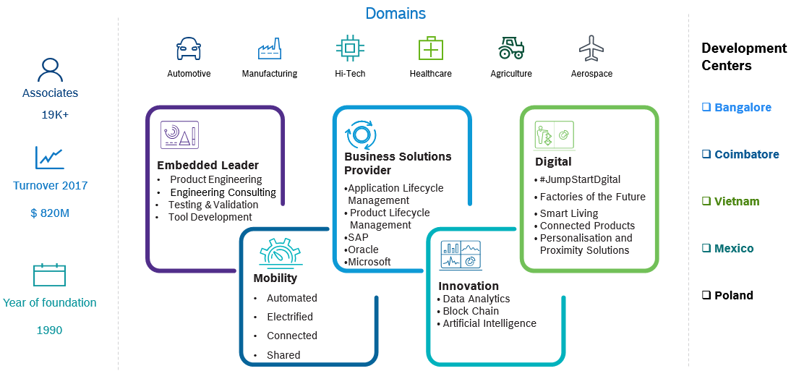

# Project details

## 2.1 Project Background

In any supply chain management system, the efficient distribution of inventory is crucial to meet demand while minimizing costs and ensuring customer satisfaction. In the context of a centralized inventory management system with multiple stock points and a central warehouse, there's a need for a robust stock redistribution algorithm. Currently stock is distributed from central warehouse to stock points. The objective of the POC is to build an algorithm which dynamically replenishes stock from excess stock points to deficit stock points while minimizing stockouts and excess inventory costs.

## 2.2 Project Objective

The primary objective of the POC is to build an intelligent stock redistribution algorithm which dynamically replenishes deficit stock points from excess stock points based on predefined norms and current inventory levels.

# Project scope

## Scope:

Design and develop an intelligent stock redistribution algorithm which dynamically replenishes deficit stock points from excess stock points based on predefined norms and current inventory levels. By utilizing the demand sheet produced by the solution, warehouse owners can redistribute their stock to locations experiencing shortages, ensuring they meet customer demands effectively.

### 3.1.1 Detailed Scope

**Algorithm Development Scope**

* Design and develop stock redistribution algorithm using SKU code level MSP norms and current stocks information for upto 40 stock points.
* Scope is to produce one demand sheet containing details about excess stock points, deficit stock points, and the quantities to be transferred from excess to deficit MSPs and will be shared once post model development.
* Preparation of detailed PPT highlighting the approach taken along with test case results.

**General:**

1. All documentations and business communication will be in English.

## Out of Scope:

1. Support co-ordination with OEM or 3rd party vendors for any product issues / bugs
2. Source system data availability and data quality related issues
3. Demand Forecasting and Route Optimization module.
4. Connection to any Database server for accessing data.
5. No model deployment scope
6. Setup and management of any DevOps / integration tools
7. Procurement and management of third-party licenses and certificates
8. Any Module and functionality not described in the above scope section.
9. Synthetic data generation for the module
10. End user training
11. Any modifications / new developments to the existing source systems
12. Reporting:
    1. Mobile app / Report Development
    2. Blueprint / Map visualization implementation
    3. Row Level Security feature
    4. UI/UX development
    5. Web App Development
    6. Administration activities

## Approach

BGSW proposes the below approach to build intelligent stock redistribution system for Carl Zeiss:

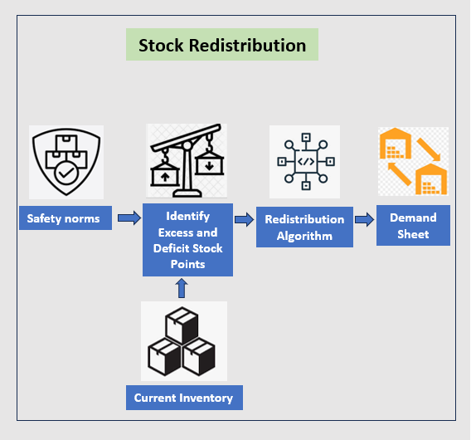

Detailed PPT will be shared post validation and the walkthrough of the approach will be provided to the customer with one-time virtual demo.

## Pre-Requisites:

Below are the key pre-requisites expected from Carl Zeiss:

|  |  |  |
| --- | --- | --- |
| # | Project Phase | Pre-requisites |
| 1 | Project Kick Off | 1. Single point of contact (SPOC) from Carl Zeiss 2. Purchase order 3. Availability of SKU code level MSP norms and current stocks information in excel/csv format. |
| 2 | Study | 1. Availability of Customer SPOC from customer for process understanding and data understanding 2. Agreement on Data quality and acceptance criteria on performance metric 3. SKU code level MSP norms and current stocks information as excel/csv files. 4. Mapping file for MSP’s and their local service providers as adjacency matrix structure in csv/excel format. |
| 3 | Design | 1. Customer SPOC shall provide timely clarification of open points. |
| 4 | Development and Unit Testing | 1. Business rules for any KPI calculations along with detailed source data mappings to be provided/ clarified by Carl Zeiss 2. Customer SPOC shall provide timely clarification of open points. |
| 5 | Demo | 1. Availability of Carl Zeiss stakeholders 2. Report detailing out approach taken and test case results. 3. Demand sheet to be generated and shared in csv format. 4. One-time virtual demo will be provided to the Carl Zeiss stakeholders to provide walkthrough of the solution. |
| 6 | Project Closure |  |

## Assumptions:

1. Scope creep will follow the CR process.
2. In case of scope creep, revised estimates for schedule and costs will be mutually discussed and agreed.
3. Customer is responsible for Data Ownership and Data Quality

## Deliverables, Receivables and Acceptance Criteria

|  |  |  |  |  |
| --- | --- | --- | --- | --- |
| # | Project Phase | Deliverables by BGSW | Receivables from Carl Zeiss | Acceptance Criteria |
| 1 | Project Kick Off | * Project plan and schedule with milestones * Team structure | * Purchase Order * Project Level Agreement * Project Team Structure | * Deliverables are in line with the project scope. |
| 2 | Study |  | * Clarifications on need basis from SMEs * SKU code level MSP norms and stocks information as excel/csv files. * Mapping file for MSP’s and their local service providers as adjacency matrix structure in csv/excel format. * Logic for identifying excess/deficit stock points, conditions for selecting optimal excess stock points to be provided by Carl Zeiss in form of documentation. * Agreement on performance metrics | * Solutioning covers identified requirements. |
| 3 | Design |  | * Clarifications on need basis | * Solutioning covers identified requirements. |
| 4 | Development and Unit Testing | * Unit Test cases derived from shared data and Test results | * Clarifications on need basis |  |
| 5 | Demo | * Detailed PPT with approach to the solution and test case results | * Feedback on results | * No critical defects * Demand sheet as per current stock data, norms and conditions provided by Carl Zeiss |
| 6 | Project Closure | * Detailed PPT with approach to the solution and test case results | * Handover confirmation * Signoff on Project closure | * No deviation from the agreed scope |

# Project schedule

The indicative timeline for this project is as depicted below.

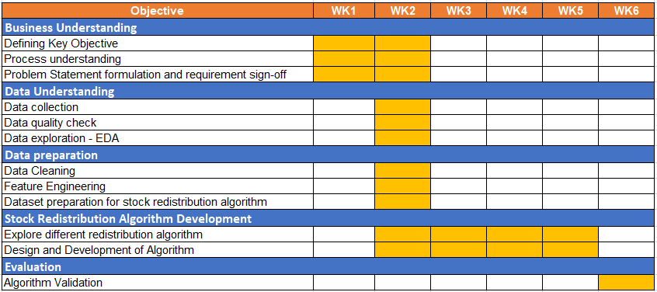

# Project Management

## 5.1 Project Execution

## 5.2 Project Management Methodology

BGSW will follow conventional phase-oriented models for PDS ProjectwithProject Preparation, phased Release (Design and realization), Implementation and Stabilization phases. In detail, this will include the following types of projects involving specific requirement: Change Requests / enhancements / developments.

**Conventional Model followed in BGSW**

* QG0 - > Approval for Concept
* QG1 - > Approval for Realization
* QG2/3 -> Approval for Productive Preparation
* QG4 - > Approval for Release / Go-Live
* QG5 - > Approval for Project Closure

**Brief description of the steps & deliverables across various phases of conventional model of BGSW,** **Project Excellence Process (PEP Methodology) is shown in the diagram below –**

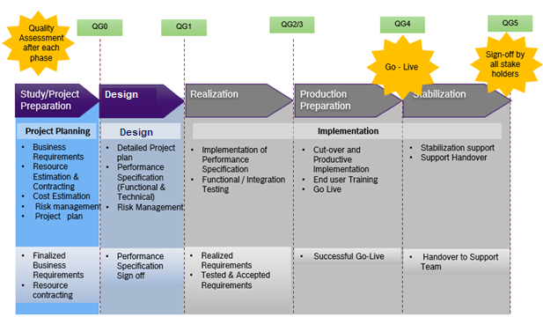

For PDS project, the review of requirement documents would be done for all the boards (plant, shop, Foreman, Area) and come up with solution design. The Realization (development/Engineering), Go-Live (commissioning until SOP) and post-go live will be done for each phased delivery as detailed in project timelines.

## Project Organization

Below would be the project organization structure proposed for this project:

<<Sample>>

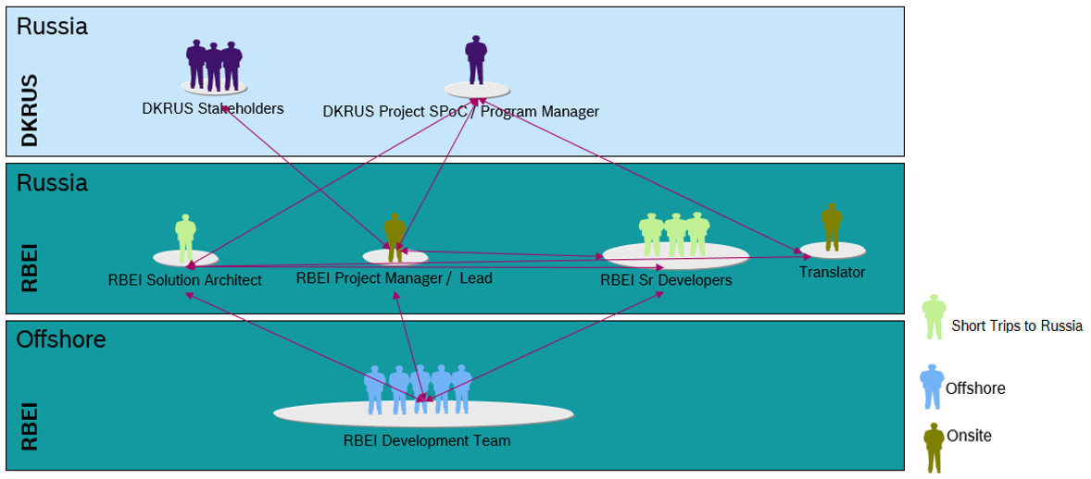

## Change Request Procedure:

The Change Request procedure (shown below) applies to all changes resulting from requirements outside the scope defined in this proposal.

<<Sample>>

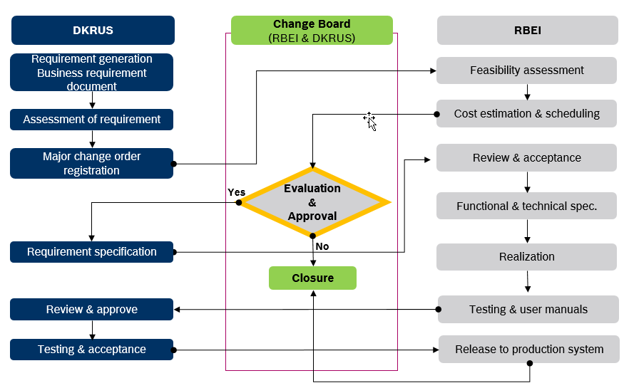

Any activity causing delay in project schedule will have an impact on project commercials and must be discussed mutually between BGSW and Carl Zeiss. Additional efforts must be incorporated in the project through Change request process.

## Roles and Responsibilities

|  |  |
| --- | --- |
| **Carl Zeiss** | |
| **Role** | **Responsibility** |
| **Carl Zeiss Project Manager** | * Responsible for project delivery * Overall project responsibility * Participate in joint reviews with BGSW * Approves change requests |
| **Carl Zeiss Core Team** | * Responsible for UAT * Reports defects to product owner during UAT |

|  |  |
| --- | --- |
| **BGSW** | |
| **Role** | **Responsibility** |
| **Project Lead** | * Responsible for overall project management * Administrative control of BGSW project team * Project inputs to Carl Zeiss Program Manager * Provide resources for the project * Coordination with teams |
| **Architect** | * Designing solution (end-to-end vision for data flow & pipeline) * Development of data models for database structures * Integration with source systems * Integration of technical functionalities including scalability, security, reliability * Visualizations |
| **Data Engineer** | * Integration of Source Interfaces * Building/developing data processing and pipeline. * Implementation of the architected solution |
| **Visualization Engineer** | * KPIs and dashboard development * UAT Support |

## Escalation Management



* Carl Zeiss Project Manager
* BGSW Project Lead
* Carl Zeiss Delivery Manager
* BGSW Service Delivery Manager



* Carl Zeiss IT Head
* BGSW Delivery Head

**BGSW Development Team**

**1st Level Escalation**

**2nd Level Escalation**

**3rd Level Escalation**

## Communication Plan

An effective communication is necessary for successful execution and tracking of the project. The below communication plan is proposed for the project.

|  |  |  |  |  |
| --- | --- | --- | --- | --- |
| S No | Communication Type / Media | Participants | Frequency | Topics to be discussed |
| 1 | Project status review | Carl Zeiss  BGSW | Weekly | Status of the project |
| 2 | Project team meeting | Project teams | Fortnightly | Activities / status / clarifications on project related activities |
| 3 | Project status reporting | Carl Zeiss  BGSW | Monthly | Monthly status of the project |
| 4 | Issue escalation | Carl Zeiss  BGSW | Ad-Hoc | Issues which are escalated |
| 5 | Steering committee | Carl Zeiss business representative  Carl Zeiss IT head  BGSW Delivery head  BGSW and Carl Zeiss  project managers  Other key stakeholders | Quarterly | Decisions, approvals & status of the project |

## Risks & Mitigations

|  |  |
| --- | --- |
| Risks | Mitigation |
| Unavailability of necessary Infrastructure/Source Systems or the interfaces for extraction of necessary data from the source systems | Carl Zeiss team to ensure availability of all necessary infrastructure/Source Systems with necessary interfaces for data extraction as defined in the prerequisites |
| Missing clarity of Data field mapping and Calculation for KPIs | Carl Zeiss team to ensure availability of all Data field mapping and calculations documented and made available to BGSW team before the Design phase |
| Delay in acceptance of deliverables resulting in schedule and effort deviations | Carl Zeiss should adhere to the plan for review and sign-off. |
| Disturbance due to Natural calamities and social chaos | Carl Zeiss to have necessary Business Continuity Plan. Schedule to be revisited, adjusted, and mutually agreed |

## Information Security

BGSW will adhere to the following information security practices.

* Will comply to Carl Zeiss guidelines and procedures – Institutionalize measures by internal audits.
* Confidentiality: Signing of confidentiality letter by each associate

# Commercials

## Commercial Proposal

## Billing Milestones

## Commercial Terms and Conditions

* Taxes as applicable are additional.
* In case the project is stopped for unforeseen circumstances, then invoice will be raised for the effort which has been spent.
* Any delay in the project schedule not attributable to BGSW will lead to a revision in the commercial estimates which will be discussed and agreed upon.
* Any change in scope or schedule from the proposal may involve re-evaluation of the pricing and revision (upward or downward) if required.
* Any change in the assumptions relating to responsibilities will involve Change Order processing and follow up proposal.
* Project start is subject to publishing of names of business users, project manager from Carl Zeiss, sign off on schedule and single point of contact in IT.
* Carl Zeiss shall bear cost of travel, accommodation and allowance in case any consultant is asked to travel to a location outside of the project location in Carl Zeiss which is not planned as part of the project
* Any clarifications on the invoice to be completed within 10 days from the date of invoice.
* Invoices are payable without deduction within thirty (30) days from the date of invoice.

# Case Studies

# Appendix

# Signatures