Land-Use Dynamics, Settlement Expansion and Road-Network Transformation in Siliguri: A Synthesis of Published GIS Evidence and Analytical Framework

Abstract
Urban expansion and transportation development are closely associated with changes in land use, settlement patterns, and spatial accessibility. Siliguri, a strategically important urban centre in northern West Bengal, provides a relevant context for examining these interrelated processes. This paper synthesises published GIS evidence and presents an analytical framework for assessing land-use and land-cover (LULC) dynamics, settlement expansion, and road-network transformation across four reference years: 1991, 2001, 2011, and 2025. The framework distinguishes the broader Siliguri Planning Area from Siliguri Municipal Corporation to avoid conflating findings derived from different geographical extents. It outlines multi-temporal LULC analysis, built-up area change calculations, settlement morphology assessment, road-network indicators, and spatial analysis for future empirical implementation. Published secondary evidence reports that built-up land within Siliguri Municipal Corporation increased from 17.26 km² in 2001 to 36.98 km² in 2015, an absolute increase of 19.72 km² or approximately 114.2%, calculated from the reported values. This finding is presented as published evidence and not as a newly generated GIS result or a direct estimate for 2025. The paper also includes a clearly separated appendix to demonstrate how LULC and road-network results may be tabulated and visualised. Hypothetical values are not actual measurements and are not used to support empirical conclusions. The framework can inform a reproducible spatial assessment of urban change in Siliguri, but definitive conclusions for 1991–2025 require harmonised satellite imagery, verified road-network datasets, documented classification procedures, and accuracy assessment.
Keywords: Geographic Information System; land-use and land-cover change; urban expansion; settlement morphology; road-network transformation; spatial accessibility; Siliguri.

1. Introduction
Urbanisation is a major driver of land-use change, urban sprawl, and shifting transportation systems. The transformation of land use, vegetation, and open space into built-up areas affects settlement morphology, landscape structure, and the spatial distribution of human activities. To grasp these changes, an integrated geographical approach is needed that integrates multi-temporal land-use/land-cover (LULC) mapping with settlement and transportation network analysis (Herold et al., 2003; Seto et al., 2012). Global assessments indicate that urban land is expanding faster than urban populations and that much of the projected expansion will occur in Asia (Angel et al., 2011; Seto et al., 2012).
The assessment of the spatial and temporal aspects of urban growth can be carried out effectively using Geographic Information Systems (GIS) and remote sensing. Remote sensing techniques enable land-cover changes to be identified, while GIS helps to conduct change detection, assess settlement morphology and integrate the geographical and infrastructural data sets. But analysing urban transformation cannot only be done by quantifying urban built-up expansion, it also needs to examine pathways of land conversion, spatial growth patterns, and how these are connected to transportation accessibility and road network structure (Reba & Seto, 2020).
The city and transport hub of Siliguri in the north of West Bengal provides a case study for the study of these interlinked processes. Dramatic urban growth, land use change and loss of vegetation have been reported in Siliguri and its adjoining area earlier (Chakraborty et al., 2021; Basu et al., 2023). However, a more holistic study of the interdependencies among the spatial dimensions of land-use change, settlement growth and road network remodification, at complementary geographical scales, is needed. Particularly, an overview of the broader land-use changes in the Siliguri Planning Area (SPA) and the connectivity, accessibility, and centrality of the road network at the municipal and ward levels of the town can offer a better understanding of urban spatial restructuring.
To solve this research problem, the present study examines the land use changes and the transformation of settlement pattern and road network in Siliguri from 1991 to 2025 through GIS and remote sensing. The study considers the changes in major LULC categories, settlement growth pattern, land conversion pathways, and road network characteristics along with investigating their spatial relationship over the wards of SMC. It is a temporal framework that has built-in historical markers of 1991, 2001 and 2011 and a geospatial assessment point in the present time of 2025, based on the availability and comparability of data.
The primary innovation of this research is to combine the multi-temporal land-use analysis in the same spatial framework with settlement morphology and road-network indicators. The purpose of the study is to establish the spatial variability of land transformation at a regional scale, in relation to accessibility and network structures at the municipal level in order to provide evidence-based implications for sustainable settlement planning. The analysis is based on identified spatial relationships, not on the hypothesis that the spatial expansion of road networks is directly responsible for the spatial expansion of settlements.

2. Literature Review

2.1 Land-Use Transformation and Urban Expansion
Land-use/land-cover (LULC) change reflects the shift of natural and agricultural land cover to urban built-up areas and is a crucial indicator of urban transformation. Herold et al. (2003) showed the utility of combining remote sensing and spatial measures to describe the spatial shape of urban sprawl. Likewise, Seto et al. (2012) pointed to the broader environmental impacts of urban growth, such as impacts on biodiversity and carbon pools. These studies validate the need for a spatial distribution and impacts-based approach to assessing urban growth beyond just built-up area. Reviews of land-use and land-cover dynamics emphasise that such change is driven by interacting socio-economic and biophysical factors and that its consequences extend to ecosystems and livelihoods (Lambin et al., 2003). In Indian cities, GIS- and remote-sensing-based studies have used spatial metrics to quantify urban sprawl and its effects on land-use patterns (Sudhira et al., 2004; Bhatta et al., 2010).

2.2 GIS and Remote Sensing in Settlement Analysis
GIS and remote sensing techniques are important tools to map urban growth, detect land-use change and assess urban morphology. Reba and Seto (2020) reviewed the various algorithms for detecting and monitoring urban land change and discussed the methodological challenges of representing and measuring urban change. However, to make sure that a temporal comparison can be done reliably, classification procedures must be consistent, spatial resolution must be adequate and independent accuracy assessment must be performed. These methods, when combined with settlement-geography approaches, may be useful to understand the nature of urban growth - compact or dispersed, corridor-based, or focused on existing settlement lines. Methodological syntheses further stress that the choice of classifier, the comparability of multi-date imagery and the use of reference samples determine the reliability of land-change estimates (Lu & Weng, 2007; Olofsson et al., 2014; Trinder & Liu, 2020).
Road networks and accessibility are important dimensions of urban spatial structure because they connect residential, commercial and institutional areas. Transportation systems are important to the spatial structure of settlements because of their ability to link up residential, commercial and institutional areas. Road density is not a complete measure of network performance, however, as connectivity and centrality and accessibility reflect different dimensions of spatial structure. Boeing (2017) showed that graph-based approaches could be beneficial for analysing the structure and connectivity of street networks. This can be useful to combine these with settlement and land-use data to make a more holistic judgement of the spatial relationship between urban expansion and transport infrastructure. Centrality-based analyses of urban street networks have likewise been used to describe the structural importance of locations within a network (Porta et al., 2006; Crucitti et al., 2006), while accessibility is commonly evaluated by combining transport and land-use components (Geurs & van Wee, 2004).

2.3 Urban Transformation in Siliguri
There is considerable documentation of the change in land use and urban expansion in Siliguri through research. Chakraborty et al. (2021) analysed the growth of the urban area in the interfluve of Teesta and Mahananda, and Basu et al. (2023) studied built-up expansion, loss of vegetation and changes in ecosystem service value in Siliguri Municipal Corporation. The studies are valuable empirical evidence of the geographical and environmental aspects of urbanisation in the region. Their results, however, also suggest that the internal spatial structure and the layout of the municipality should be separated from the regional land transformation. Other work has examined the Siliguri region using cellular-automata and Markov-chain simulation of urban expansion (Sarkar & Chouhan, 2019), peri-urban land alteration in relation to population growth (Roy & Roy, 2024), and a comparative assessment of land-use change and green-space loss in Guwahati and Siliguri (Sarkar & Kar, 2026). Land transformation in Siliguri has also been analysed with remote sensing and GIS by Jana and Gole (2022).

2.4 Research Gap
Existing literature demonstrates the importance of LULC mapping, assessment of settlement growth and analysis of road networks. Siliguri also has important opportunities for further research on the integration of these within a common temporal and spatial framework, however. When considering the spatial transformation of municipal wards, in particular, the analysis of land-use conversion and settlement morphology, in conjunction with road-network connectivity, accessibility and centrality can offer a more differentiated understanding of spatial transformation across municipal wards. This gap should be quantified by systematically comparing previous studies, such as their temporal and geographical scope, as well as their data and analysis techniques.
In this context, the present study attempts to combine multi-temporal LULC analysis for all the LULC areas in the Siliguri Planning Area and assessment of settlement-expansion for the Siliguri Municipal Corporation with detailed road-network analysis. The objective is to detect spatial relationships between the characteristics of the transportation network and land transformation, and to understand their meaning for settlement geography and sustainable urban planning.

3. Study Area and Data

3.1 Study Area
Siliguri, located in northern West Bengal, India, is an important urban and transportation centre connecting surrounding settlements and regional economic activities. Its expanding urban landscape provides a relevant setting for examining land-use transformation, settlement growth and changes in transportation infrastructure. The spatial development of Siliguri extends beyond its established urban core, making it important to consider both the broader planning area and the internal structure of the municipal area.
The study adopts a nested spatial framework comprising the Siliguri Planning Area (SPA) and Siliguri Municipal Corporation (SMC). The SPA serves as the principal geographical unit for mapping land-use/land-cover (LULC) patterns and assessing broader urban expansion. Within this wider area, SMC is used for detailed investigation of road-network characteristics, accessibility, connectivity, centrality and spatial differences between municipal wards. This framework enables regional land transformation to be examined alongside the internal spatial organisation of the urban transport network.
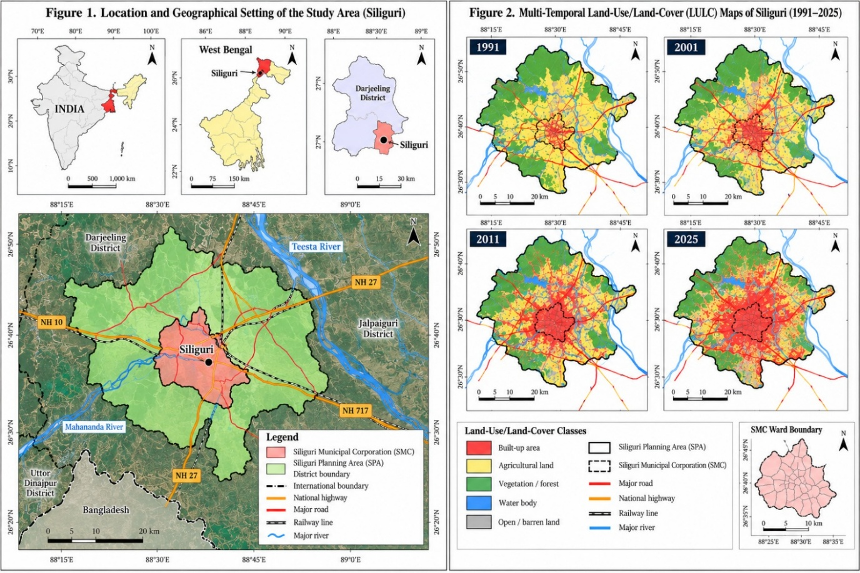
Figure 1. Location and geographical setting of the study area (Siliguri). Source: Prepared by the authors using administrative boundary data and geospatial information from relevant government and planning authorities.
Figure 2. Multi-temporal land-use/land-cover (LULC) maps of Siliguri, 1991–2025. Source: Prepared by the authors using multi-temporal satellite imagery and GIS-based LULC classification.

3.2 Temporal Framework
The study covers the period 1991–2025, using four principal benchmark years: 1991, 2001, 2011 and 2025. The first three years provide historical reference points for examining settlement and demographic change, subject to the availability of comparable records. The year 2025 represents the contemporary geospatial assessment endpoint rather than a Census year.
Multi-temporal satellite imagery and historical road-network information will be selected according to availability, spatial resolution, image quality and geographical coverage. Where the original data are unavailable or insufficiently comparable, the limitation will be explicitly documented rather than addressed through unsupported reconstruction. Consistent spatial boundaries and analytical procedures will be maintained wherever possible to facilitate temporal comparison.

3.3 Data Sources and Variables
The study will integrate satellite imagery, road-network datasets, administrative boundaries and supporting geographical information. Table 1 summarises the principal datasets and their intended analytical applications.
Table 1. Proposed datasets and analytical applications
Dataset | Key variables | Analytical purpose
Landsat satellite imagery | Spectral bands and land-cover characteristics | Historical LULC classification and change detection
Sentinel-2 imagery, where suitable | Spectral information and land-cover characteristics | Contemporary land-cover assessment
SPA and SMC boundaries | Planning-area and municipal limits | Spatial delimitation and scale integration
Municipal ward boundaries | Ward identifiers and polygons | Ward-level comparison
Historical and contemporary road data | Road length, links, intersections and road classes | Road-network reconstruction and transformation
Digital elevation model (DEM) | Elevation and terrain characteristics | Geographical interpretation, where relevant
Census and demographic records | Population, households and population density | Settlement and demographic comparison
Supporting geographical datasets | Rivers, infrastructure, land-use records and points of interest | Contextual interpretation and accessibility analysis
Source: Compiled for the proposed research design. The final manuscript must identify the actual provider, dataset version, acquisition date, spatial resolution and access date for each dataset used.

3.4 Data Preparation and Comparability
Satellite images will be selected for suitable acquisition conditions and processed using consistent procedures appropriate to their sensors and processing levels. Image preparation will include relevant atmospheric or surface-reflectance corrections, geometric checks, projection standardisation and the masking of unsuitable observations where necessary. The same LULC classification scheme will be applied across benchmark periods to improve comparability.
Historical road-network data will require particular attention because differences in source coverage, mapping conventions and positional accuracy may affect estimated changes in road length, connectivity and centrality. Network datasets will therefore be checked for completeness, topological consistency and compatibility with the relevant administrative boundaries. Ward-level analysis will use consistent ward identifiers and boundaries wherever the available records permit. Any boundary changes or historical-data limitations will be documented.
Demographic and infrastructural variables will be incorporated only when their spatial and temporal coverage is appropriate for the analysis. The availability of a variable for one year will not automatically justify its use as a historical explanatory factor for other periods. These precautions are necessary to distinguish observed geographical change from differences arising from data sources or processing procedures.

3.5 Analytical Framework
The prepared datasets will support an integrated sequence of LULC classification, accuracy assessment, change detection, settlement-growth analysis and road-network evaluation. LULC data will be used to calculate the area and percentage of each land-use category and to identify major conversion pathways. Settlement analysis will examine built-up expansion, density, direction and morphology. Road-network analysis will assess road length, density, connectivity and selected centrality and accessibility indicators, depending on data quality.
The resulting indicators will be integrated at compatible spatial scales to investigate relationships between settlement expansion, land conversion and transportation-network structure. Ward-level comparisons within SMC will be used to identify spatial differences in these relationships. Spatial statistics will be applied only where the observations, spatial units and methodological assumptions justify their use. This approach is intended to provide a reproducible basis for interpreting Siliguri's spatial transformation and its implications for sustainable settlement planning.
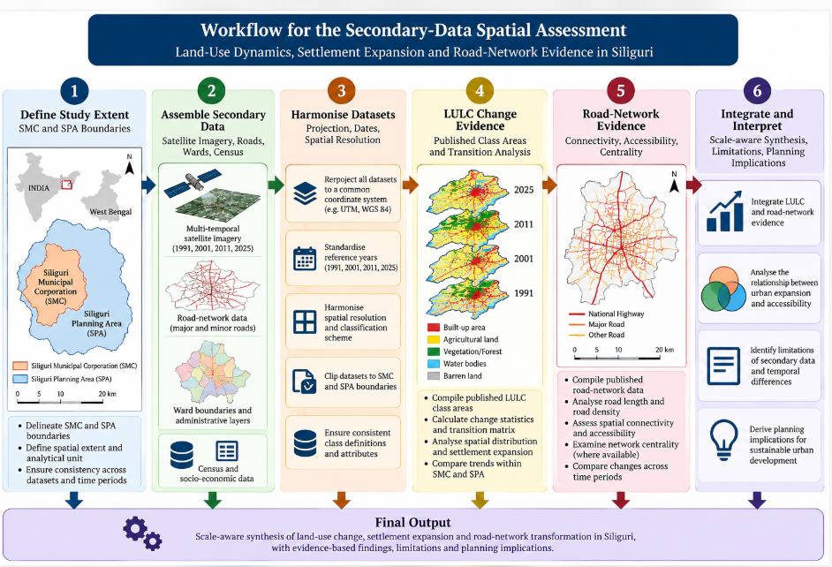
Figure 3. Workflow for the secondary-data spatial assessment. Source: Authors’ synthesis.

4. Materials and Methods

4.1 Research Design
This study adopts a quantitative, spatial and temporal research design to investigate land-use/land-cover (LULC) transformation, settlement expansion and road-network restructuring in Siliguri during 1991–2025. Geographic Information Systems (GIS) and remote sensing are used to examine changes in land-use composition, built-up distribution, settlement morphology and transportation-network characteristics. The analysis integrates the Siliguri Planning Area (SPA), which provides the broader context for urban expansion, with Siliguri Municipal Corporation (SMC), where detailed road-network and ward-level assessments are undertaken.
Four benchmark years—1991, 2001, 2011 and 2025—provide the proposed framework. Comparisons will be conducted using datasets with compatible spatial coverage and documented limitations. The analysis is designed to identify spatial associations between land-use change, settlement growth and road-network characteristics rather than presume causal relationships.

4.2 Satellite Data and GIS Database
Multi-temporal satellite imagery will be obtained from appropriate sources, including the Landsat archive and, where suitable, Sentinel-2. Administrative boundaries, municipal ward polygons, road networks, drainage features and supporting demographic information will be collected from relevant government agencies and authoritative geospatial repositories. Landsat and Sentinel-2 provide complementary multispectral records for such analysis (Roy et al., 2014; Drusch et al., 2012), and cloud-based platforms such as Google Earth Engine can be used for processing where appropriate (Gorelick et al., 2017).
The selection of imagery will depend on acquisition date, spatial resolution, cloud cover, processing level and coverage of the study area. Historical road-network information will be compiled from available cartographic records, historical imagery and authoritative datasets, where accessible.
Table 2. Proposed geospatial datasets and applications
Dataset | Primary application
Landsat imagery | Historical LULC classification and change detection
Sentinel-2 imagery, where appropriate | Contemporary LULC assessment
SPA and SMC boundaries | Spatial delimitation and scale integration
SMC ward boundaries | Ward-level analysis
Historical and current road networks | Road density, connectivity and centrality
Digital elevation model | Terrain-related interpretation, where relevant
Census and demographic records | Population and settlement comparison
The final manuscript will report the actual dataset providers, acquisition dates, spatial resolutions and processing levels.

4.3 Image Pre-processing and LULC Classification
Satellite imagery will undergo the corrections and preparation procedures appropriate to the selected sensor and product. These procedures may include atmospheric or surface-reflectance correction, cloud and shadow masking, geometric verification and projection standardisation. Images will be clipped to the study boundary and processed using consistent classification criteria.
The LULC classification scheme will distinguish the principal categories that can be reliably identified from the available imagery:
- Built-up areas.
- Agricultural land.
- Vegetation and forest.
- Water bodies.
- Open or barren land.
Additional categories, such as industrial or transportation land, will be mapped separately only when the spatial resolution and reference data support reliable differentiation. A consistent classification scheme will be applied across the benchmark years to facilitate temporal comparison.

4.4 Accuracy Assessment
Classification accuracy will be assessed using reference observations independent of the training data wherever possible. A confusion matrix will be prepared to calculate overall accuracy, producer's accuracy and user's accuracy. Cohen's kappa may also be reported where appropriate, alongside other relevant accuracy measures. The approach follows widely used recommendations for accuracy assessment and area estimation (Congalton, 1991; Foody, 2002; Olofsson et al., 2014); Cohen’s kappa is defined following Cohen (1960).
Reference data must be suitable for the corresponding observation period. Contemporary reference imagery alone will not be treated as sufficient validation for historical classifications. The sampling procedure, reference-data sources and limitations will be documented, and accuracy statistics will be reported only after validation is completed.

4.5 LULC Change Detection
LULC change will be assessed by comparing the classified maps for successive benchmark years. For each category, the area and percentage of the total study area will be calculated.
Absolute change will be calculated as:
ΔA = A_{t2} − A_{t1}
Percentage change will be calculated as:
%ΔA = [(A_{t2} − A_{t1}) / A_{t1}] × 100
Here, A_{t1} denotes the classified area of a particular land-use/land-cover category at the initial observation date, and A_{t2} denotes the classified area of the same category at the later observation date. Both areas must refer to comparable study boundaries and use consistent units. ΔA represents the absolute difference between these two area measurements; it is not itself an area measurement for the later date.
A land-use transition matrix will be developed to identify conversions between categories, particularly agricultural land, vegetation and open land converted into built-up areas. The analysis will distinguish gross gains, gross losses and net changes wherever the data permit. These calculations will be performed separately for comparable spatial extents to avoid misleading comparisons caused by differences in boundaries. Persistence and gross gains and losses will be interpreted following established approaches to categorical land-change analysis (Pontius et al., 2004), and annualised rates of change will be computed as r = (100/Δt) × ln(A2/A1), where Δt is the interval in years (Puyravaud, 2003).

4.6 Settlement Expansion and Morphological Analysis
Settlement expansion will be evaluated using the spatial extent and distribution of classified built-up areas. Indicators will include built-up area, percentage change, spatial density, directional growth and the identification of major expansion corridors.
Settlement morphology will be examined using suitable spatial metrics that characterise compactness, dispersion, fragmentation and the relationship between newly developed areas and the existing urban footprint. The choice of indicators will depend on the resolution of the classified maps and the reliability of the extracted settlement boundaries. Compactness, dispersion and sprawl indicators derived from classified built-up maps are commonly used for this purpose (Herold et al., 2002, 2003; Bhatta et al., 2010; Taubenböck et al., 2012).
The analysis will be undertaken primarily at the SPA scale to capture broader urban expansion, with additional municipal-level analysis where the data support consistent comparisons.

4.7 Road-Network Analysis
Road-network transformation will be assessed through historical and contemporary network datasets for SPA and SMC, subject to data availability. The temporal analysis will examine changes in total mapped road length, road density, intersections, road hierarchy and network connectivity.
Within SMC, the network will be represented as a graph comprising nodes and links. Selected indicators may include the beta index, alpha index, gamma index and link-to-node ratio, provided that network completeness, graph connectivity and the assumptions underlying each measure are satisfied. Graph-based street-network analysis can be implemented with open tools such as OSMnx (Boeing, 2017).
Centrality measures, including degree, betweenness and closeness centrality, will be considered to examine the structural importance of network locations. Network-based accessibility measures and shortest-path distances will be calculated where reliable network topology and suitable destination data are available. Euclidean distance will not be interpreted as equivalent to network accessibility.
Historical comparisons will account for inconsistencies in road classification, mapping coverage and positional accuracy. Results will be interpreted as changes in the documented network unless the available evidence supports a more comprehensive reconstruction.

4.8 Integrated Spatial and Ward-Level Analysis
The LULC, settlement and road-network datasets will be integrated within a common spatial framework. At the SPA scale, the analysis will examine the spatial distribution of land conversion, built-up expansion and major growth corridors. Within SMC, ward-level indicators will be used to compare built-up growth, road density, connectivity, accessibility and selected centrality measures.
Spatial overlays and proximity analysis will be used to investigate whether built-up expansion and land-conversion zones are spatially associated with roads or locations exhibiting particular network characteristics. Ward-level indicators may be standardised to support comparative assessment and the identification of contrasting spatial profiles.
Spatial autocorrelation statistics, including Global Moran's I and Local Moran's I, or Getis-Ord Gi*, will be applied only where the number of observations, spatial weights, variable distributions and research questions justify their use. Correlation or regression analysis may be employed to investigate relationships between settlement growth and selected geographical or infrastructural variables. Model specification, diagnostic testing and the limitations of observational data will be reported transparently. These statistics follow Anselin (1995) for local indicators of spatial association and Getis and Ord (1992) and Ord and Getis (1995) for local concentration statistics.

4.9 Methodological Limitations
The proposed analysis is subject to limitations relating to historical imagery availability, classification uncertainty, road-network reconstruction and the temporal comparability of administrative boundaries. Differences in sensor resolution and data quality may affect the identification of smaller land-use features and narrow transport corridors. Historical demographic and infrastructural information may also be incomplete or available only for selected years.
These limitations will be addressed through transparent dataset documentation, consistent classification procedures, accuracy assessment and sensitivity checks where feasible. The interpretation will distinguish measured spatial change from inferred geographical explanations and will avoid attributing causal effects to transportation infrastructure solely based on spatial association.

5. Results and Discussion
This revised version reports published secondary findings rather than presenting newly calculated GIS outputs. The cited studies use different geographical extents and classification schemes, so their numerical results are reported within their original study scopes and are not combined as if they were generated from one harmonised dataset. No new 2025 classification, confusion matrix, ward-level metric or road-network index has been invented.

5.1 Published evidence on built-up expansion within Siliguri Municipal Corporation
Basu et al. (2023) reported that built-up land within Siliguri Municipal Corporation increased from 17.26 km² in 2001 to 36.98 km² in 2015. This is an absolute increase of 19.72 km² and a relative increase of approximately 114.2% over the period, calculated from the two published area values. The result indicates substantial built-up expansion within the municipal boundary during the period examined by that study. It should not be treated as a measurement for the wider Siliguri Planning Area or as a direct estimate for 2025.
Table 3. Published built-up expansion indicators for Siliguri Municipal Corporation, 2001–2015.
Indicator | 2001 | 2015 | Change 2001–2015 | Source / note
Built-up area in SMC (km²) | 17.26 | 36.98 | +19.72 km² | Basu et al. (2023); published values
Relative built-up change | Baseline | 214.2% of 2001 area | +114.2% | Calculated from published values; not a new image classification
Natural-vegetation ecosystem-service value | Not stated here as area | Study reports decline | −US$9.18 million/ha/year | Basu et al. (2023); retain the authors' stated unit and definition
Interpretation: the reported increase supports the conclusion that urban land occupied a larger share of the SMC landscape by 2015. However, the published ecosystem-service estimate is a valuation result and should not be confused with a physical measure of vegetation area. Its monetary unit and calculation assumptions should be checked against the original article before reuse. Value-transfer approaches of this kind are commonly based on global coefficient sets (Costanza et al., 2014), which is one reason the monetary estimate should be treated as indicative rather than as a physical measure.
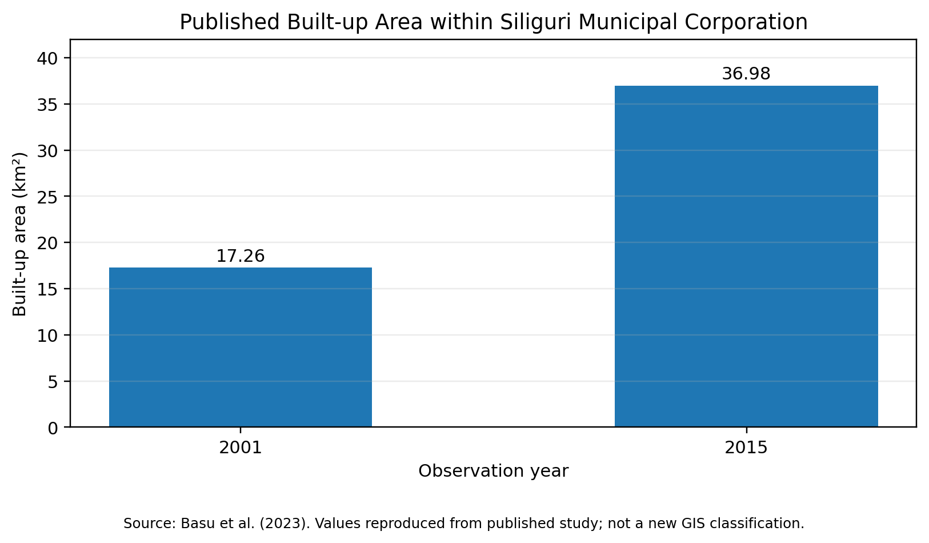
Figure 4. Published built-up area within Siliguri Municipal Corporation, 2001–2015. Source: Basu et al. (2023).

5.2 Published land-use change in the peri-urban area around Siliguri
A separate peri-urban study (Roy & Roy, 2024) reported land-use/land-cover estimates for the wider area around Siliguri for 1991, 2001, 2011 and 2021. In that study's defined study area, built-up land increased from 22.15 km² in 1991 to 106.74 km² in 2021. The absolute increase was 84.59 km², equivalent to approximately 381.9% growth relative to the 1991 value. The study also reported changes in agricultural land, fallow land, forest, tea garden and other classes. These are peri-urban study-area figures and must not be presented as SMC-only statistics.
Table 4. Published land-use/land-cover change in the Siliguri peri-urban study area, 1991–2021.
LULC class | 1991 (km²) | 2021 (km²) | Absolute change (km²) | Relative change
Built-up land | 22.15 | 106.74 | +84.59 | +381.9%
Agricultural land | 211.60 | 186.60 | −25.00 | −11.8%
Fallow land | 249.79 | 89.95 | −159.84 | −64.0%
Barren land | 45.14 | 36.78 | −8.36 | −18.5%
Water bodies | 36.23 | 38.93 | +2.70 | +7.5%
Forest | 185.76 | 203.43 | +17.67 | +9.5%
Tea garden | 131.20 | 219.42 | +88.22 | +67.2%
Source: Values transcribed from the published table in “Dynamics of Peri-Urban Land Alteration in and Around Siliguri City, India: A Geo-Spatial Study” (see References). Absolute and relative changes in this table are calculations from the published endpoint values. Class definitions, boundaries and classification procedures should be checked in the source paper before comparisons with other studies.
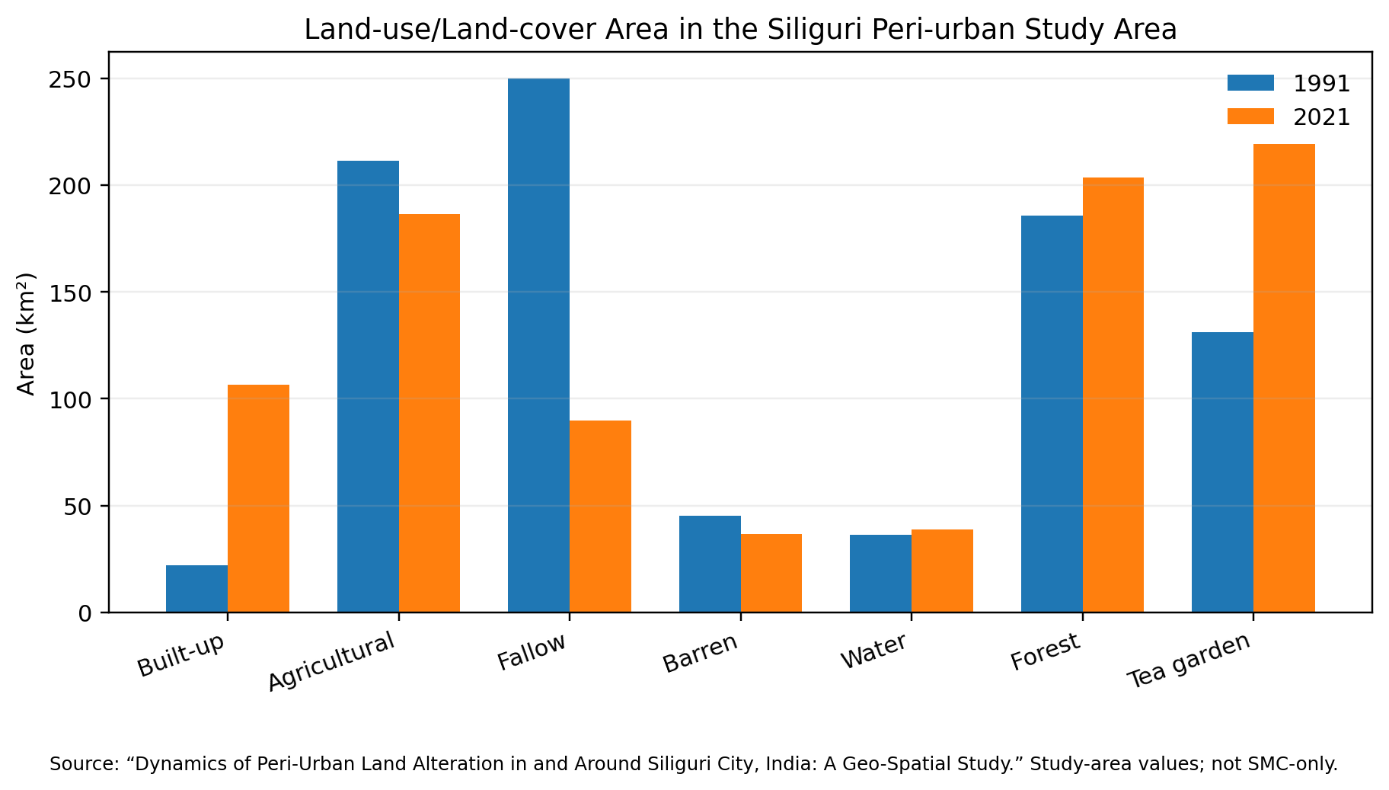
Figure 5. Land-use/land-cover area in the Siliguri peri-urban study area, 1991 and 2021. Source: Published study cited in Section 5.2.
To make the published endpoint values easier to compare, Figures 6 and 7 re-express Table 4 as net and relative change and as the share of the total study-area extent. These are arithmetic transformations of published values and not new classifications. On this basis, built-up land rose from 2.5% to 12.1% of the study-area extent and tea garden from 14.9% to 24.9%, whereas fallow land fell from 28.3% to 10.2%. The 1991 and 2021 class totals in the published table are practically identical (about 881.9 km²), which is consistent with a fixed study-area boundary.
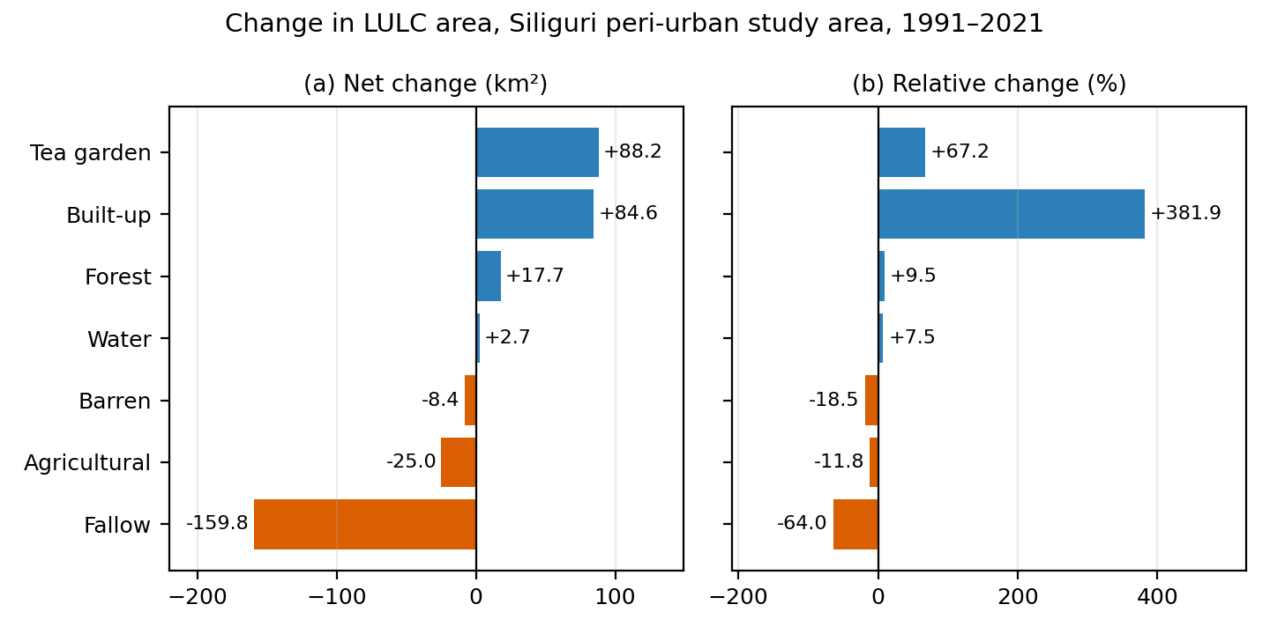
Figure 6. Net change (a) and relative change (b) in land-use/land-cover area in the Siliguri peri-urban study area, 1991–2021. Source: Calculated from the published values in Table 4 (Roy & Roy, 2024).
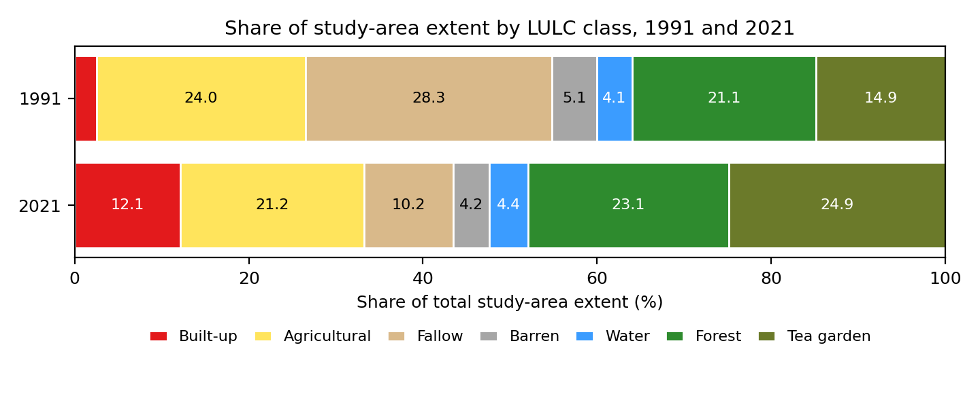
Figure 7. Share of total study-area extent by LULC class, 1991 and 2021. Source: Calculated from the published values in Table 4 (Roy & Roy, 2024); total extent is approximately 881.9 km².
Annualised rates provide a common scale for comparing magnitudes, although they must be interpreted with care. Using the compound-rate formulation (Puyravaud, 2003), built-up area in SMC grew by about 5.4% per year between 2001 and 2015 (Basu et al., 2023), while built-up land in the peri-urban study area grew by about 5.2% per year between 1991 and 2021 (Roy & Roy, 2024) (Figure 8). The similarity of these two rates should not be over-interpreted, because the studies cover different spatial extents, periods and classification schemes.
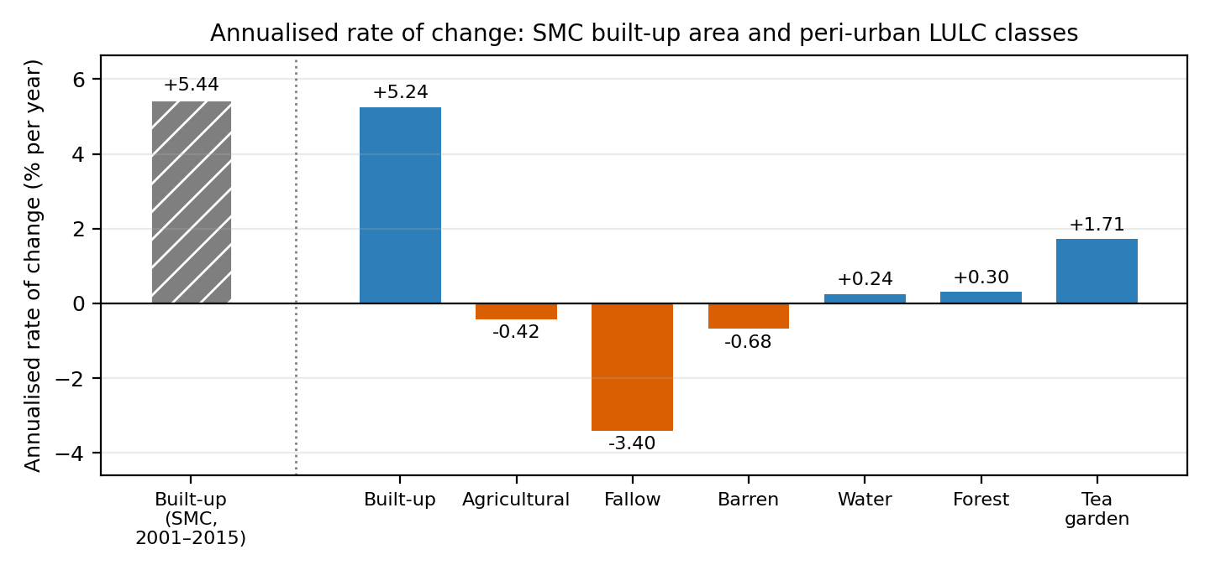
Figure 8. Annualised rate of change in built-up area in SMC (2001–2015) and in each LULC class of the peri-urban study area (1991–2021), calculated as r = (100/Δt) ln(A2/A1). Source: Calculated from published values (Basu et al., 2023; Roy & Roy, 2024). Rates are not directly comparable across the two studies.

5.3 Classification accuracy reported in the peri-urban study
The same study (Roy & Roy, 2024) reported overall classification accuracy of 93.00% and a kappa statistic of 0.91 for its classification assessment. These figures apply to that study's classification and validation design only. They are not accuracy statistics for the present manuscript's maps and should not be attributed to newly produced 1991–2025 maps.
Table 5. Classification accuracy reported in the peri-urban study.
Published measure | Reported value | How it may be used here
Overall classification accuracy | 93.00% | Contextual evidence from the cited peri-urban study only
Kappa statistic | 0.91 | Contextual evidence from the cited peri-urban study only

5.4 Road-network connectivity and accessibility
Paul and Majumdar (2022) examined road-network connectivity and accessibility in Siliguri using graph-theoretic and GIS-based measures, including beta, alpha and gamma indices, network density and accessibility indicators such as shortest paths and detour measures. The accessible publication summary describes the network as connecting Siliguri with surrounding areas and identifies variation in accessibility across the city, with central and north-western portions described as more accessible than southern areas. The source material reviewed for this revision did not provide a sufficiently verifiable year-by-year numerical series for the indices; therefore, no index values are reproduced or estimated here.
A separate North Bengal University repository record describes a road-transport-network study of SMC as covering 41.9 km² and 47 wards and using both primary and secondary information. These study-area descriptors should be verified against the official municipal boundary and the exact version of ward boundaries used in the present work before they are adopted as definitive.

5.5 What the secondary evidence supports
Taken together, the published evidence supports three cautious observations. First, built-up land expanded substantially in SMC between 2001 and 2015. Second, a separate peri-urban study recorded an increase in built-up land between 1991 and 2021 alongside substantial changes in agricultural and fallow land. Third, published road-network research indicates that connectivity and accessibility vary spatially within Siliguri. These findings motivate integrated land-use and network analysis, but they do not by themselves establish that road-network expansion caused built-up growth. Differences in study boundaries, years, classification systems and methods also prevent direct pooling of all reported numbers. These patterns are consistent with other Landsat-based assessments for Siliguri that report the conversion of forest and agricultural land into built-up area (Sarkar & Kar, 2026).
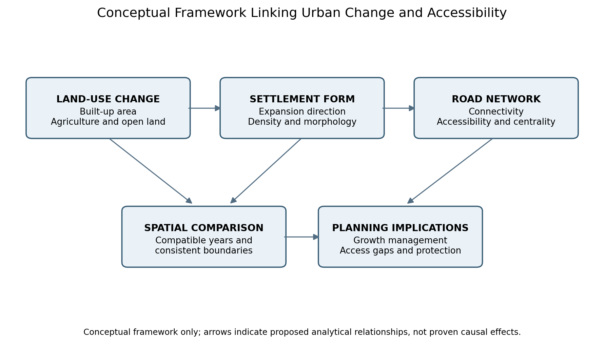
Figure 9. Conceptual framework for integrating land-use change, settlement form and road-network accessibility. Source: Authors’ conceptual synthesis; not an empirical causal model.

6. Methodological Note and Limitations
This version uses published secondary results and transparent arithmetic based on reported values. It does not claim to have downloaded and reprocessed original satellite scenes or road-network files. The secondary studies cover different extents and time periods: the SMC result for 2001–2015 is distinct from the peri-urban estimates for 1991–2021. Consequently, the evidence cannot be used to fill a complete 1991, 2001, 2011 and 2025 series for one consistent boundary. In particular, a verified 2025 LULC classification and matching road-network metrics remain unavailable in the material used for this revision.
To convert this secondary synthesis into a new, reproducible GIS study, the researchers would need to obtain the original satellite imagery, consistent boundary files, reference samples and historical/current road data; process and validate the classifications; and calculate the network indicators independently. Until then, the article should be described as a secondary-data synthesis or review-based spatial assessment, not as a newly completed 1991–2025 GIS analysis.

7. Conclusion and Planning Implications
Published studies indicate substantial urban expansion in Siliguri and marked land-use changes in its surrounding peri-urban landscape. The reported increase in SMC built-up area from 17.26 km² in 2001 to 36.98 km² in 2015 demonstrates the scale of municipal change documented by prior research. A separate peri-urban study reported an increase in built-up land from 22.15 km² in 1991 to 106.74 km² in 2021 within its own study boundary. Road-network research further indicates that accessibility is not spatially uniform. Since the studies differ in spatial extent and methods, these results should be interpreted as complementary evidence rather than as one continuous measurement series.
For planning, the evidence supports the need to coordinate land-use decisions with road-network accessibility, monitor the conversion of agricultural and open land, protect ecologically valuable areas, and assess underserved wards using updated network data. These implications should be refined after current municipal and planning-area datasets are analysed. No causal effect of roads on settlement expansion can be claimed from the secondary evidence alone.

8. Data and Source Transparency
All numerical results in Sections 5.1–5.3 are attributed to published secondary studies; derived changes are explicitly identified as arithmetic calculations from those published values. The road-network discussion is qualitative because verified numerical index values were not available in the retrieved source summaries. No fabricated or hypothetical values are presented as observed data.

Appendix A. Illustrative Demonstration Using Hypothetical Data
The tables and figures in this appendix are provided only to demonstrate how LULC and road-network results may be tabulated and visualised. All values in this appendix are hypothetical, are not actual measurements and are not used to support any empirical conclusion.

A.1 Hypothetical LULC composition
Table A1 presents a hypothetical percentage distribution for five broad land-cover classes across four illustrative dates. Percentages sum to 100% in each year. The values are intentionally labelled as hypothetical and are not estimates of the actual Siliguri Planning Area or Siliguri Municipal Corporation.
Table A1. Hypothetical LULC composition for demonstration only. Source: values created for methodological illustration; not observed or published data.
LULC class | 1991 (%) | 2001 (%) | 2011 (%) | 2025 (%)
Built-up | 12 | 18 | 25 | 34
Agriculture/open cultivated land | 38 | 34 | 29 | 23
Vegetation/green cover | 28 | 25 | 22 | 19
Water bodies/wetlands | 8 | 8 | 7 | 7
Fallow/bare/other | 14 | 15 | 17 | 17
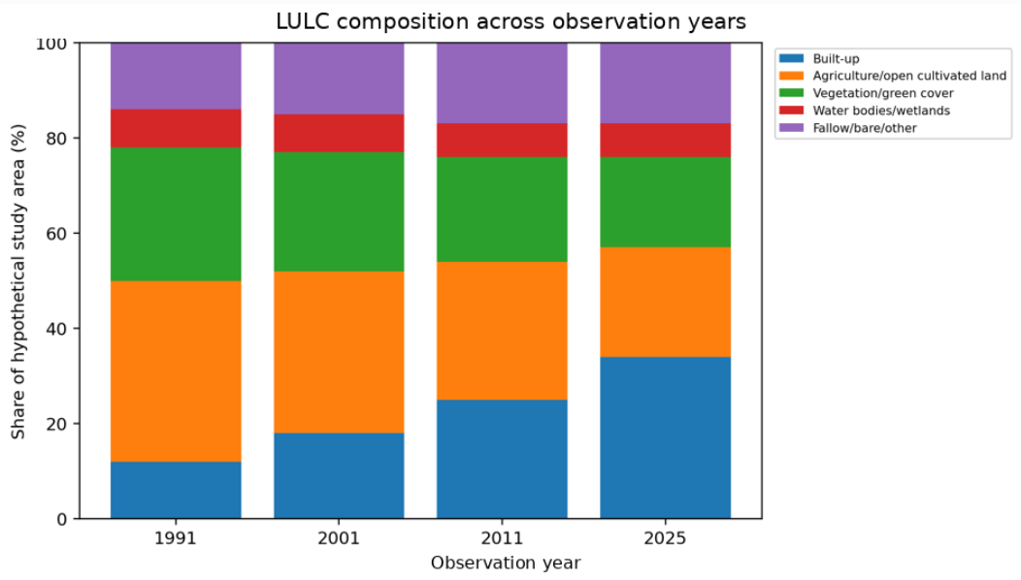
Figure A1. LULC composition across illustrative years. These proportions are not actual measurements for Siliguri. Source: Demonstration dataset.

A.2 Demonstration of change calculations
For the built-up share, the change from 1991 to 2025 is 34% − 12% = 22 percentage points. Relative change is [(34 − 12) / 12] × 100 = 183.3%. This calculation demonstrates the equations only; it is not evidence of actual urban growth.
Table A2. Calculations derived only from the percentages in Table A1. Source: Demonstration dataset.
Indicator | 1991 | 2025 | Demonstration change
Built-up share (%) | 12 | 34 | +22 percentage points
Built-up relative change (%) | Baseline | Baseline comparison | +183.3% relative to 1991
Vegetation/green cover (%) | 28 | 19 | −9 percentage points
Agriculture/open cultivated land (%) | 38 | 23 | −15 percentage points

A.3 Demonstration of road-network indicators
The following index values are hypothetical and normalised to 100 in 1991. They show how a road-network trend chart might be structured after genuine road data are processed. They are not derived from OpenStreetMap, municipal records, satellite imagery or the cited road-network study.
Table A3. The road-network indicator series for demonstration only. Source: values, not observed results.
Hypothetical index (1991 = 100) | 1991 | 2001 | 2011 | 2025
Road density index | 100 | 112 | 128 | 151
Intersection connectivity index | 100 | 108 | 119 | 133
Accessibility index | 100 | 105 | 114 | 126
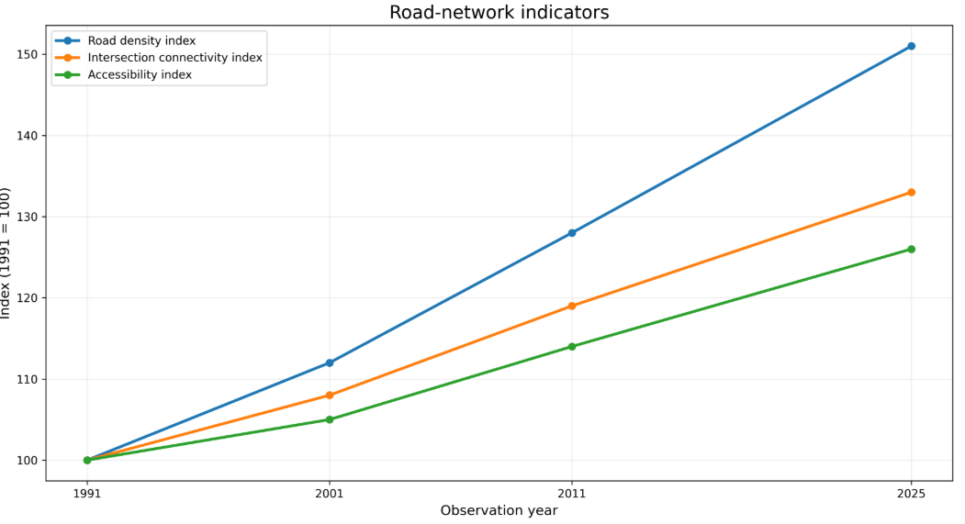
Figure A2. Hypothetical road-network indicator trends, with 1991 set to 100. Source: demonstration dataset.

References
Angel, S., Parent, J., Civco, D. L., Blei, A., & Potere, D. (2011). The dimensions of global urban expansion: Estimates and projections for all countries, 2000–2050. Progress in Planning, 75(2), 53–107. https://doi.org/10.1016/j.progress.2011.04.001
Anselin, L. (1995). Local indicators of spatial association—LISA. Geographical Analysis, 27(2), 93–115. https://doi.org/10.1111/j.1538-4632.1995.tb00338.x
Basu, T., Das, A., Das, K., & Pereira, P. (2023). Urban expansion induced loss of natural vegetation cover and ecosystem service values: A scenario-based study in the Siliguri Municipal Corporation (Gateway of North-East India). Land Use Policy, 132, Article 106838. https://doi.org/10.1016/j.landusepol.2023.106838
Bhatta, B., Saraswati, S., & Bandyopadhyay, D. (2010). Urban sprawl measurement from remote sensing data. Applied Geography, 30(4), 731–740. https://doi.org/10.1016/j.apgeog.2010.02.002
Boeing, G. (2017). OSMnx: New methods for acquiring, constructing, analyzing, and visualizing complex street networks. Computers, Environment and Urban Systems, 65, 126–139. https://doi.org/10.1016/j.compenvurbsys.2017.05.004
Cohen, J. (1960). A coefficient of agreement for nominal scales. Educational and Psychological Measurement, 20(1), 37–46. https://doi.org/10.1177/001316446002000104
Congalton, R. G. (1991). A review of assessing the accuracy of classifications of remotely sensed data. Remote Sensing of Environment, 37(1), 35–46. https://doi.org/10.1016/0034-4257(91)90048-B
Costanza, R., de Groot, R., Sutton, P., van der Ploeg, S., Anderson, S. J., Kubiszewski, I., Farber, S., & Turner, R. K. (2014). Changes in the global value of ecosystem services. Global Environmental Change, 26, 152–158. https://doi.org/10.1016/j.gloenvcha.2014.04.002
Crucitti, P., Latora, V., & Porta, S. (2006). Centrality measures in spatial networks of urban streets. Physical Review E, 73(3), 036125. https://doi.org/10.1103/PhysRevE.73.036125
Drusch, M., Del Bello, U., Carlier, S., Colin, O., Fernandez, V., Gascon, F., Hoersch, B., Isola, C., Laberinti, P., Martimort, P., Meygret, A., Spoto, F., Sy, O., Marchese, F., & Bargellini, P. (2012). Sentinel-2: ESA’s optical high-resolution mission for GMES operational services. Remote Sensing of Environment, 120, 25–36. https://doi.org/10.1016/j.rse.2011.11.026
Foody, G. M. (2002). Status of land cover classification accuracy assessment. Remote Sensing of Environment, 80(1), 185–201. https://doi.org/10.1016/S0034-4257(01)00295-4
Geurs, K. T., & van Wee, B. (2004). Accessibility evaluation of land-use and transport strategies: Review and research directions. Journal of Transport Geography, 12(2), 127–140. https://doi.org/10.1016/j.jtrangeo.2003.10.005
Getis, A., & Ord, J. K. (1992). The analysis of spatial association by use of distance statistics. Geographical Analysis, 24(3), 189–206. https://doi.org/10.1111/j.1538-4632.1992.tb00261.x
Gorelick, N., Hancher, M., Dixon, M., Ilyushchenko, S., Thau, D., & Moore, R. (2017). Google Earth Engine: Planetary-scale geospatial analysis for everyone. Remote Sensing of Environment, 202, 18–27. https://doi.org/10.1016/j.rse.2017.06.031
Herold, M., Goldstein, N. C., & Clarke, K. C. (2003). The spatiotemporal form of urban growth: Measurement, analysis and modeling. Remote Sensing of Environment, 86(3), 286–302. https://doi.org/10.1016/S0034-4257(03)00075-0
Herold, M., Scepan, J., & Clarke, K. C. (2002). The use of remote sensing and landscape metrics to describe structures and changes in urban land uses. Environment and Planning A, 34(8), 1443–1458. https://doi.org/10.1068/a3496
Jana, S., & Gole, U. (2022). Land transformation analysis of Siliguri City using remote sensing and GIS techniques. International Journal of Food and Nutritional Sciences, 11(13), 31–38. https://ijfans.org/index.php/Journal/article/view/7471
Lambin, E. F., Geist, H. J., & Lepers, E. (2003). Dynamics of land-use and land-cover change in tropical regions. Annual Review of Environment and Resources, 28, 205–241. https://doi.org/10.1146/annurev.energy.28.050302.105459
Lu, D., & Weng, Q. (2007). A survey of image classification methods and techniques for improving classification performance. International Journal of Remote Sensing, 28(5), 823–870. https://doi.org/10.1080/01431160600746456
Olofsson, P., Foody, G. M., Herold, M., Stehman, S. V., Woodcock, C. E., & Wulder, M. A. (2014). Good practices for estimating area and assessing accuracy of land change. Remote Sensing of Environment, 148, 42–57. https://doi.org/10.1016/j.rse.2014.02.015
Ord, J. K., & Getis, A. (1995). Local spatial autocorrelation statistics: Distributional issues and an application. Geographical Analysis, 27(4), 286–306. https://doi.org/10.1111/j.1538-4632.1995.tb00912.x
Paul, S., & Majumdar, N. (2022). Assessment of road network connectivity and accessibility using GIS and remote-sensing in Siliguri City, West Bengal, India. Journal of the Asiatic Society of Mumbai, 96(5, Part II). [Verify final page range and issue metadata from the published article before submission.]
Pontius, R. G., Jr., Shusas, E., & McEachern, M. (2004). Detecting important categorical land changes while accounting for persistence. Agriculture, Ecosystems & Environment, 101(2–3), 251–268. https://doi.org/10.1016/j.agee.2003.09.008
Porta, S., Crucitti, P., & Latora, V. (2006). The network analysis of urban streets: A primal approach. Environment and Planning B: Planning and Design, 33(5), 705–725. https://doi.org/10.1068/b32045
Puyravaud, J.-P. (2003). Standardizing the calculation of the annual rate of deforestation. Forest Ecology and Management, 177(1–3), 593–596. https://doi.org/10.1016/S0378-1127(02)00335-3
Reba, M., & Seto, K. C. (2020). A systematic review and assessment of algorithms to detect, characterize, and monitor urban land change. Remote Sensing of Environment, 242, Article 111739. https://doi.org/10.1016/j.rse.2020.111739
Roy, D. P., Wulder, M. A., Loveland, T. R., Woodcock, C. E., Allen, R. G., Anderson, M. C., Helder, D., Irons, J. R., Johnson, D. M., Kennedy, R., Scambos, T. A., Schaaf, C. B., Schott, J. R., Sheng, Y., Vermote, E. F., Belward, A. S., Bindschadler, R., Cohen, W. B., Gao, F., … Zhu, Z. (2014). Landsat-8: Science and product vision for terrestrial global change research. Remote Sensing of Environment, 145, 154–172. https://doi.org/10.1016/j.rse.2014.02.001
Roy, S., & Roy, R. (2024). Dynamics of peri-urban land alteration in and around Siliguri City, India: A geo-spatial study. Current World Environment, 19(1), 454–481. https://www.cwejournal.org/vol19no1/pdynamics-of-peri-urban-land-alteration-in-and-around-siliguri-city-india-a-geo-spatial-studyp
Sarkar, A., & Chouhan, P. (2019). Dynamic simulation of urban expansion based on cellular automata and Markov chain model: A case study in Siliguri Metropolitan Area, West Bengal. Modeling Earth Systems and Environment, 5, 1723–1732. https://doi.org/10.1007/s40808-019-00626-7
Sarkar, C., & Kar, B. K. (2026). Impact of rapid urban growth on land use / land cover change and loss of urban green spaces: A comparative study of Guwahati city and Siliguri city, India. AUC Geographica, 61(1), 107–125. https://doi.org/10.14712/23361980.2025.15
Seto, K. C., Güneralp, B., & Hutyra, L. R. (2012). Global forecasts of urban expansion to 2030 and direct impacts on biodiversity and carbon pools. Proceedings of the National Academy of Sciences, 109(40), 16083–16088. https://doi.org/10.1073/pnas.1211658109
Sudhira, H. S., Ramachandra, T. V., & Jagadish, K. S. (2004). Urban sprawl: Metrics, dynamics and modelling using GIS. International Journal of Applied Earth Observation and Geoinformation, 5(1), 29–39. https://doi.org/10.1016/j.jag.2003.08.002
Taubenböck, H., Esch, T., Felbier, A., Wiesner, M., Roth, A., & Dech, S. (2012). Monitoring urbanization in mega cities from space. Remote Sensing of Environment, 117, 162–176. https://doi.org/10.1016/j.rse.2011.09.015
Trinder, J., & Liu, Q. (2020). Assessing environmental impacts of urban growth using remote sensing. Geo-Spatial Information Science, 23(1), 20–39. https://doi.org/10.1080/10095020.2019.1710438

