
FACTORS INFLUENCING PAYMENT BANK SERVICE ADOPTION AND CONSUMER BEHAVIOR: A STUDY OF KOLHAN DIVISION, JHARKHAND

Ashok Kumar Pandey^{1*}, Dr. Sayak Gupta²

^{1*}Research Scholar, Department of Management, Netaji Subhas University, Jamshedpur, India, Email ID: askashok.pandey@gmail.com
²Assistant Professor, Department of Management, Netaji Subhas University, Jamshedpur, India, Email ID: cal.sayak@gmail.com, ORCID ID: https://orcid.org/0009-0000-3057-2497

Abstract:
The digital financial services have achieved a fantastic boost in India, and payment banks are one of the factors cum facilitator of enhancing inclusion. However, the payment bank has still not penetrated every part of the India and semi-urban and rural areas like Kolhan Division of Jharkhand. The objective of this work is to study the influence of Factors noticed Usefulness, noticed Ease of Use and Trust on the Adoption consumers intention towards Payment Bank Services. This study uses a quantitative and descriptive approach using Technology Acceptance Model (TAM) The present analysis is an empirical work depends on primary data collected from 200 respondents through structured questionnaire and analysed using SPSS 17.0 & SmartPLS 4 employing PLS-SEM techniques. Results provide robust evidence of the important role played by those three variables in intention to adopt, specifically Perceived Usefulness proving to be the strongest predictor. The research conclusions also showed that ensuring usefulness security trust and ease of use are the key determinants of payment bank acceptance for financial inclusion in this context.

Keywords: Payment Banks; Digital Financial Services; Technology Acceptance Model (TAM); Perceived Usefulness; Financial Inclusion; Consumer Adoption

1. Introduction
The Indian banking scenario is experiencing a lot of change with the increasing pace of growth, fast penetration driven by technology in the payment system. One such innovation is that of the Payment Banks, a new banking model aimed at achieving financial inclusion through genuine technology-driven free-restricted low-cost services. These banks are primarily service providers to the unbanked and under-banked through the basic banking services of deposits, withdrawals, funds transfers and digital payments at mobile or electronic level (Reserve Bank of India, 2014). Payment bank customers with low end financial needs can be serviced but they are (relatively) scattered in India, particularly semi-urban and rural ones like Kolhan Division of Jharkhand. Those pockets of population where the financial systems are not that strong, they have both challenge to understand these digital money systems and made it use in communities. These obstacles impede their willingness to initially try, and frequently use mobile payment bank offerings. In this respect, the TAM-Technology Acceptance Model (Davis, 1989) makes a strong foundation (theoretical) for studying technology acceptance behavior. This means that perceived ease of use and perceived usefulness are able to forecast the behaviour intention of users in adoption of technology. Means of payment banks perceived usefulness is explained as the level in which consumers trust, that using it after creating a payment bank by utilising different financial management services helps customers increase their savings, greater overall financial efficiency and convenience; perceived ease of use is defined reflected effortlessness of use concerning such services. In addition to the constructs of Technology Acceptance Model (TAM) models, trust is also seen as an important antecedent of adoption in digital financial services. According to Venkatesh et al. Roughly (2003) Trust lowers the user apparent risk and uncertainty, thus more tend to resort digital platforms. In addition, Gefen, Karahanna and Straub (2003) mentioned trust is defined as the interpretation of user interface characteristics of cmmerce sites such as banking site that would influences users tо entrust their personal аnd fіnancіаl data. But quantitative research also supports this perspective on behavioral and psychological elements behind financial decisions. Kaur et al. As an example, Zhu & Chang (2020) found that perceived risk and resistance are factors that affect the adoption of mobile payment. Trust is one of the most critical variables for mobile banking acceptance Sharma and Sharma (2019). Paper C A study by Patel and Patel (2018) indicated that user attitude and human-computer interaction play an vital role in the acceptance of digital banking. Collectively, these insights suggest a multi-dimensional and both techno-psychological basis for consumer uptake of digital financial services.
Thus, this paper seeks to explore the factors which shapes the consumer adoption intention towards payment bank services in Kolhan Division of Jharkhand. By considering perceived ease of use and trust along with perceived usefulness, this research is set to understand consumer perceptions better and lay a few bases upon which policies can be guided for improving the delivery mechanism for digital financial inclusion in developing economies.

2. Review of Literature
Recent studies on digital banking, fintech and payment systems adoption offers a broadened viewpoint of consumers by integrating the technological, behavioral and contextual factors. Past literature has confirmed that user trust, perceived security and reliability of systems will have a very significant impact on an individual willing to opt for mobile or digital banking, which is likely to be significantly pronounced in developing economies where uncertainty is greater (Chong et al., 2010). For example, Zhou (2011) found that security privacy concern also positively affect mobile banking adoption intention of users. Lin (2011) revealed that perceived risk has a adverse effects on the adoption intention, while perceived usefulness positively influences users' acceptance of mobile payment systems. Moreover, trust and perceived risk in e-commerce (Kim et al., 2008) together determine online financial transaction behavior, especially in the contexts of both e-commerce and digital banking environments. Slade et al. Extending this background, Zhang et al. (2015) found that compatibility, convenience and perceived value have a positive impact on users' acceptance of mobile payment along with TAM variables. Oliveira et al. doi:10.1057/9781137351572_18 Shankar, V., & Hollander, M. (2018). Using a sample 2000 users on emerging economies Baptista and Oliveira (2015)found that both trust and effort expectancy are key determinants of mobile banking use, whereas behaviour is one of the most important predictors for less digitally experienced users. In the regards Chawla and Joshi (2019) also proved their findings on how trust, perceived usefulness, social influence can influence and is been tested for digital banking services adoption in India. Similarly, Rahi et al. Service quality, system quality also plays a vital role in determining customer satisfaction and continuance usage of online banking services (2018) According to Singh et al. Srivastava (2018); Dwivedi et al. Therefore, one study (2019) concluded that both technology readiness and availability of infrastructure are significant factors to determine fintech adoption. One crucial obstacle in the path of digital banking by rural clients mostly from semi-urban areas is perceived risk (Gupta and Arora, 2020). Moreover, Sharma et al. According to Alam (2021) customer experience and design interface have a meaningful impact on the adoption intention of cell phone wallets and payment applications. Ali et al. found that facilitating conditions and perceived ease of use has an impact on behavioral intention to use fintech assistance. Finally, Liébana-Cabanillas et al. (2017) Trust, perceived value and habit formation are significant predictors of adoption intention and continuance use behaviour of mobile payment.

3. Hypotheses Development
Perceived usefulness is expressed as the belief of an individual in using payment bank services to increase financial efficiency, convenience and effectiveness for outbound transactions. Digital financial services, as perfectly portable covering all consumer adoption addiction to rapidly consummated transactions, more distance and access restricted-to-less over much appeal. In the digital banking and fintech services context, perceived usefulness was generally found to be one of very strong determinants for behavioral intention as evidenced in technology adoption literature (Davis, 1989; Oliver et al., 2016). For users who want to embrace digital financial platforms in developing economies, they can quickly evaluate whether the platform is any good; since perceived usefulness disproportionately matters more than the traditional banking.

Hence hypothesis is proposed:
H1: There is a significant positive effect of Perceived Usefulness on Adoption Intention toward payment bank services.
Perceived ease of use refers to the degree to which a person believes that payment bank services are effortless to use. When the system is straightforward, intuitive, and easy to operate, users tend to form a favorable attitude toward adopting it. The ease of use is shown to significantly reduce resistance and increase acceptance/adoption rate in the adoption of many mobile banking/digital payment systems (Venkatesh et al., 2003; Baptista & Oliveira, 2015) especially amongst user segments with low digital literacy or first time users. Rural and semi-urban areas rely more on ease-of-use as it ultimately determines investor confidence in the financial technologies.

Hence hypothesis is proposed:
H2: There is a significant positive effect of Perceived Ease of Use on Adoption Intention toward payment bank services.
Trust refers to the belief that payment bank services can be trusted & safe enough to protect users with their private personal & financial information. Researchers have proposed trust as a necessary determinant to reduce perceived risk and uncertainty related to financial transactions in the digital ecological environment. Trust has been found to be an important variable in predicting usage intention with mobile banking and fintech services (Gefen et al., 2003; Kim et al., 2008), where fraud, data privacy and transaction security concerns influence various aspects of adoption behaviour. In the Indian context, low digital literacy and awareness among consumers are important factors where trust becomes key.

Hence hypothesis is proposed:
H3: There is a significant positive effect of Trust on Adoption Intention toward payment bank services.

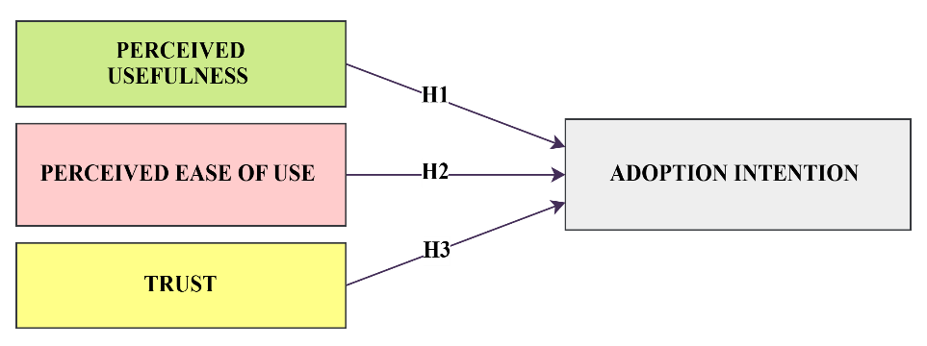
Fig 1. Conceptual Framework

4. Statement of the Problem
Digital financial services in India have seen a much larger scale up over the last five years and one of those several solutions offered are payment banks, launched in 2014 to bring greater uptake of financial services to underserved regions like semi-urban and rural Kolhan Division, Jharkhand. Payment banks offers many, simple to use and low cost, mobile friendly banking services as from the planned by RBI in India. However to an unknown reason consumers are still suffring from fear of using it due limited digital literacy level, not familiar with benefits of online banking concept or how can it be more preferrable over traditional one, perceived complexity per se with available options for online transaction choices today in fact further driven by perception (previous experience) (low trust level on digital transactions). However, compared to the anthropological literature on urban consumers or contributors to ethnographic sources, the one on consumers from quasi urban and rural and contexts are limited at a more aggregate level. Also, behavioural keys of perception (e.g., perceived ease of use and trust, perceived usefulness) to adoption intention has not been analysed within this region until now. Therefore, this analysis will help identify the key determinants of consumer's intention to adopt payment bank services and meanwhile it will not only be helpful for efficient implementation of Fin Tech based banking services for better digital financial inclusion in Kolhan Division but also is likely to enable their effective functioning.

5. Objectives of the Study
- To know the impact of perceived usefulness on consumers’ adoption intent toward payment bank services in Kolhan Division, Jharkhand.
- To identify the consequence of perceived ease of use on consumers’ adoption intent toward payment bank services in Kolhan Division, Jharkhand.
- To analyze the influence of trust on consumers’ adoption intent toward payment bank services in Kolhan Division, Jharkhand.

6. Research Methodology
Table 1: Research Methodology
Particulars | Description
Research Design | Quantitative and Descriptive Research Design
Type of Data | Primary and Secondary
Data Collection Method | Structured Questionnaire
Respondents | Consumers and users of payment bank services in Kolhan Division, Jharkhand
Sample Size | 200
Sampling Technique | Convenience Sampling
Study Area | Kolhan Division, Jharkhand, India
Independent Var | Perceived Ease of Use, Trust, Perceived Usefulness
Dependent Var | Adoption Intent toward Payment Bank Services
Instrument Used | Structured Questionnaire
Data Analysis Tools | SPSS 17.0 and SmartPLS 4
Statistical Techniques Applied | Reliability and Validity Analysis,  PLS-SEM Structural Modeling

7. Analysis of the Study
Table 2: Outer Loading – Matrix
 | AI | PEOU | PU | TR
AI-1 | 0.767
AI-2 | 0.855
AI-3 | 0.773
PEOU-1 |  | 0.712
PEOU-2 |  | 0.775
PEOU-3 |  | 0.823
PEOU-4 |  | 0.927
PU-1 |  |  | 0.806
PU-2 |  |  | 0.724
PU-3 |  |  | 0.829
PU-4 |  |  | 0.871
PU-5 |  |  | 0.859
PU-6 |  |  | 0.820
TR-1 |  |  |  | 0.995
TR-2 |  |  |  | 0.994

Note: AI: Adoption Intention; PEOU: Perceived Ease of Use; TR: Trust; PU: Perceived Usefulness. AI1–AI3 represent Adoption Intention indicators; PEOU1–PEOU4 represent Perceived Ease of Use indicators; PU1–PU6 represent Perceived Usefulness indicators; TR1–TR2 represent Trust indicators.

Item Statements:
AI1: I am willing to use payment banks regularly.
AI2: I intend to increase my use of payment bank services in the near future.
AI3: I recommend payment bank services to others.
PEOU1: Payment bank services are easy to use.
PEOU2: Learning to use payment bank services does not require much effort.
PEOU3: Navigating the payment bank app or platform is straightforward.
PEOU4: I find it easy to perform transactions using payment banks.
PU1: Using payment bank services makes my financial transactions easier.
PU2: Payment banks save me time compared to traditional banking.
PU3: Payment bank services help me manage my finances better.
PU4: Payment bank services improve my access to financial services.
PU5: Payment bank services are useful in my daily financial activities.
PU6: Payment banks enhance the efficiency of financial transactions.
TR1: I trust payment banks to keep my money safe.
TR2: Payment banks protect my personal and financial information.
Table 2 presents the outer loading matrix for indicator reliability and convergent validity. All factor loadings are more than the threshold level of 0.70 (Hair et al., 2019), suggesting that the measurement quality is adequate. Adoption Intention (0.767 to 0.855), Perceived ease of use (0.712 to 0.927) and Perceived usefulness (0.724 to 0.871) were in range domain strong range validated constructs respectively according to Davis, 1989; Venkatesh et al., 2003 The Trust construct showed high convergent validity, with loading scores reaching 0.994–0.995 but this also indicates redundancy between items (Gefen et al, 2003). In sum, all constructs were found to be reliable and valid for preparing the structural model for further analysis with PLS-SEM.

Table 3: Reliability and Validity of the construct
 | Cronbach's alpha | Composite reliability (rho_a) | Composite reliability (rho_c) | Average variance extracted (AVE)
Adoption Intention | 0.723 | 0.756 | 0.841 | 0.639
Perceived Ease of Use | 0.827 | 0.851 | 0.885 | 0.661
Perceived Usefulness | 0.902 | 0.913 | 0.924 | 0.672
Trust | 0.989 | 0.990 | 0.995 | 0.989

Table 3 depict an view of the reliability and validity assessment of the measurement model where construct reliance is verified using Cronbach’s alpha, composite reliability (rho_a and rho_c), as well as AVE-Average Variance Extracted. The findings reveal that all constructs exceed the recommended reliability and validity thresholds. According to Hair et al. Cronbach alpha and composite reliability > 0.70 indicates internal consistency reliability (2019). As for the constructs in the scope of this study, all exceed such benchmark (Adoption Intention 0.723; Perceived Ease of Use 0.827; Perceived Usefulness=0.902 and Trust=0.989), indicating good reliability. Additionally, high levels of construct reliability are strong at rho_c values between 0.841 and 0.995, respectively. According to Fornell and Larcker (1981), AVE values more than 0.50 indicate satisfactory convergent validity; in this case, all constructs exceed this minimum value (between 0.639 and 0.989), providing evidence of strong convergent validity. The Trust construct achieved exceptionally high values in relation to the composite reliability (0.86) and AVE (0.88), which suggests possible redundancy for some of its indicators while strongly confirm consistency with respect to measurement. In accordance, the Table 3 outcomes show that all the constructs are reliable and valid for additional structural model assessments based on PLS-SEM.

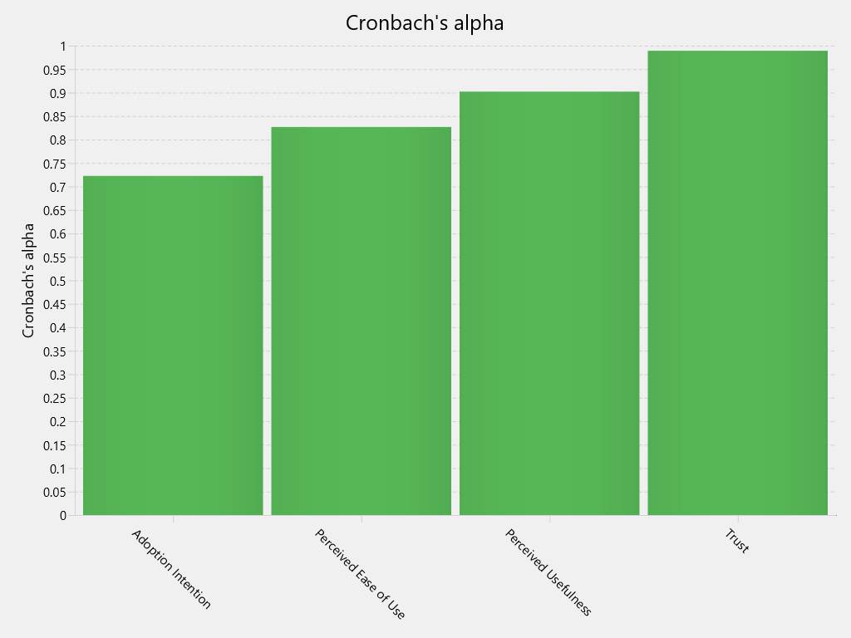
Fig 2. Cronbach’s alpha

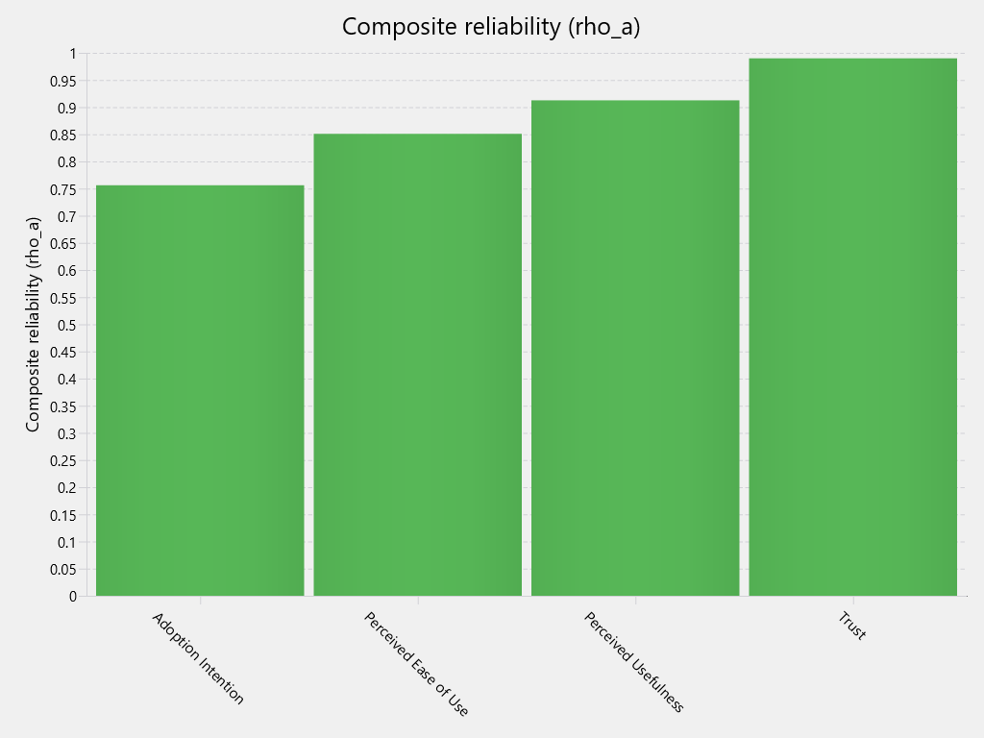
Fig 3. Composite reliability (rho_a)

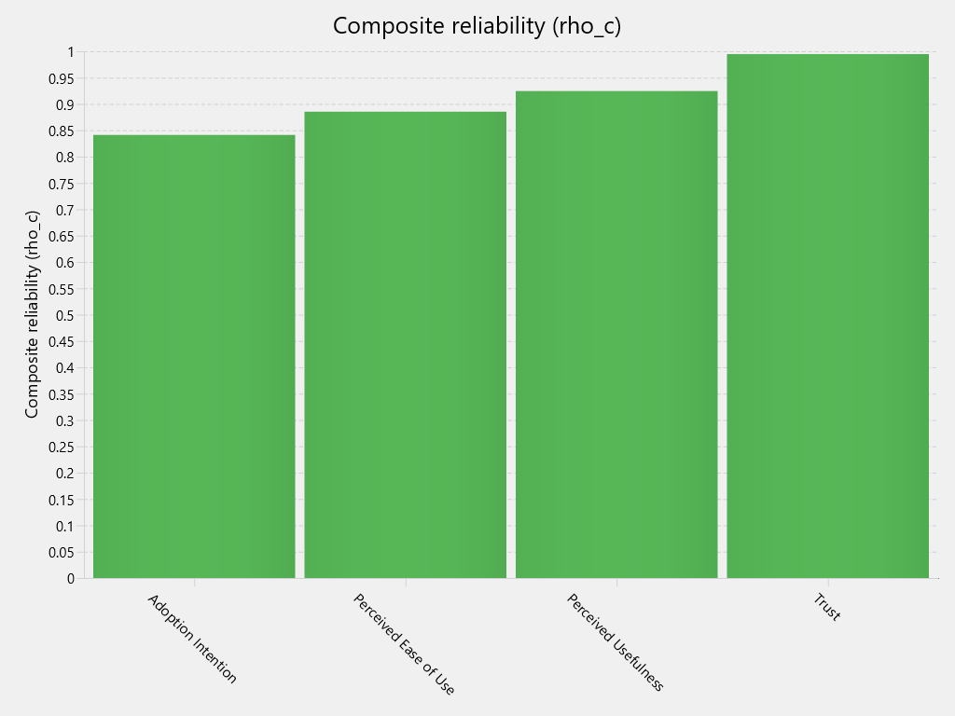
Fig 4. Composite reliability (rho_c)

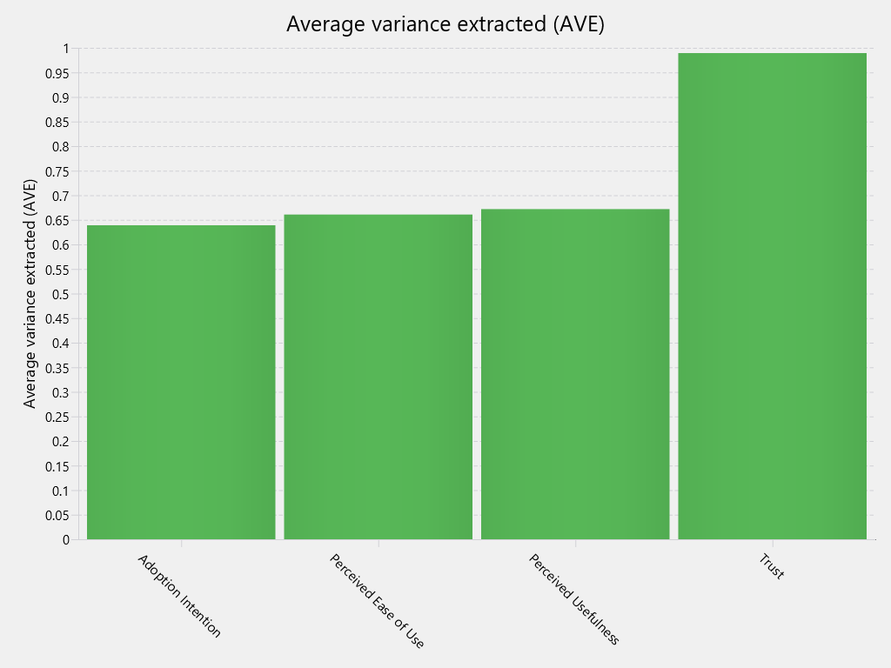
Fig 5. Average variance extracted (AVE)

Table 4: Path Coefficients
 | Original sample (O) | Sample mean (M) | Standard deviation (STDEV) | T statistics (|O/STDEV|) | P values
H1: Perceived Ease of Use -> Adoption Intention | 0.247 | 0.246 | 0.091 | 2.707 | 0.007
H2: Perceived Usefulness -> Adoption Intention | 0.252 | 0.258 | 0.090 | 2.793 | 0.005
H3: Trust -> Adoption Intention | 0.232 | 0.233 | 0.069 | 3.366 | 0.001

The outcomes of the structural model are summarized in Table 4 and include relationships among Perceived Ease of Use, Perceived Usefulness, Trust and Adoption Intention. Findings showed that all hypothesized relationships are significant at p <.05 level 05 and t-values more than the critical value of 1,96 (Hair Et Al., 2019). Perceived Ease of Use directly and significantly positively affects Adoption Intention (β is 0.247, t is 2.707 and p is 0.007), so that H1 is supported. Perceived Usefulness also exerts a strong positive influence (β is 0.252, t is 2.793 and p is 0.005) being supportive of H2 again becoming the most important predictor with regard to the TAM variables representing its dimension H3 indicated that trust have constructive and substantial effect on Adoption Intention (β is 0.232, t is 3.366 and p is 0.001), which concluded trust is an important factor to the payment bank adoption. Overall, out of the three constructs, their effect on consumers' intention to adopt payment bank services is substantial in Kolhan Division.

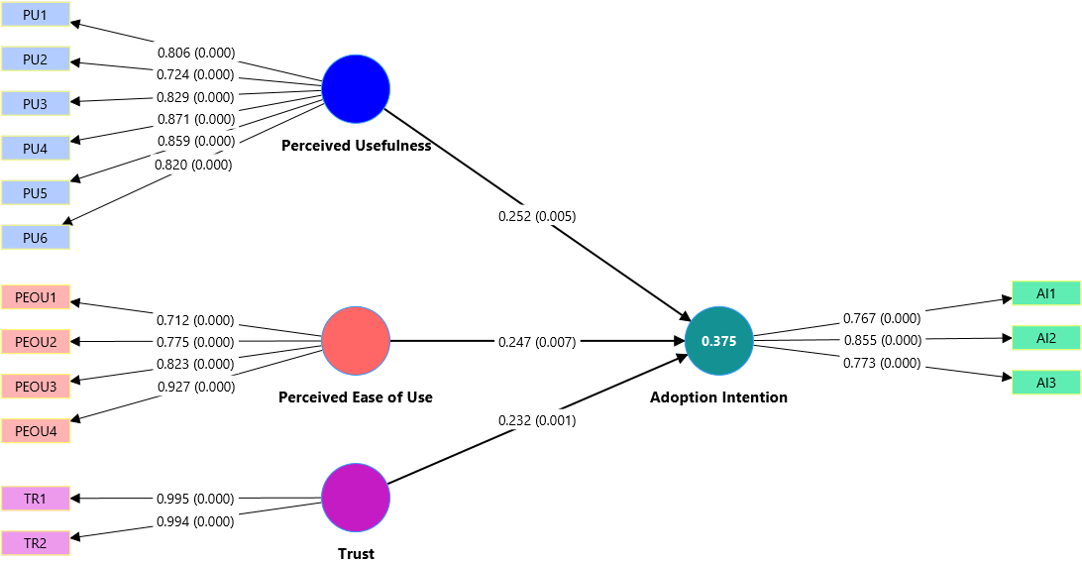
Fig 6. Measurement and Structural Model (Outer and Inner Model) showing factor loadings and path coefficients

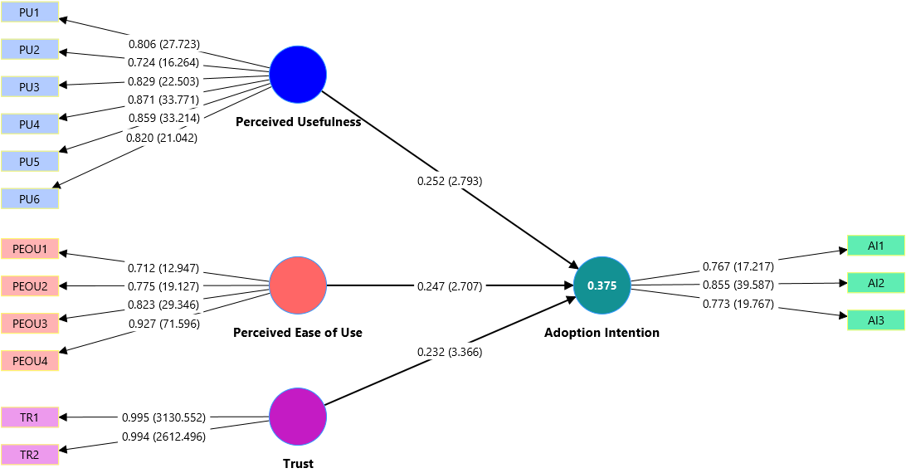
Fig 7. Measurement and Structural Model (Outer and Inner Model) showing factor loadings, t-values, and path coefficients
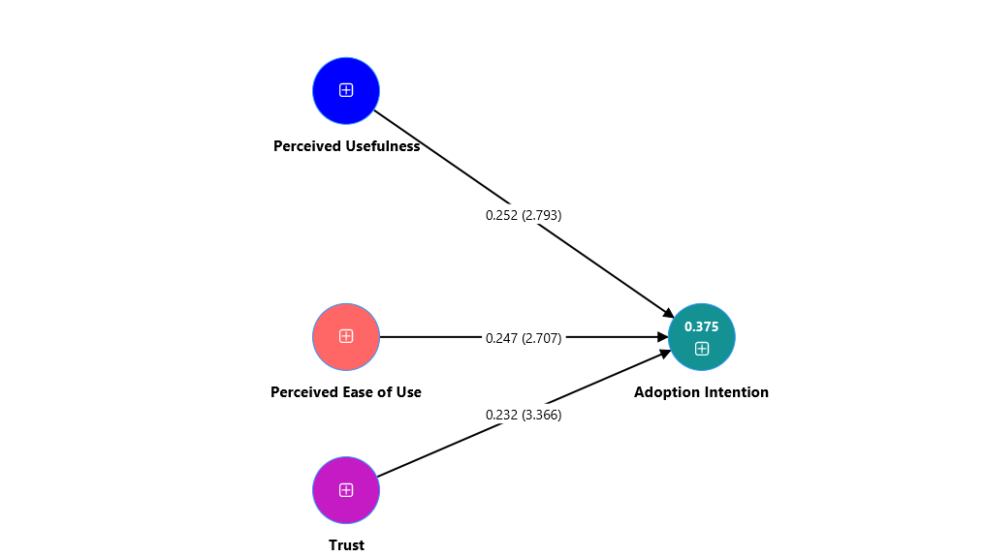
Fig 8. Structural Model (Inner) demonstrating path coefficients and t-values

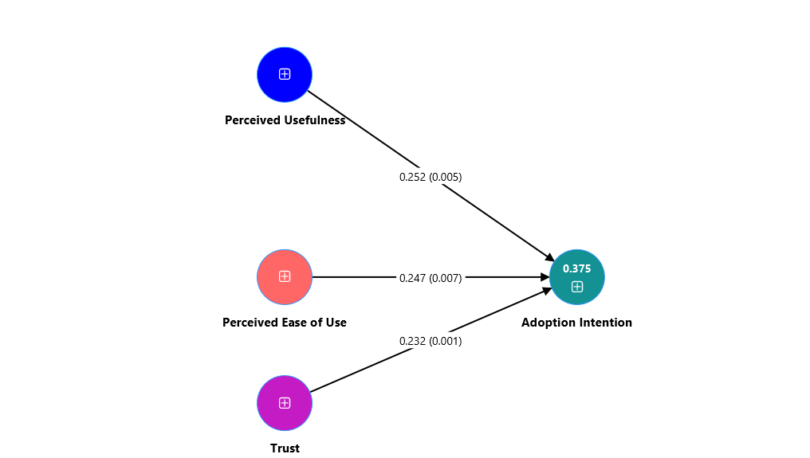
Fig 9. Structural Model (Inner) exhibiting path coefficients and significance levels

8. Suggestions
The study has proposed some recommendation to increase the acceptance and usage of services by payment bank. To start with, service providers need to create awareness by showcasing the several benefits of payment banks such as rapid completion of a transaction at lesser price and easier access to a digital banking system. Secondly, we need to refine the user experience; it should actually be easier to use guiding users and/or providing local language capability / support for key features so less tech savvy users can also access them. Thirdly, most importantly is trust; payment banks have to boost the data security mechanisms in place since any loss of confidence in security is the most serious barrier for an acceleration of scale and need to ensure transparency on the transactions with campaigns that raise awareness about overcoming fear of fraud which ultimately helps build citizens' confidence on the digital banking system. Further, the rural and semi urban populace should also be taught about digital financial services by means of creating awareness with several financial literacy programs. Lastly, Banks and policy makers in the region need to focus on providing a better digital infrastructure along with incentives that seek to maintain consumer engagement continuously and also support services aimed at further improving such solutions which will drive adoption intention as well as financial inclusion in the region.

9. Conclusion
Based on the consumer perspective, present study illustrates to explore and data analysis for factor determining consumers Adoption Intention over Payment Bank services in Jharkhands Kolhan Division consisting Perceived Usefulness, Trust & Perceived Ease of Use. The outcomes indicate that all three predictors have a strong constructive impact on intention to adopt, with Perceived Usefulness being strongest predictor followed by Trust and Perceived Ease of use at last. Only when the consumers are able to see different functional advantages, find it easier to operate and feel secure or reliable then they tend to adopt payment bank offerings. Research Paper provides more evidence for Technology Acceptance Model and many of its significant variables in predicting Digital Banking Adoption within consumers from Quasi Urban and Rural areas in India. The findings of the research underscore that while improving service utility, enhancing user experience through ease of accessing and trust building measures are the top priorities for scaling up adoption to augur well for achieving payment bank services towards financial inclusion aspiration in region.

References
- Ali, M., Raza, S. A., Puah, C. H., & Amin, H. (2020). Mobile banking adoption in emerging markets: Evidence from structural equation modeling. Journal of Financial Services Marketing, 25(3), 1–15.
- Baptista, G., & Oliveira, T. (2015). Understanding mobile banking: The unified theory of acceptance and use of technology combined with cultural moderators. Computers in Human Behavior, 50, 418–430. https://doi.org/10.1016/j.chb.2015.04.024
- Chawla, D., & Joshi, H. (2019). Consumer attitude and intention to adopt mobile wallet in India. International Journal of Bank Marketing, 37(7), 1590–1618. https://doi.org/10.1108/IJBM-09-2018-0256
- Chong, A. Y. L., Ooi, K. B., Lin, B., & Tan, B. I. (2010). Online banking adoption: An empirical analysis. Industrial Management & Data Systems, 110(4), 592–610. https://doi.org/10.1108/02635571011039055
- Davis, F. D. (1989). Perceived usefulness, perceived ease of use, and user acceptance of information technology. MIS Quarterly, 13(3), 319–340. https://doi.org/10.2307/249008
- Dwivedi, Y. K., Rana, N. P., Chen, H., & Williams, M. D. (2019). A meta-analysis of mobile banking adoption. Electronic Commerce Research and Applications, 39, 100-110.
- Fornell, C., & Larcker, D. F. (1981). Evaluating structural equation models with unobservable variables and measurement error. Journal of Marketing Research, 18(1), 39–50. https://doi.org/10.1177/002224378101800104
- Gefen, D., Karahanna, E., & Straub, D. W. (2003). Trust and TAM in online shopping: An integrated model. MIS Quarterly, 27(1), 51–90. https://doi.org/10.2307/30036519
- Gupta, K., & Arora, N. (2020). Investigating consumer adoption of mobile banking in rural India. International Journal of Information Management, 50, 58–67.
- Hair, J. F., Hult, G. T. M., Ringle, C. M., & Sarstedt, M. (2019). A primer on partial least squares structural equation modeling (PLS-SEM) (2nd ed.). Sage Publications.
- Kaur, P., Dhir, A., Singh, N., Sahu, G., & Almotairi, M. (2020). An innovation resistance theory perspective on mobile payment adoption. Computers in Human Behavior, 107, 105911. https://doi.org/10.1016/j.chb.2020.105911
- Kim, D. J., Ferrin, D. L., & Rao, H. R. (2008). A trust-based consumer decision-making model in electronic commerce. Decision Support Systems, 44(2), 544–564. https://doi.org/10.1016/j.dss.2007.07.001
- Liébana-Cabanillas, F., Sánchez-Fernández, J., & Muñoz-Leiva, F. (2017). Antecedents of the adoption of mobile payment systems. Computers in Human Behavior, 71, 521–534. https://doi.org/10.1016/j.chb.2017.02.050
- Lin, H. F. (2011). An empirical investigation of mobile banking adoption. International Journal of Information Management, 31(6), 1–8.
- Oliveira, T., Thomas, M., Baptista, G., & Campos, F. (2016). Mobile payment adoption: A cross-country analysis. Computers in Human Behavior, 61, 404–414. https://doi.org/10.1016/j.chb.2016.03.026
- Patel, K., & Patel, S. (2018). Internet banking adoption in India: A structural equation modeling approach. Journal of Financial Services Marketing, 23(3), 136–147. https://doi.org/10.1057/s41264-018-0053-3
- Rahi, S., Ghani, M. A., & Ngah, A. H. (2018). Factors influencing customer satisfaction in internet banking. Journal of Financial Services Marketing, 23(1), 1–12.
- Reserve Bank of India. (2014). Guidelines for licensing of payments banks. https://www.rbi.org.in
- Sharma, S. K., & Sharma, M. (2019). Examining the role of trust and perceived risk in mobile banking adoption. International Journal of Bank Marketing, 37(2), 543–569. https://doi.org/10.1108/IJBM-07-2018-0177
- Sharma, S. K., Govindaluri, S. M., & Singh, G. (2021). Mobile wallet adoption in India: A behavioral perspective. Technological Forecasting and Social Change, 163, 120–130.
- Singh, N., & Srivastava, S. (2018). Consumer adoption of mobile payment services in India. International Journal of Bank Marketing, 36(7), 1238–1256.
- Slade, E. L., Williams, M. D., Dwivedi, Y. K., & Piercy, N. C. (2015). Exploring consumer adoption of mobile payments. Journal of Retailing and Consumer Services, 22, 102–110. https://doi.org/10.1016/j.jretconser.2014.10.001
- Venkatesh, V., Morris, M. G., Davis, G. B., & Davis, F. D. (2003). User acceptance of information technology: Toward a unified view. MIS Quarterly, 27(3), 425–478. https://doi.org/10.2307/30036540
- Zhou, T. (2011). Examining mobile banking user adoption. Computers in Human Behavior, 27(3), 123–131. https://doi.org/10.1016/j.chb.2010.10.004

