Consumer Adoption Intention toward Payment Bank Services: The Role of Financial Literacy, Service Quality, and Social Influence in Kolhan Division, Jharkhand

Ashok Kumar Pandey^{1*}, Dr. Sayak Gupta²

^{1*}Research Scholar, Department of Management, Netaji Subhas University, Jamshedpur, India, Email ID: askashok.pandey@gmail.com, ORCID ID: 0009-0002-1288-0650
²Assistant Professor, Department of Management, Netaji Subhas University, Jamshedpur, India, Email ID: cal.sayak@gmail.com, ORCID ID: 0009-0000-3057-2497

Abstract
The rapid growth of digital financial services has increased the importance of understanding the factors influencing consumers’ adoption of payment bank services. Payment banks play a vital role in promoting financial inclusion by providing accessible and technology-driven banking solutions. This study examines the impact of Financial Literacy, Service Quality, and Social Influence on consumers’ Adoption Intention toward payment bank services in Kolhan Division, Jharkhand. A quantitative research approach was adopted, and data were collected from 200 respondents using a structured questionnaire. The collected data were analyzed using SPSS 17.0 and SmartPLS 4, and Partial Least Squares Structural Equation Modeling (PLS-SEM) was employed to test the proposed hypotheses. The findings indicate that Financial Literacy, Service Quality, and Social Influence have significant positive effects on Adoption Intention toward payment bank services. Among these variables, Financial Literacy emerged as the strongest predictor, followed by Service Quality and Social Influence. The results suggest that consumers with higher financial knowledge, positive service experiences, and favorable social influence are more likely to adopt payment bank services. The study provides valuable insights for payment banks, financial institutions, and policymakers seeking to enhance digital financial inclusion and encourage greater adoption of payment bank services.

Keywords: Payment Bank Services, Adoption Intention, Financial Literacy, Service Quality, Social Influence, Financial Inclusion.

1. Introduction
The rapid advancement of digital technology has transformed the financial services sector, leading to the emergence of innovative banking models and digital payment systems worldwide. In India, payment banks were introduced to promote financial inclusion and provide accessible banking services to underserved and unbanked populations through technology-driven platforms. The increasing penetration of smartphones, internet connectivity, and digital payment infrastructure has accelerated the adoption of digital financial services across the country. Consumer adoption intention, which refers to an individual's willingness to use a service in the future, is considered a key predictor of actual usage behavior (Ajzen, 1991). Financial literacy plays a significant role in influencing consumers' financial decisions, as individuals with greater financial knowledge are better able to understand and utilize financial products and services effectively (Lusardi & Mitchell, 2014). Studies have shown that financially literate individuals are more likely to participate in formal financial systems and adopt digital financial services (Morgan & Trinh, 2019). Service quality is another important determinant of adoption intention, particularly in digital banking environments where reliability, responsiveness, security, accessibility, and transaction efficiency influence consumer perceptions and satisfaction. Parasuraman et al. (2005) highlighted that electronic service quality significantly affects customers’ evaluations of technology-based services, while Sharma and Sharma (2019) found that superior service quality positively influences consumers’ intentions to adopt mobile banking services. Social influence also plays a crucial role in shaping consumer behavior, as recommendations and opinions from family members, friends, colleagues, and social networks can affect attitudes toward new technologies. According to Venkatesh et al. (2003), social influence is a significant determinant of behavioral intention, particularly during the early stages of technology adoption. Similarly, Martins et al. (2014) and Alalwan et al. (2017) reported that social influence positively affects consumers’ intentions to adopt digital banking services. Despite the growing importance of payment banks in India's digital financial landscape, limited research has investigated how financial literacy, service quality, and social influence affect consumer adoption intention toward payment bank services in Kolhan Division, Jharkhand. Therefore, the present study aims to examine the impact of financial literacy, service quality, and social influence on consumers’ adoption intention toward payment bank services and contribute to the growing body of knowledge on digital financial service adoption.

2. Review of Earlier Literature
Previous studies have extensively examined the factors influencing the adoption of digital banking and financial technologies. Safeena et al. (2011) found that perceived usefulness, ease of use, and trust significantly influence consumers' intention to adopt internet banking services. Riquelme and Rios (2010) reported that social norms and perceived usefulness play a crucial role in shaping mobile banking adoption behavior among consumers. Yu (2012) identified perceived behavioral control and social influence as important determinants of mobile banking acceptance. Baptista and Oliveira (2015) revealed that performance expectancy and facilitating conditions significantly affect mobile banking adoption, particularly among younger users. Shaikh and Karjaluoto (2015) highlighted that trust, security, and perceived benefits are among the most influential factors driving consumers toward mobile financial services. Malaquias and Hwang (2016) emphasized the importance of user experience and service quality in enhancing consumers’ intention to adopt mobile banking applications. Chaouali et al. (2017) found that trust and perceived value significantly impact consumers' behavioral intentions toward digital financial platforms. Singh and Srivastava (2018) demonstrated that service quality and perceived credibility positively influence internet banking adoption among Indian consumers. Al-Jabri and Sohail (2012) concluded that ease of use and perceived usefulness are key predictors of mobile banking acceptance, while risk perceptions negatively affect adoption behavior. Pandey and Gupta (2026) examined payment bank service adoption in Kolhan Division, Jharkhand, and found that perceived usefulness, perceived ease of use, and trust significantly influence consumers’ adoption intention toward payment bank services, with perceived usefulness emerging as the strongest predictor. Their findings further emphasized that usefulness, trust, security, and ease of use are essential determinants of payment bank acceptance and financial inclusion in semi-urban and rural regions. Collectively, the existing literature suggests that technological, behavioral, and trust-related factors play a significant role in shaping consumers’ intentions to adopt digital financial services, thereby providing a strong foundation for further investigation into payment bank adoption behavior.

3. Hypotheses Development
Financial Literacy and Adoption Intention
Financial literacy refers to an individual's knowledge, understanding, and ability to effectively manage financial resources and make informed financial decisions. In the context of payment bank services, financial literacy enables consumers to understand the features, benefits, risks, and operational aspects of digital financial products. Individuals with higher levels of financial literacy are generally more confident in using digital banking services and are better equipped to evaluate the advantages of innovative financial solutions. Previous studies have demonstrated that financial literacy positively influences the adoption of digital financial services by enhancing consumers’ awareness, confidence, and decision-making capabilities (Lusardi & Mitchell, 2014; Morgan & Trinh, 2019). Financially literate consumers are more likely to recognize the usefulness of payment bank services and exhibit stronger intentions to adopt such services.
Hence, the following hypothesis is proposed:

H1: There is a significant positive effect of Financial Literacy on Adoption Intention toward payment bank services.
Service Quality and Adoption Intention
Service quality refers to consumers’ overall evaluation of the excellence and effectiveness of a service provider in delivering reliable, secure, responsive, and efficient services. In digital banking environments, service quality encompasses transaction accuracy, accessibility, security, ease of use, and customer support. High-quality services enhance customer satisfaction and trust, thereby encouraging consumers to adopt and continue using digital financial services. Existing studies have consistently found that superior service quality positively affects consumers’ behavioral intentions toward online and mobile banking services (Parasuraman et al., 2005; Sharma & Sharma, 2019). When consumers perceive payment bank services as reliable and efficient, they are more likely to develop favorable attitudes and stronger intentions to adopt such services.
Hence, the following hypothesis is proposed:

H2: There is a significant positive effect of Service Quality on Adoption Intention toward payment bank services.
Social Influence and Adoption Intention
Social influence refers to the extent to which individuals perceive that important others, such as family members, friends, colleagues, and social groups, influence their decision to use a particular technology or service. In the context of payment bank services, recommendations, opinions, and experiences shared by social networks can significantly shape consumers’ perceptions and adoption decisions. Social influence reduces uncertainty and increases confidence in adopting innovative financial technologies. Prior research has identified social influence as an important determinant of technology acceptance and behavioral intention, particularly in digital banking and mobile payment contexts (Venkatesh et al., 2012; Alalwan et al., 2017). Consumers are more likely to adopt payment bank services when they receive positive recommendations and encouragement from people they trust.
Hence, the following hypothesis is proposed:

H3: There is a significant positive effect of Social Influence on Adoption Intention toward payment bank services.
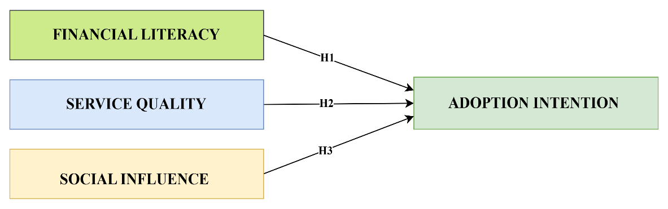
Figure 1: Conceptual Framework

4. Statement of the Problem
The rapid growth of digital financial services has transformed the banking landscape in India, with payment banks emerging as an important mechanism for promoting financial inclusion and providing accessible banking services to diverse population segments. Despite the increasing availability of payment bank services and government initiatives encouraging digital transactions, the adoption of these services remains uneven across different regions, particularly in semi-urban and rural areas. Kolhan Division of Jharkhand represents a region where digital financial infrastructure is expanding, yet the extent of consumer adoption of payment bank services remains relatively limited. Several factors may influence consumers' willingness to adopt these services, including their level of financial literacy, perceptions of service quality, and the influence of social networks. Consumers with inadequate financial knowledge may hesitate to use payment bank services, while poor service experiences can negatively affect adoption intentions. Similarly, social influence from family, friends, and peers may play a significant role in shaping consumers' attitudes toward digital financial services. Although previous studies have examined various determinants of digital banking adoption, limited empirical research has investigated the effects of financial literacy, service quality, and social influence on consumer adoption intention toward payment bank services in the context of Kolhan Division, Jharkhand. Therefore, there is a need to examine how these factors influence consumers’ adoption intention toward payment bank services to provide insights for payment banks, policymakers, and financial institutions seeking to enhance digital financial inclusion and service adoption in the region.

5. Objectives of the Study
- To examine the impact of financial literacy on consumers’ adoption intention toward payment bank services in Kolhan Division, Jharkhand.
- To analyze the effect of service quality on consumers’ adoption intention toward payment bank services in Kolhan Division, Jharkhand.
- To investigate the influence of social influence on consumers’ adoption intention toward payment bank services in Kolhan Division, Jharkhand.

6. Research Methodology
Table 1: Research Methodology
Particulars | Description
Research Approach | Quantitative Research
Research Design | Descriptive and Explanatory Research Design
Study Area | Kolhan Division, Jharkhand
Target Population | Consumers residing in Kolhan Division, Jharkhand, who use, have experience with, or possess awareness of payment bank services and are capable of evaluating their intention to adopt such services.
Sampling Unit | Individual consumers residing in Kolhan Division, Jharkhand, who use or are aware of payment bank services.
Respondents | Consumers and users of payment bank services in Kolhan Division, Jharkhand.
Sampling Technique | Convenience Sampling
Sample Size | 200 Respondents
Data Collection Method | Structured Questionnaire Survey
Source of Data | Primary Data and Secondary Data
Primary Data Source | Responses collected from consumers through a structured questionnaire.
Secondary Data Source | Research articles, books, journals, RBI reports, government publications, and relevant online sources.
Measurement Scale | Five-Point Likert Scale (1 = Strongly Disagree to 5 = Strongly Agree)
Independent Variables | Financial Literacy, Service Quality, and Social Influence
Dependent Variable | Consumer Adoption Intention toward Payment Bank Services
Data Analysis Software | SPSS 17.0 and SmartPLS 4
Statistical Techniques | Descriptive Statistics, Reliability Analysis, Validity Analysis, Measurement Model Assessment, and Partial Least Squares Structural Equation Modeling (PLS-SEM)
Hypothesis Testing Technique | Bootstrapping in PLS-SEM

7. Analysis of the Study
Table 2: Outer Loading – Matrix
 | Adoption Intention | Financial Literacy | Service Quality | Social Influence
AI1 | 0.995
AI2 | 0.995
FL1 |  | 0.785
FL2 |  | 0.799
FL3 |  | 0.920
FL4 |  | 0.915
SI1 |  |  |  | 0.801
SI2 |  |  |  | 0.770
SI3 |  |  |  | 0.940
SI4 |  |  |  | 0.936
SQ1 |  |  | 0.757
SQ2 |  |  | 0.688
SQ3 |  |  | 0.844
SQ4 |  |  | 0.804
Note: AI: Adoption Intention; FL: Financial Literacy; SQ: Service Quality; SI: Social Influence. AI1–AI2 represent Adoption Intention indicators; FL1–FL4 represent Financial Literacy indicators; SQ1–SQ4 represent Service Quality indicators; SI1–SI4 represent Social Influence indicators.

Item Statements:
AI1: I am willing to use payment bank services regularly.
AI2: I intend to increase my use of payment bank services in the near future.
FL1: I understand basic financial concepts such as savings, interest, and credit.
FL2: I am aware of digital financial products such as payment banks.
FL3: I can manage my money and budget effectively.
FL4: I am confident in using digital payment platforms securely.
SQ1: Payment banks provide reliable services.
SQ2: Payment bank transactions are completed accurately.
SQ3: Customer support provided by payment banks is responsive and helpful.
SQ4: Payment bank services are convenient and accessible.
SI1: My family encourages me to use payment bank services.
SI2: My friends or community members recommend payment bank services.
SI3: People who are important to me believe that I should use payment bank services.
SI4: Positive opinions from others influence my decision to use payment bank services.

Table 2 presents the outer loading values for the measurement model constructs, namely Financial Literacy, Service Quality, Social Influence, and Adoption Intention. The results indicate that all indicators exhibit satisfactory loadings on their respective constructs, demonstrating adequate indicator reliability and convergent validity. The Adoption Intention construct shows exceptionally high loadings for AI1 (0.995) and AI2 (0.995), indicating that both items strongly represent the construct. The Financial Literacy indicators range from 0.785 to 0.920, reflecting a strong relationship between the indicators and the latent construct. Likewise, the Social Influence indicators exhibit loadings ranging from 0.770 to 0.940, confirming their suitability for measuring the construct. The Service Quality indicators record loadings between 0.688 and 0.844, indicating acceptable reliability and validity. According to Hair et al. (2022), indicator loadings of 0.50 and above are considered acceptable for retaining indicators, particularly when the overall construct reliability and validity are satisfactory. Since all indicator loadings exceed the minimum threshold value of 0.50, all items were retained in the model. Therefore, the measurement model demonstrates adequate indicator reliability and provides support for proceeding with further validity and structural model assessments.

Table 3: Construct Reliability and Validity
 | Cronbach's alpha | Composite reliability (rho_a) | Composite reliability (rho_c) | Average variance extracted (AVE)
Adoption Intention | 0.990 | 0.990 | 0.995 | 0.990
Financial Literacy | 0.880 | 0.906 | 0.917 | 0.735
Service Quality | 0.780 | 0.809 | 0.857 | 0.601
Social Influence | 0.885 | 0.902 | 0.922 | 0.749

Table 3 presents the results of construct reliability and convergent validity for the study variables. The findings indicate that all constructs demonstrate satisfactory levels of internal consistency reliability, as the Cronbach’s alpha values range from 0.780 to 0.990, exceeding the recommended minimum threshold of 0.70. Similarly, the composite reliability values (rho_a and rho_c) for all constructs are above 0.70, confirming strong construct reliability. Adoption Intention exhibits the highest reliability with Cronbach’s alpha of 0.990, composite reliability (rho_a) of 0.990, and composite reliability (rho_c) of 0.995. Financial Literacy, Service Quality, and Social Influence also demonstrate acceptable reliability levels, indicating consistency among their respective indicators. Furthermore, convergent validity was assessed using the Average Variance Extracted (AVE). The AVE values range from 0.601 to 0.990, all exceeding the recommended threshold of 0.50, indicating that each construct explains more than 50 percent of the variance in its indicators. Social Influence records an AVE of 0.749, Financial Literacy 0.735, and Service Quality 0.601, while Adoption Intention exhibits an exceptionally high AVE of 0.990. Therefore, the results confirm that the measurement model possesses adequate reliability and convergent validity, supporting the suitability of the constructs for subsequent structural model analysis.

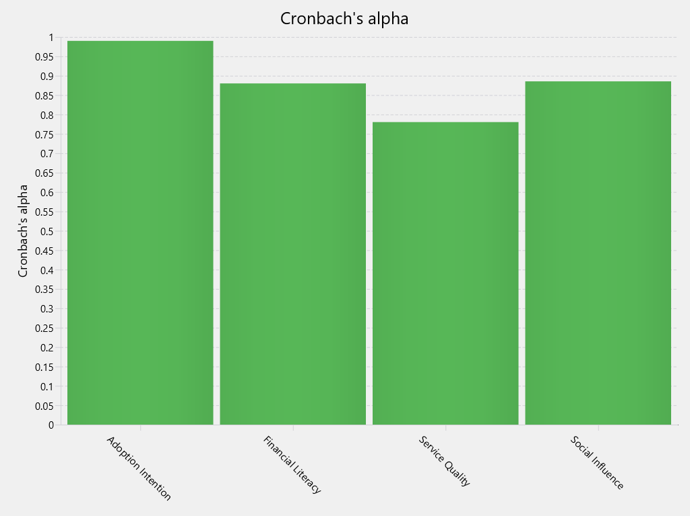
Figure 2: Cronbach’s alpha

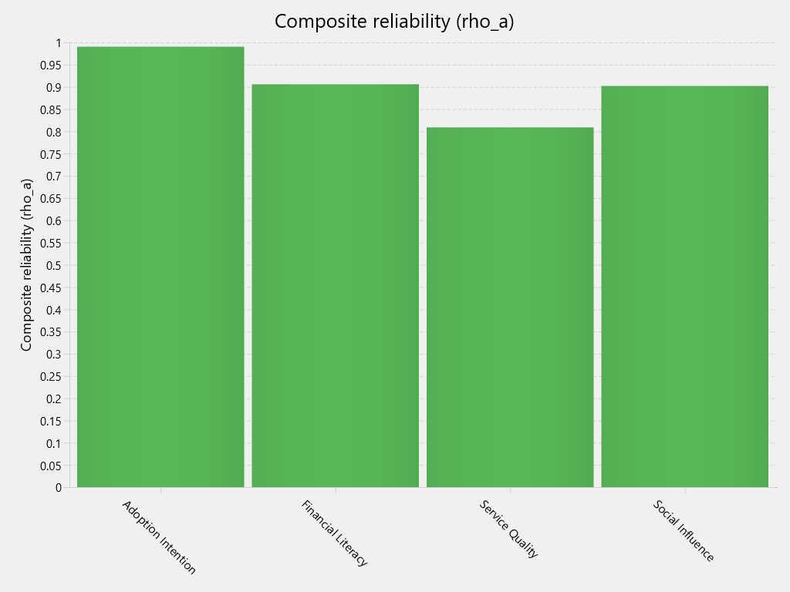
Figure 3: Composite reliability (rho_a)

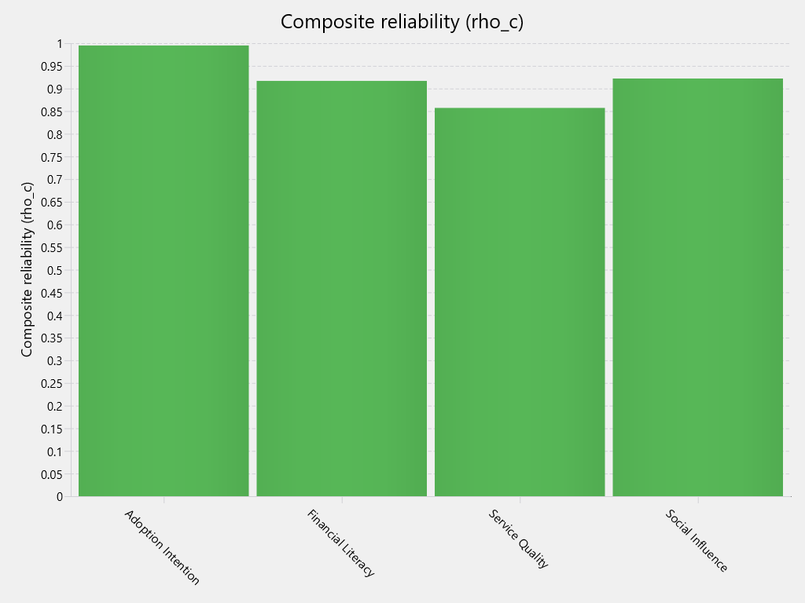
Figure 4: Composite reliability (rho_c)

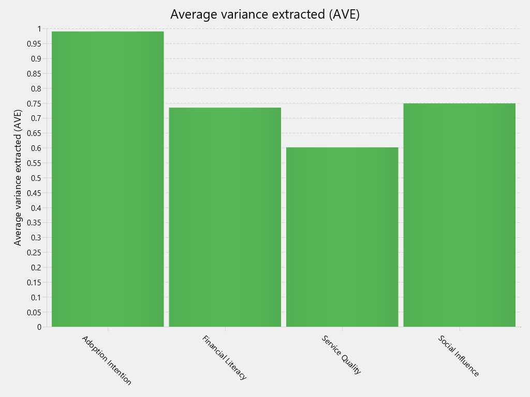
Figure 5: Average variance extracted (AVE)

Table 4: Path Coefficients - Mean, STDEV, T values, p values
 | Original sample (O) | Sample mean (M) | Standard deviation (STDEV) | T statistics (|O/STDEV|) | P values
H1: Financial Literacy -> Adoption Intention | 0.305 | 0.308 | 0.082 | 3.701 | 0.000
H2: Service Quality -> Adoption Intention | 0.221 | 0.223 | 0.072 | 3.071 | 0.002
H3: Social Influence -> Adoption Intention | 0.217 | 0.216 | 0.095 | 2.276 | 0.023

Table 4 presents the results of hypothesis testing for the structural model. The findings indicate that Financial Literacy has a significant positive effect on Adoption Intention (β = 0.305, t = 3.701, p = 0.000), thereby supporting H1. This suggests that consumers with higher financial knowledge and understanding are more likely to adopt payment bank services. Similarly, Service Quality exerts a significant positive influence on Adoption Intention (β = 0.221, t = 3.071, p = 0.002), supporting H2. The result implies that consumers are more inclined to adopt payment bank services when they perceive the services as reliable, efficient, and convenient. Furthermore, Social Influence significantly and positively affects Adoption Intention (β = 0.217, t = 2.276, p = 0.023), thus supporting H3. This finding indicates that recommendations and encouragement from family members, friends, and other important individuals play a crucial role in shaping consumers’ intentions to adopt payment bank services. Since all path coefficients are positive, the t-values exceed the critical value of 1.96, and the p-values are below the 0.05 significance level, all three hypotheses are accepted. Among the predictors, Financial Literacy exhibits the strongest influence on Adoption Intention, followed by Service Quality and Social Influence.

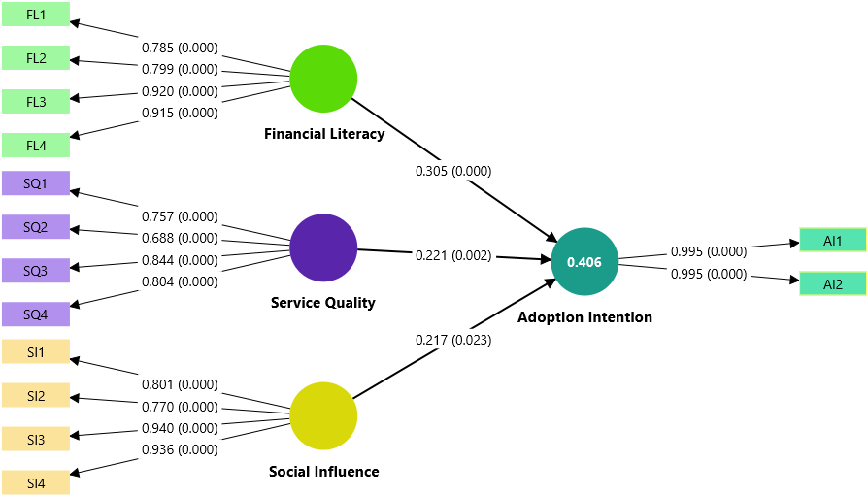
Figure 6: Measurement and Structural Model (Outer and Inner Model) showing factor loadings and path coefficients

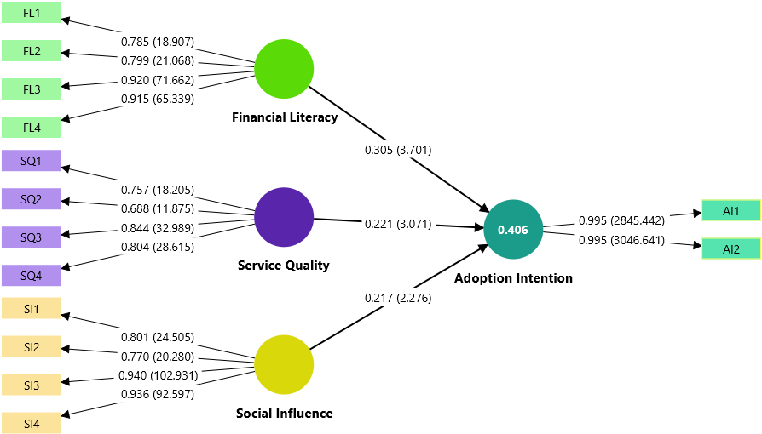
Figure 7: Measurement and Structural Model (Outer and Inner Model) showing factor loadings, t-values, and path coefficients
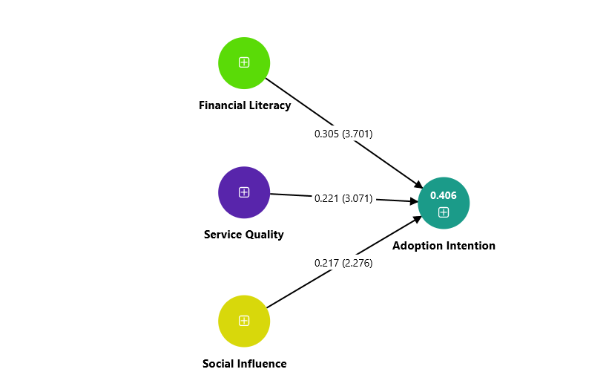
Figure 8: Structural Model (Inner Model) showing path coefficients and t-values

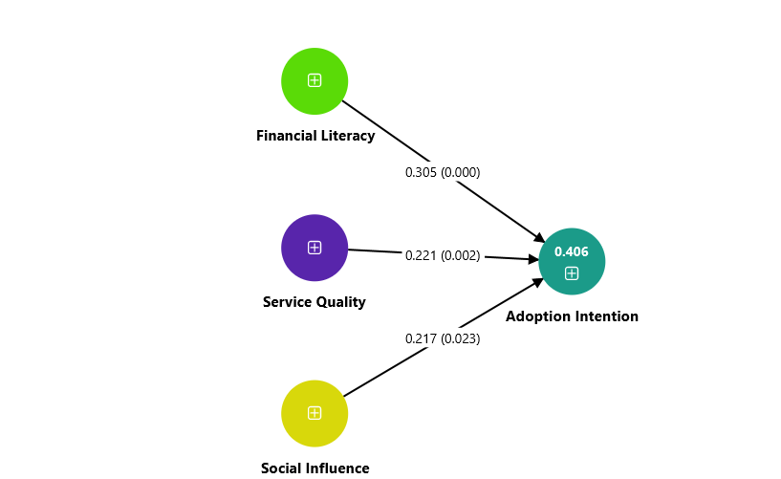
Figure 9: Structural Model (Inner Model) showing path coefficients and significance levels

8. Suggestions
Based on the findings of the study, several suggestions can be made to enhance consumers’ adoption intention toward payment bank services in Kolhan Division, Jharkhand. First, payment banks and policymakers should focus on improving financial literacy among consumers through awareness campaigns, financial education programs, and digital literacy initiatives, as financial literacy was found to have the strongest influence on adoption intention. Such efforts can help consumers better understand the benefits, features, and usage of payment bank services. Second, payment banks should continuously improve service quality by ensuring reliable transactions, user-friendly interfaces, efficient customer support, and secure digital platforms. Enhancing service quality can increase consumer confidence and encourage greater adoption of payment bank services. Third, payment banks should leverage social influence by promoting positive word-of-mouth communication, referral programs, and community-based awareness initiatives. Collaborating with local influencers, community leaders, and existing users can help build trust and encourage potential consumers to adopt payment bank services. Additionally, payment banks should strengthen their outreach efforts in semi-urban and rural areas by conducting demonstrations and awareness programs to familiarize consumers with digital financial services. Finally, policymakers and financial institutions should work together to create an enabling environment that supports digital financial inclusion and promotes the widespread adoption of payment bank services across different population segments.

9. Conclusion
The present study examined the impact of Financial Literacy, Service Quality, and Social Influence on consumers’ Adoption Intention toward payment bank services in Kolhan Division, Jharkhand. The findings revealed that all three factors significantly and positively influence consumers’ intention to adopt payment bank services. Among the predictors, Financial Literacy emerged as the most influential factor, indicating that consumers with greater financial knowledge and awareness are more likely to adopt payment bank services. Service Quality was also found to significantly affect adoption intention, highlighting the importance of reliable, efficient, and user-friendly services in encouraging consumers to embrace digital banking solutions. Furthermore, Social Influence demonstrated a significant positive effect, suggesting that recommendations and encouragement from family members, friends, and social networks play an important role in shaping consumers’ adoption decisions. The study confirms that enhancing financial literacy, improving service quality, and leveraging social influence can contribute significantly to increasing the adoption of payment bank services. These findings provide valuable insights for payment banks, financial institutions, and policymakers seeking to strengthen digital financial inclusion and promote the wider use of payment bank services in semi-urban and rural regions. Overall, the study contributes to the growing literature on digital financial service adoption and offers practical implications for improving consumer acceptance of payment bank services in emerging markets.

References
- Agarwal, S., Barua, S. K., Jacob, J., & Varma, J. R. (2019). Financial literacy and financial planning: Evidence from India. Journal of Financial Counseling and Planning, 30(1), 1–15.
- Ajzen, I. (1991). The theory of planned behavior. Organizational Behavior and Human Decision Processes, 50(2), 179–211.
- Alalwan, A. A., Dwivedi, Y. K., Rana, N. P., & Williams, M. D. (2017). Examining factors influencing Jordanian customers’ intentions and adoption of internet banking. Journal of Retailing and Consumer Services, 34, 154–165.
- Al-Jabri, I. M., & Sohail, M. S. (2012). Mobile banking adoption: Application of diffusion of innovation theory. Journal of Electronic Commerce Research, 13(4), 379–391.
- Baptista, G., & Oliveira, T. (2015). Understanding mobile banking: The unified theory of acceptance and use of technology combined with cultural moderators. Computers in Human Behavior, 50, 418–430.
- Chaouali, W., Yahia, I. B., & Souiden, N. (2017). The interplay of counter-conformity motivation, social influence, and trust in customers’ intention to adopt internet banking services. Journal of Retailing and Consumer Services, 38, 43–54.
- Chawla, D., & Joshi, H. (2020). The moderating role of gender and age in the adoption of mobile wallet. Foresight, 22(4), 483–504.
- Gupta, K. P., Manrai, R., & Goel, U. (2019). Factors influencing adoption of payments banks by Indian customers: Extending UTAUT with perceived credibility. Journal of Asia Business Studies, 13(2), 173–195.
- Hair, J. F., Hult, G. T. M., Ringle, C. M., & Sarstedt, M. (2022). A primer on partial least squares structural equation modeling (PLS-SEM) (3rd ed.). Sage Publications.
- Kesharwani, A., & Singh Bisht, S. (2012). The impact of trust and perceived risk on internet banking adoption in India. International Journal of Bank Marketing, 30(4), 303–322.
- Lusardi, A., & Mitchell, O. S. (2014). The economic importance of financial literacy: Theory and evidence. Journal of Economic Literature, 52(1), 5–44.
- Malaquias, R. F., & Hwang, Y. (2016). An empirical study on trust and mobile banking user behavior. International Journal of Bank Marketing, 34(4), 541–561.
- Martins, C., Oliveira, T., & Popovič, A. (2014). Understanding the internet banking adoption: A unified theory of acceptance and use of technology and perceived risk application. International Journal of Information Management, 34(1), 1–13.
- Morgan, P. J., & Trinh, L. Q. (2019). Determinants and impacts of financial literacy in Cambodia and Viet Nam. Journal of Risk and Financial Management, 12(1), 19.
- Pandey, A. K., & Gupta, S. (2026). Factors influencing payment bank service adoption and consumer behavior: A study of Kolhan Division, Jharkhand. Journal of Asia Entrepreneurship and Sustainability, 22(3s), 105–114. https://doi.org/10.66635/6txmqc16
- Parasuraman, A., Zeithaml, V. A., & Malhotra, A. (2005). E-S-QUAL: A multiple-item scale for assessing electronic service quality. Journal of Service Research, 7(3), 213–233.
- Riquelme, H. E., & Rios, R. E. (2010). The moderating effect of gender in the adoption of mobile banking. International Journal of Bank Marketing, 28(5), 328–341.
- Safeena, R., Date, H., Kammani, A., & Hundewale, N. (2011). Factors affecting internet banking adoption. International Journal of E-Services and Mobile Applications, 3(1), 1–10.
- Shaikh, A. A., & Karjaluoto, H. (2015). Mobile banking adoption: A literature review. Telematics and Informatics, 32(1), 129–142.
- Sharma, S. K., & Sharma, M. (2019). Examining the role of trust and quality dimensions in mobile banking adoption. International Journal of Bank Marketing, 37(1), 1–22.
- Singh, S., & Srivastava, R. K. (2018). Predicting the intention to use mobile banking in India. International Journal of Bank Marketing, 36(2), 357–378.
- Venkatesh, V., Morris, M. G., Davis, G. B., & Davis, F. D. (2003). User acceptance of information technology: Toward a unified view. MIS Quarterly, 27(3), 425–478.
- Venkatesh, V., Thong, J. Y. L., & Xu, X. (2012). Consumer acceptance and use of information technology: Extending the unified theory of acceptance and use of technology. MIS Quarterly, 36(1), 157–178.
- Yadav, R., Chauhan, V., & Pathak, G. S. (2015). Intention to adopt internet banking in an emerging economy: A perspective of Indian youth. International Journal of Bank Marketing, 33(4), 530–544.
- Yu, C. S. (2012). Factors affecting individuals to adopt mobile banking: Empirical evidence from the UTAUT model. Journal of Electronic Commerce Research, 13(2), 104–121.
- Zhou, T. (2012). Understanding users’ initial trust in mobile banking: An elaboration likelihood perspective. Computers in Human Behavior, 28(4), 1518–1525.

