CHAPTER 1
INTRODUCTION

1.1 Background of the Study

1.1.1 Ageing Population and Health Challenges in Older Adults
Population ageing is one of the most important demographic transitions shaping contemporary health care. People are living longer because of improvements in sanitation, nutrition, education, disease prevention, medical treatment and social conditions. At the same time, the rapid growth of the older population means that health systems must increasingly manage conditions that are chronic, disabling and strongly influenced by functional capacity. The World Health Organization (WHO) reports that the proportion of the global population aged 60 years and over is expected to rise from about 12% in 2015 to 22% by 2050, with the absolute number increasing from approximately 1 billion in 2020 to 1.4 billion by 2030 and 2.1 billion by 2050. The fastest growth is occurring in low- and middle-income countries, where health and social-care systems may have fewer resources to absorb the consequences of multimorbidity and disability. [1]
Chronological age alone, however, does not adequately describe the health of an older person. Contemporary healthy-ageing frameworks emphasize intrinsic capacity and functional ability rather than age as an isolated biological marker. Functional ability includes the capacity to meet basic needs, remain mobile, maintain relationships, learn and make decisions, and participate in society. It arises from the interaction between an individual's physical and mental capacities and the surrounding environment. [1,3] This perspective is particularly relevant to musculoskeletal disease because pain, stiffness and loss of mobility may reduce what an older adult can do even when life expectancy itself is not immediately threatened.
Ageing is accompanied by gradual changes in multiple physiological systems. There may be reductions in muscle mass and strength, changes in balance and gait, decreased cardiopulmonary reserve, altered sensory function, slower recovery from physiological stress, and changes in sleep architecture. Psychological and social transitions—including retirement, bereavement, changes in social roles and reduced social participation—may occur alongside these biological changes. These processes are heterogeneous: two people of the same chronological age may have very different functional capacities. [1,3] The clinical implication is that assessment and intervention should be individualized and should consider function, symptoms, comorbidity, medication burden and psychosocial circumstances.
Older adults also have a higher probability of experiencing several chronic conditions simultaneously. Osteoarthritis, cardiovascular disease, diabetes, chronic respiratory disease, sensory impairment, depression and other age-associated conditions may coexist. A systematic review of comorbidities in OA found that people with OA had a pooled prevalence of any comorbidity of approximately 67%, compared with 56% among people without OA, and the likelihood of multiple comorbidities increased as the number of coexisting conditions rose. [30] This multimorbidity makes symptom management more complex and increases the importance of interventions that can be integrated safely with existing medical care.
For gerontological and nursing practice, maintaining independence is therefore a central outcome. Independence is not simply the absence of disease; it is the ability to carry out valued activities with an acceptable level of comfort, confidence and safety. Pain that limits walking may indirectly reduce social contact, physical activity and sleep. Reduced activity can then contribute to deconditioning, weight gain and further functional decline. Such interactions illustrate why older-adult care should not treat musculoskeletal symptoms in isolation. A person-centred approach should seek to preserve function while addressing pain, emotional well-being, sleep and the individual's ability to participate in everyday life.
Domain of ageing | Potential change | Relevance to OA care
Musculoskeletal | Reduced muscle strength, balance and reserve | May amplify mobility limitation and fall risk
Cardiovascular/autonomic | Reduced physiological reserve and altered autonomic regulation | Pain and stress may have greater clinical significance
Sleep | Changes in sleep architecture and vulnerability to fragmentation | Night pain may further impair sleep continuity
Psychological | Greater vulnerability to distress during chronic illness and life transitions | Pain, inactivity and loss of independence can affect mood
Social/functional | Changes in roles, mobility and social participation | OA may restrict meaningful activities and independence
Table 1. Major domains of ageing relevant to the management of osteoarthritis. Source: synthesis based on WHO healthy-ageing principles and the OA literature. [1,3,7]

1.1.2 Osteoarthritis Among Older Adults
Osteoarthritis is a chronic, whole-joint disorder characterized by structural and functional changes involving articular cartilage, subchondral bone, synovium, ligaments, periarticular muscles and other joint tissues. It is more accurately understood as a disease of the whole joint than as simple 'wear and tear.' [2,8] The clinical phenotype varies considerably, but pain, stiffness, movement restriction and functional limitation are common. The knee, hip, hand and spine are among the frequently affected sites, with knee OA representing a particularly important source of disability in older adults.
The epidemiological burden is substantial and is increasing. The Global Burden of Disease Study 2021 estimated that about 595 million people worldwide were living with OA in 2020, corresponding to 7.6% of the global population, with marked increases projected by 2050. Knee OA cases alone are projected to rise by approximately 75% between 2020 and 2050 under the reference scenario. [4] Earlier GBD analyses similarly demonstrated a major rise in prevalent OA cases from 1990 to 2019, with age-standardized prevalence also increasing. [5,6] These figures are important because the expansion of the older population is occurring at the same time as increases in obesity and survival with chronic disease.
OA is not an inevitable or universal consequence of ageing. Rather, age is one component of a multifactorial risk profile. A systematic review of older adults identified overweight, obesity, female sex and previous knee injury as important predictors of knee pain/OA. [9] Another systematic review found associations between OA and joint injury, obesity and occupational activity, while the relationship with sport and general physical activity was more variable. [10] The interaction between mechanical loading, metabolic factors, prior injury, genetics, sex and ageing helps explain why OA develops differently across individuals.
The burden is also visible in the Indian context. A 2025 systematic review and meta-analysis of community-based studies estimated a pooled prevalence of knee OA of 47% among older persons in India, although substantial heterogeneity existed across studies and diagnostic criteria. [6] The estimate should not be interpreted as a single universal prevalence for every Indian population, but it emphasizes that knee OA is an important geriatric health issue in the country. For nursing and community health services, this burden translates into repeated encounters for pain, impaired mobility, medication use, assistive-device needs and support with activities of daily living.
OA also has an important quality-of-life dimension. A systematic review and meta-analysis found lower health-related quality-of-life scores across multiple SF-36 domains among people with OA compared with healthy controls, with particularly pronounced effects on physical role functioning. [7] A focused review of elderly OA similarly emphasized the combined effects of pain, impaired physical function, falls, reduced physical activity and psychosocial consequences on quality of life. [8] Thus, the clinical importance of OA lies not only in radiographic changes but in what those changes mean for movement, participation, sleep, mood and autonomy.
The burden of OA can be summarized as a progression from joint pathology to symptoms and then to functional consequences, but the pathway is not linear. Biological changes can influence pain, yet pain intensity is also modified by central sensitization, psychological state, sleep, expectations and social context. This distinction is essential for the present research because interventions directed at relaxation, positive affect and stress regulation would not be expected to reverse joint structural damage; rather, they may influence symptom experience and the physiological and psychological responses that accompany chronic pain.
Risk factor | Evidence / rationale | Potential implication
Increasing age | Ageing increases susceptibility to joint and tissue changes | Greater need for functional and symptom-focused assessment
Overweight/obesity | Associated with knee/hip OA through mechanical and metabolic pathways | Weight management and activity support may be appropriate
Previous joint injury | Strongly associated with later knee/hip OA | History should be included in assessment
Occupational/mechanical loading | Repetitive or high-load exposure may contribute to risk | Ergonomic and activity advice may be relevant
Female sex | Higher prevalence is consistently observed in many populations | Sex-sensitive epidemiology and care planning
Physical inactivity | May worsen deconditioning and function once OA is established | Gradual, tailored activity is a core management strategy
Table 2. Major risk factors and management implications in osteoarthritis. [9,10]

1.1.3 Clinical Manifestations and Consequences of Osteoarthritis
The most recognizable manifestation of OA is pain, but the clinical picture is broader. People may describe activity-related pain, intermittent flares, stiffness after periods of inactivity, swelling or a sense of instability. In advanced disease, pain can occur at rest or during the night. The relationship between symptoms and structural findings is imperfect: some individuals with substantial radiographic changes report relatively modest symptoms, while others experience considerable pain despite less dramatic imaging findings. [11,12]
The biological mechanisms of OA pain are complex. Cartilage itself is not richly innervated, so pain is thought to arise from innervated tissues such as synovium, subchondral bone, ligaments, capsule and periarticular tissues. Local inflammatory mediators, nerve growth factor, cytokines and altered nociceptive signaling may sensitize peripheral nerve endings. Persistent nociceptive input may also contribute to changes in central pain processing. [11,12] Evidence from systematic reviews suggests that central sensitization is present in a subgroup of people with OA, helping to explain why pain may persist beyond what would be predicted from local joint pathology alone. [13]
Stiffness and reduced range of movement can lead to compensatory movement patterns and reduced physical activity. Over time, reduced activity may produce loss of muscle strength and physical conditioning. The resulting reduction in mobility can make routine tasks—walking to the bathroom, climbing stairs, preparing meals, shopping or participating in religious and social activities—more difficult. In older adults, the practical effect can be substantial because even a modest decline in lower-limb function may threaten independence.
Functional limitations can also affect identity and social participation. People who previously considered themselves active may begin to avoid outings because of anticipated pain or difficulty walking. Family members may assume more household responsibilities, which can be helpful but may also reduce the older person's sense of autonomy. Qualitative evidence on living with OA highlights the importance of persistent symptoms, uncertainty, altered activities and the emotional meaning of reduced function. [14] These experiences reinforce the need for management strategies that are meaningful in everyday life rather than focused solely on numerical symptom reduction.
The cumulative effect of pain, impaired mobility, sleep disruption and emotional distress may reduce health-related quality of life. Because these outcomes influence one another, improvement in one domain may have secondary benefits in another. Conversely, failure to address sleep or mood may make pain management less successful. For this reason, pain, blood pressure, sleep quality and mood state are conceptually defensible as related outcomes in a study of non-pharmacological interventions for older adults with OA.

1.1.4 Pain Among Elderly Adults With Osteoarthritis
Pain is a multidimensional experience involving sensory, emotional and cognitive processes. The International Association for the Study of Pain defines pain as an unpleasant sensory and emotional experience associated with, or resembling that associated with, actual or potential tissue damage, while emphasizing that pain is personal and influenced by biological, psychological and social factors. [15] This definition is particularly appropriate to OA because the symptom cannot be reduced to a simple measure of tissue injury.
In older adults, chronic pain may be influenced by age-related sensory changes, multimorbidity, cognitive status, mood, sleep, medication use and communication difficulties. Assessment should therefore be systematic and repeated. A patient who reports 'the same pain' may nevertheless have changed in function, sleep, activity or emotional response. Chronic pain management should aim not only to lower pain intensity but also to preserve function, participation and quality of life. [16]
OA pain can be episodic or persistent. Peripheral nociceptive input from the affected joint may be accompanied by sensitization within the peripheral and central nervous systems. [11-13] Psychological responses such as catastrophizing, fear of movement and low mood can further amplify the pain experience. A recent systematic review found that adverse psychological states, higher body mass index, insufficient physical activity and poor sleep were associated with greater OA pain and poorer physical function. [17] Such findings support a biopsychosocial approach rather than a purely biomedical pain model.
Pharmacological treatment remains important, but medication-based care in older adults can be complicated by polypharmacy, renal and gastrointestinal vulnerability, cardiovascular disease, drug interactions and adverse effects. Contemporary OA guidelines therefore emphasize exercise, self-management, weight management where appropriate, and selected pharmacological or procedural options based on individual risk and preference. [18-20] Opioids are generally discouraged for routine OA management, and the safety profile of long-term medication requires careful consideration. [21] These realities strengthen the rationale for studying complementary, low-risk approaches that can be used alongside—not instead of—evidence-based medical care.
A non-pharmacological approach is especially attractive when it is simple, acceptable and feasible for older adults. Interventions that can be delivered in small groups or individually, require little equipment, and can be incorporated into nursing or community settings may have practical value. Therapeutic humor and autogenic training fit this broad description, although their effectiveness should not be assumed. Their mechanisms and evidence need to be examined critically, and the present study is positioned to contribute comparative evidence.

1.1.5 Osteoarthritis and Blood Pressure
Blood pressure is a dynamic physiological variable influenced by cardiac output, vascular resistance, circulating volume and autonomic regulation. Pain and acute stress can activate sympathetic pathways, producing increases in heart rate, vascular resistance and blood pressure. [22] The relationship between pain and blood pressure is bidirectional and context dependent. Acute nociceptive stimulation can transiently increase blood pressure, while chronic pain may alter autonomic regulation and cardiovascular risk in more complex ways.
The sympathetic nervous system has a central role in cardiovascular regulation and hypertension. Persistent sympathetic activation may influence vascular tone and cardiac workload, while chronic pain may itself be associated with sympathetic overactivity. [23,24] A recent systematic review and meta-analysis also reported an association between chronic pain and subsequent hypertension, although the causal pathways remain incompletely understood. [25] It is therefore scientifically appropriate to monitor blood pressure when evaluating interventions intended to reduce stress or arousal in older adults with chronic pain.
Importantly, the expected effect of a relaxation-based intervention should not be overstated. A single episode of laughter may acutely increase systolic blood pressure during active laughing, as shown in a small experimental study. [26] Other experimental work suggests that mirthful laughter can produce short-term changes in vascular function, but these findings do not establish a sustained antihypertensive effect. [27] The distinction between an acute physiological response during laughter and longer-term effects of a structured intervention is essential.
Autogenic training has a different immediate physiological target. By encouraging a self-induced state of calm, heaviness and warmth, the method is intended to reduce arousal rather than produce the muscular and respiratory changes associated with active laughter. Historical clinical research has reported reductions in blood pressure among people receiving autogenic training, but older studies vary in methodological quality and should not be interpreted as proof of efficacy for every patient group. [28] Therefore, blood pressure should be treated as an objectively measurable outcome that can test whether the hypothesized stress-regulation pathways translate into clinically observable physiological change.

1.1.6 Osteoarthritis and Sleep Quality
Sleep is a core component of recovery, emotional regulation, cognition and physical functioning. In older adults, sleep may already be vulnerable because of age-related changes in circadian rhythms, nocturnal awakenings, medications, medical conditions and environmental factors. OA adds another burden because pain, stiffness and difficulty changing position may interfere with sleep initiation and maintenance.
The relationship between pain and sleep is not simply one-way. Pain can fragment sleep, while insufficient or poor-quality sleep can increase pain sensitivity, fatigue and emotional reactivity. A 2024 systematic review and meta-analysis of prospective studies found that baseline sleep problems were associated with increased risk of chronic musculoskeletal pain in both short- and long-term analyses; chronic musculoskeletal pain was also associated with short-term sleep problems. [29] These findings support the concept of a self-reinforcing pain–sleep cycle.
OA-specific evidence is consistent with this pattern. A recent systematic review and meta-analysis of knee and hip OA found significantly poorer sleep quality among people with OA compared with healthy controls and identified pain and depressive symptoms as important contributors. [31] Earlier randomized-trial evidence indicates that interventions directed at sleep can influence pain and sleep outcomes in people with OA and spinal pain, although the evidence base remains heterogeneous. [32]
The clinical consequences of poor sleep extend beyond tiredness. Sleep fragmentation can reduce concentration, worsen mood, decrease motivation for physical activity and heighten sensitivity to pain. For an older adult with OA, this can produce a cycle in which night-time discomfort reduces sleep, poor sleep increases next-day fatigue and pain, and the person subsequently becomes less active. An intervention that promotes relaxation and positive emotional states could theoretically interrupt part of this cycle, but this hypothesis requires empirical testing.
Therapeutic humor may influence sleep indirectly by reducing distress and promoting positive affect. A meta-analysis of randomized trials involving laughter and humor interventions reported improvements in depression, anxiety and sleep quality in adults, although the included interventions and populations were heterogeneous. [33] Autogenic training may influence sleep through a different route, namely reduction of cognitive and physiological arousal before sleep. The evidence for AT in stress and anxiety is promising but not definitive, and methodological limitations have been noted. [34,35]

1.1.7 Osteoarthritis and Mood State
Chronic pain and functional limitation can alter mood through several pathways. Persistent discomfort can restrict activity and social participation, interfere with sleep and create uncertainty about the future. At the same time, depression and anxiety can increase the salience of pain, reduce motivation for activity and make coping more difficult. Thus, the association between OA and mood is best conceptualized as reciprocal rather than as a simple consequence of disease severity.
A systematic review and meta-analysis including more than 15,000 people with OA found pooled prevalence estimates of approximately 19.9% for depressive symptoms and 21.3% for anxiety symptoms. [36] A larger systematic review of 121 studies involving 38,085 participants found moderate positive correlations between OA pain severity and both depressive symptoms and anxiety. [37] These findings do not prove that pain causes depression, but they demonstrate that psychological assessment is clinically relevant in OA.
Mood changes can also have social consequences. An older adult who avoids activities because of pain may experience fewer opportunities for enjoyment and interpersonal connection. Social withdrawal may reinforce low mood, while low mood may further reduce engagement. In this context, an intervention that is inherently social, enjoyable and non-stigmatizing may have particular appeal. Humor has a plausible role because it can create positive emotional experiences and facilitate social interaction without requiring the participant to adopt a formal psychological treatment identity.
Autogenic training provides a contrasting pathway. It uses structured concentration and self-suggestion to produce a state of relaxation and psychological calm. Systematic review evidence suggests that AT may reduce anxiety and depressive symptoms and may alter autonomic markers such as high-frequency heart-rate variability, but the magnitude and generalizability of effects vary across populations and protocols. [35] This uncertainty reinforces the importance of a well-defined intervention protocol and objective outcome assessment.

1.2 Non-Pharmacological Management of Osteoarthritis
Modern OA care is multimodal. The aim is not merely to suppress symptoms but to preserve function, support self-management and match treatment to the individual's symptoms, comorbidities, preferences and goals. Major clinical guidelines consistently place therapeutic exercise, education and appropriate weight management near the center of care. The American College of Rheumatology/Arthritis Foundation guideline strongly recommends exercise and, for people with knee or hip OA who are overweight or obese, weight loss. [18] OARSI similarly identifies education and structured land-based exercise as core treatments, while emphasizing individualized choices according to comorbidity and frailty. [19] NICE guidance also identifies therapeutic exercise and weight management, where appropriate, as core treatments. [20]
Exercise is supported by a substantial evidence base. Meta-analytic evidence indicates that exercise therapy can improve pain and function in knee and hip OA, with benefits influenced by intervention characteristics and patient factors. [38] Education and self-management can increase confidence and help people understand symptom fluctuations, activity pacing and realistic treatment goals. Physiotherapy may address strength, range of motion, gait, balance and functional adaptation. Psychological interventions can target fear, catastrophizing, distress and coping.
Pharmacological options remain useful but are not without limitations. Topical and oral NSAIDs, duloxetine, intra-articular corticosteroids and other treatments may be considered in selected patients, while opioids are generally not recommended for routine OA management. [18,19,21] Older adults may be particularly vulnerable to adverse drug events because of multimorbidity and polypharmacy. This does not mean medication should be withheld; rather, it supports shared decision-making and the use of complementary approaches where they are safe and appropriate.
Complementary and mind-body interventions occupy a potential supportive role. Yoga, relaxation approaches and other behavioral interventions have been investigated with varying degrees of evidence. [39] The appeal of therapeutic humor and autogenic training lies in their relative simplicity and the possibility of integrating them into nursing-led supportive care. Nevertheless, 'simple' does not mean 'automatically effective.' A rigorous study must distinguish plausible mechanisms from demonstrated clinical benefit.
For older adults, feasibility is as important as efficacy. A useful intervention should be understandable, acceptable, low-cost, adaptable to sensory or mobility limitations, and sufficiently brief to fit routine care. It should also have a low burden of adverse effects and be capable of being delivered without displacing necessary medical treatment. These considerations provide the practical context for the two interventions evaluated in the present study.
Management approach | Primary purpose | Relevance to the present study
Therapeutic exercise | Improve strength, mobility, function and pain | Core standard care; provides context for complementary interventions
Education/self-management | Improve knowledge, self-efficacy and coping | Supports adherence and person-centred care
Weight management | Reduce mechanical/metabolic burden where appropriate | Important co-intervention for selected patients
Medication | Reduce pain and inflammation or modulate pain | May continue as usual care; medication use is a potential covariate
Psychological/relaxation approaches | Reduce distress, arousal and maladaptive pain responses | Mechanistically related to humor and autogenic training
Complementary interventions | Provide additional symptom and well-being support | Target area for the present comparative study
Table 3. Multimodal approaches to osteoarthritis management and their relevance to the present research. [18-20,38,39]

1.3 Therapeutic Humor

1.3.1 Concept and Definition of Therapeutic Humor
Humor is a complex psychosocial phenomenon involving the perception, interpretation and expression of something amusing or incongruous. Laughter is one possible behavioral expression of humor, but the two concepts are not identical. A person may experience humor without overt laughter, and laughter can occur in social situations without a humorous stimulus. Therapeutic humor refers to the deliberate, structured and ethically appropriate use of humor-related experiences to support health, coping, communication or well-being.
In health care, therapeutic humor should be distinguished from casual joking. It should be respectful, culturally sensitive, voluntary and responsive to the individual's preferences. Humor that embarrasses, stereotypes, trivializes pain or is directed at a person's disability is not therapeutic. For older adults, the most appropriate forms may include humorous stories, comedy videos, age-appropriate games, reminiscence involving positive experiences, cartoons, gentle group activities and laughter-promoting exercises.
Evidence in older adults is encouraging but heterogeneous. A systematic review of laughter and humor interventions in adults aged 60 years and over identified a small number of intervention studies and emphasized variability in intervention design. [40] A later meta-analysis of humor therapy in older adults reported improvements in depression, loneliness and quality of life across randomized and quasi-experimental studies, although the authors noted the need for additional high-quality trials. [41] These findings support further investigation while cautioning against presenting humor as a universal treatment.

1.3.2 Mechanisms of Therapeutic Humor
Several pathways may explain why humor could influence health outcomes. The first is emotional. Humor can generate positive affect and temporarily shift attention away from threat or discomfort. Positive emotional experiences may broaden attention, improve social engagement and make coping efforts feel less effortful. The second is physiological. Laughter changes breathing patterns, muscle activity and autonomic state, and experimental work has examined relationships between laughter, cardiovascular function and endocrine stress markers. [27,42]
The third pathway is attentional and cognitive. Humor may act as a form of distraction or cognitive reappraisal, changing how a person interprets an unpleasant experience. Experimental evidence has shown that humor can increase pain tolerance under controlled conditions, although the effect is not necessarily unique to humor and may overlap with other forms of distraction. [43] Social laughter has also been associated with increased pain thresholds, leading researchers to propose a possible endorphin-mediated mechanism. [44]
The fourth pathway is interpersonal. Shared laughter can facilitate social connection and reduce interpersonal distance. For older adults who are socially isolated or whose activity has narrowed because of OA, a group-based humor intervention may provide both an emotional experience and an opportunity for interaction. The intervention could therefore influence mood through more than one route.
These pathways should be regarded as proposed mechanisms rather than established causal chains. A conceptual sequence for the present study is: humor exposure → positive emotional response → reduced perceived stress and altered attention → relaxation and social engagement → possible changes in pain appraisal, sleep and mood. Any blood-pressure effect is likely to depend on timing and the specific characteristics of the intervention because active laughter can produce transient cardiovascular changes. [26,27]

1.3.3 Therapeutic Humor and Pain
Pain is both a sensory and interpretive experience, so an intervention that changes attention and affect may alter the experience of pain without changing the underlying joint pathology. Experimental research supports this possibility. Humor has been investigated as a cognitive technique for increasing pain tolerance, with studies suggesting that humor and other forms of distraction can increase tolerance to experimental pain. [43] Social laughter has similarly been associated with elevated pain thresholds. [44]
A randomized crossover investigation of mirthful laughter found that watching a comedy video increased positive affect and produced changes in breathing, with effects on pain tolerance examined under experimentally induced muscle soreness. [45] Although laboratory studies cannot be directly equated with chronic OA pain, they provide mechanistic plausibility. More clinically relevant evidence is still required to determine whether repeated humor sessions can reduce pain intensity or improve function in older adults with OA.
The distinction between pain tolerance and pain intensity is important. An individual may tolerate a stimulus longer without reporting less pain in daily life. For this reason, a clinical trial should use validated pain measures and interpret them alongside functional and psychosocial outcomes. The present study's inclusion of sleep, blood pressure and mood broadens the evaluation beyond a single subjective symptom.

1.3.4 Therapeutic Humor and Blood Pressure
The cardiovascular response to humor is complex. Active laughter can produce transient increases in heart rate and systolic blood pressure, as demonstrated in experimental work. [26] Conversely, mirthful laughter has been associated with favorable short-term changes in vascular function in controlled laboratory settings. [27] A systematic review and meta-analysis examining spontaneous laughter and cortisol suggests that laughter may also influence the stress response, although the magnitude and consistency of effects vary. [42]
These findings mean that humor should not be described simplistically as an antihypertensive intervention. Instead, humor may influence cardiovascular physiology through emotional and stress-regulatory pathways, while acute laughter itself can cause temporary hemodynamic changes. Repeated intervention studies are needed to determine whether any longer-term effect is clinically meaningful.
Because older adults frequently have hypertension or cardiovascular comorbidity, blood pressure monitoring is particularly relevant. The present study can therefore provide useful safety and exploratory efficacy information by measuring blood pressure under standardized conditions before and after the intervention period.

1.3.5 Therapeutic Humor and Sleep
Sleep may improve when emotional distress decreases and the individual experiences greater relaxation or positive affect. A meta-analysis of randomized trials found that laughter and humor interventions significantly reduced depression and anxiety and improved sleep quality in adults. [33] However, the included studies varied in population, intervention format and duration, so the findings should be interpreted as supportive rather than definitive.
For older adults with OA, the potential sleep benefit may be indirect. Humor could reduce pre-sleep worry, provide positive emotional activation earlier in the day and increase social connectedness. If pain-related rumination is reduced, sleep initiation may become easier. The intervention should nevertheless be scheduled so that any stimulating group activity does not interfere with the participant's normal sleep routine.

1.3.6 Therapeutic Humor and Mood
Mood is one of the outcomes for which humor has the strongest conceptual rationale. Positive affect can provide a temporary counterweight to the emotional burden of chronic pain. The older-adult literature indicates potential improvements in depression, loneliness, happiness and quality of life following humor or laughter interventions. [40,41] A broader integrative review also concluded that humor therapy may help depression and anxiety across several clinical populations, while emphasizing the need for higher-quality evidence. [46]
The social dimension may be especially relevant in later life. A group session can create opportunities for shared enjoyment, conversation and recognition of common experiences. Such effects are not necessarily captured by a pain scale, yet they may be meaningful to the individual's overall well-being.

1.3.7 Therapeutic Humor in Older Adults
Feasibility is a major consideration. Humor interventions generally require little equipment and can be adapted to seated participation, making them potentially suitable for people with mobility limitations. However, visual, hearing and cognitive limitations must be considered. Materials should use adequate font size, clear audio and simple instructions. Humor should also be culturally appropriate and avoid content that may be offensive or distressing.
Safety considerations are modest but should not be ignored. Vigorous laughing can temporarily alter blood pressure and breathing. Participants with unstable cardiovascular conditions, severe respiratory limitations or other contraindications should be screened according to the study protocol and clinical advice. The intervention should never replace clinical assessment of worsening pain, dyspnea, dizziness or other acute symptoms.

1.4 Autogenic Training

1.4.1 Concept and Definition of Autogenic Training
Autogenic training (AT) is a structured self-relaxation method developed from the work of Johannes Heinrich Schultz. The method uses focused attention, verbal formulas and passive concentration on bodily sensations such as heaviness and warmth, together with calm breathing and a quiet mental state. The purpose is to facilitate a self-induced relaxation response rather than rely on an external therapist to produce relaxation.
AT is therefore different from simple rest. It is a learned skill requiring repeated practice. The participant gradually learns to reproduce a state of calm through standardized mental exercises. In clinical research, protocols differ in length, frequency and whether classical AT is delivered alone or combined with other psychological methods. This variation is important when interpreting evidence.
A systematic review of controlled trials evaluating AT for stress and anxiety found that several studies reported positive effects, but methodological limitations and deviations from classical AT prevented firm conclusions. [34] More recent meta-analytic work has suggested beneficial effects on stress-related outcomes, including anxiety and depressive symptoms and some measures of autonomic regulation. [35] The evidence therefore supports AT as a promising relaxation technique rather than an established treatment for OA itself.

1.4.2 Mechanisms of Autogenic Training
The proposed mechanism of AT begins with deliberate reduction of cognitive and physiological arousal. Focused attention and passive concentration may reduce external attentional demands, while the repeated formulas promote a sense of heaviness, warmth and calm. As arousal decreases, muscle tension and stress-related autonomic activation may also decline.
A conceptual pathway for the present study is: autogenic training → self-induced relaxation → reduced physiological arousal → improved autonomic regulation → reduced muscle tension and stress → altered pain appraisal and improved sleep and mood. This pathway is consistent with the broader literature on stress regulation but should be viewed as a testable hypothesis rather than an established causal sequence.
Evidence from systematic review suggests that AT can reduce anxiety and depressive symptoms and may increase high-frequency heart-rate variability, a marker related to parasympathetic cardiac regulation. [35] Because autonomic regulation is also relevant to cardiovascular responses and stress-related pain, AT provides a biologically plausible intervention for a study that includes blood pressure as an outcome.

1.4.3 Autogenic Training and Pain
AT has been used within multimodal chronic pain programs because relaxation may reduce muscle tension, emotional distress and pain-related arousal. The strongest recent evidence is a systematic review and meta-analysis of randomized controlled trials involving 576 participants. The pooled analysis found a moderate beneficial effect of AT on pain compared with passive controls, although no clear difference was found when AT was compared with other psychological interventions and the overall evidence had risk-of-bias concerns. [47]
These findings are important for the present study because they suggest that AT may reduce pain without directly modifying joint structure. The likely target is the pain experience and its associated arousal rather than cartilage degeneration. This is consistent with a biopsychosocial understanding of chronic OA pain.
AT may also influence coping. A participant who can deliberately reduce physiological tension during a pain flare may feel greater control over symptoms. Increased self-efficacy could indirectly support activity and sleep. These secondary pathways should be considered when interpreting changes in pain scores.

1.4.4 Autogenic Training and Blood Pressure
Relaxation techniques can influence cardiovascular physiology by reducing sympathetic arousal and modifying autonomic balance. Historical randomized work has reported reductions in blood pressure with AT, including long-term follow-up in people with essential hypertension. [28] However, these studies are older and may not meet contemporary standards for allocation, blinding and outcome measurement.
The evidence should therefore be interpreted cautiously. AT should not be presented as a substitute for antihypertensive medication. Instead, it may be considered a supportive behavioral intervention whose cardiovascular effects can be measured objectively. The use of standardized blood-pressure measurement in the present study is therefore scientifically useful and clinically responsible.

1.4.5 Autogenic Training and Sleep Quality
AT may be particularly relevant to sleep because difficulty initiating sleep is often accompanied by cognitive and physiological arousal. Practicing relaxation before bedtime may reduce the tendency to remain mentally alert while physically tired. The effect is theoretically different from a sedative effect: AT aims to facilitate a calm state that the individual learns to reproduce.
Evidence specific to OA is limited, which itself is relevant to the research gap. Existing OA sleep literature demonstrates the clinical importance of sleep, while broader AT research provides a plausible mechanism. [29,31,32,34] A well-designed trial can therefore determine whether the theoretical benefit is observable in older adults with chronic musculoskeletal symptoms.

1.4.6 Autogenic Training and Mood State
Stress and mood are closely related to chronic pain. If AT reduces physiological arousal and provides a sense of control, it may also reduce anxiety and improve emotional regulation. Meta-analytic evidence indicates reductions in anxiety and depression-related outcomes, although effects differ by population and intervention duration. [35]
The intervention is also self-directed. This may be valuable for older adults because it provides a skill that can potentially be practiced beyond the formal study sessions. However, adherence depends on the participant's ability and willingness to practice, and the intervention should be taught in a clear, gradual manner.

1.4.7 Autogenic Training Among Older Adults
AT can generally be adapted to seated or lying positions and does not require strenuous movement. This makes it potentially feasible for older adults with mobility restrictions. Instruction should account for hearing impairment, concentration difficulties and fatigue. A quiet environment and consistent wording may improve learning.
As with any behavioral intervention, adherence is important. The protocol should record attendance and, if home practice is prescribed, document the frequency of practice. This information can help distinguish lack of efficacy from inadequate exposure to the intervention.

1.5 Comparison Between Therapeutic Humor and Autogenic Training
Therapeutic humor and AT share a broad objective—reducing the burden associated with chronic symptoms—but they reach that objective through different immediate processes. Humor primarily introduces positive affect, social engagement and attentional change. AT primarily trains self-induced relaxation and reduction of physiological arousal. This distinction makes a head-to-head comparison scientifically interesting.
The proposed humor pathway is: humor → positive emotion and social connection → altered attention/appraisal and reduced perceived stress → possible changes in pain, sleep and mood. The proposed AT pathway is: focused attention and autosuggestion → relaxation → reduced arousal and muscle tension → possible changes in pain, blood pressure, sleep and mood.
Neither intervention should be assumed superior on theoretical grounds. Humor may be more engaging for some participants and may produce social benefits, whereas AT may offer a portable self-regulation skill. Conversely, some individuals may dislike humor-based activities or find AT difficult to learn. The comparative effectiveness question is therefore empirical and patient-centred.
The available literature also shows an important gap. Evidence exists separately for humor/laughter interventions and AT, but direct comparisons between the two interventions in older adults living with OA, using pain, blood pressure, sleep quality and mood as a combined outcome set, appear limited. This gap provides a clear rationale for the proposed randomized controlled study.
Characteristic | Therapeutic humor | Autogenic training
Primary immediate target | Positive affect, attention, social interaction | Self-induced relaxation and reduced arousal
Typical delivery | Humorous material, stories, games, laughter-promoting activities | Guided mental exercises and repeated relaxation formulas
Potential pain pathway | Distraction, reappraisal, positive affect, possible endogenous analgesia | Reduced arousal, muscle tension and pain-related distress
Potential BP pathway | Complex; acute laughter may raise BP while longer-term stress effects remain uncertain | Reduced arousal may support autonomic regulation
Potential sleep pathway | Reduced distress and improved positive affect | Reduced pre-sleep arousal
Potential mood pathway | Positive affect and social connection | Stress reduction and emotional regulation
Key practical advantage | Engaging and socially interactive | Can become a self-management skill
Key research caution | Heterogeneous interventions and cultural acceptability | Protocol variability and evidence-quality limitations
Table 4. Conceptual comparison of therapeutic humor and autogenic training. [33-35,40-47]

Figure 1. From population ageing to the multidimensional burden of osteoarthritis. Conceptual synthesis based on refs. 1-8.
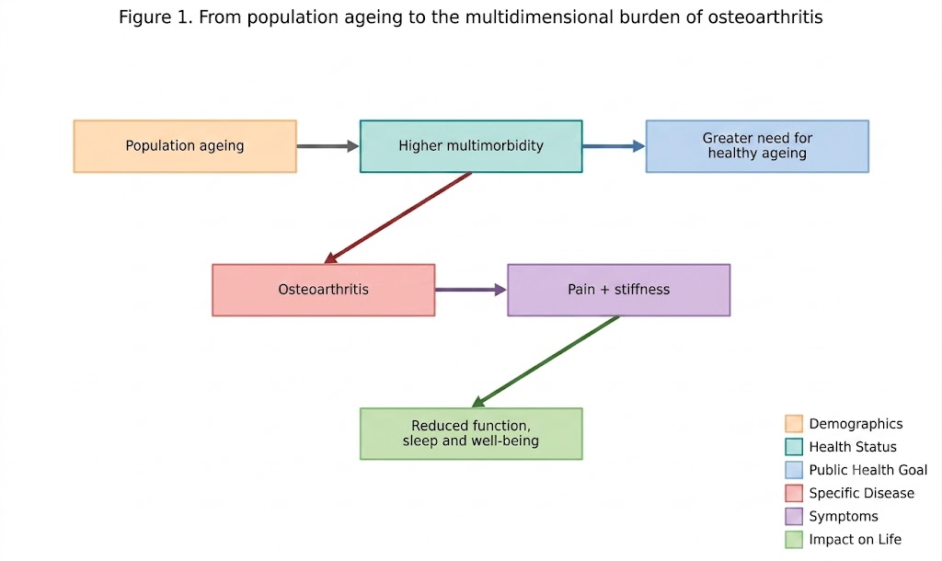

Figure 2. Biopsychosocial interaction among major osteoarthritis-related outcomes. Conceptual synthesis based on refs. 11-17, 29, 36, 37.
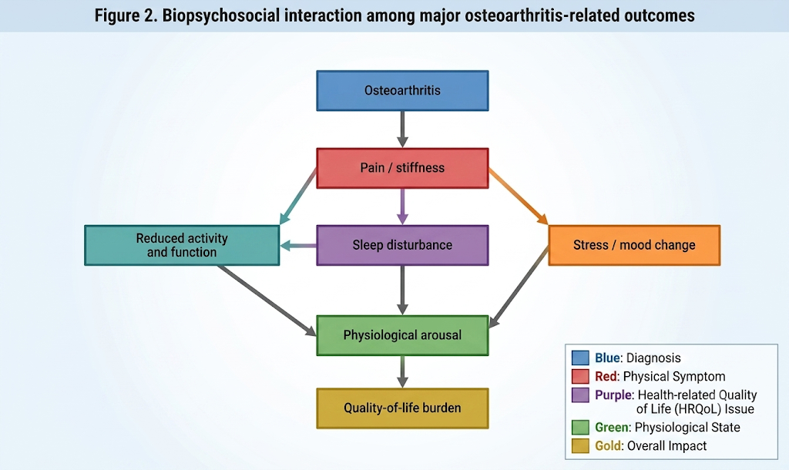

Figure 3. Proposed mechanisms linking therapeutic humor and autogenic training with study outcomes. Conceptual synthesis based on refs. 33-35, 42-47.
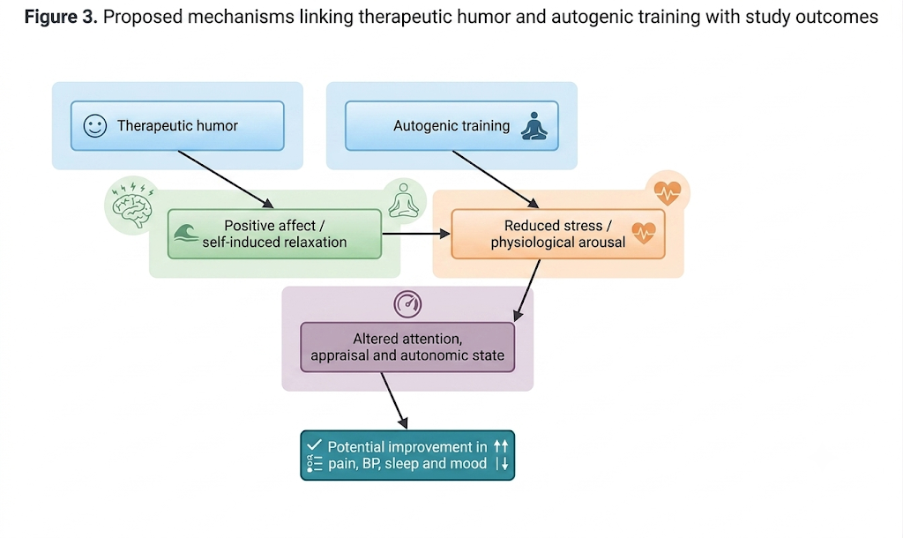

1.6 Interrelationship Among the Study Variables
The variables selected for the present study are interconnected rather than independent. OA provides the underlying chronic musculoskeletal condition; pain and stiffness are prominent symptoms; reduced mobility may affect activity and social participation; disturbed sleep can increase fatigue and pain sensitivity; mood may deteriorate as activity and independence decline; and persistent pain and emotional stress can contribute to physiological arousal. Blood pressure is therefore included as an objective physiological outcome that may reflect, in part, the interaction between stress, autonomic regulation and cardiovascular vulnerability.
The conceptual model begins with OA and its associated pain and functional limitation. Pain may contribute to sleep disturbance and mood change, while sleep and mood can in turn influence pain perception and coping. Chronic stress and persistent pain may increase sympathetic activity and alter cardiovascular regulation. [22-25,29] The resulting cycle can be conceptualized as a state of heightened burden rather than a single causal chain.
Therapeutic humor and AT are hypothesized to interrupt this cycle at different points. Humor may introduce positive affect, attention shifting and social connection. AT may reduce physiological arousal and promote a learned relaxation response. Both may therefore influence stress and emotional regulation, but their relative effects on pain, BP, sleep and mood remain uncertain. Figure 4 presents the study-specific framework.
Figure 4. Study-specific conceptual framework. *If a control/usual-care group is included, the final protocol should specify its exact content.
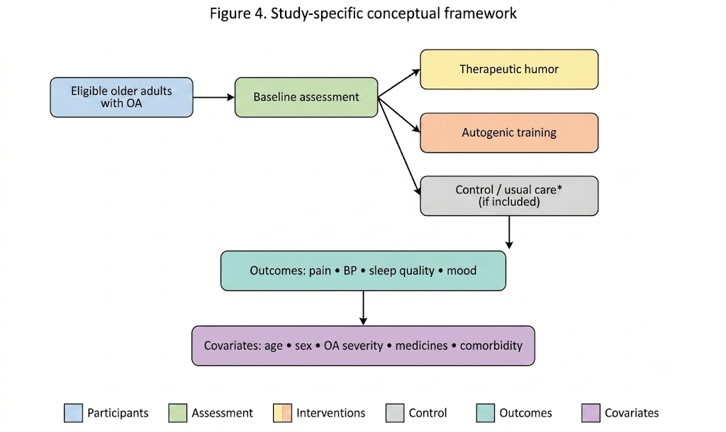

1.7 Theoretical Framework
A biopsychosocial perspective of pain provides a suitable overarching theoretical foundation for the present research. Chronic OA pain is not fully explained by tissue pathology alone; biological processes interact with psychological and social factors. [11-15] Biological factors include joint pathology, inflammation, sensitization and comorbidity. Psychological factors include mood, anxiety, expectations, attention and coping. Social factors include relationships, participation, access to care and the environment.
The relaxation/stress-response perspective complements the biopsychosocial framework by explaining how psychological interventions can influence physiological arousal. Pain and stress can activate autonomic and neuroendocrine systems, while relaxation techniques may reduce arousal and alter autonomic balance. [22-25,35] The theoretical proposition is not that relaxation reverses OA pathology, but that changing the individual's response to chronic symptoms may influence the severity and functional consequences of those symptoms.
Within this framework, therapeutic humor is conceptualized primarily as a positive-affect and attention-modulating intervention, whereas AT is conceptualized primarily as a self-induced relaxation intervention. Both may converge on reduced perceived stress and improved emotional regulation. Their downstream effects are expected to be reflected in the study outcomes if the hypothesized pathways are sufficiently strong.
The framework therefore connects: osteoarthritis → biological and psychosocial burden → intervention → psychological and physiological response → pain, blood pressure, sleep quality and mood. This theoretical structure is compatible with a randomized controlled design because the intervention is experimentally manipulated while outcomes are measured prospectively.

1.8 Conceptual Framework
The independent variable in the proposed study is the assigned intervention condition. The principal intervention groups are therapeutic humor and autogenic training; a control or usual-care group should be included only if specified in the final protocol. The dependent variables are pain, blood pressure, quality of sleep and mood state. Potential covariates include age, sex, OA duration and severity, medication use, comorbidities and baseline outcome values.
Randomization is important because these variables may influence outcomes independently of the intervention. For example, a participant with severe OA may begin with higher pain and poorer sleep than a participant with mild disease. Medication changes may also affect pain or blood pressure. Recording baseline characteristics and maintaining stable usual care where ethically and clinically appropriate will strengthen internal validity.
The conceptual framework also assumes that the intervention does not operate in a vacuum. Participants remain exposed to their usual treatment, daily activity, family environment and health conditions. Consequently, the trial should interpret intervention effects as additional effects within routine care rather than as isolated effects in an artificial environment.

1.9 Statement of the Problem
Population ageing is increasing the number of older adults who require long-term management of chronic musculoskeletal conditions. OA is one of the most common of these conditions and is a major contributor to pain, mobility limitation and reduced quality of life. [1-8] The problem is particularly important among older adults because pain occurs within a context of multimorbidity, medication use, reduced physiological reserve and vulnerability to functional decline.
OA-related pain is multidimensional. It can restrict activity, disturb sleep, affect mood and contribute to psychological distress. Evidence demonstrates associations between OA pain and anxiety/depression, as well as between musculoskeletal pain and sleep disturbance. [29,36,37] Persistent pain may also interact with autonomic and cardiovascular regulation, making blood pressure an important clinical variable. [22-25]
Current OA guidelines appropriately emphasize exercise, self-management, education and weight management, with pharmacological treatment selected according to individual circumstances. [18-20] However, older adults may require additional supportive approaches that are simple, low-cost, adaptable and compatible with existing care. Therapeutic humor and AT are plausible candidates, but the evidence base remains heterogeneous, and the interventions have not been adequately compared in the specific clinical context of older adults with OA.
The central research problem is therefore not whether OA exists or whether non-pharmacological care is desirable; those points are well established. The unresolved issue is whether two distinct, relatively simple mind-body approaches—therapeutic humor and AT—differ in their effects on pain and related physiological and psychological outcomes in older adults with OA. Direct comparative evidence is limited, particularly when pain, blood pressure, sleep quality and mood state are considered together.
Accordingly, the present randomized controlled study is designed to compare therapeutic humor and autogenic training among older adults living with OA, using the study-defined measures of pain, blood pressure, quality of sleep and mood state. The final problem statement should be adapted to the exact study setting and population: [insert geographic setting, age criterion, diagnostic criteria and intervention duration].

1.10 Need for the Study

1.10.1 Public Health Need
The public-health need arises from the convergence of population ageing and the growing burden of OA. The number of people living with OA is projected to increase substantially through 2050, while older adults are increasingly living with multiple chronic conditions. [1,4] Prevention and management strategies therefore need to be scalable and feasible in community and primary-care environments.

1.10.2 Clinical Need
Clinically, OA is more than joint pain. The condition can affect mobility, sleep, mood, social participation and quality of life. [7,8,14,29,36] Interventions that target the broader symptom experience may complement conventional care and provide additional options for patients who have persistent symptoms.

1.10.3 Nursing Need
Nurses are well positioned to deliver or facilitate non-pharmacological interventions because they work across inpatient, outpatient, community and long-term-care settings. Nursing practice includes pain assessment, health education, relaxation support, monitoring of vital signs and coordination of multidisciplinary care. An intervention that can be standardized, taught and monitored may therefore have practical relevance to nursing practice.

1.10.4 Research Need
The evidence for humor and AT is promising but not conclusive. Humor research is limited by heterogeneous intervention formats and outcome measures, while AT research is affected by variation in protocols and methodological quality. [33-35,40-47] Direct head-to-head comparisons in older adults with OA are particularly limited. A randomized controlled comparison can address this gap more directly than observational evidence.

1.10.5 Elderly-Centred Need
Older adults may value interventions that are understandable, respectful, inexpensive and compatible with mobility limitations. The ability to participate while seated, use little equipment and avoid additional medication is potentially important. At the same time, acceptability must be tested rather than assumed. Older adults are a heterogeneous group with different cultural preferences, sensory abilities and health conditions.

1.11 Significance of the Study
For older adults, the study may identify an additional non-pharmacological option for managing the broader burden of OA. If one or both interventions demonstrate benefit, the results may support the inclusion of structured humor or relaxation approaches as adjuncts to standard care. The expected benefit is not cure of OA but improved symptom management, function and well-being.
For nurses, the study may provide evidence for interventions that can be incorporated into health education, pain-management plans, geriatric care and community programs. Because both approaches can be delivered without complex equipment, positive findings could have practical implications for settings with limited resources.
For healthcare institutions, low-cost supportive interventions may help diversify chronic pain-management strategies. However, implementation should follow evidence of effectiveness, staff training, patient preference and appropriate clinical screening.
For families and caregivers, structured humor and relaxation skills may offer supportive activities that can be continued beyond formal sessions when appropriate. The study may also increase awareness that pain management in later life includes emotional and behavioral dimensions.
For nursing education and research, the study contributes comparative evidence on complementary interventions and illustrates a biopsychosocial approach to chronic musculoskeletal symptoms. Future researchers may build on the findings using larger samples, longer follow-up and additional outcomes such as physical function, quality of life, medication use or health-service utilization.

1.12 Operational Definitions
Therapeutic humor: In this study, therapeutic humor refers to the structured, intentional and ethically appropriate use of humorous material and/or laughter-promoting activities according to the study protocol, with the purpose of supporting positive affect, coping and well-being. The final operational definition should specify the exact content, session duration, frequency and facilitator role.
Autogenic training: A structured self-relaxation technique involving guided concentration and repeated formulas intended to produce sensations of heaviness, warmth, calm breathing and reduced physiological arousal, delivered according to the study protocol. [34,35,47]
Older adults/elderly adults: Participants meeting the age criterion specified in the final protocol. Because the supplied study outline does not state the exact cut-off, the manuscript should insert: [participants aged ≥__ years]. WHO commonly uses 60 years and over in healthy-ageing frameworks. [1]
Osteoarthritis: A chronic whole-joint musculoskeletal disorder characterized clinically by symptoms such as pain, stiffness and functional limitation, with diagnosis established according to the study's predefined clinical or radiographic criteria. [2,18-20]
Pain: The participant's self-reported experience of OA-related pain measured using the validated instrument specified in the study protocol. The instrument, scoring range and recall period should be stated in Chapter 3.
Blood pressure: Systolic and diastolic arterial blood pressure measured using the standardized device, posture, rest period and repeated-measurement procedure specified in the protocol.
Quality of sleep: The participant's sleep quality as assessed using the validated sleep instrument selected for the study, with scoring interpreted according to the instrument's published criteria.
Mood state: The participant's emotional state measured using the validated mood instrument selected for the study, including the relevant dimensions and scoring procedure.
Effectiveness: The magnitude and statistical significance of change in the predefined outcomes following the assigned intervention compared with the comparator condition, as determined by the planned statistical analysis.
Randomized controlled study: An experimental design in which eligible participants are allocated to intervention and comparator groups using a predefined randomization procedure and outcomes are measured prospectively.

1.13 Assumptions
1. Older adults with OA experience varying degrees of physical, functional and psychological burden.
1. Non-pharmacological interventions may influence psychological and physiological responses even when underlying joint pathology is unchanged.
1. Participants will provide responses that reasonably reflect their experience when validated instruments are administered appropriately.
1. Participants will follow the intervention protocol to the extent possible.
1. Usual medical treatment and medication use may influence outcomes and should therefore be documented and considered during analysis.

1.14 Hypotheses
The hypotheses should be aligned with the final research objectives, sample-size calculation and statistical plan. Based on the supplied outline, the following directional-neutral hypotheses are suitable for a comparative randomized design:
H1: There is a statistically significant difference in pain scores among older adults with OA receiving therapeutic humor and those receiving autogenic training.
H2: There is a statistically significant difference in systolic and diastolic blood pressure between the therapeutic-humor and autogenic-training groups.
H3: There is a statistically significant difference in quality-of-sleep scores between the therapeutic-humor and autogenic-training groups.
H4: There is a statistically significant difference in mood-state scores between the therapeutic-humor and autogenic-training groups.
If the final study includes a control/usual-care group, the hypotheses should be rewritten to include all randomized groups and the planned pairwise comparisons. If the protocol specifies repeated measurements, interaction effects between group and time should also be stated in the statistical hypotheses.

1.15 Delimitations
The delimitations should be written from the final protocol rather than inferred. The present outline indicates that the study will focus on older adults with OA and will compare therapeutic humor with AT. The final manuscript should specify: [geographic location]; [clinical/community setting]; [age range]; [diagnostic criteria]; [intervention duration and frequency]; [follow-up period]; [primary and secondary outcome measures]; and [inclusion/exclusion criteria]. These boundaries will define the population to whom the findings can reasonably be generalized.

1.16 Limitations
Several limitations are foreseeable in this type of intervention research. Participant blinding is likely to be difficult because individuals will know whether they are receiving a humor-based or relaxation-based activity. This may introduce expectancy effects. Facilitators also cannot be blinded easily, which can introduce performance or interaction bias.
Self-reported outcomes such as pain, sleep and mood are clinically meaningful but susceptible to recall, response and social-desirability effects. Repeated assessment can also create measurement reactivity. Blood pressure provides a more objective outcome, but it remains sensitive to posture, recent activity, caffeine, medication timing, anxiety and measurement technique.
Medication use and comorbidities may confound observed changes. Participants with cardiovascular disease, depression, sleep disorders or other chronic conditions may respond differently from participants without these conditions. Recording baseline characteristics and medication changes will help address this problem analytically.
A single-setting study may have limited external validity. Cultural expectations regarding humor, preferred forms of entertainment and attitudes toward relaxation techniques may vary. Intervention adherence may also differ between participants. These issues should be described as anticipated limitations only until actual study data are available. The final thesis should revise this section after recruitment and follow-up are complete.
1.17 Chapter Summary
Population ageing is creating a growing need for approaches that preserve function and well-being in later life. OA is a major chronic musculoskeletal condition within this ageing population, with a substantial and increasing global burden and particularly important consequences for pain, mobility, sleep, mood and quality of life. [1-8] OA pain is biologically complex and may involve peripheral and central sensitization as well as psychological and social influences. [11-15] In older adults, multimorbidity and medication-related considerations strengthen the rationale for complementary approaches that can be integrated with standard care.
Current OA guidelines emphasize exercise, education, self-management and appropriate weight management, while pharmacological treatments are selected according to individual risk and preference. [18-20] These strategies remain the foundation of evidence-based care. Nevertheless, there is a continuing need for feasible interventions that address the emotional and physiological dimensions of chronic pain.
Therapeutic humor and AT represent two different but potentially complementary pathways. Humor may influence positive affect, attention, social connection and pain appraisal, while AT may promote self-induced relaxation and reduced physiological arousal. Evidence suggests potential benefits of humor/laughter interventions for mood and sleep and of AT for chronic pain and stress-related outcomes, but the evidence is heterogeneous and direct comparisons in older adults with OA are limited. [33-35,40-47]
The present study therefore addresses a clinically meaningful gap by comparing therapeutic humor and AT in older adults living with OA and examining pain, blood pressure, quality of sleep and mood state. The study is grounded in a biopsychosocial perspective and a relaxation/stress-response framework. The central logic is: ageing → OA → pain and functional/psychological burden → need for multimodal management → therapeutic humor or AT → potential changes in psychological and physiological responses → changes in pain, blood pressure, sleep and mood. This sequence provides the scientific rationale for the randomized controlled investigation.

References
- World Health Organization. Ageing and health. Geneva: WHO; 2025.
- World Health Organization. Osteoarthritis. Geneva: WHO; 2023.
- World Health Organization. World report on ageing and health. Geneva: WHO; 2015.
- Cui A, Li H, Wang D, Zhong J, Chen Y, Lu H. Global, regional, and national burden of osteoarthritis, 1990-2020 and projections to 2050: a systematic analysis for the Global Burden of Disease Study 2021. Lancet Rheumatol. 2023;5(9):e508-e522.
- Long H, Liu Q, Yin H, Diao N, Zhang Y, Lin J, et al. Prevalence trends of site-specific osteoarthritis from 1990 to 2019: findings from the Global Burden of Disease Study 2019. Arthritis Rheumatol. 2022;74(7):1172-1183.
- Daniel RA, Kalaivani M, Aggarwal P, Gupta SK. Prevalence of knee osteoarthritis among elderly persons in India: a systematic review and meta-analysis. J Family Med Prim Care. 2025;14(5):1675-1684.
- Yan H, Guo J, Zhou W, Dong C, Liu J. Health-related quality of life in osteoarthritis patients: a systematic review and meta-analysis. Psychol Health Med. 2022;27(8):1859-1874.
- Atukorala I, Hunter DJ. A review of quality-of-life in elderly osteoarthritis. Expert Rev Pharmacoecon Outcomes Res. 2023;23(4):365-381.
- Blagojevic M, Jinks C, Jeffery A, Jordan KP. Risk factors for onset of osteoarthritis of the knee in older adults: a systematic review and meta-analysis. Osteoarthritis Cartilage. 2010;18(1):24-33.
- Richmond SA, Fukuchi RK, Ezzat A, Schneider K, Schneider G, Emery CA. Are joint injury, sport activity, physical activity, obesity, or occupational activities predictors for osteoarthritis? A systematic review. J Orthop Sports Phys Ther. 2013;43(8):515-B519.
- Hunter DJ, Bierma-Zeinstra S. Osteoarthritis. Lancet. 2019;393(10182):1745-1759.
- Schaible HG. Mechanisms of chronic pain in osteoarthritis. Curr Rheumatol Rep. 2012;14(6):549-556.
- Lluch E, Torres R, Nijs J, Van Oosterwijck J. Evidence for central sensitization in patients with osteoarthritis pain: a systematic literature review. Eur J Pain. 2014;18(10):1367-1375.
- Sanders C, Donovan J, Dieppe P. The significance and consequences of having painful and restricted mobility in the community: a systematic review of qualitative studies. Health Soc Care Community. 2014;22(5):493-505.
- Raja SN, Carr DB, Cohen M, Finnerup NB, Flor H, Gibson S, et al. The revised International Association for the Study of Pain definition of pain: concepts, challenges, and compromises. Pain. 2020;161(9):1976-1982.
- Bicket MC, Mao J. Chronic pain in older adults. Anesthesiol Clin. 2015;33(3):577-590.
- Rofi'i AYA, Sasat S, Nunthaitaweekul P. Factors associated with pain and physical function in osteoarthritis: a systematic review. Pain Manag Nurs. 2026. doi:10.1016/j.pmn.2026.05.007.
- Kolasinski SL, Neogi T, Hochberg MC, Oatis C, Guyatt G, Block J, et al. 2019 American College of Rheumatology/Arthritis Foundation guideline for the management of osteoarthritis of the hand, hip, and knee. Arthritis Care Res (Hoboken). 2020;72(2):149-162.
- Bannuru RR, Osani MC, Vaysbrot EE, Arden NK, Bennell K, Bierma-Zeinstra SMA, et al. OARSI guidelines for the non-surgical management of knee, hip, and polyarticular osteoarthritis. Osteoarthritis Cartilage. 2019;27(11):1578-1589.
- National Institute for Health and Care Excellence. Osteoarthritis in over 16s: diagnosis and management (NG226). London: NICE; 2022.
- Fuggle N, Curtis E, Shaw S, Spooner L, Bruyère O, Ntani G, et al. Safety of opioids in osteoarthritis: outcomes of a systematic review and meta-analysis. Drugs Aging. 2019;36(Suppl 1):129-143.
- Bruehl S, Chung OY. Interactions between the cardiovascular and pain regulatory systems: an updated review of mechanisms and clinical implications. J Pain. 2004;5(8):453-462.
- Mancia G, Grassi G, Giannattasio C, Seravalle G. Sympathetic activation in the pathogenesis of hypertension and progression of organ damage. Hypertension. 1999;34(4 Pt 2):724-728.
- Reynolds CA, Minic Z. Chronic pain-associated cardiovascular disease: the role of sympathetic nerve activity. Int J Mol Sci. 2023;24(6):5378.
- Taylor HE, Salf JC, Roper-Marchand CR, Senaratne DNS, Smith BH, Colvin LA, et al. Are adults with chronic pain more likely to develop hypertension than adults without chronic pain? A systematic review and meta-analysis. Br J Anaesth. 2025;135(3):685-696.
- Fry WF. Taking blood pressure—no laughing matter! J Hum Hypertens. 2005;19(4):301-302.
- Miller M, Fry WF. The effect of mirthful laughter on the human cardiovascular system. Med Hypotheses. 2009;73(5):636-639.
- Aivazyan TA, Zaitsev VP, Yurenev AP. Autogenic training in the treatment and secondary prevention of essential hypertension: five-year follow-up. Health Psychol. 1988;7(Suppl):201-208.
- Runge N, Ahmed I, Saueressig T, Perea J, Labie C, Mairesse O, et al. The bidirectional relationship between sleep problems and chronic musculoskeletal pain: a systematic review with meta-analysis. Pain. 2024;165(11):2455-2467.
- Swain S, Sarmanova A, Coupland C, Doherty M, Zhang W. Comorbidities in osteoarthritis: a systematic review and meta-analysis of observational studies. Arthritis Care Res (Hoboken). 2020;72(7):991-1000.
- Panigrahi A, Sahu P, Mohanty SS, Dandsena RS, Sahani JI, Pati S. Sleep disturbances and sleep quality among individuals diagnosed with osteoarthritis: a systematic review and meta-analysis. Front Med. 2025;12:1653047.
- Ho KKN, Ferreira PH, Pinheiro MB, Aquino Silva D, Miller CB, Grunstein R, Simic M. Sleep interventions for osteoarthritis and spinal pain: a systematic review and meta-analysis of randomized controlled trials. Osteoarthritis Cartilage. 2019;27(2):196-218.
- Zhang Y, et al. A meta-analysis of randomized controlled trials of laughter and humour interventions on depression, anxiety and sleep quality in adults. J Adv Nurs. 2019;75(1):3-16.
- Ernst E, Kanji N. Autogenic training for stress and anxiety: a systematic review. Complement Ther Med. 2000;8(2):106-110.
- Seo E, et al. Effect of autogenic training for stress response: a systematic review and meta-analysis. J Korean Acad Nurs. 2019;49(4):438-452.
- Stubbs B, et al. Prevalence of depressive symptoms and anxiety in osteoarthritis: a systematic review and meta-analysis. Age Ageing. 2016;45(5):637-645.
- Fonseca-Rodrigues D, Rodrigues A, Martins T, Pinto J, Amorim D, Almeida A, Pinto-Ribeiro F. Correlation between pain severity and levels of anxiety and depression in osteoarthritis patients: a systematic review and meta-analysis. Rheumatology (Oxford). 2022;61(1):53-75.
- Goh SL, Persson MSM, Stocks J, Hou Y, Lin J, Hall MC, et al. Efficacy and potential determinants of exercise therapy in knee and hip osteoarthritis: a systematic review and meta-analysis. Ann Phys Rehabil Med. 2019;62(5):356-365.
- Lauche R, Hunter DJ, Adams J, Cramer H. Yoga for osteoarthritis: a systematic review and meta-analysis. Curr Rheumatol Rep. 2019;21(9):47.
- Gonot-Schoupinsky FN, Garip G. Laughter and humour interventions for well-being in older adults: a systematic review and intervention classification. Complement Ther Med. 2018;38:85-91.
- Zhou Z, Jia Y, Yan H, Wen J, Xu J, Wang S. Effects of humor therapy on negative emotions, quality of life and cognitive function in older adults: a systematic review and meta-analysis. Geriatr Nurs. 2025;61:20-26.
- van der Wal CN, Kok RN. Laughter as medicine: a systematic review and meta-analysis of interventional studies evaluating the impact of spontaneous laughter on cortisol levels. PLoS One. 2023;18(5):e0286260.
- Weisenberg M, Tepper I, Schwarzwald J. Humor as a cognitive technique for increasing pain tolerance. Pain. 1995;63(2):207-210.
- Dunbar RIM, Baron R, Frangou A, Pearce E, van Leeuwen EJC, Stow J, et al. Social laughter is correlated with an elevated pain threshold. Proc Biol Sci. 2012;279(1731):1161-1167.
- Lapierre SS, Baker BD, Tanaka H. Effects of mirthful laughter on pain tolerance: a randomized controlled investigation. J Bodyw Mov Ther. 2019;23(4):733-738.
- Yim J. The impact of humor therapy on people suffering from depression or anxiety: an integrative literature review. Brain Behav. 2023;13(6):e3032.
- Kohlert A, Wick K, Rosendahl J. Autogenic training for reducing chronic pain: a systematic review and meta-analysis of randomized controlled trials. Int J Behav Med. 2022;29(5):531-542.

