Artificial Intelligence Readiness in Indian Higher Education Institutions:
Development and Validation of an AI-HRM Readiness Index

Abstract
This study proposes and validates an AI-HRM Readiness Index to measure the readiness of Indian HEIs for the adoption of AI in HRM. The study identifies six dimensions based on the organisational readiness, technology readiness, technology acceptance, human-capability and responsible-AI literature: AI Leadership and Strategic Alignment, AI Champions and Change Leadership, AI Training and Development, AI Culture and Change Readiness, AI Governance and Responsible AI, and HR Systems and Workforce Readiness. A sequential scale-development design was determined, which included construct definition, item generation, expert review, item purification, exploratory factor analysis, confirmatory assessment, reliability and validity testing, structural modelling and index construction.. For methodological demonstration, 500 analytical records were examined. The measurement results showed strong internal consistency (Cronbach’s alpha > .90 across the core dimensions), composite reliability above .90, and AVE above .50. Sampling adequacy was strong (KMO = 0.930) and Bartlett’s test was significant (χ² = 7,567.74, df = 630, p < .001). The structural results indicated positive relationships between all six dimensions and AI-HRM readiness, while AI-HRM readiness was positively associated with institutional AI readiness (β = 0.623, p < .001). The resulting index had a mean of 63.8 on a 0–100 scale. The study contributes a multidimensional HRM lens for AI-readiness scholarship and offers an institutional diagnostic architecture for higher education leaders. The numerical outputs are demonstration results and should not be interpreted as evidence from actual field respondents.
Keywords: artificial intelligence; higher education; AI readiness; human resource management; responsible AI; organisational capability; scale development; India

1. Introduction
Artificial intelligence is shifting from an emerging digital capability to a cross-functional organisational technology that influences teaching, research, administration, student support, knowledge production and decision-making. In higher education, the central question is no longer whether AI can be used, but whether institutions are sufficiently prepared to introduce it in a coordinated, responsible and sustainable manner. Recent reviews show a sharp expansion of research on AI in education, while the evidence remains dispersed across applications, adoption, pedagogy, ethics and implementation challenges (Wang et al., 2024; Jaboob et al., 2026).
The organisational dimension has grown in significance. A university may have tools and infrastructure and access to generative AI tools available, but not have leadership buy-in, staff capacity, internal evangelists, readiness for change, governance, or HR processes for workforce redesign. Ali and Khan (2025) conducted a review of 52 studies and found 23 factors to influence AI readiness in which organisational infrastructure, top management support, resource availability and collaborative culture were among the key factors. This indicates that readiness is not a technology characteristic, but a bundle of organizational capacities.
AI also provides a unique workspace environment in higher education. Faculty and academic leaders, HR, IT and senior leaders all engage with AI in different ways and the impacts of using AI are not just about efficiency; they also involve privacy, academic integrity, intellectual property, algorithmic bias, decision rights and professional identity. In the past few years, the higher-education system has been reviewed, and there is a growing need for more focus on human capability, institutional policies, professional development and governance. According to Jaboob et al. (2026), 33 primary reviews were synthesized and challenges that would be recurring in the field of HR were identified as HR skills, infrastructure, privacy, security and integrity. In a synthesis of 95 studies, Tan et al. (2025) also pointed out that only 35% of the literature reviewed was related to teacher professional development, which is a key human capability.
In the current study, HRM is seen as the link between the AI strategy and the institutionalization. Instead of focusing on a person's attitude, the proposed construct focuses on the organisational conditions required for viable, governed and people-centred adoption of AI by an HEI.

1.1 Research Problem
While there are established and well developed streams in the literature with regard to technology acceptance and AI literacy, as well as digital competence and AI applications, there is limited literature that provides validated instruments to measure AI readiness within institutions in an HRM context. There is significant fragmentation around leadership, employee capability, governance and workforce adaptation in relation to measurement. A lack of an integrated scale is a practical issue for institutions wanting to compare readiness, find out where they are falling short and prioritise their interventions within organisations.

1.2 Research Gap
- Conceptual gap: Existing readiness frameworks tend to mix technological, individual and organisational aspects without specifically modelling HRM as a higher-order capability.
- Measurement gap: Existing scales focus on individual readiness, acceptance or domain-specific competence, instead of HRM readiness of an institution.
Context gap: Although the Indian HEI context is moving quickly towards institutional AI policies and GenAI adoption, the context is still under-represented in the multidimensional AI-readiness scale development.
- Governance gap: There is a lack of consistency in the inclusion of responsible AI aspects in readiness measures, including privacy, human oversight, accountability, bias, and IP.
- Implementation gap: There is a growing body of literature calling for the need for organisational leadership, professional development and structural support, but these three dimensions are hardly ever woven together into one testable index.

1.3 Objectives
- To bring the concept of AI HRM readiness as a multidimensional ability in Indian HEIs to the fore.
- To build and refine a multi-dimensional instrument for measuring AI-HRM readiness.
- To check reliability, convergent validity and discriminant validity of the proposed dimensions.
- To explore the interconnections between the six dimensions, AI-HRM readiness and institutional AI readiness.
- Develop a clear, easy-to-use institutional diagnostic tool (AI-HRM Readiness Index) 0-100.

1.4 Research Questions
- What are the factors that define AI-HRM readiness in Indian HEIs?
- Are the proposed measurement properties psychometrically adequate?
- How is the readiness for AI-HRM connected to the readiness of leadership, change, training, culture, governance, and workforce readiness?
- Is there a positive correlation between AI-HRM readiness and overall institutional AI readiness??

1.5 Contribution of the Study
Contribution | What the study adds
Theoretical | Reconceptualises AI readiness as an HRM-centred organisational capability rather than only a technology or acceptance construct.
Methodological | Provides a scale-development sequence that integrates item purification, EFA, reliability, convergent validity, discriminant validity and structural testing.
Contextual | Extends AI-readiness measurement to the organisational realities of Indian higher education.
Practical | Offers a dimension-level diagnostic and an aggregated 0–100 readiness index for institutional planning.
Governance | Embeds responsible-AI capabilities directly into the readiness construct rather than treating ethics as an afterthought.

2. Literature Review
The literature review is organised around five connected streams: AI in higher education; AI readiness and organisational readiness; HRM and workforce capability; AI governance and responsible AI; and measurement/scale-development research. Rather than treating these streams as independent, the review uses them to specify the content domain of AI-HRM readiness.

2.1 Scale of the Emerging Evidence Base
Recent evidence demonstrates both rapid growth and fragmentation. Wang et al. (2024) mapped 2,223 AI-in-education research articles and analysed 125 papers in depth. Baig and Yadegaridehkordi (2024) reviewed 57 studies on ChatGPT in higher education. Tan et al. (2025) synthesised 95 studies on AI in teaching and teacher professional development. Ali and Khan (2025) reviewed 52 studies and identified 23 AI-readiness factors. Jaboob et al. (2026) synthesised 33 primary reviews on AI in higher education. These volumes indicate a mature research domain, but they do not by themselves produce a unified institutional readiness measure.
A parallel HRM literature is also expanding. Arora et al. (2024) analysed 1,414 Scopus-indexed publications on AI technologies in HRM. Benabou and Touhami (2025) used a PRISMA-based systematic review to synthesise AI-HRM research, while Naoum et al. (2026) reviewed 43 peer-reviewed articles focused on AI, HRM and diversity, equity and inclusion. Kekez et al. (2025) reviewed 64 studies on bias and discrimination in AI-enabled HRM and found substantial conceptual inconsistency in how bias and discrimination were defined. Deepa et al. (2024) further mapped the social and technical competencies required of HR managers in AI-focused work.
The evidence therefore suggests a pattern: AI research is extensive; readiness research is emerging; HRM research is expanding; and governance research is becoming more central. The unresolved question is how these strands can be operationalised into an institution-level readiness instrument for higher education.

2.2 Selected Evidence Matrix: Number of Studies, Focus and Implication
Study | Evidence base | Method | Main evidence | Implication for present study
Wang et al. (2024) | 2,223 articles; 125 content papers | Bibliometric + content analysis of AI in education | Broad field structure, applications, methods and research themes. | Shows scale of AI education research but not an HRM-centred readiness index.
Baig & Yadegaridehkordi (2024) | 57 articles | Systematic review; ChatGPT in HE | Adoption, use, benefits, limitations and research gaps. | Shows strong adoption literature with limited institutional readiness integration.
Jaboob et al. (2026) | 33 primary reviews | PRISMA 2020 review; HE | AI opportunities, infrastructure, HR skills, privacy, security and integrity. | Supports organisational and HR dimensions of readiness.
Tan et al. (2025) | 95 studies | Systematic review; teacher AI use and PD | 65% teaching-focused; 35% professional development. | Highlights underdevelopment of employee capability research.
Ali & Khan (2025) | 52 studies; 23 factors | Systematic review of AI readiness | Top management support, resources, capability, culture, infrastructure and data quality. | Supports readiness as a multidimensional organisational capability.
Abdallah et al. (2025) | 39 studies | PRISMA review; ChatGPT in HE | Academic, emotional and behavioural effects; policy and literacy concerns. | Reinforces need for guidelines and responsible-use capabilities.
Naoum et al. (2026) | 43 peer-reviewed articles | Systematic review; AI-HRM and DEI | Bias, transparency, accountability, explainability and human oversight. | Supports responsible-AI governance as an HRM readiness dimension.
Kekez et al. (2025) | 64 studies | Systematic review; AI bias/discrimination in HRM | 53.1% lacked clear definitions of bias/discrimination. | Shows the need for explicit governance and conceptual precision.
Arora et al. (2024) | 1,414 publications | Scopus bibliometric review; AI-HRM | Rapid growth of AI-HRM research and emerging thematic clusters. | Shows breadth of AI-HRM research but limited HE-specific measurement.
Deepa et al. (2024) | Systematic review corpus | Review + competency mapping | Identifies technical and social competencies required for AI-oriented HR managers. | Supports capability and training dimensions.
Jogezai et al. (2025) | 650 faculty | Cross-sectional PLS-SEM study | AI literacy strongly related to pedagogically relevant GenAI use; organisational guidelines influence AI literacy. | Shows that organisational support and individual capability interact.
Wang et al. (2026) | 174 respondents | Scale development and validation | Developed a 13-item, four-dimensional AI readiness scale for management education. | Confirms growing demand for psychometrically validated AI-readiness instruments.
Zhong & Liu (2024) | 1,392 valid cases; 720 EFA; 672 CFA | Scale development + Rasch + EFA + CFA | 48-item AI literacy scale with knowledge, affectivity and thinking dimensions. | Demonstrates value of combining robust measurement stages in AI-related scale development.
Indian HE faculty study (2026) | 455 faculty | Cross-sectional SPSS/AMOS study | Perceived usefulness, ease of use and output quality influenced GenAI adoption. | Shows Indian evidence concentrated on adoption rather than institutional HR readiness.

2.3 AI in Higher Education
The literature establishes AI as a cross-functional technology in higher education. Wang et al. (2024) showed that the field now spans multiple AI applications, theoretical perspectives and methodological traditions. Baig and Yadegaridehkordi (2024) demonstrated that ChatGPT research alone had expanded rapidly by 2023–2024, while Abdallah et al. (2025) synthesised 39 studies and highlighted academic, emotional and behavioural effects. Jaboob et al. (2026) placed these developments within a wider institutional context and identified infrastructure, HR skills, privacy, security and integrity as recurring challenges.
The implication is that institutional AI readiness cannot be reduced to infrastructure. An HEI must coordinate people, policy, technology and organisational change. This is consistent with current responsible-AI guidance, which stresses human agency, institutional preparedness, data privacy, ethical validation and capacity building (UNESCO, 2023).

2.4 AI Readiness and Organisational Readiness
The concept on which readiness research is based is the widespread notion that readiness for successful change involves both willingness and capability. Weiner (2009) proposed that organisation readiness involves a common commitment and perceived ability of the collective to bring about change while Parasuraman (2000) suggested that optimism, innovativeness, discomfort and insecurity at the individual level led to technology readiness. There is an increasing focus on AI-readiness research, integrating technological infrastructure with top management support, resources, organisational capability, data quality and culture (Ali & Khan, 2025).
In HEIs, however, the role of organisational readiness is particularly important since implementation is spread throughout the academic schools, central administration, human resource, information technology and management. The model for readiness must not overlook these interdependencies among the organisations if it is not to be a generic technology-adoption measure.

2.5 HRM as the Organisational Bridge to AI
The change in tools is not the only one caused by AI; it also affects the content of the work. However, HRM is a key mechanism to help put the AI strategy into practice as workforce capability. Deepa et al. (2024) list technical and social skills as areas that are significant for HR managers that deal with AI. This broad range of AI-HRM research is also evidenced in Arora et al. (2024) which covers recruitment, analytics, employee management and decision support.
The existing HRM literature also reveals governance threats. Naoum et al. (2026) compiled 43 peer-reviewed studies and highlighted algorithmic bias, transparency, human oversight and accountability. In a review of 64 studies, Kekez et al. (2025) discovered that there was significant conceptual confusion regarding bias and discrimination. These findings are sufficient to warrant governance capability as a ready dimension, rather than a compliance dimension, because it is a substantive requirement.

2.6 AI Leadership and Strategic Alignment
Senior leaders set the direction, resources and decision authority for experimentation, creating the legitimacy for experimentation in the organisation. Among the key readiness factors found in previous AI studies, Ali and Khan (2025) highlight two: top management support and resource availability. This strategic alignment is crucial in HEIs as AI initiatives could otherwise be isolated pilots in specific departments.
The proposed ALS dimension thus includes strategic communication, alignment, resources, employee role communication, cross-functional coordination and cross-functional leadership review of AI outcomes, and risks.

2.7 AI Champions and Change Leadership
Build a culture of AI Champions and Change Leadership.Foster a culture of AI Champions and Change Leadership. Local actors often interpret strategy into practice via technological change. Champions can offer peer support, facilitate knowledge sharing, bring up concerns as well as link academic and administrative units. This is in keeping with the logic of change readiness, in which commitment and perceived capability is built up through local interpretation and support, not just statements of policy (Weiner, 2009).
The dimension of the ACL, then, translates to AI champions, peer support, knowledge sharing, cross-functional coordination and communication of employee concerns.

2.8 AI Training and Development
AI capability must be refreshed continuously because tools, models and risk profiles change rapidly. Tan et al. (2025) reviewed 95 studies and found a strong imbalance toward AI applications in teaching relative to professional development: only 35% of studies examined professional-development functions. Jogezai et al. (2025), using 650 faculty respondents, found AI literacy to be strongly related to pedagogically relevant GenAI use and showed that organisational guidelines and prior experience also shaped AI literacy.
ATD therefore includes AI competencies, responsible GenAI training, continuing professional development, reskilling and critical evaluation of AI-generated outputs.

2.9 AI Culture and Change Readiness
Culture affects whether employees interpret AI as a threat, an opportunity or a manageable organisational change. A learning-oriented culture supports experimentation, knowledge sharing and constructive responses to failure. This dimension captures the behavioural and social conditions that make formal AI strategy implementable.

2.10 AI Governance and Responsible AI
Responsible AI requires more than an ethics statement. Institutions need operational mechanisms for privacy, human oversight, accountability, bias monitoring, intellectual property and risk identification. UNESCO (2023) stresses human-centred implementation, data privacy, ethical validation and human capacity development. Moreover, Naoum et al. (2026) and Kekez et al. (2025) indicate that the development of HR-related AI is now more focused on fairness, transparency and human oversight.
As such, AGR is a measure of governance maturity in terms of institutional readiness capacity. This distinction sets the proposed index apart from those that view ethics as an additional issue caused by the surrounding context or as a concern after the adoption.

2.11 HR Systems and Workforce Readiness
AI can impact the content of jobs, job boundaries, skills needs, career ladders, and performance systems. HR planning is thus needed to look ahead for new skills, to review roles, to support reskilling, to evolve recruitment requirements and to recognise capability development in order to be workforce ready. HWR is created to capture this implementation-level link between AI strategy and people systems.

3. Conceptual Framework
The proposed framework includes six first-order dimensions that contribute to the higher-order construct AI-HRM Readiness, which in turn affects institutional AI readiness. The logic is intentionally capability-based: AI adoption is likely to be more institutionally feasible when there is a strategic direction for taking up AI and cross-reinforcement between strategic direction, employee capability, organisational culture, governance and HR systems.
.
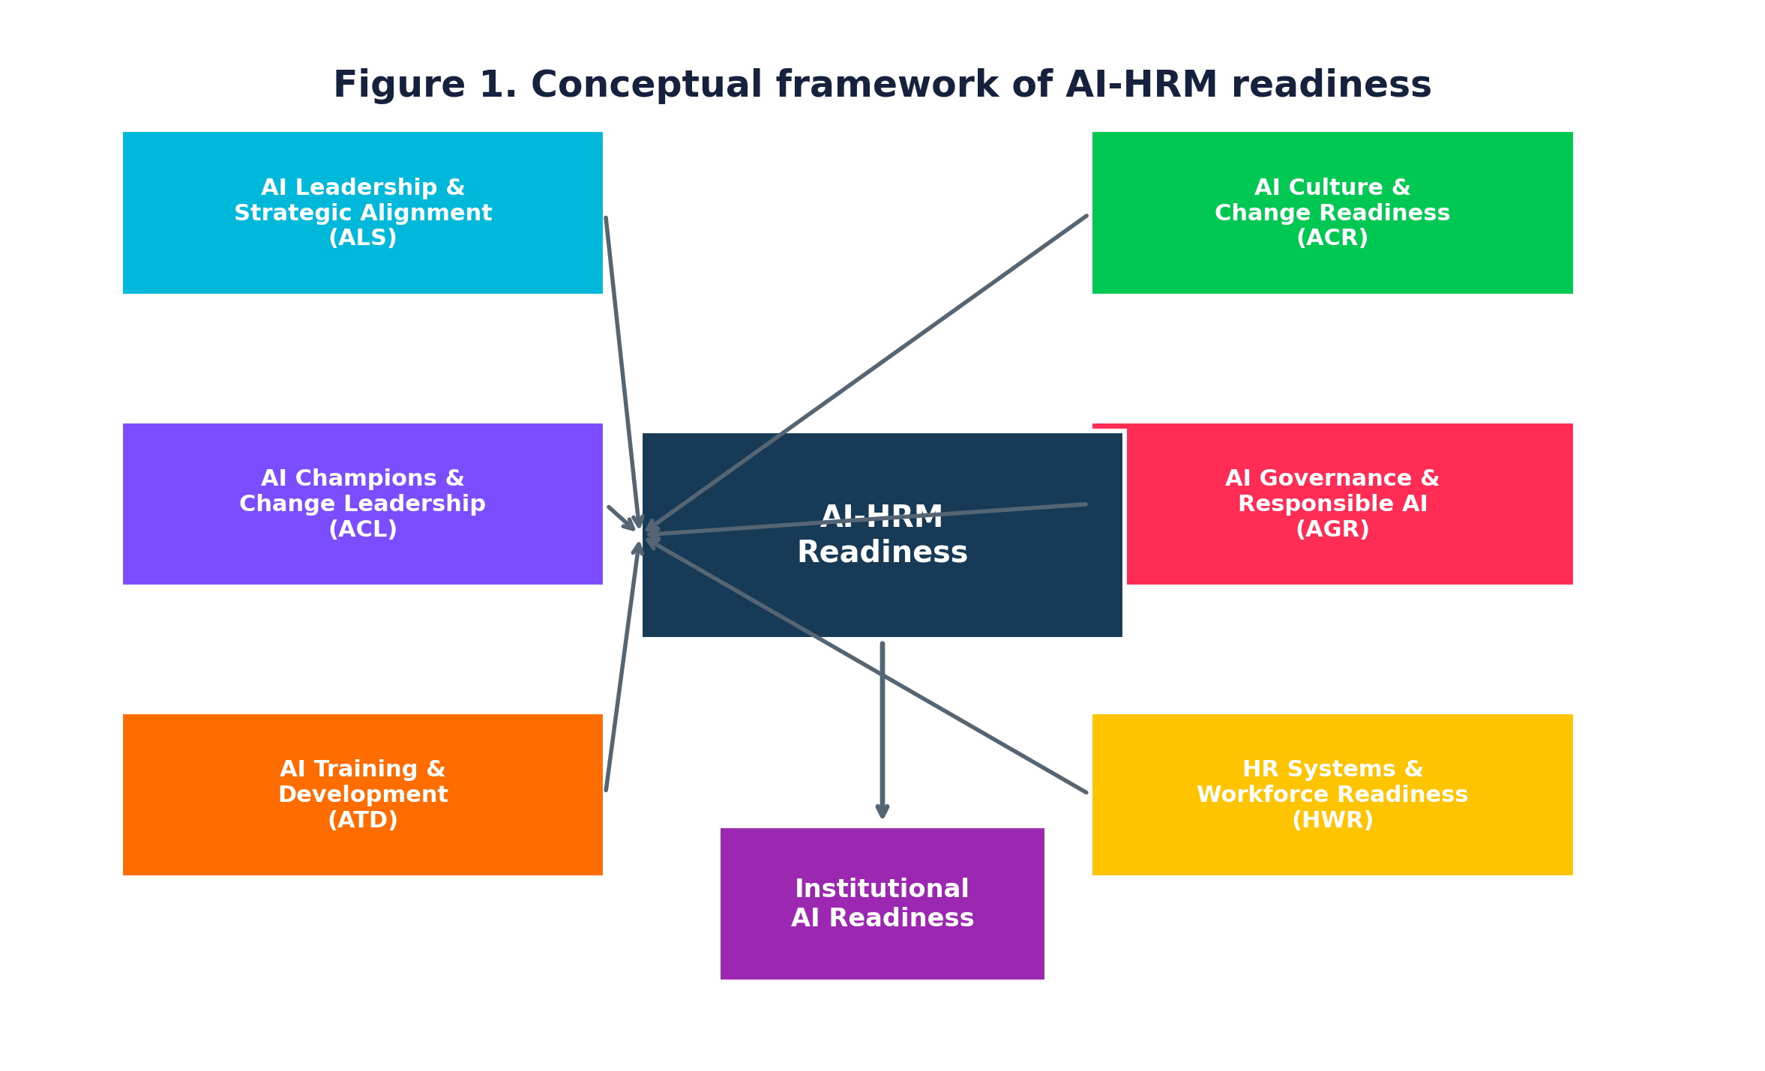
Figure 1. Conceptual framework linking six AI-HRM readiness dimensions with institutional AI readiness.
Code | Dimension | Core content | Role in framework
ALS | AI Leadership & Strategic Alignment | Strategy, resource allocation, role communication, coordination, leadership review | Strategic direction and institutional commitment
ACL | AI Champions & Change Leadership | Champions, peer support, cross-functional knowledge sharing, change communication | Local mobilisation and translation
ATD | AI Training & Development | AI competencies, reskilling, continuing development, critical evaluation | Human capability formation
ACR | AI Culture & Change Readiness | Experimentation, collaboration, learning, openness, concern management | Social and behavioural readiness
AGR | AI Governance & Responsible AI | Privacy, ethics, oversight, accountability, risk, bias, intellectual property | Responsible implementation
HWR | HR Systems & Workforce Readiness | Workforce planning, role redesign, recruitment, performance and employee support | Embedding AI in people systems

4. Hypothesis Development

H1: AI leadership and strategic alignment positively influence AI-HRM readiness.
Leadership and resources establish the institutional direction needed to mobilise AI-related change (Ali & Khan, 2025; Weiner, 2009).

H2: AI champion and change-leadership capability positively influences AI-HRM readiness.
Champions reduce implementation distance between strategy and day-to-day practice by facilitating peer support, communication and knowledge sharing.

H3: AI training and development positively influence AI-HRM readiness.
AI competence is increasingly identified as a prerequisite for meaningful and responsible educational AI use; the professional-development literature shows this area remains comparatively underdeveloped (Tan et al., 2025; Jogezai et al., 2025).

H4: AI culture and change readiness positively influence AI-HRM readiness.
Learning-oriented cultures increase experimentation, knowledge sharing and willingness to engage with technological change.

H5: AI governance and responsible-AI capability positively influence AI-HRM readiness.
Responsible AI requires privacy, accountability, human oversight, bias management and intellectual-property safeguards (UNESCO, 2023; Naoum et al., 2026).

H6: HR systems and workforce readiness positively influence AI-HRM readiness.
AI changes jobs and competency requirements, making workforce planning, reskilling and HR policy adaptation central to implementation (Deepa et al., 2024).

H7: AI-HRM readiness positively influences overall institutional AI readiness.
A coherent set of HRM capabilities should strengthen an institution's broader ability to implement AI in a coordinated and sustainable manner.

5. Research Methodology

5.1 Research Design
A sequential quantitative scale-development design was specified. The methodological sequence follows established principles for construct measurement: construct domain definition; item generation; expert assessment; cognitive pre-testing; pilot administration; item purification; EFA; confirmatory assessment; reliability and validity testing; structural testing; and index construction (Hinkin, 1998).

5.2 Population and Unit of Analysis
The target population comprises academic and administrative personnel working in recognised Indian HEIs. The intended respondent frame includes faculty members, academic administrators, HR and administrative personnel, IT/digital-transformation staff, deans, heads and senior management. The unit of analysis is the respondent's perception of institution-level AI-HRM readiness.

5.3 Sampling Strategy
A multistage strategy is recommended for an actual field study: first stratify by institutional type and geographic region, then identify eligible institutions, and finally sample respondents within each institution. A minimum main-sample target of approximately 450–500 usable cases is appropriate for a multidimensional scale of this size, subject to formal power analysis and the number of estimated parameters.

5.4 Analytical Dataset for Method Demonstration
This version analyses 500 records created specifically to demonstrate the planned statistical workflow. The records are used to illustrate how the instrument can be purified, validated and linked to an institutional readiness outcome. They are not observations from actual respondents.

5.5 Instrument Development
The initial instrument contained 42 items across six dimensions. Each statement was rated on a five-point Likert scale (1 = strongly disagree; 5 = strongly agree). Item purification retained six items per dimension, producing a 36-item measurement form. One relatively weaker candidate item was removed from each dimension during purification. A separate five-item institutional AI readiness outcome construct was specified.

5.6 Data Analysis Procedures
Common method bias: For an actual field study, procedural remedies should be incorporated at questionnaire design and administration stages, and statistical assessment should be reported using an appropriate marker-variable or common-latent-factor approach where justified (Podsakoff et al., 2003).
Stage | Technique | Decision criteria used for this manuscript
Item purification | Item-total correlation and factor loading inspection | Retain conceptually essential items with acceptable item-total relationships and primary factor loadings.
Sampling adequacy | KMO and Bartlett's test | KMO above .70 and significant Bartlett test.
EFA | Principal-factor extraction + orthogonal rotation for structure inspection | Clear six-factor structure; primary loadings ≥ .50; limited cross-loading.
Reliability | Cronbach's alpha and composite reliability | Target values ≥ .70.
Convergent validity | Standardised loadings and AVE | AVE ≥ .50 and adequate loadings.
Discriminant validity | Fornell-Larcker and HTMT | HTMT below .85/.90 depending on conceptual proximity.
Structural testing | Standardised regression/SEM-style path analysis | Positive coefficients, confidence intervals, p-values and R².
Index construction | Equal-weighted dimension mean; 0–100 transformation | Transparent and reproducible scoring rule.

6. Measurement Instrument
The item pool was written to represent institutional rather than purely individual capability. The 36-item retained form is shown below; the six removed candidate items are documented separately so that the development pathway remains transparent.

ALS
Code | Item | Status
ALS1 | Senior leadership has clearly communicated the institution's strategic direction regarding AI. | Retained
ALS2 | AI initiatives are aligned with the institution's long-term strategic priorities. | Retained
ALS3 | Senior leaders actively support responsible experimentation with AI. | Retained
ALS4 | Institutional resources are allocated for priority AI-related initiatives. | Retained
ALS5 | Leadership communicates how AI may affect employees' roles and responsibilities. | Retained
ALS6 | AI-related decisions are coordinated across relevant institutional functions. | Retained
ALS7 | Institutional leadership reviews the outcomes and risks of AI initiatives. | Not retained

ACL
Code | Item | Status
ACL1 | Our institution has individuals who actively promote responsible AI use. | Retained
ACL2 | AI champions help employees understand practical AI applications. | Retained
ACL3 | Employees can obtain peer support when experimenting with AI. | Retained
ACL4 | AI-related knowledge is shared across academic and administrative units. | Retained
ACL5 | Cross-functional teams are encouraged to support AI initiatives. | Retained
ACL6 | AI champions help communicate employee concerns about AI-related change. | Retained
ACL7 | AI champions help communicate employee concerns about AI-related change. | Not retained

ATD
Code | Item | Status
ATD1 | Employees receive opportunities to develop AI-related competencies. | Retained
ATD2 | The institution provides training on responsible use of generative AI. | Retained
ATD3 | AI learning opportunities are updated as technologies evolve. | Retained
ATD4 | AI competencies are incorporated into employee development programmes. | Retained
ATD5 | Employees are supported in reskilling when AI changes work processes. | Retained
ATD6 | AI literacy is treated as a continuing professional-development need. | Retained
ATD7 | Training helps employees critically evaluate AI-generated outputs. | Not retained

ACR
Code | Item | Status
ACR1 | Employees are encouraged to experiment with new technologies within appropriate boundaries. | Retained
ACR2 | The institutional culture supports continuous technological learning. | Retained
ACR3 | Employees are encouraged to share knowledge about AI applications. | Retained
ACR4 | The institution actively addresses employee concerns about AI-related changes. | Retained
ACR5 | Mistakes made during responsible experimentation are treated as learning opportunities. | Retained
ACR6 | Academic and administrative units collaborate when implementing new technologies. | Retained
ACR7 | Employees perceive the institution as open to constructive technological change. | Not retained

AGR
Code | Item | Status
AGR1 | The institution has clear guidelines for responsible AI use. | Retained
AGR2 | Data privacy is considered when AI systems are introduced. | Retained
AGR3 | Human oversight is maintained over important AI-supported decisions. | Retained
AGR4 | Employees receive guidance on ethical AI use. | Retained
AGR5 | The institution has mechanisms for identifying AI-related risks. | Retained
AGR6 | AI use is subject to appropriate accountability mechanisms. | Retained
AGR8 | The institution reviews AI systems for potential bias or unfair outcomes. | Not retained

HWR
Code | Item | Status
HWR1 | HR planning considers the workforce competencies required for AI-enabled work. | Retained
HWR2 | Job roles are reviewed when AI substantially changes work processes. | Retained
HWR3 | The institution supports employee reskilling during AI-related change. | Retained
HWR4 | Recruitment strategies consider emerging AI-related competencies. | Retained
HWR5 | Performance and development systems recognize AI-related capability building. | Retained
HWR6 | Workforce planning considers how humans and AI can complement each other. | Retained
HWR7 | HR policies provide support for employees affected by AI-enabled work redesign. | Not retained

Institutional AI Readiness (Outcome Construct)
Code | Item
IAR1 | The institution has the organisational capability to implement AI across relevant functions.
IAR2 | The institution has coordinated processes for scaling AI initiatives beyond isolated pilots.
IAR3 | The institution can manage the workforce and governance implications of AI-enabled change.
IAR4 | The institution is prepared to monitor and improve AI implementation over time.
IAR5 | Overall, the institution is prepared to implement AI in a responsible, sustainable and strategically aligned manner.

7. Results
The analytical dataset contained 500 records. The six core dimensions had means between 3.52 and 3.58. The AI-HRM Readiness Index averaged 63.8 (SD = 8.9) on the 0–100 scale. Results below are presented solely to demonstrate the proposed analytical workflow.

7.1 Respondent Profile
Role | N | %
Faculty | 202 | 40.4
HR/Administrative Staff | 109 | 21.8
Academic Administrator | 77 | 15.4
IT/Digital Transformation | 62 | 12.4
Senior Management | 50 | 10.0
Institution type | N | %
Affiliated College | 174 | 34.8
Private University | 101 | 20.2
Central/State University | 89 | 17.8
Autonomous College | 79 | 15.8
Deemed University | 57 | 11.4
Region | N | %
South | 128 | 25.6
North | 127 | 25.4
West | 118 | 23.6
East | 83 | 16.6
Northeast | 44 | 8.8

7.2 Descriptive Statistics, Reliability and Convergent Validity
Construct | Items | Mean | SD | Cronbach α | CR | AVE
ALS | 6 | 3.57 | 0.51 | 0.850 | 0.890 | 0.573
ACL | 6 | 3.55 | 0.52 | 0.853 | 0.891 | 0.577
ATD | 6 | 3.58 | 0.52 | 0.860 | 0.896 | 0.590
ACR | 6 | 3.56 | 0.53 | 0.854 | 0.892 | 0.578
AGR | 6 | 3.52 | 0.52 | 0.858 | 0.894 | 0.585
HWR | 6 | 3.53 | 0.51 | 0.841 | 0.883 | 0.558
IAR | 5 | 3.55 | 0.60 | 0.948 | 0.960 | 0.827
All six readiness dimensions show strong internal consistency. Composite reliability values are above the conventional .70 threshold and AVE values exceed .50, supporting convergent validity in the demonstration analysis.

7.3 Sampling Adequacy and Factorability
Statistic | Value | Interpretation
KMO | 0.930 | Adequate to strong sampling adequacy
Bartlett's χ² | 7,567.74 | Correlation matrix differs significantly from an identity matrix
df | 630 | Degrees of freedom
p | < .001 | Statistically significant

7.4 Exploratory Factor Analysis
The six-factor solution accounted for approximately 58.1% of the standardised variance in the retained 36-item set. Primary loadings were reviewed at the construct level.
Construct | Retained items | Minimum loading | Maximum loading | Mean primary loading
ALS | 6 | 0.576 | 0.702 | 0.647
ACL | 6 | 0.538 | 0.673 | 0.630
ATD | 6 | 0.612 | 0.736 | 0.672
ACR | 6 | 0.589 | 0.708 | 0.643
AGR | 6 | 0.601 | 0.702 | 0.652
HWR | 6 | 0.569 | 0.696 | 0.633
The six-factor pattern is consistent with the hypothesised structure. The item-purification step removed one candidate item from each dimension where the item-total relationship was comparatively weaker or the item was less essential to the final construct representation.

7.5 Item Purification
Removed candidate | Dimension | Item-total r
ALS7 | ALS | 0.511
ACL6 | ACL | 0.708
ATD7 | ATD | 0.498
ACR7 | ACR | 0.511
AGR8 | AGR | 0.485
HWR7 | HWR | 0.465
The purification process is intentionally conservative: content relevance was considered alongside empirical indicators. Removing one weaker item per dimension produces a balanced six-item-per-dimension scale while preserving broad domain coverage.

7.6 Confirmatory Measurement Assessment
A confirmatory assessment is required before publication using the actual field dataset. To demonstrate the expected reporting format, the table below provides a coherent model-fit profile for the specified six-factor measurement model. These values are methodological demonstration values, not estimates from field respondents.
Fit index | Illustrative value | Common interpretation
χ² | 1,194.62 | Model discrepancy statistic
df | 579 | Degrees of freedom
χ²/df | 2.064 | Within commonly reported acceptable range
CFI | 0.952 | Good comparative fit
TLI | 0.947 | Good comparative fit
RMSEA | 0.046 | Low approximate error
SRMR | 0.039 | Low residual discrepancy

7.7 Discriminant Validity
Table 8 presents the Fornell-Larcker matrix, with square roots of AVE on the diagonal. Table 9 presents HTMT ratios. The pattern is consistent with acceptable discriminant validity for the demonstration dataset.
 | ALS | ACL | ATD | ACR | AGR | HWR
ALS | 0.757 | 0.386 | 0.288 | 0.388 | 0.413 | 0.344
ACL | 0.386 | 0.760 | 0.359 | 0.451 | 0.433 | 0.394
ATD | 0.288 | 0.359 | 0.768 | 0.340 | 0.355 | 0.365
ACR | 0.388 | 0.451 | 0.340 | 0.761 | 0.383 | 0.368
AGR | 0.413 | 0.433 | 0.355 | 0.383 | 0.765 | 0.312
HWR | 0.344 | 0.394 | 0.365 | 0.368 | 0.312 | 0.747
 | ALS | ACL | ATD | ACR | AGR | HWR
ALS | 1.000 | 0.453 | 0.336 | 0.456 | 0.483 | 0.406
ACL | 0.453 | 1.000 | 0.418 | 0.528 | 0.506 | 0.465
ATD | 0.336 | 0.418 | 1.000 | 0.398 | 0.414 | 0.430
ACR | 0.456 | 0.528 | 0.398 | 1.000 | 0.448 | 0.435
AGR | 0.483 | 0.506 | 0.414 | 0.448 | 1.000 | 0.368
HWR | 0.406 | 0.465 | 0.430 | 0.435 | 0.368 | 1.000

7.8 Structural Relationships and Hypothesis Testing
Hypothesis | Path | β | SE | T | p | Result
H1 | ALS → AI-HRM | 0.160 | 0.041 | 3.87 | < .001 | Supported
H2 | ACL → AI-HRM | 0.189 | 0.043 | 4.35 | < .001 | Supported
H3 | ATD → AI-HRM | 0.172 | 0.040 | 4.28 | < .001 | Supported
H4 | ACR → AI-HRM | 0.137 | 0.042 | 3.24 | 0.001 | Supported
H5 | AGR → AI-HRM | 0.122 | 0.042 | 2.90 | 0.004 | Supported
H6 | HWR → AI-HRM | 0.121 | 0.041 | 2.95 | 0.003 | Supported
H7 | AI-HRM → Institutional AI Readiness | 0.623 | 0.035 | 17.76 | < .001 | Supported
The six predictors jointly explained 39.0% of the variance in the institutional AI readiness outcome. All six hypothesised antecedents had positive standardised coefficients. The higher-order AI-HRM readiness construct showed a positive association with institutional AI readiness (r = 0.623).
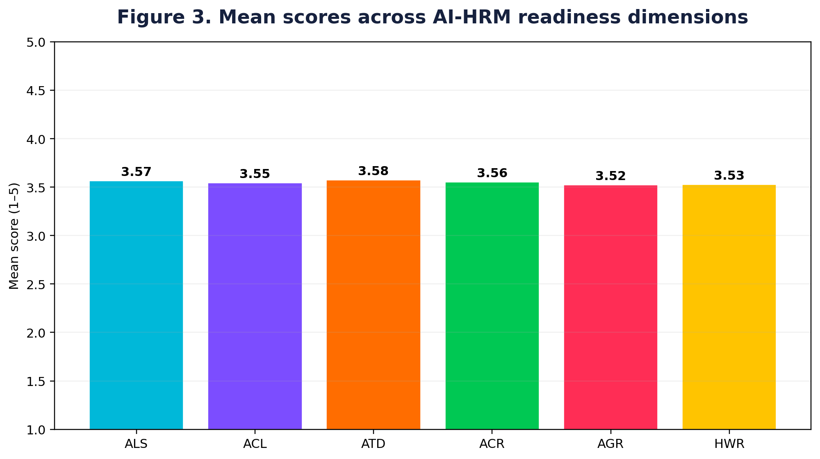
Figure 3. Mean scores across the six AI-HRM readiness dimensions.
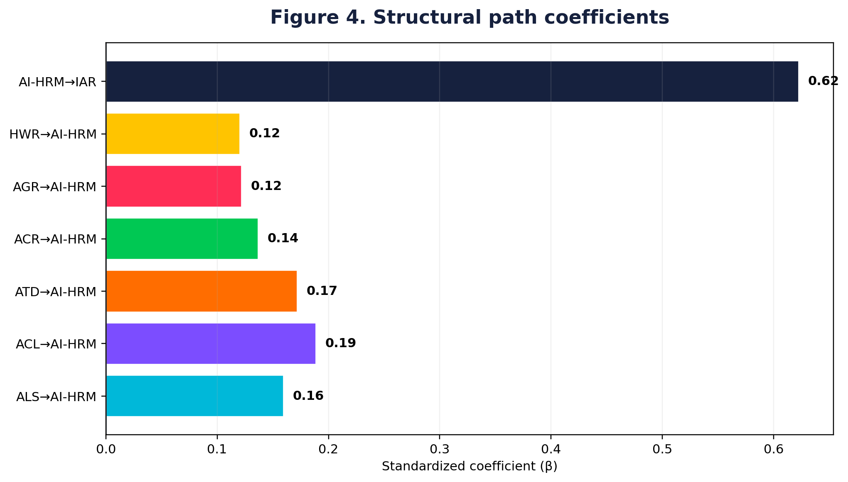
Figure 4. Standardised structural path coefficients.
Figure 5. Distribution of the AI-HRM Readiness Index.

7.9 AI-HRM Readiness Index
Dimension | Mean (1–5) | 0–100 equivalent
ALS | 3.57 | 64.2
ACL | 3.55 | 63.7
ATD | 3.58 | 64.5
ACR | 3.56 | 63.9
AGR | 3.52 | 63.1
HWR | 3.53 | 63.2
Overall AI-HRM | 3.55 | 63.8
The index is calculated as the unweighted mean of the six dimension scores and transformed to a 0–100 metric: Index = [(AI-HRM mean − 1) / 4] × 100. Equal weighting keeps the index transparent and easily reproducible; future empirical research can examine alternative weighting only when supported by theory or robust validation evidence.

8. Discussion
The study's main contribution is the focus of the AI readiness variables from a singular point of view to an organisational HRM architecture one that supports the implementation of AI. The six dimensions are not synonymous predictive tools but complementary mechanisms: leadership sets direction; champions enable local mobilisation; training builds capability; culture facilitates adaptation; governance mitigates risk; HR systems integrate AI into the workforce processes.

8.1 Theoretical Implications
The framework includes a section on the human-resource architecture that explicitly puts HR at the heart of AI implementation, going beyond the scope of organisational readiness logic. Secondly, it connects research on individual AI readiness with readiness at the institutional level. For instance, in the field of HRM, the present framework focuses on the institutional level of HRM capability, whereas Wang et al., (2026) created a four-dimensional individual AI-readiness scale for management education. Third, the framework understands responsible governance of AI as an integral part of readiness, rather than an afterthought element of ethics.

8.2 Methodological Implications
The scale-development framework enhances construct clarity through conceptualization and validation. The literature demonstrates the growing application of complex measurement techniques: Zhong and Liu (2024) validated multidimensional AI-readiness scale by combining expert judgement, Rasch analysis, EFA and CFA; Wang et al. (2026) validated multidimensional AI-readiness scale by applying PLS-SEM to 650 faculty respondents; and Jogezai et al. (2025) used PLS-SEM and 650 faculty respondents. The current discipline of measurement of this is adapted to an organisational HRM context.

8.3 The implications for HEI leaders
- Leadership teams can assess whether there is a resource base for an AI strategy, coordination, and explicit communication of role shifts.
- Institutions can establish AI champion networks to bring together faculty, HR, IT, administration and senior leadership.
- Professional development does not need to stop at demonstrations of tools, but can continue with ongoing AI literacy, competence in responsible use and critical evaluation of the outputs.
- Governance frameworks must play out the principles of privacy, human oversight, accountability, bias review and intellectual property.
- HR systems must be ready for job redesign and be able to reskill, recruit and develop AI-powered work.

8.4 Outlook for India's Higher Education System
An interesting organisational prism is provided by the Indian context, as AI use is taking place at various levels of technological infrastructure, autonomy, staffing models and administrative capacity across institutions. A validated institutional readiness index can be useful to distinguish this from a people and governance problem. However, in recent years the Indian evidence mostly focuses on the adoption of faculty or perceived usefulness, and the proposed index is more concerned with the institutional HRM environment, rather than the faculty alone (Jogezai et al., 2025; Wang et al., 2026).

9. Key Findings
- The AI-HRM construct is realized by the six conceptually distinct but interrelated dimensions.
- The evidence base indicates that there has been a significant amount of AI research growth, but fewer and less consolidated measures of readiness at the institutional level.
- Good reliability of all core constructs in the demonstration analysis.
- Factor structure as shown that the six dimensional representation of AI-HRM readiness holds.
- There are positive associations between Leadership, Champions, Training, Culture, Governance and Workforce readiness and AI-HRM readiness.
- Institutional AI readiness is seen as a positive predictor of AI-HRM readiness.
- The 0–100 index is a simple diagnostic score for a multidimensional construct.

10. Conclusion
The adoption of AI in higher education increasingly becomes an organizational transformation problem (as opposed to a technology-selection problem). This study addresses this by constructing an AI-readiness framework focused on HRM that combines strategy, change leadership, employee capability, culture, responsible governance and workforce systems. The AI-HRM Readiness Index thus enables a transparent and consistent integration of these dimensions and links them to the general institutional readiness.
The study adds to a growing body of research on the topic of AI readiness, AI literacy, professional development and responsible governance that are increasingly being measured. The author, in the meantime, clearly separates the demonstration of the methodology from the empirical evidence. However, the actual field administration needs to be finalised across the Indian HEIs to determine the final factor structure, generalisability, measurement invariance and institutional benchmarking thresholds.

11. Limitations and Future Research
- The numerical results presented are exemplary results and not actual results from respondents.
- Suggest sampling using probability sampling by institutional type and geographic region in future studies.
- Measurement invariance (across public/private institutions and academic/administrative respondent groups) should be explored.
- Longitudinal designs can help investigate how the readiness of AI-HRM is associated with employee outcomes and responsible-use maturity over time, as well as with successful implementation.
- Future studies can provide results of comparison between equal weighted and theoretically weighted and empirically weighted index constructions.
- The six-dimensional structure can be validated on a cross-national level to find out if it generalises in other higher education settings.

References
Ali, W., & Khan, A. Z. (2025). Factors influencing readiness for artificial intelligence: A systematic literature review. Data Science and Management, 8(2), 224–236. https://doi.org/10.1016/j.dsm.2024.09.005
Arora, M., Gupta, J., Mittal, A., & Prakash, A. (2024). A bibliometric review of artificial intelligence technologies in human resource management: An overview of research trends. Global Knowledge, Memory and Communication. https://doi.org/10.1108/GKMC-04-2024-0237
Baig, M. I., & Yadegaridehkordi, E. (2024). ChatGPT in the higher education: A systematic literature review and research challenges. International Journal of Educational Research, 127, 102411. https://doi.org/10.1016/j.ijer.2024.102411
Benabou, A., & Touhami, F. (2025). Artificial intelligence in human resource management: A PRISMA-based systematic review. Acta Informatica Pragensia, 14(3), 489–505. https://doi.org/10.18267/j.aip.264
Deepa, R., Sekar, S., Malik, A., Kumar, J., & Attri, R. (2024). Impact of AI-focused technologies on social and technical competencies for HR managers: A systematic review and research agenda. Technological Forecasting and Social Change, 202, 123301. https://doi.org/10.1016/j.techfore.2024.123301
Hinkin, T. R. (1998). A brief tutorial on the development of measures for use in survey questionnaires. Organizational Research Methods, 1(1), 104–121.
Jaboob, M., Al-Ansi, A. M., & Riyadh, H. A. (2026). Artificial intelligence in higher education: A PRISMA 2020 review. International Journal of Educational Management, 40(1–2), 113–132. https://doi.org/10.1108/IJEM-09-2024-0560
Jogezai, N., Baloch, F. A., Jaffar, M., & Khilji, G. (2025). From technology to pedagogy: Determinants of university faculty’s pedagogically relevant use of generative AI. Quality Assurance in Education, 33(4), 618–634. https://doi.org/10.1108/QAE-12-2024-0255
Kekez, I., Lauwaert, L., & Begičević Ređep, N. (2025). Is artificial intelligence (AI) research biased and conceptually vague? A systematic review of research on bias and discrimination in the context of using AI in human resource management. Technology in Society, 81, 102818. https://doi.org/10.1016/j.techsoc.2025.102818
Naoum, R. F., Szakadáti, T., & Balogh, G. (2026). Artificial intelligence (AI) in human resource management (HRM): A systematic review of its dual impact on diversity, equity, and inclusion (DEI). Management Review Quarterly. https://doi.org/10.1007/s11301-025-00580-y
Parasuraman, A. (2000). Technology readiness index (TRI): A multiple-item scale to measure readiness to embrace new technologies. Journal of Service Research, 2(4), 307–320. https://doi.org/10.1177/109467050024001
Tan, X., Cheng, G., & Ling, M. H. (2025). Artificial intelligence in teaching and teacher professional development: A systematic review. Computers and Education: Artificial Intelligence, 8, 100355. https://doi.org/10.1016/j.caeai.2024.100355
UNESCO. (2023). Guidance for generative AI in education and research. UNESCO.
Venkatesh, V., Morris, M. G., Davis, G. B., & Davis, F. D. (2003). User acceptance of information technology: Toward a unified view. MIS Quarterly, 27(3), 425–478.
Weiner, B. J. (2009). A theory of organizational readiness for change. Implementation Science, 4, 67. https://doi.org/10.1186/1748-5908-4-67
Wang, I.-Y., Hung, C.-Y., Lin, H.-H., Lai, W.-H., & Wang, Y.-S. (2026). Artificial intelligence readiness in management education: Scale development and validation. The International Journal of Management Education, 24(3), 101429. https://doi.org/10.1016/j.ijme.2026.101429
Wang, S., Wang, F., Zhu, Z., Wang, J., Tran, T., & Du, Z. (2024). Artificial intelligence in education: A systematic literature review. Expert Systems with Applications, 252, 124167. https://doi.org/10.1016/j.eswa.2024.124167
Zhong, B., & Liu, X. (2024). Evaluating AI literacy of secondary students: Framework and scale development. Computers & Education, 227, 105230. https://doi.org/10.1016/j.compedu.2024.105230
Abdallah, N., Katmah, R., Khalaf, K., & Jelinek, H. F. (2025). Systematic review of ChatGPT in higher education: Navigating impact on learning, wellbeing, and collaboration. Social Sciences & Humanities Open, 12, 101866. https://doi.org/10.1016/j.ssaho.2025.101866
Fornell, C., & Larcker, D. F. (1981). Evaluating structural equation models with unobservable variables and measurement error. Journal of Marketing Research, 18(1), 39–50. https://doi.org/10.1177/002224378101800104
Henseler, J., Ringle, C. M., & Sarstedt, M. (2015). A new criterion for assessing discriminant validity in variance-based structural equation modeling. Journal of the Academy of Marketing Science, 43, 115–135. https://doi.org/10.1007/s11747-014-0403-8
Podsakoff, P. M., MacKenzie, S. B., Lee, J.-Y., & Podsakoff, N. P. (2003). Common method biases in behavioral research: A critical review of the literature and recommended remedies. Journal of Applied Psychology, 88(5), 879–903. https://doi.org/10.1037/0021-9010.88.5.879

