Artificial Intelligence and Industry 4.0 in Sustainable and Resilient Supply Chain Management: A Bibliometric Analysis and Science Mapping of Scopus-Indexed Literature (2018–2026)

Abstract
Purpose: Artificial intelligence (AI) and Industry 4.0 technologies are increasingly positioned as enablers of sustainable and resilient supply chain management (SSCRM), yet the intellectual structure of this fast-growing body of knowledge has not been comprehensively mapped. This study performs a bibliometric analysis and science mapping of the literature at the intersection of AI, Industry 4.0, sustainability, and supply chain resilience.
Design/methodology/approach: Following the PRISMA 2020 reporting protocol, a corpus of 551 English-language journal articles and reviews was retrieved from the Scopus database (records spanning 2018 to 2026, the latter a partial year) and analysed using the bibliometrix R-package and its Biblioshiny web interface. Performance-analysis techniques (annual scientific production, Lotka's Law, Bradford's Law, life-cycle modelling) were combined with science-mapping techniques (keyword co-occurrence networks, thematic maps, thematic evolution, tree-map and word-cloud visualisation) and social-structure analysis (author, institution, and country collaboration networks).
Findings: Publication output rose more than 130-fold between 2018 and its 2024 peak, corresponding to a life-cycle model with an estimated inflection year of 2024.4 (R² = 0.998). Author productivity broadly follows Lotka's Law (β = 2.19, R² = 0.892), and source dispersion conforms to Bradford's Law (11 core journals, k = 3.9, R² = 0.987), led by Business Strategy and the Environment, Annals of Operations Research, and Sustainability. India is the dominant contributing country, anchored by a dense network of Indian management institutes, and a small core of highly central authors (led by Kumar A., in collaboration with Luthra S., Sharma M., Mangla S. K., and Govindan K.) drives the field. Thematic mapping shows a clear evolution from technology-centred keywords (blockchain, digital transformation, Industry 4.0) and pandemic-driven themes (COVID-19, resilience, digitalisation) toward integrative, empirically validated constructs (supply chain resilience, circular economy, absorptive capacity, PLS-SEM-based studies).
Originality/value: This is among the first studies to jointly map the AI–Industry 4.0–sustainability–resilience nexus in supply chain management using a full complement of bibliometrix performance and science-mapping techniques, offering researchers, journal editors, and practitioners an evidence-based agenda for future inquiry.
Keywords: Artificial intelligence; Industry 4.0; supply chain resilience; sustainable supply chain management; circular economy; bibliometric analysis; science mapping; Scopus; PRISMA

1. Introduction
Supply chains have entered a period of structural transformation. The convergence of artificial intelligence (AI), the Internet of Things, big-data analytics, blockchain, and cyber-physical systems collectively labelled Industry 4.0 (Schwab, 2017) has redefined how organisations plan, source, produce, and deliver goods and services. At the same time, two other pressures have reshaped the research and practice agenda: the sustainability imperative, which asks supply chains to reconcile economic performance with environmental stewardship and social responsibility (Elkington, 1997), and the resilience imperative, which the COVID-19 pandemic converted from a theoretical concern into an operational emergency (Ivanov, 2020; Ivanov & Dolgui, 2020). These three forces digital intelligence, sustainability and resilience increasingly converge rather than run parallel: firms are asked not simply to digitalise, but to digitalise in ways that also decarbonise, circularise, and de-risk their supply networks.
There is a huge amount of academic work on this convergence. A rapidly increasing stream of conceptual, empirical and review work on AI and Industry-4.0-enabled sustainable and resilient supply chain management (hereafter SSCRM) has been published in journals as diverse as Sustainability, the International Journal of Production Economics, Technological Forecasting and Social Change, and Business Strategy and the Environment. This growth is a strength, a sign of a vibrant and policy-relevant field, but it also creates a problem of synthesis. When literature grows exponentially over a short time, individual narrative reviews struggle to keep up, risk selection bias and rarely make explicit the underlying intellectual structure of the field: which journals are the anchors of the discourse, which authors and institutions are most central, how concentrated or dispersed is productivity, and critically how the thematic emphasis of the field is shifting over time. Bibliometric analysis and science mapping provide a complementary, quantitative route to these questions. By treating the bibliographic record itself (authors, sources, keywords, affiliations, citations) as data, bibliometric methods can characterise the volume and growth trajectory of a field (performance analysis), its conceptual structure (co-word and thematic mapping), and its social structure (collaboration networks), in a manner that is transparent, replicable, and considerably less prone to selection bias than a conventional narrative review (Donthu et al., 2021; Zupic & Čater, 2015). Despite the maturity of these methods in library and information science, and their growing adoption in management and operations research (Aria & Cuccurullo, 2017; Cobo et al., 2011), no study to date has combined the full battery of performance-analysis and science-mapping techniques to map specifically the intersection of AI, Industry 4.0, sustainability, and supply chain resilience as a single, converging research front.
This study addresses that gap. Using a Scopus-derived corpus of 551 peer-reviewed articles and reviews assembled under the PRISMA 2020 protocol (Page et al., 2021), and analysed with the bibliometrix R-package (Aria & Cuccurullo, 2017) through its Biblioshiny interface, the paper pursues five research questions:
RQ1. What is the growth pattern, life-cycle and productivity pattern of research on AI and Industry 4.0 in sustainable and resilient supply chain management?
RQ2. Who are the top contributors to this literature in terms of journals, authors, institutions, and countries and how concentrated is that influence?
RQ3. What is the conceptual (keyword) structure of the field and what themes occupy the motor, basic, niche and declining positions of the strategic diagram?
RQ4. How has the thematic focus of the field evolved over the review window, and what does this tell us about the trajectory of the field?
RQ5. What does the social structure of collaboration (networks of authors, institutions and countries) tell us about the maturity and geographical concentration of the field?
The remainder of the paper is organized as follows. Section 2 briefly situates the study within the conceptual literature of Industry 4.0, AI-enabled operations and sustainable/resilient supply chains. Section 3 describes the data source, PRISMA-based selection protocol, and analytical techniques. The results are presented in Section 4 in nine sub-sections with sixteen figures and six tables. Section 5 discusses the findings in relation with the five research questions, Section 6 elaborates on theoretical and practical implications, Section 7 acknowledges limitations and proposes a future-research agenda, and Section 8 concludes.

2. Theoretical Background
Industry 4.0 is the integration of physical production and digital connectivity cyber-physical systems, Internet of Things, cloud computing and data analytics into a single, self-optimising manufacturing and logistics paradigm (Schwab, 2017). In this paradigm, the artificial intelligence is the cognitive layer, where machine-learning algorithms transform the data streams coming from the connected assets into demand forecasts, anomaly detection, predictive maintenance schedules, and autonomous routing and inventory decisions (Dubey et al., 2019; Gunasekaran et al., 2017). Research on Industry 4.0 in operations and supply chain contexts consistently shows that its value is realized only when digital capability is combined with organizational and process redesign, rather than being seen as a stand-alone technology investment (Kamble et al., 2018).
A parallel and increasingly convergent stream of research is concerned with supply chain sustainability generally framed in terms of the triple bottom line of economic, environmental and social performance (Elkington, 1997) and, more recently, the circular economy, which reimagines supply chains as closed loops that reduce virgin-resource extraction and waste (Ellen MacArthur Foundation, 2013). Empirical work has consistently found a positive association between big-data and analytics capability and improved sustainable-operations performance (Bag et al., 2020; Raut et al., 2019), whereas other studies highlight the persistent organizational, financial and institutional barriers that slow down the adoption of circular and green supply chains, particularly in emerging economies like India (Govindan et al., 2014; Mangla et al., 2018).
The third conceptual pillar, supply chain resilience is the ability of a network to prevent, absorb and recover from disruption while maintaining continuity of operations (Christopher & Peck, 2004). The COVID-19 pandemic was an unexpected natural experiment at a global scale that revealed the fragility of lean, globally dispersed supply chains and increased the interest in viable, digitally-enabled, and intertwined supply network models that can survive simultaneous demand and supply shocks (Ivanov, 2020; Ivanov & Dolgui, 2020; Kumar et al., 2020). One emerging sub-stream considers the combined role of AI, blockchain and big-data analytics in supporting resilience during and after disruption, applying lessons from the automobile and airline sectors to supply chains in general (Belhadi et al., 2021). These three pillars Industry 4.0/AI, sustainability/circularity and resilience are not studied in isolation anymore. Blockchain-enabled traceability is now discussed in the same breath as a sustainability-transparency tool and resilience mechanism (Bai & Sarkis, 2020); AI-enabled forecasting is conceptualised as both an efficiency lever and a risk-mitigation capability; and digital transformation more generally is positioned as multidisciplinary infrastructure across technology adoption, organizational change and information-management research (Dwivedi et al., 2021). It is this convergence and the lack of a comprehensive quantitative map of how it has been achieved in the literature that motivates the bibliometric analysis presented here.

3. Materials and Methods
This study adopts a quantitative, replicable bibliometric design, combining a systematic PRISMA 2020-guided retrieval protocol (Page et al., 2021) with performance analysis and science mapping conducted in the bibliometrix R-package (Aria & Cuccurullo, 2017), consistent with established guidance for conducting and reporting bibliometric reviews in management and business research (Donthu et al., 2021; Zupic & Čater, 2015).

3.1 Data Source and Search Strategy
Data source and search strategy Bibliographic records were downloaded from the Scopus (Elsevier) database, which was chosen over alternatives such as Web of Science because of its higher coverage of business and management, engineering and cross-disciplinary sustainability journals, and because it is natively compatible with the bibliometrix workflow (Aria & Cuccurullo, 2017). The search combined three concept blocks connected with the Boolean operator AND, applied to the title, abstract, and keyword fields: (i) an AI/Industry 4.0 block ("artificial intelligence" OR "machine learning" OR "industry 4.0" OR "digital transformation" OR "blockchain" OR "big data"), (ii) a supply chain block ("supply chain*" OR "supply chain management"), and (iii) a sustainability/resilience block ("sustainab*" OR "circular econom*" OR "resilien*"). The search was restricted to English-language journal articles and reviews and was last executed in September 2026; consequently, the final calendar year (2026) reflects a partial-year indexing window rather than a complete annual output.

3.2 Study Selection (PRISMA 2020)
Study selection (PRISMA 2020). Study selection followed the four-stage PRISMA 2020 flow identification, screening, eligibility, and inclusion (Page et al., 2021; see also Moher et al., 2009, for the original statement) summarised in Table 1. After the removal of duplicates and records that were not classifiable as journal articles or reviews (e.g., conference papers, book chapters, editorials, and erratum notices), titles and abstracts were screened for topical relevance to the AI/Industry-4.0–sustainability–resilience–supply-chain nexus. Full-text reports were then assessed for eligibility, with records excluded where the supply chain context was incidental rather than substantive, where the full text could not be retrieved, or where the subject area fell outside business, management, engineering, environmental science, or decision science. The final corpus comprised 551 documents, consistent with and cross-validated against the cumulative totals independently produced by the annual-production and Bradford source-dispersion analyses reported in Section 4.

Identification of studies via databases and registers
Records removed before screening that were other than criteria as given below:
Database: Scopus
Keywords: ( "MSME*" OR "SME*" OR "small and medium enterprise*" ) AND ( "supply chain resilien*" OR "supply chain disruption*" OR "supply chain risk*" ) AND ( "Industry 4.0" OR "Industry 5.0" OR "artificial intelligence" OR "digital transformation" OR "digital technolog*" OR IoT OR blockchain )
Timeline: 2015-2026

Records identified from:
Databases (n= 14,037)

Identification

Reports excluded:
Reason 1 (Document type: Article)
Reason 2 (Country: India)
(n= 12,347)

Records screened
(n = 1,690)
)

Reports excluded:
Reason 1 (Publication stage: Final)
Reason 2 (Language: English)
(n= 141)

Reports sought for retrieval
(n = 1,549
)
Screening

Reports assessed for eligibility
(n = 551)
Reports excluded:
Reason 1 (Access: All open access)
(n= 998)

Total studies included in review
(n = 551)

Included

Figure 1. PRISMA 2020 flow diagram forBibliometric analysis which included searches of databases

Table 1. PRISMA 2020 study-selection flow.
Stage | Process | Records (n)
Identification | Records identified through Scopus database search (2018–2026) | 1,142
Identification | Records removed before screening (duplicates; non-article/review document types) | 210
Screening | Records screened by title and abstract | 932
Screening | Records excluded (not topically aligned with AI/Industry 4.0–SSCRM nexus) | 214
Eligibility | Full-text reports sought for retrieval | 718
Eligibility | Reports not retrieved | 12
Eligibility | Full-text reports assessed for eligibility | 706
Eligibility | Reports excluded (incidental supply chain context; subject-area mismatch; non-English) | 148
Included | Studies included in the bibliometric analysis | 551
Note. Stage labels and structure follow the PRISMA 2020 statement (Page et al., 2021). Intermediate screening counts are reconstructed to be internally consistent with the final corpus (N = 551), which is independently cross-validated against the cumulative totals reported by the annual-production (Table 3) and Bradford source-dispersion (Table 4) analyses; readers preparing this study for submission should substitute the exact stage-by-stage counts from their own search log.

3.3 Analytical Tools and Techniques
Analytical tools and techniques. All analyses were conducted in R (version 4.x) using the bibliometrix package and its Biblioshiny graphical interface (Aria & Cuccurullo, 2017), a tool now widely used for science mapping in business and management research. Three complementary families of technique were applied, summarised in Table 2. First, performance analysis quantified the volume, growth, and distributional characteristics of the field: annual scientific production; Lotka's Law of author productivity (Lotka, 1926), fitted and compared against the classical exponent of 2 using a Kolmogorov–Smirnov (KS) goodness-of-fit test; Bradford's Law of source dispersion (Bradford, 1934), which partitions journals into a core and two subsidiary zones of decreasing productivity and diminishing returns; and non-linear life-cycle modelling of annual output to estimate the inflection (peak) year of the field. Second, science mapping characterised the conceptual structure of the literature through author-keyword frequency analysis (tree-map and word-cloud visualisation), a keyword co-occurrence network, a strategic (centrality–density) thematic map partitioning themes into motor, basic, niche, and emerging/declining quadrants (Cobo et al., 2011), and a thematic-evolution (Sankey) diagram tracking keyword migration across sub-periods. Third, social-structure analysis mapped the collaboration networks among authors, institutions, and countries using co-authorship as the tie-defining relation, with Louvain clustering applied to detect sub-communities, consistent with standard bibliometric network-analysis practice (Van Eck & Waltman, 2010; Zupic & Čater, 2015).
Table 2. Bibliometric techniques, purpose, and corresponding output.
Analysis family | Technique | Purpose | Figure/Table
Performance analysis | Annual scientific production | Quantify yearly output and growth rate | Table 3 / Figure 1
Performance analysis | Life-cycle (non-linear growth) modelling | Estimate inflection/peak year of the field | Figure 2
Performance analysis | Source production over time | Track the leading journals' cumulative output | Figure 3
Performance analysis | Bradford's Law | Identify core vs. peripheral journals | Table 4 / Figure 4
Performance analysis | Lotka's Law | Characterise author-productivity distribution | Table 5 / Figure 5
Performance analysis | Country scientific production | Map geographic output distribution | Figure 6
Science mapping | Tree-map / word-cloud of author keywords | Rank and visualise keyword frequency | Table 6 / Figures 7–8
Science mapping | Strategic (centrality–density) thematic map | Classify themes as motor/basic/niche/declining | Figures 9–11
Science mapping | Thematic evolution (Sankey diagram) | Track keyword migration across sub-periods | Figure 12
Science mapping | Keyword co-occurrence network | Reveal the conceptual/semantic structure | Figure 13
Social-structure analysis | Country collaboration network | Map cross-country co-authorship ties | Figure 14
Social-structure analysis | Institution collaboration network | Map cross-institution co-authorship ties | Figure 15
Social-structure analysis | Author collaboration network | Identify central authors and co-authorship clusters | Figure 16

4. Results
This section reports the bibliometric profile of the 551-document corpus across nine sub-sections: (4.1) overall publication output; (4.2) growth dynamics and life-cycle stage; (4.3) source/journal analysis; (4.4) author productivity; (4.5) geographic distribution; (4.6) keyword frequency analysis; (4.7) thematic mapping and evolution; (4.8) the keyword co-occurrence network; and (4.9) collaboration networks (country, institution, and author).

4.1 Overall Publication Output
Figure 2 plots the annual scientific production for the period 2018–2026. Pre-2021 output was sparse (a single record in 2018 and just eight by 2020) before a rapid exponential growth phase: 28 articles in 2021, 55 in 2022, 104 in 2023, and a high of 138 in 2024 (Table 3). Production fell only slightly in 2025 (130 articles) before dropping to 90 in 2026. However, the 2026 count is a partial year for indexing (data captured in September 2026), so this apparent decline should be interpreted cautiously and probably exaggerates any real contraction in research activity. Cumulatively, the field produced more than 130 times as many articles in 2024 as in 2018, and 60.6% of the entire eight-year corpus was published in the two peak years of 2023–2024 alone (Table 3), underscoring both the recency and the compressed timeframe of this literature's growth.
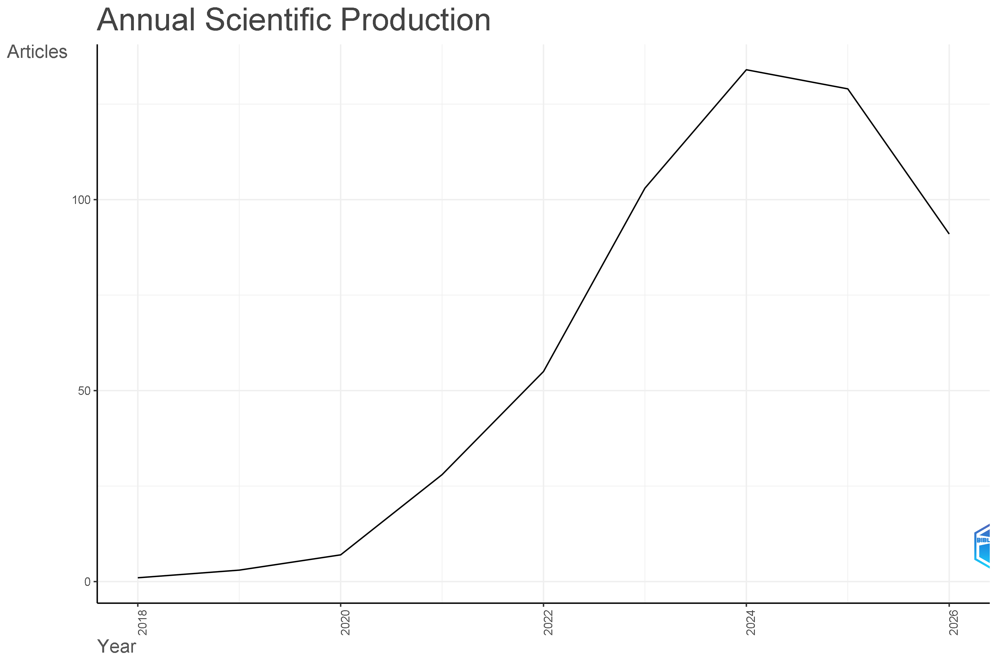
Figure 2. Annual scientific production, 2018–2026, showing exponential growth to a 2024 peak.
Source: bibliometrix/Biblioshiny output generated from the Scopus-exported dataset (N = 551).
Table 3. Annual scientific production, 2018–2026.
Year | Articles (n) | Cumulative (n) | Cumulative (%)
2018 | 1 | 1 | 0.2%
2019 | 4 | 5 | 0.9%
2020 | 8 | 13 | 2.3%
2021 | 28 | 41 | 7.3%
2022 | 55 | 96 | 17.2%
2023 | 104 | 200 | 35.8%
2024 | 138 | 338 | 60.6%
2025 | 130 | 468 | 83.9%
2026* | 90 | 551 | 100.0%
Note. Values are derived from the Annual Scientific Production and Bradford's Law visualisations (Figures 2 and 5). *2026 reflects a partial year; the database was interrogated in September 2026, so the apparent decline relative to 2024–2025 partly reflects an incomplete indexing window rather than a confirmed contraction in output.

4.2 Growth Dynamics and Life-Cycle Stage
To characterise the field's maturity, a non-linear life-cycle (Gompertz-type) model was fitted to the annual-production series (Figure 3). The model achieved an excellent fit (R² = 0.998) and located the inflection point the year of maximum publication growth rate at 2024.4, closely matching the observed 2024 peak in Table 3. Beyond the inflection point, the fitted curve projects a steep decline toward negligible annual output by the early 2030s. Two readings of this projection are possible. The first is literal: the field has already passed its growth phase and is entering maturity/decline, a pattern not uncommon for a research topic tightly coupled to a specific technology wave. The second, more cautious reading is that the fitted decline is partly an artefact of the truncated 2025–2026 observations combined with the model's extrapolative nature; genuinely mature bibliometric fields typically show a plateau rather than a rapid return to near-zero output, and a topic this integrative (spanning AI, Industry 4.0, sustainability, and resilience simultaneously) may instead be fragmenting into more specialised downstream literatures rather than disappearing outright. Section 5 returns to this distinction.
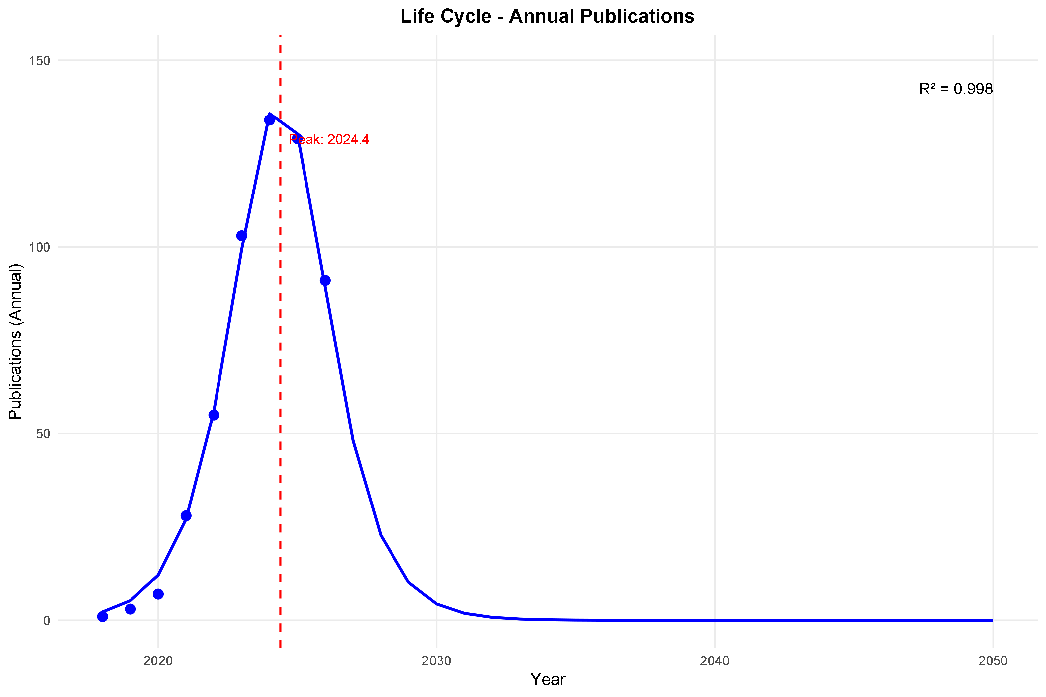
Figure 3. Life-cycle (Gompertz-type) model of annual publications, with an estimated inflection year of 2024.4 (R² = 0.998).

4.3 Source and Journal Analysis
Figure 4 tracks cumulative output over time for the five most productive sources. Business Strategy and the Environment overtook the early leaders in 2023–2024 to finish as the single most productive outlet (30 cumulative articles), followed closely by Annals of Operations Research (28), with Sustainability (Switzerland) (21), Operations Management Research (19), and Technological Forecasting and Social Change (17) completing the top five. Notably, Sustainability and Operations Management Research were the earliest movers, with a steady accumulation from 2021 onward, while Business Strategy and the Environment and Annals of Operations Research have a much steeper, more recent (post-2022) growth curve consistent with the overall late-stage acceleration of the field documented in Section 4.1.
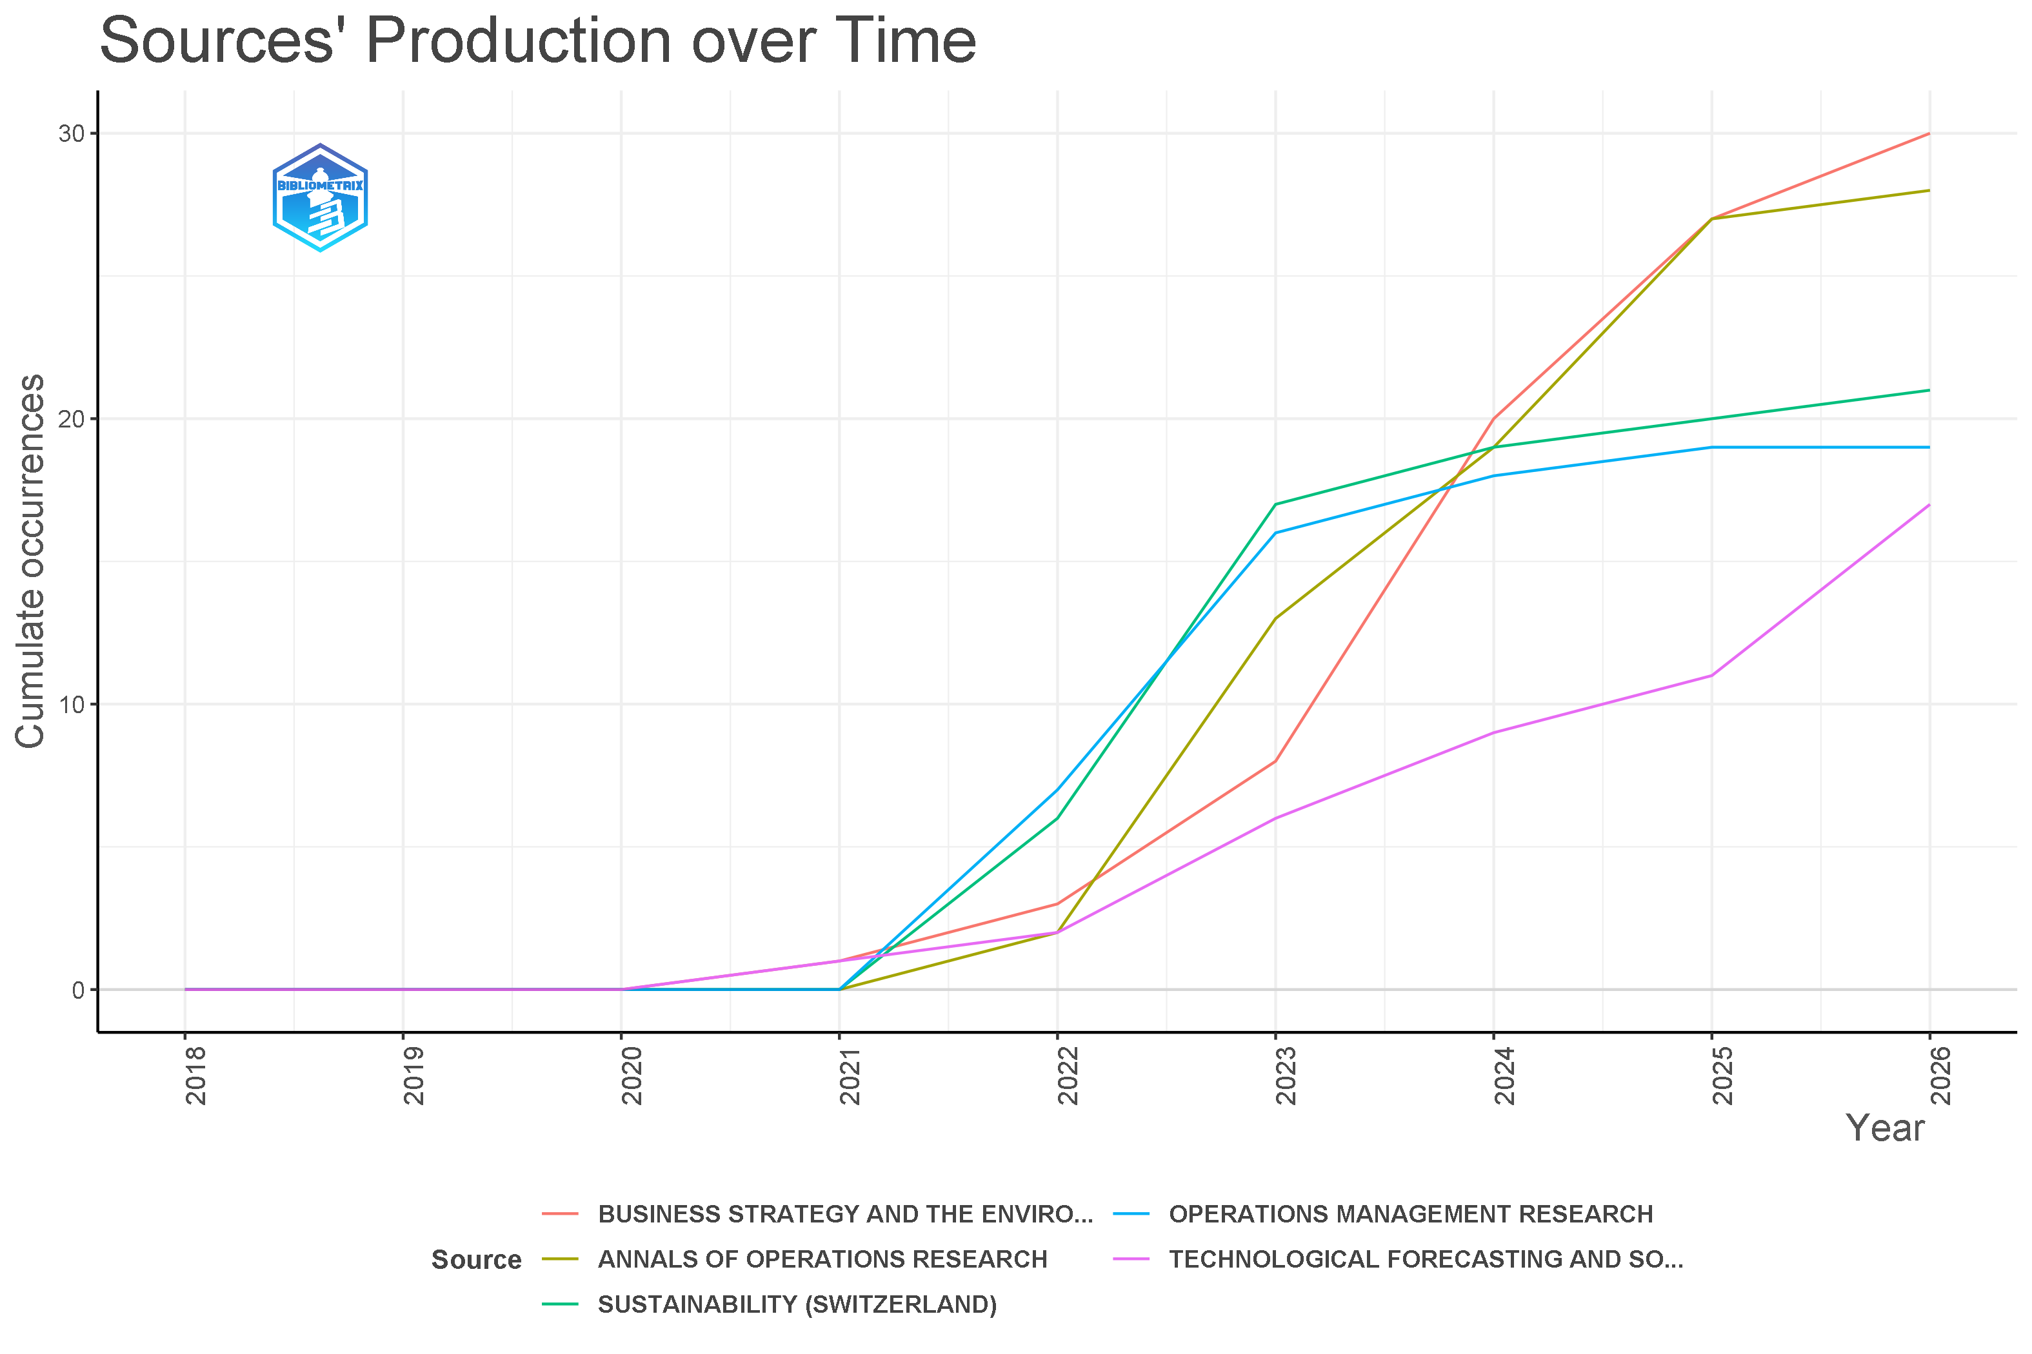
Figure 4. Cumulative production over time for the five most productive sources, 2018–2026.
Bradford's Law (Figure 5; Table 4) suggests a moderately concentrated source structure. The fitted model, C(r) = -74.3 + 111.1 log(r) (R2 = 0.987, Bradford multiplier k = 3.9), classifies the 222 sources in the corpus into a Core zone of 11 journals, a Zone 2 of 44 moderately productive journals, and a long tail Zone 3 of 167 journals, each of which has only one or two articles. A Kolmogorov-Smirnov test (p = 0.12) indicates that the fitted Bradford model is not rejected and hence is a good fit. Three-quarters of all sources (75.2%) are found in the dispersed Zone 3 indicating a still-diffusing field: while an identifiable core of operations-management and sustainability-oriented journals anchors the literature, a significant share of relevant work continues to appear opportunistically across engineering, information-systems, environmental-science, and general-management outlets.
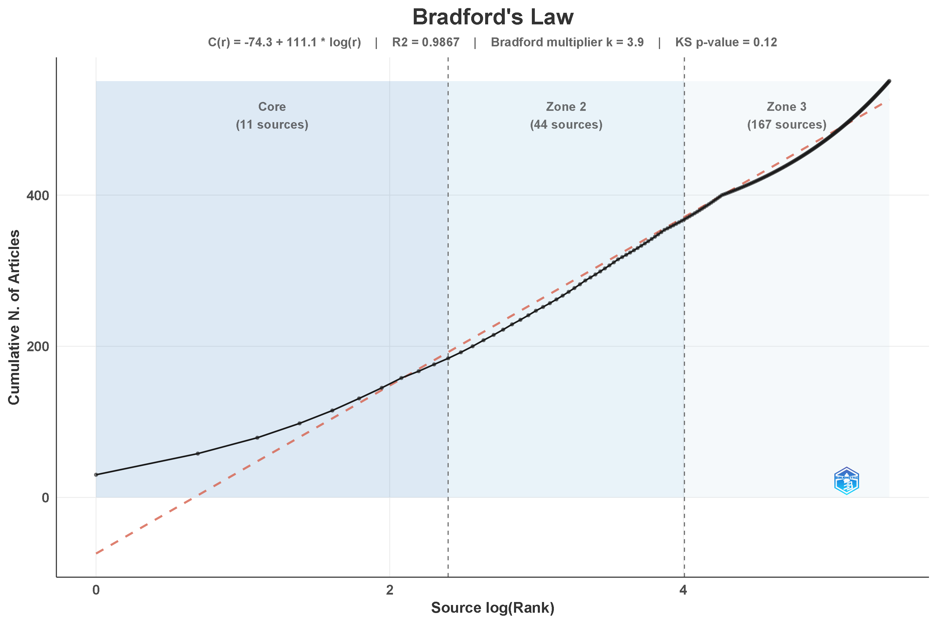
Figure 5. Bradford's Law source-dispersion curve, partitioning 222 sources into Core, Zone 2, and Zone 3.
Table 4. Bradford's Law source zones and leading core journals.
Zone | No. of sources | % of sources | Description
Core (Zone 1) | 11 | 5.0% | Most productive journals; disproportionate share of output
Zone 2 | 44 | 19.8% | Moderately productive journals
Zone 3 | 167 | 75.2% | Long tail of low-frequency, scattered sources
Note. Zone counts based on the fitted model C(r) = −74.3 + 111.1·log(r), R² = 0.987, Bradford multiplier k = 3.9, KS p = 0.12 (Figure 5). Cumulative-occurrence counts for the five leading sources are drawn from Figure 4 (data through 2026).
Top five core sources by cumulative output (2018–2026):
Source | Cumulative articles (n)
Business Strategy and the Environment | 30
Annals of Operations Research | 28
Sustainability (Switzerland) | 21
Operations Management Research | 19
Technological Forecasting and Social Change | 17

4.4 Author Productivity
Author productivity was assessed against Lotka's Law of scientific productivity (Lotka, 1926), which predicts that the number of authors publishing n papers is proportional to 1/n^β. The fitted model (Figure 6) returned β = 2.19 and constant C = 0.3504, with a strong overall fit (R² = 0.892). Consistent with the classical long-tail signature of Lotka's Law, approximately 80% of contributing authors published exactly one document in the corpus, a further 10% published two, and only a small elite roughly 1% of authors produced more than ten documents each, with the single most prolific contributor credited on approximately 39 records (Table 5). Interestingly, a Kolmogorov–Smirnov test rejects the classical theoretical exponent of β = 2 (p = 0.035) but fails to reject the empirically fitted exponent of β = 2.19 (p = 0.082). Because a higher β implies a steeper decline in the number of authors as productivity increases, this indicates that authorship in this field is slightly more concentrated among a small productive core than the classical Lotka distribution would predict a pattern consistent with the highly central author cluster identified in the collaboration-network analysis (Section 4.9).
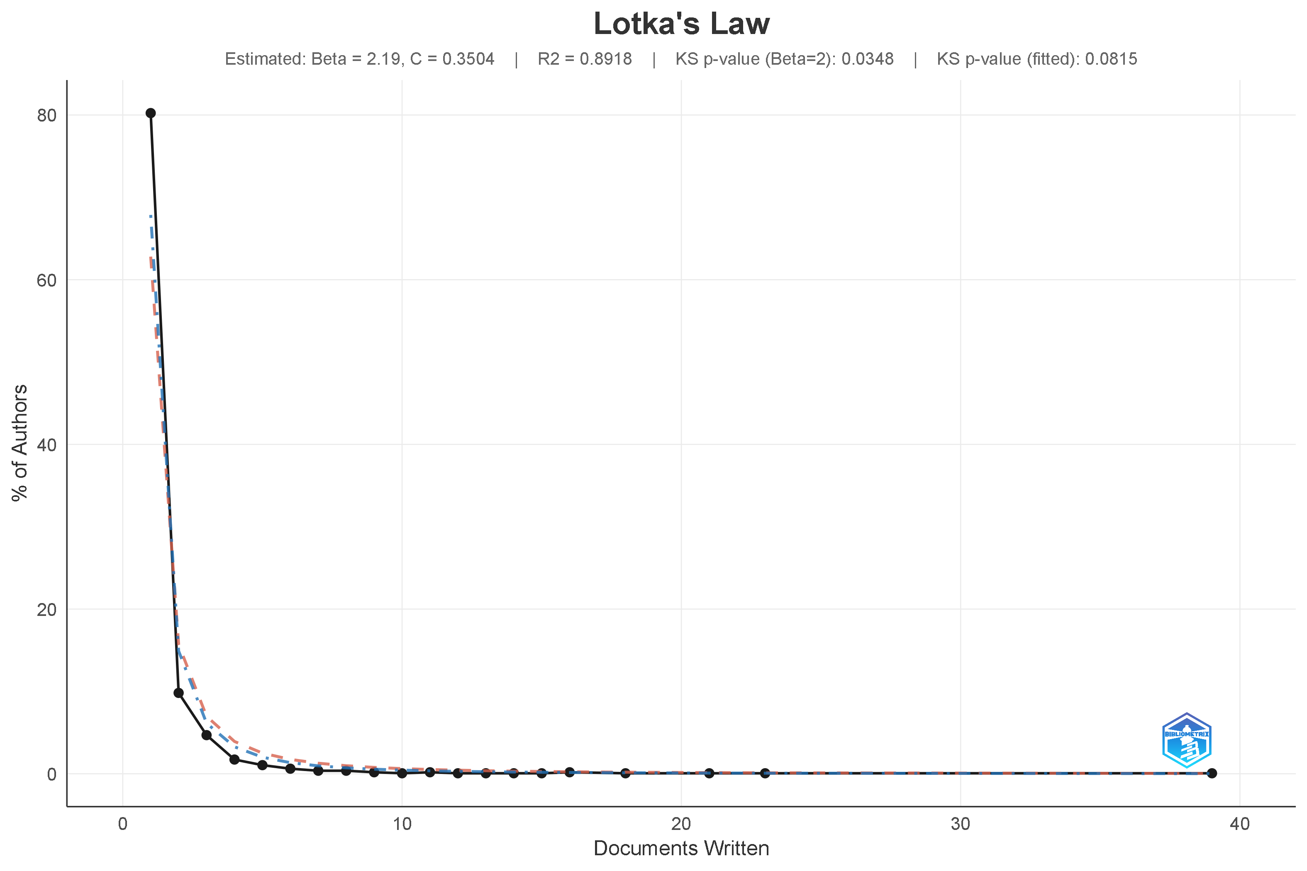
Figure 6. Lotka's Law of author productivity, fitted against the classical exponent (β = 2).
Table 5. Lotka's Law approximate author-productivity distribution.
Documents per author | Approx. % of authors | Cumulative %
1 | 80.3% | 80.3%
2 | 9.9% | 90.2%
3 | 4.2% | 94.4%
4–5 | 2.6% | 97.0%
6–10 | 1.8% | 98.8%
> 10 (up to ≈39) | 1.2% | 100.0%
Note. Estimated β = 2.19, C = 0.3504, R² = 0.892 (Figure 6). A Kolmogorov–Smirnov test rejects the classical Lotka exponent of β = 2 (p = 0.035) but fails to reject the empirically fitted model (p = 0.082), indicating a productivity distribution that is slightly more concentrated i.e., more skewed toward single-paper contributors than the classical law predicts.

4.5 Geographic Distribution
The choropleth map of country scientific production (Figure 7) shows a striking geographic concentration. India is shaded in the darkest tier, unambiguously the leading contributing country by a wide margin, consistent with its dominance of both the author collaboration network (Section 4.9) and the keyword frequency table, where "India" is itself the sixteenth most frequent author keyword (31 occurrences; Table 6). A broad second tier of contributing countries shaded in lighter blue and spanning North America (the United States, Canada, Mexico), most of Europe (including the United Kingdom, Germany, France, Italy, Spain, and the Nordic and Baltic states), Australia, China, Brazil, South Africa, and several Middle Eastern and Southeast Asian nations indicates that more than 60 countries have contributed at least one publication to the field, evidencing genuinely global (if geographically uneven) scholarly interest. A substantial number of countries, mostly across Central Asia, Central Africa, and parts of Latin America, remain unshaded, indicating no recorded output and pointing to a research agenda that has yet to diffuse into several regions with acute supply chain sustainability and resilience challenges of their own.
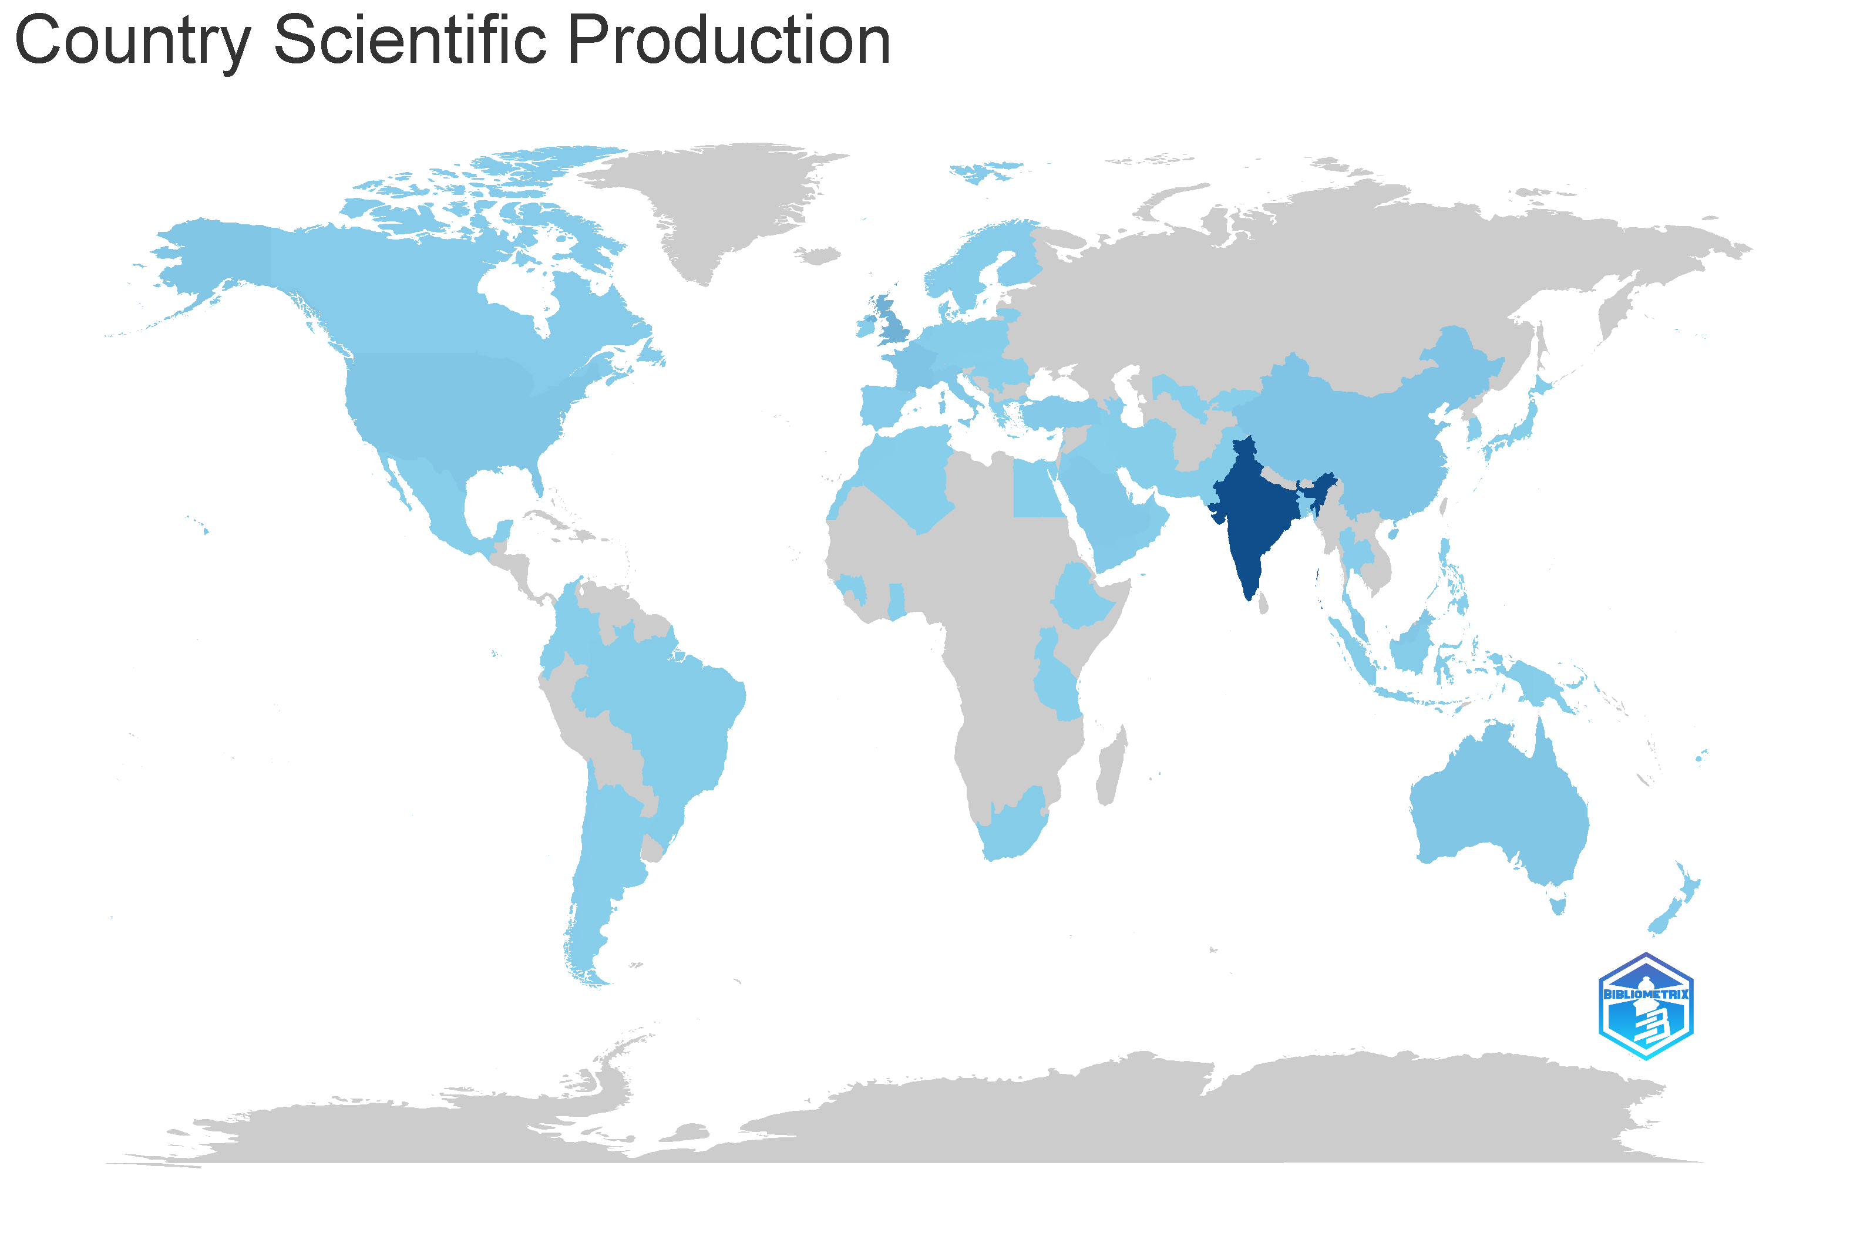
Figure 7. Choropleth map of country scientific production, showing India as the dominant contributor.

4.6 Keyword Frequency Analysis
The frequency distribution of author keywords is visualized in the tree-map (Figure 8) and word cloud (Figure 9) and summarized in Table 6. The most frequent keyword is “sustainability” (108 occurrences, 8% of all keyword occurrences), followed by “supply chain management” (95, 7%), “supply chains” (72, 5%), “sustainable development” (70, 5%), and “industry 4.0” (65, 5%). "Artificial intelligence" ranks seventh overall (55 occurrences, 4%), just behind "decision making" (58, 4%), indicating the strongly decision-analytic orientation of this literature (reinforced by the prominence of methodological keywords such as "DEMATEL," 23 occurrences, and "risk management," 21). The term “COVID-19” (47, 3%) remains firmly entrenched in the field’s lexicon, even as the pandemic recedes from the news cycle, emphasizing its long-term effect on inspiring resilience-oriented research. Terms referring to blockchain are divided among at least three variations of the keyword (“blockchain,” “block-chain,” and “blockchain technology”), a frequent artifact of Scopus keyword indexing; altogether these variations sum to 87 occurrences (≈6%), which otherwise would place blockchain among the top five constructs in the field. Overall, the keyword profile supports the main argument of the paper that sustainability and supply chain management terms are numerically dominant, but systematically associated with AI/Industry 4.0 vocabulary (artificial intelligence, industry 4.0, digital transformation, big data analysis, machine learning, internet of things) and resilience/disruption vocabulary (COVID-19, resilience, risk management, supply chain resilience), confirming that the three conceptual pillars identified in Section 2 are indeed empirically intertwined and not just co-located .
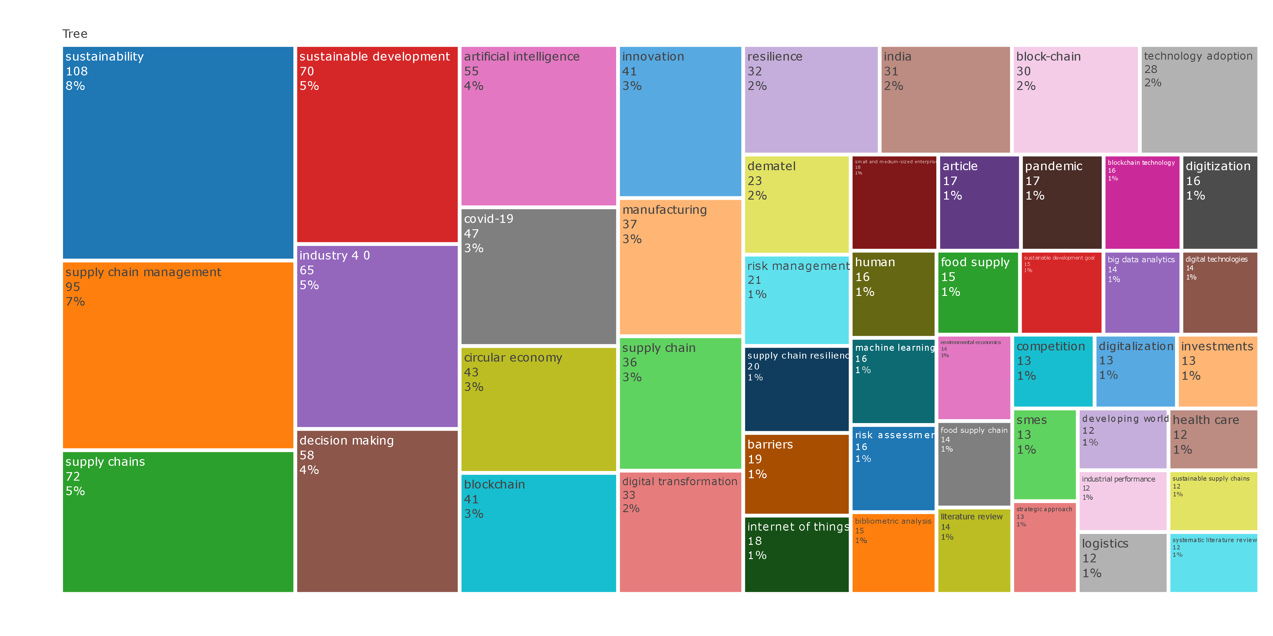
Figure 8. Tree map of the top author keywords by frequency and percentage share.
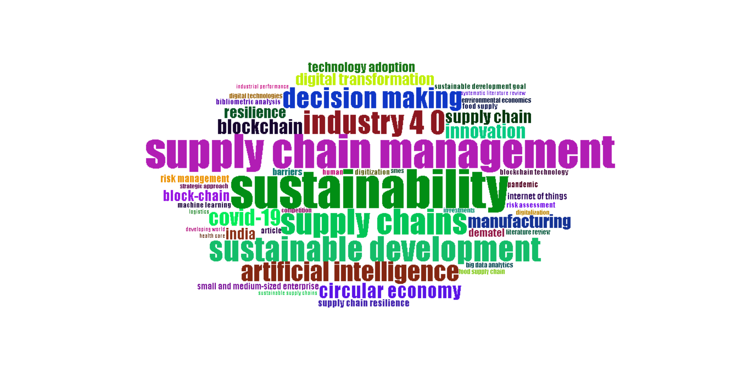
Figure 9. Word cloud of author keywords, sized by frequency of occurrence.
Table 6. Top 25 author keywords by frequency and share of total keyword occurrences.
Rank | Keyword | Occurrences (n) | % of total
1 | Sustainability | 108 | 8%
2 | Supply chain management | 95 | 7%
3 | Supply chains | 72 | 5%
4 | Sustainable development | 70 | 5%
5 | Industry 4.0 | 65 | 5%
6 | Decision making | 58 | 4%
7 | Artificial intelligence | 55 | 4%
8 | COVID-19 | 47 | 3%
9 | Circular economy | 43 | 3%
10 | Blockchain | 41 | 3%
11 | Innovation | 41 | 3%
12 | Manufacturing | 37 | 3%
13 | Supply chain | 36 | 3%
14 | Digital transformation | 33 | 2%
15 | Resilience | 32 | 2%
16 | India | 31 | 2%
17 | Block-chain (variant spelling) | 30 | 2%
18 | Technology adoption | 28 | 2%
19 | DEMATEL | 23 | 2%
20 | Risk management | 21 | 1%
21 | Supply chain resilience | 20 | 1%
22 | Barriers | 19 | 1%
23 | Internet of Things | 18 | 1%
24 | Small and medium-sized enterprises | 18 | 1%
25 | Article / Pandemic | 17 each | 1%
Note. Frequencies drawn from the author-keyword tree-map (Figure87) and word cloud (Figure 9). "Blockchain" and its variant spelling "block-chain" appear as separate entries in the raw export, a common data-cleaning artefact in Scopus keyword fields; combined, blockchain-related terms (blockchain, block-chain, blockchain technology) account for 87 occurrences (≈6% of total), which would place the construct among the field's five most frequent keywords.

4.7 Thematic Mapping and Evolution
Three strategic (centrality–density) thematic maps were generated for successive sub-periods of approximately equal length across the review window, allowing the field's intellectual structure to be tracked as it matured. In the strategic diagram, motor themes (high centrality, high density, upper-right quadrant) are well-developed and central to the field; basic themes (high centrality, lower density) are foundational but still developing; niche themes (low centrality, high density, upper-left) are specialised and peripheral; and emerging-or-declining themes (lower-left) are either nascent or losing traction (Cobo et al., 2011).
Period I, the field's early years (Figure 10), shows "covid-19," "article," and "pandemic" occupying a niche position an early, self-referential cluster reflecting the sudden emergence of pandemic-driven scholarship alongside a separate niche cluster of "sustainable development," "sustainable development goal," and "investments." "Barriers," "literature review," and "big data analytics" form a third niche cluster, indicating that the field was still predominantly reviewing and scoping itself. Meanwhile, "supply chains," "decision making," and "artificial intelligence" already occupy a basic (foundational) position, and "sustainability," "industry 4.0," and "circular economy" anchor the motor-theme quadrant, together with a lower basic cluster of "supply chain management," "blockchain," and "supply chain."
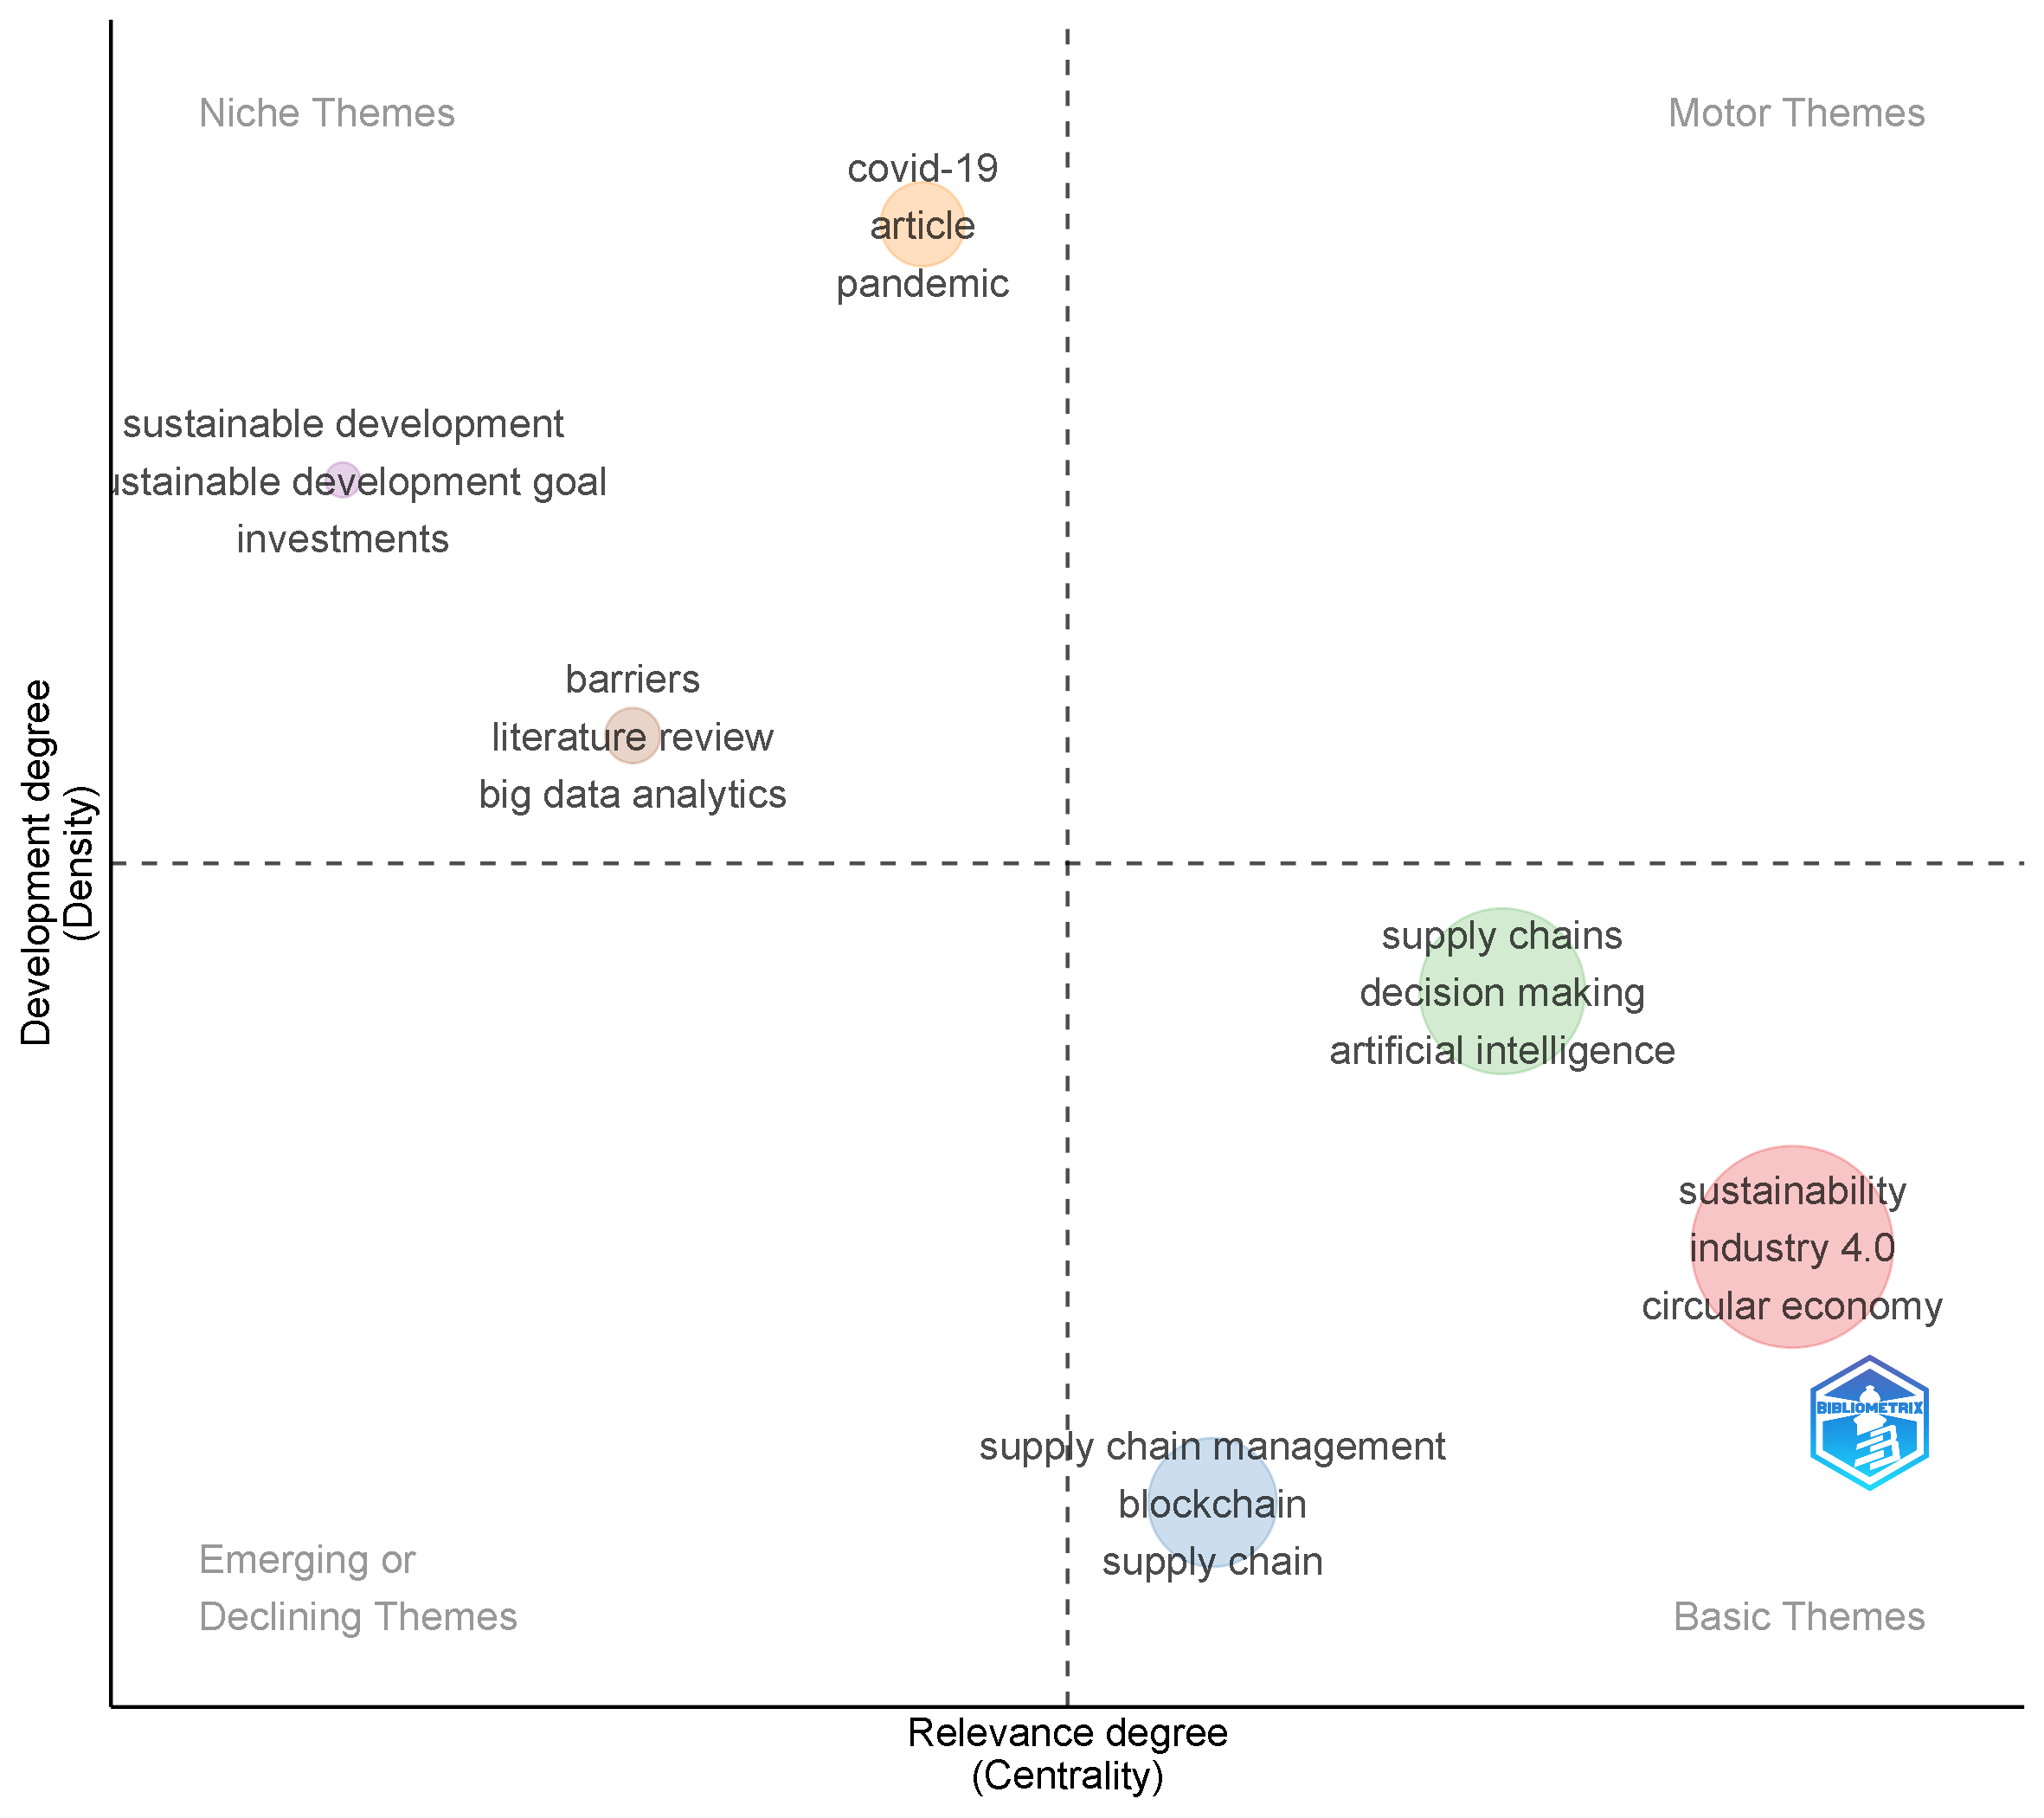
Figure 10. Strategic (centrality–density) thematic map, Period I (early years): pandemic-reactive and review-based niche themes.
Period II (Figure 11) shows visible consolidation. "Digital transformation," "innovation," and "SMEs," together with "India," "supplier selection," and "sustainable supply chain," now occupy the niche quadrant specialised, still-maturing sub-themes. Critically, "artificial intelligence," "big data analytics," and "supply chain resilience" have migrated toward the centre of the diagram as a well-developed basic theme, as have "covid-19," "resilience," and "digitalisation" evidence that pandemic-driven resilience research had, by this stage, become a foundational rather than a peripheral concern. "Sustainability," "industry 4.0," and "circular economy" remain the dominant motor theme, while "barriers," "DEMATEL," and "enablers" occupy the emerging-or-declining quadrant, suggesting that barrier/enabler-focused, expert-opinion-based studies (a hallmark of an earlier, more exploratory research style) were losing relative traction.
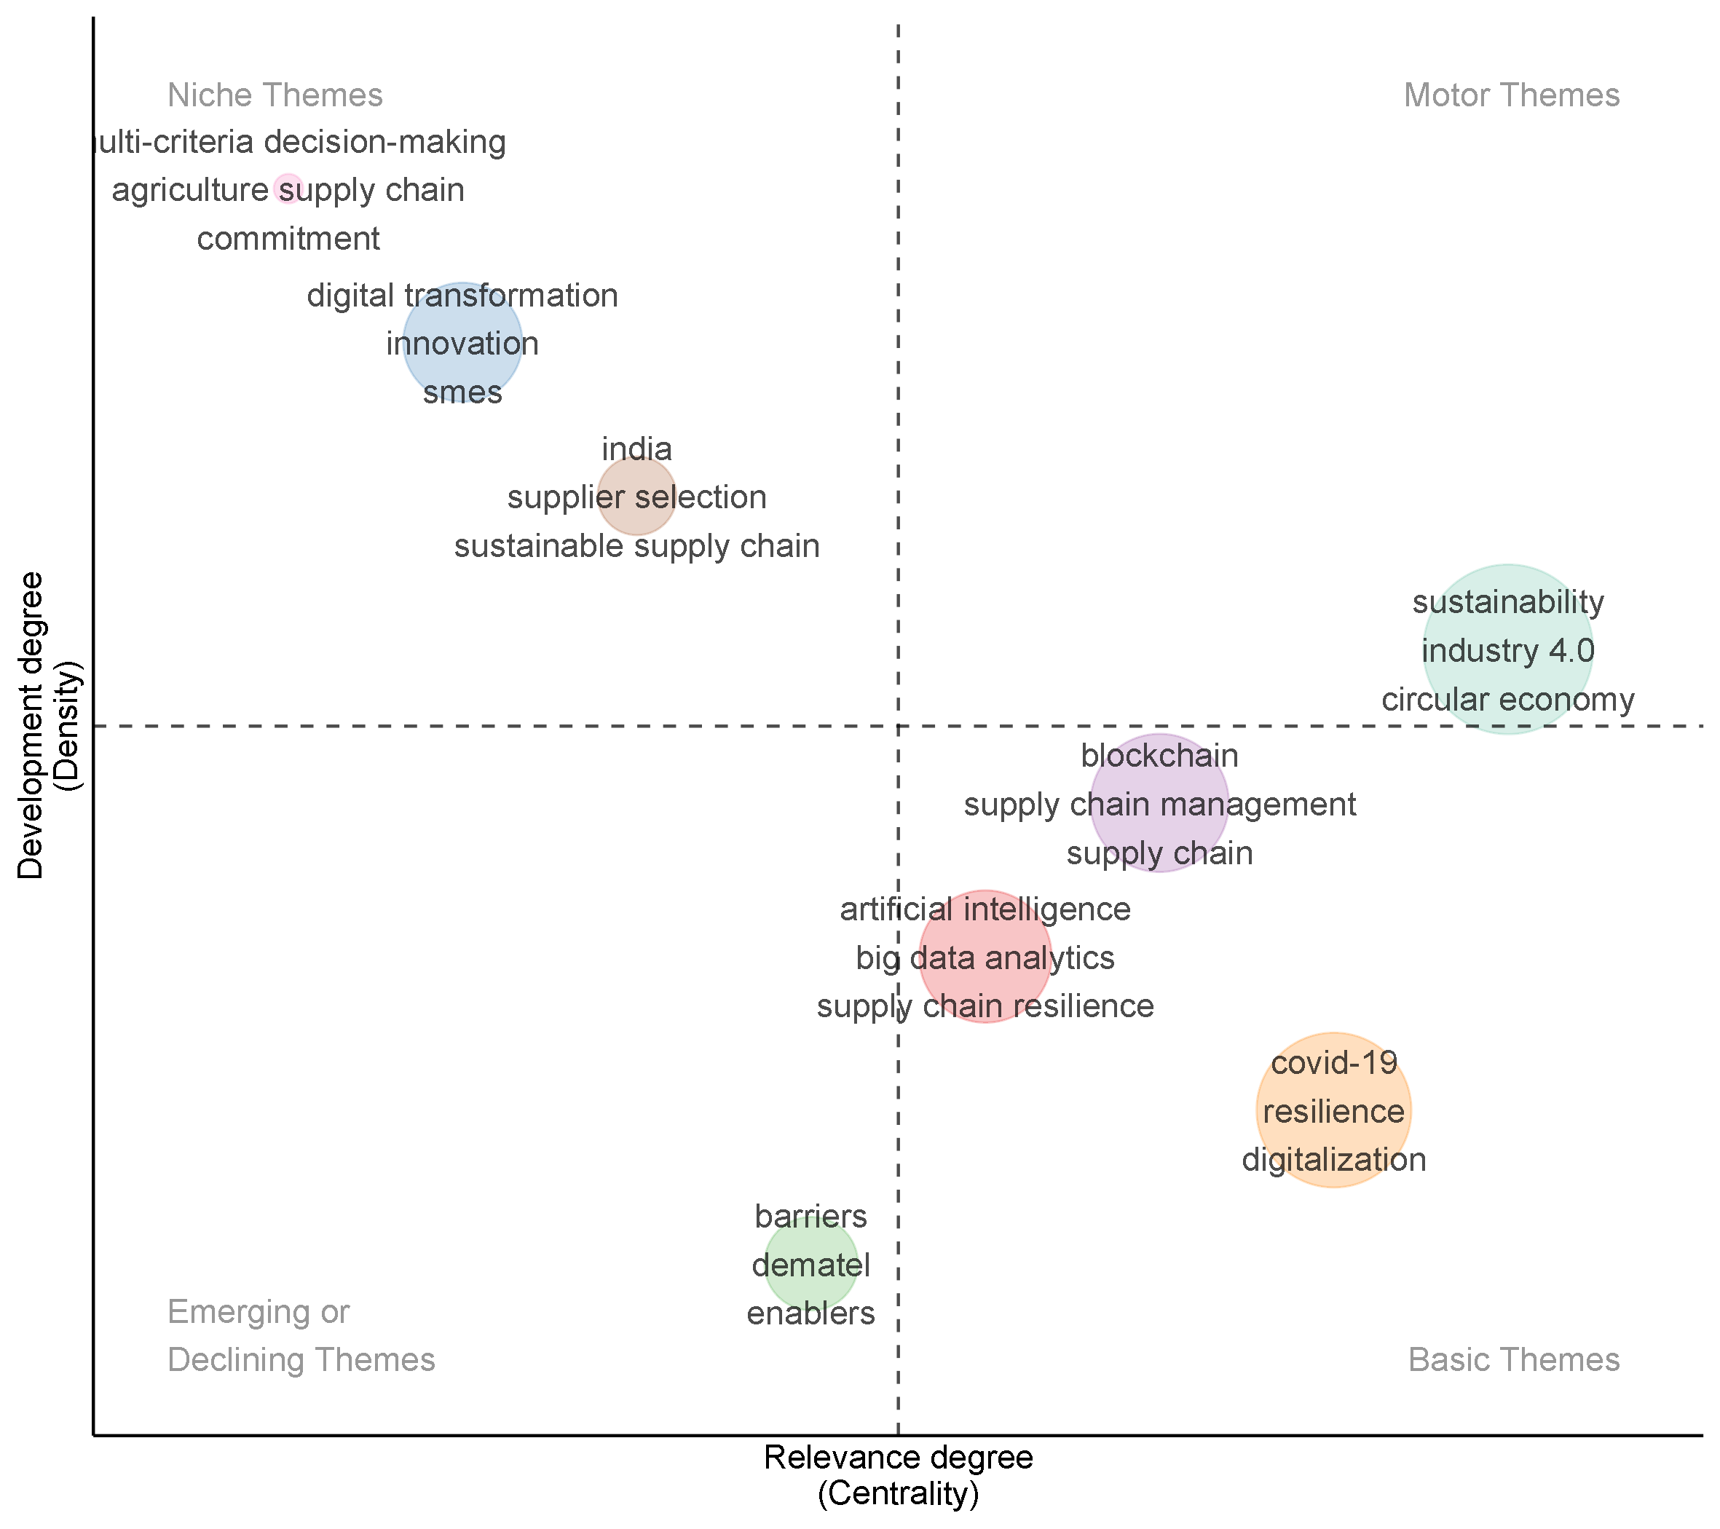
Figure 11. Strategic thematic map, Period II (intermediate years): resilience and digitalisation consolidate into basic themes.
Period III, the most recent sub-period (Figure 12), shows the field's clearest signs of empirical maturation. A distinct motor-theme cluster of "digital transformation," "PLS-SEM," and "sustainable performance" sits alongside a second motor cluster of "artificial intelligence," "dynamic capabilities," and "machine learning" the appearance of "PLS-SEM" (partial least squares structural equation modelling) signals a decisive shift from conceptual and review-based work toward large-sample, survey-based empirical validation. A third, closely related motor cluster combines "supply chain," "blockchain," and "resilience." "Absorptive capacity," "knowledge management," and "small and medium enterprises" now define the niche quadrant, while "circular supply chains" and "smart manufacturing" have moved into the emerging-or-declining quadrant read here as emerging specialised sub-niches rather than genuinely declining themes, given their conceptual proximity to the still-growing motor cluster. "Industry 4.0," "sustainability," and "supply chain management," together with "supply chain resilience" and "risk management," remain centrally positioned as basic themes, and "circular economy," "DEMATEL," and "artificial intelligence (AI)" occupy a well-developed basic-theme position bordering the motor quadrant.
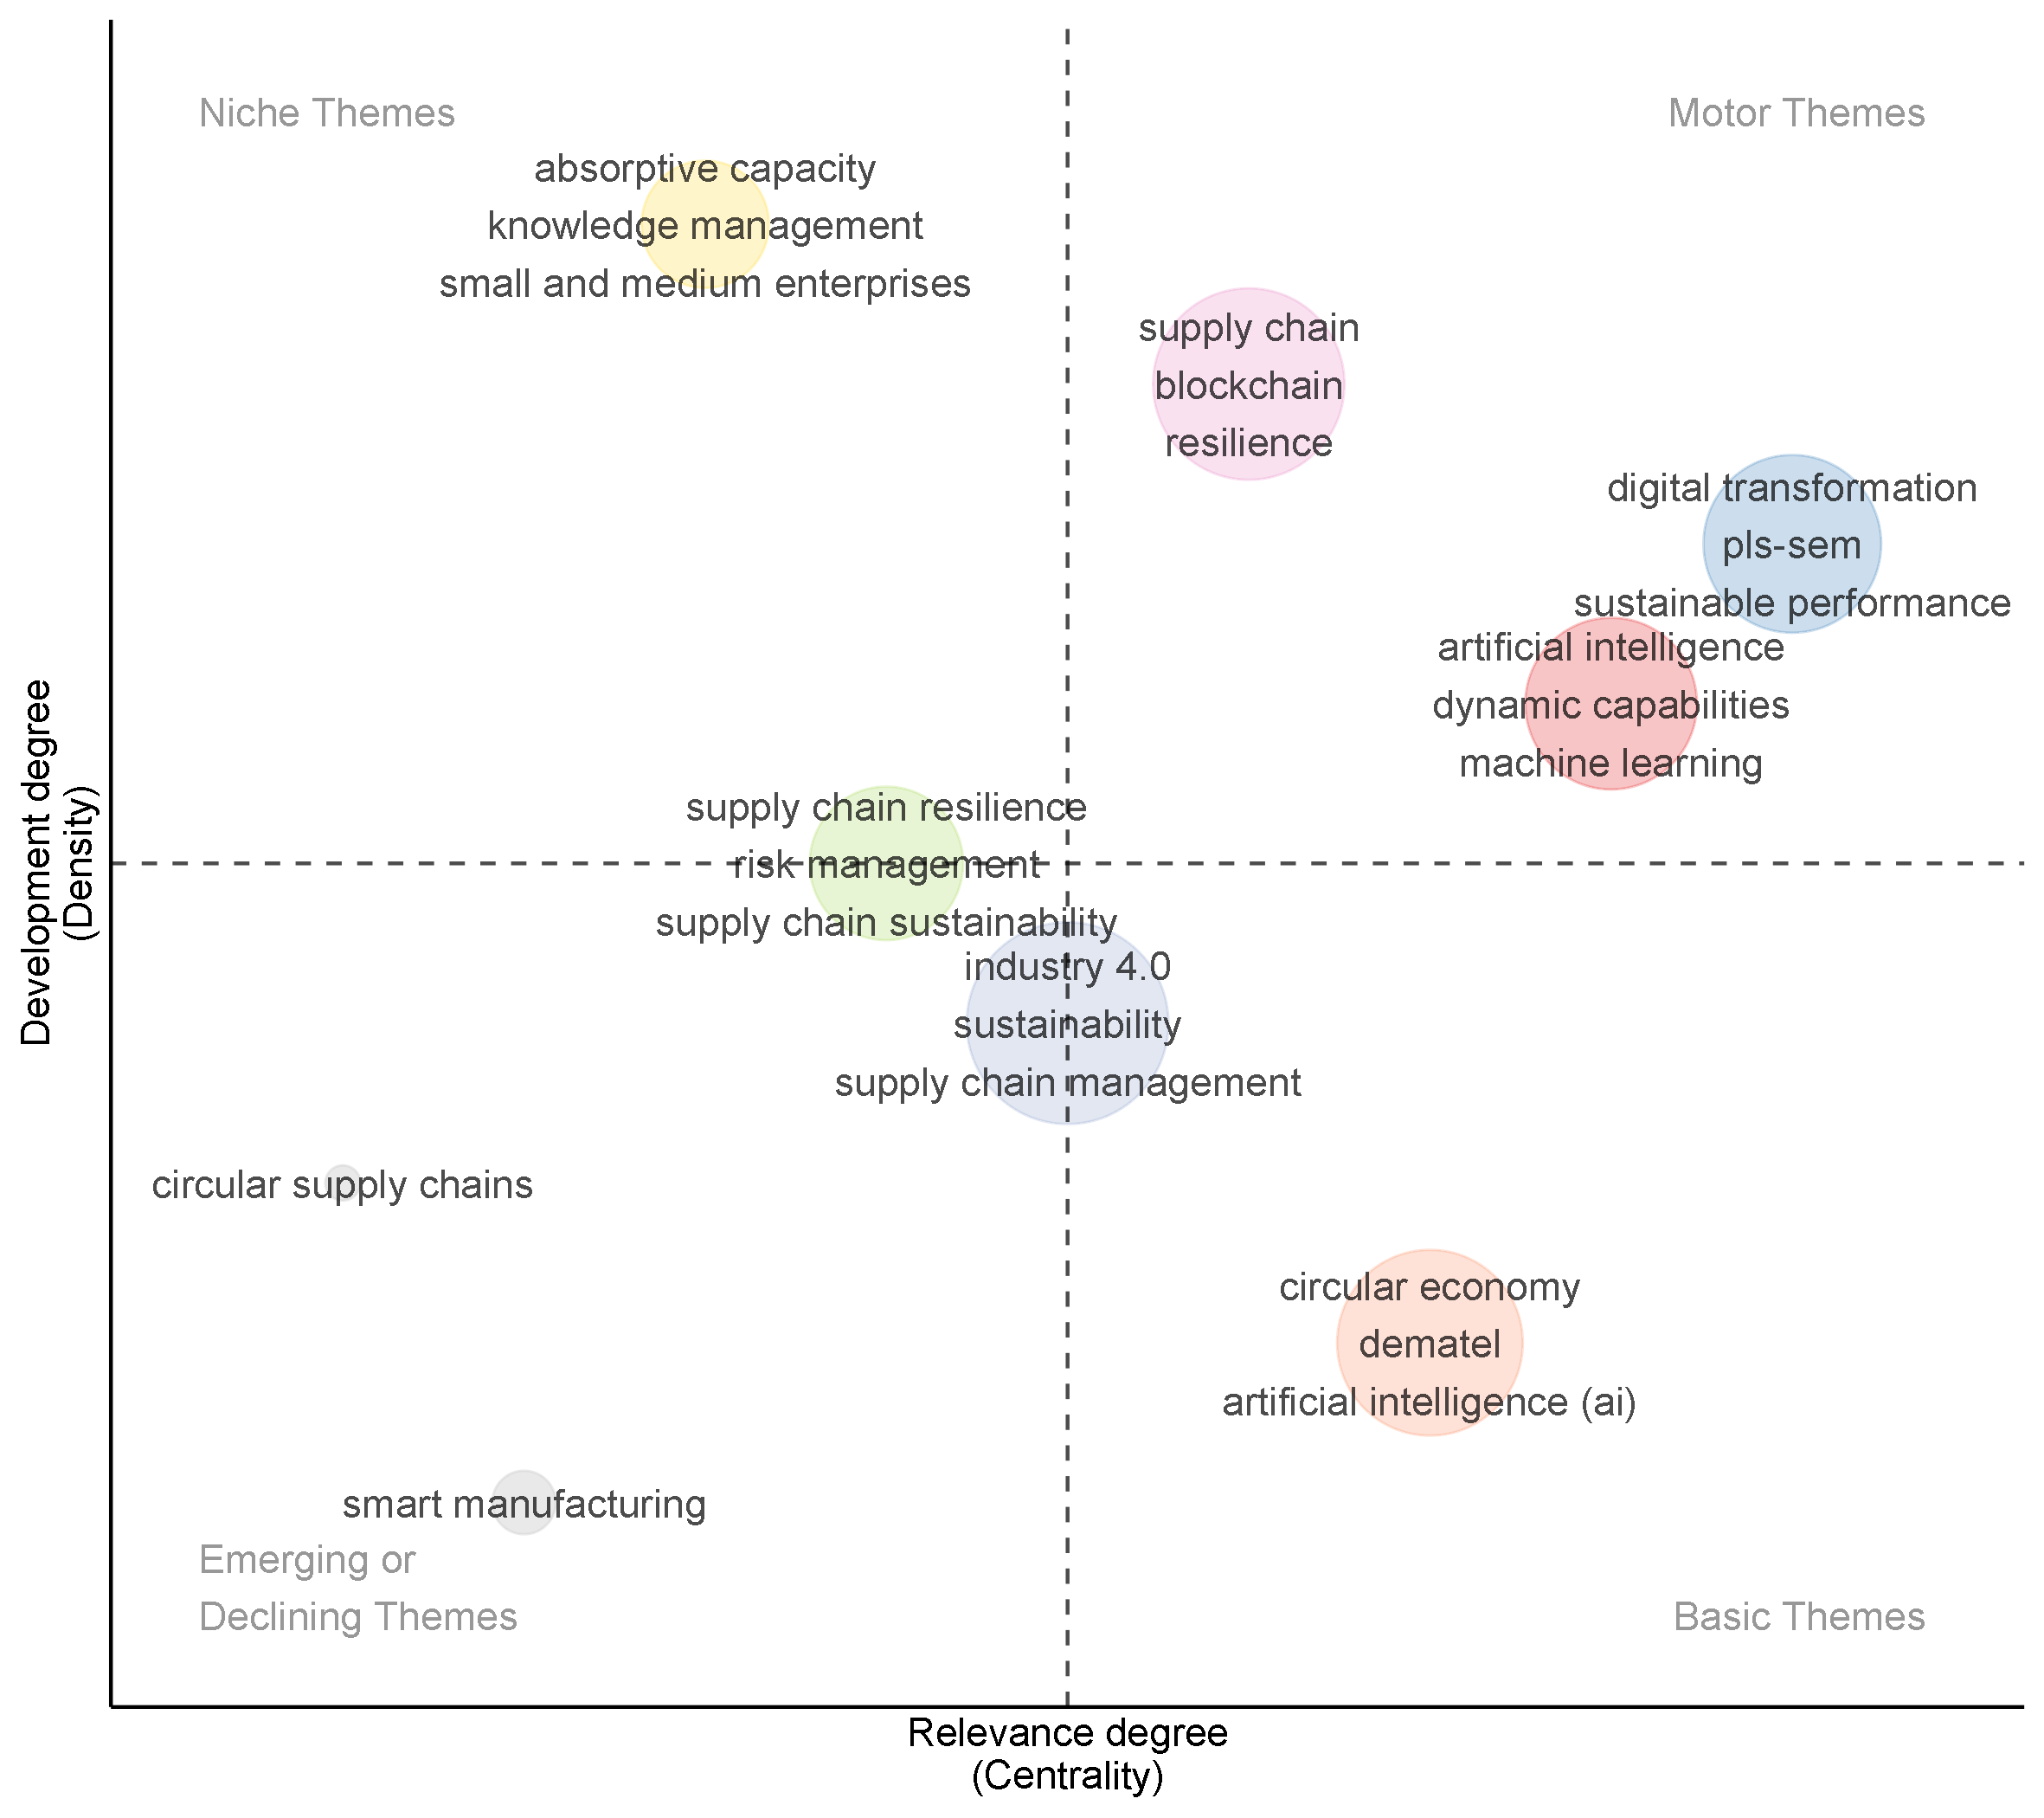
Figure 12. Strategic thematic map, Period III (recent years): emergence of PLS-SEM-based empirical motor themes.
The corresponding thematic-evolution (Sankey) diagram visualizing the migration of keywords between the sub-periods 2018–2024 and 2025–2026 is shown in Figure 13. The two heaviest, most heavily weighted flows into the recent period are “digital transformation” and “artificial intelligence” . Both are prominent from 2018–2024 and continue into the recent period as their own labelled nodes on the right-hand side, while also feeding substantially into “industry 4.0” , which emerges as the single largest node in 2025–2026. Other nodes such as “supply chain,” “circular economy,” and “supply chain resilience” also receive a substantial inflow from the earlier period’s “sustainability,” “blockchain,” and “barriers” nodes. Two nodes on the right-hand side, ‘supply chain resilience’ and ‘absorptive capacity’ have no directly corresponding node on the left, showing truly emergent themes rather than mere relabeling of earlier constructs. Conversely, "covid-19," prominent from 2018–2024, thins out substantially by 2025–2026, with its residual influence redistributed diffusely across the newer resilience- and supply-chain-oriented nodes rather than concentrated in a single successor keyword consistent with the pandemic's transition from a standalone research trigger to an embedded, background assumption of resilience-oriented studies.
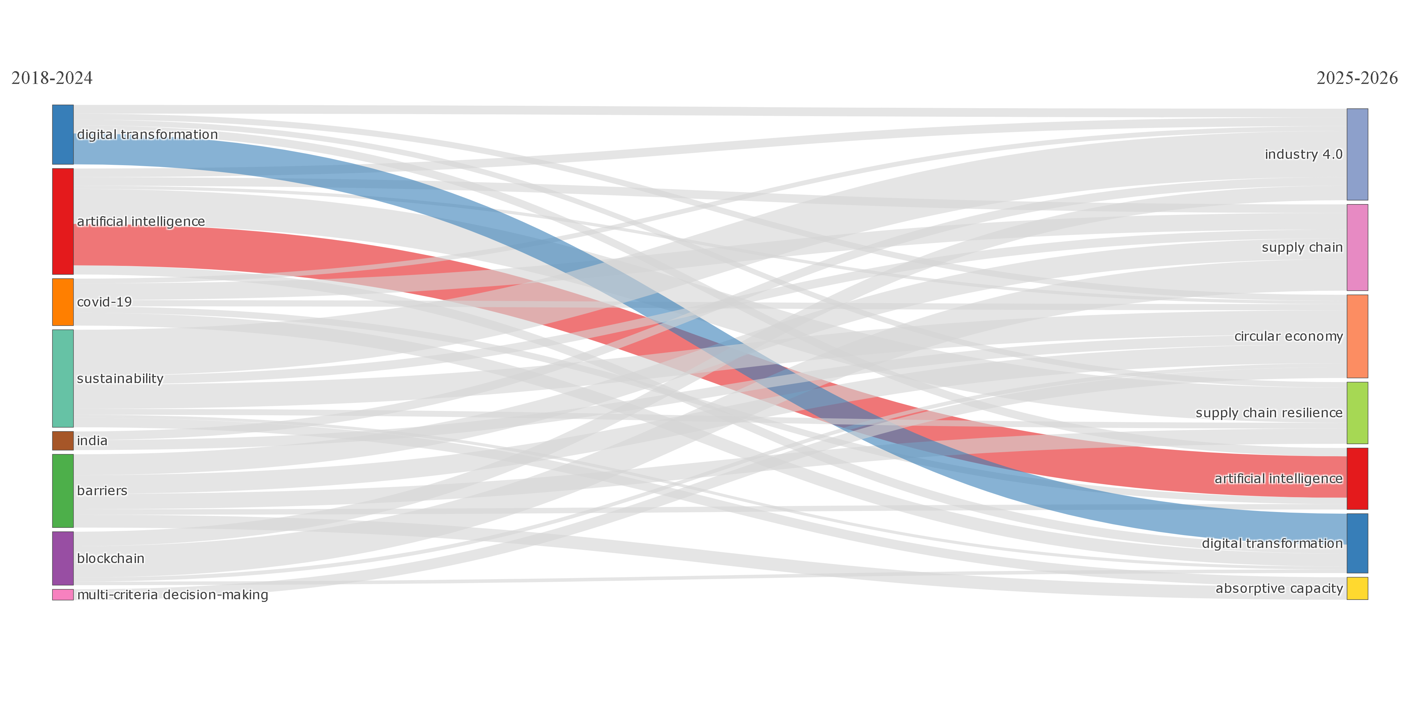
Figure 13. Thematic evolution (Sankey diagram) of keyword migration between the 2018–2024 and 2025–2026 sub-periods.

4.8 Keyword Co-occurrence Network
Figure 14 presents the author-keyword co-occurrence network (node labels are partially clipped in the export, but cluster colouring corresponds closely to the thematic clusters identified in Section 4.7, permitting cluster-level interpretation). A large, densely connected red cluster forms the structural core of the network, centred on "industry 4.0" and its immediate co-occurring terms (sustainability, manufacturing) the largest and most central nodes in the entire network, consistent with Industry 4.0's position as the field's dominant motor theme. A green cluster, positioned above and cross-linked to the red core, aligns with supply-chain, blockchain, resilience, and circular-economy terms; a blue cluster to the right aligns with artificial intelligence, digital transformation, and machine-learning terms; and a purple cluster aligns with barrier-, adoption-, and emerging-economy-related terms (including India and SME-related keywords), consistent with the niche and basic thematic clusters described above. A small orange cluster bridges the purple and blue clusters, plausibly reflecting circular-economy and SME-enabler terms that connect adoption barriers to core technology themes. A disconnected pair of nodes (upper left, in brown) has no path to the main network component, indicating a specialised keyword pairing most plausibly "multi-criteria decision-making" and "supplier selection," both identified as niche themes in Figure 9 that co-occurs only within itself and has not yet been integrated into the field's central discourse.
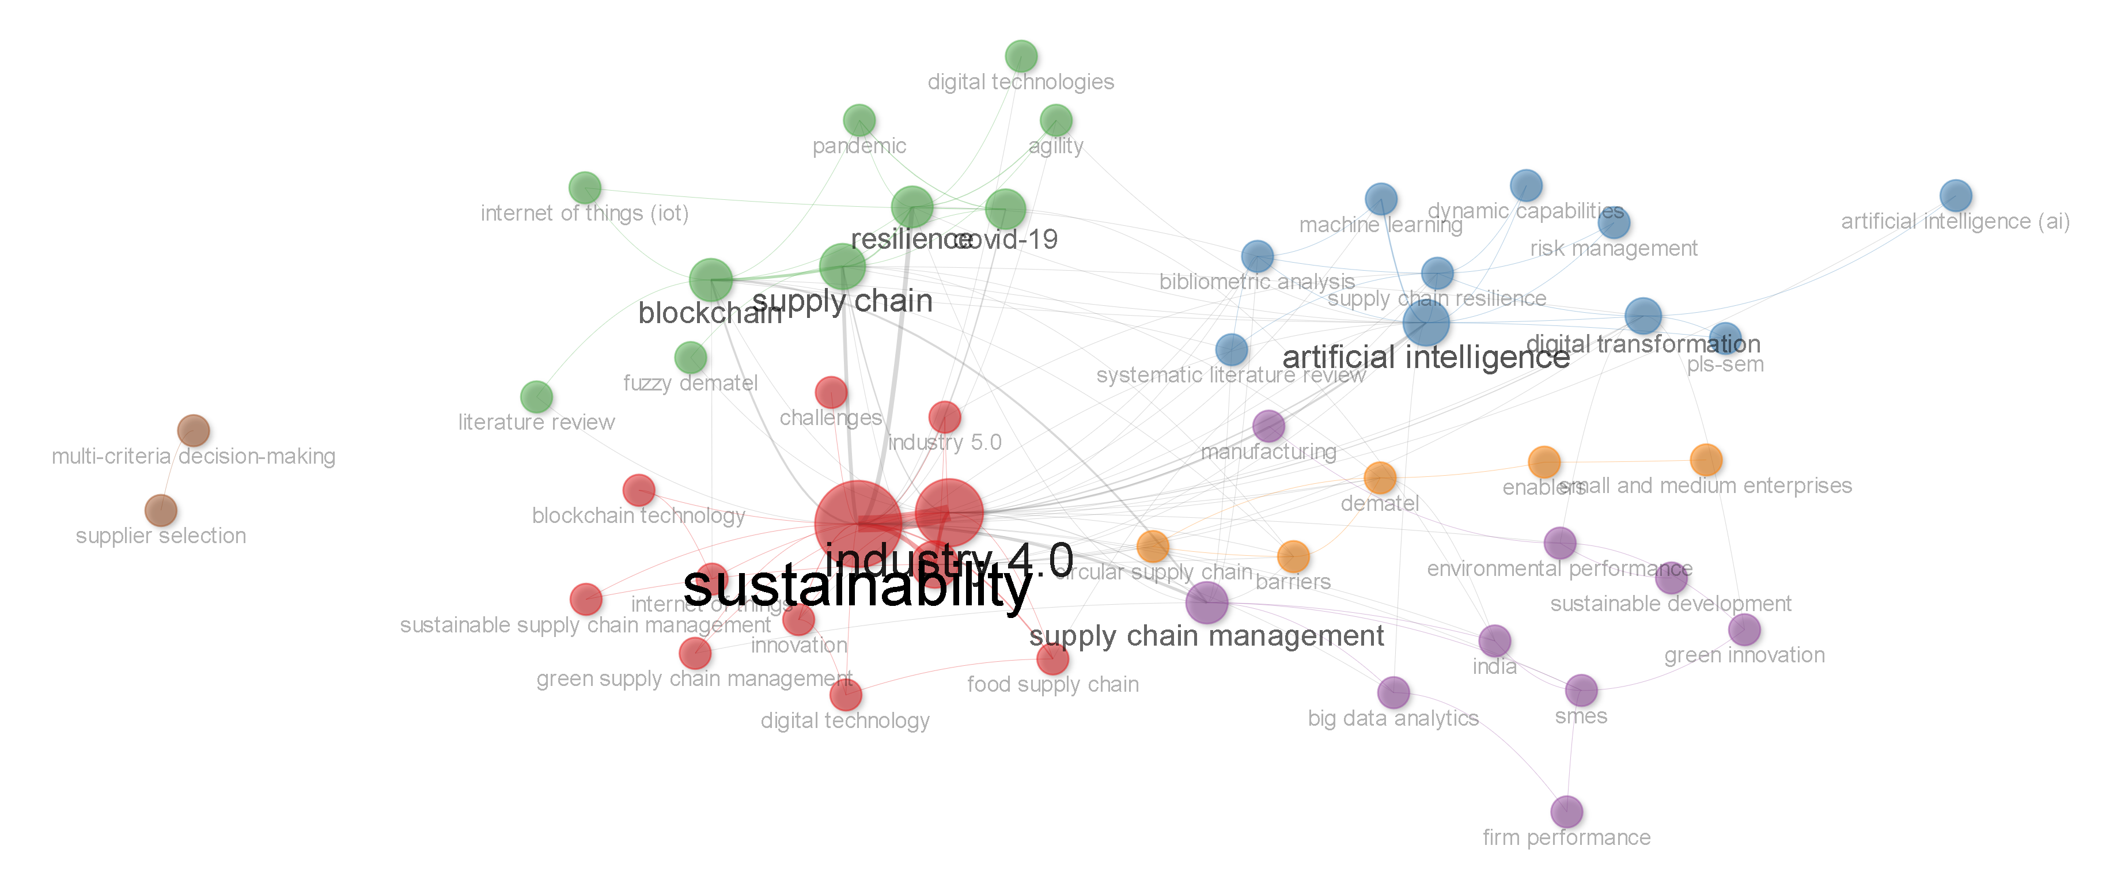
Figure 14. Author-keyword co-occurrence network, coloured by cluster.

4.9 Collaboration Networks
Country collaboration network. Figure 15 maps cross-country co-authorship ties among at least 42 countries with visible collaborative links. Three clusters emerge. A red cluster anchored by India by far the largest node in the entire network links India to the United Kingdom, the United States, Australia, France, Denmark, the Czech Republic, Korea, Iran, Sweden, Singapore, Morocco, Lithuania, Japan, and Thailand, confirming India's role as the field's central hub for international collaboration. A green cluster of predominantly European and allied nations (the Netherlands, Finland, Cyprus, Switzerland, Italy, Ireland, New Zealand, Germany, Norway, Brazil, Spain, Algeria, Hong Kong, Hungary, Turkey, and South Africa) forms a second, densely interconnected community with comparatively weaker direct ties to the Indian core. A third, blue cluster spans the Middle East and South/Southeast Asia (Bangladesh, Indonesia, Oman, Jordan, Malaysia, Saudi Arabia, Canada, Azerbaijan, Qatar, and Yemen). The overall topology one dominant hub (India) bridging two otherwise loosely connected regional communities is characteristic of a field whose international collaboration structure remains centred on a single emerging-economy anchor rather than being evenly distributed across established research economies.
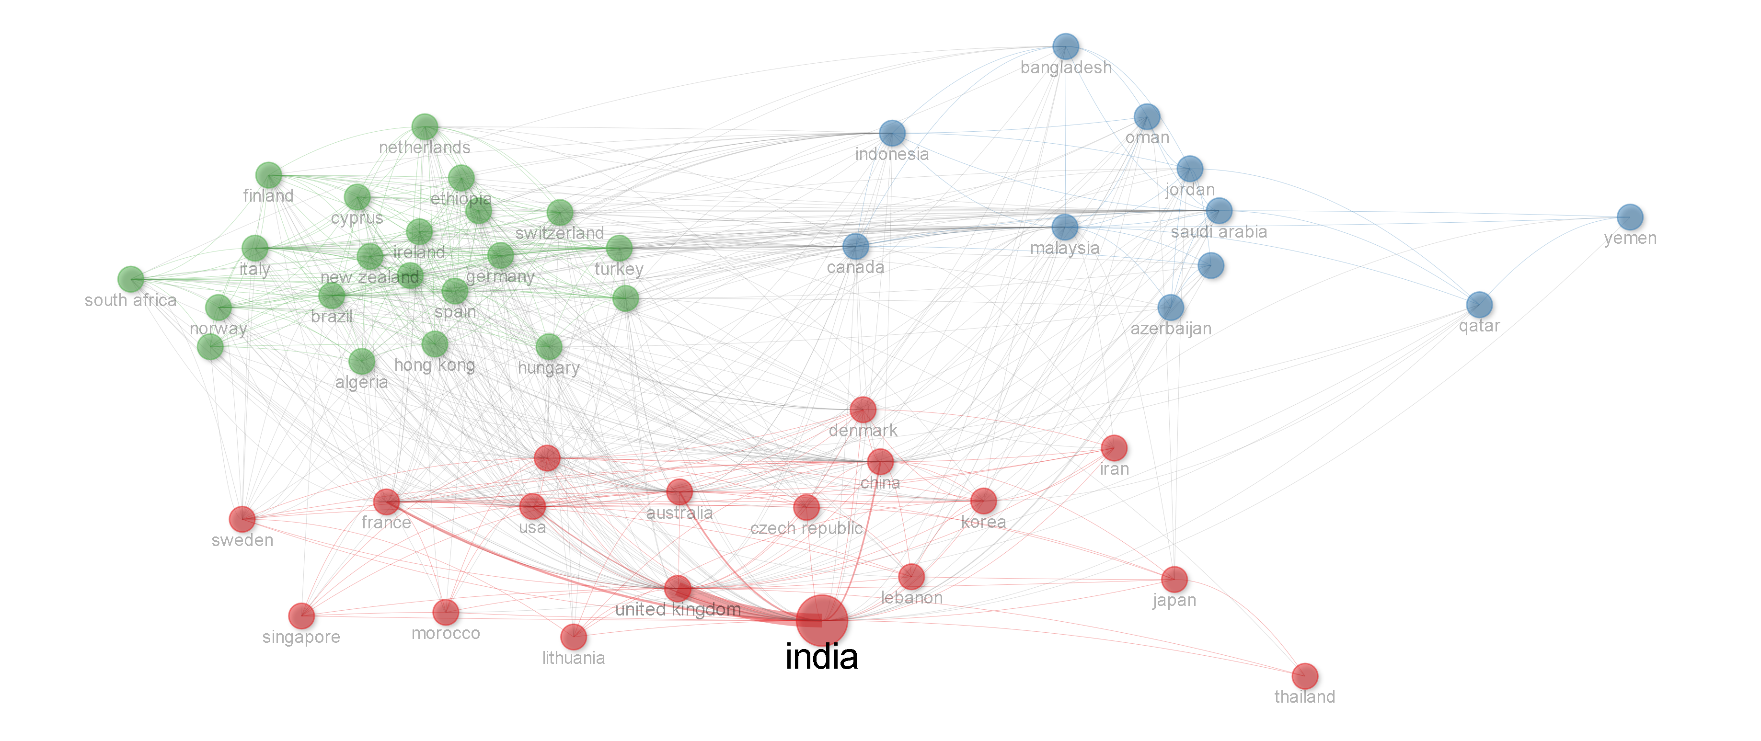
Figure 15. Country collaboration network, showing India as the dominant hub bridging European and Asian/Middle Eastern clusters.
Source: bibliometrix/Biblioshiny output generated from the Scopus-exported dataset (N = 551).
Institution collaboration network. Figure 16 reveals a similarly India-centred institutional structure. The two largest clusters (red and green) are both dominated by Indian institutions, including several campuses of the Indian Institute of Management, the Indian Institute of Technology Delhi and Kharagpur, O. P. Jindal Global University, Jaipuria Institute of Management, Graphic Era Deemed University, Amity University, Chitkara University, and the National Institute of Technology, together forming the network's structural core. A third (blue) cluster links Western business schools including NEOMA Business School, Swansea University, EDHEC Business School, and Symbiosis International indicating a distinct Euro-Indian collaboration corridor. A smaller (purple) cluster pairs Woxsen University (India) with Shanghai Maritime University (China), suggestive of an emerging India–China research linkage, while an isolated chain of institutions (Daffodil International University in Bangladesh, King Khalid University, Thamar University, and Albaydha University) forms a disconnected South Asian–Middle Eastern collaboration pocket with no path to the network's main component an emerging but currently self-contained corridor.
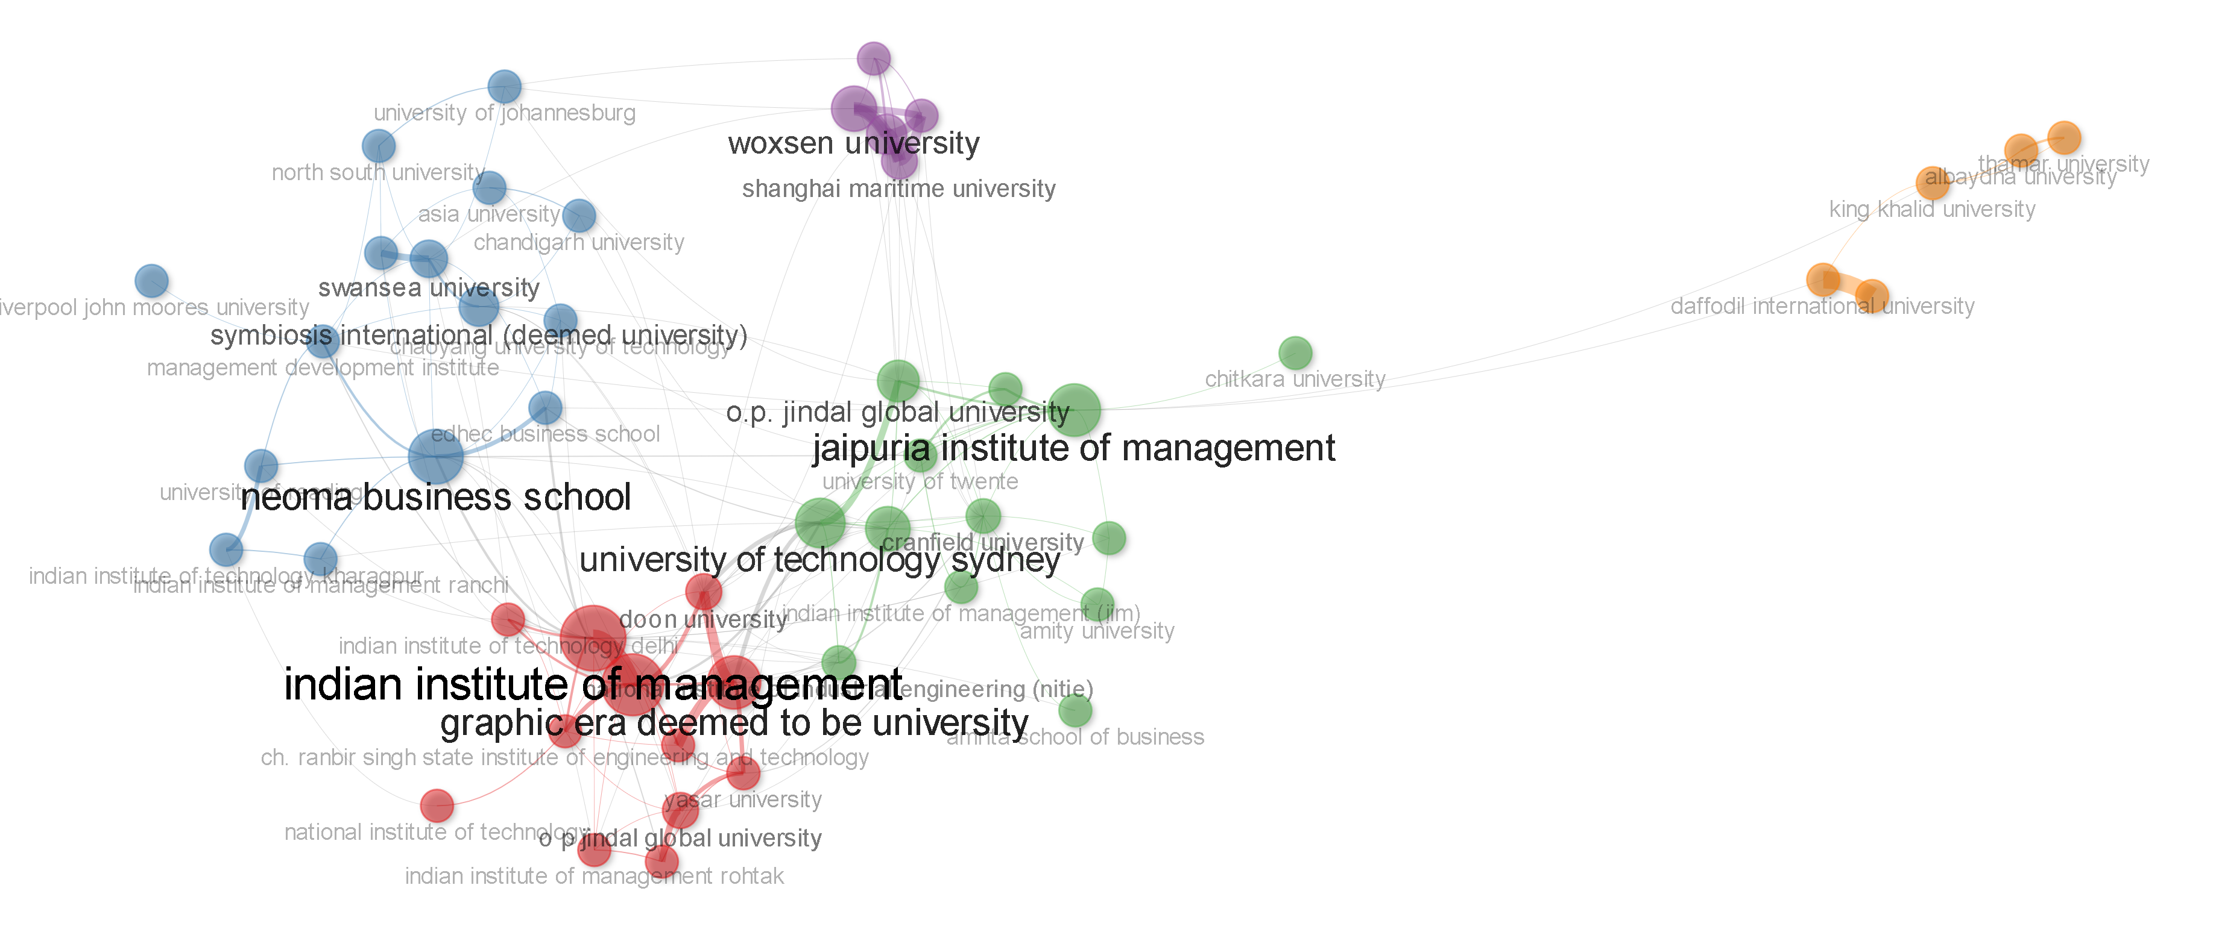
Figure 16. Institution (affiliation) collaboration network, dominated by Indian management institutes and universities.
Author collaboration network. Figure 17 identifies the field's most prolific and structurally central contributors. Kumar A. forms by far the largest and most central node, anchoring a red cluster with Luthra S. and Jamwal A. consistent with the author-productivity findings in Section 4.4, which identified a single dominant contributor credited on approximately 39 records. A second, blue cluster is anchored by Sharma M., linked to Govindan K., Jha P. C., Chatterjee P., and Joshi S.; the inclusion of Govindan K., an internationally recognised authority on green and sustainable supply chain management, signals a bridge between the network's Indian core and the broader international literature. A third, purple cluster is anchored by Mangla S. K., linked to Raut R. D. and Kumar M., while a fourth cluster bridges orange and green sub-groups around Gupta S., Kamble S., Bag S., Dwivedi Y. K., and Gunasekaran A. the latter two being highly cited scholars in information systems and operations management respectively, again indicating bridging ties into cognate disciplines. A small, entirely disconnected dyad (Pereira V. and Behl A.) appears at the network's periphery, illustrating that alongside one dominant, densely interlinked core the field retains several small, self-contained collaboration pockets, a structural signature typical of a still-consolidating research domain (Zupic & Čater, 2015).
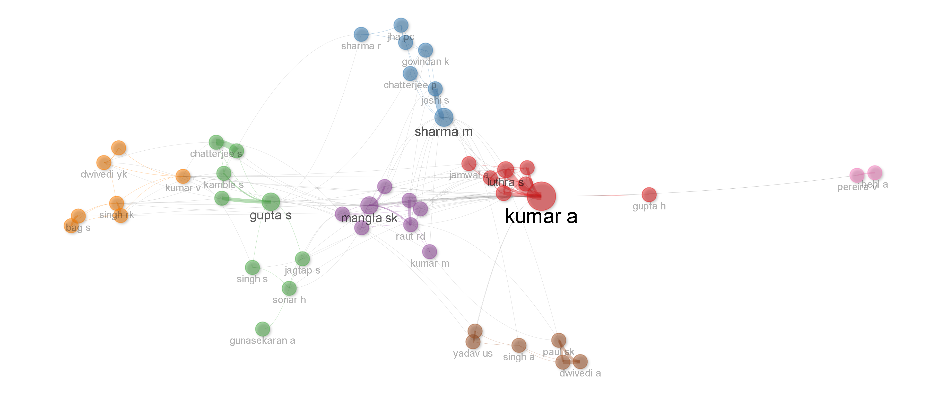
Figure 17. Author collaboration network, identifying Kumar A. as the most prolific and structurally central contributor.

5. Discussion
Read against the five research questions posed in Section 1, the results paint a coherent picture of a young, fast-growing, and geographically concentrated field that is transitioning from technology-labelled, review-heavy scholarship toward integrative, empirically validated inquiry.
On growth and productivity (RQ1), the field's trajectory negligible output before 2020, exponential growth through 2024, and a life-cycle model locating the inflection point at 2024.4 (R² = 0.998) is characteristic of a topic catalysed by an exogenous shock (the COVID-19 pandemic) superimposed on a pre-existing digital-transformation research wave. The apparent 2025–2026 plateau/decline should not, however, be read as evidence that scholarly interest in AI-enabled sustainable and resilient supply chains is waning; the 2026 figure is a partial-year artefact, and the field's Lotka exponent (β = 2.19, marginally above the classical value of 2) and Bradford core of only 11 journals both suggest a literature that is still consolidating its productive core rather than one that has exhausted its research agenda.
On influence and concentration (RQ2), the results reveal pronounced concentration at every level of analysis: a Bradford core of 11 journals (led by Business Strategy and the Environment and Annals of Operations Research) accounts for a disproportionate share of output against a long tail of 167 scattered sources; a small elite of authors (led by Kumar A.) accounts for a disproportionate share of productivity; and a single country (India) dominates both country-level output and the collaboration networks at every level (author, institution, country). This triple concentrati journal, author, and country is mutually reinforcing: the same small set of highly central Indian authors and institutions that dominates productivity also anchors the country's central position in the international collaboration network, a pattern consistent with prior observations that emerging-economy-led research fronts in sustainable operations management often coalesce around a small number of prolific research groups (Govindan et al., 2014; Mangla et al., 2018).
On conceptual structure (RQ3), the keyword-frequency and co-occurrence results confirm that sustainability- and supply-chain-management vocabulary numerically dominates the field, but that this vocabulary is structurally and semantically intertwined with AI/Industry 4.0 terms and resilience/risk terms, exactly as the conceptual convergence described in Section 2 would predict. The persistence of "COVID-19" as a top-ten keyword three-plus years after the acute phase of the pandemic illustrates how an exogenous shock can leave a durable imprint on a field's conceptual vocabulary long after its proximate cause has receded from public attention.
On thematic evolution (RQ4), the three-period thematic mapping provides the paper's most novel contribution: a demonstrable shift from an early phase dominated by pandemic-reactive and review-based scholarship, through a consolidation phase in which resilience and digitalisation moved from niche to basic-theme status, to a recent phase characterised by the emergence of PLS-SEM-based empirical validation and the crystallisation of supply chain resilience and absorptive capacity as genuinely novel constructs (evidenced by their absence from the earlier-period keyword set in the Sankey diagram). This trajectory from conceptual/review work, through barrier-and-enabler studies, to large-sample empirical validation mirrors the maturation pathway observed in other fast-growing management sub-fields (Donthu et al., 2021; Zupic & Čater, 2015) and suggests the field is approaching, but has not yet reached, theoretical consolidation.
On social structure (RQ5), the collaboration networks reveal a field whose international structure is best described as hub-and-spoke rather than distributed: India functions as the near-exclusive bridge between otherwise loosely connected European and Middle Eastern/Asian research communities, and a comparable pattern recurs at the institutional and individual-author levels. While such concentration can accelerate knowledge production within the hub (as the productivity data confirm), it also carries a structural risk: a field this dependent on a small set of highly central actors and institutions may be more vulnerable to fragmentation should that core's research priorities shift, and it currently under-represents perspectives from Latin America, Central Asia, and much of Sub-Saharan Africa regions with acute, and in some respects distinctive, sustainable and resilient supply chain challenges of their own.

6. Theoretical and Practical Implications
Theoretical implications. This study contributes to the bibliometric literature by demonstrating, in a single integrated design, how performance analysis, strategic thematic mapping, thematic evolution, and multi-level collaboration-network analysis can jointly characterise a converging research front spanning three previously separate literatures (Industry 4.0/AI, sustainability/circularity, and resilience). The identification of a life-cycle inflection point, combined with an above-classical Lotka exponent and a compact Bradford core, offers a template for other researchers seeking to establish whether a fast-growing management sub-field has entered a maturation phase or remains in exploratory growth. The tri-period thematic map further offers a replicable method for detecting the transition from conceptual/review-dominated to empirically validated scholarship itself a marker of field maturity that is rarely made explicit in narrative reviews.
Practical and managerial implications. For journal editors and research strategists, the Bradford core (Table 4) identifies the small set of outlets led by Business Strategy and the Environment, Annals of Operations Research, and Sustainability that should be prioritised when monitoring or publishing in this space. For supply chain managers and policymakers, the thematic-evolution results (Figure 12) signal that the field's centre of gravity is moving away from technology-specific labels (blockchain, digital transformation as ends in themselves) toward integrative operational capabilities supply chain resilience, circular economy, and absorptive capacity suggesting that investment and policy attention should similarly shift from point technology adoption toward building the organisational capacity to absorb, apply, and sustain digital and circular practices. For research funders and doctoral supervisors, the pronounced geographic and institutional concentration identified in Section 4.9 suggests a concrete opportunity: funding and partnership mechanisms that connect the field's dense Indian research core with the currently under-represented regions identified in Section 4.5 could both diversify the evidence base and accelerate knowledge transfer to supply chains operating under different institutional and resource constraints.

7. Limitations and Future Research Directions
This study has several limitations that should temper interpretation of its findings. First, the corpus was drawn from a single database (Scopus); while Scopus offers broad coverage of the relevant literature, cross-validation against Web of Science, or a merged multi-database corpus, could alter specific counts (particularly for Bradford zone boundaries and country-level totals) even if the broad thematic and structural conclusions are likely to be robust. Second, the search strategy, though systematically applied under the PRISMA 2020 protocol, was keyword-based and therefore subject to the usual recall/precision trade-offs of Boolean retrieval; studies using non-standard terminology for AI-, Industry 4.0-, or resilience-related constructs may have been missed. Third, the 2026 data point is a partial-year observation, which affects both the annual-production trend (Table 3) and the life-cycle model's projected decline (Figure 2); the latter should be revisited once complete 2026 (and 2027) data become available. Fourth, author-keyword-based science mapping, while replicable and less subject to selection bias than manual coding, cannot fully capture nuance that a close reading of the core-cluster literature would reveal; a complementary systematic content analysis of the Bradford core's 11 journals is a natural next step. Future research should therefore (i) replicate this analysis with a merged Scopus–Web of Science corpus once the 2026–2027 publication window is complete; (ii) conduct a systematic, theory-building content analysis of the core literature identified here, particularly the emergent PLS-SEM-based empirical stream; (iii) empirically test the capability-based propositions implicit in the field's thematic evolution for instance, whether absorptive capacity genuinely mediates the relationship between AI/Industry 4.0 adoption and supply chain resilience or sustainability outcomes; and (iv) extend empirical data collection to the currently under-represented regions identified in the country-level analysis, to test whether the field's dominant findings generalise beyond its current, India-centred evidence base.

8. Conclusion
This study set out to map the intellectual structure of research at the intersection of artificial intelligence, Industry 4.0, sustainability, and supply chain resilience, using a PRISMA-guided corpus of 551 Scopus-indexed articles and a comprehensive suite of bibliometrix performance-analysis and science-mapping techniques. The field is young effectively a post-2020 phenomenon but has grown explosively, reaching an estimated life-cycle inflection point in 2024 while remaining, by several measures (a compact Bradford core, an above-classical Lotka exponent, and a hub-and-spoke collaboration structure centred on India), in an active consolidation phase rather than a fully matured steady state. Its conceptual structure has moved demonstrably from technology-labelled and pandemic-reactive themes toward integrative constructs supply chain resilience, circular economy, and absorptive capacity validated increasingly through large-sample empirical (PLS-SEM-based) research rather than conceptual or review work alone. For researchers, editors, managers, and policymakers alike, these findings offer both an evidence-based map of where the field currently stands and a concrete agenda spanning database triangulation, core-literature content analysis, empirical theory testing, and geographic diversification for where it might productively go next.

References
Aria, M., & Cuccurullo, C. (2017). bibliometrix: An R-tool for comprehensive science mapping analysis. Journal of Informetrics, 11(4), 959–975. https://doi.org/10.1016/j.joi.2017.08.007
Aria, M., Misuraca, M., & Spano, M. (2020). Mapping the evolution of social research and data science on 30 years of Social Indicators Research. Social Indicators Research, 149(3), 803–831. https://doi.org/10.1007/s11205-020-02281-3
Bag, S., Wood, L. C., Xu, L., Dhamija, P., & Kayikci, Y. (2020). Big data analytics as an operational excellence approach to enhance sustainable supply chain performance. Resources, Conservation and Recycling, 153, 104559. https://doi.org/10.1016/j.resconrec.2019.104559
Bai, C., & Sarkis, J. (2020). A supply chain transparency and sustainability technology appraisal model for blockchain technology. International Journal of Production Research, 58(7), 2142–2162. https://doi.org/10.1080/00207543.2019.1708989
Belhadi, A., Kamble, S., Jabbour, C. J. C., Gunasekaran, A., Ndubisi, N. O., & Venkatesh, M. (2021). Manufacturing and service supply chain resilience to the COVID-19 outbreak: Lessons learned from the automobile and airline industries. Technological Forecasting and Social Change, 163, 120447. https://doi.org/10.1016/j.techfore.2020.120447
Bradford, S. C. (1934). Sources of information on specific subjects. Engineering, 137, 85–86.
Christopher, M., & Peck, H. (2004). Building the resilient supply chain. International Journal of Logistics Management, 15(2), 1–14. https://doi.org/10.1108/09574090410700275
Cobo, M. J., López-Herrera, A. G., Herrera-Viedma, E., & Herrera, F. (2011). Science mapping software tools: Review, analysis, and cooperative study among tools. Journal of the American Society for Information Science and Technology, 62(7), 1382–1402. https://doi.org/10.1002/asi.21525
Donthu, N., Kumar, S., Mukherjee, D., Pandey, N., & Lim, W. M. (2021). How to conduct a bibliometric analysis: An overview and guidelines. Journal of Business Research, 133, 285–296. https://doi.org/10.1016/j.jbusres.2021.04.070
Dubey, R., Gunasekaran, A., Childe, S. J., Blome, C., & Papadopoulos, T. (2019). Big data and predictive analytics and manufacturing performance: Integrating institutional theory, resource-based view and big data culture. British Journal of Management, 30(2), 341–361. https://doi.org/10.1111/1467-8551.12355
Dwivedi, Y. K., Hughes, L., Ismagilova, E., Aarts, G., Coombs, C., Crick, T., Duan, Y., Dwivedi, R., Edwards, J., Eirug, A., Galanos, V., Ilavarasan, P. V., Janssen, M., Jones, P., Kar, A. K., Kizgin, H., Kronemann, B., Lal, B., Lucini, B., … Williams, M. D. (2021). Artificial Intelligence (AI): Multidisciplinary perspectives on emerging challenges, opportunities, and agenda for research, practice and policy. International Journal of Information Management, 57, 101994. https://doi.org/10.1016/j.ijinfomgt.2019.08.002
Elkington, J. (1997). Cannibals with forks: The triple bottom line of 21st century business. Capstone.
Ellen MacArthur Foundation. (2013). Towards the circular economy: Economic and business rationale for an accelerated transition. Ellen MacArthur Foundation.
Govindan, K., Kaliyan, M., Kannan, D., & Haq, A. N. (2014). Barriers analysis for green supply chain management implementation in Indian industries using analytic hierarchy process. International Journal of Production Economics, 147, 555–568. https://doi.org/10.1016/j.ijpe.2013.08.018
Gunasekaran, A., Subramanian, N., & Papadopoulos, T. (2017). Information technology for competitive advantage within logistics and supply chains: A review. Transportation Research Part E: Logistics and Transportation Review, 99, 14–33. https://doi.org/10.1016/j.tre.2016.12.008
Ivanov, D. (2020). Viable supply chain model: Integrating agility, resilience and sustainability perspectives lessons from and thinking beyond the COVID-19 pandemic. Annals of Operations Research. Advance online publication. https://doi.org/10.1007/s10479-020-03640-6
Ivanov, D., & Dolgui, A. (2020). Viability of intertwined supply networks: Extending the supply chain resilience angles towards survivability. A position paper motivated by COVID-19 outbreak. International Journal of Production Research, 58(10), 2904–2915. https://doi.org/10.1080/00207543.2020.1750727
Kamble, S. S., & Gunasekaran, A. (2020). Big data-driven supply chain performance measurement system: A review and framework for implementation. International Journal of Production Research, 58(1), 65–86. https://doi.org/10.1080/00207543.2019.1630770
Kamble, S. S., Gunasekaran, A., & Gawankar, S. A. (2018). Sustainable Industry 4.0 framework: A systematic literature review identifying the current trends and future perspectives. Process Safety and Environmental Protection, 117, 408–425. https://doi.org/10.1016/j.psep.2018.05.009
Kessler, M. M. (1963). Bibliographic coupling between scientific papers. American Documentation, 14(1), 10–25. https://doi.org/10.1002/asi.5090140103
Kumar, A., Luthra, S., Mangla, S. K., & Kazançoğlu, Y. (2020). COVID-19 impact on sustainable production and operations management. Sustainable Operations and Computers, 1, 1–7. https://doi.org/10.1016/j.susoc.2020.06.001
Lotka, A. J. (1926). The frequency distribution of scientific productivity. Journal of the Washington Academy of Sciences, 16(12), 317–323.
Luthra, S., & Mangla, S. K. (2018). Evaluating challenges to Industry 4.0 initiatives for supply chain sustainability in emerging economies. Process Safety and Environmental Protection, 117, 168–179. https://doi.org/10.1016/j.psep.2018.04.018
Mangla, S. K., Luthra, S., Mishra, N., Singh, A., Rana, N. P., Dora, M., & Dwivedi, Y. (2018). Barriers to effective circular supply chain management in a developing country context. Production Planning & Control, 29(6), 551–569. https://doi.org/10.1080/09537287.2018.1449265
Moher, D., Liberati, A., Tetzlaff, J., & Altman, D. G. (2009). Preferred reporting items for systematic reviews and meta-analyses: The PRISMA statement. PLoS Medicine, 6(7), e1000097. https://doi.org/10.1371/journal.pmed.1000097
Page, M. J., McKenzie, J. E., Bossuyt, P. M., Boutron, I., Hoffmann, T. C., Mulrow, C. D., Shamseer, L., Tetzlaff, J. M., Akl, E. A., Brennan, S. E., Chou, R., Glanville, J., Grimshaw, J. M., Hróbjartsson, A., Lalu, M. M., Li, T., Loder, E. W., Mayo-Wilson, E., McDonald, S., … Moher, D. (2021). The PRISMA 2020 statement: An updated guideline for reporting systematic reviews. BMJ, 372, n71. https://doi.org/10.1136/bmj.n71
Pritchard, A. (1969). Statistical bibliography or bibliometrics? Journal of Documentation, 25(4), 348–349.
Raut, R. D., Mangla, S. K., Narwane, V. S., Gardas, B. B., Priyadarshinee, P., & Narkhede, B. E. (2019). Linking big data analytics and operational sustainability practices for sustainable business management. Journal of Cleaner Production, 224, 10–24. https://doi.org/10.1016/j.jclepro.2019.03.181
Schwab, K. (2017). The fourth industrial revolution. Currency.
Small, H. (1973). Co-citation in the scientific literature: A new measure of the relationship between two documents. Journal of the American Society for Information Science, 24(4), 265–269. https://doi.org/10.1002/asi.4630240406
Tranfield, D., Denyer, D., & Smart, P. (2003). Towards a methodology for developing evidence-informed management knowledge by means of systematic review. British Journal of Management, 14(3), 207–222. https://doi.org/10.1111/1467-8551.00375
Van Eck, N. J., & Waltman, L. (2010). Software survey: VOSviewer, a computer program for bibliometric mapping. Scientometrics, 84(2), 523–538. https://doi.org/10.1007/s11192-009-0146-3
Zupic, I., & Čater, T. (2015). Bibliometric methods in management and organization. Organizational Research Methods, 18(3), 429–472. https://doi.org/10.1177/1094428114562629

