Chapter 1
Introduction, Review of Literature and Research Methodology
1.1 Background of India–Maldives Relations in the 21st Century
India – Maldives bilateral relations are a significant part and parcel of India's foreign policy towards its South Asian and maritime neighbours. Geographical proximity, historical and cultural linkages, economic interdependence, defence cooperation and strategic significance of the Indian Ocean are all shaping the relationship. While the two countries differ as far as geographical size, population size and economic structure are concerned, their geographical proximity and shared maritime environment have provided a long-standing platform for bilateral engagement.
The Maldives is an archipelagic country located in the Indian Ocean, to the southwest of the Indian continent. It plays an important role in maritime affairs in the region, considering the presence of commercial shipping and energy supplies along the Indian Ocean. The stable and cooperative relations between India and the Maldives in the field of maritime security, regional stability, protection of sea lines of communication, and prevention of external threats in the maritime neighbourhood are important for India. The Maldives has opportunities to receive assistance from India in development, healthcare, education, infrastructure development, disaster relief and security cooperation (Ministry of External Affairs [MEA] Government of India, n.d.).
The Maldives gained independence in 1965, and India and the Maldives established formal diplomatic relations with each other. In the following decades, bilateral cooperation, besides the diplomatic relationship, developed to include economic support, development cooperation, defence training, maritime security and people-to-people exchanges. This early interaction with the Maldives laid the basis for the India-Maldives relationship that has been crucial for both countries, albeit marred by political tensions and variance on the foreign policy agendas from time to time.
New opportunities and challenges arose for this relationship at the dawn of the twenty-first century. Changing international trade, the rise of China as an economic and strategic force, the rising importance of maritime security and the emergence of the Indo-Pacific changed the environment in the region. Thus, India-Maldives relations were not perceived simply as relations between two neighbouring countries; rather, they were seen as being part of the wider geopolitical competition-cooperation in the Indian Ocean.
The Neighbourhood First Policy, which was announced as one of the highest foreign policy priorities under Prime Minister Narendra Modi, is aimed at fostering greater engagement, cooperation, connectivity and security ties with neighbouring countries. However, the Maldives is of strategic importance in this policy due to its geographical location and the various bilateral interests that the two countries have with each other. Financial assistance, infrastructure projects, capacity building, humanitarian assistance, and maritime cooperation (MEA, Government of India, n.d.) have been a part of India's engagement.
However, bilateral ties have not been progressing evenly. The Maldives' foreign policy direction and India's engagement with the Maldives have been impacted by the country's political developments over time. While the Maldivians were engaging more with China, tensions arose in the relations during the presidency of Abdulla Yameen (2013--2018) over domestic political developments. Post-2018 elections of Ibrahim Mohamed Solih, there has been a renewed diplomatic engagement and focus on deepening ties with India. The sensitivity of bilateral relations to political considerations and the question of national sovereignty was further underscored by the subsequent political changes, such as the election of Mohamed Muizzu in 2023 and the shift in approach between the two countries in the areas of defence and development cooperation.
Such changes and continuity in the India-Maldives relations underscore India's commitment to keeping the ties afloat while also trying to bring new dynamics to the bilateral relationship. The likelihood of cooperation is high because of their geographical location and the fact that they share security interests; however, political differences, domestic public opinion and competing external partnerships can create tension. Thus, a historical understanding of the relationship, as well as the strategic context, the economic aspects and evolving political conditions in the twenty-first century are essential to an understanding of the relationship.
This study explores these interwoven aspects of India–Maldives relations. It puts special stress on the evolving nature of bilateral relations, India's security concerns, the impact of China, results of the bilateral dialogue, effectiveness of India's policy of neighbourhood first and the relevance of the Maldives in the security concerns of the Indo-Pacific region. The study employs a mixed methodology by analysing qualitative (official statements, agreements and expert interviews) and quantitative (secondary data) sources to gain a complete picture of the opportunities and challenges that are influencing the bilateral relationship.
Geographical, Historical, Cultural and Economic Connections between India and the Maldives
One of the most significant pillars of bilateral relations between the two countries is the geographical proximity. One of the key pillars of the bilateral relationship between India and the Maldives is its geographical proximity. It is to be noted that the Maldives is situated in the north-central Indian Ocean, to the south-west of the Indian mainland and is not far from India's Lakshadweep region. It is more than just a relatively small geographical area because of its proximity to main maritime routes that link the Middle East, Africa and Asia. The Maldives is about 70 nautical miles away from Minicoy and 300 nautical miles from the Indian west coast, according to the High Commission of India in Malé. It is also in proximity to some of the key sea lanes used for commercial shipping, leading to cooperation between the two countries being relevant to maritime security and regional stability (High Commission of India, Malé, n.d.).
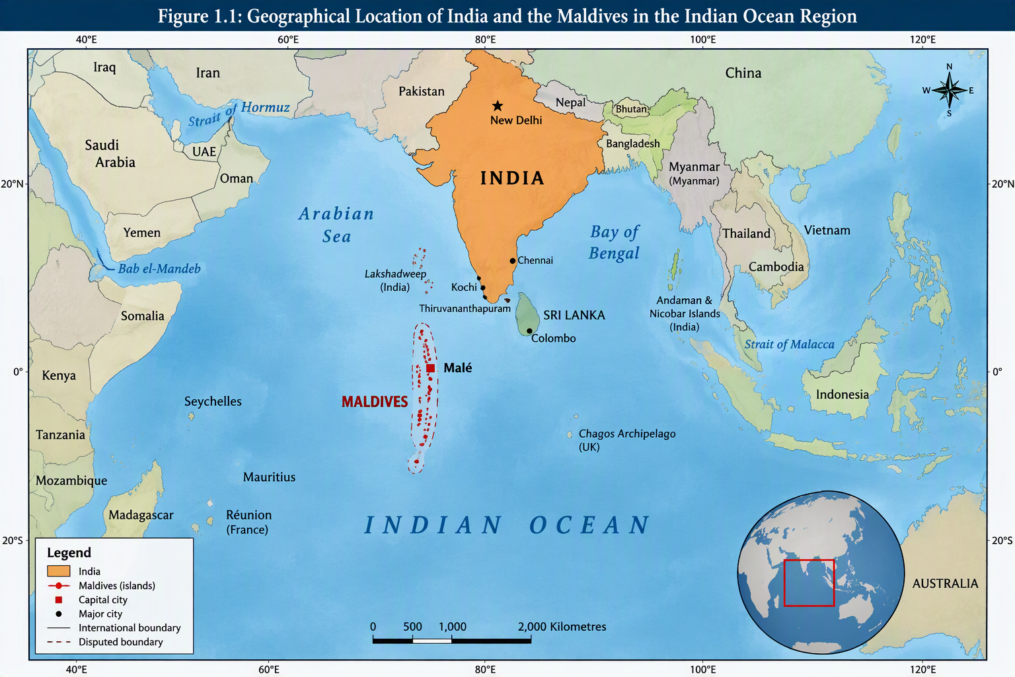
Figure 1.1: Geographical Location of India and the Maldives in the Indian Ocean Region
Source: Adapted from India Maldives Locator Map, Wikimedia Commons (Public Domain). [commons.wi...imedia.org]
India and the Maldives have had historical ties via migration, Indian Ocean cultural interactions and exchanges, and maritime trade. Long-standing relations between the two countries in terms of ethnic, linguistic, cultural, religious and commercial ties are recognised in the official bilateral account. These contacts have helped to build familiarity and laid the groundwork for a social basis for diplomatic working. After the Maldives gained independence in 1965, India was one of the first countries to establish diplomatic relations with the newly independent country (High Commission of India, Malé, n.d.).
Cultural links are still a vital aspect of the relationship. The geographic location has enabled people to move for educational, employment, health, tourism and business purposes. Indian professionals have been contributing to the Maldives in areas like education and healthcare, etc., and Maldivians have been heading to India for medical treatment, higher education, etc. Such exchanges foster linkages beyond the formal diplomatic framework and serve as a means to sustaining people-to-people connections. Meanwhile, this kind of relationship relies on the trust of the public and respect and sensitivity towards the domestic political issues of both nations.
Economical relations have also increased significantly. In 1981, India and the Maldives inked a trade deal which includes exports of essential goods to the Maldives. Later, bilateral economic cooperation has grown via trade, infrastructure, financial support, tourism, and health and digital communication. The relationship has gained significance in recent times as the Maldives is reliant on foreign supplies of goods and services, and India is accessible geographically to supply the essential goods, services and development assistance.
Infrastructure and connectivity are, in turn, also components of the economic dimension. Indian financial and technical support has been instrumental in the implementation of projects like the Greater Malé Connectivity Project and Hanimaadhoo International Airport in order to achieve the Maldivian development agenda. At the state visit of His Holiness the President (H.E. Mohamed Muizzu) to India in October 2024, the two countries reaffirmed their commitment to promoting further economic cooperation and agreed to the vision of a Comprehensive Economic and Maritime Security Partnership. During the visit, financial cooperation agreements and initiatives were also reached (Press Information Bureau [PIB], 2024a; Ministry of External Affairs, Government of India, 2025), as well as agreements on infrastructure and development.
Another aspect of economic exchange is tourism. Tourism is a critical part of the Maldivian economy, and accounts for a significant portion of the country's GDP, foreign exchange revenues, and jobs. Since the outbreak of Covid-19, the Indian tourist market has become an important market for the Maldives, especially after the pandemic. But tourism flows can be altered due to economic conditions, travel preferences, diplomatic developments, competition from other destinations, etc. Thus, data on tourism can contribute to the assessment of whether there has been a change in economic and people-to-people engagement but cannot stand alone to determine improvement or deterioration in bilateral political engagement (High Commission of India, Malé, n.d.).
In geopolitical, historical, cultural and economic aspects, India's proximity, historical ties, cultural interaction and economic interdependence offer a strong footing for the bilateral relationship between India and the Maldives. But that does not mean that these do not pose any political controversy or strategic rivalry. Instead, they offer a framework to encourage both nations to keep communicating and collaborating even in the face of U.S.-China differences regarding foreign policy priorities. To comprehend this dynamic, one needs to look into its history as well as the new strategic context in the twenty-first century.
Significance of Bilateral Relations in South Asia and the Indian Ocean Region
India-Maldives bilateral relations are not only important on a bilateral level but also of strategic significance, as both countries are located in a strategically vital maritime zone. The Indian Ocean is the link between the important economic centres of Asia, the Middle East, Africa and Europe. It has a significant volume of commercial traffic and is significant for the transportation of energy supplies, manufactured goods and other commodities. Stability in this marine setting is thus significant for the economic development in the region and for international trade.
Maldives is the closest neighbouring country of India at sea. Its geographical location is relevant to both maritime domain awareness, SAR, HA and DR as well as the prevention of transnational maritime crime due to its proximity to strategic shipping routes and its cooperation with India. India has therefore established defence and security partnership with the Maldives in the areas of military training, joint exercises, capacity building, provision of assistance, equipment, etc. Defence and security is one of the key areas of the bilateral partnership, as recognised by the Government of India (MoE, 2025).
The Maldives also has its national security and development interests. It is a small island nation and is plagued with problems of maritime surveillance, climate change, environmental vulnerability, economic reliance on tourism and the protection of its vast maritime areas. India's cooperation can help it build its capacity to respond to emergencies; enhance maritime security, and strengthen critical infrastructure. But the Maldives also wants to maintain its sovereignty, strategic independence and the freedom to have relations with several outsiders. It is therefore important to not view its foreign policy as being limited to regional interests of India.
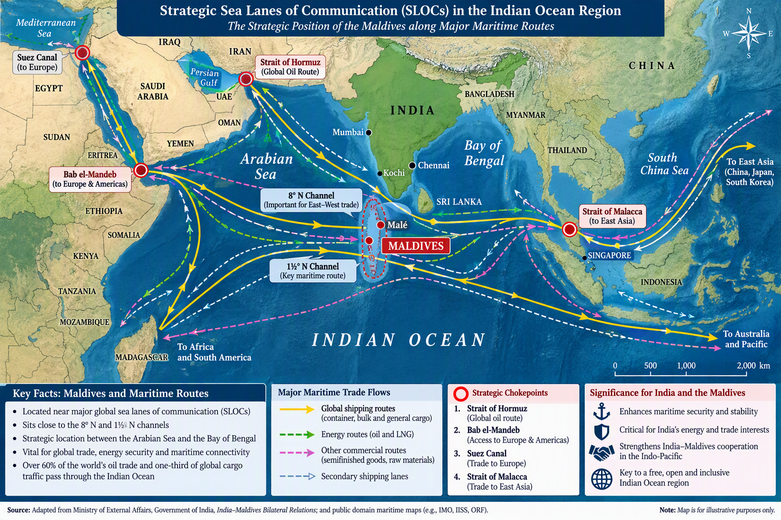Figure 1.2: Strategic Sea Lanes of Communication (SLOCs) and the Strategic Position of the Maldives in the Indian Ocean Region
Source: Adapted from India–Maldives Bilateral Relations, Ministry of External Affairs, Government of India.
India-Maldives relations not only overlap with the broader mechanisms of cooperation in the Indian Ocean at the regional level, but also play a key role in the broader Indian Ocean framework. Regional cooperation in areas of maritime security, disaster management and information sharing is complemented by bilateral cooperation. The Colombo Security Conclave, involving the participation of India, Maldives, Sri Lanka and other countries, aims to tackle common security challenges will be an institutional mechanism. India, Maldives, Sri Lanka, and Mauritius, in August 2024, signed the founding documents of the conclave, working towards building regional cooperation. India, Maldives, Sri Lanka and Mauritius signed the founding documents of the conclave in August 2024, with a focus on strengthening regional cooperation.
The connection also holds for India's overall Indo-Pacific approach. This has made the Indo-Pacific a very relevant strategic topic for discussion, owing to the interplay between maritime trade, military strength, connectivity and competition among the great powers. India's positive engagement with the Maldives is crucial for fostering a stable maritime setting and fostering regional cooperation. Interactions with India and other actors in the region help the Maldives to attract investment, access development assistance and improve its foreign relations.
But regional cooperation should not be seen as a substitute for the danger of over-competition among regionals. In India-China dynamics, the Maldives' stand-off with India could be seen as a reflection of its own foreign policy preferences and developmental priorities, which may not be given due consideration. An India-Maldives sustainable bilateral relationship, therefore, requires both sides to attend to the practical needs of the Maldives with the recognition of its sovereignty and the right of diversification of the Maldives' external partnerships.
Bilateral development and security, regional stability in the Indian Ocean and South Asia, and the larger Indo-Pacific strategic landscape are thus key to India–Maldives relations. The dimensions serve as a foundation for an analysis of how opportunities and constraints for India to engage with the Maldives.
Changing Regional and International Geopolitical Environment
The Indian Ocean region has witnessed some dramatic shifts in geopolitics in the 21st century. The strategic value of island states like the Maldives has been enhanced in recent years due to their rising economic significance, the development of maritime trade and connectivity and rising involvement of external powers in the region. Both India and the Maldives have seen their foreign policy calculations change due to these changes.
The security of the neighbourhood and the security of the sea-lanes approach to India are considered among the important interests of the country. India has always considered the security of its immediate neighbourhood as an important interest of the country, and also the security of the sea-lanes approaches to India. This concern is evident in its cooperation with the Maldives in the fields of development cooperation, defence cooperation, financial support and diplomatic dialogue. The Neighbourhood First Policy spells out the concept of enhancing the ties with neighbouring states, while the cooperativeness and regional security aspects are highlighted in India's maritime outlook. In October 2024, India and the Maldives signed a Comprehensive Economic and Maritime Security Partnership (PIB, 2024a) that is a mix of economic development and maritime cooperation.
Meanwhile, as China has increased its economic and diplomatic presence in South Asia and the Indian Ocean, other factors have entered into India's regional equation. Chinese involvement in the Maldives has involved infrastructure, finance and enhanced political ties. Based on the Maldivian point of view, partnerships with China could open up investment opportunities, infrastructure and economic opportunities. But from the Indian point of view, the growth of Chinese influence in its immediate maritime environment is a matter of concern from both strategic access and regional competition aspects, as well as external involvement for long-term consequences.
Sultana (2024) has looked at the increasing Chinese presence in the Maldives and the Chinese motives as well as India's anxieties. According to her analysis, China-Maldives engagement would be a strategic intent on China's part and the economic and developmental aspirations of the Maldives. The relationship should thus be regarded not as a military-security one, but rather as an economic one, made up of a mix of diplomatic decisions and extended geopolitical considerations.
This is complicated by domestic politics in the Maldives. Nahushal (2024) emphasises the link between domestic conflict and the nation's partnership management with the outside world. Political leadership changes can have an impact on public discourse on foreign policy, the presence of foreign personnel, development trade agreements, and the India versus China balance. The changes show that the factors of external pressure, as well as internal political competition and considerations for sovereignty, can also influence Maldivian foreign policy.
The recent days after the election of President Mohamed Muizzu in 2023 are a significant illustration. There were political issues relating to the deployment of Indian military personnel on Indian-provided aviation platforms. In February 2024, the two governments' High-Level Core Group met to discuss the methods for replacing military personnel linked to those platforms, a sensitivity of the defence cooperation in the bilateral relationship (Ministry of Foreign Affairs, Republic of Maldives, 2024).
Later, however, the tensions between the two sides were not a hindrance to further diplomatic contact. The Comprehensive Economic and Maritime Security Partnership and financial aid to the Maldives are some of the components of the framework that was created during President Muizzu's state visit to India in October 2024. This shows the need for dialogue and institutional procedures in the resolution of disagreements. The Indian Council of World Affairs then termed the new level of engagement “significant” as it is associated with balancing regional security concerns with the national interests of the two countries (Mallempati, 2024).
There is thus a mix of cooperation, competition and negotiation in the geopolitical context. India wants to have a peaceful, friendly and secure maritime neighbourhood and the Maldives wants economic development, strategic autonomy and fruitful relations with several nations. The increasing regional footprint of China is another factor in these considerations, but it does not take away the agency of the Maldivian government.
Hence, the present study considers the India–Maldives relationship as a dynamic bilateral relationship, set against the backdrop of a regional and international framework. The study does not mean to imply that the Maldives have to opt for either India or China. Rather, it looks at how political developments, strategic considerations, economic ties and diplomatic efforts affect the options that are available for both nations and how these will impact regional cooperation.
1.2 Statement of the Research Problem
The bilateral relations between India and the Maldives have always been defined by their geographical proximity, cultural links, economic cooperation and economic interests in the sea. But the connection has undergone a lot of transformation in the twentieth century due to political shifts in the Maldives, India's Indian Ocean neighbourhood policy of India and the presence of China in the region, and its changing security priorities. Apart from the non-conformism regarding foreign policy orientation, defence arrangements and external partnerships, both countries have strong interests in cooperation but, at times, have caused diplomatic tensions.
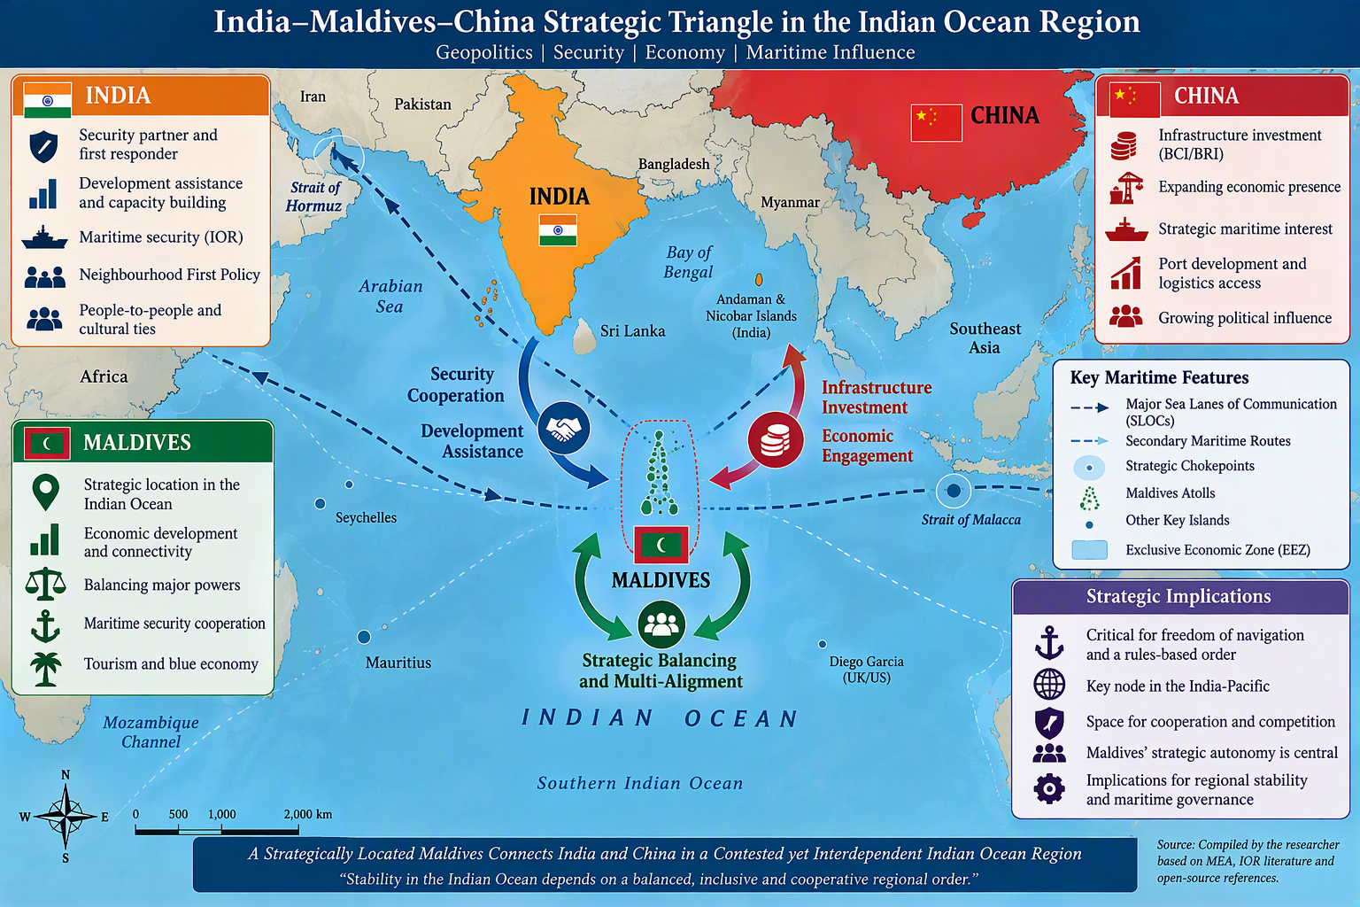
Figure 1.4: India–Maldives–China Strategic Triangle in the Indian Ocean Region
Source: Developed by the researcher based on India–Maldives Bilateral Relations and literature on Indo-Pacific geopolitics.
The overall research question of this study is: What went wrong in India- Maldives relations in the twenty-first century, and how has India tried to safeguard its strategic interests while keeping its relations with the Maldives cooperative? The issue is bilateral cooperation, domestic politics, external power rivalry and regional security.
The following is a discussion of four major aspects of this research problem.
1.2.1 Changing Dynamics of India–Maldives Relations
The most significant issues that mar the understanding of the bilateral relationship between India and the Maldives are the different nature and intensity of engagement between India and the Maldives during different Maldivian governments. Political leadership and domestic political factors have affected the way foreign policy is considered and the degree of cooperation with India, although the relationship has a strong geographical and historical basis.
These changes are shown in the period from 2013 onwards. Abdulla Yameen's presidency saw the Maldives intensify its relationship with China, and India's political and diplomatic partnership with the Maldives was beset by challenges. Following the election of Ibrahim Mohamed Solih in 2018, there has been a renewed engagement with India and greater focus on development assistance and bilateral interaction. The elections in 2023 saw a resurgence of debates on the presence of Indian military personnel and the direction of the Maldives' foreign policy with Mohamed Muizzu's election.
The developments show that while there is no automatic link between geographical proximity and steady political relations, the latter can be established with the help of friendship of a long-standing nature. Rather, bilateral relations are shaped by the domestic political preferences, public perceptions, economic interests and priorities of the different governments that come and go. The paper by Nahushal (2024) emphasises the relationship between domestic political rivalries and the Maldives' relationship with external powers, thus highlighting the critical role of domestic politics in a proper understanding of the Maldives' foreign policy.
Meanwhile, the reopening of the dialogue over the past months, which culminated in a vision of a Comprehensive Economic and Maritime Security Partnership in October 2024, demonstrated that diplomatic dialogue can serve to defuse potential disagreements and re-establish cooperation (PIB, 2024a).
The problem of this research is, therefore, to explain the factors that caused the continuity and change in the relationship. It aims to determine if bilateral engagement is more institutionalised and resilient or less, and if it is more sensitive to political changes than it is to foreign policy priorities.
1.2.2 Strategic Competition between India and China in the Indian Ocean
The second issue is the growing strategic significance of the Maldives in the larger strategic context between India and China. The Indian Ocean is an important region for global trade, shipping and ocean security. As such, the geopolitics of the Maldives are more significant than the size and population of the Maldives.
India is interested in the Maldives' stability for its maritime interests and regional security. It is cooperating with the Maldives in the areas of defence training, maritime surveillance, capacity-building and assistance for security infrastructure development. These activities highlight India's efforts to create a peaceful and cooperative maritime neighbourhood (Ministry of External Affairs, Government of India, 2025).
The rising economic and diplomatic ties between China and the Maldives are adding a new layer of geopolitical complexities. The cooperation in the form of infrastructure and finance from China can play a role in the development of the Maldives and also boost the presence of the Chinese economy and diplomacy in the Indian Ocean region. According to the report by Sultana (2024), China's increasing proximity to the Maldives is driven by its strategic interests and the Maldives' developmental aspirations and has raised concerns for its neighbours, specifically India.
The question isn't so much whether China has gained more influence in the Maldives. The character of such influence, the difference between economic engagement and strategic involvement, as well as how the Maldivian government leverages external partnerships to further its national interest, should also be explored.
In addition, the effectiveness and sustainability of India's response needs to be seen. If trust is lost due to excessive focus on strategic competition because Maldivian domestic issues and demands for sovereign decision-making are not taken into consideration, it could cause mistrust. On the other hand, India can continue to have positive relations with the Maldives without the latter having to forfeit all other relationships if it continues to maintain economic cooperation, development assistance and diplomatic engagement.
This study thus looks at the implications of China-Maldives relations on India's security concerns, India's reactions to them and whether bilateral relations can accommodate the Maldives' freedom of choice in foreign policy actions without compromising India's right to its maritime interests.
1.2.3 Political and Diplomatic Challenges in Bilateral Relations
The third aspect of the research question is the political and diplomatic issues which intermittently hamper the India-Maldives relationship. While there are clearly economic and security interests that make the countries more alike than different, the presence and role of foreign personnel, military cooperation, public statements, development arrangements and the right level of external partnerships can all be a source of disagreement.
The debate over Indian soldiers after the presidential elections of President Muizzu is an example of such a dilemma. The Maldives–India High-Level Core Group held talks on the arrangements for replacing the Indian military personnel operating aviation platforms in February 2024. This issue was a clear example of how a security cooperation area established between two nations could be politically sensitive when discussing matters related to sovereignty and foreign policy (Ministry of Foreign Affairs, Republic of Maldives, 2024).
These steps are indicative of two levels of bilateral relations. Practically, both countries have good reasons to cooperate at the governmental level in the fields of maritime security, development, trade and disaster response. But at the national level, foreign policy choices can be contested, fought out in elections and subjected to nationalist discourse. They have the potential to impact the level of trust and influence in Diplomatic relations and the implementation of Bilateral agreements at home.
India's task is to ensure that it continues to work together with the Maldives, but be sensitive to their political concerns. The Maldives' problem is how to move toward strategic autonomy while at the same time not harming the relationship that promotes its security and development. Both countries need to henceforth consider balancing national agenda and the utility of a sustained engagement.
The diplomatic engagement in October 2024 came with a renewed sense of willingness to cooperate, but merely a joint vision and formal agreement are not sufficient for successful implementation. There is a need to evaluate the effectiveness of bilateral mechanisms, difference management (in terms of regular dialogue) and the sustainability of bilateral cooperation in the midst of political leadership changes.
Therefore, this paper explores the key political and diplomatic challenges to bilateral relations and how dialogue, institutional mechanisms and mutual sensitivity could be used to handle these challenges.
1.2.4 India's Concerns Regarding Regional Security and External Powers
The fourth dimension of the research problem is the issue of security and India's apprehensions of the growing role of external powers in the Indian Ocean. The Maldives is a geopolitically strategic area, adjacent to major sea lanes. Therefore, events within the country can impact India's rating of maritime security, regional stability and India's wider Indo-Pacific interests.
India's security threats are in the fields of maritime surveillance, security of sea lines of communication, transnational crime, the possibility of strategic competition between external powers affecting the regional balance of security and security during humanitarian emergencies. The cooperation in the defence field has been taking shape in the areas of training, joint exercises, sharing of maritime information and capacity building between India and the Maldives. The two countries have also sought to deepen the cooperation through the security instruments of the respective regions, such as the Colombo Security Conclave, 2025 (organised by the Ministry of External Affairs, Government of India).
However, the mere fact of external presence in the Indian Ocean does not necessarily mean it presents a direct security threat. Economic support, infrastructure and diplomatic relations can be for legitimate developmental purposes. The question is how to separate out from the usual international cooperation the activities that might have a more far-reaching impact on regional security.
This has been sparked by China's increasing involvement in the Maldives. The work of Sultana (2024) and Nahushal (2024) explores the connection between China's strategic desires and the Maldives' developmental objectives and the significance of domestic political competition and the Maldives' effort to balance competing external demands, respectively. From this research, it becomes clear that regional development has to be analysed in the context of international strategic competition and that action is needed in the name of the smaller states.
India thus needs to adopt a policy that does not compromise the sovereignty of the Maldives and safeguards Indian interests in the sea. However, this will need to be backed by credible security cooperation, development partnerships, and diplomatic consultation and regional engagement. It is also important to acknowledge that the Maldives might want to pursue ties with multiple outside actors, instead of only Western ones.
The research problem thus is to find out how India can effectively deal with the security threats in the region and at the same time maintain a mutually beneficial relationship with the Maldives. It also aims to explore if the Neighbourhood First Policy is an effective policy for balancing India's strategic goals with those of the Maldives, and its foreign policy independence.
Concluding Statement of the Research Problem
It has been demonstrated in the preceding chapter that India-Maldives relations cannot be seen as pure geographical proximity, historical friendship or strategic rivalry. The interplay of domestic political shifts, economic interdependence, defence cooperation, external power rivalry and regional security needs are all responsible for shaping the relationship.
While these factors are crucial, a thorough evaluation should take into account how these factors interact over time, as well as how bilateral actions have been translated into concrete results. It has to also differentiate between the policy goals and the actual execution of those goals, and between economic involvement and actual rather than strategic influence.
With this backdrop, the present study aims at analysing the nature of the India–Maldives relationship in the twenty-first century, analysing India's security concerns and the response to China's rising influence, assessing the outcomes of the dialogue between the two countries, identifying significant political and diplomatic challenges and assessing India's Neighbourhood First Policy and its contribution to bilateral cooperation. It also explores the importance of the Maldives in the Indo-Pacific security landscape and the potential for an engagement-based approach to balance and ensure stability in the region.
The main question is whether, despite the differences in their politics and growing external competition, India and the Maldives can maintain a stable and cooperative relationship, and what policy options can increase the partnership's potential in the future.
1.3 Review of Literature
1.3.1 Introduction
In the present study, India – Maldives Relations in the Twenty-First Century, the review of literature is a crucial part. It offers an essential analysis of the various ways in which the growth of bilateral relations, India's policy of neighbourhood cooperation, the strategic importance of the Maldives, Chinese influence, and security cooperation in the Indian Ocean have been seen.
The diplomatic engagement or official statements of India-Maldives relations cannot be the only yardstick. They are influenced by historical connections, geographic proximity, domestic political events, the interests of maritime security and economic interdependence and the shifting power dynamics of the Indo-Pacific region. Thus, the literature that can be applied to this study is interdisciplinary and encompasses international relations, foreign policy analysis, strategic studies, regional security and political economy.
The changing nature of the relationship is one of the themes that runs throughout the literature. The Maldives has always been seen as a key maritime neighbour and partner in ensuring security in the Indian Ocean by India. The Maldives, on the other hand, has tried to maintain its sovereignty and has strived to develop its economy and broaden its ties with the outside world. China's growing economic and diplomatic engagement has introduced a new element to this relationship, so that bilateral relations are becoming increasingly intertwined with the broader strategic competition.
The literature also suggests that the India-Maldives relationship cannot be viewed just in terms of a competition between India and China. Domestic political rivalry in the Maldives, perceptions of foreign military presence, policy agendas of the governments in power and the Maldives' quest for strategic autonomy are also crucial. The focus of the present review is to outline the key themes of the existing scholarship, highlight links and contrasts between the themes, and outline the space that is being filled by this thesis.
1.3.2 Studies on the Historical Development of India–Maldives Relations
An understanding of the contemporary strategic and diplomatic relationship between India and the Maldives requires having an understanding of the historical development of the Indian-Maldives relationship. The two nations have several geographical, historical, cultural and trade links. After the Maldives gained independence in 1965, the formal ties progressed to a more formalised one with political consultation, development cooperation, trade and tourism, defence and regional diplomacy.
The official account of the High Commission of India in Malé, the Bilateral Relations between India & Maldives, underscores the many historical, cultural, linguistic, religious and commercial ties between the two nations. It also mentions that the geographical nearness and the location of the Maldives, close to the important maritime routes, are also important grounds in support of the bilateral relationship (High Commission of India, Malé, n.d.). It is the official point of view that sets the historical and geographical foundations of the partnership. It is an institutional account, however, and mainly reflects the interpretation of bilateral relations of the Indian government and not really a critical comparison of the interests and perceptions of both countries.
A major milestone in the history of the relationship has been the shift of India towards playing a regional security role. The attempted coup in the Maldives in 1988 and the subsequent military operation in India known as Operation Cactus were important events in bilateral relations. The intervention restored government control in the Maldives and enhanced India's ability to deal with security challenges in the neighbourhood. Concurrently, this episode serves as an excellent starting point for discussion on the Maldives' concerns about sovereignty and foreign entanglements and how they relate to the Indian role in regional security.
The significance of historical events is not just in terms of their short-term consequences, but also their impact on expectations for future politics. India has helped countries in emergencies, leading to India's image as a first responder. However, the politicisation of Indian involvement in Maldivian affairs shows that historical cooperation does not translate to public and political support for India's current involvement in Maldivian affairs.
In the literature on bilateral relations, the progress of practical cooperation in various fields, including infrastructure, healthcare, education, disaster prevention, capacity building, and maritime security, is highlighted. The areas of interaction showcase the connection that is not just confined to diplomacy and defence. They also highlight the impact of the bilateral partnership on the everyday developmental needs of the Maldives.
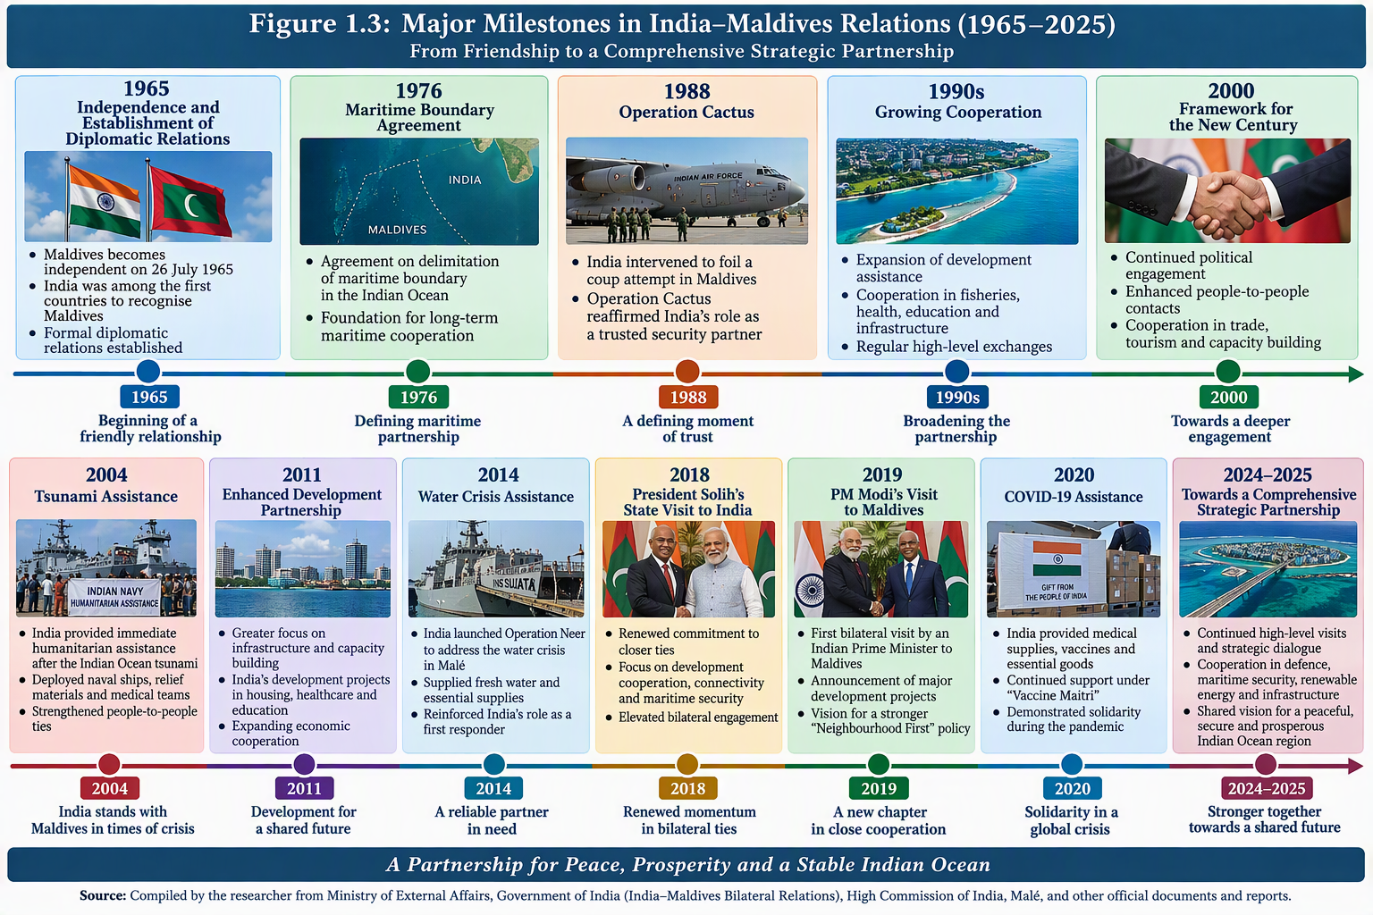
Figure 1.3: Major Milestones in India–Maldives Relations (1965–2025)
Source: Compiled by the researcher from India–Maldives Bilateral Relations, Ministry of External Affairs and High Commission of India, Malé
Defence cooperation, development projects, capacity-building and institutional engagement are important aspects of the India-Maldives relationship, as highlighted in the Indian government's 2025 India – Maldives Bilateral Brief (Ministry of External Affairs [MEA], Government of India, 2025). This is an excellent source of information on the scope of current cooperation. Official descriptions of programmes and agreements, however, should be looked at in conjunction with independent research in order to assess the programmes' implementation, political reception and future implications.
The theme echoes the historical context, with S. Mallempati's (2024) study on the recent India–Maldives engagements providing a modern twist to the historical overview. It discusses recent developments in the diplomatic field in the regional context and the importance of maintaining bilateral engagement. The latter analysis, India–Maldives Relations: A Timely Reset, takes up how India's re-engagement after a spell of tension has assumed importance (Mallempati, 2025). Together, these analyses indicate that the friendship-cooperation relationship is not a straightforward one. Rather, it is defined by a continuity of strategic interests, coupled with periodic squabbles about the nature and degree of Indian participation.
This is especially seen in the events of 2023-2024. Issues of sovereignty, domestic political legitimacy and bilateral cooperation were brought into the limelight due to political differences over Indian military personnel and foreign security assistance. The Maldives Ministry of Foreign Affairs' statement to the press on the second meeting of the High Level Core Group for the Maldives for February 2024 included discussion about the replacement of Indian military personnel on aviation platforms with civilian personnel, on agreed timelines (Ministry of Foreign Affairs, Republic of Maldives, 2024). The importance of this official Maldivian account is that it records the issue from the Maldives' point of view alongside Indian government accounts which focus on maritime security, development cooperation, etc.
Interrelationship between the studies: Bilateral interest and its continuity have been observed in historical and contemporary literature, which revealed tension between them, and the political interpretation of India's role has changed over time. While the long-term friendship, security cooperation and developmental interaction are highlighted as the official Indian approach, Indian diplomatic sources speak of negotiating conditions of cooperation, as Maldivian diplomatic statements do. Mallempati's analyses link these views by focusing on the process of renewed engagement as one of diplomacy rather than assuming that historical bonds have done away with current disagreements.
The core implication of the historical development of India–Maldives relations in the present research is to analyse the domestic political conditions while studying the changing aspects of India–Maldives relations. Tensions can arise, and bilateral cooperation can be restored for historical reasons, but not simply because of these.
1.3.3 Literature on India's Neighbourhood Policy
To understand India's relationship with the Maldives, it is essential to understand India's neighbourhood policy, which gives a broader foreign policy framework for the same. India is often seen to engage with neighbours in the context of regional peace and stability, political consultation, development cooperation, connectivity, trade, disaster response and security cooperation. The Neighbourhood First Policy aims to prioritise India's immediate neighbours in its diplomatic approach and regional cooperation.
The policy holds significance in the context of the Maldives due to the geographical closeness, maritime location, development needs and applicability of the policy in the context of security of the Indian Ocean for India. India's involvement of India has been in the areas of infrastructure, community development, health and education support, capacity building, financial assistance, disaster relief and also in maritime cooperation. The activities provide an illustration of the use of both strategic and developmental instruments for neighbourhood policy.
The bilateral short document by MEA from the Government of India (2025) details the spectrum of Indian assistance and cooperation to the Maldives. A Vision for Comprehensive Economic and Maritime Security Partnership between India and Maldives (Press Information Bureau [PIB], Government of India, 2024a) also views bilateral relations as encompassing economic cooperation and maritime security and development priorities for the Indian government as declared in October 2024. These sources can help to align policy goals and institutional pledges to India's engagement.
But just because a project, money or official visit occurs within a neighbourhood, it does not mean that the policy is effective. Comprehensive assessment should also include a consideration of project implementation on schedule, effective delivery of project benefits, impact on local perceptions and/or bilateral cooperation stability in the event of government change.
The policy discourse on the neighbourhood also poses the question of what India should do to achieve a balance between its own aspirations for leadership and the sovereign equality of smaller neighbouring states. India's geographical and economic strengths have the potential to make it a key partner, but can also lead to a sense of 'asymmetry'. Smaller states could also be more likely to appeal to domestic political actors to mobilise the people in order to renegotiate agreements or look for a different international partner if they are concerned about external influence.
The Maldives is a relevant example to look at this problem. Its government might appreciate Indian support, yet at the same time want more autonomy over the conditions of security and economic co-operation. Therefore, if there is a disagreement on a specific project or military deal, it does not necessarily signal a breakdown in the bilateral relationship. Instead, it may represent a shift by the Maldivian political forces to re-imagine the relationship in a way that is to their domestic liking.
The diplomatic reset as discussed by Mallempati (2025) is relevant here to the process of maintaining political engagement even after a time of disagreement. The comprehensive partnership framework that was signed in October 2024 also shows how both sides can reaffirm their partnership and how the institutional and political framework (PIB) can be adapted (PIB, Government of India, 2024a).
Interrelationship among the studies: The official policy literature provides a description of what India is seeking through its neighbourhood policy, and the contemporary diplomatic literature offers insights into why this policy could be politically fraught to implement. The first focuses on cooperation, assistance and strategic partnership; the second on negotiation, public perceptions and shifting of political leadership. Both of them propose to assess the effectiveness of the Neighbourhood First Policy based on both the tangible results and the partner country's acceptance.
The main concern in this thesis is then not just whether India is giving priority to the Maldives but whether India's neighbourhood policy has had an impact on bilateral cooperation, India's strategic autonomy of the Maldives and the stability of relations during periods of political transition.
1.3.4 Research on the Strategic Importance of the Maldives
The importance of the Maldives has been discussed in the discussion of Indian Ocean geopolitics quite often. This is because of its location in the central Indian Ocean, its close proximity to the southern maritime approaches of India and its location near the important shipping routes in the Indian Ocean. These geographical features link the Maldives with maritime security, commercial shipping, surveillance, regional security and the interests of outside powers.
Maldives has become the subject of research that is increasingly looking beyond boundaries as a small island state to one whose geographication has brought it importance beyond its territory. This location has implications for India's activities to ensure awareness of the sea, security of sea lines of communication, timely response in case of emergency and combating transnational threats like piracy, trafficking and illegal fishing.
Anand Kumar's (2012) study on Chinese Engagement with the Maldives: Impact on Security Environment in the Indian Ocean Region focuses on the objectives of Chinese engagement with the Maldives and its implications for the security environment of the Indian Ocean Region. The article places the Maldives in the wider context of foreign interests and foreign involvement and examines the possible impact on the regional balance. It is important because it involves bilateral ties with the broader security context of the Indian Ocean, instead of viewing bilateral ties as a standalone diplomatic problem. Read Kumar's study.
Another contribution is the study by Kumar, Singh and Kundu (2024) Changing Contours of India–Maldives Relations. The authors link the geopolitical relevance of the Maldives to India's geopolitical interests, Maldives domestic political developments and China's growing presence in the Maldives. They also share India's efforts, such as the Neighbourhood First Policy and SAGAR, on the aspects of regional engagement and maritime stability. Their analysis makes it clear that the geopolitical importance of the Maldives is indissociable from its internal political dynamics and the broader geopolitical context. Read the study
Description of the maritime geography and its links with the security policies of neighbouring states is also highlighted in the strategic literature. India's concern for the Maldives is a testament to its proximity to its surrounding maritime waters, which are important to national security and trade. Meanwhile, the Maldives has its own security agenda, such as in the protection of its exclusive economic zone, maritime resources, territorial sovereignty and economic infrastructure. Therefore, the strategic relationship has two aspects – one regional and the other national for the Maldives.
However, this is significant as the strategic value of the Maldives cannot be assumed to indicate that the country is only a great power game field. The Maldives has a geographical advantage and multiple partners to work towards its development goals, improve its international image and to negotiate the conditions of external support.
Interrelationship between the studies: Kumar (2012) looks at China's involvement in the Indian Ocean and its potential impact on security in the Indian Ocean, while Kumar, Singh and Kundu (2024) focus on the evolving bilateral relationship in the light of Chinese strategic efforts and domestic politics in the Maldives. As a whole, these works show a move away from a purely external focus on the presence of power towards a focus on geography and domestic political decisions and regional competition.
These studies set the foundation for the strategic importance of the Maldives for the present thesis. But the research should not stop there; it should look at how this importance affects policy implementation in India, bilateral talks, security collaboration and how the Maldives will react to other foreign partnerships.
1.3.5 Studies on China's Growing Influence in the Maldives
In recent years, one of the most discussed topics in the field of studies on India–Maldives relations has been China's increasing presence in the Maldives. The development of the China–Maldives relationship has included diplomatic engagement, infrastructure development, economic cooperation and China's broader regional connectivity initiatives. Scholars have considered whether these developments offer the Maldives any useful economic prospects, affect the country's foreign-policy choices, or generate new strategic challenges for India.
Anand Kumar's (2012) study is an early contribution to this debate. Kumar's research on Chinese involvement and its impact on the security dynamics in the Indian Ocean highlights the linkages between China's relations with the Maldives and the broader strategic situation. The value of the work is that Chinese engagement could affect more than trade and development is realised at an early stage. However, the analysis of the subject should take into consideration changes in China-Maldives relations since then and the domestic political environment in which the relations between the two countries have emerged.
The article by Gulbin Sultana (2024), A Retrospective View on Growing Proximity between Maldives and China and India's Concerns, is more recent and nuanced. Sultana believes that China's strategic interests and those of the Maldives for economic and development purposes have helped foster greater bilateral ties. The article also highlights potential benefits in this relationship as well as some challenges, notably in the Maldives. It also observes that geopolitics is a political issue and that India has advantages due to its geographic proximity and stake among certain segments of the Maldivian population relating to the Chinese strategic concerns.
This analysis is significant since it raises a question about the nature of China–Maldives relations – does it mean that India is completely supplanted from the equation? The Maldives' quest for investment, infrastructure and diversified external relationships may also be seen as a relationship. Meanwhile, the politics of relations with China to weaken India's influence can raise concerns in New Delhi. The result is a high level of economic cooperation, as well as political competition and strategic interpretation at home.
An alternative understanding of the developments can be gained from the article 'Geopolitics in the Maldives: Intersection of Foreign Relations and Internal Political Rivalries' written by Ibrahim Nahushal (2024). Nahushal believes the external geopolitical environment and internal political controversies have long influenced Maldivian foreign policy. Foreign partnerships can be formed or developed for domestic political purposes by different political actors. The study thus warns against the interpretation of the Maldives' foreign policy in terms of the agendas of great powers.
The argument of Nahushal adds to Sultana's analysis. While Sultana is more focused on the development of China-Maldives ties and the concomitant Indian concerns, Nahushal talks about the shifting political connotations of external relationships in the face of domestic rivals. The two studies collectively argue that China's influence needs to be examined from at least three interconnected perspectives: through the prism of the economic impact of Chinese involvement in the country, the possible strategic implications, and the domestic political framework in which the relationship is viewed.
The concept of the security dilemma is applied in the case of India–China rivalry in the Maldives by a more recent study by Sidhyendra Sisodia (2025), Security Dilemma in the Maldives?: Analysing Sino-Indian Rivalry in a Strategic Island State. The study reveals that in the Maldivian context, a security dilemma exists between the two powers; however, the defensive nature of their actions in the study helps to reduce the intensity of the security dilemma. It provides a helpful frame of reference for the way in which defensive or cooperative actions that are performed by one state can be seen as a threat or a challenge by another state.
There is also a potential problem for smaller states from the security-dilemma viewpoint, namely that the smaller state is likely to be the target of an attack. The actions taken by India to increase its awareness of the sea or enhance its security cooperation can be looked at in broader terms of the Chinese strategic activity. On the other hand, the proposed movement of China could be interpreted in India as a threat to their security in the region even if specific projects are billed as ‘economic' or ‘developmental'. This means that the Maldives has a context shaped by a strategic competition over the intentions of external actors.
The security-dilemma approach can't, however, be applied mechanically. Not all Chinese infrastructure projects are necessarily seen as a strategic or military challenge, and not all Indian security projects are necessarily seen as a negative by the Maldives. All developments need to be judged individually on their parts: purpose, financial and institutional arrangements, implementation and political reception.
The interaction of the Chinese ambitions and the Maldives' developmental needs, the security implications of the Chinese engagement and the domestic political rivalry which may drive foreign-policy decisions are explored in these studies by Kumar (2012), Sultana (2024), Nahushal (2024), and Sisodia (2025). These are not alternatives to each other, but are in addition to one another. As they see it, there is too much of China's influence to be clearly attributed to strategic competition alone.
The primary research question for this thesis is how India's reaction to the growing engagement with China due to its rising presence maintains bilateral cooperation with the Maldives, and how the Maldives deals with challenges and opportunities arising from the competition among two key partners.
1.3.6 Literature on Regional Security and Cooperation
A broader context for in-depth study of the India-Maldives relations, outside the confines of bilateral cooperation, can be provided by the regional security and cooperation literature. The regional security and cooperation literature can provide a more general framework for assessing the bilateral relations between India and Maldives beyond the limited scope of bilateral contacts. The Indian Ocean is a sea region that is interwoven, and the security of one state can be impacted by other developments within the region. Maritime cooperation is important for both coastal and island states for the purpose of commercial shipping, energy transportation, fishing activities, utilisation of marine resources, environmental threats and transnational crimes.
Some of how India has been involved in the security of the Indian Ocean region are bilateral defence cooperation, defence training, joint exercises, maritime surveillance and cooperation via regional arrangements. These have been linked to capacity building and emergency response activities and efforts to enhance the country's maritime capabilities in the Maldives.
In addition to development assistance and political engagement, defence and security cooperation is identified as one of the key aspects of the India-Maldives bilateral ties in the MEA's India-Maldives Bilateral Brief (2025). Maritime security is also included in the broader context of bilateral cooperation in the comprehensive economic and maritime security partnership (PIB, Government of India, 2024a) announced in October 2024. These official documents contribute to the creation of the declared goals and institutional frameworks of cooperation, but the descriptions need to be evaluated in terms of implementation and effects.
Multiple states and institutions are also needed to gain security in the region. The Colombo Security Conclave is an example of cooperation on common security issues between the members of the Conclave. Considering the bilateral nature of their cooperation, arrangements like these are relevant to the Maldives as it gives opportunities to coordinate responses to maritime threats, as well as other transnational issues, apart from bilateral arrangements.
A more general issue that can be raised from the literature on regional cooperation is whether security partnerships can be maintained in cases of different perceptions by the member states about external powers. The regional cooperation and security cooperation capacity building initiatives may be aimed at bolstering capability and capacity, but their success will rely upon the willingness of partner countries to engage in them and how they feel it will affect national sovereignty.
The issue links directly with the recent issues of diplomacy between India and the Maldives. The debates on Indian security personnel flying on aviation platforms reveal that security cooperation is a political decision in respect of people, tasks and the public display of India-Pakistan security cooperation. The agreement for replacing the Indian military personnel with civilian ones in a certain period of time is recorded in the Maldivian government's statement in the High-Level Core Group in February 2024 (Ministry of Foreign Affairs, Republic of Maldives, 2024). It is clear from this case that the ongoing security cooperation will need to be adapted to take the new form as well as go deeper into the scope.
There is also regional security literature which applies to the Indo-Pacific. The geographical location of the Maldives becomes even more important as the external powers step up their diplomatic, economic and maritime relations in the Indian Ocean. But an orderly regional order needs more than strategic competition. Communication, transparency, respect for sovereignty, crisis management and working on common issues are also important.
Interrelationship of the studies: Official bilateral documents provide insights into the institutional aspects in which Indian and Maldivian security cooperation is conducted, and research on Sino-Indian rivalry provides explanations as to why the cooperation is more and more seen as broad strategic cooperation. The relevance of the work is the strategic competition and security perceptions, which are of particular importance, whereas the official statements show that cooperation is still going on via direct bilateral agreements.
The present research thus addresses regional security, both as a practical and a political process. It explores the potential of cooperation to enhance maritime and national security capabilities, its impact when political leaders change and how it can intensify or mitigate pressures resulting from external-power competition in the region.
1.3.7 Critical Synthesis and Interrelationship of the Literature
The literature above shows that there is no single strategic consideration that impacts India–Maldives relations; instead, several interconnected factors are at play. Historical relations form the basis for bilateral cooperation; the Maldives' neighbourhood policy sets the agenda for diplomatic and development cooperation; the strategic significance of the Maldives' geographical location opens up new opportunities and challenges; the rise of China's influence creates more opportunities and concerns; and regional security mechanisms set the institutional framework for Indian-Maldives cooperation.
These themes can be synthesised through five major arguments.
One, the past is no indication of the future in terms of political cooperation. Official Indian sources emphasise historical ties and long-standing assistance. The history of the bilateral relationship, though, in 2023-2024, indicates that bilateral relations can become problematic when domestic political priorities and perceptions of sovereignty shift. The relationship needs to be interpreted as a historically-situated but politically-charged one.
Secondly, India's 'neighbourhood policy' is a developmental and strategic policy. In the Maldives, India's assistance in the areas of infrastructure, capacity building, financial cooperation and security is a concrete solution provided to the needs of the Maldives and also enhances India's neighbourhood engagement. But the literature shows that just because assistance exists doesn't mean that it works. Its results are subject to implementation, acceptance by the public and the consistent implementation of political cooperation.
Thirdly, it is not possible to see the rise of China as a threat to India only. Kumar (2012) points to the possible security concerns in Chinese involvement, and Sultana (2024) stresses the connection between China's agenda and the Maldives' hopes for development. Nahushal (2024) also shows how domestic political competition shapes the nature of external partnerships, and how these partnerships are understood. All the studies suggest that Maldivian foreign policy is driven by its own logic and rationale, which is both internal and developmental.
Fourth, agency exists in the Maldives in spite of the asymmetry in power. It has a leadership that can engage in negotiations with India and China, reach out to the external world in a multi-faceted manner and attempt to safeguard national sovereignty. In this regard, Nahushal's analysis is quite significant as it focuses on the political players in Maldivian society. The Maldives cannot, therefore, be examined simply as a strategic battleground, but as a state which actively engages with it.
Fifth, the security relationship between the two sides and regional strategic competition are interrelated. Increased maritime cooperation will help bolster security capabilities, but can also prove politically sensitive if the involvement of foreign personnel, military arrangements or strategic intentions are up for discussion. Sisodia's (2025) security-dilemma analysis sheds light on the relationship between uncertainty and defensive policies between two powers. However, the impact of specific projects and agreements needs to be more explicitly determined via empirical research and not taken for granted.
Combined literature suggests that the India-Maldives relations need to be analysed in an integrated way which comprises the external pressures, domestic politics, bilateral institutions and measurable policy outcomes. This holistic approach sets the basis for determining the research gap.
1.3.8 Research Gap
Although there is a considerable literature on India – Maldives relations, there are a number of areas that need to be explored in greater depth. The absence of research doesn't mean that the topic has not been studied before. On the contrary, it is related to the necessity to join together existing explanations, to critically examine them in a systematic way and to critically look at knowledge gaps found in the literature examined.
1. Limited integration of historical, domestic and strategic explanations
Much of the literature addresses specific facets of the bilateral relationship – historical linkages, strategic interests of India, growing China presence, etc. – and changes in Maldivian foreign policy. The approaches are useful, but they do not necessarily account for all aspects of the interactions between the factors.
Thus, while historical friendship might account for India's historical presence in the Maldives, it cannot account for why there are disagreements in respect of military presence or foreign policy. Likewise, China's rise may affect India's strategic thinking although it does not completely account for the variability in Maldivian political actors' China and India policies.
Research gap: The need for an integrated analysis covering the relationship between continuity and change in domestic politics, bilateral diplomacy and external strategic competition throughout the twenty-first century.
2. Insufficient systematic evaluation of India's Neighbourhood First Policy
The Indian development assistance, defence cooperation and economic relations with the Maldives are described by official sources. But it is important to note that determining policy commitments is not the same as assessing the impacts of policies.
The literature reviewed serves as a foundation to understand the policy goals and the specifics of the policy, including bilateral trade, tourism, financial assistance, implementation of projects, security agreements and diplomatic engagements must be examined to determine the effectiveness of the policy. However, political take-up of Indian efforts needs to be addressed.
Research gap: It is essential to study the impact of the policy on India–Maldives relations in terms of its substance, continuity and public-political aspects beyond just the official statements and lists of projects.
3. The need to distinguish Chinese economic influence from strategic influence
The literature on the China–Maldives relations acknowledges opportunities for development as well as any security concerns. Yet, economic cooperation and diplomacy and military-strategic considerations are analytically separate and sometimes even in conflict, even if they merge.
The existence of infrastructure investment or an investment contract (development agreement) does not automatically imply strategic control. Likewise, if there is a debt exposure risk, or an impact on critical infrastructure, or a potential impact on maritime access or future security arrangements, it may be beneficial to examine an initiative in more detail and consider its underlying purpose as a measure of economic cooperation.
Research gap: The study should separate the economic footprint, political influence and possible strategic implications of China and explore the impact of each of these separate footprints on policy responses by India and the room for Maldives' diplomatic manoeuvre.
4. Underexplored relationship between domestic political change and bilateral outcomes
It is important to note that Nahushal (2024) offers an important account of the interplay of domestic political rivalries with Maldivian foreign politics. This is an essential viewpoint in the context of the diplomatic tensions surrounding the year 2023–2024.
The implications of the domestic political change, however, should be analysed in various aspects and across various periods of time and policy domains. Adapting to the changes in political leadership can affect the nature of military cooperation, bilateral negotiations, public statements and the rate of project implementation. It is important, therefore, not to confuse short-term differences in the bilateral relationship with greater shifts in the bilateral relationship.
Research gap: In order to have a systematic look at the influence of political leadership change, party competition and discussions on sovereignty on India's engagement and bilateral negotiations in the Maldives.
5. Need for systematic assessment of bilateral talks and agreements
Meetings, declarations, agreements and commitments are typical things that are recorded in an official statement. These sources are fundamental for determining the government's declarations and agreements. The announcement of an agreement doesn't necessarily indicate that its goals have been met, though.
For instance, a good diplomatic meeting can yield a deal on human resources, facilities, funding or security assistance. To comprehend its meaning, researchers have to differentiate between the announcement, formal agreement, the implementation and the observable outcome.
Research gap: The question of how bilateral talks and agreements can be analysed systematically through a process-tracing approach that links talks to policymaking and its impacts is yet to be addressed.
6. Need to connect bilateral relations with the wider Indo-Pacific security environment
It is known from the literature that the Maldives is of strategic importance in the Indian Ocean region, and that there has been an increase in the Maldives' engagement with external powers. The linkage of bilateral developments with the general regional security, however, needs further study.
The activities and perceptions of other powers can affect bilateral decisions, and India – Maldives cooperation can impact maritime security and regional diplomacy. Regional cooperation mechanisms offer potential for responding to common threats; however they can only be effective if they are used to respond to common threats and have trust and mutual interests.
Research gap: There is a need to invest in further research to understand the impact of Maldives' strategic location on India's maritime security considerations, the influence of external-power competition on bilateral cooperation and the role of regional mechanisms in enhancing security and stability in the region.
7. Need for an integrated empirical and analytical approach
Another deficiency is in the methodology. Qualitative research offers good explanations in the area of political events, strategic plans, and diplomatic differences. Official documents provide information on commitments of policy and institutional arrangements. Changes in the quantitative aspects of bilateral relations, such as trade and tourism, financial and other measurable aspects, can be identified by means of quantitative indicators.
These types of evidence are most beneficial when looked at all together, however. The qualitative interpretations can offer insight into the nature of changes in bilateral engagement, but cannot be used alone to explain why a diplomatic crisis may have occurred; quantitative trends can be used only to suggest changes in bilateral engagement occurred, and can indicate the scale and timing of those changes.
The research gap is to be tackled in the present research by the application of both qualitative and quantitative analysis techniques of the official documents, agreements, political speeches/diplomatic development, as well as secondary data, which is the relevant quantitative information. Using content analysis and process tracing, patterns and processes of change will be analysed.
1.3.9 How the Present Study Addresses the Research Gap
The present research, India-Maldives Relations in the 21st Century, aims at filling the above gaps by conducting an in-depth analysis of the bilateral relations from historical, diplomatic, strategic, economic and security dimensions.
Research gap | Approach adopted in the present study
Limited integration of historical and contemporary explanations | Examines the evolution of bilateral relations alongside changing regional and domestic political circumstances.
Insufficient evaluation of Neighbourhood First Policy | Studies development cooperation, economic engagement, diplomatic initiatives and security partnerships.
Difficulty distinguishing economic and strategic influence | Examines Chinese engagement through economic, political and security dimensions.
Limited analysis of domestic political change | Investigates how political leadership, party competition and sovereignty concerns affect bilateral relations.
Insufficient assessment of diplomatic outcomes | Analyses bilateral talks, agreements, implementation and subsequent developments through process tracing.
Limited connection with wider regional security | Examines maritime security, India's regional interests and the role of external powers in the Indo-Pacific.
Need for integrated empirical evidence. | Combines qualitative content analysis with quantitative secondary data from appropriate official and institutional sources.

The originality of the present study is in the effort to link the dimensions in one analytical approach. While normally the Indian neighbourhood policy, Chinese influence, Maldivian domestic politics and Indian Ocean security are taken as separate fields of study, it examines the interactions and the impact of these on the bilateral outcomes.
The study also separates between policy goals, diplomatic promises and policy results. This distinction is significant because that's how one can see the goals of the government in official statements and in the results of its implementation and the repercussions for the economy and diplomacy that come after.
The research will thus rely on primary sources (whenever available) such as official statements, treaties, agreements, diplomatic correspondence, political speeches and interviews. Secondary sources will be scholarly books and journal articles, policy research, institutional reports and relevant statistical publications. Qualitative content analysis will be employed to highlight emerging themes and process tracing will be employed to provide the context of the relationship between significant political events, negotiations and policy changes. The trends in bilateral interaction in the relevant areas will be traced with the help of quantitative secondary data.
It would not be correct to state that the study makes the assumption that India–Maldives relations are only influenced by the competition between India and China. Rather, it looks at the importance of geographical proximity, historical relationships, development needs, domestic political preferences, strategic perceptions and security issues in the region.
This way, the thesis aims to offer a balanced view of the 21st-century India-Maldives relations, understand the factors for cooperation and tension in the relations and how the two nations can maintain positive engagement in the evolving regional and international scenario.
1.4 Research Objectives
- To gain insight into the nature of India – Maldives relations in the changing scenario.
- To analyse India's security concerns in the Maldives and how it tries to balance Chinese influence.
- To investigate the results of 21st-century bilateral talks.
- To highlight the key issues in India – Maldives relations.
- To analyse the effect on the Maldives due to India's Neighbourhood First Policy.
- To understand the importance of the Maldives in Indo-Pacific security in the face of extra-regional powers.
1.5 Research Questions
- In the last few years, has India's foreign policy towards the Maldives been more cooperative or not?
- What is the strategic significance of the Maldives to India?
- Describe the change in relations between India and the Maldives in the twenty-first century.
- What is the success rate of India's policy of 'Neighbourhood first' in the relations with the Maldives?
- How has India been dealing with the increasing relations with China and the Maldives?
- What are some of the obstacles to security cooperation between the South Asian countries?
1.6 Hypothesis
- In the 21st century, India's foreign policy towards the Maldives has become more active towards fostering cooperation and friendship.
- India and the Maldives have been engaged in a bilateral relationship to counter threats to security in the region and strategic concerns.
1.7 Research Methodology
Research methodology is a systematic approach of the research process regarding the collection, organisation, analysis and interpretation of data to reach the goal of a study. The present research on India-Maldives Relations in the Twenty-First Century is an empirical and analytical approach which will analyse the evolution of bilateral relations, India's security interests, the rise of China's influence and the results of bilateral negotiations as well as the importance of the Maldives in Indo-Pacific security.
1.7.1 Nature of Research
The present study is of an empirical type and is also analytical. It is empirical, that is, it is based on evidence gathered from official documents, bilateral agreements, government reports, statistical data, research publications, political speeches and interviews (if available). The sources contain information on the diplomatic process, on economic and security cooperation and on foreign policy shifts.
The study is analytical in nature as it looks at the determining factors for the India–Maldives relationship and also analyses the relationship between the political developments and the strategic interests and outcomes of the bilateral relations. It aims to not only discover what has changed but also why and the impact of the changes on the relations between the two countries.
1.7.2 Research Design
The research adopts an exploratory and descriptive research design.
The exploratory aspect will look into issues that are evolving and dimensions of the India – Maldives relationship, particularly the impact of domestic political developments in India, India's Neighbourhood First Policy, and the strategic competition in the Indian Ocean between India and China and their engagement with the Maldives.
The descriptive part provides a brief overview of the evolution of bilateral relations, visits, agreements, and cooperation in the areas of economy, defence and security, and regional cooperation in the twenty-first century.
The combination of these methods allows for a description of the major developments and also provides an insight into political, economic and strategic factors that might help to explain these developments.
1.7.3 Sources of Data
Primary data and secondary data have been used in the study.
Primary sources can be official government publications, bilateral agreements, treaties, joint statements, diplomatic communications, parliamentary documents, political speeches and interviews with appropriate experts and officials (if available). These sources contribute to the definition of the respective stances of the two governments and the substance of bilateral agreements as well as the time frame of key diplomatic events.
Secondary sources are those that are books, peer-reviewed journal articles, research reports, policy papers, academic dissertations and publications by research institutes. These materials give theoretical points of view, historical interpretations and critical evaluations on India – Maldives relations, India's policy towards the Indian Ocean and the rise of Chinese presence in the Indian Ocean.
A combination of these two types of sources enables the study to make an official interpretation side-by-side with an independent scholarly one. In cases of conflicting information, the institutional context, intent and written support for the information will be taken into account.
1.7.4 Research Methods: Qualitative and Quantitative
The study takes on both qualitative and quantitative approaches in order to gain an overview of bilateral relations.
Diplomatic, foreign policy developments, political speeches, bilateral agreements and strategic debates are analysed with the help of qualitative methods. They address common themes such as strategic autonomy and external-power competition, regional security, and development cooperation, among others.
For the various numbers involved, quantitative methods will be used to explore numbers if they can be obtained and compared. They can range from bilateral trade, the number of tourists, financial support, expenditure on development projects and much more. Data will be presented in tables, charts and comparisons of time series, when appropriate.
The two methods are complementary. Quantitative information can reveal change and trends, and qualitative information can be used to provide insights into the political and strategic environment of the change. The study will not be used to make statistical inferences about causation.
1.7.5 Data Collection
Data will be gathered from relevant sources of official, academic and institutional data. There are 2 major groups:
- Official documents: The official documents include publications and statements by the Ministry of External Affairs of India, the Maldives and their foreign ministries/missionaries.
- Treaties and bilateral agreements: Documents on bilateral cooperation in the economic, development, defence, maritime security and other fields.
- Joint statements and diplomatic records: Records of high-level visits, bilateral meetings, Ministerial dialogues, etc. and diplomatic communications.
- Research reports and academic publications: Research work that is created by universities, research institutes, policy organisations and academic journals.
- Political speeches and public statements: Speeches and public statements by political and government officials on bilateral relations, foreign policy, sovereignty and security in the region.
- Statistical publications: Official statistics, such as those relating to trade and tourism, assistance for development, etc.
- Interviews: As much as possible, semi-structured interviews of foreign policy experts, academics, strategic analysts, former diplomats, and other informants with knowledge of foreign policy.
Access, informed consent and appropriate research-ethics procedures will be followed in conducting interviews. Responses to the interview questions will not be used alone to arrive at conclusions or findings, but will be analysed in conjunction with documentary evidence.
The study will focus on authoritative sources and documents where, when and what the data used in the study is quantitative in nature. If it is not possible to directly compare figures, where they come from different institutions, the differences will be noted.
1.7.6 Analytical Techniques
The study employs content analysis and process tracing as its principal analytical techniques.
Content analysis will be used to examine official documents, speeches, joint statements, agreements and research publications. Materials will be coded according to recurring themes, such as:
- Bilateral cooperation and diplomacy should be conducted.
- India's security interests in the Maldives are a major concern. India's security interests in the Maldives are a major concern.
- The market offers an opportunity for China to make deeper economic and strategic advances.
- Neighbourhood First Policy
- The concept of sovereignty and the changes in domestic politics.The idea of sovereignty and the changes in domestic politics.
- Areas of shared interest in maritime security and cooperation in the Indo-Pacific.
- Relationships with other countries (bilateral issues)
This will assist in the analysis of policy shifts in terms of language, priority and understanding of bilateral issues in the future.
Selected diplomatic and political developments will be pieced together through the use of process tracing. Will explore the connection between events, decisions, negotiations and their outcomes. Special focus will be on periods of tension in diplomatic relations, bilateral negotiations, and shifts in security mechanisms and efforts aimed at revitalising or strengthening cooperation.
For instance, the study can investigate how a political process developed resulted in diplomatic consultations, how negotiations paved the way for a specific agreement and whether there is evidence that it was implemented or that bilateral engagement has changed. Where there is evidence to support an alternative explanation, this will be taken into consideration.
These techniques will be supplemented by quantitative analysis by describing the data in summary format, comparing data on an annual basis and determining trends in some of the indicators. Triangulation of findings from various sources will be used to increase the reliability and minimise reliance on any one source.
1.7.7 Scope of the Study
The study will focus on the nature of the India Maldives relations in the twenty-first century, with specific emphasis on the nature of bilateral relations, the changing political situation and developments within the larger Indian Ocean and Indo-Pacific areas.
The scope of the themes comprises six main themes:
- The evolution of the India–Maldives relationship.
- 2. India's security concerns and its reactions towards China's rise.
- Bilateral talks and agreements' results.
- Large-scale political, diplomatic, economic and security issues.
- How the ‘Neighbourhood first policy’ has affected the bilateral engagement of India.
- Maldives' role in the security of the Indian Ocean and Indo-Pacific.
The study is geographically focussed on the Indian region and the Maldives, and does not exclude the involvement of China and other powers beyond the region, if their engagement has an impact on bilateral relations or on the security of the region.
The research looks at continuity and change. It takes into account the historical context underlying the relationship but focuses on the twenty-first century. The analysis aims to explain the evolution of bilateral relations, what has influenced this evolution and how the two countries have adapted to the changing regional circumstances.
1.7.8 Limitations of the Study
Although the study has several sources and researched through multiple methods, it may have several limitations.
First is the right to access confidential diplomatic correspondence, internal government conferences and classified security documents might be restricted. As a result, certain parts of the policy decision-making process may need to consider evidence that is publicly available.
Secondly, quantitative data could be available and not consistent between years and institutions. Some data from outside sources may not be directly comparable due to differing definitions, statistical methods, or reporting periods. Where data is missing, it will be flagged as missing, not assumed to be unsupported values.
Thirdly, interviews may be limited due to the availability of interviewees, their willingness to participate and their own views. Therefore, findings of the interviews will be interpreted with caution and verified with documentary evidence.
Fourth, the domestic political situations in India and Maldives, and broader international events, shape India–Maldives relations. The observations for a given era may not be representative of later events. The study, therefore, will specify the time span of its findings and differentiate certain findings from interpretations that are still pending.
Fifth, institutional views of the producing organisations can be seen in some of the official documents and policy reports. To overcome this shortcoming, the research will attempt to compare Indian and Maldivian sources with independent academic research and other reputable sources where possible.
An analytical examination of the relationship is not prevented by the limitations; they simply mean that source evaluation must be carried out with careful attention, analytical procedures must be transparent, and the conclusions must be appropriately qualified.
1.8 Chapter Scheme
The thesis is structured in chapters which will explore the India–Maldives relations from historical, political, economic, strategic and regional perspectives. The suggested chapter scheme is as follows.
Chapter 1: Introduction, Review of Literature and Research Methodology
This chapter introduces the research topic and the background and importance of India–Maldives relations in the twenty-first century. It introduces the research problem, summarises the existing literature, defines the research gap, and discusses the research purpose, questions and hypotheses, method, scope and limits of the study.
Chapter 2: Historical Evolution of India–Maldives Relations
This chapter analyzes the historical bases of bilateral relations and explains how they have developed since the establishment of diplomatic relations. It examines political relations, historical co-operation, significant diplomatic events and the nature of the relationship in the early twenty-first century.
Chapter 3: India's Strategic and Security Interests in the Maldives
This chapter examines the strategic significance of Maldives for India, focusing on maritime security, geographical proximity, sea lines of communication, defence cooperation and India's attempts to counter China's increasing engagement in the Maldives. It also looks at the Maldives' contribution to India's broader Indian Ocean and Indo-Pacific perspective.
Chapter 4: Bilateral Cooperation, Agreements and India's Neighbourhood First Policy
This chapter explores bilateral talks, diplomatic visits, economic development and cooperation, trade and tourism, infrastructure and capacity-building and security. It analyses the impact of India's Neighbourhood First Policy on bilateral relations and how far bilateral commitments are being realised in action.
Chapter 5: Challenges and Changing Dynamics in India–Maldives Relations
The purpose of this chapter is to explore the significant issues that impact bilateral relations, namely domestic political transformations, sovereignty issues, diplomatic differences, evolving public sentiments, and the impact of further deepening Maldives’ ties with China. It takes into account the factors that contribute to conflict and the strategies employed in dealing with conflict.
Chapter 6: The Maldives and Indo-Pacific Security: Findings and Conclusion
This chapter examines the importance of the Maldives within the broader security landscape of the Indian Ocean and Indo-Pacific region in terms of the influence of extra-regional powers and regional security cooperation. It summarises the main results of the research, discusses the hypotheses with the evidence gathered and provides findings and recommendations for improving stable and positive India–Maldives ties.
The chapter scheme aims to tie in the historical aspect of the relationship with the political, economic and strategic aspects of the same today. Through the chapters, it will seek to discuss the research goals and give an integrated evaluation of the evolving nature of India–Maldives relations in the twenty-first century.

References
- High Commission of India, Malé. (n.d.). India–Maldives bilateral relations. Government of India. https://www.hcimale.gov.in/page/bilateral-relations/
- Ministry of External Affairs, Government of India. (2025). India–Maldives bilateral brief. Government of India. https://www.mea.gov.in/Portal/ForeignRelation/Bilateral-Brief-25.pdf
- Ministry of Foreign Affairs, Republic of Maldives. (2024, February 2). The second meeting of the High-Level Core Group between the Maldives and India. https://foreign.gov.mv/index.php/en/media-center/news/press-release-2024-pr-26
- Nahushal, I. (2024). Geopolitics in the Maldives: Intersection of foreign relations and internal political rivalries. Contemporary South Asia, 44(2). https://doi.org/10.1177/02627280241241546
- Sultana, G. (2024). A retrospective view on growing proximity between Maldives and China and India's concerns. Strategic Analysis, 48(5), 446–466. https://doi.org/10.1080/09700161.2024.2434416
- High Commission of India, Malé. (n.d.). India–Maldives bilateral relations. https://www.hcimale.gov.in/page/bilateral-relations/
- Kumar, A. (2012). Chinese engagement with the Maldives: Impact on security environment in the Indian Ocean Region. Strategic Analysis, 36(2), 276–289. https://doi.org/10.1080/09700161.2012.646504
- Kumar, A., Singh, R., & Kundu, S. (2024). Changing contours of India–Maldives relations. Library Progress International, 44(3). https://doi.org/10.48165/bapas.2024.44.2.1
- Ministry of External Affairs, Government of India. (2025). India–Maldives bilateral brief. https://www.mea.gov.in/Portal/ForeignRelation/Bilateral-Brief-25.pdf
- Ministry of Foreign Affairs, Republic of Maldives. (2024, February 2). The second meeting of the High-Level Core Group between the Maldives and India. https://foreign.gov.mv/index.php/en/media-center/news/press-release-2024-pr-26
- Nahushal, I. (2024). Geopolitics in the Maldives: Intersection of foreign relations and internal political rivalries. South Asia Research, 44(2), 230–247. https://doi.org/10.1177/02627280241241546
- Sisodia, S. (2025). Security dilemma in the Maldives? Analysing Sino-Indian rivalry in a strategic island state. India Review, 24(4), 375–404. https://doi.org/10.1080/14736489.2025.2555136
- Sultana, G. (2024). A retrospective view on growing proximity between Maldives and China and India’s concerns. Strategic Analysis, 48(5), 446–466. https://doi.org/10.1080/09700161.2024.2434416
- Press Information Bureau, Government of India. (2024, October 7). India and Maldives: A vision for comprehensive economic and maritime security partnership. https://www.pib.gov.in/PressReleasePage.aspx?PRID=2062780&lang=2&reg=48
- Mallempati, S. (2024, October 30). Significance of India–Maldives recent engagement. Indian Council of World Affairs. https://icwa.in/show_content.php?lang=1&level=3&lid=7293&ls_id=12001
- Mallempati, S. (2025, August 11). India–Maldives relations: A timely reset. Indian Council of World Affairs. https://www.icwa.in/show_content.php?lang=1&level=3&lid=8149&ls_id=13358

