Factors Influencing Payment Bank Service Adoption and Consumer Behavior: A Study of Kolhan Division, Jharkhand
Ashok Kumar Pandey ^{1*}, Dr. Sayak Gupta²

¹Research Scholar, Department of Management, Netaji Subhas University, Jamshedpur
²Assistant Professor, Department of Management, Netaji Subhas University, Jamshedpur

askashok.pandey@gmail.com ^{1*}, cal.sayak@gmail.com²

Abstract:
The rapid expansion of digital financial services in India has led to the emergence of payment banks as an important tool for promoting financial inclusion. However, the adoption of payment bank services remains uneven, particularly in semi-urban and rural regions such as the Kolhan Division of Jharkhand. This study examines the factors influencing consumers’ adoption intention toward payment bank services, focusing on Perceived Usefulness, Perceived Ease of Use, and Trust. The study is based on the Technology Acceptance Model (TAM) and employs a quantitative and descriptive research design. Primary data were collected from 200 respondents using a structured questionnaire and analyzed using SPSS 17.0 and SmartPLS 4 through PLS-SEM techniques. The results indicate that all three variables significantly influence adoption intention, with Perceived Usefulness emerging as the strongest predictor. The study concludes that enhancing system usefulness, simplifying usage, and building trust are critical for increasing adoption of payment bank services and improving financial inclusion in the region.
Keywords: Payment Banks; Adoption Intention; Perceived Usefulness; Perceived Ease of Use; Trust; Technology Acceptance Model (TAM); Digital Banking; Financial Inclusion; PLS-SEM; Consumer Behavior

1. Introduction
The Indian banking sector has witnessed a significant transformation due to rapid advancements in financial technology and digital payment systems. Among these developments, payment banks have emerged as an innovative banking model aimed at promoting financial inclusion by offering accessible, low-cost, and technology-enabled financial services. These banks primarily target unbanked and underbanked populations by facilitating basic banking functions such as deposits, withdrawals, fund transfers, and digital payments through mobile and electronic platforms (Reserve Bank of India, 2014). Despite their potential, the adoption of payment bank services in India remains uneven, particularly in semi-urban and rural regions such as the Kolhan Division of Jharkhand. Consumers in these regions often face challenges such as limited digital literacy, lack of awareness, perceived risk, and low trust in digital financial systems. These barriers significantly influence their willingness to adopt and continuously use payment bank services. The Technology Acceptance Model (Davis, 1989) provides a strong theoretical foundation for understanding technology adoption behavior. It suggests that perceived usefulness and perceived ease of use are the primary determinants of users’ behavioral intention toward technology adoption. In the context of payment banks, perceived usefulness refers to the extent to which consumers believe that using these services enhances their financial efficiency and convenience, while perceived ease of use reflects the degree of effortlessness associated with using such services. In addition to TAM constructs, trust has been identified as a critical factor in digital financial service adoption. According to Venkatesh et al. (2003), trust reduces perceived uncertainty and risk, thereby increasing users’ intention to engage with digital platforms. Gefen, Karahanna, and Straub (2003) further emphasized that trust plays a vital role in online financial transactions, where users are required to share sensitive personal and financial information. Empirical studies also support the importance of behavioral and psychological factors in shaping financial decision-making. Kaur et al. (2020) highlighted that perceived risk and resistance significantly affect mobile payment adoption, while Sharma and Sharma (2019) found that trust is a major determinant of mobile banking acceptance. Similarly, Patel and Patel (2018) demonstrated that digital banking adoption is strongly influenced by user perceptions and system usability. These findings collectively indicate that consumer adoption of digital financial services is multidimensional and influenced by both technological and behavioral factors.
Therefore, this study aims to examine the factors influencing consumers’ adoption intention toward payment bank services in the Kolhan Division of Jharkhand. By focusing on perceived usefulness, perceived ease of use, and trust, the study seeks to provide a deeper understanding of consumer behavior and offer practical insights for enhancing digital financial inclusion in emerging economies.
2. Review of Earlier Literature
Recent research on digital banking, fintech, and payment system adoption has expanded the understanding of consumer behavior by integrating technological, behavioral, and contextual factors. Studies indicate that mobile and digital banking adoption is strongly influenced by user trust, perceived security, and system reliability, particularly in developing economies where uncertainty is higher (Chong et al., 2010). Similarly, Zhou (2011) found that perceived security and privacy concerns significantly affect users’ willingness to adopt mobile banking services. Lin (2011) emphasized that perceived risk negatively impacts adoption intention, while perceived usefulness strengthens user acceptance of mobile payment systems. Further, Kim, Ferrin, and Rao (2008) highlighted that trust and perceived risk jointly determine online financial transaction behavior, especially in e-commerce and digital banking environments. Slade et al. (2015) extended this understanding by showing that mobile payment adoption is driven by compatibility, convenience, and perceived value in addition to TAM variables. Oliveira et al. (2016) confirmed that performance expectancy and facilitating conditions significantly influence mobile payment adoption in European contexts. In emerging economies, Baptista and Oliveira (2015) found that effort expectancy and trust are strong predictors of mobile banking usage, particularly among less digitally experienced users. Chawla and Joshi (2019) further demonstrated that trust, perceived usefulness, and social influence significantly affect adoption of digital banking services in India. Similarly, Rahi et al. (2018) identified that service quality and system quality also play a crucial role in shaping customer satisfaction and continued usage of internet banking services. Singh and Srivastava (2018) observed that demographic factors such as age, education, and income influence digital payment adoption behavior in India, while Dwivedi et al. (2019) emphasized the importance of technological readiness and infrastructure availability in fintech adoption. Gupta and Arora (2020) highlighted that perceived risk remains a major barrier in rural digital banking adoption, particularly in semi-urban regions. Moreover, Sharma et al. (2021) found that customer experience and interface design significantly impact adoption intention toward mobile wallets and payment applications. Ali et al. (2020) reported that behavioral intention toward fintech services is strongly shaped by perceived ease of use and facilitating conditions. Finally, Liébana-Cabanillas et al. (2017) concluded that trust, perceived value, and habit formation are critical determinants of mobile payment adoption and continued usage behavior.
3. Hypotheses Development
Perceived Usefulness and Adoption Intention
Perceived usefulness refers to the degree to which an individual believes that using payment bank services enhances financial efficiency, convenience, and overall transaction effectiveness. In the context of digital financial services, consumers are more likely to adopt systems that provide clear functional benefits such as faster transactions, reduced time consumption, and improved accessibility. Prior studies in technology adoption literature have consistently highlighted perceived usefulness as a strong predictor of behavioral intention toward digital banking and fintech services (Davis, 1989; Oliveira et al., 2016). In developing economies, users tend to prioritize practical value when deciding whether to adopt digital financial platforms, as usefulness directly influences perceived benefits over traditional banking methods.
Based on this, the first hypothesis is formulated as:
H1: There is a significant positive effect of Perceived Usefulness on Adoption Intention toward payment bank services.
Perceived Ease of Use and Adoption Intention
Perceived ease of use refers to the extent to which an individual believes that using payment bank services requires minimal effort. If users perceive a system as simple, user-friendly, and easy to navigate, they are more likely to develop a positive attitude toward adoption. Studies have shown that ease of use significantly reduces user resistance and enhances acceptance of mobile banking and digital payment systems, particularly among first-time users and individuals with low digital literacy (Venkatesh et al., 2003; Baptista & Oliveira, 2015). In rural and semi-urban regions, simplicity of use becomes even more critical as it directly affects confidence in using financial technologies.
Based on this, the second hypothesis is formulated as:
H2: There is a significant positive effect of Perceived Ease of Use on Adoption Intention toward payment bank services.
Trust and Adoption Intention
Trust refers to the belief that payment bank services are secure, reliable, and capable of protecting users’ personal and financial information. In digital financial environments, trust plays a crucial role in reducing perceived risk and uncertainty associated with online transactions. Previous research has demonstrated that trust is a key determinant of adoption behavior in mobile banking and fintech services, as users are often concerned about fraud, data privacy, and transaction security (Gefen et al., 2003; Kim et al., 2008). In the Indian context, trust becomes particularly important due to varying levels of digital literacy and awareness among consumers.
Based on this, the third hypothesis is formulated as:
H3: There is a significant positive effect of Trust on Adoption Intention toward payment bank services.
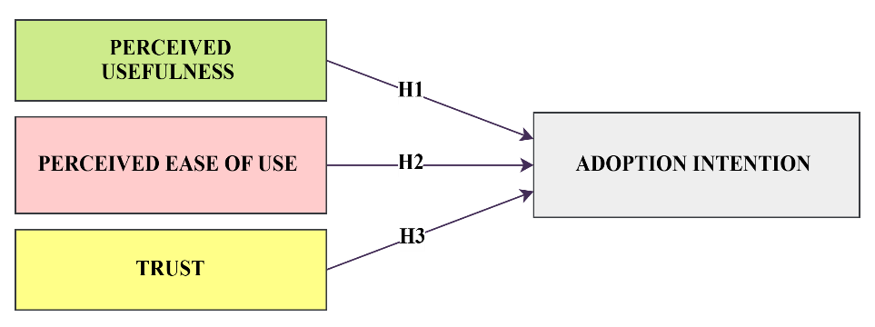
Figure 1: Conceptual Framework
4. Statement of the Problem
Despite the rapid expansion of digital financial services in India and the introduction of payment banks to promote financial inclusion, their adoption remains relatively low in semi-urban and rural regions such as the Kolhan Division of Jharkhand. Although payment banks are designed to provide simple, low-cost, and accessible banking services, many consumers still hesitate to use them due to limited digital literacy, lack of awareness, perceived complexity, security concerns, and low trust in digital transactions. Existing literature has largely focused on urban populations, leaving a significant research gap in understanding consumer behavior in rural and semi-urban contexts. Moreover, the combined influence of key behavioral factors such as perceived usefulness, perceived ease of use, and trust on adoption intention has not been sufficiently explored in this region. Therefore, there is a need to identify and analyze the critical determinants affecting consumers’ intention to adopt payment bank services in Kolhan Division, which can help in improving digital financial inclusion and enhancing the effectiveness of fintech-based banking services.
5. Objectives of the Study
1. To examine the impact of perceived usefulness on consumers’ adoption intention toward payment bank services in Kolhan Division, Jharkhand.
2. To analyze the effect of perceived ease of use on consumers’ adoption intention toward payment bank services in Kolhan Division, Jharkhand.
3. To investigate the influence of trust on consumers’ adoption intention toward payment bank services in Kolhan Division, Jharkhand.
6. Hypotheses of the Study
1. H1: There is a significant positive effect of Perceived Usefulness on Adoption Intention toward payment bank services.
2. H2: There is a significant positive effect of Perceived Ease of Use on Adoption Intention toward payment bank services.
3. H3: There is a significant positive effect of Trust on Adoption Intention toward payment bank services.
7. Research Methodology
Table 1: Research Methodology
Particulars | Description
Research Design | Quantitative and Descriptive Research Design
Type of Data | Primary Data & Secondary Data
Data Collection Method | Structured Questionnaire
Respondents | Consumers and users of payment bank services in Kolhan Division, Jharkhand
Sample Size | 200 respondents
Sampling Technique | Convenience Sampling
Study Area | Kolhan Division, Jharkhand, India
Independent Variables | Perceived Usefulness, Perceived Ease of Use, Trust
Dependent Variable | Adoption Intention toward Payment Bank Services
Instrument Used | Structured Questionnaire
Data Analysis Tools | SPSS 17.0 and SmartPLS 4
Statistical Techniques Applied | Reliability and Validity Analysis, Measurement Model Assessment, Structural Model Assessment (PLS-SEM)

8. Analysis of the Study
Table 2: Outer Loading – Matrix
 | Adoption Intention | Perceived Ease of Use | Perceived Usefulness | Trust
AI1 | 0.767
AI2 | 0.855
AI3 | 0.773
PEOU1 |  | 0.712
PEOU2 |  | 0.775
PEOU3 |  | 0.823
PEOU4 |  | 0.927
PU1 |  |  | 0.806
PU2 |  |  | 0.724
PU3 |  |  | 0.829
PU4 |  |  | 0.871
PU5 |  |  | 0.859
PU6 |  |  | 0.820
TR1 |  |  |  | 0.995
TR2 |  |  |  | 0.994
Note: AI: Adoption Intention, PEOU: Perceived Ease of Use, PU: Perceived Usefulness, TR: Trust, AI1–AI3: Adoption Intention indicators/items, PEOU1–PEOU4: Perceived Ease of Use indicators/items, PU1–PU6: Perceived Usefulness indicators/items, TR1–TR2: Trust indicators/items.
Table 2 presents the outer loading matrix used to assess indicator reliability and convergent validity of the measurement model. All factor loadings exceed the recommended threshold of 0.70 (Hair et al., 2019), confirming good measurement quality. Adoption Intention (0.767–0.855), Perceived Ease of Use (0.712–0.927), and Perceived Usefulness (0.724–0.871) show strong and acceptable loadings, supporting their validity as key constructs in line with Davis (1989) and Venkatesh et al. (2003). The Trust construct shows extremely high loadings (0.994–0.995), indicating very strong convergent validity but also possible redundancy between items (Gefen et al., 2003). Overall, the results confirm that all constructs are reliable and suitable for further structural analysis using PLS-SEM.
Table 3: Construct Reliability and Validity
 | Cronbach's alpha | Composite reliability (rho_a) | Composite reliability (rho_c) | Average variance extracted (AVE)
Adoption Intention | 0.723 | 0.756 | 0.841 | 0.639
Perceived Ease of Use | 0.827 | 0.851 | 0.885 | 0.661
Perceived Usefulness | 0.902 | 0.913 | 0.924 | 0.672
Trust | 0.989 | 0.990 | 0.995 | 0.989

Table 3 presents the construct reliability and validity assessment of the measurement model using Cronbach’s alpha, composite reliability (rho_a and rho_c), and Average Variance Extracted (AVE). The results indicate that all constructs meet the recommended reliability and validity thresholds. According to Hair et al. (2019), Cronbach’s alpha and composite reliability values above 0.70 confirm internal consistency reliability. In this study, all constructs exceed this benchmark, with Adoption Intention (0.723), Perceived Ease of Use (0.827), Perceived Usefulness (0.902), and Trust (0.989), indicating strong reliability. Composite reliability values (rho_c) ranging from 0.841 to 0.995 further confirm excellent construct reliability. As suggested by Fornell and Larcker (1981), AVE values above 0.50 indicate adequate convergent validity; in this case, all constructs exceed this threshold, with values ranging from 0.639 to 0.989, confirming strong convergent validity. Notably, the Trust construct shows exceptionally high reliability and AVE values, which may indicate redundancy among indicators, although it strongly confirms measurement consistency. Overall, the results in Table 3 establish that all constructs are reliable and valid for further structural model analysis using PLS-SEM.
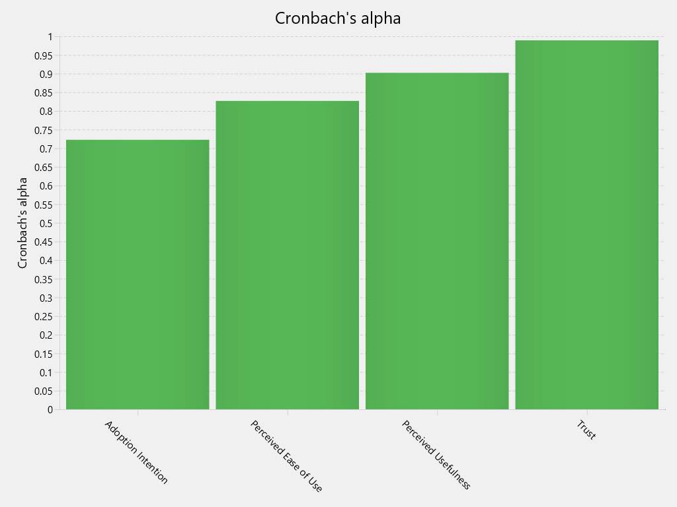
Figure 2: Cronbach’s alpha

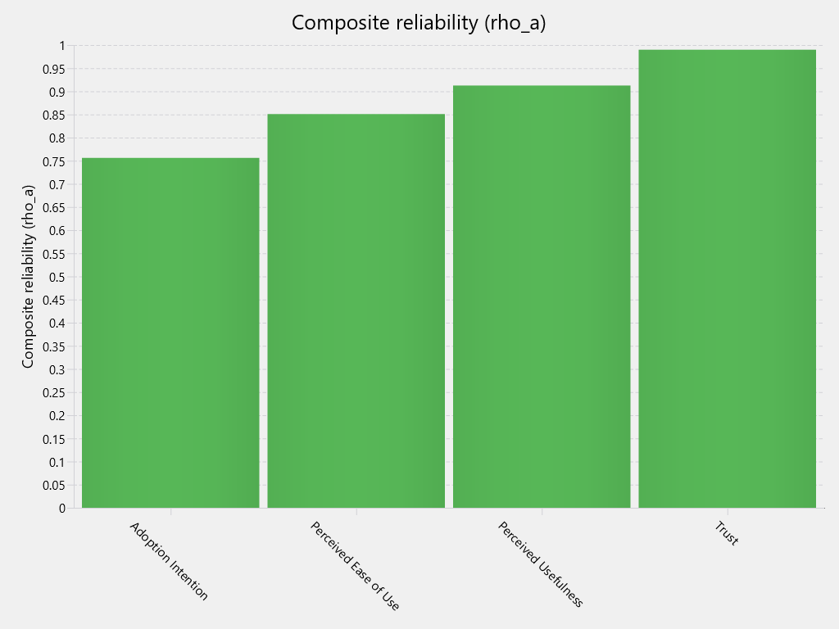
Figure 3: Composite reliability (rho_a)

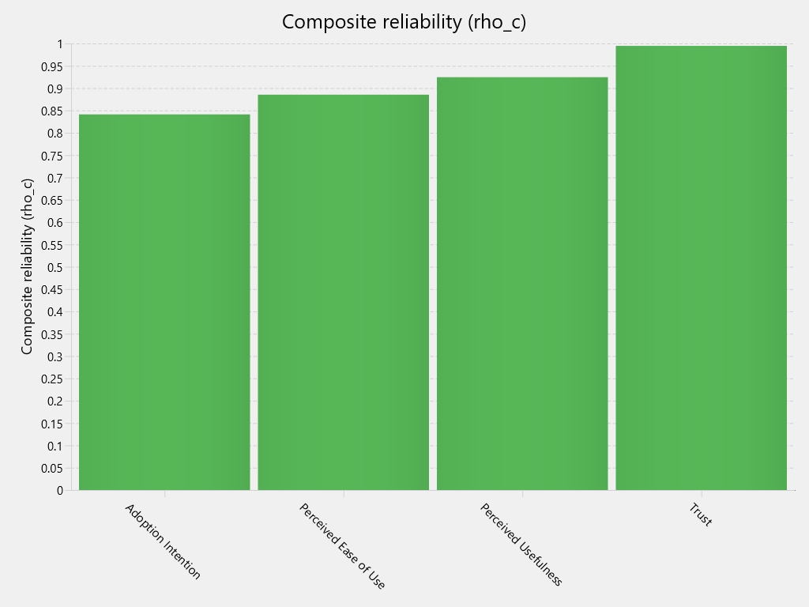
Figure 4: Composite reliability (rho_c)
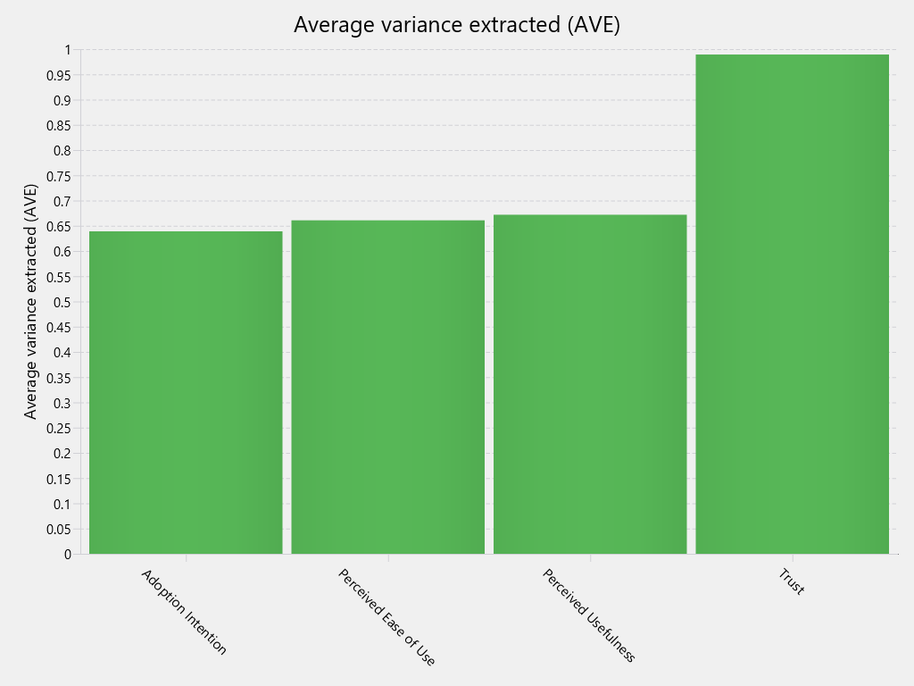
Figure 5: Average variance extracted (AVE)
Figures 2 to 5 present the reliability and validity results of the measurement model. All constructs meet the recommended threshold values, with Cronbach’s alpha and composite reliability above 0.70 (Hair et al., 2019), confirming strong internal consistency. AVE values are also above 0.50 (Fornell & Larcker, 1981), indicating adequate convergent validity. Overall, the results confirm that the measurement model is reliable and valid for further structural analysis.
Table 4: Path Coefficients - Mean, STDEV, T values, p values
 | Original sample (O) | Sample mean (M) | Standard deviation (STDEV) | T statistics (|O/STDEV|) | P values
H1: Perceived Ease of Use -> Adoption Intention | 0.247 | 0.246 | 0.091 | 2.707 | 0.007
H2: Perceived Usefulness -> Adoption Intention | 0.252 | 0.258 | 0.090 | 2.793 | 0.005
H3: Trust -> Adoption Intention | 0.232 | 0.233 | 0.069 | 3.366 | 0.001

Table 4 presents the results of the structural model analysis assessing the relationships between Perceived Ease of Use, Perceived Usefulness, Trust, and Adoption Intention. The results indicate that all hypothesized relationships are statistically significant at the 5% level, as all p-values are below 0.05 and t-values exceed the critical value of 1.96 (Hair et al., 2019). Perceived Ease of Use has a positive and significant effect on Adoption Intention (β = 0.247, t = 2.707, p = 0.007), supporting H1. Perceived Usefulness also shows a significant positive impact (β = 0.252, t = 2.793, p = 0.005), supporting H2 and indicating it as the strongest predictor among the TAM variables. Trust exhibits a significant positive influence on Adoption Intention (β = 0.232, t = 3.366, p = 0.001), supporting H3 and highlighting its critical role in payment bank adoption. Overall, the results confirm that all three constructs significantly influence consumers’ intention to adopt payment bank services in the Kolhan Division.
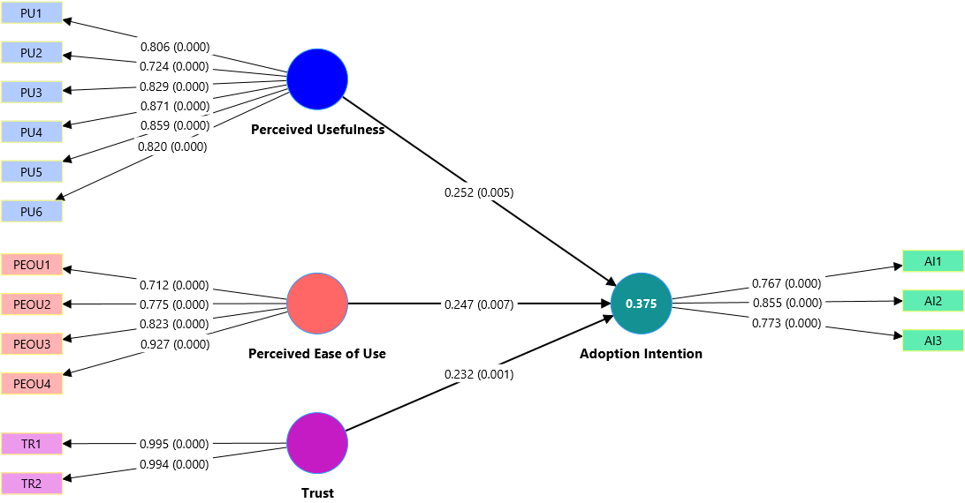
Figure 6: Measurement and Structural Model (Outer and Inner Model) showing factor loadings and path coefficients
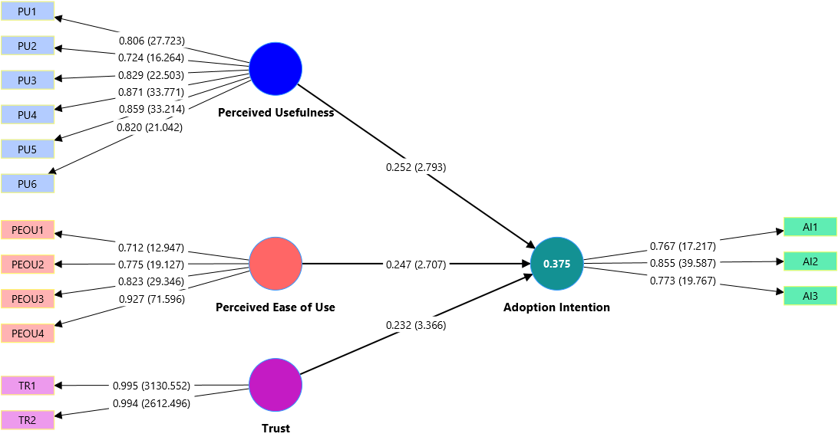
Figure 7: Measurement and Structural Model (Outer and Inner Model) showing factor loadings, t-values, and path coefficients
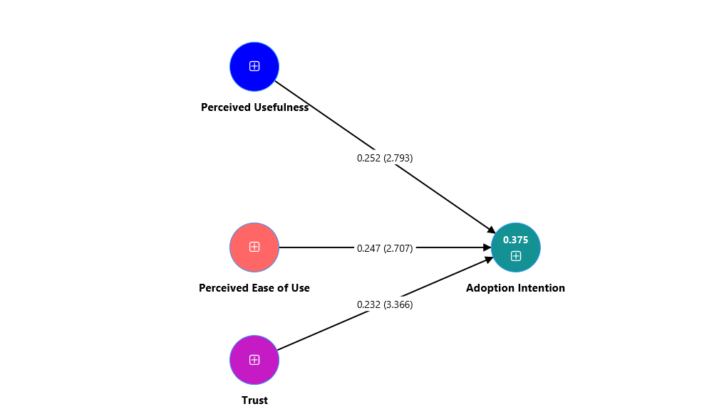
Figure 8: Structural Model (Inner Model) showing path coefficients and t-values

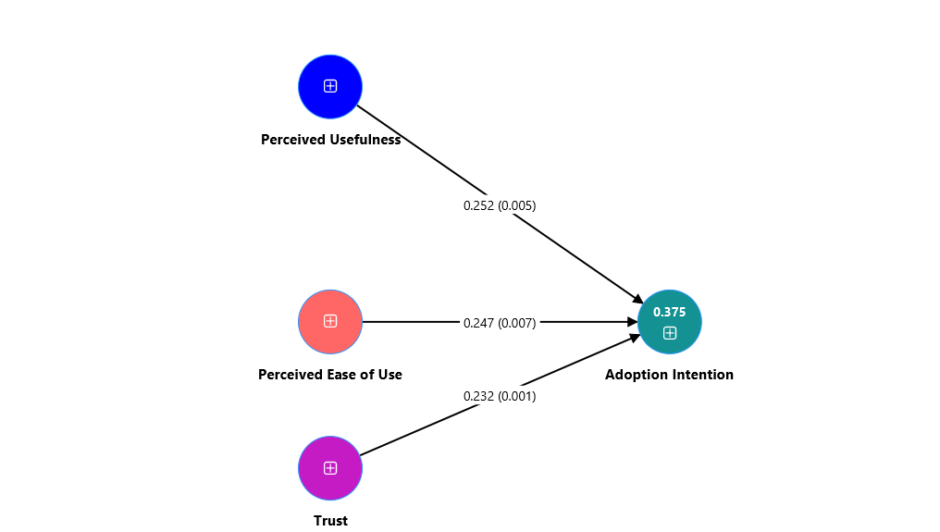
Figure 9: Structural Model (Inner Model) showing path coefficients and significance levels
Figure 6 shows the combined measurement and structural model with factor loadings and path coefficients, confirming that all constructs are well-measured and relationships are positive. Figure 7 presents the measurement and structural model with factor loadings, t-values, and path coefficients, indicating that all paths are statistically significant. Figure 8 illustrates the structural model with path coefficients and t-values, confirming the strength and significance of relationships among constructs. Figure 9 shows the structural model with path coefficients and significance levels, further confirming that all hypothesized relationships are supported.
9. Suggestions
Based on the findings of the study, several practical suggestions can be made to improve the adoption of payment bank services in the Kolhan Division of Jharkhand. First, service providers should focus on enhancing perceived usefulness by clearly communicating the benefits of payment banks such as faster transactions, lower costs, and convenient digital access to banking services. Second, improving user experience and simplicity is essential; interfaces should be made more user-friendly, and step-by-step guidance or local language support should be provided to increase perceived ease of use among less tech-savvy users. Third, building trust is crucial for increasing adoption; payment banks should strengthen data security measures, ensure transparent transactions, and conduct awareness campaigns to reduce fear of fraud and improve confidence in digital banking systems. Additionally, financial literacy programs should be promoted in rural and semi-urban areas to increase awareness and understanding of digital financial services. Finally, banks and policymakers should collaborate to improve digital infrastructure and encourage continuous engagement through incentives and customer support services, which will ultimately enhance adoption intention and financial inclusion in the region.
10. Conclusion
The study examined the factors influencing consumers’ adoption intention toward payment bank services in the Kolhan Division of Jharkhand, focusing on Perceived Usefulness, Perceived Ease of Use, and Trust. The findings confirm that all three factors have a significant positive impact on adoption intention, with Perceived Usefulness emerging as the most influential determinant, followed by Trust and Perceived Ease of Use. This indicates that consumers are more likely to adopt payment bank services when they perceive clear functional benefits, find the system easy to use, and have confidence in its security and reliability. The study also validates the applicability of the Technology Acceptance Model in the context of digital banking adoption in semi-urban and rural regions of India. Overall, the results highlight that improving service utility, simplifying user experience, and strengthening trust-building measures are essential for enhancing the adoption of payment bank services and promoting financial inclusion in the region.
References
Ali, M., Raza, S. A., Puah, C. H., & Amin, H. (2020). Mobile banking adoption in emerging markets: Evidence from structural equation modeling. Journal of Financial Services Marketing, 25(3), 1–15.
Baptista, G., & Oliveira, T. (2015). Understanding mobile banking: The unified theory of acceptance and use of technology combined with cultural moderators. Computers in Human Behavior, 50, 418–430. https://doi.org/10.1016/j.chb.2015.04.024
Chawla, D., & Joshi, H. (2019). Consumer attitude and intention to adopt mobile wallet in India. International Journal of Bank Marketing, 37(7), 1590–1618. https://doi.org/10.1108/IJBM-09-2018-0256
Chong, A. Y. L., Ooi, K. B., Lin, B., & Tan, B. I. (2010). Online banking adoption: An empirical analysis. Industrial Management & Data Systems, 110(4), 592–610. https://doi.org/10.1108/02635571011039055
Davis, F. D. (1989). Perceived usefulness, perceived ease of use, and user acceptance of information technology. MIS Quarterly, 13(3), 319–340. https://doi.org/10.2307/249008
Dwivedi, Y. K., Rana, N. P., Chen, H., & Williams, M. D. (2019). A meta-analysis of mobile banking adoption. Electronic Commerce Research and Applications, 39, 100-110.
Fornell, C., & Larcker, D. F. (1981). Evaluating structural equation models with unobservable variables and measurement error. Journal of Marketing Research, 18(1), 39–50. https://doi.org/10.1177/002224378101800104
Gefen, D., Karahanna, E., & Straub, D. W. (2003). Trust and TAM in online shopping: An integrated model. MIS Quarterly, 27(1), 51–90. https://doi.org/10.2307/30036519
Gupta, K., & Arora, N. (2020). Investigating consumer adoption of mobile banking in rural India. International Journal of Information Management, 50, 58–67.
Hair, J. F., Hult, G. T. M., Ringle, C. M., & Sarstedt, M. (2019). A primer on partial least squares structural equation modeling (PLS-SEM) (2nd ed.). Sage Publications.
Kaur, P., Dhir, A., Singh, N., Sahu, G., & Almotairi, M. (2020). An innovation resistance theory perspective on mobile payment adoption. Computers in Human Behavior, 107, 105911. https://doi.org/10.1016/j.chb.2020.105911
Kim, D. J., Ferrin, D. L., & Rao, H. R. (2008). A trust-based consumer decision-making model in electronic commerce. Decision Support Systems, 44(2), 544–564. https://doi.org/10.1016/j.dss.2007.07.001
Liébana-Cabanillas, F., Sánchez-Fernández, J., & Muñoz-Leiva, F. (2017). Antecedents of the adoption of mobile payment systems. Computers in Human Behavior, 71, 521–534. https://doi.org/10.1016/j.chb.2017.02.050
Lin, H. F. (2011). An empirical investigation of mobile banking adoption. International Journal of Information Management, 31(6), 1–8.
Oliveira, T., Thomas, M., Baptista, G., & Campos, F. (2016). Mobile payment adoption: A cross-country analysis. Computers in Human Behavior, 61, 404–414. https://doi.org/10.1016/j.chb.2016.03.026
Patel, K., & Patel, S. (2018). Internet banking adoption in India: A structural equation modeling approach. Journal of Financial Services Marketing, 23(3), 136–147. https://doi.org/10.1057/s41264-018-0053-3
Rahi, S., Ghani, M. A., & Ngah, A. H. (2018). Factors influencing customer satisfaction in internet banking. Journal of Financial Services Marketing, 23(1), 1–12.
Reserve Bank of India. (2014). Guidelines for licensing of payments banks. https://www.rbi.org.in
Sharma, S. K., & Sharma, M. (2019). Examining the role of trust and perceived risk in mobile banking adoption. International Journal of Bank Marketing, 37(2), 543–569. https://doi.org/10.1108/IJBM-07-2018-0177
Sharma, S. K., Govindaluri, S. M., & Singh, G. (2021). Mobile wallet adoption in India: A behavioral perspective. Technological Forecasting and Social Change, 163, 120–130.
Singh, N., & Srivastava, S. (2018). Consumer adoption of mobile payment services in India. International Journal of Bank Marketing, 36(7), 1238–1256.
Slade, E. L., Williams, M. D., Dwivedi, Y. K., & Piercy, N. C. (2015). Exploring consumer adoption of mobile payments. Journal of Retailing and Consumer Services, 22, 102–110. https://doi.org/10.1016/j.jretconser.2014.10.001
Venkatesh, V., Morris, M. G., Davis, G. B., & Davis, F. D. (2003). User acceptance of information technology: Toward a unified view. MIS Quarterly, 27(3), 425–478. https://doi.org/10.2307/30036540
Zhou, T. (2011). Examining mobile banking user adoption. Computers in Human Behavior, 27(3), 123–131. https://doi.org/10.1016/j.chb.2010.10.004

