CURRICULUM VITAE
SHIVANGI CHATURVEDI
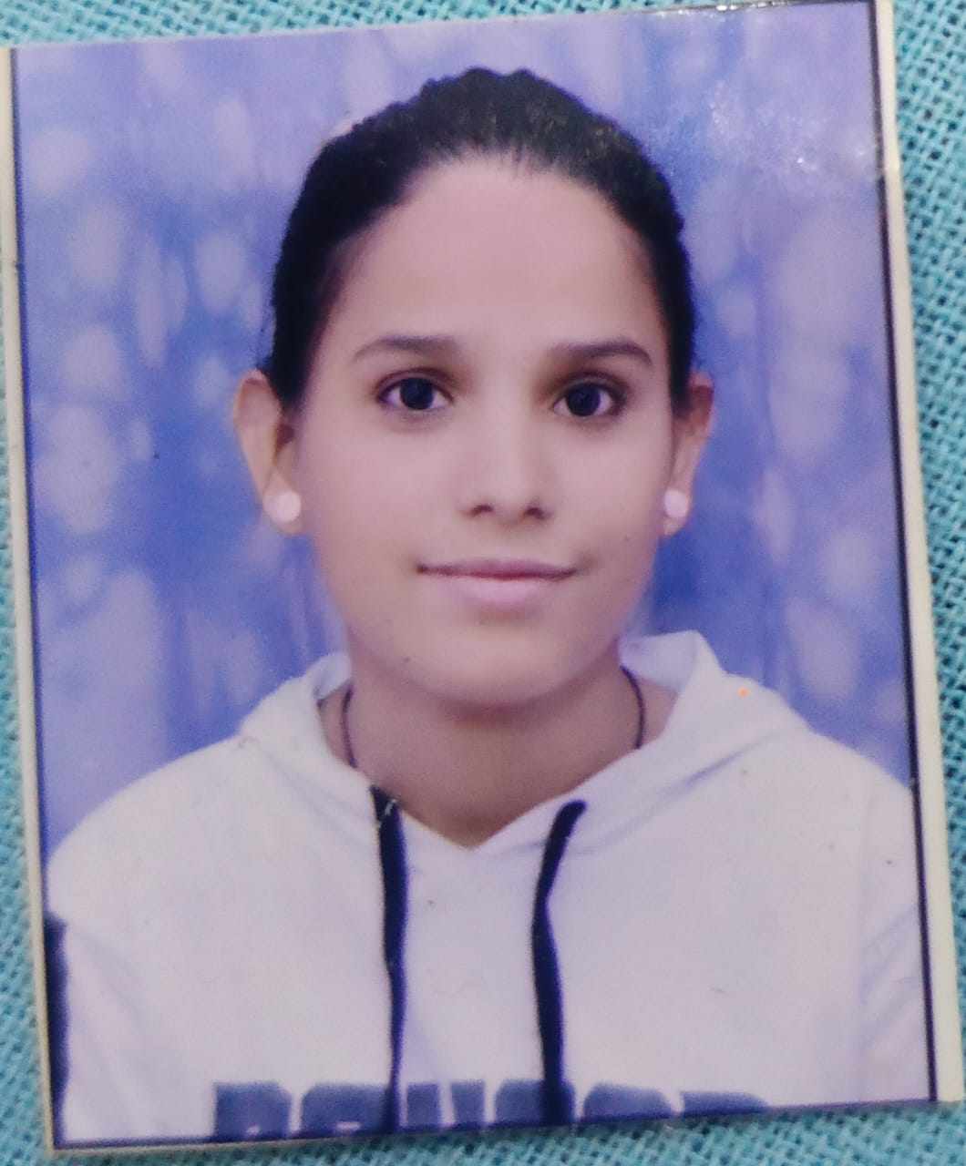
D/O Mr.Dhirendra Chaturvedi
Vill+Post:- 64,Chandrawar Gate , Firozabad
Dist- Firozabad , 283203
Mob. No:- 8279703215
Email Id:- shivangichaturvedi80@gmail.com
- CAREER OBJECTIVES
To Peruse My Career with my Professional Experience ande Skills, Which I have Acquired over a Periodtime
- PROFESSIONAL & ACADEMIC QUALIFICATION
Degree | University | Year of Passing | Division
High school | CBSE Board | 2016 | Ist
Intermediate | CBSE Board | 2018 | Ist
B.com | Agra University | 2021 | Ist
B.Ed | Agra University | 2024 | Ist
L.L.B. | Agra University | Pursuing

- OTHER QUALIFICATION
- 1 Year’s Computer Course ADCA + Tally prime with GST in 2025
- Hindi & English typing
- EXPERIENCE
6 Months Experience As Accountant Under CA R.P. Goyal
- PERSONAL DETAILS
Father’s Name :- Mr. Dhirendra Chaturvedi
Date of Birth :- 04-05-2000
Sex :- Female
Marital Status :- Unmarried
Nationality :- Indian
Language Known:- Hindi & English
Hobbies :- Reading Book
Strength :- Project Management Skills, Determined , Result Oriented, Creativeness, Positive Attitude, Hard Worker & Punctuality, Quick Learner , Responsible.
- DECLARATION
I I Hereby declare that all the above given information about me correct to the best of my Knowledge. Date SHIVANGI CHATURVEDI

