SYNOPSIS
FOR THE REGISTRATION OF
DOCTOR OF PHILOSOPHY (Ph.D.)
IN
COMPUTER SCIENCE AND ENGINEERING
TOPIC
CTI-ENGINE: An Open-Source Explainable Cyber Threat Intelligence Engine Using Hybrid Deep Learning, Quantum-Inspired Neural Networks, and Metaheuristic Feature Optimization for OSINT Analysis
Submitted by
RAMESH KUMAR SHARMA
Ph.D. Research Scholar
Department of Computer Science and Engineering, BIT Sindri, Dhanbad – 828123
Affiliated to Jharkhand University of Technology (JUT), Ranchi – 834010, Jharkhand, India
Under the Supervision of
Prof. (Dr.) Dharmendra Kumar Singh
Vice Chancellor, Jharkhand University of Technology, Ranchi, India
Dr. Rajesh P. Barnwal
Senior Principal Scientist & Head, Information Technology Group, CSIR – Central Mechanical Engineering Research Institute (CSIR-CMERI), Durgapur, India; Associate Professor (Hon.), AcSIR

1. Introduction
Cyber Threat Intelligence (CTI) is now an integral part of an organisation's cybersecurity operations, allowing them to proactively identify, detect, and address malicious activity before it turns into a security incident. The sources that feed the CTI pipelines have evolved over time, and one of the most useful sources to date has been Open-Source Intelligence (OSINT), which refers to blogs, threat advisories, vendor reports, paste sites, code repositories, social platforms, and underground forums, among others. Oftentimes, OSINT is the first publicly available glimpse of a new campaign, a newly disclosed vulnerability, or a new tooling change by the adversary, before it gets to commercial or government threat feeds.
OSINT is also high volume, unstructured, heterogenous, and noisy. Reports of threats are written in a natural language with inconsistent terminology, indicators of compromise are included in free text and discussed with irrelevant information, and one and the same underlying entity – a malware family, a threat actor or an infrastructure asset – is often referred to by multiple aliases in different sources. The process of turning this raw material into decisions that an analyst can trust and act on needs to be automated, and it needs to be a pipeline that collects, features, classifies and — crucially — explains its results. There are some existing open-source CTI platforms like MISP or OpenCTI which offer good IOC sharing and knowledge-graph functionality but require OSINT collection, machine-learning-based classification and explainability to be performed outside of the platform. Commercial products like Recorded Future and ShadowDragon start to fill in some of these gaps, providing proprietary, non-open analytics for use that are not reproducible by the research community and cannot be inspected by analysts.
This research introduces an open-source, modular, and explainable framework, called CTI-ENGINE, that consumes OSINT information and generates human readable threat classifications. The framework combines four different technical contributions: automated OSINT collection and feature engineering, optimisation of features using metaheuristic methods, a quantum-inspired neural classifier, and a model-agnostic explainability layer, all of which are packed into a reproducible pipeline and made available as an open-source tool and not as a closed research prototype.

2. Literature Review

2.1 OSINT-Based Cyber Threat Intelligence
The need for CTI programmes to rely more and more heavily on OSINT and the ongoing challenge of getting structured, actionable intelligence from unstructured public sources at scale has been documented by both Avrahami et al. (2025) and Santos et al. (2025). Both Babenko et al. (2025) and Dale et al. (2025) highlight that noise and informal language on platforms continue to be significant challenges for automated OSINT analyses and point to the need to investigate platform-specific noise and informal language.
Two of these barriers are directly addressed by the candidate's own previous work. Sharma et al. (2026a) present a transformer-based framework for automatically categorizing OSINT threat narratives into MITRE ATT&CK techniques, which involves preprocessing of the OSINT text, extraction of the threats from the text, semantic representation learning of the extracted threat text and multi-label, confidence-aware classification; results indicate that the proposed framework outperforms the keyword-matching baselines and the conventional machine-learning baselines, including on low-density ATT&CK categories. Sharma et al. (2026b) also introduce a deep-learning entity-resolution system that encodes cyber-threat entities (IP addresses, malware families, threat-actor aliases) using multilingual transformer embeddings and uses similarity learning and graph-based entity linking to resolve them, achieving high resilience to alias ambiguity over heterogeneous OSINT text. Both papers lay the foundation for OSINT ingestion, indicator extraction, entity normalisation as used in CTI-ENGINE.

2.2 Deep Learning and Transformer Architectures for Threat Classification
In this thesis, two methods for threat classification are presented: Deep Learning and Transformer Architectures. Despite the efforts of many models, transformer models have emerged as the state-of-the-art architecture for modeling contextual semantic representations from unstructured security text, and have consistently outperformed bag-of-words and shallow-embedding models on domain-specific classification tasks such as ours. A CNN–LSTM hybrid is employed to deliver semantic and temporal features from various heterogeneous OSINT sources that are able to reach accuracy of 96.4%, 95.8%, and 94.2% on three separate datasets independently, while the classification results, the model metadata, and the confidence score are logged on a blockchain-ledger as an immutable record for post-incident audits. Similarly, Shoukat et al. (2025) found that deep-learning threat detectors that are transparent and easily explainable to analysts are good at detecting threats and are also more trusted by analysts than opaque deep-learning detectors.

2.3 Metaheuristic Feature Optimisation
Transformer embeddings and N-gram statistics are used to generate a high dimensional feature matrix, but this includes a significant amount of noise and redundancy that can be a burden during training, and these features can also obscure discriminative signal in the features. The Particle Swarm Optimisation (Kennedy & Eberhart, 1995) and the Grey Wolf Optimizer (Mirjalili et al., 2014) are population-based metaheuristics without the need of gradient information and have been widely used for selecting features for a classification task. Zhao et al. (2025) make further improvements to multi-population metaheuristic search in multi-objective optimisation problems of this type. This family of researchers is already well demonstrated to be practically useful; an ablation study showed that the inclusion of the feature optimisation step without itself was a measurable degradation in accuracy (1.485%), while an enhanced multi-population optimisation (EMPO) algorithm using discriminative attributes from BERT-derived features improved classification accuracy by 14.951 percentage points over an unoptimised baseline.

2.4 Quantum-Inspired Neural Networks
QINNs use the principles of quantum computation, such as a superposition-like weighted representation of the states, and a combination of signals via interference, in a classical and simulatable network architecture, without physical quantum devices. The work of Gonon et al. (2025) analyzes the universality properties of feedback-driven recurrent quantum neural networks, and Biamonte et al. (2017) offers the basic review of how quantum computation relates to machine learning in general. In the candidate's previous work, an optimised BERT model on a benchmark dataset was tested with a dynamic feed-forward quantum neural network (DFF-QNN) to be used as the final classification stage, achieving an overall accuracy of 98.197%, and an ablation study demonstrated that the accuracy was lowered by 0.833% if the final classification layer was replaced by a conventional network. This architecture is directly applied in CTI-ENGINE to the quantum-inspired classifier which has been repurposed from the social-media authenticity classification to OSINT threat detection.

2.5 Explainable AI for Security Decisions
There are two popular model-agnostic explanation methods, SHAP (Lundberg & Lee, 2017) and LIME (Ribeiro et al., 2016), which explain the prediction of a model in terms of the contribution of individual features in the input. For security-critical machine learning, explainability is not a theoretical nicety, but a practical necessity: if an analyst is unable to understand the reasoning behind a model, he won't use it, or he will use it with great suspicion. (Adadi and Berrada 2018; Şahin et al. 2025) Alketbi and Mehmood (2025) come to the same conclusion, and in particular for insider-threat detection. This thesis addresses this gap and is the only system reviewed to use a quantum inspired, metaheuristic-optimised classifier combined with a SHAP/LIME explanation layer in a single open-source OSINT pipeline, up to this point.

2.6 Existing Open-Source and Commercial CTI Platforms
Table 1. Capability comparison of CTI-ENGINE against the two closest open-source CTI platforms.
Capability | MISP | OpenCTI | CTI-ENGINE (Proposed)
Open-source | Yes | Yes | Yes
IOC sharing / correlation | Yes (core) | Yes (via graph) | Not core focus
Built-in OSINT collection | No | No | Yes
ML-based classification | No | External only | Yes
Metaheuristic feature optimisation | No | No | Yes (PSO + GWO)
Quantum-inspired classifier | No | No | Yes
Built-in explainability (SHAP/LIME) | No | No | Yes
STIX2 output | Yes | Yes (native) | Yes (planned)

CTI-ENGINE is not meant to replace MISP or OpenCTI, but rather to work in parallel with them, with classified, explained output in STIX2 format that will be ingested into these platforms, while its value to the community is the analysis layer – from ingestion all the way to explainable classification – that these platforms don't currently have natively. The global OSINT market is projected to reach USD 11.6–12.7 billion by 2025 and is expected to grow by 20-28% annually, while the data from the Industry Survey (SANS CTI Survey) shows that 72% of threat intelligence teams already use three or more OSINT platforms simultaneously, indicating that none of the existing commercial or open-source products covers the whole OSINT-to-decision workflow to its full extent, which is what this research aims to solve.

3. Research Gap
- No existing open-source CTI platform combines automated OSINT collection, ML-based classification, metaheuristic feature optimisation, and built-in explainability within a single pipeline; MISP and OpenCTI treat these as external, disconnected concerns.
- Classical deep-learning classifiers applied to OSINT threat text (CNN, LSTM, and their hybrids) plateau in accuracy once feature redundancy and noise are not addressed before classification, as shown in the candidate's own CNN-LSTM blockchain study.
- Quantum-inspired neural architectures have been validated on a related but distinct task (fake-profile / social-authenticity classification) but have not been evaluated specifically for OSINT-based cyber-threat detection.
- Most ML-driven CTI research reports accuracy metrics alone, without a transparent, per-decision reasoning trace that a security analyst can audit - a trust barrier to operational adoption that recent XAI-for-security literature identifies but rarely resolves end-to-end.
- "Quantum-inspired" classifiers in the security literature are frequently under-specified; a precise technical definition that distinguishes the proposed architecture from a relabelled classical network is required and is treated as a first-order deliverable of this thesis, not an afterthought.

4. Research Objectives
- To design and implement an automated OSINT collection and preprocessing module that extracts named entities and indicators of compromise from forums, threat feeds, pastes, RSS sources, and code repositories.
- To construct a hybrid feature representation combining BERT-based contextual embeddings with N-gram statistical features for OSINT threat text.
- To develop a metaheuristic feature-optimisation stage using Particle Swarm Optimisation (PSO) and the Grey Wolf Optimizer (GWO) to select the most discriminative feature subset prior to classification.
- To design, implement, and empirically validate a quantum-inspired neural network classifier for OSINT-based threat detection, with a precise technical specification distinguishing it from classical architectures.
- To integrate a SHAP/LIME-based explainability layer that attributes each classification decision to specific input features, producing a human-readable reasoning trace alongside each threat verdict.
- To release the complete pipeline as an open-source tool and benchmark it against existing open-source (MISP, OpenCTI) and published classical/deep-learning baselines on accuracy, F1-score, and explanation fidelity.

5. Proposed Methodology
CTI-ENGINE is organised as a five-stage modular pipeline, each stage independently testable and replaceable, consistent with the open-source and reproducibility goals of the thesis.
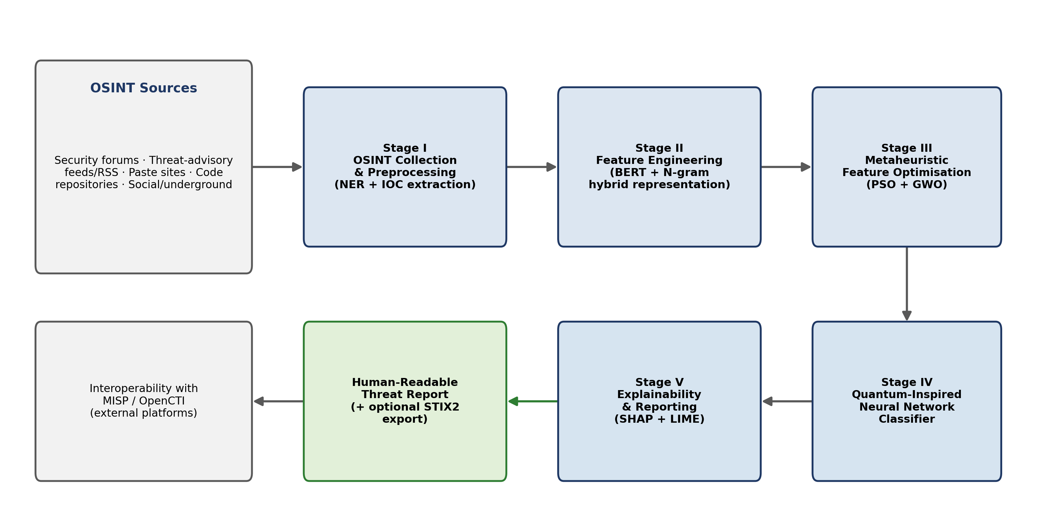
Figure 1. CTI-ENGINE system architecture: OSINT collection through explainable threat classification.

5.1 Stage I — OSINT Collection
Entities are extracted and classified using ATT&CK from the collected raw text data from security forums, threat-advisory feeds, paste sites, RSS feeds and public code repositories by automated tools, following prior work by the candidate (Sharma, Singh, and Barnwal, 2026a, 2026b) in entity-resolution and classification of ATT&CK.

5.2 Stage II — Feature Engineering
Collected text is represented as a numeric feature matrix extracted from BERT contextual embeddings (Devlin et al., 2019) and N-gram frequency features, as well as from IOCs derived by named-entity recognition and regex.
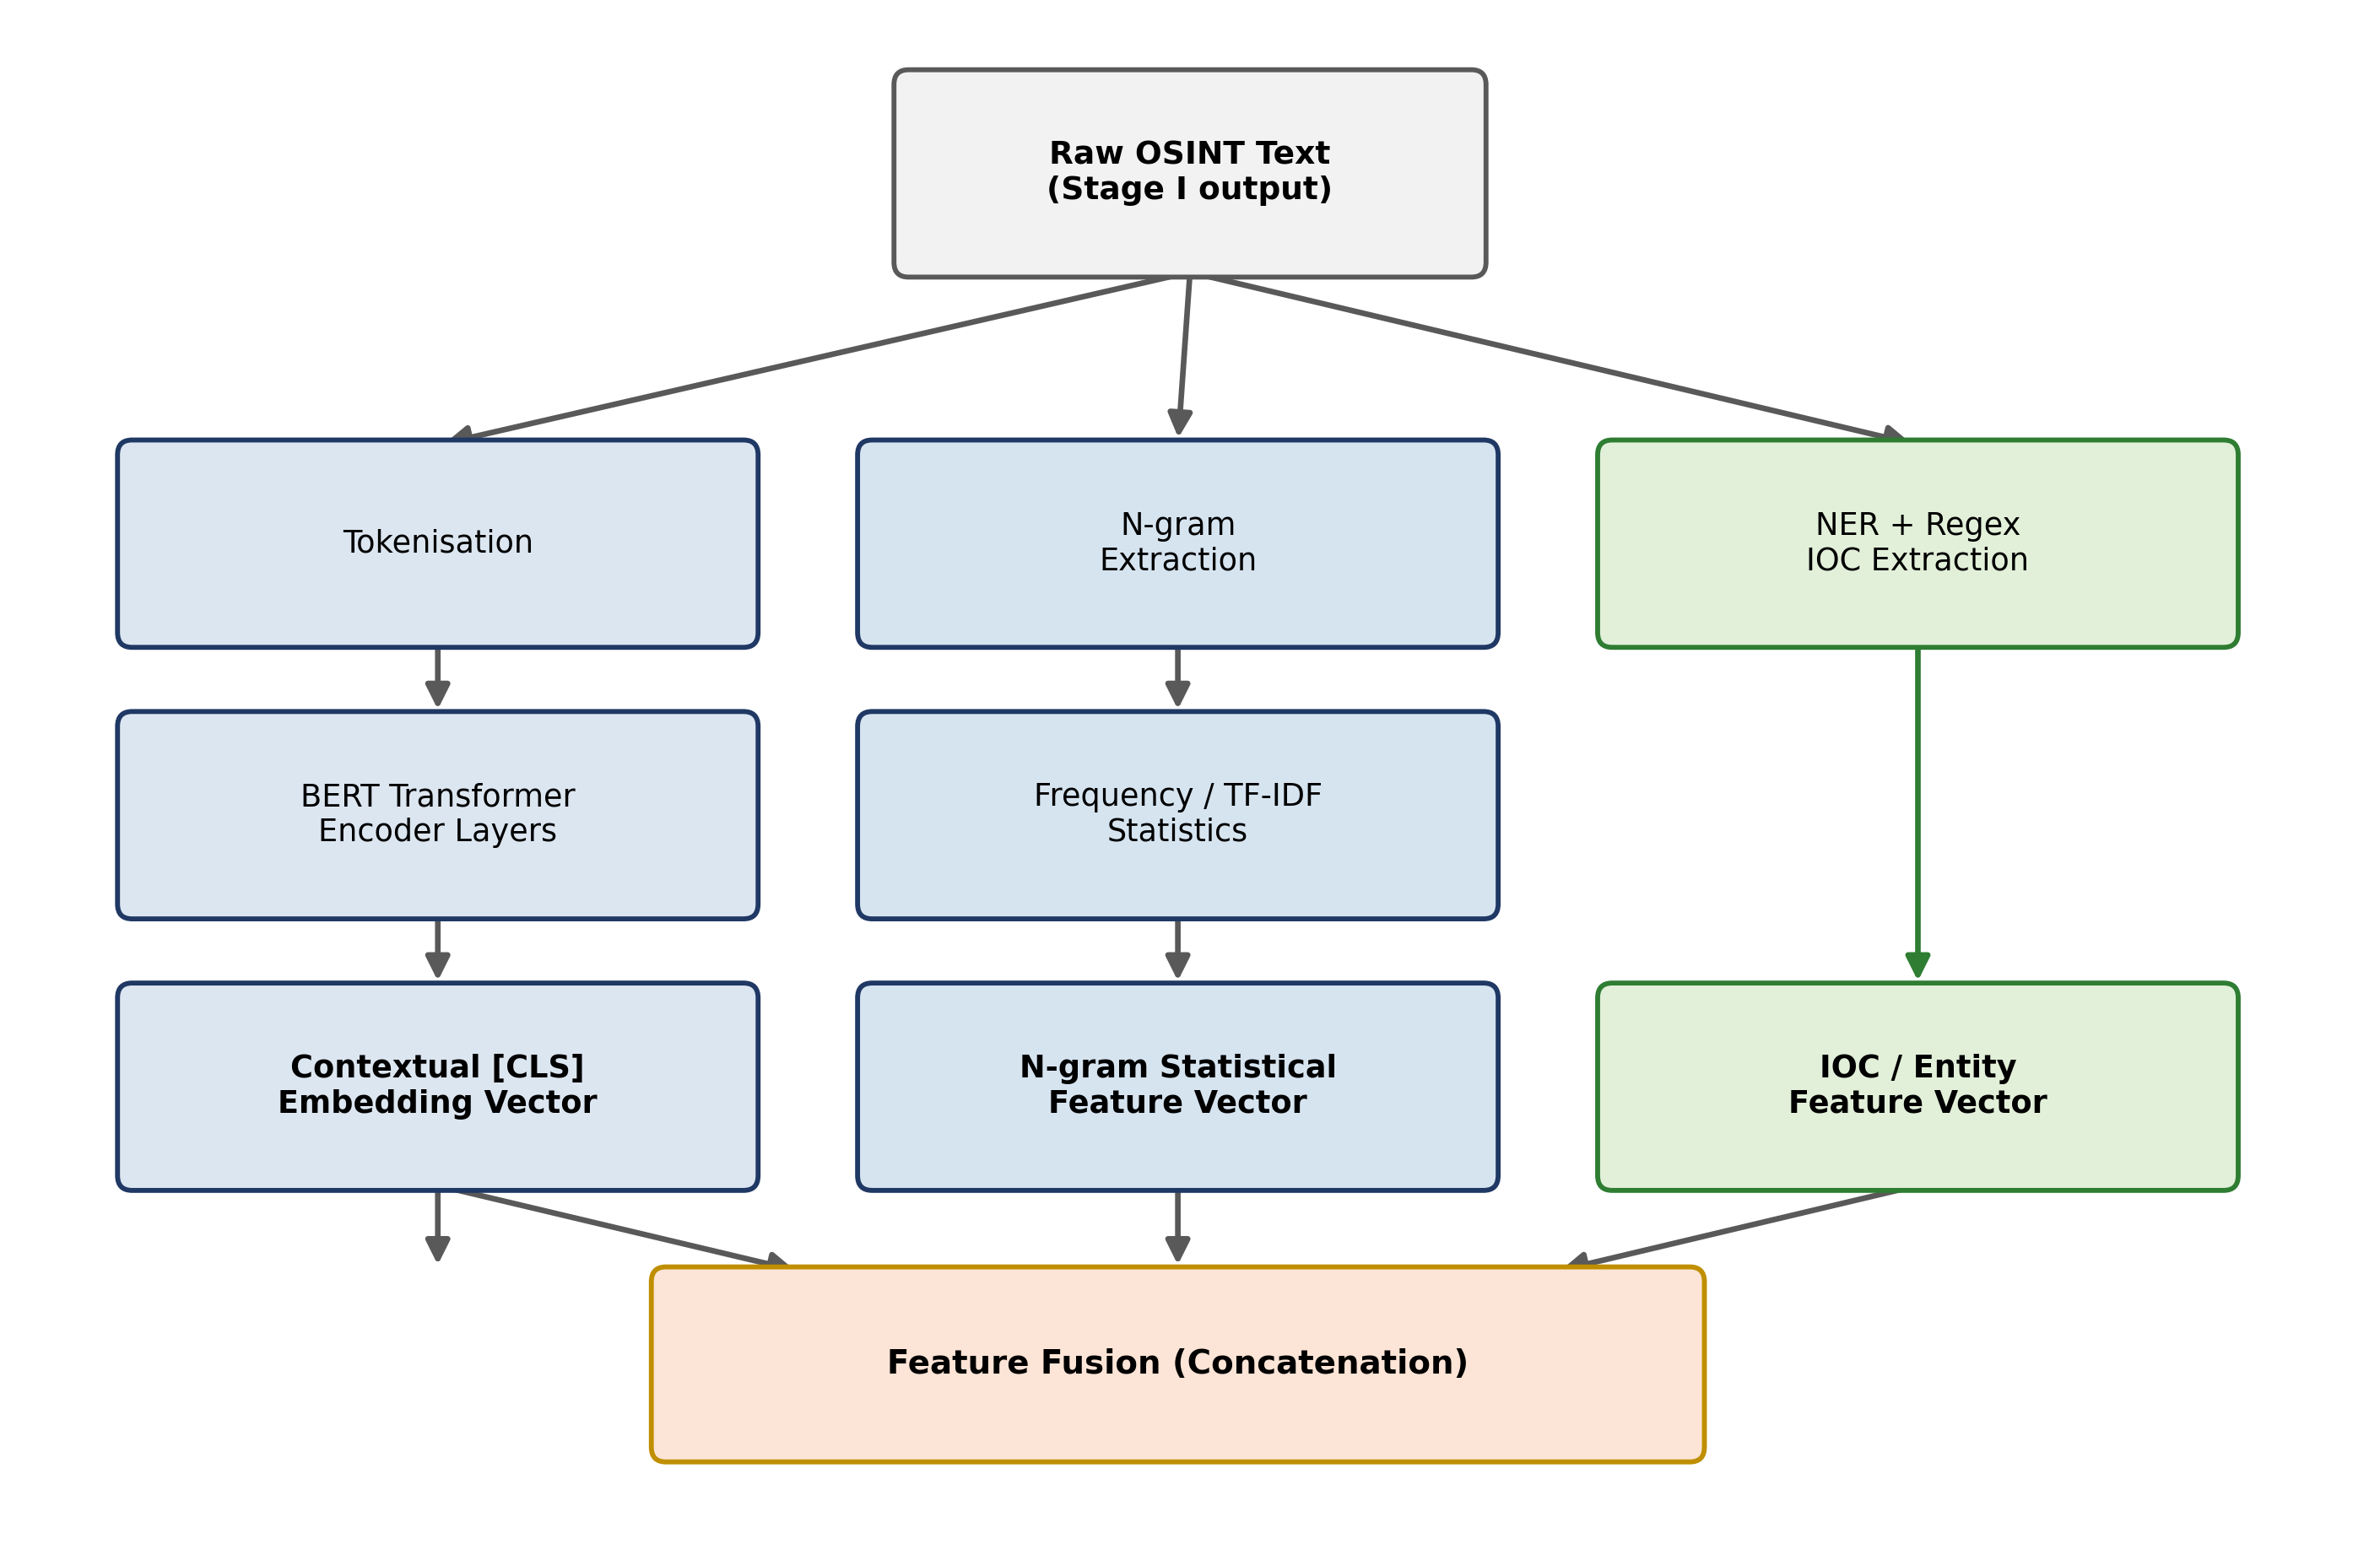
Figure 2. Hybrid deep-learning feature-extraction architecture (BERT + N-gram + IOC fusion) — Stage II.

5.3 Stage III — Metaheuristic Feature Optimisation
PSO and GWO are applied, both separately and together, to an algorithm for searching the feature space to find the subset that maximises the discriminability of the classifiers, but reduces dimensionality, and are tested on the basis of the previous study on the candidate's fake-profile detection problem, where accuracy benefits were shown from the application of population based optimisation.

5.4 Stage IV — Quantum-Inspired Neural Network Classification
The optimised subset of features is fed into a quantum-inspired neural network (QINN), a classically simulated neural network with a feature set that implements the quantum superposition principle of weighted state representations and the interference principle of layer combination, allowing the network to be trained to classify OSINT items as threat-relevant or benign, and, if labels are available, specific threat categories or MITRE ATT&CK techniques.
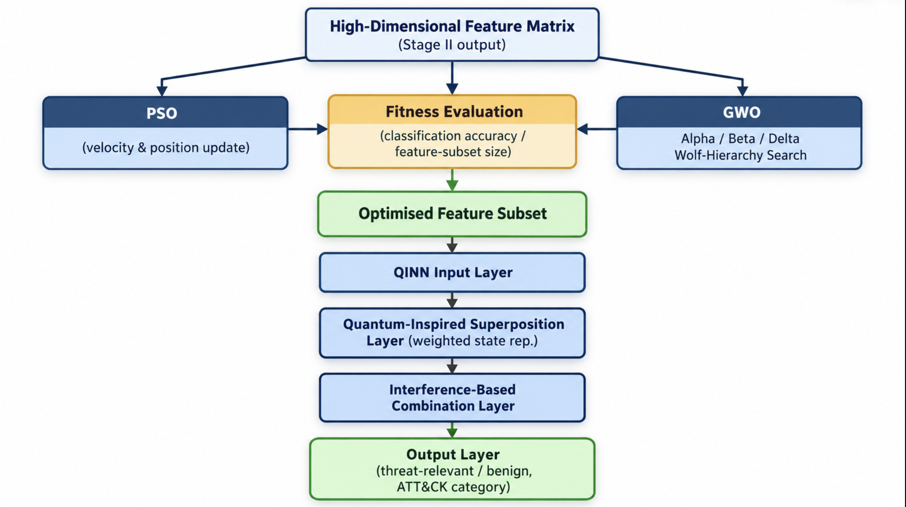
Figure 3. Metaheuristic (PSO + GWO) feature optimisation and quantum-inspired neural network classification — Stages III–IV.

Table 2. Algorithmic configuration and hyperparameter settings for the PSO, GWO, and QINN modules.
Component | Parameter | Value / Range | Rationale
PSO | Swarm size | 30–50 particles | Balances search diversity against per-generation compute cost
PSO | Inertia weight (w) | 0.4–0.9 (linearly decreasing) | Favours exploration early, exploitation in later iterations
PSO | Cognitive / social coeff. (c1, c2) | c1 = c2 = 2.0 | Standard Kennedy & Eberhart (1995) configuration
PSO | Max. iterations | 100–150 | Convergence observed in candidate's prior fake-profile study
GWO | Pack size | 30–50 wolves | Matched to PSO swarm size for fair comparison
GWO | Control parameter (a) | Linearly decreased 2 → 0 | Mirjalili et al. (2014) default decay schedule
GWO | Max. iterations | 100–150 | Matched to PSO for comparable optimisation budget
QINN | Hidden layers | 2–4 quantum-inspired layers | Depth consistent with candidate's prior DFF-QNN architecture
QINN | Learning rate | 1e-4 – 1e-3 (Adam optimiser) | Standard range for transformer-derived feature inputs
QINN | Batch size | 32–64 | Memory-efficient for BERT-derived high-dimensional vectors
QINN | Training epochs | 50–100 with early stopping | Prevents overfitting on labelled OSINT threat corpora

5.5 Stage V — Explainability and Reporting
SHAP and LIME are used after training the classifier to produce explanations of the decisions that the classifier makes, based on individual features. The final result is a well-formatted, human readable threat report containing an attached reasoning trace and optionally exported in STIX2 format to allow for the feeding of classified, explained intelligence into existing platforms, like MISP or OpenCTI.

5.6 Datasets and Evaluation
The evaluation will be based on the OSINT and social media datasets already used in the candidate's previous research (e.g. the CNN–LSTM evaluation on three datasets, and the Instagram authenticity benchmark) and will include further labelled OSINT threat corpora. The accuracy, precision, recall, and F1-score will be used to report the results, with ablation studies focusing on the optimisation and quantum-inspired stages, as done in the candidate's published work.
Table 3. Datasets used for training, ablation, and evaluation of the CTI-ENGINE pipeline.
Dataset | Source / Type | Size (approx.) | Labels / Classes | Role in Study
OSINT Threat Text Corpus I–III | Security forums, threat-advisory feeds, paste sites (candidate's CNN–LSTM study) | 3 independent corpora | Threat-relevant vs. benign; ATT&CK technique labels | Baseline classifier benchmarking and ablation studies
Instagram Authenticity Benchmark | Social-media profile data (candidate's fake-profile study) | Benchmark dataset (prior work) | Genuine vs. fake profile | Validation of QINN transfer from social-authenticity to OSINT threat task
MITRE ATT&CK-Labelled OSINT Set | Threat narratives mapped to ATT&CK techniques (candidate's prior classification study) | Multi-label corpus | ATT&CK technique categories (incl. low-density classes) | Fine-grained threat-category classification evaluation
New OSINT Threat Corpora (to be collected) | Live collection via Stage I module (forums, RSS, pastes, code repos) | To be determined during Phase I–II | Threat-relevant / benign; IOC entities | End-to-end pipeline validation and open-source release benchmarking

5.7 Software Architecture and Implementation
The thesis aims to realize this open-source tool in a modular and installable form as a python package called CTI-ENGINE, which allows each pipeline stage to be developed, tested, and released independently. The collection, feature-engineering, optimisation, modelling and explainability logic are separated in different sub-packages behind a single orchestration layer, with command-line and programmatic (API) entry points, and a STIX2 exporter for interoperability with MISP and OpenCTI.

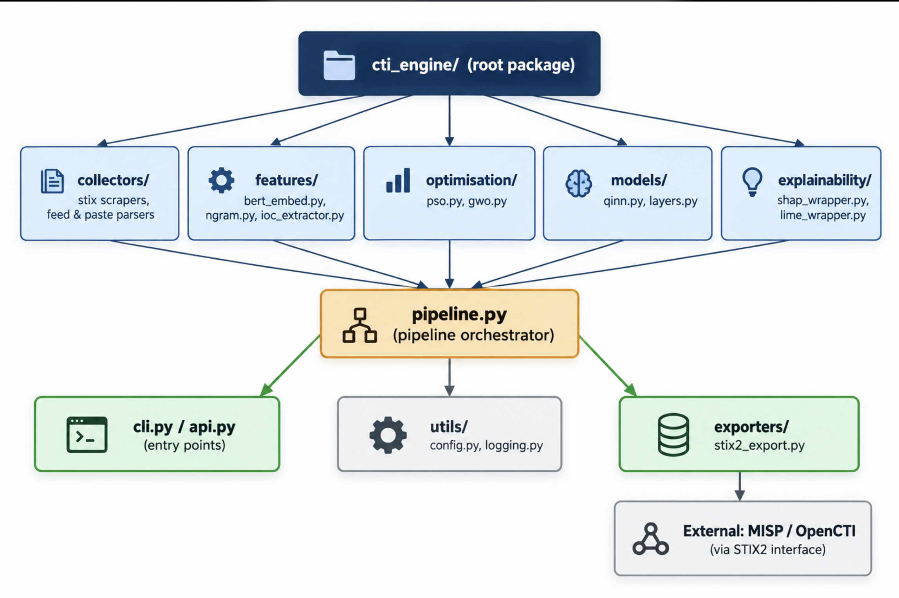
Figure 4. Structure of the Python software implementation of the CTI-ENGINE toolkit.

6. Expected Outcomes and Contributions
- A released, open-source, modular CTI pipeline (CTI-ENGINE) usable independently or alongside MISP/OpenCTI.
- A precise technical specification of the quantum-inspired architecture used, addressing the terminological ambiguity common in the literature.
- Empirical evidence, through ablation studies, of the individual contribution of metaheuristic optimisation and the quantum-inspired classifier to OSINT threat-detection accuracy.
- A reusable SHAP/LIME explanation layer generalisable to other CTI classification tasks.
- At least three to four publishable research outputs spanning feature-selection, model-architecture, explainability, and systems/tooling contributions, extending the candidate's existing publication record (two IJCISIM articles published; two manuscripts under review).

7. Tentative Work Plan
Table 4. Phase-wise tentative work plan for the proposed research.
Phase | Duration | Activities
I | Months 1–6 | Literature consolidation; OSINT collection module and dataset assembly; baseline feature extraction (BERT + N-gram).
II | Months 7–12 | Design and implementation of PSO/GWO feature-optimisation stage; comparative baseline experiments.
III | Months 13–20 | Design, implementation, and validation of the quantum-inspired neural classifier; ablation studies.
IV | Months 21–26 | SHAP/LIME explainability integration; STIX2 output formatting; MISP/OpenCTI interoperability testing.
V | Months 27–33 | Full-system benchmarking; open-source release; publication of remaining papers; thesis compilation.
VI | Months 34–36 | Thesis finalisation, internal review, and submission.

References
Adadi, A., & Berrada, M. (2018). Peeking inside the black-box: A survey on explainable artificial intelligence. IEEE Access, 6, 52138-52160.
Alketbi, K. S., & Mehmood, A. (2025). A Comprehensive Survey of Explainable Artificial Intelligence Techniques for Malicious Insider Threat Detection. IEEE Access.
Almukaynizi, M., Mariconti, E., & Stringhini, G. (2017). Mining cyber threat intelligence from hacker forums and dark web marketplaces. Proceedings of IEEE EuroS&P Workshops, 98-102.
Alsodi, O., Zhou, X., Gururajan, R., Shrestha, A., & Btoush, E. (2025). From Tweets to Threats: A Survey of Cybersecurity Threat Detection Challenges, AI-Based Solutions and Potential Opportunities in X. Applied Sciences, 15(7), 3898.
Applebaum, A., Miller, B., & Strom, C. (2019). Improving threat intelligence with ATT&CK. MITRE Technical Report.
Avrahami, Z., Zwilling, M., & Hajaj, C. (2025). Leveraging OSINT for Advanced Proactive Cybersecurity: Strategies and Solutions. IEEE Access.
Babenko, T., Kolesnikova, K., Abramkina, O., & Vitulyova, Y. (2025). Automated OSINT Techniques for Digital Asset Discovery and Cyber Risk Assessment. Computers, 14(10), 430.
Biamonte, J., Wittek, P., Pancotti, N., Rebentrost, P., Wiebe, N., & Lloyd, S. (2017). Quantum machine learning. Nature, 549(7671), 195-202.
Dale, D. S., McClanahan, K., Elder, W. S., & Li, Q. (2025). Twitter-Based OSINT for Cyber Event Analytics. IEEE Access.
Devlin, J., Chang, M.-W., Lee, K., & Toutanova, K. (2019). BERT: Pre-training of deep bidirectional transformers for language understanding. Proceedings of NAACL-HLT, 4171-4186.
Filigran. OpenCTI — Open Cyber Threat Intelligence Platform. https://www.opencti.io/
Gonon, L., Martínez-Peña, R., & Ortega, J. P. (2025). Feedback-driven recurrent quantum neural network universality. arXiv preprint arXiv:2506.16332.
He, H., & Garcia, E. A. (2009). Learning from imbalanced data. IEEE Transactions on Knowledge and Data Engineering, 21(9), 1263-1284.
Kennedy, J., & Eberhart, R. (1995). Particle swarm optimization. Proceedings of ICNN'95 - International Conference on Neural Networks, 1942-1948.
Khan, S., Dilshad, N., Ahmad, N., Noor, S., & AlQahtani, S. A. (2025). Integrating AI in security information and event management for real time cyber defense. Scientific Reports, 15(1), 35872.
Liao, T., Chen, L., & Ji, J. (2019). Cybersecurity named entity recognition using deep learning. Computers & Security, 85, 1-14.
Liu, Y., Ott, M., Goyal, N., et al. (2019). RoBERTa: A robustly optimized BERT pretraining approach. arXiv preprint arXiv:1907.11692.
Lundberg, S. M., & Lee, S.-I. (2017). A unified approach to interpreting model predictions (SHAP). Advances in Neural Information Processing Systems, 30.
Mirjalili, S., Mirjalili, S. M., & Lewis, A. (2014). Grey Wolf Optimizer. Advances in Engineering Software, 69, 46-61.
MITRE Corporation. (2023). MITRE ATT&CK: Techniques, Tactics, and Procedures.
Nguyen, H. T., Jung, J. J., & Camacho, D. (2020). Cyber threat intelligence extraction using deep learning. IEEE Access, 8, 104012-104025.
Open Information Security Foundation. MISP — Open Source Threat Intelligence and Sharing Platform. https://www.misp-project.org/
Ribeiro, M. T., Singh, S., & Guestrin, C. (2016). "Why should I trust you?": Explaining the predictions of any classifier (LIME). Proceedings of ACM SIGKDD, 1135-1144.
Şahin, E., Arslan, N. N., & Özdemir, D. (2025). Unlocking the black box: an in-depth review on interpretability, explainability, and reliability in deep learning. Neural Computing and Applications, 37(2), 859-965.
Santos, P., Abreu, R., Reis, M. J. C. S., Serodio, C., & Branco, F. (2025). A systematic review of cyber threat intelligence: the effectiveness of technologies, strategies, and collaborations in combating modern threats. Sensors, 25(14), 4272.
Sharma, R. K., Singh, D. K., & Barnwal, R. P. (2026). Automated MITRE ATT&CK Technique Classification Using OSINT and Advanced NLP. International Journal of Computer Information Systems and Industrial Management Applications, 18(18s), 726-738.
Sharma, R. K., Singh, D. K., & Barnwal, R. P. (2026). Deep-Learning-Enhanced Entity Resolution for Cyber Threat Intelligence Using OSINT Sources. International Journal of Computer Information Systems and Industrial Management Applications, 18(6s), 1019-1029.
Sharma, R. K., Singh, D. K., & Barnwal, R. P. Deep Learning-based OSINT Threat Classification on Blockchain Infrastructure. (Manuscript under review).
Sharma, R. K., Singh, D. K., & Barnwal, R. P. OSINT-Enhanced Hybrid Optimal Deep Learning Framework for Fake Profile Detection in Online Social Media. (PhD research article, under review).
Shoukat, S., Gao, T., Javeed, D., Saeed, M. S., & Adil, M. (2025). Trust my IDS: An explainable AI integrated deep learning-based transparent threat detection system for industrial networks. Computers & Security, 149, 104191.
Tolah, A. (2025). BlockIntelChain: a blockchain-based cyber threat intelligence sharing architecture. Scientific Reports.
Zhao, T., Wu, L., Cui, Z., & Qin, A. K. (2025). An adaptive strategy based multi-population multi-objective optimization algorithm. Information Sciences, 686, 120913.

