Visual Analogue Scale (VAS)
Place a mark on the line below to indicate your current level of pain
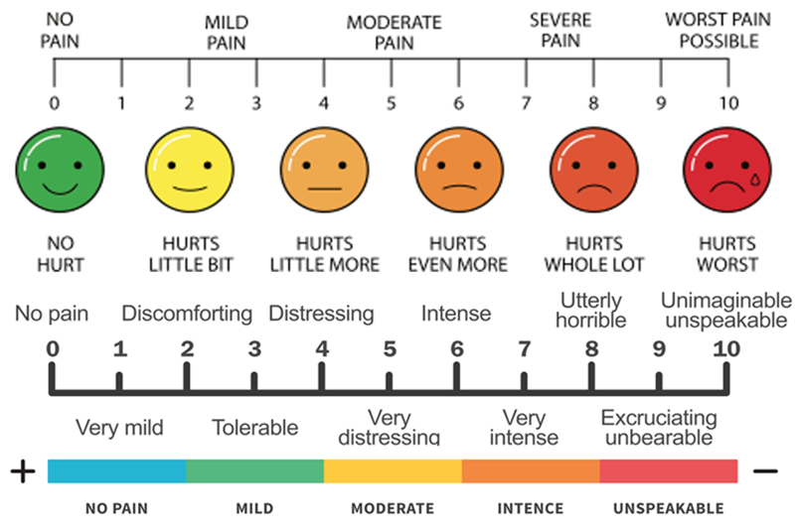
It is used to assess the subjective perception of elderly with joint pain.
This tool consists of 10 cm line „0‟ on one end, representing no pain and „10‟ on the other, representing severe pain. The pain scale was shown to elderly during pre test and post test.
▪ No pain - 0
▪ Mild pain - 1 to 3
▪ Moderate pain - 4 to 6
▪ Severe pain - 7 to10

