Kinesiophobia, Balance, Gait Performance and Fear of Falling Among Older Adults: A Cross-Sectional Screening Study

Abstract
Background: Falls are a leading cause of injury and loss of independence in older adults. Kinesiophobia, an excessive fear of movement, may limit balance and gait beyond what physical decline alone explains, yet it is rarely screened for in Indian community geriatric care.
Objective: To describe kinesiophobia, balance, gait and fear of falling in community-dwelling older adults, compare them by fall history, sex and age band, and examine how kinesiophobia relates to the other measures.
Methods: A cross-sectional screening study enrolled 77 ambulatory adults aged 60–74 years at a hospital outreach programme in Coimbatore, South India. Participants completed the Tampa Scale for Kinesiophobia (TSK-17), Fullerton Advanced Balance Scale (FAB), Dynamic Gait Index (DGI) and Falls Efficacy Scale–International (FES-I); fall history was recorded by structured interview. Groups were compared with independent t-tests (confirmed by Mann–Whitney U), associations with Pearson and Spearman coefficients, and the independent contribution of kinesiophobia with multiple linear regression adjusted for age and sex.
Results: Mean age was 67.6 ± 5.0 years; 62.3% were women and 36.4% reported a fall. Mean scores were TSK 39.6 ± 9.6, FAB 20.7 ± 8.2, DGI 15.7 ± 4.6 and FES-I 31.0 ± 14.4. High kinesiophobia (TSK > 37) was present in 61.0%, FAB fall risk (≤ 25) in 68.8%, DGI fall risk (≤ 19) in 76.6%, and high concern about falling (FES-I ≥ 28) in 48.1%. Only FES-I differed between fallers and non-fallers (35.6 vs 28.4; p = 0.033; d = 0.51). Kinesiophobia correlated with poorer balance (r = −0.52), poorer gait (r = −0.45) and greater fear of falling (r = 0.45; all p < 0.001), and remained an independent predictor of FAB (β = −0.52), DGI (β = −0.44) and FES-I (β = 0.38) after adjustment. Women had higher TSK (42.5 vs 34.8; p < 0.001; d = 0.86) and FES-I (34.2 vs 25.7; p = 0.011) with no difference in FAB or DGI.
Conclusion: Kinesiophobia was common and independently linked to poorer balance and gait, while concern about falling, not kinesiophobia, distinguished those who had fallen. Screening both movement-related fear and fall-related self-efficacy alongside performance tests, with attention to older women, may sharpen fall-prevention planning in community physiotherapy.
Keywords: kinesiophobia; fear of falling; postural balance; gait; accidental falls; aged; India

1. Introduction
Population ageing is fastest in low- and middle-income countries. By 2030, one in six people worldwide will be 60 or older, and by 2050 about 80% of older adults will live in low- and middle-income countries [1]. India is part of this shift, and the health system's capacity to keep older people mobile and independent will be tested over the coming decades.
Falls are one of the costliest consequences of that shift. Roughly a quarter to a third of community-dwelling older adults fall each year, and falls are a leading cause of injury, disability and injury-related death in this age group [2,3]. Classic risk factors include poor balance, slow or variable gait, lower-limb weakness, polypharmacy and previous falls [4]. Indian community studies report falls prevalence in a similar range, with a substantial share of fallers losing some functional independence afterwards [5].
Physical capacity does not explain fall risk on its own. Fear of falling is reported by up to half of older adults, including many who have never fallen, and it predicts activity restriction, deconditioning and future falls [6,7]. A recent meta-analysis placed its pooled global prevalence near 50% and linked it to female sex, depressive symptoms and poorer self-rated health [7]. Fear of falling is usually measured as low falls efficacy, that is, low confidence in performing daily tasks without falling [8,9].
Kinesiophobia is a related but broader construct. Kori and colleagues described it as an excessive, irrational and debilitating fear of physical movement arising from a feeling of vulnerability to injury [10]. The fear-avoidance model holds that such fear leads people to avoid movement, which in turn causes disuse, deconditioning and further disability [11]. Although the construct was developed in chronic pain, kinesiophobia predicts physical function in older adults with and without pain [12], and a scoping review found it to be a stronger driver of activity levels than pain intensity itself [13]. Older adults with higher kinesiophobia walk more slowly, show poorer dynamic and dual-task balance, and those with a fall history score higher on the Tampa Scale for Kinesiophobia [14,15]. Kinesiophobia and fear of falling are now viewed as overlapping parts of one fear-avoidance pathway [16].
Three gaps remain. First, most studies examine kinesiophobia or fear of falling, not both alongside objective balance and gait tests in the same people. Second, few studies come from Indian community settings, where cultural expectations about activity in later life and access to rehabilitation differ from those in high-income countries. Third, it is unclear which of these measures best separates people who have already fallen from those who have not, which matters for choosing a brief screening battery.
This study therefore aimed to (i) describe kinesiophobia, balance, gait and fear of falling in community-dwelling older adults in South India and estimate the proportion above published risk thresholds; (ii) compare these measures by fall history, sex and age band; and (iii) test whether kinesiophobia is associated with balance, gait and fear of falling independently of age and sex. We hypothesised that higher kinesiophobia would be associated with poorer balance and gait and greater fear of falling.

2. Materials and methods

2.1 Study design and setting
This was a cross-sectional screening study conducted through the community outreach programme of the Department of Physiotherapy, Sri Lakshmi Medical Center & Hospital, Coimbatore, Tamil Nadu, India, between [month year] and [month year]. Reporting follows the STROBE statement for cross-sectional studies [17].

2.2 Participants
Older adults attending outreach screening were recruited by convenience sampling. Inclusion criteria were age 60–74 years, independent ambulation with or without a walking aid, being cognitively intact on clinical screening, and willingness to give written informed consent. Exclusion criteria were acute illness, non-ambulatory status and cognitive impairment. Seventy-seven participants met the criteria and completed all assessments.
With n = 77 and two-sided α = 0.05, the study had about 76% power to detect a correlation of r = 0.30 and more than 99% power for r ≥ 0.45 (Fisher z approximation).

2.3 Data collection
A physiotherapist recorded age, sex, body weight and height, then administered the questionnaires by interview [language(s) to confirm], followed by the performance tests. Fall history was obtained by structured interview using the ProFaNE definition of a fall as an unexpected event in which the person comes to rest on the ground, floor or a lower level [18], and coded as yes or no for the preceding [12 months — confirm recall period]. Rest was allowed as needed, and participants were guarded during all balance and gait tasks.
Height was recorded below 110 cm for four participants and at 120 cm for two more, values that are implausible for ambulatory adults and that produced body mass index (BMI) values up to 77 kg/m². Because these errors could not be corrected, BMI was not used in any analysis.

2.4 Outcome measures
The four instruments, their ranges and the thresholds used for screening are summarised in Table 1.
Table 1. Assessment instruments and screening thresholds
Instrument | Construct | Items | Range | Direction | Threshold used
Tampa Scale for Kinesiophobia (TSK-17) [19,20] | Fear of movement or re-injury | 17, 4-point Likert | 17–68 | Higher = more fear | > 37 = high kinesiophobia [20]
Fullerton Advanced Balance Scale (FAB) [21,22] | Static and dynamic balance, multisensory | 10 tasks, 0–4 each | 0–40 | Higher = better | ≤ 25 = increased fall risk [22]
Dynamic Gait Index (DGI) [23] | Gait adaptation to task demands | 8 tasks, 0–3 each | 0–24 | Higher = better | ≤ 19 = increased fall risk [23]
Falls Efficacy Scale–International (FES-I) [24,25] | Concern about falling in daily activities | 16, 4-point Likert | 16–64 | Higher = more concern | 16–19 low, 20–27 moderate, 28–64 high [25]
The TSK-17 is the original kinesiophobia questionnaire and is widely used outside chronic pain [19]. The FAB was designed for functionally independent older adults and avoids the ceiling effect of the Berg Balance Scale [21]. The DGI scores the ability to change speed, turn the head, step over and around obstacles, and climb stairs while walking [23]. The FES-I extends the original Falls Efficacy Scale to social and outdoor activities and has strong cross-cultural validity [24,25].
[Author note: eight FES-I totals (11–15) fall below the scale minimum of 16. Please check these against the score sheets before submission; they were analysed as recorded.]

2.5 Statistical analysis
Continuous variables are reported as mean ± standard deviation (SD), median and range, and categorical variables as counts and percentages. Normality was checked with the Shapiro–Wilk test; because several scores departed from normality, every parametric test was repeated with its non-parametric equivalent, and conclusions are based on agreement between the two.
Fallers and non-fallers, women and men, and the 60–64 and 65–74 year bands were compared with independent-samples t-tests and Mann–Whitney U tests. Effect sizes are reported as Cohen's d with 95% confidence intervals (CI), read as small (0.2), medium (0.5) and large (0.8) [26]. Categorical variables were compared with the χ² test. Associations among scores were examined with Pearson's r and confirmed with Spearman's ρ.
To test whether kinesiophobia was associated with each outcome independently of demographics, separate multiple linear regressions were fitted with FAB, DGI and FES-I as dependent variables and TSK, age and sex as predictors. A binary logistic regression with fall history as the outcome and all four scores plus age and sex as predictors explored which measure was independently associated with having fallen; discrimination was summarised by the area under the receiver operating characteristic curve (AUC). Significance was set at p < 0.05 (two-tailed). Analyses were run in SPSS v25 and cross-checked in Python 3 (SciPy, statsmodels).

2.6 Ethics
The study was approved by the Institutional Ethics Committee of [institution] (approval no. [number], dated [date]) and conducted in accordance with the Declaration of Helsinki. All participants gave written informed consent, and data were anonymised before analysis.

3. Results

3.1 Participant characteristics and screening burden
All 77 participants completed every assessment. Mean age was 67.6 ± 5.0 years; 48 (62.3%) were women and 28 (36.4%) reported at least one fall. Fall history did not differ by sex (women 39.6% vs men 31.0%; χ² p = 0.61) or age band (60–64 years 50.0% vs 65–74 years 30.9%; p = 0.19), and fallers and non-fallers were of similar age (67.4 ± 5.5 vs 67.7 ± 4.8 years; p = 0.81).
Sixty-five participants (84.4%) exceeded at least one published risk threshold (Table 2, Figure 1). Three in five had high kinesiophobia, two in three had FAB scores in the fall-risk range, three in four had DGI scores in the fall-risk range, and almost half reported high concern about falling.
Table 2. Demographic characteristics and screening scores (N = 77)
Variable | Mean ± SD | Median | Range | Shapiro–Wilk p | Above risk threshold, n (%)
Age (years) | 67.55 ± 5.02 | 68 | 60–74 | < 0.001 | —
Weight (kg) | 61.84 ± 13.30 | 60 | 35–95 | 0.402 | —
Female sex, n (%) | 48 (62.3) |  |  |  | —
History of falls, n (%) | 28 (36.4) |  |  |  | —
TSK-17 (17–68) | 39.61 ± 9.64 | 42 | 17–57 | 0.012 | > 37: 47 (61.0)
FAB (0–40) | 20.73 ± 8.24 | 19 | 3–37 | 0.056 | ≤ 25: 53 (68.8)
DGI (0–24) | 15.65 ± 4.55 | 16 | 7–24 | 0.039 | ≤ 19: 59 (76.6)
FES-I (16–64) | 30.99 ± 14.36 | 26 | 11–64 | < 0.001 | ≥ 28: 37 (48.1)
FES-I concern levels: low (≤ 19) 21 (27.3%), moderate (20–27) 19 (24.7%), high (≥ 28) 37 (48.1%). TSK, Tampa Scale for Kinesiophobia; FAB, Fullerton Advanced Balance Scale; DGI, Dynamic Gait Index; FES-I, Falls Efficacy Scale–International.
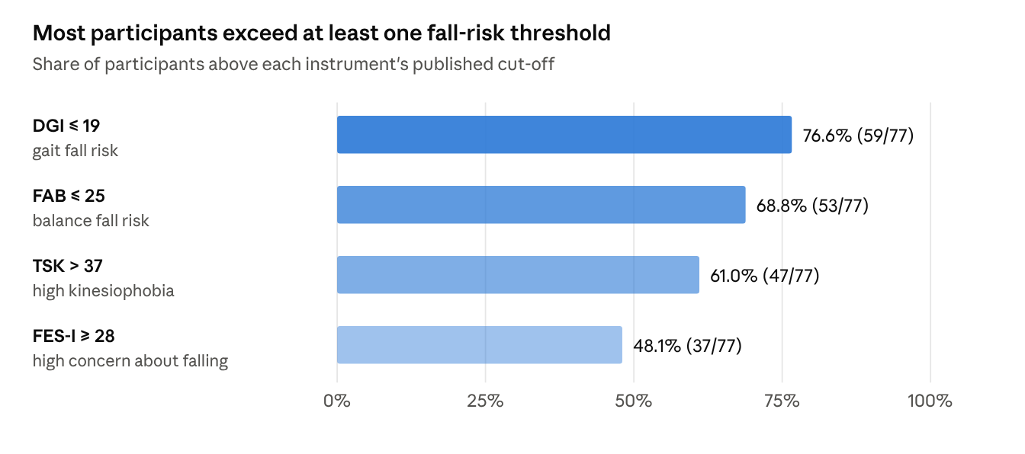
Geriatric Screening Assessment – updated 080626.xlsx · N = 77
Figure 1. Proportion of participants above published risk thresholds on each screening instrument (N = 77). Cut-offs: DGI ≤ 19 [23], FAB ≤ 25 [22], TSK > 37 [20], FES-I ≥ 28 [25].

3.2 Comparison by fall history
Concern about falling was the only measure that differed between fallers and non-fallers (Table 3). Fallers scored 7.2 points higher on the FES-I (95% CI 0.6 to 13.8; d = 0.51), and the Mann–Whitney test agreed (p = 0.038). Fallers also tended to have higher TSK and lower FAB and DGI scores, but these differences were small (|d| ≤ 0.27) and their confidence intervals included zero. High FES-I concern was more frequent among fallers (64.3% vs 38.8%), a difference at the margin of significance (χ² p = 0.055).
Table 3. Screening scores by fall history
Measure | Fallers (n = 28) | Non-fallers (n = 49) | Mean difference (95% CI) | t (df = 75) | p (t-test) | p (Mann–Whitney) | Cohen's d (95% CI)
TSK | 40.29 ± 9.44 | 39.22 ± 9.83 | 1.06 (−3.51 to 5.63) | 0.46 | 0.645 | 0.645 | 0.11 (−0.36 to 0.57)
FAB | 19.32 ± 8.45 | 21.53 ± 8.09 | −2.21 (−6.09 to 1.67) | −1.13 | 0.260 | 0.248 | −0.27 (−0.73 to 0.20)
DGI | 15.18 ± 4.17 | 15.92 ± 4.77 | −0.74 (−2.89 to 1.42) | −0.68 | 0.496 | 0.470 | −0.16 (−0.63 to 0.30)
FES-I | 35.57 ± 14.35 | 28.37 ± 13.83 | 7.20 (0.59 to 13.82) | 2.17 | 0.033 | 0.038 | 0.51 (0.04 to 0.99)
Values are mean ± SD. Bold indicates p < 0.05.
In the logistic regression including all four scores, age and sex, only FES-I was independently associated with fall history (OR 1.05 per point, 95% CI 1.00 to 1.09; p = 0.035). TSK (OR 0.97; p = 0.34), FAB (OR 0.95; p = 0.30) and DGI (OR 1.05; p = 0.60) were not. The model explained little variance (McFadden R² = 0.07) and discriminated modestly (AUC 0.67). On their own, FES-I gave the highest AUC (0.64), followed by FAB (0.58), DGI (0.55) and TSK (0.53).

3.3 Comparison by sex and age band
Women carried a heavier psychological burden than men without a matching gap in performance (Table 4, Figure 2). Women scored 7.7 points higher on the TSK (d = 0.86, a large effect) and 8.4 points higher on the FES-I (d = 0.61), while FAB and DGI did not differ. The two age bands differed only on FES-I, which was higher in the 65–74 group (d = 0.51); this difference was not confirmed by the Mann–Whitney test (p = 0.063) and should be read with caution.
Table 4. Screening scores by sex and age band
Measure | Women (n = 48) | Men (n = 29) | p (t / U) | d | 60–64 y (n = 22) | 65–74 y (n = 55) | p (t / U) | d
TSK | 42.50 ± 9.47 | 34.83 ± 7.98 | < 0.001 / < 0.001 | 0.86 | 39.82 ± 9.77 | 39.53 ± 9.68 | 0.906 / 0.883 | −0.03
FAB | 19.60 ± 8.02 | 22.59 ± 8.41 | 0.125 / 0.136 | −0.37 | 21.36 ± 7.84 | 20.47 ± 8.45 | 0.671 / 0.795 | −0.11
DGI | 15.00 ± 4.44 | 16.72 ± 4.61 | 0.108 / 0.110 | −0.38 | 16.14 ± 4.77 | 15.45 ± 4.49 | 0.556 / 0.557 | −0.15
FES-I | 34.17 ± 15.38 | 25.72 ± 10.80 | 0.011 / 0.030 | 0.61 | 25.82 ± 11.71 | 33.05 ± 14.89 | 0.045 / 0.063 | 0.51
Values are mean ± SD. d is women minus men, and 65–74 minus 60–64 years. Bold indicates p < 0.05.
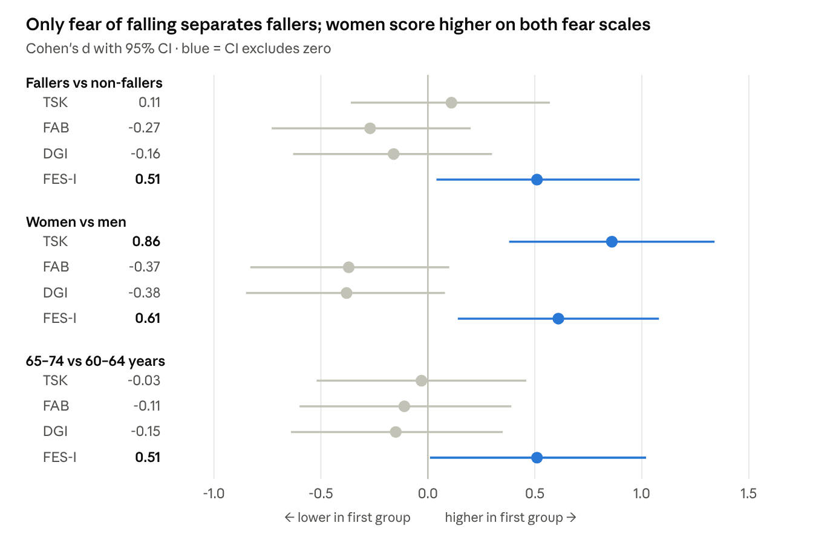
Geriatric Screening Assessment – updated 080626.xlsx · N = 77
Figure 2. Standardised mean differences (Cohen's d, 95% CI) in screening scores by fall history, sex and age band. Positive values indicate a higher score in the first-named group. Note that higher TSK and FES-I scores mean more fear, whereas higher FAB and DGI scores mean better performance.

3.4 Associations between kinesiophobia, balance, gait and fear of falling
Kinesiophobia was moderately and significantly associated with every other screening measure (Table 5, Figure 3). Higher TSK scores went with lower FAB (r = −0.52) and DGI (r = −0.45) and higher FES-I (r = 0.45; all p < 0.001). FAB and DGI were strongly correlated (r = 0.72). Spearman coefficients were within 0.05 of the Pearson values for every pair. Age was not related to kinesiophobia, balance or gait, and only weakly to FES-I (r = 0.23; p = 0.045; ρ = 0.18, p = 0.12).
Table 5. Correlation matrix (Pearson r below the diagonal, Spearman ρ above)
 | Age | TSK | FAB | DGI | FES-I
Age | 1 | 0.02 | −0.10 | −0.16 | 0.18
TSK | 0.05 | 1 | −0.50*** | −0.44*** | 0.44***
FAB | −0.13 | −0.52*** | 1 | 0.72*** | −0.26*
DGI | −0.17 | −0.45*** | 0.72*** | 1 | −0.35**
FES-I | 0.23* | 0.45*** | −0.31** | −0.37** | 1
* p < 0.05; ** p < 0.01; *** p < 0.001 (two-tailed).
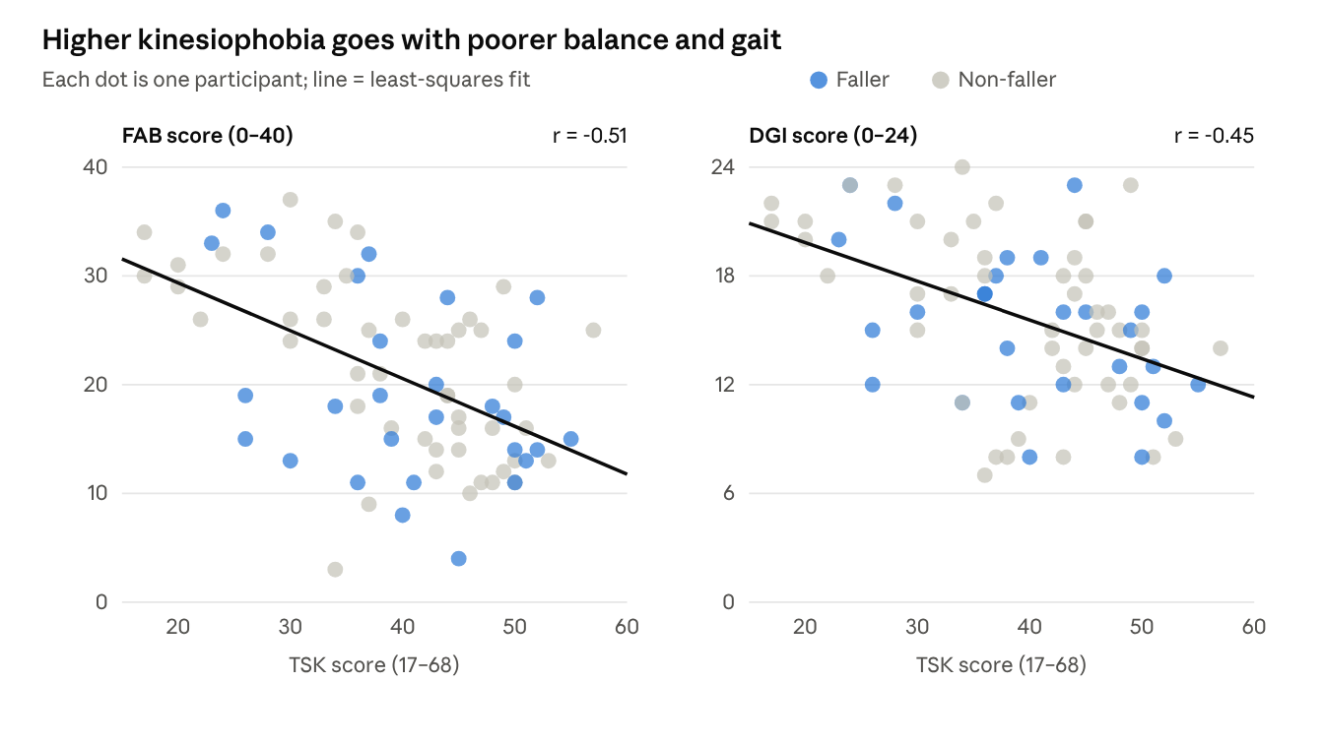
Geriatric Screening Assessment – updated 080626.xlsx · N = 77
Figure 3. Relationship of kinesiophobia (TSK) with balance (FAB, left) and dynamic gait (DGI, right). Fallers are shown in blue and non-fallers in grey; fallers are spread across the full range of kinesiophobia, consistent with the absence of a TSK difference by fall history.

3.5 Kinesiophobia as an independent correlate
Kinesiophobia remained a significant predictor of all three outcomes after adjustment for age and sex (Table 6). Each one-point rise in TSK was associated with a 0.44-point lower FAB score, a 0.21-point lower DGI score and a 0.56-point higher FES-I score. Sex was not significant in any model once TSK was included, which suggests that the higher FES-I in women runs largely through their higher kinesiophobia. Age added independently only to FES-I.
Table 6. Multiple linear regression of balance, gait and fear of falling on kinesiophobia, age and sex
Outcome | Predictor | B (95% CI) | β | p | Model R² (adjusted) | F (3, 73), p
FAB | TSK | −0.44 (−0.63 to −0.26) | −0.52 | < 0.001 | 0.28 (0.25) | 9.32, < 0.001
 | Age | −0.18 | — | 0.289
 | Female | 0.33 | — | 0.857
DGI | TSK | −0.21 (−0.31 to −0.10) | −0.44 | < 0.001 | 0.23 (0.20) | 7.17, < 0.001
 | Age | −0.14 | — | 0.143
 | Female | −0.21 | — | 0.843
FES-I | TSK | 0.56 (0.24 to 0.89) | 0.38 | < 0.001 | 0.26 (0.23) | 8.64, < 0.001
 | Age | 0.63 | — | 0.034
 | Female | 4.40 | — | 0.176
B, unstandardised coefficient; β, standardised coefficient. Bold indicates p < 0.05.

4. Discussion
This study found that kinesiophobia was common among community-dwelling older adults in South India and was independently associated with poorer balance, poorer gait and greater concern about falling. Concern about falling, rather than kinesiophobia or performance-based measures, was the only score that distinguished people who had already fallen. Women showed markedly higher kinesiophobia and fall-related concern despite balance and gait similar to men.

4.1 Kinesiophobia, balance and gait
The moderate inverse correlations between TSK and both FAB and DGI, which held after adjustment for age and sex, support the fear-avoidance model in an ageing population [11]. In that model, fear of movement leads to avoidance of challenging activity, and the resulting disuse erodes the very balance and gait reserves that protect against falls [11,16]. Our findings agree with Naugle and colleagues, who showed that kinesiophobia predicted physical function in older adults [12], and with Abit Kocaman and Aydoğan Arslan, who reported poorer gait, balance and dual-task performance in older adults with higher kinesiophobia [14]. TSK explained roughly a quarter of the variance in FAB and a fifth in DGI, a sizeable share for a single questionnaire given the many physical determinants of balance in later life [27].
The direction of this relationship cannot be established from cross-sectional data. Poor balance may generate fear of movement as readily as fear may degrade balance, and the two probably reinforce each other. The near-absence of association between age and either TSK or the performance tests in this narrow 60–74 range suggests that kinesiophobia is not simply a marker of being older.

4.2 Fear of falling and fall history
Only FES-I separated fallers from non-fallers, with a medium effect, and it was the only score independently associated with fall history in multivariable analysis. This fits the view that falls efficacy reflects lived experience of instability, including the experience of having fallen [6,9]. Kinesiophobia, by contrast, did not differ by fall history. One explanation is that the TSK captures a general fear of movement and injury that can arise from pain, illness beliefs or cultural norms about rest in old age, whereas the FES-I asks specifically about falling during daily activities [13,16]. A second explanation is that a single fall may sharpen fall-specific worry without changing broader beliefs about movement.
The absence of a FAB or DGI difference between fallers and non-fallers was unexpected, given that both tests predict prospective falls in other cohorts [22,23]. Retrospective fall history is a weaker reference standard than prospective follow-up, because some falls are forgotten and some fallers improve or adapt afterwards [28]. The high proportion of participants below the FAB and DGI thresholds, regardless of fall history, also narrows the contrast between groups. The modest discrimination of every measure (AUC 0.53–0.64) argues against using any one of them alone to classify fall risk.

4.3 Sex differences
Women scored higher on both fear measures by medium-to-large margins, while their balance and gait did not differ significantly from men's. Higher fear of falling in older women is consistent across populations [7,29], and our data extend this pattern to kinesiophobia in an Indian sample. Once TSK entered the regression, sex no longer predicted FES-I, which suggests that women's greater concern about falling may run through a broader fear of movement. Women in this age group in India may also have fewer opportunities for vigorous activity and more caregiving and household roles that shape how they judge physical risk; these factors were not measured here and deserve study.

4.4 Clinical implications
The screening burden in this cohort was high: three in five had high kinesiophobia and two in three or more fell below balance or gait thresholds. Performance tests alone would miss the psychological component that independently relates to function, while fear questionnaires alone would miss many people with objective balance deficits. A combined battery of a fear-of-movement measure, a falls-efficacy measure and one performance test appears justified for community screening. Given the strong FAB–DGI correlation, one of the two may be enough when time is short.
For intervention, exercise programmes reduce both falls and fear of falling in community-dwelling older adults [30,31], and multicomponent approaches that add cognitive-behavioural elements show the most consistent effects on fear [32]. Programmes that grade exposure to feared movements, explain the benefits of activity, and include balance and strength training may address kinesiophobia and physical capacity together. Older women, who carried the highest fear burden, may be a priority group.

4.5 Strengths and limitations
Strengths include the use of four validated instruments covering both psychological and performance domains in the same participants, analysis with both parametric and non-parametric methods with consistent results, adjustment for age and sex, and a setting that is under-represented in the literature.
Several limitations apply. The cross-sectional design precludes causal inference. Convenience sampling from a single hospital outreach programme limits generalisability to other regions and to urban or rural populations. Fall history was self-reported and retrospective, so recall bias is likely [28]. Cognition was screened clinically rather than with a standardised tool such as the MoCA. Pain, depression, comorbidity and medication use, all of which can influence kinesiophobia and fear of falling, were not recorded. BMI could not be analysed because of height recording errors, and eight FES-I totals below the scale minimum need verification. Finally, the 60–64 group was small (n = 22), limiting age-band comparisons.

4.6 Future research
Prospective studies should test whether baseline TSK and FES-I predict incident falls beyond FAB and DGI, and establish cut-offs for Indian older adults. Randomised trials could compare kinesiophobia-targeted physiotherapy, such as graded exposure, with standard balance training. Multi-centre sampling, standardised cognitive and mood screening, and objective gait measurement with wearable sensors would strengthen future work.

5. Conclusion
In 77 community-dwelling older adults in South India, kinesiophobia was present in three of five participants and was independently associated with poorer balance, poorer gait and greater concern about falling. Concern about falling was the only measure that differed by fall history, and women carried a substantially higher burden of both fears without a matching deficit in performance. Community fall-risk screening should pair a performance test with measures of fear of movement and falls efficacy, and physiotherapy programmes should address movement-related fear directly, particularly in older women.

Declarations
Acknowledgements: The authors thank the participants and the outreach staff of Sri Lakshmi Medical Center & Hospital.
Funding: This research received no specific grant from any funding agency. [Confirm]
Conflict of interest: The authors declare no conflict of interest.
Ethics approval: [Institutional Ethics Committee name, approval number and date].
Consent: Written informed consent was obtained from all participants.
Data availability: De-identified data are available from the corresponding author on reasonable request.
Author contributions (CRediT): [Author 1]: conceptualisation, methodology, investigation; [Author 2]: data curation, formal analysis; [Corresponding author]: supervision, writing – review and editing. All authors approved the final manuscript.
Use of AI tools: [Declare any AI assistance in drafting or analysis, as most journals now require.]

References
- World Health Organization. Ageing and health [fact sheet]. Geneva: WHO; 2024. Available from: https://www.who.int/news-room/fact-sheets/detail/ageing-and-health
- World Health Organization. WHO global report on falls prevention in older age. Geneva: WHO; 2007.
- Montero-Odasso M, van der Velde N, Martin FC, et al. World guidelines for falls prevention and management for older adults: a global initiative. Age Ageing. 2022;51(9):afac205.
- Tinetti ME, Speechley M, Ginter SF. Risk factors for falls among elderly persons living in the community. N Engl J Med. 1988;319(26):1701–1707.
- Pitchai P, Dedhia HB, Bhandari N, Krishnan D, D'Souza NRJ, Bellara JM. Prevalence, risk factors, circumstances for falls and level of functional independence among geriatric population – a descriptive study. Indian J Public Health. 2019;63(1):21–26.
- Scheffer AC, Schuurmans MJ, van Dijk N, van der Hooft T, de Rooij SE. Fear of falling: measurement strategy, prevalence, risk factors and consequences among older persons. Age Ageing. 2008;37(1):19–24.
- Xiong W, Wang D, Ren W, et al. The global prevalence of and risk factors for fear of falling among older adults: a systematic review and meta-analysis. BMC Geriatr. 2024;24(1):321.
- Houston L, Piazza J, Fisher K. The relationship between fear of falling and functional mobility. Innov Aging. 2025;9(Suppl 2):igaf122.2874.
- Hadjistavropoulos T, Delbaere K, Fitzgerald TD. Reconceptualizing the role of fear of falling and balance confidence in fall risk. J Aging Health. 2011;23(1):3–23.
- Kori SH, Miller RP, Todd DD. Kinesiophobia: a new view of chronic pain behavior. Pain Manag. 1990;3:35–43.
- Vlaeyen JWS, Linton SJ. Fear-avoidance and its consequences in chronic musculoskeletal pain: a state of the art. Pain. 2000;85(3):317–332.
- Naugle KM, Blythe C, Naugle KE, Keith N, Riley ZA. Kinesiophobia predicts physical function and physical activity levels in chronic pain-free older adults. Front Pain Res. 2022;3:874205.
- Alpalhão V, Cordeiro N, Pezarat-Correia P. Kinesiophobia and fear avoidance in older adults: a scoping review on the state of research activity. J Aging Phys Act. 2022;30(6):1075–1084.
- Abit Kocaman A, Aydoğan Arslan S. Comparison of gait speed, mobility, balance, and dual-task performance in older adults with and without kinesiophobia. Somatosens Mot Res. 2023;40(3):83–89.
- Aydemir M, Altuntaş O. Factors related to kinesiophobia in individuals living in nursing homes. Exp Aging Res. 2026;52(3):429–440.
- Peeters G, Bennett M, Donoghue OA, Kennelly S, Kenny RA. Understanding the aetiology of fear of falling from the perspective of a fear-avoidance model – a narrative review. Clin Psychol Rev. 2020;79:101862.
- von Elm E, Altman DG, Egger M, Pocock SJ, Gøtzsche PC, Vandenbroucke JP. The Strengthening the Reporting of Observational Studies in Epidemiology (STROBE) statement: guidelines for reporting observational studies. Lancet. 2007;370(9596):1453–1457.
- Lamb SE, Jørstad-Stein EC, Hauer K, Becker C. Development of a common outcome data set for fall injury prevention trials: the Prevention of Falls Network Europe consensus. J Am Geriatr Soc. 2005;53(9):1618–1622.
- Miller RP, Kori SH, Todd DD. The Tampa Scale: a measure of kinesiophobia. Clin J Pain. 1991;7(1):51.
- Vlaeyen JWS, Kole-Snijders AMJ, Boeren RGB, van Eek H. Fear of movement/(re)injury in chronic low back pain and its relation to behavioral performance. Pain. 1995;62(3):363–372.
- Rose DJ, Lucchese N, Wiersma LD. Development of a multidimensional balance scale for use with functionally independent older adults. Arch Phys Med Rehabil. 2006;87(11):1478–1485.
- Hernandez D, Rose DJ. Predicting which older adults will or will not fall using the Fullerton Advanced Balance scale. Arch Phys Med Rehabil. 2008;89(12):2309–2315.
- Shumway-Cook A, Baldwin M, Polissar NL, Gruber W. Predicting the probability for falls in community-dwelling older adults. Phys Ther. 1997;77(8):812–819.
- Yardley L, Beyer N, Hauer K, Kempen G, Piot-Ziegler C, Todd C. Development and initial validation of the Falls Efficacy Scale-International (FES-I). Age Ageing. 2005;34(6):614–619.
- Delbaere K, Close JCT, Mikolaizak AS, Sachdev PS, Brodaty H, Lord SR. The Falls Efficacy Scale International (FES-I). A comprehensive longitudinal validation study. Age Ageing. 2010;39(2):210–216.
- Cohen J. Statistical power analysis for the behavioral sciences. 2nd ed. Hillsdale (NJ): Lawrence Erlbaum; 1988.
- Osoba MY, Rao AK, Agrawal SK, Lalwani AK. Balance and gait in the elderly: a contemporary review. Laryngoscope Investig Otolaryngol. 2019;4(1):143–153.
- Ganz DA, Higashi T, Rubenstein LZ. Monitoring falls in cohort studies of community-dwelling older people: effect of the recall interval. J Am Geriatr Soc. 2005;53(12):2190–2194.
- Zijlstra GAR, van Haastregt JCM, van Eijk JTM, van Rossum E, Stalenhoef PA, Kempen GIJM. Prevalence and correlates of fear of falling, and associated avoidance of activity in the general population of community-living older people. Age Ageing. 2007;36(3):304–309.
- Sherrington C, Fairhall NJ, Wallbank GK, et al. Exercise for preventing falls in older people living in the community. Cochrane Database Syst Rev. 2019;1(1):CD012424.
- Kendrick D, Kumar A, Carpenter H, et al. Exercise for reducing fear of falling in older people living in the community. Cochrane Database Syst Rev. 2014;(11):CD009848.
- Zijlstra GAR, van Haastregt JCM, van Rossum E, van Eijk JTM, Yardley L, Kempen GIJM. Interventions to reduce fear of falling in community-living older people: a systematic review. J Am Geriatr Soc. 2007;55(4):603–615.

