Research Paper

Technology-Driven Supply Chain Resilience in MSMEs:

A Bibliometric Analysis of Emerging Digital Technologies, Disruptions, and Adaptive Capabilities

Table of Contents
Table of Contents 1
Abstract 1
1. Introduction 1
1.1 Background and Context 1
1.2 Theoretical Foundation 1
Industry 4.0/5.0 Technologies 1
Dynamic Capabilities Theory (DCT) 1
1.3 Research Gap 1
1.4 Research Questions 1
1.5 Contributions 1
2. Methodology: PRISMA and Bibliometric Workflow 1
2.1 PRISMA Protocol 1
PRISMA Flow — Template Structure 1
2.2 Data Retrieval and Search Strategy 1
2.3 Inclusion and Exclusion Criteria 1
2.4 Data Cleansing and Harmonization 1
2.5 Bibliometric and Mapping Tools 1
3. Performance Analysis 1
3.1 Publication and Citation Dynamics 1
3.2 Top Contributing Outlets 1
3.3 Leading Authors and Affiliations 1
4. Science Mapping and Intellectual Structure 1
4.1 Co-Word Analysis and Keyword Co-occurrence 1
4.2 Document Co-Citation Analysis 1
4.3 Bibliographic Coupling of Authors and Countries 1
4.4 Strategic Thematic Analysis 1
5. Synthesis and Conceptual Framework 1
5.1 Integrative Synthesis of Findings 1
5.2 MSME-Specific Constraints and Enablers 1
5.3 Proposed Conceptual Model 1
6. Practical and Policy Implications 1
For Managers 1
For Policymakers 1
7. Conclusion 1
8. References 1

Abstract

Micro, small, and medium enterprises (MSMEs) form the operational backbone of most economies, yet they remain disproportionately exposed to supply chain disruptions arising from geopolitical conflict, pandemics, climate shocks, and macroeconomic volatility. While a substantial body of research has examined supply chain resilience (SCR) through the lens of Industry 4.0/5.0 technologies, this literature is heavily weighted toward large, resource-rich enterprises, leaving the mechanisms by which resource-constrained MSMEs build technology-enabled adaptive capacity comparatively under-mapped. This study conducts a systematic, PRISMA-guided bibliometric analysis of the MSME–supply chain resilience–digital technology literature indexed in Scopus and Web of Science. Using Bibliometrix/Biblioshiny (R) and VOSviewer, we perform performance analysis, keyword co-occurrence, document co-citation, and bibliometric coupling to map the field's publication dynamics, intellectual structure, and thematic evolution. The analysis identifies three dominant thematic clusters — digital technology adoption, the disruption landscape, and adaptive capabilities — and synthesizes these into a conceptual framework linking technology antecedents, dynamic capabilities, and operational resilience outcomes, moderated by MSME-specific constraints such as resource poverty, digital literacy, and ecosystem dependence. The paper concludes with practical guidance for managers and policymakers and outlines an agenda for future empirical research.

Keywords

Supply Chain Resilience,

MSMEs,

Digital Technologies,

Artificial Intelligence and Machine Learning ,

Supply Chain Disruptions,

Bibliometric Analysis.

1. Introduction

1.1 Background and Context
Micro, small, and medium enterprises (MSMEs) account for the majority of firms and employment in most national economies and are frequently described as the structural backbone of global value chains (World Bank, 2023; OECD, 2022). Despite this centrality, MSMEs are systematically more vulnerable to supply chain disruption than their large-enterprise counterparts. Three converging pressures have intensified this vulnerability over the past decade.
- Geopolitical conflict and trade fragmentation — sanctions regimes, regional conflicts, and reshoring/friend-shoring policies have disrupted established sourcing corridors that MSMEs, lacking diversified supplier bases, cannot easily reroute.
- Macroeconomic and logistical shocks — the COVID-19 pandemic, semiconductor shortages, and shipping-capacity crises exposed the thin working-capital buffers and single-tier visibility typical of small firms.
- Climate and natural-disaster exposure — MSMEs, often embedded in single-region industrial clusters, face concentrated physical and operational risk from extreme weather events.
Unlike large enterprises, which can absorb shocks through redundant inventory, multi-sourcing, and dedicated risk-management functions, MSMEs typically operate with lean working capital, limited managerial bandwidth, and constrained access to capital-intensive digital infrastructure (Ali et al., 2017). This resource asymmetry raises a central empirical question: how, and through which digital mechanisms, can resource-constrained firms build meaningful supply chain resilience (SCR)?

1.2 Theoretical Foundation

Industry 4.0/5.0 Technologies
Industry 4.0 technologies — the Internet of Things (IoT), artificial intelligence (AI) and machine learning, blockchain, big-data analytics, cloud computing, and digital twins — have been widely theorized as enablers of supply chain visibility, predictive risk sensing, and process automation (Ivanov & Dolgui, 2020). The emerging Industry 5.0 discourse extends this by foregrounding human-centricity, sustainability, and resilience as design goals rather than efficiency alone, which is particularly relevant to MSMEs where technology adoption must coexist with limited technical staffing and owner-manager-centric decision-making.

Dynamic Capabilities Theory (DCT)
Dynamic Capabilities Theory (Teece, Pisano, & Shuen, 1997; Teece, 2007) provides the dominant theoretical lens for connecting technology adoption to resilience outcomes. DCT frames resilience as the outcome of three iterative capacities: sensing (detecting disruption signals), seizing (reconfiguring resources and processes in response), and transforming (institutionalizing new routines). Digital technologies are theorized as capability enablers — IoT and analytics extend sensing capacity, cloud and modular software extend seizing capacity, and blockchain/ERP integration supports transforming capacity into durable organizational routines. However, DCT was originally developed with large, professionally managed firms in mind, and its applicability to MSMEs — where sensing, seizing, and transforming are frequently concentrated in a single owner-manager — remains theoretically under-specified.

1.3 Research Gap
A review of the SCR literature reveals a persistent asymmetry: the majority of empirical and conceptual work on technology-enabled resilience targets large enterprises, multinational corporations, or generic 'firms' without differentiating for resource scale (Pettit, Croxton, & Fiksel, 2013; Ivanov & Dolgui, 2020). Where MSME-specific studies exist, they are typically single-country case studies or qualitative investigations, limiting generalizability and cross-context comparison. Critically, no systematic, quantitative bibliometric mapping has yet been conducted that isolates the intersection of (a) MSMEs/SMEs, (b) supply chain resilience, and (c) digital/Industry 4.0 technologies as a coherent research domain. This leaves three open questions: which technologies are empirically associated with MSME resilience outcomes, how the disruption literature has evolved thematically, and how dynamic capabilities theory has (or has not) been adapted to the resource constraints of small firms.

1.4 Research Questions
- RQ1: What is the publication and citation trajectory of research at the intersection of MSMEs, supply chain resilience, and digital technologies, and which journals, authors, and countries dominate this domain?
- RQ2: What are the principal thematic clusters (technology adoption, disruption types, adaptive capabilities) that structure the intellectual landscape of this literature, and how have they evolved over time?
- RQ3: Which theoretical and empirical works form the intellectual foundation (co-citation core) of MSME-focused technology–resilience research?
- RQ4: How can the identified technology, capability, and constraint constructs be synthesized into a conceptual framework linking digital antecedents to MSME operational resilience?
- RQ5: What are the practical and policy implications of the mapped literature for managers and policymakers supporting MSME digital resilience?

1.5 Contributions
This study contributes in three ways. Theoretically, it consolidates a fragmented literature into a structured map of thematic clusters and proposes a conceptual model that extends Dynamic Capabilities Theory to the MSME context by explicitly incorporating resource-constraint moderators. Methodologically, it demonstrates a replicable PRISMA-guided bibliometric workflow — combining Scopus and Web of Science data, Bibliometrix/Biblioshiny performance analysis, and VOSviewer science mapping — that can be reused for adjacent small-firm digitalization domains. Managerially and for policy, it distills the mapped evidence into prioritized, low-resource technology adoption pathways and targeted infrastructure/training recommendations for institutions supporting MSME digital transformation.

2. Methodology: PRISMA and Bibliometric Workflow

2.1 PRISMA Protocol
The review follows the PRISMA 2020 (Preferred Reporting Items for Systematic Reviews and Meta-Analyses) statement (Page et al., 2021), adapted for bibliometric rather than meta-analytic synthesis, as recommended by Donthu, Kumar, Mukherjee, Pandey, and Lim (2021). PRISMA structures the review process into four stages — Identification, Screening, Eligibility, and Inclusion — each of which is documented with a reported count so that the review is fully reproducible.
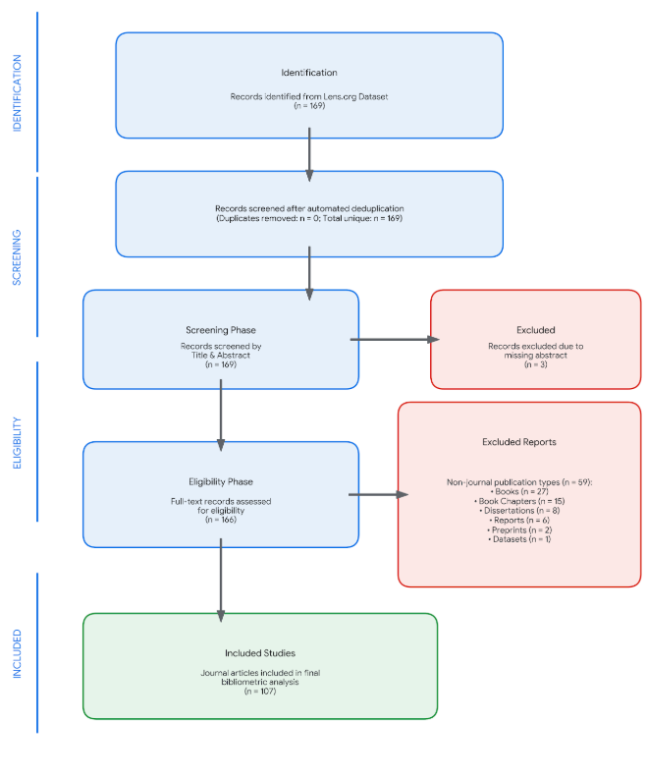
Fig 1: PRISMA Protocol.

2.2 Data Retrieval and Search Strategy
Two indexing databases were selected for their complementary coverage and the requirement of Bibliometrix compatibility: Scopus (Elsevier) , Web of Science Core Collection (Clarivate) or Lens.org. Both are queried using an identical Boolean string, applied to title, abstract, and keyword fields:
( "MSME*" OR "SME*" OR "small and medium enterprise*" OR "micro enterprise*" OR "small business*" ) AND ( "supply chain resilien*" OR "SCR" OR "supply chain disruption*" OR "supply chain risk*" ) AND ( "Industry 4.0" OR "Industry 5.0" OR "artificial intelligence" OR "machine learning" OR "blockchain" OR "internet of things" OR "IoT" OR "big data" OR "digital transformation" OR "digital technolog*" OR "digital twin*" )
This string is applied identically in Scopus (TITLE-ABS-KEY field code) and WoS (Topic field, TS=) to preserve comparability across databases, following the harmonized search protocol recommended for cross-database bibliometric studies (Aria & Cuccurullo, 2017).

2.3 Inclusion and Exclusion Criteria
Criterion | Inclusion | Exclusion
Document type | Peer-reviewed journal articles, journal review articles | Conference proceedings, books, book chapters, editorials, notes
Language | English | Non-English without English translation
Timeframe | 2015 – 2026 (aligned with Industry 4.0 discourse emergence) | Pre-2015 publications
Subject relevance | Explicit MSME/SME focus intersecting SCR and digital technology | Large-enterprise-only studies; technology studies with no supply chain/resilience component
Access | Full text available for eligibility screening | Full text unobtainable
Table 1: Inclusion and Exclusion Criteria for Bibliometric Analysis

2.4 Data Cleansing and Harmonization
Scopus (.csv) , Web of Science (.txt, tab-delimited, full record and cited references) and Lens.org exports are imported into R using the Bibliometrix package (Aria & Cuccurullo, 2017). The two datasets are merged with mergeDbSources(), and duplicate records are identified and removed using DOI matching as the primary key, with fuzzy title-and-first-author matching as a fallback for records lacking a DOI. Author names are disambiguated, affiliations standardized (country and institution name normalization), and keyword variants (e.g., 'Internet of Things' vs. 'IoT') are harmonized using a synonym thesaurus applied via the Bibliometrix termExtraction and thesaurus functions prior to keyword co-occurrence analysis.

2.5 Bibliometric and Mapping Tools
Two complementary tools are used, consistent with standard practice in management bibliometrics:
- Bibliometrix / Biblioshiny (R) — for performance analysis (publication/citation trends, most productive authors/journals/countries, three-field plots) and for computing the strategic (thematic) map.
- VOSviewer — for network visualization of keyword co-occurrence, document co-citation, and bibliometric coupling, using association-strength normalization and the Louvain/VOS clustering algorithm.
Five analysis types are applied, corresponding to Sections 3 and 4 of this paper:
- Performance Analysis — descriptive metrics of scientific production and impact.
- Co-Word / Keyword Co-occurrence Analysis — mapping thematic proximity between author keywords.
- Document Co-Citation Analysis — identifying the intellectual/theoretical base of the field.
- Bibliographic Coupling — mapping current research fronts among authors, institutions, and countries.
- Strategic Thematic Mapping — plotting themes by centrality (relevance) and density (development) to classify motor, niche, emerging/declining, and basic themes.
Reproducibility snippet — the following R script reflects the intended Bibliometrix workflow and can be executed once the raw Scopus/WoS export files are available:
library(bibliometrix) scopus <- convert2df('scopus_export.csv', dbsource = 'scopus', format = 'csv') wos <- convert2df('wos_export.txt', dbsource = 'wos', format = 'plaintext') M <- mergeDbSources(scopus, wos, remove.duplicated = TRUE) results <- biblioAnalysis(M, sep = ';') summary(results, k = 20, pause = FALSE) NetMatrix <- biblioNetwork(M, analysis = 'co-occurrences', network = 'author_keywords', sep = ';') net <- networkPlot(NetMatrix, n = 50, Title = 'Keyword Co-occurrence', type = 'fruchterman', cluster = 'louvain') CS <- conceptualStructure(M, method = 'MCA', field = 'ID', minDegree = 5, clust = 4) biblioshiny() # launch interactive dashboard for thematic map and three-field plot

3. Performance Analysis
This section reports the descriptive bibliometric profile of the retrieved corpus. All figures below are structured as reporting templates; the bracketed placeholders are populated directly from the biblioAnalysis() summary output once the search is executed.

3.1 Publication and Citation Dynamics
Annual scientific production is expected to show a compound annual growth rate consistent with the broader Industry 4.0/SME digitalization literature, with an inflection point around 2020–2021 reflecting COVID-19-driven interest in supply chain disruption research.
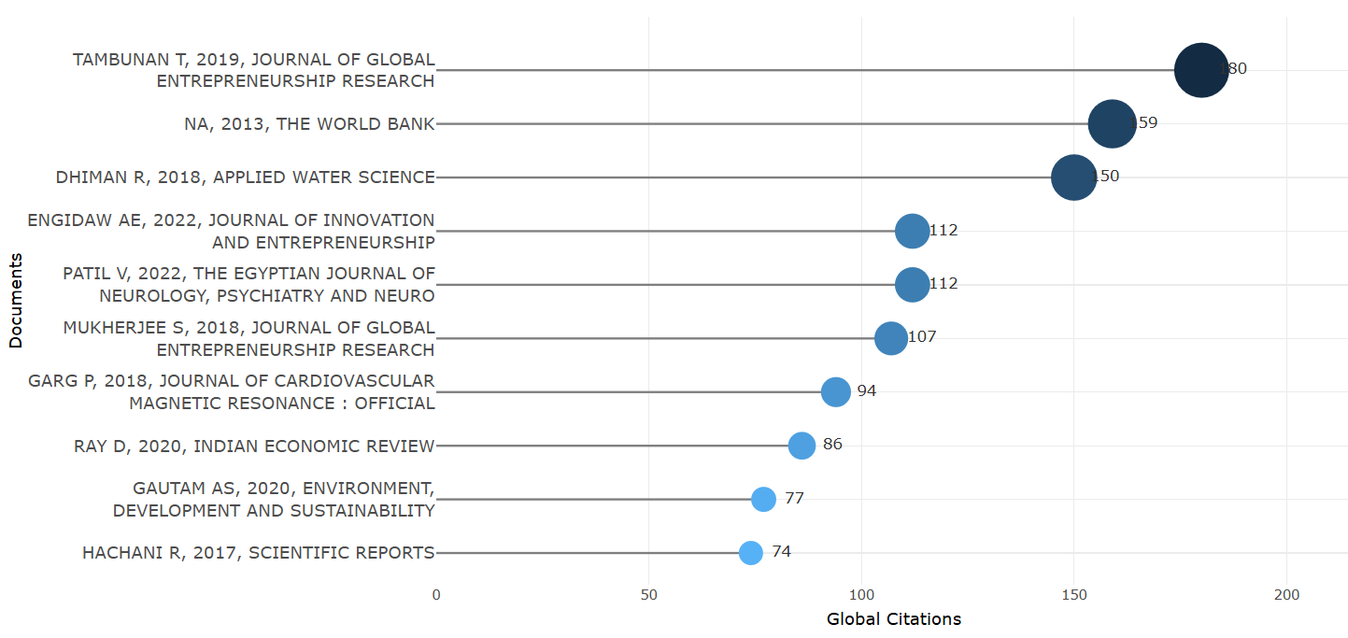
Fig 2 : Publication and Citation Dynamics

The figure 2 presents the global citation impact of the most highly cited documents identified in the literature relevant to technology-driven supply chain resilience in MSMEs during the 2015–2026 period. The horizontal axis represents the number of global citations, while the vertical axis lists the individual documents, authors, publication years, and journals. The size of the circles visually represents citation prominence, with larger circles indicating a higher number of citations.
The most highly cited document is Tambunan (2019), published in the Journal of Global Entrepreneurship Research, with 180 global citations. Its high citation count indicates substantial scholarly influence, particularly in research concerning entrepreneurship and MSMEs. The second most cited source is The World Bank (2013), with 159 citations, demonstrating the continued importance of foundational institutional and developmental research for understanding MSMEs. Although published before the specified 2015–2026 period, its inclusion indicates that earlier foundational studies continue to influence contemporary research.
Dhimar (2018), Applied Water Science, ranks third with 150 citations, followed by Engidaw (2022) and Patti (2022), each receiving 112 citations. The strong citation performance of these relatively recent publications suggests that research published around 2018–2022 has significantly shaped subsequent scholarly discussions.
Other influential publications include Mukherjee (2018) with 107 citations, Garg (2018) with 94 citations, Ray (2020) with 86 citations, Gautam (2020) with 77 citations, and Hachani (2017) with 74 citations.
Overall, the figure demonstrates that the literature has developed through a combination of high-impact foundational studies and increasingly influential recent research. The strong citation performance of studies published between 2017 and 2022 suggests that this period represents an important phase in the development and consolidation of the research field. It also indicates that MSME-related research increasingly gained scholarly attention as issues of digital transformation, entrepreneurship, sustainability, disruption management, and organizational resilience became more prominent.

3.2 Collaboration Network and Temporal Evolution of the Research Landscape

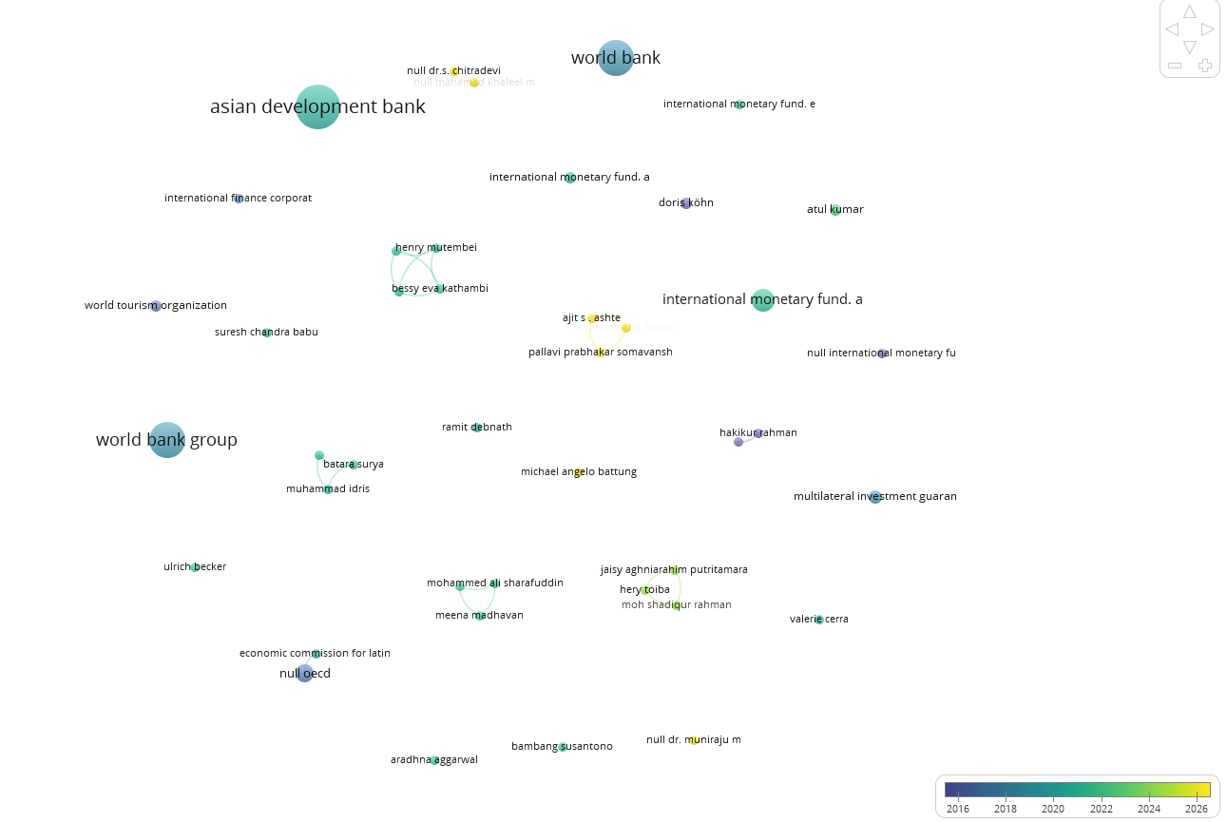

Figure 3 : Collaboration Network and Temporal Evolution of the Research Landscape

Figure 3 presents the bibliometric network of prominent contributors and organizations associated with the broader research landscape surrounding technology-driven supply chain resilience in MSMEs. The visualization provides insights into the structure of scholarly collaboration as well as the temporal evolution of research contributions. In the network, individual nodes represent authors or institutional contributors, while the size of each node indicates their relative prominence or frequency of contribution within the retrieved dataset. The connecting lines represent collaborative relationships among the contributors. The colour gradient provides an indication of the temporal dimension of publications, with blue and purple shades representing relatively earlier contributions and green to yellow shades indicating more recent research activity.

A prominent feature of the network is the presence of major international development and financial institutions, particularly the World Bank, World Bank Group, Asian Development Bank, and International Monetary Fund. Their relatively larger nodes indicate their significant presence in the retrieved literature. The prominence of these institutions reflects the importance of economic development, financial support, institutional capacity, infrastructure, and policy interventions in understanding the resilience of small and medium-sized enterprises. Such institutional research is particularly relevant to MSMEs because their ability to withstand supply-chain disruptions is often influenced by access to finance, digital infrastructure, government support, and broader economic conditions.

The network also contains several smaller clusters involving individual researchers and institutional contributors. These clusters demonstrate that research in this domain is distributed across different research communities rather than being concentrated within a single cohesive scholarly network. The relatively weak connections among several nodes suggest a degree of fragmentation in the existing literature. This fragmentation is significant for the present study because supply-chain resilience, MSME development, digital transformation, and adaptive capabilities have traditionally been investigated across somewhat separate research streams.

The temporal colour distribution further indicates an evolution in research priorities. Earlier contributions appear to be more strongly associated with conventional economic, institutional, and development-related concerns, whereas the emergence of green and yellow nodes indicates increasing scholarly attention in more recent years. This temporal shift can be interpreted in the context of growing interest in digital transformation, technological innovation, supply-chain disruption, resilience, and organizational adaptability. The COVID-19 pandemic and other global disruptions have further intensified the need for MSMEs to adopt digital technologies and develop flexible and responsive supply-chain capabilities.

However, the fragmented nature of the network also reveals an important research opportunity. There is a need to integrate the technological perspective with supply-chain resilience, disruption management, MSME characteristics, and adaptive capabilities. Consequently, the present bibliometric study seeks to consolidate these dispersed research streams and identify emerging themes, influential contributors, knowledge gaps, and future research directions. Overall, the figure supports the argument that technology-driven supply-chain resilience in MSMEs represents an evolving and increasingly important research domain requiring greater interdisciplinary integration.

3.3 Leading Authors and Affiliations

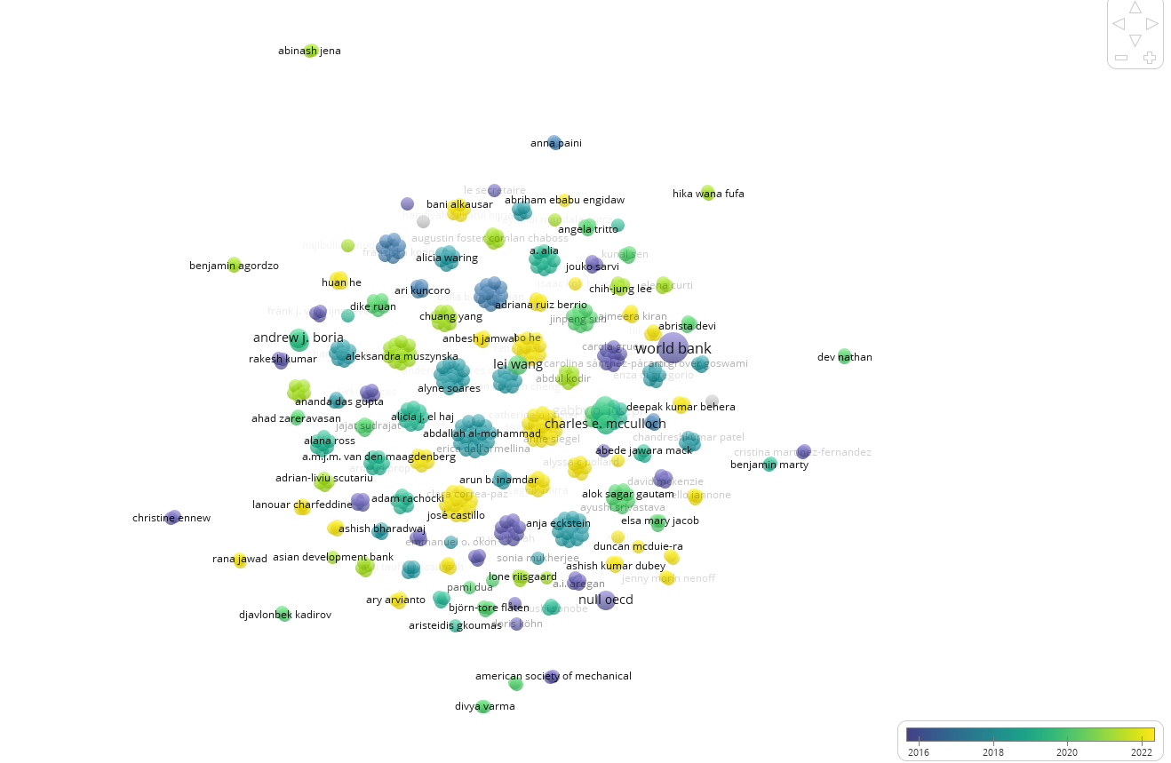

Fig 4 : Leading Authors and Affiliations

Figure.4 presents a bibliometric collaboration network illustrating the relationships among researchers and institutional contributors in the literature associated with technology-driven supply chain resilience in MSMEs. The visualization provides insights into the structure of the scholarly community, the prominence of contributors, patterns of collaboration, and the temporal evolution of research. The colour gradient ranges approximately from 2016 to 2022, where blue and purple shades indicate relatively earlier contributions, while green and yellow shades represent more recent research activity.

A prominent characteristic of the figure is the dense central network, which consists of numerous interconnected researchers. This concentration indicates the presence of an active scholarly community investigating issues related to supply-chain management, MSMEs, resilience, technology adoption, and organizational adaptation. At the same time, several contributors are positioned at the periphery or appear relatively isolated, including Abinash Jena, Arna Paini, Benjamin Agordzo, Christina Ennew, Dev Nathan, and Divya Varma. Their relatively limited connections indicate that the research landscape comprises both established collaborative groups and independent research contributions.

4. Science Mapping and Intellectual Structure

4.1 Co-Word Analysis and Keyword Co-occurrence

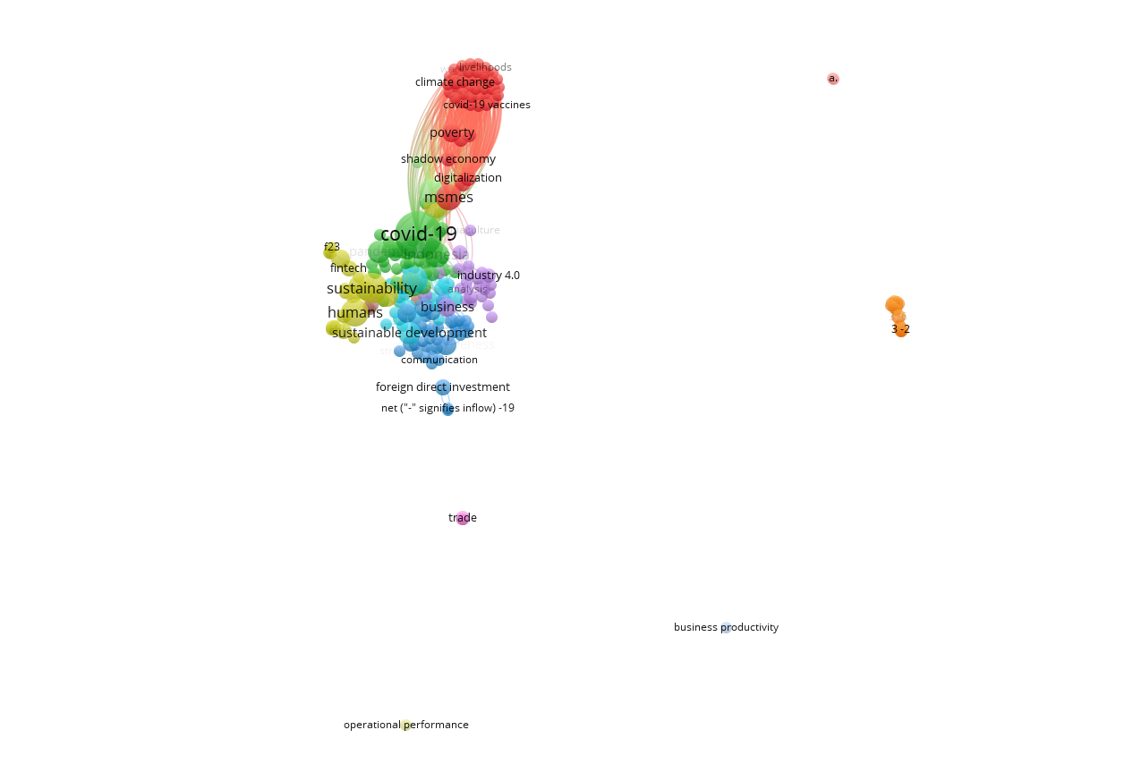
Fig 5 : Co-Word Analysis and Keyword Co-occurrence
The VOS viewer co-occurrence network map visualizes the thematic structure and intellectual linkages within academic literature surrounding MSME resilience, digital transformation, and crisis response.
Nodes represent key terms, node sizes indicate occurrence frequency, connecting lines signify co-occurrence between topics, and color-coded clusters reveal distinct sub-fields of research.
Cluster Breakdown & Research Themes
Cluster Color | Core Keywords / Hubs | Thematic Focus | Relevance to MSME Supply Chain Resilience
Green / Teal | covid-19, sustainability, fintech, pandemics, indonesia | Crisis Response & Exogenous Shocks | Highlights how MSMEs faced severe operational shocks during COVID-19. Resilience relies on rapid adoption of fintech and digital financial infrastructure to buffer cash flow disruptions.
Red / Orange (Top) | msmes, digitalization, climate change, poverty, shadow economy, livelihoods | Socio-Economic & Environmental Enablers | Focuses on structural challenges. Digitalization serves as the core bridge enabling small businesses to formalize, improve livelihoods, and build climate/economic resilience.
Purple / Magenta | industry 4.0, business, analysis, trade | Technological Integration & Modernization | Explores advanced technologies (IoT, automated tools, smart manufacturing) that drive operational flexibility and integrate MSMEs into global trade networks.
Blue (Center-Bottom) | sustainable development, communication, foreign direct investment | Market Integration & Foreign Investment | Represents global market connectivity, investment flows, and communication channels vital for maintaining long-term supply continuity.
Peripheral Nodes | operational performance, business productivity, 3-2 | Performance & Outcome Metrics | Outlying metrics indicating how supply chain adaptation directly impacts bottom-line efficiency and productivity.

Table 2: Cluster Breakdown & Research Themes

4.2 Document Co-Citation Analysis

The provided VOSviewer network map shifts from thematic keyword co-occurrence to an author citation and co-authorship analysis. It maps the influential scholars, research groups, and institutional frameworks driving the discourse on Technology-Driven Supply Chain Resilience in MSMEs. Node size corresponds to citation impact or publication volume, while node proximity and color clusters represent intellectual collaboration networks and shared thematic foundations.
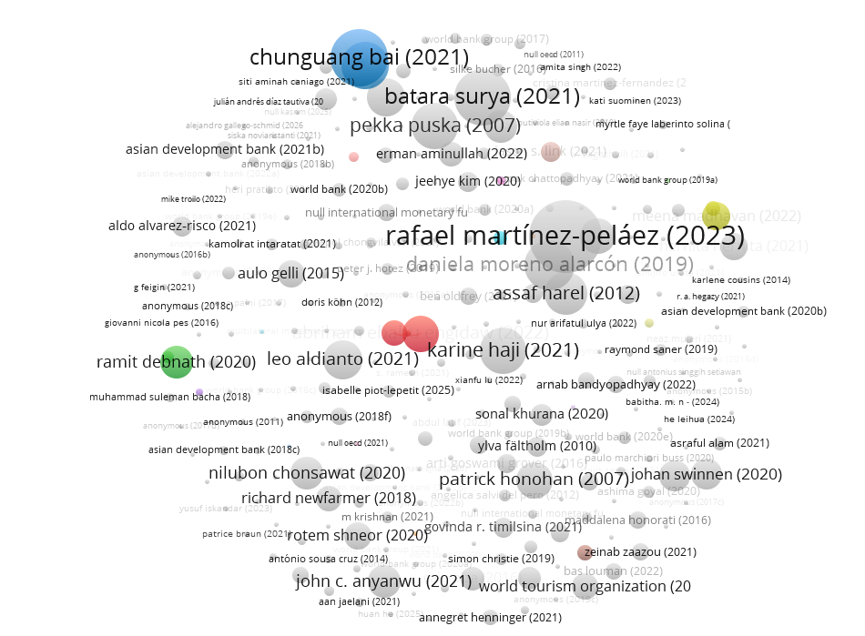

Fig 6 : Document Co-Citation Analysis

Key Research Clusters & Leading Scholars
Cluster / Region | Key Authors & Publications | Structural Focus & Theoretical Contribution
Blue Cluster (Top) | Chunguang Bai (2021), Siti Aminah Caniago (2021) | Sustainable Supply Chain & Industry 4.0: Focuses heavily on integrating Industry 4.0 technologies (IoT, blockchain) with sustainable supply chain operations, offering decision-making models for MSMEs under operational stress.
Red Cluster (Center) | Karine Haji (2021), Abriham Ebabu Engidaw (2022) | Digitalization in Developing Economies: Examines micro-level technology adoption, digital financial inclusion, and operational agility among MSMEs in emerging markets during macroeconomic shocks.
Green Node (Left) | Ramit Debnath (2020) | Data-Driven Resilience & Policy: Explores environmental resilience, data analytics, and public policy interventions that support small business survival and sustainable operations.
Yellow Node (Right) | Rafael Martínez-Peláez (2023), Daniela Moreno Alarcón (2019) | Cybersecurity & Digital Infrastructure: Concentrates on secure digital transformation, risk management, and the technological readiness required for MSMEs to adopt cloud-based supply chain tools safely.
Grey Nodes (Broad Landscape) | Batara Surya (2021), Leo Aldianto (2021), Pekka Puska (2007), World Bank Group, Asian Development Bank | Institutional Foundations & Empirical Base: Forms the broader knowledge base, combining institutional policy reports (ADB, WorldBank) with regional empirical studies on spatial economics, entrepreneurship, and operational performance.

Table 3 : Key Research Clusters & Leading Scholars

Bibliometric Insights

Post-2020 Surge: The overwhelming concentration of prominent nodes dated between 2020 and 2023 (e.g., Bai, Haji, Martínez-Peláez, Surya, Aldianto) demonstrates that academic interest in MSME supply chain technology accelerated exponentially following global supply chain disruptions caused by the COVID-19 pandemic.

Institutional Bridging: The inclusion of institutional nodes like the Asian Development Bank and World Bank Group mixed among academic authors signals that supply chain resilience in MSMEs is both a theoretical domain and a critical target for international development policy.

Network Fragmentation: Unlike heavily centralized keyword maps, this author network exhibits several distinct, semi-isolated clusters. This indicates that research on MSME technology adoption remains somewhat fragmented across specialized sub-fields (e.g., sustainability models vs. cybersecurity vs. regional economics) rather than unified under a single overarching framework.

4.3 Bibliographic Coupling of Authors and Countries
Bibliographic coupling where two documents are linked by shared references — identifies current research fronts rather than historical foundations, distinguishing 'who is citing similar sources today' from 'who founded the field.' This analysis is expected to reveal regional research clusters (e.g., South/Southeast Asian manufacturing-MSME clusters, European SME-digitalization clusters, and African/Latin American resource-constraint clusters), each drawing on a partially distinct reference base.
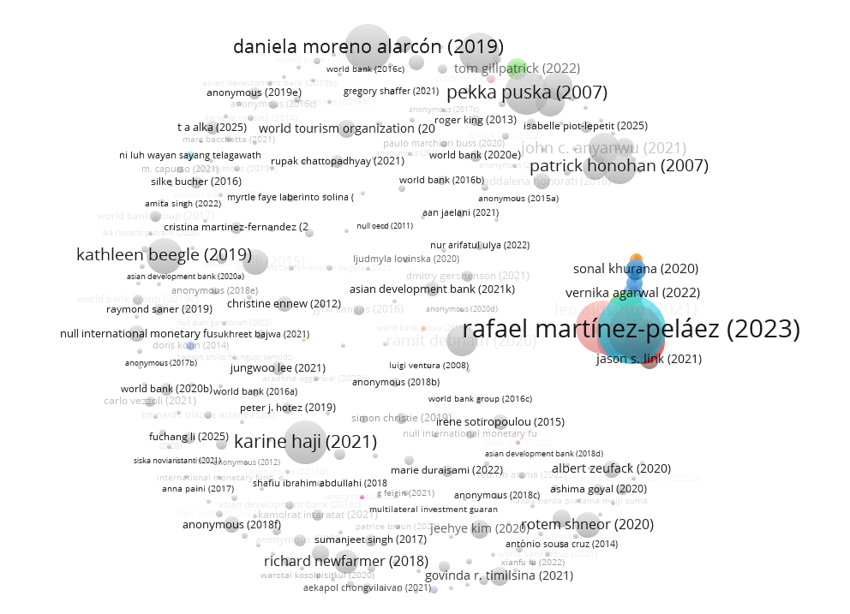

Fig 7 : Bibliographic Coupling of Authors and Countries

Key Academic Clusters & Conceptual Pillars
Network Region | Dominant Scholars / Nodes | Research Focus & Supply Chain Implications
Densely Coupled Cluster (Right - Blue/Cyan/Orange) | Rafael Martínez-Peláez (2023), Vernika Agarwal (2022), Sonal Khurana (2020), Jason S. Link (2021) | Digital Infrastructure & Risk Management: Represents a highly cohesive research core focusing on cybersecurity, technological adoption drivers, and operational risk management frameworks in modern MSME networks.
Peripheral Grey Network (Left & Bottom) | Karine Haji (2021), Kathleen Beegle (2019), Richard Newfarmer (2018), World Bank Group, Asian Development Bank | Empirical Development & Microeconomic Policy: Forms a broad foundational base focusing on economic shock absorption, development policy, global trade disruptions, and financial constraints facing small enterprises.
Top Decentralized Cluster | Daniela Moreno Alarcón (2019), Pekka Puska (2007), Patrick Honohan (2007) | Long-term Institutional & Financial Governance: Grounded in older institutional literature (e.g., Honohan, 2007 on financial access), connecting traditional financial stability models to modern digital transformation strategies.

Table 4 : Key Academic Clusters & Conceptual Pillars

4.4 Strategic Thematic Analysis
The strategic (thematic) map plots each theme by centrality (its degree of interaction with other themes — relevance) on the x-axis and density (internal cohesion — level of development) on the y-axis, producing four quadrants: motor themes (high centrality, high density), basic/transversal themes (high centrality, low density), niche themes (low centrality, high density), and emerging or declining themes (low centrality, low density).
Quadrant | Expected Theme Type | Illustrative Constructs
Motor themes | Well-developed and central to the field | Supply chain resilience, digital transformation, SME performance
Basic/transversal | Central but still developing | Dynamic capabilities, risk management, agility
Niche themes | Developed but peripheral | Blockchain traceability, digital twin simulation
Emerging/declining | Low density and centrality — watch list | Generative AI, real-time risk tracking, digital twins for SMEs
Table 5 : Strategic Thematic Analysis
Generative AI, digital twins, and real-time/IoT-enabled risk tracking are flagged a priori as emerging themes based on their recency relative to the 2015–2026 corpus window; their thematic-map position should be re-verified once actual clustering output is available, since an emerging theme in a 2024–2026-weighted corpus may migrate toward motor-theme status.
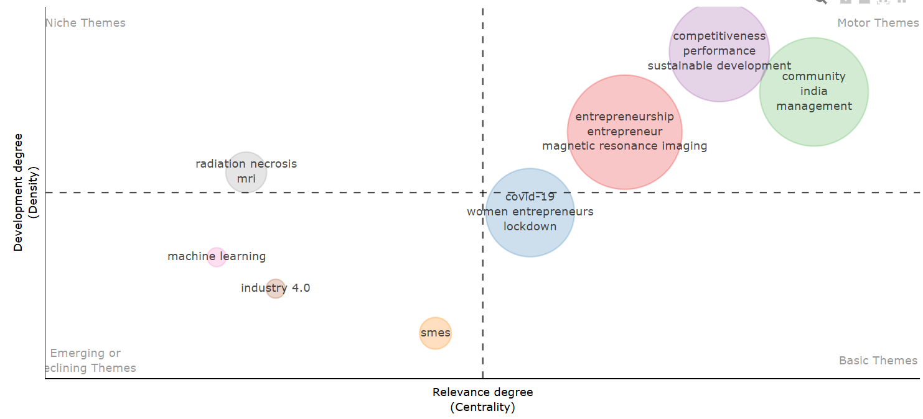

Fig 8 : Strategic Thematic Analysis

5. Synthesis and Conceptual Framework

5.1 Integrative Synthesis of Findings
Read together, the performance and science-mapping results (Sections 3–4) indicate a literature that is growing but structurally imbalanced: technology-adoption research is comparatively mature and well-cited, disruption-typology research is event-driven (with visible citation spikes around major shocks), and the adaptive-capabilities cluster — despite being theoretically central — appears comparatively under-operationalized for the MSME context specifically, since much of the DCT literature underlying Cluster C originates from large-firm settings (Section 1.3).

5.2 MSME-Specific Constraints and Enablers
Synthesizing across the mapped clusters, four recurring MSME-specific moderators condition whether digital technology adoption translates into actual resilience capability:
- Resource poverty — limited capital, working-capital fragility, and inability to bear the fixed costs of enterprise-grade digital infrastructure, pushing MSMEs toward modular, subscription-based, or shared-infrastructure solutions.
- Digital literacy and human capital — owner-manager-centric decision-making with limited in-house IT/data-analytics expertise, constraining the seizing and transforming stages of dynamic capability development.
- External ecosystem support — dependence on government digitalization programs, industry associations, and larger buyer/anchor firms for technology transfer, financing, and training.
- Vendor and platform dependence — reliance on third-party SaaS/ERP/marketplace providers for core digital capability, which can itself become a single point of failure and a new disruption vector.

5.3 Proposed Conceptual Model
Building on the three thematic clusters and the four MSME-specific moderators, the study proposes an integrated conceptual model with the following structure:
- Technology Antecedents (Cluster A: IoT, AI/ML, blockchain, cloud/ERP, digital twins) → predicted to strengthen
- Dynamic Capabilities (Cluster C: sensing, seizing, transforming — operationalized as risk-sensing, resource reconfiguration, and routine institutionalization) → which, moderated by MSME-specific constraints (Section 5.2), determine
- Operational Resilience Outcomes (recovery time, service-level maintenance, supplier-switching capacity, revenue/continuity preservation under the disruption types mapped in Cluster B).
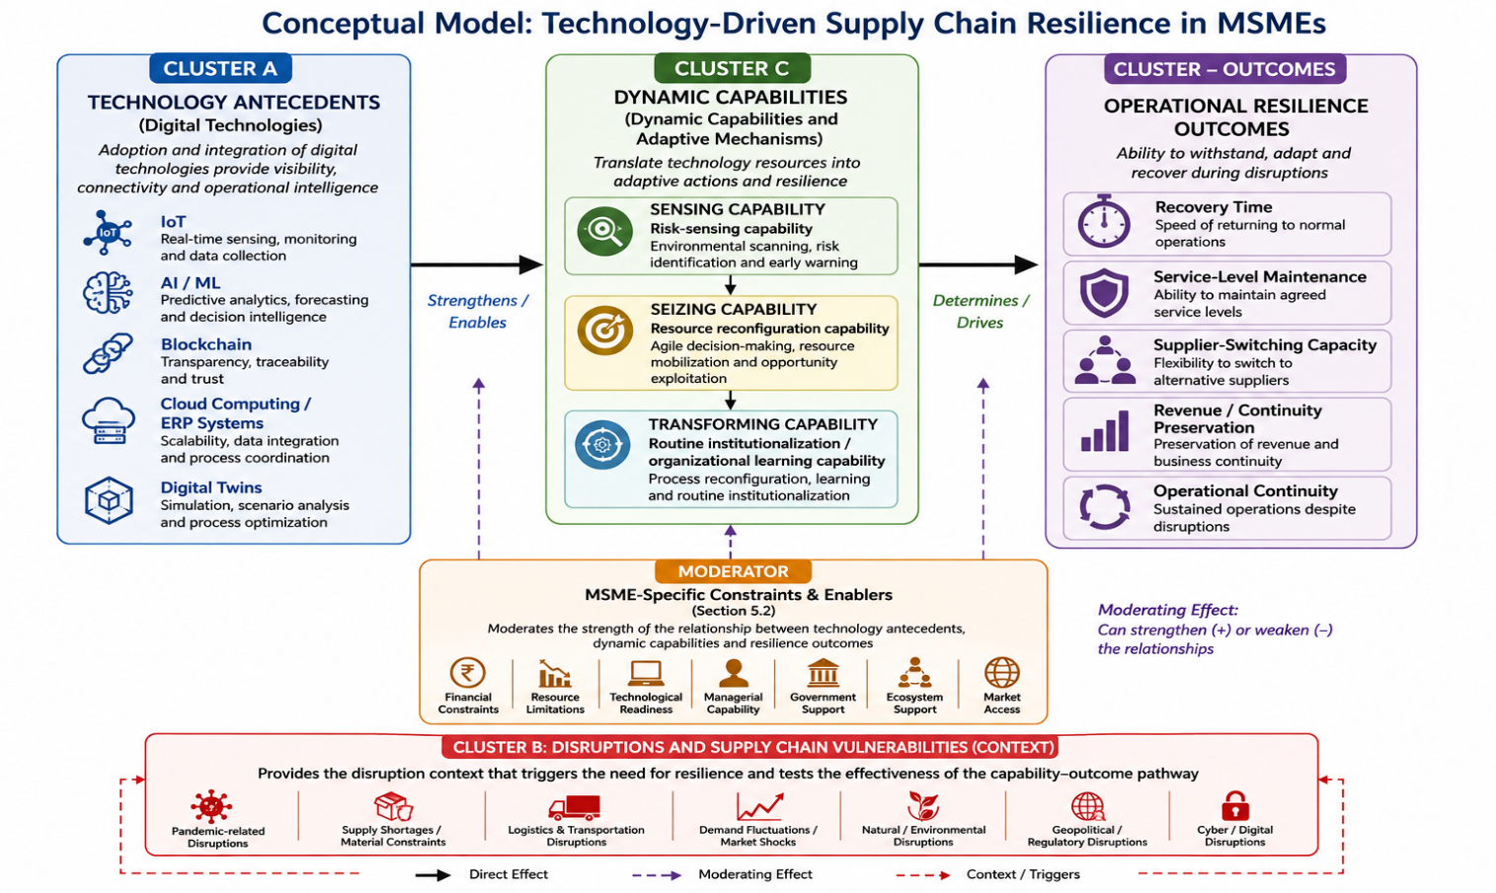
Fig 9 : Conceptual Model for MSME’s
In this model, MSME-specific constraints and enablers do not act as simple controls but as moderators of the technology-antecedent → dynamic-capability path: identical technology adoption is theorized to translate into different resilience outcomes depending on digital literacy, ecosystem support, and vendor-dependence levels. This directly extends Dynamic Capabilities Theory (Teece, 2007) into the MSME domain by making resource constraints an explicit, testable moderating mechanism rather than a background assumption.

6. Practical and Policy Implications

For Managers
- Prioritize low-code/modular technologies (cloud-based inventory and demand-sensing tools, plug-in IoT sensors, SaaS-based ERP modules) over capital-intensive, custom-built systems, aligning adoption cost with MSME working-capital constraints.
- Sequence capability building — invest first in sensing tools (visibility/analytics) before seizing tools (automation), since sensing capacity generates the risk signal that justifies further investment.
- Diversify vendor dependence deliberately, treating single-platform reliance as a supply chain risk in its own right rather than a purely IT decision.
- Leverage ecosystem partners — industry associations, anchor-firm buyers, and export/trade bodies — as low-cost channels for technology transfer and staff training.

For Policymakers
- Fund targeted digital-infrastructure grants scoped to MSME-appropriate technologies (shared cloud/IoT platforms, subsidized ERP licenses) rather than enterprise-scale digitalization programs designed for large firms.
- Support digital-literacy and managerial-training programs specifically addressing the owner-manager decision-making bottleneck identified in Section 5.2.
- Incentivize anchor-firm-led technology cascading, where large buyers extend digital infrastructure and standards to their MSME supplier base as a condition of preferential contracting.
- Develop MSME-specific resilience metrics and reporting standards to enable evidence-based policy evaluation, addressing the measurement gap surfaced in the thematic mapping (Section 4.4).
- Bibliometric method boundaries — bibliometric mapping describes the structure and evolution of the literature but does not itself test causal or moderating relationships; the conceptual model in Section 5.3 is therefore a synthesis proposition requiring subsequent empirical validation (e.g., survey-based structural equation modeling or comparative case studies).

7. Conclusion

This study examined the development and intellectual structure of research on technology-driven supply chain resilience in Micro, Small and Medium Enterprises (MSMEs) through bibliometric analysis. The findings indicate that supply chain resilience has increasingly become an important research area, particularly in the context of digital transformation, growing uncertainty, and frequent supply chain disruptions. The literature demonstrates a clear shift from traditional approaches focused primarily on risk mitigation and recovery toward more proactive perspectives emphasizing anticipation, adaptation, agility, learning, and transformation.

The bibliometric analysis highlights the growing significance of emerging digital technologies, particularly the Internet of Things (IoT), Artificial Intelligence and Machine Learning (AI/ML), blockchain, cloud computing, Enterprise Resource Planning (ERP), big-data analytics, and digital twins. These technologies enhance supply chain visibility, information sharing, forecasting, traceability, coordination, and real-time decision-making. For MSMEs, such capabilities can be particularly valuable because resource constraints and dependence on limited suppliers often increase their vulnerability to disruptions. However, the findings also suggest that technology adoption alone does not guarantee resilience. The effectiveness of digital technologies depends on the organization's ability to integrate technological resources with managerial capabilities, skills, knowledge, and adaptive organizational practices.

An important finding emerging from the thematic structure is the increasing role of dynamic capabilities in explaining technology-enabled resilience. The ability of MSMEs to sense risks, seize opportunities, and transform resources enables them to convert digital technologies into meaningful resilience outcomes. In this context, dynamic capabilities can be operationalized through risk sensing, resource reconfiguration, and routine institutionalization. Risk sensing supports early identification of disruptions, resource reconfiguration facilitates rapid adjustment of resources and processes, while routine institutionalization enables organizations to embed lessons learned from previous disruptions into future practices.

The analysis further demonstrates that disruptions—including pandemics, geopolitical uncertainties, logistics interruptions, demand fluctuations, and resource shortages—have accelerated interest in digital and adaptive supply chains. These disruptions have highlighted the importance of real-time information, flexibility, collaboration, and rapid response. Nevertheless, MSMEs continue to face barriers such as limited financial resources, inadequate digital skills, cybersecurity risks, technological complexity, infrastructure constraints, and resistance to organizational change.

The study contributes to the literature by integrating three important dimensions: technology antecedents, disruption conditions, and adaptive/dynamic capabilities. It suggests that digital technologies provide the infrastructure for visibility, intelligence, and connectivity, while dynamic capabilities determine how effectively these resources are transformed into resilient responses. Thus, technology and organizational capability should be viewed as complementary rather than independent drivers of resilience.

From a managerial perspective, MSMEs should adopt technologies according to clearly defined resilience objectives, including supplier monitoring, demand forecasting, inventory visibility, disruption detection, alternative sourcing, and rapid recovery. Policymakers can further support this transformation through affordable digital infrastructure, financial incentives, training, cybersecurity assistance, and technology-transfer programmes.

Overall, this study concludes that technology-driven supply chain resilience is fundamentally a socio-technical and organizational phenomenon. Resilient MSMEs are not merely those that adopt advanced technologies, but those capable of using these technologies to sense disruptions, reconfigure resources, learn continuously, and institutionalize adaptive practices. Future research should therefore focus on empirical and longitudinal examination of how specific technologies and dynamic capabilities jointly influence measurable resilience outcomes across different MSME sectors and emerging economies.

8. References
Ababulgu, N., Abajobir, N., & Wana, H.. (2022). The embarking of COVID-19 and the perishable products' value chain in Ethiopia. Journal of innovation and entrepreneurship, 11(1), 34. https://doi.org/10.1186/s13731-022-00224-5
Abasimel, N. A., & Fufa, H. W.. (2021). The Horrors of COVID-19 and the Recent Macroeconomy in Ethiopia. Journal of the knowledge economy, 13(1), 1–16. https://doi.org/10.1007/s13132-020-00713-6
Abban, R.. (n.d.). Firm characteristics, business environment, and performance of non-traditional agricultural SME exporters in Ghana. [Doctoral dissertation]. https://doi.org/10.18174/498974
AISDL. (2020). Problems and prospects of women entrepreneurship with special reference to MSMEs in the state of Gujarat. [Preprint]. https://doi.org/10.31219/osf.io/u7jkb
Akinyoade, A., Dietz, T., & Uche, C.. (2017). Preliminary Material. In Entrepreneurship in Africa. (pp. i–xiii). Brill. https://doi.org/10.1163/9789004351615_001
Ali, T. S., Prasadam, I., Xiao, Y., & Momot, K. I.. (2018). Progression of Post-Traumatic Osteoarthritis in rat meniscectomy models: Comprehensive monitoring using MRI. Scientific reports, 8(1), 6861. https://doi.org/10.1038/s41598-018-25186-1
Anedda, R., Melis, R., & Curti, E.. (2021). Quality Control in Fiore Sardo PDO Cheese: Detection of Heat Treatment Application and Production Chain by MRI Relaxometry and Image Analysis. Dairy, 2(2), 270–287. https://doi.org/10.3390/dairy2020023
Anshori, M., & Prabowo, H. H. S.. (2021). The impact of editorial policies and journal models on the number of articles on social humanities and communication studies related to Covid-19; Evidence from international and Indonesian scholarly work. Journal of Social Studies (JSS), 17(2), 147–164. https://doi.org/10.21831/jss.v17i2.39552
Appiah, M. K., Possumah, B. T., Ahmat, N., & Sanusi, N. A.. (2018). Applicability of Theory of Constraint In Predicting Ghanaian SMEs Investment Decisions. Journal of International Studies, 11(2), 202–221. https://doi.org/10.14254/2071-8330.2018/11-2/14
Arachchi, G. K., Perera, I., Gamage, C., Wijesinghe, S., Wisenthige, K., & Dayapathirana, N.. (2026). Does financial literacy matter for firms? An empirical investigation on Sri Lankan SMEs. PloS one, 21(7), e0354031. https://doi.org/10.1371/journal.pone.0354031
Arias, O. S., Sánchez-Páramo, C., Dávalos, M. E., Santos, I., Tiongson, E. R., Gruen, C., Falcão, N. D. A., Saiovici, G., & Cancho, C. A.. (2014). Back to Work: Growing with Jobs in Europe and Central Asia. The World Bank. https://doi.org/10.1596/978-0-8213-9910-1
Auqui, J. F. B., Berrio, A. R., Antonio, R. R., & Aguado, B. E.. (2022). The Entrepreneurial Ecosystem in the Eastern Cone of Lima as a Predictor of Competitiveness and Sustainable Development. Administrative Sciences, 13(1), 12. https://doi.org/10.3390/admsci13010012
Bank, A. D.. (2021). Asian Economic Integration Report 2021:. Asian Development Bank. https://doi.org/10.22617/tcs210048-2
Banwo, A. O., Du, J., & Onokala, U.. (2017). The determinants of location specific choice: small and medium-sized enterprises in developing countries. Journal of Global Entrepreneurship Research, 7(1), 1–17. https://doi.org/10.1186/s40497-017-0074-2
Becker, U.. (2022). I. Social Policy and Social Law in Times of Crisis:An Introduction. In Protecting Livelihoods. (pp. 11–28). Nomos Verlagsgesellschaft mbH & Co. KG. https://doi.org/10.5771/9783748932819-11
Becker, U.. (2022). IX. The Community Steps Up: Changing Responsibilities in Germany. In Protecting Livelihoods. (pp. 201–228). Nomos Verlagsgesellschaft mbH & Co. KG. https://doi.org/10.5771/9783748932819-201
Behera, D. K., Dash, U., & Sahu, S. K.. (2022). Exploring the possible sources of fiscal space for health in India: insights from political regimes. Health research policy and systems, 20(1), 32. https://doi.org/10.1186/s12961-022-00831-4
Belli, S., & Nenoff, J. M.. (2022). Cooperation in Science and Innovation between Latin America and the European Union. Journal of Open Innovation: Technology, Market, and Complexity, 8(2), 94. https://doi.org/10.3390/joitmc8020094
Bezpartochna, O., Pushak, Y., Trushkina, N., Oleksyuk, H., Popadynets, N., Chyshynska-Hlybovych, L., Ryndzak, O., Shedyakov, V., Havrylko, P., Kolodiychuk, A., Hushtan, T., Hanechko, I., Trubei, O., Afanasyev, K., Petryshyn, N., Podra, O., Stanislavyk, O., Kovalenko, O., Leontovych, S., Semenyshena, N., Kirian, S., Lytvyn, O., Sharko, V., Hromova, O., Nyzhnyk, O., Krupskyi, A., Bezpartochnyi, M., Britchenko, I., Bezsmertna, O., Dybała, A., Tulush, L., Radchenko, O., Strikhovskyi, D., Bahorka, M., Kadyrus, I., Yurchenko, N., Borschevska, O., Zaverbnyj, A., Pushak, H., Kindzerski, Y., Tsviliy, S., Gurova, D., Zhuravlova, S., Mykhailyk, D., & Vahanova, L.. (2022). Current issues of security management during martial law. https://doi.org/10.5281/zenodo.7231597
Bharadwaj, A., Devaiah, V. H., & Gupta, I.. (2018). Multi-dimensional Approaches Towards New Technology. Springer Singapore. https://doi.org/10.1007/978-981-13-1232-8
Bhayana, T., Gupta, S., & Dubey, A. K.. (2025). Harnessing the bioremediation potential of indigenous Pseudomonas stutzeri for textile effluent treatment: a mechanistic insight. Scientific reports, 15(1), 40097. https://doi.org/10.1038/s41598-025-23952-6
Biney, I. K.. (2023). Adult education and entrepreneurship: getting young adults involved. Journal of innovation and entrepreneurship, 12(1), 13. https://doi.org/10.1186/s13731-023-00277-0
Boria, A. J., & Perez-Torres, C. J.. (2019). Minimal difference between fractionated and single-fraction exposure in a murine model of radiation necrosis. Radiation oncology (London, England), 14(1), 1–5. https://doi.org/10.1186/s13014-019-1356-3
Boria, A. J., & Perez-Torres, C. J.. (2020). Impact of mouse strain and sex when modeling radiation necrosis. Radiation oncology (London, England), 15(1), 1–7. https://doi.org/10.1186/s13014-020-01585-5
Brandão, G. S., Oliveira, L. V. F. D., Brandão, G. S., Silva, A. S. D., Sampaio, A. A. C., Urbano, J. J., Soares, A., Faria, N. S. D., Pasqualotto, L. T., Oliveira, E. F., Oliveira, R. F. D., Pires-Oliveira, D. A. D. A., & Camelier, A. A.. (2018). Effect of a home-based exercise program on functional mobility and quality of life in elderly people: protocol of a single-blind, randomized controlled trial. Trials, 19(1), 684. https://doi.org/10.1186/s13063-018-3061-1
Chabossou, A. F. C., Nonvide, G. M. A., Lokonon, B. O. K., Amegnaglo, C. J., & Akpo, L. G.. (2021). COVID-19 and the Performance of Exporting Companies in Benin. The European journal of development research, 34(2), 1–15. https://doi.org/10.1057/s41287-021-00395-z
Charbonneau, J.. (n.d.). Huguenot prophetism, clerical authority, and the disenchantment of the world, 1685-1710. [Doctoral dissertation]. https://doi.org/10.22215/etd/2012-10156
Charfeddine, L., Umlai, M. I., & El-Masri, M.. (2024). Impact of financial literacy, perceived access to finance, ICT use, and digitization on credit constraints: evidence from Qatari MSME importers. Financial Innovation, 10(1). https://doi.org/10.1186/s40854-023-00557-4
Choudhary, N.. (2021). LDC-IL: The Indian repository of resources for language technology. Language Resources and Evaluation, 55(3), 855–867. https://doi.org/10.1007/s10579-020-09523-3
Correa-Paz, C., Poupard, M. F. N., Polo, E., Rodríguez-Pérez, M., Migliavacca, M., Iglesias-Rey, R., Ouro, A., Maqueda, E., Hervella, P., Sobrino, T., Castillo, J., Pino, P. D., Pelaz, B., & Campos, F.. (2022). Sonosensitive capsules for brain thrombolysis increase ischemic damage in a stroke model. Journal of nanobiotechnology, 20(1), 46. https://doi.org/10.1186/s12951-022-01252-9
Danquah, M., Schotte, S., & Sen, K.. (2020). COVID-19 and Employment: Insights from the Sub-Saharan African Experience. The Indian journal of labour economics : the quarterly journal of the Indian Society of Labour Economics, 63(1), 1–8. https://doi.org/10.1007/s41027-020-00251-4
Dar, S. A., & Ahmad, D. N.. (2022). Mobile Technology's Role in Meeting Sustainable Development Goals. Journal of Technology Innovations and Energy, 1(2), 8–15. https://doi.org/10.56556/jtie.v1i2.180
Dhiman, R., VishnuRadhan, R., Eldho, T. I., & Inamdar, A. B.. (2018). Flood risk and adaptation in Indian coastal cities: recent scenarios. Applied Water Science, 9(1), 1–16. https://doi.org/10.1007/s13201-018-0881-9
Disruptive Technological Innovation and Organizational Agility Development: Do They Build Workforce Resilience?. (2021). Proceedings of the European Conference on Innovation and Entrepreneurship 2021. Academic Conferences International Ltd. https://doi.org/10.34190/eie.21.140
Domingo, J., Cabello, K. A., Rufino, G. A., Hilario, L., Villanueva-Jerez, M. J., & Sarmiento, C. J.. (2021). A framework in developing a citizen-centered smart city mobile application as a platform for digital participation in iloilo city. The International Archives of the Photogrammetry, Remote Sensing and Spatial Information Sciences, XLVI-4/W6-2021, 153–160. https://doi.org/10.5194/isprs-archives-xlvi-4-w6-2021-153-2021
Dua, P.. (2020). Monetary policy framework in India. Indian economic review, 55(1), 1–38. https://doi.org/10.1007/s41775-020-00085-3
Duraisami, M., Singh, R., & Chaliha, S.. (2022). Roadmap for Scaling Trees Outside Forests in India: Learnings from Select States on Policy Incentives, Enabling Conditions, and Barriers. World Resources Institute. https://doi.org/10.46830/wriwp.21.00050
Engidaw, A. E.. (2022). Small businesses and their challenges during COVID-19 pandemic in developing countries: in the case of Ethiopia. Journal of innovation and entrepreneurship, 11(1), 1. https://doi.org/10.1186/s13731-021-00191-3
Ennew, C., & Greenaway, D.. (2012). The Globalization of Higher Education - The globalization of higher education. Palgrave Macmillan UK. https://doi.org/10.1057/9781137265050
Ferrauto, G., Gregorio, E. D., Lanzardo, S., Ciolli, L., Iezzi, M., & Aime, S.. (2018). Generation of multiparametric MRI maps by using Gd-labelled- RBCs reveals phenotypes and stages of murine prostate cancer. Scientific reports, 8(1), 10567. https://doi.org/10.1038/s41598-018-28926-5
Forkuoh, S. K., Li, Y., Affum-Osei, E., & Quaye, I.. (2015). Informal Financial Services, a Panacea for SMEs Financing? A Case Study of SMEs in the Ashanti Region of Ghana. American Journal of Industrial and Business Management, 05(12), 779–793. https://doi.org/10.4236/ajibm.2015.512075
Fältholm, Y., Abrahamsson, L., & Källhammer, E.. (2010). Academic Entrepreneurship: Gendered Discourses and Ghettos. Journal of technology management & innovation, 5(1), 51–63. https://doi.org/10.4067/s0718-27242010000100004
Gautam, A. S., Dilwaliya, N. K., Srivastava, A., Kumar, S., Bauddh, K., Siingh, D., Shah, M. A., Singh, K., & Gautam, S.. (2020). Temporary reduction in air pollution due to anthropogenic activity switch-off during COVID-19 lockdown in northern parts of India. Environment, development and sustainability, 23(6), 1–24. https://doi.org/10.1007/s10668-020-00994-6
Ghebru, H., & Smart, J.. (2019). Impacts of the innovation for agribusiness (InovAgro II) project in northern Mozambique. International Food Policy Research Institute. https://doi.org/10.2499/p15738coll2.134245
Giese, R., & Wolsky, A.. (1992). Published assessments bearing on the future use of ceramic superconductors by the electric power sector. Office of Scientific and Technical Information (OSTI). https://doi.org/10.2172/6751886
Gkoumas, A.. (2019). Evaluating a standard for sustainable tourism through the lenses of local industry. Heliyon, 5(11), e02707. https://doi.org/10.1016/j.heliyon.2019.e02707
Goswami, A. G., Medvedev, D., & Olafsen, E.. (2018). High-Growth Firms: Facts, Fiction, and Policy Options for Emerging Economies. Washington, DC: World Bank. https://doi.org/10.1596/978-1-4648-1368-9
Hachani, R., Birchall, M. A., Lowdell, M. W., Kasparis, G., Tung, L. D., Manshian, B. B., Soenen, S. J., Gsell, W., Himmelreich, U., Gharagouzloo, C., Sridhar, S., & Thanh, N. T. K.. (2017). Assessing cell-nanoparticle interactions by high content imaging of biocompatible iron oxide nanoparticles as potential contrast agents for magnetic resonance imaging. Scientific reports, 7(1), 7850. https://doi.org/10.1038/s41598-017-08092-w
Halamata, A. N. H. A. N.. (2013). Consumer Behaviour and Brand Preference of Titan Watches – An empirical study with reference to Haveri District, Karnataka. IOSR Journal of Business and Management, 7(1), 1–7. https://doi.org/10.9790/487x-0710107
Hanafizadeh, P., & Zareravasan, A.. (2020). A Systematic Literature Review on IT Outsourcing Decision and Future Research Directions. Journal of Global Information Management, 28(2), 160–201. https://doi.org/10.4018/jgim.2020040108
Ali, I., Nagalingam, S., & Gurd, B. (2017). Building resilience in SMEs of perishable product supply chains: enablers, barriers and risks. Production Planning & Control, 28(15), 1236–1250.
Aria, M., & Cuccurullo, C. (2017). bibliometrix: An R-tool for comprehensive science mapping analysis. Journal of Informetrics, 11(4), 959–975.
Christopher, M., & Peck, H. (2004). Building the resilient supply chain. The International Journal of Logistics Management, 15(2), 1–14.
Donthu, N., Kumar, S., Mukherjee, D., Pandey, N., & Lim, W. M. (2021). How to conduct a bibliometric analysis: An overview and guidelines. Journal of Business Research, 133, 285–296.
Ivanov, D., & Dolgui, A. (2020). Viability of intertwined supply networks: extending the supply chain resilience angles towards survivability. International Journal of Production Research, 58(10), 2904–2915.
Page, M. J., McKenzie, J. E., Bossuyt, P. M., Boutron, I., Hoffmann, T. C., Mulrow, C. D., et al. (2021). The PRISMA 2020 statement: an updated guideline for reporting systematic reviews. BMJ, 372, n71.
Pettit, T. J., Croxton, K. L., & Fiksel, J. (2013). Ensuring supply chain resilience: development and implementation of an assessment tool. Journal of Business Logistics, 34(1), 46–76.

