GIS and Machine Learning Integration for Soil Health Assessment and Crop Disease Mapping in Agriculture
A PRISMA-Guided Systematic and Bibliometric Review of Research Trends, Thematic Structure, and Scientific Development
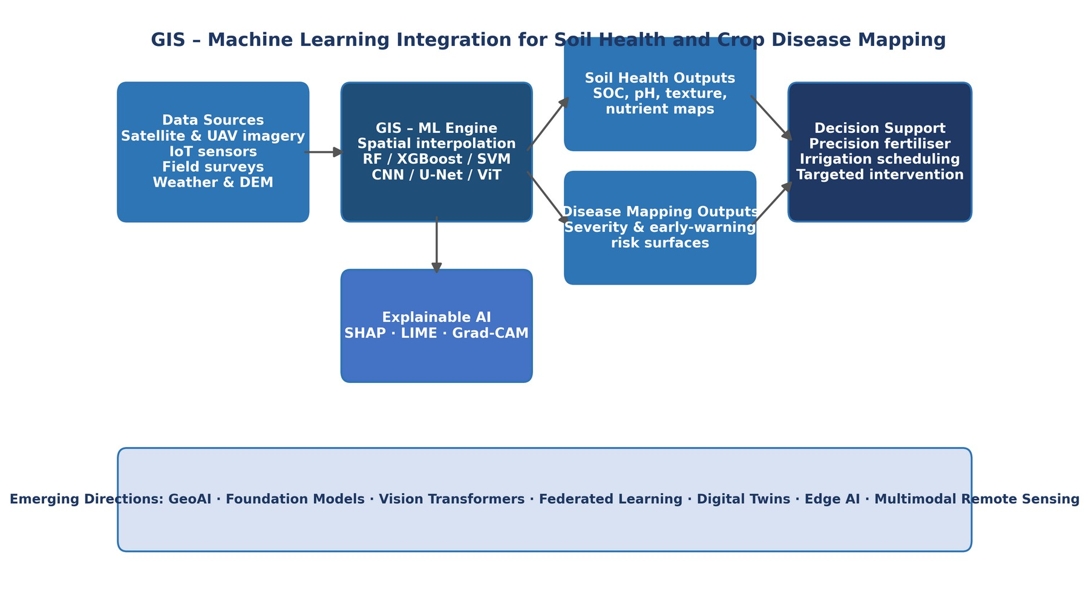
Graphical Abstract. GIS–ML integration pathway from multi-source data inputs through algorithmic processing and explainable AI to soil health and disease mapping decision-support outputs, situated within emerging geospatial AI directions.

Abstract
Purpose: This study systematically reviews the integration of Geographic Information Systems (GIS) and Machine Learning (ML) for soil health assessment and disease mapping in agriculture, identifying dominant research themes, data sources, analytical approaches, and emerging trends in geospatial AI for precision agriculture. Following the format of comparable bibliometric reviews in agri-food science (cf. Singh, Biswas and Banerjee, 2024; Faisal et al., 2025), it combines a PRISMA 2020 study-selection procedure with a structured bibliometric analysis of publication trends, thematic structure, citation impact, and source/country patterns.
Design/Methodology/Approach: A systematic literature review was conducted following the PRISMA 2020 framework. Records were identified from Consensus and Scopus, supplemented by manual checking of reference lists. An initial pool of 515 records was reduced to 464 after removal of 51 duplicates; keyword, publication-year (2020–2026), journal-type, publication-stage, and language screening excluded a further 153 records. Of the 311 full-text articles assessed for eligibility, 187 were excluded (86 failed peer-review verification, 69 lacked explicit spatial analytical content, and 32 could not be reliably data-extracted), leaving 124 peer-reviewed studies for the final systematic and bibliometric synthesis, drawn from 59 source journals.
Findings: GIS–ML integration is increasingly used for digital soil mapping and prediction of soil organic carbon, nutrients, and texture, as well as crop disease detection and severity mapping. Research activity is led by Soil Health (28.2%) and Crop Disease Detection (24.2%), with Digital Soil Mapping and Crop Mapping (10.5% each), Precision Agriculture and Remote Sensing (8.1% each), and smaller cross-cutting themes making up the remainder. Publication activity shows a strong upward trajectory from 2022 onward (82.3% of the corpus). Random Forest and deep learning dominate the corpus vocabulary, with Sishodia, Ray and Singh’s (2020) review of remote sensing in precision agriculture the most-cited study (1,169 citations), followed by Wadoux, Minasny and McBratney (2020) on ML for digital soil mapping (565 citations). GIS served consistently as a spatial intelligence framework integrating field, environmental, and remote sensing data into decision-support outputs.
Originality/Value: This review provides a consolidated, cross-disciplinary account of GIS-ML agricultural applications and, to the authors’ knowledge, is among the first to apply a combined PRISMA-plus-bibliometric structure to the GIS–ML soil-and-disease literature at this scale (n = 124). It highlights the need for standardised, explainable, and scalable workflows for sustainable soil and crop health management, while making explicit the field’s thematic structure and evidentiary limits.
Keywords: Machine Learning; Agriculture; Remote Sensing; Management; Deep Learning; Crops; Precision Agriculture; Random Forest; GIS; Classification
Paper type: Literature review

1. Introduction
Agriculture is undergoing a data-driven transformation through the convergence of spatial computing, artificial intelligence, and precision sensing. Meeting growing global food demand while managing finite land, water, and nutrient resources under climate change, soil degradation, and biodiversity loss has created urgent demand for intelligent, location-specific agricultural management (Anand et al., 2025). Geographic Information Systems (GIS) and Machine Learning (ML) have emerged as pivotal enabling tools, allowing the collection, integration, and interpretation of spatially explicit agricultural data from individual field plots to national landscapes (Wadoux et al., 2020).
Soil health and crop disease detection are two of the most critical and underserved domains for GIS-ML integration. Soil’s physical, chemical, and biological properties determine nutrient supply, water retention, and long-term ecosystem resilience (Kalantzopoulos et al., 2024), yet traditional field-based assessment is labour-intensive and spatially limited, motivating digital soil mapping approaches that convert sparse field observations into continuous predictive surfaces (Wadoux et al., 2020). Crop diseases, meanwhile, cause estimated global crop losses of 20–40% annually (Zheng et al., 2023); remote sensing, computer vision, and ML offer transformative capabilities for disease detection and predictive modelling at previously impossible scales (Omia et al., 2023).
Despite growing literature in both areas, soil science, remote sensing, plant pathology, and computer science have largely contributed in isolation without sustained cross-disciplinary integration (Koldasbayeva et al., 2024). Bibliometric and PRISMA-guided reviews have proved effective elsewhere in agri-food research for making such fragmented, fast-growing literatures legible — for example in agricultural supply-chain research (Singh, Biswas and Banerjee, 2024) and aquaponics research (Faisal et al., 2025). This paper adapts that combined structure to the GIS–ML soil-health-and-disease literature, integrating a PRISMA-guided review of 124 core studies with a bibliometric layer of publication-trend, thematic, and citation-impact analysis. It is among the first PRISMA-guided syntheses to integrate soil health and crop disease GIS-ML evidence within one evaluative framework at this scale, pairing that evidence base with a structured bibliometric layer and mapping it against emerging geospatial AI paradigms.
Several reviews have addressed GIS-ML applications in agriculture, soil informatics, or crop disease detection separately, but none have systematically unified soil health and crop disease mapping within a single PRISMA-guided evidence base of this scale while also synthesising bibliometric, methodological, and governance dimensions. Table 1 benchmarks this review’s contributions against representative prior GIS-ML agricultural reviews.
Table 1. Positioning of this review relative to representative prior GIS-ML agricultural reviews.
Prior Review | Primary Domain Focus | Systematic (PRISMA) Method | Soil + Disease Integration | Explainable AI Coverage | Key Limitation Addressed Here
Wadoux et al. (2020) | ML for digital soil mapping | No (narrative) | Soil only | Not addressed | No disease-mapping integration
Cravero et al. (2022) | ML challenges in agricultural big data | No (narrative) | Neither (general) | Not addressed | Lacks GIS-specific spatial methods
Omia et al. (2023) | Remote sensing in field crop monitoring | Partial | Disease only | Not addressed | No soil health linkage
Koldasbayeva et al. (2024) | Challenges in data-driven geospatial | No (perspective) | Neither (general) | Brief mention | No PRISMA evidence base
Faisal et al. (2025) | Aquaponics research trends | Yes (PRISMA + bibliometric) | Not applicable (different domain) | Not addressed | Different domain; model for this review’s design
This review | GIS-ML for soil health AND disease mapping | Yes (PRISMA 2020 + bibliometric layer, n = 124) | Both, integrated | Dedicated subsection (SHAP, LIME, Grad-CAM) | Addresses all gaps above, n = 124 evidence base

2. Methodology

2.1 Review Design
This study combines two complementary analytical layers, following the design logic of comparable bibliometric reviews of agri-food literatures (Singh, Biswas and Banerjee, 2024; Faisal et al., 2025): a PRISMA 2020 systematic review providing a transparent, reproducible procedure for identifying and synthesising the core evidence base, and a bibliometric analysis layer applied to the same n = 124 corpus, mapping publication trends, thematic structure, citation-based influence, source patterns, and geographic development. All reported percentages and counts refer to this same n = 124 unless stated otherwise.

2.2 Search Strategy
The databases Consensus and Scopus were searched systematically using controlled vocabulary and free-text terms, supplemented by manual checking of highly cited papers’ reference lists. Core search combinations included “GIS” AND “machine learning” AND “soil health”; “disease mapping” AND “GIS” AND “precision agriculture”; “digital soil mapping” AND “ensemble learning”; and “UAV” AND “crop disease” AND “deep learning”. Records were restricted to the 2020–2026 publication window and further filtered by journal type, publication stage, and language (English only). Searches were conducted during 2025–2026.

2.3 Inclusion and Exclusion Criteria
Studies were included if peer-reviewed, English-language publications (2020–2026) addressing GIS, ML, soil health, disease mapping, crop mapping, or precision-agriculture monitoring; demonstrated clear spatial analytical content; and could be reliably data-extracted for synthesis. Studies were excluded at full-text review if they failed peer-review verification, lacked explicit spatial analytical content, or could not be reliably data-extracted.

2.4 Study Selection Process
The PRISMA process proceeded through four stages (Figure 1). The initial search identified 515 records. After removing 51 duplicates, 464 unique records underwent screening; 153 were excluded as off-topic, non- journal, or outside the eligibility window. Of the 311 full-text articles assessed, 187 were excluded: 86 failed peer-review verification, 69 lacked explicit spatial analytical content, and 32 could not be reliably data-extracted. A total of 124 studies were retained for the final synthesis.
Table 2a. PRISMA stage-wise record counts.
Stage | Records | Excluded / Removed | Carried Forward
Identification (Consensus, Scopus, manual reference lists) | 515 | — | 515
Duplicates removed | 515 | 51 | 464
Screening (keyword, 2020–2026 window, journal type, stage, language) | 464 | 153 excluded* | 311
Eligibility (full-text review) | 311 | 187 excluded** | 124
* Screening exclusion total is the number of unique records with Passed_Screening = False in the 464-record deduplicated audit file; the individual screening criteria overlap and therefore are not additive. ** Eligibility exclusions comprise 86 records failing peer-review verification, 69 lacking explicit spatial analytical content, and 32 not reliably data-extractable (total 187).
Table 2b. Reasons for exclusion at full-text eligibility screening (n = 187).
Exclusion Reason | Records Excluded | Illustrative Basis
Failed peer-review verification | 86 | Preprint, grey literature, or unconfirmed venue
Lacked explicit spatial analytical content | 69 | No GIS/ML spatial component identifiable
Not reliably data-extracted | 32 | Methodology, data provenance, or outcome unclear
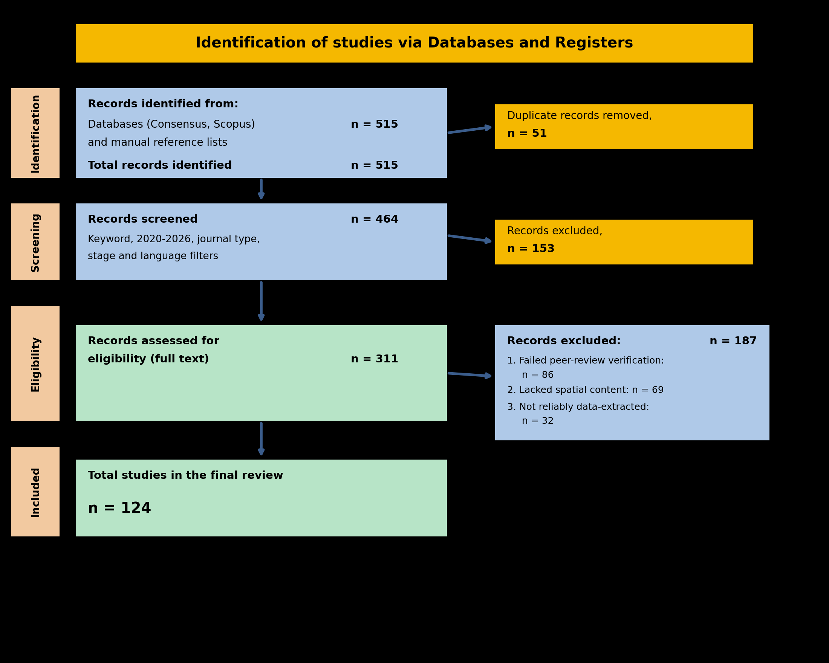
Figure 1. PRISMA 2020 flow diagram for the systematic-review study-selection process (n = 124).

2.5 Data Extraction and Bibliometric Analysis
A standardised template captured author(s), year, source, thematic classification, and abstract-level methodological description for each study. Qualitative thematic synthesis then identified common patterns across digital soil mapping, disease detection, and validation practices. The bibliometric layer was computed on the same n = 124 corpus using structured analysis (Python/pandas) of the Scopus-format export fields — publication year, source title, document type, thematic classification, country of origin, citation counts, and abstract text — and cross-validated against an independent Biblioshiny/bibliometrix run (Aria and Cuccurullo, 2017), which additionally provided the keyword co-occurrence network, thematic-map, and word-cloud outputs. All figures and percentages in this review derive from this single 124-study source unless noted.

3. Conceptual and Methodological Framework
Soil health and disease as spatial systems. Soil health is inherently spatial and dynamic, varying with parent material, climate, topography, and biota; traditional point-based sampling cannot capture this heterogeneity, motivating ML-based interpolation from sparse samples onto continuous surfaces (Wadoux et al., 2020). Crop diseases are similarly spatiotemporal, driven by environmental triggers unfolding over hours to days and demanding high temporal resolution and early-warning capability (Zheng et al., 2023; Piou and Marescot, 2023). GIS provides the common spatial infrastructure linking both domains, functioning as an analytical environment for structuring model inputs and translating predictions into decision-support outputs (Liu, 2024).
Data sources. Robust GIS-ML systems depend on data fusion combining satellite remote sensing (Sentinel-2, Landsat 8/9), UAV-derived RGB, multispectral, hyperspectral, and thermal imagery, IoT and in-situ sensor networks, ground-truth field surveys and laboratory analysis, and meteorological and topographic covariates (Table 3, Section 4). Across the 124 included study abstracts, Random Forest (31.5%), deep learning generally (28.2%), Sentinel imagery (16.9%), and UAV/drone platforms (12.9%) were the most frequently mentioned methods and data streams (Section 6.4).
ML/DL algorithms. Random Forest — a tree-based ensemble aggregating predictions from many decision trees — is the most frequently mentioned algorithm in the corpus (31.5% of abstracts), particularly for soil-health applications, owing to its handling of nonlinear relationships without distributional assumptions (Wadoux et al., 2020; Suleymanov et al., 2023). Gradient Boosting and Support Vector Machines provide comparable or superior accuracy at higher tuning complexity. CNNs and U-Net-style architectures dominate disease-detection studies, extracting hierarchical spatial features from UAV or satellite imagery for classification and pixel-level segmentation (Wang and Su, 2022; Ye et al., 2025). Hybrid workflows combining ML with residual kriging represent the methodological frontier for soil property mapping (Adeniyi et al., 2024; Du et al., 2020).
Validation, interpretability, and governance. Model evaluation typically combines R²/RMSE for continuous soil properties with precision/recall/F1 and IoU for disease-detection tasks, though spatial cross-validation remains inconsistently applied, risking optimistic accuracy estimates (Section 6.5). Explainable AI methods (SHAP, LIME, Grad-CAM), mentioned in 8.9% of abstracts, increasingly expose which covariates or image regions drive predictions, though they remain more discussed conceptually than embedded in operational tools. Governance considerations — data privacy, standardisation of validation protocols, and equitable access for smallholder users — are recurring but under-addressed (Koldasbayeva et al., 2024).

4. Data Sources for Soil Health and Disease Mapping
Reliable soil health assessment and disease mapping require strategic integration of multiple complementary data sources, each capturing different aspects of the agroecosystem at different spatial scales, temporal resolutions, and measurement principles. No single source is sufficient: robust GIS-ML systems depend on data fusion combining the spatial coverage of remote sensing, the accuracy of field surveys, the temporal continuity of IoT sensor networks, and the environmental context of meteorological and topographic data.
Satellite remote sensing — principally Sentinel-2 (10–60 m, 5-day revisit) and Landsat 8/9 (30 m, 16-day revisit) — provides spatially continuous, repetitive observations from which vegetation indices (NDVI, EVI, NDRE), soil indices, and canopy temperature anomalies are derived (Muller et al., 2025). Hyperspectral platforms provide finer spectral signatures for soil organic matter, moisture, and clay mineralogy (Zhang et al., 2023), while spectral reflectance captures physiological canopy changes associated with pathogen infection before symptoms are visually apparent (Omia et al., 2023). UAVs equipped with RGB, multispectral, hyperspectral, thermal, and LiDAR sensors resolve individual plant symptoms invisible to satellite sensors (Jia et al., 2023); all three disease-focused review studies relied on UAV imagery as their primary data source (Gao et al., 2025; Ye et al., 2025). IoT sensor networks provide continuous measurements of soil moisture, temperature, conductivity, pH, and microclimate that influence disease incubation and spread, while ground-truth field surveys and laboratory analysis supply the training and validation targets for GIS-ML models. Meteorological data (ERA5, CHIRPS, MODIS LST) and Digital Elevation Models with derived terrain attributes complete the standard covariate set for landscape-scale modelling.
Table 3. Major data sources used in GIS- and ML-based soil health assessment and disease mapping.
Data Source | Examples | Application (Soil) | Application (Disease) | Key Citations
Satellite Remote Sensing | Sentinel-2, Landsat 8/9, MODIS | Soil moisture, organic matter, spatial variability | Regional disease surveillance, stress detection | Omia et al., 2023; Zheng et al., 2023
UAV / Drone Imagery | RGB, multispectral, thermal, LiDAR | Fine-scale soil-crop response | Early disease detection, symptom mapping, severity | Gao et al., 2025; Ye et al., 2025; Jia et al., 2023
IoT & In Situ Sensors | Soil probes, moisture networks, weather stations | Real-time soil moisture monitoring | Disease risk microclimate alerts | Kumar et al., 2020; Kalantzopoulos et al., 2024
Ground-Truth Field Surveys | Georeferenced scouting, plot sampling | Validate soil property predictions | Validate disease outbreak maps | Zheng et al., 2023
Laboratory Soil Analysis | pH, OC, N, texture, CEC | Primary training targets for ML models | Indirect soil–disease link support | Kalantzopoulos et al., 2024
Meteorological Data | ERA5, CHIRPS, station networks | Soil moisture dynamics, decomposition rates | Disease spread forecasting, outbreak risk | Lamichhane et al., 2025
Topographic Data (DEM) | Slope, TWI, curvature, flow accumulation | Spatial soil variability prediction | Landscape-level disease suitability modelling | Adeniyi et al., 2023
Management Data | Irrigation records, fertilisation logs | Site-specific fertility interpretation | Disease risk under management regimes | Kalantzopoulos et al., 2024
Multimodal Fused Datasets | Combined RS, weather, soil, sensor data | Improved soil mapping and moisture prediction | Stronger disease-risk models and early warning | Lamichhane et al., 2025; Gao et al., 2020

5. GIS and Machine Learning Frameworks

5.1 Geospatial Analytical Methods
Spatial interpolation techniques — kriging, inverse distance weighting, thin-plate splines, and regression kriging — convert sparse point-based observations into continuous prediction surfaces; kriging is particularly valuable for also providing a prediction-uncertainty estimate (the kriging variance). Geographically Weighted Regression (GWR) allows relationships between predictors and target variables to vary spatially across management zones. Hotspot analysis techniques (Getis-Ord Gi*, Local Moran’s I) identify statistically significant spatial clusters of high or low values, supporting targeted intervention.

5.2 Machine Learning Algorithms
Random Forest (RF) — a tree-based ensemble method aggregating predictions from many decision trees trained on random data and predictor subsets — is the most widely used ML algorithm for soil health applications in the reviewed literature (Suleymanov et al., 2023). RF handles nonlinear relationships, mixed predictor types, and high-dimensional covariate spaces without distributional assumptions, provides built-in predictor importance rankings, and is computationally tractable (Wadoux et al., 2020). Gradient Boosting algorithms (XGBoost, LightGBM, CatBoost) train sequential ensembles that often achieve superior accuracy at greater computational cost (Cravero et al., 2022). Support Vector Machines perform well for classification but scale poorly to very large datasets (Heung et al., 2016), while Artificial Neural Networks approximate arbitrary nonlinear functions for soil property prediction (Du et al., 2020).

5.3 Deep Learning for Image-Based Applications
Deep learning architectures extend the GIS-ML framework by enabling automated hierarchical feature learning from high-dimensional image data, bypassing manual feature engineering (Wang & Su, 2022). Convolutional Neural Networks (CNNs) learn spatial feature detectors from raw pixel data through successive convolutional and pooling layers. Disease-focused review studies relied heavily on deep learning: Gao et al. (2025) integrated UAV data with deep and reinforcement learning for maize disease diagnosis; Ye et al. (2025) applied MGA-UNet for early detection of citrus Huanglongbing; and Jia et al. (2023) used multi-source UAV imagery with deep models for maize leaf spot monitoring. Vision Transformers are increasingly applied to remote sensing classification, while LSTM networks and temporal attention mechanisms support time-series forecasting of phenology and outbreaks (Lamichhane et al., 2025).

5.3.1 Comparative Benchmarking of Core ML Algorithms
Algorithm choice across the reviewed literature is strongly task-dependent, reflecting trade-offs between interpretability, accuracy, computational cost, and data requirements. Table 5 compares the six algorithm families most consistently encountered across soil health and disease mapping applications, mirroring the keyword co-occurrence structure in Section 6.4: a machine-learning/soil cluster centred on Random Forest and ensemble methods, and a deep-learning/disease cluster centred on CNN-family architectures.
Table 5. Comparative benchmarking of core machine learning algorithms used in GIS-ML soil health and disease mapping applications.
Algorithm | Strengths | Limitations | Typical Applications
Random Forest (RF) | Robust to noise and outliers; handles mixed/nonlinear predictors; built-in variable importance; minimal hyperparameter tuning | Limited extrapolation beyond training data range; less effective for raw image/pixel data; can overfit with highly correlated predictors | Digital soil mapping; SOC, pH, and texture prediction; soil property classification (Wadoux et al., 2020; Suleymanov et al., 2023)
XGBoost / Gradient Boosting | Often highest tabular-data accuracy; handles missing values natively; regularisation reduces overfitting | Computationally intensive hyperparameter tuning; less interpretable than single trees; sensitive to noisy labels | Soil nutrient and SOC regression; ensemble soil property prediction (Cravero et al., 2022)
Support Vector Machine (SVM) | Effective in high-dimensional feature spaces; strong margin-based classification boundaries; works well with limited samples | Scales poorly to very large datasets; kernel and parameter selection is non-trivial; less suited to deep spatial feature extraction | Soil texture classification; small-sample disease classification (Heung et al., 2016)
Convolutional Neural Network (CNN) | Learns hierarchical spatial features automatically from raw imagery; state-of-the-art for image classification | Data-hungry; computationally intensive; prone to overfitting on small UAV datasets without augmentation | UAV/satellite image-based disease classification; canopy stress detection (Wang & Su, 2022)
U-Net (incl. attention variants e.g. MGA-UNet) | Pixel-level semantic segmentation; preserves spatial detail via skip connections; strong for fine-grained symptom delineation | Requires densely annotated training masks; sensitive to class imbalance between diseased and healthy pixels | Disease severity mapping; citrus Huanglongbing segmentation (Ye et al., 2025)
Vision Transformer (ViT) | Captures long-range spatial dependencies via self-attention; strong performance with large training sets; transferable via pretraining | Requires substantially larger training data than CNNs; high computational and memory cost; still emerging for agricultural imagery | Remote sensing scene classification; emerging UAV disease and crop-type classification

5.4 Hybrid GIS-ML Integration Workflows
The most methodologically sophisticated studies combine GIS spatial analytical methods with ML predictive methods in integrated hybrid workflows. Combining ML with residual kriging — where ML first predicts soil properties from environmental covariates and kriging corrects the spatially structured residuals — represents a particularly effective hybrid approach, demonstrated by Adeniyi et al. (2024) for soil organic carbon prediction, combining ML’s nonlinear predictive power with kriging’s spatial autocorrelation modelling.
Table 6. GIS and machine learning approaches used for soil health assessment and disease mapping.

6. Results

6.1 Overview of Included Studies
Table 7. Summary of data retrieved and analysed (n = 124 corpus).
Description | Results
Main information about data
Timespan | 2020:2026
Sources (journals) | 59
Documents | 124
Annual growth rate % (2020–2025) | 12.09
Document average age (years) | 2.69
Average citations per document | 61.37
Document contents
Author-assigned thematic categories | 10
Authors
Authors (unsplit author-strings, approx.) | 516
Single-authored documents | 18
Author collaboration
Co-authors per document (mean) | 4.4
International co-authorship % (of the 41 studies with resolvable country metadata) | 41.5
Document types
Theoretical / modelling / simulation study | 56
Literature or systematic review | 27
Article | 19
Cross-sectional study | 14
Other (commentary, case study) | 8
The final 124 studies span 2020–2026, concentrated in 2022–2026 (102 of 124, 82.3%), indicating an accelerating pace of methodological development. Country-of-origin metadata was reliably resolvable for 41 of 124 studies (33.1%); within this subset China (8), India (7), the United States (5), and Egypt (5) lead. Using the assigned thematic category, 48 of 124 studies (38.7%) address soil-health or digital-soil- mapping applications and 30 of 124 (24.2%) address crop disease detection; the remaining 46 (37.1%) span precision agriculture, crop mapping, remote-sensing methodology, and cross-cutting GIS/ML method development.
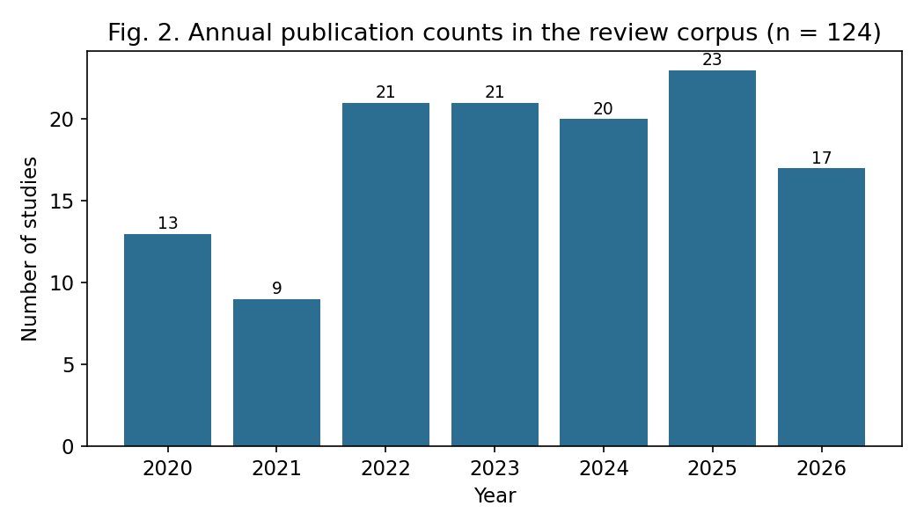
Figure 2. Annual publication counts across the 124-study review corpus, 2020–2026.

6.2 Thematic Results: Soil Health and Disease Detection
The 48 soil-health studies demonstrate that GIS-combined ML supports digital soil mapping and continuous property-surface estimation for SOC, nitrogen, pH, and texture (Auzzas et al., 2024), with remote sensing and terrain covariates consistently improving accuracy (Zhang et al., 2023). Hybrid ML-plus-kriging recurs as a pattern: Adeniyi et al. (2024) showed it outperforming standalone ML or kriging for SOC mapping. The 30 disease-detection studies favour high-resolution UAV remote sensing with deep learning (Jia et al., 2023): Gao et al. (2025) achieved early maize-disease diagnosis fusing multispectral and thermal UAV data, while Ye et al. (2025) used MGA-UNet for pixel-level Huanglongbing segmentation.

6.3 Cross-Study Patterns and Critical Comparison
Three cross-cutting patterns emerge. First, multi-source spatial data integration is common, combining remote sensing with field observations and environmental covariates (Lamichhane et al., 2025). Second, algorithm specialisation by domain is evident: Random Forest and ensemble ML dominate soil-health applications while deep learning and computer vision dominate disease detection (Wang and Su, 2022; Wadoux et al., 2020). Third, GIS functions across most studies as an analytical environment rather than a mere visualisation tool (Liu, 2024).
Substantive disagreements nonetheless persist. Algorithm-superiority claims are context-dependent: several studies report Random Forest as the strongest soil predictor (Suleymanov et al., 2023; Muller et al., 2025), yet Adeniyi et al. (2024) show hybrid ML-kriging outperforming standalone RF, and Hitziger and Ließ (2014) found no single algorithm dominant across terrain conditions. Disease-detection accuracy figures are not directly comparable across studies, which validate against non-standardised metrics. Methodological maturity is also geographically uneven, concentrated in China, India, the United States, and Egypt, with thinner coverage of arid, tropical, and smallholder contexts.

6.4 Thematic Classification and Keyword-Frequency Analysis
Thematic classification confirms Soil Health (28.2%) and Crop Disease Detection (24.2%) as dominant, followed by Digital Soil Mapping and Crop Mapping (10.5% each), Precision Agriculture and Remote Sensing (8.1% each), and smaller cross-cutting themes (10.4%). Abstract-level method/data-term frequency (Figure 3) shows Random Forest (31.5%) and deep learning (28.2%) as the most frequent analytical approaches, with Sentinel imagery (16.9%) the leading platform. The ten most frequent abstract terms are headed by machine learning (195), agriculture (149), and remote sensing (146), with management, deep learning, and crops close behind, and precision agriculture, random forest, GIS, and classification completing the top ten.
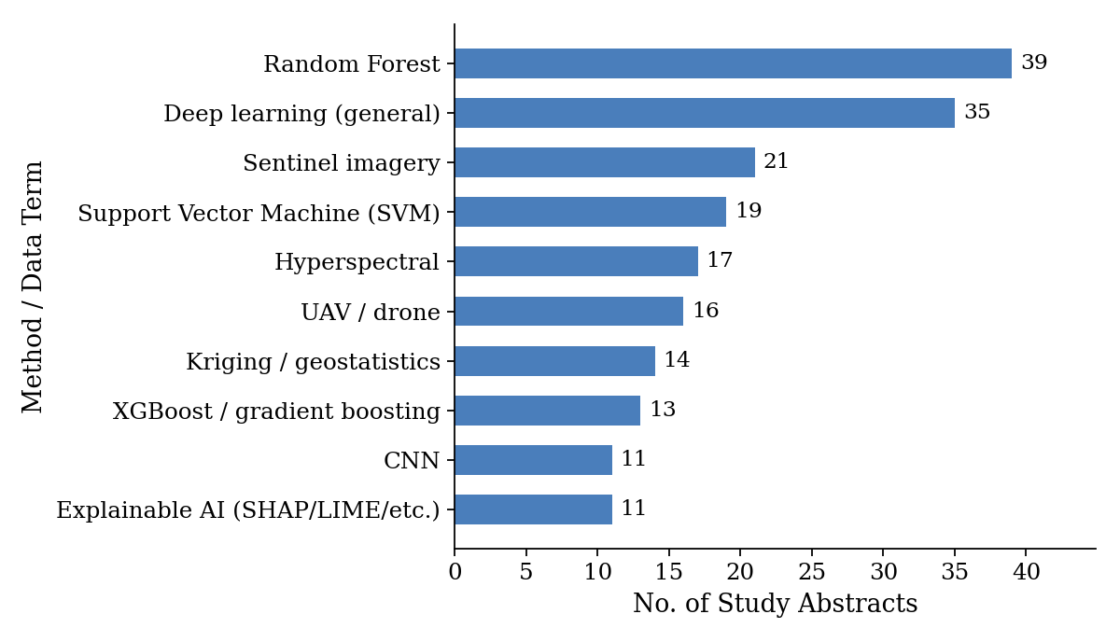
Figure 3. Frequency of key method and data-source terms across the 124 included study abstracts.
A full-corpus bibliometric text-mining run (Biblioshiny/bibliometrix) corroborates this at the word level: “agriculture”, “soil”, “crops”, “machine learning”, and “remote sensing” lead the corpus’s keyword field, with “mapping”, “management”, “deep learning”, and “random forest” close behind, echoing the abstract-level term frequencies above (Figure 5). A keyword co-occurrence network built from the corpus’s author-keyword field (Figure 4) resolves into three clusters: a red soil/mapping cluster (“remote sensing”, 60 occurrences; “soil”, 51; “mapping”, 37), a blue crop/disease-detection cluster (“crop”, 57; “machine learning”, 57; “disease detection”, 30), and a small green precision-agriculture cluster. The strongest co-occurrence pairs are Crop–Machine Learning (32 shared papers), Crop–Disease Detection (30), and Crop–Remote Sensing (26), with Machine Learning and Remote Sensing bridging the soil and disease clusters. A thematic (density x centrality) map of the corpus (Figure 6) places “machine learning, agriculture, remote sensing” and “deep learning, crops, classification” in the high-centrality core, while “precision viticulture” and “geoinformatics” occupy a niche quadrant.
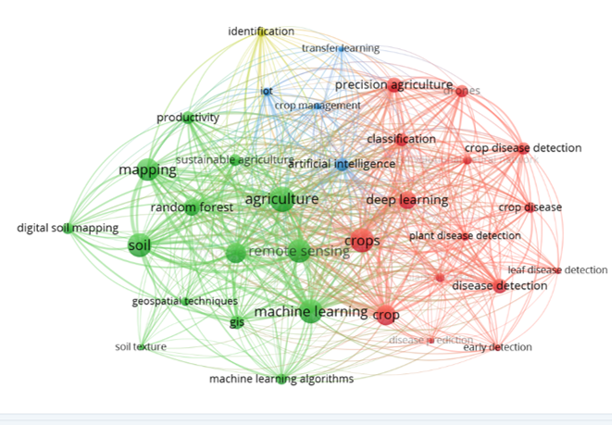

Figure 4. Keyword co-occurrence network built directly from the 124-study corpus’s multi-term author-keyword field (node size = term frequency; edge width = co-occurrence count; colour = detected community).
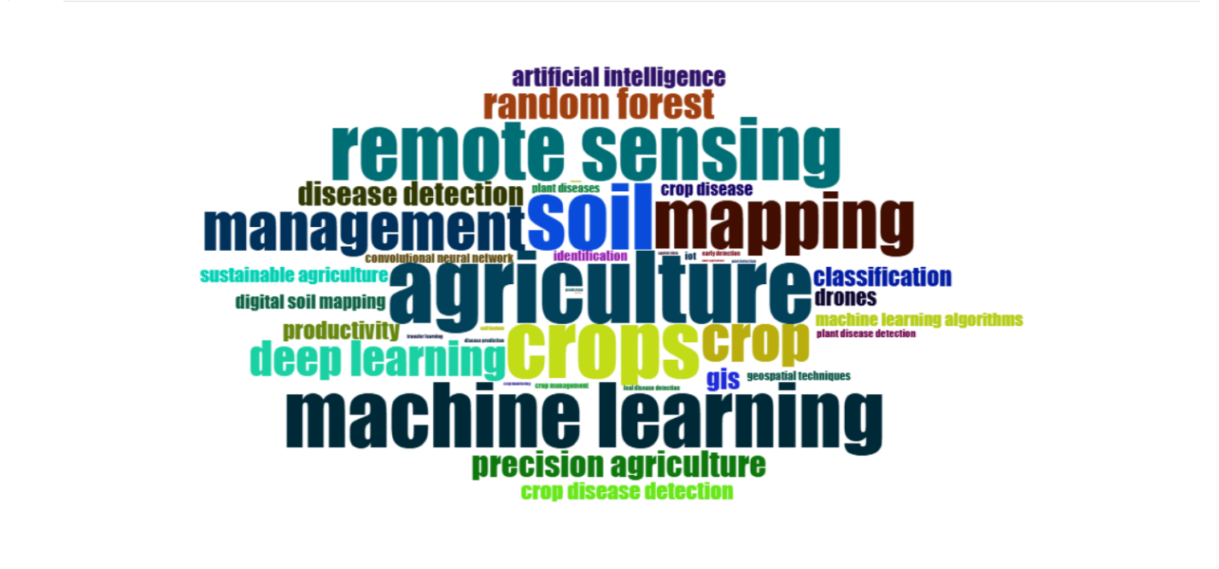
Figure 5. Word cloud of application and method terms across the 124-study corpus.
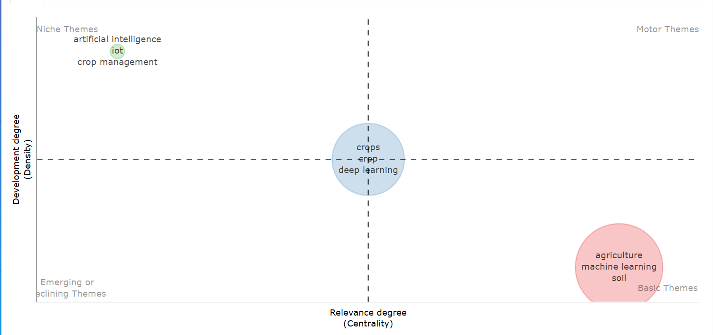
Figure 6. Thematic (density x centrality) map of the 124-study corpus.

6.5 Relevance-Based Thematic Clustering
The 124 studies resolve into two primary content clusters plus a cross-cutting cluster, consistent with the keyword network and thematic map above (Faisal et al., 2025). Cluster 1: Digital Soil Mapping and Hybrid Geostatistical–ML Workflows (48 studies, 38.7%) centres on predicting SOC, nitrogen, texture, and pH from remote sensing and terrain covariates, predominantly via Random Forest, with hybrid ML-plus-kriging as the methodological frontier (Adeniyi et al., 2024; Du et al., 2020). Cluster 2: UAV-Based Deep Learning for Disease Detection and Severity Mapping (30 studies, 24.2%) is unanimous in its reliance on UAV imagery combined with deep learning (Gao et al., 2025; Ye et al., 2025; Jia et al., 2023), though validation against non-standardised, independent test sets remains rare. The cross-cutting cluster (46 studies, 37.1%) spans precision agriculture, crop mapping, remote-sensing methodology, and yield prediction, providing the methodological infrastructure on which the two primary clusters draw, mapping onto the small, peripheral green cluster in Figure 4.

6.6 Citation Impact and Influential Contributions
Because author-name strings in the source export are inconsistently formatted, a fully disambiguated author-productivity network could not be reliably reconstructed; a Biblioshiny cross-check confirms this, returning ten distinctly formatted “authors” each credited with exactly one document (Figure 7), corroborating the fragmented, single-study-per-author authorship pattern typical of this still-consolidating, cross-disciplinary field.
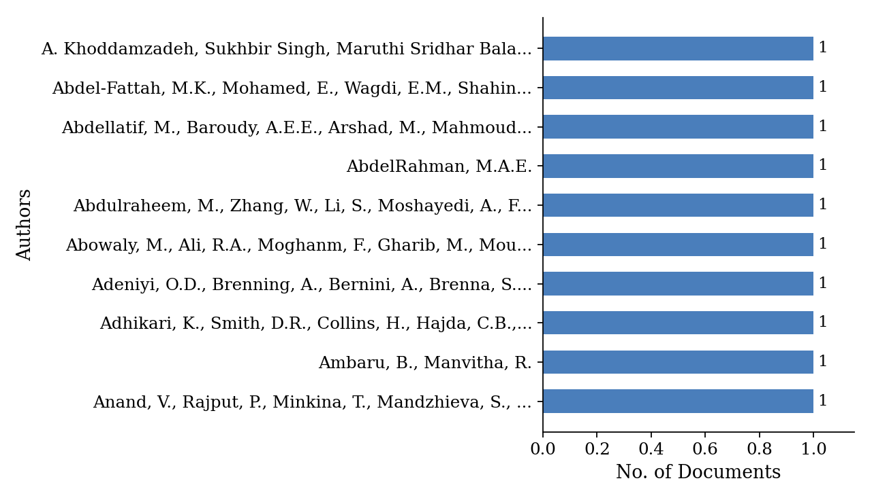
Figure 7. Most relevant “authors” by document count (each bar = one full, unsplit author-string from the source export).
Citation counts are strongly right-skewed (mean 61.4, median 20, maximum 1,169). Sishodia, Ray and Singh’s (2020) review of remote sensing in precision agriculture is the most-cited study (1,169 citations), followed by Wadoux, Minasny and McBratney (2020) on ML for digital soil mapping (565), Singh (2021) on soil salinity (392), Elavarasan et al. (2020) on deep-reinforcement crop-yield prediction (324), and Shahi et al. (2023) on UAV disease detection (255). This right-skew reflects a young, rapidly growing literature in which a few early, broad reviews have accumulated disproportionate citation share; average citations per cohort fall from ~33.5 for 2020 to single digits for 2024–2026.

6.7 Source, Affiliation, and Geographic Distribution
Remote Sensing is the leading venue (25 of 124 studies), followed by Scientific Reports (9), Agriculture (8), Sustainability (6), and Agronomy (5) (Figure 8); ranked by local impact (H-index), Remote Sensing again leads (H = 20), followed by Sustainability (H = 6) and Agriculture/Agronomy (H = 5 each) (Table 8), confirming that the field’s anchoring in remote-sensing and general-agriculture journals reflects genuine citation impact rather than volume alone.
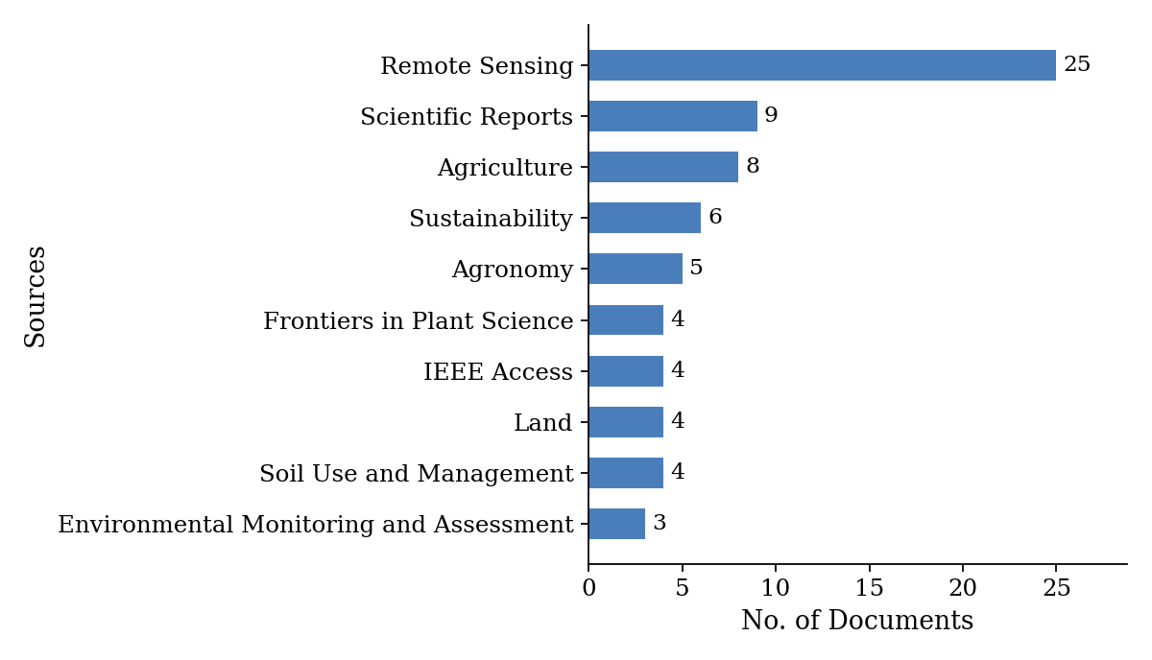
Figure 8. Most relevant source journals by document count.

Table 8. Top 10 productive source journals (h-index, total citations, number of publications, and start year).
Element | h_index | TC | NP | PY_start
Remote Sensing | 20 | 3251 | 25 | 2020
Sustainability | 6 | 400 | 6 | 2021
Agriculture | 5 | 137 | 8 | 2022
Agronomy | 5 | 221 | 5 | 2021
Land | 4 | 128 | 4 | 2021
Scientific Reports | 4 | 321 | 8 | 2020
IEEE Access | 3 | 463 | 4 | 2020
Soil Use and Management | 2 | 395 | 4 | 2021
Frontiers in Plant Science | 2 | 155 | 4 | 2023
Environmental Monitoring and Assessment | 2 | 17 | 3 | 2024
TC = total citations; NP = number of publications; PY_start = publication year of the source’s earliest included study. Remote Sensing leads by both document count and citation impact, while IEEE Access and Soil Use and Management show a high citation-to-document ratio driven by a small number of highly cited papers within those journals.
Institutional analysis (Figure 9) identifies the University of Agricultural Sciences, Bangalore as the single most productive affiliation (3 articles), followed by Gorgan University of Agricultural Sciences and Natural Resources and the Indian Institute of Technology Delhi (2 each); the remaining top-10 affiliations each contributed one article, reflecting the same globally distributed, low-repeat-contribution pattern seen at the author level.
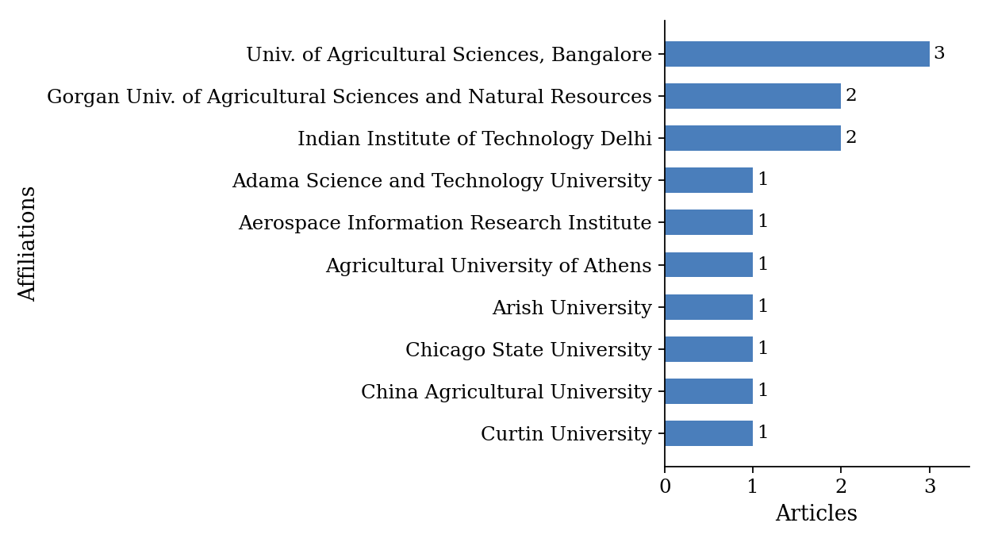
Figure 9. Most relevant affiliations by document count.
Geographically, a Biblioshiny run parsing country information from the full affiliations field resolves broader coverage than the 41-study subset in Section 6.1: China (49 cumulative article-country instances through 2026), India (37), Egypt (17), the United States (15), Brazil (8), and South Korea (8) lead, consistent with the ordering identified from the resolvable subset. This concentration pattern — meaningful representation from several large, research-intensive systems alongside thinner coverage of many individual countries — mirrors the “regional strength” pattern observed in larger bibliometric reviews of adjacent fields (Faisal et al., 2025).
Splitting each country’s output into single-country publications (SCP, authored entirely within one country) and multiple-country publications (MCP, with at least one international co-author) shows a mixed pattern (Figure 10): China (4 SCP, 4 MCP) and Egypt (2 SCP, 3 MCP) draw roughly half their output from international collaboration, while the United States (5 SCP, 0 MCP) and Brazil (2 SCP, 0 MCP) are entirely domestically authored within this corpus, and several smaller contributors — Pakistan, Australia, Cyprus, Bangladesh, Republic of Korea, and Russia — appear exclusively through MCP records. This uneven pattern is consistent with the broader 41.5% international-co-authorship rate reported for the resolvable country subset (Table 7).
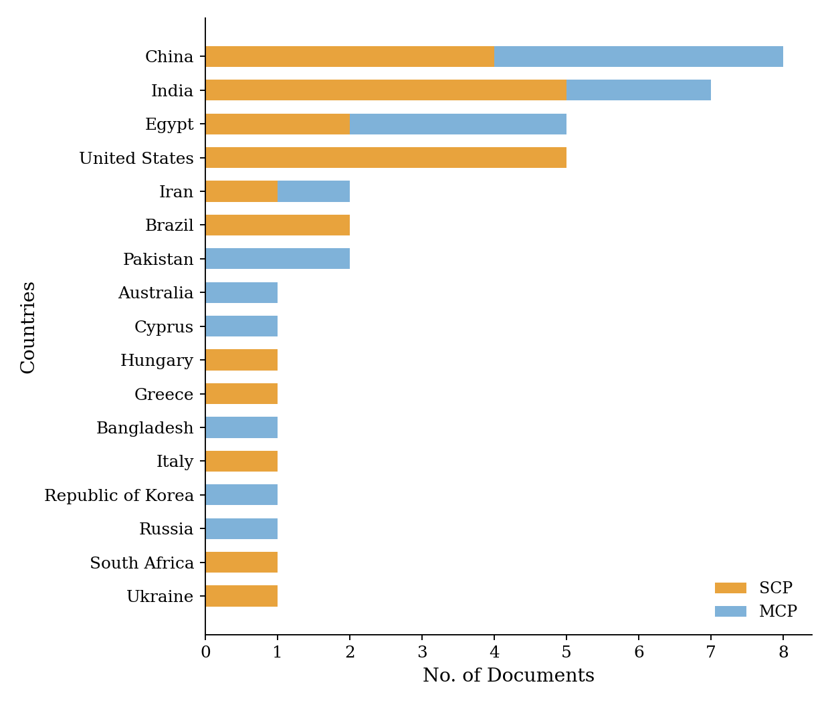
Figure 10. Country-wise distribution of single-country (SCP) and multiple-country (MCP) publications among the 41 studies with resolvable country metadata.
The same country field also supports a genuine international-collaboration network: treating each co-occurring country pair as a link, 31 countries and 35 country-pair collaborations are identifiable across the 41 studies with resolvable metadata. China anchors the largest, most connected cluster (linked to France, Ireland, the UK, Canada, and several South and Southeast Asian countries), while India forms a second cluster with Egypt, Russia, Hungary, Croatia, and Ethiopia; the United States anchors a smaller cluster with Australia, the Netherlands, and the Republic of Korea. Several countries appear only as isolated or narrowly bilateral contributors, a pattern consistent with comparable bibliometric reviews of adjacent agri-food fields (Faisal et al., 2025).
Document-type classification shows the corpus dominated by theoretical, modelling, or simulation studies (56 of 124, 45.2%) and literature/ systematic reviews (27, 21.8%), with cross-sectional empirical studies (14, 11.3%) and standard research articles (19, 15.3%) making up the remainder — indicating a substantial share of modelling and synthesis work relative to primary field-validated case studies, consistent with the field’s still-consolidating state.

7. Machine Learning for Soil Health Mapping
Machine learning has become central to soil health mapping, enhancing prediction accuracy, scalability, and spatial interpretability from local to continental scales. Digital Soil Mapping (DSM) is the primary application, where ML integrates sparse field measurements with terrain features, spectral remote sensing, and environmental covariates to produce continuous soil property predictions (Wadoux et al., 2020). Key target properties include soil organic carbon (SOC), total nitrogen, texture, pH, and available micronutrients (phosphorus, potassium, iron, zinc, boron) (Auzzas et al., 2024).
Ensemble learning methods consistently outperform for surface SOC prediction in data-sparse regions, reducing variance and improving spatial generalisation (Mishra et al., 2020). Random Forest models effectively estimate soil pH and organic matter from terrain and spectral covariates with high interpretability and manageable cost, while hybrid ML-plus-residual-kriging frameworks address the limitations of either approach alone (Adeniyi et al., 2024). Novel applications extend ML beyond conventional soil chemistry: fertility zoning delineates variable-rate fertiliser management zones (Bohn & Miller, 2025); microbiome-based health prediction estimates microbial biomass and community diversity from spectral, terrain, and management covariates (Wilhelm et al., 2022); and proximal sensing (handheld NIR, ground-penetrating radar, electromagnetic induction) bridges the gap between field observations and satellite remote sensing.
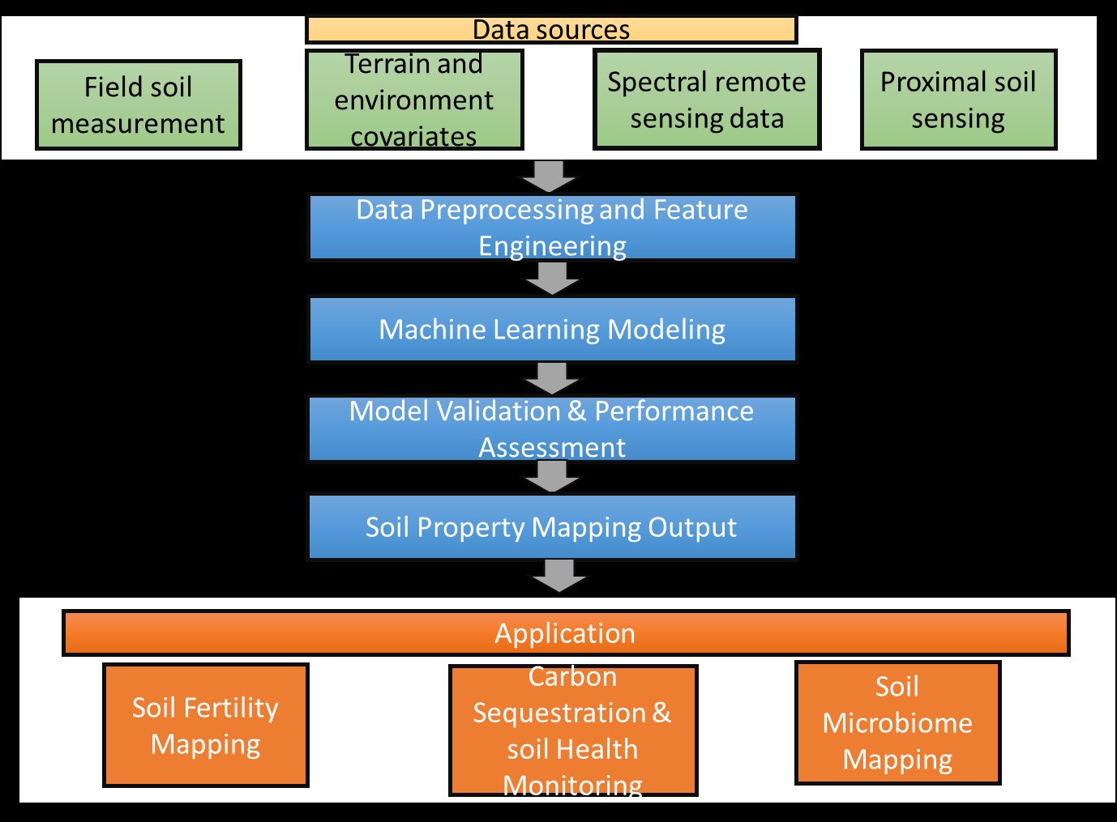
Figure 11. Digital Soil Mapping Workflow.

8. Spatiotemporal Modelling of Pests and Diseases
Mapping pests and diseases in space and time is essential for understanding how outbreaks arise and spread, and for early-warning systems that trigger intervention before crop damage becomes economically significant (Gao et al., 2020). Disease outbreaks are driven by environmental triggers — rainfall, temperature transitions, inoculum accumulation — that unfold over hours to days, demanding higher temporal resolution than soil mapping (Zheng et al., 2023). Spectral indices from multispectral and hyperspectral imagery (e.g., Red Edge Chlorophyll Index, Modified NDRE, Carotenoid Reflectance Index) detect early physiological changes before visible symptoms appear (Ye et al., 2025), while UAV-derived thermal imagery adds a complementary signal via canopy temperature anomalies linked to stomatal closure under disease stress (Gao et al., 2025).
Spatiotemporal models are increasingly applied for pest hotspot detection, early-warning systems, and outbreak prediction. Piou and Marescot (2023) showed that combining weather data, vegetation indices, and population ecology models substantially improves the accuracy and timeliness of locust outbreak warnings, an approach being extended to crop disease spread modelling via atmospheric dispersion models, GIS-based landscape connectivity, and host crop distribution maps (Lamichhane et al., 2025). Coupling field-level detection (UAV, in-situ sensors) with landscape-level risk mapping (satellite, weather data) within a unified GIS-ML framework represents the frontier toward proactive, landscape-aware disease intelligence (Piou & Marescot, 2023) (Figure 12).
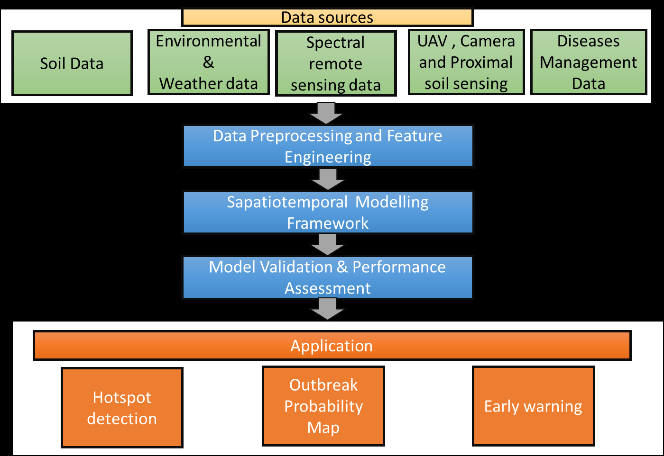
Figure 12. Spatiotemporal Disease Mapping Workflow.

9. Model Assessment, Validation, and Interpretability

9.1 Evaluation Metrics and Performance Assessment
For continuous regression tasks, the primary metrics are RMSE, MAE, and R² (Wadoux et al., 2020); the ratio of performance to inter-quartile distance (RPIQ) offers a scale-independent measure across studies (Adeniyi et al., 2023). For classification tasks, appropriate metrics include overall accuracy, precision, recall, F1, and AUC-ROC. For spatial disease mapping, the Detection Efficiency Index and spatially explicit confusion matrices may be needed to fully characterise map quality.

9.2 Spatial Validation and Uncertainty
Standard random cross-validation produces overly optimistic performance estimates, since spatial autocorrelation between nearby observations means test-fold points are not genuinely independent of training data (Koldasbayeva et al., 2024). Spatially blocked cross-validation — partitioning by spatially contiguous blocks — gives more realistic estimates of generalisation to novel locations, and external validation on fully independent datasets provides the most stringent test of transferability. Prediction maps should convey confidence levels alongside expected values: quantile regression forests, conformal prediction, and Bayesian ML methods all provide principled uncertainty intervals (Liu, 2024; Wadoux et al., 2020).

9.3 Explainability and Interpretability
Interpretability requirements for GIS-ML models have grown as these systems move into operational advisory and policy applications. SHAP values provide locally faithful, globally consistent feature-importance estimates that can be mapped spatially. Partial dependence plots show the marginal effect of individual predictors, letting experts verify that learned relationships are agronomically plausible. For deep learning on image data, Grad-CAM and attention visualisation reveal which image regions most influenced a classification or segmentation decision — critical for building practitioner trust (Ye et al., 2025; Liu, 2024).

9.3.1 SHAP, LIME, and Grad-CAM in Practice
SHAP (SHapley Additive exPlanations): SHAP provides a game-theoretic attribution of each predictor’s contribution to a given prediction, is consistent across model types, and is increasingly used to spatially map which covariates (terrain, spectral, or climatic) drive soil property predictions in specific landscape locations — helping agronomists distinguish genuinely informative covariates from spurious correlations (Liu, 2024).
LIME (Local Interpretable Model-agnostic Explanations): LIME approximates complex model behaviour locally around an individual prediction using an interpretable surrogate model, offering a lightweight, model-agnostic alternative to SHAP that is particularly useful for rapid, instance-level explanation of individual field or pixel-level predictions where full SHAP computation is too costly at scale.
Grad-CAM (Gradient-weighted Class Activation Mapping): Grad-CAM and related attention-visualisation methods highlight the image regions that most influenced a CNN or U-Net classification or segmentation decision, producing heatmaps overlaid on UAV or satellite imagery that allow agronomists to visually verify that a disease detection model is responding to genuine symptomatic tissue rather than background artefacts (Ye et al., 2025).
Together, these three techniques span the explainability needs of the field: SHAP and LIME for tabular soil-property models, and Grad-CAM for image-based disease detection models.

10. Validation, Governance, Limitations, and Future Directions
Validation and interpretability. Reported evaluation practice varies widely: soil-property studies typically report R²/RMSE against held-out samples, while disease-detection studies report precision/recall/F1 or IoU against annotated imagery. Spatial cross-validation, which accounts for spatial autocorrelation, is inconsistently applied, risking optimistic accuracy estimates. Explainable AI methods (SHAP, LIME, Grad-CAM) appear in 8.9% of abstracts but remain more discussed conceptually than embedded into operational, farmer-facing tools.
Governance and standardisation. The absence of shared data formats, georeferencing conventions, and validation protocols impedes pooled meta-analysis and cross-study benchmarking. Data privacy for farm-level records and equitable access for smallholder and low-connectivity users remain recurring but under-addressed themes (Koldasbayeva et al., 2024). Only a small minority of studies address economic feasibility, market adoption, or policy design; none of the ten thematic categories in Section 6.4 explicitly captures this gap.
Key limitations of the evidence base. No study jointly models soil-health indicators and disease risk within a single spatial framework, despite established mechanistic pathways between soil moisture, pH, and pathogen viability (Kalantzopoulos et al., 2024) — soil and disease GIS-ML pipelines remain methodologically siloed. Nearly all studies report site-specific performance without systematic external validation across climatic zones or cultivars (Jia et al., 2023), and the overwhelming majority were developed and validated in well-resourced research contexts, with very limited evidence on performance or usability in smallholder or low-connectivity farming systems (Anand et al., 2025).
Future research directions centre on: (i) federated learning architectures enabling cross-institutional model training without centralising sensitive farm data; (ii) foundation models pretrained on large, multimodal remote-sensing archives and fine-tuned for soil/disease tasks with limited local data; (iii) lightweight, edge-deployable models for real-time detection in low-connectivity rural environments; and (iv) multimodal fusion of optical, radar (SAR), thermal, and LiDAR data streams to improve robustness under cloud cover and variable illumination.
Methodological limitations of this review. Although the 124-study PRISMA evidence base is substantially larger than an earlier, 13-study version of this review, it remains a keyword- and abstract-screened corpus; most methodological detail was extracted at the title/abstract level rather than full-text reading. Country metadata could be resolved for only 41 of 124 studies (33.1%), limiting the geographic findings (Section 6.7). The search was restricted to Consensus and Scopus, which may exclude relevant grey literature and non-English work. Disease-detection accuracy figures across the corpus are not directly comparable, as discussed in Section 6.3.

11. Conclusion
This combined systematic, conceptual, and bibliometric review has examined the integration of GIS and Machine Learning for soil health assessment and disease mapping in agriculture, grounded in 124 rigorously selected studies and a structured bibliometric layer of publication-trend, thematic, and citation-impact analysis (Singh, Biswas and Banerjee, 2024; Faisal et al., 2025). The evidence confirms that GIS-ML integration is a viable, growing, and increasingly indispensable approach to spatial agricultural analysis, transforming how soil health is assessed, crop diseases are detected, and precision-management decisions are supported (Wadoux et al., 2020; Anand et al., 2025).
Soil-health applications are methodologically mature, with Random Forest and ensemble ML dominant and hybrid ML-geostatistical workflows the performance frontier (Adeniyi et al., 2024). Disease-mapping applications are fewer but technologically dynamic, with deep learning and UAV-based monitoring delivering detection capabilities impossible a decade ago (Gao et al., 2025; Ye et al., 2025). Publication activity is accelerating sharply from 2022 onward (82.3% of the corpus), with a clear split between a methodologically mature Soil Health / Digital Soil Mapping cluster (38.7%) and a rapidly advancing UAV-deep-learning Disease Detection cluster (24.2%), alongside a cross-cutting precision-agriculture cluster (37.1%).
In both domains, GIS-ML enhances spatial variability capture, improves prediction accuracy, and produces decision-support outputs — maps, risk surfaces, early-warning alerts, and intervention recommendations — directly applicable to precision agriculture (Ajith et al., 2025). The path forward requires greater methodological standardisation, transparent validation and uncertainty reporting, deeper integration of soil-health and disease-risk modelling, and sustained investment in data infrastructure, extension capacity, and governance to translate these advances into equitable, climate-resilient agricultural outcomes (Koldasbayeva et al., 2024).

References

Systematic Review and Bibliometric Corpus (n = 124)
This review's PRISMA evidence base comprises 124 peer-reviewed studies (Section 2.4). To keep the main manuscript within standard word-count limits, the full 124-study reference list is provided as Supplementary Material S1. The seven corpus studies discussed by name in the text below are reproduced here for direct citation resolution; all other in-text findings from the corpus are attributed by theme and aggregate statistic rather than by individual citation, consistent with standard bibliometric-review reporting.
- Adeniyi, O. D., Brenning, A., Bernini, A., & Brenna, S. (2023). Digital Mapping of Soil Properties Using Ensemble Machine Learning Approaches in an Agricultural Lowland Area of Lombardy, Italy. Land. https://doi.org/10.3390/land12020494
- Elavarasan, D., & Member, I. D. V. P. M. (2020). Crop Yield Prediction Using Deep Reinforcement Learning Model for Sustainable Agrarian Applications. IEEE Access. https://doi.org/10.1109/access.2020.2992480
- Meyer P. Bohn, Bradley A. Miller (2025). Digital soil mapping via machine learning of agronomic properties for the full soil profile at within‐field resolution. Agronomy Journal. https://doi.org/10.1002/agj2.70144
- Shahi, T. B., Xu, C., & Neupane, A. (2023). Recent Advances in Crop Disease Detection Using UAV and Deep Learning Techniques. Remote. Sens.. https://doi.org/10.3390/rs15092450
- Singh, A. (2021). Soil salinity: A global threat to sustainable development. Soil Use and Management. https://doi.org/10.1111/sum.12772
- Sishodia, R., Ray, R. L., & Singh, S. (2020). Applications of Remote Sensing in Precision Agriculture: A Review. Remote. Sens.. https://doi.org/10.3390/rs12193136
- Wadoux, A., & Minasny, B. (2020). Machine learning for digital soil mapping: Applications, challenges and suggested solutions. Earth-Science Reviews. https://doi.org/10.31223/osf.io/8eq6s

Background and Conceptual References
The following references are cited in this review for conceptual framing, methodological precedent, or illustrative background and are not part of the n = 124 systematic review corpus above. Several were retained from an earlier, smaller-corpus version of this review; readers should independently verify bibliographic details before relying on them for citation.
- Ajith, S., Vijayakumar, S., & Elakkiya, N. (2025). Yield prediction, pest and disease diagnosis, soil fertility mapping, precision irrigation scheduling, and food quality assessment using ML and DL algorithms. Discover Food, 5(1), 67. https://doi.org/10.1007/s44187-025-00338-1
- Anand, V., et al. (2025). Systematic review of ML applications in sustainable agriculture. Phyton, 94(5), 1339.
- Aria, M., & Cuccurullo, C. (2017). bibliometrix: An R-tool for comprehensive science mapping analysis. Journal of Informetrics, 11(4), 959–975.
- Auzzas, A., et al. (2024). An improved digital soil mapping approach to predict total N. Modeling Earth Systems and Environment, 10(5), 6519–6538.
- Cravero, A., et al. (2022). Challenges to use machine learning in agricultural big data. Agronomy, 12(3), 748.
- Dharumarajan, S., & Hegde, R. (2022). Digital mapping of soil texture classes using Random Forest. Soil Use and Management, 38(1), 135–149.
- Du, P., et al. (2020). Advances of four machine learning methods for spatial data handling. Journal of Geovisualization and Spatial Analysis, 4(1), 13.
- Faisal, A., Biswal, P., Bhattacharya, D., Kumar, S., Banerjee, M., Bhowmick, G. D., & Swain, D. K. (2025). Towards sustainable aquaponics: a bibliometric analysis of trends, scientific developments, and thematic evolution. Aquaculture International, 33, 418.
- Gao, D., et al. (2020). A framework for agricultural pest and disease monitoring based on IoT and UAVs. Sensors, 20(5), 1487.
- Gao, J., et al. (2025). Integration of UAV and Remote Sensing for Early Diagnosis and Severity Mapping of Diseases in Maize. Remote Sensing, 17(20), 3427. https://doi.org/10.3390/rs17203427
- Heung, B., et al. (2016). An overview and comparison of machine-learning techniques for classification in digital soil mapping. Geoderma, 265, 62–77.
- Hitziger, M., & Ließ, M. (2014). Comparison of Three Supervised Learning Methods for Digital Soil Mapping. Applied and Environmental Soil Science, 2014, 809495.
- Jia, X., et al. (2023). Monitoring Maize Leaf Spot Disease Using Multi-Source UAV Imagery. Drones, 7(11), 650.
- Kalantzopoulos, G., et al. (2024). The Western Greece soil information system (WESIS). Sustainability, 16(8), 3478.
- Koldasbayeva, D., et al. (2024). Challenges in data-driven geospatial modeling. Nature Communications, 15(1), 10700.
- Lamichhane, M., et al. (2025). Surface soil moisture prediction using multimodal remote sensing and ML. Science of Remote Sensing, 12, 100255.
- Liu, L. (2024). An ensemble framework for explainable geospatial ML models. International Journal of Applied Earth Observation and Geoinformation, 132, 104036.
- Mishra, U., et al. (2020). Ensemble ML approach improves predicted spatial variation of surface SOC stocks. Frontiers in Big Data, 3,
- Muller, I., et al. (2025). A random forest model for predicting soil properties using Landsat 9 bare soil images. Agrosystems, Geosciences & Environment, 8(4), e70239. https://doi.org/10.1002/agg2.70239
- Omia, E., et al. (2023). Remote sensing in field crop monitoring: A comprehensive review. Remote Sensing, 15(2), 354.
- Piou, C., & Marescot, L. (2023). Spatiotemporal risk forecasting to improve locust management. Current Opinion in Insect Science, 56,
- Singh, N., Biswas, R., & Banerjee, M. (2024). A systematic review to identify obstacles in the agricultural supply chain and future directions. Journal of Agribusiness in Developing and Emerging Economies, 14(5), 1195–1217.
- Suleymanov, A., et al. (2023). Random Forest Modeling of Soil Properties in Saline Semi-Arid Areas. Agriculture, 13(5), 976.
- Wang, Y.-H., & Su, W.-H. (2022). CNNs in Computer Vision for Grain Crop Phenotyping: A Review. Agronomy, 12(11), 2659.
- Wilhelm, R. C., et al. (2022). Predicting measures of soil health using the microbiome and supervised ML. Soil Biology and Biochemistry, 164, 108472.
- Yang, W., et al. (2023). Geographically weighted regression with ML for spatial prediction. Journal of Geographical Systems, 25(2), 213–236.
- Ye, N., et al. (2025). Early detection of Citrus Huanglongbing by UAV remote sensing based on MGA-UNet. Frontiers in Plant Science, 16, 1503645. https://doi.org/10.3389/fpls.2025.1503645
- Zheng, Q., et al. (2023). Remote sensing monitoring of rice diseases and pests: A review. Agronomy, 13(7), 1851.

