A CLINICAL STUDY TO EVALUATE THE EFFECT OF VIRECHANA KARMA IN THE MANAGEMENT OF STHAULYA WITH SPECIAL REFERENCE TO OBESITY

By
Dr SWETA SHANDILYA

Dissertation Submitted to the
Bihar University of Health Sciences, Bihar

In partial fulfilment
of the requirements for the degree of

Degree Name

In Subject Name

Under the guidance of
Dr. AKHILESH PD. SINGH
MD (AY.) Kayachikista
H.O.D Dept. Of Panchakarma
GACH, Patna -03

DEPARTMENT OF PANCHAKARMA
GOVERNMENT AYURVEDIC COLLEGE & HOSPITAL, PATNA -800003 SESSION (2023-26)

Bihar University of Health Sciences, Bihar

DECLARATION BY THE CANDIDATE

I hereby declare that this dissertation/thesis entitled “A clinical study to evaluate the effect of virechana karma in the management of sthaulya with special reference to obesity ” is a bona fide and genuine research work carried out by me under the guidance of Dr Akhilesh PD. Singh, MD(AY.) Kayachikista, Head of the Department of Panchakarma.
Date: | Signature of the Candidate:
Place: | Name:

CERTIFICATE BY THE GUIDE
This is to certify that the dissertation entitled “A clinical study to evaluate the effect of virechana karma in the management of sthaulya with special reference to obesity ” is a bona fide research work done by Dr Sweta Shandilya in partial fulfilment of the requirements for the degree of ___________.
Date: | Signature of the Guide:
Place: | Name:  Designation & Department

ENDORSEMENT BY THE HOD, PRINCIPAL/HEAD OF THE INSTITUTION
This is to certify that the dissertation entitled A clinical study to evaluate the effect of virechana karma in the management of sthaulya with special reference to obesity ” is a bonafide research work done by Dr Sweta Shandilya under the guidance of Dr Akhilesh PD. Singh, MD(AY.) Kayachikista, Head of the Department of Panchakarma.
.
Seal & Signature of the HOD  Name: | Seal & Signature of the Principal:  Name
Date  Place: | Date:  Place:
COPYRIGHT
Declaration by the Candidate
I hereby declare that the Bihar University of Health Sciences, Bihar shall have the rights to preserve, use and disseminate this dissertation / thesis in print or electronic format for academic / research purpose.

Date: | Signature of the Candidate:
Place: | Name:

© Bihar University of Health Sciences, Bihar

ACKNOWLEDGEMENT

Date: | Signature of the Candidate:
Place: | Name:

LIST OF ABBREVIATIONS USED
Abbreviation | Expansion
BMI | Body Mass Index
WC | Waist Circumference
WHR | Waist-Hip Ratio
WHO | World Health Organization
ICMR | Indian Council of Medical Research
NFHS | National Family Health Survey
T2DM | Type 2 Diabetes Mellitus
CVD | Cardiovascular Disease
HDL-C | High-density Lipoprotein Cholesterol
LDL-C | Low-density Lipoprotein Cholesterol
TG | Triglycerides
GI | Gastrointestinal

ABSTRACT

TABLE OF CONTENTS

1. | Introduction
2. | Objectives
3. | Review of Literature
4. | Methodology
5. | Results
6. | Discussion
7. | Conclusion
8. | Summary
9. | Bibliography
10. | Annexures

LIST OF TABLES
SI.No | Tables | Page No

LIST OF FIGURES

SI.No | Figures | Page No

1. Introduction
Obesity is now understood as a chronic, relapsing disease in which excess or dysfunctional adiposity impairs health rather than as a simple consequence of lack of willpower. Overweight and obesity are defined by the World Health Organization as abnormal or excessive fat buildup that may have negative health effects. In 2022, over 890 million adults were obese and around 2.5 billion adults were overweight, meaning that approximately one in eight people globally were obese(1). Because obesity affects blood pressure, blood sugar management, lipoprotein metabolism, respiratory mechanics, musculoskeletal loads, reproductive function, sleep, mental health, and cancer risk, the scope of the issue is significant. Additionally, it influences health care utilization across decades as opposed to a single sickness episode.
Obesity is also considered a problem of energy homeostasis in the modern biology perspective(2). The relationship between energy intake and expenditure is reflected in long-term body weight, but this seemingly straightforward equation is controlled by central neural circuits, gastrointestinal signals, hormones derived from adipose tissue, genetics, epigenetics, sleep, stress, drugs, the food environment, and socioeconomic circumstances. According to Lin and Li, tissue-level biology, behavior, social environment, genes, and epigenetic control all have a role in the development of obesity(2). Adipose-tissue hypertrophy, ectopic lipid deposition, insulin resistance, oxidative stress, and persistent low-grade inflammation are additional mechanisms that Jin and colleagues identify as connecting excess adiposity to organ failure(3). Therefore, a short-term weight loss strategy does not always equate to good obesity management; anthropometry, symptoms, metabolic risk, and other factors should be taken into account in a clinically useful evaluation.
In a similar vein, management is multi-component. Nutrition and physical activity programs, behavioral techniques, treatment of contributing disorders, medication where necessary, and metabolic/bariatric surgery for certain patients are all used in the current treatment of adult obesity. Goals should go beyond a target number on the weighing scale to improve complications and function, according to a recent clinical evaluation(4). This is pertinent to research in traditional medicine since a therapy should be examined using results that can be interpreted in both contemporary clinical practice and its own conceptual framework.
Both metabolic and mechanical processes contribute to the clinical burden of obesity. Type 2 diabetes, hypertension, dyslipidemia, atherosclerotic cardiovascular disease, steatotic liver disease linked to metabolic dysfunction, obstructive sleep apnea, osteoarthritis, gastroesophageal reflux, infertility, polycystic ovarian syndrome, and various cancers are all linked to adult obesity. Additionally, it impacts quality of life, mobility, and self-perceived health. According to Ansari and colleagues, the difficulties are interconnected rather than isolated; when multiple complications coexist, management becomes more challenging and medical expenses increase(5). This pattern encourages early intervention prior to the development of severe end-organ disease.
An active endocrine and immunological organ is adipose tissue. Insulin resistance and systemic inflammation can be exacerbated by local hypoxia, macrophage recruitment, and changes in adipokine release when adipocytes grow. While variations in adiponectin and inflammatory mediators affect how glucose and fats are handled, leptin resistance may impair satiety signaling. Gjermeni and colleagues' pathophysiological assessment also emphasizes central pathways that protect body weight during weight reduction, endocrine regulation, and gut-brain transmission(6). This helps to explain why obesity should be handled as a chronic illness and why weight gain is typical following a period of calorie restriction.
This chronic and systemic nature offers a helpful starting point for an Ayurvedic study. Classical descriptions of Sthaulya include disproportionate accumulation, decreased enthusiasm or exertional capacity, excessive hunger and thirst, perspiration, and other functional abnormalities in addition to increased bodily size(7). Both models acknowledge that excess body mass can coexist with reduced physiological function, but they cannot be directly mapped onto biological factors. Therefore, a dual reading is required for a clinical research of Virechana Karma: changes in weight, BMI, circumferences, and metabolic measurements provide modern clinical interpretability, while improvements in Sthaulya lakshana should be recorded within the Ayurvedic framework.
Undernutrition continues while overweight, obesity, and metabolic disease are on the rise in India, which is going thru a nutritional transformation. The ICMR-INDIAB study demonstrated that central adiposity is not exclusive to urban populations and reported abdominal and generalized obesity in both urban and rural populations(7). Since then, analyzes of the National Family Health Survey-5 have revealed that abdominal obesity is prevalent and varies significantly by age, sex, urban/rural location, and region(8). These findings are crucial because, in South Asian populations, where visceral fat accumulation and metabolic abnormalities may occur at lower BMI values than in many Western populations, BMI alone may miss risk.
Instead of depending solely on body weight, the Endocrine Society of India clinical practice guideline suggests that anthropometry and obesity-related comorbidities be included in the evaluation of Indian adults(9). Higher body fat percentages, a larger propensity for central adiposity, insulin resistance, and dyslipidemia at a particular BMI are common characteristics of the Indian phenotype. The application of universal cut-offs in India is complicated by a number of factors, according to Nadiger and colleagues, including ethnic variance, variations in body composition, and a significant prevalence of metabolic disorders in individuals who would not satisfy traditional Western standards for obesity(10).
Elevated triglycerides, low HDL cholesterol, and atherogenic particle patterns are frequent features of South Asian dyslipidemia, especially when central obesity and insulin resistance combine(11). These characteristics encourage the use of metabolic evaluation and waist circumference in addition to BMI. Because cardiometabolic risk increases at lower BMI than the traditional international cut-offs, Indian consensus approaches have traditionally employed lower BMI thresholds—23.0–24.9 kg/m² for overweight and at least 25 kg/m² for obesity in Asian Indians (12). Additionally, culturally appropriate food, exercise, sleep, behavioral modification, and early risk-factor treatment are highlighted in management guidelines for Asian Indians(13).
Recent debates in India have advocated for a diagnosis that takes into account the distribution of adiposity and the existence of obesity-related diseases in addition to BMI(14). This is particularly relevant when studying Sthaulya because the traditional description is functional and phenotypic rather than limited to a single numerical cut-off. Although they may not always identify the same people, general and abdominal obesity may overlap(15). Thus, while assessing waist-related anthropometry and clinical characteristics, the current study can maintain BMI as a repeatable eligibility or outcome measure.
Weight in kilos divided by height in meters squared yields the BMI. Its simplicity, affordability, and cross-population comparability are its strong points; nevertheless, it is unable to determine fat distribution or differentiate between lean and fat mass(16). Therefore, BMI is increasingly paired with waist circumference, waist-to-height ratio, clinical staging, or complication evaluation in modern obesity guidelines. The requirement to interpret BMI in conjunction with central adiposity and metabolic risk is emphasized in the 2022 obesity diagnosis guideline update, especially for Asian populations(16).
Consensus cut-offs that categorize BMI 23.0–24.9 kg/m² as overweight and at least 25 kg/m² as obese, together with sex-specific waist thresholds, have also been examined in Indian clinical practice(17). The goal of these reduced cut-offs is to better identify individuals who have cardiometabolic risk even tho their BMI would be considered normal or only slightly raised by international standards. They are not only a semantic shift. Analyzes of national surveys also reveal a clustering of obesity and associated risk variables for noncommunicable diseases with age, urban location, socioeconomic transitions, and lifestyle exposures(18).
Because visceral fat is metabolically active and linked to insulin resistance and cardiovascular risk, abdominal adiposity has special therapeutic significance. South Asians frequently had higher body fat and truncal fat at the same BMI than White populations, according to reviews of the Indian subcontinent that highlight central obesity as an independent risk sign(19). The multisystem nature of obesity is further supported by population analyzes from India that connect it to vascular and neurological risk pathways(20).
Therefore, standardized weight, height, and BMI; waist and hip circumference when possible; blood pressure; dietary and activity history; symptoms associated with obesity; medication use; pertinent comorbidities; and Ayurvedic variables like prakriti, agni, koshta, nidana, and Sthaulya lakshana should all be recorded in a clinically useful assessment on Virechana Karma..The same measuring technique should be used at baseline and follow-up. Short-term changes must be interpreted cautiously because fluid shifts around a purgation procedure can transiently affect body weight(20).
Genetic change alone cannot account for the significant rise in obesity at the population level. The primary environmental change is a persistent mismatch between energy availability and energy expenditure, which is caused by increased access to foods high in calories, larger portions, ultra-processed meals, sugar-sweetened beverages, motorized transportation, sedentary labor, screen time, and altered sleep patterns. However, each person's vulnerability varies(21). Because of differences in appetite control, energy expenditure, fat distribution, pharmaceutical exposure, life-course factors, and psychosocial stress, some persons gain significant weight while others stay slim.
The prevalence of overweight and obesity among Indian women is not randomly distributed, but rather clusters geographically with socioeconomic and contextual factors, according to spatial analyzes(21). The distribution of BMI categories in India has also changed over time, according to temporal analyzes(22). The shifting load may be influenced by changes in education, affluence, urbanization, parity, age structure, and behavioral exposures, according to decomposition studies using national survey data(23). Therefore, rather than being the result of a single behavioral error, obesity is better understood as the result of an obesogenic environment working on biological predisposition.
When reading Ayurvedic nidana, this frame is also relevant. Dietary excess, heavy and decadent foods, inactivity, daytime sleep, and constitutional predisposition are all frequently highlighted in classical accounts of Sthaulya. Both highlight recurring exposure patterns rather than a single event, even if the terminology and causation models are different from those of contemporary epidemiology (23) . Instead of asserting that one is a direct historical description of the other, it is helpful to portray these as parallel explanatory systems.
Initially, an excess of energy causes adipose tissue to grow and store triglycerides. Adipocytes grow, immune cells build up, lipolysis increases, and free fatty acids enter the liver, muscles, and other organs when storage capacity is exhausted or adipose growth becomes dysfunctional. Insulin action is hampered by ectopic lipid and inflammatory signals(23). Skeletal muscle glucose absorption decreases, the liver produces more glucose and triglyceride-rich lipoprotein, and the secretory demand on pancreatic beta cells rises. This network may eventually result in fatty liver disease, dyslipidemia, and type 2 diabetes.
The persistence of obesity is also influenced by neuroendocrine adaptability. Weight loss can lead to biological reactions that promote weight gain, such as increased hunger and decreased energy expenditure. Thru bile acid signaling, incretin hormones, nutrition sensing, and microbial metabolites, the gut makes a contribution. These pathways are summarized in current studies, which highlight how cerebral, peripheral, and environmental signals interact to cause obesity(24). Adipose dysregulation is also associated with respiratory conditions, musculoskeletal disability, kidney illness, cardiovascular disease, and cancer, according to more recent pathophysiological research(25). Similar to this, a comprehensive clinical evaluation of obesity characterizes the condition as a chronic illness that calls for integrated prevention and treatment as opposed to a brief course of treatment(26).
Body weight and central adiposity, hunger and satiety symptoms, bowel pattern, fasting glucose or lipid profile when included in the protocol, and patient-reported symptoms or functional measurements are some of the measurable domains that these processes offer for a research of Virechana Karma. Claims regarding bile-acid, microbiota, or inflammatory pathways should be restricted to what has been measured. These pathways can be considered as theories backed by earlier research rather than as proven mechanisms of action if the study does not test them(23).
The fundamental principle of treating obesity is still lifestyle modification. If the patient is able to follow a number of food patterns, a sustained energy deficit can be maintained, and regular exercise helps maintain function, cardiometabolic health, and weight loss. Self-monitoring, goal-setting, stimuli control, sleep optimization, problem-solving, and relapse planning are examples of behavioral techniques. While metabolic/bariatric surgery provides the greatest and most long-lasting weight loss for certain patients with severe obesity, pharmacotherapy is increasingly more frequently employed for patients who meet BMI- and complication-based criteria(22). However, there is a treatment gap due to access, cost, side effects, long-term adherence, weight gain, and patient preference.
This gap partly explains interest in Ayurveda and Panchakarma-based interventions. Preventing the replacement of one oversimplification with another is a scientific challenge. Modern obesity should not be reduced to a laboratory stand-in for an Ayurvedic dosha, and a traditional method should not be characterized as a universal cleansing solution. Rather, the study should pose a specific question: what changes occur in predetermined subjective and objective outcomes following a standardized Virechana procedure in suitably selected individuals with Sthaulya and obesity, and are those changes safe and clinically significant?(20,21)
Sthaulya is traditionally classified as a disorder linked to abnormal increases in Meda and overnutrition. Because excess Meda and Mamsa are accompanied by functional restrictions and a variety of problems, it is sometimes classified as one of the undesirable bodily states. Thus, nidana parivarjana, pathya, langhana/lekhana principles, shamana formulations, and shodhana are used in Ayurvedic treatment for specific individuals(24). One of the main Shodhana procedures, virechana is performed after the patient, dosha, strength, season, agni, and koshta have been assessed. Preparatory oleation and sudation are followed by therapeutic purgation and a progressive post-procedure diet.
The clinical reasoning does not support the idea that purging is equivalent to losing weight. Reduced adipose tissue should not be confused with gastrointestinal contents and fluid loss, which can cause an immediate drop in body weight. The more pertinent theory is that a structured Virechana intervention incorporated into post-procedure care and dietary regulation may affect bowel movements, appetite, adherence to a lighter diet, metabolic symptoms, or other pathways, all of which may lead to subsequent improvements in anthropometry(22). Gut microbial changes following Virechana have also been the subject of published exploratory investigations; however, these results are still preliminary and need to be confirmed.
Therefore, when efficacy is operationalized beforehand, the suggested goal—"to evaluate the efficacy of Virechana Karma in the management of Sthaulya with special reference to obesity"—is clinically defendable. Results should indicate the timing of measures in relation to purgation, differentiate Ayurvedic symptom scores from biomedical anthropometry, and record adverse occurrences and hydration levels. Clinicians and researchers outside of Ayurveda can read the results thanks to a design that respects Virechana's inherent logic(4).
Three gaps make this study necessary. First, the prevalence of obesity is rising, and many patients look for treatment options that go beyond traditional lifestyle recommendations. Second, there is a wide range of data supporting Ayurvedic obesity treatments; studies vary in terms of case definitions, Panchakarma techniques, medications, co-interventions, length, outcome evaluation, and follow-up. Third, Virechana studies may report early weight change without sufficiently distinguishing fluid-related effects from long-term anthropometric change, and they frequently have small sample sizes.
By employing a replicable Virechana methodology, precise eligibility requirements, standardized Sthaulya assessment, objective anthropometry, predetermined follow-up, and transparent safety monitoring, a targeted clinical trial can strengthen this body of evidence. The Ayurvedic theory of Sthaulya, the concepts of Agni, Ama, Dhatu, and Srotas that are pertinent to its pathogenesis, the therapeutic principles of Langhana and Shodhana, the procedural logic of Virechana, potential modern biological interfaces, and the results and limitations of prior clinical studies are all examined in the Review of Literature that follows(26).
Two parallel case definitions are required for a clinical investigation that employs the phrase "Sthaulya with special reference to obesity." While Sthaulya is the Ayurvedic clinical construct utilized for diagnosis, dosha-dushya involvement evaluation, and treatment planning, obesity is the modern biological condition used for anthropometric classification(7)There might be significant overlap between the two without them being regarded as synonyms. This distinction shields the study from a typical methodological issue in integrative research, which is the presumption that a single contemporary measurement can be easily transferred from a traditional diagnostic category.
Because BMI is affordable, repeatable, and appropriate for repeated follow-up, it continues to be the most useful screening tool for obesity. However, BMI does not assess visceral adiposity directly and does not differentiate between lean and fat mass. In South Asian communities, where cardiometabolic risk can occur at lower BMI values than in many Western cultures, waist circumference and waist-hip ratio thus provide information on central fat distribution(7,11–17). As a result, in many therapeutic scenarios, Indian and Asian guidelines suggest lower action points or risk thresholds than traditional worldwide cut-offs(9,11–17). During analysis, the protocol should specify which classification is being used and refrain from switching between global and Asian cut-offs.
In a Virechana investigation, measurement timing is equally crucial. Intestinal emptying and fluid balance have an impact on the body weight measured right after therapeutic purgation. As a result, it is helpful as a procedural observation, but it shouldn't be mistaken with adipose tissue loss(4). After the individual has finished Samsarjana Krama, resumed stable oral intake, and attained a clinically euvolemic condition, a more convincing efficacy assessment is obtained. At predetermined follow-up intervals, repeated weight and waist measurements can then demonstrate whether any early reduction is sustained. Similar to this, current assessments of obesity place more emphasis on long-term changes in adiposity and comorbidities than on brief variations in scale-weight(4,24–26).
The Ayurvedic side of assessment should also be operationalized before recruitment. If characteristics like Chala Sphika, Chala Udara, Chala Stana, Atikshudha, Atipipasa, Swedadhikya, Ayasena Shwasa, and Alasya are employed as results, they require clear grading standards. The investigator should specify what a one-grade improvement is and whether the score is determined by clinical observation, patient narrative, or both. The techniques should include the components and scoring range of any aggregate Sthaulya score. Instead than relying on an implicit clinical perception, this makes the Ayurvedic result repeatable(22).
Therefore, it is important to understand the current goal as an integrative efficacy issue with distinct but complementary outcome areas. Anthropometric results provide information on changes in central adiposity or body size. Sthaulya symptom scores provide an answer to the question of whether the conventional clinical phenotype shifts. When used, metabolic testing address related cardiometabolic risk. Whether Virechana was administered as planned and safely tolerated is determined by procedural factors and adverse occurrences. By keeping these domains separate, it avoids the assertion that a change in one domain inevitably leads to a change in all others and instead discusses convergence when many outcomes improve simultaneously.

Duration is the last design factor. Virechana is administered throughout a relatively brief therapeutic experience, whereas obesity is a chronic condition. If the protocol was intended to test short-term efficacy, the study can show it; nonetheless, the discussion should not go beyond short-term follow-up to assert long-term obesity control. Future efficacy studies would benefit from knowing whether people maintained Pathya, gained weight, continued to be physically active, or sought out additional therapy after the official trial time. In this way, the goal stays on the quantifiable response to Virechana while recognizing that long-term management of obesity typically necessitates ongoing clinical and behavioural assistance (4,9,24–26).

2. REVIEW OF LITERATURE:

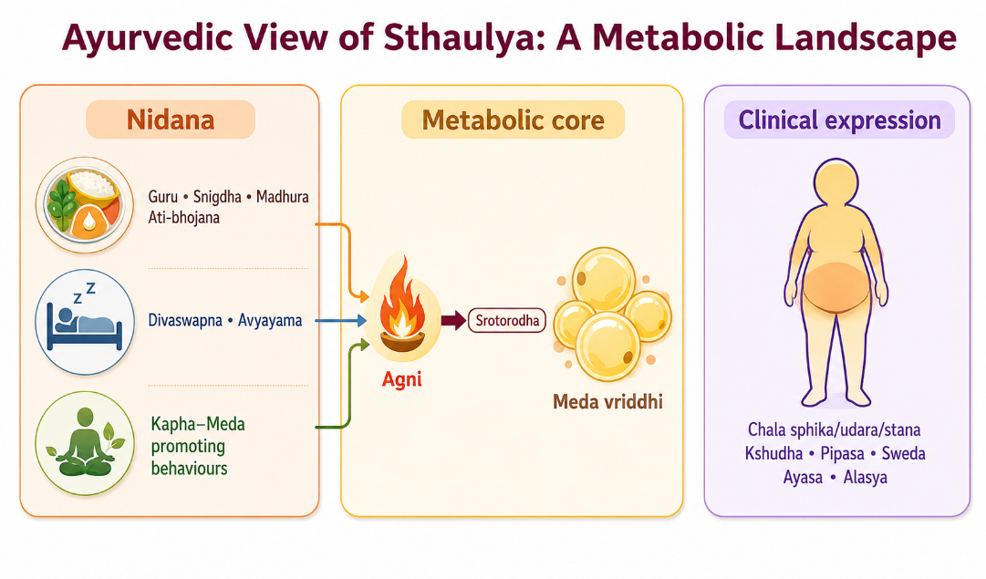
2.1 Foundations of Ayurveda relevant to Sthaulya

Figure 1. Ayurvedic metabolic landscape of Sthaulya

2.1.1 Ayurveda as a systems-oriented medical tradition
Ayurvedic philosophy posits that wellness is an intricate dance of interconnected elements such as constitution, bodily tissues, waste, digestive fire, pathways, the mind, sensory perception, behavior and environmental influences. Historians Jaiswal and Williams have extensively examined Ayurveda as a holistic medical tradition that seamlessly integrates preventive measures, personalized evaluations, diet, lifestyle modifications, medication and therapeutic interventions, rather than compartmentalizing them as distinct entities(27). For Sthaulya, this means that excessive body size is not assessed in isolation. The clinician considers constitution, digestive-metabolic function, tissue status, strength, bowel tendency, causative habits and associated symptoms before choosing therapy.
- The concept of Agni is central because it organizes digestion, absorption, transformation and tissue metabolism within Ayurvedic physiology. Agrawal and colleagues explain Jatharagni, Bhutagni and Dhatvagni as functional levels of transformation, with disturbance at one level potentially influencing nourishment at another(28).
- Modern terms such as “metabolism” can help communicate the general idea, but Agni should not be equated with a single enzyme, basal metabolic rate or mitochondrial pathway. It is a broader clinical construct inferred from appetite, digestion, postprandial comfort, bowel function and systemic signs.
- Dhatu Siddhanta describes sequential nourishment and differentiation of tissues. Sharma and Chaudhary discuss the theory of Dhatu formation and its relation to tissue maintenance(29).
- In the context of Sthaulya, Meda Dhatu is central, but the disorder is not simply “more adipose tissue.” Classical explanations describe disproportionate nourishment of Meda with compromised nourishment or function of other tissues. This provides a conceptual basis for symptoms such as reduced stamina despite excessive body mass.
Ama is another relevant construct. A critical appraisal of Ama describes it as a product or state associated with incomplete or disturbed digestion and metabolism rather than a single chemically identifiable toxin(30). In dissertation writing, this distinction matters. “Ama” should not be translated as “toxins” without qualification because the latter suggests a measurable poisonous substance. A more defensible wording is “a classical construct denoting incompletely processed or pathological metabolic material.”

2.1.2 Prakriti, susceptibility and individualized risk
Prakriti represents constitutional tendencies expressed through structural, physiological and psychological traits. Dey and colleagues reviewed associations between Prakriti and metabolism and proposed that constitution may offer hypotheses for stratified prevention(31). Some studies have reported associations between Kapha-predominant phenotypes and higher body mass, lipid abnormalities or insulin resistance, although methods of Prakriti assessment vary.
- Mahalle and colleagues examined constitutional type in relation to cardiovascular risk factors, inflammatory markers and insulin resistance, illustrating one approach to connecting Ayurvedic phenotyping with measurable biomedical variables(32).
- Metabolomic studies have also identified differences in circulating metabolites across Prakriti groups, suggesting that constitution research can be approached empirically rather than only descriptively(33).
- Gut-microbiome studies have similarly explored whether Prakriti phenotypes stratify microbial community patterns(34). These findings are exploratory and should not be used to claim that a Dosha has been “proven” as a genomic or microbiome entity. Their value is that they support testable research questions about heterogeneity in response.
For Sthaulya, constitutional predisposition may be considered alongside acquired nidana. A person with Kapha-related traits is not destined to develop obesity; repeated dietary excess, inactivity, sleep patterns and other exposures remain important. This resembles the modern distinction between susceptibility and exposure without implying that the two systems are identical.

2.1.3 Gut, digestion and the concept of internal ecology
Recent Ayurveda research has increasingly examined the gut microbiota because gastrointestinal transformation is prominent in classical concepts of Agni and because gut microbes influence bile acids, short-chain fatty acids, immune signaling and drug metabolism. Ranade and colleagues discussed the gut microbiota as a possible contemporary research frontier for interpreting aspects of Agni and Aharapaka(35). Chauhan and colleagues reviewed how Ayurvedic diet and lifestyle practices may influence microbial ecology(36).
These papers provide a bridge for hypothesis generation, not proof of equivalence. The microbiome is a measurable ecological community, while Agni is a clinical-functional construct. Nevertheless, both perspectives reinforce the idea that digestion, food pattern, bowel function and systemic metabolism are interdependent. This becomes relevant to Virechana because purgation produces a major, time-limited change in intestinal contents and transit; any proposed microbiome effect should therefore be studied using longitdinal sampling rather than inferred from symptoms alone(35).

2.2 Ayurvedic description of Sthaulya
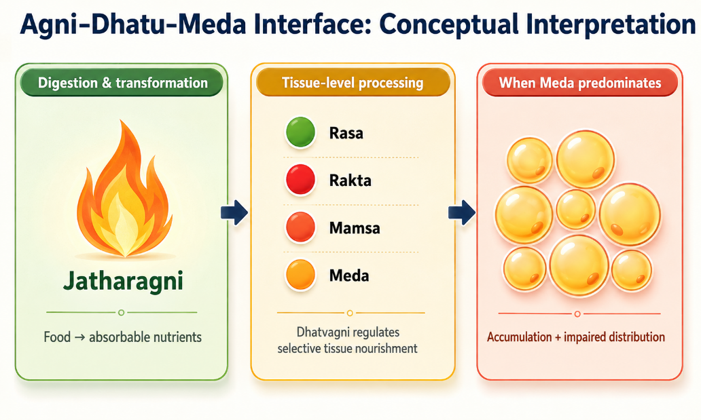
Figure 2. Conceptual Agni–Dhatu–Meda interface

2.2.1 Terminology and clinical identity
Sthaulya denotes a state of excessive corpulence characterized by disproportionate increase of Meda and Mamsa, particularly in regions such as the abdomen, buttocks and breasts, together with reduced functional efficiency(37). The term Medoroga is often used in related literature when disorders of Meda and lipid metabolism are the focus. In clinical research, the two terms should not be used interchangeably without stating the operational definition.
- A cross-sectional study of lifestyle factors in patients with Sthaulya found frequent exposure to lack of physical activity, daytime sleep and dietary patterns described in classical nidana(37). This supports the practical relevance of detailed lifestyle history. It does not prove classical causation, but it shows that the risk behaviors emphasized in Ayurveda remain common among contemporary patients.
मेदोमांसातिवृद्धत्वाच्चलस्फिगुदरस्तनः।
अयथोपचयोत्साहो नरोऽतिस्थूल उच्यते॥९॥(38)
- Excessive increase of Meda and Mamsa is associated with Chala Sphika, Chala Udara and Chala Stana, together with Ayathopachaya and reduced Utsaha
- The definition therefore combines excessive tissue accumulation with altered body configuration and function rather than relying on body weight alone.
Ayurvedic pharmacological discussions of Medohara and Lekhaniya dravyas identify multiple herbs and formulations traditionally selected to reduce Meda-related symptoms and support digestive-metabolic function(39). Their properties are described through Rasa, Guna, Virya, Vipaka and Prabhava rather than a single pharmacological target. When such literature is used in a Virechana study, it helps explain why preparatory, purgative or post-procedure drugs are chosen, but the efficacy of the complete procedure should be evaluated separately from the presumed action of individual ingredients.

2.2.2 Nidana of Sthaulya
The etiological factors of Sthaulya can be grouped into Aharaja, Viharaja, Manasika and other predisposing factors. Aharaja nidana include frequent use of Guru, Madhura and Snigdha foods, excessive quantity, repeated eating and food patterns that favour Kapha and Meda. Viharaja factors include Avyayama and Divaswapna. Psychological or behavioural descriptions, such as Achintana or persistent comfort-seeking, are sometimes listed, though they require careful interpretation in contemporary research to avoid moralising body weight(37).
The most useful way to operationalize Nidana in a clinical study is to translate each exposure into a measurable question: frequency of fried or energy-dense foods; portion pattern; eating between meals; physical-activity duration; sedentary time; daytime sleep; total sleep; alcohol; tobacco; medicines associated with weight gain; and family history. This enables correlation between classical categories and modern exposures without changing the original Ayurvedic terminology(36).
- Beeja-related or hereditary susceptibility is also described in Ayurveda. Modern obesity genetics supports a strong heritable component, but the classical concept should not be retrofitted into specific genes unless studied directly. It is sufficient to describe heredity as a shared area of interest: both traditions recognize that individuals differ in susceptibility even under similar environmental conditions(39).
तदतिस्थौल्यमतिसम्पूरणाद्गुरुमधुरशीतस्निग्धोपयोगादव्यायामादव्यवायाद्दिवास्वप्नाद्धर्षनित्यत्वादचिन्तनाद्बीजस्वभावाच्चोपजायते॥ (Charaka Samhita, Sutra Sthana 21/7–8)(38)
- Avyayama and Divaswapna represent Viharaja contributors, while Achintana and related behavioural descriptions are traditionally grouped under Manasika factors. Beeja Swabhava denotes inherited or constitutional susceptibility
Table 1. Classification of Nidana of Sthaulya
Category | Classical examples | Clinical/research interpretation
Aharaja / Aharatmaka | Ati Sampurana; Guru, Madhura, Sheeta and Snigdha Ahara. | Assess portion size, meal frequency, sweets, fried/energy-dense foods and repeated eating.
Viharaja | Avyayama, Divaswapna and low physical exertion. | Assess physical activity, sedentary time, occupation and daytime sleep.
Manasika | Achintana and related behavioural descriptions. | Record psychosocial and behavioural context without moralising body weight.
Beeja Swabhava | Hereditary/constitutional susceptibility. | Record family history; do not equate Beeja with one specific gene unless studied.

2.2.3 Samprapti: from causative exposure to Meda accumulation
A commonly presented Ayurvedic sequence begins with repeated Santarpana and Kapha-Meda promoting exposures. Disturbance of Agni and tissue-level transformation favors excessive Meda formation. Increased Meda and Kapha contribute to obstruction of Srotas, while Vata particularly in relation to gastrointestinal function is described as becoming functionally altered. One classical paradox is that the patient may experience strong appetite despite excessive adiposity. This is clinically relevant because it warns against assuming that an obese patient necessarily has poor appetite or slow digestion(32).
- The pathogenesis is therefore better understood as dysregulated distribution and transformation rather than simple caloric storage. In contemporary terms, one can cautiously compare this with the observation that obesity may coexist with increased appetite, adipose expansion, insulin resistance and impaired metabolic flexibility. But the study should label such comparisons as conceptual parallels(31,32).
- The concepts of Srotas and Srotorodha add a distributional dimension. Srotas are not equivalent to blood vessels or lymphatics alone; they represent channels or pathways of transport and transformation at multiple levels.
- In Sthaulya, Meda-related obstruction is used to explain impaired movement of nutrients and Dosha. Therapeutic strategies such as Langhana, Rukshana, Lekhana and Shodhana are then selected to counter excessive heaviness, unctuousness and obstruction(36).
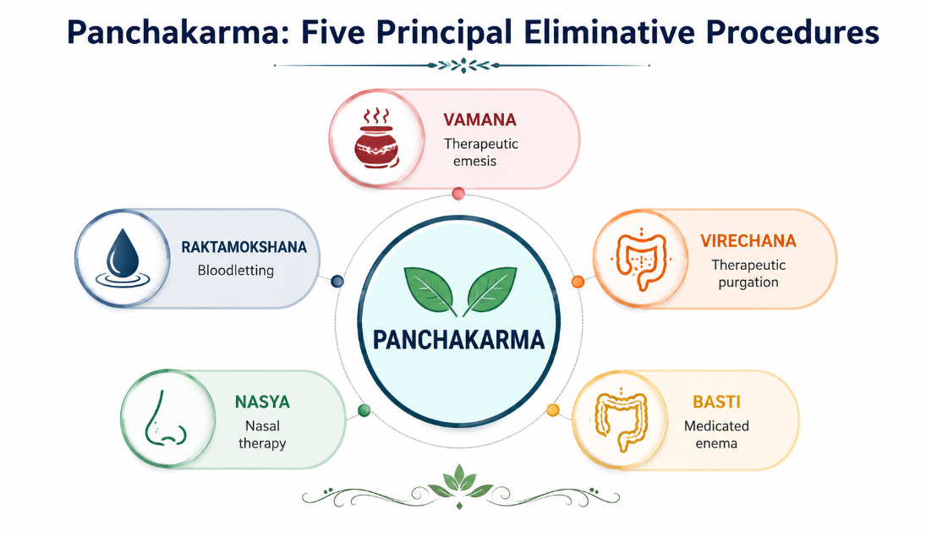
Figure 3. Panchakarma as five principal eliminative procedures
मेदसाऽऽवृतमार्गत्वाद्वायुः कोष्ठे विशेषतः।
चरन् सन्धुक्षयत्यग्निमाहारं शोषयत्यपि॥५॥
तस्मात् स शीघ्रं जरयत्याहारं चातिकाङ्क्षति।
विकारांश्चाश्नुते घोरान् कांश्चित्कालव्यतिक्रमात्॥६॥
Charaka Samhita, Sutra Sthana 21/7–8(38)
- Meda-related obstruction is described as altering the movement of Vata, particularly in the Koshta, and stimulating Agni. Consequently, the person may digest food rapidly and experience repeated or excessive hunger.
- This explains the classical paradox that strong appetite may coexist with pathological Meda accumulation. In research, appetite, meal timing, bowel function and anthropometry should therefore be assessed as separate domains.
एतावुपद्रवकरौ विशेषादग्निमारुतौ।
एतौ हि दहतः स्थूलं वनदावो वनं यथा॥७॥
मेदस्यतीव संवृद्धे सहसैवानिलादयः।
विकारान् दारुणान् कृत्वा नाशयन्त्याशु जीवितम्॥८॥
Charaka Samhita, Sutra Sthana 21/7–8(38)
- These verses emphasize that the interaction of Agni, Vata and excessive Meda can be associated with serious complications.
- The forest-fire analogy conveys the potential severity of uncontrolled pathology. It should be interpreted within the Ayurvedic explanatory system rather than translated directly into a single modern biomedical mechanism.

2.2.4 Lakshana and Ashta Dosha
The phenotype of Sthaulya includes Chala Sphika, Chala Udara and Chala Stana, reflecting lax or pendulous deposition of tissue; Ayathopachaya or disproportionate body development; and reduced enthusiasm or exertional capacity. Other commonly assessed symptoms include Atikshudha, Atipipasa, Swedadhikya, Daurgandhya, Alasya and Ayasena Shwasa. These symptoms can be converted into an ordinal score if the grading system is defined before recruitment and applied consistently(36,37,39).
- The classical “Ashta Dosha” of Atisthaulya describe functional disadvantages or complications. Their importance in modern research is not that each maps perfectly onto a biomedical diagnosis, but that the classical literature recognized obesity as clinically adverse rather than cosmetically undesirable. This supports the study of symptom burden and function in addition to kilograms lost.
- For outcome assessment, subjective symptom scores should be accompanied by objective measures. Weight and BMI are the minimum; waist circumference, waist-hip ratio, skinfold thickness or body-composition measures can add information where feasible(33).
- Timing is critical around Virechana: the immediate post-purgation body weight may reflect fluid and intestinal-content changes. A later measurement after restoration of usual hydration is more informative for adiposity-related change.

2.3 Principles of management of Sthaulya
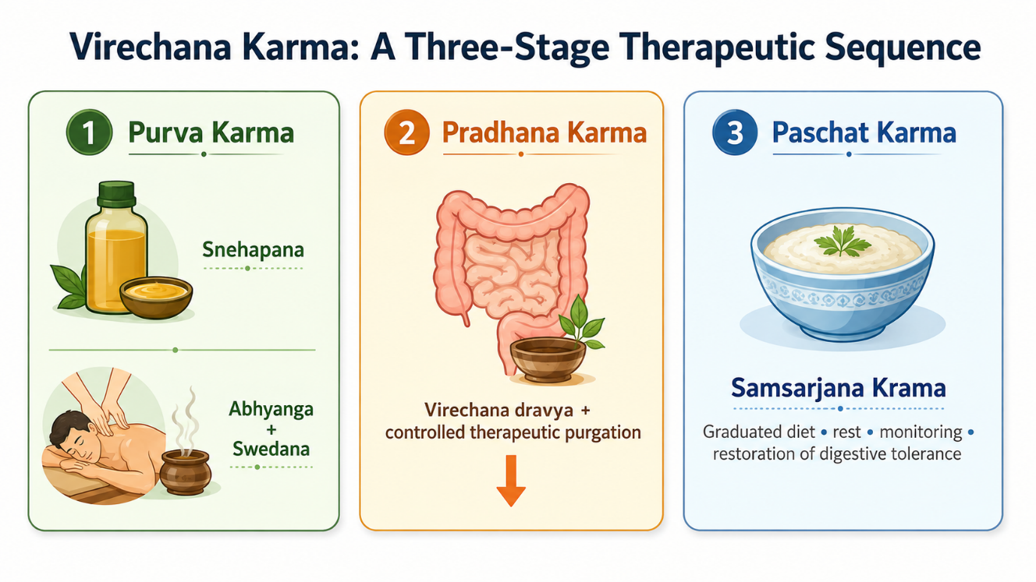
Figure 4. Three-stage sequence of Virechana Karma .

2.3.1 Nidana Parivarjana, Pathya and behaviour
Nidana Parivarjana—avoidance or modification of causative factors—is the logical first step in Sthaulya management. Without correction of food pattern, inactivity and sleep-related exposures, any procedure is likely to have a temporary effect. Pathya therefore forms part of treatment rather than an optional add-on. A research should document the prescribed diet and activity plan because these co-interventions can contribute to weight change(39).
Ayurvedic advice in Sthaulya generally favors foods and practices that are less Guru and Snigdha, that improve satiety without excessive caloric density, and that support regular physical activity according to the patient’s capacity. Modern obesity treatment arrives at similar practical behaviors through a different explanatory model: reduced energy density, adequate protein and fiber, physical activity, sleep regulation and long-term adherence. These overlaps can be discussed pragmatically without claiming doctrinal identity(34).
प्रजागरं व्यवायं च व्यायामं चिन्तनानि च।
स्थौल्यमिच्छन् परित्यक्तुं क्रमेणाभिप्रवर्धयेत्॥२८॥
Charaka Samhita, Sutra Sthana 21/28 (38)
- Charaka advises gradual increase of behaviours that oppose the habitual pattern associated with Sthaulya, including physical activity and mental engagement.
- The important methodological point is that lifestyle modification is not an incidental addition to treatment; it forms part of the therapeutic context and must be reported if it is prescribed during a Virechana study.

2.3.2 Langhana, Rukshana and Lekhana
Langhana refers to therapeutic lightening or reduction and includes a range of approaches from dietary regulation to stronger eliminative procedures depending on indication. Rukshana employs measures with drying or non-unctuous qualities, while Lekhana is described as “scraping” or reducing excessive tissue or pathological accumulation. In Sthaulya these principles are selected because the dominant phenotype is Guru, Snigdha and excessive Meda.
The review of Medohara and Lekhaniya drugs illustrates how formulations are chosen to oppose Kapha-Meda qualities and to support Agni(39). However, the term “scraping” should not be translated literally as mechanical removal of body fat. It is a pharmacodynamic concept within Ayurveda. Clinical research still needs to demonstrate measurable changes in weight, circumference or metabolism.
गुरु चातर्पणं चेष्टं स्थूलानां कर्शनं प्रति।
कृशानां बृंहणार्थं च लघु सन्तर्पणं च यत्॥२०॥
Charaka Samhita, Sutra Sthana 21/20 (38)
- The verse presents Karshana as the therapeutic direction for excessive obesity while simultaneously recognizing the need to maintain appropriate nourishment.
- It does not support indiscriminate fasting. Rather, the choice of Guru, Atarpana or other measures is individualized according to the patient’s condition, digestive capacity and strength.

2.3.3 Shamana and Shodhana
Shamana aims to pacify or manage disturbed Dosha without a major eliminative procedure, whereas Shodhana uses planned procedures to expel Dosha after appropriate preparation. The choice depends on patient strength, disease strength, season, age, Agni and Koshta. Sthaulya can be a challenging context because the patient may have a large body habitus but variable physiological reserve. Assessment of Bala therefore matters before prescribing intensive Shodhana(40).
Shodhana has also been discussed experimentally as a process that may modify the biological activity or safety of certain medicinal substances, illustrating the broader Ayurvedic meaning of purification(40). Panchakarma-related metabolomic research in healthy volunteers has reported short-term changes in several plasma metabolite classes after a multi-component Ayurvedic intervention(41). Because such programs include diet, massage, herbs, rest and multiple procedures, these findings cannot be attributed to Virechana alone, but they demonstrate that Panchakarma can be studied using contemporary biomarkers.
वातघ्नान्यन्नपानानि श्लेष्ममेदोहराणि च।
रूक्षोष्णा बस्तयस्तीक्ष्णा रूक्षाण्युद्वर्तनानि च॥२१॥
Charaka Samhita, Sutra Sthana 21/21 (38)
- The management principle simultaneously considers Vata while targeting excessive Shleshma/Kapha and Meda. Ruksha, Ushna and Tikshna measures, Basti and Udvartana are described according to the classical therapeutic logic. This supports a multimodal approach rather than reducing Sthaulya management to a single medicine.
गुडूचीभद्रमुस्तानां प्रयोगस्त्रैफलस्तथा।
तक्रारिष्टप्रयोगश्च प्रयोगो माक्षिकस्य च॥२२॥
Charaka Samhita, Sutra Sthana 21/22(38)
- This verse lists Guduchi, Bhadra Musta, Triphala, Takrarishta and honey among classical measures used in the management of excessive obesity. Its relevance to the review is to show that Shamana measures and dietary/medicinal approaches coexist with Shodhana within the classical management framework.

2.3.4 Importance of Agni and recovery after purification
The state of Agni influences both selection of treatment and recovery. Kuttikrishnan and colleagues studied Jatharagni in relation to Prakriti among young adults and demonstrated that the construct can be assessed systematically rather than left as an unrecorded clinical impression(42). Singh and colleagues developed and validated a self-assessment tool for Agnibala, illustrating efforts to improve measurement reliability(43).
For Virechana, this is relevant before and after the main procedure. The preparatory period aims to mobilize Dosha and ready the gastrointestinal tract, while the post-procedure Samsarjana Krama gradually reintroduces food according to digestive tolerance. If the study does not standardize this recovery diet, between-patient variation can affect both symptoms and early body weight(43).

2.4 Panchakarma and Virechana Karma
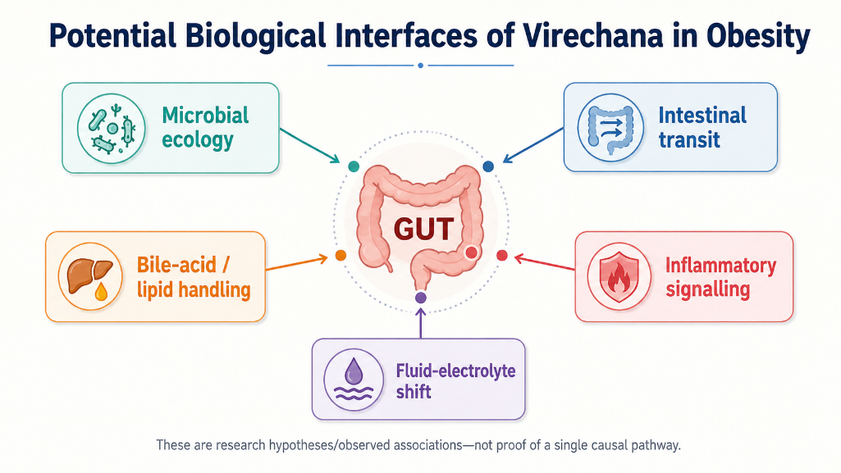
Figure 5. Potential biological interfaces of Virechana
2.4.1 Panchakarma as a structured therapeutic program
Panchakarma is commonly described through preparatory procedures, the main eliminative procedure and post-procedure care. The five principal procedures are Vamana, Virechana, Basti, Nasya and Raktamokshana, although classification varies across texts and teaching traditions. A broad account of Ayurvedic principles emphasizes that procedural therapy is individualized and embedded within diet, lifestyle and pharmacological preparation (27).
- Contemporary integrative research sometimes tries to correlate Panchakarma with autonomic, metabolic, inflammatory or microbiome effects. Qualitative work comparing Ayurvedic and modern medical perspectives has shown that clinicians use concepts such as Agni and Srotas to describe systemic regulation, but direct translation into biomedical pathways remains incomplete(44). This is a methodological caution: the safest approach is to measure biological outcomes directly rather than infer them from conceptual similarity.
- Cross-disciplinary reviews have proposed links between chronic inflammation and Ayurvedic constructs such as Ama and impaired Agni(45).
- Other conceptual work has examined autonomic regulation and even the vagus nerve as a possible interface for studying Vata-related functions(46). Such papers are useful for generating hypotheses around appetite, gut-brain signaling and stress, but they do not establish the mechanism of Panchakarma or Virechana.

2.4.2 Virechana: definition, indications and patient selection
Virechana is therapeutic purgation performed with planned administration of purgative drugs after appropriate preparation. It is classically associated with elimination of Pitta and also used in conditions involving Kapha-Pitta or metabolic accumulation depending on the clinical context(47). Patient selection considers age, strength, Agni, Koshta, disease state, contraindications and the ability to tolerate fluid loss and repeated bowel movements.
- Bowel characteristics are relevant because Koshta influences expected response to purgatives. Ayurvedic literature on Purisha Pariksha describes stool and bowel examination as part of clinical assessment(47).
- A modern protocol should complement this with exclusion of dehydration, severe anemia, unstable cardiovascular disease, significant renal impairment, pregnancy and other conditions in which purgation may pose risk, according to institutional and ethical guidance.
Chaganti and colleagues analyzed Virechana using Danti Avaleha and documented procedural variables such as onset, frequency and features of purgation(48). Such studies help identify parameters for standardization: dose, timing, number of vegas, duration, symptoms and criteria for adequate purification. In an obesity study, these procedural details should be reported alongside weight outcomes so that the intervention can be reproduced(48).
कृष्णाशुण्ठी त्रिवृत्क्षारचूर्णं क्षौद्रेण लेहयेत्॥१९॥
एतद्विरेचनं मुख्यं सर्वश्लेष्मविकारिणाम्॥२०॥
Vangasena Samhita, Chapter 89/19–20 (38)
The verse provides the classical basis for the formulation used in the protocol. Clinical efficacy, however, must be demonstrated through prespecified outcomes rather than inferred solely from the textual indication

2.4.3 Purva Karma: Deepana-Pachana, Snehana and Swedana
Purva Karma prepares the patient for the main eliminative procedure. Deepana-Pachana may be prescribed to improve digestive readiness and reduce features interpreted as Ama. Internal oleation (Snehapana) is then administered in a graded or protocol-based manner until features of adequate oleation are observed. External Abhyanga and Swedana are subsequently used to facilitate movement of Dosha toward the gastrointestinal tract according to classical rationale(47).
- In Sthaulya, the use of Sneha can appear counterintuitive because the phenotype is already Snigdha and Meda-dominant. The rationale is procedural rather than nutritive: Snehana is used as part of Shodhana preparation, with dose and duration individualized.
- The research should therefore describe the exact Sneha, starting dose, escalation schedule, total quantity, criteria for Samyak Snigdha Lakshana, and any adverse symptoms. If calorie intake changes substantially during Snehapana, that should also be acknowledged when interpreting body weight(46).
Swedana produces heat exposure and sweating. Its immediate effects may include vasodilation and fluid loss; hence pre- and post-procedure hydration should be standardized. In an obese participant, careful monitoring is prudent because hypertension, sleep apnea, reduced exercise tolerance or occult cardiometabolic disease may increase procedural risk(47).
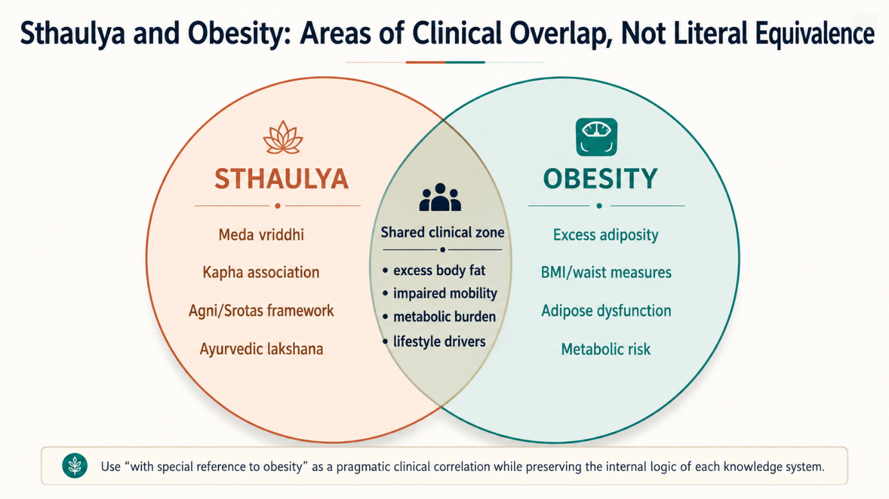

Figure 6. Sthaulya and obesity.

2.4.4 Pradhana Karma: administration and assessment of Virechana
On the day of Virechana, the purgative is administered after confirming appropriate preparation and clinical stability. The patient is observed for onset of bowel movements, number and character of vegas, nausea, abdominal discomfort, dizziness, thirst and signs of dehydration(49). The classical assessment distinguishes adequate, inadequate and excessive purification. From a research perspective, these categories should be translated into predefined operational criteria.
- A clinical study evaluating Virechana has demonstrated measurable changes in serum electrolytes around the procedure, which underlines the importance of physiological monitoring(49).
- Even when electrolyte changes remain within clinically acceptable ranges, the possibility of sodium, potassium or chloride shifts means that safety cannot be inferred solely from traditional experience. Baseline comorbidities, concomitant medicines and hydration influence risk.
Virechana has also been used in clinical studies outside obesity, including reproductive and metabolic disorders, demonstrating that investigators have standardized its preparatory and post-procedure phases across different indications(50,51). These studies are not evidence that Virechana treats obesity, but they provide procedural information and safety considerations.
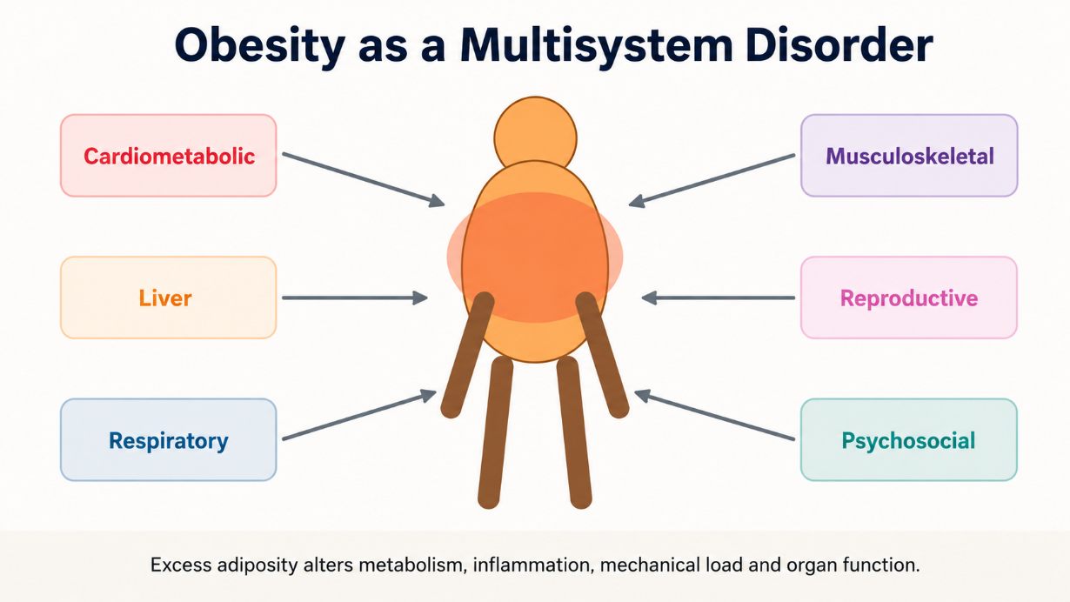
Figure 7. Obesity as a multisystem disorder.

2.4.5 Paschat Karma and Samsarjana Krama
After therapeutic purgation, the patient is usually advised rest and a graduated dietary regimen. Samsarjana Krama begins with easily digestible preparations and progresses according to Agni and the intensity of purification. The objective is to restore digestive tolerance without abruptly loading the gastrointestinal system(7).
This phase can have a large effect on body weight because dietary intake is temporarily restricted. Therefore, a study should avoid attributing immediate weight reduction entirely to a specific “fat-reducing” mechanism of Virechana. A better design measures body weight after the patient has completed the graduated diet and returned to stable hydration, and again at later follow-up. This separates acute procedural loss from sustained change(7,8).

2.4.6 Virechana in metabolic disorders
Ayurvedic reviews of type 2 diabetes describe Virechana among Panchakarma procedures selected for some patients after individualized assessment(52). A narrative review of Ayurveda clinical evidence in migraine also summarizes Virechana protocols and highlights the recurring sequence of Snehana, Swedana, purgation and post-procedure diet(53). Although the indications differ, these reports reinforce the need to view Virechana as a process rather than a single laxative dose.
- Experimental and pharmacological work on intestinal motility can also inform the purgative component. Studies of Ayurvedic formulations used to alter bowel transit show that herbal combinations can exert measurable gastrointestinal effects(54).
- The exact pharmacology depends on the Virechana drug; therefore, the research should describe the ingredients and known actions of the chosen formulation rather than generalize across all Virechana agents.
Panchakarma procedures may also influence autonomic or stress-related physiology. Research on Shirodhara has examined biological stress markers(55). While Shirodhara is a different procedure, such work illustrates a broader methodological point: traditional procedures can be evaluated with objective biomarkers, and mechanistic claims should be linked to measurements rather than assumed.
Table 2. Three-stage sequence of Virechana and variables relevant to research
Stage | Main components | Variables to document
Purva Karma | Deepana-Pachana when indicated; Snehapana; Abhyanga; Swedana. | Drug/formulation, daily and total dose, digestion/tolerance, diet, hydration and adverse symptoms.
Pradhana Karma | Virechana formulation and observation of purgation. | Exact dose/time, onset, Vegas, duration, symptoms, fluid intake, vitals and adequacy/excess response.
Paschat Karma | Rest and Samsarjana Krama with return to usual diet. | Diet stages, duration, tolerance, hydration, Pathya adherence and later follow-up outcomes.

2.5 Contemporary biological interfaces relevant to Virechana and obesity
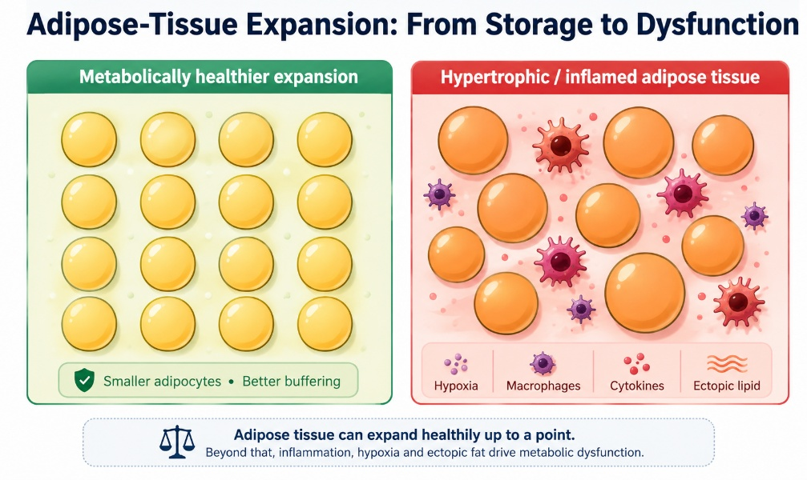
Figure 8. Adipose-tissue expansion and inflammatory dysfunction

2.5.1 Gastrointestinal transit and gut microbiota
The strongest immediately plausible biomedical effect of Virechana is altered gastrointestinal transit. Repeated purgation changes luminal contents, stool frequency, water and electrolyte handling, and short-term microbial exposure(34). Because gut microbiota are associated with obesity through energy harvest, short-chain fatty acid production, bile-acid metabolism, gut permeability and inflammation, a change in intestinal ecology is a reasonable research hypothesis. However, a single post-procedure stool sample cannot establish a durable microbiome-mediated weight-loss mechanism.
Ayurveda-microbiome literature proposes that diet, Prakriti and digestive function may interact with microbial ecology(35,36). A rigorous Virechana mechanism study would obtain baseline samples, immediate post-procedure samples and later follow-up, and use sequencing or culture methods with appropriate controls. It would also record diet and antibiotics because both strongly affect the microbiome(35).
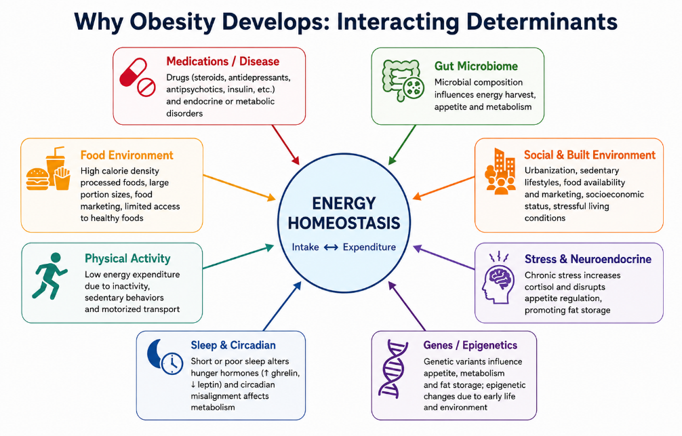

Figure 9. Interacting determinants of obesity and energy homeostasis.

2.5.2 Bile acids, lipid handling and enterohepatic signalling
Purgation may modify intestinal handling of bile acids and lipids in the short term. Bile acids are not only detergents; they signal through receptors involved in glucose and energy metabolism. Yet no clinical obesity study should claim that Virechana improves bile-acid signalling unless it measures bile acids or a validated downstream marker. This is an example of the distinction between biological plausibility and demonstrated mechanism.
In Ayurvedic language, Virechana is used to eliminate aggravated Pitta through the lower route, and Pitta is broadly associated with transformative functions(42,55). A research bridge can therefore discuss bile and hepatointestinal physiology as a possible area for future measurement, while explicitly avoiding the statement that Pitta “is” bile acid metabolism.

2.5.3 Inflammation and metabolic signalling
Obesity is accompanied by chronic low-grade inflammation, particularly when visceral adiposity and ectopic fat are present. Cross-disciplinary Ayurveda literature has explored whether Ama-related states can be studied using inflammatory markers(56). This does not validate a direct equivalence, but it suggests a measurable domain. Future Virechana studies could examine hs-CRP, selected cytokines, insulin resistance or adipokines if sample size and resources permit.
Case-based Ayurveda literature in fatty liver and obesity has reported changes in body weight and liver-related outcomes after multi-component interventions that included Virechana(57). Because such interventions contain diet, medicines and other procedures, causality cannot be assigned to Virechana alone. Their main value is to show which metabolic outcomes have been considered clinically relevant.

2.5.4 Fluid balance and interpretation of early weight change
Therapeutic purgation necessarily affects water balance. One liter of fluid deficit corresponds to approximately one kilogram of body weight, so an early fall on the weighing scale may be dominated by fluid rather than fat loss. This is a critical issue in efficacy studies. Participants should be weighed under standardized conditions, and the primary endpoint should not be limited to the day after Virechana(51).
A clinically credible design can include three anthropometric time points: baseline before preparatory therapy; a safety-oriented immediate post-procedure measurement; and an efficacy-oriented measurement after recovery and at later follow-up. If the study has only pre/post measurements, the discussion must acknowledge that acute changes cannot be assumed to represent adipose loss(55).

2.5.5 Appetite, dietary reset and behavioural adherence
Another plausible pathway is behavioral. Virechana is accompanied by a period of disciplined preparation, supervised treatment and graduated diet. This can interrupt habitual eating patterns and may increase adherence to Pathya for a period after treatment. Changes in hunger, cravings, portion size or eating frequency could therefore contribute to later weight change(53).
This pathway is testable using dietary recalls, appetite scales or adherence scores. It is also clinically relevant because obesity treatment depends on sustained behavior after the procedure. A study that reports only the number of bowel movements and kilograms lost misses this potential mediator(55).

2.6 Clinical integration, safety and research methodology

2.6.1 Correlating Sthaulya with obesity
The phrase “Sthaulya with special reference to obesity” is useful because it signals correlation rather than identity. Obesity is operationalized through anthropometry and health impact, whereas Sthaulya is identified through classical phenotype, etiological factors and Dosha-Dhatu-Srotas assessment. A participant can satisfy both sets of criteria, allowing the study to evaluate the traditional intervention with contemporary outcomes.
The research should avoid statements such as “Meda Dhatu is adipose tissue” or “Ama is inflammatory cytokines.” These may be used as heuristic comparisons but not as literal translations. Preserving conceptual boundaries improves scientific credibility and prevents the ROL from appearing to overclaim biomedical validation of Ayurvedic theory(55).

2.6.2 Outcome domains for the present objective
For the stated objective, outcome domains can be grouped into Ayurvedic clinical outcomes, anthropometric outcomes, functional outcomes and metabolic outcomes. Ayurvedic outcomes include the predefined severity of Chala Sphika, Chala Udara, Chala Stana, Atikshudha, Atipipasa, Swedadhikya, Ayasena Shwasa, Alasya and related features. Anthropometric outcomes include body weight, BMI and circumferences. Functional outcomes can include exercise tolerance or a validated quality-of-life measure. Metabolic outcomes depend on the protocol and may include fasting glucose and lipid profile(51,52).
Each outcome should have a specified time point. If multiple comparisons are planned, the primary outcome should be declared in advance. For a single-group before-after study, effect estimates with confidence intervals are preferable to reporting only p-values. For a comparative design, between-group differences should be emphasized rather than within-group significance alone(53).

2.6.3 Safety monitoring
Safety is part of efficacy research. Expected procedural effects include repeated loose stools and transient fatigue. Potential adverse events include excessive purgation, dehydration, dizziness, syncope, electrolyte disturbance, abdominal pain and intolerance of preparatory oleation. Participants with high-risk medical conditions require careful screening and, where appropriate, exclusion or physician clearance(57).
A study report should state the number of adverse events, their severity, relationship to treatment and management. This is especially important because obese patients may have undiagnosed hypertension, diabetes, sleep apnea or cardiovascular disease. The assumption that a traditional therapy is safe because it has long historical use is not sufficient for clinical research(56,57).

2.6.4 Methodological issues in the available literature
Ayurvedic obesity studies often use small samples, short follow-up, heterogeneous diagnostic criteria and multi-component interventions. Some combine Panchakarma with herbs, yoga and a restricted diet, making it difficult to identify the independent contribution of each component. Several studies report statistically significant within-group reductions without a concurrent control group. Others use symptom scores that were not validated or do not describe assessor blinding(51–53).
These limitations do not make the literature unusable. Instead, they define how the present study can improve upon earlier work: register the protocol, use standardized case definitions, report the Virechana procedure in detail, specify co-interventions, define outcomes before treatment, use appropriate statistics, include follow-up after rehydration and document harms. Even a modest sample can produce more interpretable evidence if measurement and reporting are rigorous(53).

2.7 Interpretive synthesis for the present study
The literature suggests that a study of Virechana in Sthaulya should be designed around the full therapeutic sequence and not around the purgative day alone. The intervention begins with selection. Obese patients vary widely in age, cardiometabolic burden, bowel pattern, physical reserve and medication use(46,58). A person who appears physically large may still have low exercise tolerance, dehydration risk, poorly controlled diabetes or undiagnosed cardiovascular disease. Classical assessment of Bala and contemporary medical screening therefore address different aspects of the same practical question: can this individual tolerate the planned procedure safely?
- Preparation is the second methodological issue. Deepana-Pachana, Snehapana, Abhyanga and Swedana are not neutral preliminaries. They alter food intake, fluid intake, bowel habit and daily routine and may themselves influence weight or symptoms(10,11).
- For this reason the study should report the start and end of each preparatory phase and, where possible, distinguish baseline weight before Purva Karma from weight immediately before Virechana. This allows the reader to see whether change began during preparation.
- The Virechana day is best treated as a procedural and safety endpoint. Number of vegas, onset time, duration, symptoms, oral fluid intake and clinical assessment of purification are useful variables. Immediate weight loss is not a strong efficacy endpoint because purgation changes gastrointestinal contents and water balance(13–15).
- If laboratory facilities are available, serum electrolytes before and after the procedure can provide objective safety information, especially in participants who experience many bowel movements.
The post-procedure period is where efficacy becomes more interpretable. Samsarjana Krama imposes a graduated diet and can temporarily reduce energy intake. After this phase, sustained Pathya and activity determine whether body weight continues to fall, stabilizes or rebounds. Therefore at least one follow-up after return to a stable diet is desirable. A four- to eight-week follow-up is more informative for adiposity than next-day weight, while a longer follow-up would help assess maintenance(19,20).
- Subjective Sthaulya outcomes also deserve methodological care. Symptoms such as Atikshudha, Atipipasa, Swedadhikya and Ayasena Shwasa may change independently of body weight. If these symptoms are graded using a locally constructed scale, the grading anchors should be explicit.
- For example, exertional dyspnea can be graded according to the activity that provokes it rather than vague categories of mild, moderate and severe. Sweating can be linked to frequency or interference with daily activity. Hunger can be linked to meal frequency or inability to delay food. Clear anchors reduce observer variability(17,30).
- Anthropometry should follow standard operating procedures. Weight should be measured on a calibrated digital scale with light clothing and no footwear, preferably at a similar time of day. Height is measured at baseline with a stadiometer.
- Waist circumference should be taken at a defined anatomical site after normal expiration, and the same site should be used at follow-up. If hip circumference is recorded, waist-hip ratio can be derived. Repeated measurements improve precision(24). These apparently simple details matter because a difference of one to two centimeters can be lost within measurement error if technique changes.
The analysis should present magnitude as well as statistical significance. A reduction of two kilograms may be statistically significant in a paired analysis yet have different clinical meaning depending on baseline weight and duration. Reporting absolute change, percent change and confidence intervals allows better interpretation. For symptom scales, median change or the proportion achieving a predefined response may be useful. If multiple secondary outcomes are tested, the discussion should avoid presenting every p-value below 0.05 as an independent proof of efficacy(32,45,53).
Mechanistic discussion needs equal restraint. The available literature makes the gut microbiota an attractive hypothesis because Virechana directly changes the intestinal environment. But a change in culture pattern or relative abundance after purgation can be transient. It could result from bowel cleansing, altered diet, herbal exposure or hydration rather than a stable therapeutic remodeling. To claim that microbiome change mediates weight loss, future studies would need serial sampling, adequate controls, dietary measurement and analysis linking microbial changes to later anthropometric outcomes(14,16,43,57).
- The same caution applies to lipid and inflammatory pathways. Virechana may be followed by changes in triglycerides, glucose or inflammatory markers, but these outcomes are influenced by caloric intake, weight loss, medication adherence and regression to the mean. A controlled design is the strongest way to separate intervention effects from these influences(7).
- If a control group is not feasible, the study should state this clearly and interpret before-after change as association with the treatment program rather than definitive causal efficacy.
- A further issue is the meaning of “efficacy.” In explanatory clinical trials efficacy usually refers to effect under controlled conditions, while effectiveness refers to benefit in routine practice. Many Ayurveda studies described as efficacy trials are pragmatic before-after studies without a comparator(35).
- The present study can still use the approved objective wording, but the methods and discussion should describe the actual design accurately. If it is a single-arm study, phrases such as “improvement following Virechana” are more defensible than “Virechana proved superior.”(27)
Taken together, the theoretical and clinical literature supports studying Virechana as a structured, monitored therapeutic program for carefully selected patients with Sthaulya and obesity. It does not yet establish a single biomedical mechanism or the magnitude of durable weight reduction. This uncertainty is the reason for further clinical research. A study that separates immediate purgation effects from follow-up outcomes, records co-interventions and reports safety can add evidence even if the sample is modest.

2.8 Nidana and the logic of Santarpana
Open-access analyses of Sthaulya consistently describe a pattern of repeated dietary and behavioral exposures that favor Kapha and Meda: frequent intake of heavy, sweet and unctuous foods, excess quantity, reduced physical activity, prolonged sitting, daytime sleep and constitutional susceptibility(37,39). These descriptions fit the broader Ayurvedic category of Santarpanottha disorders, in which excessive or inappropriate nourishment produces pathological tissue accumulation. The clinical implication is that treatment cannot be reduced to a one-day eliminative procedure. Nidana Parivarjana—removal or modification of the causative pattern—remains the background against which Shodhana and Shamana are expected to work(36).
- This has a direct research implication. During a Virechana protocol, diet is usually altered during Deepana-Pachana, Snehapana and Samsarjana Krama. If the participant also receives structured advice on meal composition, sleep and activity, these are active co-interventions. They can influence weight and symptoms independently of purgation(26).
- A study should therefore describe these exposures rather than referring to them generically as “Pathya.” The amount of dietary restriction, duration of the graduated diet, return to regular food and advice regarding physical activity all determine how the observed outcome should be interpreted(26).
- The classical causal language and modern obesity epidemiology should be allowed to remain different explanatory systems. Modern research identifies energy density, food processing, sleep, inactivity, social environment and biological susceptibility as interacting determinants, as summarized in the Introduction.
- Ayurvedic sources organize repeated exposures according to qualities, Dosha, Agni and Dhatu consequences (27,37,39). Their overlap can be discussed at the level of clinical pattern repeated energy-rich intake and low activity but a one-to-one equivalence between Guru-Snigdha Ahara and a specific macronutrient, or between Kapha and a modern hormone, is not required for the study to be scientifically coherent.

2.8.1 Agni in Sthaulya: the apparent paradox of appetite and tissue dysfunction
Agni is used in Ayurveda to describe transformation at digestive and tissue levels. Open-access physiological discussions distinguish Jatharagni from the broader processing attributed to Bhutagni and Dhatvagni (28,29,42,43). Sthaulya is clinically interesting because an individual can show strong or frequent appetite while simultaneously exhibiting pathological Meda accumulation. This is sometimes described as an Agni paradox: appetite and rapid digestion do not necessarily imply balanced tissue metabolism.
For research, the value of this concept lies less in attempting to identify a laboratory equivalent of Agni and more in recognizing appetite, meal timing, bowel function and metabolic phenotype as separate domains. A participant may report Atikshudha before treatment and reduced hunger after the procedural diet; another may show unchanged appetite but decreased waist circumference over follow-up(42). These responses need not be forced into a single mechanism. Tools developed to operationalize Agnibala show that Ayurveda research can convert traditionally assessed constructs into explicit, reproducible items, although external validation remains an ongoing need(43).
- The Agni framework also reminds the investigator that digestion and tolerance determine treatment planning. Snehapana in a participant with poor tolerance can produce nausea, anorexia or delayed preparation, whereas another participant may digest the administered Sneha rapidly.
- These procedural differences can change the duration of Purva Karma and the total energy consumed. Recording daily dose, digestion time, appetite, nausea and bowel pattern gives the study a more accurate account of how the intervention was actually experienced(42,43).

2.8.2 Meda Dhatu, Medovaha Srotas and distribution of excess tissue
Dhatu theory describes sequential nourishment and tissue-specific transformation rather than a simple anatomical list . Meda is commonly discussed in relation to unctuousness, energy reserve, body bulk and tissue lubrication, but equating Meda Dhatu directly with adipose tissue is too narrow(29). Modern adipose tissue is an endocrine and immune organ with subcutaneous, visceral and ectopic depots that differ in metabolic behavior, as summarized in the contemporary obesity literature in the Introduction. The research can compare these domains cautiously while preserving their conceptual boundaries.
Srotas provide another level of Ayurvedic explanation. The language of Srotorodha in Sthaulya conveys impaired movement or exchange within bodily channels and is often linked with excessive Meda and altered Vata movement. A contemporary discussion can use this as a clinical systems concept without translating it literally into arterial obstruction or lymphatic blockage(50). That distinction matters because obesity-related vascular disease is a defined biomedical process, whereas Srotorodha has a broader Ayurvedic meaning.
From a measurement perspective, regional distribution of excess tissue is captured better by waist circumference and waist-hip ratio than BMI alone. This is one area where the Ayurvedic emphasis on body configuration and the biomedical emphasis on central adiposity can be discussed side by side. But the study should state that waist circumference is being used as a validated anthropometric risk marker, not as a direct measurement of Meda Dhatu or Medovaha Srotas(14,44).

2.8.3 Ama and metabolic incompleteness: limits of biomedical analogy
Ama is described in the Ayurvedic literature as a pathological product associated with impaired digestion or transformation, altered qualities and disease propagation(30). Contemporary integrative papers sometimes compare Ama with inflammatory or metabolic by-products, and chronic inflammation has been discussed as a possible area of conceptual dialogue(45,56). Such comparisons are hypotheses, not equivalence statements. There is no accepted laboratory assay that measures “Ama” as a single biochemical entity.
This distinction should be explicit in a study on obesity because low-grade inflammation is well documented in dysfunctional adipose tissue(56). Enlarged adipocytes, macrophage recruitment, cytokine signaling and ectopic lipid are measurable processes. If C-reactive protein, interleukins or other biomarkers are not measured in the study, the discussion should not claim that Virechana “removed inflammatory Ama.” A safer formulation is that Ayurveda uses the concept of Ama to explain impaired transformation and accumulation, while contemporary obesity biology identifies inflammatory and metabolic abnormalities that may provide areas for future mechanistic study(56).
Virechana-related dietary restriction and bowel cleansing could alter several biomarkers transiently. Therefore even when inflammatory markers are measured, timing matters. A sample drawn the morning after multiple purgative stools may reflect acute fluid shifts, altered intake or stress. Serial sampling after recovery would be required to determine whether a change is sustained and related to later clinical improvement(55).

2.8.4 Prakriti and heterogeneity of obesity
Prakriti is a constitutional framework intended to capture stable interindividual differences. Studies have reported associations of Prakriti categories with metabolic traits, cardiovascular risk factors, metabolomic patterns and gut-microbiome composition(31–35). These findings are exploratory and do not establish deterministic biological subtypes, but they reinforce a clinically relevant principle: patients with the same BMI can differ in appetite, fat distribution, insulin resistance, bowel habits, treatment tolerance and complication burden.
For a Virechana study, Prakriti can therefore be recorded as a descriptive baseline variable rather than used to make unsupported subgroup claims. Unless the sample is powered for interaction testing, post-hoc statements that one Prakriti “responded better” should be avoided. More useful is to report whether the sample was constitutionally diverse and whether Koshta, Agnibala or treatment dose varied across participants. These variables may explain procedural heterogeneity and can generate hypotheses for future stratified trials(33,34).

2.9 Therapeutic framework for Sthaulya and the place of Virechana (Langhana, Lekhana and Shodhana as related but distinct strategies)
Ayurvedic management of excess nourishment uses several therapeutic ideas that are related but not interchangeable. Langhana broadly denotes measures that reduce heaviness or metabolic burden; Lekhana refers to a scraping or reducing therapeutic orientation; and Shodhana denotes planned eliminative procedures. Reviews of Medohara and Lekhaniya drugs show that pharmacological management of Sthaulya has historically used substances selected for qualities expected to counter Kapha-Meda predominance(39). Panchakarma adds procedural treatment to this broader regimen(40,41).
The relevance to the present objective is that Virechana should be described as one component within a therapeutic framework, not as a stand-alone synonym for weight reduction. A participant may receive Deepana-Pachana drugs, Sneha, Swedana, the Virechana formulation, Samsarjana Krama and continuing Pathya. Each component has a defined place in the sequence and can influence symptoms. The intervention section of a study should therefore read almost like a reproducible protocol: name and source of medicines, dose escalation, criteria for adequate oleation, timing of Swedana, purgative drug and dose, monitoring of vegas, criteria for completion, and the post-procedure diet(41).

2.9.2 Purva Karma: preparing the patient and standardizing the intervention
Purva Karma commonly includes Deepana-Pachana when indicated, internal oleation, external oleation and sudation before Virechana. Methodologically, this phase is critical because treatment exposure begins here. Internal Sneha intake can replace or reduce usual food intake, and its duration varies according to digestion, clinical signs and protocol. Swedana changes thermal exposure and fluid loss. If these elements are not documented, the reader cannot determine whether two participants received comparable preparation(49).
Standardization does not mean ignoring individualized Ayurveda. A pragmatic protocol can define a permissible range: for example, rules for dose escalation of Sneha based on digestion, objective recording of total administered quantity, and prespecified clinical criteria for moving to the next phase. The individualized decision remains, but it becomes transparent. Similar reasoning applies to the choice of Virechana drug and dose, which may depend on Koshta, Bala, age and disease status (48–50).
A further issue is medication reconciliation. Many adults with obesity take antihypertensive, antidiabetic, lipid-lowering or other medicines. Fasting, altered meal timing and purgation can change the safe timing of these drugs. The study protocol should specify whether routine medicines are continued, withheld or modified, and such decisions should be made with appropriate medical oversight rather than inferred from the Panchakarma protocol alone(49).

2.9.3 Pradhana Karma: what should be recorded on the Virechana day
The purgative day is the most observable component of Virechana. Studies of Virechana in different conditions demonstrate that dose, onset of purgation, number of vegas and clinical assessment of the procedure can be recorded systematically (48–51). These variables are not merely traditional descriptors; they are treatment-fidelity and safety data. They allow the investigator to distinguish participants who completed the planned procedure from those who had inadequate response or excessive purgation.
At minimum, a research case record can document time of drug administration, dose, onset of first bowel movement, total duration, number of vegas, vomiting if present, fluid intake, pulse, blood pressure, symptoms of dizziness or cramps, and clinical signs used to classify the response(49). If the protocol uses Shuddhi grading, the basis for grading should be stated. A threshold based solely on stool frequency may oversimplify the traditional assessment, whereas an unstructured global judgment is difficult to reproduce.
Serum electrolytes have been specifically examined in relation to Virechana(49). That literature supports attention to hydration and electrolyte safety but does not justify assuming that all protocols are physiologically identical. Drug choice, dose, participant comorbidity, climate and replacement fluids can modify risk. Clinical monitoring remains necessary even when previous studies report acceptable average electrolyte values(48).

2.9.4 Paschat Karma and Samsarjana Krama: a major contributor to early outcomes
Samsarjana Krama is a staged return from a restricted post-purgation diet to regular food. It is therapeutically meaningful within Ayurveda and also a major potential confounder in obesity research. Reduced caloric intake over several days can lower body weight and modify glucose or triglycerides even without a specific purgative mechanism. If early post-treatment outcomes are measured during this period, the study should say so explicitly(57).
This does not reduce the legitimacy of the intervention. Virechana is a treatment sequence, and Samsarjana Krama is part of that sequence. The point is attribution: the study is evaluating the effect of the Virechana program as delivered, unless it contains a design capable of isolating the purgative component. That distinction should be reflected in the wording of conclusions(56,57).
For obesity, a useful design includes at least one assessment after normal oral intake has resumed. If weight continues to decline or waist circumference remains reduced several weeks later, the finding is less likely to be explained entirely by bowel emptying or short-term dietary restriction. Longer follow-up also reveals whether appetite, activity and adherence to Pathya change after the procedure(55).

2.9.5 Selection of Virechana drug, Koshta and dose
Virechana is not one fixed medication. Published clinical reports use different purgative agents and formulations, and response varies with preparation and patient characteristics (48–51,53). Koshta is one of the traditional variables used to anticipate bowel responsiveness. In research, this can be recorded prospectively because it may explain why equal nominal doses produce different numbers of vegas.
Dose should be reported in exact units rather than as “appropriate dose.” If the dose is individualized, the decision rule should be described. Product details also matter: formulation, manufacturer or pharmacy, batch when available, preparation method for classical formulations, storage and administration vehicle. These data support reproducibility and pharmacovigilance(50).
Obesity itself can tempt investigators to scale a purgative dose to body size without evidence. That approach should not be assumed unless it is part of a validated protocol. Traditional assessment incorporates Bala, Agni, Koshta, age and disease status, while modern safety assessment includes comorbidity, renal function, medication use and dehydration risk. Both should inform eligibility and monitoring; neither should be reduced to BMI alone(52).

2.9.6 Samyak, Heena and Ati Yoga as treatment-fidelity and safety categories
Traditional Virechana assessment distinguishes adequate, insufficient and excessive responses. In a clinical study, these categories can be translated into prespecified procedural observations without claiming that they are equivalent to modern toxicity grades. Heena response may include failure to achieve the intended purgation or persistence of symptoms; Ati response raises concern for excessive fluid loss, weakness, dizziness or other complications.
The study should specify what happens when the procedure falls outside the intended range. Rescue hydration, antiemetic treatment, electrolyte testing, termination criteria and referral pathways are part of a credible protocol(14–16). Participants who require rescue treatment should remain in safety reporting even if they are excluded from a per-protocol efficacy analysis. An intention-to-treat framework may be appropriate in comparative trials, while single-arm studies should transparently report the denominator at every stage.
These categories can also be used to study dose-response hypotheses, but only cautiously. A larger number of vegas should not automatically be interpreted as a stronger therapeutic effect. More purgation may simply produce greater acute fluid loss. Correlating procedural intensity with later waist reduction or symptom improvement is more informative than correlating it with same-day weight change(15).

2.10 Contemporary biological interfaces and research hypotheses (Gut microbiota and bowel cleansing)
The gut microbiome is relevant to obesity through microbial metabolites, bile-acid transformation, intestinal barrier function and interactions with host metabolism. Ayurveda-oriented reviews have proposed the gut microbiota as one possible interface for studying dietary, lifestyle and constitutional concepts(34,35). Virechana is particularly interesting because the procedure directly changes intestinal contents, transit and diet.
However, bowel cleansing itself is a strong ecological perturbation. A post-Virechana change in cultured organisms or sequencing abundance does not demonstrate that a beneficial metabolic microbiome has been permanently created. It may reflect washout, temporary dietary restriction, the pharmacological action of the purgative or altered stool water content. Stronger mechanistic studies would collect samples at baseline, shortly after Virechana and again after several weeks, use a comparator, quantify diet and connect microbial changes to clinical outcomes(35).
The open-access obesity-specific Virechana study discussed in the past-studies section provides a useful proof of feasibility but not definitive microbiome causality. The theory section should therefore present the gut microbiome as a testable pathway rather than the established mechanism of Virechana.

2.10.2 Bile acids, intestinal transit and the gut-liver-adipose axis
Therapeutic purgation changes intestinal transit, and any intervention that changes intestinal contents has the potential to influence bile-acid cycling, nutrient absorption and gut-liver signalling. Modern obesity biology shows that bile acids act not only in lipid digestion but also as signalling molecules affecting glucose, energy expenditure and microbial ecology(35,36). These pathways provide plausible research questions for Virechana, but direct evidence remains limited.
The appropriate language is therefore conditional. Virechana “may influence” intestinal transit and bile-acid exposure; it should not be stated that the procedure “clears hepatic fat through bile” unless such a pathway has been demonstrated. Studies of Virechana in metabolic or Meda-related conditions, including Sthula Prameha and dyslipidemia, suggest that metabolic outcomes can be measured alongside procedural outcomes (51,52,57). They do not establish one common mechanism across conditions.
The gut-liver-adipose axis is particularly relevant for future trials because changes can be assessed at multiple levels: stool microbiome, fasting lipids, glucose, liver enzymes, ultrasound or controlled attenuation parameter for hepatic steatosis, and anthropometry. A mechanistic study would need to define which level is primary and establish temporal sequencing between the procedural exposure and the later metabolic response(53).

2.10.3 Appetite, satiety and neuroendocrine adaptation
Weight regulation involves central appetite circuits and peripheral signals from the gastrointestinal tract, pancreas and adipose tissue, as outlined in the Introduction. After weight loss, compensatory hunger can increase and energy expenditure can decrease, favoring regain. In a Virechana program, appetite may change for several reasons: Deepana-Pachana, Snehapana, fasting, the purgative drug, Samsarjana Krama, altered meal timing and the participant’s expectations(47,48).
- Atikshudha is therefore a clinically relevant Sthaulya outcome, but its measurement should be separated from assumed hormone effects. If ghrelin, leptin, GLP-1 or other hormones are not assayed, the study should not claim that improvement in hunger proves normalization of those pathways.
- A simple prospective appetite scale administered at standardized times may be more informative than retrospective symptom grading. Future studies could combine Ayurvedic appetite constructs with validated visual analogue scales and selected metabolic hormones(50).
This domain also matters for maintenance. A procedure that produces transient weight loss but leaves hunger unchanged may be followed by rapid regain. Conversely, a participant who reports improved satiety and adheres to Pathya may sustain weight reduction. Follow-up beyond the immediate post-Virechana period is therefore essential for interpreting whether appetite-related changes have practical value(49).

2.10.4 Inflammation, oxidative stress and metabolic markers
Obesity-associated inflammation arises largely from dysfunctional adipose tissue, ectopic lipid and immune-metabolic signalling(56). Ayurveda-oriented integrative literature has explored conceptual links between chronic inflammation and traditional constructs(45,56). These papers justify research dialogue but not substitution of terminology. C-reactive protein, TNF-related pathways or oxidative-stress markers are biomedical measurements; Ama, Dosha and Agni are Ayurvedic constructs.
A Virechana trial that includes biomarkers can strengthen mechanistic interpretation if it accounts for timing and confounding. Fasting lipids or glucose measured after several days of a restricted diet may improve because energy intake changed. Inflammatory markers may fluctuate with acute stress, hydration and intercurrent illness. Repeated measurements and a comparator improve causal interpretation(56).
For a study whose primary objective is clinical efficacy, mechanistic biomarkers should remain secondary unless the sample size and protocol were designed around them. It is preferable to answer one clinical question clearly than to collect many biomarkers that cannot be interpreted.

2.11 Methodological framework for interpreting efficacy
The central measurement problem is that Virechana produces an acute change in gastrointestinal contents and fluid balance, while obesity treatment aims for reduction in excess adiposity and improvement in health. These processes occur on different time scales. Same-day or next-day weight is therefore a procedural outcome; weight after recovery and waist circumference over weeks are efficacy outcomes. Skinfold thickness or body-composition measures can add information when feasible, but technique and device precision must be standardized.
- A primary outcome should be selected before analysis. If the study is designed around BMI, absolute and percentage weight change should still be shown because BMI change is mathematically derived from weight when height is constant(7,56). Waist circumference can be a key secondary outcome. Ayurvedic symptom scores should be analyzed in parallel, not merged mathematically with BMI unless a validated composite exists.
- The minimum clinically meaningful effect should also be discussed. Contemporary obesity care often evaluates percentage weight loss because cardiometabolic benefit relates to the magnitude and durability of sustained reduction, as discussed in the Introduction.
- A Panchakarma study with short follow-up may not be expected to achieve large long-term weight loss; it can instead report exact change and confidence intervals and avoid calling a small transient difference a cure(39,40).

2.11.2 Controlling co-interventions and regression to the mean
Participants often enter obesity studies when symptoms or weight are concerning, which creates potential regression to the mean. A single baseline measurement can therefore exaggerate apparent improvement. Repeat baseline measurements or a comparator group can reduce this problem. Diet, physical activity and concurrent medicines also need monitoring because they can explain part of the observed change.
In Ayurveda trials, co-interventions are often intentionally bundled(41). This is acceptable if the research question concerns the whole Virechana program. But the intervention must then be named accurately. If all participants receive a hypocaloric Pathya plan, the conclusion should not imply that the purgative drug alone caused the outcome. Factorial or dismantling designs would be needed to isolate components, although these may not always align with clinical practice.
Adherence should be reported for the periods before and after Virechana(44). A participant who completes purgation but does not follow Samsarjana Krama received a different exposure from one who completes the entire sequence. Similarly, long-term Pathya adherence may mediate weight change. These data help separate treatment fidelity from biological response.

2.11.3 Comparative designs and statistical interpretation
A single-group before-after study can estimate change associated with treatment but cannot reliably exclude secular change, expectancy effects, repeated-measurement effects or co-interventions. A controlled study provides stronger evidence, and randomization improves balance of measured and unmeasured baseline characteristics. If randomization is not feasible, matched or concurrently recruited comparator groups are preferable to historical controls(4,23).
Within-group p-values are not evidence that one intervention is superior to another. In a comparative trial, the main analysis should test the between-group difference in change or use a model that appropriately accounts for baseline values and repeated measures. Confidence intervals provide the range of effects compatible with the data. For small samples, exact or non-parametric methods may be needed for ordinal symptom scores, but the choice should follow the distribution and scale rather than convention(25,27).
Missing data require explicit handling. Participants may discontinue because they dislike Snehapana, do not achieve intended Virechana, experience an adverse event or fail to attend follow-up. These reasons are clinically informative and should be shown in a participant flow diagram. Complete-case analysis can bias efficacy estimates if dropout is related to response or tolerability(26).

2.11.4 Safety, feasibility and external validity
An obesity population is not automatically a healthy population. Hypertension, dysglycemia, fatty liver disease, sleep apnea, gallbladder disease, osteoarthritis and cardiovascular risk may be present even in younger adults; these complications were reviewed in the Introduction. Pre-procedure screening should therefore include medical history, medication review, vital signs and any laboratory or physician assessment required by the protocol. Pregnancy, severe systemic illness, unstable cardiovascular disease and other contraindications must be handled according to institutional and specialty standards(51).
- Feasibility includes more than completion of purgation. It includes the number screened, number eligible, willingness to undergo Snehapana and diet restriction, duration of treatment, time away from work, need for attendant support, adverse events and adherence to follow-up.
- These factors determine whether an intervention that works under close supervision can be implemented in routine practice.
- External validity also depends on how the sample is described. If participants are mostly young adults without major comorbidity, findings should not be generalized to all people with obesity(31,33). If the intervention is delivered in an inpatient Panchakarma unit, results may differ from outpatient settings. Reporting these boundaries strengthens rather than weakens the study because it makes clear where the evidence applies(24).

2.12 Overall theoretical synthesis
The literature supports a coherent integrative rationale for studying Virechana in Sthaulya, but it also sets boundaries around interpretation. Ayurveda frames Sthaulya through Nidana, Dosha, Agni, Dhatu, Srotas and constitutional context and uses Langhana, Lekhana, Shodhana and Pathya as coordinated therapeutic strategies (29,30,44,51). Virechana is a sequenced procedure with preparation, therapeutic purgation and post-procedure rehabilitation, and open-access clinical literature shows that its delivery and safety variables can be measured systematically(41,42,49).
- Contemporary obesity research describes a chronic disease involving adipose dysfunction, neuroendocrine regulation, gut-liver signaling, inflammation and environmental determinants, as summarized in the Introduction. These bodies of literature can inform one study without being declared biologically identical.
- What matters for the present objective is whether a standardized Virechana program produces reproducible improvement in clearly defined Sthaulya outcomes and obesity-related anthropometry after the acute effects of purgation have resolved(49).
- A stronger study also documents treatment fidelity, co-interventions, adverse events and follow-up. Mechanistic explanations involving the microbiome, bile acids, appetite hormones or inflammation should be presented as hypotheses unless they are directly measured. This approach allows the study to remain faithful to Ayurvedic clinical reasoning while meeting contemporary expectations for transparent clinical research(44).

2.13 Evidence quality and the place of the present study
The existing literature is best viewed as a developing evidence base rather than a settled body of efficacy evidence. Some Ayurveda studies use randomized or controlled designs, but many are single-centre, have small samples, use multiple simultaneous interventions and have short follow-up. Procedure descriptions are sometimes detailed enough for clinical readers yet insufficient for replication across centres. Outcome reporting can also favor percentage “relief” in symptom scores without giving raw scale distributions, confidence intervals or clinically interpretable thresholds. These issues are methodological, not merely editorial, because they influence whether an observed change can be attributed to the intervention and whether another investigator could reproduce it(41).
- The present study can contribute by being explicit at four levels. First, diagnostic transparency means stating how Sthaulya is diagnosed and which BMI/waist criteria define obesity. Second, intervention transparency means documenting the complete Virechana sequence, individualization rules and co-interventions.
- Third, measurement transparency means separating acute post-purgation changes from outcomes measured after recovery and using the same anthropometric technique at every visit. Fourth, analytic transparency means reporting denominators, missing observations, adverse events, effect sizes and uncertainty rather than relying only on statements of statistical significance(46,57).
- This framework also determines how conclusions should be written. If the study has no comparator, improvement can be described as occurring after or in association with the Virechana program. If a concurrent comparator or randomized design is used, the between-group estimate can support a stronger inference.
- In either case, a result is more useful when the magnitude and persistence of change are visible. The value of the study will therefore depend not only on whether outcomes reach a p-value threshold, but on whether it shows a clinically coherent pattern across Sthaulya symptoms, anthropometry, tolerability and follow-up(47,49).

REVIEW OF PAST STUDIES
Chaturvedi et al: A prospective clinical study included 19 patients with obesity and Madhyama Koshta and evaluated stool bacterial patterns before and after Virechana. The authors reported reduction in facultative aerobic bacterial colonization, including Escherichia coli, together with improvement in obesity-related clinical features. The study is directly relevant because it evaluates Virechana in obesity and proposes a gut-microbiome pathway. Its limitations are the small sample, absence of a parallel control group, and a microbiological method that does not provide the breadth of modern sequencing-based microbiome analysis(59).
Goyal, Kaur and Chandola et al This placebo-controlled clinical study enrolled 83 patients, with 68 completing treatment. Thirty-eight participants received Agnimanthadi compound and 30 received placebo for seven weeks. The treatment group showed greater improvement in body weight, BMI, several Sthaulya symptoms and some lipid parameters. The study is useful because it demonstrates that Ayurvedic obesity research can use a comparator and objective anthropometry, but it studied an oral formulation rather than Virechana(60).
Goyal, Goyal and Chandola: This study examined Agnimanthadi compound and Vashpa Svedana in Sthaulya. It reported reductions in weight, BMI and other clinical measures after a combined intervention. Its relevance lies in the role of Swedana as a procedure used in the broader management of Sthaulya and as part of preparation for Shodhana. Because the intervention combined treatment components, the independent effect of each component cannot be isolated(61).
Antiwal, Singh and Tiwari et al The clinical evaluation of Lekhaniya Kashaya Vasti assessed subjective and objective outcomes in patients with Sthaulya and reported improvement in weight, BMI, circumferences and symptom scores. This study supports the general Panchakarma approach to Meda-related disorders, although Basti differs mechanistically and procedurally from Virechana. It is therefore supportive rather than direct evidence for the present intervention(62).

Pattonder et al. Sixty-six patients with obesity were treated with processed Shilajatu in this clinical study. The authors reported reductions in body weight and BMI along with symptomatic improvement. The study contributes to the pharmacological evidence base for Ayurvedic obesity management but does not address a purification procedure. Its outcome pattern is useful for comparison with the magnitude and sustainability of anthropometric change in the present study(63).

Pooja and Bhatted: This standard-controlled study compared Virechana Karma, Lekhana Basti and atorvastatin-related management in patients with dyslipidemia. All groups showed changes in lipid parameters; Virechana was reported to have a more pronounced effect on triglycerides, while Lekhana Basti influenced cholesterol measures. Although the target condition was dyslipidemia rather than obesity, the study is relevant to Meda-related metabolic outcomes and provides procedural evidence for Virechana(64).

Singh et al This pilot study compared two procedural routes using Triphaladi oil in obesity and assessed anthropometry and Ayurvedic symptom measures. It showed that procedure-based Ayurvedic interventions can be studied with reproducible objective outcomes. The sample size and pilot design limit generalizability, and neither intervention was Virechana, but the study is useful for contextualising Panchakarma-based obesity research(65).

Rioux et al. A whole-systems program combining individualised Ayurveda, diet, lifestyle and Yoga produced mean weight loss during and after the intervention, with high participant acceptability. The study emphasizes an important point for interpreting Panchakarma trials: the surrounding diet and behaviour program can contribute substantially to weight change. Its multi-component nature prevents attribution to any single Ayurvedic procedure(66).

Gupte et al. This clinical study evaluated HFO-02 in overweight individuals and reported reductions in body circumferences and skinfold thickness. The use of skinfolds and circumference measures is relevant because they are less sensitive than immediate body weight to short-term fluid changes. The intervention was pharmacological rather than procedural, so it provides background evidence for Ayurvedic anti-obesity management rather than direct evidence for Virechana(58).

Chandake et al.: This randomized double-blind controlled clinical trial assessed Tryushnadya Churna in participants with metabolic syndrome and obesity and reported improvements in body weight, BMI and quality-of-life measures, with changes in other anthropometric outcomes across intervention groups. The design is stronger than many earlier single-arm Ayurveda obesity studies, although it evaluates an oral formulation with diet and Yoga rather than Virechana(67).

Munshi et al.: This single-centre clinical study assessed anthropometry, lipid markers and transcriptional effects of selected genes after Lekhan Basti and Navak Guggul-based interventions. It represents a newer trend in Ayurveda research that combines clinical outcomes with molecular measures. Its relevance to the present study lies in demonstrating how Meda-related therapy can be linked to mechanistic biomarkers, while its intervention remains distinct from Virechana(68).

Giri et al.: This recent clinical study evaluated the safety and efficacy of an Ayurvedic multi-herbal regimen in obesity and reported improvement in anthropometric and clinical outcomes without major safety signals. The study strengthens the open-access evidence base for Ayurveda obesity treatment, but it also illustrates continuing heterogeneity in interventions. It should therefore be compared with Virechana studies at the level of outcomes and methodology rather than pooled conceptually as the same treatment(69).
Table 1. Summary of past studies relevant to Sthaulya/obesity
Study | Intervention | Main relevance | Key limitation
Chaturvedi et al. | Virechana | Direct obesity + gut-flora study | n=19; no parallel control
Goyal et al. | Agnimanthadi | Placebo-controlled obesity trial | Oral drug; not Virechana
Goyal et al. | Agnimanthadi + Vashpa Svedana | Procedure + drug obesity management | Combined intervention
Antiwal et al. | Lekhaniya Kashaya Vasti | Panchakarma obesity outcomes | Different Panchakarma procedure
Pattonder et al. | Processed Shilajatu | Anthropometric outcomes | Pharmacological intervention
Pooja & Bhatted | Virechana / Lekhana Basti | Meda/lipid metabolic outcomes | Dyslipidemia, not obesity primary
Singh et al. | Lekhana Basti / Rechana Nasya | Pilot obesity procedure study | Small pilot
Rioux et al. | Whole-systems Ayurveda + Yoga | Weight loss and acceptability | Cannot isolate components
Gupte et al. | HFO-02 | Circumference and skinfold outcomes | Herbal formulation
Chandake et al. | Tryushnadya Churna | Randomized double-blind design | Not Virechana
Munshi et al. | Lekhan Basti + Navak Guggul | Clinical + molecular outcomes | Single centre / combined interventions
Giri et al. | Multi-herbal Ayurveda | Recent safety and anthropometry | Non-procedural regimen

4. Methodology:
4.1 Study design:
This study was designed as a single-arm, open-label clinical trial to assess the effect of Virechana Karma in managing Sthaulya, specifically focusing on obesity.
4.2 Study setting:
The study took place in the Department of Panchakarma at Government Ayurvedic College and Hospital in Kadamkuan, Patna, Bihar. Patients visiting the Outpatient Department (OPD) and Inpatient Department (IPD) with signs and symptoms of Sthaulya (obesity) were screened for eligibility and considered for the study. The necessary drugs were prepared in the hospital's pharmacy according to Ayurvedic formulations and administered to the selected patients at Government Ayurvedic College and Hospital, Patna.
4.3 Study duration:
The total duration of the study was 36 days. Treatment lasted for 21 days, followed by two follow-up assessments at 7-day intervals after the therapy was completed.
4.4 Participants - inclusion/exclusion criteria
Inclusion Criteria
Patients meeting these criteria were eligible for inclusion:
1. Patients showing classical signs and symptoms of Sthaulya, such as Chala Udara, Chala Stana, Chala Sphika, Javoparodha, Krcchavyavaya, Daurbalya, Atikshudha, and Atitrishna.
2. Patients exhibiting signs of obesity, such as increased body weight, excess fat around the waist, lethargy, breathlessness, increased sweating, and difficulty in daily activities.
3. Patients deemed fit for Virechana Karma.
4. Patients aged 18 to 60 years.
5. Patients with a BMI greater than 25 kg/m² and less than 40 kg/m², thus including overweight and obese individuals.
Exclusion Criteria
Patients meeting any of the following criteria were excluded:
1. Patients younger than 18 years or older than 60 years.
2. Patients with serious cardiac, renal, or liver diseases.
3. Patients with significant illnesses like poorly controlled diabetes.
4. Pregnant or breastfeeding women.
5. Patients not fit for Virechana Karma based on established criteria.
6. Patients with a BMI over 40 kg/m².
4.5 Study sampling:
Patients visiting the OPD/IPD at Government Ayurvedic College and Hospital, Patna, who showed signs and symptoms of Sthaulya (obesity) were screened for eligibility. Those meeting the predefined inclusion and exclusion criteria were selected for the study.
4.6 Study sample size:
The total number of participants for the study was 30.
4.7 Study parameters:
The effect of Virechana Karma was evaluated using both subjective and objective parameters.
Subjective parameters
The study evaluated the following clinical features of Sthaulya using the grading criteria outlined in the study proforma:
1. Chala Sphika, Udara, and Stana
2. Alasya/Utsahahani
3. Kshudra Shvasa
4. Daurbalyata/Alpa Vyayama
5. Swedadhikya
6. Daurgandhya
7. Atipipasa
8. Atikshudha
9. Angagaurava
Objective parameter
- Body Mass Index (BMI) served as the objective parameter.
- BMI was calculated using the formula:
- BMI = Weight (kg) / Height (m²)
- BMI was assessed before treatment, after treatment, and during follow-up to evaluate how patients responded to treatment.
4.8 Study procedure:
The study involved patients attending the OPD and IPD at Government Ayurvedic College and Hospital, Kadamkuan, Patna, who displayed signs and symptoms of Sthaulya (obesity). Patients arriving at the hospital were initially screened for participation eligibility. A clinical assessment identified patients showing the classic features of Sthaulya and obesity. The patients were evaluated against the established inclusion and exclusion criteria.
Patients aged 18 to 60 years with a BMI greater than 25 kg/m² and less than 40 kg/m² and deemed fit for Virechana Karma were selected for the study. The study procedures were explained to the participants after their recruitment. They received details about the treatment and follow-up, and informed consent was obtained prior to participation. The consent form outlined that participants could withdraw from the study at any moment.
A detailed case proforma was used to record each participant's clinical information. Baseline information included demographic details, presenting complaints, history of present illness, past medical history, treatment history, family history, personal history, general examination, physical findings, and systemic examination results were documented. Relevant Ayurvedic clinical assessments were also recorded in the case proforma.
Before treatment began, participants were assessed according to the predefined subjective and objective parameters. Subjective parameters included Chala Sphika-Udara-Stana, Alasya/Utsahahani, Kshudra Shvasa, Daurbalyata/Alpa Vyayama, Swedadhikya, Daurgandhya, Atipipasa, Atikshudha, and Angagaurava. BMI was noted as the objective parameter.
The selected participants received Virechana Karma according to the study protocol. The necessary drugs were prepared in the pharmacy of the institution in line with the prescribed formulation and then administered to the patients at Government Ayurvedic College and Hospital, Patna.
Treatment lasted for 21 days. Throughout this period, participants were instructed to adhere to the suggested Pathya Aahar and Vihar for Sthaulya. They were closely monitored during the treatment, with any pertinent clinical changes documented in the case proforma. Once the treatment was completed, participants were evaluated again using identical subjective and objective measures. To evaluate the treatment's effectiveness, the outcomes post-treatment were compared with initial findings. Two follow-up assessments were carried out one week apart after the therapy. These sessions involved re-evaluating participants to check the persistence of the treatment's effects. Observations were meticulously recorded before and after the treatment, as well as during the follow-ups. The treatment's overall impact was judged by changes in subjective scores and BMI. Participants who experienced significant side effects, were unwilling to continue, or could not follow instructions were excluded from the study. Data from all participants were collected and subjected to statistical analysis to evaluate the efficacy of Virechana Karma in managing Sthaulya.

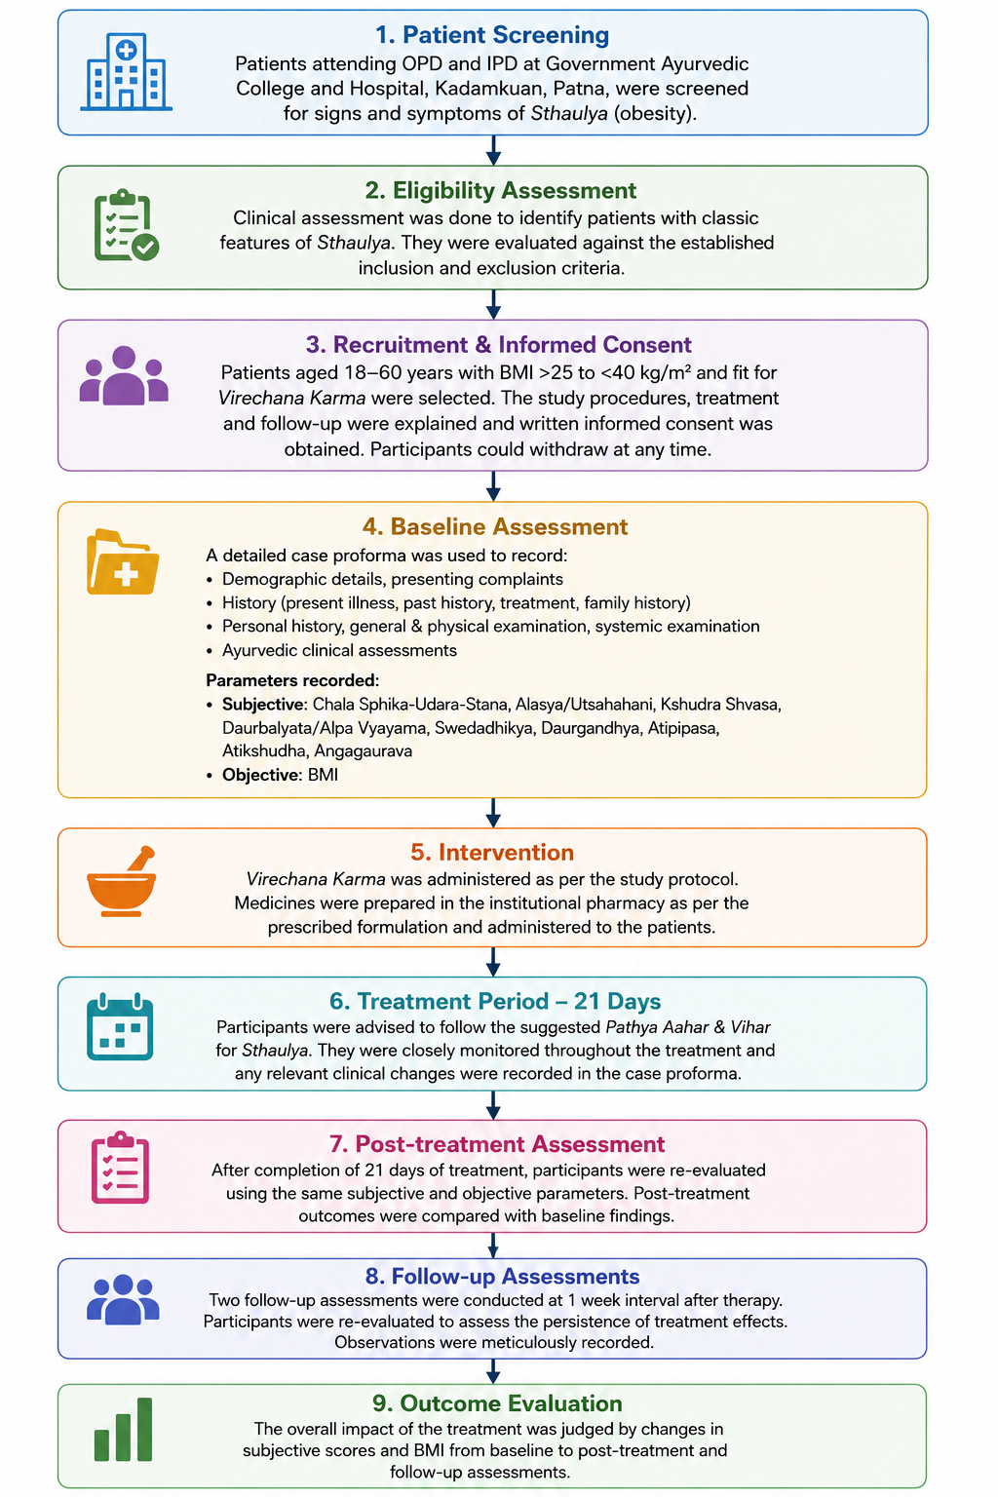
Methodology flowchart
4.9 Study data collection:
Data collection involved patients who met the specified criteria and visited the OPD/IPD at Government Ayurvedic College and Hospital, Patna. Clinical data were systematically gathered using a standardized case proforma. This document captured demographic details, presenting complaints, history of the current illness, past medical history, treatment history, family history, personal history, general and physical examinations, and systemic examinations. Additionally, findings from Ayurvedic clinical evaluations were documented. Study parameters were noted at the start, post-treatment, and during follow-up. Subjective parameters concerning the clinical features of Sthaulya were evaluated using a predefined grading system, while BMI served as the objective parameter. Observations throughout the study were recorded in the case proforma and later compiled for statistical analysis. Patients were monitored before, during, and after the trial's completion.
4.10 Data analysis:
Data from study participants were gathered and analyzed using both subjective and objective measures. The analysis focused on the response to Virechana Karma by examining findings before treatment, after treatment, and during follow-up. Relief percentages for the parameters were calculated, and the therapy's overall effectiveness was determined based on established criteria. Statistical analyses were conducted with the help of a biostatistician to evaluate the significance of the changes. The results were then interpreted according to these statistical evaluations and presented accordingly.
4.11 Ethical considerations:
The research was initiated only after obtaining informed consent from participants. Before joining, participants were thoroughly briefed on the trial's aims, procedures, treatment protocols, and necessary follow-ups. Participation was entirely voluntary, and individuals were informed that they could withdraw at any point without providing a reason. During both the treatment and follow-up stages, participants were closely monitored for any adverse effects. Those who experienced significant side effects, opted to leave, or could not adhere to the instructions were excluded from the study. The confidentiality of participants was maintained throughout the research.

References:
- World Health Organization. Obesity and overweight [Internet]. Geneva: World Health Organization; 2025 [cited 2026 Aug 16]. Available from: https://www.who.int/news-room/fact-sheets/detail/obesity-and-overweight
- Lin X, Li H. Obesity: epidemiology, pathophysiology, and therapeutics. Front Endocrinol (Lausanne). 2021;12:706978. doi: 10.3389/fendo.2021.706978.
- Jin X, Qiu T, Li L, Yu R, Chen X, Li C, et al. Pathophysiology of obesity and its associated diseases. Acta Pharm Sin B. 2023;13(6):2403–24. doi: 10.1016/j.apsb.2023.01.012.
- Elmaleh-Sachs A, Schwartz JL, Bramante CT, Nicklas JM, Gudzune KA, Jay M. Obesity management in adults: a review. JAMA. 2023;330(20):2000–15. doi: 10.1001/jama.2023.19897.
- Ansari S, Haboubi H, Haboubi N. Adult obesity complications: challenges and clinical impact. Ther Adv Endocrinol Metab. 2020;11:2042018820934955. doi: 10.1177/2042018820934955.
- Gjermeni E, Kirstein AS, Kolbig F, Kirchhof M, Bundalian L, Katzmann JL, et al. Obesity—an update on the basic pathophysiology and review of recent therapeutic advances. Biomolecules. 2021;11(10):1426. doi: 10.3390/biom11101426.
- Pradeepa R, Anjana RM, Joshi SR, Bhansali A, Deepa M, Joshi PP, et al. Prevalence of generalized and abdominal obesity in urban and rural India—the ICMR-INDIAB Study (Phase-I) [ICMR-INDIAB-3]. Indian J Med Res. 2015;142(2):139–50. doi: 10.4103/0971-5916.164234.
- Chaudhary M, Sharma P. Abdominal obesity in India: analysis of the National Family Health Survey-5 (2019–2021) data. Lancet Reg Health Southeast Asia. 2023;14:100208. doi: 10.1016/j.lansea.2023.100208.
- Madhu SV, Kapoor N, Das S, Raizada N, Kalra S. ESI clinical practice guidelines for the evaluation and management of obesity in India. Indian J Endocrinol Metab. 2022;26(4):295–318. doi: 10.4103/2230-8210.356236.
- Nadiger N, Anantharamu S, Prasad CN, Vidal-Puig A, Mukhopadhyay A. Unique attributes of obesity in India: a narrative review. Obes Med. 2022;35:100454. doi: 10.1016/j.obmed.2022.100454.
- Misra A, Shrivastava U. Obesity and dyslipidemia in South Asians. Nutrients. 2013;5(7):2708–33. doi: 10.3390/nu5072708.
- Mahajan K, Negi PC, Thakur M. Predictors of obstructive coronary artery disease in women. Indian Heart J. 2018;70(1):194–5. doi: 10.1016/j.ihj.2017.11.002.
- Behl S, Misra A. Management of obesity in adult Asian Indians. Indian Heart J. 2017;69(4):539–44. doi: 10.1016/j.ihj.2017.04.015.
- Kalra S, Kapoor N, Verma M, Shaikh S, Das S, Jacob J, et al. Defining and diagnosing obesity in India: a call for advocacy and action. J Obes. 2023;2023:4178121. doi: 10.1155/2023/4178121.
- Gupta RD, Tamanna N, Siddika N, Haider SS, Apu EH, Haider MR. Obesity and abdominal obesity in Indian population: findings from a nationally representative study of 698,286 participants. Epidemiologia (Basel). 2023;4(2):163–72. doi: 10.3390/epidemiologia4020017.
- Haam JH, Kim BT, Kim EM, Kwon H, Kang JH, Park JH, et al. Diagnosis of obesity: 2022 update of clinical practice guidelines for obesity by the Korean Society for the Study of Obesity. J Obes Metab Syndr. 2023;32(2):121–9. doi: 10.7570/jomes23031.
- Sharma S, Raina SK, Bhardwaj AK, Chander V, Kumar D, Sharma S. Utility of consensus statement in assessment of obesity: a study among undergraduate medical students from rural northwest India. J Family Med Prim Care. 2013;2(3):274–6. doi: 10.4103/2249-4863.120759.
- Vennu V, Abdulrahman TA, Bindawas SM. The prevalence of overweight, obesity, hypertension, and diabetes in India: analysis of the 2015–2016 National Family Health Survey. Int J Environ Res Public Health. 2019;16(20):3987. doi: 10.3390/ijerph16203987.
- Prasad DS, Kabir Z, Dash AK, Das BC. Abdominal obesity, an independent cardiovascular risk factor in Indian subcontinent: a clinico-epidemiological evidence summary. J Cardiovasc Dis Res. 2011;2(4):199–205. doi: 10.4103/0975-3583.89803.
- Venkatrao M, Nagarathna R, Majumdar V, Patil SS, Rathi S, Nagendra H. Prevalence of obesity in India and its neurological implications: a multifactor analysis of a nationwide cross-sectional study. Ann Neurosci. 2020;27(3-4):153–61. doi: 10.1177/0972753120987465.
- Chakrabarty M, Let S. Spatial clustering of overweight/obesity among women in India: insights from the latest National Family Health Survey. PLoS One. 2024;19(7):e0305205. doi: 10.1371/journal.pone.0305205.
- Sung M, Kumar A, Mishra R, Kulkarni B, Kim R, Subramanian SV. Temporal change in prevalence of BMI categories in India: patterns across states and union territories of India, 1999–2021. BMC Public Health. 2024;24(1):1322. doi: 10.1186/s12889-024-18784-4.
- Verma M, Esht V, Alshehri MM, Aljahni M, Chauhan K, Morsy WE, et al. Factors contributing to the change in overweight/obesity prevalence among Indian adults: a multivariate decomposition analysis of data from the National Family Health Surveys. Adv Ther. 2023;40(12):5222–42. doi: 10.1007/s12325-023-02670-3.
- Ahmed SK, Mohammed RA. Obesity: prevalence, causes, consequences, management, preventive strategies and future research directions. Metab Open. 2025;27:100375. doi: 10.1016/j.metop.2025.100375.
- Kong Y, Yang H, Nie R, Zhang X, Zuo F, Zhang H, et al. Obesity: pathophysiology and therapeutic interventions. Mol Biomed. 2025;6(1):25. doi: 10.1186/s43556-025-00264-9.
- Ullah MI, Tamanna S. Obesity: clinical impact, pathophysiology, complications, and modern innovations in therapeutic strategies. Medicines (Basel). 2025;12(3):19. doi: 10.3390/medicines12030019.
- Jaiswal YS, Williams LL. A glimpse of Ayurveda—the forgotten history and principles of Indian traditional medicine. J Tradit Complement Med. 2017;7(1):50–3. doi: 10.1016/j.jtcme.2016.02.002.
- Agrawal AK, Yadav CR, Meena MS. Physiological aspects of Agni. Ayu. 2010;31(3):395–8. doi: 10.4103/0974-8520.77159.
- Sharma V, Chaudhary AK. Concepts of Dhatu Siddhanta (theory of tissues formation and differentiation) and Rasayana; probable predecessor of stem cell therapy. Ayu. 2014;35(3):231–6. doi: 10.4103/0974-8520.153731.
- Manohar PR. Critical review and validation of the concept of Āma. Anc Sci Life. 2012;32(2):67–8. doi: 10.4103/0257-7941.118524.
- Dey S, Pahwa P. Prakriti and its associations with metabolism, chronic diseases, and genotypes: possibilities of new born screening and a lifetime of personalized prevention. J Ayurveda Integr Med. 2014;5(1):15–24. doi: 10.4103/0975-9476.128848.
- Mahalle NP, Kulkarni MV, Pendse NM, Naik SS. Association of constitutional type of Ayurveda with cardiovascular risk factors, inflammatory markers and insulin resistance. J Ayurveda Integr Med. 2012;3(3):150–7. doi: 10.4103/0975-9476.100186.
- Shirolkar A, Chakraborty S, Mandal T, Dabur R. Plasma metabolomics reveal the correlation of metabolic pathways and Prakritis of humans. J Ayurveda Integr Med. 2018;9(2):113–22. doi: 10.1016/j.jaim.2017.05.002.
- Jnana A, Murali TS, Guruprasad KP, Satyamoorthy K. Prakriti phenotypes as a stratifier of gut microbiome: a new frontier in personalized medicine? J Ayurveda Integr Med. 2020;11(3):360–5. doi: 10.1016/j.jaim.2020.05.013.
- Ranade AV, Shirolkar A, Pawar SD. Gut microbiota: one of the new frontiers for elucidating fundamentals of Vipaka in Ayurveda. Ayu. 2019;40(2):75–8. doi: 10.4103/ayu.AYU_210_18.
- Chauhan A, Semwal DK, Semwal RB, Joshi SK, Adhana RK, Goswami MS. Modulation of gut microbiota with Ayurveda diet and lifestyle: a review on its possible way to treat type 2 diabetes. Ayu. 2022;43(2):35–44. doi: 10.4103/ayu.AYU_7_20.
- Shukla A, Baghel AS, Vyas M. Lifestyle related factors associated with Sthaulya (obesity): a cross-sectional survey study. Ayu. 2016;37(3-4):174–83. doi: 10.4103/ayu.AYU_87_16.
- Charak Samhita [Internet]. Ashtauninditiya Adhyaya [cited 2026 Aug 26]. Available from: https://www.carakasamhitaonline.com/index.php?title=Ashtauninditiya_Adhyaya
- Kumari H, Pushpan R, Nishteswar K. Medohara and Lekhaniya dravyas (anti-obesity and hypolipidemic drugs) in Ayurvedic classics: a critical review. Ayu. 2013;34(1):11–6. doi: 10.4103/0974-8520.115437.
- Maurya SK, Seth A, Laloo D, Singh NK, Gautam DNS, Singh AK. Śodhana: an Ayurvedic process for detoxification and modification of therapeutic activities of poisonous medicinal plants. Anc Sci Life. 2015;34(4):188–97. doi: 10.4103/0257-7941.160862.
- Peterson CT, Lucas J, John-Williams LS, Thompson JW, Moseley MA, Patel S, et al. Identification of altered metabolomic profiles following a Panchakarma-based Ayurvedic intervention in healthy subjects: the Self-Directed Biological Transformation Initiative (SBTI). Sci Rep. 2016;6:32609. doi: 10.1038/srep32609.
- Kuttikrishnan M, Sridhar R, Varghese E. Jatharagni and Prakriti of young Indian adult population: a descriptive cross-sectional study. J Ayurveda Integr Med. 2022;13(1):100438. doi: 10.1016/j.jaim.2021.04.008.
- Singh A, Singh G, Patwardhan K, Gehlot S. Development, validation, and verification of a self-assessment tool to estimate Agnibala (digestive strength). J Evid Based Complementary Altern Med. 2017;22(1):134–40. doi: 10.1177/2156587216656117.
- Dhruva A, Hecht FM, Miaskowski C, Kaptchuk TJ, Bodeker G, Abrams D, et al. Correlating traditional Ayurvedic and modern medical perspectives on cancer: results of a qualitative study. J Altern Complement Med. 2014;20(5):364–70. doi: 10.1089/acm.2013.0259.
- Sumantran VN, Tillu G. Cancer, inflammation, and insights from Ayurveda. Evid Based Complement Alternat Med. 2012;2012:306346. doi: 10.1155/2012/306346.
- Sumantran VN, Nair PP. Can the vagus nerve serve as biomarker for Vata dosha activity? J Ayurveda Integr Med. 2019;10(2):146–51. doi: 10.1016/j.jaim.2019.04.003.
- Uikey R, Kar AC. A review on Purisha Pariksha in Ayurveda. Ayu. 2015;36(2):125–9. doi: 10.4103/0974-8520.175536.
- Chaganti S, Prasad BS. Analysis of Virechana karma with Danti avaleha: a retrospective study. J Ayurveda Integr Med. 2015;6(4):300–4. doi: 10.4103/0975-9476.172420.
- Rais A, Bhatted S. Clinical study to evaluate the effect of Virechanakarma on serum electrolytes. Ayu. 2013;34(4):379–82. doi: 10.4103/0974-8520.127719.
- Varsakiya JN, Goyal M, Thakar A, Patel B. Role of Virechana and Ashwatha Phala Churna in the management of Ksheena Shukra (oligozoospermia): a pilot study. Ayu. 2016;37(2):113–9. doi: 10.4103/ayu.AYU_71_15.
- Pandey RK, Bhatt NN, Singhala TM, Shukla VD. A comparative study of Vamana and Virechana Karma in the management of Sthula Pramehi w.s.r. to type-2 diabetes. Ayu. 2011;32(4):536–9. doi: 10.4103/0974-8520.96129.
- Gordon A, Buch Z, Baute V, Coeytaux R. Use of Ayurveda in the treatment of type 2 diabetes mellitus. Glob Adv Health Med. 2019;8:2164956119861094. doi: 10.1177/2164956119861094.
- Soman A, Venkatram S, Chikkanna U, Ramakrishna KK, Bhargav H, Mailankody P, et al. Ayurveda for management of migraine: a narrative review of clinical evidence. J Family Med Prim Care. 2022;11(8):4228–35. doi: 10.4103/jfmpc.jfmpc_2109_21.
- Patel AG, Patel MR, Nariya MB. Assessment of Trisama, an Ayurvedic formulation on intestinal transit time in Swiss albino mice. Ayu. 2018;39(1):46–9. doi: 10.4103/ayu.AYU_33_18.
- Rajan S, Shamkuwar MK, Tanwar AK. Impact of Shirodhara on biological markers of stress: a case study. J Ayurveda Integr Med. 2021;12(1):178–81. doi: 10.1016/j.jaim.2021.01.008.
- Nair PP, Krishnakumar V, Nair PG. Chronic inflammation: cross linking insights from Ayurvedic sciences, a silver lining to systems biology and personalized medicine. J Ayurveda Integr Med. 2024;15(4):101016. doi: 10.1016/j.jaim.2024.101016.
- Sahu AK, Upadhyay A, Bhakuni H, Attanayake AMHS, Sharma P. Effect of Ayurveda interventions in non-alcoholic grade II fatty liver associated with obesity: a case report. J Ayurveda Integr Med. 2022;13(3):100605. doi: 10.1016/j.jaim.2022.100605.
- Chaturvedi A, Nath G, Yadav VB, Antiwal M, Shakya N, Swathi C, et al. A clinical study on Virechana Karma (therapeutic purgation) over the gut flora with special reference to obesity. Ayu. 2019;40(3):179–84. doi: 10.4103/ayu.AYU_302_19.
- Goyal R, Kaur M, Chandola HM. A clinical study on the role of Agnimanthadi compound in the management of Sthaulya (obesity). Ayu. 2011;32(2):241–9. doi: 10.4103/0974-8520.92553.
- Goyal R, Goyal M, Chandola HM. A clinical study on the role of Agnimanthadi compound and Vashpa Svedana in the management of Sthaulya (obesity). Ayu. 2013;34(4):390–6. doi: 10.4103/0974-8520.127721.
- Antiwal M, Singh JP, Tiwari SK. Clinical evaluation of Lekhaniya Kashaya Vasti in the management of Sthaulya (obesity). Ayu. 2014;35(1):28–34. doi: 10.4103/0974-8520.141907.
- Pattonder RK, Chandola HM, Vyas SN. Clinical efficacy of Shilajatu (Asphaltum) processed with Agnimantha (Clerodendrum phlomidis Linn.) in Sthaulya (obesity). Ayu. 2011;32(4):526–31. doi: 10.4103/0974-8520.96127.
- Pooja BA, Bhatted SK. A standard controlled clinical study on Virechana Karma and Lekhana Basti in the management of dyslipidemia (Medoroga). Ayu. 2016;37(1):32–7. doi: 10.4103/ayu.AYU_14_15.
- Singh SK, Swami P, Rajoria K. Effects of medicated enema and nasal drops using Triphaladi oil in the management of obesity: a pilot study. J Ayurveda Integr Med. 2020;11(2):173–6. doi: 10.1016/j.jaim.2020.02.001.
- Rioux J, Howerter A. Outcomes from a whole-systems Ayurvedic medicine and yoga therapy treatment for obesity pilot study. J Altern Complement Med. 2019;25(S1):S124–37. doi: 10.1089/acm.2018.0448.
- Gupte P, Harke S, Deo V, Shrikhande BB, Mahajan M, Bhalerao S. A clinical study to evaluate the efficacy of Herbal Formulation for Obesity (HFO-02) in overweight individuals. J Ayurveda Integr Med. 2020;11(2):159–62. doi: 10.1016/j.jaim.2019.05.003.
- Chandake S, Tubaki BR, Gonugade V, Sharma O. Efficacy of Tryushnadya Churna in metabolic syndrome with obesity: a randomized double-blind controlled clinical trial. J Ayurveda Integr Med. 2024;15(4):100973. doi: 10.1016/j.jaim.2024.100973.
- Munshi R, Panchal F, Kumbhar D. Effect of Lekhan Basti and Navak Guggul on lipid markers and transcriptional effects of selected genes in obese patients: a single-centre, open-labelled, randomized, comparative, pilot study. J Ayurveda Integr Med. 2025;16(3):101129. doi: 10.1016/j.jaim.2025.101129.
- Giri SK, Vedi SK, Doddamani S, Naik R, Sharma S, Gavali K, et al. Clinical safety and efficacy of Ayurveda multi-herbal formulation in the management of obesity. Glob Adv Integr Med Health. 2025;14:27536130251356447. doi: 10.1177/27536130251356447

