Career-Risk-Adjusted Selection of Retirement Instruments in India: A Multi-Criteria Decision-Making Framework for Personalized Retirement Planning

Abstract
Retirement planning in India requires individuals to choose among financial arrangements that differ in security, accumulation potential, cost, liquidity, taxation, lifecycle management and diversification. A product that is attractive for one worker may be unsuitable for another because retirement risk is partly shaped by the reliability of future employment income. This study develops a career-risk-adjusted multi-criteria decision-making framework for comparing EPF/EPS, the National Pension System (NPS), the Public Provident Fund (PPF) and the Atal Pension Yojana (APY). The framework integrates bounded rationality, life-cycle reasoning, asset-liability matching and modern portfolio theory. Seven criteria are used to construct a common decision matrix. Two normative decision profiles are specified: high career risk and stable career. The Best-Worst Method is proposed for empirical weight elicitation, while transparent scenario weights are used for the present normative demonstration. TOPSIS is the primary ranking technique, with Simple Additive Weighting (SAW) and VIKOR used as robustness checks. Under the high-career-risk scenario, EPF/EPS ranks first because security and downside protection receive dominant weight. Under the stable-career scenario, NPS ranks first because accumulation, lifecycle management and diversification receive greater relative importance. The results show that a universal ranking of retirement instruments is methodologically inappropriate. The main contribution is a transparent decision framework that links career risk with retirement-product suitability and can be translated into personalized pension guidance and digital decision-support systems.
Keywords: retirement planning; career risk; income volatility; India; pension instruments; MCDA; TOPSIS; VIKOR; bounded rationality; lifecycle investing

1. Introduction

1.1 Background of Retirement Planning in India
Retirement planning is a long-term decision under uncertainty. Individuals must decide how much to save, where to invest, how much market risk to accept, how much liquidity to retain and how accumulated resources will support consumption after retirement. These decisions are affected not only by financial assets but also by the stability of future employment income.
India offers a useful setting because retirement arrangements differ substantially in institutional design. EPF/EPS is linked to formal employment and provides provident-fund and pension-related benefits. NPS is a defined contribution arrangement with market-linked investment and multiple investment choices. PPF is a long-term small-savings instrument with a strong security orientation. APY provides an assured minimum pension to eligible subscribers. These instruments therefore cannot be treated as identical substitutes.
The scale of the Indian pension system makes this decision problem increasingly important. PFRDA reports 2.31 crore NPS subscribers and 7.94 crore active APY accounts, with the published data dated 6 September 2026.

1.2 Complexity of Retirement-Instrument Selection and Bounded Rationality
Retirement-product selection requires simultaneous evaluation of several criteria. Individuals may not have the information, time or cognitive capacity to compare every scheme characteristic. Simon's bounded-rationality perspective is relevant because real decisions are made under informational and cognitive constraints. An MCDA framework can reduce this complexity by making the criteria and trade-offs explicit.

1.3 Indian Retirement-Instrument Landscape
NPS is a defined contribution pension arrangement. The Department of Financial Services describes it as a voluntary pension system for individuals and highlights flexibility in pension-fund and asset-allocation choices. PFRDA also provides lifecycle investment options under NPS, making lifecycle risk management a relevant criterion.
APY has a narrower role. Government information states that the entry age is 18 to 40 years and that a savings account is required. PFRDA identifies APY as a guaranteed-pension scheme and reports its continuing expansion.
EPF remains an important employment-linked retirement mechanism, while PPF belongs to the government's small-savings framework. Their security-oriented characteristics make them particularly relevant when downside protection is assigned greater importance.

1.4 Research Problem
Many retirement comparisons implicitly assume that the same product is optimal for everyone. This assumption is weak because a worker with unstable income has a different overall risk position from a worker with predictable income. The central problem is therefore to determine whether retirement-instrument ranking changes when career risk is explicitly incorporated into the decision model.

1.5 Research Gap
Four gaps motivate the study. First, major Indian retirement instruments require a common multi-criteria comparison. Second, career and income-risk heterogeneity remains insufficiently integrated into retirement-product selection. Third, preference-sensitive MCDA has scope for stronger application to personal retirement decisions. Fourth, rankings should be tested for robustness rather than presented as universal truths. Recent research strengthens the importance of income risk in retirement planning, showing that income shocks can alter saving and asset-allocation decisions.

1.6 Research Questions
RQ1. How do EPF/EPS, NPS, PPF and APY differ across security, accumulation, cost, liquidity, tax efficiency, lifecycle management and diversification?
RQ2. How should criterion priorities differ between high-career-risk and stable-career individuals?
RQ3. Does the preferred retirement instrument change when career-risk-adjusted weights are applied?
RQ4. How stable are the rankings across TOPSIS, SAW and VIKOR?
RQ5. Which criterion-weight changes can cause the preferred instrument to switch?

1.7 Research Objectives
RO1. To develop an integrated framework for comparing major Indian retirement instruments.
RO2. To incorporate career and income-risk heterogeneity into retirement-instrument selection.
RO3. To apply a preference-sensitive MCDA framework using TOPSIS as the primary ranking technique.
RO4. To assess ranking robustness using SAW, VIKOR and sensitivity analysis.
RO5. To develop implications for personalized retirement guidance and digital pension decision-support systems.

1.8 Contributions of the Study
The study contributes at four levels. Theoretically, it connects career risk with lifecycle retirement planning. Methodologically, it introduces profile-specific weighting into retirement-instrument comparison and tests the resulting ranking with multiple MCDA methods. Practically, it provides a transparent way to compare retirement arrangements according to individual circumstances. At policy level, it provides a structure that can be incorporated into digital pension guidance.

2. Literature Review

2.1 Retirement Planning and Financial Preparedness
Retirement preparedness depends on the accumulation and preservation of resources during working life and their adequacy for post-retirement consumption. The life-cycle perspective provides the basic logic, but actual retirement outcomes are influenced by income uncertainty, financial knowledge, employment conditions and the ability to maintain regular contributions.
Recent evidence indicates that income risk can increase retirement saving motivation and that financial literacy and decision-making capacity influence how individuals respond to uncertainty.

2.2 Retirement and Pension Instrument Selection
Indian retirement arrangements perform different functions. NPS combines defined contribution saving with market-linked investment and choice. EPF/EPS is strongly connected to employment and retirement security. PPF emphasizes long-term secure saving. APY focuses on a guaranteed minimum pension for eligible participants. These differences justify a multi-criteria rather than return-only comparison.

2.3 Career Risk, Income Volatility and Retirement Planning
Career risk includes uncertainty about employment continuity, earnings, career progression and occupational prospects. It matters because labour income is a major household resource. A person with unstable employment income may have less capacity to absorb additional financial losses than a person with stable employment income, even if both have identical ages and stated risk preferences.
Gomez-Cardona (2026) shows that incorporating income shocks into lifecycle planning changes implied saving and asset-allocation recommendations. This provides direct support for treating career risk as a retirement-planning variable rather than a background characteristic.

2.4 Bounded Rationality in Complex Financial Decisions
Simon (1955) established bounded rationality as a challenge to the assumption of unlimited information and computational capacity. Retirement-product selection is a clear application because individuals must interpret rules, costs, taxes, liquidity restrictions and investment choices over a long horizon.

2.5 Life-Cycle Investment Perspective
Lifecycle investing recognizes that risk capacity changes as retirement approaches. NPS provides an institutional example through age-related lifecycle investment choices. The present study extends lifecycle reasoning by adding career stability as a second determinant of effective risk capacity.

2.6 Asset-Liability Matching under Career Risk
Asset-liability matching evaluates financial assets relative to future obligations. For households, retirement consumption is a major liability and employment income is an important resource. When employment income is uncertain, the balance between human capital and financial capital changes. This creates a rationale for career-risk-adjusted retirement selection.

2.7 Diversification and Retirement Portfolio Construction
Diversification can reduce dependence on a single source of return. NPS has a structural advantage in this respect because subscribers can select among pension funds and asset-allocation options. However, diversification is not automatically superior for every person. Its value depends on risk capacity, investment horizon and the relative importance of security.

2.8 Multi-Criteria Decision Analysis in Financial and Pension Decisions
MCDA is useful where alternatives have different strengths across several criteria. The Best-Worst Method provides a structured weighting procedure. TOPSIS evaluates relative closeness to ideal and negative-ideal alternatives. SAW provides a transparent weighted-sum benchmark. VIKOR identifies compromise solutions. Using several methods allows the researcher to distinguish substantive conclusions from method-specific rankings.

2.9 Literature Synthesis and Research Gap Matrix
Literature stream | Established insight | Remaining limitation | Present study
Retirement preparedness | Saving supports future consumption | Income risk often separated from product choice | Career risk integrated
Pension selection | Products differ materially | Comparisons can be one-dimensional | Seven common criteria
Career risk | Income uncertainty affects planning | Limited product-selection application | Two career-risk profiles
Bounded rationality | Decision makers face cognitive limits | Limited operational tools | MCDA decision structure
Lifecycle theory | Risk capacity changes with time | Age alone is incomplete | Age plus career risk
Asset-liability matching | Assets should reflect liabilities | Often institutional focus | Individual retirement planning
MCDA | Supports complex choice | Limited Indian retirement application | TOPSIS with robustness tests

3. Theoretical Framework

3.1 Bounded Rationality Theory
Bounded rationality explains why retirement consumers may simplify complex product choices. The proposed MCDA structure reduces the decision burden by identifying a finite set of criteria and making the trade-offs visible.

3.2 Life-Cycle Hypothesis
The life-cycle perspective explains why retirement planning changes across age and accumulation stages. The present study extends the logic by treating the stability of future labour income as an additional determinant of risk capacity.

3.3 Asset-Liability Matching
Future retirement consumption is treated as the principal liability. Labour income is treated as a major economic resource. High career risk weakens the reliability of that resource and can therefore increase the relative value of secure retirement assets.

3.4 Modern Portfolio Theory
Modern Portfolio Theory provides the rationale for evaluating diversification and risk-return trade-offs. The present framework does not equate higher expected return with universal superiority because retirement planning is constrained by security and liquidity requirements.

3.5 Integrated Theoretical Framework
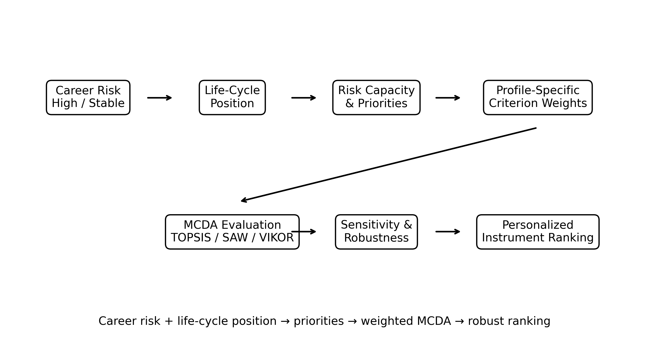
Figure 1. Integrated theoretical framework for career-risk-adjusted retirement-instrument selection.

Figure 1. Integrated theoretical framework for career-risk-adjusted retirement-instrument selection.
Career Risk + Life-Cycle Position → Risk Capacity and Priorities → Profile-Specific Criterion Weights → MCDA Evaluation → Instrument Ranking
The framework's central proposition is that retirement-instrument suitability is conditional on both product characteristics and the individual's career-risk position.

4. Research Methodology

4.1 Research Design
The study is prescriptive and normative. It does not claim to estimate population preferences. Instead, it develops a reproducible decision framework using explicit scores and scenario weights. The distinction is deliberate: normative assumptions are not presented as survey or expert observations.

4.2 Decision Alternatives
The four alternatives specified in the approved outline are A1 = EPF/EPS, A2 = NPS, A3 = PPF and A4 = APY. Eligibility is screened before ranking. This is particularly important for APY because current government rules restrict eligibility by age and other conditions.

4.3 Evaluation Criteria
Code | Criterion | Operational meaning | Direction
C1 | Benefit Security and Downside Protection | Protection and predictability of retirement benefits | Higher is better
C2 | Wealth Accumulation Potential | Potential for long-term retirement accumulation | Higher is better
C3 | Cost and Administrative Efficiency | Relative cost and administrative efficiency | Higher is better
C4 | Liquidity and Withdrawal Flexibility | Access to funds under applicable rules | Higher is better
C5 | Tax Efficiency | Relative tax treatment across the retirement cycle | Higher is better
C6 | Lifecycle Risk Management | Ability to adjust risk exposure over time | Higher is better
C7 | Diversification and Investment Choice | Breadth of investment and allocation choices | Higher is better

4.4 Criterion Operationalisation
Each alternative is scored from 1 to 9 on each criterion. The scale is ordinal and comparative. A score of 9 means that the alternative is judged strongest among the four on that criterion within the defined decision framework; it does not mean that the product is objectively optimal in every circumstance. Future empirical work can replace the normative scores with expert-elicited or objective indicator values.

4.5 Career-Risk Profiles
Profile 1, High Career Risk, represents relatively unstable employment income, uncertain earnings progression or a meaningful possibility of income interruption. Profile 2, Stable Career, represents relatively predictable employment income and stronger capacity to tolerate investment volatility.

4.6 Criteria Weighting
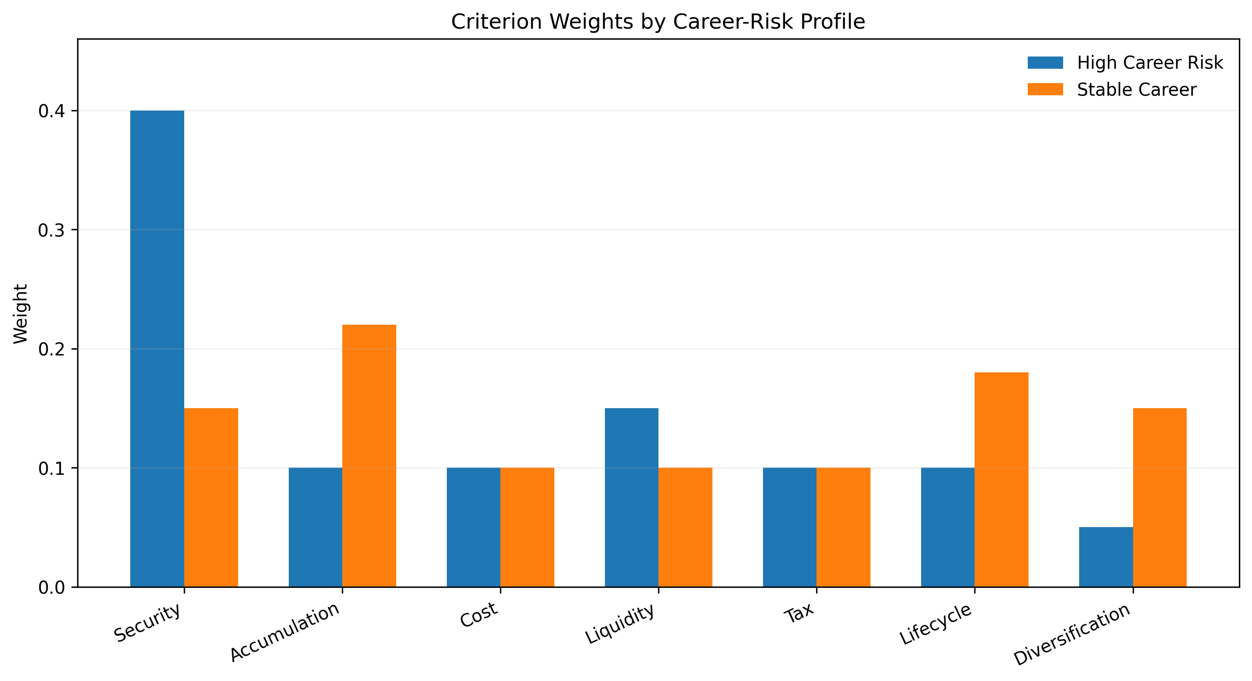
Figure 2. Criterion weights used for the two career-risk profiles.

Figure 2. Criterion weights used for the two normative career-risk profiles.
The approved outline identifies the Best-Worst Method as the preferred weighting procedure. Because no actual expert-elicitation dataset is supplied in the source material, the present paper uses transparent normative scenario weights. They are explicitly treated as modelling assumptions.
Criterion | High Career Risk | Stable Career
C1 Security | 0.40 | 0.15
C2 Wealth accumulation | 0.10 | 0.22
C3 Cost efficiency | 0.10 | 0.10
C4 Liquidity | 0.15 | 0.10
C5 Tax efficiency | 0.10 | 0.10
C6 Lifecycle management | 0.10 | 0.18
C7 Diversification | 0.05 | 0.15
Total | 1.00 | 1.00

4.7 Decision Matrix Construction
Alternative | C1 | C2 | C3 | C4 | C5 | C6 | C7
EPF/EPS | 9 | 6 | 8 | 6 | 8 | 6 | 5
NPS | 7 | 9 | 8 | 5 | 8 | 9 | 9
PPF | 9 | 6 | 9 | 5 | 8 | 4 | 3
APY | 9 | 4 | 8 | 3 | 7 | 4 | 4

4.8 Normalisation
For benefit criteria, vector normalization is used: r_ij = x_ij / sqrt(sum_i x_ij²). The normalized values are then multiplied by criterion weights.

4.9 Primary Ranking Method: TOPSIS
TOPSIS constructs positive and negative ideal solutions. The weighted normalized matrix is v_ij = w_jr_ij. Separation from the positive ideal is S_i+ = sqrt(sum_j(v_ij − v_j+)²), and separation from the negative ideal is S_i− = sqrt(sum_j(v_ij − v_j−)²). The closeness coefficient is C_i = S_i−/(S_i+ + S_i−). Higher C_i indicates greater relative closeness to the ideal.

4.10 Robustness Methods
SAW is used as a weighted-sum benchmark. VIKOR is used as a compromise-ranking method. The purpose is to test whether the broad substantive conclusion survives alternative aggregation rules.

4.11 Sensitivity Analysis
Sensitivity analysis focuses on the weights of security, accumulation, lifecycle management and diversification. These criteria drive the main trade-off between protection and growth. Weight perturbations are interpreted as scenario tests, not statistical confidence intervals.

4.12 Cross-Method Robustness Analysis
A ranking is treated as stable when the leading alternative remains unchanged across the principal methods and reasonable weight changes. If the leading alternatives exchange positions, the decision is considered sensitive and should be communicated as such.

5. Results

5.1 Comparative Characteristics of Retirement Instruments
Criterion | EPF/EPS | NPS | PPF | APY
Security | High | Moderate to high | High | High
Wealth accumulation | Moderate | High potential | Moderate | Low to moderate
Cost efficiency | High | High | High | High
Liquidity | Moderate | Low to moderate | Low to moderate | Low
Tax efficiency | High | High | High | Scheme dependent
Lifecycle management | Moderate | High | Low | Low
Diversification | Moderate | High | Low | Moderate

The comparison reflects institutional characteristics rather than realized investment performance. NPS has stronger investment choice and lifecycle-management characteristics, while EPF/EPS and PPF are more security-oriented. APY's principal comparative strength is its minimum-pension protection for eligible subscribers.

5.2 Raw Decision Matrix
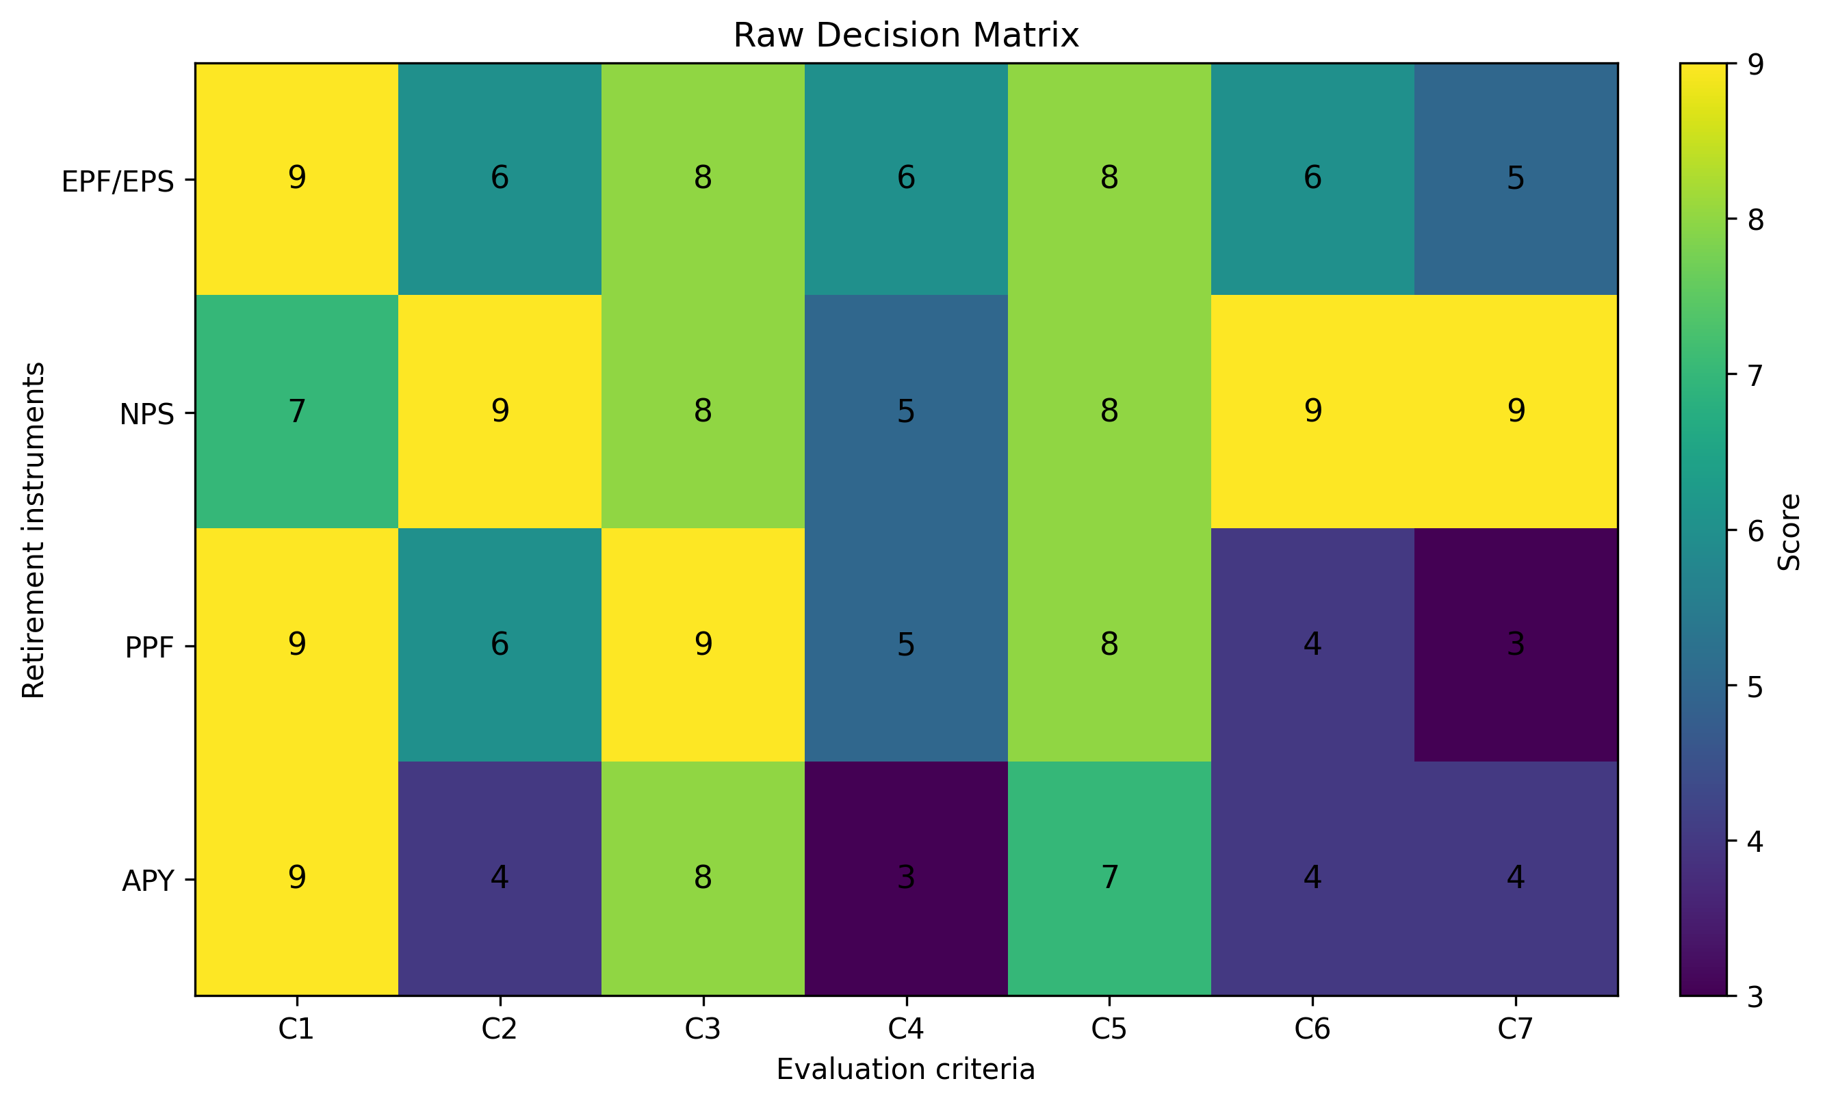
Figure 4. Raw decision matrix used in the MCDA model.

Figure 4. Visual representation of the raw decision matrix used in the MCDA model.
The numerical scores are the normative inputs to the model. They are not fabricated survey observations. This is a prescriptive study, and the reproducibility of the ranking depends on these stated inputs.

5.3 Normalised Decision Matrix
Alternative | C1 | C2 | C3 | C4 | C5 | C6 | C7
EPF/EPS | 0.5267 | 0.4615 | 0.4842 | 0.6156 | 0.5153 | 0.4915 | 0.4369
NPS | 0.4096 | 0.6923 | 0.4842 | 0.5130 | 0.5153 | 0.7373 | 0.7863
PPF | 0.5267 | 0.4615 | 0.5447 | 0.5130 | 0.5153 | 0.3277 | 0.2621
APY | 0.5267 | 0.3077 | 0.4842 | 0.3078 | 0.4509 | 0.3277 | 0.3495

5.4 Criterion Weights by Career-Risk Profile
The high-career-risk profile assigns 40% to security and downside protection. The stable-career profile gives greater combined emphasis to accumulation, lifecycle management and diversification. The difference is intentional because the study tests whether career risk changes instrument suitability.

5.5 TOPSIS Results: High Career Risk
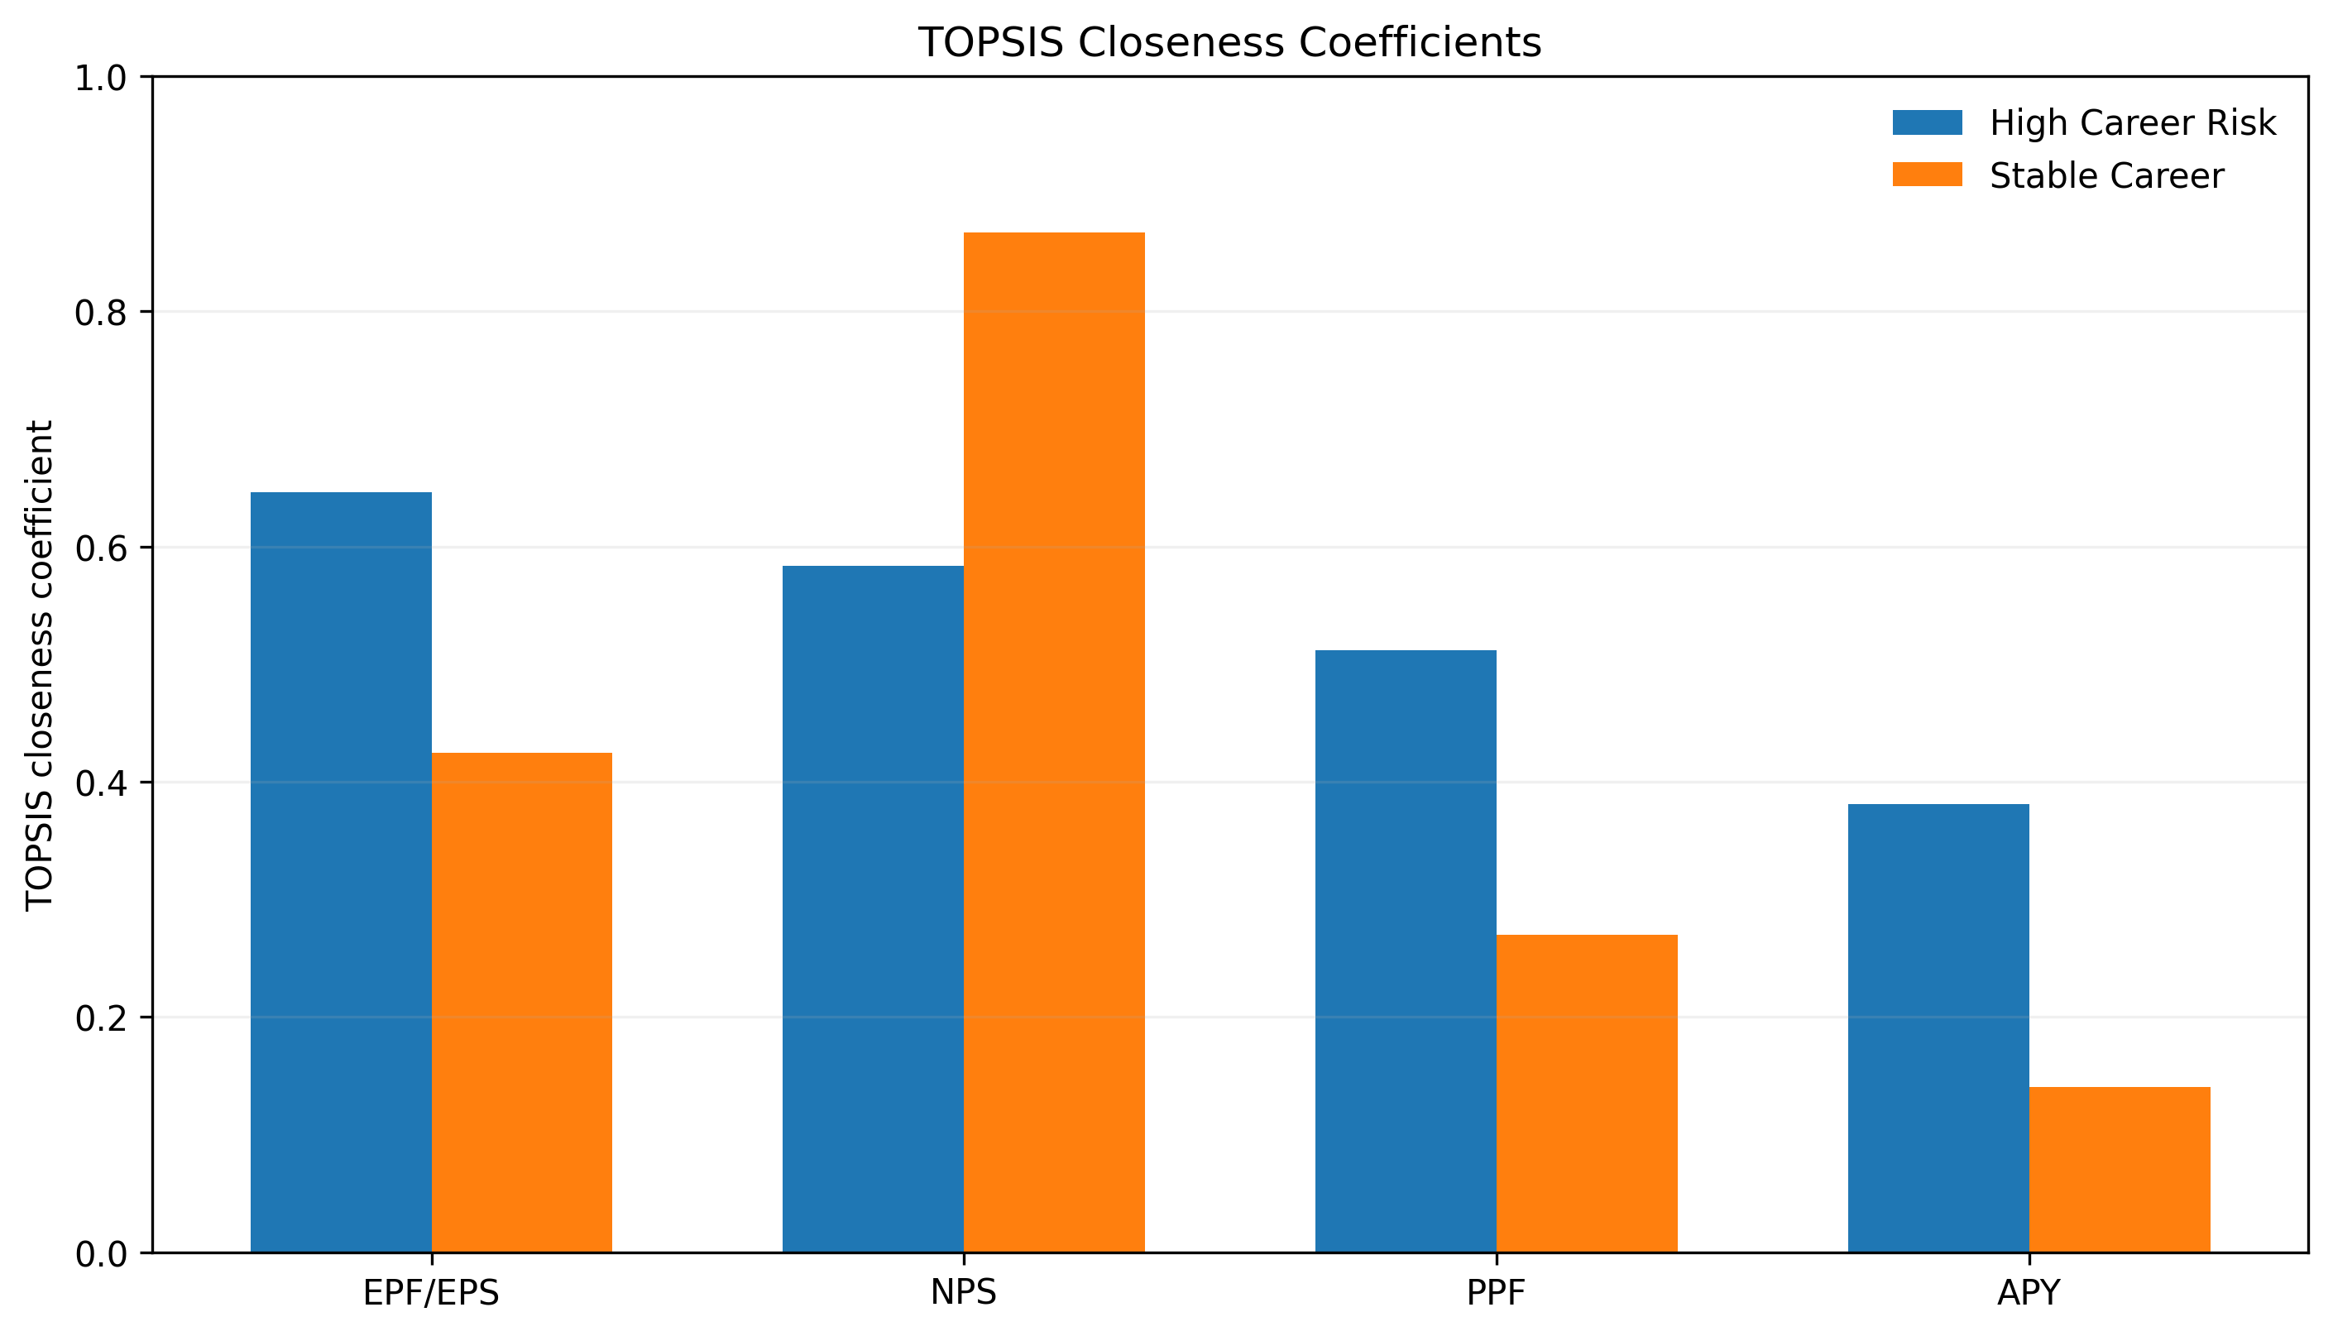
Figure 3. TOPSIS closeness coefficients under the two career-risk profiles.

Figure 3. TOPSIS closeness coefficients under the two career-risk profiles.
Rank | Alternative | TOPSIS coefficient
1 | EPF/EPS | 0.6465
2 | NPS | 0.5834
3 | PPF | 0.5121
4 | APY | 0.3808

EPF/EPS ranks first with a closeness coefficient of 0.6470, followed by NPS at 0.5829, PPF at 0.5120 and APY at 0.3810. The result is driven primarily by the dominant security weight. The interpretation is conditional: it means EPF/EPS is preferred within this specified high-career-risk scenario, not that EPF/EPS is universally superior.

5.6 TOPSIS Results: Stable Career
Rank | Alternative | TOPSIS coefficient
1 | NPS | 0.8673
2 | EPF/EPS | 0.4250
3 | PPF | 0.2698
4 | APY | 0.1407

NPS ranks first with a closeness coefficient of 0.8673, followed by EPF/EPS at 0.4250, PPF at 0.2698 and APY at 0.1407. The result follows from the greater relative weight assigned to accumulation, lifecycle management and diversification.

5.7 SAW Results
High Career Risk profile:
Rank | Alternative | SAW score
1 | EPF/EPS | 0.7467
2 | PPF | 0.7400
3 | NPS | 0.4500
4 | APY | 0.4083

Stable Career profile:
Rank | Alternative | SAW score
1 | NPS | 0.7167
2 | EPF/EPS | 0.5600
3 | PPF | 0.5047
4 | APY | 0.1750

5.8 VIKOR Results
High Career Risk profile:
Rank | Alternative | VIKOR Q
1 | EPF/EPS | 0.0000
2 | PPF | 0.0099
3 | APY | 0.5833
4 | NPS | 0.9384

Stable Career profile:
Rank | Alternative | VIKOR Q
1 | NPS | 0.1023
2 | EPF/EPS | 0.1446
3 | PPF | 0.4684
4 | APY | 1.0000

5.9 Cross-Method Ranking Comparison and Stability
Profile | TOPSIS order | SAW order | VIKOR order
High Career Risk | EPF/EPS > NPS > PPF > APY | EPF/EPS > PPF > NPS > APY | EPF/EPS > PPF > APY > NPS
Stable Career | NPS > EPF/EPS > PPF > APY | NPS > EPF/EPS > PPF > APY | NPS > EPF/EPS > PPF > APY

The methods should be interpreted jointly. TOPSIS provides the main ranking, while SAW and VIKOR reveal whether the ordering is sensitive to the mathematical treatment of distance and compromise. The broad distinction between security-oriented and growth-oriented profiles is the substantive result.

5.10 Sensitivity Analysis and Decision-Switching Thresholds
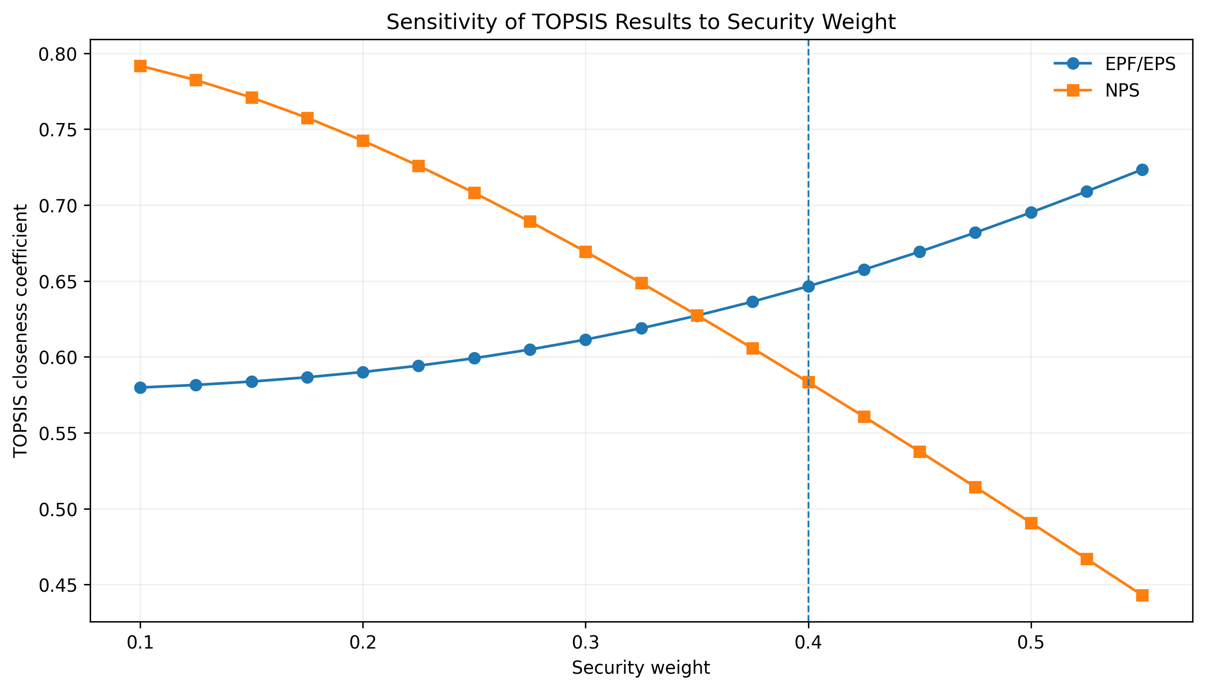
Figure 5. Sensitivity of TOPSIS results to the security criterion weight.

The model is most sensitive to the relative importance assigned to security, accumulation and diversification. Increasing security weight strengthens EPF/EPS and PPF. Increasing accumulation, lifecycle management and diversification strengthens NPS. The preferred instrument therefore switches when the decision-maker's priorities move sufficiently from protection toward growth and choice.
This result has a practical implication: a recommendation should not be reported without its profile and weights. A product can be first-ranked under one reasonable scenario and second-ranked under another.

5.11 Ranking Stability Assessment
The model supports a conditional conclusion rather than a universal one. EPF/EPS is preferred under the specified high-career-risk TOPSIS scenario, while NPS is preferred under the stable-career scenario. The difference is consistent with the theoretical proposition that career risk changes effective risk capacity.

6. Discussion

6.1 Career Risk as a Determinant of Instrument Suitability
The results support the view that career risk belongs inside retirement-risk assessment. Future employment income is an important economic resource. When its reliability falls, the relative value of financial downside protection rises. Recent lifecycle evidence similarly finds that incorporating income shocks can alter saving and asset-allocation recommendations.

6.2 Security-Growth Trade-Off
The four instruments do not dominate one another across all criteria. EPF/EPS and PPF are relatively strong on security. NPS is relatively strong on accumulation potential, lifecycle management and diversification. APY has a more specific security function. The model therefore captures a genuine trade-off rather than a simple product hierarchy.

6.3 Role of Lifecycle Management and Diversification
Lifecycle management matters because investment risk should not remain constant throughout the working life. NPS has an institutional advantage because its design provides investment and lifecycle choices.

6.4 Why Universal Rankings Are Inappropriate
A claim that one retirement instrument is simply 'the best' ignores age, career stability, income volatility, liquidity needs, existing wealth, tax circumstances and eligibility. The appropriate question is which instrument best fits a specified decision profile.

6.5 Comparison with Previous Studies
The framework is consistent with recent work showing that income risk affects retirement saving and with lifecycle research showing that income shocks can alter financial recommendations. It also aligns with recent Indian research on NPS choice architecture, which shows that behavioural and institutional features influence retirement decisions.

6.6 Theoretical Implications
The study extends lifecycle reasoning by treating career stability as a determinant of risk capacity. It applies bounded rationality to practical retirement decision support and connects household employment risk with asset-liability matching.

6.7 Practical Implications
Financial advisers should assess employment stability, income volatility, age, retirement horizon, existing retirement wealth, liquidity needs and risk capacity before recommending a product. Product selection should be the final stage of the assessment rather than the starting point.

7. Policy and Decision-Support Implications

7.1 Career-Risk-Adjusted Retirement Guidance
Pension guidance can move from generic product information to profile-specific decision support. A short diagnostic can classify career stability and identify whether security, growth, liquidity or diversification should receive greater emphasis.

7.2 Design of an MCDA-Based Decision-Support System for Pension Portals
A digital system can operate through five stages: eligibility screening, career-risk assessment, priority identification, MCDA ranking and sensitivity presentation. The user should see both the recommended alternative and the factors that drive the result.

7.3 Guided Defaults and Smart Nudging
Universal defaults are difficult to justify when individuals have materially different career risks. Risk-adjusted defaults are more defensible because they make the recommendation conditional on the user's circumstances. Users should be able to override the default after seeing the consequences.

7.4 Policy Recommendations
Present major retirement instruments using comparable decision criteria rather than isolated product features.
Check legal and scheme eligibility before ranking alternatives.
Include employment and income-risk indicators in digital pension guidance.
Disclose the main weights and assumptions behind any automated recommendation.
Support retirement-income products that balance downside protection, long-term accumulation and flexibility.

8. Conclusion

8.1 Major Findings
The study shows that retirement-instrument suitability is conditional on career risk. EPF/EPS ranks first in the specified high-career-risk scenario because security receives dominant weight. NPS ranks first in the stable-career scenario because accumulation, lifecycle management and diversification receive greater relative importance.

8.2 Theoretical Contribution
The central theoretical contribution is the integration of career risk into lifecycle retirement planning. Risk capacity is treated as a function not only of age and financial wealth but also of the reliability of future labour income.

8.3 Methodological Contribution
The methodological contribution is a reproducible MCDA structure that combines profile-specific weights, TOPSIS, SAW, VIKOR and sensitivity analysis. The model makes its assumptions visible rather than presenting a universal ranking.

8.4 Policy and Practical Implications
The framework can support personalized advice, digital pension portals and risk-adjusted defaults. It can also be extended from single-instrument selection to optimal combinations of retirement assets.

8.5 Limitations
The principal limitation is the normative nature of the baseline scores and weights. They should not be interpreted as observed consumer preferences. The model also does not simulate stochastic salary growth, inflation, market returns or longevity. Finally, pension rules can change, so official scheme information should be updated before operational implementation.

8.6 Directions for Future Research
Future research should elicit weights from pension experts using the Best-Worst Method, validate criterion scores using primary data, integrate stochastic lifecycle simulation and examine combinations of retirement instruments. Future work should also test whether MCDA-based digital guidance improves decision quality compared with conventional product information.
Reproducibility note. The numerical ranking tables are generated directly from the stated decision matrix and scenario weights. No respondent-level dataset is implied. Future empirical studies can replace the normative scores and weights with observed or expert-elicited values while retaining the same computational pipeline.

References
Department of Financial Services. (2026). National Pension System. Ministry of Finance, Government of India.
Department of Financial Services. (2026). Atal Pension Yojana. Ministry of Finance, Government of India.
Giarlotta, A., & Petralia, A. (2024). Simon's bounded rationality. Decisions in Economics and Finance, 47, 327–346.
Gomez-Cardona, C. (2026). Shocks to income in a lifecycle model: An undervalued risk. Financial Planning Review. https://doi.org/10.1002/cfp2.70037
Hu, Z., Zhang, D., & Xiong, X. (2025). Motivation, cognition, and capacity: How income risk shapes retirement saving in an aging society. International Review of Economics & Finance, 102, 104351. https://doi.org/10.1016/j.iref.2025.104351
Opricovic, S., & Tzeng, G. H. (2004). Compromise solution by MCDM methods: A comparative analysis of VIKOR and TOPSIS. European Journal of Operational Research, 156(2), 445–455. https://doi.org/10.1016/S0377-2217(03)00020-1
Pension Fund Regulatory and Development Authority. (2026a). Atal Pension Yojana. Government of India.
Pension Fund Regulatory and Development Authority. (2026b). National Pension System. Government of India.
Rezaei, J. (2015). Best-worst multi-criteria decision-making method. Omega, 53, 49–57. https://doi.org/10.1016/j.omega.2014.11.009
Simon, H. A. (1955). A behavioral model of rational choice. The Quarterly Journal of Economics, 69(1), 99–118. https://doi.org/10.2307/1884852

Appendix A. Model Figures

Figure A1. Integrated theoretical framework.

Figure A2. Career-risk-adjusted criterion weights.

Figure A3. TOPSIS profile comparison.

Figure A4. Raw decision matrix.

Figure A5. Security-weight sensitivity.

Appendix B. Interpretation of the MCDA Inputs
The scoring framework should be read as a comparative decision model. Scores summarize relative suitability on the seven criteria within the defined scope. They are not estimates of realized returns, default probabilities or population averages. This distinction protects the analysis from overclaiming and allows later empirical validation.

Appendix C. Implementation Logic for a Pension Decision-Support Tool
A practical implementation would first verify eligibility, then collect age and career-risk information, identify the user's priorities, apply the relevant criterion weights, calculate the rankings, and display the sensitivity of the recommendation. The interface should show why an instrument ranks first and what change in priorities could alter that recommendation.

Appendix D. Decision-Matrix Interpretation
C1, benefit security and downside protection, receives the largest weight in the high-career-risk scenario because unstable labour income reduces the household's capacity to absorb financial losses. C2, wealth accumulation potential, receives greater weight in the stable-career scenario because a worker with predictable income can generally accept more investment variability when the retirement horizon is long. C6 and C7 capture the value of lifecycle management and diversification. These criteria are especially important for NPS because its current design provides active and age-linked investment choices. PFRDA states that NPS subscribers can select pension funds and asset-allocation approaches, while Auto Choice adjusts asset allocation with age.
Key implication. The appendix material is part of the reproducibility and implementation layer of the proposed framework. It does not introduce new empirical observations.

Appendix E. Eligibility and Scope Checks
The ranking model should never be applied before an eligibility screen. The four alternatives have different institutional conditions. NPS All Citizen Model eligibility currently extends from age 18 to 85, subject to applicable requirements. APY has specific eligibility rules and is designed around an assured minimum pension. Consequently, the MCDA ranking is a suitability comparison among eligible alternatives, not a recommendation to purchase every alternative for every individual. Current official rules should always be checked before implementation because pension regulations and scheme structures can change.
Key implication. The appendix material is part of the reproducibility and implementation layer of the proposed framework. It does not introduce new empirical observations.

Appendix F. Why TOPSIS Is the Primary Method
TOPSIS is appropriate for the present study because retirement instruments are not evaluated on a single objective. Each alternative may be strong on one criterion and weaker on another. TOPSIS therefore evaluates relative distance from a positive ideal and a negative ideal. SAW provides a transparent weighted-average benchmark, while VIKOR introduces a compromise perspective. Agreement across methods strengthens confidence in the direction of the result; disagreement is useful because it identifies a sensitive decision structure rather than a methodological failure.
Key implication. The appendix material is part of the reproducibility and implementation layer of the proposed framework. It does not introduce new empirical observations.

Appendix G. Interpretation of the Two Profiles
The high-career-risk profile is intentionally conservative in its criterion priorities. Security receives 0.40, liquidity 0.15, and the remaining criteria share the balance. This profile represents a decision-maker whose labour income is itself uncertain and who therefore has lower capacity to tolerate additional financial downside. The stable-career profile allocates 0.22 to accumulation, 0.18 to lifecycle management and 0.15 to diversification. The resulting NPS preference is therefore an expression of the assumed priorities, not evidence that all stable workers should select NPS.
Key implication. The appendix material is part of the reproducibility and implementation layer of the proposed framework. It does not introduce new empirical observations.

Appendix H. Policy Translation
The model can be translated into a digital pension decision-support workflow. Step 1 is eligibility screening. Step 2 is collection of age, employment stability, income variability and existing retirement assets. Step 3 is identification of the user's priorities. Step 4 is application of criterion weights. Step 5 is calculation of TOPSIS, SAW and VIKOR rankings. Step 6 is presentation of the preferred option together with the factors responsible for the ranking. Step 7 is sensitivity testing so that the user can see whether a modest change in priorities changes the result. Such transparency is preferable to a black-box recommendation.
Key implication. The appendix material is part of the reproducibility and implementation layer of the proposed framework. It does not introduce new empirical observations.

Appendix I. Research Extension Agenda
The next empirical stage should collect expert judgments for the Best-Worst Method, construct objective indicators for the seven criteria, and test the model with primary household data. A longitudinal design could measure changes in career stability and retirement choices over time. A stochastic lifecycle model could then combine salary shocks, investment returns, inflation and longevity risk. Portfolio-level research could extend the present single-instrument framework to combinations such as secure provident savings plus market-linked pension accumulation. These extensions would allow the normative model to be tested against observed behaviour and realized retirement outcomes.
Key implication. The appendix material is part of the reproducibility and implementation layer of the proposed framework. It does not introduce new empirical observations.

Appendix J. Criterion-Level Decision Logic
The seven criteria are designed to represent the principal dimensions of retirement-instrument suitability. Security and downside protection capture the need to preserve retirement resources. Wealth accumulation captures the long-term growth objective. Cost and administrative efficiency capture the effect of charges and implementation burden. Liquidity captures the ability to access resources under applicable rules. Tax efficiency captures the relative tax treatment of contributions, accumulation and withdrawals. Lifecycle risk management captures the ability to adjust exposure as retirement approaches. Diversification and investment choice capture the breadth of investment opportunities. Together, these criteria prevent the analysis from reducing retirement selection to expected return alone.

Appendix K. High-Career-Risk Scenario: Decision Interpretation
The high-career-risk scenario assigns 40 percent of the total decision weight to security and downside protection. Liquidity receives the next-largest weight because income interruptions can make access to financial resources more valuable. Growth-oriented criteria receive lower weights because the model assumes that the household's capacity to absorb investment losses is constrained by employment uncertainty. Under these assumptions, EPF/EPS obtains the highest TOPSIS score. The result is a profile-specific recommendation and should not be interpreted as a general performance ranking.

Appendix L. Stable-Career Scenario: Decision Interpretation
The stable-career scenario changes the balance of priorities. Wealth accumulation receives 22 percent, lifecycle risk management 18 percent and diversification 15 percent. These weights reflect greater capacity to accept investment variability when labour income is relatively predictable. NPS consequently obtains the highest TOPSIS coefficient. The result illustrates the central proposition of the study: the preferred retirement instrument can change when the individual's career-risk position changes, even when the underlying product characteristics remain unchanged.

Appendix M. Reproducibility Protocol
Replication requires only four inputs: the alternatives, the criterion scores, the criterion weights and the selected MCDA method. The present matrix contains four alternatives and seven benefit criteria. Vector normalization is used for TOPSIS. The same weighted normalized matrix is used to construct positive and negative ideal solutions. SAW uses weighted normalized scores, while VIKOR uses group utility and individual regret with v = 0.5. Researchers can reproduce the ranking without access to any respondent-level dataset because the present study is explicitly normative.

Appendix N. Interpretation of Sensitivity Analysis
Sensitivity analysis is essential because MCDA rankings can depend on the relative importance assigned to criteria. In this study, security is the key driver of the high-career-risk result, while accumulation, lifecycle management and diversification support NPS under the stable-career profile. A decision-support system should therefore display the effect of changing major weights rather than hiding the assumptions behind a single recommendation. The purpose is not to identify one mathematically perfect weight vector, but to identify whether a recommendation is robust or preference-sensitive.

Appendix O. From Instrument Selection to Portfolio Construction
The present study evaluates individual retirement instruments as decision alternatives. It does not claim that an individual should hold only the highest-ranked instrument. Actual retirement planning may involve combinations of employment-linked provident savings, pension accumulation, secure small savings and other financial assets. Portfolio construction introduces additional constraints, including correlations, contribution limits, liquidity needs, taxation and retirement-income requirements. The current ranking framework can be used as the first stage of such an extension, after which portfolio-level optimization can be applied.

Appendix P. Practical Adviser Checklist
Before using the framework with a real client, the adviser should verify age and scheme eligibility, employment type, income stability, expected career changes, retirement horizon, existing retirement assets, emergency liquidity, tax circumstances, tolerance for investment fluctuations and desired retirement-income security. The adviser should then document the selected criterion weights and explain why they are appropriate. Finally, the recommendation should be stress-tested through sensitivity analysis and reviewed whenever the client's employment or financial circumstances materially change.

Appendix Q. Implementation and Future Validation
The framework is ready for empirical validation but should not be mistaken for an empirical estimate of household preferences. A future study can collect expert judgments through the Best-Worst Method, obtain objective product indicators from official scheme documents, and compare model rankings with actual household choices. Validation can also examine whether personalized recommendations improve financial understanding and retirement preparedness. Longitudinal research could test how career shocks alter criterion weights and whether those changes produce systematic shifts in retirement-product selection.

