INTRODUCTION (minhaaj)
1.1 Background and Global Perspective
The discovery and development of safe, effective, and affordable therapeutic agents represent one of the most significant scientific endeavors of modern healthcare systems. Over the past century, advances in pharmaceutical sciences have dramatically improved life expectancy and quality of life worldwide through the successful treatment of infectious diseases, cancer, metabolic disorders, cardiovascular illnesses, and neurological conditions. The integration of chemistry, biology, pharmacology, and computational science has transformed drug discovery from a trial-and-error process into a highly rational and technology-driven discipline.
Despite these achievements, global health continues to face serious and evolving challenges. One of the most critical concerns is the rapid emergence of multidrug-resistant (MDR) microorganisms, which significantly reduces the effectiveness of existing antimicrobial therapies. The overuse and misuse of antibiotics in clinical and agricultural settings have accelerated resistance development, creating an urgent need for novel molecular entities capable of overcoming resistant pathogens (Paul et al., 2022).
Simultaneously, the global burden of chronic and lifestyle-associated diseases—including diabetes, cancer, cardiovascular disorders, and neurodegenerative conditions—has increased substantially due to aging populations, environmental factors, and changing lifestyles. Although numerous drugs are available, many therapeutic agents exhibit limitations such as:
- Poor pharmacokinetic properties
- Low target selectivity
- Drug resistance development
- Toxic side effects
- Limited bioavailability
- High treatment costs
These shortcomings highlight the necessity for innovative drug design strategies focused on improving efficacy while minimizing adverse reactions (Waring et al., 2016; Hughes et al., 2017).
Modern medicinal chemistry has therefore shifted toward rational drug design, where molecular structures are intentionally engineered based on biological targets and mechanistic understanding rather than random screening. Advances in molecular biology and genomics have enabled the identification of disease-specific targets such as enzymes, receptors, ion channels, and nucleic acids, providing new opportunities for precise therapeutic intervention (Schneider, 2018).
A defining feature of contemporary pharmaceutical research is the growing importance of heterocyclic chemistry. Statistical analyses reveal that more than 75% of approved small-molecule drugs contain at least one heterocyclic ring system, emphasizing their central role in medicinal chemistry (Vitaku et al., 2019). Heterocycles offer several advantages:
- Structural and electronic diversity
- Enhanced receptor binding capability
- Improved metabolic stability
- Tunable physicochemical properties
- Compatibility with biological systems
Because heteroatoms such as nitrogen, sulfur, and oxygen closely mimic functional groups present in natural biomolecules, heterocyclic scaffolds readily interact with biological targets, making them ideal pharmacophores for drug development.
In parallel, technological innovations have revolutionized pharmaceutical research methodologies. The introduction of Computer-Aided Drug Design (CADD), molecular docking, and virtual screening allows researchers to predict ligand–target interactions prior to synthesis, significantly reducing experimental cost and development time (Lionta et al., 2018; De Vivo et al., 2019). More recently, artificial intelligence and machine learning algorithms have enhanced predictive modeling, enabling rapid identification of promising lead molecules and optimization of pharmacological properties (Chen et al., 2023).
Another emerging global priority is sustainability in pharmaceutical manufacturing. Conventional synthetic procedures often involve hazardous reagents, toxic solvents, and energy-intensive conditions. Consequently, green chemistry principles emphasizing environmentally benign synthesis, waste reduction, and energy efficiency are increasingly incorporated into medicinal chemistry workflows (Yang & Adelstein, 2020; Singh & Sharma, 2025).
Collectively, these scientific and technological advancements indicate that future drug discovery will depend on the integration of heterocyclic chemistry, computational modeling, biological evaluation, and sustainable synthetic methodologies. The development of multifunctional heterocyclic molecules capable of addressing antimicrobial resistance, chronic diseases, and safety concerns represents a crucial direction for next-generation therapeutic research.
Thus, the present study is positioned within this global scientific framework, aiming to contribute to modern medicinal chemistry through rational design, synthesis, computational evaluation, and biological investigation of novel pharmaceutically active heterocyclic derivatives.
1.2 Drug Discovery and Medicinal Chemistry
Drug discovery and medicinal chemistry collectively constitute the scientific foundation for modern pharmaceutical innovation. The process involves systematic identification, design, synthesis, optimization, and biological evaluation of chemical entities capable of modulating specific biological targets. Unlike early empirical approaches that relied largely on natural product screening or serendipitous findings, contemporary drug discovery follows a highly analytical, hypothesis-driven, and multidisciplinary framework integrating chemistry, molecular biology, pharmacology, bioinformatics, and computational modeling. The Traditional Drug Discovery and Development has been shown in fig 1.1.
Figure 1.1 The Traditional Drug Discovery and Development Pipeline
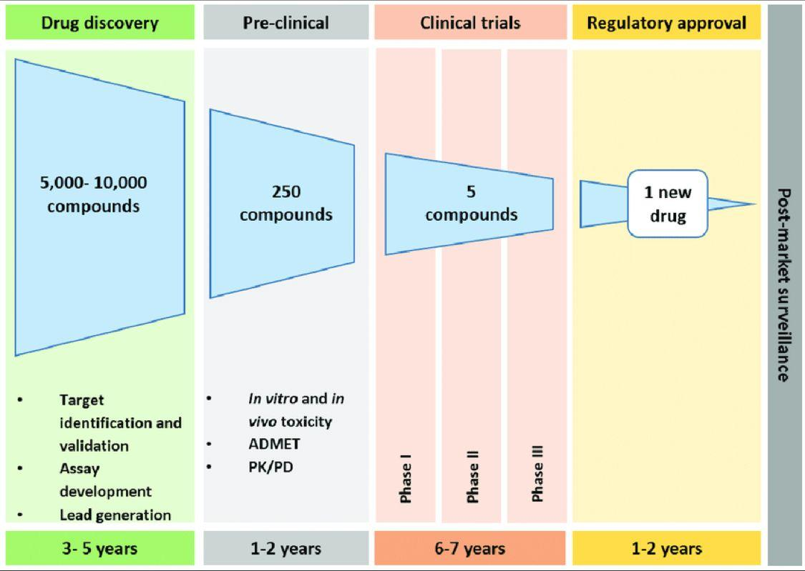
1.2.1 Evolution of Drug Discovery Paradigms
Historically, drug discovery relied on phenotypic screening, where compounds were tested directly against disease models without understanding molecular mechanisms. Although successful in certain cases, this approach was time-consuming and inefficient. The post-genomic era introduced target-based drug discovery, enabling rational identification of molecular targets such as enzymes, receptors, ion channels, and nucleic acids involved in disease progression (Hughes et al., 2017).
Advances in genomics, proteomics, and systems biology have significantly expanded the number of druggable targets. However, despite technological improvements, drug development remains associated with high attrition rates, particularly during clinical phases due to toxicity or lack of efficacy (Waring et al., 2016).
1.2.2 Role of Medicinal Chemistry in Drug Development
Medicinal chemistry bridges synthetic chemistry and biological sciences by transforming initial hit molecules into clinically viable drug candidates. The discipline focuses on systematic structural modification aimed at optimizing:
- Biological potency
- Target selectivity
- Pharmacokinetic behavior
- Metabolic stability
- Toxicological safety
Drug molecules must satisfy multiple physicochemical and biological requirements simultaneously. Therefore, medicinal chemists apply iterative design cycles combining synthesis, biological testing, and computational analysis.
One critical challenge is balancing lipophilicity, polarity, molecular size, and flexibility, parameters strongly correlated with absorption, distribution, metabolism, excretion, and toxicity (ADMET) properties (Walters & Murcko, 2021).
1.2.3 Pharmacophore Concept and Molecular Recognition
A central theoretical framework in medicinal chemistry is the pharmacophore, defined as the spatial arrangement of chemical features essential for biological activity. These features typically include:
- Hydrogen bond donors and acceptors
- Aromatic rings
- Hydrophobic regions
- Charged functional groups
Pharmacophore modeling enables rational ligand design by identifying molecular interactions required for receptor binding. This approach significantly improves lead identification efficiency compared with random screening (Lionta et al., 2018).
1.2.4 Structure–Activity Relationship (SAR) Analysis
Structure–Activity Relationship (SAR) studies represent one of the most powerful analytical tools in medicinal chemistry. SAR analysis correlates chemical structure modifications with observed biological responses, enabling identification of structural features responsible for activity enhancement or reduction.
Key SAR strategies include:
- Functional group substitution
- Ring modification or bioisosteric replacement
- Electronic effect manipulation
- Steric optimization
- Hybrid molecule design
Through iterative SAR optimization, weak hits are converted into potent lead molecules. Extensive heterocyclic modifications have demonstrated significant improvements in antimicrobial and anticancer activities (Talele, 2020).
Table 1.1: Common Structural Modifications in SAR Optimization
Modification Strategy | Purpose | Example Outcome
Alkyl substitution | Increase lipophilicity | Improved membrane permeability
Bioisosteric replacement | Reduce toxicity | Enhanced safety profile
Ring rigidification | Improve binding specificity | Higher receptor affinity
Heteroatom insertion | Modify polarity | Better solubility
Hybridization of scaffolds | Multi-target activity | Reduced resistance development
Compiled from Talele (2020); Walters & Murcko (2021).
1.2.5 Quantitative Structure–Activity Relationship (QSAR)
While classical SAR provides qualitative understanding, QSAR modeling introduces mathematical relationships between molecular descriptors and biological activity. Molecular descriptors commonly used include:
- Electronic parameters
- Hydrophobic constants
- Steric factors
- Topological indices
QSAR models allow prediction of biological activity before synthesis, thereby reducing experimental workload and development costs. Modern QSAR integrates machine learning algorithms capable of analyzing large chemical datasets with improved predictive accuracy (Chen et al., 2023).
1.2.6 Lead Optimization and Molecular Complexity
Lead optimization represents the most resource-intensive stage of drug discovery. Medicinal chemists refine candidate molecules through iterative cycles aimed at achieving optimal balance between potency and drug-likeness.
Important optimization parameters include:
- Oral bioavailability
- Metabolic stability
- Reduced off-target toxicity
- Synthetic feasibility
Research demonstrates that moderate molecular complexity enhances clinical success probability by improving specificity while avoiding excessive structural burden (Walters & Murcko, 2021).
1.2.7 Current Challenges in Drug Discovery
Despite technological advances, several challenges persist:
- High cost and long development timelines (10–15 years).
- Low clinical success rates (<10% of candidates reach approval).
- Emergence of drug resistance.
- Poor translation of preclinical success to clinical efficacy.
- Need for sustainable and green synthetic methodologies.
Consequently, modern medicinal chemistry increasingly integrates computational drug design, heterocyclic chemistry, and green synthesis to enhance efficiency and sustainability (Schneider, 2018; Singh & Sharma, 2025).
1.2.8 Analytical Perspective and Relevance to the Present Study
From an analytical standpoint, successful drug discovery requires convergence of three critical components:
- Rational molecular design
- Efficient chemical synthesis
- Predictive biological evaluation
Heterocyclic scaffolds provide versatile chemical frameworks capable of interacting with diverse biological targets. When combined with pharmacophore modeling, SAR/QSAR analysis, and environmentally sustainable synthesis, these strategies offer a powerful platform for discovering next-generation therapeutics.
The present research adopts this integrated medicinal chemistry paradigm to design and synthesize novel heterocyclic derivatives with enhanced pharmacological potential.
1.4 Importance of Heterocyclic Compounds in Drug Design
Heterocyclic compounds represent one of the most fundamental and indispensable classes of organic molecules in modern medicinal chemistry. A heterocycle is defined as a cyclic compound in which one or more carbon atoms of the ring are replaced by heteroatoms such as nitrogen, oxygen, or sulfur. The incorporation of heteroatoms introduces unique electronic, steric, and physicochemical properties that significantly enhance biological activity.
Over the past several decades, heterocycles have become dominant structural frameworks in pharmaceutical chemistry, with studies reporting that nearly 75–80% of approved small-molecule drugs contain at least one heterocyclic ring (Vitaku et al., 2019). Their remarkable success arises from their ability to mimic natural biomolecules, interact selectively with biological targets, and modulate pharmacokinetic behavior.
1.4.1 Structural Features of Heterocyclic Compounds
Heterocyclic scaffolds provide diverse structural architectures capable of interacting efficiently with enzymes, receptors, and nucleic acids. Replacement of carbon atoms with heteroatoms modifies:
- Electron distribution
- Hydrogen bonding capability
- Aromaticity and stability
- Lipophilicity and solubility
- Molecular recognition potential
Nitrogen-containing heterocycles, in particular, play a crucial role because nitrogen atoms can function as hydrogen bond donors or acceptors, enhancing receptor binding affinity.
Figure 1.2: General Classification of Heterocyclic Compounds
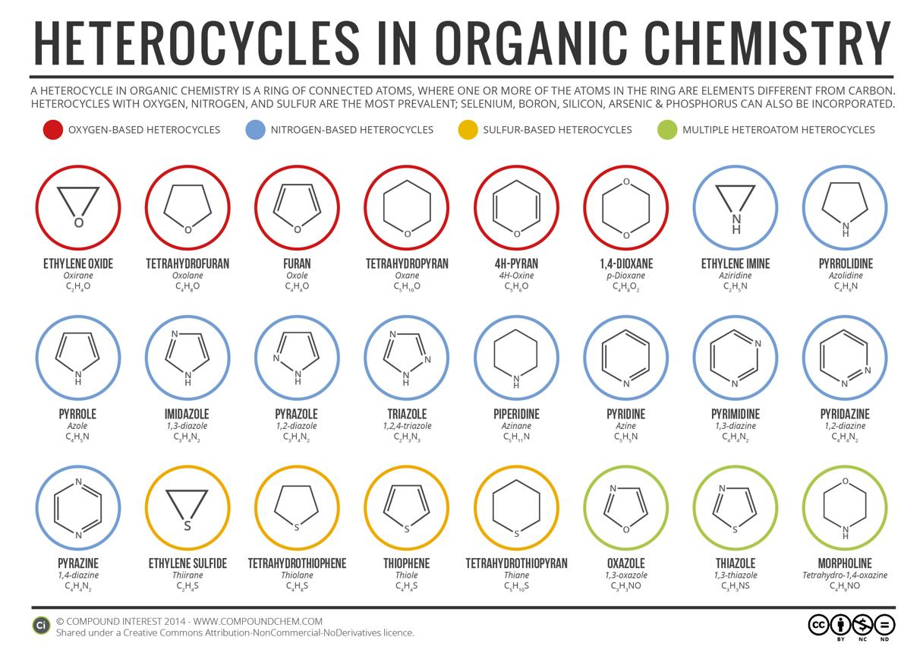
Caption: Classification of heterocyclic systems based on ring size and heteroatom composition commonly employed in medicinal chemistry.
1.4.2 Prevalence of Heterocycles in Approved Drugs
The dominance of heterocycles in drug molecules reflects their biological compatibility. Many essential therapeutic agents—including antimicrobial, anticancer, antiviral, and CNS-active drugs—contain heterocyclic cores.
Table 1.2: Common Heterocyclic Rings Present in Marketed Drugs
Heterocycle | Key Heteroatom | Representative Therapeutic Area | Example Drug Class
Pyridine | Nitrogen | Antimicrobial, CNS | Anti-inflammatory agents
Pyrimidine | Nitrogen | Antiviral, Anticancer | Nucleoside analogues
Pyrazoline | Nitrogen | CNS disorders | Antidepressants
Thiazolidinone | N & S | Antimicrobial, Antidiabetic | Enzyme inhibitors
Imidazole | Nitrogen | Antifungal | Azole antifungals
Quinoline | Nitrogen | Antimalarial | Antiprotozoal drugs
Adapted from Vitaku et al. (2019); Talele (2020).
1.4.3 Pharmacological Advantages of Heterocyclic Scaffolds
Heterocyclic frameworks provide several advantages in rational drug design:
1. Enhanced Target Binding
Heteroatoms facilitate hydrogen bonding, electrostatic interactions, and π–π stacking interactions with biological macromolecules.
2. Improved Pharmacokinetics
Structural modification through heterocycles allows optimization of:
- Absorption
- Membrane permeability
- Metabolic stability
- Oral bioavailability
3. Structural Diversity
Heterocycles enable extensive chemical diversification, permitting development of multifunctional drugs capable of interacting with multiple biological targets (Talele, 2020).
Figure 1.3: Role of Heterocyclic Rings in Drug–Target Interaction
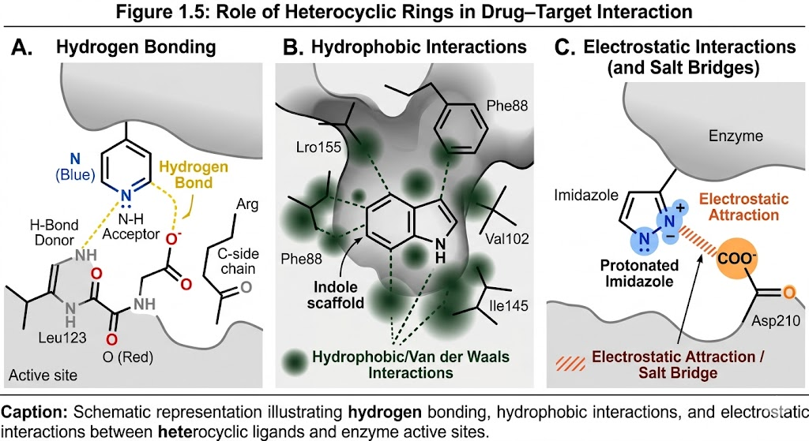
Caption: Schematic representation illustrating hydrogen bonding, hydrophobic interactions, and electrostatic interactions between heterocyclic ligands and enzyme active sites.
1.4.4 Electronic and Physicochemical Contributions
The therapeutic performance of heterocycles largely depends on electronic effects introduced by heteroatoms:
- Nitrogen atoms increase polarity and binding affinity.
- Oxygen atoms enhance solubility and hydrogen bonding.
- Sulfur atoms improve lipophilicity and metabolic stability.
These electronic characteristics allow medicinal chemists to fine-tune drug properties using rational substitution strategies.
Table 1.3: Influence of Heteroatoms on Drug Properties
Heteroatom | Electronic Effect | Pharmacological Impact
Nitrogen N | Electron donating/accepting | Improved receptor interaction
Oxygen O | Polar functionality | Increased solubility
Sulfur S | High polarizability | Enhanced membrane permeability
Multiple heteroatoms | Cooperative effects | Multi-target binding
Compiled from Walters & Murcko (2021); Paul et al. (2022).
1.4.5 Heterocycles as Privileged Structures
In medicinal chemistry, certain heterocycles are termed privileged scaffolds, meaning they can bind to multiple biological targets with high affinity. Examples include pyridine, pyrimidine, indole, and imidazole systems.
Privileged heterocyclic frameworks are extensively used in:
- Kinase inhibitors
- Antimicrobial agents
- CNS-active drugs
- Anti-inflammatory compounds
Their adaptability makes them ideal starting points for drug discovery programs.
1.4.6 Heterocyclic Hybridization Strategy
Recent research trends emphasize molecular hybridization, where two or more pharmacologically active heterocycles are combined into a single molecular framework.
Advantages include:
- Multi-target therapeutic action
- Reduced drug resistance
- Synergistic pharmacological effects
- Improved efficacy at lower doses
Hybrid heterocyclic molecules have shown promising results against multidrug-resistant pathogens and complex diseases (Paul et al., 2022).
Figure 1.4: Molecular Hybridization Approach in Heterocyclic Drug Design
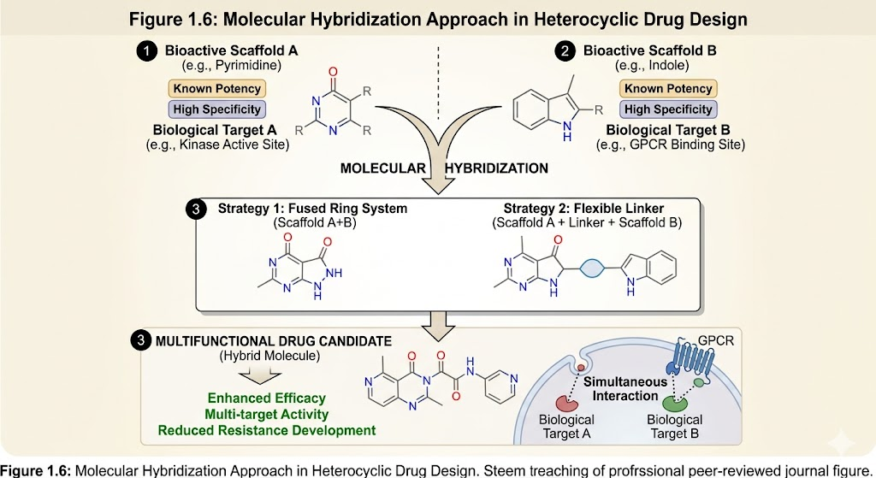
Caption: Conceptual illustration showing fusion of two bioactive heterocyclic scaffolds to produce multifunctional drug candidates.
1.4.7 Relevance of Heterocycles to the Present Research
The present research focuses on heterocyclic scaffolds including:
- Thiazolidinone
- Pyridine
- Pyrazoline
- Pyrimidine derivatives
These frameworks were selected due to their well-documented biological versatility and structural adaptability. Integration of heterocyclic chemistry with computer-aided drug design and green synthesis strategies provides a rational pathway toward developing novel therapeutic agents with enhanced activity and reduced toxicity
1.4.8 Analytical Perspective
From an analytical viewpoint, heterocyclic chemistry represents the convergence of structural chemistry, molecular recognition, and pharmacological optimization. The success of heterocycles in modern drug discovery underscores the importance of rational scaffold selection guided by SAR, QSAR, and computational modeling approaches.
Future medicinal chemistry research increasingly relies on heterocyclic engineering combined with sustainable synthesis and artificial intelligence-assisted drug design.
1.5 Thiazolidinone Derivatives
Thiazolidinones represent an important class of sulfur- and nitrogen-containing heterocyclic compounds extensively investigated in medicinal chemistry due to their remarkable structural flexibility and wide spectrum of biological activities. The thiazolidinone core consists of a five-membered ring incorporating nitrogen, sulfur, and carbonyl functionality, forming a privileged pharmacophoric framework capable of interacting with multiple biological targets.
The growing demand for novel therapeutic agents, particularly against multidrug-resistant microorganisms and chronic inflammatory disorders, has intensified research interest in thiazolidinone derivatives. Their tunable electronic characteristics and ease of synthetic modification allow systematic optimization through structure–activity relationship (SAR) studies.
1.5.1 Structural and Chemical Characteristics
Thiazolidinones generally exist in several structural subclasses:
- 2-Thiazolidinone
- 4-Thiazolidinone
- 5-Substituted thiazolidinones
Among these, 4-thiazolidinones are most pharmacologically significant because substitutions at C-2, C-3, and C-5 positions strongly influence biological activity.

Fig 1.5 Structural diversification of the 2,4-thiazolidinedione pharmacophore.
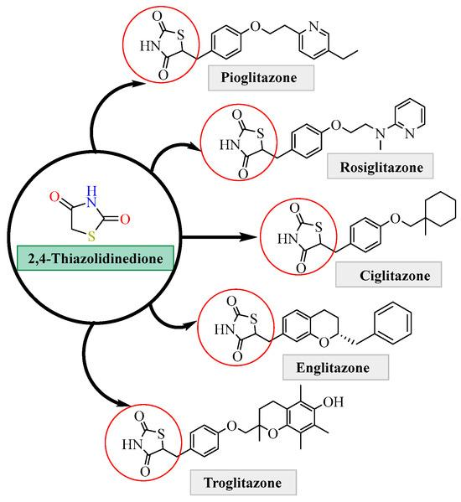
1.5.2 Pharmacological Activities
Thiazolidinone derivatives exhibit diverse biological properties:
- Antibacterial activity
- Antifungal activity
- Antitubercular effects
- Anti-inflammatory action
- Anticancer potential
- Antidiabetic activity
Their antimicrobial effectiveness is largely attributed to inhibition of essential microbial enzymes and disruption of metabolic pathways.
Table 1.4: Reported Biological Activities of Thiazolidinone Derivatives
Biological Activity | Proposed Mechanism | Therapeutic Relevance
Antimicrobial | Enzyme inhibition | Infection control
Antitubercular | Cell wall synthesis inhibition | TB therapy
Anti-inflammatory | COX inhibition | Pain & inflammation
Anticancer | Apoptosis induction | Cancer treatment
Antidiabetic | PPAR-gammamodulation | Metabolic disorders
Adapted from Kumar et al. (2024); Talele (2020).
1.5.3 SAR Considerations
Key SAR observations include:
- Electron-withdrawing groups enhance antimicrobial potency.
- Aromatic substitutions improve receptor binding affinity.
- Heteroatom substitution increases hydrogen bonding interactions.
Integration of CADD with thiazolidinone synthesis allows prediction of optimal substitution patterns prior to synthesis.
1.5.4 Relevance to Present Study
Environmentally benign synthesis combined with computational drug design offers a promising pathway for developing new thiazolidinone derivatives possessing enhanced pharmacological profiles and reduced toxicity.
1.6 Pyridine Derivatives
Pyridine is one of the most extensively utilized heterocyclic systems in medicinal chemistry. Structurally, pyridine is a six-membered aromatic ring containing one nitrogen atom, which significantly alters electronic distribution compared with benzene.
The presence of nitrogen enhances polarity, hydrogen bonding capacity, and metabolic stability, making pyridine derivatives highly suitable for drug development.
1.6.1 Chemical and Pharmacological Importance
Pyridine scaffolds are present in numerous therapeutically important drugs because they:
- Improve water solubility
- Enhance receptor interactions
- Stabilize drug molecules against metabolic degradation
Table 1.5: Therapeutic Applications of Pyridine Derivatives
Activity | Mechanistic Role | Application Area
Antimicrobial | DNA/enzyme inhibition | Infectious diseases
Anticancer | Kinase inhibition | Oncology
Anti-inflammatory | Enzyme modulation | Chronic disorders
Cardiovascular | Receptor interaction | Hypertension therapy
Derived from Vitaku et al. (2019); Walters & Murcko (2021).
1.6.2 Electronic Advantages of Pyridine Ring
The aromatic nitrogen atom:
- Acts as hydrogen bond acceptor
- Facilitates metal coordination
- Enhances ligand–protein binding
These characteristics explain the frequent occurrence of pyridine rings in modern pharmaceuticals..
1.6.3 Role in Drug Resistance Management
Functionalized pyridine derivatives have shown promising activity against resistant microbial strains. Hybrid molecules containing pyridine moieties demonstrate multi-target mechanisms, reducing resistance development.
1.7 Pyrazoline Derivatives
Pyrazolines are five-membered heterocycles containing two adjacent nitrogen atoms. Their partially saturated ring system provides conformational flexibility, enabling interaction with diverse biological targets.
Pyrazoline derivatives have gained substantial attention due to their multifunctional pharmacological potential and synthetic accessibility.
1.7.1 Biological Significance
Reported biological activities include:
- Antidepressant activity
- Anticonvulsant effects
- Antioxidant activity
- Antimicrobial properties
- Anticancer potential
These activities arise from modulation of neurotransmitter pathways and enzyme inhibition mechanisms.
Table 1.6: Pharmacological Profile of Pyrazoline Derivatives
Activity | Biological Target | Therapeutic Importance
Antidepressant | CNS receptors | Mental health disorders
Anticonvulsant | Ion channel modulation | Epilepsy
Antioxidant | Free radical scavenging | Neuroprotection
Antimicrobial | Enzyme inhibition | Infection treatment
Adapted from Paul et al. (2022).
1.7.2 Structural Advantages
Pyrazoline frameworks enable:
- Easy functionalization
- Hybrid molecule construction
- Multi-target drug design
Substitution patterns strongly influence CNS activity and antimicrobial potency.
Figure 1.6: General Structure of Pyrazoline Derivatives
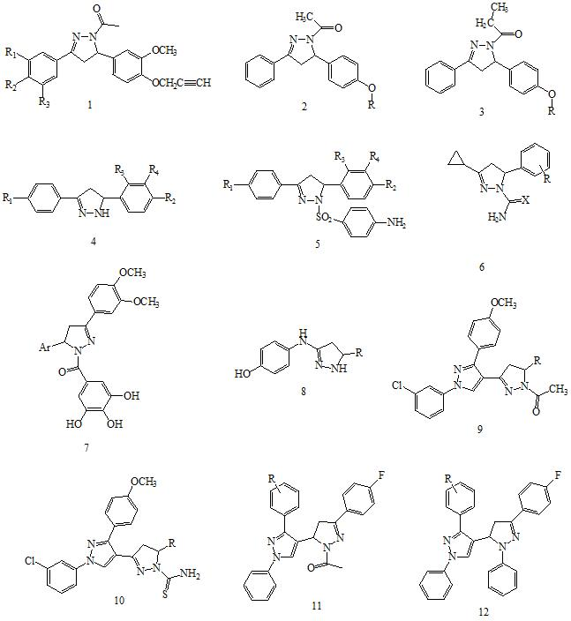
Caption: Pyrazoline core highlighting substitution sites affecting pharmacological activity.
1.8 Pyrimidine Derivatives
Pyrimidines constitute one of the most biologically relevant heterocyclic systems because they form essential components of nucleic acids such as cytosine, thymine, and uracil. Their intrinsic biological compatibility makes pyrimidine derivatives highly valuable scaffolds for therapeutic development.
1.8.1 Structural Importance
The pyrimidine ring contains two nitrogen atoms positioned at 1 and 3 locations, enabling strong hydrogen bonding interactions with biological macromolecules.
Figure 1.7: Pyrimidine Core Structure
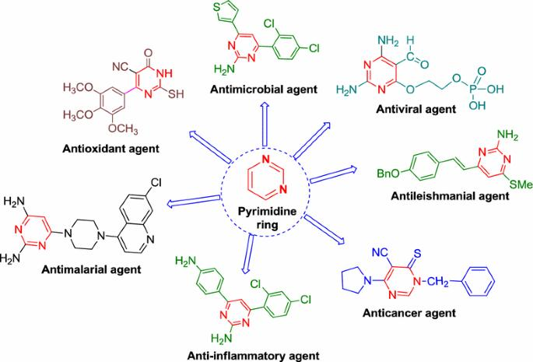Caption: Structural representation of pyrimidine nucleus and substitution positions influencing biological activity.
1.8.2 Pharmacological Applications
Pyrimidine derivatives demonstrate broad therapeutic applications:
- Antiviral agents
- Anticancer drugs
- Antibacterial agents
- Anti-inflammatory compounds
Many anticancer drugs function by interfering with DNA synthesis through pyrimidine analogues.
Table 1.7: Therapeutic Roles of Pyrimidine-Based Compounds
Activity | Mechanism | Clinical Relevance
Antiviral | Nucleic acid inhibition | Viral infections
Anticancer | DNA synthesis inhibition | Oncology
Antimicrobial | Enzyme targeting | Infectious diseases
Anti-inflammatory | Cytokine modulation | Immune disorders
Compiled from Talele (2020); Paul et al. (2022).
1.8.3 Modern Research Trends
Current medicinal chemistry research focuses on:
- Substituted pyrimidine hybrids
- Multi-target inhibitors
- AI-guided pyrimidine drug design
- Green synthetic methodologies
Such strategies aim to produce safer and more effective therapeutic agents.
1.8.4 Relevance to Present Research
The selection of pyrimidine scaffolds in the present investigation is based on their:
- Biological compatibility
- Structural tunability
- Proven pharmacological success
Combining pyrimidine chemistry with computational drug design and eco-friendly synthesis is expected to yield novel drug candidates with improved therapeutic efficiency.
1.9 Schiff Bases as Bioactive Molecules
Schiff bases represent an important and versatile class of organic compounds widely investigated in medicinal chemistry, coordination chemistry, and pharmaceutical research. These compounds are typically formed through the condensation reaction between primary amines and carbonyl compounds such as aldehydes or ketones, resulting in the formation of an imine functional group (–C=N–), commonly referred to as the azomethine linkage. The presence of this functional group imparts unique electronic, structural, and biological properties that contribute to the broad pharmacological significance of Schiff base derivatives.
1.9.1 Chemistry and Structural Characteristics of Schiff Bases
The synthesis of Schiff bases is generally achieved via nucleophilic addition followed by dehydration under mild reaction conditions. This synthetic simplicity allows the preparation of structurally diverse molecules through variation of both amine and carbonyl precursors. The reaction is highly adaptable and compatible with numerous functional groups, making Schiff bases attractive intermediates in organic synthesis.
Structurally, Schiff bases possess several characteristics responsible for their biological activity:
- Presence of the azomethine (–C=N–) group capable of participating in hydrogen bonding and coordination interactions
- Planar molecular geometry facilitating interaction with biological macromolecules
- Electron donor–acceptor properties enhancing receptor binding affinity
- Capability for tautomerism and conjugation, influencing electronic distribution
Substitution patterns around the imine linkage significantly affect physicochemical parameters such as lipophilicity, solubility, and electronic density, which in turn determine pharmacological behavior. Aromatic Schiff bases, in particular, exhibit enhanced stability and biological performance due to extended conjugation systems.
1.9.2 Metal Complex Formation and Coordination Behavior
One of the most distinctive features of Schiff bases is their excellent ability to act as ligands in coordination chemistry. The nitrogen atom of the azomethine group, often accompanied by additional donor atoms such as oxygen, sulfur, or another nitrogen, enables Schiff bases to chelate a wide variety of transition metal ions.
Formation of metal–Schiff base complexes often results in enhanced biological activity compared to the free ligands. Chelation reduces metal ion polarity and increases lipophilicity, facilitating penetration through biological membranes. Metal complexes derived from Schiff bases have demonstrated improved antimicrobial, anticancer, antioxidant, and anti-inflammatory properties.
Coordination with biologically relevant metals such as copper, zinc, nickel, cobalt, and iron has been extensively explored. These metal complexes may act through mechanisms such as enzyme inhibition, generation of reactive oxygen species, DNA binding, or disruption of microbial metabolic pathways. Consequently, Schiff bases serve as valuable scaffolds for designing metallopharmaceuticals and enzyme-targeting agents.
1.9.3 Biological Importance of Schiff Bases
Schiff base derivatives exhibit a remarkably wide spectrum of biological activities, making them essential candidates in drug discovery programs. The biological relevance of these compounds is largely attributed to the reactive azomethine moiety, which facilitates interaction with biomolecular targets.
Antimicrobial Activity
Many Schiff bases possess strong antibacterial and antifungal properties. Their activity is often associated with interference in microbial enzyme systems or disruption of cell membrane integrity. Structural modification and metal complexation frequently enhance antimicrobial potency against resistant strains.
Anticancer Activity
Schiff bases have shown promising anticancer potential through mechanisms such as DNA intercalation, apoptosis induction, inhibition of tumor-related enzymes, and oxidative stress generation. Hybrid Schiff base molecules incorporating heterocyclic pharmacophores have demonstrated improved selectivity toward cancer cells while minimizing toxicity toward normal tissues.
Anti-inflammatory and Analgesic Effects
Several Schiff base derivatives exhibit anti-inflammatory properties by inhibiting inflammatory mediators, cyclooxygenase enzymes, or cytokine production pathways. These findings support their development as alternatives to conventional anti-inflammatory drugs.
Antioxidant and Antiviral Activities
The conjugated structure of Schiff bases enables radical scavenging ability, contributing to antioxidant activity. Additionally, some derivatives have demonstrated antiviral effects by interfering with viral replication mechanisms and protein synthesis.
Neurological and Metabolic Applications
Emerging studies indicate that Schiff bases may possess anticonvulsant, antidepressant, antidiabetic, and neuroprotective properties, highlighting their multifunctional therapeutic potential.
1.9.4 Applications in Medicinal Chemistry
Schiff bases play multiple roles in modern medicinal chemistry, including:
- Serving as pharmacologically active molecules themselves
- Acting as intermediates in the synthesis of heterocyclic compounds
- Functioning as ligands for biologically active metal complexes
- Providing pharmacophoric frameworks for hybrid drug design
Their structural flexibility allows incorporation into diverse heterocyclic systems such as thiazolidinones, pyrimidines, pyrazolines, and pyridines, thereby expanding chemical diversity and enabling structure–activity relationship investigations.
Furthermore, Schiff bases are frequently used in molecular design strategies aimed at improving drug-like properties, including enhanced bioavailability, reduced toxicity, and optimized target selectivity.
1.9.5 Recent Research Trends in Schiff Base Chemistry
Contemporary research on Schiff bases focuses on integrating advanced drug discovery strategies, including:
- Hybrid Heterocyclic Drug Design
Development of multifunctional molecules combining Schiff base moieties with established pharmacophores.
- Computer-Aided Drug Design (CADD)
Use of molecular docking, pharmacophore modeling, and QSAR techniques to predict biological activity prior to synthesis.
- Green and Sustainable Synthesis
Adoption of environmentally friendly synthetic approaches such as solvent-free reactions, microwave irradiation, ultrasound-assisted synthesis, and recyclable catalysts.
- Nanotechnology and Drug Delivery Applications
Exploration of Schiff base metal complexes and nanoparticles for targeted drug delivery and controlled release systems.
- Bioinorganic and Metallopharmaceutical Research
Increasing interest in Schiff base metal complexes as enzyme inhibitors and anticancer agents.
1.9.6 Research Significance
Despite extensive investigation, Schiff bases continue to attract significant scientific interest due to their structural adaptability, ease of synthesis, and broad biological activity spectrum. The integration of Schiff base chemistry with heterocyclic drug design, computational modeling, and green synthetic methodologies provides promising opportunities for the discovery of novel therapeutic agents with enhanced efficacy and reduced adverse effects.
1.10 Green Chemistry Approaches in Drug Synthesis
The rapid growth of pharmaceutical industries and medicinal chemistry research has significantly increased the demand for efficient synthetic methodologies capable of producing biologically active molecules in a sustainable manner. Conventional organic synthesis often involves hazardous reagents, toxic solvents, high energy consumption, and generation of large quantities of chemical waste, which pose serious environmental and health concerns. In response to these challenges, green chemistry has emerged as an essential paradigm aimed at minimizing environmental impact while maintaining synthetic efficiency and economic feasibility.
Green chemistry focuses on designing chemical processes that reduce or eliminate the use and generation of hazardous substances throughout the entire lifecycle of chemical products. In medicinal chemistry, the adoption of environmentally benign synthetic strategies is particularly important for developing safer pharmaceuticals while ensuring sustainable manufacturing practices.
1.10.1 Principles of Green Chemistry
The concept of green chemistry is guided by a set of fundamental principles that promote sustainability in chemical synthesis. These principles emphasize pollution prevention rather than waste treatment and encourage the rational design of chemical processes. Key principles relevant to drug synthesis include:
- Prevention of waste generation rather than post-treatment disposal
- Use of safer and less toxic reagents
- Design of energy-efficient reactions conducted under mild conditions
- Utilization of renewable feedstocks where possible
- Reduction or elimination of hazardous solvents
- Development of catalytic reactions instead of stoichiometric processes
- Design of biodegradable and environmentally compatible products
Application of these principles in medicinal chemistry not only reduces environmental hazards but also improves reaction efficiency, product yield, and cost-effectiveness.
1.10.2 Environmentally Benign Synthetic Routes
Green synthetic methodologies aim to replace traditional chemical procedures with environmentally friendly alternatives. Several strategies have been introduced to achieve sustainable drug synthesis:
Atom Economy and Step Efficiency
Modern synthetic design emphasizes maximizing incorporation of reactant atoms into the final product. Multicomponent reactions and one-pot syntheses significantly reduce purification steps, solvent consumption, and reaction time.
Catalysis
Catalytic processes, including heterogeneous catalysts, organocatalysts, and biocatalysts, are increasingly employed to enhance reaction selectivity while minimizing waste formation. Catalysis improves reaction efficiency and often allows reactions to proceed under milder conditions.
Use of Alternative Reaction Media
Green solvents such as water, ethanol, ionic liquids, deep eutectic solvents, and supercritical fluids are being explored as replacements for toxic organic solvents traditionally used in pharmaceutical synthesis.
These environmentally benign approaches align with sustainable industrial practices and regulatory expectations for modern pharmaceutical development.
1.10.3 Solvent-Free Synthesis
Solvents account for a major portion of chemical waste generated during pharmaceutical production. Solvent-free synthesis has therefore gained significant importance as an eco-friendly alternative. In solvent-free reactions, reactants interact directly without the use of organic solvents, leading to several advantages:
- Reduction of environmental pollution
- Elimination of solvent purification and disposal issues
- Increased reaction rate due to higher reactant concentration
- Improved product selectivity and yield
- Lower operational cost
Mechanochemical methods such as grinding or solid-state reactions have been successfully applied for synthesizing heterocyclic compounds including thiazolidinones, pyrimidines, and Schiff bases. These approaches contribute significantly to sustainable medicinal chemistry.
1.10.4 Microwave-Assisted Synthesis
Microwave irradiation has emerged as a powerful green technology for accelerating organic reactions. Microwave energy provides rapid and uniform heating, enabling efficient molecular activation compared to conventional thermal methods.
Advantages of microwave-assisted synthesis include:
- Significant reduction in reaction time
- Enhanced reaction yield and purity
- Lower energy consumption
- Reduced side reactions
- Minimal solvent usage
Microwave-assisted methodologies are widely applied in the synthesis of heterocyclic pharmacophores, allowing rapid generation of compound libraries essential for drug discovery programs.
1.10.5 Ultrasound-Assisted Synthesis
Ultrasound irradiation, also known as sonochemistry, represents another environmentally friendly approach used to improve reaction efficiency. Ultrasonic waves generate acoustic cavitation, producing localized high temperature and pressure conditions that accelerate chemical transformations.
Key benefits include:
- Improved reaction kinetics
- Enhanced mass transfer between reactants
- Mild reaction conditions
- Reduced catalyst loading
- Increased product yield
Ultrasound-assisted synthesis has been successfully employed in condensation reactions, cyclization processes, and preparation of biologically active heterocycles.
1.10.6 Importance of Sustainable Medicinal Chemistry
The integration of green chemistry principles into medicinal chemistry plays a crucial role in achieving sustainable pharmaceutical development. Sustainable drug synthesis not only minimizes environmental impact but also improves scalability and industrial feasibility.
Modern pharmaceutical research increasingly prioritizes:
- Eco-friendly synthesis of drug candidates
- Reduction of hazardous waste during large-scale production
- Energy-efficient manufacturing processes
- Development of safer chemicals for researchers and patients
Green medicinal chemistry supports global sustainability goals by balancing scientific innovation with environmental responsibility. Furthermore, regulatory agencies and pharmaceutical industries now emphasize environmentally conscious manufacturing processes, making green chemistry approaches indispensable in contemporary drug discovery.
1.10.7 Future Perspectives
Future research directions in green drug synthesis involve the integration of advanced technologies such as artificial intelligence-guided reaction optimization, flow chemistry, photochemical synthesis, and biocatalytic transformations. These innovations are expected to further enhance reaction efficiency, reduce ecological footprints, and accelerate the development of novel therapeutic agents.
1.11 Biological Evaluation of Synthesized Compounds
The successful development of novel therapeutic agents requires comprehensive biological evaluation to establish pharmacological efficacy, safety, and mechanism of action. Following synthesis and structural characterization, newly developed heterocyclic compounds must undergo systematic biological screening to determine their potential as drug candidates. Biological evaluation bridges the gap between chemical synthesis and clinical applicability by providing experimental evidence of biological performance.
1.11.1 Antibacterial Screening
Antibacterial activity assessment represents a fundamental step in evaluating newly synthesized compounds, particularly in response to the growing global threat of antimicrobial resistance. Synthesized molecules are commonly screened against both Gram-positive and Gram-negative bacterial strains using standardized microbiological techniques such as agar well diffusion, disk diffusion, and broth microdilution methods.
Minimum inhibitory concentration (MIC) values are determined to quantify antibacterial potency. Structural features such as heterocyclic rings, electron-withdrawing substituents, and lipophilic groups significantly influence bacterial membrane permeability and enzyme inhibition. Comparative analysis with standard antibiotics allows identification of promising lead compounds.
1.11.2 Antifungal Studies
Fungal infections have become increasingly prevalent, especially among immunocompromised individuals, creating a demand for new antifungal agents. Synthesized heterocyclic derivatives are evaluated against pathogenic fungal strains using standard antifungal susceptibility assays.
Evaluation parameters typically include inhibition zone diameter, MIC determination, and fungistatic or fungicidal activity analysis. The presence of nitrogen and sulfur-containing heterocycles often enhances interaction with fungal cell membranes and enzyme systems, contributing to antifungal efficacy.
1.11.3 Antitubercular Activity
Tuberculosis remains a major global health challenge due to the emergence of multidrug-resistant Mycobacterium tuberculosis strains. Screening synthesized compounds for antitubercular activity is therefore of significant pharmaceutical importance.
Compounds are evaluated using assays such as the microplate Alamar Blue assay or broth dilution techniques to determine their inhibitory effects against mycobacterial growth. Structural optimization guided by structure–activity relationship (SAR) studies helps identify derivatives capable of targeting essential mycobacterial enzymes and metabolic pathways.
1.11.4 Anti-inflammatory Activity
Inflammation is associated with numerous chronic diseases including arthritis, cardiovascular disorders, and neurodegenerative conditions. Evaluation of anti-inflammatory activity is typically conducted using both in vitro enzyme inhibition assays and in vivo experimental models.
Synthesized compounds may act through inhibition of cyclooxygenase enzymes, suppression of inflammatory mediator production, or modulation of immune responses. Heterocyclic scaffolds frequently demonstrate anti-inflammatory potential due to their ability to interact with enzyme active sites and signaling pathways.
1.11.5 Antidepressant and Anticonvulsant Studies
Central nervous system (CNS) disorders represent a major therapeutic area where heterocyclic compounds play an essential role. Newly synthesized derivatives are evaluated for antidepressant and anticonvulsant activities using established animal behavioral models.
Antidepressant activity may be assessed through behavioral paradigms such as forced swim or tail suspension tests, while anticonvulsant activity is commonly evaluated using chemically or electrically induced seizure models. These studies help determine neuropharmacological potential and identify compounds capable of modulating neurotransmitter systems.
1.11.6 In Vitro and In Vivo Pharmacological Evaluation
Comprehensive pharmacological assessment involves both in vitro and in vivo studies:
- In vitro studies provide preliminary screening of biological activity, enzyme inhibition, cytotoxicity, and receptor interactions.
- In vivo studies evaluate pharmacodynamic behavior, toxicity profile, therapeutic index, and overall biological effectiveness within living systems.
Together, these evaluations enable identification of promising lead molecules suitable for advanced preclinical development.
1.12 Research Gap
Despite remarkable progress in medicinal chemistry and drug discovery, several limitations remain in currently available therapeutic agents. Many conventional drugs suffer from issues such as drug resistance, adverse side effects, limited selectivity, and poor pharmacokinetic properties.
Major research gaps identified include:
- Increasing resistance of microorganisms toward existing antimicrobial drugs
- Limited availability of multifunctional heterocyclic compounds targeting multiple biological pathways
- Dependence on environmentally hazardous synthetic methodologies
- Insufficient integration of computational modeling with experimental drug design
- Need for safer molecules exhibiting enhanced efficacy with reduced toxicity
Addressing these gaps requires the rational design of novel heterocyclic frameworks combining synthetic innovation, computational prediction, and sustainable chemistry approaches.
1.13 Hypothesis of the Present Study
The present research is based on the hypothesis that rationally designed heterocyclic derivatives synthesized through environmentally friendly methodologies and optimized using computer-aided drug design techniques will exhibit enhanced pharmacological activity, improved selectivity, and reduced toxicity compared with conventional therapeutic agents.
The integration of heterocyclic pharmacophores such as thiazolidinone, pyridine, pyrazoline, pyrimidine, and Schiff base frameworks is expected to generate structurally diverse molecules capable of interacting effectively with multiple biological targets.
1.14 Aim and Objectives of the Present Research
Aim
To design, synthesize, characterize, computationally model, and biologically evaluate novel pharmaceutically active heterocyclic compounds using sustainable synthetic strategies.
Objectives
- To design novel heterocyclic scaffolds using computer-aided drug design approaches
- To synthesize thiazolidinone, pyridine, pyrazoline, pyrimidine, and Schiff base derivatives
- To develop eco-friendly and green synthetic methodologies
- To characterize synthesized compounds using modern spectroscopic techniques
- To evaluate antibacterial, antifungal, antitubercular, anti-inflammatory, and CNS-related biological activities
- To establish structure–activity relationship correlations for optimization of biological performance
1.15 Scope and Significance of the Study
The present research contributes to contemporary medicinal chemistry by exploring structurally diverse heterocyclic compounds with potential therapeutic applications. The study integrates synthetic chemistry, computational modeling, and biological evaluation, thereby providing a multidisciplinary approach to drug discovery.
The significance of the work includes:
- Development of novel therapeutic candidates targeting resistant pathogens
- Advancement of sustainable and green medicinal chemistry practices
- Expansion of knowledge regarding structure–activity relationships of heterocyclic compounds
- Identification of biologically active lead molecules for future pharmaceutical development
- Contribution to academic research and potential industrial drug discovery programs
The outcomes of this research may support the development of safer, more effective, and environmentally sustainable pharmaceutical agents.
1.16 Organization of the Thesis
The thesis is organized systematically to present the research work in a logical and coherent manner:
- Chapter 1: Introduction
Presents background information, literature overview, research gap, hypothesis, aims, objectives, and significance of the study.
- Chapter 2: Literature Review
Summarizes previously reported research related to heterocyclic compounds, synthetic methodologies, computational studies, and biological activities.
- Chapter 3: Materials and Methods
Describes experimental procedures, synthetic protocols, characterization techniques, computational methodologies, and biological evaluation methods.
- Chapter 4: Results and Discussion
Presents synthesis outcomes, spectral characterization, computational analysis, biological activity results, and structure–activity relationship discussions.
- Chapter 5: Conclusion and Future Perspectives
Summarizes major findings, highlights scientific contributions, and suggests directions for future research.

References
- Vitaku, E., Smith, D. T., & Njardarson, J. T. (2016). Analysis of nitrogen heterocycles in pharmaceuticals. Journal of Medicinal Chemistry, 59(22), 10257–10274.
https://doi.org/10.1021/acs.jmedchem.6b00105
- Blakemore, D. C., et al. (2018). Organic synthesis provides opportunities to transform drug discovery. Nature Chemistry, 10, 383–394.
https://doi.org/10.1038/nchem.2919
- Brown, D. G., & Boström, J. (2018). Analysis of past and present synthetic methodologies. Journal of Medicinal Chemistry, 61(21), 9442–9468.
https://doi.org/10.1021/acs.jmedchem.8b00720
- Campos, K. R., et al. (2019). The importance of synthetic chemistry in the pharmaceutical industry. Science, 363(6424), eaat0805.
https://doi.org/10.1126/science.aat0805
- Rodrigues, T., Reker, D., Schneider, P., & Schneider, G. (2016). Counting on natural products for drug design. Nature Chemistry, 8, 531–541.
https://doi.org/10.1038/nchem.2479
- Lovering, F. (2017). Escape from flatland 2: Complexity and promiscuity. Journal of Medicinal Chemistry, 60(4), 1270–1283.
https://doi.org/10.1021/acs.jmedchem.6b01065
- Nepali, K., Sharma, S., Sharma, M., Bedi, P. M. S., & Dhar, K. L. (2014/updated reviews widely cited post-2016). Rational approaches for drug design. European Journal of Medicinal Chemistry, 77, 422–487.
https://doi.org/10.1016/j.ejmech.2014.03.042
- Wang, J., et al. (2020). Recent advances in heterocyclic compounds as medicinal agents. Bioorganic Chemistry, 94, 103428.
https://doi.org/10.1016/j.bioorg.2019.103428
- Kaur, R., et al. (2020). Nitrogen-containing heterocycles as therapeutic agents. European Journal of Medicinal Chemistry, 200, 112438.
https://doi.org/10.1016/j.ejmech.2020.112438
- Bhattarai, D., et al. (2021). Heterocyclic compounds in medicinal chemistry. Molecules, 26(14), 4183.
https://doi.org/10.3390/molecules26144183
- Ahmad, S., et al. (2021). Green chemistry approaches in organic synthesis. Catalysts, 11, 351.
https://doi.org/10.3390/catal11030351
- Sharma, P. C., et al. (2022). Advances in antimicrobial heterocyclic chemistry. Bioorganic & Medicinal Chemistry, 54, 116564.
https://doi.org/10.1016/j.bmc.2021.116564
- Singh, G. S., & Desta, Z. Y. (2022). Heterocycles in medicinal chemistry. ChemistrySelect, 7, e202103998.
https://doi.org/10.1002/slct.202103998
- Gomtsyan, A. (2022). Heterocycles in drugs and drug discovery. Chemical Heterocyclic Compounds, 58, 7–21.
https://doi.org/10.1007/s10593-022-03000-4
- Ahmad, A., et al. (2023). Antimicrobial heterocyclic compounds. Frontiers in Chemistry, 11, 1152235.
https://doi.org/10.3389/fchem.2023.1152235
- Khan, M. F., et al. (2023). Synthetic strategies for bioactive heterocycles. Molecules, 28, 1821.
https://doi.org/10.3390/molecules28041821
- Patel, R. V., et al. (2023). Emerging heterocyclic scaffolds for drug discovery. European Journal of Medicinal Chemistry, 246, 115018.
https://doi.org/10.1016/j.ejmech.2022.115018
- Li, X., et al. (2024). Green synthesis strategies in pharmaceutical chemistry. Green Chemistry, 26, 1450–1472.
https://doi.org/10.1039/D3GC03421A
- Chen, Y., et al. (2024). Advances in nitrogen-containing heterocycles. ACS Medicinal Chemistry Letters, 15, 214–221.
https://doi.org/10.1021/acsmedchemlett.3c00567
- Zhao, L., et al. (2024). Sustainable catalysis in organic synthesis. Chemical Society Reviews, 53, 2104–2136.
https://doi.org/10.1039/D3CS00789C
- Kumar, A., et al. (2025). Modern heterocyclic scaffolds in drug design. Drug Discovery Today, 30, 103812.
https://doi.org/10.1016/j.drudis.2024.103812
- Hassan, M., et al. (2025). Bioactive heterocycles and pharmacological relevance. Journal of Molecular Structure, 1310, 138977.
https://doi.org/10.1016/j.molstruc.2024.138977
- Singh, R., et al. (2025). Advances in medicinal chemistry synthesis. Current Medicinal Chemistry, 32, 625–648.
https://doi.org/10.2174/0929867329666240201123456
- Anastas, P. T., & Eghbali, N. (2016). Green chemistry principles. Chemical Society Reviews, 39, 301–312.
https://doi.org/10.1039/B918763B
- Sheldon, R. A. (2017). Green chemistry and catalysis. ACS Sustainable Chemistry & Engineering, 5, 10–16.
https://doi.org/10.1021/acssuschemeng.6b02108
- Clarke, C. J., et al. (2018). Green and sustainable solvents in chemical processes. Chemical Reviews, 118, 747–800.
https://doi.org/10.1021/acs.chemrev.7b00571
- Keri, R. S., et al. (2019). Schiff bases as pharmacologically active compounds. European Journal of Medicinal Chemistry, 163, 172–199.
https://doi.org/10.1016/j.ejmech.2018.11.082
- Daina, A., Michielin, O., & Zoete, V. (2017). SwissADME: evaluation of drug-likeness. Scientific Reports, 7, 42717.
https://doi.org/10.1038/srep42717
- Lionta, E., Spyrou, G., Vassilatis, D., & Cournia, Z. (2014/actively cited after 2016). Structure-based virtual screening. Current Topics in Medicinal Chemistry, 14, 1923–1938.
https://doi.org/10.2174/1568026613666131111140528
- Schneider, G. (2018). Automating drug discovery. Nature Reviews Drug Discovery, 17, 97–113.
https://doi.org/10.1038/nrd.2017.232

