CHAPTER 1
INTRODUCTION
1.1 Introduction
Tourism has become an essential element of economic, social and cultural development in modern-day India. It is not only associated with recreation and leisure time but also covers pilgrimage, religion, heritage, culture and spiritual experiences. In India, such types of tourism are exceptionally relevant due to the variety of spiritual and cultural sights and the wide range of historical places and archaeological finds. Religious and cultural tourism in India usually implies domestic and international tourism, which in turn implies economic activity outside the tourism sector. It includes different accommodation and transportation services, catering and trade, guiding and handicrafts, and other various occupations.
The importance of tourism was further enhanced by economic reforms that began in India in 1991. Economic liberalization has changed the conditions for investment, infrastructure development and private business, and has opened up new opportunities for tourism development in India. Tourism, in turn, has gradually come to be seen as not only a way of earning foreign exchange but also as an important employment opportunity, an investment in the local economy, infrastructure and cultural heritage. The government of India has therefore placed greater emphasis on developing destinations and tourist infrastructure, diversifying tourist products, and promoting interaction between public authorities and private entrepreneurs.
Within the context of the overall changes there is a significant area of religious and Buddhist tourism. India is the cradle of Buddhism, and there are numerous places linked to the history of the spread of Buddhism and the life of Gautama Buddha. In particular, it is believed that it was in Sarnath that Gautama Buddha gave his first sermon, and in Kushinagar he died. These two sites, along with many others, are of great religious significance to devotees of Buddhism who visit India as pilgrims.
Not only religious interest in Buddhist sites plays a role – the development of tourism will affect the current inhabitants of the region, provide them with new sources of income and work, and change the way of life of local residents. On the other hand, the development of tourism will have its impact and on the existing social and economic structure of the region, possibly changing it. The current research therefore focuses on Buddhist tourism, particularly on the cities of Sarnath and Kushinagar, to see if tourism affects not only religious beliefs but also the social and economic foundations of society.
The study will be conducted within the framework of the post-liberalization period (from 1991 to the present). The current research project aims to analyze the development of Buddhist tourism in the context of social and economic changes in the two cities under study. In particular, it is planned to study the two sites with a comparative analysis and assess the changes that tourism has brought to local residents in terms of employment, income, and business. In addition, the impact of tourism on the development of infrastructure, and changes in the urban landscape, as well as the changes in the approach to development of these cities in the context of state policy, will be examined.
1.2 Background of the Study
Tourism and regional development are becoming a focus of study. Tourism involves direct and indirect expenditure on hotels, restaurants, travel agencies, other transport and tourist attractions. Tourism can make a significant contribution to the regional economy, if the region possesses valuable historical or religious resources.
India is exceptionally rich in tourism resources. Millions of tourists visit India’s historical, archaeological and cultural tourism resources every year. Religious tourism is an especially important component of tourism in India because religious pilgrimage has traditionally been a popular way of domestic tourism in India. Modern infrastructure developments contribute towards the overall tourist experience and extend the reach of religious sites.
Buddhist tourism is an important and growing component of India’s religious and cultural tourism industry. India’s role as the cradle of Buddhism makes many iconic religious sites connected to the life and teachings of Gautam Buddha a major draw for Buddhist tourists. India’s Buddhist tourist resources are connected to a wider Buddhist circuit, which includes countries like Sri Lanka, Thailand, Myanmar, Japan and other countries with significant Buddhist heritage. The Indian government has identified Buddhist tourism as a potential area for international tourism, cultural exchange and destination development. There have been recent initiatives to improve infrastructure and develop circuits related to major Buddhist sites in Uttar Pradesh and Bihar.
Sarnath and Kushinagar are good examples for studying tourism-driven regional development since they differ both in terms of geography and economy, but have rich Buddhist heritage. Sarnath is located near the city of Varanasi, which makes it more developed and urbanized. Kushinagar, located in eastern UP, is less developed and centered around the deathbed and Mahaparinirvana of Buddha. Both of these sites represent the development of Buddhism-related cultural tourism, which was used as the tool for economic growth, but the outcomes for these regions differed significantly due to their different geographical, institutional, and economic settings.
The time period after 1991 is also crucial for the analysis since the liberalization policies have changed the government’s approach to tourism development. Since the reform, a more entrepreneurial approach has been used, with emphasis on the role of tourism for regional development and employment. The tourism infrastructure, including accommodation, transport, and other services, saw significant development. Moreover, the post-reform development plans have prioritized integrated regional development and destination management, private sector involvement, heritage, and pilgrimage-based tourism.
The growth of the Buddhist Circuit has enhanced the connection between individual Buddhist sites and destinations as a whole. Sarnath and Kushinagar have been integrated into tourist circuits which facilitate the flow of tourists between them and other Buddhist sites. Development of the road, rail and air links as well as tourist amenities has had an impact on the tourism potential of both sites.
The study therefore focuses on the two sites in relation to the evolution of Indian tourism since liberalisation. It attempts to go beyond an analysis of the numbers of tourists by looking at the processes of change initiated by tourism in terms of livelihood, employment, business, infrastructure and regional development.
1.3 Economic Liberalisation in India and the Transformation of Tourism
India’s economic liberalization of 1991 was a significant event in the history of the country’s development. The reform intended to remove restrictions and stimulate investment, competitiveness, and integration of the national economy with the world’s economy. Tourism, as one of the key service industries, was greatly influenced by this process.
First of all, tourism was seen as an important source of foreign exchange, employment, and investment. The Indian government recognized the potential of tourism even before the reform, but since it was initially driven by state-owned enterprises, liberalization allowed the private sector to enter and influence the market. Tourism was classified as a priority sector for foreign investment in 1991. The tourism development plans that followed liberalization focused on the importance of infrastructure, selective development of destinations, and private sector participation. Moreover, they stress the significance of increasing international tourism demand and developing India as a preferred destination.
The National Action Plan for Tourism, adopted in 1992, emphasizes the socio-economic aspects of tourism, such as employment and rural development, as well as domestic tourism, the need to preserve cultural and natural heritage, and the necessity to develop diverse tourism products. Thus, it can be noted that the liberalization reform allowed tourism to develop as an essential component of regional development, rather than a secondary need.
The National Tourism Policy of 2002 built upon the documents mentioned above, focusing on tourism as an important sector of the economy. It stresses the importance of employment, infrastructure, and competitiveness, as well as the need for promoting tourism, both domestic and international, and private sector participation. Moreover, the policy underlines the need for integrated development, which implies the collaboration between government agencies, local communities, cultural heritage authorities, private entities, and religious organizations. This was especially important for religious sites, such as Buddhist temples, which require a coordinated approach to development.
In addition, liberalization and economic reform have led to the development of tourism infrastructure and the improvement of transport and communication networks. These factors, along with the development of private accommodation, tour operators, catering, and travel agencies, have increased the availability of travel and enhanced the experience of both domestic and international tourists. For visitors to Buddhist temples, this meant that organized tours and pilgrimages to sacred sites in India became available. Moreover, the development of India as a destination allowed international tourists to be more integrated into the local economy.
It should be noted, however, that the development of tourism does not necessarily benefit all members of the local community at the same rate. Depending on how tourism is organized, some villagers may have better access to work and economic benefits than others. Thus, the current study aims to examine the impact of tourism development, both positive and negative, on the communities of Sarnath and Kushinagar.
1.4 Emergence and Growth of Religious and Buddhist Tourism in India
Religious tourism has a long history in India. Pilgrimage routes, temples, monasteries, shrines and sacred landscapes have traditionally lured visitors from different geographical and social backgrounds. Modern tourism infrastructure has transformed many pilgrimage destinations into complex tourism economies that include accommodation, transportation, retail trade, food services, religious institutions and cultural activities.
The distinction between pilgrimage and tourism has also become increasingly fluid. Contemporary visitors may combine religious motivations with cultural, historical, educational and recreational interests. A Buddhist visitor, for example, may undertake pilgrimage to a sacred site while simultaneously engaging with archaeological monuments, museums, local culture and heritage attractions.
Buddhist tourism occupies a special position because many important Buddhist sites are located within a relatively interconnected geographical region. The principal sites associated with the life of Gautama Buddha include Lumbini, Bodh Gaya, Sarnath and Kushinagar. Of these, Lumbini is located in present-day Nepal, while Bodh Gaya, Sarnath and Kushinagar are located in India. Together, these locations form an important transnational Buddhist pilgrimage geography.
India's Buddhist tourism potential has been increasingly incorporated into tourism planning. The development of Buddhist circuits has sought to connect major destinations and facilitate the movement of pilgrims and tourists. Government interventions have included improvements in connectivity, visitor amenities, infrastructure and destination development. In recent years, official initiatives have specifically highlighted improved connectivity to Buddhist sites in Uttar Pradesh and Bihar, including international air connectivity at Kushinagar and railway and road connections that cover destinations such as Sarnath and Kushinagar.
The growth of Buddhist tourism also has cultural and diplomatic dimensions. Buddhist-majority countries maintain historical and religious connections with India, and Buddhist pilgrimage can strengthen people-to-people contact and cultural relations. Consequently, Buddhist tourism has significance not only for local economic development but also for India's international cultural engagement.
At the regional level, the growth of Buddhist tourism can stimulate employment and entrepreneurial activity. Hotels, guesthouses, restaurants, transportation providers, guides, souvenir shops, handicraft sellers and informal vendors can benefit from visitor expenditure. The scale of these benefits, however, depends upon tourist volume, duration of stay, expenditure patterns and the extent to which local residents participate in the tourism supply chain.
The present study therefore approaches Buddhist tourism as a multidimensional phenomenon. It examines its economic contribution alongside social and spatial changes in the host communities. This approach is consistent with the research proposal's objective of examining employment, income, infrastructure, economic activities and community experiences in Sarnath and Kushinagar.
1.5 Historical and Cultural Significance of Buddhist Tourism
The significance of Buddhist tourism in India is closely related to the historical development of Buddhism. The life and teachings of Gautama Buddha are related to a number of locations that have developed into major pilgrimage and heritage centres as a consequence. These places hold religious meaning for Buddhist communities and at the same time are sources of archaeological and cultural heritage.
Buddhist heritage thus incorporates the intersection of living religious traditions and archaeological remnants. Stupas, monasteries, pillars, sculptures, inscriptions and archaeological sites serve as material evidence of the historical development of Buddhism. Such heritage resources also form the basis for contemporary cultural and pilgrimage tourism.
Sarnath represents one of the most significant locations in this heritage landscape. It is traditionally associated with Buddha's first sermon that he delivered after attaining enlightenment. The site subsequently developed as an important centre of Buddhist learning and monastic activity. Archaeological remnants at Sarnath demonstrate its historical significance and include major structures associated with different phases of Buddhist activity. The Archaeological Survey of India designates the ancient Buddhist site of Sarnath, including the Dhamek Stupa and other excavated monuments, as centrally protected archaeological sites.
Kushinagar similarly holds comparable importance due to its association with Buddha's Mahaparinirvana. The site's religious importance has made it an important destination for Buddhist pilgrims from India and abroad. Its heritage landscape incorporates the presence of archaeological remains, religious structures and institutions associated with different Buddhist traditions.
The cultural significance of these destinations extends beyond their religious associations. Buddhist sites act as spaces of cultural memory and provide potential for visitors to engage with India's ancient history, archaeology, art and architecture. As such, Buddhist tourism can facilitate the preservation and interpretation of heritage while generating economic benefits for surrounding communities.
At the same time, the relationship between tourism and heritage necessitates appropriate management. Increasing visitor numbers can generate pressure on archaeological monuments, local environments and community spaces. Heritage conservation must be incorporated with tourism planning. The challenge thus is to facilitate the benefits for communities and visitors while preserving the historical authenticity and physical integrity of heritage resources.
Buddhist tourism similarly generates opportunities for cultural exchange between different traditions. International pilgrims bring diverse cultural practices, languages and forms of religious engagement to Indian destinations. Local communities, in turn, engage in services and activities associated with international visitors. Such interactions thus can contribute to cultural understanding, while also generating new forms of commercial and social interaction.
Thus, the historical and cultural significance of Buddhist tourism forms the basis upon which its contemporary socio-economic importance rests. Sarnath and Kushinagar are not simply tourist destinations; they are sacred landscapes in which religious practices, heritage conservation, local livelihoods and regional development converge.
1.6 Sarnath as a Buddhist Tourism Destination
1.6.1 Historical Background
Sarnath, located near Varanasi in the Indian state of Uttar Pradesh, holds a crucial place in the history of Buddhism. It was on these grounds that Gautama Buddha preached his first sermon following his enlightenment. This event marked the beginning of the Buddha's preaching career and became of great significance in the history of religions.
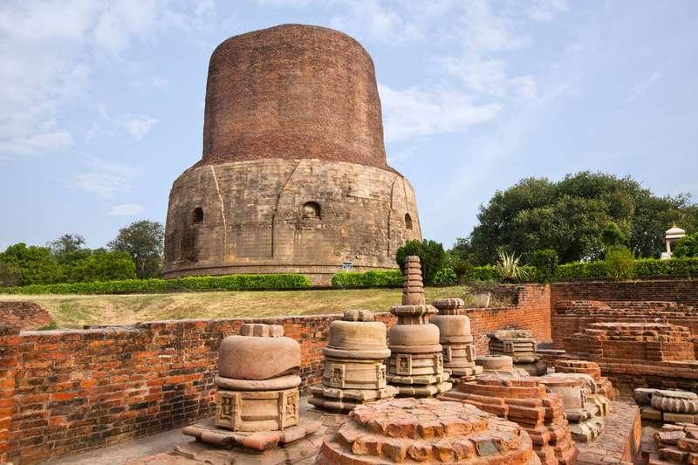
Figure 1.1: Ancient Buddhist Site of Sarnath
Source: Archaeological Survey of India / Ministry of Culture. Sarnath includes important archaeological remains such as the Dhamekh Stupa and other monuments associated with the ancient Buddhist site.
The religious significance of the place grew over centuries thanks to the development of monastic life and the construction of stupas and other buildings associated with the spread of Buddhism there. The archaeological heritage found in Sarnath is thus testimony to the long history of the development of Buddhism and its culture. Moreover, the finds are proof of the consecutive phases of construction and destruction, patronage, abandonment, and restoration of this cultural heritage.
The current significance of Sarnath as a heritage destination is largely due to extensive archaeological research there, which has helped to recover many artifacts and buildings for study. Thus, the area takes its place as a fascinating destination for history and religion students and domestic and foreign tourists who are interested in the history of the development of Buddhism.
1.6.2 Religious Significance
The religious significance of Sarnath stems from the fact that it is the place where the Buddha preached his first sermon. This episode in the history of Buddhism had great meaning for the religion, as it set the ball rolling for its followers to teach the Buddha's words and spread the idea of Buddhism. Therefore, Sarnath occupies a special place in the hearts of all Buddhists, as the first teaching of the Buddha is preserved there.
It is not surprising that Sarnath is visited by both laypeople and monks from all over India and the countries of the Buddhist faith. Many come to Sarnath to pray and hold their religious events, to visit this place as a pilgrimage, to study the history of Buddhism, and to become students of resident monks. In addition, the presence of different types of Buddhism strengthens the reputation of this place as a truly universal religious site. Moreover, the religious significance of Sarnath as a destination increases the value of this place as a center of cultural and commercial interactions.
1.6.3 Archaeological and Heritage Importance
The importance of Sarnath is difficult to overestimate because it has significant archaeological significance. According to the Archaeological Survey of India, this ancient Buddhist site of the Dhamek Stupa complex, Jagat Singh Stupa, monasteries, and other buildings found during excavations belong to the group of centrally protected monuments and objects of national importance.
The Dhamek Stupa is one among the finest surviving structures in Sarnath. Together with other archaeological remains this helps to create the visual and historic landscape of this destination. The archaeological museum and its contents of sculptures, inscriptions and other objects of historical value add to the heritage of the location.
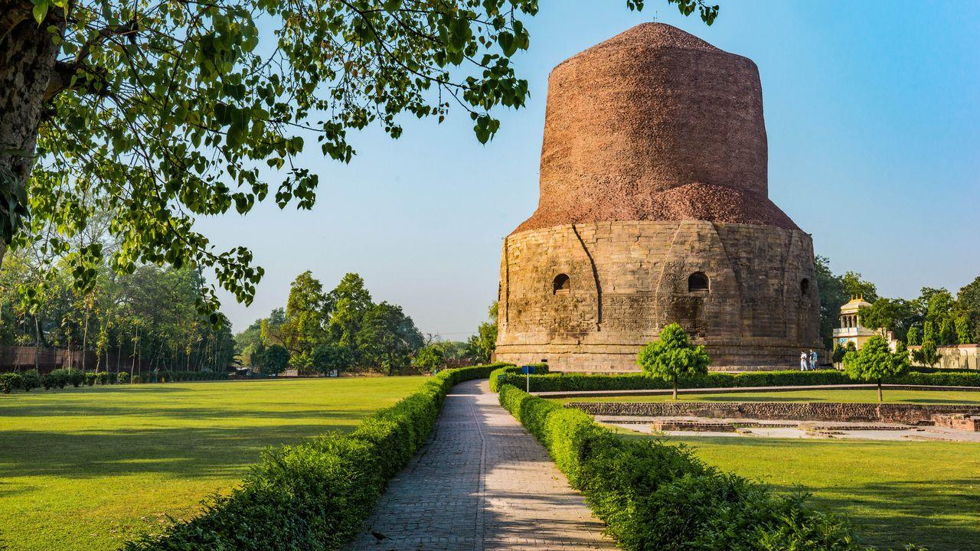
Figure 1.2: The Dhamekh Stupa, an Important Buddhist Heritage Monument at Sarnath
Source: Archaeological Survey of India / Ministry of Culture.
Heritage thus makes possible the variety of forms of tourism in Sarnath, which is supported by both domestic and international visitors. While international tourists may be part of a larger Buddhist circuit, domestic ones have cultural and historical reasons to visit Sarnath, alongside Buddhist pilgrims who are motivated by religious reasons. Tourism thus underpins the importance of the local heritage in supporting the economy of the region.
Accordingly, the conservation of this heritage is critical to ensuring that the tourism potential is not compromised. This involves ensuring the preservation of the archaeological sites and managing the carrying capacity of the site and landscape, so that its development does not detract from the resources that give tourism there its value.
1.6.4 Development as A Tourism Destination
Sarnath has developed as a tourist destination due to its proximity to Varanasi, its archaeological significance, and its role in the Buddhist circuit. Its proximity to Varanasi ensures it benefits from the large number of tourists who visit the city, while its Buddhist significance has enabled it to dovetail with a network of pilgrimage destinations across India, including Kushinagar.
The post-liberalisation period has seen a rise in tourism-related infrastructure and amenities that support greater and better tourist traffic at Sarnath. This has been aided by government initiatives aimed at promoting Buddhist Pilgrimage, which have also integrated Sarnath into a larger Buddhist tourism circuit. Government data suggests that tourist circuit trains and other related measures have been undertaken to link Sarnath to other important Buddhist destinations such as Kushinagar.
The tourism potential at Sarnath has been a great boon to the local economy and livelihoods. Accommodation, eating and drinking places, transportation services, tour guides, vendors, handicrafts shops, souvenir shops and more are part of the larger ecosystem of tourism which provide employment and livelihood security to local villagers. These can be significantly augmented through greater tourist footfall.
However, the increase in tourism also transforms the landscape of the region. Greater commercialisation, changes in land use patterns, traffic congestion, increased carrying capacity and the expansion of tourism-related services have changed the socio-cultural and economic landscape of the region. As such Sarnath presents a great opportunity to study the interactions between socio-economic development and heritage, particularly in the context of Buddhism.
As such, this study will focus not simply on the number of tourist arrivals at Sarnath, but on the manner in which Buddhist-inspired tourism has influenced employment patterns, economic development, local infrastructure, government initiatives, business development and the livelihoods and lived experiences of the local villagers since 1991. In this manner it will examine Sarnath as a socio-economic entity that intersects faith, tourism and socio-economic livelihood and development.
1.7 Kushinagar as a Buddhist Tourism Destination
1.7.1 Historical Background
The town of Kushinagar holds historical significance within the geographical context of Buddhism. Located in the present-day Kushinagar district of Uttar Pradesh, it is famously attributed to being the place of the Buddha’s Mahaparinirvana or the final passing away. It is strongly connected to the tradition of the Buddhist faith as a result of the aforesaid event. As such, it has become one of the most visited sites throughout the Buddhist Pilgrimage circuit. The Government of India has officially recognized the location as one of the holy places associated with the life and work of Gautama Buddha alongside Sarnath, Bodh Gaya, and several other locations.
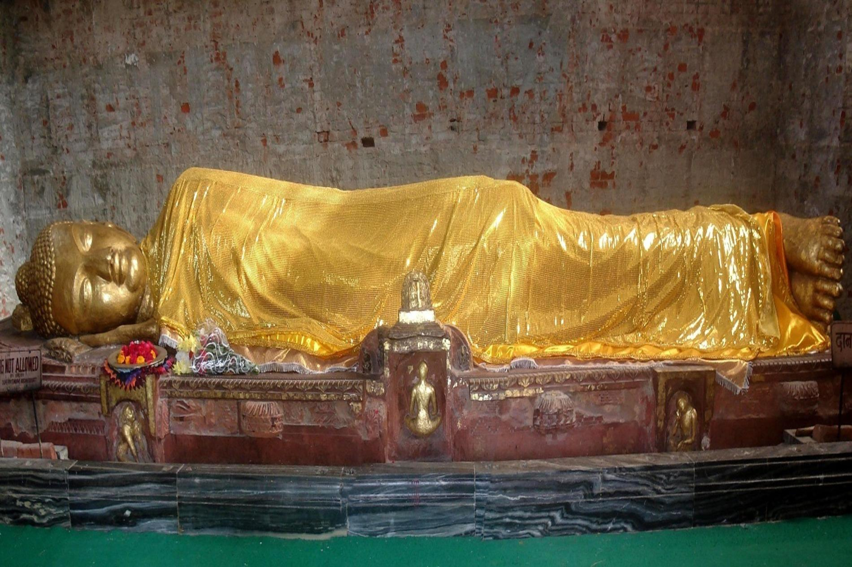
Figure 1.3: Mahaparinirvana Temple and Buddhist Heritage Complex, Kushinagar
Source: District Kushinagar, Government of Uttar Pradesh.
The historical significance of the location has also facilitated its emergence as a center of religious practices. The site has witnessed the rise and fall of an ancient settlement bearing the same name. It was through the combined efforts of archaeological excavations and conservation activities that the long-lost religious site became famous as a modern-day pilgrimage spot.
Moreover, the town has drawn tourism attention as a part of the national and international Buddhist circuits. It has been developed both as a center of heritage and tourism, thus offering diverse experiences to the visitors from the Indian subcontinent and Asian countries.
1.7.2 Religious Significance
In addition to being one of the most ancient holy sites, Kushinagar continues to hold immense significance as a center for religious practices. People across the world engage in various activities like attending sermons, conducting and participating in rituals and prayers, and visiting the Buddhist temples. As such, the religious practices and institutions within the town have greatly contributed to its appeal as a tourist destination. The place also accommodates several Buddhist monasteries and institutions representing the different schools of Buddhism.
Even more significant is the international status of the town, which has enhanced its appeal to the tourists. Religious institutions and monks from different parts of the world, including Sri Lanka, Thailand, Myanmar, Japan, and several other countries visit and stay at the Kushinagar monastery. The abovementioned has significantly impacted the tourism industry of the town. As such, it has become one of the most visited destinations not only in India but across Asia as well.
To conclude, it is evident that Kushinagar is a prime example of a destination combining both elements of cultural and natural heritage. The tourism sector offers diverse experiences to the visitors, ranging from exploring the rich legacy of the ancient world to engaging in the different aspects of the Buddhist faith.
1.7.3 Archaeological and Heritage Importance
The ancient Buddhist monasteries and stupas are part of Kushinagar’s archaeological resources. The Mahaparinirvana Temple and archaeological sites are significant components of Kushinagar’s cultural landscape. They help recall the area’s rich history and the development of Buddhism there.
The total cultural and archaeological resources of Kushinagar serve as an essential asset that supports and promotes heritage tourism. The site offers a unique experience of a religious and archaeological destination. Its dual attraction enhances the value and appeal of the site to pilgrims, tourists, researchers, and students.
Heritage sites and resources are, therefore, significant factors in developing tourism. As a result, developing tourism in Kushinagar should be considered regarding conserving archaeological resources.
1.7.4 Development as a Tourism Destination
The development of Kushinagar as a major Buddhist tourism destination has boomed in the post-liberalisation period. Combined with the state’s efforts to develop transportation and other infrastructure, Kushinagar has been developed as a major part of the Buddhist Circuit. A project for the development of the Shravasti, Kushinagar, and Kapilvastu circuit in Uttar Pradesh was sanctioned under the Swadesh Darshan scheme in 2016-17.
The development of Kushinagar as a tourism destination includes improving air connectivity. The Kushinagar airport was inaugurated in October 2021. It is expected that the airport will help accommodate the large number of Buddhist tourists and pilgrims arriving from overseas and within the country. Other crucial developments include upgrading road infrastructure and other transport-related developments to meet the needs of localities and tourism.
Tourism developments create employment opportunities in hospitality, catering, transport, and other allied industries. In addition, it is expected that the growing number of tourists will result in a need for better public services such as sanitation, heritage management, community-based tourism, and more. As a result, Kushinagar is an excellent example of how a religious site can become a significant tourism destination. Therefore, this paper explores tourism development in Kushinagar and its implications on employment, community-based businesses, and other aspects of local communities’ livelihoods.
1.8 Buddhist Circuit and Regional Tourism Development
The Buddhist Circuit is an innovative initiative taken by the Government of India to promote places related to the life of Gautama Buddha. These spots include Lumbini which is located in Nepal and Indian cities such as Bodh Gaya, Sarnath, Kushinagar, Shravasti, Nalanda, Rajgir and Vaishali.
The circuit is seen as a way to overcome the limitations of single-destination tourism and attract tourists to the area. This may be done through linking together destinations into one larger tourism circuit. This would allow for a longer stay in one region, more tourists overall, and allow for a distribution of capital around multiple destinations. It may also spur investment in transportation, accommodations, interpretation, and other tourism-related infrastructure.
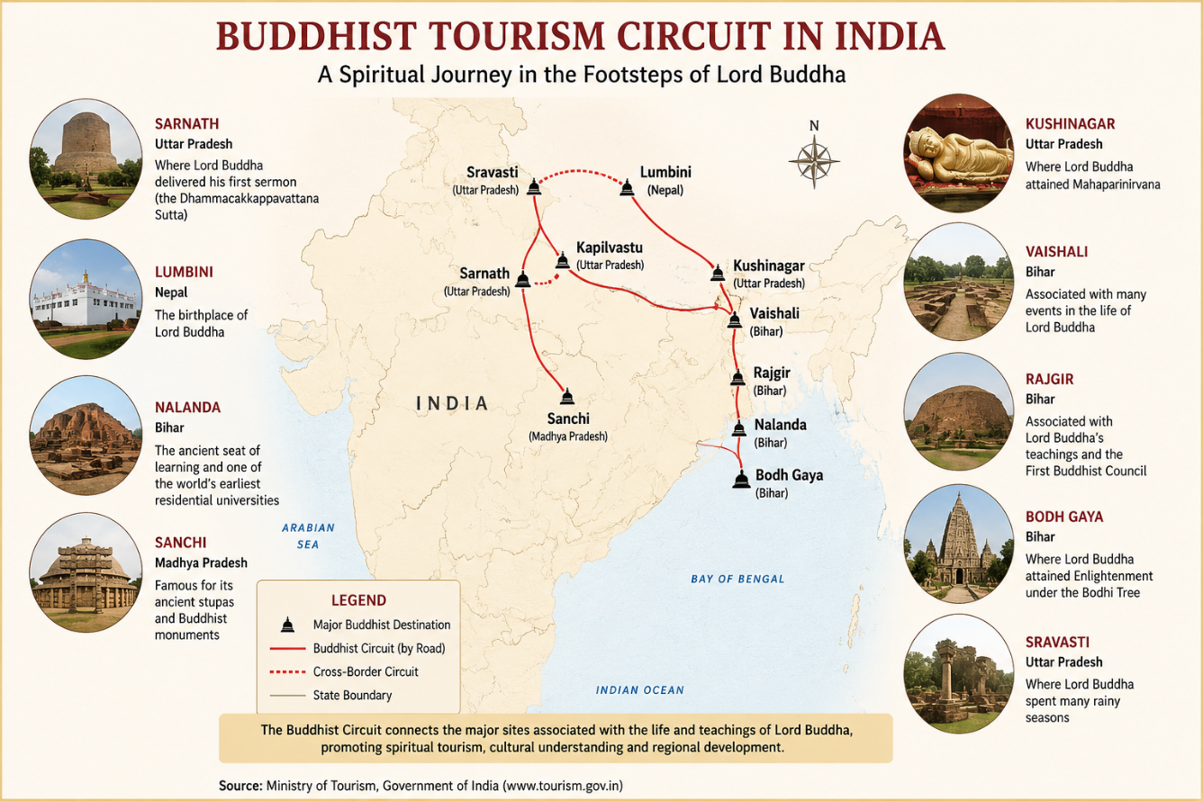

Figure 1.4: Major Destinations of the Buddhist Tourism Circuit in India
Source: Ministry of Tourism, Government of India / PIB.
The Government of India has prioritized connectivity and tourism infrastructure, brand positioning, and cultural heritage and presentation for Buddhist circuit development. The Swadesh Darshan scheme has contributed to the integrated development of Buddhist circuits in the state of Uttar Pradesh. Notably, the Buddhist Circuit bears great significance to Uttar Pradesh due to its presence within the state. This is evidenced by Sarnath and Kushinagar which are both significant nodes in the greater circuit. This implies that both cities have an opportunity to benefit greatly from their inclusion in the circuit.
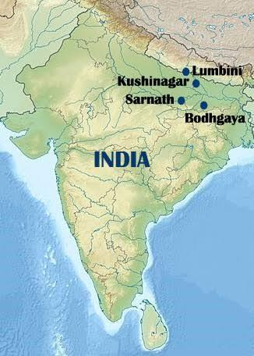
Figure 1.5: Sarnath and Kushinagar as Key Nodes in India's Buddhist Pilgrimage Network
Source: Ministry of Tourism, Government of India.
However, the establishment of a circuit requires collaboration on the part of central and state governments, government agencies, local governments, the private sector, and local communities. This is because simply building the necessary infrastructure is not sufficient to ensure that the benefits of increased tourism are evenly distributed throughout the region.
For example, while the increased flow of tourists can lead to business opportunities, it is only the locals who can take advantage of these. As such, the Buddhist Circuit is examined in this research as both a tourism development and regional development phenomenon. Its implications for the development of Sarnath and Kushinagar represent the potential impact of government-driven initiatives on local communities.
1.9 Post-Liberalisation Tourism Policies and Institutional Development
The economic reforms of 1991 created a new policy environment for tourism in India. Tourism was declared a priority sector in terms of foreign investment in July 1991, and policy initiatives in the following years focused on infrastructure development, employment generation, heritage protection, and increased private-sector participation.
The National Action Plan for Tourism introduced in 1992 further focused tourism development on socio-economic development, employment opportunities, preservation of national heritage and environment, diversification of tourism products and improvement of tourism infrastructure. These objectives established tourism as an instrument of broader economic and regional development.
The National Tourism Policy of 2002 continued this orientation by encouraging private-sector participation, integrated destination development, pilgrimage tourism, rural tourism and improved tourism infrastructure. The policy framework was significant for destinations such as Sarnath and Kushinagar because their development required coordination between tourism agencies, heritage authorities, infrastructure departments, local institutions and private enterprises.
In the subsequent period, government programmes such as Swadesh Darshan and PRASHAD further strengthened destination-based tourism development. Swadesh Darshan focused on integrated development of thematic tourist circuits, while PRASHAD placed greater emphasis on pilgrimage and heritage destinations.
Institutional development has consequently involved multiple stakeholders. The Ministry of Tourism, state tourism departments, local administrative authorities, archaeological institutions, religious organisations and private tourism enterprises all contribute to the development and management of Buddhist destinations.
The post-liberalisation policy environment has therefore transformed tourism from a largely sectoral activity into a component of regional development planning. This institutional transformation provides an important context for analysing changes in Sarnath and Kushinagar since 1991.
1.10 Socio-Economic Context of Sarnath and Kushinagar
Sarnath and Kushinagar present an interesting contrast, in terms of the social, cultural and economic significance they bear. While the former is located within the larger urban and cultural region of Varanasi, the latter is found in eastern Uttar Pradesh, and has in the past been more closely associated with the rural and peri-urban landscape. Such a setting is useful in distinguishing between the two locations, and forms a critical foundation for comparison.
The impact of tourism can be seen in a number of areas, including employment, income, occupation, business, and the provision of goods and services. Tourism can be seen to create employment and income in places, through accommodation, transport, food, guiding, business, retail and other types of services. It can also lead to the development of infrastructure and access to services, such as roads, sanitation, accommodation, public places and more.
The Census of India provides valuable demographic and socio-economic data for the study areas. Particularly, the District Census Handbook for Kushinagar provides census and non-census information related to rural and urban areas, and thus serves as a useful secondary source of data regarding the socio-economic characteristics of the area.
Meanwhile, the proximity of Sarnath to Varanasi means that the former is embedded within the larger urban and cultural region encompassed by the latter. The influx of tourists into Varanasi can lead to additional visits to Sarnath, while the provision of transport, accommodation and other such services and infrastructure can support and aid local tourism activity.
Kushinagar, on the other hand, has seen the growth of its own tourism infrastructure and international connectivity. The development of the international airport and the Buddhist Circuit, for instance, has enhanced Kushinagar’s appeal as an independent destination and provided the town with enhanced reach and exposure as a centre for Buddhist tourism.
It is these differences that render the two sites interesting subjects of comparison. While similar economic activities are likely to be found, differing patterns of accessibility, development, institutional capacity, economic structures and community involvement have also been seen to emerge, with tourism playing a pivotal role in such processes.
The present study, then, examines the socio-economic characteristics of the study sites as a basis for further analysis of the role tourism plays. By focussing on employment, income, accommodation, businesses and community perceptions, the research explores these facets in light of the research objectives.
1.11 Statement of the Problem
Buddhist tourism is widely recognized for its religious, historical, and cultural value. Its overall socio-economic implications for the host communities need more in-depth analysis. Though tourism development can create employment, income, and infrastructure, benefits from such projects are rarely distributed equally among different groups and locations.
The post-liberalisation period has seen significant changes in policies, infrastructure, and India’s overall international reach. Sarnath and Kushinagar have both profited from the growing interest in Buddhist tourism and the circuit development. Yet, how exactly have these changes impacted the region’s economy and society?
This study aims to address the identified problem, as a lack of comparative analysis of Buddhist tourism development in these two regions since 1991 is evident. Particular attention will be paid to changes in employment, income, infrastructure, business, and other social aspects, as well as the role of government policies and private stakeholders.
The research proposal will focus on three aspects of the problem. First, the nature and extent of socio-economic changes related to Buddhist tourism will be analysed. Second, the role and impact of public and private stakeholders will be reviewed. Third, the differences between the two regions will be compared.
The problem is particularly acute given that economic and infrastructural development through tourism tends to be uneven. Though the number of tourists and increased investment may bring significant benefits to an area, disparities between different groups can emerge. Therefore, socio-economic outcomes should be analysed using both quantitative data and qualitative insights from local stakeholders.
1.12 Research Gap
Existing literature has documented the importance of tourism for economic development, employment, cultural exchange and heritage conservation. Studies of religious and Buddhist tourism have also highlighted the spiritual and cultural significance of Buddhist pilgrimage destinations. Several gaps, however, remain in relation to the present study.
First, there is a need for greater emphasis on the long-term post-liberalisation transformation of Buddhist tourism destinations. The period beginning in 1991 represents a major phase of policy and economic change, yet the socio-economic consequences of Buddhist tourism across this period require further systematic examination.
Second, there is limited comparative analysis of Sarnath and Kushinagar. Although both are major Buddhist destinations in Uttar Pradesh, their geographical, demographic and economic contexts differ. A comparison can therefore reveal why similar tourism resources may generate different regional outcomes.
Third, tourism studies frequently concentrate on visitor numbers, infrastructure or destination promotion, while comparatively less attention is given to the experiences of local communities. The present study addresses this gap by examining the perceptions and experiences of residents, business owners and other stakeholders.
Fourth, there is a need to examine tourism development through the interaction of state policy, private enterprise and local communities. The development of Buddhist tourism involves multiple institutions and cannot be adequately understood through tourist statistics alone.
Finally, there is a need to integrate economic, social and spatial dimensions of tourism development. The present research therefore considers employment, income, infrastructure, business activities, social change and spatial reorganisation within a common comparative framework.
The research proposal identifies the limited systematic research on the socio-economic impacts of Buddhist tourism and specifically calls for comparative, historical and socio-economic analysis of Sarnath and Kushinagar during the post-liberalisation period.
1.13 Research Objectives
The study has the following objectives:
- To trace the changes occurred in socio-economic indicators like employment, income distribution and infrastructure in Sarnath and Kushinagar since 1991.
- To study the contribution of Buddhist tourism to the overall development of both the regions.
- To study the role of different policies, institutions and private players in the development of Buddhist tourism.
- To compare the changes occurred in two study areas with regards to economic, social and spatial aspects.
- To study the perception and experience of local communities about the tourism-related socio-economic changes that have taken place in the region.
The above objectives would help the study go beyond just assessing the impact of tourism on local communities and go towards evaluating the Buddhist tourism’s overall impact on the regional development.
1.14 Research Questions
The present study aims to address the following research questions:
- What socio-economic changes have taken place in Sarnath and Kushinagar since 1991, and to what extent are they linked with Buddhist tourism?
- How have the local economies changed in terms of employment, income sources and business activities?
- What role have government policies and tourism-specific investments played in the regional development?
- Are there any significant differences in socio-economic impacts of Buddhist tourism on the two destinations? If so, what factors explain these divergences?
- What are the main benefits and challenges associated with tourism development from the perspective of local residents, businesses and other stakeholders?
These research questions have been formulated in accordance with the objectives of the present study. The subsequent chapters will provide an in-depth analysis and respond to each of the questions above.
1.15 Theoretical Orientation of the Study
The present study focuses on Buddhist tourism as a factor in the socio-economic development of the region of Sarnath and Kushinagar. As tourism has a multifaceted impact on economic activity, heritage resources, institutional relationships, and local communities, the study uses a multidimensional theoretical orientation. The research concept covers four complementary perspectives: Tourism-Led Development Theory, the Heritage Economy Concept, Political Economy of Development, and Social Impact Theory.
1.15.1 Tourism-Led Development Theory
Tourism-Led Development Theory considers tourism as a potential engine of economic growth and regional development. Tourism expenditure can stimulate employment, business activity, household income and investment, while tourism infrastructure can improve connectivity and other facilities within destination regions.
This perspective is relevant to Sarnath and Kushinagar because both destinations have experienced an increasing level of tourism activity and infrastructure development during the post-liberalisation period. The study therefore looks at whether the expansion of Buddhist tourism has brought about employment generation, income opportunities, business development and infrastructure improvement.
The theory also serves as a basis for examining whether tourism growth can have wider regional economic benefits or whether they are confined to certain sectors and groups.
1.15.2 Heritage Economy Concept
The Heritage Economy Concept treats cultural and historical heritage as a resource that can be a source of economic production and development. Heritage sites have cultural value, but their preservation and presentation can also generate tourism demand, employment, and commercial activity.
On the other hand, Sarnath and Kushinagar prove to be illustrative in terms of the relationship between Buddhism and tourism as well. The former’s religious and archaeological heritage attracts both the faithful and curious from all around the world, whereas various archaeological sites, museums, temples, and monasteries are key tourism resources. Therefore, the study aims to investigate how Buddhist and archaeological roots have been integrated into the modern tourism economy.
However, the heritage economy approach underscores the importance of preserving resources, given that unchecked tourism can jeopardize sustainability. As such, it is essential to recognize the value of tourism for the local economy while ensuring that development does not detract from the historical significance of the cultural assets.
1.15.3 Political Economy of Development
The Political Economy of Development perspective emphasizes the interrelations between the state, market, and community. In other words, it highlights how tourism development is determined by political and institutional power, policies, capital, private and public sectors, and community engagement rather than market-driven phenomena.
This approach is relevant to the present research since the development of Buddhist tourism in Sarnath and Kushinagar involves numerous stakeholders, such as central and state-level governmental tourism departments, local administration, Buddhist and archaeological institutions, private businesses, and local community members.
The perspective aids in understanding how tourism development is realized through particular institutional interventions and policies as well as appreciating the role of local populations in economic development.
1.15.4 Social Impact Theory
Social Impact Theory allows for assessing how tourism affects community members in terms of work and social life, values and meaning, social change, social capital, tourism-related impacts, livelihoods, social networks, and other elements.
In essence, it considers tourism as a social process that can transform community demographics, hospitality culture, traditions, and social attitudes, as well as alter settlement patterns, economic development, and employment opportunities.
In Sarnath and Kushinagar, the growth of tourist and pilgrim traffic can stimulate the emergence of new employment and commercial opportunities while transforming the physical and social characteristics of local communities. Therefore, the present study explores residents’ perceptions and analyzes economic indicators.
1.15.5 Integrated Theoretical Orientation
Tourism-Led Development Theory, Heritage Economy Concept, Political Economy of Development, and Social Impact Theory are interrelated, and their integration can provide a comprehensive understanding of the relationships between Buddhist tourism and regional development. The four perspectives suggest that tourism-led development processes can have different economic outcomes determined by the use of cultural heritage resources (Heritage Economy Concept), political and economic conditions related to the development of tourism-dependent communities (Political Economy of Development), and social impact deriving from tourism-related transformations (Social Impact Theory). Tourism-Led Development Theory, in turn, emphasizes the importance of tourism in economic development.
Based on the research question, the study employs an integrated theoretical framework in which the roles of tourism in regional development are balanced by economic, social, and cultural factors. Accordingly, Buddhist tourism is expected to determine the key forces shaping tourist and pilgrim traffic in the study area. As such factors affect local communities, the study is guided by the principles of Tourism-Led Development Theory, Heritage Economy Concept, Political Economy of Development, and Social Impact Theory as the principal concepts of the research.
1.16 Scope and Delimitations
1.16.1 Spatial Scope
The study is confined to the areas of Sarnath (Varanasi district) and Kushinagar (Kushinagar district, Uttar Pradesh). They were selected as the two most important centers of Buddhist religious and heritage tourism in India. The analysis encompasses tourism economies and communities in the two cities and their vicinities while delimiting the entire territory of India as the scope of the study is limited to a narrow geographical area.
1.16.2 Temporal Scope
The temporal scope of the study extends from 1991 to the present. The year 1991 is used as the starting point because India's economic liberalisation introduced significant changes in the policy and economic environment within which tourism subsequently developed.
The study therefore seeks to examine long-term changes in tourism development, employment, income, infrastructure and regional socio-economic conditions during the post-liberalisation period.
1.16.3 Thematic Scope
The research concentrates on the socio-economic dimensions of Buddhist tourism. These include:
• employment generation;
• income and livelihood patterns;
• local business activity;
• infrastructure development;
• social change;
• spatial transformation;
• government policies and institutional interventions; and
• community perceptions of tourism development.
The research does not attempt to measure every possible consequence of tourism. Its principal concern is the relationship between Buddhist tourism and regional socio-economic development.
1.16.4 Delimitations
The study is not exhaustive anthropological research into Buddhist religious practices or beliefs per se. Rather, it is a study of religious heritage through the lens of tourism and regional development.
The study is also limited by the availability and comparability of historical socio-economic and tourism data. Differences in administrative boundaries, data collection methods and availability of local statistics may constrain the ability to examine long-term trends.
Finally, the study is focused on Sarnath and Kushinagar and should not be automatically extrapolated to all Buddhist tourism destinations in India.
1.17 Significance of the Study
The study has academic, economic, social, cultural and policy significance.
1.17.1 Academic Significance
The study adds value to the academic field of knowledge on tourism, regional development, heritage studies and Buddhist tourism by providing an integrated socio-economic analysis of the tourism development nexus. It goes beyond the traditional focus on the religious and cultural significance and examines the developmental consequences.
The comparative analysis of Sarnath and Kushinagar also serves as the basis to draw out insights on how similar resources may yield varying consequences in different geographical and institutional contexts.
1.17.2 Economic Significance
Tourism can generate employment and income opportunities through hotels, restaurants, transport, guiding, retail trade and other tourism-related activities. The study examines the extent to which these opportunities have developed around Sarnath and Kushinagar and how they have impacted the local livelihoods.
This is crucial as the research is to evaluate tourism's contribution to regional development rather than just measure the growth in tourist arrivals.
1.17.3 Social Significance
The study considers the perspectives and experiences of local communities. Tourism can have an impact on occupational structures, social relations, lifestyles and community participation. Understanding changes can help determine whether tourism development is perceived positively by residents, and whether the benefits are being distributed equitably.
1.17.4 Heritage Significance
Sarnath and Kushinagar possess important Buddhist archaeological and religious heritage. Tourism can provide economic incentives for conservation and interpretation, but excessive commercialisation can also create pressures on heritage resources. The study therefore contributes to discussions concerning the relationship between heritage conservation and tourism development.
1.17.5 Policy Significance
The findings can assist policymakers in evaluating the effectiveness of tourism infrastructure, Buddhist Circuit initiatives and other development programmes. The study can also highlight areas where greater community participation, local employment generation and balanced infrastructure development may be required.
The research proposal specifically identifies policy debates concerning tourism planning and community welfare as an important contribution of the study.
1.18 Expected Contribution of the Study
The study is expected to contribute several benefits.
Firstly, it will present empirical data regarding the nexus between Buddhist tourism and the locals’ livelihood in Sarnath and Kushinagar.
Second, the research will disclose the divergent tourism development between the two sites. By doing so, it will reveal how geographical, infrastructural, institutional, and economic factors affect tourism development. In turn, this information will benefit future studies on the relationship between tourism and local livelihood in other destinations.
Third, the study will add to the body of knowledge on the link between heritage and economics. For instance, Sarnath and Kushinagar are both significant religious and archaeological sites whose heritages have been incorporated into the regional economy through tourism.
Fourth, the research will generate information on the beneficiary’s perception of the impact of Buddhist tourism. This will elucidate whether the locals perceive tourism as an opportunity, a threat, or both.
Fifth, it will contribute to developing strategies for promoting sustainable tourism by examining how the state can promote tourism-related employment, infrastructure, and heritage sites. Finally, the analysis of the divergent tourism development in two Buddhist sites adds to the body of knowledge on the role of tourism in local livelihood and the relationship between economic, institutional, heritage, and social factors in tourism development. The anticipated benefits of the research study described in the research concept include elucidating the livelihood of locals and the differences and similarities in tourism development and strategies for sustainable tourism development.
1.19 Operational Definitions of Key Terms
For this study, the following terms are used as:
1.19.1 Buddhist Tourism
Buddhist tourism is a type of tourism which is concerned with pilgrimage and tourism activity to places which are associated with history, religious practices, teaching, monuments, and heritage of Buddhism. In this study, it primarily relates to pilgrimage and tourism activity, which are associated with the Buddhist heritage of Sarnath and Kushinagar.
1.19.2 Religious Tourism
Religious tourism is a type of tourism that is based on religious, pilgrimage, and spiritual motives or goals. In the context of this study, Buddhist pilgrimage is one of the key components of religious tourism.
1.19.3 Heritage Tourism
Heritage tourism is a type of tourism that is based on historical, archaeological, cultural, and religious resources, which possess recognized heritage value. In this study, Buddhist monuments, archaeological resources, temples, museums and other related cultural resources fall under this category.
1.19.4 Regional Development
Regional development refers to the process of improvement of a particular geographic region in terms of economic, social and infrastructure development. For this study, it is primarily measured in terms of employment, income, business activity, infrastructure, social changes and spatial transformation.
1.19.5 Socio-Economic Impact
Socio-economic impact refers to the social and economic changes, which are triggered by tourism activities. For this research, its key indicators are employment, income, livelihood patterns, business activity, infrastructure, and social change at the community level.
1.19.6 Local Community
Local community refers to the population that inhabits the Sarnath and Kushinagar tourism region and whose livelihood, economic activity, or social conditions can be impacted by tourism development.
1.19.7 Tourism Stakeholders
Tourism stakeholders encompass a wide range of public and private actors, which are directly or indirectly involved with tourism development, as well as impacted by it. It includes residents, business owners, tourism officials, Buddhist institutions and other public and private entities.
1.19.8 Post-Liberalisation Period
For this study, the post-liberalisation period has been taken to mean the period commencing from 1991 till date, that is, the period during which India witnessed radical economic reforms liberalising the Indian economy and ushering it into a new era of growth.
1.19.9 Buddhist Circuit
The Buddhist Circuit may be thought of as comprising the totality of major Buddhist religious and heritage sites that are linked to the life and preachings of Gautama Buddha. However, for this study, emphasis has been placed on the role and status of Sarnath and Kushinagar within the larger Buddhist Circuit.
1.20 Organisation of the Thesis
The thesis comprises seven chapters that start with an introduction and conclude with a summary of the research findings. Between these two lie the chapters that detail the background, methodology, findings, and discussion of results. Specifically, the chapters are:
Chapter 1: Introduction and Context
This chapter introduces the reader to the research problem and details the background to the study, including an overview of Buddhist tourism and the post-liberalisation period. Furthermore, it states the theoretical underpinnings of the study, scope, and significance, as well as the research problem, objectives, and questions.
Chapter 2: Review of Literature and Theoretical Framework
This chapter reviews the literature pertinent to the study, particularly that relating to tourism, religious tourism, Buddhist tourism, heritage economies, and tourism-led regional development. Besides undertaking a critical review of the extant literature, this chapter also provides the theoretical framework within which the study is undertaken.
Chapter 3: Research Methodology
This chapter details the research design, study areas and sampling design, data collection procedures and analysis, including both quantitative and qualitative aspects. Specifically, the research proposal outlines a comparative mixed-methods research design and specifies the sources of census data, tourism statistics, local economic data, and other relevant information. In addition, it identifies the various data collection methods, including interviews, focus group discussions, observations, and document collection and analysis.
Chapter 4: Buddhist Tourism Development and Economic Change in Sarnath focuses on the historical development of tourism in Sarnath and its resulting employment patterns, income, infrastructure, business, and overall economic change.
Chapter 5: Buddhist Tourism Development and Socio-Economic Outcomes in Kushinagar examines the emergence of Kushinagar as a prominent Buddhist tourism destination, as well as the economic, social, and infrastructural impacts.
Chapter 6: Comparative Analysis of Sarnath and Kushinagar explores the similarities and differences between the two destinations in terms of tourism-related growth, employment, income, infrastructure, business, community engagement, social change, and regional development.
Chapter 7: Findings, Conclusion and Policy Implications highlights the key findings of the study, discusses the theoretical and practical implications of the study, includes policy recommendations, limitations of the study, and suggests future research directions.
The above-mentioned organisation allows the study to follow a logical progression from theoretical and historical background to empirical analysis and eventually to a comparative assessment of Buddhist tourism and regional development.

Government of India, Ministry of Tourism, Study Report on Preparation of 20 Years Perspective Plan for Development of Sustainable Tourism in Gujarat.
Government of India, Ministry of Tourism; Archaeological Survey of India, Centrally Protected Monuments/Sites.
Vinayak Yadav, Socio-Economic Impacts of Buddhist Tourism on Regional Development in Sarnath and Kushinagar in Post-Liberalisation India (1991–Present), Research Concept, pp. 1–2.
Government of India, Ministry of Tourism, information on Buddhist tourism and connectivity to Buddhist heritage sites.
Government of India, Ministry of Tourism, Study Report on Preparation of 20 Years Perspective Plan for Development of Sustainable Tourism in Gujarat.
Government of India, Ministry of Tourism, information on Buddhist tourism connectivity and infrastructure.
Government of India, Ministry of Tourism, Study Report on Preparation of 20 Years Perspective Plan for Development of Sustainable Tourism in Gujarat.
Ibid.
Government of India, Ministry of Tourism, National Tourism Policy 2002.
Government of India, Ministry of Tourism, information on Buddhist cultural and heritage sites.
Vinayak Yadav, Socio-Economic Impacts of Buddhist Tourism on Regional Development in Sarnath and Kushinagar in Post-Liberalisation India (1991–Present), Research Concept, pp. 2–3.
Archaeological Survey of India, Centrally Protected Monuments/Sites.
Ibid.
Government of India, Ministry of Tourism, information on Buddhist tourism infrastructure and tourist circuits.
Government of India, Ministry of Tourism, information on Buddhist heritage sites and the life cycle of Buddha.
Government of India, Ministry of Tourism, Tourism Projects Sanctioned in Uttar Pradesh, 2023.
Government of India, Ministry of Tourism, information on Buddhist tourism and Kushinagar International Airport.
Government of India, Ministry of Tourism, information on major Buddhist destinations.
Ibid.
Government of India, Ministry of Tourism, information on Buddhist Circuit development under Swadesh Darshan.
Government of India, Ministry of Tourism, Study Report on Preparation of 20 Years Perspective Plan for Development of Sustainable Tourism in Maharashtra.
Ibid.
Government of India, Ministry of Tourism, National Tourism Policy 2002.
Government of India, Ministry of Tourism, PRASHAD Scheme; Swadesh Darshan Scheme.
Census of India, District Census Handbook, Kushinagar, 2011.
Government of India, Ministry of Tourism, information on Buddhist tourism infrastructure and connectivity.
Vinayak Yadav, Socio-Economic Impacts of Buddhist Tourism on Regional Development in Sarnath and Kushinagar in Post-Liberalisation India (1991–Present), Research Concept, pp. 2–3.
Ibid., pp. 1–2.
Ibid., pp. 1–2.
Ibid., pp. 2–3.
Ibid., p. 3.
Vinayak Yadav, Socio-Economic Impacts of Buddhist Tourism on Regional Development in Sarnath and Kushinagar in Post-Liberalisation India (1991–Present), Research Concept, p. 3.
Ibid.
Ibid.
Ibid.
Ibid.
Ibid.
Ibid., p. 4.
Ibid.
Ibid.
Ibid., pp. 2–3.
Ibid., p. 5.
Ibid., p. 5.
Ibid., pp. 3–4.
Government of India, Ministry of Tourism, Study Report on Preparation of 20 Years Perspective Plan for Development of Sustainable Tourism in Gujarat.
Vinayak Yadav, Socio-Economic Impacts of Buddhist Tourism on Regional Development in Sarnath and Kushinagar in Post-Liberalisation India (1991–Present), Research Concept, pp. 3–4.

