Advancements in Burn Care: A Comprehensive Meta-Analysis and Systematic Approach to Wound Healing and Rehabilitation

Abstract
Background: Burn injuries are significant globally and contribute to high morbidity, mortality, and healthcare costs. Despite the advances in medical management of burn wounds, patients still experience frequent or prolonged hospital stays coupled with long-term physical and psychosocial complications. To this end, this study aims to systematically evaluate recent advancements in burn care, with a focus on wound healing strategies and rehabilitative and supportive interventions that may enhance burn care.
Method: A comprehensive literature search was conducted across major databases to identify relevant studies published between 2010 and 2025, including studies on wound dressings, topical therapies, negative pressure wound therapy (NPWT), and non-silver sulfadiazine (non-SSD) topical agents. Eligible studies were included based on predefined criteria, and data from the studies were extracted for quantitative synthesis using meta-analytic methods.
Results: Ten studies involving 942 patients were included. For the alternative dressings versus SSD subgroup (5 studies, 254 patients), the random-effects model showed a significant reduction in healing time (MD = -3.00 days, 95% CI -5.34 to -0.66, P = 0.01), with substantial heterogeneity (I² = 82.3%, P = 0.0007). For the NPWT versus conventional treatment subgroup (3 studies, 200 patients), no statistically significant overall effect was observed (MD = -3.78 days, 95% CI -15.62 to 8.06, P = 0.53), and heterogeneity was very high (I² = 96.5%, P < 0.0001). For the non-SSD topical agents versus control subgroup (3 studies, 529 patients), the pooled effect was not statistically significant (MD = -4.42 days, 95% CI –14.96 to 6.13, P = 0.41), with considerable heterogeneity (I² = 89.6%, P = 0.0001).
Conclusion: Compared with traditional SSD, modern dressings significantly reduce healing time in partial-thickness burns. However, NPWT and non‑SSD topical agents showed no consistent overall benefit on healing time.

Key words: Burns, Wound Healing, Silver Sulfadiazine, Re-epithelialization, Burn Rehabilitation

Introduction
Burn injuries remain a major global health burden, causing physical, psychological, and socioeconomic consequences ^{[1]}. Millions are affected annually, particularly in low- and middle-income countries where specialized care is limited ^{[2]}. Non-fatal burns often lead to long‑term disability, chronic pain, and disfigurement. Young children and the elderly with comorbidities are at highest risk, and occupational exposures further contribute to adult burns ^{[3,4]}. Gender disparities also exist, with women facing greater risks from household cooking-related burns ^{[5]}. These burn damages are not confined to the immediate damage and subsequent recovery. Patients might need a long hospital stay, intensive care and surgery including grafting or reconstructive surgeries, which typically impose psychological and financial burdens on the afflicted individuals. Burn care extends beyond survival; it must also address long‑term functional and psychological recovery. Infection, contracture and delayed healing may complicate a long recovery process since the patient has comorbidities such as diabetes ^{[6]}. Improved burn and scar management is urgently needed.
Although new technologies such as bioengineered skin substitutes, stem cell therapies, and nanotechnology‑based dressings have emerged, their adoption has been limited by infection control challenges, antibiotic resistance, and resource constraints. Clinical practices also vary widely. For example, early excision and grafting are associated with better survival and lower infection rates, but the optimal timing remains debated ^{[7]}. De La Tejera et al. reported better outcomes with excision within 72 hours ^{[8]}, whereas Moussa et al. found no survival difference with later excision, though center‑to‑center variation persists ^{[9]}. The methods and scope of grafting are also different. There are those studies which are using mesh grafts on large wounds and others prefer sheet grafts in functional areas leading to a variation in graft take and scarring. Also, research on bioengineered skin substitutes also shows variability. As an example, Heimbach et al reported that cultured epidermal autografts (CEA) enhanced wound healing in patients with more than 50 total body surface area (TBSA) burn ^{[10]}, but recent evidence indicates poorer durability and mechanical weakness compared to split‑thickness grafts ^{[11, 12]}. This heterogeneity makes burn care, management and standardization difficult.

Therefore, a synthesis of high‑level evidence is needed to translate innovations into optimized, standardized clinical practice. This review aims to critically synthesize recent findings on burn care developments, focusing on wound healing strategies and rehabilitative interventions, to inform guidelines and improve patient outcomes.

Materials and Methods
This paper was originally a meta-analysis study to quantitatively assess burn care, wound-healing and rehabilitation outcomes, as part of the Preferred Reporting Items of Systematic Reviews and Meta-Analysis ^{[13]}. We aimed at synthesizing the available evidence and modern practices in burn care, which would be systematized in accordance with the population of patients with burn injuries of all ages and the severity of the burn. The intervention measured was modern wound care or advanced wound care which comprised bioengineered dressing, stem cell wound care treatment, early excision and grafting, nanotechnology dressing, and structured rehabilitation. These were compared with conventional burn treatment practices and wound dressings, among others. The primary outcomes assessed were wound healing rate or time, infection rate, and surgical or aesthetic recovery. The secondary outcomes were based on factors such as graft take rate, length of hospital stay, mortality, and patient-reported quality-of-life measures.

Data information sources and search strategy
A comprehensive data and literature search was performed using major databases such as Cochrane Central, Web of Science, ClinicalTrials.gov, Europe PMC, and PubMed for the duration from 2010 – 2025. The search strategies combine both free-text terms and Medical Subject Headings (MeSH). A comprehensive literature search, using a combination of controlled words and free-text terms such as “burn”, “burn care”, “tissue repair”, “wound healing”, “skin regeneration”, “tissue repair”, and “re-epithelialization”, was conducted. Also, to get detailed information on recent innovations and interventions that were captured using terms such as “stem cell therapy”, “mesenchymal stem cells”, “adipose-derived stem cells”, “skin substitutes”, “bioengineered skin”, “graft”, “negative pressure wound therapy”, “vacuum-assisted closure”, “hydrogel dressing”, “silver lining”, “laser therapy”, “reconstructive surgery”, and “microsurgery”. Additionally, modern technological approaches were identified using terms such as “telemedicine”, “digital wound monitoring”, “artificial intelligence”, “machine learning”, and “wearable sensors”. At the same time, the latest studies on systemic and critical care management were captured. Whereas systemic and critical care management was captured through terms such as “fluid resuscitation”, “nutritional support”, “sepsis prevention”, “critical care”, and “pain management”. Boolean operators (AND, OR) were applied to combine their terms to ensure a comprehensive search across the database listed above.
Study eligibility
Studies eligible for inclusion for this study met the following criteria: (i) studies that involved human participants with burn injuries and quantitative assessed outcomes related to wound healing or rehabilitation; (ii) involving only randomized controlled trials or non-randomized controlled clinical studies that collected data to compute effect size; (iii) comparative studies that evaluated outcomes such as wound healing rate, graft uptake, functional recovery or infection control. Likewise, observational or quasi-experimental studies that reported standardized outcomes that measure comparable results across interventions were included.
Studies were excluded if they were trials focusing on exclusive psychological or social rehabilitation outcomes without measurable physical healing parameters. Also, case reports, reviews, meta-analyses, animal or in vitro studies, or studies lacking sufficient quantitative information to compute effect size were not considered in this review. Clinical trials that did not define the intervention, used an unvalidated outcome measure, or presented duplicate datasets from previously published studies were excluded to avoid bias and maintain rigor and data integrity.

Risk of bias assessment

Two reviewers independently assessed the risk of bias for each included study. Disagreements were resolved by discussion, or by consulting a third reviewer when necessary. For the eight randomized controlled trials, the Cochrane Risk of Bias 2 (RoB 2) tool was used ^{[14]}, covering five domains: randomization process, deviations from intended interventions, missing outcome data, measurement of the outcome, and selection of the reported result. Each domain was rated as “low risk”, “some concerns”, or “high risk”. For the two non‑randomized controlled studies, the Newcastle‑Ottawa Scale (NOS) was applied, with scores ranging from 0 to 9. Studies scoring 7-9 were considered low risk, 5-6 moderate risk, and ≤4 high risk. The detailed domain‑level judgments are presented in the Results section ^{[15,16]}. The overall risk of bias was taken into account when interpreting the evidence and conducting sensitivity analyses.

Data extraction and missing data handling
Two reviewers independently extracted data using a standardized form. The following information was collected: first author, year, country, study design, sample size, patient characteristics (age, TBSA%, burn depth), intervention and comparator details, healing time (mean and SD), infection rate, and adverse events. If standard deviation was not reported, it was estimated from confidence intervals, ranges, or interquartile ranges using the method of Wan et al. (2014). When key data were missing, corresponding authors were contacted. Studies with > 20% missing outcome data were excluded from the primary analysis but included in sensitivity analysis.

Effect size and statistical model
For the continuous outcome of healing time (days), the mean difference (MD) with 95% confidence interval (CI) was calculated, as all studies used the same unit. For dichotomous outcomes (infection rate, adverse events), the odds ratio (OR) was planned. A random‑effects model (DerSimonian‑Laird method) was used for all primary analyses to account for anticipated clinical and methodological heterogeneity across studies.

Heterogeneity and publication bias
Heterogeneity was assessed using the I² statistic and Cochrane’s Q test. I² values of 25%, 50%, and 75% represented low, moderate, and high heterogeneity, respectively. In case of high heterogeneity (I² > 75%), pooled estimates were interpreted with caution, and sensitivity analyses were performed to explore potential sources. Because each subgroup contained fewer than 10 studies (dressings vs SSD: 5 studies; NPWT: 3 studies; non-SSD topical agents: 3 studies), publication bias was not formally assessed.

Subgroup and sensitivity analyses
Predefined subgroup analyses were performed according to intervention type: (1) alternative dressings vs SSD, (2) NPWT vs conventional treatment, (3) non‑SSD topical agents vs control. Sensitivity analysis was conducted using the leave‑one‑out method, sequentially excluding each study to examine the influence of individual studies on the pooled estimate. All analyses were performed using Review Manager (RevMan) version 5.4 and STATA version 17.0 (StataCorp, College Station, TX, USA). A two‑sided P value < 0.05 was considered statistically significant. Figures were generated using R software. Squares represent individual study estimates weighted by inverse variance, horizontal lines indicate 95% CIs, and the diamond represents the pooled effect size.

Results

Study selection characteristics
A comprehensive literature search was performed to identify studies reporting clinical outcomes related to burn wound management and post-burn rehabilitation from the above-mentioned databases. The search covered studies between 2010-2025, with an English language restriction applied. The combined searches yielded a total of 20,699 records identified. Following the removal of 1292 duplicated records, 19,407 articles remained for the title and abstract screening. At this stage, studies were excluded for the following reasons: unqualified publication types (n =14,030), no evaluation of effectiveness (n = 5,028), and absence of a control group (n = 272). A total of 77 studies were retrieved for full-text review. After detailed screening, additional exclusions were made for the quantitative study (n = 49), studies not related to burn care (n =6), and those lacking a control group (n = 12). Finally, 10 studies met all the eligibility criteria and were included in the quantitative meta-analysis (Table 1). The study selection process is summarized in the PRISMA flow diagram (Figure 1). A total of 942 patients were included in this study. The overall pooled mean age ranged from 26 to 54 years, reflecting a predominantly adult population. Although one study included pediatric patients and another included elderly patients. Similarly, mean TBSA was approximately 1-3%. However, some patients had more intensive injuries with mean TBSA of about 30-32%. This variability in ages and burn extent reflects the clinical heterogeneity of the study population included in this analysis.
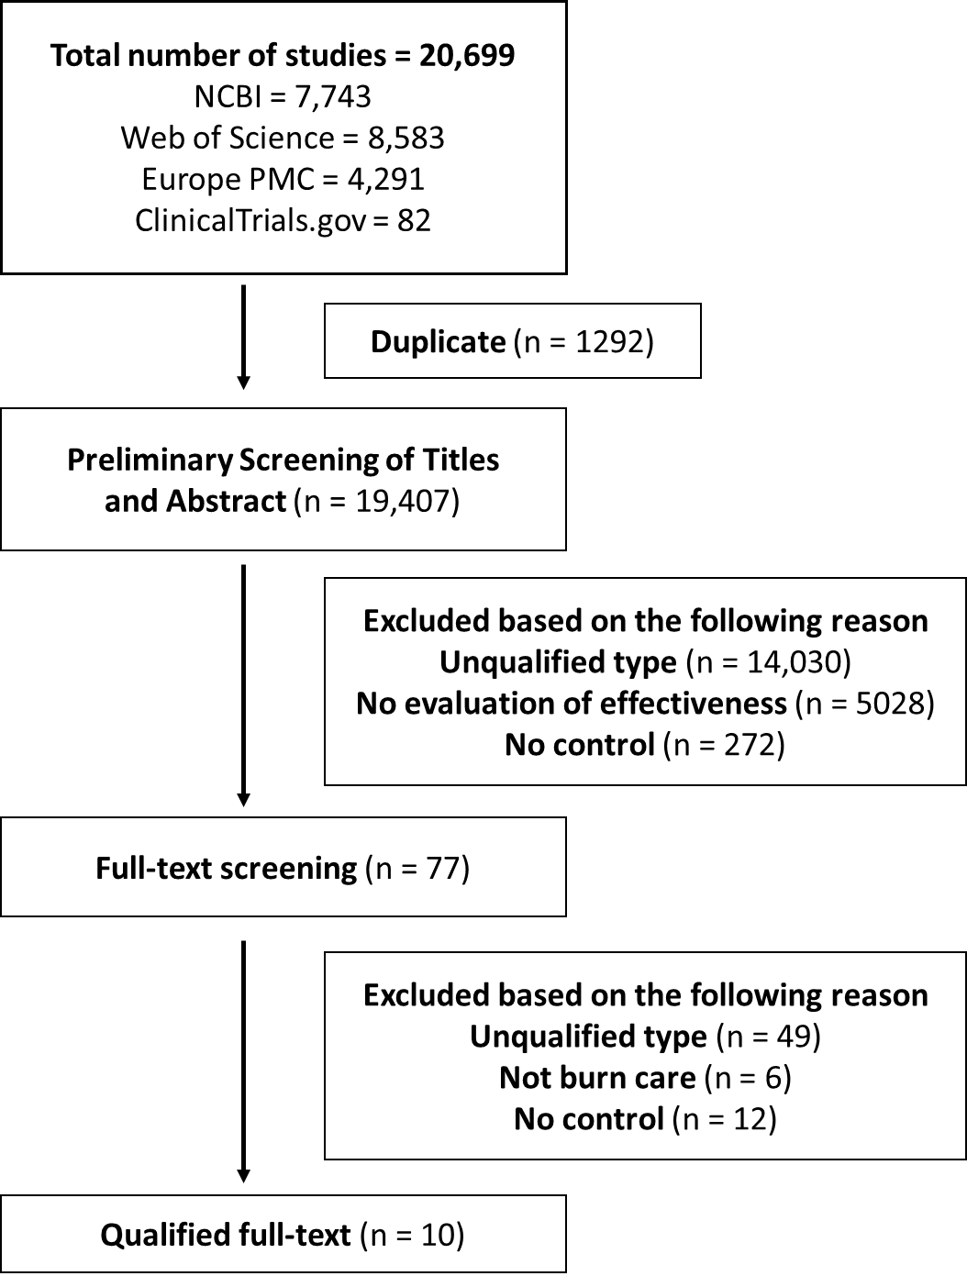
Figure 1 PRISMA flow diagram of study selection process.
The reviewed studies cluster into several major thematic groups. A substantial group of studies evaluates biological and biosynthetic dressings for burn wound coverage. A large and methodologically coherent group of studies focuses on dressings and topical agents used as alternatives to silver sulfadiazine (SSD), reflecting ongoing efforts to replace SSD as the historical standard of care in partial-thickness burn management.

Table 1. Summary of included studies
Reference | Study  Design | Participants  (Context) | Sample Size
Tapking et al., 2024^{[17]} | Prospective, Randomized-ControlledTrial (RCT) | Negative Pressure Wound Therapy in Burns | 61
Ibrahim et al., 2019^{[18]} | Comparative Study (Likely NonRandomized) | Wound healing in burns (NPWT vs. Microcurrent) | 38
Moreira et al., 2022^{[19]} | Randomized Clinical Trial (RCT) | Nanocrystalline silver vs. silver sulfadiazine | 100
Wattanaploy et al., 2017^{[20]} | Randomized Controlled Trial (RCT) | Polyhexanide/Betaine Gel vs. Silver Sulfadiazine | 46
Badr et al., 2023^{[21]} | Randomized, Double-blind Clinical Trial | Herbal formulation vs. Silver Sulfadiazine Cream 1% | 32
Frear et al., 2021^{[22]} | Randomized Controlled Trial (RCT) | Pediatric burn care (NPWT) | 101
Rosenberg et al., 2014^{[23]} | Multicenter RCT | Enzymatic debridement agent | 318
Muangman et al., 2010^{[24]} | Prospective, RCT | Partial thickness burns | 35
Guo et al, 2010^{[25]} | Clinical study (prospective, likely controlled) | Used recombinant human epidermal growth factor  (EGF) | 80
Barret et al, 2017^{[26]} | Randomized Phase III Clinical Trial |  | 131

Risk of bias results
For the eight RCTs assessed using RoB 2, six were rated as low risk of bias across all five domains: Moreira et al., 2022; Wattanaploy et al., 2017; Badr et al., 2023; Rosenberg et al., 2014; Muangman et al., 2010; and Barret et al., 2017. Two RCTs (Tapking et al., 2024; Frear et al., 2021) were judged to have “some concerns” due to incomplete outcome data and lack of blinding in outcome assessment. No RCT was rated as high risk. For the two non‑randomized studies, the NOS score was 6 for Ibrahim et al. (2019), indicating moderate risk, and 7 for Guo et al. (2010), indicating low risk. No non‑randomized study was rated as high risk.

Comparative Effectiveness of Modern and Biologically Derived Dressings versus SSD
Across these investigations, a wide range of alternative dressings, including nanocrystalline silver (Moreira et al., 2022), polyhexanide/betaine gel (Wattanapoly et al., 2017), Boswellia carteri ointment (Badr et al., 2023), and silver hydrofiber dressings (Muangman et al., 2010), were directly compared with SSD, providing a coherent subgroup suitable for comparison ^{[19-21, 24]}. Although Heydari et al. (2025) evaluated a traditional herbal ointment, it was assessed against standard care rather than SSD, and therefore does not align methodologically with the SSD-controlled subgroup ^{[27]}. When pooled using a fixed-effect inverse-variance model, these SSD comparator studies showed a statistically significant reduction in healing time, favoring the alternative dressings. The MD of the combined effect = -2.64, 95% CI -3.52 to -1.77). In contrast, the random-effects model showed a statistically significant reduction in healing time (MD = -3.00 days, 95% CI -5.34 -0.66). This was supported by substantial heterogeneity across studies (I² = 82.3%, P = 0.0007), indicating considerable variability in study design, patient populations, and treatment, suggesting that the overall benefit of dressing differed across studies despite the differences in dressing composition and biological processes. These findings support the growing evidence that there are multiple modern or biologically inspired dressings that have better results than SSD in enhancing re-epithelialization in partial-thickness burns.
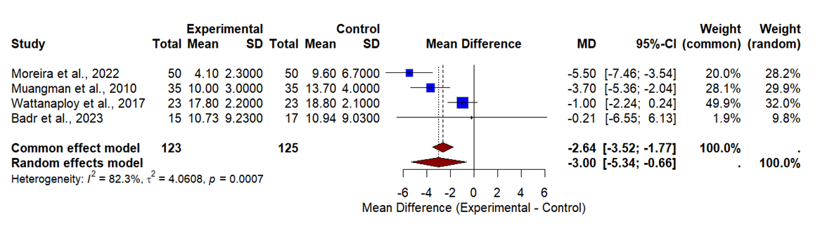
Figure 2 Forest plot of healing time: alternative dressings vs silver sulfadiazine (SSD).

Comparative Effectiveness of Negative Pressure Wound Therapy on Burn Healing
Across the covered studies, both the clinical and economic impacts of negative pressure wound therapy (NPWT) in the management of burns have been analyzed. According to a prospective randomized controlled trial conducted by Tapking et al. (2024), NPWT can be of clinical value as a supplement in the acute treatment of burns ^{[17]}. A non‑randomized study by Ibrahim et al. (2019) compared NPWT with microcurrent electrical stimulation and reported better wound contraction and epithelialization rates with NPWT, although its findings should be interpreted with caution due to the non-randomized design ^{[18]}. Also, the economic benefits of NPWT as presented by Frear et al. (2021) underscored the economic advantage of NPWT in pediatric burn patients, confirming their utility in enhancing healing outcomes, as well as the efficiency of healthcare resource utilization ^{[22]}.
Due to very high heterogeneity (I² = 96.5%, P < 0.0001), the random‑effects model was considered the primary analysis. It showed no statistically significant overall effect of NPWT on healing time (MD = -3.78 days, 95% CI -15.62 to 8.06, P = 0.53). The fixed‑effect model (MD = -0.26 days, 95% CI -1.89 to 1.37, P = 0.76) is less reliable under such high heterogeneity. Although individual studies (e.g., Tapking et al., 2024; Frear et al., 2021) have suggested potential benefits in specific settings (e.g., deep burns or pediatric patients), the pooled evidence does not support a consistent overall benefit of NPWT across all burn patients (Figure 3).
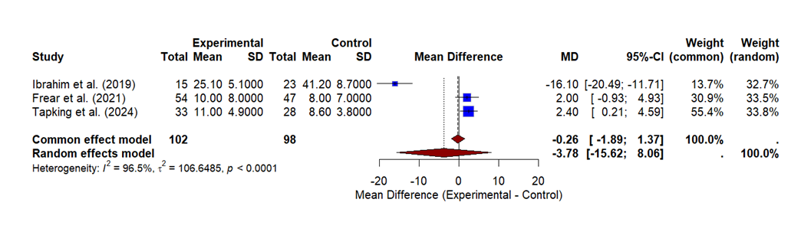
Figure 3 Forest plot of healing time: NPWT vs comparator treatments in burn patients.

Comparative Effectiveness of Non-SSD Topical Agents in Burn Wound Healing
The other coherent subgroup consisted of studies that evaluated other topical biological, pharmacologic, or enzymatic agents that did not compare them with SSD. This involves Phase III testing of topical betulin gel (Barret et al., 2017), recombinant human epidermal growth factor (EGF), when used with elderly patients with deep partial-thickness burns (Guo et al., 2010), and the use of a selective enzymatic debridement agent (Rosenberg et al., 2014) ^{[23, 25, 26]}. Despite their diversity in their composition and mode of action, these agents represent a conceptually consistent category devoted to non-SSD topical therapeutic interventions to deal with burn wounds.
The combination of these studies showed no statistically significant effect when using the random‑effects model (MD = -4.42 days, 95% CI -14.96 to 6.13, P = 0.41), although the fixed-effect model suggested a significant effect (MD = -2.15 days, 95% CI -3.74 to -0.56, P = 0.008). Given the high heterogeneity (I² = 89.6%, P = 0.0001), the random-effects model is more appropriate, and the results indicate that the overall effect of non‑SSD topical agents on healing time is not statistically significant (Figure 4).
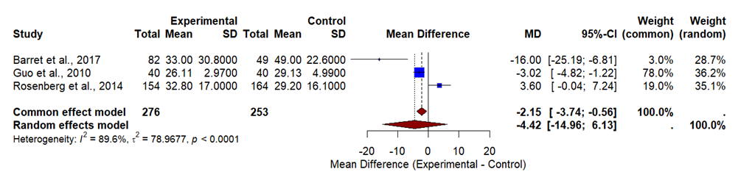
Figure 4 Forest plot of healing time: non‑SSD topical agents vs control.

Secondary outcomes
Although the analysis of secondary outcomes (infection rate and adverse events) was pre‑specified in the Methods, the included studies either did not report these outcomes or reported them in formats that could not be pooled. Therefore, no meta‑analyses were performed for secondary outcomes.

Discussion Wound Healing and Rehabilitation
This meta-analysis included ten studies with 942 patients, comparing three categories of interventions for partial-thickness burns. The results showed that modern dressings (nanocrystalline silver, polyhexanide/betaine gel, Boswellia ointment, and silver hydrofiber) significantly reduced wound healing time compared with SSD, with a mean difference of-3.00 days (95% CI-5.34 to-0.66) ^{[19‑21, 24]}. However, substantial heterogeneity was present (I²=82.3%, P = 0.0007), indicating considerable variability across studies in terms of dressing composition, burn depth, dressing change interval, and outcome measures. This finding supports the growing consensus that SSD is no longer the optimal choice for superficial partial‑thickness burns, and that modern biologically inspired dressings offer better re-epithelialization outcomes with increased patient comfort, decreased nursing workload, and reduced treatment expenses ^{[19‑21, 24, 28]}.
For NPWT, the pooled analysis showed no statistically significant overall benefit on healing time (random‑effects MD =-3.78 days, 95% CI-15.62 to 8.06, P = 0.53), with very high heterogeneity (I²=96.5%, P < 0.0001). Despite individual studies reporting clinical and economic advantages-Tapking et al. (2024) found that NPWT facilitates faster granulation tissue growth and less bioburden ^{[17]}; Ibrahim et al. (2019) reported better wound contraction and epithelialization rates compared with microcurrent stimulation ^{[18]}; and Frear et al. (2021) demonstrated cost-effectiveness in pediatric patients ^{[22]}-the extreme heterogeneity suggests that the effect of NPWT is highly context-dependent. The observed heterogeneity in NPWT analysis may be attributed to differences in sample size, age, patient demographics, and the number of surgical interventions prior to NPWT use ^{[17, 18, 22]}. One limitation is that some studies did not account for prior surgical interventions, which would affect the healing pattern observed. Nevertheless, the individual study results are consistent in supporting the therapeutic benefit of NPWT, particularly in deep partial‑thickness wounds and donor sites needing rapid granulation, as NPWT increases tissue perfusion, helps in exudate drainage, and promotes a better healing environment in both adult and pediatric burn patients ^{[17, 18, 22]}.
For non-SSD topical agents (betulin gel, recombinant human epidermal growth factor, and enzymatic debridement), the random‑effects model did not demonstrate a statistically significant reduction in healing time (MD = -4.42 days, 95% CI -14.96 to 6.13, P = 0.41), with high heterogeneity (I²=89.6%, P = 0.0001) ^{[23, 25, 26]}. Although the fixed‑effect model suggested a significant effect (MD = -2.15 days, 95% CI -3.74 to -0.56, P = 0.008), the presence of substantial heterogeneity makes the random-effects model more appropriate. Differences in study design, patient populations, mechanisms of action, and comparators are likely sources of this heterogeneity ^{[23, 25, 26]}. Notably, xenograft trials on tilapia skin by Lima Júnior et al. (2019, 2020) showed benefits in pain reduction, faster re‑epithelialization, and patient comfort compared with standard dressings ^{[30, 33]}. Similar effects were observed with recombinant human epidermal growth factor ^{[34]} and cultured epidermal allografts ^{[31]}, both leading to faster wound healing and improved epithelial quality. Subsequent research on acellular dermal matrices and cultured autologous dermo‑epidermal replacements established the significance of dermal scaffolding in minimizing contracture and enhancing functional and cosmetic results ^{[35, 36]}. However, a majority of these studies had small sample sizes and mixed burn depths, which may affect generalizability.
The high heterogeneity observed across all subgroups reflects the lack of standardized outcome definitions in burn care research. Variations in the definition of “complete wound healing”, assessment intervals, blinding procedures, and dressing change frequency limit direct comparability between studies. This is a well‑recognized challenge in the field and underscores the need for consensus on core outcome measures.
Based on these findings, several clinical implications can be drawn. For superficial partial-thickness burns, modern dressings should be preferred over SSD, as they shorten healing time, improve patient comfort, and reduce treatment expenses. SSD should no longer be considered first‑line therapy. NPWT should not be used routinely for all burn patients; it should be reserved for selected cases such as deep partial‑thickness wounds requiring rapid granulation before grafting, graft donor sites, or problematic and slow-healing wounds, particularly in adults. In pediatric patients, NPWT has shown cost-effectiveness and safety ^{[22]}. Non‑SSD topical agents and biological skin substitutes may be considered in partial‑thickness burns where rapid epithelial restoration is clinically vital, but clinicians should be aware of the limited sample sizes and mixed evidence ^{[30-36]}. Beyond local wound management, a holistic approach integrating early psychological support, rehabilitation, and nutrition is important for enhancing functional recovery and quality of life in burn patients ^{[37-52]}.
This study has several limitations. The included studies varied considerably in burn depth, patient characteristics, and outcome measures, making direct comparisons between interventions difficult and contributing to the high heterogeneity observed. Sample sizes were generally small, and follow-up periods were often short, so long‑term healing or scar quality could not be reliably assessed. There was also inconsistency across studies in the reporting of adverse events, cost data, and standardized scar assessments. Moreover, most studies had small sample sizes and mixed burn depths, which limits generalizability, and some did not account for the number of surgical interventions performed before NPWT was applied. The restriction to English-language publications may have introduced language bias. Nevertheless, these limitations do not diminish the value of the existing evidence in identifying current trends and emerging methods in burn care.
Future research should prioritize multicenter randomized controlled trials with uniform approaches to measuring healing time, pain, infection rates, and scar quality. Standardized reporting systems-including a shared definition of wound closure and validated scar scales-are urgently needed to enable meaningful comparisons between studies. Long-term follow-up of at least six months to one year is essential to determine functional and cosmetic outcomes, particularly for interventions involving skin substitutes, xenografts, and surgical procedures. Economic appraisals should also be incorporated, given the increasing interest in cost-effective burn care, especially in low-and middle‑income countries. Finally, more widespread inclusion of pediatric patients, deep partial‑thickness injuries, and burns in low-resource settings will improve the generalizability of evidence and support fairer global guidelines.

Conclusion
Compared with traditional SSD, modern dressings significantly reduce healing time in partial‑thickness burns and are superior in enhancing re‑epithelialization. NPWT shows no consistent overall benefit in the pooled analysis; however, individual studies support its use in selected cases such as deep partial-thickness wounds, donor sites, and problematic pediatric burns. Non-SSD topical agents have not demonstrated a statistically significant effect on healing time in this meta-analysis, and current evidence is insufficient to support their routine use. Previous studies on biological skin substitutes (not included in this meta‑analysis) have shown promise, but require further confirmation. The high heterogeneity across studies highlights the critical need for standardized outcome definitions and longer follow-up. Future well‑designed, multicenter RCTs are required to optimize burn care strategies and improve patient outcomes.
Data Availability Statement
All data generated during this study are provided within the article.

Conflict of Interest Statement
The authors declare that there are no commercial or financial relationships that could be construed as a potential conflict of interest.
Funding.
XXXXXXXXXXXXXXXXXXXX

References
- Ghasemi, H., M. Omranifard, M. Bahrami, M. Moghimian, and S. Farzi, Challenges in burn care management: a qualitative study of health professionals’ and patients’ perspectives. Scientific Reports, 2025. 15(1): p. 33401 DOI: 10.1038/s41598-025-18722-
3.
- Lee, N., Y. Bae, S. Jang, D.W. Lee, and S.W. Lee, Global, Regional, and National Burden of Burn Injury by Total Body Surface Area (TBSA) Involvement from 1990 to 2021, with Projections of Prevalence to 2050. Healthcare (Basel), 2025. 13(16) DOI:
10.3390/healthcare13162077.
- Pelizzo, G., V. Calcaterra, C.P.M. Canonica, V.C. Magenes, M. Marinaro, E. Durante, et al., Burns in Early Childhood: Age-Specific Causes, Risks, Management, and ImplicationsA Narrative Review. Children (Basel), 2025. 12(11) DOI: 10.3390/children12111424.
- Mian, M.A., R.F. Mullins, B. Alam, C. Brandigi, B.C. Friedman, J.R. Shaver, et al., Workplace-related burns. Ann Burns Fire Disasters, 2011. 24(2): p. 89-93.
- Mehta, K., N. Thrikutam, P.E. Hoyte-Williams, H. Falk, K. Nakarmi, and B. Stewart, Epidemiology and Outcomes of Cooking- and Cookstove-Related Burn Injuries: A World Health Organization Global Burn Registry Report. J Burn Care Res, 2023. 44(3): p. 508516 DOI: 10.1093/jbcr/irab166.
- Choong, E., D. Jurat, B. Sandeep, B. Rainnie, S. Manzanero, M. Dowsey, et al., The impact of infection on length of stay in adult burns: A scoping review. Burns, 2024. 50(4): p. 797807 DOI: https://doi.org/10.1016/j.burns.2024.01.003.
- Syarif, A.N., F. Afira, A. Wardhana, and A. Ramadhan, Analyzing Mortality And The Effect Of Early Excision As A Preliminary Treatment Of Acute Burn Patients In A Limited
Resource Setting Using LA50 As An Outcome Measurement. Ann Burns Fire Disasters, 2022. 35(2): p. 125-136.
- De La Tejera, G., K. Corona, T. Efejuku, P. Keys, A. Joglar, E. Villarreal, et al., Early wound excision within three days decreases risks of wound infection and death in burned patients. Burns, 2023. 49(8): p. 1816-1822 DOI: 10.1016/j.burns.2023.06.003.
- Moussa, A., C.H. Lo, and H. Cleland, Burn wound excision within 24 h: A 9-year review. Burns, 2021. 47(6): p. 1300-1307 DOI: 10.1016/j.burns.2020.12.014.
- Heimbach, D., A. Luterman, J. Burke, A. Cram, D. Herndon, J. Hunt, et al., Artificial dermis for major burns. A multi-center randomized clinical trial. Ann Surg, 1988. 208(3): p. 313-20 DOI: 10.1097/00000658-198809000-00008.
- Atiyeh, B.S. and M. Costagliola, Cultured epithelial autograft (CEA) in burn treatment: three decades later. Burns, 2007. 33(4): p. 405-13 DOI: 10.1016/j.burns.2006.11.002.
- Supp, D.M. and S.T. Boyce, Engineered skin substitutes: practices and potentials. Clin Dermatol, 2005. 23(4): p. 403-12 DOI: 10.1016/j.clindermatol.2004.07.023.
- Shamseer, L., D. Moher, M. Clarke, D. Ghersi, A. Liberati, M. Petticrew, et al., Preferred reporting items for systematic review and meta-analysis protocols (PRISMA-P) 2015: elaboration and explanation. Bmj, 2015. 350: p. g7647 DOI: 10.1136/bmj.g7647.
- Nejadghaderi, S.A., M. Balibegloo, and N. Rezaei, The Cochrane risk of bias assessment tool 2 (RoB 2) versus the original RoB: A perspective on the pros and cons. Health Sci Rep, 2024. 7(6): p. e2165 DOI: 10.1002/hsr2.2165.
- Lo, C.K., D. Mertz, and M. Loeb, Newcastle-Ottawa Scale: comparing reviewers' to authors' assessments. BMC Med Res Methodol, 2014. 14: p. 45 DOI: 10.1186/1471-228814-45.
- Bidiwala, S., D. Jabarkhyl, and K. Bidiwala, Outcomes of Minimally Invasive Glaucoma Surgery (MIGS) in Glaucoma Patients With Coexisting Cataract: A Systematic Review and Meta-Analysis. Cureus, 2025. 17(1): p. e77007 DOI: 10.7759/cureus.77007.
- Tapking, C., J. Endlein, J. Warszawski, D. Kotsougiani-Fischer, E. Gazyakan, G. Hundeshagen, et al., Negative pressure wound therapy in burns: a prospective, randomized-controlled trial. Burns, 2024. 50(7): p. 1840-1847 DOI:
10.1016/j.burns.2024.04.005.
- Ibrahim, Z.M., I.S. Waked, and O. Ibrahim, Negative pressure wound therapy versus microcurrent electrical stimulation in wound healing in burns. J Wound Care, 2019. 28(4): p. 214-219 DOI: 10.12968/jowc.2019.28.4.214.
- Moreira, S.S., M.C. Camargo, R. Caetano, M.R. Alves, A. Itria, T.V. Pereira, et al., Efficacy and costs of nanocrystalline silver dressings versus 1% silver sulfadiazine dressings to treat burns in adults in the outpatient setting: A randomized clinical trial. Burns, 2022. 48(3): p. 568-576 DOI: 10.1016/j.burns.2021.05.014.
- Wattanaploy, S., K. Chinaroonchai, N. Namviriyachote, and P. Muangman, Randomized Controlled Trial of Polyhexanide/Betaine Gel Versus Silver Sulfadiazine for PartialThickness Burn Treatment. Int J Low Extrem Wounds, 2017. 16(1): p. 45-50 DOI: 10.1177/1534734617690949.
- Badr, P., S. Afsharypuor, H.R. Tohidinik, A.A. Mohammadi, and S. Daneshamouz, Burn Wound Healing Effect of a Sterilized Traditional Formulation of Boswellia carteri vs. Silver Sulfadiazine Cream 1% in Patients Presenting Second-degree Burn Wounds: A Randomized, Double-blind Clinical Trial. Iran J Med Sci, 2023. 48(2): p. 137-145 DOI: 10.30476/ijms.2022.91853.2307.
- Frear, C.C., B.R. Griffin, L. Cuttle, R.M. Kimble, and S.M. McPhail, Cost-effectiveness of adjunctive negative pressure wound therapy in paediatric burn care: evidence from the SONATA in C randomised controlled trial. Sci Rep, 2021. 11(1): p. 16650 DOI: 10.1038/s41598-021-95893-9.
- Rosenberg, L., Y. Krieger, A. Bogdanov-Berezovski, E. Silberstein, Y. Shoham, and A.J. Singer, A novel rapid and selective enzymatic debridement agent for burn wound management: a multi-center RCT. Burns, 2014. 40(3): p. 466-74 DOI:
10.1016/j.burns.2013.08.013.
- Muangman, P., C. Pundee, S. Opasanon, and S. Muangman, A prospective, randomized trial of silver containing hydrofiber dressing versus 1% silver sulfadiazine for the treatment of partial thickness burns. Int Wound J, 2010. 7(4): p. 271-6 DOI: 10.1111/j.1742481X.2010.00690.x.
- Guo, X., M. Tan, L. Guo, A. Xiong, Y. Li, and X. He, [Clinical study on repair of burn wounds of degree II with recombinant human epidermal growth factor in elderly patients]. Zhongguo Xiu Fu Chong Jian Wai Ke Za Zhi, 2010. 24(4): p. 462-4.
- Barret, J.P., F. Podmelle, B. Lipový, H.O. Rennekampff, H. Schumann, A. Schwieger-Briel, et al., Accelerated re-epithelialization of partial-thickness skin wounds by a topical betulin gel: Results of a randomized phase III clinical trials program. Burns, 2017. 43(6): p. 12841294 DOI: 10.1016/j.burns.2017.03.005.
- Heydari, M., H. Mehrbani, S.M. Seyyedkazemi, A. Rustamzadeh, M.T. Joghataei, N. Sadigh, et al., The bioactive compound of traditional herbal ointment accelerates wound closure, epithelialization, and angiogenesis in patients with second-degree burn wound: A randomized clinical trial. Tissue Cell, 2025. 93: p. 102787 DOI:
10.1016/j.tice.2025.102787.
- Karlsson, M., M. Elmasry, I. Steinvall, F. Huss, P. Olofsson, S. Elawa, et al., Biosynthetic cellulose compared to porcine xenograft in the treatment of partial-thickness burns: A randomised clinical trial. Burns, 2022. 48(5): p. 1236-1245 DOI:
10.1016/j.burns.2021.09.017.
- Lima Júnior, E.M., M.O. Moraes Filho, A.J. Forte, B.A. Costa, F.V. Fechine, A. Alves, et al., Pediatric Burn Treatment Using Tilapia Skin as a Xenograft for Superficial PartialThickness Wounds: A Pilot Study. J Burn Care Res, 2020. 41(2): p. 241-247 DOI:
10.1093/jbcr/irz149.
- Lima-Junior, E.M., M.O. de Moraes Filho, B.A. Costa, F.V. Fechine, M.E.A. de Moraes, F.R. Silva-Junior, et al., Innovative treatment using tilapia skin as a xenograft for partial thickness burns after a gunpowder explosion. J Surg Case Rep, 2019. 2019(6): p. rjz181 DOI: 10.1093/jscr/rjz181.
- Sakamoto, M., Y. Minaki, T. Nakano, I. Tsuge, H. Yamanaka, Y. Sowa, et al., A novel approach for wound treatment using dried cultured epidermal allograft: A phase I/II, single-center, open-label clinical trial. Burns, 2023. 49(5): p. 1079-1086 DOI: 10.1016/j.burns.2022.10.006.
- Gardien, K.L.M., A. Pijpe, K.M. Brouwer, M. Stoop, S.K. Singh, F.W. Timmermans, et al., Short- and Long-term Outcomes of an Acellular Dermal Substitute versus Standard of Care in Burns and Reconstructions: A Phase I/II Intrapatient Randomized Controlled Trial. Adv Skin Wound Care, 2023. 36(10): p. 540-548 DOI: 10.1097/asw.0000000000000040.
- Lima Júnior, E.M., M.O. De Moraes Filho, B.A. Costa, A.V.P. Rohleder, M.B. Sales Rocha, F.V. Fechine, et al., Innovative Burn Treatment Using Tilapia Skin as a Xenograft: A Phase II Randomized Controlled Trial. J Burn Care Res, 2020. 41(3): p. 585-592 DOI: 10.1093/jbcr/irz205.
- Boehm, D., C. Schröder, D. Arras, F. Siemers, A. Siafliakis, M. Lehnhardt, et al., Fluid Management as a Risk Factor for Intra-abdominal Compartment Syndrome in Burn Patients: A Total Body Surface Area-Independent Multicenter Trial Part I. J Burn Care Res, 2019. 40(4): p. 500-506 DOI: 10.1093/jbcr/irz053.
- Chang, S.C., C.W. Lin, J.C. Chen, Y.H. Wu, S.G. Chen, Y.Y. Huang, et al., Effects of ON101 for Hard-to-Heal Diabetic Foot Ulcers in a Randomized Phase III Trial: A Post Hoc Analysis. Adv Wound Care (New Rochelle), 2025. 14(8): p. 381-392 DOI:
10.1089/wound.2023.0167.
- Schiestl, C., K. Neuhaus, M. Meuli, M. Farkas, F. Hartmann-Fritsch, J. Elrod, et al., LongTerm Outcomes of a Cultured Autologous Dermo-Epidermal Skin Substitute in Children: 5-Year Results of a Phase I Clinical Trial. J Burn Care Res, 2025. 46(2): p. 326-334 DOI: 10.1093/jbcr/irae150.
- Dmitry, B., R. Kornhaber, and M. Cleary, Psychosocial concerns in burn survivors and their families: A narrative review. Injury, 2025. 56(10): p. 112626 DOI: https://doi.org/10.1016/j.injury.2025.112626.
- Su, Y.J., Prevalence and predictors of posttraumatic stress disorder and depressive symptoms among burn survivors two years after the 2015 Formosa Fun Coast Water Park explosion in Taiwan. Eur J Psychotraumatol, 2018. 9(1): p. 1512263 DOI:
10.1080/20008198.2018.1512263.
- Panayi, A.C., D.K. Heyland, C. Stoppe, M.G. Jeschke, O. Didzun, D. Matar, et al., The long-term intercorrelation between post-burn pain, anxiety, and depression: a post hoc analysis of the "RE-ENERGIZE" double-blind, randomized, multicenter placebocontrolled trial. Crit Care, 2024. 28(1): p. 95 DOI: 10.1186/s13054-024-04873-8.
- Kornhaber, R., A. Wilson, M.Z. Abu-Qamar, and L. McLean, Coming to terms with it all:
adult burn survivors' 'lived experience' of acknowledgement and acceptance during rehabilitation. Burns, 2014. 40(4): p. 589-97 DOI: 10.1016/j.burns.2013.08.038.
- Thombs, B.D., M.G. Bresnick, and G. Magyar-Russell, Depression in survivors of burn injury: a systematic review. Gen Hosp Psychiatry, 2006. 28(6): p. 494-502 DOI: 10.1016/j.genhosppsych.2006.08.010.
- Ali, H. and M. Pervaiz, Depression in adults post burn injury: a descriptive study conducted in the burn centre of a tertiary care hospital in Karachi. Ann Burns Fire Disasters, 2019. 32(1): p. 33-36.
- Fauerbach, J.A., A.K. Gehrke, S.T. Mason, N.F. Gould, S.M. Milner, and J. Caffrey, Cognitive Behavioral Treatment for Acute Posttrauma Distress: A Randomized, Controlled Proof-of-Concept Study Among Hospitalized Adults With Burns. Arch Phys Med Rehabil, 2020. 101(1s): p. S16-s25 DOI: 10.1016/j.apmr.2018.11.027.
- Abdelhafiz, A.H.K., M. Makboul, H.M. Azab, H. Khalifa, Z.A.E.-L. Mohamed, N.M. Ahmed, et al., The impact of antidepressant drugs on the psychological status of the hospitalized burn patients. Indian Journal of Burns, 2015. 23(1).
- Schieffelers, D.R., D. Dombrecht, C. Lafaire, L. De Cuyper, T. Rose, M. Vandewal, et al., Effects of exercise training on muscle wasting, muscle strength and quality of life in adults with acute burn injury. Burns, 2023. 49(7): p. 1602-1613 DOI:
10.1016/j.burns.2023.04.003.
- Schieffelers, D.R., T. Ru, H. Dai, Z. Ye, E. van Breda, U. Van Daele, et al., Effects of early exercise training following severe burn injury: a randomized controlled trial. Burns Trauma, 2024. 12: p. tkae005 DOI: 10.1093/burnst/tkae005.
- Pu, H., G.S. Doig, P.T. Heighes, and M.J. Allingstrup, Early Enteral Nutrition Reduces Mortality and Improves Other Key Outcomes in Patients With Major Burn Injury: A MetaAnalysis of Randomized Controlled Trials. Crit Care Med, 2018. 46(12): p. 2036-2042 DOI:
10.1097/ccm.0000000000003445.
- Yang, X., R. Li, J. Zhai, Y. Fan, S. Gong, L. Li, et al., Effects of early enteral nutrition in patients with severe burns: A systematic review. Medicine (Baltimore), 2024. 103(7): p. e37023 DOI: 10.1097/md.0000000000037023.
- Galfo, M., A. De Bellis, F.J.J.o.E. Melini, and C.C. Medicine, Nutritional therapy for burns in children. 2018, 2018. 2.
- Vanaclocha, N., L. Miranda Gómez, M.D. Pérez Del Caz, V. Vanaclocha Vanaclocha, and F.J. Miranda Alonso, Higher serum prealbumin levels are associated with higher graft take and wound healing in adult burn patients: A prospective observational trial. Burns, 2024. 50(4): p. 903-912 DOI: 10.1016/j.burns.2023.12.015.
- Tao, W., G. Xu, J. Zhou, Y. Luo, and P.-S. Li, Glutamine Supplementation on Burn Patients: A Systematic Review and Meta-analysis. Journal of Burn Care & Research, 2024. 45(3): p. 675-684 DOI: 10.1093/jbcr/irae007 %J Journal of Burn Care & Research.

