Green Operations, Green Customer Integration, and Sustainability Performance:
A Bibliometric Analysis of Global Research with Insights into the Indian Context

Abstract
Green operations and green customer integration have become central levers through which firms translate environmental intent into measurable sustainability performance, yet the literature that connects these three constructs remains scattered across operations management, marketing, and strategy journals. This study applies bibliometric analysis to map the intellectual structure, productivity patterns, and thematic evolution of this research stream. Following the PRISMA 2020 protocol, 485 English-language journal articles were retrieved from Scopus (2015–2026) and analysed using Biblioshiny (Bibliometrix, R). The corpus generated 24,986 citations across 155 sources and 1,632 authors, with an annual growth concentrated after 2020. Business Strategy and the Environment, Journal of Cleaner Production, and International Journal of Production Economics anchor the core literature under Bradford's Law, while Sunil Luthra, Kannan Govindan, and Antony Paulraj emerge as the most locally influential authors by h-, g-, and m-index. Keyword co-occurrence, thematic mapping, and thematic evolution analysis show the field consolidating around sustainable supply chain management, environmental performance, circular economy, and Industry 4.0, with green customer integration surfacing as a still-maturing niche theme. India ranks among the three most productive nations in author affiliations, and Indian scholarship on green supply chain management critical success factors offers a distinctive contextual thread within the global conversation. The study offers researchers a validated map of intellectual structure and signals under-researched intersections particularly the customer-facing side of green operations for future theory-building.
Keywords: green operations; green customer integration; sustainability performance; bibliometric analysis; Bibliometrix; PRISMA; supply chain management; India

1. Introduction
Firms across manufacturing and service sectors now face converging pressure from regulators, investors, and increasingly from their own customers to demonstrate that environmental commitments translate into measurable outcomes. Two operational mechanisms sit at the centre of this shift. The first is green operations the redesign of production, sourcing, and logistics processes to reduce material and energy intensity (Liu et al., 2017). The second is green customer integration, the practice of drawing customers into product design, feedback loops, and joint problem-solving so that environmental requirements travel both upstream and downstream through the value chain (Guo et al., 2021; Nguyen et al., 2023b). Where these two mechanisms meet, they are theorised to jointly determine a firm's sustainability performance, understood broadly as the simultaneous pursuit of environmental, economic, and social outcomes rather than any single bottom line (Alsawafi et al., 2021).
Research on this triad has grown quickly but unevenly. Studies of green supply chain management, environmental performance, and circular economy have multiplied since the mid-2010s, generating well-cited streams on supplier-side practices (Geng et al., 2017; Paulraj et al., 2017), digitalisation and Industry 4.0 (Agrawal et al., 2022; Lerman et al., 2022), and big data-enabled sustainability (Maroufkhani et al., 2020; Raut et al., 2019). Customer-facing mechanisms have received comparatively less sustained attention: a smaller cluster of studies examines how customer pressure, leverage, and collaboration shape supplier environmental behaviour (Marshall et al., 2019; Onofrei et al., 2020; Burki & Dahlstrom, 2017), but this cluster has not yet been mapped against the broader green operations and sustainability performance literature as a coherent field. Practitioners and doctoral researchers entering this space are consequently left to reconstruct its boundaries, key contributors, and emerging themes largely by hand.
Bibliometric analysis offers a systematic remedy. By combining performance analysis (who and what has been most productive and influential) with science mapping (how concepts, sources, and collaborators relate to one another), bibliometric methods let a field's intellectual structure be reconstructed from citation and co-occurrence data rather than from any single reviewer's reading list (Donthu et al., 2021; Zupic & Čater, 2015). Applied to a well-defined corpus, this approach can identify the core journals and authors a newcomer should read first, expose which themes are already "basic" or foundational versus which remain niche or emergent, and reveal where the customer-integration and green-operations literatures converge or, more tellingly, where they do not.
This study addresses three research questions. First, what is the productivity and citation structure of research linking green operations, green customer integration, and sustainability performance which sources, authors, and documents anchor the field, and how has output grown over time? Second, what is the field's conceptual structure which themes are motor, basic, niche, or emerging, and how have keywords evolved between the 2015–2024 and 2025–2026 periods? Third, what does the geographic and collaborative structure of this literature reveal, and what distinctive contribution does research situated in the Indian context make to it?
To answer these questions, 485 Scopus-indexed articles published between 2015 and 2026 were analysed following the PRISMA 2020 reporting protocol and processed in Biblioshiny, the R-based bibliometrix interface (Aria & Cuccurullo, 2017). The remainder of the paper proceeds as follows. Section 2 situates the three focal constructs conceptually. Section 3 details the search strategy, screening protocol, and analytical techniques. Section 4 reports the bibliometric results across performance and science-mapping indicators. Section 5 discusses the findings, Section 6 focuses specifically on the Indian context, Section 7 draws out theoretical and practical implications, Section 8 acknowledges limitations, and Section 9 concludes.

2. Conceptual Background
Green operations research extends classical operations management by embedding environmental criteria into decisions about process design, sourcing, and logistics. Liu et al. (2017) show that the payoff from green operations strategies is contingent on a firm's internal environmental proactivity, an early signal that green operations is best understood as a capability rather than a discrete practice. This capability view recurs throughout the corpus: Khanra et al. (2022) frame green innovation as a strategic firm resource in the resource-based tradition, while Lerman et al. (2022) treat green supply chain management as a configurational bundle of digital and environmental capabilities rather than a checklist of initiatives.
Green customer integration is the less-theorised half of the triad. It refers to the deliberate involvement of customers whether downstream manufacturers, retailers, or end consumers in a focal firm's environmental decision-making, spanning joint product redesign, shared monitoring, and reciprocal pressure (Guo et al., 2021). Marshall et al. (2019) demonstrate that direct customer power measurably shifts first-tier suppliers toward socially responsible procurement, while Onofrei et al. (2020) find that customer leveraging, alongside supplier leveraging, builds the relational capital that underlies innovation performance. Nguyen et al. (2023a, 2023b) extend this line by showing that environmental customer pressure and green reputation concerns jointly shape environmental management system adoption among export-oriented manufacturers, with process innovation acting as a mediating mechanism. Read together, these studies suggest that customer integration functions less as a one-directional demand and more as a two-way governance channel through which environmental standards are negotiated.
Sustainability performance is typically operationalised through the triple bottom line of environmental, economic, and social outcomes (Alsawafi et al., 2021). Its antecedents in this literature range from internal quality management routines (Alsawafi et al., 2021) to organisational capabilities that convert green practices into competitive advantage (Gelhard & von Delft, 2016; Masudin et al., 2025), a relationship that holds even for small and medium-sized manufacturing enterprises in emerging Asian economies (Mani et al., 2020). A recurring theoretical scaffold across these studies is dynamic capability theory, which frames sustainability performance as the outcome of a firm's capacity to sense environmental pressures, reconfigure resources, and integrate both suppliers and customers into that reconfiguration (Ahmadi-Gh & Bello-Pintado, 2024). Institutional theory supplies a complementary lens, explaining why sustainability practices diffuse through supply chains via isomorphic pressure from powerful buyers or customers rather than through voluntary adoption alone (Ahmadi-Gh & Bello-Pintado, 2024; Muduli et al., 2020).
Because green operations, green customer integration, and sustainability performance are theorised but rarely mapped as a connected system, a bibliometric account of how this literature has developed provides a necessary complement to the conceptual synthesis above.

3. Methodology

3.1 Research design
This study follows a bibliometric research design combining performance analysis and science mapping, the two complementary techniques that define contemporary bibliometric practice in management research (Donthu et al., 2021; Zupic & Čater, 2015). Performance analysis summarises the productivity and citation impact of authors, sources, countries, and documents; science mapping visualises the relational structure of the field through co-occurrence, collaboration, and thematic-evolution networks. All analyses were conducted in Biblioshiny, the web interface of the bibliometrix R package (Aria & Cuccurullo, 2017), using raw metadata exported directly from Scopus in BibTeX format.

3.2 Search strategy and eligibility criteria
Scopus was selected as the sole data source because of its broader journal coverage relative to Web of Science in business and management fields and its structured export format, which is required for clean bibliometric processing. The search combined three concept blocks connected with the Boolean operator AND: (i) green operations green operation OR green operations management OR green operational practice OR green manufacturing OR green production OR green supply chain OR sustainable operation OR environmental operation OR eco-efficient operation; (ii) green customer integration green customer integration OR green customer involvement OR green customer collaboration OR customer integration OR customer involvement OR customer collaboration OR green customer engagement OR environmental customer integration; and (iii) sustainability performance sustainability performance OR sustainable performance OR environmental performance OR economic performance OR social performance OR triple bottom line OR sustainability outcome OR environmental sustainability. Within each block, terms were joined with OR to maximise recall of near-synonymous phrasing. The search was restricted to the period 2015–2026 to capture the last decade of sustained growth in this literature.

3.3 PRISMA 2020 selection process
Study selection followed the PRISMA 2020 statement for reporting systematic reviews (Page et al., 2021), adapted here for a bibliometric rather than a narrative synthesis. As shown in Figure 1, the initial Scopus search returned 2,904 records. At the identification stage, 1,099 records outside the Business, Management and Accounting subject area were removed, leaving 1,805 records screened. At the screening stage, 485 records that were not journal articles or not published in English were excluded, leaving 1,320 reports sought for retrieval. A further 835 reports were then excluded for not being in final publication stage or not meeting the open-access criterion applied to ensure full-text availability for verification, leaving 485 reports assessed for eligibility. All 485 reports met the eligibility criteria in full and were retained, yielding a final analytical corpus of 485 articles, exported in BibTeX format directly from Scopus on 24 August 2026.

Identification of studies via databases and registers

Records removed before screening that were other than criteria as given below:
Database: Scopus
Keywords: green operation OR green operations management OR green operational practice OR green manufacturing OR green production OR green supply chain OR sustainable operation OR environmental operation OR eco-efficient operation AND green customer integration OR green customer involvement OR green customer collaboration OR customer integration OR customer involvement OR customer collaboration OR green customer engagement OR environmental customer integration AND sustainability performance OR sustainable performance OR environmental performance OR economic performance OR social performance OR triple bottom line OR sustainability outcome OR environmental sustainability
Timeline: 2015-2026

Records identified from:
Databases (n =2,904)

Identification

Reports excluded other than:
Reason 1 (subject area: Business, Management and Accounting)
(n = 1,099)

Records screened
(n = 1,805)

Reports sought for retrieval
(n = 1,320)
Reports excluded other than:
Reason 1 (Doc Type: Article)
Reason 2 (Language: English)
(n = 485)

Screening

Reports excluded other than:
Reason 1 (Publication stage: Final)
Reason 2 (Open Access: All open access)
(n = 835)

Reports assessed for eligibility
(n = 485)

Total studies included in review
(n = 485)

Included

\

Figure 1. PRISMA 2020 flow diagram of the identification, screening, and inclusion process for the bibliometric corpus (n = 485).

3.4 Analytical techniques
The bibliometrix workflow in Biblioshiny was used to generate: (i) descriptive performance indicators (annual production, most-cited documents, most relevant sources and authors); (ii) author impact metrics the h-index (Hirsch's measure of sustained productivity and citation), g-index (which credits highly cited papers more heavily), and m-index (h-index normalised by academic age) computed at the level of the retrieved corpus (local impact) rather than an author's entire career; (iii) Bradford's Law zoning of core, Zone 2, and Zone 3 sources (Bradford, 1934); (iv) Lotka's Law fitting of the author productivity distribution (Lotka, 1926); (v) geographic and collaboration mapping through country scientific production and a countries' collaboration world map; and (vi) conceptual structure mapping through author-keyword and keywords-plus word clouds, an author-keyword co-occurrence network, a strategic (thematic) map based on centrality and density, and a thematic evolution (Sankey) diagram comparing the 2015–2024 and 2025–2026 sub-periods. Citation counts reflect total Scopus citations recorded as of the export date and should be read as a time-bound snapshot rather than a fixed measure.

4. Results

4.1 Descriptive profile of the dataset
Table 1 summarises the main characteristics of the retrieved corpus. The 485 articles were published across 155 distinct sources between 2015 and 2026, involving 1,632 individual authors, of whom only 22 published single-authored papers. The collaboration index of 3.83 co-authors per document, together with an international co-authorship rate of 53.8%, indicates that this is a strongly collaborative and internationally networked field rather than one built on isolated single-institution efforts. The corpus accumulated 24,986 total citations, an average of 51.5 citations per document, with a dataset-level h-index of 82 and g-index of 141 figures that confirm both broad citation reach and a small set of exceptionally high-impact papers pulling the distribution upward.
Table 1. Main information about the bibliometric dataset (2015–2026).
Description | Result
Timespan | 2015–2026
Sources (journals) | 155
Documents | 485
Document type | Article (100%)
Average document age | 4.3 years
Average citations per document | 51.5
Total citations | 24,986
Dataset h-index | 82
Dataset g-index | 141
Author's keywords (DE) | 1,572
Keywords Plus (ID) | 1,225
Authors | 1,632
Single-authored documents | 22
Co-authors per document | 3.83
International co-authorship | 53.8%

4.2 Annual scientific production and citation dynamics
Annual output grew from 9 articles in 2015 to a peak of 100 articles in 2025 (56 by the August 2026 export cut-off), with the sharpest acceleration occurring after 2020 the year in which annual production first exceeded 30 articles and never subsequently fell below it (Table 2). Roughly three-quarters of the entire corpus (376 of 485 articles) was published in the five years from 2022 to 2026, confirming that this is a young, rapidly consolidating research stream rather than a mature one.
Table 2. Annual scientific production, 2015–2026.
Year | Articles | % of corpus | Cumulative %
2015 | 9 | 1.9% | 1.9%
2016 | 17 | 3.5% | 5.4%
2017 | 16 | 3.3% | 8.7%
2018 | 9 | 1.9% | 10.6%
2019 | 18 | 3.7% | 14.3%
2020 | 32 | 6.6% | 20.9%
2021 | 32 | 6.6% | 27.5%
2022 | 49 | 10.1% | 37.6%
2023 | 58 | 12.0% | 49.6%
2024 | 89 | 18.4% | 67.9%
2025 | 100 | 20.6% | 88.6%
2026* | 56 | 11.5% | 100.0%

Partial year; export date 24 August 2026.
Figure 8 (Average Citations per Year) plots mean citations normalised by the number of years since publication rather than raw production. The line shows a irregular but broadly declining trajectory from 10 citations per year for the 2015 cohort to a peak above 18 for articles published around 2022, followed by a steep fall to below 2 for the 2025–2026 cohort. This pattern is the expected citation-lag artefact common to any actively growing field: the newest articles have simply not had time to accumulate citations, while the 2022 peak marks a cohort of unusually well-cited papers several of which, including Rodríguez-Espíndola et al. (2022), Khanra et al. (2022), and Feng et al. (2022), anchor the circular-economy and green-innovation clusters discussed in Section 4.9.
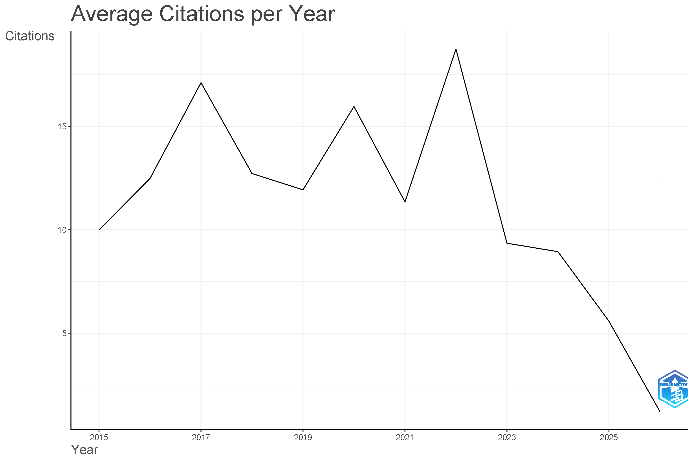
Figure 8. Average citations per year by publication cohort, showing the expected citation-lag decline toward the most recent (2025–2026) articles.

4.3 Most influential documents
Table 3 lists the fifteen most globally cited articles in the corpus. Dwivedi et al. (2022), an editorial reflection on digital technologies and climate governance published around COP26, leads the corpus with 729 citations, considerably ahead of the second-ranked paper. The next tier is dominated by green supply chain management and circular economy studies: Geng et al. (2017) meta-analyse the green supply chain management–performance relationship in Asian emerging economies (561 citations), Khanra et al. (2022) develop a resource-based account of green innovation (515 citations), and Chen et al. (2017) synthesise supply chain collaboration for sustainability (493 citations). Notably, seven of the fifteen most-cited papers were published in or after 2020, indicating that citation leadership in this field is not solely a function of a paper's age several recent contributions on circular economy, big data analytics, and business analytics capability (Rodríguez-Espíndola et al., 2022; Maroufkhani et al., 2020; Kristoffersen et al., 2021) have accumulated citations unusually quickly.
Table 3. Fifteen most globally cited documents.
Rank | Authors (Year) | Title | Journal | Citations
1 | Dwivedi et al. (2022) | Climate change and COP26: Are digital technologies and information management part of the problem or the solution? | International Journal of Information Management | 729
2 | Geng et al. (2017) | The relationship between green supply chain management and performance: A meta-analysis of empirical evidences in Asian emerging economies | International Journal of Production Economics | 561
3 | Khanra et al. (2022) | A resource-based view of green innovation as a strategic firm resource | Business Strategy and the Environment | 515
4 | Chen et al. (2017) | Supply chain collaboration for sustainability: A literature review and future research agenda | International Journal of Production Economics | 493
5 | Rodríguez-Espíndola et al. (2022) | The role of circular economy principles and sustainable-oriented innovation to enhance social, economic and environmental performance | International Journal of Production Economics | 404
6 | Maroufkhani et al. (2020) | Big data analytics adoption: Determinants and performances among small to medium-sized enterprises | International Journal of Information Management | 385
7 | Batista et al. (2018) | In search of a circular supply chain archetype–a content-analysis-based literature review | Production Planning and Control | 372
8 | Kristoffersen et al. (2021) | The effects of business analytics capability on circular economy implementation | International Journal of Production Economics | 368
9 | Raut et al. (2019) | Linking big data analytics and operational sustainability practices for sustainable business management | Journal of Cleaner Production | 348
10 | Govindan et al. (2020) | An integrated hybrid approach for circular supplier selection and closed loop supply chain network design under uncertainty | Journal of Cleaner Production | 319
11 | Paulraj et al. (2017) | Motives and performance outcomes of sustainable supply chain management practices: A multi-theoretical perspective | Journal of Business Ethics | 318
12 | Marshall et al. (2015) | Going above and beyond: How sustainability culture and entrepreneurial orientation drive social sustainability supply chain practice adoption | Supply Chain Management | 308
13 | Formentini & Taticchi (2016) | Corporate sustainability approaches and governance mechanisms in sustainable supply chain management | Journal of Cleaner Production | 300
14 | Yu et al. (2020) | Green human resource management and environmental cooperation | International Journal of Production Economics | 298
15 | Feng et al. (2022) | Green supply chain innovation: Emergence, adoption, and challenges | International Journal of Production Economics | 296

4.4 Source dynamics: Bradford's Law
Bradford's Law identifies the core set of journals responsible for the bulk of a field's output (Bradford, 1934). Applying the Bradford model to the 155 sources in the corpus (Figure 2) partitions them into a Core zone of 7 journals, a Zone 2 of 23 journals, and a Zone 3 comprising the remaining 126 journals a distribution the model fits closely (R² = 0.9933, Bradford multiplier k = 4.38, Kolmogorov–Smirnov p = 0.958). Table 4 lists the leading sources by article count. Business Strategy and the Environment (45 articles, 2,891 citations), Journal of Cleaner Production (36 articles, 3,346 citations), and International Journal of Production Economics (20 articles but the single highest citation total at 4,286) form the nucleus of the Core zone, alongside Production Planning and Control and International Journal of Operations and Production Management. That the highest citation total belongs to a source ranked fourth by article count underlines that publication volume and citation impact are related but distinct dimensions of source relevance.
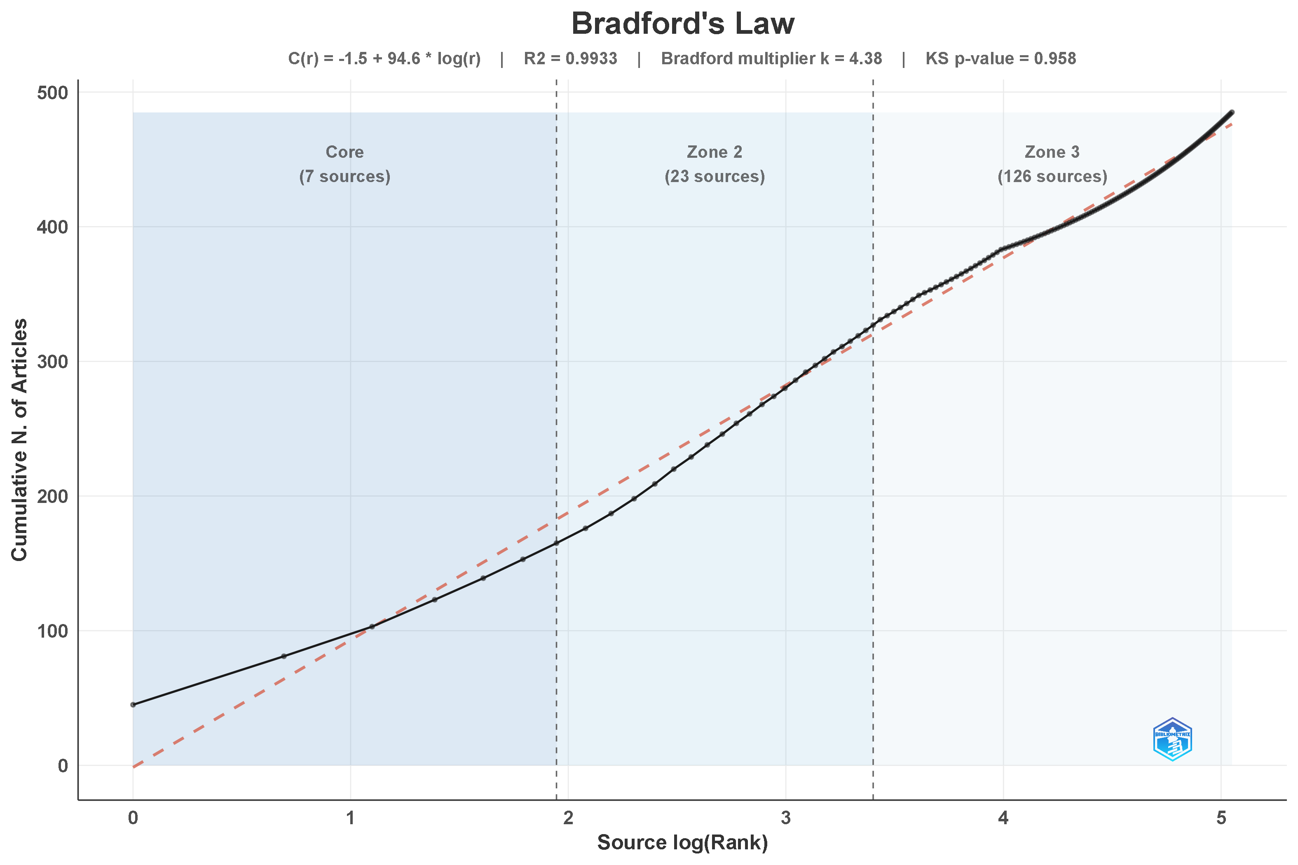
Figure 2. Bradford's Law source-dispersion curve identifying Core (7), Zone 2 (23), and Zone 3 (126) journals.
Table 4. Ten most relevant sources by article count.
Rank | Source | Articles | Total citations | Bradford zone
1 | Business Strategy and the Environment | 45 | 2,891 | Core
2 | Journal of Cleaner Production | 36 | 3,346 | Core
3 | Production Planning and Control | 22 | 1,472 | Core
4 | International Journal of Production Economics | 20 | 4,286 | Core
5 | International Journal of Operations and Production Management | 16 | 881 | Core
6 | Sustainable Futures | 14 | 191 | Core
7 | Cogent Business and Management | 12 | 210 | Core
8 | Transportation Research Part E: Logistics and Transportation Review | 11 | 1,068 | Zone 2
9 | Uncertain Supply Chain Management | 11 | 227 | Zone 2
10 | Industrial Marketing Management | 11 | 660 | Zone 2

4.5 Author productivity: Lotka's Law
Lotka's Law models the expected inverse-square relationship between the number of papers an author publishes and the proportion of authors reaching that output level (Lotka, 1926). Figure 3 fits this model to the corpus's 1,632 authors and estimates an exponent (Beta) of 3.37 steeper than the classical Beta = 2 with C = 0.7944 and R² = 0.9883. The Kolmogorov–Smirnov test rejects the classical Beta = 2 specification (p = 0.088, only marginally, but the fitted model achieves a perfect KS p-value of 1). Roughly 90% of authors in the corpus contributed exactly one paper, a slightly more concentrated pattern than Lotka's original law predicts, consistent with a field still absorbing large numbers of first-time contributors relative to a smaller core of repeat authors.
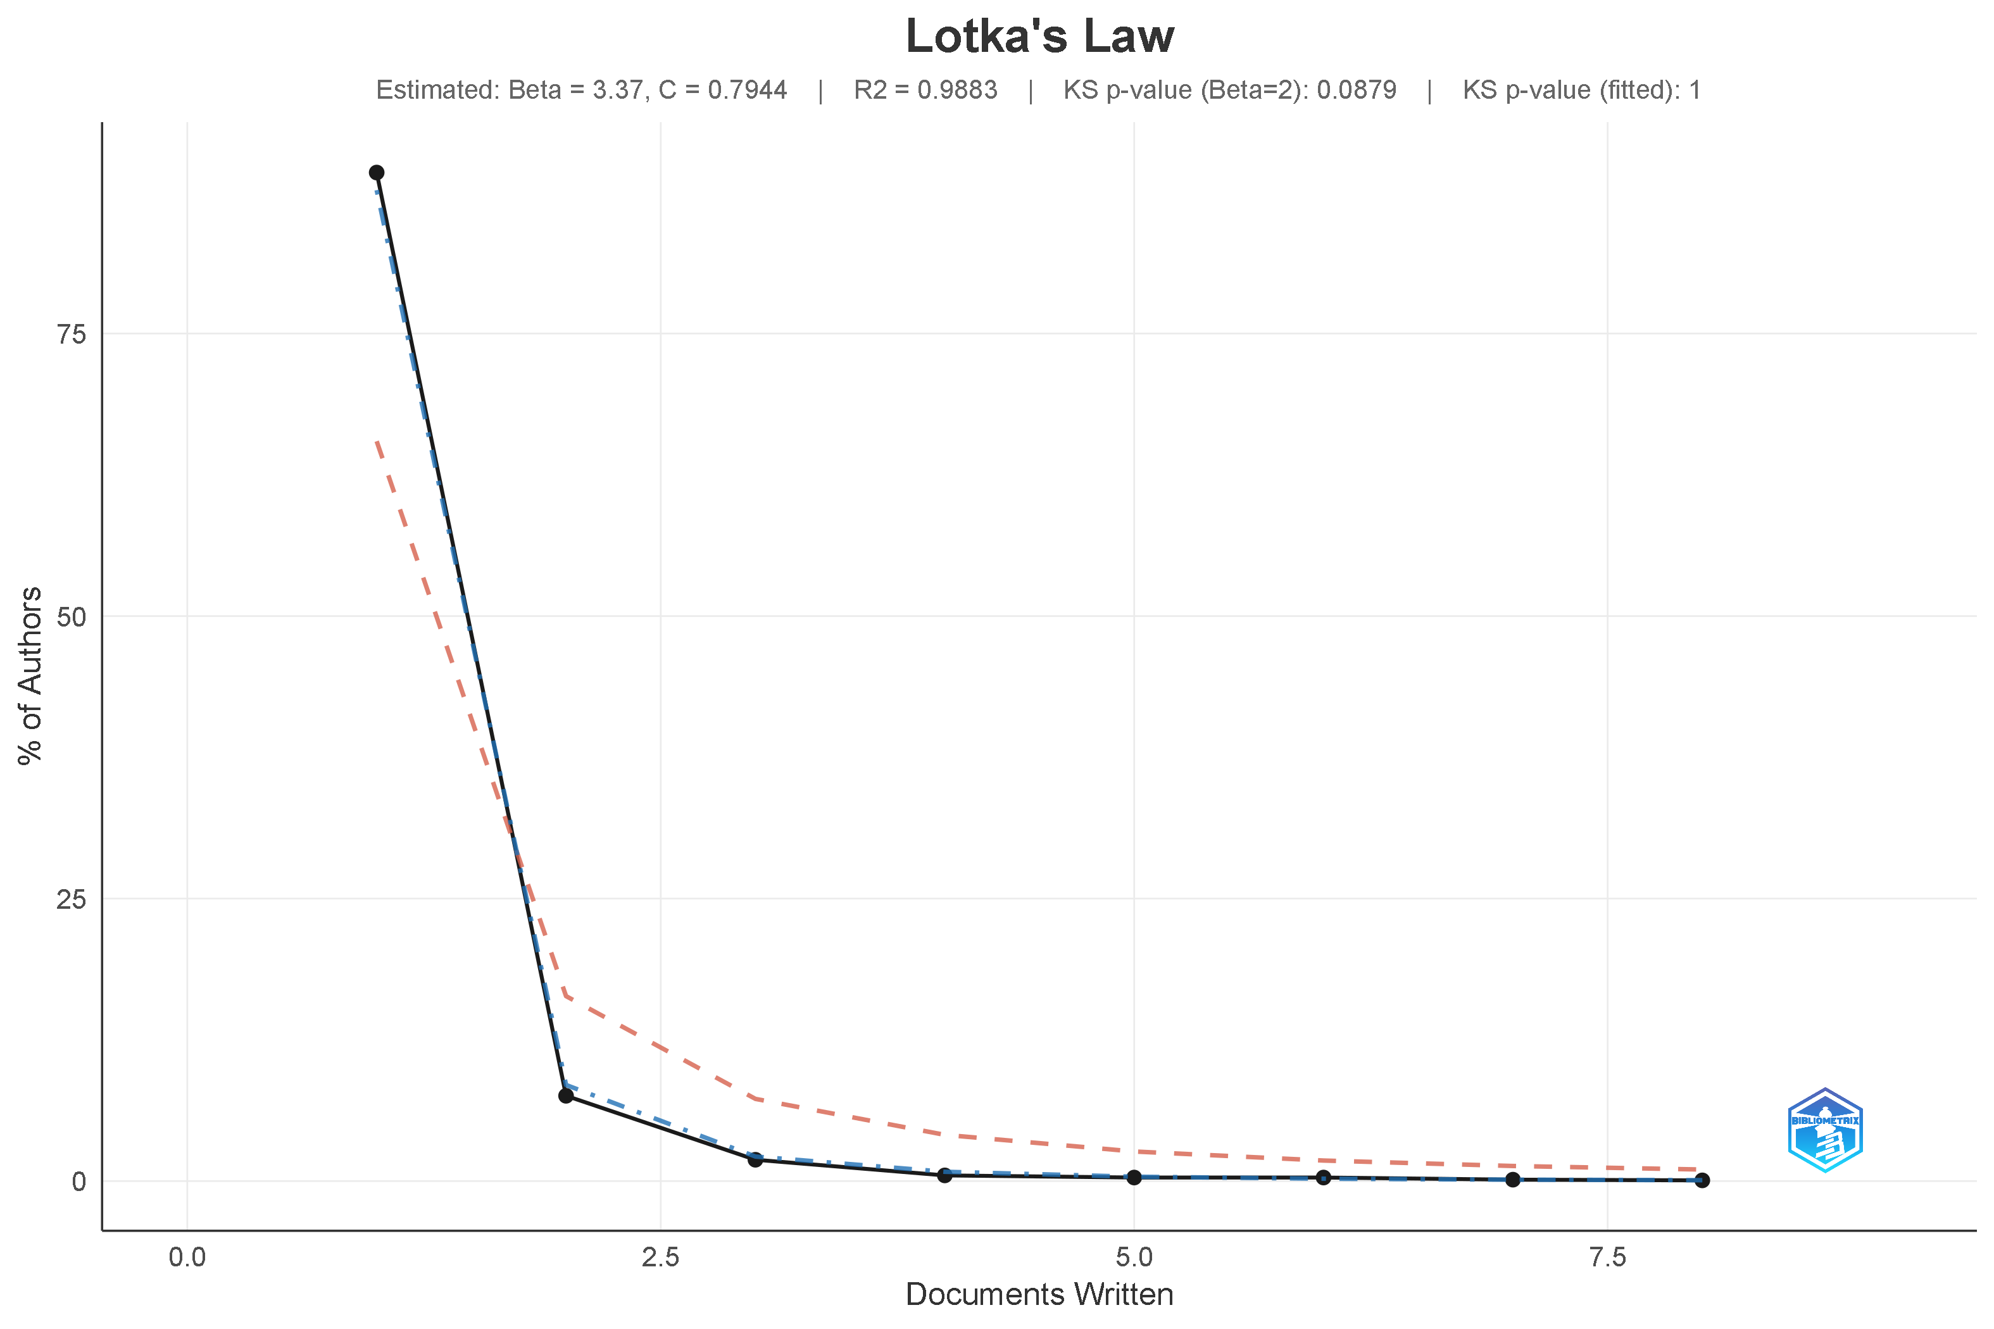
Figure 3. Lotka's Law author-productivity distribution, with the empirical curve (black), the theoretical Beta = 2 curve (red dashed), and the fitted model (blue dash-dot).

4.6 Author impact: h-, g-, and m-index
Figures 4–6 and Table 5 report the ten most influential authors in the corpus by local h-, g-, and m-index indices computed only on the papers each author contributed to this specific dataset, not their entire publication record. Sunil Luthra leads decisively on both h-index (8) and g-index (8), followed by Kannan Govindan, Anil Kumar, Nachiappan Subramanian, and Ying Yang, each with a local h-index of 6. On the m-index, which normalises impact by the number of years an author has been active in the field, Anil Kumar records the highest score (1.2), narrowly ahead of a cluster of authors tied at 1.0, reflecting rapid, recently accumulated impact rather than a long publication history. Cross-referencing these rankings against Table 6 in Section 4.8 shows that Luthra's contributions are consistently affiliated with Indian institutions, a point developed further in Section 6.
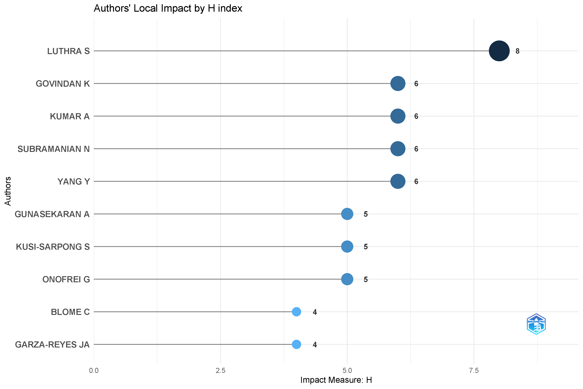
Figure 4. Ten most influential authors by local h-index, led by Luthra, S. (h = 8).
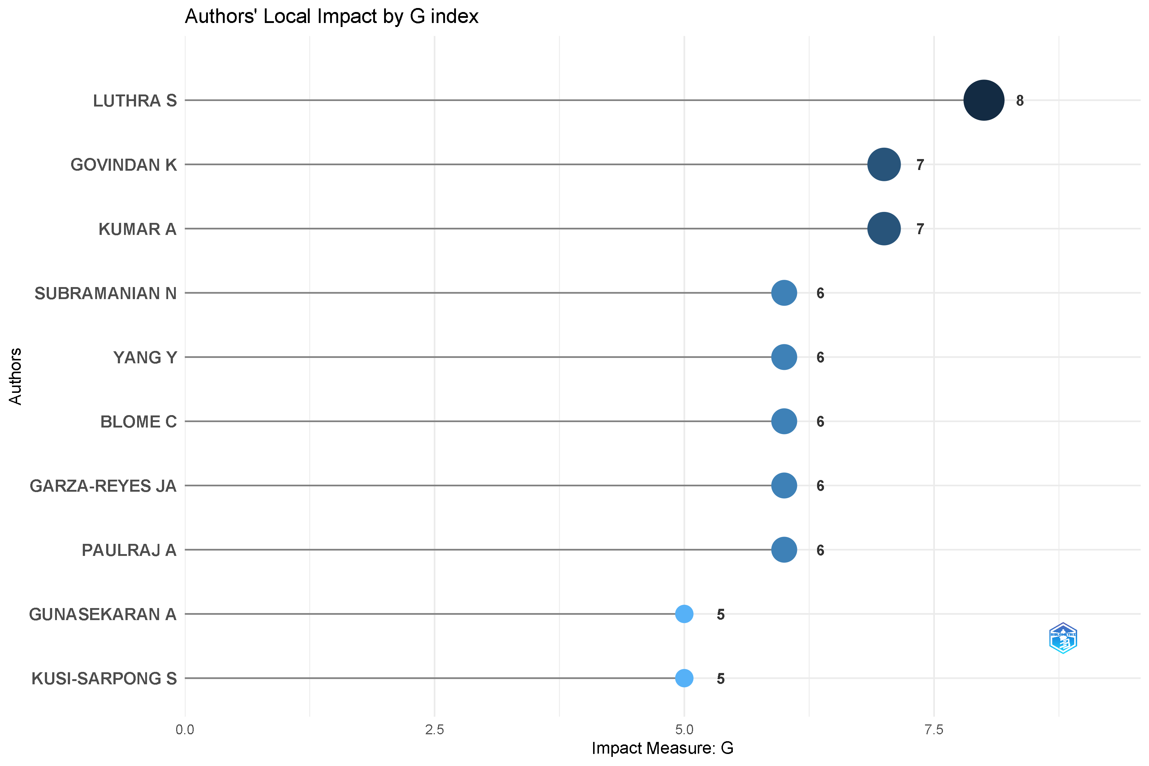
Figure 5. Ten most influential authors by local g-index, again led by Luthra, S. (g = 8), with Govindan, K. and Kumar, A. tied at g = 7.
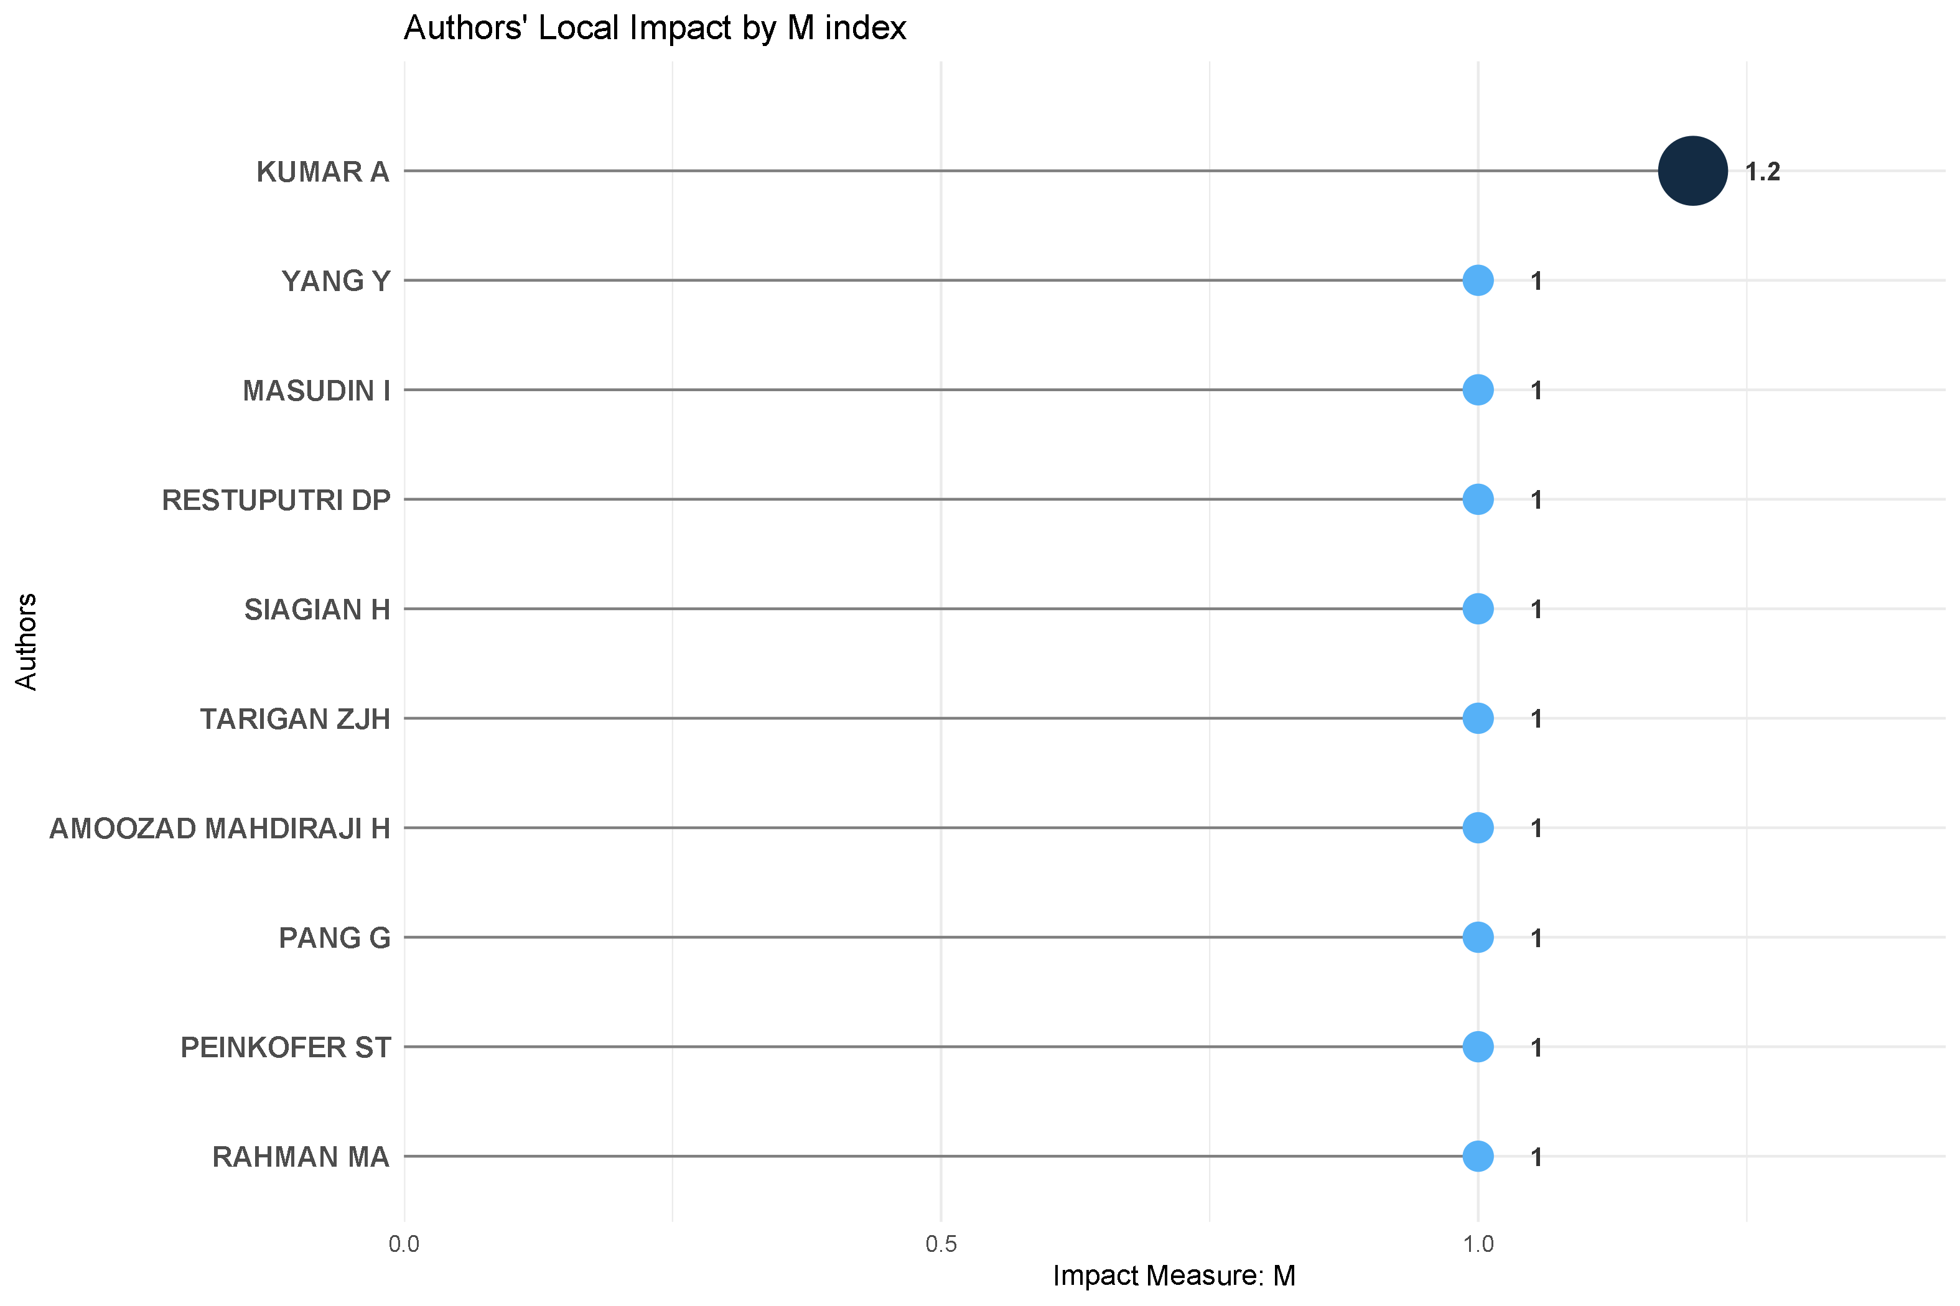
Figure 6. Ten most influential authors by local m-index, led by Kumar, A. (m = 1.2), reflecting rapid recent citation accumulation.
Table 5. Ten most productive authors by document count.
Rank | Author | Documents | Total citations
1 | Luthra, S. | 8 | 912
2 | Govindan, K. | 7 | 958
3 | Paulraj, A. | 6 | 396
3 | Blome, C. | 6 | 748
3 | Subramanian, N. | 6 | 436
6 | Yang, Y. | 5 | 147
6 | Garza-Reyes, J.A. | 5 | 392
6 | Papadopoulos, T. | 5 | 320
6 | Gunasekaran, A. | 5 | 457
6 | Kusi-Sarpong, S. | 5 | 975

4.7 Authors' production over time and collaboration pattern
Figure 7 tracks the ten most productive authors' publication timelines, with bubble size denoting the number of articles published in a given year and colour intensity denoting total citations received that year. The chart shows two distinct career patterns: long-tenured contributors such as Luthra, S., Gunasekaran, A., and Kusi-Sarpong, S., who span the entire 2015–2025 window with modest per-year output, and more recently active authors such as Kumar, A. and Yang, Y., whose publication activity is concentrated from 2021 onward but whose bubbles are markedly larger consistent with their high m-index scores in Section 4.6. Govindan, K. shows a distinctive spike in 2021, coinciding with several of his highly cited circular-economy and Supply Chain 4.0 contributions.
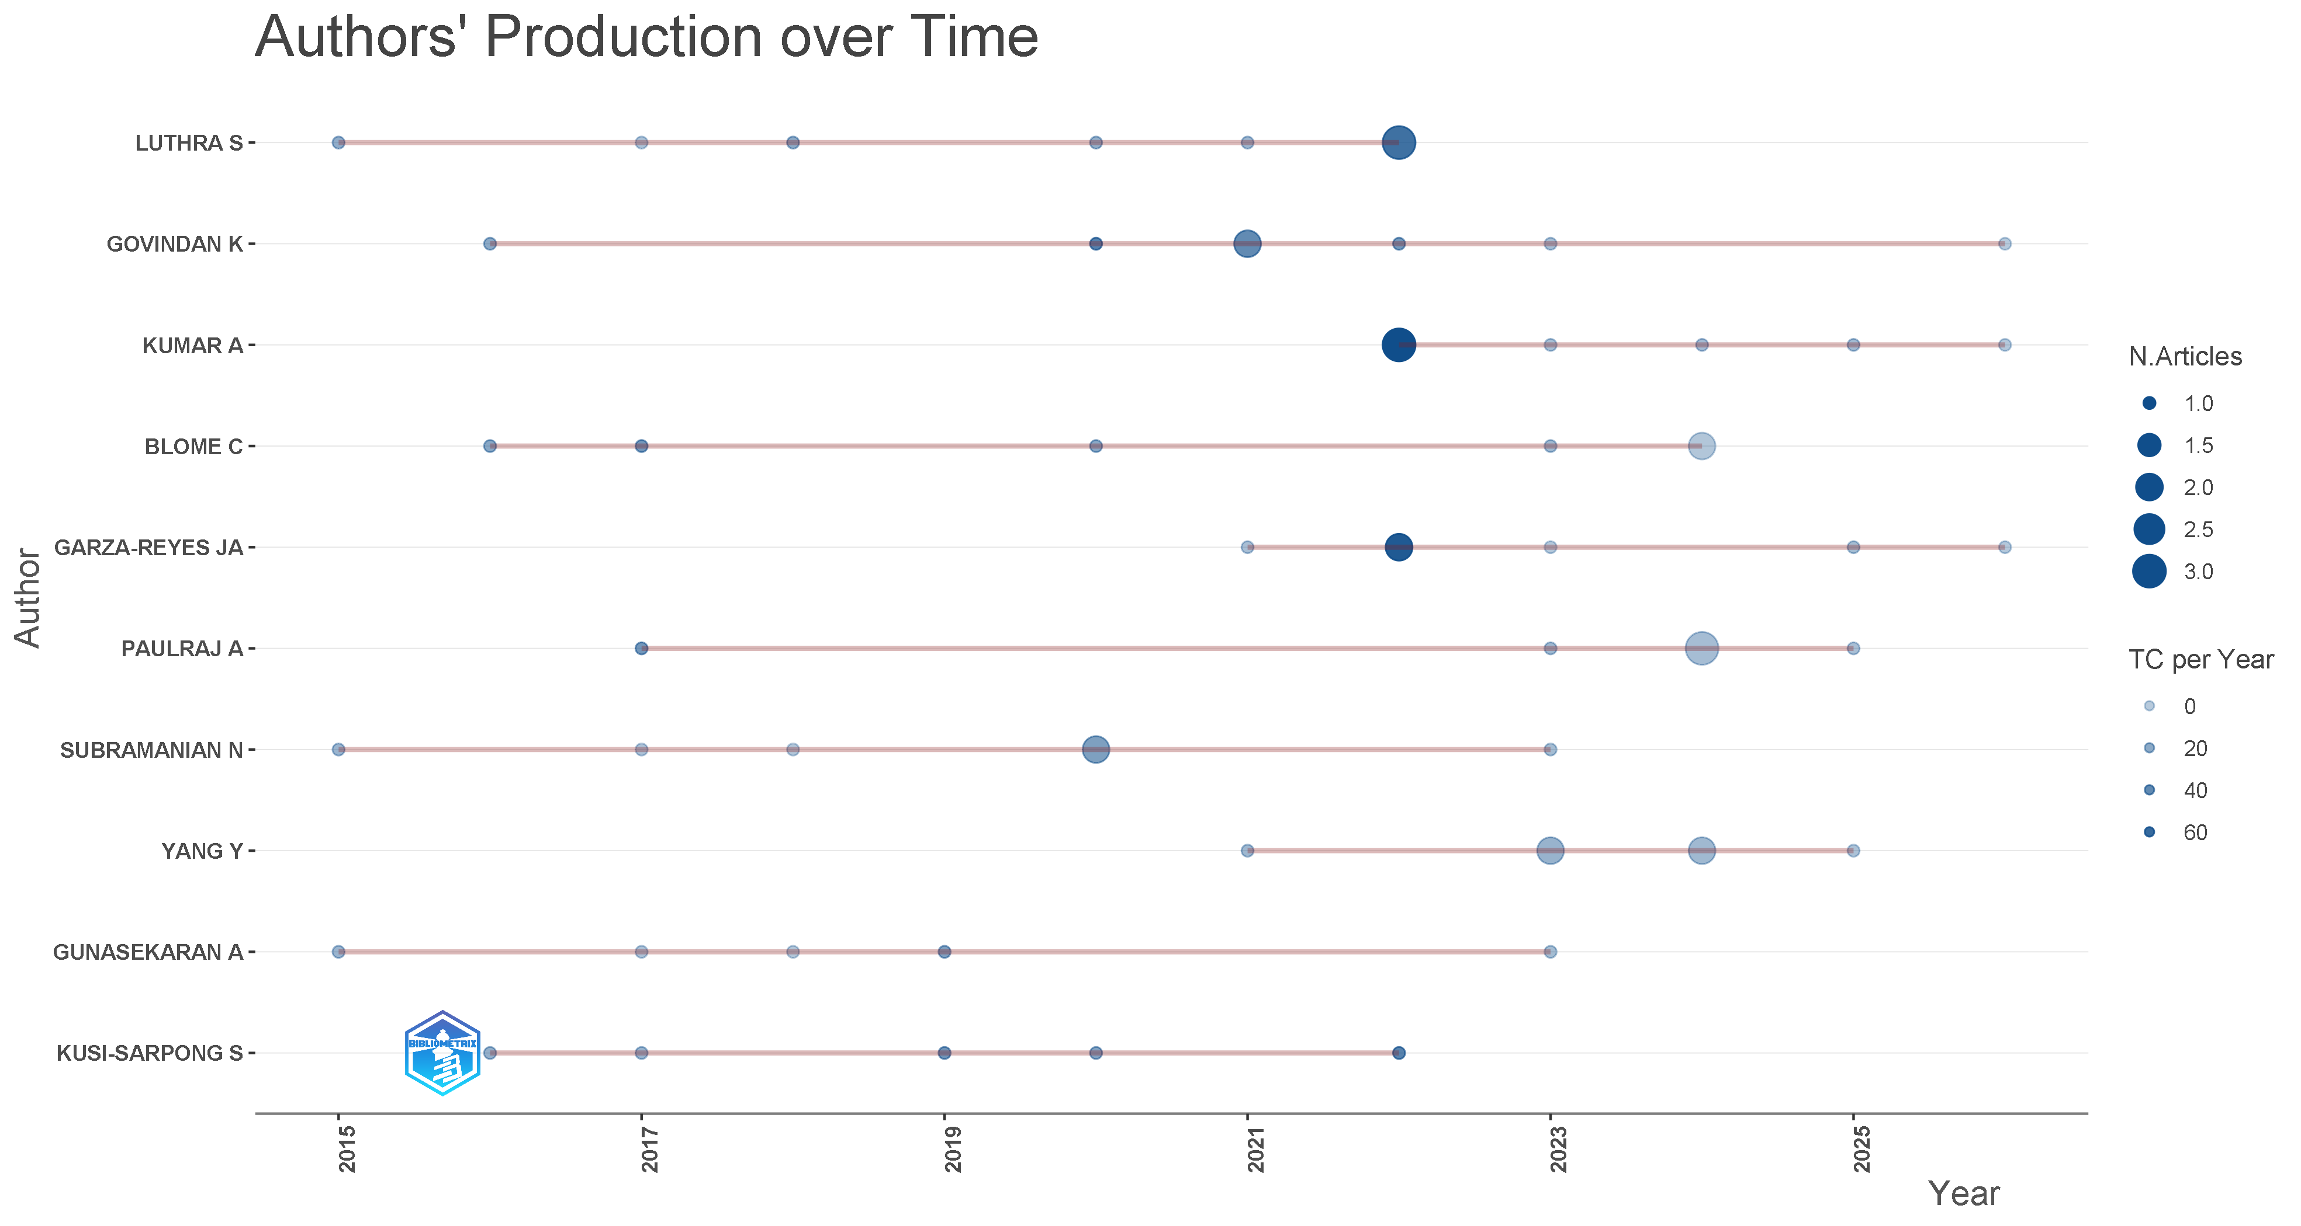
Figure 7. Publication timelines of the ten most productive authors, 2015–2026 (bubble size = articles per year; colour = citations per year).

4.8 Geographic distribution and collaboration structure
Author affiliations were traced to 50 distinct countries. Table 6 and Figure 9 show the United Kingdom as the single most represented country (142 affiliation instances), followed by China (71), India (66), the United States (56), and Australia (47). Figure 10, the countries' collaboration world map, shows a dense transatlantic and Europe–Asia collaboration corridor anchored in the United Kingdom, with strong secondary arcs connecting China, India, Australia, and continental Europe back to that core a visual confirmation that international collaboration in this literature, while extensive overall (53.8% of documents co-authored across borders), concentrates along a limited number of high-traffic country pairs rather than spreading evenly across all 50 countries represented in the corpus.
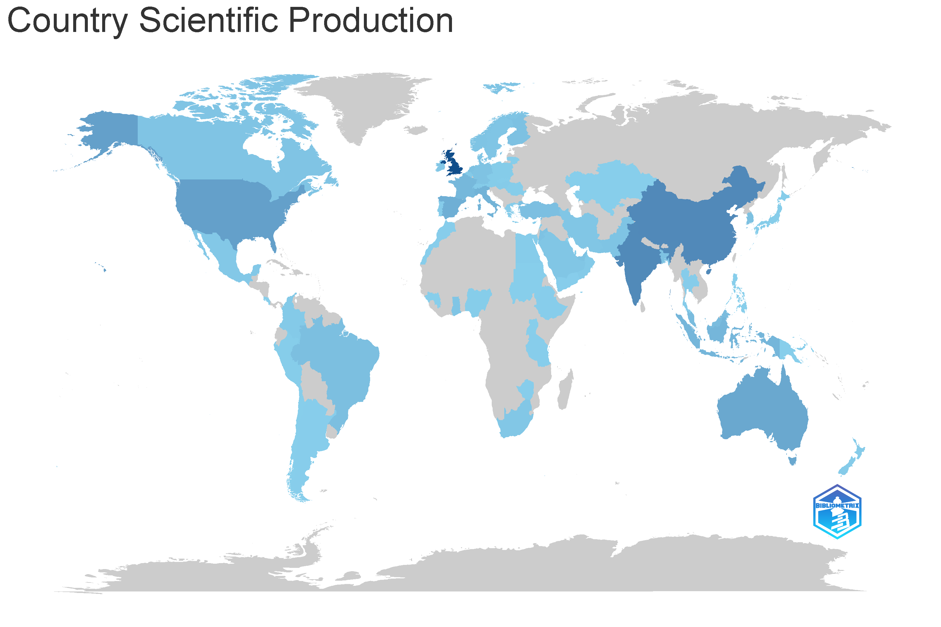
Figure 9. Country scientific production map, with darker shading indicating a higher volume of author affiliations; the United Kingdom records the highest count.
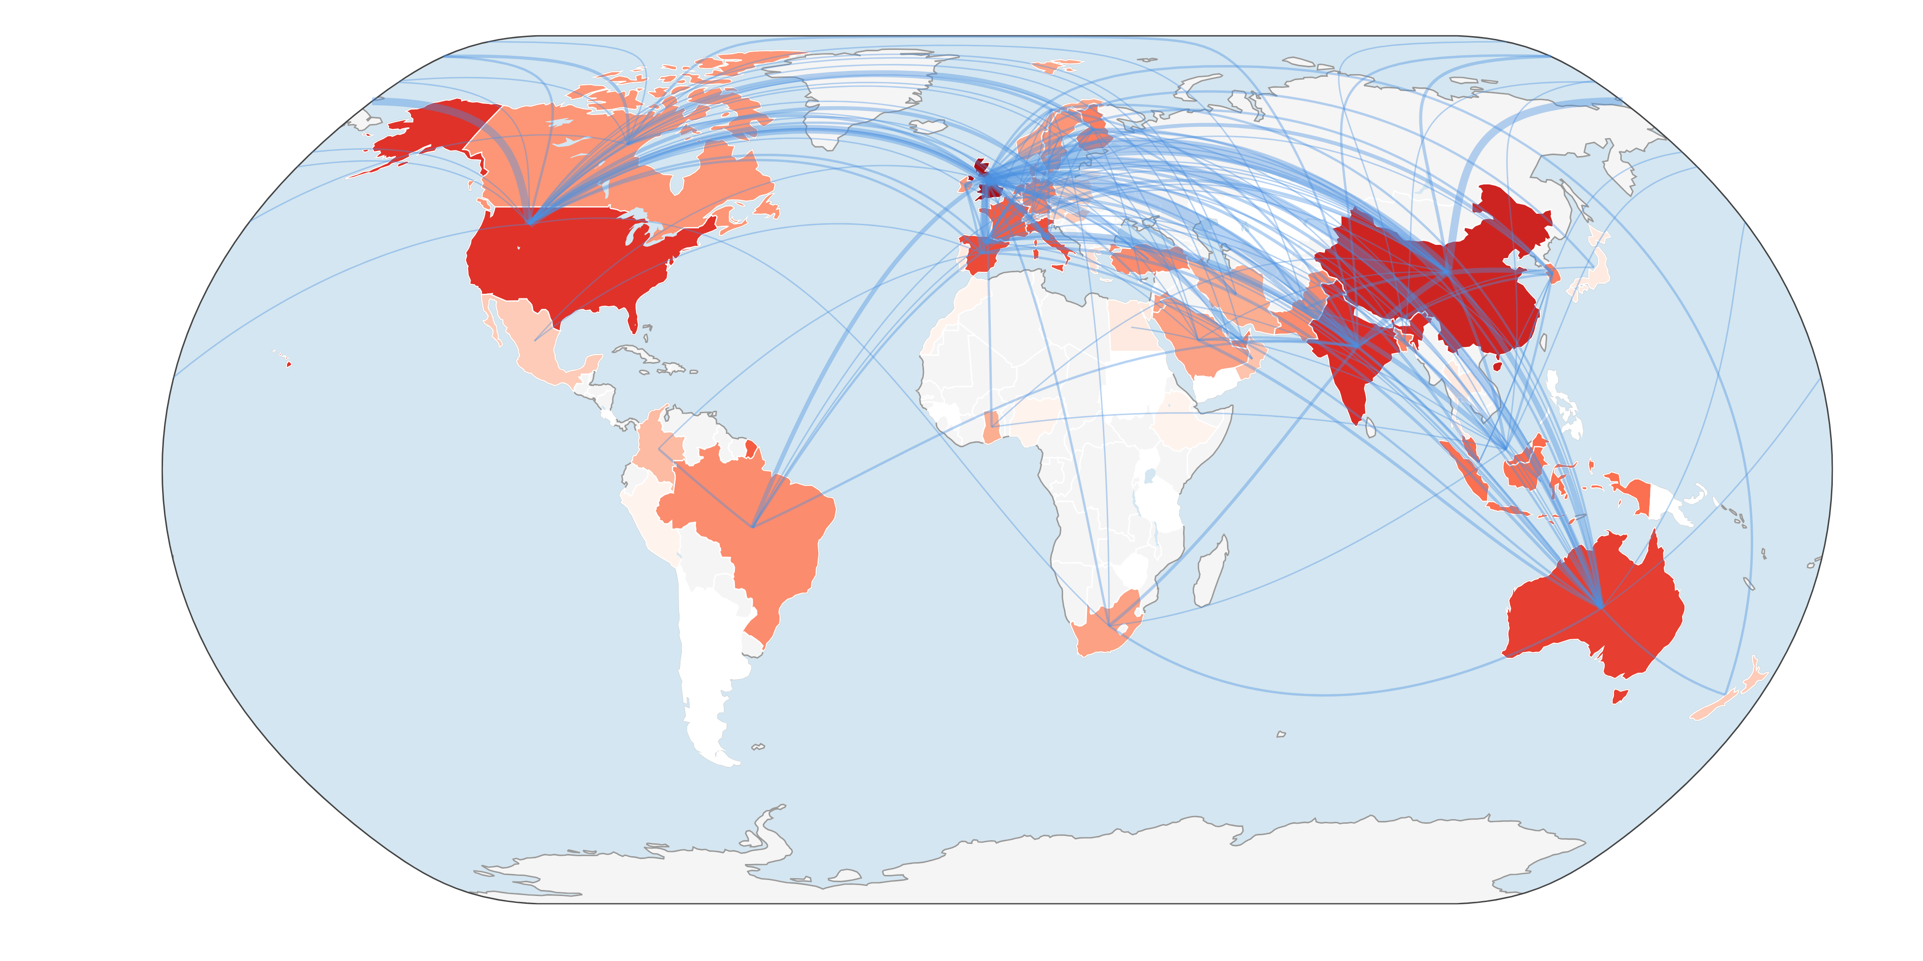
Figure 10. Countries' collaboration world map; arc thickness denotes the frequency of co-authored papers between country pairs.
Table 6. Fifteen most represented countries by author affiliation frequency.
Rank | Country | Affiliation instances
1 | United Kingdom | 142
2 | China | 71
3 | India | 66
4 | United States | 56
5 | Australia | 47
6 | Spain | 39
7 | Italy | 37
8 | France | 30
9 | Malaysia | 25
10 | Indonesia | 23
11 | Netherlands | 20
12 | South Korea | 19
12 | Finland | 19
14 | United Arab Emirates | 18
14 | Germany | 18

4.9 Conceptual structure: keywords, thematic maps, and thematic evolution
The two word clouds (Figures 11 and 12), built respectively from author keywords (DE) and Keywords Plus (ID) fields, converge on the same dominant vocabulary: sustainable development, sustainability, and supply chain management form the three largest terms in both renderings, trailed by environmental performance, circular economy, green supply chain management, and industry 4.0. Table 7 quantifies this pattern using author keywords: sustainability appears in 91 articles (18.8% of the corpus), supply chain management in 27, and environmental performance and circular economy tied at 24 each. Terms specific to the customer-integration side of the search string such as customer integration or customer collaboration do not appear among the top twenty keywords, a first quantitative signal that this sub-theme remains conceptually subordinate to the broader green supply chain and sustainability performance vocabulary rather than an independently recognised research stream.
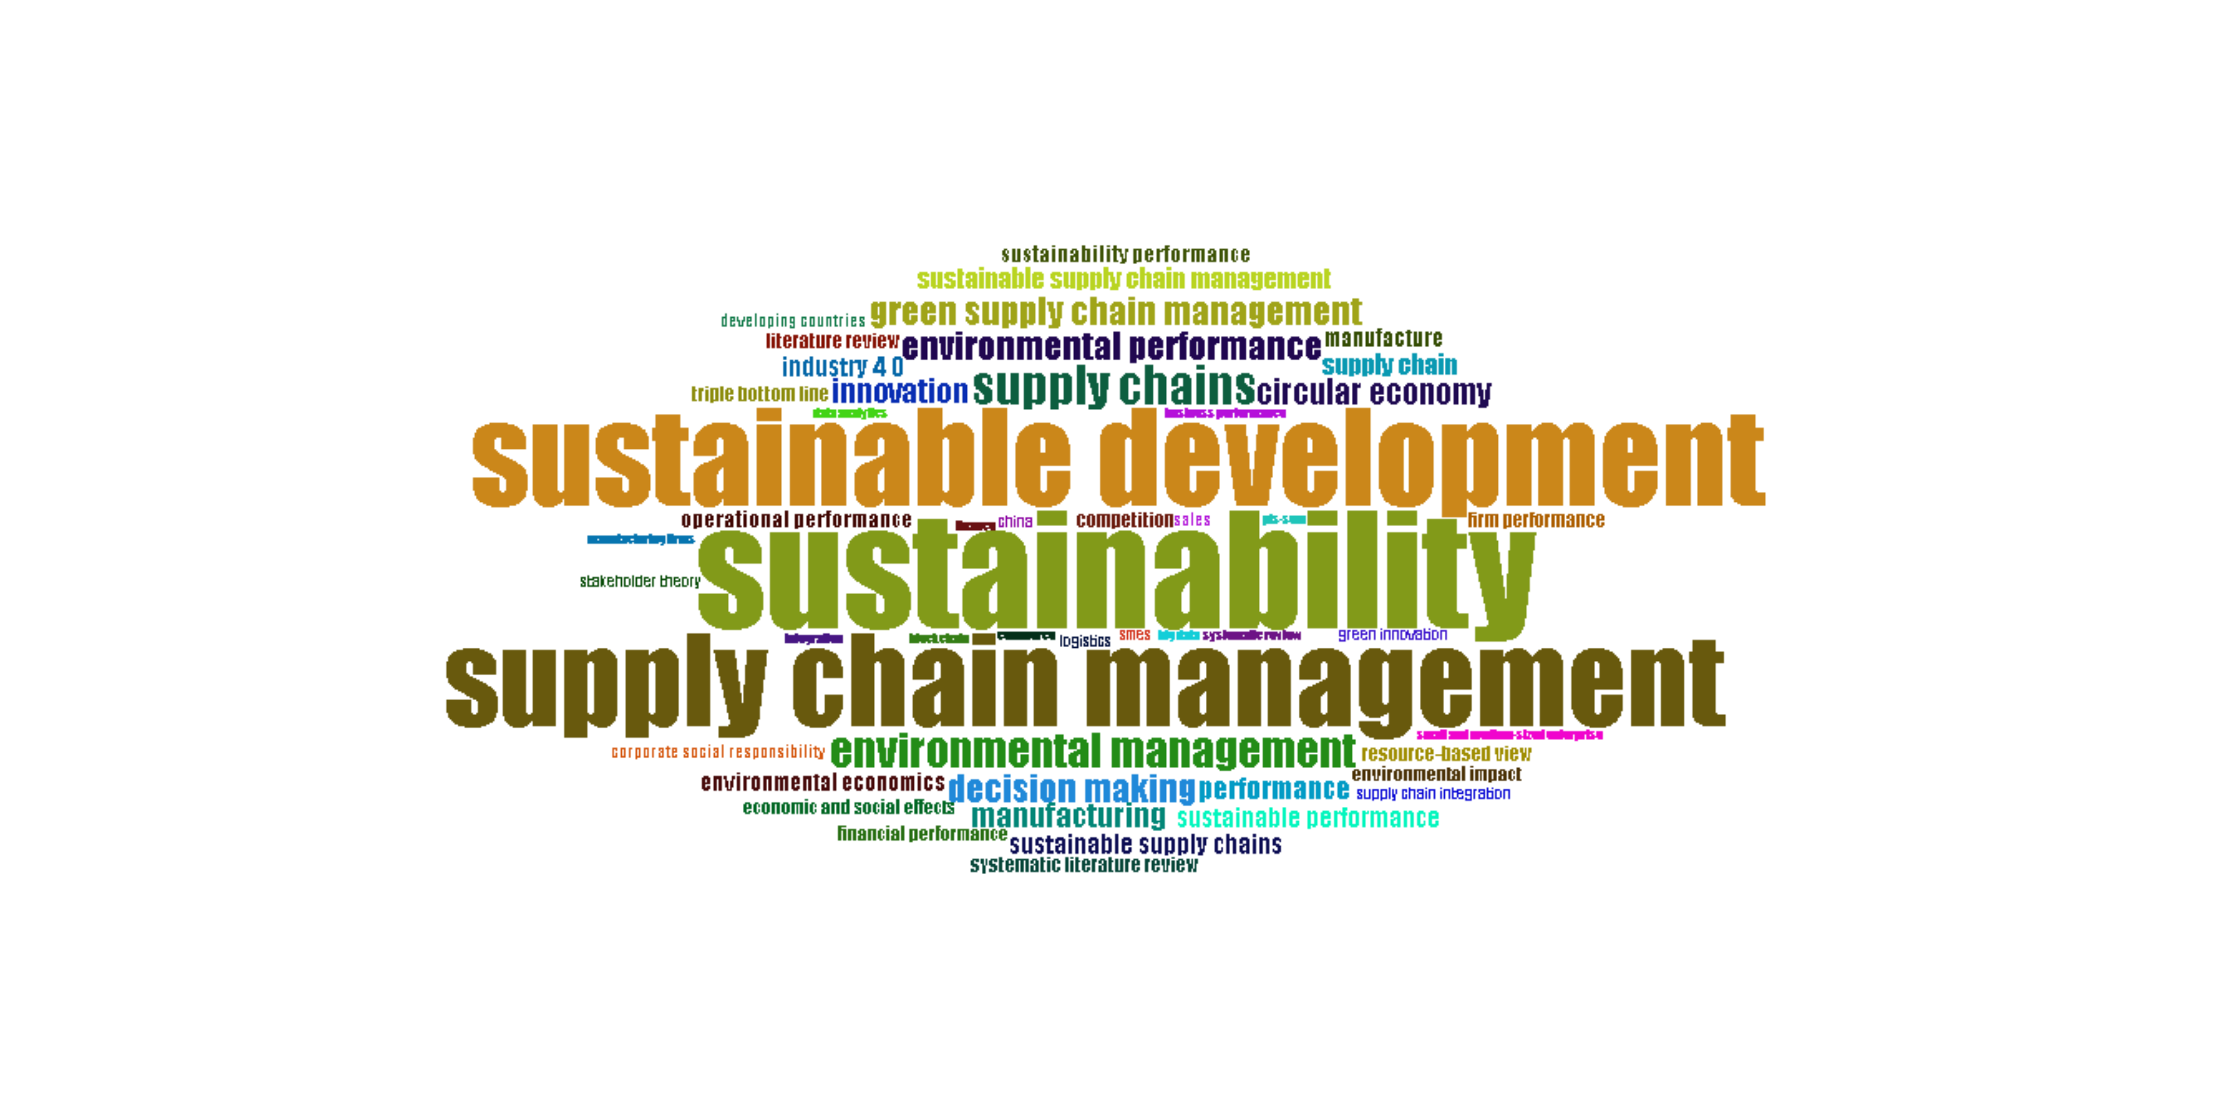
Figure 11. Word cloud of author keywords (DE), dominated by sustainable development, sustainability, and supply chain management.
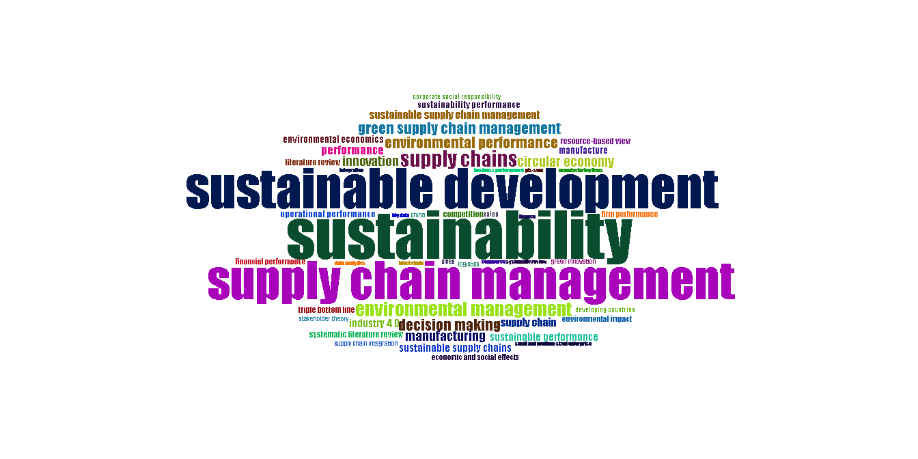
Figure 12. Word cloud of Keywords Plus (ID) index terms, corroborating the same dominant vocabulary from an independently assigned indexing field.
Table 7. Twenty most frequent author keywords.
Rank | Keyword | Frequency
1 | Sustainability | 91
2 | Supply chain management | 27
3 | Environmental performance | 24
3 | Circular economy | 24
5 | Green supply chain management | 22
6 | Supply chain | 21
7 | Sustainable supply chain management | 20
7 | Performance | 20
9 | Industry 4.0 | 19
10 | Sustainable development | 18
10 | Sustainable performance | 18
12 | Operational performance | 15
13 | Sustainability performance | 14
14 | Triple bottom line | 12
14 | Green innovation | 12
14 | SMEs | 12
14 | Supply chain integration | 12
14 | Firm performance | 12
19 | Innovation | 11
19 | Systematic literature review | 11

Figure 13 presents the author-keyword co-occurrence network, in which each node is a keyword, edge thickness denotes how frequently two keywords co-occur within the same article, and node colour marks six algorithmically detected thematic clusters. The red cluster is by far the largest, anchored on the hub term sustainability and radiating to innovation, business performance, bibliometric analysis, and environmental management visual confirmation that sustainability functions as the field's unifying umbrella rather than one theme among several. Two adjacent clusters supply this umbrella with operational content: a purple cluster (sustainable supply chain management, green innovation, resource-based view, stakeholder engagement) and a blue cluster (circular economy, industry 4.0, digitalization, digital transformation), indicating that the field's vocabulary is organised around resource-based/stakeholder theorising on one side and digitally enabled circular-economy practice on the other. Smaller green (stakeholder theory, institutional theory) and orange (SMEs, triple bottom line, sustainability performance) clusters sit closer to the periphery, while an isolated brown pair dynamic capability and supply chain resilience shares no visible ties to the rest of the network, a conceptual analogue to the peripheral collaboration pattern noted for countries in Section 4.8. Notably, despite the search string's explicit inclusion of customer integration and related terms, no dedicated customer-integration keyword appears as a node in this structure at all reinforcing the Section 4.9 finding above.
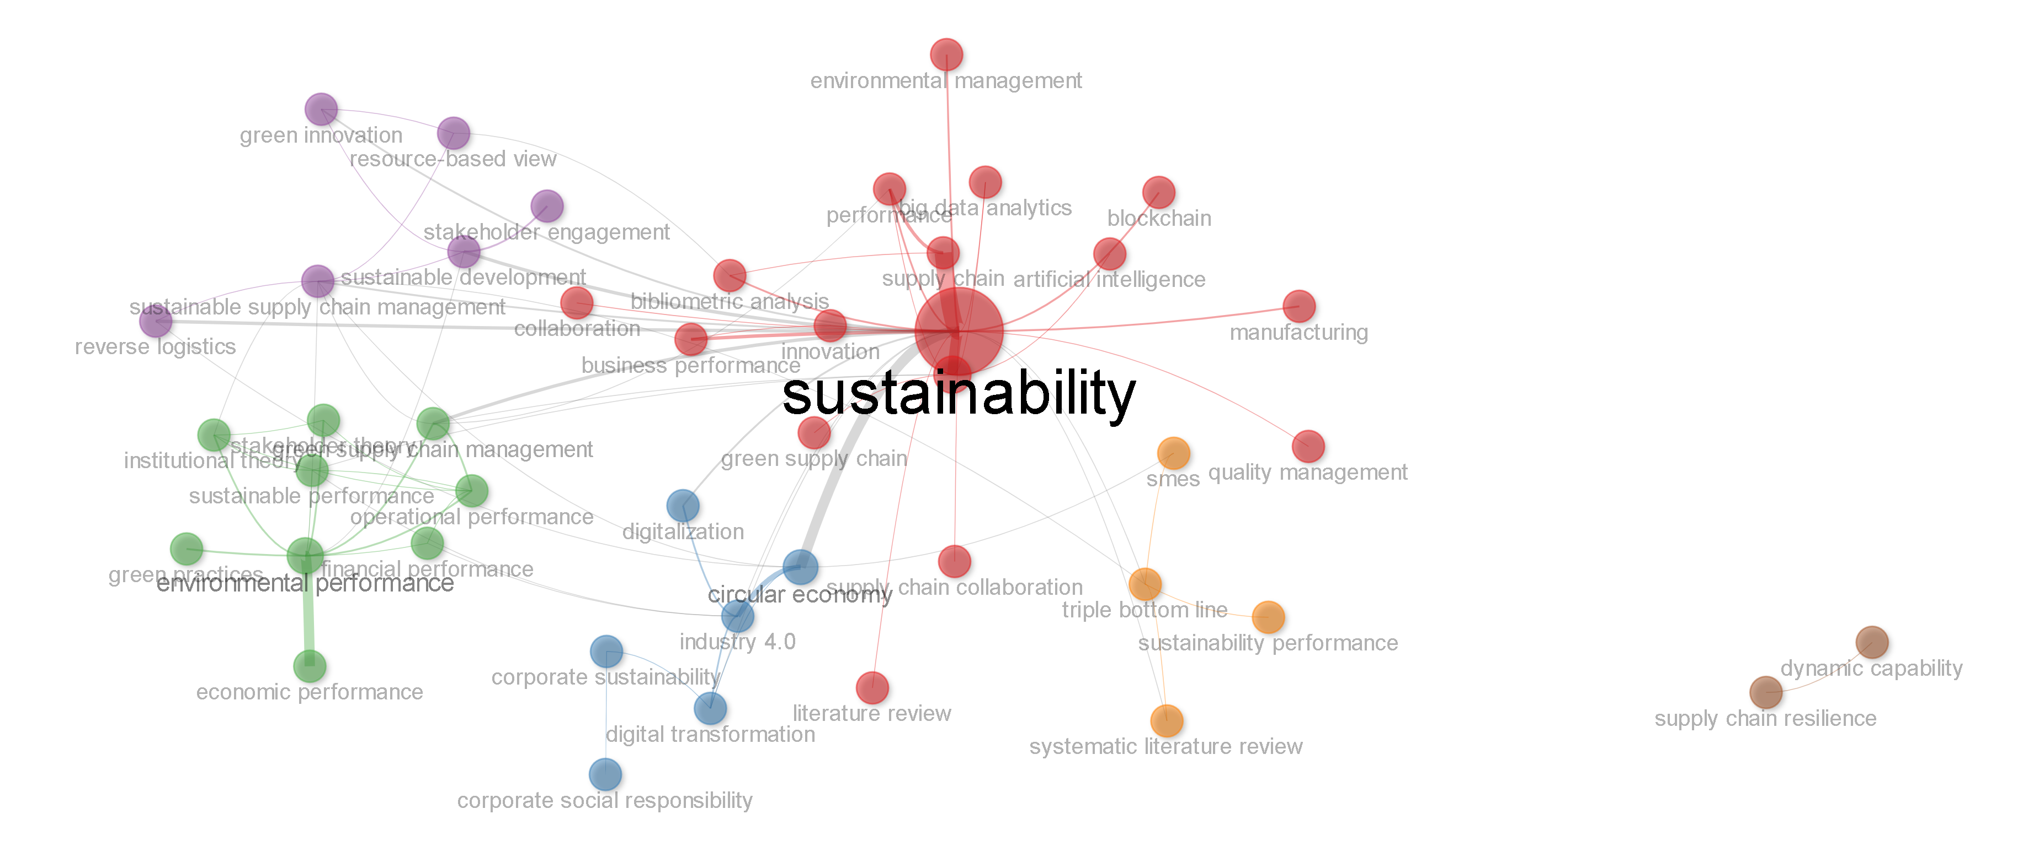
Figure 13. Author-keyword co-occurrence network resolving into six colour-coded thematic clusters, anchored on the hub term sustainability.
The strategic (thematic) maps in Figures 14 and 15 plot keyword clusters by centrality (relevance to the field) and density (internal development). For the 2015–2024 sub-period (Figure 14), sustainability, circular economy, and green supply chain management occupy the Basic Themes quadrant (high centrality, lower density) foundational, widely connected, but not yet a tightly self-contained specialism while environmental performance, sustainable supply chain management, and sustainable performance sit as Motor Themes bordering the same quadrant, indicating well-developed, central clusters driving the field forward. Sustainability performance, corporate sustainability, and dynamic capability occupy the Niche Themes quadrant, well developed internally but more peripheral to the field's overall centre of gravity precisely where a still-consolidating construct like green customer integration would be expected to sit once it accrues enough dedicated studies to register as its own cluster. For the more recent 2025–2026 sub-period (Figure 15), supply chain management, decision making, and circular economy move into the Motor Themes quadrant (high centrality and high density), suggesting these have matured from foundational to actively driving themes, while environmental management and green supply chain management remain strong secondary clusters and sustainable development, supply chains, and competition appear as Basic Themes with room to deepen.
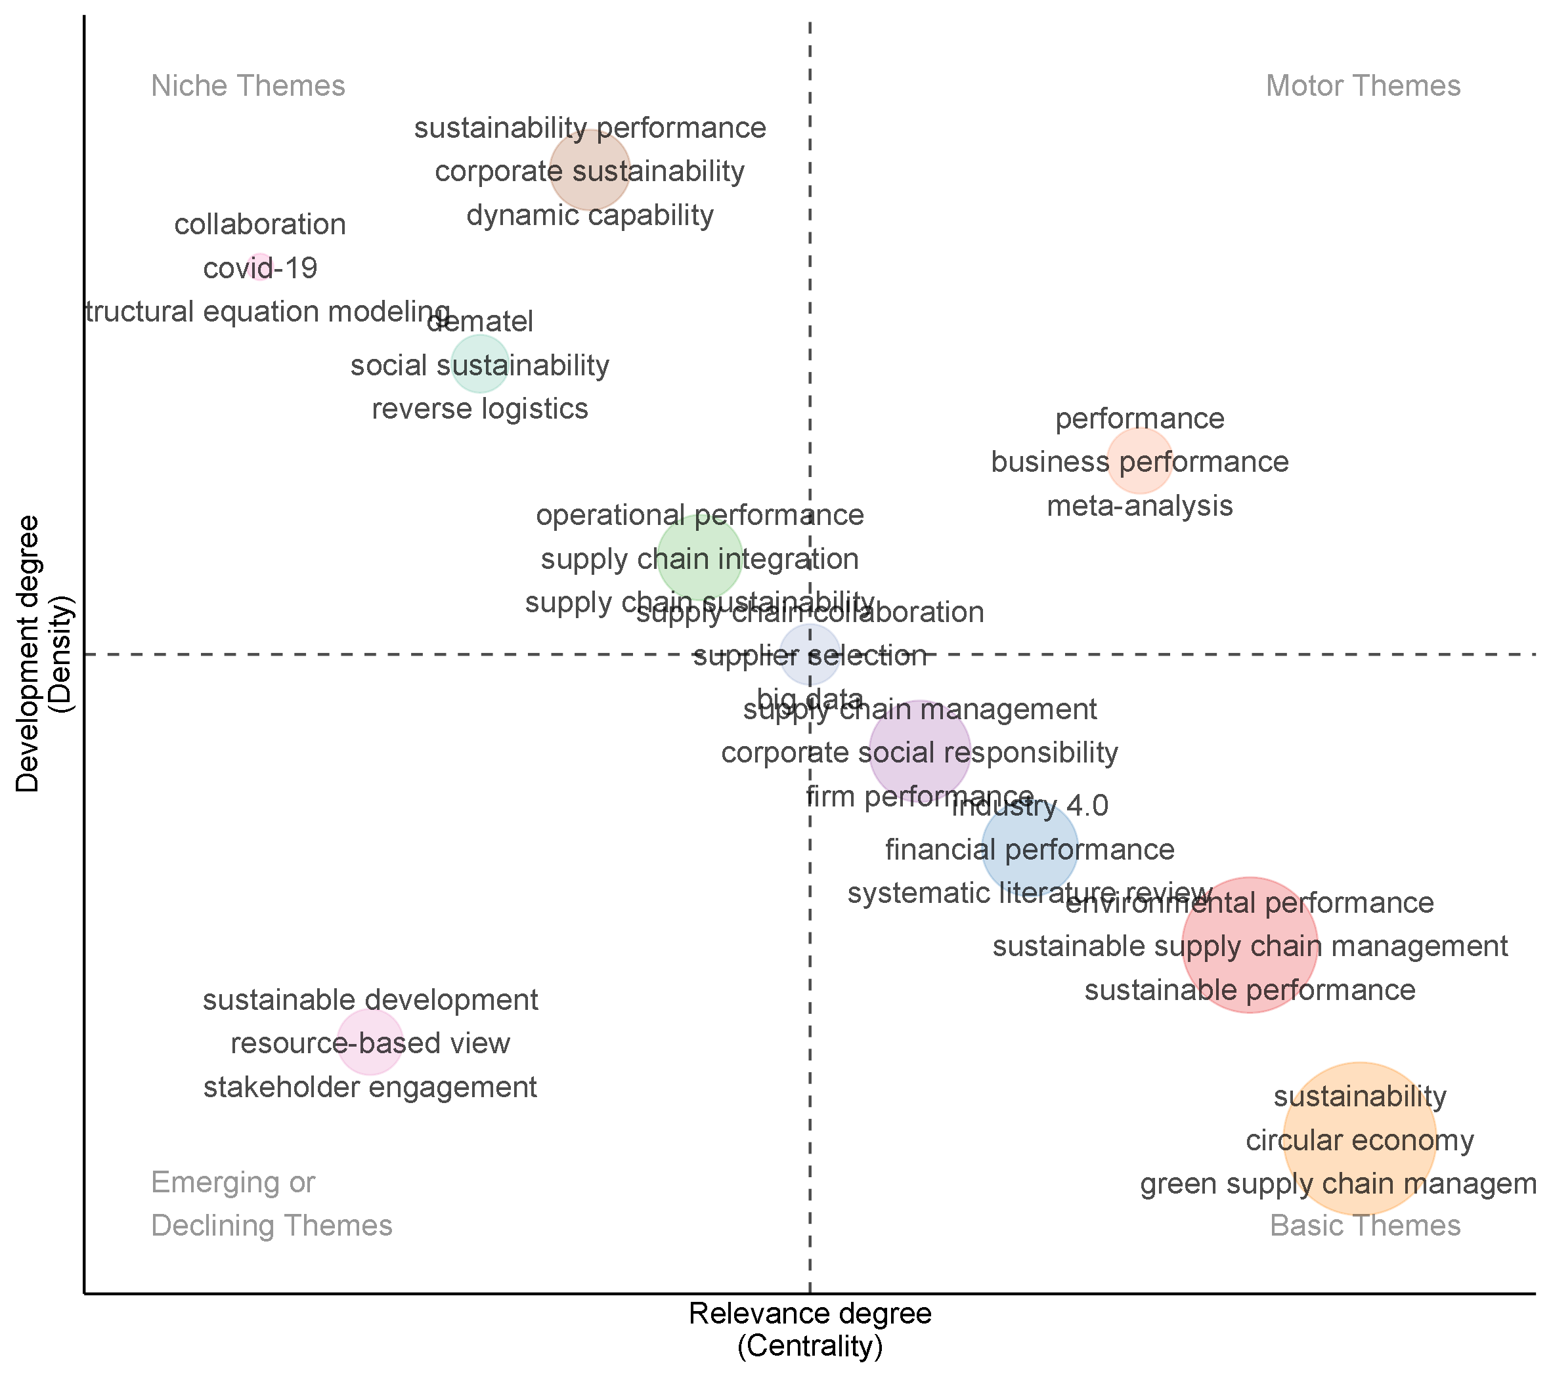
Figure 14. Strategic thematic map for 2015–2024, showing sustainability, circular economy, and green supply chain management as Basic Themes and environmental/sustainable performance clusters as Motor Themes.
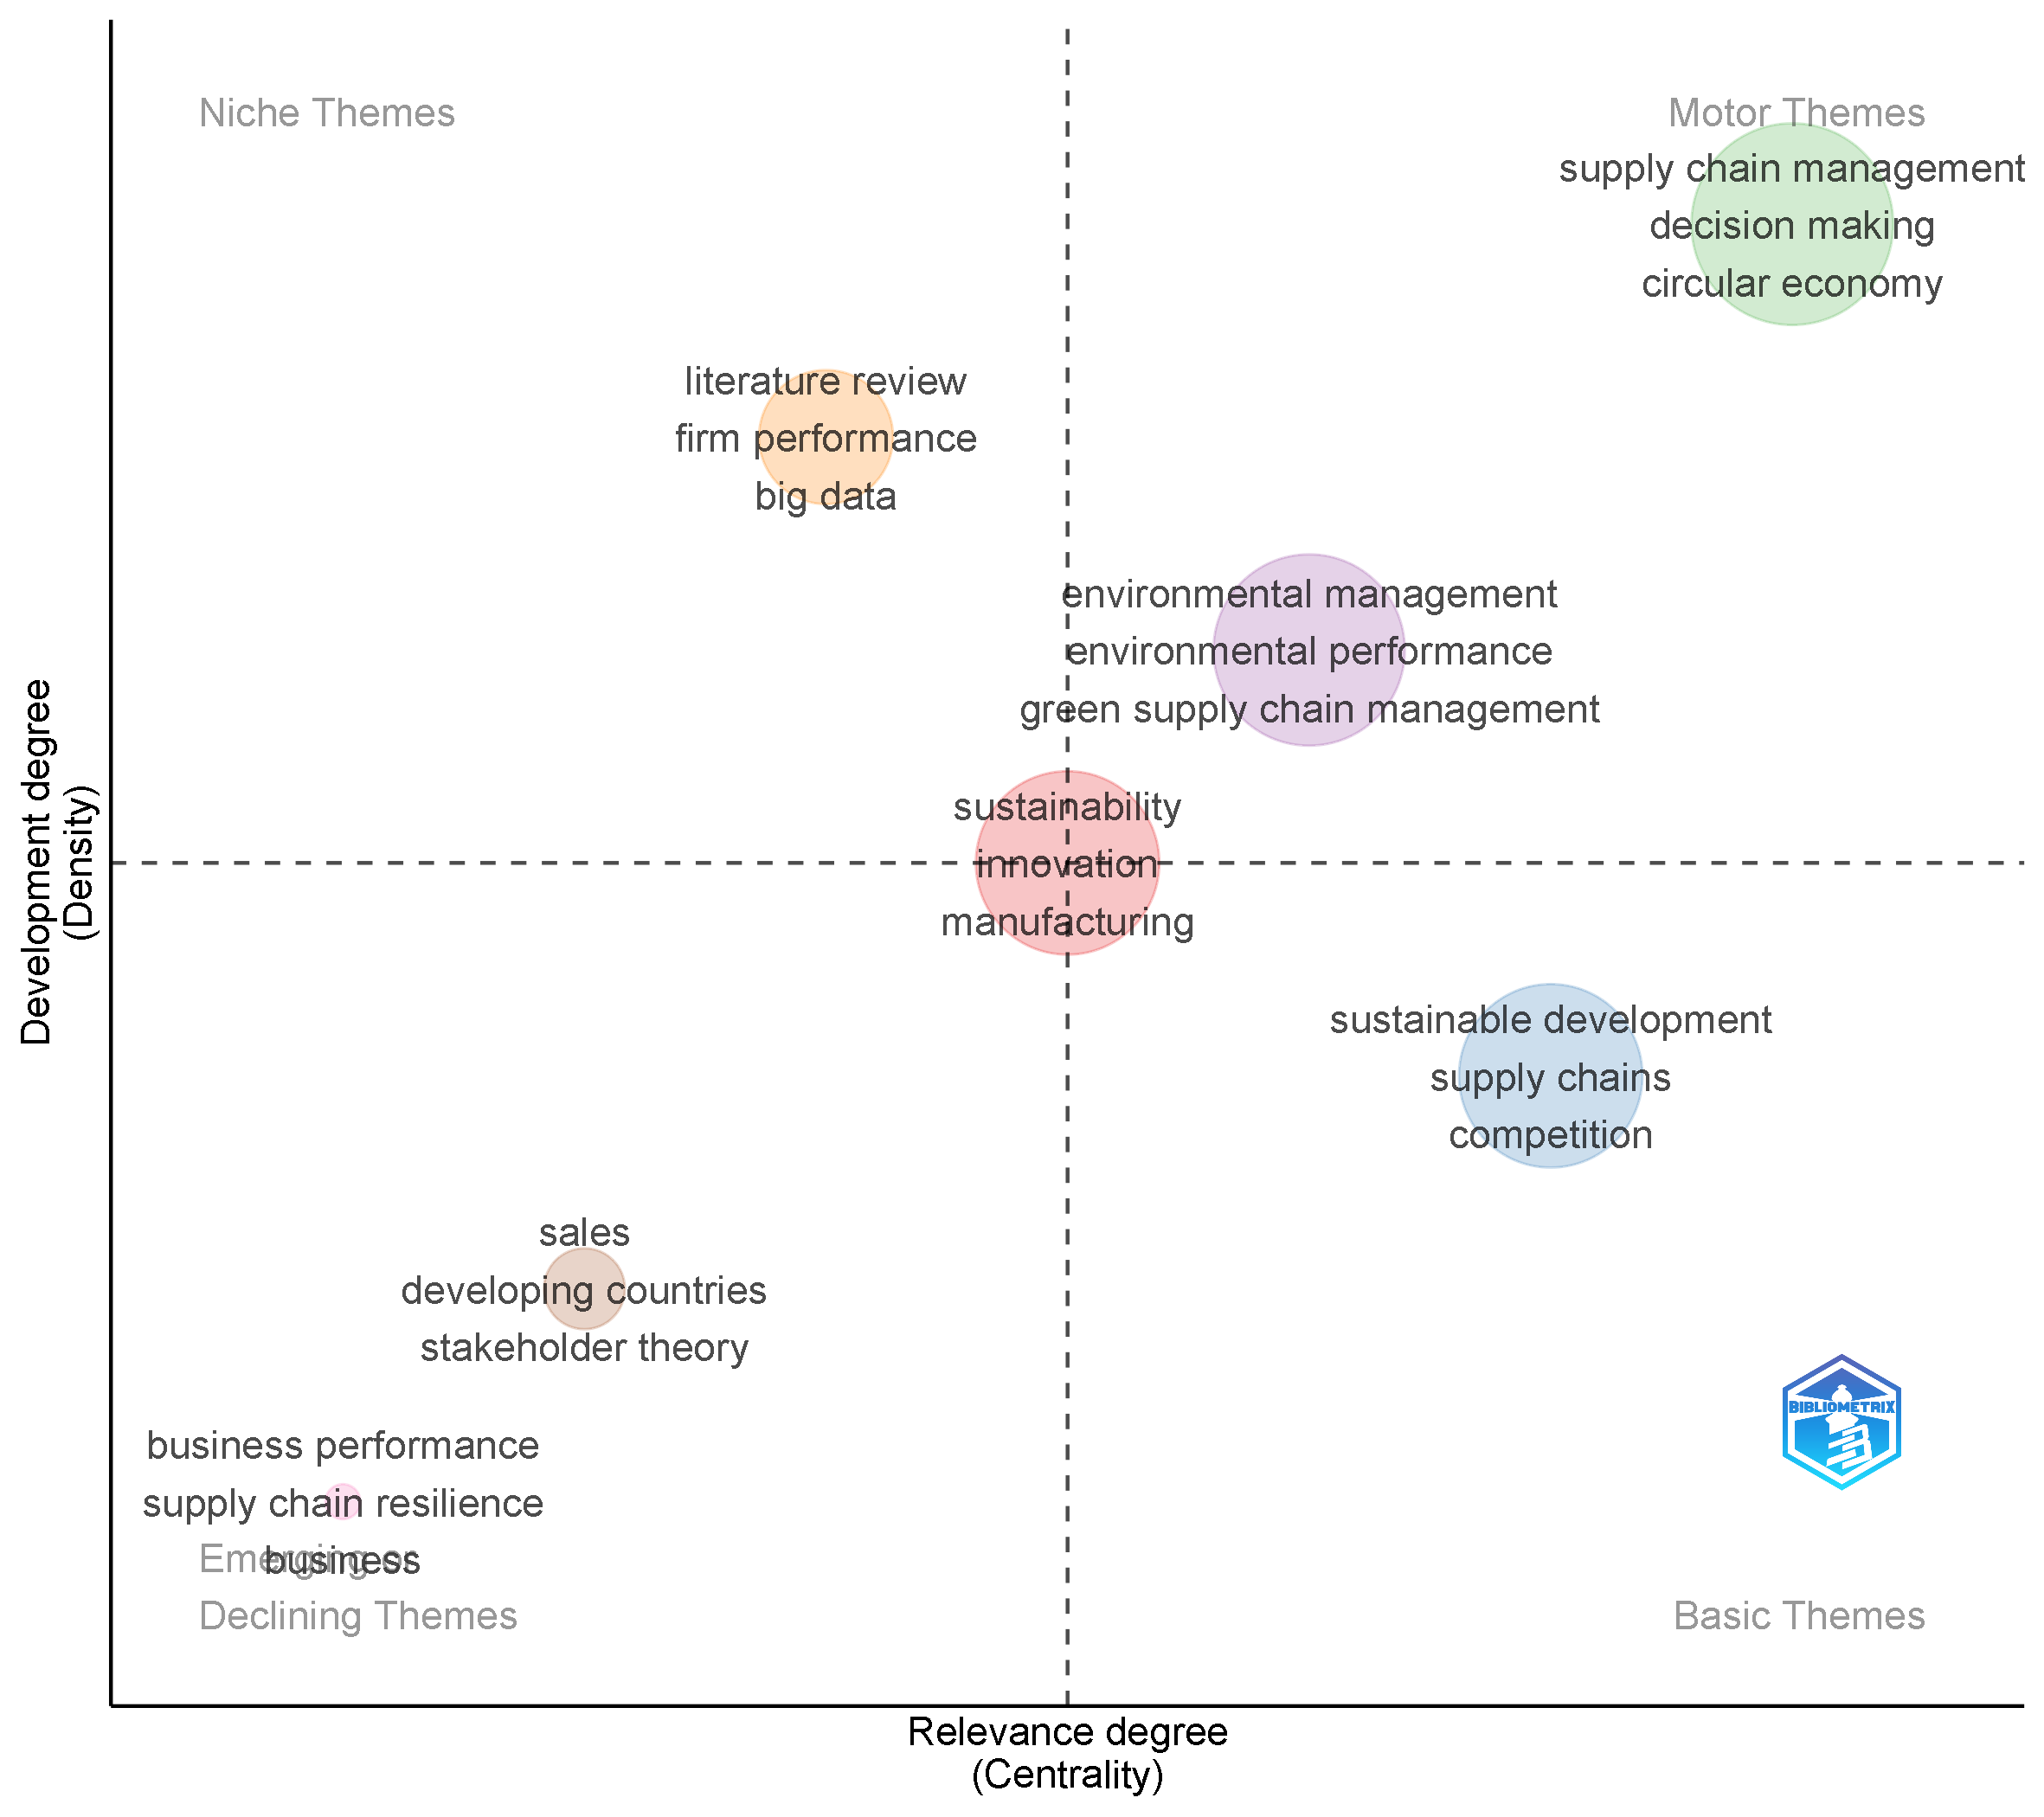
Figure 15. Strategic thematic map for 2025–2026, showing supply chain management, decision making, and circular economy consolidating into Motor Themes.
Figure 16, the thematic evolution (Sankey) diagram, traces how keyword clusters from the 2015–2024 period feed into those of 2025–2026. The largest flows show sustainability (2015–2024) splitting into both sustainability and supply chain management in the later period, while environmental performance and supply chain management (2015–2024) both feed substantially into sustainable performance and supply chain management respectively in 2025–2026. A distinctive new node, absorptive capacity, emerges prominently in the 2025–2026 period with inflows from sustainability performance and dematel-related methodological clusters, signalling a possible shift toward capability-based theorising consistent with the dynamic-capability framing discussed in Section 2 as the field matures. Industry 4.0 persists across both periods with a stable, moderate flow, indicating a steady rather than accelerating research interest.
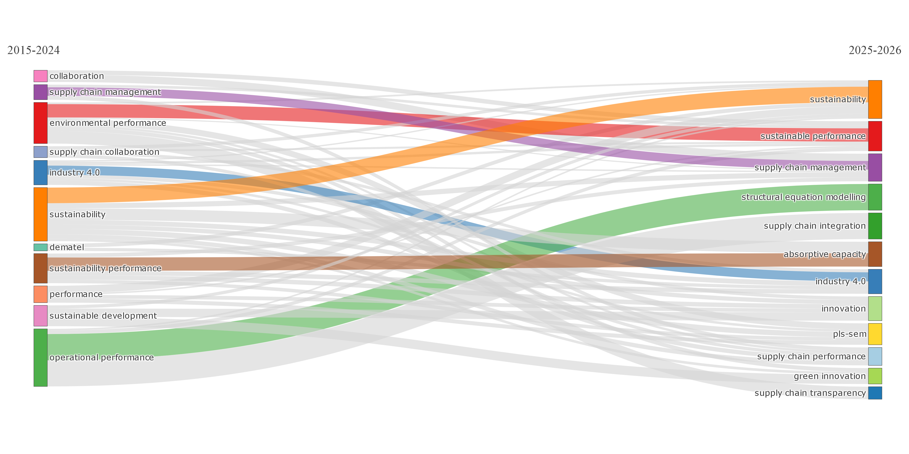
Figure 16. Thematic evolution diagram tracing keyword-cluster flows from 2015–2024 to 2025–2026, highlighting the emergence of absorptive capacity as a new thematic node.

5. Discussion
Three findings stand out when the performance and science-mapping results are read together. First, the field is unambiguously operations- and supply-chain-centred rather than marketing- or customer-centred. Every performance indicator the leading journals (Table 4), the most-cited documents (Table 3), and the dominant keywords (Table 7) points toward supply chain management, environmental performance, and circular economy as the literature's organising vocabulary. Green customer integration surfaces only indirectly, through a smaller cluster of studies on customer pressure, leverage, and collaboration (Guo et al., 2021; Marshall et al., 2019; Nguyen et al., 2023a, 2023b; Onofrei et al., 2020) that have not yet coalesced into a visible node on the thematic maps. This is not evidence that customer integration is unimportant several of these studies are well cited relative to their age but that it remains subordinate to the supplier- and process-facing side of green operations.
Second, the citation-lag pattern in Figure 8, combined with the rapid rise in annual output after 2020 (Table 2), indicates a field in an active growth phase rather than one approaching saturation. Nearly 89% of the corpus was published from 2020 onward, meaning most of the literature has not yet had time to accumulate its full citation potential. This has a direct implication for the interpretation of author impact metrics in Section 4.6: authors such as Anil Kumar, who leads on the m-index despite a comparatively short local publication history, illustrate how citation velocity, not just citation volume, increasingly distinguishes emerging influence in a fast-growing field.
Third, the geographic and collaboration results (Section 4.8) show a field that is internationally networked but not evenly so. The United Kingdom's dominance in author-affiliation counts, paired with China's and India's strong secondary positions, suggests that European institutions continue to anchor the field's collaborative core even as Asian and specifically Indian contributions grow. The concentration of collaboration-map arcs (Figure 10) along a limited set of high-traffic country pairs further suggests that, despite an international co-authorship rate above 50%, collaboration consolidates within regional clusters rather than forming one undifferentiated global network a pattern echoed conceptually in the six-cluster keyword co-occurrence structure (Figure 13) and in the Bradford's Law finding that a small Core of seven journals accounts for a disproportionate share of output.
The thematic evolution diagram (Figure 16) adds a forward-looking dimension to these observations. The emergence of absorptive capacity as a new node in the 2025–2026 period, feeding from earlier sustainability performance and methodological (dematel) clusters, suggests the field is beginning to ask not only whether green operations and customer integration improve sustainability performance, but how firms build the internal capacity to absorb and act on the environmental information that customer integration generates. This is a promising theoretical bridge between the green-operations literature's traditional process focus and the more relational, capability-based framing that customer-integration studies have started to introduce.

6. Insights into the Indian Context
India's position in this literature merits separate attention for two reasons. Empirically, India ranks third among all countries by author-affiliation frequency (66 instances, Table 6), behind only the United Kingdom and China, and ahead of long-established research economies such as the United States and Australia. Substantively, the single most influential author in the entire corpus by both local h-index and g-index, Sunil Luthra (h = 8, g = 8; Table 5, Figures 4–5), is affiliated with Indian institutions across the majority of his contributions to this dataset, making Indian scholarship not merely numerically present but analytically central to the field's core.
Three papers from this Indian-affiliated stream illustrate its distinctive contribution. Luthra et al. (2015) identify the critical success factors for green supply chain management adoption in the Indian automobile industry, establishing an early empirical baseline for how a large emerging-market manufacturing sector operationalises green supply chain practices under resource constraints that differ markedly from those assumed in much of the European and North American literature. Kausar et al. (2017) extend this work by mapping the key enablers of sustainable supply chain management specifically "from an Indian insight," while Luthra et al. (2018) apply a Grey-DEMATEL approach to model the interrelationships among critical success factors for sustainability initiatives in Indian supply chains a methodological contribution (DEMATEL-based multi-criteria modelling) that recurs as a niche but well-developed theme in the strategic thematic map (Figure 14). A fourth study, Muduli et al. (2020), broadens the lens beyond India specifically but includes Indian co-authorship in examining the "soft side" of organisations behavioural and cultural factors in green supply chain implementation, reinforcing a recurring emphasis in this stream on organisational and human factors alongside technical process redesign.
Collectively, this body of Indian-context research suggests that critical success factor identification, multi-criteria decision modelling (DEMATEL, and related structural techniques visible in Figure 14's niche-theme cluster), and behavioural or "soft" organisational factors constitute India's distinctive methodological and thematic signature within the global literature a signature oriented more toward implementation barriers and enablers within resource-constrained manufacturing contexts than toward the customer-integration mechanisms that dominate the European- and North American-centred studies discussed in Section 5. For a country that combines large-scale manufacturing with an increasingly environmentally conscious consumer base, this suggests a clear opportunity: Indian research on green operations has established a strong foundation on the supply and production side, but has not yet produced a comparable body of work on how Indian firms integrate customers domestic or export-market into their environmental decision-making, a gap that mirrors, and could help close, the global one identified in Section 5.

7. Theoretical and Practical Implications
Theoretically, this study offers three contributions. It provides an empirically grounded map of a literature that connects green operations, green customer integration, and sustainability performance three constructs usually studied within separate disciplinary silos of operations management, marketing, and strategy and shows precisely where they intersect and where they do not. It identifies dynamic capability and institutional theory as the two lenses most consistently used to explain how green practices diffuse through supply chains and translate into performance, giving future researchers a validated starting point. And it flags absorptive capacity as an emerging theoretical bridge, visible directly in the thematic evolution data (Figure 16), between process-oriented green operations research and the more relational customer-integration literature.
Practically, the Bradford's Law and most-cited-document results (Sections 4.3–4.4) give managers, consultants, and doctoral researchers a validated shortlist of journals and papers to prioritise when building an evidence base for green operations investment decisions, rather than relying on ad hoc searches. The author and country mapping (Sections 4.6–4.8) identifies the specific research groups anchored around Luthra, Govindan, and Paulraj best positioned to advise on implementation questions, particularly for organisations sourcing from South Asian manufacturing contexts. For managers interested in the customer-facing dimension of sustainability, the relative thinness of the customer-integration cluster (Section 5) is itself an actionable signal: firms that invest early in structured customer-integration mechanisms joint product redesign, shared environmental monitoring, transparent reporting to customers are moving into an under-theorised but potentially high-differentiation space.

8. Limitations and Future Research Directions
This study has four principal limitations. First, reliance on a single database (Scopus) and English-language, final-stage, open-access journal articles means the corpus, while systematically constructed, necessarily excludes conference proceedings, books, non-English scholarship, and closed-access or in-press articles that may contain relevant findings. Second, citation counts are a time-bound snapshot as of the August 2026 export date; the citation-lag effect visible in Figure 8 means recent and especially 2025–2026 publications are almost certainly under-represented in influence terms and should be revisited in future updates. Third, the Boolean search string, while deliberately broad across three concept blocks, inevitably reflects the authors' judgment about which terms adequately represent "green operations," "green customer integration," and "sustainability performance"; studies using markedly different terminology for functionally similar constructs may have been missed. Fourth, bibliometric methods describe structure and pattern but cannot adjudicate the substantive validity of any individual study's findings; the results reported here should be read as a map of the literature's shape, not a quality assessment of its content.
These limitations point directly to future research opportunities. A systematic, hand-coded content analysis of the customer-integration sub-cluster identified in Section 5 would help establish whether this theme is genuinely under-researched or simply under-labelled in keyword indexing. Comparative bibliometric analysis across Scopus, Web of Science, and Dimensions could test the sensitivity of the reported structure to database choice. Given the prominent Indian contribution identified in Section 6, a dedicated systematic review of Indian and, more broadly, South Asian green supply chain research extending beyond bibliometric mapping into qualitative synthesis of findings would usefully complement the present study. Finally, the emergence of absorptive capacity as a new thematic node (Figure 16) suggests an empirically testable opportunity: future primary research could examine whether firms with higher absorptive capacity translate green customer integration into sustainability performance more effectively than those without it, directly bridging the two currently disconnected halves of this literature.

9. Conclusion
This bibliometric analysis of 485 Scopus-indexed articles (2015–2026) maps, for the first time, the intellectual structure of research connecting green operations, green customer integration, and sustainability performance. The field is young, fast-growing, and organised around a compact Core of seven journals and a small set of highly influential authors led by Sunil Luthra, Kannan Govindan, and Antony Paulraj. Its dominant conceptual vocabulary sustainability, supply chain management, environmental performance, and circular economy confirms that green operations research has matured into a coherent, internationally collaborative field, while green customer integration remains a comparatively underdeveloped node awaiting fuller theoretical and empirical attention. India's strong showing, both in author-affiliation volume and in the field's single most influential author, marks Indian scholarship as a distinctive and increasingly central contributor, with a methodological signature centred on critical success factors and multi-criteria implementation modelling. As the field's thematic evolution toward absorptive capacity suggests, the next phase of research is well positioned to connect the process-oriented rigour of established green operations scholarship with the relational, customer-facing mechanisms that this analysis shows are still waiting for their own dedicated body of work.

References
Agrawal, R., Wankhede, V.A., Kumar, A., Upadhyay, A., & Garza-Reyes, J.A. (2022). Nexus of circular economy and sustainable business performance in the era of digitalization. International Journal of Productivity and Performance Management, 71(3), 748–774. https://doi.org/10.1108/IJPPM-12-2020-0676
Ahmadi-Gh, Z., & Bello-Pintado, A. (2024). Sustainability isomorphism in buyer–supplier relationships: The impact of supply chain leadership. Business Strategy and the Environment, 33(4), 3635–3653. https://doi.org/10.1002/bse.3668
Alsawafi, A., Lemke, F., & Yang, Y. (2021). The impacts of internal quality management relations on the triple bottom line: A dynamic capability perspective. International Journal of Production Economics, 232, 107927. https://doi.org/10.1016/j.ijpe.2020.107927
Aria, M., & Cuccurullo, C. (2017). bibliometrix: An R-tool for comprehensive science mapping analysis. Journal of Informetrics, 11(4), 959–975. https://doi.org/10.1016/j.joi.2017.08.007
Batista, L., Bourlakis, M., Smart, P., & Maull, R. (2018). In search of a circular supply chain archetype–a content-analysis-based literature review. Production Planning and Control, 29(6), 438–451. https://doi.org/10.1080/09537287.2017.1343502
Bradford, S. C. (1934). Sources of information on specific subjects. Engineering: An Illustrated Weekly Journal, 137, 85–86.
Burki, U., & Dahlstrom, R. (2017). Mediating effects of green innovations on interfirm cooperation. Australasian Marketing Journal, 25(2), 149–156. https://doi.org/10.1016/j.ausmj.2017.05.001
Chen, L., Zhao, X., Tang, O., Price, L., Zhang, S., & Zhu, W. (2017). Supply chain collaboration for sustainability: A literature review and future research agenda. International Journal of Production Economics, 194, 73–87. https://doi.org/10.1016/j.ijpe.2017.04.005
Donthu, N., Kumar, S., Mukherjee, D., Pandey, N., & Lim, W. M. (2021). How to conduct a bibliometric analysis: An overview and guidelines. Journal of Business Research, 133, 285–296. https://doi.org/10.1016/j.jbusres.2021.04.070
Dwivedi, Y.K., Hughes, L., Kar, A.K., Baabdullah, A.M., Grover, P., Abbas, R., Andreini, D., Abumoghli, I., Barlette, Y., Bunker, D., Chandra Kruse, L., Constantiou, I., Davison, R.M., De, R., Dubey, R., Fenby-Taylor, H., Gupta, B., He, W., Kodama, M., ... Wade, M. (2022). Climate change and COP26: Are digital technologies and information management part of the problem or the solution? An editorial reflection and call to action. International Journal of Information Management, 63, 102456. https://doi.org/10.1016/j.ijinfomgt.2021.102456
Feng, Y., Lai, K.h., & Zhu, Q. (2022). Green supply chain innovation: Emergence, adoption, and challenges. International Journal of Production Economics, 248, 108497. https://doi.org/10.1016/j.ijpe.2022.108497
Formentini, M., & Taticchi, P. (2016). Corporate sustainability approaches and governance mechanisms in sustainable supply chain management. Journal of Cleaner Production, 112, 1920–1933. https://doi.org/10.1016/j.jclepro.2014.12.072
Gelhard, C., & von Delft, S. (2016). The role of organizational capabilities in achieving superior sustainability performance. Journal of Business Research, 69(10), 4632–4642. https://doi.org/10.1016/j.jbusres.2016.03.053
Geng, R., Mansouri, S.A., & Aktas, E. (2017). The relationship between green supply chain management and performance: A meta-analysis of empirical evidences in Asian emerging economies. International Journal of Production Economics, 183, 245–258. https://doi.org/10.1016/j.ijpe.2016.10.008
Govindan, K., Mina, H., Esmaeili, A., & Gholami-Zanjani, S.M. (2020). An integrated hybrid approach for circular supplier selection and closed loop supply chain network design under uncertainty. Journal of Cleaner Production, 242, 118317. https://doi.org/10.1016/j.jclepro.2019.118317
Guo, Y., Yen, D.A., Geng, R., & Azar, G. (2021). Drivers of green cooperation between Chinese manufacturers and their customers: An empirical analysis. Industrial Marketing Management, 93, 137–146. https://doi.org/10.1016/j.indmarman.2021.01.004
Kausar, Garg, D., & Luthra, S. (2017). Key enablers to implement sustainable supply chain management practices: An Indian insight. Uncertain Supply Chain Management, 5(2), 89–104. https://doi.org/10.5267/j.uscm.2016.10.005
Khanra, S., Kaur, P., Joseph, R.P., Malik, A., & Dhir, A. (2022). A resource-based view of green innovation as a strategic firm resource: Present status and future directions. Business Strategy and the Environment, 31(4), 1395–1413. https://doi.org/10.1002/bse.2961
Kristoffersen, E., Mikalef, P., Blomsma, F., & Li, J. (2021). The effects of business analytics capability on circular economy implementation, resource orchestration capability, and firm performance. International Journal of Production Economics, 239, 108205. https://doi.org/10.1016/j.ijpe.2021.108205
Lerman, L.V., Benitez, G.B., Müller, J.M., de Sousa, P.R., & Frank, A.G. (2022). Smart green supply chain management: a configurational approach to enhance green performance through digital transformation. Supply Chain Management, 27(7), 147–176. https://doi.org/10.1108/SCM-02-2022-0059
Liu, Y., Zhu, Q., & Seuring, S. (2017). Linking capabilities to green operations strategies: The moderating role of corporate environmental proactivity. International Journal of Production Economics, 187, 182–195. https://doi.org/10.1016/j.ijpe.2017.03.007
Lotka, A. J. (1926). The frequency distribution of scientific productivity. Journal of the Washington Academy of Sciences, 16(12), 317–323.
Luthra, S., Garg, D., & Haleem, A. (2015). Critical success factors of green supply chain management for achieving sustainability in Indian automobile industry. Production Planning and Control, 26(5), 339–362. https://doi.org/10.1080/09537287.2014.904532
Luthra, S., Mangla, S.K., Shankar, R., Prakash Garg, C., & Jakhar, S. (2018). Modelling critical success factors for sustainability initiatives in supply chains in Indian context using Grey-DEMATEL. Production Planning and Control, 29(9), 705–728. https://doi.org/10.1080/09537287.2018.1448126
Mani, V., Jabbour, C.J.C., & Mani, K.T. (2020). Supply chain social sustainability in small and medium manufacturing enterprises and firms' performance: Empirical evidence from an emerging Asian economy. International Journal of Production Economics, 227, 107656. https://doi.org/10.1016/j.ijpe.2020.107656
Maroufkhani, P., Tseng, M.L., Iranmanesh, M., Ismail, W.K.W., & Khalid, H. (2020). Big data analytics adoption: Determinants and performances among small to medium-sized enterprises. International Journal of Information Management, 54, 102190. https://doi.org/10.1016/j.ijinfomgt.2020.102190
Marshall, D., McCarthy, L., Claudy, M., & McGrath, P. (2019). Piggy in the middle: How direct customer power affects first-tier suppliers' adoption of socially responsible procurement practices and performance. Journal of Business Ethics, 154(4), 1081–1102. https://doi.org/10.1007/s10551-016-3387-0
Marshall, D., McCarthy, L., McGrath, P., & Claudy, M. (2015). Going above and beyond: How sustainability culture and entrepreneurial orientation drive social sustainability supply chain practice adoption. Supply Chain Management, 20(4), 434–454. https://doi.org/10.1108/SCM-08-2014-0267
Masudin, I., Barraq, R.F., Zulfikarijah, F., Nasyiah, T., Restuputri, D.P., Trireksani, T., & Djajadikerta, H.G. (2025). Examining sustainable performance using SEM-FsQCA: The role of TQM, green SCM, and competitive advantage in small and medium enterprises (SMEs). Sustainable Futures, 9, 100635. https://doi.org/10.1016/j.sftr.2025.100635
Muduli, K.k., Luthra, S., Kumar Mangla, S., Jabbour, C.J.C., Aich, S., & de Guimarães, J.C.F. (2020). Environmental management and the "soft side" of organisations: Discovering the most relevant behavioural factors in green supply chains. Business Strategy and the Environment, 29(4), 1647–1665. https://doi.org/10.1002/bse.2459
Nguyen, H., Onofrei, G., Wiengarten, F., Yang, Y., McClelland, R., & Akbari, M. (2023a). The dual environmental customer and green reputation pressures on environmental management systems: the performance implications of manufacturing exports. Supply Chain Management, 28(4), 695–709. https://doi.org/10.1108/SCM-10-2021-0488
Nguyen, H., Onofrei, G., Yang, Y., Pham, H., Wiengarten, F., & Nkhoma, M. (2023b). Handling customer green pressures: The mediating role of process innovation among export-oriented manufacturing industries. Business Strategy and the Environment, 32(4), 2312–2326. https://doi.org/10.1002/bse.3250
Onofrei, G., Nguyen, H.M., Zhang, M., & Fynes, B. (2020). Building supply chain relational capital: The impact of supplier and customer leveraging on innovation performance. Business Strategy and the Environment, 29(8), 3422–3434. https://doi.org/10.1002/bse.2586
Page, M. J., McKenzie, J. E., Bossuyt, P. M., Boutron, I., Hoffmann, T. C., Mulrow, C. D., Shamseer, L., Tetzlaff, J. M., Akl, E. A., Brennan, S. E., Chou, R., Glanville, J., Grimshaw, J. M., Hróbjartsson, A., Lalu, M. M., Li, T., Loder, E. W., Mayo-Wilson, E., McDonald, S., ... Moher, D. (2021). The PRISMA 2020 statement: An updated guideline for reporting systematic reviews. BMJ, 372, Article n71. https://doi.org/10.1136/bmj.n71
Paulraj, A., Chen, I.J., & Blome, C. (2017). Motives and performance outcomes of sustainable supply chain management practices: A multi-theoretical perspective. Journal of Business Ethics, 145(2), 239–258. https://doi.org/10.1007/s10551-015-2857-0
Raut, R.D., Mangla, S.K., Narwane, V.S., Gardas, B.B., Priyadarshinee, P., & Narkhede, B.E. (2019). Linking big data analytics and operational sustainability practices for sustainable business management. Journal of Cleaner Production, 224, 10–24. https://doi.org/10.1016/j.jclepro.2019.03.181
Rodríguez-Espíndola, O., Cuevas-Romo, A., Chowdhury, S., Díaz-Acevedo, N., Albores, P., Despoudi, S., Malesios, C., & Dey, P. (2022). The role of circular economy principles and sustainable-oriented innovation to enhance social, economic and environmental performance: Evidence from Mexican SMEs. International Journal of Production Economics, 248, 108495. https://doi.org/10.1016/j.ijpe.2022.108495
Yu, W., Chavez, R., Feng, M., Wong, C.Y., & Fynes, B. (2020). Green human resource management and environmental cooperation: An ability-motivation-opportunity and contingency perspective. International Journal of Production Economics, 219, 224–235. https://doi.org/10.1016/j.ijpe.2019.06.013
Zupic, I., & Čater, T. (2015). Bibliometric methods in management and organization. Organizational Research Methods, 18(3), 429–472. https://doi.org/10.1177/1094428114562629

