Documentation

Team: ᒍᑌᔕT ᑕOᗪE

Purplebit

Table of Contents

[1. Team 3](https://d.docs.live.net/6c33bdc79629dce9/Работен%20плот/-T-O-E/Documentation/JustCodeDocumentation.docx#_Toc121884848)

1.1 Stanislav Petrov 9G – Scrum Trainer 3

1.2 Bozhidar Dimov 9V – Back-End Developer 3

1.3 Gospodin Radev 9A – Front-End Developer 3

1.4 Kristian Gaidov – Q&A Engineer 3

[2.Goals 4](https://d.docs.live.net/6c33bdc79629dce9/Работен%20плот/-T-O-E/Documentation/JustCodeDocumentation.docx#_Toc121884853)

3. Stages of development 4

3.1 Start of the project and planning 4

4.Stages of realization 4

4.1 Planning 4

4.3 Testing 4

5. Site description and structure 5

5.1 Structure 5

5.2 Description 5

6.Table with functions and explanations 5

# 1. Team

# 1.1 Stanislav Petrov 9G – Scrum Trainer

I am the leader of the team. I helped in the presentation and documentation, I created the repository and the files inside so that my team could work on them. In order to organise my team I made issues and projects.

# 1.2 Bozhidar Dimov 9V – Back-End Developer

I worked on the C++ code. I made the functuallity of the games, organised and fixed the code and the files. I worked on the structure of the code, added comments to it, and also helped in doing the presentation and documentation. Fixed the outer look of the github repository, made issues and helped in organising the team.

# 1.3 Gospodin Radev 9A – Front-End Developer

I worked on the C++ code. I made the main menu and organised it. I helped with doing the structure of the games, also in the documentation and presentation. Helped with some of the design of the games and helped with organising the team.

# 1.4 Kristian Gaidov – Q&A Engineer

I made and organised test cases of the games which I included in the QA documentation. I tested the code which the developers had written and I helped them to fix their errors. I included the results which I made in the QA documentation. I made the logo of the team and helped with some of the team’s design.

Интр

# 2.Goals

Our goal is to create a game which requires basic knowledge of the progarmming language C++. We managed to make the game with basic knowledge and we tend to think that it is a fun, relaxing and easy game, with which you can easily learn basic progarmming knowledge.

# 3. Stages of development

# 3.1 Start of the project and planning

After our team’s formation we started by organising our work in Microsoft Teams. From there we made a Discord server, because we thought that it is an easier platform to maintain communication. Then our Scrum Trainer registered us, made a repository in GitHub and the project began by discussing ideas for the final product and then we started work.

# 4.Stages of realization

# 4.1 Planning

After we had assigned the roles and did everything at first the developers had ideas to make an easy computer game with words and numbers.

**4.2 Realization**

We decided what is the project going to include. During the process we maintained communication with frequent meetings in Discord and deciding what we were going to do. Every single one of us has helped each other and we maintained good balance between the work.

# 4.3 Testing

The Q&A Engineer made sure that all of our functions and the code itself were functioning correctly and if not he made sure that we knew that we had made a mistake and correct it as soon as possible.

# 5. Site description and structure

# 5.1 Structure

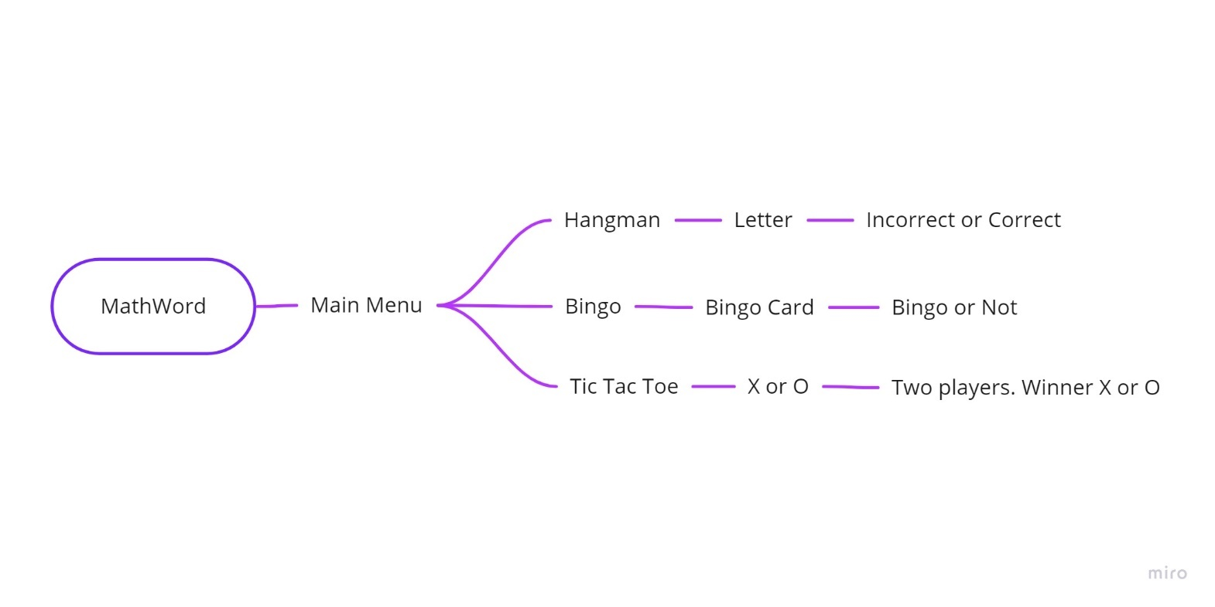

# 5.2 Description

In our game you will find three options when you first get into the main menu: 1. Hangman, 2. Bingo, 3. Tic Tac Toe. For the hangman game you will need to enter a letter and if that letter is in the word given you move ahead, and if not you lose one life. If you lose 6 lifes you die and if you want to you can restart. For the Bingo game you have to enter 25 numbers in a 5x5 bingo card. It is like a lottery game and if your number is on the board you move ahead and if not, the counter goes down. If you manage to get 5 numbers horizontally, vertically or diagonally you win, and if not you lose and you can try again. For the tic tac toe game you will have to play it with two people. The rules are simple.

# 6.Table with functions and explanations

|  |  |
| --- | --- |
| Function name | Description |
| void draw() | Draws the tic tac toe board. |
| void input() | Inputs a number for the tic tac toe game. |
| void togglePlayer() | Toggles the player on the tic tac toe board. |
| char win() | Returns the winner of the tic tac toe game. |
| void playTicTacToe | Does the main function of the game. |
| void drawMan | Outputs the style of the hangman. |
| int playGame(std::string *wordlist) | Main function for the hangman game. |
| void display() | Displays the bingo board. |
| void playBingo() | Main function of the bingo game. |
| void mainMenu() | Main function for the main menu. |

Made by: Team ᒍᑌᔕT ᑕOᗪE