**PYTHON END SEM PROJECT DOCUMENTATION**

**TOPIC:**

CLASS ROOM ALLOTMENT

**DONE BY:**

S.V.PRAVEEN KUMAR

CB.EN.U4CSE17053

Abstract:

The ‘Class Room Allotment’ is a platform where every student from amrita university can know the class room allocated to their section. The college staff will also be able to post the class room details if he is a registered user. Else the college staff can also register new account and update the details (python flask is used here and dblite is used database to store login details and class room details).The user has facilities for updating and deleting the class room details that he/she has created. There is also a unique account details page for each registered user where the user can update their profile image and also update their personal details.

There is also information regarding the Coimbatore campus of amrita. The complete details of the campus. (Information is web scrapped from the official amrita site using url lib and beautiful soap)

The detailed description of all the intricate details which in present in the applications is discussed in this documentation.

The various features with are present in the web-application is discussed in details with code snippets given wherever possible along with how the features looks like in the web-application.

Additional Information:

* App has a secret key without which running the web-application is not possible which is present in the file __init__.py.
* See to that all the needed packages are installed in the system in which this application is going to tested on.

**STEPS TO EXECUTE THE PROGRAM**

**Using VisualStudioCode:**

1.Open VisualStudioCode and open the folder(CB.EN.U4CSE17053) in which the program files are stored.

2.Open Terminal and Run the command “*python run.py”* and In Terminal link will displayed Click it and you will be directed to the home page.

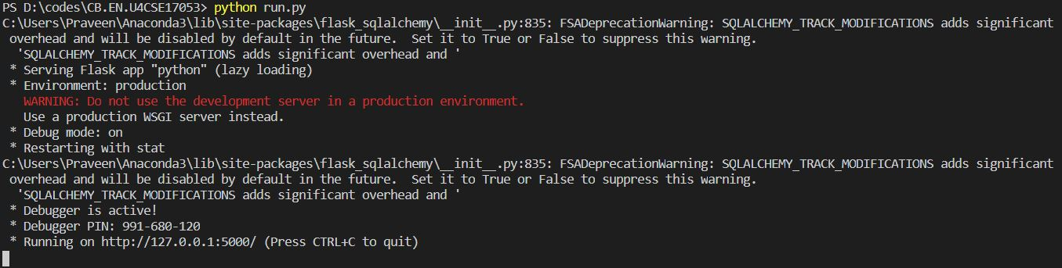

**Screen Recording link:**

https://drive.google.com/open?id=1cPnYAP4Odf7DVpTEsDvWuF8H7ZVFKjJV

Home Page:

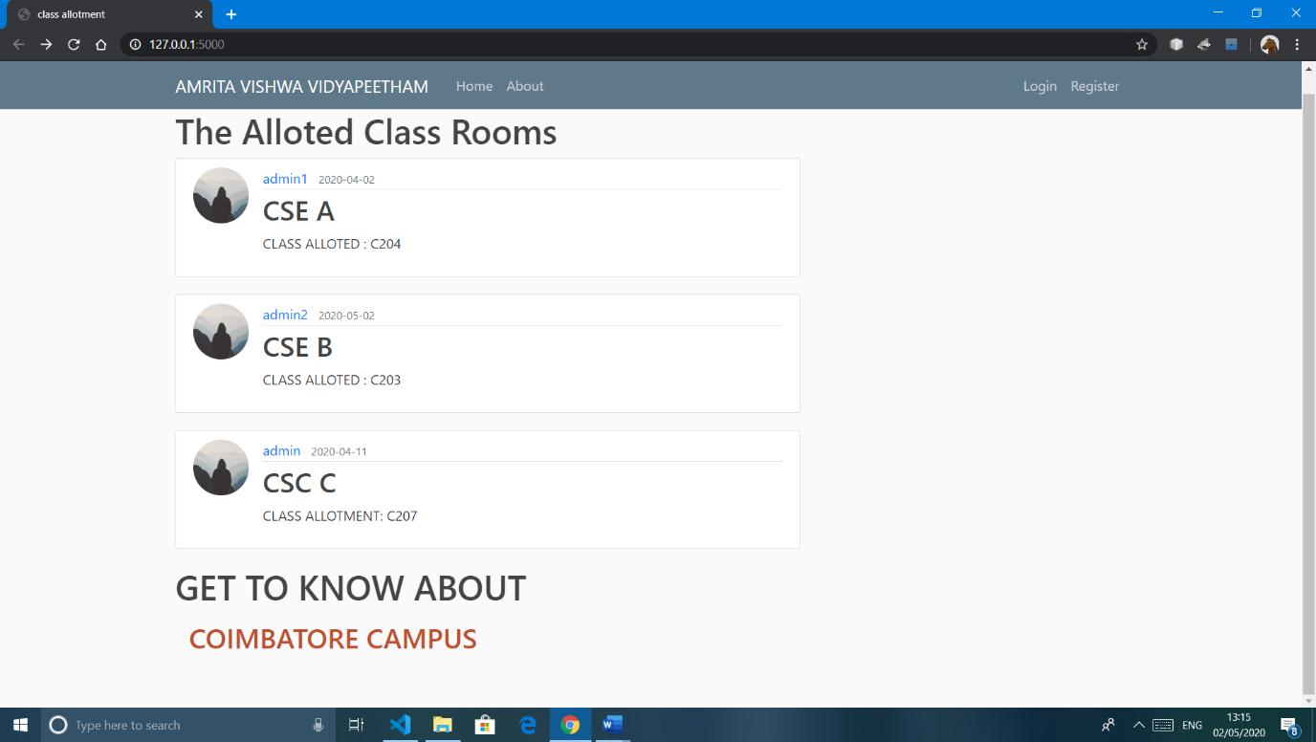

Description:

* This is the home page where we find all the class rooms allotted to students of Amrita University with different staffs with their username, profile pic, time of creation and the details content arranged in the order of the time of creation of the respective posts.
* In this we also see a click link Coimbatore campus where amrita Coimbatore campus data is webscrapped in it.

Login Page:

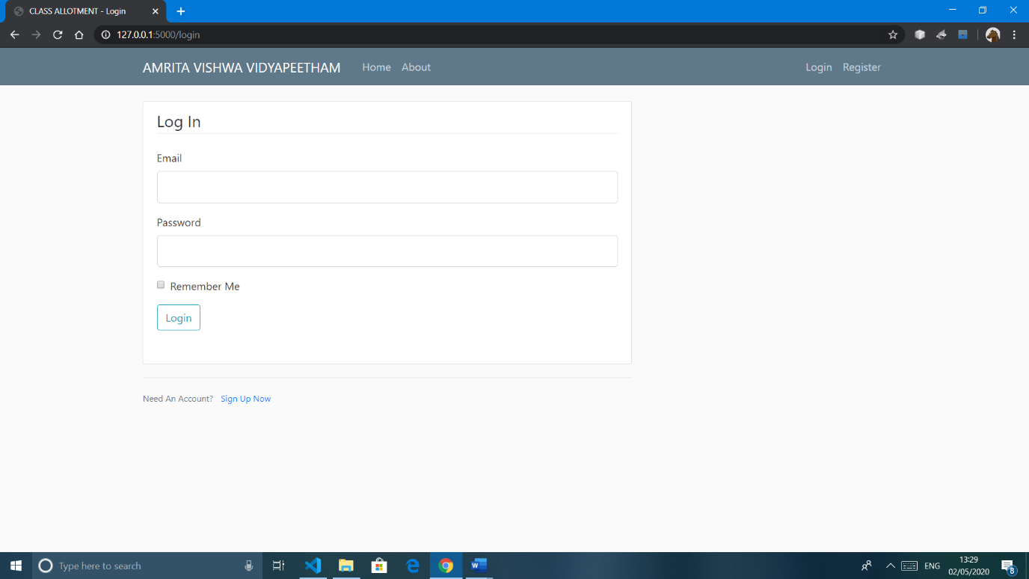

Description:

* Login page where the user gives his username and password which gets validated at the user is logged. (Available: email= [admin3@gmail.com](mailto:admin3@gmail.com) password=1234)
* When the user does not have an account, he can click on the Sign Up which redirects the user to the Register page.

Register Page:

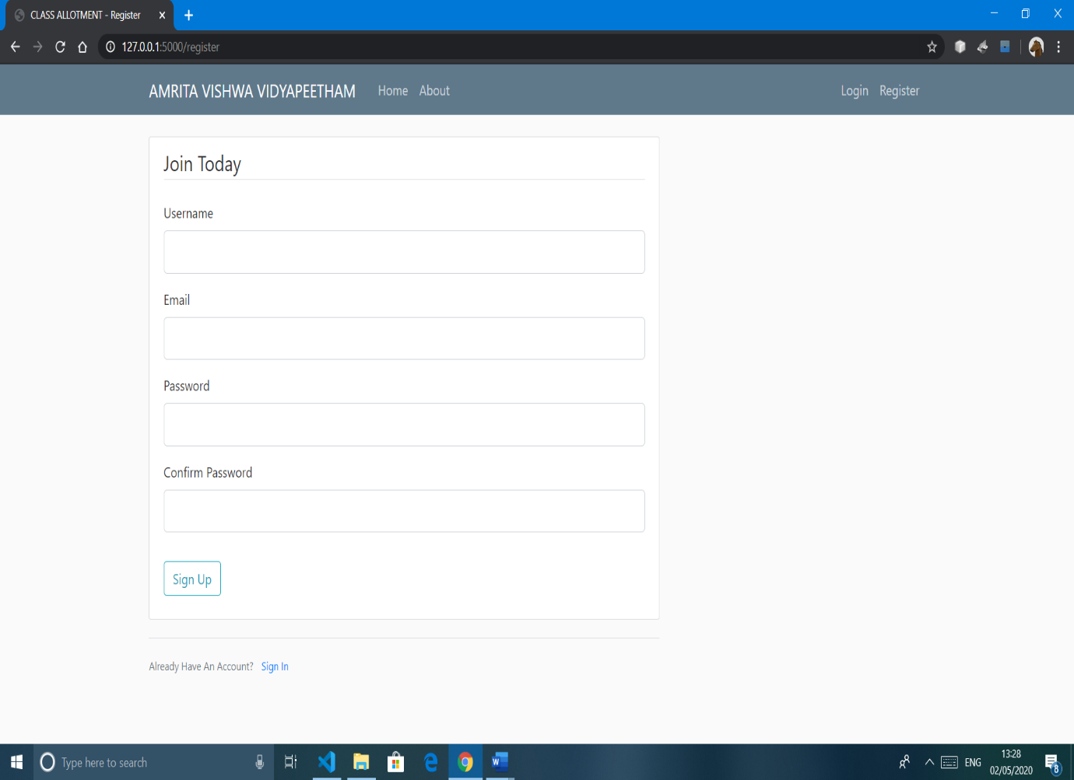

Description:

* The new user has to fill up the details of their username, email, password, confirm password for creating his/her account.
* If the user is already a registered user. The Sign In option in this page helps in redirecting the user to the Login Page.

Logged Page:

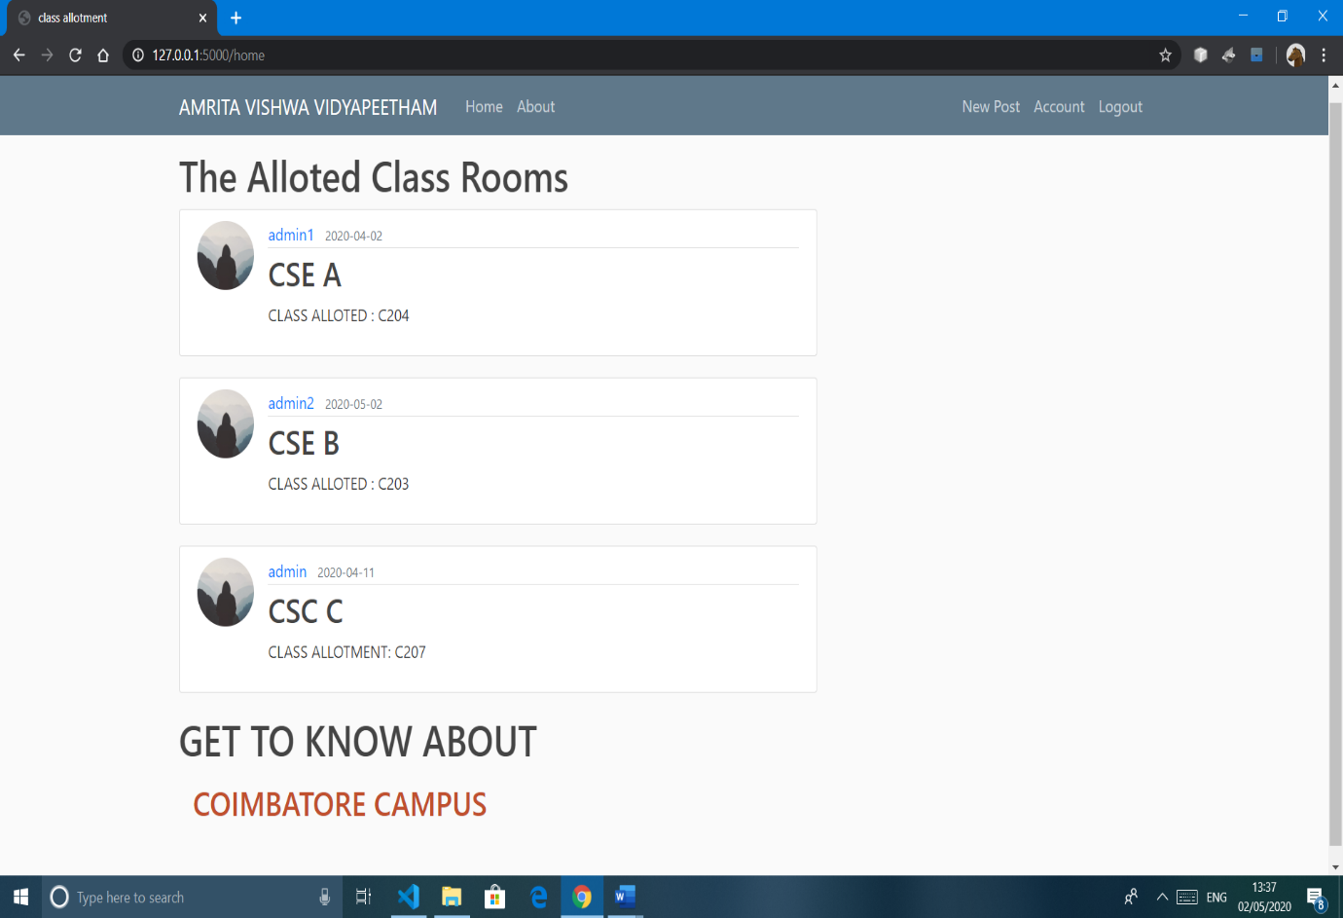

Description:

* The user can post the details of the class room by clicking “new post” .
* The user can log out by clicking “logout”.
* The user can also edit the account details by clicking “Account”.

Account Page:

The user can edit the details of the account and also update profile pic.

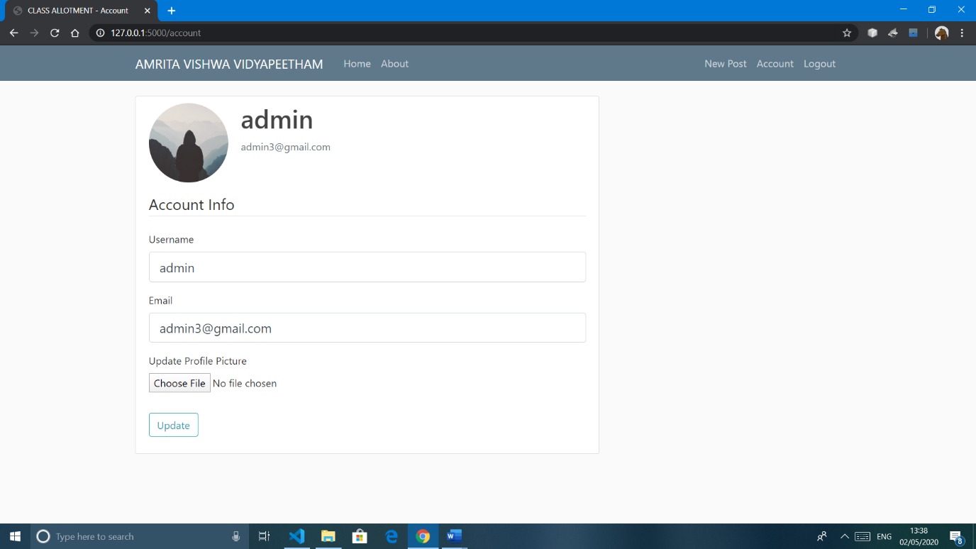

Post Page:

The user can add new post regarding class room alloted and can also delete it.

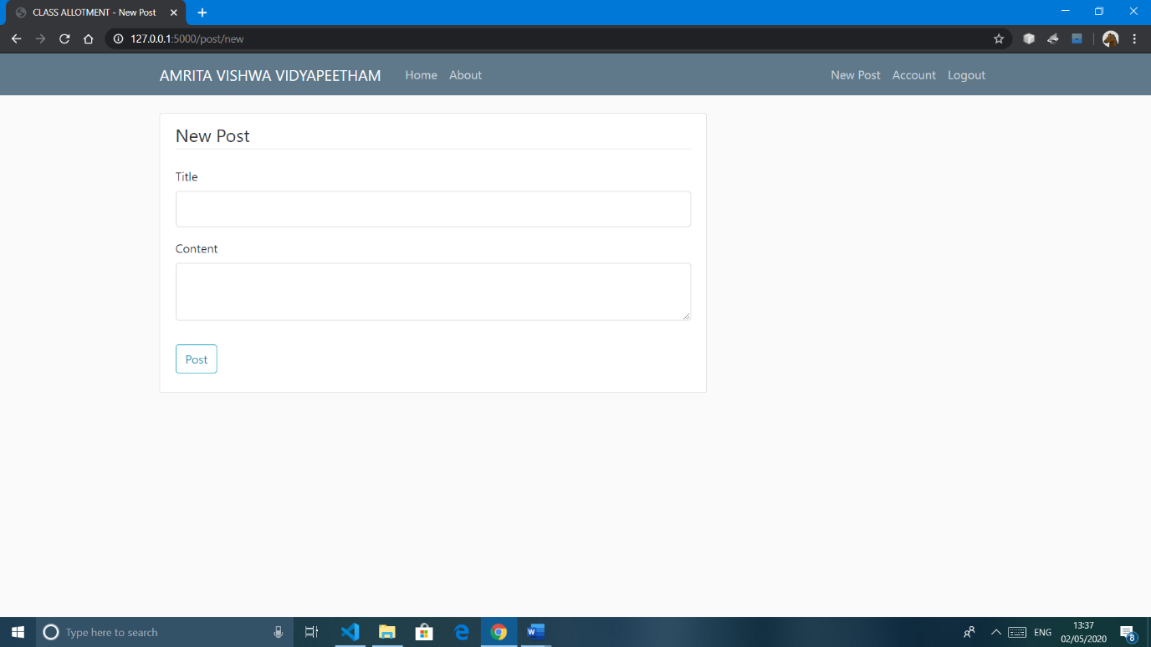

In the home page below there is a information as

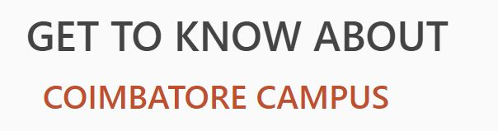

The Students can click on the “COIMBATORE CAMPUS” to get the details about the amrita Coimbatore campus and this is web scrapped from amrita official site.

later the data is displayed in a new html page.

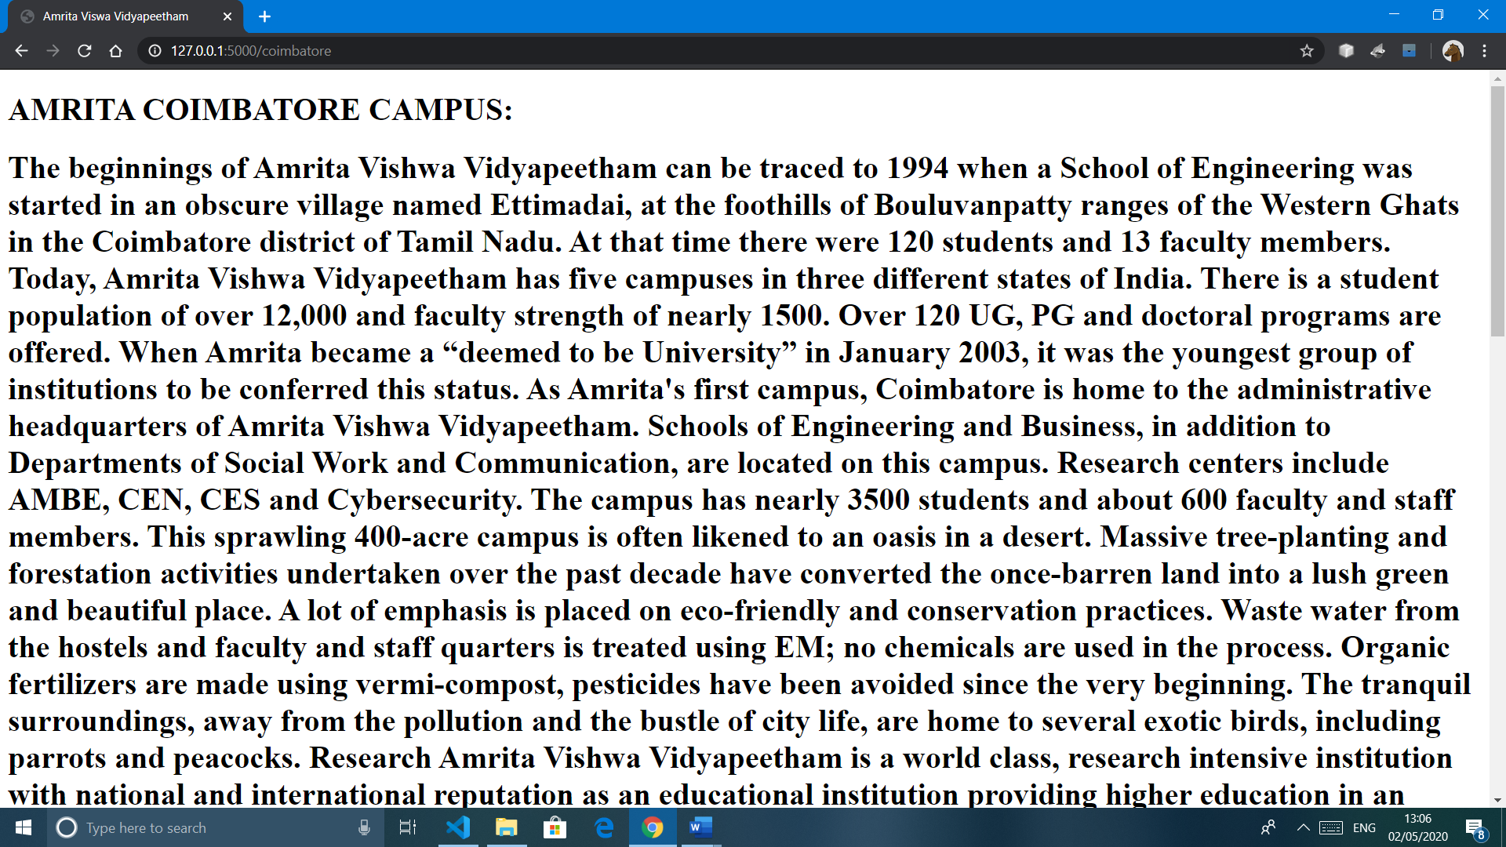

**CONCEPTS USED:**

1.FLASK SESSIONS

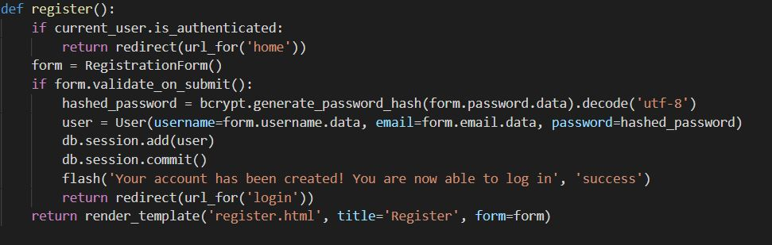

* A session is nothing but the execution of the application in the given time span and the variables used for storing the information of the changes in the given session is called session variables.

2.COOKIES

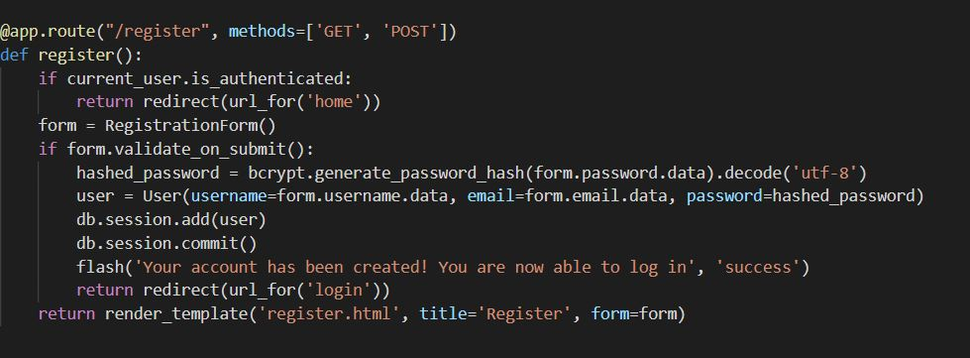

* The cookies are set on the response object by using the set_cookie() method on the response object. The response object can be formed by using the make_response() method in the function as given below

3.ERROR HANDLING

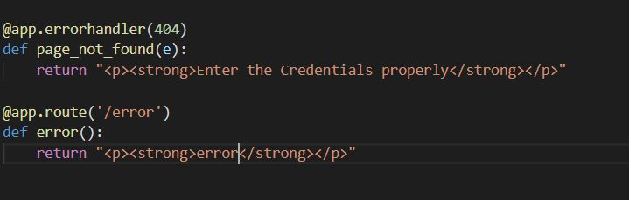

* Generally, try: except: block is used for error handling in this application flash has been used in place for it.
* flash() does the same work as try: except: but in a still professional and appealing way in the UI.

4.URLLIB/REQUEST

* The request context keeps track of the request-level data during a request. Rather than passing the request object to each function that runs during a request, the [**request**](https://flask.palletsprojects.com/en/1.1.x/api/#flask.request) and [**session**](https://flask.palletsprojects.com/en/1.1.x/api/#flask.session) proxies are accessed instead.
* When the [**Flask**](https://flask.palletsprojects.com/en/1.1.x/api/#flask.Flask) application handles a request, it creates a [**Request**](https://flask.palletsprojects.com/en/1.1.x/api/#flask.Request) object based on the environment it received from the WSGI server. Because a worker (thread, process, or coroutine depending on the server) handles only one request at a time, the request data can be considered global to that worker during that request. Flask uses the term context local for this
* In this urllib is used when extraction data from internet website.

5.BEAUTIFUL SOAP

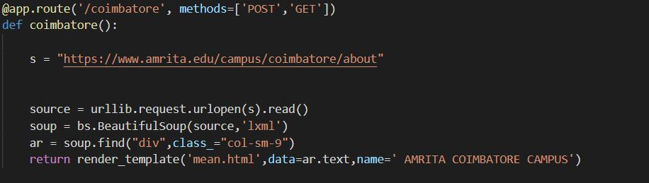

* It is a Python library for pulling data out of HTML and XML files.
* The below code snippet shows the code for Beautiful soup and soap.find() that has been used in the project.

6.HASHING

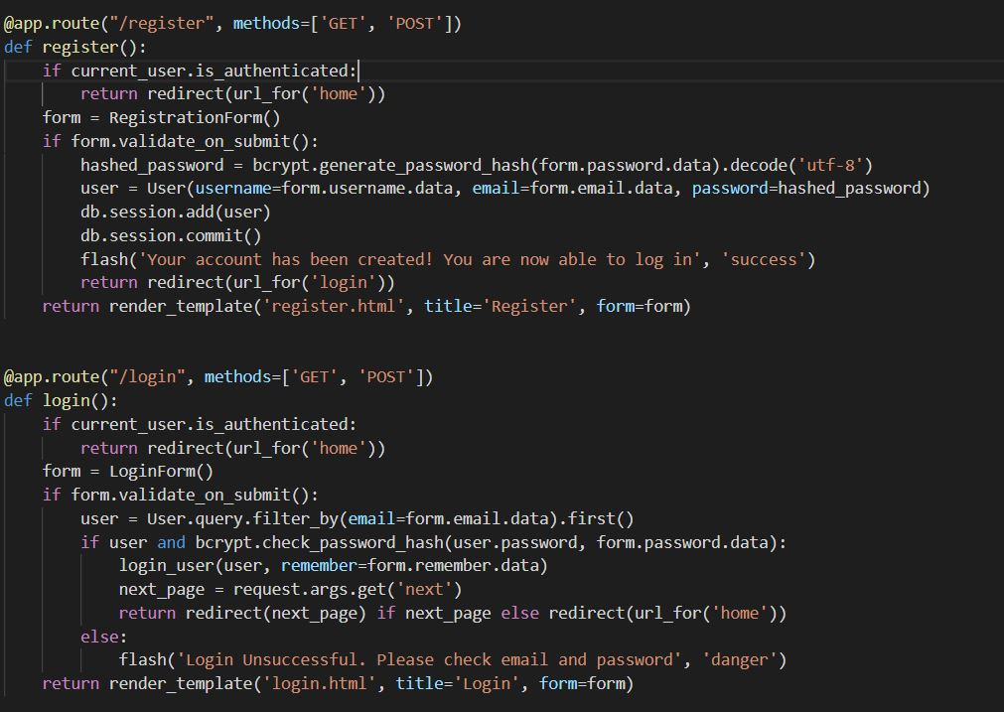

* Hashing is a method by which the user’s password is encrypted and is decrypted in the server side and is checked with the password entered by the user.

7.BACKEND DATABASE

* This application uses the SQLite database and there is no need of the software to be installed in the system as the code will take care of it.
* There is also the file named site.db which is the database which is included with the other files.

**Screen Recording link:**

https://drive.google.com/open?id=1cPnYAP4Odf7DVpTEsDvWuF8H7ZVFKjJV