EX:NO:02 SIMPLE CALCULATOR ROLL.NO:210701290

DATE:16/02/2024

**AIM:-**

Develop a simple calculator to perform arithmetic and mathematical functions using Math class.

**PROCEDURE:-**

Step 1: Design the layout in activity_main.xml file

Step 2: Open styles.xml file and add a new style for toast message.

Step 3: Define function in MainActivity.kt to perform arithmetic and mathematical functions.

Step 4: Add an OnClickListener to the buttons and perform the corresponding operation.

**PROGRAM CODE:-**

**AndroidManifest.xml:**

<?xml version="1.0" encoding="utf-8"?>

<manifest xmlns:android="http://schemas.android.com/apk/res/android"

package="com.example.calculator">

<application

android:allowBackup="true"

android:icon="@mipmap/ic_launcher"

android:label="@string/app_name"

android:roundIcon="@mipmap/ic_launcher_round"

android:supportsRtl="true"

android:theme="@style/AppTheme">

<activity android:name=".MainActivity">

<intent-filter>

<action android:name="android.intent.action.MAIN" />

<category android:name="android.intent.category.LAUNCHER" />

</intent-filter>

</activity>

</application>

</manifest>

**activity_main.xml:**

<?xml version="1.0" encoding="utf-8"?>

<RelativeLayout xmlns:android="http://schemas.android.com/apk/res/android"

xmlns:tools="http://schemas.android.com/tools"

android:layout_width="match_parent"

android:layout_height="match_parent"

android:padding="16dp"

tools:context=".MainActivity">

<EditText

android:id="@+id/inputEditText"

android:layout_width="match_parent"

android:layout_height="wrap_content"

android:layout_marginBottom="16dp"

android:hint="Enter expression"

android:inputType="text"

android:singleLine="true" />

<Button

android:id="@+id/calculateButton"

android:layout_width="wrap_content"

android:layout_height="wrap_content"

android:layout_below="@id/inputEditText"

android:layout_centerHorizontal="true"

android:text="Calculate" />

<TextView

android:id="@+id/resultTextView"

android:layout_width="wrap_content"

android:layout_height="wrap_content"

android:layout_below="@id/calculateButton"

android:layout_marginTop="16dp"

android:text="Result: "

android:textSize="20sp" />

</RelativeLayout>

**MainActivity.kt:**

package com.example.calculator

import androidx.appcompat.app.AppCompatActivity

import android.os.Bundle

import android.widget.Button

import android.widget.EditText

import android.widget.TextView

import kotlin.math.*

class MainActivity : AppCompatActivity() {

override fun onCreate(savedInstanceState: Bundle?) {

super.onCreate(savedInstanceState)

setContentView(R.layout.activity_main)

val inputEditText: EditText = findViewById(R.id.inputEditText)

val calculateButton: Button = findViewById(R.id.calculateButton)

val resultTextView: TextView = findViewById(R.id.resultTextView)

calculateButton.setOnClickListener {

val expression = inputEditText.text.toString()

if (expression.isNotEmpty()) {

try {

val result = evaluateExpression(expression)

resultTextView.text = "Result: $result"

} catch (e: Exception) {

resultTextView.text = "Error: ${e.message}"

}

} else {

resultTextView.text = "Please enter an expression"

}

}

}

private fun evaluateExpression(expression: String): Double {

return when {

expression.contains(Regex("[a-zA-Z]")) -> throw IllegalArgumentException("Invalid characters")

else -> evaluateMath(expression)

}

}

private fun evaluateMath(expression: String): Double {

return try {

val result = ScriptEngineManager().getEngineByName("rhino").eval(expression)

result as Double

} catch (e: Exception) {

throw IllegalArgumentException("Invalid expression")

}

}

}

**OUTPUT:-**

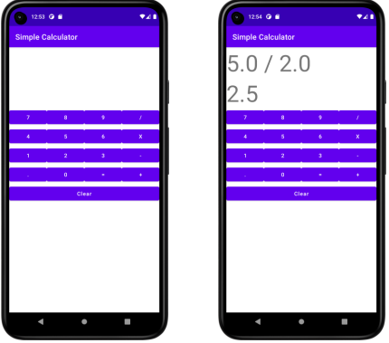

**RESULT:-**

Thus to develop a scientific calculator to perform arithmetic and mathematical functions using Math class is implemented and executed successfully.