**EXP NO :1 DATE: 27/01/24**

**CAESAR CIPHER**

**Aim:** To implement encryption algorithm using Caesar Cipher technique. **Algorithm:**

● Step 1: Prompt the user to enter a message to encrypt (text) and the encryption key (key).

● Step 2: Iterate through each character in text, applying the Caesar Cipher encryption.

● Step 3: Print the encrypted message.

**Program:**

#include<stdio.h

> int main() {

char text[500];

int key;

printf("Enter a message to encrypt: ");

scanf("%s", text);

printf("Enter the key: ");

scanf("%d", &key);

for (int i = 0; text[i] != '\0'; ++i) {

char ch = text[i];

if ('a' <= ch && ch <= 'z')

ch = (ch - 'a' + key) % 26 + 'a';

else if ('A' <= ch && ch <= 'Z')

ch = (ch - 'A' + key) % 26 + 'A';

else if ('0' <= ch && ch <= '9')

ch = (ch - '0' + key) % 10 + '0';

text[i] = ch;

}

printf("Encrypted message: %s", text);

return 0;

}

**Output:**

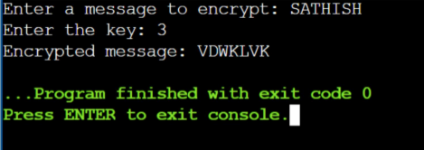

**Result:**

Thus the encryption algorithm using Caesar Cipher technique is implemented successfully.