**EXP NO:3 DATE: 10/02/24**

**RAIL FENCE CIPHER**

**Aim:** To implement an encryption algorithm using Rail Fence Cipher technique.

**Algorithm:**

● Step 1: Declare msg and key, initializing msg with the original message, and set key to the desired rail fence key.

● Step 2: Create railMatrix with dimensions [key][msgLen], initializing elements with newline characters.

● Step 3: Iterate through msg, placing characters in railMatrix based on the Rail Fence Cipher pattern, updating row and col.

● Step 4:Print the encrypted message by traversing railMatrix, excluding newline characters.

● Step 5:Return 0 for successful execution and program termination.

**Program:**

#include<stdio.h>

#include<string.h>

void encryptMsg(char msg[], int key){ int msgLen

= strlen(msg), i, j, k = -1, row = 0, col = 0;

char railMatrix[key][msgLen];

for(i = 0; i < key; ++i) for(j =

0; j < msgLen; ++j)

railMatrix[i][j] = '\n'; for(i = 0;

i < msgLen; ++i){

railMatrix[row][col++] =

msg[i]; if(row == 0 || row ==

key-1)

k = k * (-1);

row = row + k;

}

printf("\nEncrypted Message: ");

for(i = 0; i < key; ++i)

for(j = 0; j < msgLen;

++j) if(railMatrix[i][j]

!= '\n')

printf("%c",

railMatrix[i][j]);

}

int main(){

char msg[] = "I am Varusha";

int key = 4;

printf("Original Message: %s",

msg); encryptMsg(msg, key);

return 0;

}

**Output:**

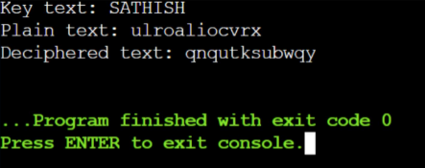

**Result:**

**T**hus the encryption algorithm using Rail Fence Cipher technique is implemented successfully.