# Dot and Cross Products on Vectors

A quantity that is characterized not only by magnitude but also by its direction, is called a vector. Velocity, force, acceleration, momentum, etc. are vectors.

Vectors can be multiplied in two ways:

* Scalar product or Dot product
* Vector Product or Cross product

### Scalar Product/Dot Product of Vectors

The resultant of scalar product/dot product of two vectors is always a scalar quantity. Consider two vectors **a** and **b**. The scalar product is calculated as the product of magnitudes of a, b, and cosine of the angle between these vectors.

**Scalar product = |a||b| cos α**

*Here, |a| = magnitude of vector****a*** *|b| = magnitude of vector****b*** *α = angle between the vectors*

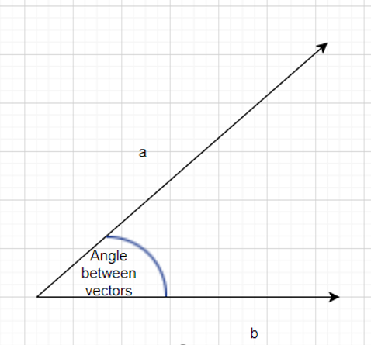

*Vectors****a****and****b****with angle α between them*

### Projection of one vector on other Vector

Vector **a** can be projected on the line l as shown below:

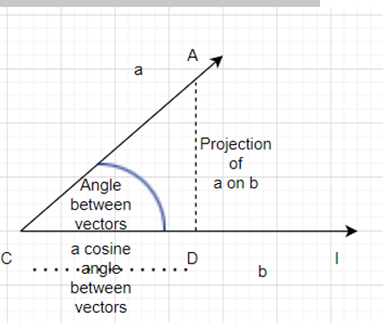

*CD = projection of vector a on vector b*

It is clear from the above figure that we can project one vector over another vector. AC is the magnitude of vector A. In the above figure, AD is drawn perpendicular to line l. CD represents the projection of vector **a** on vector**b**.

Triangle ACD is thus a right-angled triangle, and we can apply trigonometric formulae.

*If α is the measure of angle ACD, then*

*cos α = CD/AC*

*Or,****CD = AC cos α***

From the figure, it is clear that CD is the projection of vector a on vector b

So, we can conclude that one vector can be projected over the other vector by the cosine of the angle between them.

MG_EXPORT double operator%( mgVector_c const &v1, mgVector_c const &v2 )

{

// Dot product

return (

( v1.iComp[0] * v2.iComp[0] ) +

( v1.iComp[1] * v2.iComp[1] ) +

( v1.iComp[2] * v2.iComp[2] )

);

}

### Properties of Scalar product:

* Scalar product of two vectors is always a real number (scalar).
* Scalar product is commutative i.e. a.b =b.a= |a||b| cos α
* If α is 90° then Scalar product is zero as cos(90) = 0. So, the scalar product of unit vectors in x, y directions is 0.
* If α is 0° then the scalar product is the product of magnitudes of **a** and **b** |a||b|.
* Scalar product of a unit vector with itself is 1.
* Scalar product of a vector a with itself is |a|2
* If α is 1800, the scalar product for vectors a and b is -|a||b|
* Scalar product is distributive over addition

**a.**(**b** + **c**) = **a.b** + **a.c**

* For any scalar k and m then,

               l**a.**(m **b**) = km **a.b**

* If the component form of the vectors is given as:

**a**= a1x + a2y + a3z

**b**= b1x + b2y + b3z

           then the scalar product is given as

**a.b** = a1b1 + a2b2 + a3b3

* The scalar product is zero in the following cases:
  + The magnitude of vector a is zero
  + The magnitude of vector b is zero
  + Vectors a and b are perpendicular to each other

### Inequalities Based on Dot Product

**Cauchy – Schwartz inequality**

According to this principle, for any two vectors **a** and **b**, the magnitude of the dot product is always less than or equal to the product of magnitudes of vector a and vector b

**|a.b|**≤**|a| |b|**

**Proof:**

*Since, a.b = |a| |b| cos α*

*We know that 0 < cos α < 1*

*So, we conclude that |a.b| ≤ |a| |b|*

**Triangle Inequality**

For any two vectors **a** and **b**, we always have

|**a**+ **b**| ≤ |**a**| + | **b**|

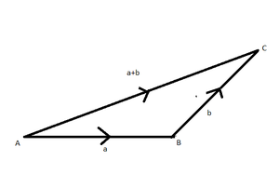

*Triangle inequality*

**Proof:**

*|****a****+****b****|2=|****a****+****b****||****a****+****b****|*

*=****a.a****+****a.b****+****b.a****+****b.b***

*= |****a****|2+ 2****a.b****+|****b****|2(dot product is commutative)*

*≤ |****a****|2+ 2|****a||b****| + |****b****|2*

*≤ (****|a****| + |****b|****)2*

*This proves that |****a****+****b****| ≤ |****a****| + |****b|***

### Examples of Dot Product of Vectors

**Question 1. Consider two vectors such that |a|=6 and |b|=3 and α = 60°. Find their dot product.**

**Solution:**

***a.b****= |a| |b| cos α*

*So,****a.b****= 6.3.cos(60°)*

*=18(1/2)*

***a.b = 9***

**Question 2. Prove that the vectors a = 3i+j-4k and vector b = 8i-8j+4k are perpendicular.**

**Solution**:

*We know that the vectors are perpendicular if their dot product is zero*

***a.b****= (3i+j-4k)(  8i-8j+4k)*

*= (3)(8) +(1)(-8)+(-4)(4)*

*=24-8+16 =0*

***Since the scalar product is zero, we can conclude that the vectors are perpendicular to each other.***

### Cross Product/Vector Product of Vectors

Readers are already familiar with a three-dimensional right-handed rectangular coordinate system. In this system, a counterclockwise rotation of the x-axis into the positive y-axis indicates that a right-handed (standard) screw would advance in the direction of the positive z-axis as shown in the figure.

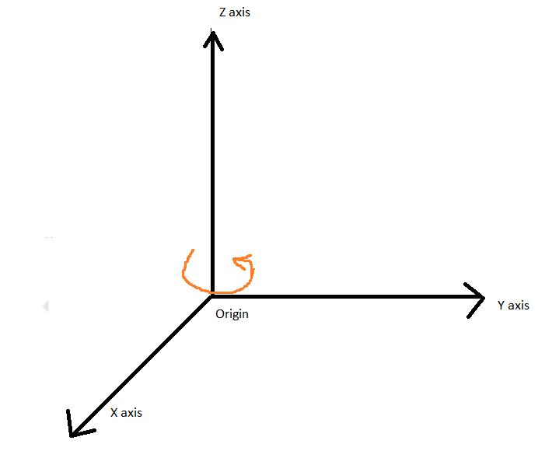

*3D Rectangular coordinate system*

The vector product of two vectors **a** and **b**with an angle α between them is mathematically calculated as

**a × b = |a| |b| sin α**

It is to be noted that the cross product is a vector with a specified direction. The resultant is always perpendicular to both a and b.

In case a and b are parallel vectors, the resultant shall be zero as sin(0) = 0

Cross product formula between any two [vectors](https://www.cuemath.com/geometry/vectors/) gives the area between those vectors. The cross product formula gives the magnitude of the resultant vector which is the area of the parallelogram that is spanned by the two vectors.

### Properties of Cross Product:

* Cross Product generates a vector quantity. The resultant is always perpendicular to both a and b.
* Cross Product of parallel vectors/collinear vectors is zero as sin(0) = 0.

**i × i = j × j = k × k = 0**

* Cross product of two mutually perpendicular vectors with unit magnitude each is unity. (Since sin(0)=1)
* Cross product is not commutative.

**a × b is not equal to b × a**

* Cross product is distributive over addition

**a ×** (**b**+ **c**) = **a** **× b**+ **a** **×** **c**

* If k is a scalar then,

**k(a × b) = k(a) × b = a × k(b)**

* On moving in a clockwise direction and taking the cross product of any two pair of the unit vectors we get the third one and in an anticlockwise direction, we get the negative resultant.

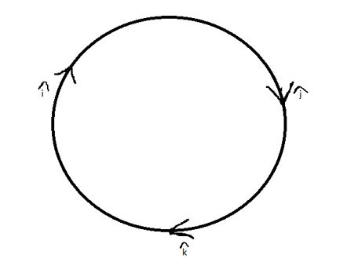

*Cross product in clockwise and anticlockwise direction*

           The following results can be established:

           i × j = k     j × k = i       k × i = j

           j × i = -k   i × k= -j       k × j = -i

### Cross product in Determinant Form

If the vector**a** is represented as **a = a1x + a2y + a3z** and vector **b** is represented as **b = b1x + b2y + b3z**

Then the cross product **a × b**can be computed using determinant form

**a × b** = x(a2b3 – b2a3) + y(a3b1 – a1b3) + z(a1b2 – a2b1)

If a and b are the adjacent sides of the parallelogram OXYZ and α is the angle between the vectors a and b.

Then the area of the parallelogram is given by |**a × b**| = |a| |b|sin.α

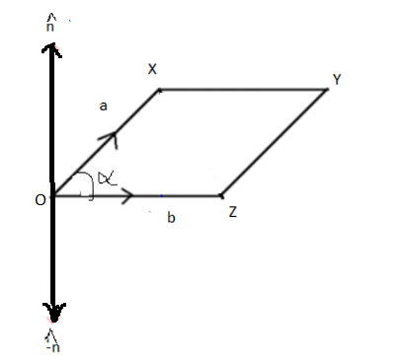

*Vectors a and b as adjacent sides of a parallelogram*

### Examples of Cross product of Vectors

**Question 1. Find the cross product of two vectors a and b if their magnitudes are 5 and 10 respectively. Given that angle between then is 30°.**

**Solution:**

***a × b****= a.b.sin (30) = (5) (10) (1/2)*

*= 25 perpendicular to****a****and****b***

**Question 2. Find the area of a parallelogram whose adjacent sides are**

**a = 4i+2j -3k**

**b= 2 i +j-4k**

**Solution**:

*The area is calculated by finding the cross product of adjacent sides*

*a × b = x(a2b3 – b2a3) + y(a3b1 – a1b3) + z(a1b2 – a2b1)*

*= i(-8+3) + j(-6+16) + k(4-2)*

*= -5i +10j + 2k*

*Therefore, the magnitude of area is*

*=*

*=*

**Application:**Dot products and cross products are extensively useful for engineering applications.

MG_EXPORT mgVector_c operator*( mgVector_c const &v1, mgVector_c const &v2 )

{

// Cross product

double components[3];

components[0] = ( (v1.iComp )[1] * (v2.iComp )[2] ) -

( (v1.iComp )[2] * (v2.iComp )[1] );

components[1] = ( (v1.iComp )[2] * (v2.iComp )[0] ) -

( (v1.iComp )[0] * (v2.iComp )[2] );

components[2] = ( (v1.iComp )[0] * (v2.iComp )[1] ) -

( (v1.iComp )[1] * (v2.iComp )[0] );

return mgVector_c ( components );

}

BOOL mgVector_c::isParallelTo( const mgVector_c& vIn ) const

{

if ( isNull() || vIn.isNull() )

return FALSE;

mgUnitVector_c unitV1(*this);

mgUnitVector_c unitV2(vIn);

double dot = unitV1%unitV2;

if ( fabs(fabs(dot) - 1.0) < gcLengthTolerance )

return TRUE;

else

return FALSE;

}

**Valid / Invalid operations:**

u, v & w are vectors

u.v+|w| - Valid. |w| is scalar. And u.v is also scalar.

u.v.w – Invalid. u.v is scaler. w is vector.

u.(v-w)- Valid. v-w is vector. Vector. Vector is possible.

# View Xform in 3D Transformation

3-D Transformation :  
3-D Transformation is the process of manipulating the view of a three-D object with respect to its original position by modifying its physical attributes through various methods of transformation like Translation, Scaling, Rotation, Shear, etc.

### Types of Transformations :

1. Translation
2. Scaling
3. Rotation
4. Shear
5. Reflection

Translation :  
It is the process of changing the relative location of a 3-D object with respect to the original position by changing its coordinates. Translation transformation matrix in the 3-D image is shown as –

**Rotation:**

The following figure explains the rotation about various axes −

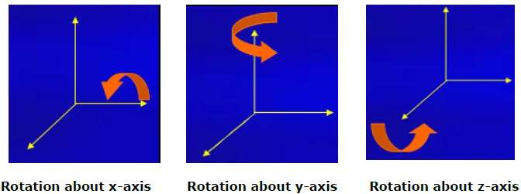

**Scaling:**

You can change the size of an object using scaling transformation. In the scaling process, you either expand or compress the dimensions of the object. Scaling can be achieved by multiplying the original coordinates of the object with the scaling factor to get the desired result. The following figure shows the effect of 3D scaling −

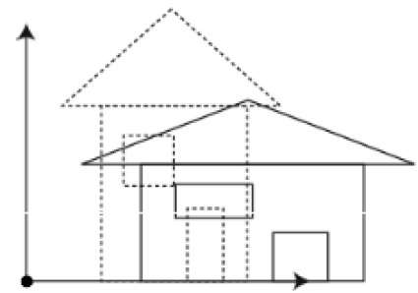

# Convex Polygon

A convex polygon is a closed figure where all its interior angles are less than 180° and the vertices are pointing outwards.

* A convex polygon is a polygon where all the interior [angles](https://www.cuemath.com/geometry/angles/) are less than 180º.

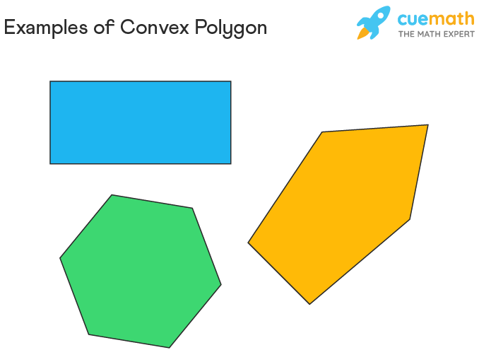

### Sum of Interior Angles

The sum of interior angles of a convex polygon with 'n' sides is given by the formula, 180(n-2)°. For example, a hexagon has 6 sides. So the sum of its interior angles is 180(6-2)°, which is equal to 720°.

### Sum of Exterior Angles

### The sum of exterior angles of a convex polygon is equal to 360°/n, where 'n' is the number of sides of the polygon.

# Concave Polygon

### At least one interior angle is greater than 180°.

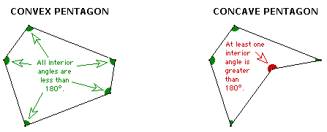 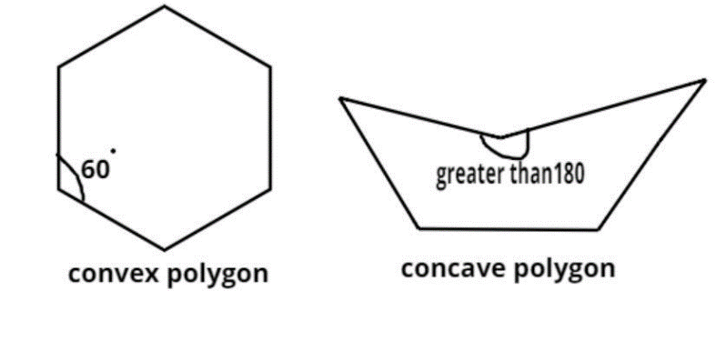

### How do I check whether a given point lies inside a triangle whose coordinates are given?

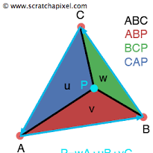

Suppose ABC is a triangle whose coordinates of the vertices A, B and C are given.

We can find the lengths of sides AB, BC and CA using distance formula of coordinate geometry.

Suppose O is a point whose vertices are given. Find OA, OB and OC using the same distance formula.

If (OA + OB +OC) < (AB + BC+ CA) then O lies inside the triangle.