SSN College of Engineering – Kalavakkam
Chennai – 603110
ICS1513 – Computer Networks Laboratory

Experiement 1 – Analysing network diagnostic tools

Saravana Senthilkumar – 3122247001057 25.06.2025

1a. Apply and analyze the use of various networking diagnostic and monitoring tools in a computer network environment. Demonstrate the execution of the following tools and record your observations regarding network status, configuration, connectivity, routing, and performance:

• netstat
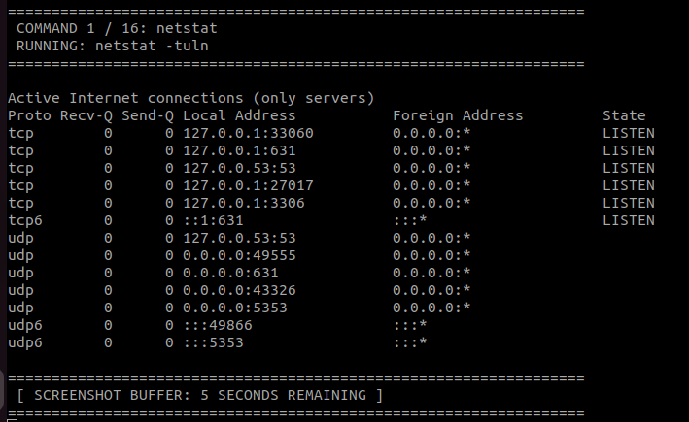
netstat (Network Statistics)

Purpose: Displays active network connections, routing tables, and interface statistics.

Observation Focus: The -tuln flags show listening (l) TCP (t) and UDP (u) ports numerically (n). Look for 0.0.0.0:XX or :::XX, which indicates services on your local machine actively waiting for incoming network connections.

• ifconfig
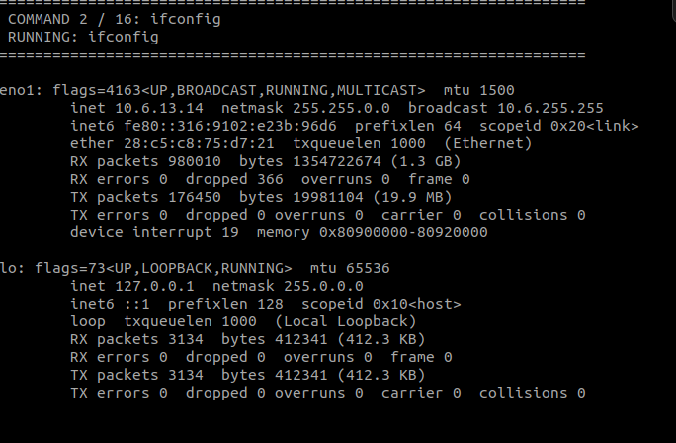
ifconfig (Interface Configuration)

Purpose: Displays or configures network interface parameters.

Observation Focus: Identifies active network cards (eth0, wlan0, lo). Note the inet address (your local IPv4 address), netmask, and RX/TX packets to verify that data is actively being sent and received.

• iwconfig
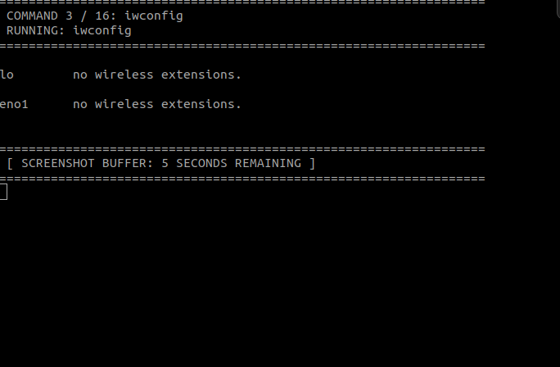

iwconfig (Wireless Interface Configuration)
- Purpose: Dedicated specifically to wireless network interfaces.
- Observation Focus: If you are on Wi-Fi, it reveals the SSID (network name), link quality, signal strength (in dBm), and data bit rate. If you are on a wired VM, it will say "no wireless extensions".

• ping

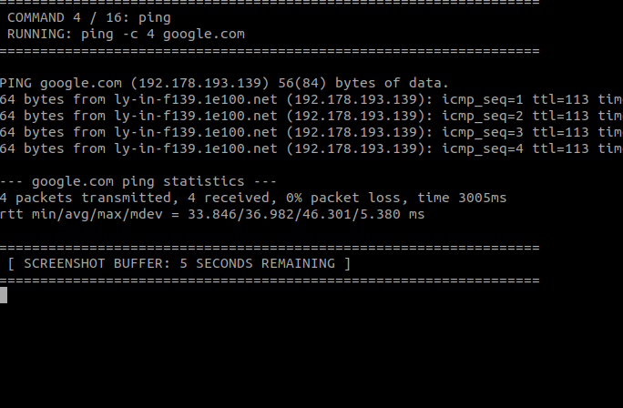

ping (Packet InterNet Groper)
- Purpose: Tests reachability of a host across an IP network and measures round-trip time.
- Observation Focus: Look at the time=XX ms value; lower values mean lower latency. Check the packet loss percentage at the bottom; 0% loss confirms a highly stable, working connection to the target server.

• route
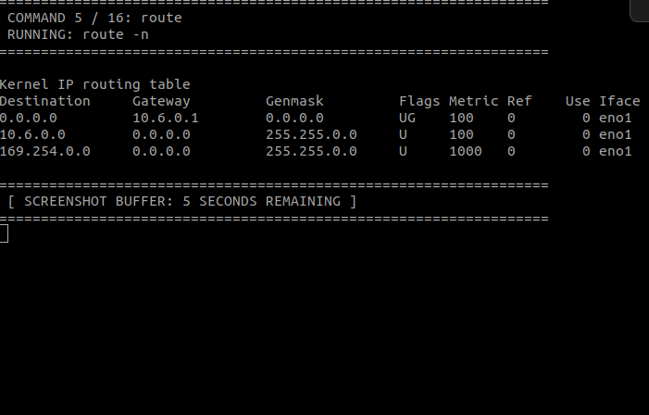

route (Routing Table)
- Purpose: Displays and manipulates the IP routing table.
- Observation Focus: Look for the destination 0.0.0.0 with the G (Gateway) flag. This row displays your Default Gateway (typically your local router's IP), which is the exit point your traffic uses to reach the broader internet.

• nmap

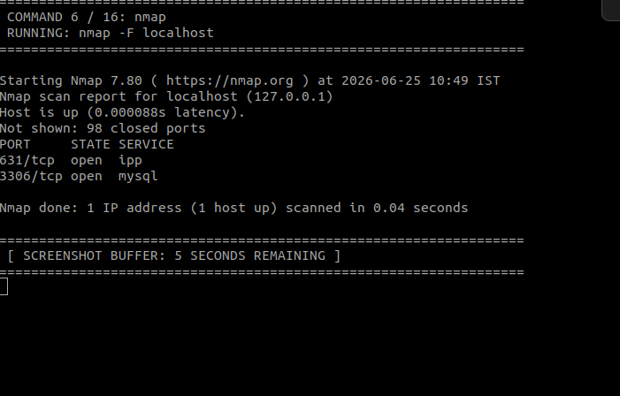

nmap (Network Mapper)
- Purpose: Network exploration tool and security/port scanner.
- Observation Focus: The output displays a list of open ports on the target machine (localhost). It tells you which services (like SSH, HTTP, or RPC) are actively running and exposed on that machine.

• tcpdump
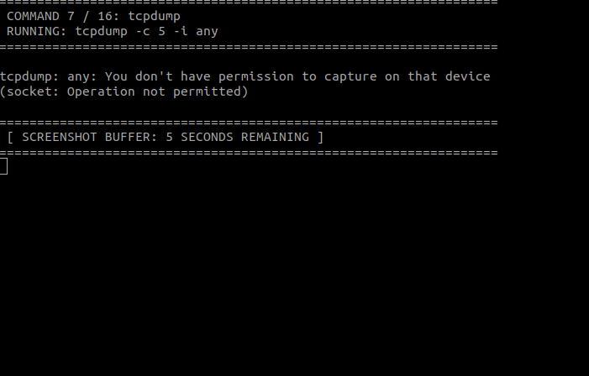

tcpdump (Command-line Packet Analyzer)
- Purpose: Captures and displays network packets flowing through an interface in real-time.
- Observation Focus: Each line represents a packet. Observe the timestamps, source IP/port, destination IP/port, and protocol flags (like [S] for SYN or [.] for ACK), showcasing the underlying handshake mechanics of network traffic.
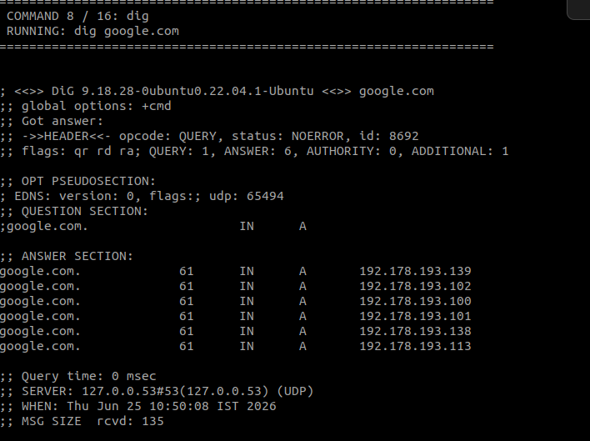
• dig

dig (Domain Information Groper)
- Purpose: A flexible tool for interrogating DNS name servers.
- Observation Focus: Look at the ANSWER SECTION. It shows the mapping of a human-readable domain name to its direct public IPv4 address, along with the TTL (Time to Live) value.
• traceroute
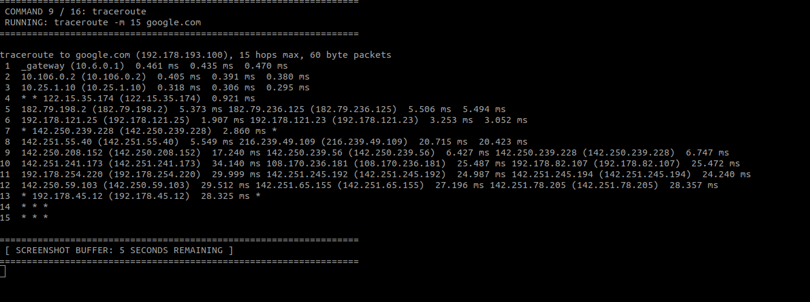

traceroute (Trace Route)
- Purpose: Displays the route (path) and measures transit delays of packets across an IP network.
- Observation Focus: Each numbered line represents a "hop" (a router) between your computer and the target destination. If you see asterisks (* * *), it means that specific router is configured to drop diagnostic ICMP/UDP requests for security.
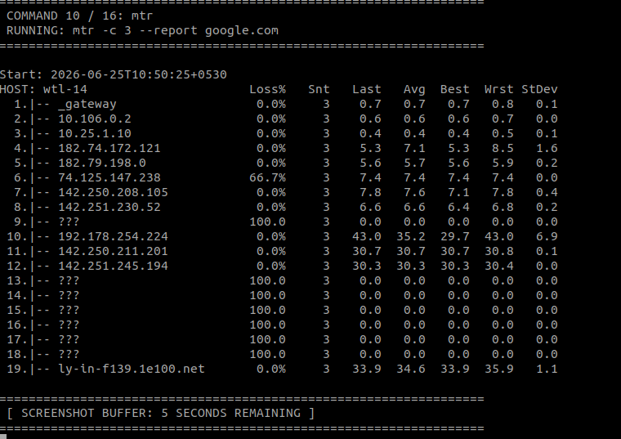
• mtr

mtr (My Traceroute)
- Purpose: Combines the functionality of ping and traceroute into a continuous diagnostic tool.
- Observation Focus: The report mode prints out a summary table showing every hop along the path alongside real-time stats like Loss%, Best, Avg, and Worst latency timings, making it easy to isolate exactly which router is causing a bottleneck.

• curl
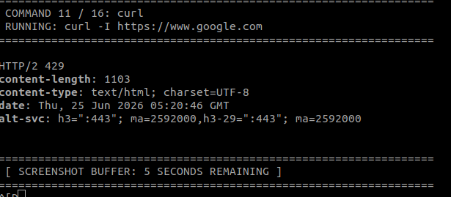

curl (Client URL)
- Purpose: Transfers data to or from a server.
- Observation Focus: Using the -I flag fetches only the HTTP response headers. Observe the HTTP/2 200 OK (or 301/302 Redirect) status code, the Server type, and cache configurations, proving successful application-layer communication.
• wget
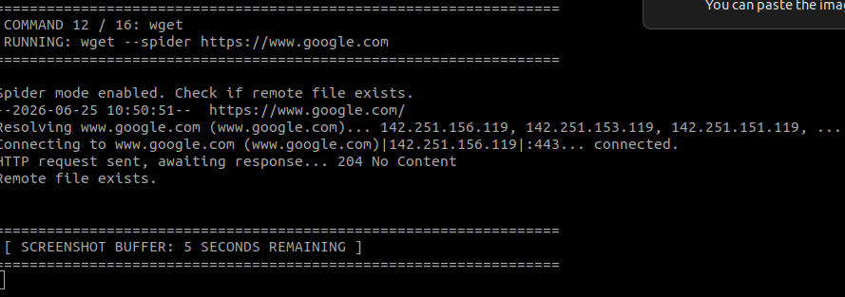

wget (World Wide Web Get)
- Purpose: Non-interactive network downloader.
- Observation Focus: The --spider flag verifies the remote file or page exists without downloading it. The output shows the connection handshake, HTTP request sent, and the remote server's response code.

• tracepath
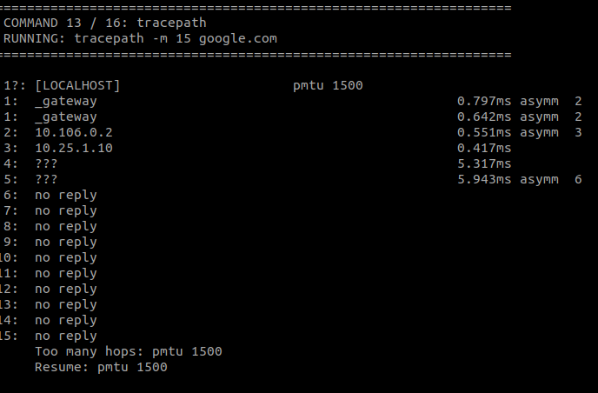

tracepath (Trace Path)
- Purpose: Traces the network path to a remote host, similar to traceroute, but maps the MTU (Maximum Transmission Unit).
- Observation Focus: It determines the path MTU size (usually 1500 bytes), highlighting whether packets are forcing fragmentation down the line.

• nslookup
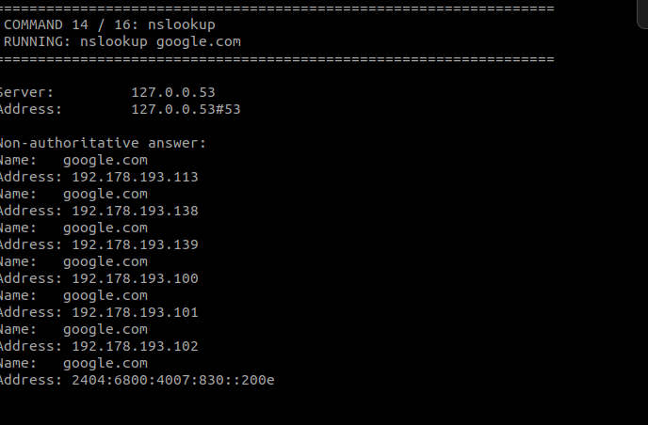

nslookup (Name Server Lookup)
- Purpose: Queries internet name servers interactively or non-interactively.
- Observation Focus: Displays the IP address of the local DNS server used to resolve the query, followed by the "Non-authoritative answer" containing the IP addresses associated with the target domain.

• host
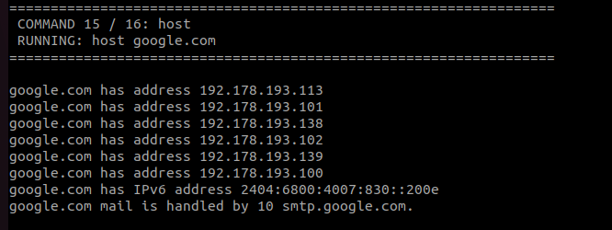

host (DNS Lookup Utility)
- Purpose: A simple, concise utility for performing DNS lookups.
- Observation Focus: Provides a highly readable, short summary showing that the domain name translates directly to its corresponding IPv4 and IPv6 addresses, as well as its mail handling servers (MX records).
• whois
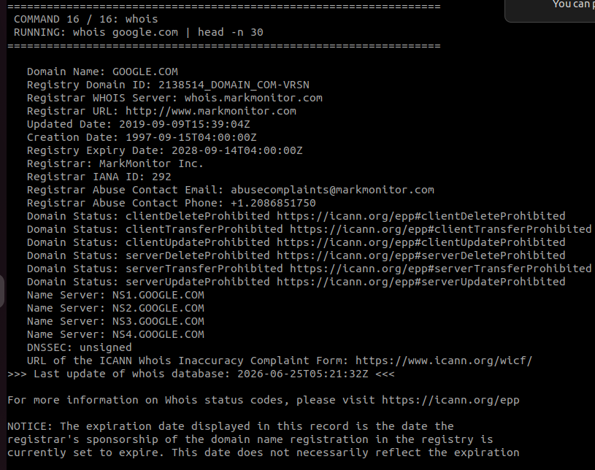

whois (Domain Registry Lookup)
- Purpose: Queries databases that store the registered users or assignees of an internet resource.
- Observation Focus: Displays public ownership records of the domain, including the domain registrar, creation date, expiration date, and assigned administrative name servers.

