**UNIVERSITY OF INFORMATION TECHNOLOGY, VNUHCM**

**FACULTY OF COMPUTER NETWORK AND COMMUNICATION**



**PROJECT REPORT**

TOPIC: <NAME>

**Course:** <Class code> - <Name of course>

**Instructor: <**Name of your instructor>

**Group <Group number>:**

1. Full name of member 01 StudentID Leader
2. Full name of member 02 StudentID Member
3. Full name of member 03 StudentID Member

**Duration:** <Start date> - <End date>

# TABLE OF CONTENT

TABLE OF CONTENT 2

LIST OF FIGURES, TABLES 3

ABSTRACT 4

Chapter I. INTRODUCTION. 5

1. Topic introduction. 5

1.1. Subsection if necessary. 5

1.2. Another subsection. 5

2. Theoretical basis. 5

Chapter II. SYSTEM DESIGN. 6

Chapter III. SYSTEM DEPLOYMENT. 7

1. Create an Azure account. 7

2. Resource initialization and configuration. 7

3. Deploy a web application. 7

Chapter IV. CONCLUSION. 8

REFERENCE 9

# LIST OF FIGURES, TABLES

Figure 1. The architecture of Kubernetes. 6

Figure 2. Docker's architecture. 6

**Note:** For a course project, attaching figure lists and table lists in the report file is usually optional. If the number of illustrations and tables is too many, add a list like above. When adding, it is a good practice to create a separate page for the list of shapes and a page for the list of tables.

# ABSTRACT

A summary of the team's project topic will be written here. Encourage writing briefly, without going into details, and listing the important points in the content of the project and the results achieved by the team.

# Chapter I. INTRODUCTION.

## 1. Topic introduction.

### 1.1. Subsection if necessary.

The contents of this section should answer the following questions:

1. What is the main content of the project topic?
2. What was the reason why the group chose to do the project?
3. How is the topic related to the subject content?

### 1.2. Another subsection.

## 2. Theoretical basis.

What are the technologies, tools, or techniques that the team uses in the project? It is recommended to explain the concept and present the theory of them in each subsection separately.

# Chapter II. SYSTEM DESIGN.

Provide a diagram of the system architecture and analysis of each component used, in which it should be explained: How does the processing flow work? How do components interact with each other?

**Note:** This section has very diverse content types depending on the requirements of the project. The types of charts to provide in the report will also vary (e.g. database design analysis, user flow charts, logical network models, etc.)

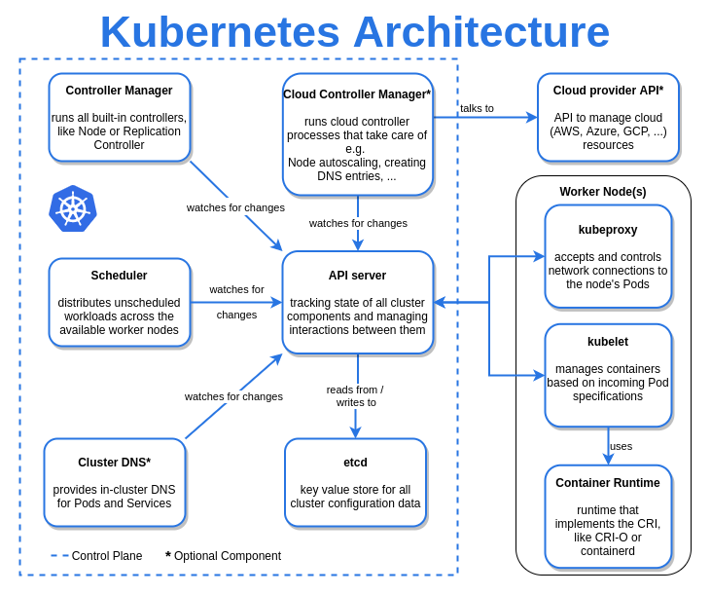

Figure 1. The architecture of Kubernetes.

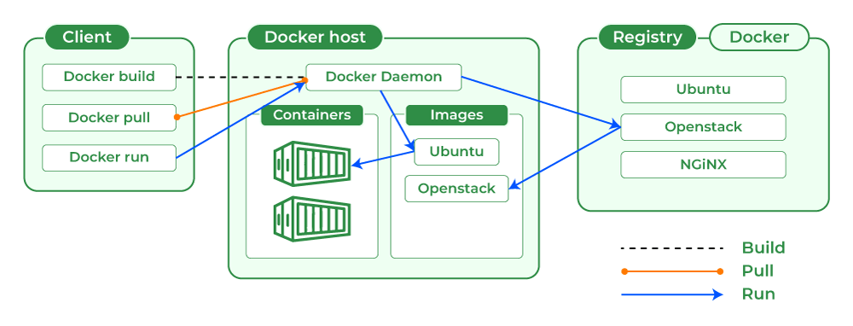

Figure 2. Docker's architecture.

# Chapter III. SYSTEM DEPLOYMENT.

|  |  |  |  |
| --- | --- | --- | --- |
| **Column 1** | **Column 2** | **Column 3** | **Column 4** |
| 12345 | 12345 | 12345 | 12345 |
| 12345 | 12345 | 12345 | 12345 |
| 12345 | 12345 | 12345 | 12345 |
| 12345 | 12345 | 12345 | 12345 |

Table 1. An example table for how to assign labels.

This is a detailed description of the process of understanding, building, and deploying the system chosen by the team. You can consider dividing into many subsections corresponding to each step of realizing your project.

## 1. Create an Azure account.

Content.

## 2. Resource initialization and configuration.

Content.

## 3. Deploy a web application.

Content.

# Chapter IV. CONCLUSION.

Everything the team has done in the project and the lessons learned will be written here. The limitations or errors encountered will also be outlined and the team could also map out the future development direction for the project or propose solutions to overcome weaknesses (if any).

# REFERENCE

1. [Write great papers with Microsoft Word - Microsoft Support](https://support.microsoft.com/en-gb/topic/write-great-papers-with-microsoft-word-52cc22e6-7a7a-4fd9-834d-fb6521451af1#ID0EBBF=Getting_started) (if only referring to a certain website).
2. J. Kim, C. Ko, A. Frenzel, S. Ramanathan, and J. E. Homan, Nanoscale imaging and control of resistance switching in VO2 at room temperature, Applied Physics Letters 96, 213106 (2010) (if referring to studies, scientific articles).
3. Subject syllabus <Subject name> (if mainly referenced in the subject lecture slide).