Name | Varun Manoj Sharma
Roll no | 24204A0031
Batch | 2
Subject name | Python Programming & Data Structure
Teacher Name | Ms. Rasika Patil

Experiments | 8
Title | a) Develop python program to demonstrate use of math and string built in function.  b) Develop python program to implement half adder and full adder by creating function with the help of user defined function.
Practical significance
Python includes multiple math-related and string-related functions. The math built-in module is used to perform various mathematical calculations, such as numeric, trigonometric, logarithmic, and exponential calculations. The Python string module provides several constants that are useful for checking to see if a character, slice, or string contains letters, digits, symbols, etc. To use these modules, we need to import the module into our code.

Relevant Theoretical Background
- List of Math’s built-in Functions and its attributes:
Function | Description
ceil(x) | Return the Ceiling value. It is the smallest integer, greater or equal.
copysign(x, y) | Returns x with the sign of y.
cos(x) | Return the cosine of x in radians.
exp(x) | Returns e**x.
factorial(x) | Returns the factorial of x.
floor(x) | Returns the largest integer less than or equal to x.
fmod(x, y) | Returns the remainder when x is divided by y.
gcd(x, y) | Returns the Greatest Common Divisor of x and y.
log(x[, base]) | Returns the Log of x, where base is given. The default base is e.
log2(x) | Returns the Log of x, where base is 2.
log10(x) | Returns the Log of x, where base is 10.
remainder(x, y) | Find remainder after dividing x by y.
radians(x) | Convert angle x from degrees to radian.
pow(x, y) | Return the x to the power y value.
sqrt(x) | Finds the square root of x.
sin(x) | Return the sine of x in radians. tan(x) Return the tangent of x in radians.

- String built-in functions: Python includes the following built-in methods to manipulate strings:

Function | Description
capitalize() | Converts the first character to upper case
enter() | Pad the string with the specified character.
count() | Returns the number of occurrences of a substring in the string.
encode() | Encodes strings with the specified encoded scheme
find() | Returns the lowest index of the substring if it is found
ormat() | Formats the string for printing it to console
index() | Returns the position of the first occurrence of a substring in a string
isalnum() | Checks whether all the characters in a given string is alphanumeric or not
isalpha() | Returns “True” if all characters in the string are alphabets
isdecimal() | Returns true if all characters in a string are decimal
isdigit() | Returns “True” if all characters in the string are digits
isidentifier() | Check whether a string is a valid identifier or not
islower() | Checks if all characters in the string are lowercase
isnumeric() | Returns “True” if all characters in the string are numeric characters
isdigit() | Returns True if all characters in the string are digits
lower() | Converts a string into lower case
replace() | Returns a string where a specified value is replaced with a specified
upper() | Converts a string into upper case
title() | Converts the first character of each word to upper case

Programming Questions with Answer
1 | Program using math functions  Power, ceiling, square root, factorial
SCRIPT | import math  num = int(input("Enter a number: "))  print("Power (num^2):", math.pow(num, 2))  print("Ceiling value:", math.ceil(5.4))  print("Square root:", math.sqrt(num))  print("Factorial:", math.factorial(num))
OP | 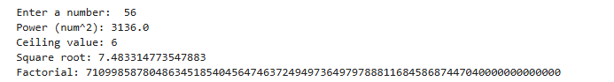
2 | Program using string functions  Uppercase , lowercase, replace, find, concatination
SCRIPT | s1 = input("\nEnter a string: ")  s2 = input("Enter another string: ")  print("Uppercase:", s1.upper())  print("Lowercase:", s1.lower())  print("Replaced string:", s1.replace("Python", "Java"))  print("Position of 'is':", s1.find("is"))  print("Concatenated string:", s1 + " " + s2)
OP | 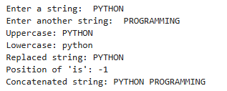
3 | Program for Half Adder and Full Adder using functions
SCRIPT | HALF ADDER:  x = int(input("\nEnter first bit for Half Adder: "))  y = int(input("Enter second bit for Half Adder: "))  s, c = half_adder(x, y)  print("Half Adder Sum:", s, "Carry:", c)\  FULL ADDER:  x = int(input("\nEnter first bit for Full Adder: "))  y = int(input("Enter second bit for Full Adder: "))  cin = int(input("Enter carry-in: "))  s, c = full_adder(x, y, cin)  print("Full Adder Sum:", s, "Carry:", c)
OP | HALF ADDER:  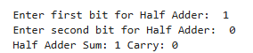  FULL ADDER:  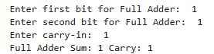
4 | Write a Python script that uses find() function to search for the “language” string from the original string "Python is a powerful language" and returns its index in the Python string.
SCRIPT | text = "Python is a powerful language"  index = text.find("language")  print("\nIndex of word 'language':", index)
OP
Debugging Questions with Corrected Answers
1 | Debug the following code  Wrong code:  import math  print(sqrt(25))
OP | Error: 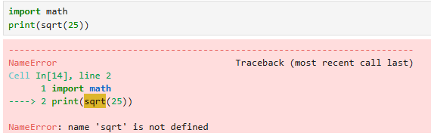  Correct code:  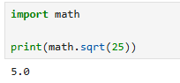
2 | Debug the following code  Wrong code:  def add(a, b)  return a + b
OP | Error:  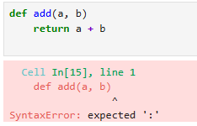  Correct code:  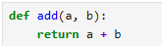
Conclusion | Thus, the Python programs using math and string built-in functions were successfully implemented. Additionally, Half Adder and Full Adder circuits were designed using user-defined functions, helping to understand both Python programming concepts and basic digital logic operations.
Performance Indicators |  | Teachers Dated and Signature
Process Related  (15 M) | Product Related  (10 M) | Total (25 M)

