Name | Varun Sharma
Roll no | 24204A0031
Batch | 2
Subject name | Python Programming & Data Structure
Teacher Name | Ms. Rasika Patil

Experiments | 10
Title | *a) Develop python program to demonstrate use of: Built-in module (e.g. numeric, mathematical functional and programming module) in python.  *b) Develop python program to create a user-defined module (e.g.: building calculator) in python.
Practical significance.
Python's built-in modules for file handling and input/output (I/O) operations offer a wide range of tools and functions for reading, writing, and manipulating files and data streams. These modules are essential for working with files, whether for data processing, text manipulation, or data storage.

Relevant Theoretical Background
- There are several built-in modules in Python, which you can import whenever you like. A module is a collection of Python objects such as functions, classes, and so on. Python interpreter is bundled with a standard library consisting of large number of built-in modules.
- Built-in modules are generally written in C and bundled with Python interpreter in precompiled form. A built-in module may be a Python script (with .py extension) containing useful utilities.
- A module may contain one or more functions, classes, variables, constants, or any other Python resources.
- Numeric and Mathematical Modules:
This module provides numeric and math-related functions and data types.
Following are the modules which are classified as numeric and mathematical modules.
  - numbers (Numeric abstract base classes).
  - math (Mathematical functions).
  - cmath (Mathematical functions for complex numbers).
  - decimal (Decimal fixed point and floating point arithmetic).
  - fractions (Rational numbers).
  - random (Generate pseudo-random numbers).
  - statistics (Mathematical statistics functions).
- Functional Programming Modules:
These modules provide functions and classes that support a functional programming style and general operations on callables.
Following are modules which comes under functional programming modules.
  - itertools (functions creating iterators for efficient looping).
  - functools (higher-order functions and operations on callable objects).
operator (standard operators as functions).

- User Defined Package:
- In Python, A user-defined package is a package that you create yourself, as opposed to one of the built-in packages that are included with Python by default.
- Creating a user-defined package is a way to organise your code and make it more modular and reusable.
- User-defined packages are those packages that are designed or created by the developer to categorise classes and packages.
- It can be imported into other classes and used the same as we use built-in packages.
- First, we create a directory and give it a package name, preferably related to its operation.
Directory name=Cars
- Then we put the classes and the required functions in it.
Filename=Maruti.py class Maruti:
def init (self): self.models=['800','Alto','WagonR']
def PModel(self): print("Models of Maruti") for model in self.models:
print('\t%s ' % model) Filename=Mahindra.p class Mahindra
def init (self): self.models=['Scorpio','Bolero','Xylo']
def PModel(self): print("Models of Mahendra") for model in self.models:
print('\t%s ' % model)
- Finally we create an init .py file inside the directory, to let Python know that the directory is a package.
Filename= init .py
from Maruti import Maruti
from Mahindra import Mahindra
- To access package car, create sample.py file and access classes from directory car Filename=sample.py
from Maruti import Maruti
from Mahindra import Mahindra
ModelMaruti=Maruti() ModelMaruti.PModel() ModelMahindra=Mahindra() ModelMahindra.PModel()
Output:
Models of Maruti 800
Alto WagonR
Models of Mahindra Scorpio
Bolero Xylo

Programming Questions with Answer
1 | Write a Python script to calculate the DC output voltage(Vdc) of Half wave rectifier using Formula: Vdc=(Vm/π) where Vm is the peak value of output voltage using math module
SCRIPT | import math  Vm = float(input("Enter peak voltage Vm: "))  Vdc = Vm / math.pi  print("DC Output Voltage (Vdc) =", Vdc)
OP | 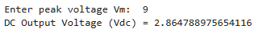
2 | Write a Python Script by using statistics module to calculate mean (average value), median (middle value), mode (most often value), standard deviation (spread of values).
SCRIPT | import statistics  data = [10, 20, 20, 30, 40]  mean_val = statistics.mean(data)  median_val = statistics.median(data)  mode_val = statistics.mode(data)  std_dev = statistics.stdev(data)  print("Mean =", mean_val)  print("Median =", median_val)  print("Mode =", mode_val)  print("Standard Deviation =", std_dev)
OP | 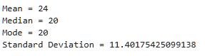
3 | Program to create and use a user-defined calculator module  Step 1 — Create module: calculator.py  Import and use calculator module
SCRIPT | 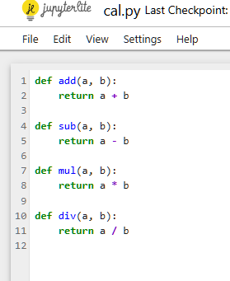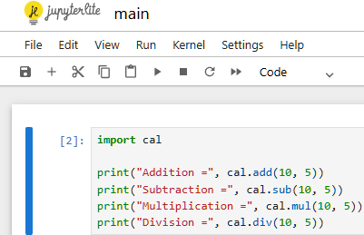
OP | 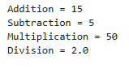
Debugging Questions with Corrected Answers
1 | Debug the following code  Wrong code:  import math  print(sqrt(16))
OP | Error:  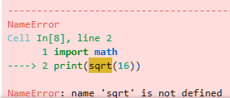  Correct code:  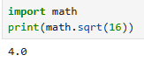
2 | Debug the following code  Wrong code:  import calc  print(calc.add(5, 3))
OP | Error:  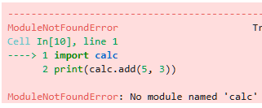  Correct code:  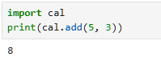
Conclusion | Thus, we successfully studied and implemented Python built-in modules such as math and statistics. We also created and used a user-defined module to perform calculator operations. This practical helped us understand modular programming and code reusability in Python.
Performance Indicators |  | Teachers Dated and Signature
Process Related  (15 M) | Product Related  (10 M) | Total (25 M)

