Name | Varun Sharma
Roll no | 24204A0031
Batch | 2
Subject name | Python Programming & Data Structure
Teacher Name | Ms. Rasika Patil

Experiments | 1
Title | a) Install Python IDE  b) Program for equivalent resistance in series/parallel  c) Program to calculate voltage using Ohm’s law
Relevant Theoretical Background
Python was created by Guido van Rossum during 1985- 1990. Like Perl, Python source code is also available under the GNU General Public License (GPL). Python is named after a TV Show called ‘Monty Python’s Flying Circus’ and not after Python- the snake.
Installing Python in Windows:
- Open any internet browser. Type http:///www.Python.org/downloads/ in address bar , press Enter.
- Home page of Python will have displayed as shown in Fig. 1
Installation on Windows
Visit the link https://www.python.org to download the latest release of Python.
In this process, we will install Python 3.11.3 on our Windows operating system. When we click on the above link, it will bring us the following page.

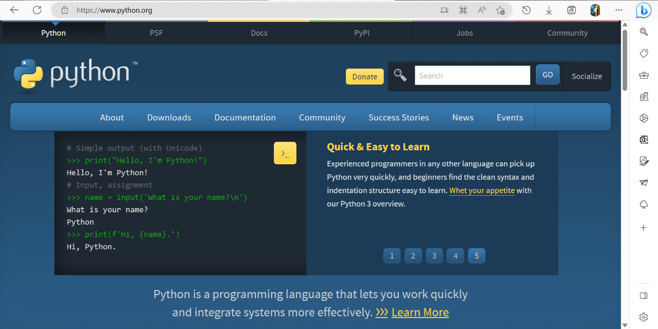
Step - 1: Select the Python's version to download. click download button to download the exe file of Python.
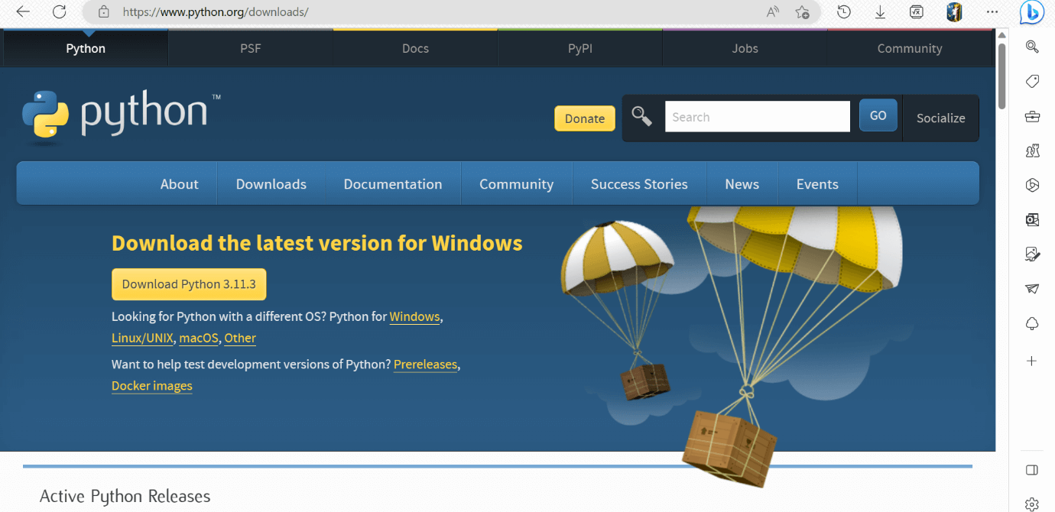

If in case you want to download the specific version of Python. Then, you can scroll down further below to see different versions from 2 and 3 respectively. Click on download button right next to the version number you want to download.
Step - 2: Click on the Install Now
Double-click the executable file, which is downloaded.
The following window will open. Click on the Add Path check box, it will set the Python path automatically.
Step - 3 Installation in Process
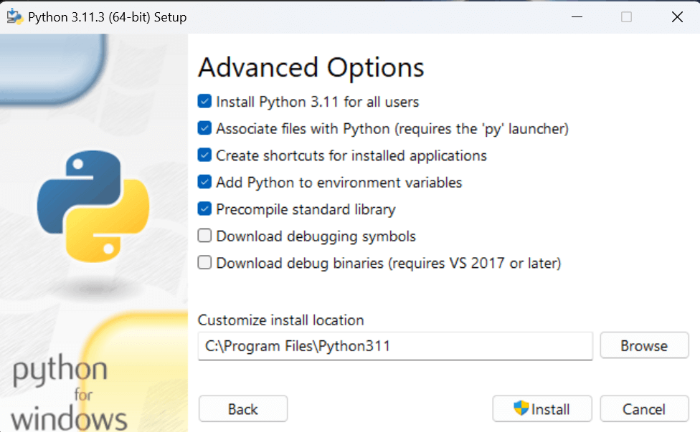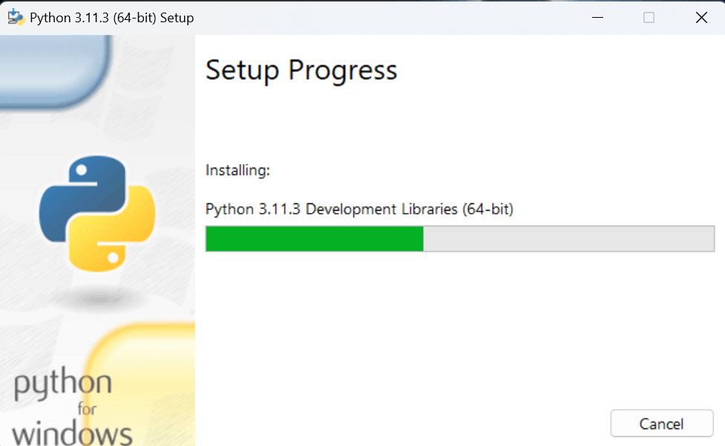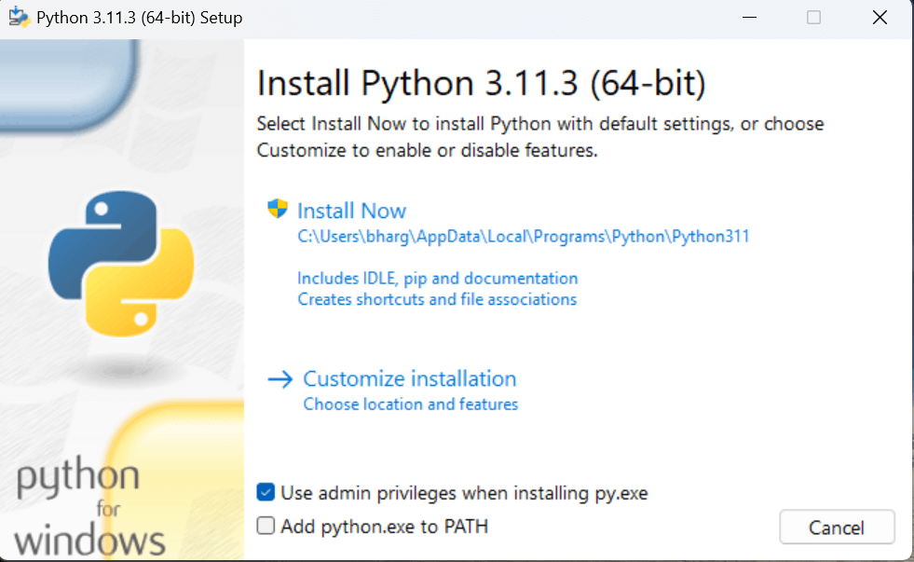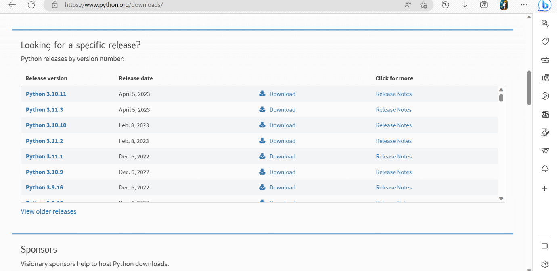

The set up is in progress. All the python libraries, packages, and other python default files will be installed in our system. Once the installation is successful, the following page will appear saying " Setup was successful ".

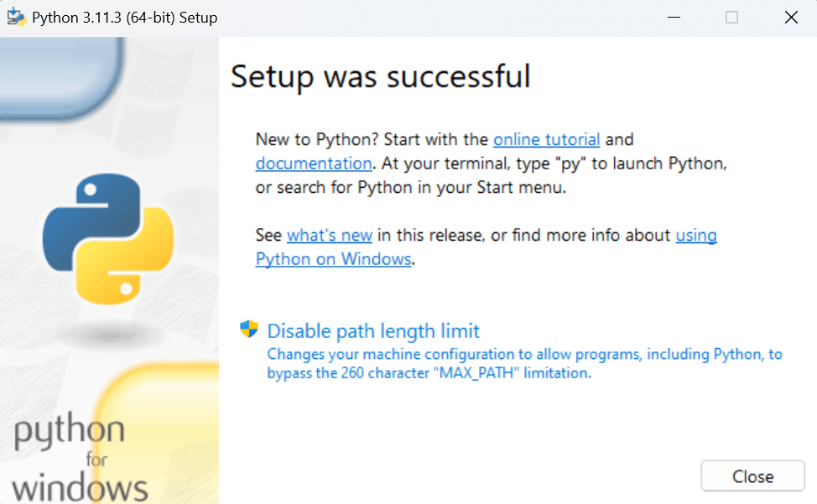

Step - 4: Verifying the Python Installation
To verify whether the python is installed or not in our system, we have to do the following.
- Go to "Start" button, and search " cmd ".
- Then type, " python - - version ".
- If python is successfully installed, then we can see the version of the python installed.
- If not installed, then it will print the error as " 'python' is not recognized as an internal or external command, operable program or batch file. ".
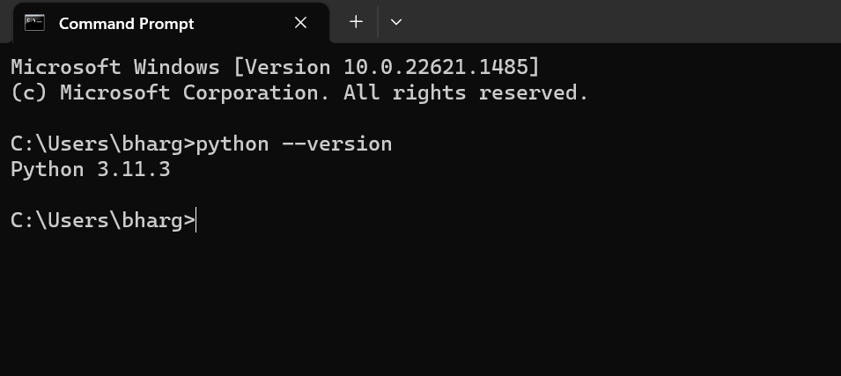
We are ready to work with the Python.
Step - 5: Opening idle.
Now, to work on our first python program, we will go the interactive interpreter prompt(idle). To open this, go to "Start" and type idle. Then, click on open to start working on idle.
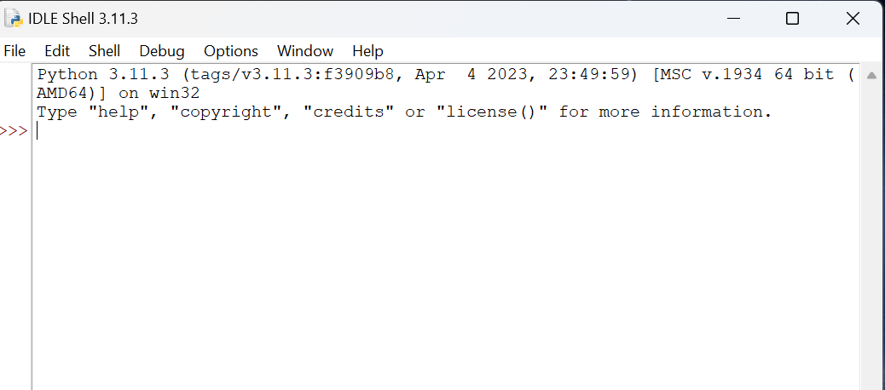
Electrical formulas used:
• Series resistance: Rₛ = R₁ + R₂ + …
• Parallel resistance: 1/Rₚ = 1/R₁ + 1/R₂ + …
• Ohm’s Law: V = I × R
Syntax
• print() for output
• input() for user input
• float() for numeric conversion
• Arithmetic operators: + − * /

Programming Questions with Answer
1 | Program to calculate equivalent resistance in series
SCRIPT | 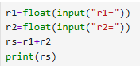
OP | 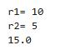
2 | Program to calculate equivalent resistance in parallel
SCRIPT | 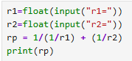
OP | 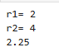
3 | Program to calculate voltage using Ohm’s Law
SCRIPT | 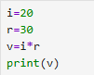
OP
Debugging Questions with Corrected Answers
1 | Debug the following code  Wrong code:  R1 = input("R1: ")  R2 = input("R2: ")  Rs = R1 + R2  print(Rs)
OP | Error:  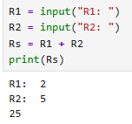  It performs concatition instead of addition.  Correct code:  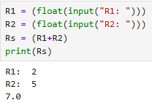
2 | Debug the following code  Wrong code:  V = I * R  I = float(input("I: "))  R = float(input("R: "))  print(V)
OP | Error: The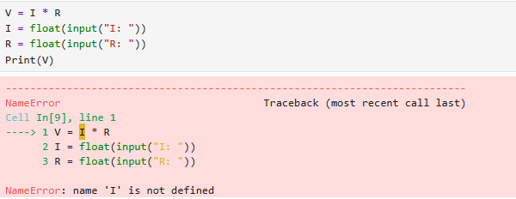The equation is declared before variables  Correct code:  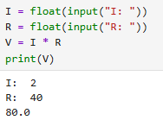
Conclusion | Hence we are able to perform and run basic python fundamentals
Performance Indicators |  | Teachers Dated and Signature
Process Related  (15 M) | Product Related  (10 M) | Total (25 M)

