**JSPM’s**

**Jaywantrao Sawant college of Engineering**

**Department of Information Technology**

**DBMSL Mini Project report on**

**“Bank Management System”**

**Group No.-**

**Mini Project Group Members:**

S190408545-Navlesh Todkar

S190408555-Tejas Raut

S190408557-Vaibhavi Salunkhe

S190408559-Mohd. Raiyaan Shaikh

**Under the guidance of**

Prof.A.K.Gupta

**Academic Year 2022-23**

**INDEX**

1.Abstract

2. Introduction

3. Project Specification

3.1 Problem Statement

3.2 Objectives

3.3 Scope

3.4 Requirement

3.4.1 Hardware Requirement

3.4.2 Software Requirement

3.5 Assumptions/constraints

4. E-R Diagram with description

5. Data dictionary

6. Normalization

7. Functions of the system

8. Conclusion

**1. ABSTRACT**

A bank management system refers to the process of managing the Banks’s activities. To ensure a smooth running of the banking system, it must be properly managed.The system is designed to store and retrieve information about bank customers, their accounts and other related data. The system is developed using database management system technology, which provides a reliable and secure platform for storing and managing large volumes of data. Overall, the bank management system that helps in banking operations, improve customer service, and enhance the overall performance of the banking institution.

**2. INTRODUCTION**

The banking sector plays a vital role in facilitating financial transactions and providing essential services to individuals and businesses.The traditional manual methods of banking have given modern and efficient way in Bank Management Systems. The bank management system is an essential software that helps in the efficient management of various banking operations.

The system stores data about customers, such as their names, addresses, contact information, and account details. This system records transactions made by customers, including deposits, withdrawals, transfers, and other banking activities. The system uses this data to generate reports, such as account statements, transaction summaries, and financial statements, which help bank staff to manage their operations more effectively. Self-service options such as account opening, balance checking helps customers to manage their finances from their homes.

One of the key benefits of a Bank Management System is the improved efficiency it brings to banking operations. Manual processes that were prone to errors and delays have been replaced by automated systems that perform tasks swiftly and accurately. Time-consuming activities like data entry are now streamlined, allowing bank employees to focus on more complex tasks and delivering personalized customer service.

Moreover, Bank Management Systems offer a range of features designed to enhance the overall customer experience. Also a Bank Management System brings efficiency and convenience to the banking industry.

**3.Project Specifications**

**3.1 Problem statement**

To provide a system for the ease of customers and bank staff to manage their accounts and transactions in an efficient and reliable manner.

3.2 Objectives of the project

The Specific objectives of the project are:

* Create and manage customer information, including personal, contact and account.
* Save customer’s time- Client doesn’t need to go to the bank to do small operations.
* The goal is to provide a user-friendly and efficient banking system.

3.3 Scope

It is focused on developing a computer program that manages banking operations and making the transactions easier for the customer. This will result in:

* customers to open bank accounts, deposit and withdraw money and transfer funds remotely.
* Bank employees to manage customer accounts, process transactions, and generate reports with ease.
* Reduction in labour to store and manage customer information, account details in a secure and organized manner.

**3.4 Requirements**

3.4.1.Hardware Requirements:

|  |  |
| --- | --- |
| **Content** | **Description** |
| Processor | Intel i3 64bit x86 |
| Memory | 4GB |
| Disk space | 800MB |

3.4.2.Software Requirements:

|  |  |
| --- | --- |
| Operating System | Windows, MacOS, Linux |
| Database | MongoDB |

**3.5.1 Assumptions**

* We are assuming a specific branch of bank.
* Customers are not allowed to create joint account
* Customer can perform transactions to his account only.
* The operating hours for the banking system is 9AM to 5PM.
* The customer will perform all the transactions and operations with his bank only.
* All the transactions and accounts will be viewed by the bank employees and will be displayed for them only.
* The account statistics will be displayed to the respective customer only.

**Constraints**

* If the age is above 18 then only a customer is eligible to open account.
* Every customer has unique customer ID and account number.
* Minimum account balance should be less than or equal to Rs.1000.
* Failure to comply with banking regulations can lead to penalties, legal issues, and reputational damage.

**4. ER diagram**

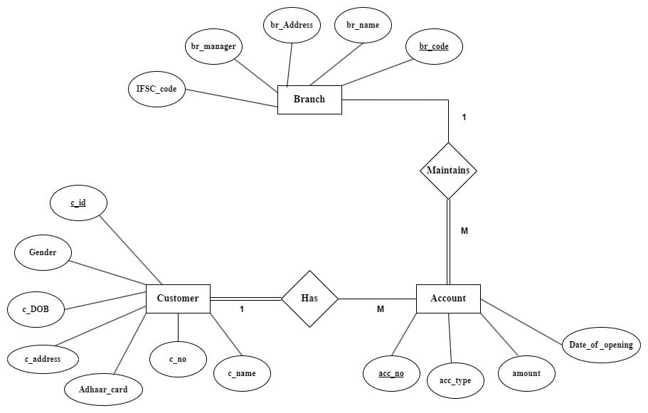

**Description:**

**Entities:**

There are three entities Branch, Account and Customer.

* + - * + Branch- The Physical location of a specific Bank.

Attributes of Branch:

br_code- Primary key for branch of the bank.

br_name- Name of the bank.

br_address- Physical location of the branch.

br_manager- Manager of a specific branch of a bank.

IFSC_code- IFSC code of a particular branch.

* + - * + Customer- The person who creates an account in the bank.

Attributes of Customer:

c_id- The primary key for each customer.

c_name-Name of the customer.

c_address-Permanent Address of the customer

c_DOB- Date of birth of a customer.

Adhaar_card- Adhaar number of customer.

Gender- Gender of customer.

c_no- Contact number of a customer.

* + - * + Account- Financial account maintained by a bank for a customer.

Attributes of Account:

acc_no- The primary key for unique account number for each customer.

acc_type- Type of the account customer wants to open or currently holds.

amount- Current balance in the account of customer.

Date_of_opening- Date of account opening.

Relationships:

One to Many:

One branch maintains many accounts.

One customer may have many accounts.

**Participation:**

* + Accounts in the branch have total participation in the branch of the specific bank.
  + A customer has total participation in his/her account(s).

**5. Data Dictionary**

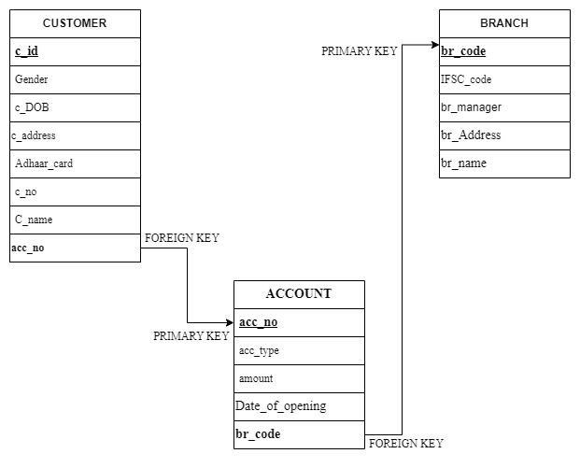

**6. Nomalization**

FIRST NORMAL FORM(1NF):

CUSTOMER

Schema :- (c_id, Adhaar_card, c_address, c_DOB, Gender, c_no, c_name, acc_no)

The CUSTOMER table is in first normal for because it follow the requirement for INF:-

* All the attributes of researcher table are single valued attribute.
* It does not contain any composite or Multi-valued attributes

ACCOUNT

Schema:-(acc_no, acc_type, amount, Date_of_opening, br_code)

The ACCOUNT table is in first normal for because it follow the requirement for INF:-

* All the attributes of researcher table are single valued attribute.
* It does not contain any composite or Multi- valued attributes

BRANCH

Schema:-(br_code, br_name, br_address, br_manager, IFSC_code)

The BRANCH table is in first normal for because it follow the requirement for INF:-

* All the attributes of researcher table are single valued attribute.
* It does not contain any composite or Multi- valued attributes

SECOND NORMAL FORM(2NF):-

CUSTOMER

Schema :- (c_id, Adhaar_card, c_address, c_DOB, Gender, c_no, c_name, acc_no)

The CUSTOMER table is in second normal for because it follow the requirement for 2NF:-

FUNCTION DEPENDENCIES:

* KEY->{c_id}
* {c_id}->{Adhaar_card, c_address, c_DOB , Gender, c_no, c_name, acc_no}

ACCOUNT

Schema:-(acc_no, acc_type, amount, Date_of_opening, br_code)

The ACCOUNT table is in second normal for because it follow the requirement for 2NF:-

FUNCTION DEPENDENCIES:

* KEY->{acc_no}
* {acc_no}->{acc_type, amount, br_code}

BRANCH

Schema:-(br_code, br_name, br_address, br_manager, IFSC_code)

The BRANCH table is in second normal form because it follow the requirement for 2NF:-

FUNCTION DEPENDENCIES:

* KEY->{br_code}
* {br_code}->{br_name, br_address, br_manager,IFSC_code}

THIRD NORMAL FORM(3NF):-

CUSTOMER

Schema :- (c_id, Adhaar_card, c_address, c_DOB, Gender, c_no, c_name, acc_no)

The CUSTOMER table is in THIRD normal for because it follow the requirement for 3NF:-

* KEY->{c_id}
* {c_id}->{Adhaar_card, c_address, c_DOB, Gender, c_no, c_name, acc_no}

CUSTOMER IS ALREADY IN 3NF

ACCOUNT

Schema:-(acc_no, acc_type, amount,Date_of_opening, br_code)

The ACCOUNT table is in second normal for because it follow the requirement for 2NF:-

* KEY->{acc_no}
* {acc_no}->{acc_type, amount, Date_of_opening, br_code}

ACCOUNT IS ALREADY IN 3NF

BRANCH

Schema:-(br_code, br_name, br_address, br_manager, IFSC_code)

The BRANCH table is in second normal for because it follow the requirement for 2NF:-

* KEY->{br_code}
* {br_code}->{br_name, br_address, br_manager, IFSC_code}

BRANCH IS ALREADY IN 3NF

**7. Functions of the System**

* Account opening:

Account opening and maintenance: The system can be used to open new accounts, add and remove authorized users, and update account information.

* Transaction processing:

The system can be used to process deposits, withdrawals, transfers, and payments.

* Display result:

It displays all account details, current balance, minimum balance required, etc.

* Trigger operation:

It triggers notification when account balance goes below a specific amount.

* Grand and revoke :

Manger will have access to critical information and can make changes to the data.

Employee will have access to some extent only.

* View :

Customers are able to view their account information only and not the background activities.

**8. Conclusion**

A bank management system greatly simplifies and enhances the work of both customers and employees. It provides customers with convenient self-service options, such as online and mobile banking, enabling them to access their accounts, make transactions, and obtain information easily. It also facilitates accurate and real-time data for reporting, improves risk management, and enables scalability and adaptability to meet evolving needs. Overall, a bank management system significantly eases the workload for both customers and employees, resulting in enhanced efficiency, improved customer experience, and streamlined operations.