**Experiment_Part_2**

**Introduction**

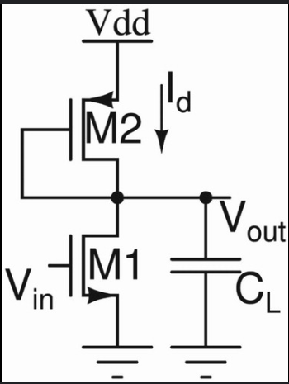An amplifier that uses both PMOS and NMOS transistors is called a CMOS amplifier (Complementary Metal Oxide Semiconductor amplifier), where the combination of both types of transistors allows for improved performance by utilizing their complementary characteristics, often resulting in better power efficiency and reduced distortion compared to using only one type of MOSFET.

**DC Operation Point**

**Procedure:**

1. To check the operating point first calculate the Id value with the help of VDD and the power budget mentioned in the question.
2. From the part 1 of this experiment, we can say that the current ID must be around 27.7 uA.
3. So through trail and error we should fill the values of W,L for the PMOS and then by calculation, we can write the maximum required VG value.
4. In this case the maximum required value for VG must be less than 1.4V.
5. Here we take the value of VG is -5V.

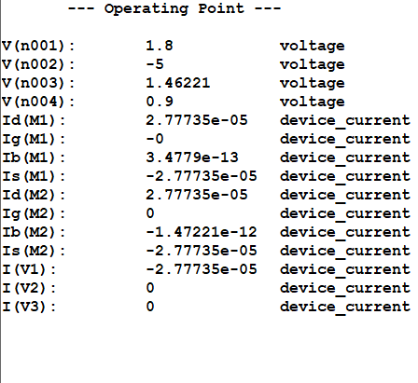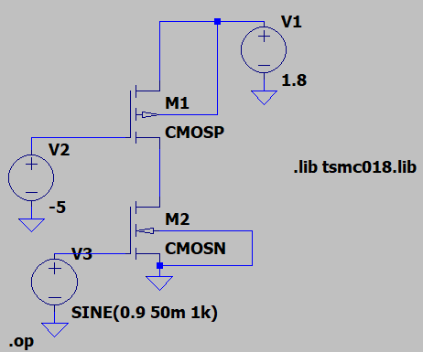

**Transient Analysis**

* For transient analysis, first we need to give the required frequency of 1KHz.
* Then ensure that it follows the condition for small signal analysis (Vgs<<2Vov).
* Then take the readings for 5 cycles by giving time period as 5ms).
* Type ‘.tran5m’ to give the time period.

**Output waveform**

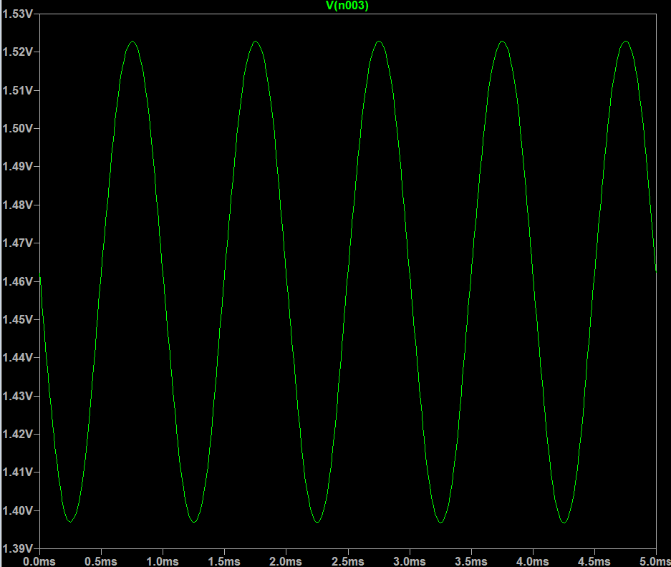

**Input waveform**

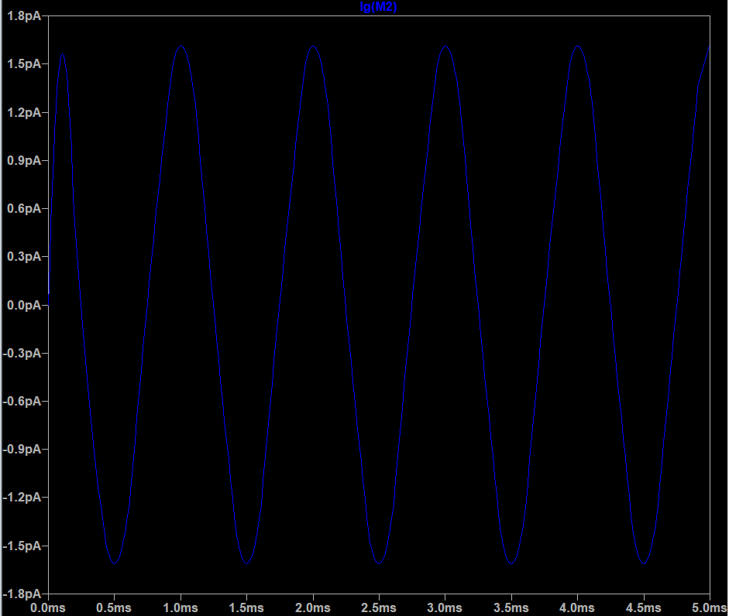

Therefore, the voltage gain is:

**Av = -( Vout/ Vin) = -(1.554/50m) = -31.1**

**AC Analysis**

Next, we can perform the AC analysis, this can be done by clicking on ‘configure analysis’ and then clicking on the ‘AC analysis’ tab.

Now give the required parameters and place the directive near the circuit.

For this circuit give the following parameters:

For our analysis, choose “Type of Sweep” = Decade, so that the plot of gain will be dB/decade, and the number of points per decade = 20. Set start frequency = 0.1 Hz, end frequency = 1 THz, which gives us a large range of frequency to find results.

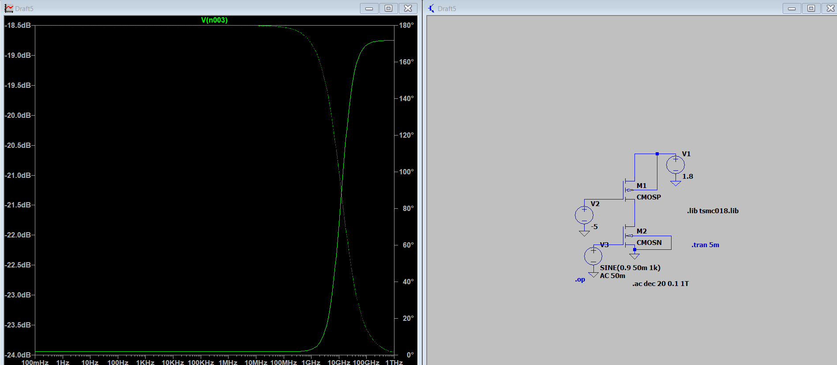

Converting our gain from V/V to dB, using the formula A’V = -10log10(Av)

**A’V = -10log10(31.1) = -10(1.5507) = -14.92**

**DC Sweep**

**Transfer characteristics**

The next analysis we can perform is the AC analysis, to compute the small signal AC behaviour of the circuit, and calculate the midband and find breaking frequencies, i.e., fL, fH.

The resultant graph gives us the Bode plot of the circuit’s behaviour, which is the variation of gain over frequency, and also the variation of phase over frequency, in one plot.

For this circuit we should choose, “Type of Sweep” = Decade, so that the plot of gain will be dB/decade, and the number of points per decade = 20. Set start frequency = 0.1 Hz, end frequency = 1 THz, which gives us a large range of frequency to find results.

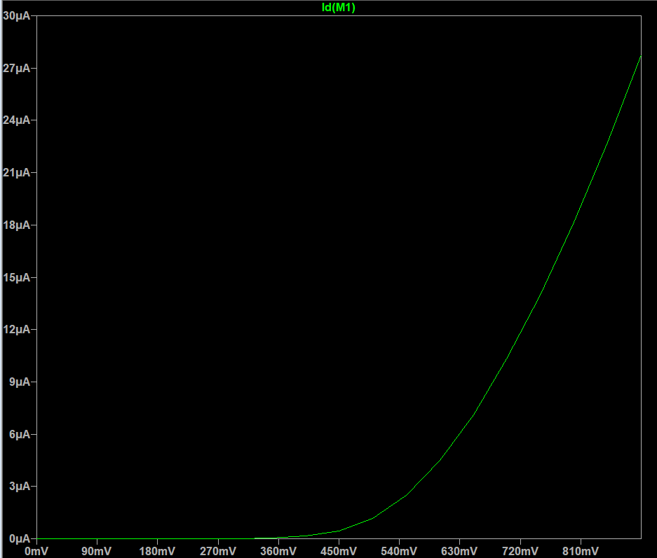Place the **“.ac dec 20 0.1 1T”** directiveanywhere on the schematic and click Run.

**Drain characteristics**

To perform the DC sweep on VDS, and obtain drain characteristics, we go to the “Configure Analysis” option and choose the DC sweep tab, and input the parameters. For this analysis, set the name of 1st source to sweep = VDD, the type of sweep = Linear, start value = 0V, stop value = 1.8V, which is the maximum value of the input gate voltage, increment = 0.1V.Place the **“.dc VDD 0 1.8 0.1”** directive anywhere on the schematic, and then click on the “Run” 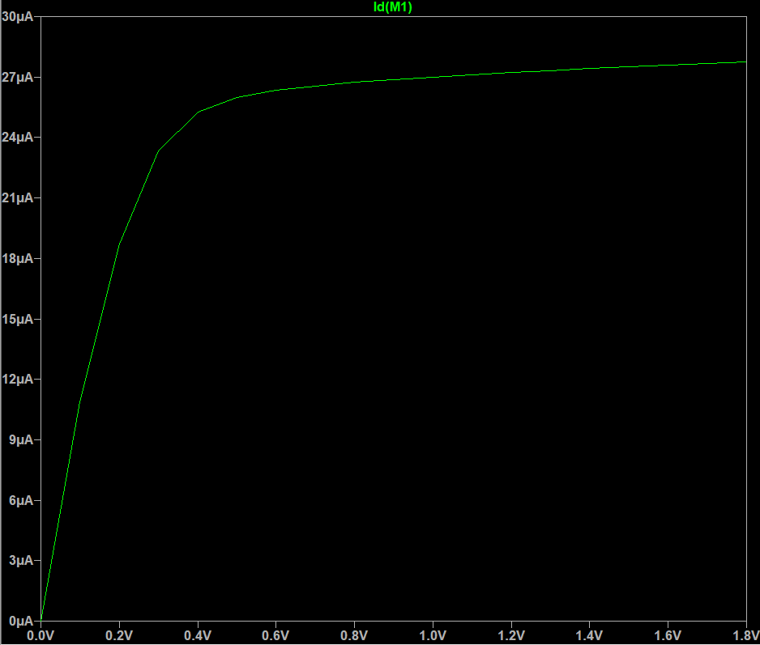icon.

From this graph, we can see that the saturation region starts at around 0.4V and the maximum current reaches to 27.7uA.

**Inference**

From this experiment, we understand the behavior of the MOSFET using various analyses, such as DC analysis, transient analysis, DC sweep, AC analysis. The results of our analysis prove that the MOSFET is a voltage controlled current device, since changing the values of input value VGS changes the values of output current.

We can also when we perform AC analysis, the MOSFET amplifies input signal, from 50 mV, to 1.77 V, giving a gain of -35.54, due to a 180° phase shift, causing output to be inverted compared to output. The AC analysis results give us a gain of -15 dB, with a phase shift of almost 180°.

Next, we saw the variation of drain current due to W, L parameters of the MOSFET. We also saw the variation of ID, with R1, i.e., RD value.

Finally, we learnt how to use the LTSpice simulation tool, which provides an easy way to simulate and test circuits, while maintaining process parameters that would be used during fabrication, via SPICE directives, .lib files.