Uzduotys

1. LED mirksintis 2s indikuoja MCU veikima 0.5s/gauna komandas is CAN.
2. Toggle Shuffle all musics
3. **BT isjungimas ir ijungimas**
4. Vienos komandos vygdymas

UART-DBG Protokolas

|  |  |  |
| --- | --- | --- |
| Komanda | Funkcija | Fukcijos aprasimas |
| **ID**  Ats.: ID | ID Grazinimas |  |
| **ON**  Ats.: ON | Power on |  |
| **OF**  Ats.: OF | Power off |  |
| **F1**  Ats.: F1 | Skip Forward |  |
| **B1**  Ats.: F1 | Skip Backward |  |
| **P1**  Ats.: P1 | Play/Pause |  |
| **S2**  Ats.: S2 | STOP | Gal nenaudojamas tas pats kaip ir Play/Pause |
| **AA**  Ats.: Audio 0/1 | Audio active status |  |
| **PA**  Ats.: Power 0/1 | BT power status |  |
| **CS**  Ats.: call 0/1 | Incoming/outcoming/call state |  |
| **SR**  Ats.: SET radio | Set radio audio source |  |
| **SA**  Ats.: SET AUX | Set AUX audio source |  |
| **SB**  Ats.: SET BT | Set BT audio source |  |
| **RB**  **ATS.:RB** | Restart BT |  |
| **AN**  **ATS.: AN** | Answer |  |
| **RE**  **ATS.: RE** | REject |  |
| **TT**  **ATS.: TT** | Test trumpa mygtuka CAN |  |
| **TL**  **ATS.: TL** | Test ilgo mygtuko paspaudima CAN |  |
| **BC**  **ATS.: BC 0/1** | Get BT connected jei prisijungta prie modulio |  |
|  |  |  |

//Jeigu source BT ir ConnectedNo perjungiame radija po 20s

//jeigu source Radio ir buvo Disconnect pries tai ir dabar Connect. perjungiame BT is karto.

//BT prijungia source nuo prisijungimo.

//BT/Radio source ant vairo veikia kaip numatyta perjungia bet bt lieka prisijunges

//kai skambinama perjungia BT source

Mygtukai

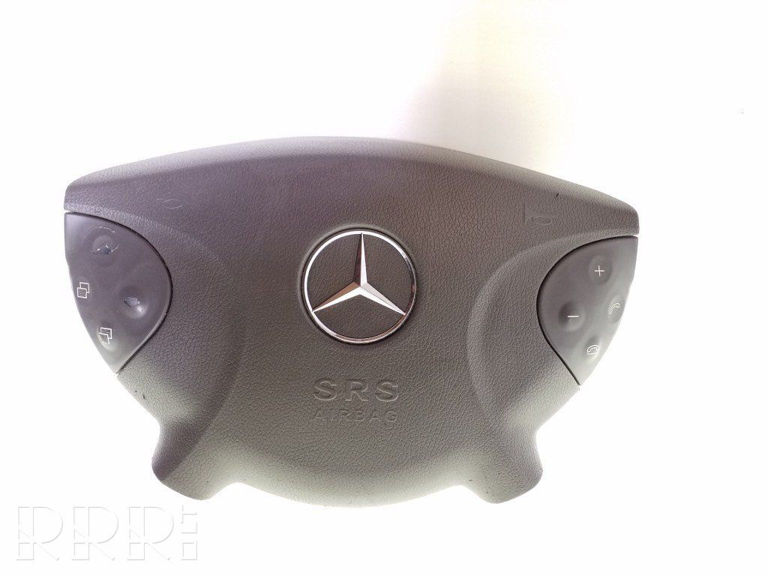

**4**

**3**

**2**

**1**

7

8

**5**

**6**

ECU NAME: MRM_A2, ID: 0x01A8. MSG COUNT: 16

MSG NAME: WIPPE_4_2 - Button on the bottom right to bottom, OFFSET 0, LENGTH 1

MSG NAME: WIPPE_4_1 - Button on the right bottom to top, OFFSET 1, LENGTH 1

MSG NAME: WIPPE_3_2 - Button on the right top to bottom, OFFSET 2, LENGTH 1

MSG NAME: WIPPE_3_1 - Button on the top right to the top, OFFSET 3, LENGTH 1

MSG NAME: WIPPE_2_2 - Button on the bottom left to bottom, OFFSET 4, LENGTH 1

MSG NAME: WIPPE_2_1 - Button on the left bottom to top, OFFSET 5, LENGTH 1

MSG NAME: WIPPE_1_2 - Button top left to bottom, OFFSET 6, LENGTH 1

MSG NAME: WIPPE_1_1 - Button top left to top, OFFSET 7, LENGTH 1

MSG NAME: WIPPE_8_2 - reserve, OFFSET 8, LENGTH 1

MSG NAME: WIPPE_8_1 - reserve, OFFSET 9, LENGTH 1

MSG NAME: WIPPE_7_2 - reserve, OFFSET 10, LENGTH 1

MSG NAME: WIPPE_7_1 - reserve, OFFSET 11, LENGTH 1

MSG NAME: WIPPE_6_2 - reserve, OFFSET 12, LENGTH 1

MSG NAME: WIPPE_6_1 - reserve, OFFSET 13, LENGTH 1

MSG NAME: WIPPE_5_2 - reserve, OFFSET 14, LENGTH 1

MSG NAME: WIPPE_5_1 - reserve, OFFSET 15, LENGTH 1

//ECU NAME: KOMBI_A5, ID: 0x01CA. MSG COUNT: 25 //LENGHT 32

/*MSG NAME: KI_STAT - status combi, OFFSET 0, LENGTH 8

MSG NAME: BUTTON_4_2 - phone End, OFFSET 8, LENGTH 1

MSG NAME: BUTTON_4_1 - phone Send, OFFSET 9, LENGTH 1

MSG NAME: BUTTON_3_2 - "-" key, OFFSET 10, LENGTH 1

MSG NAME: BUTTON_3_1 - "+" Key, OFFSET 11, LENGTH 1

MSG NAME: BUTTON_2_2 - reserve, OFFSET 12, LENGTH 1

MSG NAME: BUTTON_2_1 - reserve, OFFSET 13, LENGTH 1

MSG NAME: BUTTON_1_2 - Previous display, OFFSET 14, LENGTH 1

MSG NAME: BUTTON_1_1 - Next display, OFFSET 15, LENGTH 1

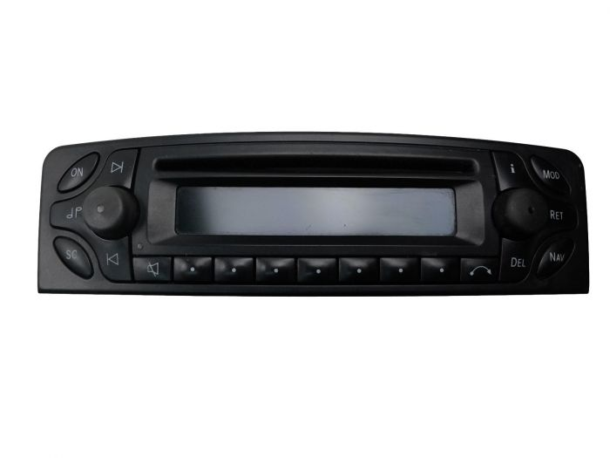 

Bluetooth integruojamas i mageli (sena)

Su CAN pajungimu

**HD**

5

Bluetooth

Skip forward – trumpas pas.

Answer – trumpas pas.

Skip backward– trumpas pas.

Reject – trumpas pas.

Skip backward– trumpas pas.

Perjungti i radija/bluetooth – ilgas(>5s)

Skip forward– trumpas pas.

Restart Bluetooth – ilgas(>5s)

On/OFF blueatooth – ilgas(>5s)

Play/pause – trumpas

