**Historical reconstruction of the population dynamics of southern right whales in the southwestern Atlantic Ocean**

Romero, M.A. 1,2*, M.A. Coscarella 3,4, J.C. Pedraza 5, R.A. González 1,2 and E.A. Crespo 3

**Objectives:**

Implement a state-space population dynamics model for Southern Right Whales using the backwards approach adapted from Zerbini et al 2019. Implementation includes nine sensitivity runs to account for uncertainties in priors and data. This will replace the forwards approach currently used.

**Grant and John’s responsibilities (Grant lead):**

1. Adapt the code base used for Zerbini et al 2019 to incorporate process errors and alternative distributions required by Romero et al but not implemented in Zerbini et al (Inverse-Gamma), Multivariate log-normal, Truncated log-normal).

2. Fit base model and sensitivity models using above code.

3. Generate plots of prior predictive checks, posterior predictive checks, time series of catch/abundance distributions, fits to absolute and relative abundance, distributions of derived or estimated parameters.

4. Update methods text? I can help with this section.

**Romero et al responsibilities:**

1. Provide required data (time series of catch, relative abundance, absolute abundance)

2. Provide model specifications including data and priors to be used for each sensitivity run.

3. Update results and discussion text.

**Base case**

**Population model:**

* Prior on Rmax: U[0, 0.11]
  + Done 4/28/21
* Prior on Nrecent: the recent year was taken 2019 and assigned a prior of U[100, 10,000].
  + Done 4/28/21
  + The SIR samples a value for abundance in year 2019 from U[100, 10,000] and back calculates the K that would have been needed to obtain that value of N in 2019 given the data and the samples of the other parameters
  + Suggest a sensitivity run selecting a different year. Likely will make no difference but good to show it doesn’t. This is a good idea; it could be 2010.
* Pmsy ~ U(0.5, 0.8)
  + Done 4/28/21
* Prior on process error is diffuse inverse-gamma.
 $σ^{2}\sim invgamma(4, 0.1)$

 + Done 4/28/21

**Abundance model**

* Absolute abundance data: estimates of absolute abundance (N2009 and N2010) (table 4).
  + N2010: 4245 (SE: 245, 95% CV = 245/4245).
    - Included in likelihood assuming lognormal
    - Done 4/28/21
  + N 2009: 4029 (SE: no available);
    - Not included in likelihood
    - Could estimate a variance and include? This value comes from a IWC report and not additional information is supply (or I couldn´t find). Not include.
* Relative abundance data: accumulated numbers of observed right whales 1998-2019.
  + Grant needs data for 2018 and 2019. I´m sending the file with all the data. I apologize for that, but since I did not use those years into parameter estimation, I had the abundance data in another file.
  + This is column Nt from datosModeloBallenasmiles2020Miles.csv, correct? Yes.
  + Estimate time-invariant q, variance ($τ^{2}$), and correlation $ρ$
    - I can calculate analytical q, need to do some more math for variance and correlation.
  + Assume multivariate lognormal distribution

 $Nt\sim MVLogNorm(q*\hat{N}t,Σ)$

 $Nt$  - is relative abundance from year t, $\hat{N}t$ is estimated abundance. Nt is the relative abundance (that the accumulated number of observed right whales) and $\hat{N}t$ is the unobserved annual abundance for the SRW population exposed to whaling, correct?
    - $Σ=diag(τ$) * CorrMat * diag($τ$) = Variance-Covariance matrix
    - Size NxN where N is the number of relative abundance observations
    - CorrMat (NxN) = Correlation matrix

|  |  |  |  |  |
| --- | --- | --- | --- | --- |
| 1 | $$ρ$$ | … | $ρ$ | $ρ$ |
| $$ρ$$ | 1 | … | $ρ$ | $ρ$ |
| … | … | … | … | … |
| $$ρ$$ | $$ρ$$ | … | 1 | $$ρ$$ |
| $ρ$ | $ρ$ | … | $$ρ$$ | 1 |

* + - * I’m assuming that all observations are equally correlated despite distance in time being difference because they use the same regression parameters, is that correct? I assume that it is OK, but I would like Mariano to give his opinion.
      * The calculation of the relative abundance estimates cannot output a variance-covariance matrix that we could put into the model rather than estimating, right? Idem previous comment.
  + Ran a sensitivity assuming univariate lognormal, analytical q and inverse-gamma prior on variance ($τ)$: $τ^{2}\sim invgamma(2, 0.5)$ using data from 1998-2017 and including the absolute index of abundance and looking good. This also includes the setup of the population dynamics listed above and catch dynamics listed below. The sampling is quite slow, so this is not converged:

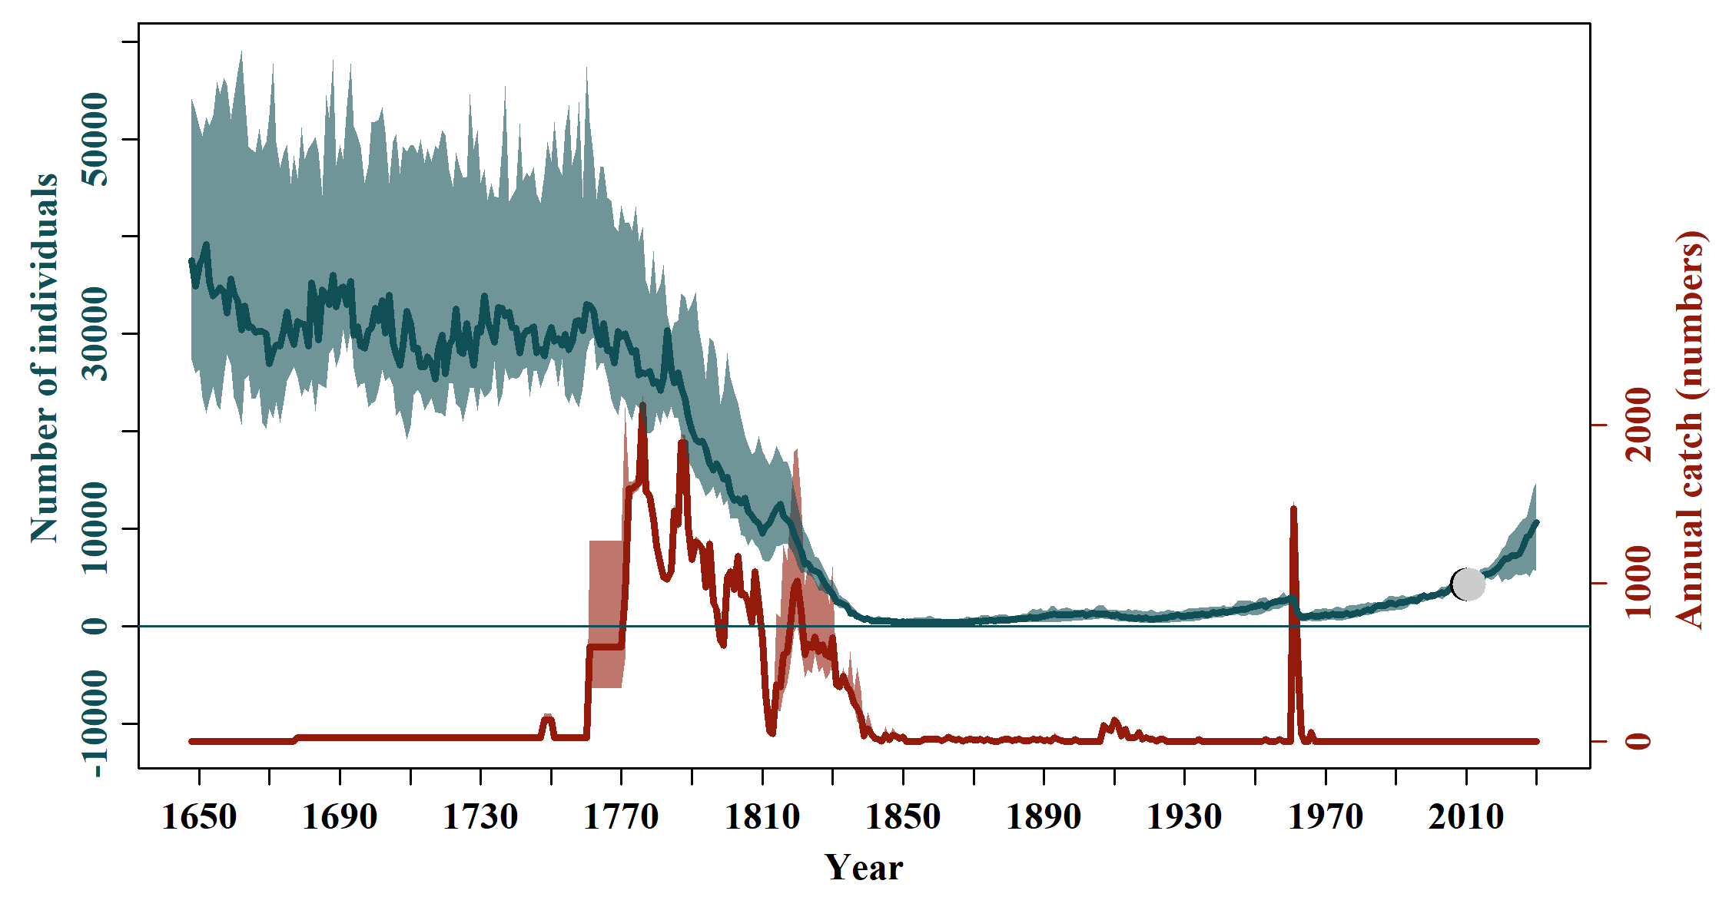

**Catch model:**

* High and low catch time series.
  + Prior on $π$: U[0,1].
  + Done 4/28/21
* Prior on ${SRL}_{1}$ and ${SRL}_{2}$: two normally distributed priors were used.
  + period 1: 1648-1770: struck and lost rate factor = 1
  + period 2: 1771-1850: struck and lost rate factor ~ norm(1.60, 0.04^2 )
  + period 3: 1851-1973: struck and lost rate factor ~ norm(1.09, 0.04^2 )
  + period 4: 1974-2030: struck and lost rate factor = 1
  + Done 4/28/21

**Table 1. Scenarios for runs of the South Atlantic Right Whale Assessment Model:**

|  |  |  |  |  |  |  |  |
| --- | --- | --- | --- | --- | --- | --- | --- |
| Sens | Rmax | $$σ^{2}$$ | $$τ^{2}$$ | $$z$$ | SLR | Catch | 1971-1973/1982-1983 |
| Base | $$unif(0.01, 0.11)$$ | $$invgamma(4, 0.1)$$ | $$invgamma(2, 0.5)$$ | 2.39 | Include | $$unif(Low, High)$$ | Exclude |
| 1 | $lnorm(μ_{R_{max}}=-2.65, σ_{R_{max}}=0.5)$ T(0,0.11) | $$invgamma(4, 0.1)$$ | $$invgamma(2, 0.5)$$ | 2.39 | Include | $$unif(Low, High)$$ | Exclude |
| 2 | $$unif(0.01, 0.11)$$ | $invgamma(2, 0.05$) | $$invgamma(2, 0.5)$$ | 2.39 | Include | $$unif(Low, High)$$ | Exclude |
| 3 | $$unif(0.01, 0.11)$$ | $$invgamma(8, 0.2)$$ | $$invgamma(2, 0.5)$$ | 2.39 | Include | $$unif(Low, High)$$ | Exclude |
| 4 | $$unif(0.01, 0.11)$$ | $$invgamma(4, 0.1)$$ | $$invgamma(1, 0.25)$$ | 2.39 | Include | $$unif(Low, High)$$ | Exclude |
| 5 | $$unif(0.01, 0.11)$$ | $$invgamma(4, 0.1)$$ | $$invgamma(4, 1)$$ | 2.39 | Include | $$unif(Low, High)$$ | Exclude |
| ~~6~~ |  |  |  | ~~5.04~~ | ~~Include~~ |  | Exclude |
| 7 | $$unif(0.01, 0.11)$$ | $$invgamma(4, 0.1)$$ | $$invgamma(2, 0.5)$$ | 2.39 | Exclude | $$unif(Low, High)$$ | Exclude |
| 8 | $$unif(0.01, 0.11)$$ | $$invgamma(4, 0.1)$$ | $$invgamma(2, 0.5)$$ | 2.39 | Include | Low | Exclude |
| 9 | $$unif(0.01, 0.11)$$ | $$invgamma(4, 0.1)$$ | $$invgamma(2, 0.5)$$ | 2.39 | Include | High | Exclude |
| 10 | $$unif(0.01, 0.11)$$ | $$invgamma(4, 0.1)$$ | $$invgamma(2, 0.5)$$ | 2.39 | Include | $$unif(Low, High)$$ | Include |