**Historical reconstruction of the population dynamics of southern right whales in the southwestern Atlantic Ocean**

Romero, M.A. 1,2*, M.A. Coscarella 3,4, J.C. Pedraza 5, R.A. González 1,2 and E.A. Crespo 3

1 Escuela Superior de Ciencias Marinas - Universidad Nacional del Comahue. San Martín 247 (8520) San Antonio Oeste, Río Negro, Argentina.

2 Centro de Investigación Aplicada y Transferencia Tecnológica en Recursos Marinos “Almirante Storni” (CIMAS). Consejo Nacional de Investigaciones Científicas y Técnicas (CONICET). Güemes 1030 (8520) San Antonio Oeste, Rio Negro, Argentina.

3 Laboratorio de Mamíferos Marinos, Centro para el Estudio de Sistemas Marinos (CESIMAR) CENPAT-CONICET, Blvd. Brown 2915 (9120) Puerto Madryn, Chubut, Argentina.

4 Universidad Nacional de la Patagonia San Juan Bosco, Blvd. Brown 3051 (9120) Puerto Madryn, Chubut, Argentina.

5 Ciclo Básico Común - Área Matemática - Universidad de Buenos Aires. Ciudad Universitaria, Nuñez, Av. Cantilo S/N, Pab 3, Subsuelo (1428) CABA, Argentina.

* Corresponding author: María Alejandra Romero, e-mail: [romero.ale@gmail.com](mailto:romero.ale@gmail.com)

**Abstract**

Understanding the recovery of whale populations is critical for developing population-management and conservation strategies. The southern right whale (SRW) *Eubalena australis* is one of the species of baleen whales that has experienced centuries of exploitation. We assess here for the first time the population dynamics of the SRW from the southwestern Atlantic Ocean at the regional level to measure numerically the effect of whaling and estimate the population trend and recovery level after depletion. We reconstructed the catch history of whaling for the period 1670-1973 by an extensive review of different literature sources and developed a Bayesian state-space model to estimate the demographic parameters. The population trajectory indicated that the pre-exploitation abundance was close to 30,000 individuals. The abundance dropped to its lowest abundance levels in the 1830s when fewer than 1,000 individuals remained. The current population abundance is estimated at 6,000 whales, suggesting that the SRW population remains small relative to its pre-exploitation abundance (recovery level: 15-18%). Our results provide insights into the severity of the whaling operation in the southwestern Atlantic along with the population´s response at low densities, thus contributing to an understanding of the observed differences in population trends over the distributional range of the species worldwide.

**Keywords:** right whales, whaling, population trajectory, recovery, southwestern Atlantic Ocean, Bayesian modelling

**Introduction**

From the pioneering models for growing populations—such as the classical logistic function of Verhulst and Elton’s focus on population cycles—ecologists and managers have been interested in understanding how populations change over time [1,2]. Analyses of temporal series of animal abundances are of great interest for life history theory, population ecology, and wildlife management through providing estimates of abundance trends or growth rates as well as density-dependence processes [3,4,5]. Demographic assessment is also an essential step in conservation biology because that evaluation enables one to diagnose the cause of long-term changes in population abundance [6].

Populations of large vertebrates have undergone numerous threats, including habitat loss, harvesting, climate change and prey depletion, leading to drastic reductions in their abundance [7,8,9]. In the marine realm, the past large-scale whaling and sealing operations were the main threats for marine mammal´s populations [10,11]. Whales and seals have been pursued historically as prized sources of oil, fur, meat, baleen and ambergris [12,13,14]. At present, certain populations remain at low abundance levels since the end of commercial whaling, while others have continued to decline or have even become extinct or extirpated. Most, however, have manifested remarkable recoveries after severe depletions [15,16,17,18]. Effective conservation actions require a better understanding of the underlying mechanisms that determine the magnitude of the population trends.

The southern right whale (SRW) *Eubalaena australis* (Desmoulins, 1822) was one of the baleen-whale species most extensively hunted by commercial whaling in the Southern Hemisphere, having been driven almost to the border of extinction around the mid-19th century [19,20,21,22,23,24]. Whaling activity started in the early 17th century, and was mainly led by American, British, French, Portuguese and Spanish whalers. Despite the whales having been protected by an international agreement since 1935, illegal hunting by the Soviet Union whaling fleet in the 1960s and 1970s killed off half the existing population at the time [24,25].

Reconstructions of historical trajectories indicated that before whaling over 70,000 SRWs could be found in the 12 wintering grounds [17,23,24,26]. Between the 18th and the mid-19th centuries a conservative estimate suggested that more than 150,000 SRW had been killed, with only around 300 individuals remaining worldwide by the 1920s [23,24,26]. Today, the SRW populations have increased totalling roughly 12,000–15,000 individuals over the species’s circumpolar distribution [26].

Despite the positive global trend, SRW populations have evidenced different population growths. Carroll et al. [27] estimated that the New Zealand SRW population was growing at 7% per annum. The South African-Namibian breeding population was likewise thriving with an annual population growth rate of 6.5% [28]. The ‘western’ Australian SRW subpopulation evidences a population trend of 5.6% per year, while the ‘eastern’ subpopulation remains relatively small [29]. The continued low abundance of the SRW in certain regions, such as in southeast Australia and the Chile-Peru area, was linked to a strong female fidelity to calving grounds [30,31,32].

The breeding ground off Península Valdés (42–43°S), Argentina, has been increasing at around 6-7% annually over the past 50 years, thus housing the largest aggregations of SRWs in the southwestern Atlantic Ocean [26,33,34]; whereas during the last ten years the rate of increase has declined to almost 3%, indicating a density-dependence process [35]. A growing breeding ground also exists along the east coast of South America at Santa Catarina State (27–29° S), Brazil [36,37], while an increasing number of sightings has been reported in Uruguay, farther north from Península Valdés and south of Santa Catarina and the Falkland (Malvinas) Islands [38,39,40,41,42,43,44,45,46]. All this area, referred to as the ´Brazil Banks´, was intensively exploited between the 17th and 20th centuries by whaling that took a minimum of 30,000 individuals [22,47,48].

Evidence from different sources suggests that SRWs from the southwestern Atlantic Ocean belong to the same population. The annual growth rate in southern Brazil has been estimated to be higher than expected due to a purely endogenous increase, suggesting that immigration from other wintering grounds, such as the Península Valdés, may be occurring [36]. This interchange of SRWs between both breeding grounds had previously been indicated by photo-ID studies [49]. Recently, satellite track data from animals tagged in northern Patagonia demonstrated substantial displacements from Uruguay to South Georgia (Islas Georgia del Sur) and the Scotia Sea (Mar de Escocia), suggesting that the SRW inhabits vast extensions of the south Atlantic Ocean and visits multiple potential feeding areas each season [50]. This result is also consistent with findings from isotopic analysis [51,52,53], genetic studies [31,54,55] and whaling voyage logbooks that indicate a continuum in recorded catches along the South-American-Atlantic coastline [20,25,56].

The current international management recognizes this population to be of a single stock, and therefore emphasizes the urgency of integrated conservation actions along the east coast of South America. A call was issued to achieve regional-scale estimates of demographic parameters in order to fully understand the dynamics and recovery rates of the SRW population from the southwest Atlantic [57]. The lack of an extensive pre-modern whaling dataset, however, has severely limited our ability to conduct regional assessments of the SRW commercial whaling in the past so as to develop population trajectories for estimating pre-exploitation baselines and current recovery levels.

Therefore, in the work reported here we have assessed for the first time the population dynamics of the SRW from the southwestern Atlantic Ocean at the regional level in order to measure numerically the effect of whaling and estimate the population trend and recovery level after depletion. We reconstructed the catch history of whaling for the period 1670-1973 by an extensive review of different literatures sources, and then used this information to calculate the current abundance estimates from the pre-exploited population. To estimate the parameters of the population dynamic, we developed a Bayesian state-space surplus production model. The results from this analysis enhance our understanding of the response of the species to past exploitation and thus can assist in quantifying baselines for conservation objectives so as to ensure effective resource management.

**Materials and Methods**

*Annual whaling data*

Whalers termed the *Eubalaena* spp. as the ´right´ whale to kill because of their accessibility in nearshore habitats, and being relatively slow-moving, their tendency to float when dead. Moreover, their capture yielded long baleen plates and copious oil [23]. The first whalers used the Basque-shore whaling technique which was exported to the South Atlantic by 1602 [58]. This basic technique was first appropriated by European nations but then spread all the way from Salvador de Bahia to Imbituba, Brazil [59]. Following the decline in the Basque-style era at the end of the 17th century, the American shore and pelagic whaling methods prevailed during approximately two centuries [60]. Offshore whaling, although termed American (“Yankee”), was in fact conducted by many nations, plundering the South Atlantic for the remnants of the SRW population [56,61,62]. By the start of modern whaling at the beginning of the 20th century, the species had already become rare [63].

The catch history of the SRW from the southwestern Atlantic Ocean (Fig. 1) was reconstructed by combining information from the following sources:

1. *An extensive review of published articles, books, and theses*. Partial catch reconstructions are available for different fleets, but vary in completeness and in the information tabulated. The whaling operation along the coast of Brazil was initially reviewed by Ellis [64,65] and subsequently by Palazzo & Carter [66]. Du Pasquier [47] provided a list of whaling voyages for French whaling vessels, including a detailed description of the whales killed. The whaling activities of American, British, French, Spanish and Portuguese fleets up to the middle of the 18th century was reviewed by Richards [22]. These data were assigned for the period 1772-1812. Additional data were compiled from [67,68,69,70,71,72].
2. *The database available on the Whaling History website* ([www.whalinghistory.org](http://www.whalinghistory.org)). This dataset contains information about the American offshore whaling, the British Southern Whale Fishery, and the French whaling. The [American Offshore Whaling Logbook](https://whalinghistory.org/av/logs/aowl/) database [73] was extracted from the original whaling logbooks compiled by [Lt. Cmdr. Matthew Fontaine Maury](https://whalinghistory.org/av/logs/maury/) in the 1850s, by [Charles Haskins Townsend](https://whalinghistory.org/av/logs/townsend/) in the 1930s and by the [Census of Marine Life](https://whalinghistory.org/av/logs/coml/) project (CoML, [www.coml.org](http://www.coml.org)). This database contains records providing information on the whales seen and captured along with the date and the location of the vessel. These records were plotted and filtered to select all those included in the study area. The Voyage database of the British Southern Whale Fishery [74], which operated from 1775 to 1859, documents the events of around 2,550 whaling or sealing voyages to the south of Britain in over 930 different vessels. The records provided the quantity of whale oil measured in tuns, casks or barrels, but are not linked to a specific geographic position. Therefore, the voyages were selected according to the destination, keeping separate those whose destination was exclusively the southwestern Atlantic Ocean from the records where this area had been included *en route* to other destinations. The catches were organized according to the year the vessel returned from the voyage, as nearly 90% of the voyages analysed took fewer than two years. The data for French whaling [75] comes primarily from a digitization of T. Du Pasquier’s books. The criterion for filtering the data was similar to that used for the British Southern Whale Fishery database.
3. *The Records of the Boards of Customs (Reference: CUST) of the UK Government obtained from the National Archives* ([www.nationalarchives.gov.uk/](http://www.nationalarchives.gov.uk/)). The CUST 4 division is available in digital format and contains the ledgers of imports to Britain giving, under the names of the exporting countries, the several articles imported from each along with the quantities and official values. These annual records cover the period between 1809 and 1899. From each of these documents was extracted the information on the quantity of train oil and blubber (tuns) imported from South America in order to construct a vector of annual whale catches. Unavoidable uncertainties occur with respect to the whaling methods and the precise date—the latter since the year of export would not necessarily be the year the whale was caught. Although how to address this uncertainty was not apparent, this long-term dataset was nevertheless essential for reconstructing the catches that took place during the second half of the 19th century, which information is absent in the other sources.
4. *Historical catch data for the period 1907-1966, computed from the International Whaling Commission (IWC) catch database* [76]. The data for the illegal Soviet whaling was obtained combing the three available data from Tormosov [25] for the southwestern Atlantic Ocean with this database.

We converted the reports of whale oil to rough numbers of whales using an average number of 60 barrels of oil (1 tun = 8 barrels; 1 cask = 6.5 barrels) per right whale, following Best [48]. We then filtered all records to select those included in the study area (Fig. 1). This area extends west of 20° W from Salvador de Bahia to the northern Weddell Sea (Mar de Weddell). The selection covered different periods of whaling operations although certain catches were duplicated or triplicated. For example, the records for the French Offshore fleet were partially covered by Du Pasquier [47], Richards [22] and the French database from the Whaling History website [75]. An additional source of uncertainty comes from the lack of identification of whale species in the British Southern Whale Fishery database and in the records obtained from the Customs of the UK. Moreover, the term *train oil* probably also included the oil from pinnipeds and humpback whales.

The uncertainties in the catch records were addressed by developing two temporal series of annual catches, a low- and a high–SRW-catch series. We constructed the low series considering the minimum value among overlapped records and excluding the Custom dataset and records with more than one destination. Since only a fraction of the available American offshore whaling logs have been analysed in sufficient detail to provide catch information [73], all these records were included in the low-catch series. For the high-catch series, we assumed that all the estimated catches from the Custom dataset corresponded to right whales that were killed within the study area.

The catch series were corrected to account for whales struck by whalers but lost during whaling operation. The ‘struck and lost’ rate factor () for the pre-modern period (1771-1850) was set at a value of ~ N(1.6, 0.04) [1/(1 minus the loss rate)]. The average of all the available struck and loss rates [47,77] suggested a loss rate close to 35%, *i.e.*, the rate at which right whales were struck but lost. For the modern whaling period (1851-1973), the catches were corrected upward through the use of a factor of ~ N(1.09, 0.04) [78]. No *SLR*s were used for 1648-1770 and 1974-present.

*Estimates of relative abundance*

Estimates of relative abundance were calculated using a two stage approach. First, an aerial-survey protocol as described in Crespo et al. [35] was performed in 1999, 2000, and 2005-2019. Stated succinctly, the procedure was the following: A monitoring area was defined from the south of Península Valdés to the limit of the main concentration area, totalling a coastal strip 620 km in length. Between 2 and 8 flights were made each year depending on the weather conditions and the financial support. Relative abundance was estimated by counting the total number of whales within the monitoring area and using the methods described in Crespo et al. [35]. Flights were carried out between May 1999 and October 2019. The total number of whales in the area per day was estimated for each year through the generalized-linear-model (GLM) procedure because that method can accurately assess the parameters for the cumulative data, such as the censuses for the SRW [79,80,81]. As predictor variables, we included Year (categorical), Julian day (continuous), and Julian day^2 (continuous), allowing the models to explore a nonlinear relationship resulting from the seasonal variation. We assumed a negative binomial distribution and log link and estimated parameters using the MASS package in the R Statistical Environment [82]. The second step, employing the parameters of the GLM, involved the use of the estimated daily number of whales for each year to build a cumulative curve that assessed the number of whales that came into the breeding ground each year:

9

where is the Julian day and the year, is the estimated number of whales on Julian day for the year . As the whales come to the area in April, we assumed that for the range . The values for , , and are the estimates of the GLM.

Any individual whale will remain in the area a certain number of days that will be shorter than the whole season, and hence the number of whales estimated for the Julian day *t* cannot be directly added to the previous day to build the accumulated curve since the number of transient whales will be seriously overestimated [83] through a failure to subtract those that have egressed. The time any given whale remains in the area is given by a probability distribution . We assumed this probability distribution function to be normal ; furthermore, the parameters are derived from the only available published information [83]. We also assumed that is independent of the day the whale came into the area.

denotes the number of individuals coming into the area during the Julian day for the year . Thus, if is the accumulated number of whales coming into the area from day until day , we can write:

Moreover, we can denote as indicating to the number of whales that leave the area the Julian day for the year . The outgoing function is related to the incoming function by means of the distribution in the following way:

where . We assumed that .

Both, the incoming and the outgoing functions are related to the estimated number of whales in a particular Julian day for the year with the number of estimated whales the following way:

hence the difference between the number of whales entering and leaving the area is the same as the difference between the number of estimated whales for any given Julian day *t* and those present the previous day. As we assumed that , so we can be infer:

then,

The final formulation for the accumulated number of whales is:

If we assume that , within the range of for and between for the year , this function enables an estimation of the accumulated number of whales through the use of the number of estimated whales for a given Julian day and the preceding one () (Table S1). Given the small probability of new whales entering the area after mid-November, we set the following restriction .

OTHER INDICES OF RELATIVE ABUNDANCE DESCRIPTION

*Estimates of absolute abundance*

Estimated absolute abundance for 2010 of 4,245 (SE: 245) was taken from the IWC (SOURCE).

*Population dynamics modelling*

The population dynamics of the SRW from the southwestern Atlantic Ocean was modelled via an age- and sex-aggregated density-dependent model. The model was implemented in a Bayesian state-space framework. This approach is regarded as a powerful tool for modelling time-varying abundance indices because such an implementation simultaneously accounts for both stochastic variability (the state model) and stochastic measurement error (the observation model) [4,84]. The state model accounts for the unobservable stochasticity in the evolution of the animal population over time and with changes in environmental conditions, while the observation model takes into consideration the imperfect detection and sampling variations. Simpler approaches that ignore either noise process or observation error may be biased and may also suggest density-dependence when the latter is not present [85]. With this approach, all the identifiable sources of uncertainty related to the mathematical representation of the biological system were addressed in producing the posterior distribution of the parameters. The key population parameters comprise the carrying capacity (), the maximum rate of increase (), the proportion of *K* at which maximum production is achieved (*Pmsy*), and the predictions of population abundance. The annual abundances were treated as unobserved random variables in the Bayesian modelling framework. The model was run for the period 1648–2019 and projected forward to 2030. The input of data for this model included annual-catch records, relative abundance estimates (accumulated numbers of whales), and estimated absolute abundance in 2010. Different modelling scenarios were proposed to test the sensitivity of model outputs to the available data and the assumptions of the model.

The basic population dynamic process was modelled by means of the following discrete formulation:

where is the unknown underlying state variable in year (in this instance, the unobserved annual abundance for the SRW population exposed to whaling, = 1648,..., 2019), the number of individuals removed by commercial whaling in year , the correction factor for the year () to account for whales that were struck and lost, and a surplus-production function. This function was specified as the following generalized theta-logistic equation [86]:

where is the maximum rate of increase (*i.e*., the intrinsic population growth rate when 0), the carrying capacity, and a shape parameter that controls the level of nonlinearity in the density-dependence. This parameter was calculated analytically from *Pmsy*.

The two estimated time-series of annual catches, given uncertainty in the number of landed whales, were combined to estimate according to Zerbini et al. [89]:

where , the catch parameter, determines the true landings and and correspond, respectively, to the minimum and maximum total estimated catch in year .

Process error was accounted for in the state process by assuming independent and multiplicative lognormal error structures with the variance parameter [91]. This model also assumed that the pre-exploitation population was at the environmental carrying capacity before the beginning of whaling operations in 1678 (i.e., ). The median population abundance in year is . To avoid estimates of negative abundance and attempting to take the log of a negative number, a lower boundary of 0 was placed on [92]. Therefore, the state process was assumed to follow a centred stochastic transition model as:

The observation process of the stochastic model assumed that the accumulated number of observed right whales () were proportional to the true abundance () through the catchability coefficient . Observation error was accounted for by assuming a multivariate lognormal error structure:

Where andare vectors of the accumulated and estimated number of observed whales, respectively. and is the variance-covariance matrix of the log accumulated number of observed whales calculated by numerical simulation. Catchability was derived numerically assuming a multivariate lognormal distribution following Ludwig & Walters (1994):

Observation error for absolute abundance in 2010 was accounted for by assuming a univariate lognormal error structure:

*Parameter estimation*

Bayesian estimation was applied to estimate both the abundance trajectory ( with 1648-2030) and the uncertainty in the parameter estimates following a backwards approach (CITE) using a sampling-importance-resampling (SIR) algorithm implemented by (CITE). Rather than estimating and assigning a prior to carrying capacity () directly, the backwards approach assigns a prior to a recent abundance and back-calculates the abundance trajectory. Therefore. the unknown parameters in the model were. Priors for base case and sensitivity models are described below. A total of 10,000 posterior draws were generated for each model.

In our Base Case model, vaguely informative prior distributions were used for model parameters, centred at plausible values, and constrained within realistic biological bounds (Table 1). Owing to uncertainty about an appropriate prior mean for , a uniform prior distribution spanning 0 – 0.11 was chosen. The uniform prior distribution was restricted to a maximum value of 0.11, based on the maximum biologically possible rate of increase [93]. A uniform distribution over the interval 100-10,000 was used to describe the prior for in 2019 (Table 1). The ‘struck and lost’ rate factors for pre-modern and modern eras () were assumed to be normally distributed (described above). A uniform prior was imposed on spanning 0–1. The prior for the process error variance was chosen to be a uniform distribution. The lower bound was derived by simulating an age-structured population with process error in juvenile and adult survival using the model implemented by (CITE) and calculating the variance in total abundance at equilibrium. To simulate the age-structured population we used though following input parameters and associated uncertainty from CITE: annual calf mortality rate (0.179; S.E. 0.027; CITE), interannual variation in calf mortality rate (S.D. 0.10), annual adult mortality rate (0.026; S.E. 0.003), annual rate of population increase (1.065, S.E. 0.002), age-at-first-pregnancy (7.58, S.E. 0.18). To our knowledge, there are no current estimates of interannual variation in adult mortality rate of SRW. We therefore assumed interannual variation in survival of SRW was similar to that of North Atlantic Right whales from CITE (S.D. 0.19423).

A useful diagnostic from a Bayesian numerical integration is the so-called *post-model-pre-data* distribution. These distributions reveal how the priors interact with a model given the catch data but before the model is fitted to an abundance index. This approach enables evaluation of the extent to which fitting the model to abundance index data updates the distributions determined by the interaction of the priors and inputted catch records within the model formulation. The post-model-pre-data distribution was compared to the posterior distribution to indicate the extent of posterior updating on each parameter.

*Sensitivity analysis*

Model sensitivity to the prior probability specifications and the input data was evaluated by exploring eight alternative models to the Base Case scenario. `Model assumption` scenarios assessed variation in the model outputs when different prior distributions were specified for , , and . Scenario Scen 1 evaluated variation in the model outputs when an informative truncated lognormal prior on was used instead of the uniform, non-informative prior. Distribution parameters were computed from SRW life-history data [26,93] with a CV of 50%, enabling sufficient flexibility to be able to estimate the probable value of . This prior was truncated at 11% (maximum plausible) [93]. In scenarios Scen 2 and Scen 3, the inverse-gamma distribution on was moved to half and double from the baseline, respectively. In Scen 4, a uniform prior from 100 to 10,000 was used for for 2004. The `Catch` scenarios investigated the effects when struck-and-lost rates were excluded (Scen 5), and when only the low (Scen 6) or the high- (Scen 7) catch series was considered. The `relative abundance` scenario (Scen 8) investigated the impact of an alternative relative abundance estimate.

*Model uncertainty*

The goodness-of-fit of the competing models was inferred by the Deviance Information Criterion (*DIC*) [104]. The estimator of model complexity was , where is the posterior mean of the deviance. The consistency between the model and the data was checked by the Bayesian posterior-predictive-checking proceduresdesigned to check the ability of the model *a posteriori* to replicate abundance data similar to those observed. The Bayesian *p*-value was calculated to assess the probability that the posterior predictive replicates could be as extreme as or more so than the observed data [105]. We assumed a reasonable fit if 0.1 < *p*-value < 0.9. For each iteration of the MCMC sampling, the posterior predictive distribution of replicated data was computed.

After the Bayesian analysis of each model, we performed a multi-model inference using Bayesian model averaging (BMA) in order to balance model goodness of fit and model selection uncertainty, rather than relying on one ‘true’ model [106]. The mean values of the posterior distributions of the outcomes from the candidate models were weighted on the basis of their *DIC*s. According to the resulting weight of each model, the corresponding proportion of the posterior MCMC runs from each model were selected randomly and then all the selected posterior MCMC runs combined to give the model-averaged MCMC. When weighting the models, models with *DIC* larger than 5 were ruled out because of the extremely small weight [104]. Models belonging to the `Catch` scenarios were not included in model averaging because those scenarios excluded plausible data with the only objective being to assess the sensitivity of model outputs.

**Results**

The reconstruction of annual catches suggested that since the mid-17th century the whaling operation had killed between 35,000 to 74,000 SRWs along the east coast of South America, under the scenario of maximal catches (Table S1). The largest number of whales caught occurred from the mid-18th to mid-19th centuries, peaking between 1761–1776. The first stage in the whaling activity involved a monopoly of the Portuguese crown, resulting in an expansion of the armação (land whaling station) southwards along the Brazilian coast [64,65]. The Brazilian whalers exploited the breeding stock of SRWs from these coastal whaling stations. During the period 1772–1812, American (40% of the total number of identified whaleships), British (49%), French (8.6%), and Spanish (2.4%) whalers dominated the exploitation of SRWs at the Brazil Bank [22]. The catches of the 19th century were led by the British fleet (50% of total catches), followed by the French (28%) and the Portuguese (0.16%). Relatively few whales were taken during the modern whaling period. Until the advent of international protection in 1935, 40% of the whales caught were taken by Norway, 26% by Argentina, 17% by the UK, and 15% by Chilean whalers. Illegal Soviet catches during the period 1951/52–1971/72 peaked in 1961/1962 when 1,335 whales were caught off the Patagonia [25,76].

Overall, the Bayesian population dynamic model performed here provided the first estimate of pre-exploitation abundances while predicting reasonable dynamics for the SRW from the southwestern Atlantic Ocean at the regional level. Through the use of the multi-model inference procedure, five models were selected to generate the model-averaged trajectory (Table S2, Fig. 2). Nevertheless, the candidate model with the highest weight was Scen 4 (Weight = 0.99). The estimated means were generally greater than the medians, thus indicating a positive skewness. Table 2 summarises the posterior distributions of the key biological parameters after model averaging. All the parameters fall within biologically plausible constraints. The observation error was found to be slightly greater than the process error. That a long-lived, slow-growing, and late-maturing species such as the SRW would display few temporal fluctuations in the aggregated population abundance as reflected in the slightly low process error is not surprising. The estimated coefficient was 0.37, which means that close to 40% of the SRW population visits the waters of the Península Valdés, the main breeding ground, every year.

The data were compared with the median and the 95% credible intervals of the corresponding posterior predictive distributions, with all the observed abundance points falling within the 25th and 75th percentiles of the predictions () provided by the model (Fig. 3). The estimated states were also compared with abundance data not included in the modelling procedure. All past and current values were well captured by the model (Fig. 3).

The model-averaged population trajectory (*i.e.*, the posterior distribution of mean abundances, ) indicated that the pre-exploitation abundance was close to 32,000 individuals (median = 31,190). After the beginning of whaling operation, the population decreased slightly in abundance followed by a rapid and severe depletion of the SRW population in the early 1770s due, primarily, to the sizeable catches taken along the coast of Brazil (Fig. 2). The abundance dropped to the lowest abundance levels in the 1830s when fewer than 1,000 individuals (median = 330; 95% CI = 114–3,500 individuals) were left along the southwestern Atlantic Ocean. The population remained at low levels during the 19th century, and by the early 20th century was estimated to be around 2% of the pre-exploitation abundance. A brief recovery period was observed after 1920, followed by a second decline in abundance in the 1960s when illegal Soviet whaling operated in the Southern Hemisphere. Since no whaling occurred after 1973, the population increased at a growth rate close to until the present. The current population abundance () is estimated at 5,600 whales (95% CI = 2,100–12,000), revealing that the SRW population still remains small relative to its pre-exploitation abundance (recovery level: 15-18%) (Fig. 2). The projected abundance, however, indicates that the population will continue to grow for the next decade.

Figure 4 illustrates the posterior distribution of the model parameters selected for the Base Case and the nine sensitivity scenarios. All the models implemented converged adequately in all three chains. The Gelman and Rubin statistics equalled 1.05 or lower for all the model parameters, thus providing no evidence for a lack of convergence in the distribution of the MCMC samples with the posterior distribution. No strong posterior correlations between parameters emerged in any models (all correlations < 0.5; Fig. S1.1-10). Despite the relatively wide posterior distributions, most key parameter distributions differed markedly from the prior and post-model-pre-data distributions, suggesting that the information content in the likelihood was informative for parameter estimation (Fig. 5 and Fig. S2.1-10). For example, the posterior distribution of when modelled with lognormal prior (Scen 1) indicated a central tendency of the posterior distribution close to the Base Case, but with a slightly higher precision (Fig. S2.1-2). Posterior checking revealed no inconsistency between the model *a posteriori* and the data. The models considered in the model-averaging procedure had predictive Bayesian *p*-values close to 0.6, indicating a satisfactory *a posteriori* ability to replicate the abundance data (Table S2).

In general terms, the posterior probability distributions of the proposed sensitivity scenarios were broadly consistent with the Base Case scenario (Fig. 4). Among the `Model assumption` scenarios, when an informative prior on population growth was used (Scen 1), the posterior distribution was updated to lower values, similar to those observed when a uniform prior was used. The posteriors for the process and observation error variance (Scen 2-5) and for the shape parameter (Scen 6) were also sensitive to their prior distribution, but the effect on the other estimated parameters was limited. Posterior medians for and were slightly lower when the struck-and-lost rate factors were not included in the analyses (Scen 7) or when the catches were modelled with the low- SRW catch series (Scen 8). Overall, the parameter estimates were relatively insensitive to the `Catch` scenarios.

Table S3 and Figs. S3-S5 of the Supplementary Material present the results of the independent checking through implementation of the backward approach. Since this model considers fewer sources of uncertainty than the one implemented in this study—*i.e.*, in treating only observation error—the dispersion of the estimated values was less. The model properly converged and estimated a population trajectory that is consistent with the previous results (Fig. S3). The observed annual number of SRWs was well approximated by the model (Fig. S4). The population trajectory also revealed a very protracted period of population bottleneck that started slightly later than was estimated by the forward approach. The posterior medians for and were similar to those previously estimated (Table S3, Fig. S5). The main difference between both approaches was the posterior distribution on . The backward approach favoured a very low ranging between 0.025 and 0.041. This value is likely to be an unrealistically low rate of increase for southern right whales.

**Discussion**

The southern right whale was one of the species of baleen whales that has experienced long periods of exploitation. Here, we integrated information from multiple sources for a better understanding of the SRW population dynamic from the southwestern Atlantic Ocean over a 370-year time frame. The modelling approach was based on a Bayesian state-space surplus production model that, for the first time, enabled an estimation the population trajectory, the historical carrying capacity of the population, and the main biological parameters. An in-depth reconstruction of whaling catches was essential to generate plausible population dynamics. Our estimates of the total SRW removals from the study area since the 17th century are higher than previous estimates, which were limited to shorter time periods or smaller areas than considered here. Richards [22] reported a total removal of 30,000 whales during the period 1772-1813, this value is close to our low catch-series. If this catch series is corrected by the ‘struck and lost’ rate factors, at least 50,000 SRW were removed from the southwestern Atlantic Ocean since the beginning of whaling activities.

*Uncertainties in the data and the structure of the model*

Stock assessments of cetacean species are subject to different sources of uncertainty that impact the estimation of population trajectories. The Bayesian state-space framework implemented here enabled that uncertainty in the estimates of parameters, catch data, biological stochasticity, and measurement error to be adequately incorporated [84]. The selection of plausible prior distributions for parameters combined with the multi-model inference provided reliable posterior distributions for the parameters. Although the relatively wide posterior credible intervals suggested some degree of uncertainty in the parameters, no estimation problems were diagnosed upon subjection to the analytical criteria. The posterior distribution for most of the estimated parameters were smooth and unimodal (Fig. S2), the three chains converged adequately, and the posterior distribution of the measurement error and process stochasticity did not appear correlated (Fig. S2), indicating that no obvious estimation problem had occurred [107]. Alternative possibilities such as a larger sample size or sampling replicates could substantially improve the capacity of the state-space model for monitoring biological populations [108,109], but for many observational studies such as those performed here, to have replicates of estimates is often impossible. Similarly, in a Bayesian framework, specifying informative priors typically stabilizes model fitting and reduces the uncertainty with respect to estimated quantities, but specification of the latter should rely on a solid foundation such as meta-analyses or independent data. Particular caution is required if informative priors are specified for main biological parameters such as carrying capacity or intrinsic-growth rate because these are the main parameters determining management quantities [110].

The model-structure uncertainty—within the context of analyses of cetacean populations—is related mainly to uncertainties concerning the stock structure [111]. In the example of SRW, the biological and historical evidence do not currently suggest multiple separate populations calving in the southwestern Atlantic Ocean. Recent evidence from genetic data indicate a connectivity between Brazil and Argentina. Samples from the South-Georgia feeding ground were associated with wintering grounds in the South Atlantic, rather than the Indo-Pacific and were closer to the Argentine and Brazilian wintering grounds than to the South-African [55]. The authors also suggested that the Chile-Peru population could have historically been a “stepping stone” between the south Atlantic and Indo-Pacific, rather than more closely linked to the southwest Atlantic wintering grounds as they had initially hypothesized. Analyses of SRWs satellite-tracked from the north of Península Valdés indicated areas of potentially major foraging on the outer continental shelf off southern South America, the South Atlantic Basin, the Eastern Scotia Sea (Mar de Escocia), and the northern Weddell Sea (Mar de Weddell) [50]. All these findings were considered during the filtering of whaling records from the multiple historical datasets studied for the generation of the time-series of catches impacting on population dynamics.

Whaling catches have been identified as another source of uncertainty that usually has great impact on estimates of the current abundance of cetacean populations [112]. Zerbini et al. [89] assessed the recovery of southwestern Atlantic humpback whales (*Megaptera novaeangliae*) and found that scenarios where pre-modern whaling catches and struck-and-lost rates were not included resulted in a lower estimate of pre-exploitation abundance and higher estimates of the status parameters, thus underscoring the need to incorporate all available catches and loss rates in cetacean assessments. Although certain caveats associated with catch series estimates still remain (*e.g*., the barrel-to-whale conversion factor, local whaling stations for which no catch records exist, the patchiness of import records), the large amount of data compiled here about the whaling operation in the South Atlantic and information about the ‘struck and lost’ rate enable us to minimise the sources of uncertainty in the whaling catches. Preliminary analyses did not account for the catches from the Records of the Boards of Customs of the UK, suggesting a recovery in the population trajectory in the early 20th century that was due to an underestimation of catches in the second half of 19th century [113]. Similar results were obtained from Scen 8 which modelled the whaling impact with the low-catch series. These results suggest that for the SRW model the main impact of the catch uncertainty was on the estimation of population trajectory instead of parameter estimates.

The uncertainty or gaps in the whaling records may also lead to an imprecise estimate of the pre-exploitation baseline because analyses for cetacean stocks conventionally started in the first year for which catches were recorded with the assumption being made that the stock was at carrying capacity at that time. The choice of baseline year is not a trivial task and may lead to unrealistically low estimates of depletion levels, having considerable management implications for the rebuilding and conservation of these populations [114,115,116]. In general, the estimates of carrying capacity from analyses in which the projections start fairly recently are imprecise [111]. Just this year, Collins et al. [117] demonstrated that for eight species of Canadian mammals the use of 1850 rather 1970 as the baseline year resulted in a shift of four species from an increase to a decrease in population since 1970. For the SRW, in 2001, the IWC performed a global assessment to obtain an estimate of the initial population size [23] setting the pre-exploitation baseline in 1770. This analysis estimated recovery levels at approximately 20–25% in 2009 for the Southern Hemisphere populations. In our study, the population was assumed to be at equilibrium (carrying capacity) in 1677, when the first estimates of annual catches are available [65]. Before this year, coastal whaling activity was restricted to northern Brazil and its catches were assumed to be negligible within the context of the history of whaling. Overall, through the use of long-term corrected whaling records and an accounting for certain key uncertainties (*e.g*. through a state-space framework, sensitivity analyses and BMA) by a Bayesian modelling approach, this study presents a plausible assessment of the population dynamics of the SRW in the southwestern Atlantic Ocean.

*Population modelling*

The estimated model-averaged trajectory suggested that the pre-exploitation SRW population abundance was between 20,000-40,000 individuals. The most plausible values were in agreement with the results obtained from other populations and basins. Jackson et al. [118] estimated a pre-exploitation abundance of the New Zealand SRW population at between 28,000–47,000 individuals. For the SRWs off South Africa, the initial population size was roughly estimated at 20,000 individuals [119], based on a cumulative catch estimate of 12,000 whales from 1785 to 1805. Within the circumpolar area, the most recent analysis estimated a total of 95,000–102,000 including both males and females [17]. Those authors also estimated a pre-exploitation abundance totalling 70,000 individuals for the Atlantic and Indian Oceans; which figure is consistent with the estimates available for South Africa and the southwestern Atlantic Ocean, though information is lacking with respect to other management units. Although the current state of knowledge about the interplay of biotic and abiotic factors of the southern Ocean is incomplete, a plausible estimate of the baseline state of the system has enabled us to more completely understand the true impact of anthropic activities.

Our model indicated that the population had collapsed by 1830. de Morais et al. [72] had reconstructed the pre-modern catch data in the tropical southwestern Atlantic Ocean by establishing a relationship between whaling stations’ history and the distribution of the species hunted along the coast. That study suggested that this population collapsed within the same decade on the basis of increasingly rare reports of sightings for the 19th century and the closing of the last armação in the breeding grounds off southern Brazil.

The current observed abundances were accurately estimated by the SRW model (Fig. 3), suggesting a total population abundance in 2020 of close to 6,000 individuals throughout the study area. This figure implies a recovery rate close to 18% from the pre-exploitation abundance. Slightly lower rates were estimated for the New Zealand region (*i.e*., 7–12%) [118], and circumpolar distribution. Tulloch et al. [17] estimated that the SRWs worldwide remain at less than 11% of their estimated carrying capacity. The South-African population manifested a total abundance of 6,116 animals in 2017, suggesting a recovery of over 25%, although mention was made that this rate needed a reconsideration [28,120]. The SRW recovery level is lower than the humpback whale, which species exhibits an estimated current population of 93% of its pre-exploitation size in the southwestern Atlantic Ocean [89]. This recovery can be explained in part by the high growth rate estimated for this population (median = 0.087).

The slow recovery rate of the SRW may be the consequence of multiple causes in a process that is undoubtedly dynamic. Relatively limited removals in the late 19th and 20th centuries from a population at an extremely low abundance constituted a major condition contributing to the failure of SRW recovery in the southwestern Atlantic Ocean for more than 100 years. Recent SRW-calf die-offs at Península Valdés has been identified as a potential threat to future recovery [121]. The fidelity to migratory destinations has been inferred in order to explain the spatially variable recovery of the SRW [30,122] and humpback whale [123,124]. The apparent loss of cultural memory when whales are extirpated that display fidelity to a migratory destination likewise seems to be contributing to the slow recovery of the SRW [31,119]. This influence could also be exacerbated if individuals show fidelity to suboptimal feeding grounds. In the southwestern Atlantic Ocean, González Carman et al. [125], using Ensemble Distribution Models, found evidence that the Subtropical Frontal Zone and the Polar Front systems stand as prominent potential feeding grounds for SRWs from late spring to early fall within the circumpolar region. Those authors hypothesized that the cultural memory of feeding in the relatively stable and predictable high productive waters of the Subtropical Frontal Zone might have been lost because of whaling. The location of the whaling operations supports this hypothesis since most of the whaling records involving SRWs have occurred at mid-latitudes. Moreover, reproductive success has been linked to climate conditions through a negative effect on foraging-ground quality [126,127]; and accordingly, in view of the current global-warming projections, the level of recovery of the SRW population from the southwestern Atlantic Ocean would be compromised in overcoming years of low recruitment through changes in prey distribution and abundance driven by climate [127].

Nevertheless, the differences in movement patterns reported from satellite tracking [50] along with the diversity of food sources revealed from isotopic signals [52,53] have suggested a degree of plasticity in the migratory fidelity of SRWs in the southwestern Atlantic Ocean. This notion is also supported by evidence of recolonization of previously inhabited migratory destinations [36,44,45,46]. Sueyro et al. [128], assessing the change in the distribution of SRWs in the breeding grounds of Península Valdés, proposed that a threshold in the whale’s density within breeding areas triggered a density-dependent response, with the mother-calf pairs remaining in the area and the other groups being displaced to new regions. Currently, the underlying process of the observed recovery of the SRW population from the southwestern Atlantic Ocean appears to involve a slower increase within the traditional feeding ground [35] accompanied by a higher probability of recolonizing ancient habitats [44,128]. These findings, together with model estimates for the entire study area, lead us to propose that the SRW population will continue growing for many decades, though density-dependent effects on population parameters can be expected.

*Limitations and future directions*

Bayesian surplus production models are useful when the available data comprise only aggregate catches and population abundance time series [129]. Although modern catch series offer information on sex composition [76], most pre-modern whaling data on the SRW are only available on the species level or have been reconstructed by converting barrels of landed and exported oil into whale numbers (*e.g*., the data from the Records of the Boards of Customs of UK). Currently, the lack of age- or size-structured data for SRW catches from Brazil Bank limits the development of models that enable an assessment of selective catching (*e.g*. mothers with dependent calves) to the population trajectory. Nevertheless, production models are widely used for the stock assessment of cetaceans (e.g., 89,118), and experience has often indicated little justification for the inclusion of sex-structure in such analyses [111]. A notable exception occurs when catches have been female-biased, in which instance the decline in the population could be underestimated.

The density-dependent logistic model used here assumes that , and are constant over time. This assumption agrees with the current modelling approach used by the IWC. The catchability coefficient was kept constant throughout the study period to avoid model over-parameterization and because information about temporal variations of the proportion of the population inside the survey area is not available to propose time-blocked changes in catchability. Nevertheless, the estimated value of absolute abundance was in accordance with current census information [26]. In the future, if the abundance in traditional breeding grounds remains stable over time, and the population continues to increase over the distribution area, certain concerns should be taken into account in relation to this parameter.

The time-invariant carrying capacity would limit the ability of our model to project the population trajectory of the SRW forward over the long-term if both food availability and space to reproduce change over time, thus reducing the environmental carrying capacity. Past changes in available calving and foraging habitats are less likely to have affected the estimated trajectory since the population remained at an extremely low level of abundance over the past 200 years. A recent study coupled a predator–prey model to a global climate model to project the SRW population in the Atlantic and Pacific basins forward to 2100. This study suggested that, despite the initially slow recovery of the SRW, the circumpolar populations will reach ~90% of their pre-exploitation numbers by 2100 [17].

Even though the prior for the maximum rate of population increase was set at values close to the highest rates of annual increase () reported for the population [26,33,34,93] (Scen 1), our model updated the distribution of the parameter, favouring values below 6%. The most recent estimate of the increasing population rate from aerial surveys—which has used as predictive variables the year, Julian day, and Julian day^2 by means of generalized linear models—has suggested a value of 3.15% annually for the period 1999-2015 (95% CI = 0.53%–5.75% per year) [35]. The trend of combined direct-surveys data and catch-series data does not support a high maximum rate of increase, as suggested by the stage-structured model on the basis of photo-id data [34], both from forward and backward approaches. An exploratory analysis involving input data on the female-breeding abundance provided by Cooke [33] and the IWC [26] estimated female abundance accurately (Fig. S6), while also calculating values of (median= 0.039, 95% CI = 0.014–0.072) lower than those obtained by the stage-structured model [26,33]. Overall, similar results were observed for the New Zealand SRW population, where the density-dependent model used favoured population growth rates below 6% since higher rates were associated with a low bottleneck in abundance [118].

Different age- and sex-structured population dynamics models have been explored to identify the existence and cause of delayed density-dependent feedbacks in seven species of baleen whales (suborder Mysticeti) [130]. A model with a growth rate that is not fixed and is density-regulated by intraspecific natural selection was the most plausible for explaining the observed time lag. The selection-delayed model estimated higher rates of current growth for all species and a higher initial abundance for the SRW. These conclusions have implications on the conservation status of the species and should be explored in future assessments of the SRW population from the southwestern Atlantic Ocean. At the same time, the present analysis did not account for other possible low anthropic impacts—*e.g*., habitat degradation, ship strikes, entanglement, kelp seagull harassment, impact of man-made debris—that would probably lead to an overestimation of the current status of the population. Continued annual monitoring of the population will be essential to assess progress toward recovery and will, therefore, allow for validation (or not) of the results presented here on a scale that fitted to correspond to the analysis of the species's past disruption.

*Conclusion*

The SRW is recovering from severe depletion, but is still far from its historical abundance. In the present work, we assessed for the first time the population dynamics of the SRW population from the southwestern Atlantic Ocean employing a backward reconstruction of the population trajectory. The density-regulated model implemented produced plausible estimates of the SRW population trajectory and life-history parameters with respect to biological realism. This satisfactory approximation of the trajectory was made possible by integrating our long-term whale abundance database with the reconstructed series of catch data. Our results provide insights into the severity of the whaling operations that occurred in the South Seas and the way in which the population responded at low densities, thus contributing to an understanding of the observed differences in population trends over the worldwide distribution of the species. We also contributed to a filling-in of the gaps in the exploitation history, mainly within the pre-modern period. Overall, the results constitute a baseline for future studies aimed at accounting for alternative modelling structures, additional data (*e.g*., bottleneck size, mark-recapture data), and additional anthropically caused cetacean mortalities.

**Data Availability**

All the data generated or analysed during this study are included in this published article (and its Supplementary Information files).

**References**

1. Hutchinson, G. E. *An introduction to Population Ecology*. (New Haven: Yale University, 1978).

2. Erb, J., Boyce, M. S. & Stenseth, N. C. Population dynamics of large and small mammals. *Oikos* **92**, 3-12 (2001).

3. Gaillard, J. M., Festa-Bianchet, M. & Yoccoz, N. G. Population dynamics of large herbivores: variable recruitment with constant adult survival. *Trends Ecol. Evol.* **13**, 58-63 (1998).

4. Dennis, B., Ponciano, J. M., Lele, S. R., Taper, M. L. & Staples, D. F. Estimating density dependence, process noise, and observation error. *Ecol. Monogr.* **76**, 323-341 (2006).

5. Rockwood, L. L. *Introduction to Population Ecology* (John Wiley & Sons, 2015).

6. Caughley, G. Directions in conservation biology. *J. Anim. Ecol.* **63**, 215-244 (1994).

7. Myers, R. A. & Worm, B. Rapid worldwide depletion of predatory fish communities. *Nature* **423**, 280-283 (2003).

8. Hoffmann, M., *et al.* The impact of conservation on the status of the world’s vertebrates. *Science* **330**, 1503-1509 (2010).

9. Ripple, W. J., *et al*. Collapse of the world’s largest herbivores. *Sci. Adv.* **1**, e1400103 (2015).

10. Dickinson, A. B. A History of Sealing in the Falkland Island and Dependencies, 1764-1972. Doctoral dissertation, Scott Polar Research Institute, University of Cambridge. (1987).

11. Clapham, P. J., & Baker, C. S. Whaling, modern in *Encyclopedia of marine mammals* (eds. Perrin, W. F., Würsig, B. & Thewissen, J. G. M.) 1070-1074 (Academic Press, 2018).

12. Reeves, R. R. The origins and character of ‘aboriginal subsistence’ whaling: a global review. *Mamm. Rev*. **32**, 71-106 (2002).

13. Reeves, R. R. Hunting of marine mammals in *Encyclopedia of marine mammals* (eds. Perrin, W. F., Würsig, B. & Thewissen, J. G. M.) 585-588 (Academic Press, 2009).

14. Kaschner, K. & Pauly, D. Competition between marine mammals and fisheries: food for thought in *The state of the animals III: 2005* (eds. Salem, D.J. & Rowan, A.N.) 95-117 (Humane Society Press, 2005).

15. Magera, A. M., Flemming, J. E. M., Kaschner, K., Christensen, L. B. & Lotze, H. K. Recovery trends in marine mammal populations. *PLoS One*, **8**, e77908 (2013).

16. Thomas, P. O., Reeves, R. R. & Brownell Jr, R. L. Status of the world's baleen whales. *Mar. Mamm. Sci*., **32**, 682-734 (2016).

17. Tulloch, V. J., Plagányi, É. E., Matear, R., Brown, C. J. & Richardson, A. J. Ecosystem modelling to quantify the impact of historical whaling on Southern Hemisphere baleen whales. *Fish Fish*. **19**, 117-137 (2017).

18. Best, P.B. Increase rates in severely depleted stocks of baleen whales. *ICES J. Mar. Sci.*, **50**, 169-186 (1993).

19. Harmer, S. F. History of whaling. *Proc. Linn. Soc. Lond*. **140**, 51-95 (1928).

20. Townsend, C. H. The distribution of certain whales as shown by logbook records of American whaleships. *Zoologica. Sci. Contr. New York Zool. Soc*. **19**, 1–50 (1935).

21. Du Pasquier, J. T. *Les baleiniers français au XIXe siècle, 1814-1868* (Terre et mer, 1982).

22. Richards, R. *Into the South Seas: The Southern Whale Fishery Comes of Age on the Brazil Banks 1765 to 1812* (The Paramatta Press, 1993).

23. International Whaling Commission. Report of the workshop on the comprehensive assessment of right whales: a worldwide comparison. *J. Cetacean Res. Manage.* (Special Issue) **2**, 1–60 (2001).

24. Jackson, J., Patenaude, N., Carroll, E., & Baker, C. S. How few whales were there after whaling? Inference from contemporary mtDNA diversity. *Mol. Ecol.* **17**, 236–251 (2008).

25. Tormosov, D. D., *et al.* Soviet catches of southern right whales *Eubalaena australis*, 1951–1971. Biological data and conservation implications. *Biol. Conserv*. **86**, 185-197 (1998).

26. International Whaling Commission. Report of the IWC Workshop on the Assessment of Southern Right Whales. *J. Cetacean Res. Manage. (Supp)* **14**, 439-462 (2013).

27. Carroll, E. L., *et al*. Accounting for female reproductive cycles in a superpopulation capture–recapture framework. *Ecol. Appl.* **23**, 1677-1690 (2013).

28. Brandão, A., Vermeulen, E., Ross-Gillespie, A., Findlay, K. & Butterworth, D. Updated application of a photo-identification based assessment model to southern right whales in South African waters, focussing on inferences to be drawn from a series of appreciably lower counts of calving females over 2015 to 2017. IWC SC/67b/SH/22 (2018).

29. Bannister, J. L. Project A7- Monitoring Population Dynamics of ‘Western’ Right Whales off Southern Australia 2015-2018. Final report to National Environment Science Program, Australian Commonwealth Government. (2017).

30. Baker, C. S., Patenaude, N. J., Bannister, J. L., Robins, J. & Kato, H. Distribution and diversity of mtDNA lineages among southern right whales (*Eubalaena australis*) from Australia and New Zealand. *Mar. Biol.* **134**, 1-7 (1999).

31. Patenaude, N. J., *et al*. Mitochondrial DNA diversity and population structure among southern right whales (*Eubalaena australis*). *J. Hered.* **98**, 147–157 (2007).

32. Carroll, E. L., *et al*. Population structure and individual movement of southern right whales around New Zealand and Australia. *Mar. Ecol. Prog. Ser.* **432**, 257–268 (2011).

33. Cooke, J. G., Rowntree, V. J. & Payne, R. Estimates of demographic parameters for southern right whales (*Eubalaena australis*) observed off Península Valdés, Argentina. *J. Cetacean Res. Manage.* (Special Issue) **2**, 125-132 (2001).

34. Cooke, J., Rowntree, V. & Sironi, M. Southwest Atlantic right whales: interim updated population assessment from photo-id collected at Península Valdéz, Argentina. IWC SC/66a/BRG/23 (2015).

35. Crespo, E. A., *et al*. The southwestern Atlantic southern right whale, *Eubalaena australis*, population is growing but at a decelerated rate. *Mar. Mamm. Sci*. **35**, 93-107 (2019).

36. Groch, K. R., Palazzo, J. T. Jr, Flores P. A. C., Adler, F. R. & Fabian, M. E. Recent rapid increases in the right whale (*Eubalaena australis*) population off southern Brazil. *LAJAM* **4**, 41–47 (2005).

37. Danilewicz, D., Moreno, I. B., Tavares, M. & Sucunza, F. Southern right whales (*Eubalaena australis*) off Torres, Brazil: group characteristics, movements, and insights into the role of the Brazilian-Uruguayan wintering ground. *Mammalia* **81**, 225-234 (2017).

38. Costa, P., Praderi, R., Piedra, M. & Franco-Fraguas, P. Sightings of southern Right Whales, *Eubalaena australis*, off Uruguay. *LAJAM* **4**, 157–161 (2005).

39. Costa, P., Piedra, M., Franco, P. & Paez, E. Distribution and habitat use patterns of southern right whales, *Eubalaena australis*, off Uruguay. *J. Cetacean Res. Manage*. **9**, 45–51 (2007).

40. Lodi, L. & Tardelli Rodrigues, M. Southern right whale on the coast of Rio de Janeiro State, Brazil: conflict between conservation and human activity. *J. Mar. Biol. Ass. UK* **87**, 105-107 (2007).

41. Belgrano, J., Iñíguez, M., Gibbons, J., García, C. & Olavarría, C. South-west Atlantic right whales *Eubalaena australis* (Desmoulins, 1822) distribution nearby the Magellan Strait. *Anales Instituto Patagonia (Chile)* **36**, 69-74 (2008).

42. Belgrano, J., Kröhling, F., Arcucci, D., Melcón, M. & Iñíguez, M. First Southern right whale aerial surveys in Golfo San Jorge, Santa Cruz, Argentina. IWC SC/63/BRG11 (2011).

43. Santos, M. C. D. O., *et al.* Cetacean records along São Paulo state coast, southeastern Brazil. *Brazil. J. Oceanogr*. **58**, 123-142 (2010).

44. Arias, M., *et al.* Southern right whale *Eubalaena australis* in Golfo San Matías (Patagonia, Argentina): Evidence of recolonisation. *PloS One* **13**(12), e0207524 (2018).

45. Mandiola M. A., *et al*. Half a century of sightings data of southern right whales in Mar del Plata (Buenos Aires, Argentina). *J. Mar. Biol. Ass. UK* **100**, 165-171 (2020).

46. Weir, C. R. & Stanworth, A. The Falkland Islands (Malvinas) as sub-Antarctic foraging, migratory and wintering habitat for southern right whales. *J. Mar. Biol. Ass. UK* **100**, 153-163 (2020).

47. Du Pasquier, T. Catch history of French right whaling mainly in the South Atlantic. Right Whales: Past and Present Status. *Rep. Int. Whaling Commission (Special Issue)* **10**, 269-274 (1986).

48. Best, P. B. Estimates of the landed catch of right (and other whalebone) whales in the American fishery, 1805-1909. *Fish. Bull*. **85**, 403-418 (1987).

49. Best, P. B., Payne, R., Rowntree, V., Palazzo, J.T. & Both, M.C. Long-range movements of South Atlantic right whales, *Eubalaena australis*. *Mar. Mamm. Sci*. **9**, 227–234 (1993).

50. Zerbini, A. N., *et al.* Satellite tracking of Southern right whales (*Eubalaena australis*) from Golfo San Matias, Rio Negro Province, Argentina. IWC SC/67b/CMP/17 (2018).

51. Rowntree, V. J., Valenzuela, L. O., Fraguas, P. F. & Seger, J. Foraging behaviour of Southern Right Whales (*Eubalaena australis*) inferred from variation of carbon stable isotope ratios in their baleen. IWC SC/60/BRG23 (2008).

52. Vighi, M., A., *et al.* Stable isotopes indicate population structuring in the Southwest Atlantic population of right whales (Eubalaena australis). *PLoS One* **9**, e90489 (2014).

53. Valenzuela, L. O., Rowntree, V. J., Sironi, M. & Seger, J. Stable isotopes (d15N, d13C, d34S) in skin reveal diverse food sources used by southern right whales *Eubalaena australis*. *Mar. Ecol. Prog. Ser.* **603**, 243–255 (2018).

54. Ott, P. H., Flores, P. A. C., Freitas, T. R. O. & White, B. N. Genetic diversity and population structure of southern right whales, *Eubalaena australis*, from the Atlantic coast of South America. IWC SC/S11/RW25 (2011).

55. Carroll, E. L., *et al*. Genetic diversity and connectivity of southern right whales (*Eubalaena australis*) found in the Brazil and Chile-Peru wintering grounds and the South Georgia (Islas Georgias del Sur) feeding ground. *J. Hered.* **111**, 263–276 (2020).

56. Smith, T. D., Reeves, R. R., Josephson, E. A. & Lund, J. N. Spatial and seasonal distribution of American whaling and whales in the age of sail. *PLoS One* **7**, e34905 (2012).

57. International Whaling Commission. Report of the Scientific Committee of the International Whaling Commission. *J. Cetacean Res. Manage.* **20** (Suppl.), 675 pp (2019).

58. Peterson, B. W. South Atlantic whaling: 1603–1830. Ph.D. thesis, University of California. (1948).

59. Palazzo, J. T. Jr., Groch, K. R. & Silveira, H. A. Projeto Baleia Franca: 25 anos de pesquisa e conservação, 1982–2007 (2007).

60. Reeves, R. R. & Smith, T. D. A taxonomy of world whaling in *Whales, whaling, and ocean ecosystems* (eds. Estes, J. A., DeMaster, D. P., Doak, D. F., Williams, T. M. & Brownell, R. L. Jr.) 82-101 (University of California Press, Berkeley, 2006).

61. Richards, R. Past and present distributions of southern right whales (*Eubalaena australis*). *N. Z. J. Zool*. **36**, 447–459 (2009).

62. Harcourt, R., Van Der Hoop, J., Kraus, S. & Carroll, E. L. Future directions in *Eubalaena* spp.: comparative research to inform conservation. *Front. Mar. Sci*. **5**, 530 (2019).

63. Cooke, J. G. & Zerbini, A. N. *Eubalaena australis*. IUCN Red List of Threatened Species 2018: e. T8153A50354147 (2018).

64. Ellis, M. Aspectos da pesca da baleia no Brasil colonial. *Rev. Hist. Sao Paulo* **14**, 1-126 (1958).

65. Ellis, M. *A baleia no Brasil colonial* (Melhoramentos, 1969).

66. Palazzo, J. T., Jr. & Carter, L. A. *A caça de baleias no Brasil* (AGAPAN, 1983).

67. Furniss, H. W. Whaling in Brazil. *Bulletin of the International Union of the American Republics* **2**, 1048-1054 (1909).

68. Acosta y Lara, E. F. Un ballenero inglés en la Cisplatina. *Hoy es Historia* **24**, 82-88 (1987).

69. Moore M. J., *et al*. Relative abundance of large whales around South Georgia (1979-1998). *Mar. Mamm. Sci*. **15**, 1287-1302 (1999).

70. Comerlato, F. A baleia como recurso energético no Brasil. *Simpósio Internacional de História Ambiental e Migrações* 1119-1138 (2010).

71. Comerlato, F. As armações baleeiras na configuração da costa catarinense em tempos coloniais. *Tempos Históricos* **15**, 481-501 (2011).

72. de Morais, I. O. B., *et al*. From the southern right whale hunting decline to the humpback whaling expansion: a review of whale catch records in the tropical western South Atlantic Ocean. *Mammal Rev.* **47**, 11-23 (2017).

73. American Whaling Logbook Data: A Database, by New Bedford Whaling Museum and Mystic Seaport Museum, Inc. Compilers Judith Lund and Tim Smith. Hosted at [whalinghistory.org](http://www.whalinghistory.org/). (2020).

74. BSWF Databases. 2020. Compilers–A. G. E. Jones; Dale Chatwin; Rhys Richards. Contributors–Jane Clayton; Mark Howard. Hosted at [whalinghistory.org](http://www.whalinghistory.org/)

75. French Offshore Whaling Voyages: A Database, https://whalinghistory.org/fv/, Mystic Seaport Museum, Inc. and New Bedford Whaling Museum.

76. Allison, C. IWC summary catch database Version 6.1. (2016).

77. Carroll, E. L., Jackson, J. A., Paton, D., & Smith, T. D. (2014). Two Intense Decades of 19th Century Whaling Precipitated Rapid Decline of Right Whales around New Zealand and East Australia. PLoS One, 9(4), e93789.

78. Reeves, R. R., Leatherwood, S., Karl, S. A. & Yohe, E. R. Whaling results at Akutan (1912–39) and Port Hobron (1926–37), Alaska. *Rep. Int. Whal. Comm.* **35**, 441–457 (1985).

79. McCullagh, P. & Nelder, J. *Generalized Linear Models*. *Monographs on Statistics and Applied Probability* (Chapman and Hall, 1989).

80. Zuur, A. F., Ieno, E. N., Walker, N. J., Saveliev, A. A. & Smith, G. M. *Mixed effects model and extension in ecology with R* (Springer-Verlag, 2009).

81. Ward, E., Zerbini, A., Kinas, P. G., Engel, M. H. & Adriolo, A. Estimates of growth rates of humpback whales (*Megaptera novaeangliae*) in the wintering grounds off the coast of Brazil (Breeding Stock A). *J. Cetacean Res. Manage.* (Special Issue) **3**, 145–149 (2011).

82. R Core Team. R: A language and environment for statistical computing. R Foundation for Statistical Computing, Vienna, Austria (2019).

83. Rowntree, V., Payne, R. & Schell, D. M. Changing patterns of habitat use by southern right whales (*Eubalaena australis*) on their nursery ground at Península Valdés, Argentina, and in their long-range movements. *J. Cetacean Res. Manage.* (Special Issue) **2**, 133–143 (2001).

84. de Valpine, P. & Hastings, A. Fitting population models incorporating process noise and observation error. *Ecol. Monogr*. **72**, 57–76 (2002).

85. Knape, J. & de Valpine, P. Are patterns of density dependence in the global population dynamics database driven by uncertainty about population abundance? *Ecol. Lett.* **15**, 17–23 (2012).

86. Pella, J. J. & Tomlinson, P. K. A generalised stock production model. *Inter-American Tropical Tuna Comm. Bull.* **13**, 421–496 (1969).

87. Butterworth, D. S., & Best, P. B. The origins of the choice of 54% of carrying capacity as the protection level for baleen whale stocks, and the implications thereof for management procedures. *Rep. Int. Whaling Comm.* **44**, 491–497 (1994).

88. Punt, A. E., & Butterworth, D. S. On assessment of the Bering-Chukchi-Beaufort Seas stock of bowhead whales (*Balaena mysticetus*) using a Bayesian approach. *J. Cetacean Res. Manage.* **1**, 53–71 (1999).

89. Zerbini, A. N., *et al.* Assessing the recovery of an Antarctic predator from historical exploitation. *Roy. Soc. Open Sci*. **6**, 190368 (2019).

90. Meyer, R. & Millar, R. B. Bayesian stock assessment using a state-space implementation of the delay difference model. *Can J. Fish. Aquat. Sci*. **56**, 37–52 (1999).

91. Halley, J. & Inchausti, P. Lognormality in ecological time series. *Oikos* **99**, 518–530 (2002).

92. Best, J. K. & Punt, A. E. Parameterizations for Bayesian state-space surplus production models. *Fish. Res.* **222**, 105411 (2020).

93. Best, P., Brandao, A., Butterworth, D. Demographic parameters of southern right whales off South Africa. *J. Cetacean Res. Manage.* (Special Issue) **2**, 161–169 (2001).

94. McAllister, M. K. & Kirkwood, G. P. Using Bayesian decision analysis to help achieve a precautionary approach for managing developing fisheries. *Can. J. Fish. Aquat. Sci*. **55**, 2642–2661 (1998).

95. Lunn, D. J., Thomas, A., Best, N. & Spiegelhalter, D. WinBUGS - a Bayesian modelling framework: concepts, structure, and extensibility. *Stat. Comp.* **10**, 325–337 (2000).

96. Lunn, D., Spiegelhalter, D., Thomas, A. & Best, N. The BUGS project: Evolution, critique and future directions. *Stat. Med.* **28**, 3049–3067 (2009).

97. Romero, M. A., *et al.* Analysing the natural population growth of a large marine mammal after a depletive harvest. *Sci. Rep*. **7**, 5271 (2017).

98. Sturtz, S., Ligges, U. & Gelman, A. R2WinBUGS: A Package for Running WinBUGS from R. *J. Stat. Soft.* **12**, 1–16 (2005).

99. Best, N. G., Cowles, M. K. & Vines, S. K. CODA: Convergence diagnosis and output analysis software for Gibbs sampling output. Available: <http://www.mrc-bsu.cam.ac.uk/bugs/classic/coda04/readme.shtml> (1997).

100. Plummer, M., Best, N., Cowles, K. & Vines, K. CODA: Convergence Diagnosis and Output Analysis for MCMC. *R News* **6**, 7–11 (2006).

101. Gelman, A. & Rubin, D. B. Inference from iterative simulation using multiple sequences (with discussion). *Stat. Sci.* **7**, 457–511 (1992).

102. Spiegelhalter, D. J., Thomas, A., Best, N. & Lunn, D. WinBUGS User Manual (version 1.4.1). MRC Biostatistics Unit (2004).

103. Zerbini, A. N., Ward, E. R. I. C., Engel, M. H., Andriolo, A. & Kinas, P. G. A Bayesian assessment of the conservation status of humpback whales (*Megaptera novaeangliae*) in the western South Atlantic Ocean (Breeding Stock A). IWC SC/58/SH2 (2011).

104. Spiegelhalter, D., Best, N., Bradley, P. & van der Linde, A. Bayesian measures of model complexity and fit. *J. Roy. Stat. Soc.* **64**, 583–639 (2002).

105. Gelman, A., Carlin, J. B., Stern, H. & Rubin, D. B. *Bayesian Data Analysis*. *Texts in Statistical Science* (Chapman and Hall, 2004).

106. Chang, Y. J., *et al.* Model selection and multi-model inference for Bayesian surplus production models: a case study for Pacific blue and striped marlin. *Fish. Res.* **166**, 129-139 (2015).

107. Auger-Méthé, M. *et al*. State-space models’ dirty little secrets: even simple linear Gaussian models can have estimation problems. *Sci. Rep.* **6**,26677 (2016).

108. Barker, D. & Sibly, R. M. The effects of environmental perturbation and measurement error on estimates of the shape parameter in the theta-logistic model of population regulation. *Ecol. Model*. **219**, 170-177 (2008).

109. Dennis, B., Ponciano, J. M. & Taper, M. L. Replicated sampling increases efficiency in monitoring biological populations. *Ecology* **91**, 610–620 (2010).

110. Pedersen, M. W. & Berg, C. W. A stochastic surplus production model in continuous time. *Fish Fish.* **18**, 226-243 (2017).

111. Punt, A. E. Review of contemporary cetacean stock assessment models. *J. Cetacean Res. Manage*. **17**, 35–56 (2017).

112. Punt, A. E., Butterworth, D. S., de Moor, C. L., De Oliveira, J. A. & Haddon, M. Management strategy evaluation: best practices. *Fish Fish*. **17**, 303-334 (2016).

113. Romero, M. A., González, R. & Crespo, E. Reconstruyendo la trayectoria poblacional de la ballena franca austral *Eubalaena australis*. *Libro de Resúmenes de las XXXII Jornadas Argentinas de Mastozoología*. Pag. 278 (2019).

114. Baker, C. S. & Clapham, P. J. Modelling the past and future of whales and whaling. *Trends* *Ecol. Evol*. **19**, 365–371 (2004).

115. Lotze, H. K. & Worm, B. Historical baselines for large marine animals. *Trends Ecol. Evol*. **24**, 254–262 (2009).

116. Foley, C. M. & Lynch, H. J. A method to estimate pre‐exploitation population size. *Conserv. Biol*. **34**, 256-265 (2020).

117. Collins, A. C., Böhm, M. & Collen, B. Choice of baseline affects historical population trends in hunted mammals of North America. *Biol. Conserv.* **242**, 108421 (2020).

118. Jackson, J. A., *et al*. An integrated approach to historical population assessment of the great whales: case of the New Zealand southern right whale. *Roy. Soc. Open Sci*. **3**, 150669 (2016).

119. Richards, R. & Du Pasquier, T. Bay whaling off southern Africa, c. 1785-1805. *S. Afr. J. Mar. Sci.* **8**, 231-250 (1989).

120. Brandão, A., Best, P. B. & Butterworth, D. S. Estimates of demographic parameters for southern right whales off South Africa from survey data from 1979 to 2006. IWC SC/62/BRG30 (2010).

121. Rowntree, V. J., *et al.* Unexplained recurring high mortality of southern right whale *Eubalaena australis* calves at Península Valdés, Argentina. *Mar. Ecol. Progr. Ser.* **493**, 275-289 (2013).

122. Valenzuela, L. O., Sironi, M., Rowntree, V. J. & Seger, J. Isotopic and genetic evidence for culturally inherited site fidelity to feeding grounds in southern right whales (*Eubalaena australis*). *Mol. Ecol.* **18**, 782-791 (2009).

123. Clapham, P. J., Aguilar, A. & Hatch, L. T. Determining spatial and temporal scales for management: lessons from whaling. *Mar. Mamm. Sci*. **24**, 183-201 (2008).

124. Baker, C. S. *et al*. Strong maternal fidelity and natal philopatry shape genetic structure in North Pacific humpback whales. *Mar. Ecol. Prog. Ser*. **494**, 291–306 (2013).

125. González Carman, V., Piola, A., O'Brien, T. D., Tormosov, D. D. & Acha, E. M. Circumpolar frontal systems as potential feeding grounds of Southern Right whales. *Prog. Oceanogr*. **176**, 102123 (2019).

126. Leaper, R., *et al*. Global climate drives southern right whale (*Eubalaena australis*) population dynamics. *Biol. Lett*. **2**, 289-292 (2006).

127. Seyboth, E., *et al.* Southern right whale (*Eubalaena australis*) reproductive success is influenced by krill (*Euphausia superba*) density and climate. *Sci. Rep.* **6**, 28205 (2016).

128. Sueyro, N., Crespo, E. A., Arias, M. & Coscarella, M. A. Density-dependent changes in the distribution of Southern Right Whales (*Eubalaena australis*) in the breeding ground Peninsula Valdés. *PeerJ* **6**, e5957 (2018).

129. Punt, A.E. Extending production models to include process error in the population dynamics. *Can. J. Fish. Aquat. Sci.* **60**, 1217–1228 (2003).

130. Witting, L. Selection-delayed population dynamics in baleen whales and beyond. *Popul. Ecol*. **55**, 377-401 (2013).

131. Pante, E. & Benoit S.-B. marmap: A Package for Importing, Plotting and Analyzing Bathymetric and Topographic Data in R. *PLoS ONE* **8**, e73051 (2013).

132. Wickham, H. ggplot2: Elegant Graphics for Data Analysis. Springer-Verlag New York (2016).

**Acknowledgements**

This paper is dedicated to our colleague Susana N. Pedraza, who passed away while the calculations on the total number of whales and newborn calves were being done. We thank Bob Brownell Jr., Randy Reeves, Judith Lund, Dale Chatwin, Rhys Richards, Chesley W. Sanger, and Tim Smith; who provided help in searching the unpublished information on right-whale catches. We are particularly grateful to Alex Zerbini, who provided useful comments on the review of the manuscript and assisted with the backward analysis. The SRW surveys were supported by the International Whaling Commission, Fundación Vida Silvestre Argentina, BIOCON 04 BBVA Foundation, CONICET, ANPCyT, University of Patagonia, GEF/PNUD 02/018, the Secretaría de Turismo de la Provincia de Chubut, AANP Península Valdés, and the Secretaría de Medio Ambiente de la Provincia de Río Negro. Assistance in flying was also provided by the private tour operators BKB SRL, Punta Ballena, Southern Spirit SRL, Whales Argentina SRL, and Peke Sosa Turismo de Aventura. We thank the several pilots and observers throughout the period but mainly pilot Peter Domínguez. Dr. Donald F. Haggerty, a retired academic career investigator and native English speaker, edited the final version of the manuscript.

**Author Contributions Statement**

MAR, MAC, JCP, RAG, and EAC conceived the ideas and designed methodology; MAR, MAC, RAG and EAC collected the data; MAR, MAC and JCP analysed the data; MAR, MAC, and EAC led the writing of the manuscript. All authors contributed critically to the drafts and gave final approval for publication.

**Competing Interests Statement**

The authors declare no competing interests.

**Tables**

Table 1. Estimable parameters and prior specifications for Bayesian state-space models. Alternative prior specifications were considered in the sensitivity analyses (Scens 1-6).

|  |  |  |
| --- | --- | --- |
| Parameter | Base Case prior | Alternative prior |
|  |  | (Scen4) |
| maximum rate of increase |  | (Scen1) |
| process variance |  | ) (Scen2)  (Scen3) |
| Depletion at maximum sustainable yield |  |  |
| struck and lost’ rate factor (period: 1771-1850) |  |  |
| struck and lost’ rate factor (period: 1851-1973) |  |  |
| catch parameter |  |  |

Table 2. Posterior mean, standard deviations and 95% Bayesian credible intervals (CI) for the key biological parameters estimated by the model-averaged assessment of the southern right whale *Eubalaena australis*.

|  |  |  |  |  |  |
| --- | --- | --- | --- | --- | --- |
|  |  |  |  |  |  |
| mean | 32.03 | 0.016 | 0.049 | 0.415 | 0.556 |
| sd | 13.11 | 0.005 | 0.022 | 0.327 | 0.264 |
| 2.5% | 11.39 | 0.009 | 0.021 | 0.038 | 0.091 |
| 25% | 20.87 | 0.012 | 0.031 | 0.084 | 0.332 |
| median | 31.19 | 0.015 | 0.044 | 0.368 | 0.576 |
| 75% | 42.60 | 0.019 | 0.064 | 0.732 | 0.785 |
| 97.5% | 54.11 | 0.027 | 0.098 | 0.954 | 0.962 |

**Figures**

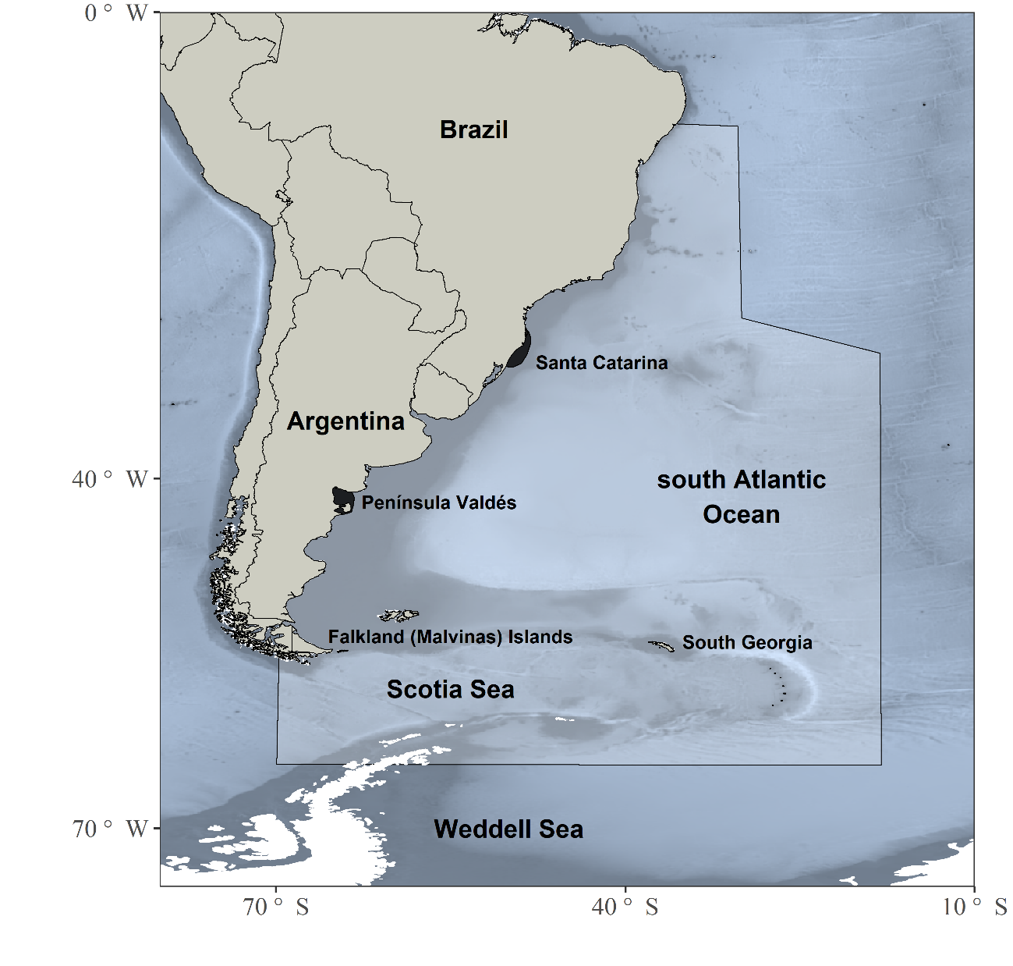

Figure 1. Population range of the southern right whale *Eubalaena australis* over the southwestern Atlantic Ocean, indicating the two breeding grounds (Santa Catarina and Península Valdés; black swathes). Polygon indicates the main area of the whaling operations. Map created with R [82] through the use of marmap [131] and ggplot2 [132] packages.

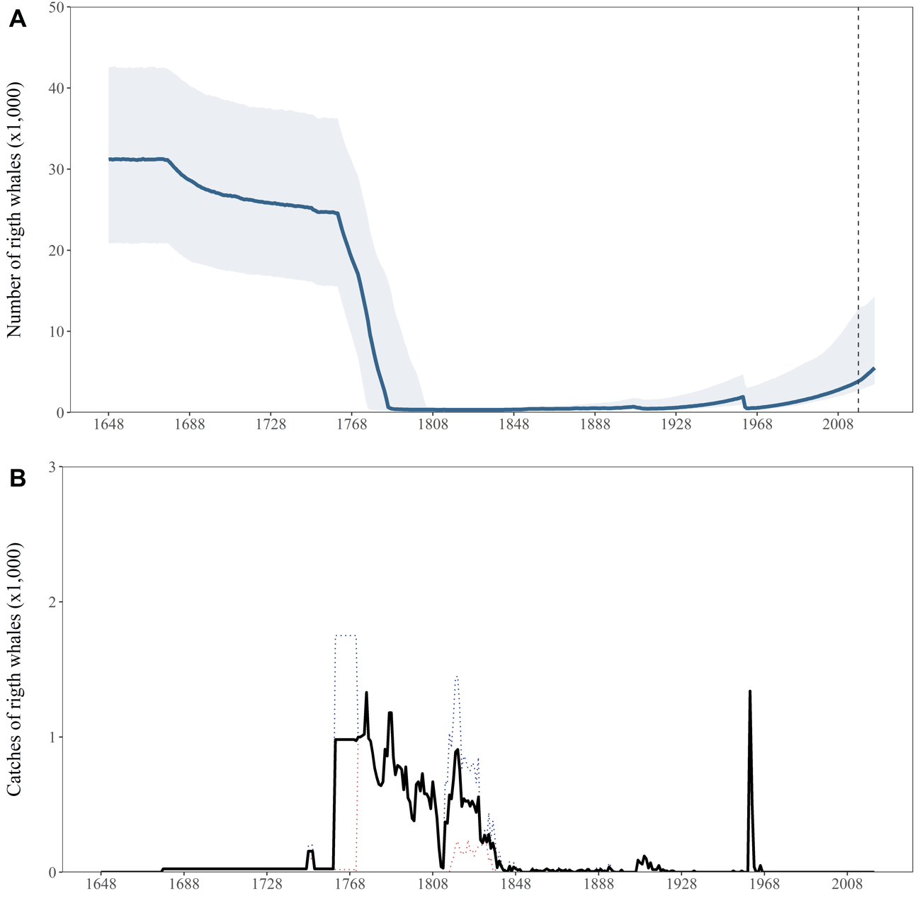

Figure 2. Population trajectories (Panel A) and time series of catches (Panel B) of southern right whale (SRW) *Eubalaena australis*. Panel A: The solid blue line represents the median estimated model-averaged trajectory of the population abundance (), while the shaded areas correspond to the first and third quartiles. The vertical dashed line demarcates where projections start (year 2018). Panel B: The solid line represents the average number of whaling catches as estimated by the catch parameter (), while the red and blue dotted lines represent the low and high SRW catch series, respectively.

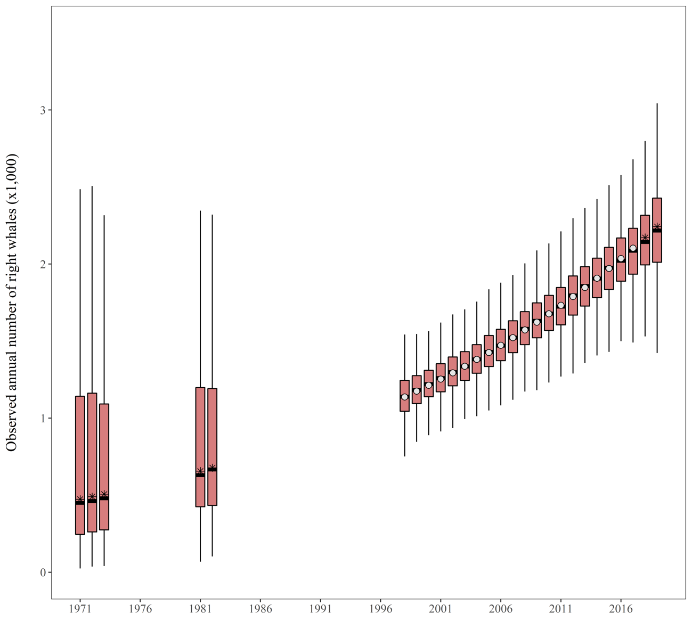

Figure 3. Trend of the observed annual numbers of the southern right whale *Eubalaena australis*. Time series of observed annual number (white dots), together with posterior medians (black horizontal lines), first and third quartiles (boxes), and the 2.5/97.5 percentiles (whiskers) provided by the model averaging are plotted on the ordinate. The asterisks represent the abundance estimates used to validate the model but not considered in the population assessment.

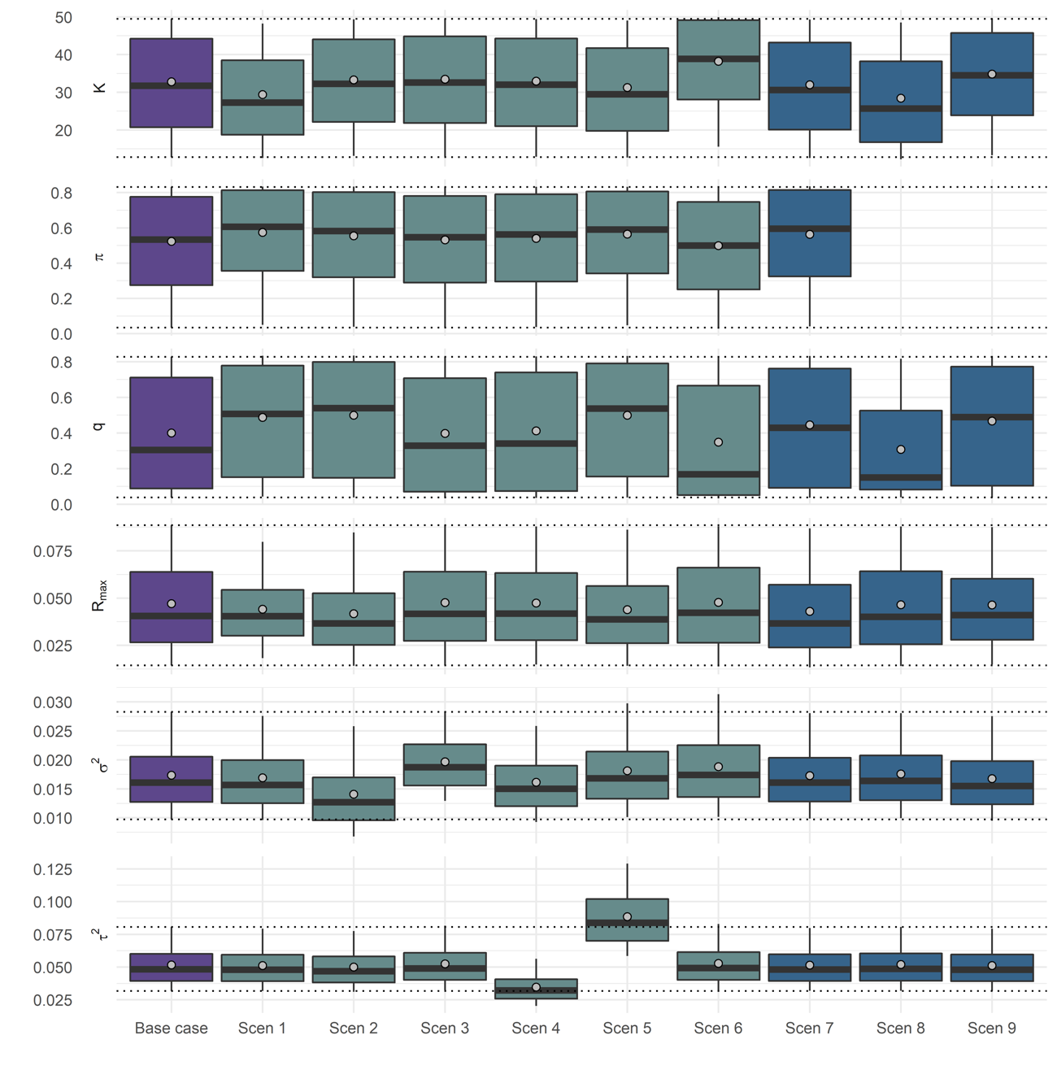

Figure 4. Posterior probability distribution of the key biological parameters for the Base Case and the sensitivity scenarios. The mean (gray dots in the boxes) and median (solid black lines in boxes) estimates, first and third quartiles (boxes), and the 95% CIs (whiskers) are presented. For each of the parameters considered—carrying capacity , catch parameter, detectability coefficient , maximum rate of increase , process variance and observation variance —the two gray horizontal dotted lines outside the boxes indicate the 95% CIs obtained with the Base Case model. Scen 1-6 correspond to `Model assumption` scenarios and Scen 7-9 to actual `Catch` scenarios.

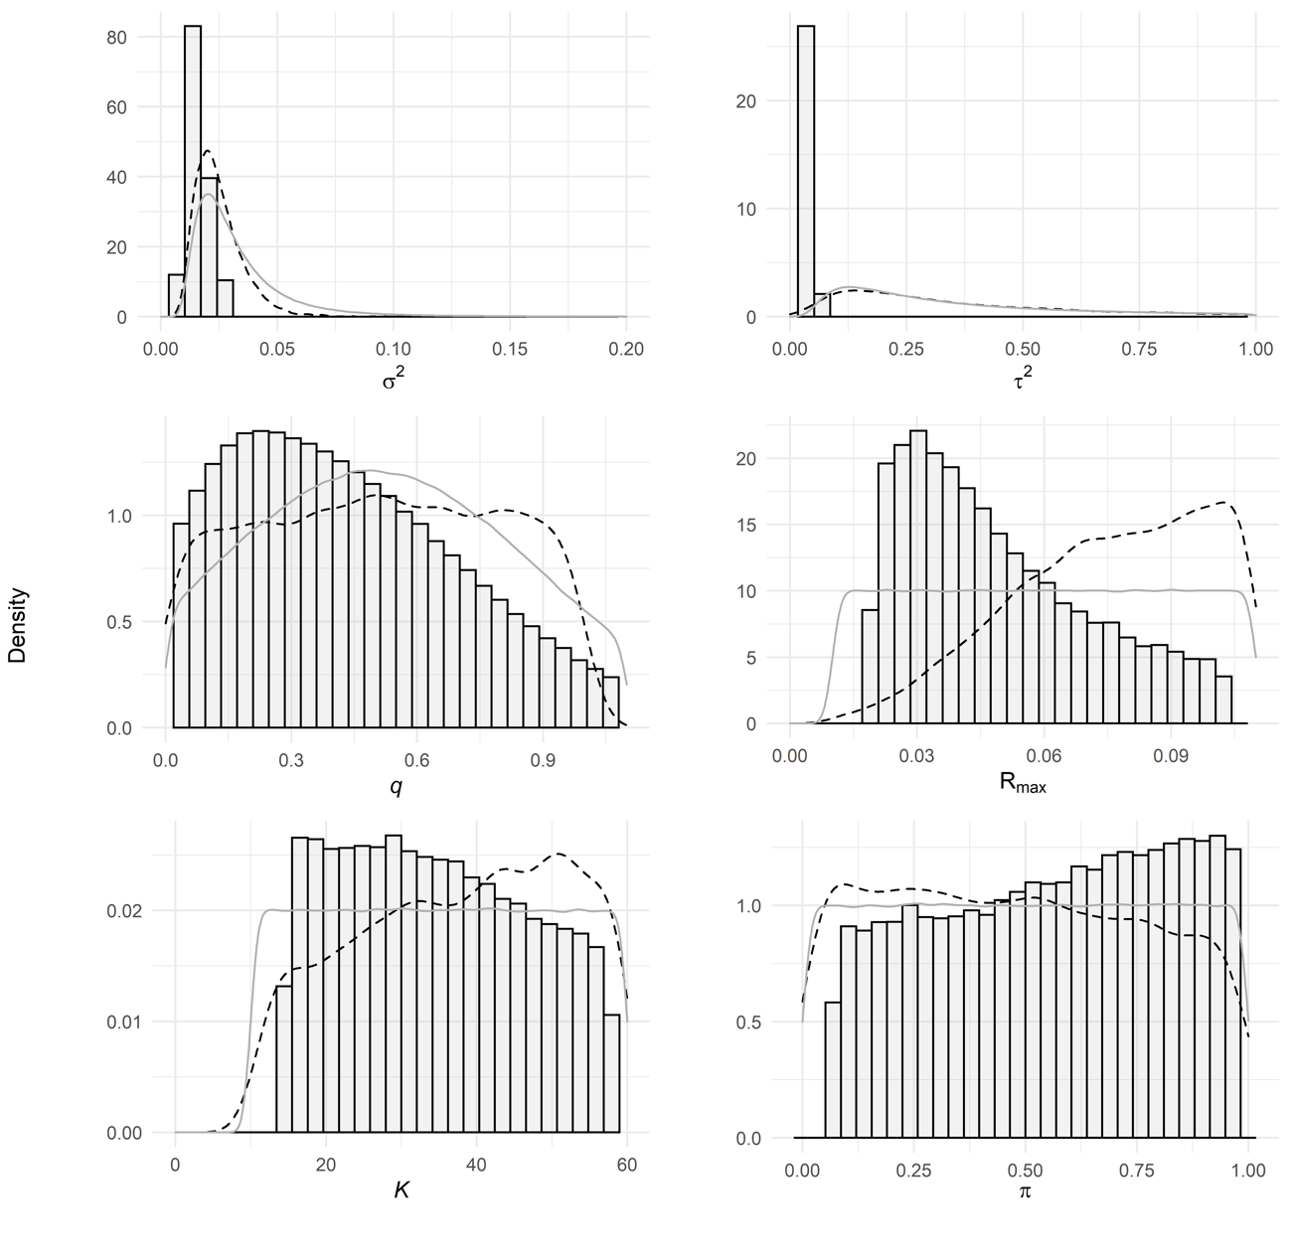

Figure 5. Example results for parameters-distribution update. Prior (solid gray line), post-model-pre-data (dashed line) and posterior probability-density distributions (histogram) of the key biological parameters— process variance , observation variance , detectability coefficient , maximum rate of increase , carrying capacity and catch parameter—from the Scen 4 model are presented in the 6 panels. This model manifested the highest weight on the basis of the *DIC*.