**Historical reconstruction of the population dynamics of southern right whales in the southwestern Atlantic Ocean**

Romero, M.A. 1,2*, M.A. Coscarella 3,4, J.C. Pedraza 5, R.A. González 1,2 and E.A. Crespo 3

**Objectives:**

Implement a state-space population dynamics model for Southern Right Whales using the backwards approach adapted from Zerbini et al 2019. Implementation includes nine sensitivity runs to account for uncertainties in priors and data. This will replace the forwards approach currently used.

**Grant and John’s responsibilities (Grant lead):**

1. Adapt the code base used for Zerbini et al 2019 to incorporate process errors and alternative distributions required by Romero et al but not implemented in Zerbini et al (Inverse-Gamma), Multivariate log-normal, Truncated log-normal).

2. Fit base model and sensitivity models using above code.

3. Generate plots of prior predictive checks, posterior predictive checks, time series of catch/abundance distributions, fits to absolute and relative abundance, distributions of derived or estimated parameters.

4. Update methods text (Done 5/22/21)

**Romero et al responsibilities:**

1. Provide required data (time series of catch, relative abundance, absolute abundance)

2. Provide model specifications including data and priors to be used for each sensitivity run.

3. Update results and discussion text.

**Base case**

**Population model:**

* Prior on Rmax: U[0, 0.11]
  + Done 4/28/21
* Prior on Nrecent: the recent year was taken 2019 and assigned a prior of U[100, 10,000].
  + Done 4/28/21
  + The SIR samples a value for abundance in year 2019 from U[100, 10,000] and back calculates the K that would have been needed to obtain that value of N in 2019 given the data and the samples of the other parameters
* Pmsy ~ U(0.5, 0.8)
  + Done 4/28/21
* Prior on process error is diffuse inverse-gamma.
 $σ^{2}\sim invgamma(4, 0.1)$

 + Done 4/28/21

**Abundance model**

* Absolute abundance data: estimates of absolute abundance (N2009 and N2010) (table 4).
  + N2010: 4245 (SE: 245, 95% CV = 245/4245).
    - Included in likelihood assuming lognormal
    - Done 4/28/21
  + N 2009: 4029 (SE: no available);
    - Not included in likelihood
* Relative abundance data: accumulated numbers of observed right whales 1998-2019.
  + Estimated using MASS package where y~as.factor(Year) + Julian Day + Julian Day^2
  + Estimate time-invariant q analytically
  + Variance covariance matrix is estimated using numerical simulation and input into the model
  + Assume multivariate lognormal distribution

 $It\sim MVLogNorm(q*\hat{N}t-diag(Σ)/2,Σ)$

 $It$  - is relative abundance from year t (accumulated number of observed whales), $\hat{N}t$ is estimated abundance in the surplus production model.
  + Done 5/22/21
* Alternative indices of abundance? – Don’t think I have these data?

**Catch model:**

* High and low catch time series.
  + Prior on $π$: U[0,1].
  + Done 4/28/21
* Prior on ${SRL}_{1}$ and ${SRL}_{2}$: two normally distributed priors were used.
  + period 1: 1648-1770: struck and lost rate factor = 1
  + period 2: 1771-1850: struck and lost rate factor ~ norm(1.60, 0.04^2 )
  + period 3: 1851-1973: struck and lost rate factor ~ norm(1.09, 0.04^2 )
  + period 4: 1974-2030: struck and lost rate factor = 1
  + Done 4/28/21

Base example (need to run out longer):

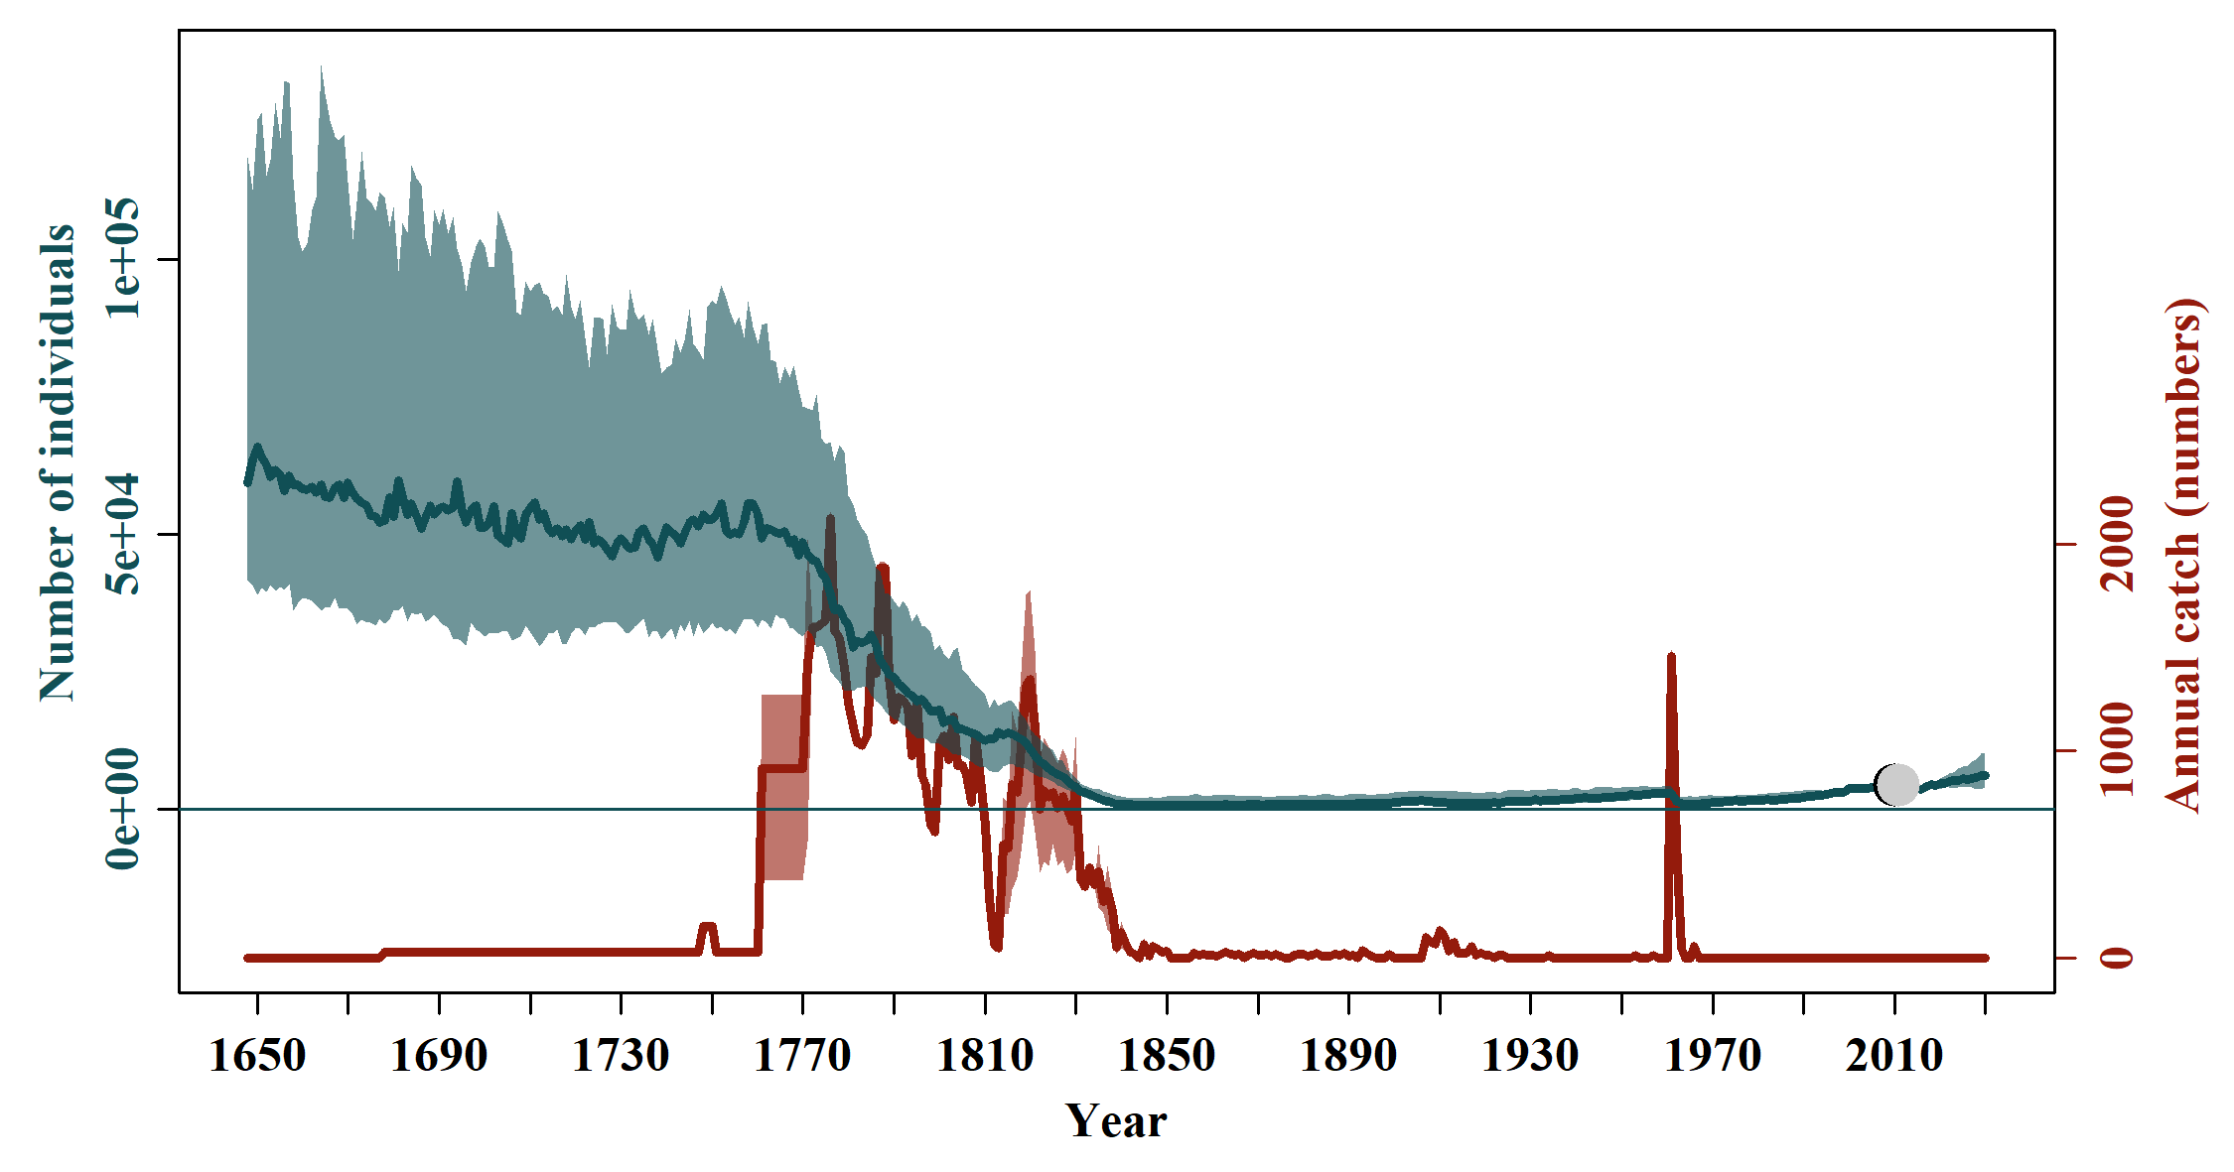

**Table 1. Scenarios for runs of the South Atlantic Right Whale Assessment Model:**

|  |  |  |  |  |  |  |  |
| --- | --- | --- | --- | --- | --- | --- | --- |
| Sens | Rmax | $$σ^{2}$$ | $$Pmsy$$ | SLR | Catch | 1971-1973/1982-1983 | Nrecent |
| Base | $$unif(0.01, 0.11)$$ | $$invgamma(4, 0.1)$$ | *unif(0.6, 0.8)* | Include | $$unif(Low, High)$$ | Exclude | 2019 U[100, 10,000] |
| 1 | $lnorm(μ_{R_{max}}=-2.65, σ_{R_{max}}=0.5)$ T(0,0.11) | $$invgamma(4, 0.1)$$ | *unif(0.6, 0.8)* | Include | $$unif(Low, High)$$ | Exclude | 2019 U[100, 10,000] |
| 2 | $$unif(0.01, 0.11)$$ | $invgamma(2, 0.05$) | *unif(0.6, 0.8)* | Include | $$unif(Low, High)$$ | Exclude | 2019 U[100, 10,000] |
| 3 | $$unif(0.01, 0.11)$$ | $$invgamma(8, 0.2)$$ | *unif(0.6, 0.8)* | Include | $$unif(Low, High)$$ | Exclude | 2019 U[100, 10,000] |
| 4 | $$unif(0.01, 0.11)$$ | $$invgamma(4, 0.1)$$ | *unif(0.6, 0.8)* | Include | $$unif(Low, High)$$ | Exclude | 2004 U[100, 10,000] |
| 5 | $$unif(0.01, 0.11)$$ | $$invgamma(4, 0.1)$$ | *unif(0.6, 0.8)* | Exclude | $$unif(Low, High)$$ | Exclude | 2019 U[100, 10,000] |
| 6 | $$unif(0.01, 0.11)$$ | $$invgamma(4, 0.1)$$ | *unif(0.6, 0.8)* | Include | Low | Exclude | 2019 U[100, 10,000] |
| 7 | $$unif(0.01, 0.11)$$ | $$invgamma(4, 0.1)$$ | *unif(0.6, 0.8)* | Include | High | Exclude | 2019 U[100, 10,000] |
| 8 | $$unif(0.01, 0.11)$$ | $$invgamma(4, 0.1)$$ | *unif(0.6, 0.8)* | Include | $$unif(Low, High)$$ | Include | 2019 U[100, 10,000] |