SRW 2023 Update

Grant Adams

2024-03-13

# 2023 population assessment of southern right whales in the southwestern Atlantic Ocean

Romero, M.A.^^1,2*, M.A. Coscarella 3,4, G.D. Adams 5, J.C. Pedraza 6, R.A. González 1,2 and E.A. Crespo 3

1 Escuela Superior de Ciencias Marinas - Universidad Nacional del Comahue. San Martín 247 (8520) San Antonio Oeste, Río Negro, Argentina.

2 Centro de Investigación Aplicada y Transferencia Tecnológica en Recursos Marinos “Almirante Storni” (CIMAS). Consejo Nacional de Investigaciones Científicas y Técnicas (CONICET). Güemes 1030 (8520) San Antonio Oeste, Rio Negro, Argentina. 3 Laboratorio de Mamíferos Marinos, Centro para el Estudio de Sistemas Marinos (CESIMAR) CENPAT-CONICET, Blvd. Brown 2915 (9120) Puerto Madryn, Chubut, Argentina.

4 Universidad Nacional de la Patagonia San Juan Bosco, Blvd. Brown 3051 (9120) Puerto Madryn, Chubut, Argentina.

5 University of Washington, School of Aquatic and Fishery Science, 1122 NE Boat St (355020) Seattle, WA, United States.

6 Ciclo Básico Común - Área Matemática - Universidad de Buenos Aires. Ciudad Universitaria, Nuñez, Av. Cantilo S/N, Pab 3, Subsuelo (1428) CABA, Argentina.

## Abstract

We updated the Bayesian state-space surplus production models developed for southern right whale (SRW) Eubalena australis by Romero et al (2022) to include recent aerial-surveys conducted in 2021-2023. Demographic parameters were derived from a model averaged ensemble of 11 Bayesian state-space models from Romero et al (2022) updated with recent data. The population trajectory indicated that the pre-exploitation abundance was close to 58,000 individuals (median = 58,212; 95% CI = 33,329–100,920). The abundance dropped to its lowest abundance levels in the 1830s when fewer than 2,000 individuals remained. The current median population abundance was estimated at 4,742 whales (95% CI = 3,853–6,013), suggesting that the SRW population remains small relative to its pre-exploitation abundance (median depletion P_2021 8.7%). We estimated that close to 36% of the SRW population visits the waters of the Península Valdés, the main breeding ground, every year.

11 models including depensation were developed that allowed maximum rate of increase (R_max) to vary based on depletion level. The model-averaged population estimated that the pre-exploitation abundance was close to 57,000 individuals (median = 57,132; 95% CI = 31,003–104,985), lower than estimated in Romero et al (2022). We estimated a higher R_max and lower K than in the Romero et al. (2022) due to the inclusion of depensation. The current population abundance was estimated at 4,479 whales (95% CI = 3,663–5,656), suggesting that the SRW population remains small relative to its pre-exploitation abundance (median depletion P_2021 7.9%).

## Data

Data mirror those used for the population assessment of southern right whales (SRW) from the southwestern Atlantic ocean described in Romero et al. (2022) and include estimates of annual catch, relative abundance, and absolute abundance in 2010. Both annual catch data and estimate of absolute abundance for 2010 (4,245 whales, SE = 245; IWC 2013) were the same as those from Romero et al. (2022). However, relative abundance estimates were updated to include additional years of aerial-surveys conducted in 2021-2023 (Table 1). This was in addition to survey data from 1999, 2000, and 2005-2019 included in Romero et al. (2022). Estimates of relative abundance were calculated using a two-stage approach described in Romero et al. (2022) using the aerial-survey protocol from Crespo et al. (2019). Estimates of relative abundance can be found in Table 2.

## Population dynamics modelling

The population dynamics of the SRW was modelled via Bayesian state-space surplus production models using a sampling-importance-resampling algorithm implemented by McAllister et al. (1999). The surplus-production function was specified as a generalized theta-logistic equation (Pella & Tomlinson 1969). The key estimable population parameters were carrying capacity (), the maximum rate of increase (), and the proportion of at which maximum production is achieved (). Rather than estimating and assigning a prior to carrying capacity () directly, the backwards approach was used, which assigns a prior to a recent abundance and back-calculates the abundance trajectory. Models were run for the period 1648–2023 and projected forward to 2030. Models assumed that the pre-exploitation population was at carrying capacity before the beginning of whaling operations in 1678 (i.e., ).

Eleven models were developed to account for uncertainty regarding model formulation, prior probability specifications, and input data. Five model variations, including the base model, accounted for uncertainty regarding prior distributions for , process error, and . Three models were developed to account for uncertainty in the minimum population size constraints given multiple estimates of the number of mtDNA haplotypes (IWC 2013). One model variation was developed to account for uncertainty regarding whales that were struck and lost. Two models were developed to account for time-varying and/or density-dependent catchability. Specific details can be found in Table 1 and Table S4 of Romero et al. (2022).

Estimates of annual abundance were derived from multi-model inference using Bayesian model averaging to balance model goodness of fit and model uncertainty, rather than relying on one ‘true’ model (Chang et al 2015). The posterior distributions from the 11 models were sampled relative to the model’s posterior probability based on the calculated Bayes factors assuming all models were equally probable a priori (Kass & Raftery 1995). Bayes factors for each of the eleven models can be found in Table 3. Naming conventions follow Romero et al. (2022).

Table 4 lists the posterior medians and posterior 95% intervals for key population parameters from the model-averaged assessment. Included are population size in 2019, 2023, and 2030.

## References

Chang, Y. J., et al. Model selection and multi-model inference for Bayesian surplus production models: a case study for Pacific blue and striped marlin. Fish. Res. 166, 129-139 (2015).

Crespo, E. A., et al. The southwestern Atlantic southern right whale, Eubalaena australis, population is growing but at a decelerated rate. Mar. Mamm. Sci. 35, 93-107 (2019).

International Whaling Commission. Report of the IWC Workshop on the Assessment of Southern Right Whales. J. Cetacean Res. Manage. (Supp) 14, 439-462 (2013).

Kass, R.E. & Raftery, A. E. Bayes factors. J. Am. Stat. Assoc. 90: 773–795 (1995)

McAllister, M. K., Pikitch, E. K., Punt, A. E. & Hilborn, R. Bayesian approach to stock assessment and harvest decisions using the sampling/importance resampling algorithm. Can. J. Fish. Aquat. Sci. 12, 2673-2687 (1999).

Pella, J. J. & Tomlinson, P. K. A generalised stock production model. Inter-American Tropical Tuna Comm. Bull. 13, 421–496 (1969).

Romero, M.A., et al. Historical reconstruction of the population dynamics of southern right whales in the southwestern Atlantic Ocean. Sci. Rep. 12, 3324 (2022).

**Table 1.** Observed total number of whales from the aerial-survey across the monitoring area south of Península Valdés to the limit of the main concentration area, totalling a coastal strip 620 km in length.

Flight

Year

Month

Observed whales

Julian day

1

1

1999

5

5

139

2

2

1999

7

117

183

3

3

1999

8

460

229

4

4

1999

9

549

272

5

5

1999

11

172

314

6

6

1999

12

10

349

7

9

2000

5

43

149

8

10

2000

7

323

194

9

11

2000

9

558

271

10

12

2000

11

296

319

13

19

2005

6

84

159

14

20

2005

7

591

200

15

21

2005

9

733

251

16

22

2005

10

217

298

17

23

2005

12

3

351

18

25

2006

3

1

87

19

26

2006

5

4

130

20

27

2006

7

657

212

21

28

2006

9

786

250

22

29

2006

10

484

296

23

32

2007

5

57

143

24

33

2007

6

393

177

25

34

2007

8

1,006

234

26

36

2007

10

957

275

27

37

2007

11

108

328

28

39

2008

4

16

120

29

40

2008

7

606

183

30

42

2008

9

621

251

31

43

2008

9

502

267

32

44

2008

11

173

315

33

46

2009

5

5

126

34

47

2009

6

335

176

35

48

2009

9

705

253

36

49

2010

4

6

117

37

50

2010

10

662

274

38

51

2011

5

14

133

39

52

2011

8

1,262

228

40

53

2011

10

284

278

41

54

2012

5

58

144

42

55

2012

8

802

215

43

56

2013

5

50

138

44

57

2013

7

1,143

207

45

58

2013

9

909

249

46

59

2013

11

161

317

47

60

2014

4

1

113

48

61

2014

6

253

170

49

62

2014

10

468

281

50

63

2015

4

3

113

51

64

2015

6

112

159

52

65

2015

9

557

257

53

66

2015

10

278

275

54

67

2015

11

102

322

55

68

2016

8

725

222

56

69

2016

9

439

265

57

70

2016

10

112

301

58

71

2017

7

542

188

59

72

2017

9

838

247

60

73

2017

10

246

294

61

74

2018

5

39

143

62

75

2018

8

1,079

213

63

76

2018

8

1,605

243

64

77

2019

7

301

189

65

78

2019

8

1,077

237

66

79

2019

10

362

275

67

80

2021

8

1,006

216

68

81

2021

9

1,139

249

69

82

2021

10

194

302

70

83

2022

7

1,029

194

71

84

2022

9

1,114

252

72

85

2022

11

20

328

73

86

2023

7

1,237

194

74

87

2023

10

592

284

**Table 2.** Estimated abundance (A_y: accumulated number of right whales) and log-scale variance-covariance matrix from the two stage regression model. Regression parameters were estimated as follows intercept a=-13.63 (0.67 SE), julian day c=0.17 (0.0060 SE), and Julian day^2 d=-0.00035 (0.000013 SE). Year specific regression parameters (b_y) are given below.

Sigma

Year

b_y

A_y

1999

2000

2005

2006

2007

2008

2009

2010

2011

2012

2013

2014

2015

2016

2017

2018

2019

2021

2022

2023

1999

0.0000

1,020.9289

0.0287

0.0016

0.0015

0.0010

0.0015

0.0014

0.0012

0.0021

0.0011

0.0012

0.0013

0.0018

0.0017

0.0005

0.0003

0.0003

-0.0001

0.0004

0.0011

0.0004

2000

0.6742

2,011.5366

0.0016

0.0377

0.0015

0.0008

0.0013

0.0012

0.0012

0.0018

0.0009

0.0010

0.0012

0.0014

0.0013

0.0000

0.0004

0.0005

0.0000

0.0001

0.0011

0.0001

2005

0.1695

1,211.4276

0.0015

0.0015

0.0326

0.0007

0.0012

0.0010

0.0009

0.0016

0.0008

0.0010

0.0011

0.0011

0.0013

0.0002

0.0002

0.0001

-0.0002

0.0003

0.0010

0.0002

2006

0.3865

1,510.3474

0.0010

0.0008

0.0007

0.0384

0.0007

0.0008

0.0008

0.0010

0.0007

0.0010

0.0007

0.0012

0.0010

0.0000

0.0002

0.0006

0.0001

-0.0003

0.0004

0.0002

2007

0.8184

2,315.7465

0.0015

0.0013

0.0012

0.0007

0.0303

0.0013

0.0012

0.0018

0.0008

0.0013

0.0011

0.0016

0.0015

0.0001

0.0004

0.0005

0.0000

-0.0001

0.0009

0.0002

2008

0.6795

2,016.9111

0.0014

0.0012

0.0010

0.0008

0.0013

0.0320

0.0009

0.0015

0.0007

0.0010

0.0011

0.0016

0.0015

0.0001

0.0002

0.0004

0.0001

0.0002

0.0009

0.0001

2009

0.3521

1,471.5676

0.0012

0.0012

0.0009

0.0008

0.0012

0.0009

0.0567

0.0018

0.0013

0.0023

0.0013

0.0018

0.0011

-0.0003

0.0001

0.0016

0.0000

-0.0005

0.0000

0.0003

2010

0.4992

1,742.3740

0.0021

0.0018

0.0016

0.0010

0.0018

0.0015

0.0018

0.0996

0.0014

0.0022

0.0017

0.0024

0.0021

0.0006

0.0011

0.0007

-0.0001

0.0002

0.0012

0.0006

2011

0.2925

1,385.2805

0.0011

0.0009

0.0008

0.0007

0.0008

0.0007

0.0013

0.0014

0.0531

0.0017

0.0010

0.0015

0.0009

-0.0002

0.0000

0.0008

-0.0002

-0.0002

0.0007

0.0003

2012

0.6015

1,911.3545

0.0012

0.0010

0.0010

0.0010

0.0013

0.0010

0.0023

0.0022

0.0017

0.0777

0.0013

0.0020

0.0012

-0.0009

0.0001

0.0016

-0.0001

-0.0002

0.0001

0.0004

2013

0.8026

2,289.5147

0.0013

0.0012

0.0011

0.0007

0.0011

0.0011

0.0013

0.0017

0.0010

0.0013

0.0379

0.0013

0.0014

0.0002

0.0002

0.0005

-0.0001

0.0002

0.0011

0.0003

2014

0.4288

1,595.1374

0.0018

0.0014

0.0011

0.0012

0.0016

0.0016

0.0018

0.0024

0.0015

0.0020

0.0013

0.0634

0.0016

0.0001

0.0001

0.0013

0.0000

0.0000

0.0007

0.0004

2015

0.2368

1,296.5989

0.0017

0.0013

0.0013

0.0010

0.0015

0.0015

0.0011

0.0021

0.0009

0.0012

0.0014

0.0016

0.0357

0.0004

0.0002

0.0003

-0.0001

0.0003

0.0012

0.0003

2016

-0.0617

968.4367

0.0005

0.0000

0.0002

0.0000

0.0001

0.0001

-0.0003

0.0006

-0.0002

-0.0009

0.0002

0.0001

0.0004

0.0478

0.0000

-0.0003

0.0000

0.0003

0.0005

0.0003

2017

0.4220

1,569.8633

0.0003

0.0004

0.0002

0.0002

0.0004

0.0002

0.0001

0.0011

0.0000

0.0001

0.0002

0.0001

0.0002

0.0000

0.0471

0.0003

-0.0003

0.0003

0.0004

0.0000

2018

0.7385

2,156.2273

0.0003

0.0005

0.0001

0.0006

0.0005

0.0004

0.0016

0.0007

0.0008

0.0016

0.0005

0.0013

0.0003

-0.0003

0.0003

0.0494

0.0001

-0.0004

0.0000

0.0003

2019

0.2150

1,275.8292

-0.0001

0.0000

-0.0002

0.0001

0.0000

0.0001

0.0000

-0.0001

-0.0002

-0.0001

-0.0001

0.0000

-0.0001

0.0000

-0.0003

0.0001

0.0470

-0.0002

-0.0004

-0.0001

2021

0.5083

1,711.0629

0.0004

0.0001

0.0003

-0.0003

-0.0001

0.0002

-0.0005

0.0002

-0.0002

-0.0002

0.0002

0.0000

0.0003

0.0003

0.0003

-0.0004

-0.0002

0.0472

0.0006

0.0003

2022

0.6499

1,974.4893

0.0011

0.0011

0.0010

0.0004

0.0009

0.0009

0.0000

0.0012

0.0007

0.0001

0.0011

0.0007

0.0012

0.0005

0.0004

0.0000

-0.0004

0.0006

0.0488

0.0001

2023

1.0702

3,040.5825

0.0004

0.0001

0.0002

0.0002

0.0002

0.0001

0.0003

0.0006

0.0003

0.0004

0.0003

0.0004

0.0003

0.0003

0.0000

0.0003

-0.0001

0.0003

0.0001

0.0707

**Table 3.** Bayes factor comparison of scenarios. Blank indicates the model was not included in model averaging.

X

Model

Bayes factor

1

B

0.0984

2

S-1

0.0883

3

S-2

0.0467

4

S-3

0.0748

5

S-4

NA

6

S-5

NA

7

S-6

0.1020

8

S-7

0.0958

9

S-8

NA

10

S-9

NA

11

S-10

0.0984

12

S-11

0.0984

13

S-12

0.0986

14

S-13

0.0977

15

S-14

0.1008

16

MA

NA

**Table 4.** Posterior mean, standard deviations and 50% and 95% Bayesian credible intervals (CI) for the key biological parameters estimated by the model-averaged assessment of the southern right whale Eubalaena australis. P_Min refers to the minimum estimated abundance relative to K.

Parameter

Mean

Median

2.5% CI

25% CI

75% CI

97.5% CI

Unique

1

0.017

0.016

0.002

0.01

0.023

0.035

18,609

2

57,224

54,991

32,359

46,147

66,176

93,381

18,771

3

4.214

3.402

1.072

1.911

6.003

10.56

18,687

4

0.647

0.647

0.507

0.572

0.723

0.793

18,687

5

0.019

0.02

0.009

0.015

0.023

0.025

18,687

6

1,588

1,302

324

759

2,300

3,813

18,771

7

Max depletion

0.027

0.023

0.008

0.015

0.036

0.062

18,771

11

3,589

3,579

2,874

3,313

3,847

4,386

18,771

12

4,818

4,791

3,991

4,494

5,106

5,799

18,771

13

5,006

4,967

4,060

4,626

5,340

6,174

18,771

14

5,206

5,159

4,126

4,754

5,592

6,585

18,771

15

5,882

5,760

4,224

5,121

6,504

8,261

18,771

16

Depletion in 1999

0.067

0.064

0.04

0.055

0.076

0.109

18,771

17

Depletion in 2019

0.091

0.087

0.047

0.071

0.107

0.159

18,771

18

Depletion in 2021

0.095

0.09

0.047

0.073

0.113

0.167

18,771

19

Depletion in 2023

0.099

0.094

0.048

0.075

0.118

0.178

18,771

20

Depletion in 2030

0.113

0.105

0.05

0.081

0.137

0.219

18,771

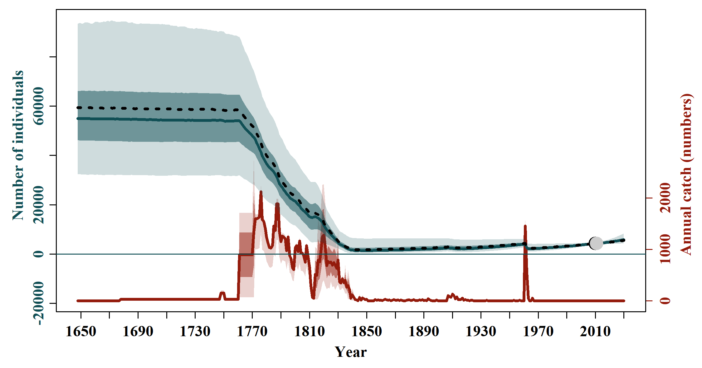

**Figure 1.** Model averaged population trajectories (blue lines) and time series of estimated catches (red lines) of southern right whale (SRW) Eubalaena australis. The solid blue line represents the median estimated model-averaged trajectory of the population abundance (N_y), while the shaded areas correspond to the 50% and 95% credible intervals. The dashed line represents the median estimated base case trajectory of the abundance. The solid red line represents the average number of whaling catches as estimated by the catch parameter (π), while the red shaded areas correspond to the 50% and 95% credible intervals. The grey and black dots represent the estimated and observed, respectively, absolute abundance in 2010 (confidence and credible intervals can be found in Figure 4).

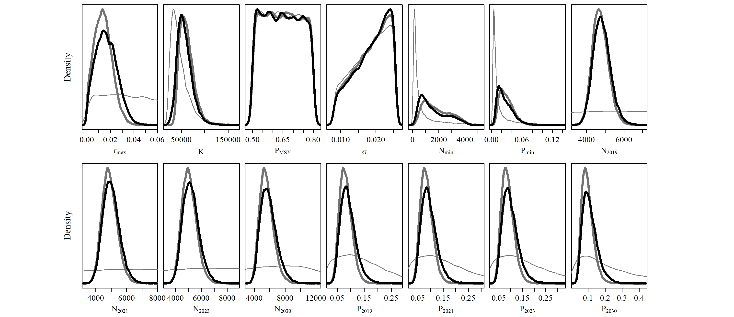

**Figure 2.** Posterior probability distributions of the key biological parameters for the 2023 Base Case (thick grey line) and model-averaged (thick black line) assessment of southern right whale (SRW) Eubalaena australis. Post-model pre-data probability distributions of the key biological parameters for the Base Case are presented in the thin grey line.

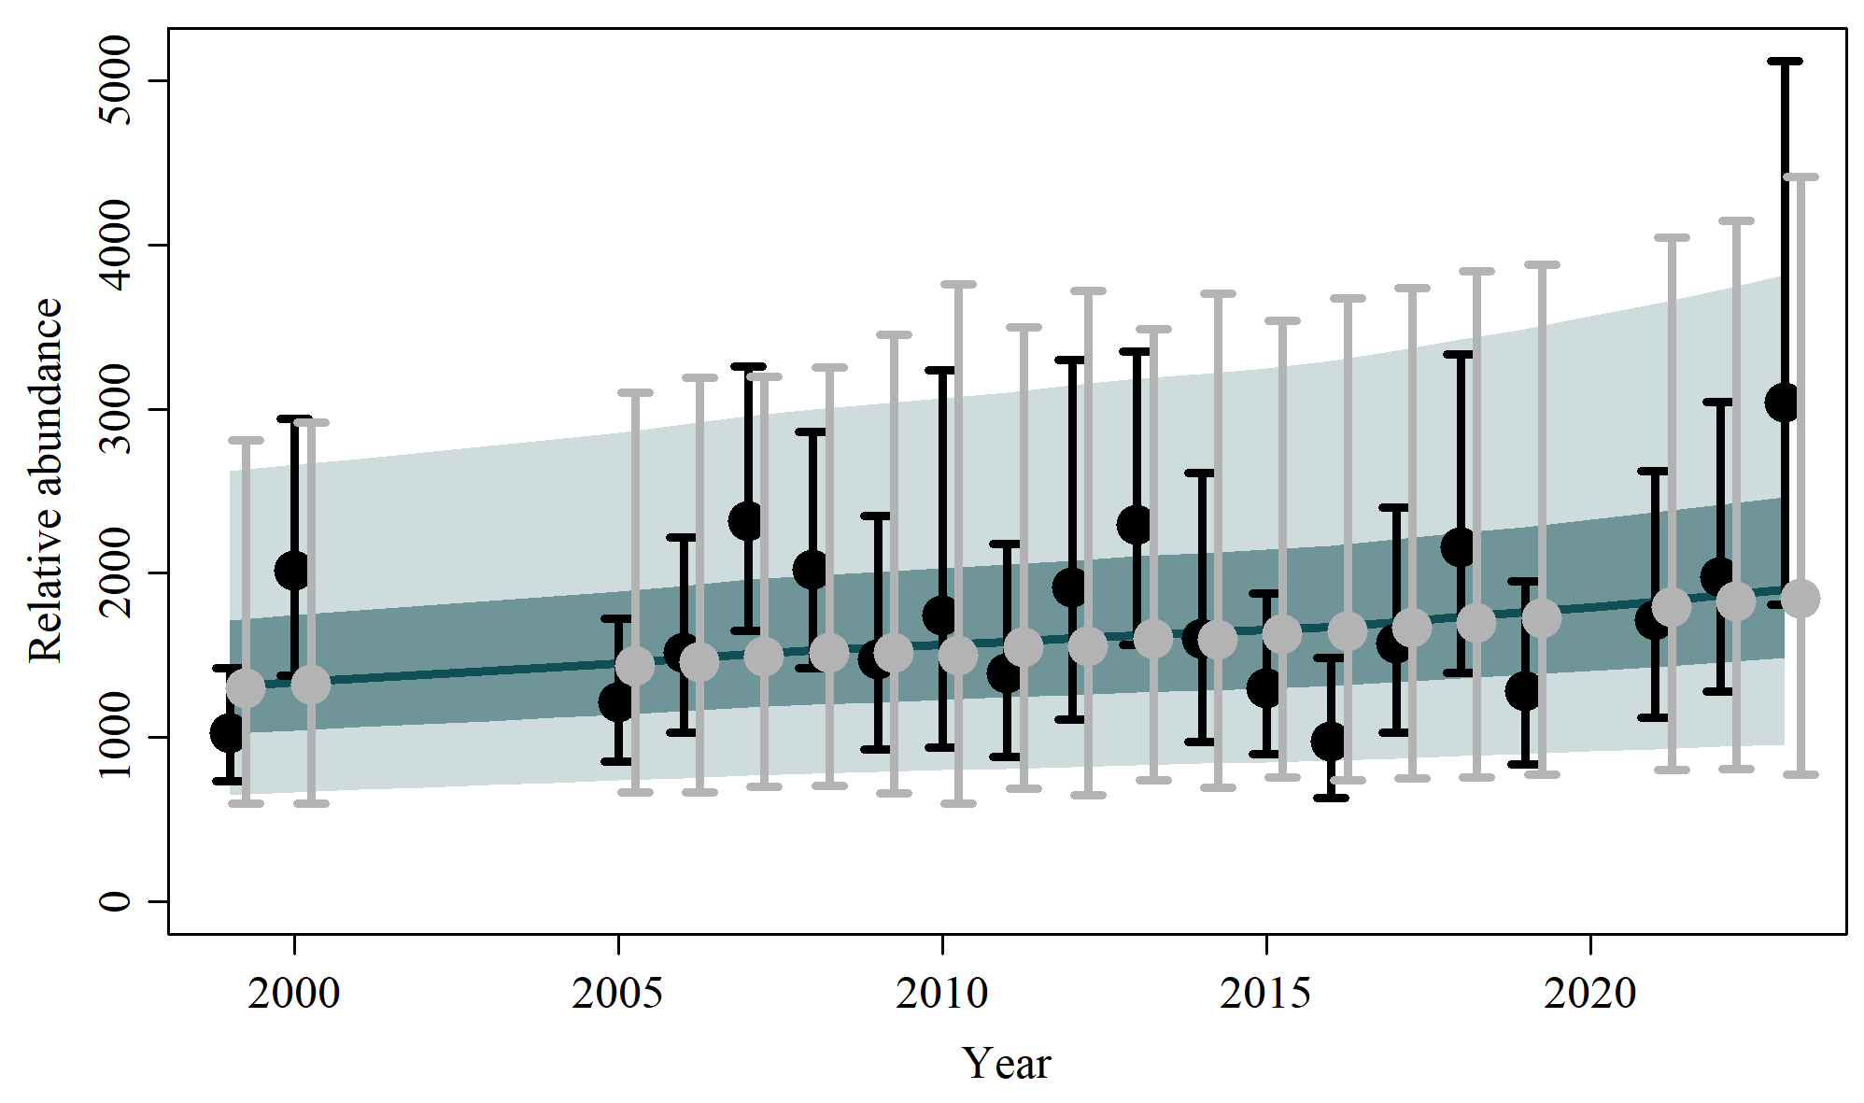

**Figure 3.** Trend of the observed (black dots) and estimated (grey dots) accumulated numbers of the southern right whale Eubalaena australis and associated 95% confidence interval (black bars) and 95% posterior predictive intervals (grey bars). The solid blue line represents the median estimated model-averaged trajectory of the population abundance (N_y) multiplied by posterior catchability (q), while the shaded areas correspond to the 50% and 95% credible intervals.

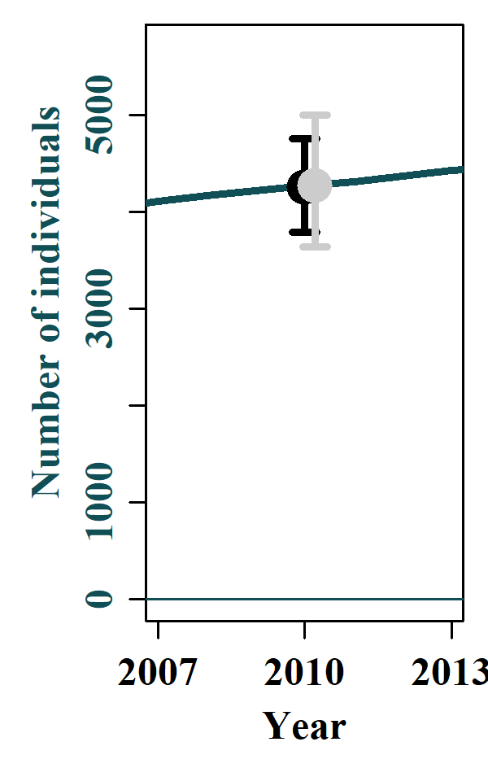

**Figure 4.** Fits of the observed (black dots) and estimated (grey dots) absolute abundance of southern right whale Eubalaena australis and associated 95% confidence interval (black bars) and 95% posterior predictive intervals (grey bars). The blue line is the median abundance trajectory and the shaded areas correspond to the 50% and 95% credible intervals.