**Exercici 1**

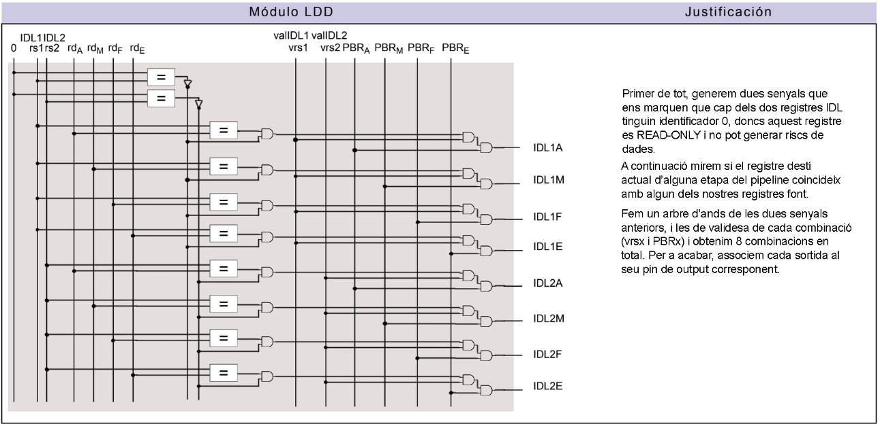

**Exercici 2**

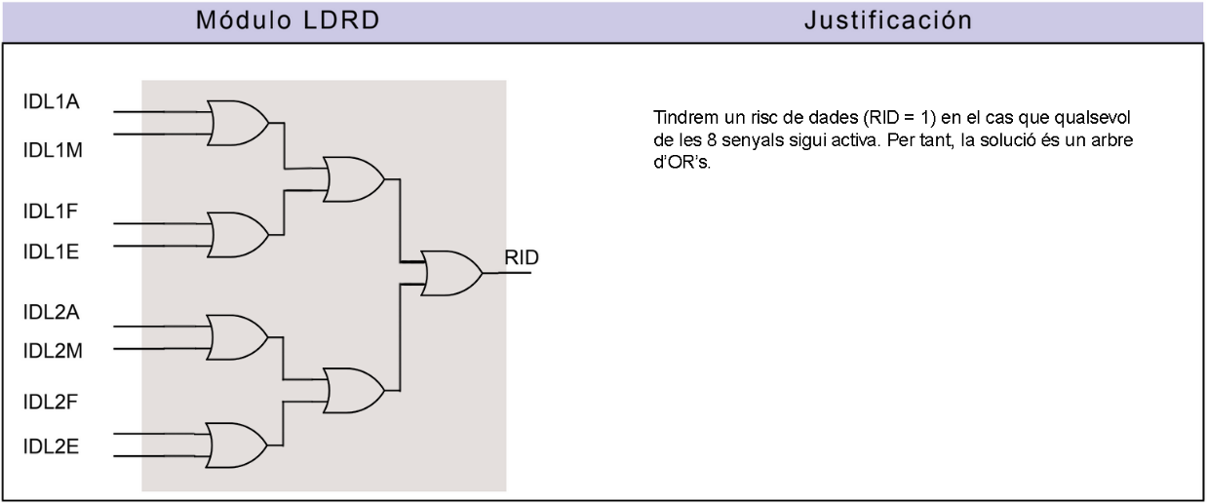

**Exercici 3**

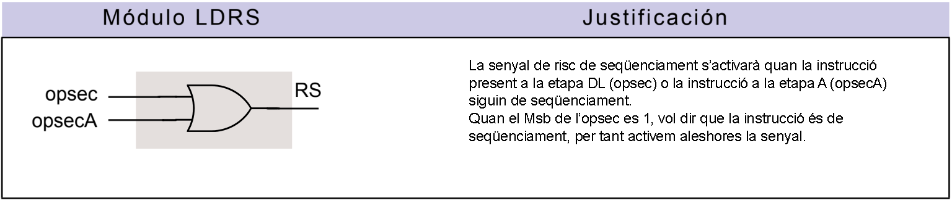

**Exercici 4**

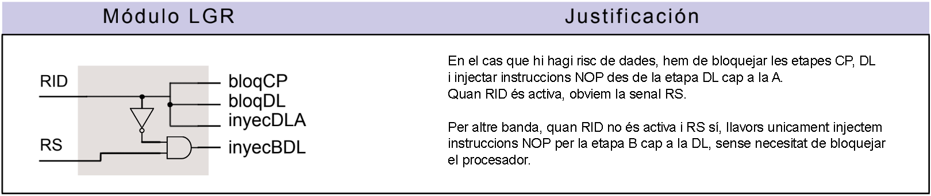

**Exercici 5**

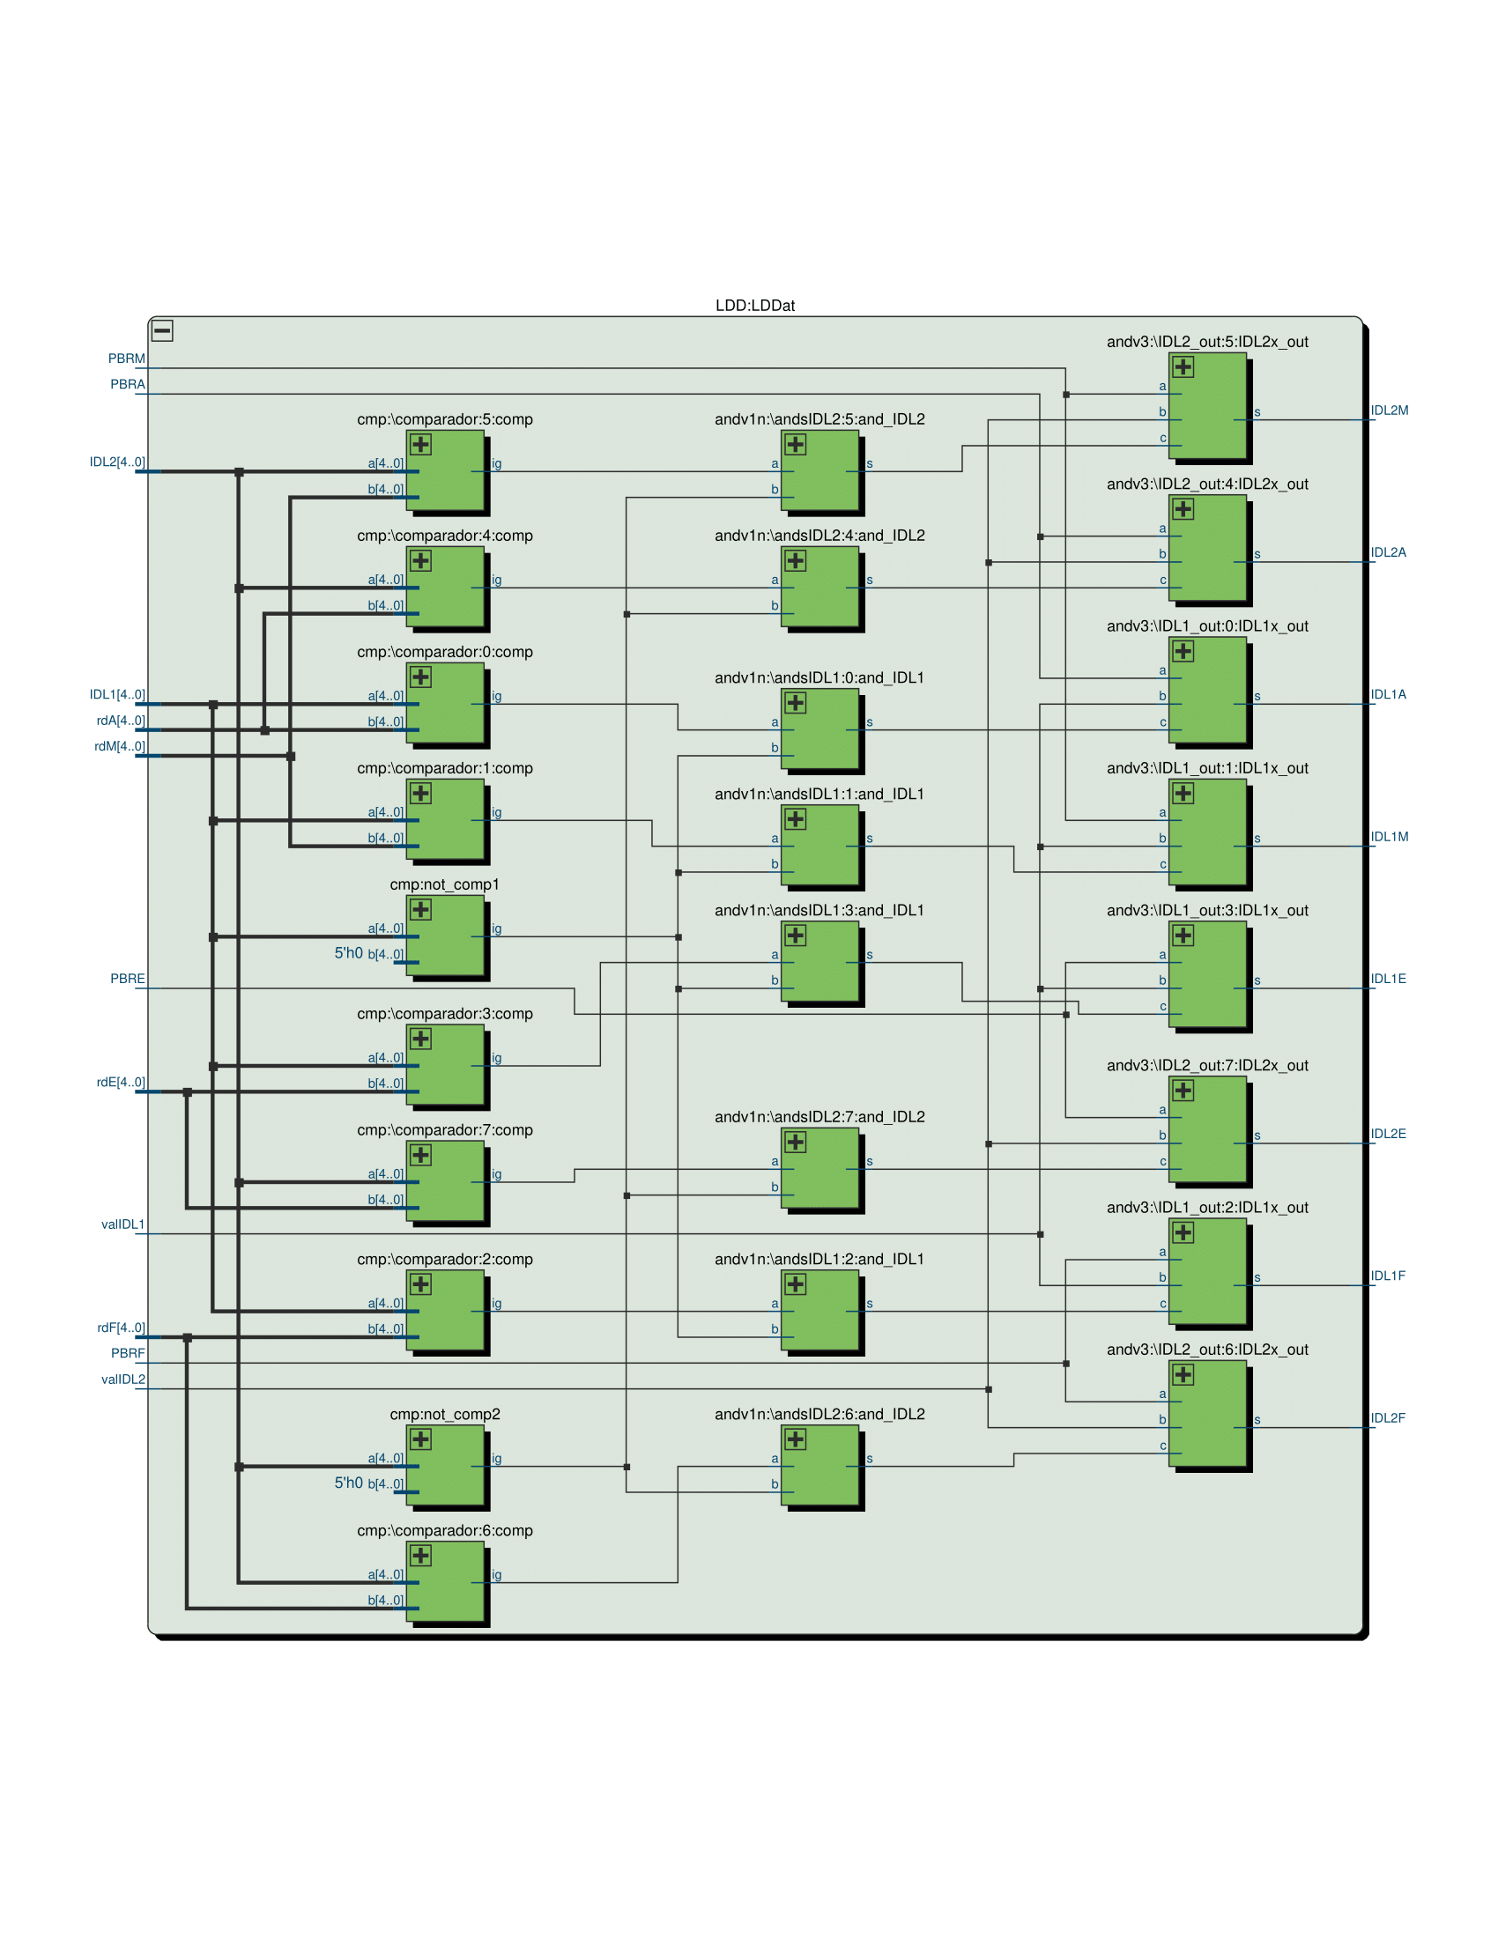

**Exercici 6**

**Exercici 8**

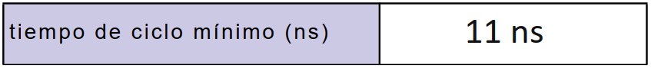

**(Exercici 7 a l’altre cara)**

**Exercici 7**

