DAY7 SESSION ASSIGNMENTS (Theory)

1. Consider the user story: “As a customer I want to use ATM”. What would be my acceptance criteria (“so that......)”? List all possible acceptance criteria.

Answers:

- So that i can view my account balance.
- So that i can withdraw money from my account.
- So that i can generate mini statements from atm machine.
- So that i can Make sure my money is easily accesible withou the chaos of cheques and DD.
- So that i can take the balance reciept of my account easily from the macine.

2. What are the advanced Scrum Master skills?

Answers:

- Individual learning – SM need to learn the new technologies and tools for the growth of our Dev team. So that he can mentor him with the present technologies.
- Open communication – SM need to have an open communication with all the team members and PO so that there is no chance for any kind of storming and norming inside the team.
- Alignment – SM will ensure that the team is colocated such that there will be no delay in information passing between the teams. This alignment is really important because when distance increases the delay in communication among the team mates will also increase.
- Creativity and innovation – SM should be always more and more creative so that he can make the Burn down chart, Project status board more simple and easy to understand.
- Ownership – Adapt to change, Plan for the next sprint when one ends and start accordingly to it.
- Organaization and leadership – Team release planning, Team bonding activities,Performance monitoring.
- Competences – Make the team defect free, A mediator for issues within the team,
- Achievements – Celebrate succes of the project. Appreciate the team for their good work.

3. How do you think you can use Agile practices in large projects? (Given that the team can have no more than 9 people, do you think large projects with large teams can be involved in agile practices?)

Answers:

- We can use agile methodology for for large projects. For this we introduced scaling of scrum.
- We split our large team into small dev-teams of 9 members.
- We will have a structure like ,
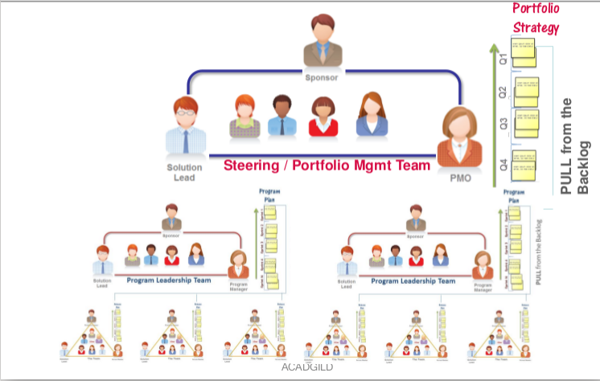

- Small teams of 9 members and then we select SM,PO,Architect from each team and that will group together into a large management team which is Scrum of scrum.
- We can control the team by video conference , and we can give each team a certain colour for ease of understanding.
- The representatives from each team will attend the daily scrum meeting and conclude their views on each issue in the general meeting of the chiefs.
- There will be a general plan for the whole team and the each sub team will have it’s own prioritized task chart.

4. What are the Possible options for tracking project performance in Agile?

Answers:

- Project performance in agile can be tracked using Burned down charts and product backlog progress
- Burned down charts and burned up chart shows us how the team is performing with the tasks and how much working days we have burnt for the planned sprint and now how many days we do hve left.
- Product backlog need to get higher and higher in each sprint release that’s how we achieve all the milestones we planned.
- Matrics gives us a stright numbers about the cost and days in CPI and SPI
- Velocity is the rate at ewhich our product is completing.

All the above mentioned points can be used as atool fpr the performance computing.

5. In Agile, the team always picks up business value user stories in every sprint. Do we still need to know earned value?

Answers:

- Although we will be deciding the project success based on the business value. But, we do need earned value which will let you know about the cost and schedule against the planned performance within the project.
- In every project we need to know how we deviated from the planned one’s so that we can make a note on that and try to improve with the upcoming sprints planned.
- With the EV we could know if our cost do get spent rightly.

