Proof-of-Concept (PoC) Document
Title: Metabolite-Driven Microbiome Modulation in the Tomato Rhizosphere: A Prebiotic Approach to Manage Bacterial Wilt Caused by Ralstonia solanacearum
Document Identifier: [POC-001]
Author: Swaminathan N
Affiliation: ICAR-NIBSM
Contact Email: swamisuba3098@gmail.com
Date of Conception (Documented): 27.10.2023
Date of Declaration: 20.11.2025
Repository DOI / Link: https://github.com/SWAMI3098/Tomato-Prebiotic-PoC.git
1. Abstract
Bacterial wilt, caused by Ralstonia solanacearum, remains one of the most devastating soil-borne phytopathogens limiting tomato productivity worldwide, particularly under soil conditions that favour pathogen persistence. Conventional control strategies—chemical pesticides, resistant cultivars, antibiotics, and probiotic biocontrol—often fail due to persistent rhizosphere dysbiosis that undermines natural soil suppressiveness.
This Proof-of-Concept proposes a novel ecological approach: Metabolite-Driven Microbiome Modulation, where specific tomato plant-derived metabolites act as rhizosphere prebiotics to selectively enrich beneficial, disease-suppressive microbial guilds. Drawing an analogy from prebiotic modulation of the human gut microbiome, this framework redefines pathogen control from direct eradication to ecological restoration of microbiome balance from dysbiosis to homeostasis.
We hypothesize that certain root exudate metabolites, which accumulate in bacterial wilt–conducive soils by a healthy tomato plant, can serve as selective carbon sources to reprogram the native microbiome toward suppressive configurations. Comparative metabolomic analyses of root exudates from healthy and wilted tomato plants reveal distinct signature metabolites that are rapidly assimilated by beneficial microbiota in healthy soils but remain unmetabolized in diseased ones. These compounds potentially drive ecological cascades involving nutrient competition, antibiosis, hyperparasitism by phages and protists, and induced systemic resistance.
This PoC systematically validates a novel framework for identifying, validating, and functionally characterizing these key metabolites using a custom-designed rhizosphere model system (a modified Leonard jar) integrated with multi-omics analyses. A critical component is the isolation and structural elucidation of key prebiotic metabolites through solid-phase extraction and NMR spectroscopy, providing a direct path to patentable compositions. The validated outcome of this PoC is a scalable, prebiotic-based bio-stimulation strategy to manage bacterial wilt, offering a sustainable, chemical-free, and microbiome-resilient solution to safeguard global tomato production.
Keywords: Bacterial wilt; Ralstonia solanacearum; Rhizosphere dysbiosis; Disease-suppressive microbiome; Root exudates; Targeted and Untargeted metabolomic analysis; Prebiotic metabolites
2. Purpose and Use of This Proof-of-Concept (PoC) Document
2.1. Definition and Objective
A Proof-of-Concept (PoC) is a targeted, preliminary investigation designed to demonstrate the fundamental feasibility and practical potential of a novel idea before committing to full-scale development. This document serves as a structured blueprint to test the core hypothesis that specific plant-derived metabolites can function as rhizosphere prebiotics to suppress bacterial wilt by reprogramming the native soil microbiome. Its primary objective is to bridge the gap between the theoretical framework and a tangible, validated demonstration. We are developing a new class of sustainable crop protection products based on a revolutionary concept. Instead of spraying chemicals or adding microbes, we apply specific plant-derived metabolite signals that instruct the native soil microbiome to defend itself against bacterial wilt. Our 24-month Proof-of-Concept will identify and patent these key metabolite signals, de-risking the core science and paving the way for a shelf-stable, easy-to-use product that can save the global tomato industry billions of dollars annually while aligning with the world's demand for chemical-free agriculture.
2.2. Primary Functions and Applications
This PoC is strategically designed to fulfil multiple critical functions for different stakeholders:
- Our approach includes a defined pipeline for isolating and characterizing the active prebiotic metabolites, ensuring a clear path to intellectual property protection.
- For Grant Agencies & Scientific Reviewers: It provides the scientific rationale and a rigorous, actionable plan, demonstrating that the proposed research is grounded, innovative, and has a high probability of success.
- For Potential Investors & Industry Partners: It acts as a de-risking tool, outlining a clear pathway from a disruptive idea to a viable product, complete with validation milestones and a competitive analysis.
- For the Research Team: It serves as a comprehensive methodological blueprint, ensuring a unified approach and establishing standardized protocols for all experimental phases.
- For the Scientific Community: When shared via open-science platforms (e.g., OSF, GitHub), it establishes intellectual precedence, fosters reproducibility, and invites collaboration.
2.3. Validation Pathway: From Concept to Demonstration
This document outlines a systematic validation pathway to:
- Confirm Core Feasibility: Test whether applied metabolites truly enrich disease-suppressive microbial guilds in vitro and within a custom rhizosphere model system.
- Elucidate Mechanisms: Provide direct evidence for the proposed multi-layered suppression mechanisms, including competition, antibiosis, hyperparasitism, and Induced Systemic Resistance (ISR).
- Assess Practical Potential: Demonstrate the feasibility of formulating these metabolites into stable, scalable, and cost-effective agricultural inputs like seed coatings and granular amendments.
2.4. Intended Use Cases
This PoC is intended to be:
- The centrepiece of funding requests, attached to grant proposals as the definitive feasibility study.
- Supplementary material for publications, providing the foundational context and detailed methodology for related research or review articles.
- A citable, open-science record deposited on platforms like OSF and GitHub to timestamp the conceptual innovation and experimental design.
- The foundational document for commercial translation, forming the core of future technology transfer dossiers or start-up pitch decks.
By fulfilling these purposes, this PoC provides the critical, evidence-based link between a transformative scientific concept and its development into a sustainable, impactful solution for global agriculture.
3. Introduction & Rationale
3.1 The Challenge
Bacterial wilt caused by Ralstonia solanacearum remains one of the most destructive vascular diseases of tomato (Solanum lycopersicum), inflicting global yield losses of 30–50% and annual economic damage exceeding USD 2 billion (Balamurugan et al., 2020; Ma et al., 2023). The pathogen’s remarkable ecological adaptability, long-term soil persistence, and rapid systemic colonization render conventional management approaches largely ineffective (Ababa, 2024; Singh et al., 2025; Wang et al., 2023). R. solanacearum is widely recognized as a pathological “villain” of exceptional virulence and ecological adaptability when compared with other tomato phytopathogens, including Fusarium oxysporum f. sp. lycopersici, Verticillium dahliae, Pythium spp., and Xanthomonas spp (See Figure 1) (Álvarez, B., Biosca, E. G., & López, M. M., n.d.).
Existing control methods—including chemical bactericides (e.g., copper hydroxide, copper oxychloride), resistant cultivars (‘Hawaii 7996’), and microbial inoculants (Bacillus subtilis, Pseudomonas fluorescens)—offer limited and inconsistent field protection (Zerbini et al., 2014; Ptaszek et al., 2023). Chemical and antibiotic use accelerates antimicrobial resistance (AMR) gene proliferation (e.g., strA-strB, tetA, tetB) and degrades soil microbial integrity (Li et al., 2024). Furthermore, critical antibiotics once trialed in agriculture—streptomycin and oxytetracycline—are now banned in many countries due to their importance in human medicine and demonstrated risk of horizontal AMR gene transfer (Li et al., 2024).
These limitations highlight the urgent need for an ecological paradigm shift—from direct pathogen suppression to restoration of rhizosphere equilibrium.
3.2 Pathobiological Rationale for Ecological Management
The pathobiology of R. solanacearum is not defined solely by invasion, but by its capacity to induce rhizosphere dysbiosis—a breakdown of the functional microbial equilibrium essential for plant health (Kashyap et al., 2023). The pathogen reprograms tomato root exudates, suppressing defense-related metabolites (phenolics, flavonoids, organic acids) while enhancing the secretion of sugars, amino acids, and volatiles that promote pathogen proliferation (Venturi & Keel, 2016).
Such biochemical manipulation weakens beneficial microbial guilds, diminishes nutrient competition, and fosters a disease-conducive soil niche. Comparable metabolite-driven dysbioses are evident in Fusarium, Rhizoctonia, and Pythium interactions, underscoring a conserved ecological mechanism of pathogen-mediated community destabilization (Deng et al., 2024).
3.3 Conceptual Innovation: Metabolite-Mediated Microbiome Engineering
Inspired by advances in gut microbiome science, this Proof-of-Concept (PoC) project introduces a rhizosphere prebiotic strategy for bacterial wilt control (Wen et al., 2020). Analogous to dietary prebiotics that enrich beneficial gut microbes, plant-derived metabolites can be harnessed to reprogram the native soil microbiome.
This represents a transition from the traditional “probiotic inoculant” model—introducing foreign microbes that often fail to establish—to a “Metabolite-Mediated Microbiome Engineering” framework. In this model, defined metabolite mixtures act as biochemical cues that stimulate indigenous, well-adapted microbial consortia to reassemble into a resilient, disease-suppressive network (Kaur et al., 2025; Sasse et al., 2018).
While the high-level analogy of “info-in-a-bag” may be retained for conceptual clarity, all technical descriptions refer to Signal-Based Microbiome Reprogramming to maintain scientific precision.
3.4 Ecological Mechanisms Underpinning the Strategy
This approach operationalizes two complementary plant-microbiome recruitment paradigms— “cry for help” and “feed your enemies.” Under pathogen attack, plants exude defense-related metabolites that attract protective microbes (“cry for help”) (Kashyap et al., 2023). Conversely, in disease-prone soils, pathogens manipulate exudates to favor their own proliferation (“feed your enemies”) (Liu et al., 2021).
Our prebiotic intervention strategically amplifies the “cry for help” mechanism by applying key recruitment signals proactively—before pathogen establishment—thereby pre-empting dysbiosis and suppressing R. solanacearum colonization.
3.5 Research Objectives and Validation Framework
This 24-month PoC project will systematically execute the following integrated objectives:
- Pathogen Characterization
- Isolate and characterize highly virulent Ralstonia solanacearum strains from infected tomato plants to establish pathogen baseline and virulence metrics.
- Metabolite Discovery
- Conduct comparative targeted and untargeted metabolomic analysis of root exudates from healthy versus wilted tomato plants using a custom rhizosphere model system.
- Suppressive Microbiome Isolation
- Isolate and culture the disease-suppressive microbiome from healthy tomato rhizosphere soil in Ralstonia-conducive conditions.
- Prebiotic Metabolite Identification
- Identify key tomato root metabolites that selectively enrich beneficial microbial guilds through integrated metabolome-microbiome correlation analysis.
- Structural Elucidation and IP Protection
- Isolate and structurally characterize key prebiotic metabolites through solid-phase extraction and NMR spectroscopy, establishing a direct path to patentable compositions.
- Efficacy Validation
- Validate disease-suppressive efficacy of identified metabolites using the custom rhizosphere model system with temporal monitoring of pathogen suppression and microbiome restructuring.
- Mechanistic Elucidation
- Elucidate suppression mechanisms through integrated multi-omics (metagenomics, metatranscriptomics, metabolomics) and network analyses to define functional pathways.
- Application Timing Optimization
- Determine optimal application timing through comparative evaluation of:
  - Prebiotic pre-application for preventive control
  - Post-infection application of prebiotics combined with suppressive SynCom for curative measures
- Formulation Development
- Develop and optimize scalable delivery systems (seed coatings, granular amendments) for translational application and field readiness.
3.6 Broader Significance and Impact
By leveraging native, ecologically adapted microbes, this strategy circumvents the establishment failure of introduced strains and aligns with global sustainability imperatives. It offers:
- Enhanced Efficacy: Multi-mechanism suppression reduces resistance risk.
- Regulatory Simplicity: GRAS-status plant metabolites streamline approval.
- Economic Viability: Shelf-stable, low-input formulations minimize costs.
- Sustainability Alignment: Chemical-free approach improves soil health and biodiversity.
Ultimately, this work pioneers a new class of biochemical-ecological inputs that restore rhizosphere homeostasis, reinforce plant resilience, and redefine the foundation of sustainable crop protection.
4. Core Hypothesis and Conceptual Framework
4.1 Core Hypothesis
We hypothesize that tomato-derived metabolites act as ecological prebiotics that reprogram native soil microbiomes into disease-suppressive networks. By selectively enriching beneficial microbial guilds and modulating Ralstonia solanacearum signalling, these metabolites restore rhizosphere homeostasis and confer sustainable resistance to bacterial wilt.
4.2 Conceptual Foundation: From Probiotics to Prebiotics
Conventional microbial inoculants (“probiotics”) often fail to establish in complex field environments due to ecological incompatibility and competition with native taxa. In contrast, our approach—Metabolite-Mediated Microbiome Engineering—harnesses the plant’s own biochemical language to activate and organize indigenous microbial communities.
This signal-based reprogramming framework shifts the control point from microbial introduction to metabolite-guided selection and activation, allowing the rhizosphere to self-assemble into a resilient, pathogen-suppressive ecosystem.
4.3 The “Gut Health” Analogy — Guided but Grounded
Inspired by human gut microbiome science, this framework parallels how dietary prebiotics enrich beneficial gut bacteria to maintain host health. Similarly, specific tomato root metabolites function as rhizosphere prebiotics, enriching keystone microbial taxa that suppress R. solanacearum through multiple ecological mechanisms.
While the analogy aids conceptual clarity, it is grounded in ecosystem-specific signaling: plant metabolites (phenolics, flavonoids, organic acids, and signaling compounds) act as biochemical “instructions” that guide microbial community reassembly rather than as generic nutrient sources.
4.4 Mechanistic Model
The Metabolite-Driven Microbiome Modulation framework operates across three integrated tiers of interaction:
- Metabolite Signalling: Tomato-derived compounds function as selective chemoattractants and transcriptional modulators, stimulating beneficial microbial guilds.
- Microbial Network Reorganization: Enriched beneficial taxa form cooperative and antagonistic subnetworks that competitively exclude R. solanacearum through antibiosis, quorum-quenching, and niche occupation.
- Plant Defense Integration: Microbial feedback induces systemic resistance (ISR) and metabolic priming in the plant, reinforcing rhizosphere stability and pathogen resistance.
Together, these interactions establish a self-sustaining ecological feedback loop—metabolite signalling initiates microbial assembly, which in turn enhances plant defense and suppresses pathogen resurgence. The healthy tomato metabolome actively drives the natural selection of a synergistic microbial community that suppresses R. solanacearum (See Figure 2).
4.5 Testable Predictions
- Application of defined metabolite blends will reproducibly shift the rhizosphere microbiome toward disease-suppressive compositions.
- Reprogrammed microbial networks will exhibit reduced R. solanacearum colonization and wilt incidence.
- Integrated multi-omics analyses will reveal coherent metabolite-microbe-pathogen signalling pathways underlying suppression.
4.6 Significance
This hypothesis reframes plant disease management as a microbiome engineering challenge, positioning metabolites as the operational signals of ecological control. By activating native, co-evolved microbial networks rather than introducing foreign inoculants, this approach delivers:
- Sustainability: Chemical-free, AMR-conscious management aligned with global ESG goals.
- Resilience: Multi-layered suppression mechanisms minimizing resistance evolution.
- Scalability: Simple, stable metabolite formulations adaptable to field conditions.
Collectively, this framework defines a new biological class of agricultural inputs—metabolite-based rhizosphere reprogrammers—pioneering the next generation of sustainable crop protection technologies.
5. Proposed Mechanism of Action: Metabolite-Driven Microbiome Modulation
5.1 Multi-Tiered Suppression Mechanisms
5.1.1 Primary Mechanisms
- Competitive Exclusion: Beneficial microbes outcompete R. solanacearum for exudates and spatial niches; biofilm exclusion limits vascular entry.
- Antibiosis: Production of lipopeptides (surfactin, iturin, fengycin), phenazines, and hydrolytic enzymes that directly inhibit pathogen growth.
- Quorum-Quenching: Enzymatic degradation of R. solanacearum quorum-sensing molecules, disrupting virulence signalling.
5.1.2 Secondary Mechanisms
- Induced Systemic Resistance (ISR): Rhizosphere metabolites and beneficial microbes prime jasmonate/ethylene defense pathways, reducing disease incidence.
- Hyperparasitism & Predation: Trichoderma spp., bacteriophages, and predatory protists attack or consume R. solanacearum cells, lowering inoculum levels.
- Allelopathic VOC Suppression: Beneficial consortia release volatiles that interfere with pathogen signaling and metabolism.
5.1.3 Tertiary Stabilizing Mechanisms
- AMF-Bacterial Synergism: Mycorrhizal hyphae act as conduits for beneficial bacteria, enhancing nutrient interception and pathogen exclusion.
- Ecological Resilience: Functional redundancy and feedback signaling maintain a suppressive state across growth cycles.
5.2 Integrated Multi-Omics & Network-Analysis Pipeline
This pipeline is designed to systematically translate observational data into causal, mechanistic insights, bridging the gap between metabolite identification and functional ecological outcomes.
Step 1 – Metabolomic Profiling and Differential Analysis
This step establishes the foundational chemical landscape of the rhizosphere. We will decode the metabolomic fingerprints of tomato root exudates from healthy versus wilted plants grown in Ralstonia-conducive conditions to pinpoint prebiotic candidates. The workflow, detailed in Figure 3, initiates with:
- Plant Bioassays: Evaluating the pathogenicity and virulence of R. solanacearum isolates.
- Exudate Collection: Simultaneous collection from healthy and wilt-infected plants.
- Metabolite Preservation: Samples undergo snap-freezing, lyophilization, and storage at -80°C to preserve labile compounds (Wu et al., 2017; Escolà Casas & Matamoros, 2021).
- Sample Preparation: Reconstitution in solvents and derivatization reagents optimized for GC-MS and LC-MS platforms (Fiehn, 2002; Möller et al., 2024).
- Metabolite Analysis: Targeted and untargeted analysis using GC-MS/LC-MS to detect a broad spectrum of known and novel metabolites, with annotation against databases like MetaboLights and PubChem (Guerrieri et al., 2021; Wishart et al., 2022).
This step directly fulfills Research Objectives 1, 2, and provides the candidate metabolite list for Objective 4.
Step 2 – Discovery and Prioritization of Prebiotic Metabolites
Candidate metabolites are filtered based on essential prebiotic criteria: stability in soil conditions and specificity for beneficial microbes (De Faria et al., 2021). We distinguish between:
- Low-abundance metabolites that act as selective carbon sources for suppressive guilds.
- High-abundance metabolites that function as signal modulators for microbial homeostasis (Ptaszek et al., 2023).
As shown in Figure 4, statistical analyses (PCA, PLS-DA, volcano plots) and network-based correlations (WGCNA, SparCC) are used to link metabolite abundance to the enrichment of disease-suppressive microbiota (Berihu et al., 2023). Mechanistically, these prebiotics are not mere nutrients but molecular cues that modulate communication, interfering with pathogen quorum sensing or enhancing chemotaxis of beneficial taxa (Ku et al., 2025). The lead metabolite clusters identified here are channeled into the Metabolite Isolation and Structural Elucidation Pipeline (Section 5.5) for purification and novelty assessment, fulfilling Research Objectives 4 and 9.
Step 3 – Metagenomic and Amplicon Sequencing
To profile the microbial response, we will conduct 16S rRNA (bacteria) and ITS (fungi) amplicon sequencing on rhizosphere soils from metabolite-treated and control plants. Shotgun metagenomics will further resolve functional gene shifts. This determines taxonomic and functional shifts in the microbiome, supporting Research Objective 3 and Objective 6.
Step 4 – Time-Series Microbial Succession Analysis
Sequential sampling at Days 1, 3, 7, 14, and 21 post-treatment will capture the dynamic assembly of the microbiome, tracking the emergence of keystone taxa and the stability of the suppressive state. This temporal data is crucial for Research Objective 8 (optimizing application timing).
Step 5 – Network Correlation Modelling and Integrated Analysis
Normalized metabolomic and metagenomic datasets will be integrated using WGCNA and SparCC (p < 0.01, |r| > 0.6) to construct robust co-occurrence networks.
Network Biology Framework: Integrating Cytoscape, Gephi, and KEGG Pathway Analytics
Understanding metabolite-microbe-mechanism interactions requires a systems-level perspective. We employ a triangulated analytical platform:
- Cytoscape (v3.9+): Core platform for multi-layered network visualization and topology-driven hypothesis generation.
- Gephi (v0.10+): Advanced quantitative network analytics, modularity detection, and dynamic layout optimization to identify hub nodes.
- KEGG Pathway Mapping: Functional annotation of metabolite-gene-enzyme relationships for mechanistic validation.
This framework computes modularity, betweenness, and clustering coefficients to identify hub metabolites and microbial nodes, providing unprecedented resolution of prebiotic mechanisms and directly addressing Research Objective 6 (See Figure 8).
Step 6 – Functional Pathway Mapping
Hub metabolites and associated microbial taxa are mapped to KEGG pathways using MetScape and MetaboAnalyst. This links specific metabolite clusters to enriched functional genes and the suppression mechanisms outlined in Section 5.1 (e.g., antibiosis, ISR), thereby elucidating the mechanistic pathways for Research Objective 6.
Step 7 – Experimental Cross-Validation
Predicted metabolite-microbe relationships and functional outputs from the network models are empirically validated. This involves:
- Culture-Based Enrichment: Testing if candidate metabolites selectively promote the growth of predicted beneficial taxa.
- Pot Bioassays: Measuring functional outputs like antibiosis activity and ISR marker expression (e.g., PR-1, PDF1.2) in the custom rhizosphere model system.
This critical step moves beyond correlation to establish causation, validating the efficacy outlined in Research Objective 5 (See Figure 6).
5.3 Critical Validation Framework: Establishing Causation
Most microbiome studies stop at correlative inference; this framework introduces robust causal verification layers to confirm that identified metabolites drive suppressive outcomes:
- Perturbation Experiments: Systematically remove individual hub metabolites or microbial taxa from synthetic communities to assess loss-of-function effects on pathogen suppression.
- Reciprocal Inoculations: Transfer microbiomes from metabolite-treated, suppressive soils to naïve, pathogen-conducive soils to confirm the transmissibility of the suppressive function.
- Time-Resolved Causality: Combine high-frequency sequential sampling with Granger-causality or similar modeling on time-series data to infer directional relationships (metabolite → microbe → pathogen suppression).
- Isotopic Tracing: Use ¹³C-labeled key metabolites to confirm their assimilation and utilization by the target beneficial microbial taxa, providing direct evidence of substrate uptake.
5.4 Essential Experimental Controls
Control Type | Purpose | Implementation
Carbon-Source Control | Distinguish specific prebiotic signalling from general nutrient effects | Treat with glucose or succinate at an identical molar concentration
Killed-Pathogen Control | Separate immune activation from infection effects | Apply heat-killed R. solanacearum suspension
Formulation Control | Assess inert-carrier influence | Apply seed coating or granule without metabolites
Pathogen Counter-Adaptation Test | Evaluate the risk of resistance evolution | Serially pass R. solanacearum in sub-inhibitory metabolite concentrations; monitor MIC and virulence changes

5.5. Metabolite Isolation and Structural Elucidation Pipeline
To transition from correlative metabolomic "features" to chemically defined, patentable prebiotic compounds, we will implement a rigorous bioactivity-guided fractionation and structural elucidation pipeline.
5.5.1. Bioactivity-Guided Solid-Phase Extraction (SPE)
Following network analysis, candidate metabolite clusters will be isolated from bulk root exudates.
- Sample Preparation: Pooled root exudates from healthy, resistant tomato plants will be lyophilized and reconstituted in acidified water (pH 3.0).
- SPE Fractionation: A sequential SPE workflow using cartridges with different stationary phases (e.g., C18, HLB, Ion-Exchange) will fractionate the complex exudate mixture.
- Bioactivity Screening: Each SPE fraction will be tested for: (1) In vitro suppression of R. solanacearum; (2) Selective enrichment of beneficial Pseudomonas and Bacillus; and (3) Efficacy in reducing the Disease Severity Index (DSI) in the Leonard Jar system.
- Iterative Refinement: Active fractions will be subjected to further chromatographic separation (e.g., Preparative HPLC) until pure compounds are obtained.
5.5.2. Structural Elucidation via ¹H-NMR Spectroscopy and LC-HRMS
The identity of purified, bioactive metabolites will be unambiguously determined.
- ¹H-Nuclear Magnetic Resonance (NMR) Spectroscopy: Pure compounds will be dissolved in deuterated solvents and analyzed using a high-field NMR spectrometer (e.g., 600 MHz). 1D (¹H, ¹³C) and 2D (COSY, HSQC, HMBC) experiments will assign the complete structure.
- Liquid Chromatography-High Resolution Mass Spectrometry (LC-HRMS): This will provide exact molecular mass and formula (< 5 ppm accuracy), with MS/MS fragmentation providing additional structural confirmation.
5.5.3. Pathway to Patent Registration and Novelty Assessment
This pipeline is designed to secure robust intellectual property.
- Novel Compound Identification: Novel natural products identified are eligible for strong "composition of matter" patents.
- Use Patents for Known Compounds: Known metabolites with a novel application as a rhizosphere prebiotic will be protected via "method of use" patents.
- Synergistic Formulation Patents: Defined combinations of metabolites showing synergistic effects will be protected through formulation patents.
The successful execution of this pipeline is a critical Go/No-Go milestone, generating the defined chemical entities required for patent filing and fulfilling Research Objective 9.
5.6 Experimental Platform: Modified Leonard Jar System
A modular two-chamber design bridges lab precision and ecological relevance (See Figure 7).
- Dual-Zone Configuration: Root zone and nutrient reservoir separated by a porous barrier for controlled metabolite diffusion.
- Non-Destructive Sampling: Enables repeated root-exudate and soil-microbiome collection.
- Transparent Chambers: Allow visual tracking of colonization and disease progression.
- Field-Soil Inoculation: Introduces native microbiomes from sites with different wilt histories to retain ecological realism.
- Temporal Monitoring: Supports multi-day succession sampling for omics integration.
5.7 Mechanistic Cascade (Conceptual Overview)
- Prebiotic Application: Targeted metabolites introduced via seed coating, drench, or granules.
- Selective Microbial Enrichment: Pseudomonas (organic acids), Bacillus (amino acids), Streptomyces (flavonoids), and AM fungi proliferate.
- Guild Assembly: Cross-feeding and protist/phage top-down control establish multi-trophic balance.
- Pathogen Suppression: Competitive, biochemical, and ISR mechanisms collectively restrict R. solanacearum.
- Ecological Stabilization: Functional redundancy and feedback maintain suppressive resilience over time (See Figure 5).
5.8 Expected Temporal and Functional Outcomes
Time Point (Days Post-Treatment) | Dominant Process | Analytical Focus
1–3 | Immediate metabolite signaling and chemotactic recruitment | Metabolite turnover, microbial chemotaxis genes
7 | Community restructuring and early antagonism | 16S/ITS profiles, antibiosis assays
14 | Establishment of ISR and suppression networks | Defense gene expression, VOC profiling
21+ | Stabilized disease-suppressive equilibrium | Functional redundancy, persistence metrics

5.9 Integration and Significance
This reorganized mechanistic framework transforms the prebiotic concept into a quantifiable, testable ecological model. By embedding rigorous temporal design, causal inference, and essential controls, it enables reproducible validation of metabolite-driven microbiome modulation as a next-generation strategy for sustainable bacterial-wilt management, directly addressing Research Objectives 5, 6, and 7.
6. Value Proposition and Comparative Advantage
The Metabolite-Driven Microbiome Modulation (MDMM) framework transcends conventional disease management by shifting from chemical or microbial input–based control to information-based ecological engineering. Instead of killing pathogens or introducing foreign inoculants, it deploys precisely defined root-exudate metabolites that reprogram native soil communities into self-organizing, suppressive networks against Ralstonia solanacearum.
6.1 Comparative Advantage Matrix
Aspect | Conventional Pesticides / Antibiotics | Organic Amendments / Probiotics | Proposed Metabolite-Driven Microbiome Modulation (MDMM)
Mechanism | Direct toxicity or inhibition of pathogen; single-mode action | Bulk nutrient enrichment or external inoculation; variable outcomes | Targeted enrichment of native suppressive guilds via defined metabolite cues (organic acids, flavonoids, amino acids)
Ecological Specificity | Non-specific; damages beneficial microbes and soil fauna | Semi-specific; broad microbial stimulation without directionality | Highly specific; selectively activates taxa with metabolic capacity for pathogen suppression (e.g., Pseudomonas, Bacillus, Trichoderma)
Resistance Risk | High; selects for resistant strains via single-target pressure | Moderate; ecological drift and inconsistent selection | Minimal; multi-mechanism suppression (competition, antibiosis, ISR, predation) prevents single-point adaptation
Environmental Impact | Persistent residues, heavy-metal accumulation, and toxicity | Variable organic load; potential pathogen introduction | Biodegradable, GRAS-status metabolites that integrate into natural carbon cycles with zero residue buildup
Functional Stability | Rapid loss of efficacy due to resistance and microbial imbalance | Highly variable with soil type, moisture, and compost quality | Self-sustaining microbial networks with metabolic memory and ecological redundancy maintaining long-term suppressiveness
Field Compatibility | Requires repeated applications; phytotoxic risk | Inconsistent performance, storage instability of live inoculants | Shelf-stable metabolite formulations; easy delivery via seed coating, granules, or drench
Regulatory / Safety Compliance | Increasingly restricted (e.g., copper, streptomycin bans) | Partially compliant with organic standards | Fully aligned with global sustainability policies (EU Green Deal 2030, FAO One-Health framework)

6.2 Key Comparative Insights
- From chemical eradication → ecological orchestration: The MDMM system transforms pathogen suppression into an emergent property of the rhizosphere ecosystem.
- From reactive control → proactive stability: Instead of fighting outbreaks, it builds a persistent, adaptive soil immune system.
- From variability → reproducibility: Defined metabolite formulations standardize outcomes across soils and seasons.
- From input dependency → self-reinforcing ecology: Once established, suppressive guilds maintain themselves through metabolic feedback loops and microbial succession.
6.3 Strategic Advantage Summary
The MDMM paradigm provides a unified framework that:
- Escapes the pesticide treadmill by avoiding selective resistance pressure.
- Outperforms inconsistent biological inoculants through activation of locally adapted microbiomes.
- Meets sustainability and regulatory imperatives while enhancing soil function.
- Offers practical scalability and economic viability for diverse agricultural systems.
In essence, MDMM replaces chemical aggression with ecological intelligence — transforming the rhizosphere from a passive substrate into an active, self-defending ecosystem.
7. Preliminary Evidence and Supporting Literature
The conceptual foundation of metabolite-driven microbiome modulation is deeply rooted in ecological theory and is strongly supported by a growing body of empirical evidence, validating its feasibility for the sustainable management of bacterial wilt in tomato.
7.1 Foundational Ecological Principles
Root exudates are well-established as central mediators of plant–microbe communication, orchestrating microbiome assembly through a combination of nutrient provision, chemotactic attraction, and defense-related signaling. Foundational research has demonstrated that specific metabolites can selectively recruit beneficial guilds or suppress pathogenic ones in a host-driven manner, thereby shaping disease outcomes through mechanisms such as resource competition, niche exclusion, and induced systemic resistance (ISR) (Berendsen et al., 2012; Pieterse et al., 2014). These core ecological principles provide the logical basis for deploying defined metabolites as prebiotic interventions to steer rhizosphere dynamics.
7.2 Empirical Evidence for Metabolite-Mediated Modulation
Building on these principles, recent metabolomic and metagenomic studies have provided concrete evidence that tomato root exudates—rich in flavonoids, phenolic acids, alkaloids, and isoprenoids—directly regulate microbiome composition and function, influencing the abundance of key disease-suppressive taxa (Massalha et al., 2017; Nakayasu et al., 2021; Genesiska & Salles, 2023; Bouwmeester et al., 2023).
A pivotal advance was achieved by Wen et al. (2021), who provided direct proof that specific rhizosphere metabolites can function as prebiotics, enriching beneficial microbial consortia and suppressing Ralstonia solanacearum infection. This work established the critical precedent that exogenous metabolite supplementation can reprogram microbial ecology to achieve disease suppression, laying the groundwork for prebiotic plant protection strategies.
7.3 Bridging to the Current PoC: From Correlation to Causation and Multi-Trophic Integration
While Wen et al. (2021) provided foundational proof-of-concept by demonstrating that prebiotic metabolites can enrich beneficial commensal microbes to suppress Ralstonia, their approach primarily targeted the general enhancement of resident, plant-growth-promoting bacteria.
This Proof-of-Concept (PoC) strategically pivots from this model in two key dimensions:
- From General Commensals to Targeted Suppressive Guilds: We move beyond the enrichment of general beneficial commensals to the precise recruitment of defined disease-suppressive microbial guilds—functional groups with documented antagonistic activity against R. solanacearum (e.g., specific antibiotic-producing Pseudomonas, Bacillus, and Streptomyces clades). Our network-based discovery pipeline (Section 5.2) is designed to identify metabolites that act as specific recruitment signals for these protective guilds, not just general microbiota.
- From Bacterial-Centric to Multi-Trophic Integration: Furthermore, we explicitly incorporate and validate the roles of multi-trophic interactions—including fungal antagonists (Trichoderma), bacteriophages, and protist predators—that are crucial for ecological stability but were outside the scope of Wen's study. This approach reconceptualizes the rhizosphere as a multi-layered defense ecosystem, where metabolite cues initiate trophic cascades that collectively stabilize the community and provide durable resistance against pathogen invasion.
By integrating a causal inference framework (Section 5.3) with this expanded ecological scope, this PoC bridges a critical gap. It advances the paradigm from metabolite-driven enrichment of commensals to the targeted engineering of a resilient, multi-kingdom, suppressive network, offering a more robust and predictable foundation for field-translatable plant protection solutions.
7.4 Conceptual Validation and Current Status
A comprehensive theoretical and methodological exposition of this framework has been articulated in the review manuscript titled: “Metabolite-Driven Microbiome Modulation in the Tomato Rhizosphere: A Prebiotic Approach to Manage Bacterial Wilt,” submitted to Rhizosphere (Elsevier) on October 27, 2025, and currently under peer review.
This companion manuscript provides detailed mechanistic models, comparative analyses, and translational insights that collectively establish the scientific and practical foundation of the present PoC.
7.5 Key References
- Berendsen, R. L., Pieterse, C. M. J., & Bakker, P. A. H. M. (2012). The rhizosphere microbiome and plant health. Trends in Plant Science, 17(8), 478–486.
- Pieterse, C. M. J., et al. (2014). Induced systemic resistance by beneficial microbes. Annual Review of Phytopathology, 52, 347–375.
- Massalha, H., et al. (2017). Small molecules below ground: The role of specialized metabolites in the rhizosphere. Plant Journal, 90(4), 788–807.
- Nakayasu, M., et al. (2022). Root exudate chemistry drives microbiome assembly and plant performance. Nature Microbiology, 7, 1225–1238.
- Wen, T., et al. (2023). Tapping the rhizosphere metabolites for the prebiotic control of soil-borne bacterial wilt disease. Nature Communications, 14(1), 4497.
- Carrión, V. J., et al. (2018). Pathogen-induced activation of disease-suppressive functions in the endophytic root microbiome. Science, 360(6393), 546–550.
- Zhao, Y., et al. (2023). Cross-kingdom microbial interactions in the rhizosphere and their ecological roles in plant health. Microbiome, 11, 21.
- Lareen, A., Burton, F., & Schafer, P. (2016). Plant root–microbe communication in shaping root microbiomes. Plant Molecular Biology, 90, 575–587.
- Kwak, M.-J., et al. (2018). Rhizosphere microbiome structure and function in tomato plants resistant to bacterial wilt. ISME Journal, 12, 1913–1926.
- Genesiska, E., & Salles, J. F. (2025). Engineering plant microbiomes through targeted metabolite modulation. Frontiers in Plant Science, 16, 12245.
- Bouwmeester, H. J., et al. (2025). Metabolic control of rhizosphere interactions in sustainable agriculture. Nature Plants, 11, 550–563.
8. Future Research and Validation Plan
This phased research roadmap outlines a comprehensive translational pipeline from in-vitro discovery to field-scale implementation of Metabolite-Driven Microbiome Modulation (MDMM) for the sustainable suppression of Ralstonia solanacearum.
Candidate Metabolite Library: A curated library of 50+ compounds will be sourced from:
- Validated Chemoattractants for beneficial taxa (e.g., malic acid for Pseudomonas).
- Differential Metabolites enriched in root exudates of wilt-resistant tomato cultivars.
- Pathway-Derived Compounds predicted via KEGG mapping to support suppression-associated microbial functions.
This tripartite strategy ensures a balance between discovering novel molecules and validating established ecological mechanisms.
8.1 Phase 1: Foundational Screening and Mechanistic Elucidation (Months 1-9)
8.1.1 In-vitro Screening
High-throughput assays will quantify baseline efficacy and selectivity, including dual-culture pathogen inhibition, beneficial-microbe enrichment, quorum-sensing interference, and biofilm disruption.
8.1.2 Multi-omics Mechanistic Profiling
Integrated 16S/ITS sequencing, metatranscriptomics, and metabolomics on treated rhizosphere samples will reveal the molecular mechanisms driving prebiotic modulation, linking specific metabolites to shifts in microbial taxonomy and gene expression.
8.1.3 Network-Driven Discovery
Advanced correlation networks (WGCNA, SparCC) will identify master-regulator metabolites, cross-feeding networks, and ecological resilience parameters (redundancy, modularity) to inform predictive models.
8.1.4 Metabolite Isolation and Structural Elucidation
Top candidate metabolite clusters from network analysis will be isolated from root exudates using bioactivity-guided Solid-Phase Extraction (SPE). Pure compounds will be structurally characterized using ¹H-NMR spectroscopy and LC-HRMS. This critical step for defining patentable chemical entities will be completed by Month 9.
8.2 Phase 2: Controlled-System Validation (Months 10-15)
8.2.1 Modified Leonard Jar Microcosms
This custom system will decouple metabolite, plant, and pathogen effects, enabling precise monitoring of microbial succession, metabolite flux, and phage/protist dynamics in a controlled rhizosphere environment.
8.2.2 Greenhouse Microcosm Experiments
Semi-natural trials in soil under controlled environmental conditions will evaluate the robustness of lead formulations.
Environmental-Perturbation Sub-Plan
- Research Question: How do abiotic stresses alter the efficacy and stability of MDMM?
- Method: Microcosms will undergo controlled drought or nutrient-shift cycles to test the persistence of the prebiotic-induced suppressive state under stress.
8.3 Phase 3: Functional Ecology and Resilience Testing (Months 16-21)
8.3.1 Keystone-Taxa Identification
Machine-learning-assisted network inference and Synthetic Community (SynCom) validation will pinpoint the core taxa, including protists and phages, essential for the suppressive function.
8.3.2 Signal-Modulator vs. Prebiotic Dynamics
Comparative time-series metabolomics will disentangle transient signalling effects from durable prebiotic enrichment to optimize application timing and composition.
8.3.3 Temporal Dynamics and Resilience Testing
- Legacy Effect: Microbiome composition and pathogen load will be monitored across ≥2 consecutive tomato growth cycles.
- Resilience Metric: A mid-cycle drought perturbation will be imposed to evaluate community recovery, with a target of >85% return to the suppressive state within one growth cycle.
8.4 Phase 4: Formulation and Field Translation (Months 22-24)
Seed-coating, granular, and drench prototypes will be developed and optimized for delivery efficiency, shelf stability (>6 months), and field scalability. Multi-site field trials will benchmark disease suppression, yield, and soil-health indicators under diverse agro-climatic conditions. Regulatory pathways will be navigated using a GRAS-aligned framework for plant-derived metabolites.
8.5 Critical Research Gaps and Addressing Strategies
Gap Category | Specific Challenge | Addressing Strategy
Knowledge Gaps | Microbial succession dynamics, keystone-taxa ecology | Time-series multi-omics & SynCom validation (Phases 1 & 3)
Methodological | Multi-omics integration, high-frequency sampling | Standardized pipelines & network analysis (Section 5.2)
Translation Barriers | Formulation stability, farmer adoption | Encapsulation tech, on-farm pilot trials (Phase 4)
Emerging Frontiers | SynCom–prebiotic synergy, climate resilience | Integrated application experiments (Phase 3)

8.6 Validation Metrics and Success Criteria
Dimension | Indicator | Target Threshold
Biological Efficacy | Pathogen suppression | ≥ 70% reduction in disease incidence
 | Beneficial-taxa enrichment | ≥ 2-fold increase in keystone taxa
 | Plant health / Yield | ≥ 25% biomass/yield gain
Ecological Impact | Soil health / Diversity | Maintained or enhanced indices
 | Legacy Effect | Suppressiveness maintained ≥ 2 cycles
Practical Feasibility | Formulation stability | ≥ 6-month shelf life
 | Cost-effectiveness | ≤ cost of conventional biocontrol
 | Additional Key Metrics
 | Mechanism Validation | ≥ 3 concurrent suppression mechanisms confirmed
 | Metabolite Recovery | ≥ 80% from seed coatings after planting
 | Economic Viability | ≤ 50% cost of chemical controls
 | Environmental Safety | Zero detectable residue 30 days post-application

8.7 Technical Feasibility and Risk-Mitigation Matrix
Potential Risk | Impact | Mitigation Strategy
Metabolite Instability | Loss of efficacy in formulation/storage | Encapsulation; rigorous stability testing under variable conditions
Variable Soil Response | Reduced efficacy across soil types | Pre-screen soil parameters; include site-specific calibration trials
Abiotic Stress | Loss of microbial function | Stress-simulation trials (Phase 3); select resilience-linked metabolites
Scaling Cost | Economic infeasibility | Optimize synthesis via fermentation; early cost-benefit modeling
Regulatory Delay | Commercialization slowdown | Early engagement with regulators; GRAS-based compound prioritization
Non-Target Effects | Unintended microbial disruption | Multi-trophic ecological assessment in all trials

8.8 Synthesis and Expected Outcome
This enhanced framework, incorporating temporal legacy analysis and abiotic-stress perturbation, ensures both scientific robustness and translational viability.
- Lead Candidate Identification and Patent Strategy: The top 3-5 metabolite clusters, purified and structurally defined, will be prioritized for patent application.
  - Novel Compounds: 'Composition of matter' patents.
  - Novel Use: 'Method of use' patents for known compounds.
  - Synergistic Blends: Formulation patents for defined combinations.
- Provisional Patent Filing: Target upon structural elucidation of the first lead candidate (Month 12).
The final deliverable will be a validated, resilient, and scalable prebiotic system that sustainably suppresses Ralstonia solanacearum, enhances plant productivity, and provides a transferable blueprint for metabolite-guided disease management across cropping systems.
9. Timeline & Milestones
This section presents a complete, risk-aware implementation roadmap from discovery to pre-commercial validation, integrating feasibility, monitoring checkpoints, and mitigation strategies.
9.1. Project Timeline: 24-Month Implementation Roadmap
Phase | Timeline | Key Milestones | Deliverables
Phase 1: Pathogen & Interaction Profiling | Months 1-4
Pathogen Characterization | Month 1-2 | • Complete virulence profiling of 3+ Ralstonia strains  • Establish EPS quantification baseline  • Document quorum sensing dynamics | • Virulence index database  • Standardized EPS assay protocol  • Quorum sensing modulation targets
Plant-Pathogen Interaction | Month 3-4 | • Define infection latency windows (early, mid, late)  • Map histological progression  • Identify critical prebiotic application timing | • Infection stage definitions  • Histopathological atlas  • Prebiotic timing optimization guide
Phase 2: Metabolite Discovery & Screening | Months 5-9
High-Throughput Screening | Month 5-7 | • Test 50+ candidate metabolites in co-culture  • Establish dose-response curves (0.1-10mM)  • Identify biofilm disruption efficacy >70% | • Metabolite efficacy ranking  • Optimal concentration ranges  • Biofilm disruption metrics
Cluster Validation | Month 8-9 | • Validate top 10 metabolite clusters  • Confirm CFU reduction >2-log  • Establish disease severity index (DSI) | • Validated metabolite clusters  • CFU reduction benchmarks  • DSI scoring system  • Preliminary network topology
Metabolite Isolation & ID | Month 8-9 | • Isolate top candidates via SPE  • Achieve structural elucidation via ¹H-NMR/LC-HRMS  • Confirm bioactivity of pure compounds | • Pure compound libraries  • ¹H-NMR spectral data  • Preliminary IP assessment
Phase 3: Ecological Validation | Months 10-15
Microbiome Restructuring | Month 10-12 | • Document microbial community shifts  • Verify stress tolerance enhancement  • Confirm competition dynamics | • Microbial succession patterns  • Stress response profiles  • Competition mechanism maps
Resilience Assessment | Month 13-15 | • Validate persistence across 3 growth cycles  • Test under drought/temperature stress  • Confirm network stability | • Persistence duration data  • Stress resilience metrics  • Network stability indices  • Gephi community detection  • KEGG pathway annotation
Phase 4: Functional Integration | Months 16-21
Multi-Omics Correlation | Month 16-18 | • Complete 16S/ITS sequencing  • Integrate metagenomic functional profiling  • Correlate metabolite enrichment with suppression | • Taxonomy-functional maps  • Metabolite-microbe networks  • Mechanism validation  • Network-driven experimental design
Molecular Validation | Month 19-21 | • Profile defense gene expression (PR-1, PDF1.2)  • Quantify ISR marker induction  • Validate quorum quenching activity | • Gene expression profiles  • ISR activation metrics  • Quorum quenching efficacy
Phase 5: Formulation & Scaling | Months 22-24
Product Development | Month 22-23 | • Optimize seed coating formulation  • Develop granular amendment  • Establish shelf-life stability (>6 months) | • Formulation protocols  • Application guidelines  • Stability test results
Field Trial Design | Month 24 | • Design multi-location field trials  • Establish farmer partnerships  • Finalize regulatory assessment | • Field trial protocols  • Partnership agreements  • Regulatory pathway map
Phase 6: Commercial Preparation | Months 25-30 | • File provisional patents for lead formulations  • Establish industry partnerships  • Conduct cost-benefit analysis | • Patent applications  • Partnership agreements  • Commercialization roadmap

9.2 Critical Milestones & Go/No-Go Decision Points
Milestone Checkpoint | Timeline | Success Criteria | Decision Action
M1: Pathogen Baseline | Month 2 | • Virulence index established  • EPS production >500 μg/mL in virulent strains | GO: Proceed to interaction studies  NO-GO: Re-isolate/characterize strains
M2: Infection Window | Month 4 | • Clear latency stages defined  • Application window identified (24-72h post-infection) | GO: Advance to metabolite screening  NO-GO: Refine methods
M3: Lead Metabolites | Month 7 | • ≥5 metabolites show >70% suppression  • Dose optimization complete | GO: Scale to validation  NO-GO: Expand library
M4: Community Shift | Month 12 | • ≥2-fold enrichment of beneficial taxa  • Diversity maintained/enhanced | GO: Functional validation  NO-GO: Adjust ratios
M5: Mechanism Validation | Month 18 | • Strong correlation (R²>0.7)  • Defense genes upregulated >3-fold | GO: Formulation  NO-GO: Deepen studies
M6: Formulation Ready | Month 23 | • Shelf-life >6 months confirmed  • Efficacy maintained | GO: Field trials  NO-GO: Reformulate
M7: Economic Projection | Month 23 | • Cost targets met  • Positive ROI calculated | GO: Commercial partnerships  NO-GO: Re-evaluate sourcing

9.3. Resource Allocation Timeline
Resource Category | Phase 1 (M1-4)  Discovery & Pathogen Profiling | Phase 2 (M5-9)  Metabolite Screening & ID | Phase 3 (M10-15)  Ecological Validation | Phase 4 (M16-21)  Mechanism & Integration | Phase 5 (M22-24)  Formulation & Translation
Personnel (FTE) | 2.5  (Pathologist, Microbiologist, 0.5 RA) | 3.0  (+ Metabolomics Specialist) | 3.5  (+ Bioinformatician) | 3.0  (+ Molecular Biologist) | 2.0  (Formulation Scientist, Field Coordinator)
Lab Equipment & Platforms | Basic microbiology, microscopy, histopathology lab | HPLC-MS, GC-MS, ¹H-NMR spectrometer | Illumina MiSeq for 16S/ITS, high-performance computing cluster | qPCR, microplate readers, multi-omics data integration software | Coating apparatus, granulator, stability chambers
Consumables Cost (INR) | ₹ 12,00,000  (Media, reagents, staining kits, glassware) | ₹ 32,00,000  (Solvents, columns, NMR tubes, standards) | ₹ 48,00,000  (Seq. kits, DNA/RNA extraction, cloud computing) | ₹ 35,00,000  (qPCR reagents, enzyme assays, antibodies) | ₹ 28,00,000  (Polymers, carriers, analytical testing)
External Services & Partnerships | Strain validation & deposition (e.g., MTCC, NCCS) | Commercial metabolite library procurement | Bioinformatic analysis: WGCNA, SparCC, KEGG mapping | Regulatory pre-consultation (CIB&RC) | On-farm pilot trial partners & farmer cooperatives
Key Objectives | • Pathogen isolation  • Virulence profiling  • Histology | • HTS of 50+ metabolites  • SPE & Structural Elucidation  • IP assessment | • Microbiome succession  • Network analysis  • Resilience testing | • Multi-omics correlation  • ISR & QQ validation | • Prototype development  • Shelf-life testing  • Field trial design
Total Estimated Budget: ₹ 1,55,00,000
9.4. Risk Mitigation Timeline
Potential Risk | Monitoring Point | Mitigation Strategy
Pathogen variability | Month 2 | Include 3+ geographically distinct strains
Metabolite instability | Month 7 | Test derivatives with improved stability
Microbiome context-dependency | Month 12 | Validate across 3+ soil types
Formulation challenges | Month 22 | Multiple delivery systems
Field efficacy drop-off | Month 24 | Adaptive trials with real-time monitoring

9.5. Comprehensive Risk Mitigation Strategy
9.5.1. Technical Risks:
- Metabolite Instability: Test derivative compounds; explore encapsulation
- Field Efficacy: Multi-site validation across diverse soils
- Microbiome Variability: Characterize baseline microbiomes at all sites
9.5.2. Commercial Risks:
- Regulatory Hurdles: Early engagement with consultants; GRAS prioritization
- Farmer Adoption: Compatible formulations; target early adopters
- Scale-up: Partner with established manufacturers
9.5.3. Technical Feasibility Matrix
Component | TRL | Key Risks | Mitigation Strategy
Metabolite Screening | 3 | False positives; phytotoxicity | Multi-tiered screening; carbon controls; dose-response
Leonard Jar System | 4 | Ecological relevance; sampling disturbance | Parallel soil validation; non-invasive sensors; n=6 minimum
Multi-omics Integration | 3 | Data complexity; correlation vs causation | Phased approach; simple correlations first; experimental validation
Metabolite Isolation & ID | 3 | Low abundance; known compounds | Scale-up production; focus on novel combinations
Formulation Development | 2 | Instability; compatibility; cost | Expert partnerships; stable analogs; small-scale testing
Field Transition | 2 | Efficacy drop-off; environmental variables | Controlled field trials; baseline characterization; adaptive protocols

This structured timeline ensures systematic progression with clear decision points, effective resource management, and proactive risk mitigation throughout the 24-month project lifecycle.
10. Data Transparency and Open Science Integration
To ensure full transparency, reproducibility, and scholarly permanence, this Proof-of-Concept employs an integrated documentation and data management strategy leveraging both GitHub and the Open Science Framework (OSF).
Dynamic Development Environment – GitHub
All analytical scripts, computational workflows, custom code for network analysis, and data visualization pipelines are maintained in a dedicated, version-controlled GitHub repository. This facilitates collaborative development, tracks all iterations of the code, and ensures complete transparency in the data analysis process.
Permanent, Citable Record – OSF
A parallel, structured OSF project serves as the central hub for the full Proof-of-Concept documentation, experimental protocols, and supplementary materials. A key feature of OSF is its registration system, which creates a timestamped, immutable version of the project core, complete with a Digital Object Identifier (DOI). This establishes an unalterable record of the conceptual framework and research plan, ensuring scholarly credit and archival stability.
Seamless Integration via OSF Add-On
The GitHub repository is linked directly to the OSF project using the OSF-GitHub "Add-on." This integration synchronizes live code updates from the dynamic development environment with the formal project record, preserving both the flexibility of active development and the rigor of versioned, citable documentation.
Formal Registration and Citation
Upon finalization of the core project plan, the OSF project will be formally registered. This action generates a frozen, DOI-assigned version of the complete PoC, converting the conceptual innovation into a citable scholarly artifact. This record is suitable for referencing in grant applications, subsequent publications, and intellectual property claims, firmly establishing precedence.
Outcome:
This integrated strategy combines the dynamic, collaborative adaptability of GitHub with the archival permanence and scholarly recognition of OSF. The result is a robust, transparent, and FAIR-aligned (Findable, Accessible, Interoperable, and Reusable) framework for the entire project lifecycle, from initial concept to validated findings.
11. Statement of Origin and Precedence
I, Swaminathan N., hereby declare that I am the originator and sole conceptual architect of the research framework entitled: “Metabolite-Driven Microbiome Modulation in the Tomato Rhizosphere: A Prebiotic Approach to Manage Bacterial Wilt.”
The core ideas, hypotheses, mechanistic models, and integrative research framework presented in this document were conceived, developed, and structured independently by me, representing an original intellectual contribution to the field of plant–microbiome ecology and sustainable disease management.
11.1 Original Contributions Include:
- Conceptual Innovation:
The first integration of multi-trophic rhizosphere interactions—including bacteria, fungi, protists, and bacteriophages—into a unified prebiotic framework for ecological disease suppression.
- Mechanistic Framework:
Development of the Sequential Ecological Cascade Model, describing the hierarchical flow from metabolite cues to microbiome restructuring, pathogen suppression, and plant immune priming.
- Methodological Advancement:
Design of a Modified Leonard Jar System and an Integrated Multi-Omics Validation Pipeline specifically tailored for studying metabolite-driven microbiome modulation under Ralstonia-conducive conditions. All schematic figures were created by the author using BioRender.com under an academic license.
- Research Translation Pathway:
Formulation of a Phased Translational Roadmap that systematically bridges laboratory findings to field-scale applications within a sustainable, prebiotic-based plant protection paradigm.
11.2 Establishment of Precedence
This work constitutes an independent and original body of conceptual and methodological innovation. A foundational review manuscript derived from this framework was submitted to a peer-reviewed journal on October 27, 2025.
The present document, along with its timestamped deposition on $https://github.com/SWAMI3098/Tomato-Prebiotic-PoC.git$ serves as a verifiable and permanent record of intellectual authorship and precedence. It is intended to ensure transparency, reproducibility, and the protection of authorship rights before subsequent publication or patent submission.
Digitally Signed,
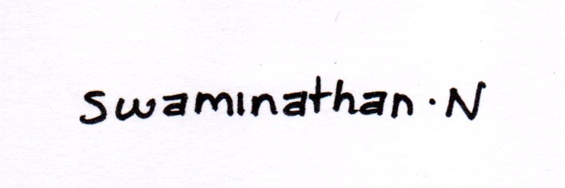
Swaminathan N
Date:
12. Appendix
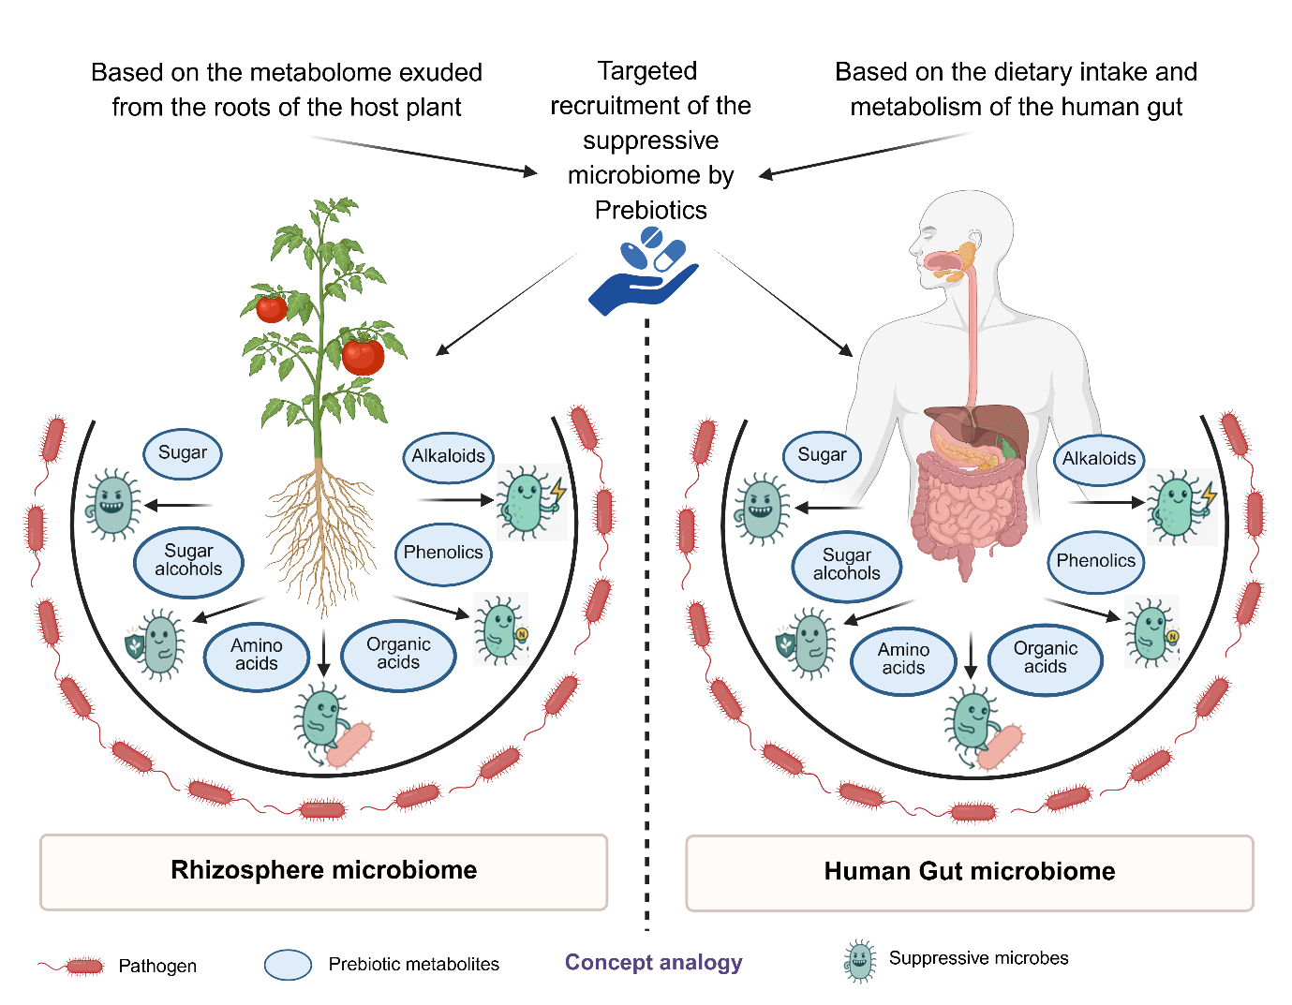
- Graphical Abstract
Figure CatLog and Conceptual Descriptions
The conceptual design echoes recent cross-kingdom microbiome comparisons (Singh et al., 2018) and visual modelling approaches such as those presented by Pang et al. (2024) while extending the analogy toward prebiotic-mediated microbiome engineering in both plant and human systems. Figure conceptualized and created by the author using BioRender.com.
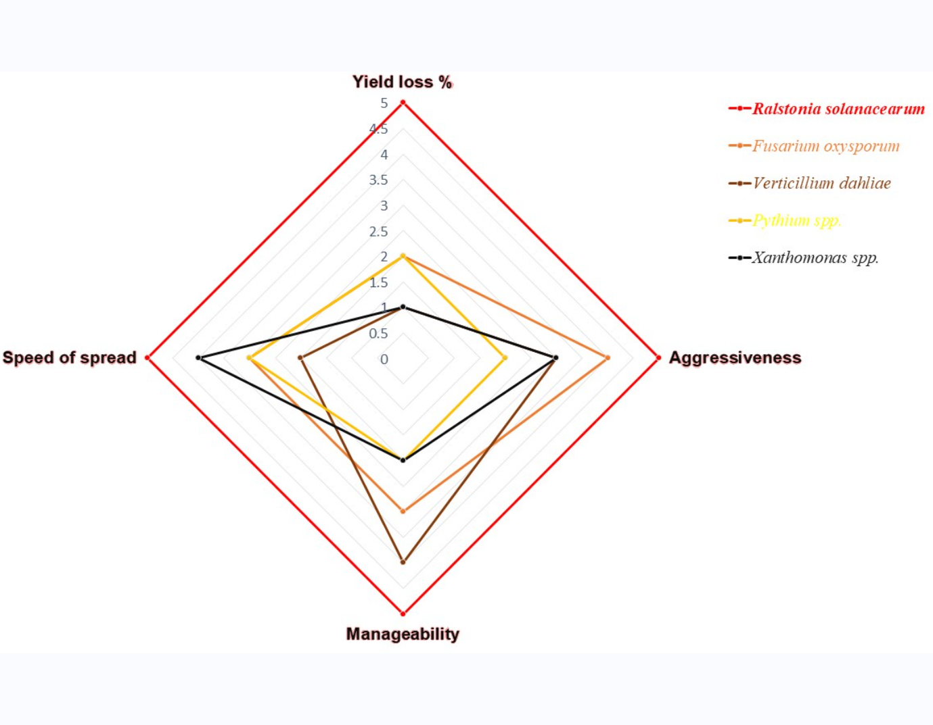
- Figure 1. Comparative traits of major tomato pathogens based on yield loss, aggressiveness, ease of management, and speed of spread (1 = lowest, 5 = highest). R. solanacearum consistently ranks as the most destructive pathogen compared to F. oxysporum f. sp. lycopersici, V. dahliae, Pythium spp., and Xanthomonas spp.
Figure CatLog and Conceptual Descriptions
- Visual Format: Radial chart comparing major tomato pathogens across multidimensional virulence traits.
- Key Insight: Ralstonia solanacearum consistently exhibits the highest destructive capacity across metrics of yield loss, aggressiveness, management complexity, and dissemination rate compared to F. oxysporum f. sp. lycopersici, V. dahliae, Pythium spp., and Xanthomonas spp.
- Conceptual Significance: Establishes R. solanacearum as both a model pathogen and a conceptual proxy for studying microbiome-mediated disease dynamics in soilborne systems.
- Creation Tools: Microsoft PowerPoint (Radial Chart).
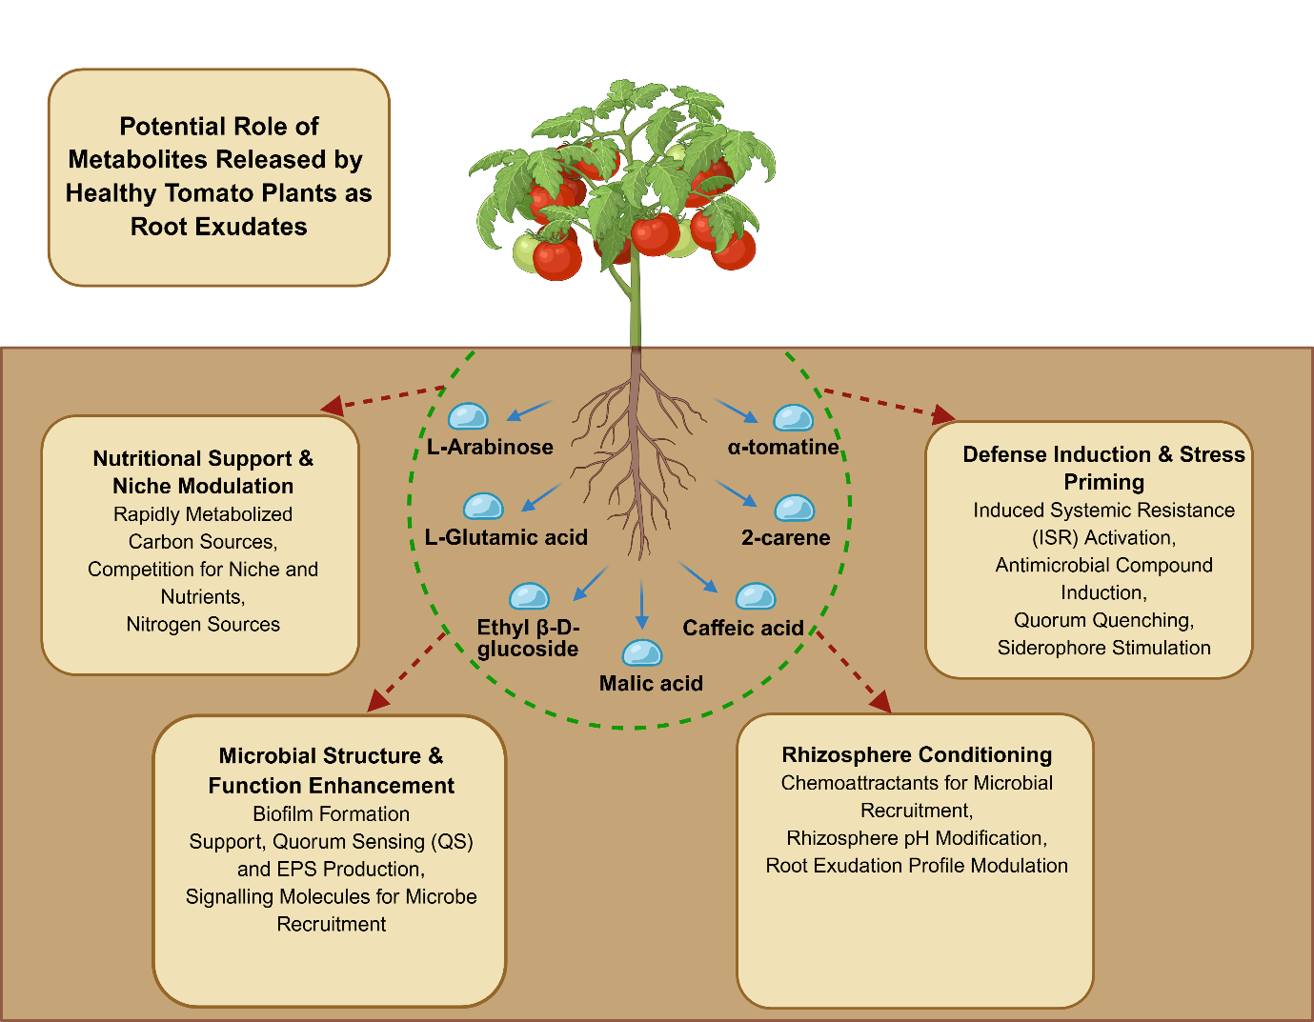
- Originality: Author-conceptualized comparative analysis.

- Figure 2: Functional Classification of Tomato Plant’s released metabolites.
Figure CatLog and Conceptual Descriptions
- Visual Format: Systematic categorization of tomato root exudate metabolites.
Functional Categories:
- Nutritional support metabolites
- Microbial structure enhancers
- Defense-inducing compounds
- Rhizosphere conditioning molecules
- Conceptual Foundation: Adapted from Genesiska et al. (2024) with original structural modifications.
- Creation Tools: BioRender.com.
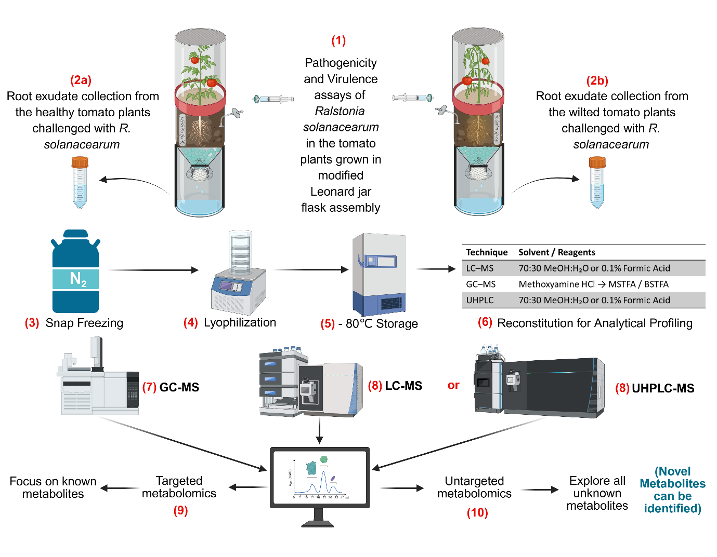
- Research Value: Provides a taxonomic and functional scaffold for screening and deploying prebiotic metabolites in disease suppression studies.
- Figure 3: A systemic pipeline for targeted and untargeted metabolomics of collected tomato root exudates across the samples (Healthy vs Wilted in Ralstonia-conducive).
Figure CatLog and Conceptual Descriptions
- Visual Format: Workflow diagram illustrating the complete metabolomics pipeline for root exudate analysis.
- Methodological Sequence:
- Plant bioassays under Ralstonia-conducive conditions
- Root exudate collection (Healthy vs. Wilted plants)
- Metabolite preservation (snap-freezing, lyophilization, −80 °C storage)
- Analytical preparation and solvent reconstitution
- Multi-platform metabolomics (GC-MS, LC-MS, UHPLC-MS)
- Database integration and functional network analysis
- Technical Foundation: Integrates established analytical workflows with original methodological innovations.
- Innovation: Optimization of the Modified Leonard Jar System for rhizosphere metabolomics.
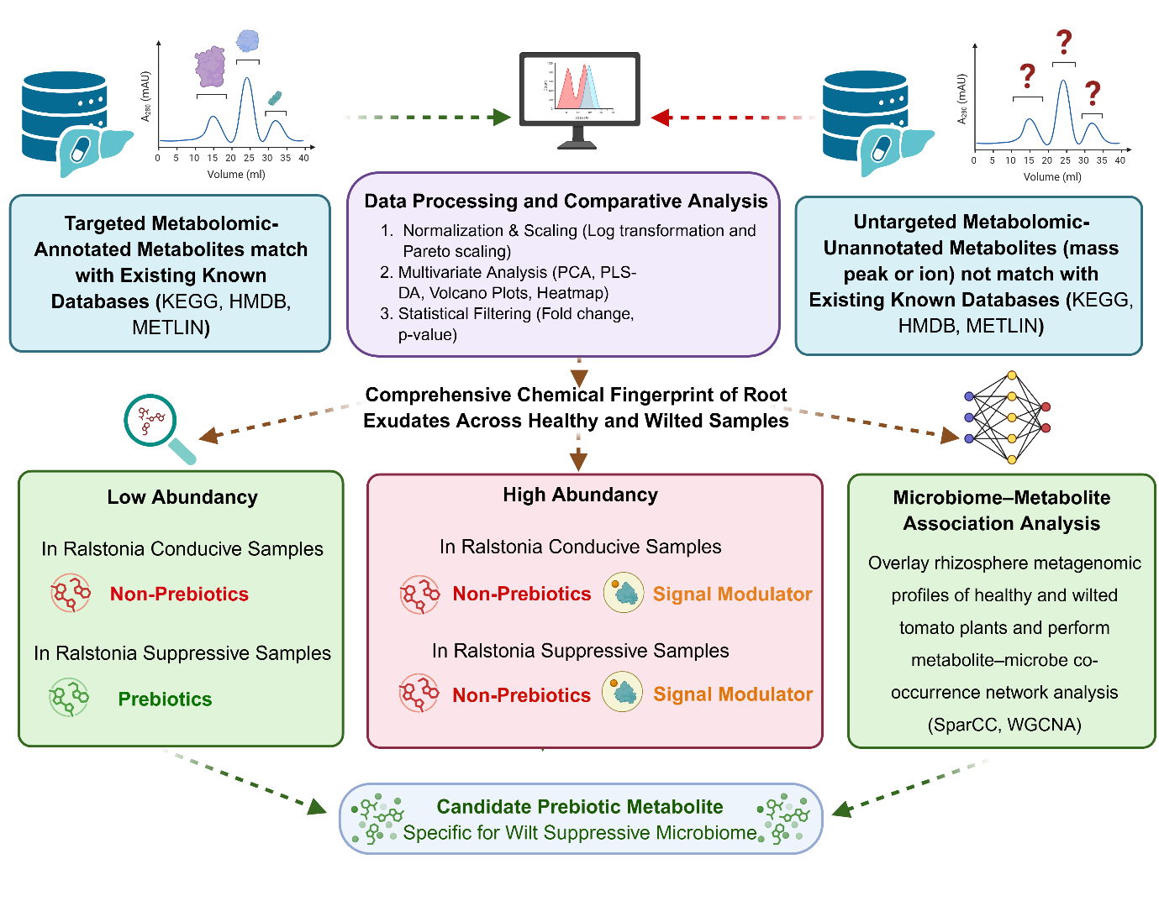
- Creation Tools: BioRender.com.
- Figure 4: Decoding of tomato rhizosphere prebiotic metabolites with a wilt disease suppressive microbiome.
Figure CatLog and Conceptual Descriptions
- Visual Format: Integrated multi-omics correlation framework.
- Analytical Approach:
- Chemical fingerprinting and statistical modeling (PCA, PLS-DA, volcano plots)
- Network-based correlation (WGCNA, SparCC)
- Microbiome–metabolite association mapping
- Conceptual Inspiration: Builds upon standard metabolomics frameworks enhanced by original network ecology adaptations.
- Research Application: Identifies candidate prebiotic metabolites linked to disease-suppressive microbiota.
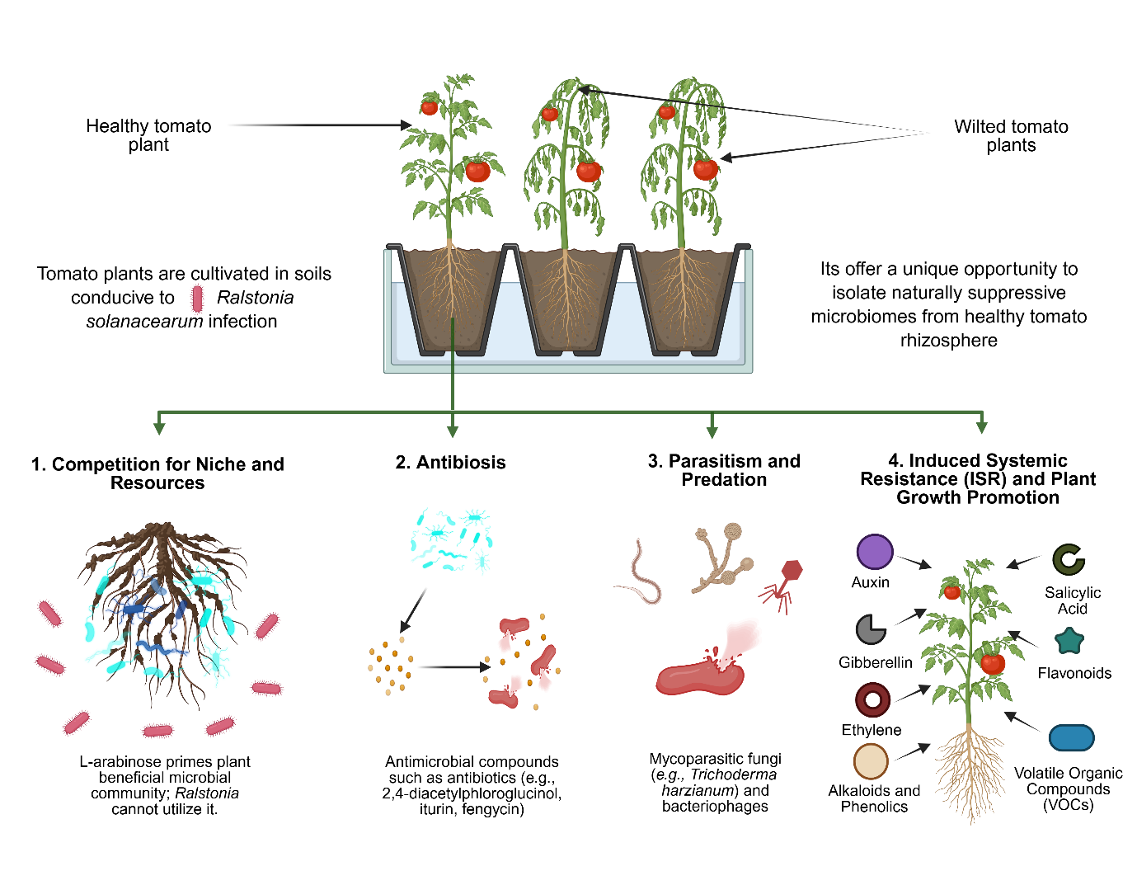
- Creation Tools: PowerPoint and BioRender.com.
- Figure 5: Harnessing natural defense by isolating suppressive microbiome from the healthy tomato rhizosphere in Ralstonia-conducive soils
Figure CatLog and Conceptual Descriptions
- Visual Format: Schematic of suppressive microbiome harvesting from healthy rhizospheres.
- Mechanistic Elements:
- Microbial competition and niche exclusion
- Antibiosis via secondary metabolites (e.g., DAPG, iturin, fengycin)
- Hyperparasitism and predation by fungi, protists, and bacteriophages
- Induced systemic resistance (ISR) through signaling molecules and VOCs
Conceptual Foundation: Integrates microbial ecology and host defense with original methodological design.
- Strategic Value: Provides a framework for leveraging natural microbial defense consortia against R. solanacearum.
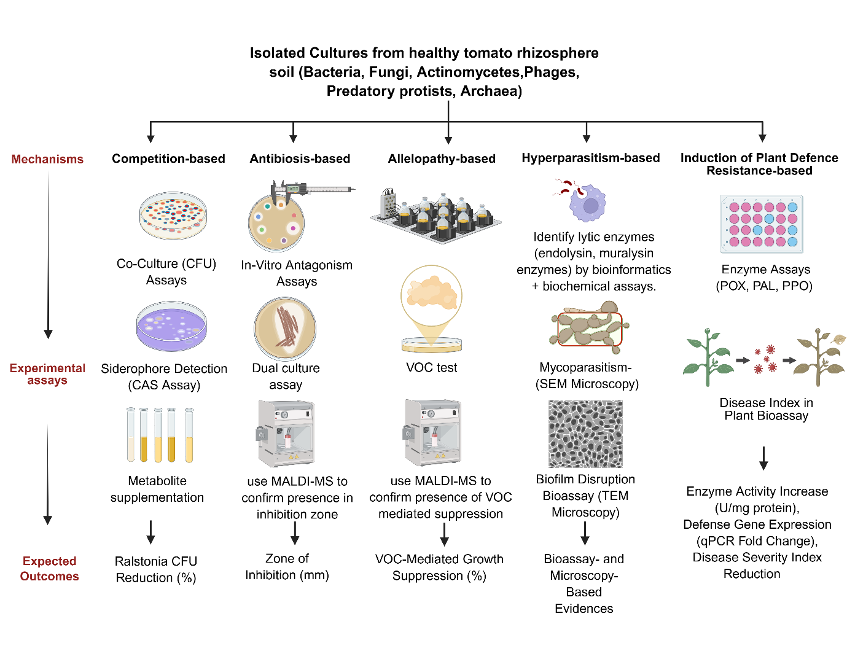
- Creation Tools: BioRender.com.
- Figure 6: Mechanisms and experimental approaches for studying Ralstonia-specific rhizosphere suppressiveness.
Figure CatLog and Conceptual Descriptions
- Visual Format: Comprehensive schematic of experimental validation of rhizosphere suppressiveness.
- Experimental Domains:
- Competition-based assays (CFU counts, siderophore production)
- Antibiosis testing (dual culture and volatile antagonism)
- Allelopathic interaction assays (VOC and diffusible compound profiling)
- Hyperparasitism and predation assays (SEM/TEM visualization of fungal and phage interactions)
- Plant resistance induction (enzyme activity and gene expression profiling)
Technical Integration: Merges ecological, microbiological, and molecular tools into a unified pipeline.
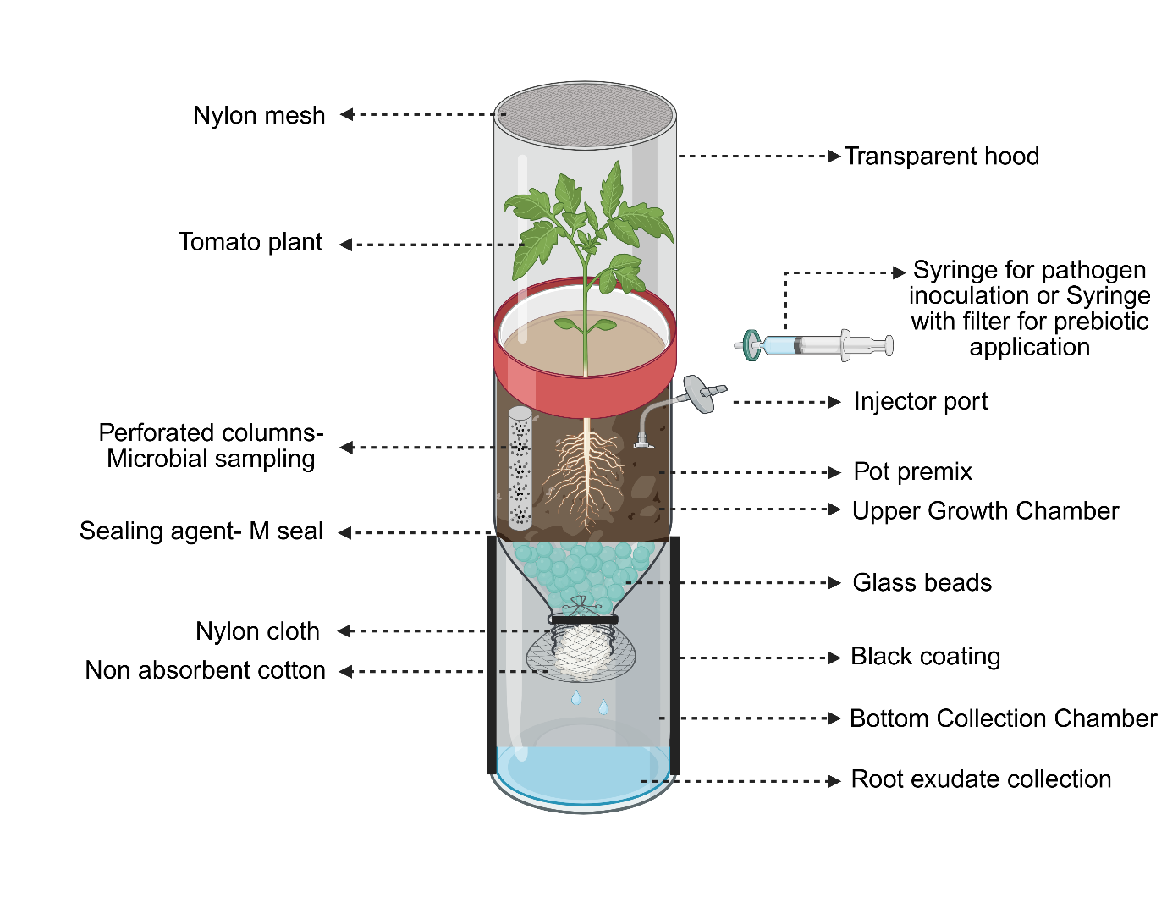
- Research Utility: Provides a standardized validation protocol for assessing Ralstonia-specific rhizosphere suppressiveness.Creation Tools: BioRender.com.
- Figure 7. Modified Leonard Jar System
Figure CatLog and Conceptual Descriptions
- Visual Format: Technical schematic of the customized rhizosphere research apparatus.
- System Features:
- Perforated microbial sampling columns
- Precision injection ports for metabolite treatments
- Multi-chamber design for gas and moisture control
- Integrated metabolite collection and filtration modules
- Technical Evolution: Builds upon historical Leonard designs with modern adaptations for metabolomics and microbiome sampling.
- Innovation Contribution: Tailored optimization for tomato rhizosphere metabolite studies.
- Creation Tools: BioRender.com.
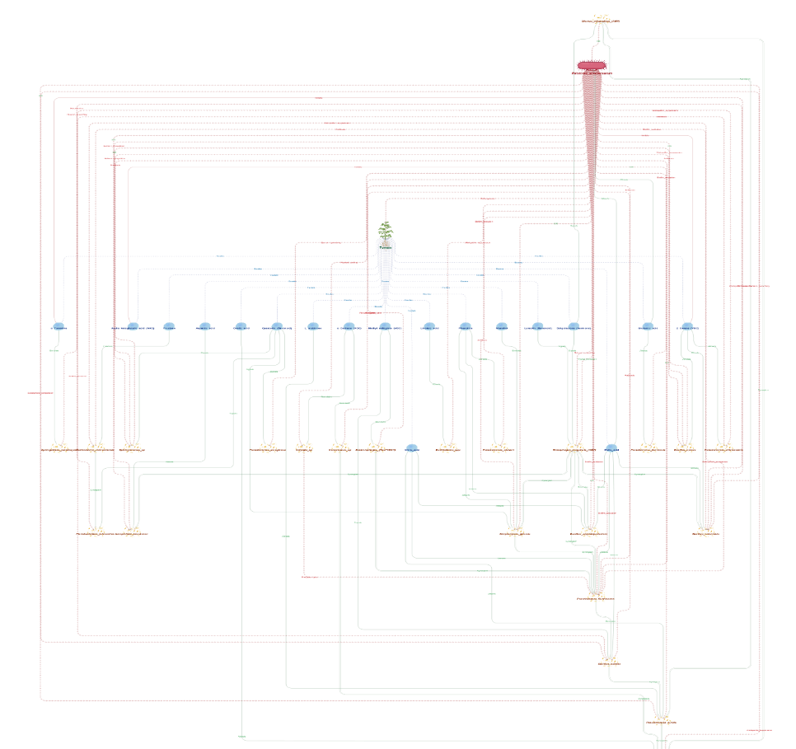
- Figure 8: Integrated Network Visualization of Metabolite-Microbe-Mechanism Interactions
Figure CatLog and Conceptual Descriptions
Network Architecture:
- Node Types: Metabolites (chemical class-coded), Microbial taxa (phylogenetically colored), Suppression mechanisms (functionally categorized)
- Edge Properties: Correlation strength (weighted), direction (positive/negative), statistical significance
- Layout Optimization: Force-directed algorithms revealing natural clustering patterns
- Creation Tools: Cytoscape, Geph, and KEGG Pathway Analytics
Analytical Features:
- Modularity analysis identifying functional clusters across trophic levels
- Centrality metrics pinpointing keystone metabolites and microbial taxa
- Dynamic filtering by correlation threshold and node properties
- Pathway overlays connecting network topology to biochemical function
13. Complete References

