EXECUTIVE SUMMARY FOR GOVERNMENT STAKEHOLDERS
Spain’s Top 50: a revolving door at the bottom, a stable core at the top
Content maturity, release lifecycle and playlist rotation · Atlantic Recording Corporation / Unified Mentor · October 2026
Bottom line. Spain’s daily Top 50 turns over slowly on average (3.3% of the list a day) but in violent bursts: 17 album-release days (3% of days) account for 20% of all new entries. Most new songs vanish within weeks; a minority stay for months and hold most of the chart. The tracks that last are decided early — by rank in the first days — and not by whether they are explicit, single or album tracks.

What we studied
555 daily snapshots of Spain’s Top 50 (18 May 2024 – 27 Nov 2025) — 544 distinct songs by 201 lead artists — were validated, reconstructed into song lifecycles and analysed for survival, rotation and content effects. Six headline indicators and an interactive dashboard accompany the full research paper.

Major findings
- Short lives, long stays. A new entry’s median stay is 13 days; 60% reach a week, 39% a month, 22% three months. Songs lasting over 90 days are 21% of songs but hold 73% of chart slot-days.
- Churn happens at the bottom. 61% of entries land at ranks 41–50 and 81% of exits leave from there; the Top 10 changes by only about one track every 1.7 days. Songs leave because newcomers outrank them, not because they lose appeal (popularity is still 93% of peak on the last day).
- Album drops reshape the chart. Tracks entering in a mass album release have a median stay of 5 days versus 26 for other entries; 75% of a typical drop’s tracks are gone in a week, though 9 of 18 drops produced at least one track lasting 60+ days.
- Content labels matter less than assumed. Explicit and clean songs last equally long overall (1.07×, 95% CI 0.79–1.43). Singles outlast album tracks by 1.73×, but only 1.23× (not significant) once album-drop releases are set aside. Explicit songs hold 42% of chart slots.
- Early rank predicts staying power. 69% of songs entering in the Top 10 are still listed after 30 days, against 26%–38% for songs entering lower.

Impact
For Atlantic, the results support Spain-specific release planning: stagger album tracks behind one or two focus songs, front-load promotion, judge campaigns by early rank, and protect the catalogue core that holds most of the chart. For public stakeholders, they show that single-day chart positions are a volatile statistic dominated by a few release events.

Recommended actions
Action | Basis | Measure of success
Industry (Atlantic). Pilot a focus-track-plus-staggered-tail release on one upcoming album | Drop entries: 5-day median vs 26 | Days listed of focus track; share of tracks alive on day 30
Industry. Set day-3 / day-7 rank checkpoints for scaling marketing spend | Top-10 entry: 69% day-30 survival vs 26%–38% | Spend share on Top-10-by-day-3 tracks
Industry. Keep an evergreen budget for mature catalogue; test UK/US playbooks with the same method | Songs >90 days old hold 44% of slots | Catalogue share of slots; cross-market survival curves
Public statistics. If chart positions feed any official or subsidy-linked indicator, use multi-week smoothed measures, not daily rank | 20% of entries come from 3% of days | Month-to-month stability of the indicator
Data governance. Require integrity checks (exactly 50 entries, no missing days) and add release-date and artist-origin fields | 1 duplicated day, 4 missing days, 106 zero scores found | Share of days passing checks; metadata coverage

Risks and caveats
- Association, not causation. The data are observational; recommended changes should be piloted.
- Narrow evidence base. One market, 18 months, no release dates, genres, stream counts or artist-origin data; claims about domestic versus international content, or about Spain versus the UK/US, cannot be made from this dataset.
- Few events carry much weight. 18 album drops drive the rotation statistics; results would shift with the release calendar.
- Explicit content. The share is 41% (Jun–Dec 2024) to 43% (2025), a borderline trend (p=0.054). A possible longevity premium for explicit songs outside album drops (1.41×) is exploratory and should not support policy or commercial decisions on its own.

Key indicators at a glance
Indicator | Value | In plain language
Average days on playlist | 45.6 (median 10.5) | Typical song is gone in about a week and a half; a few last over a year
Entry-to-peak time | 10.3 days (median 0.5) | Half of songs are at their best rank the day they enter
Playlist churn rate | 3.3% a day | About 1.7 songs replaced a day, in bursts around album releases
Retention stability index | 0.927 | 1 = never moves; long-lived songs reach 0.968
Explicit lifecycle score | 1.07× | Explicit vs clean: no reliable difference in lifespan
Single vs album longevity | 1.73× | Mostly an album-drop effect (1.23× without drops)

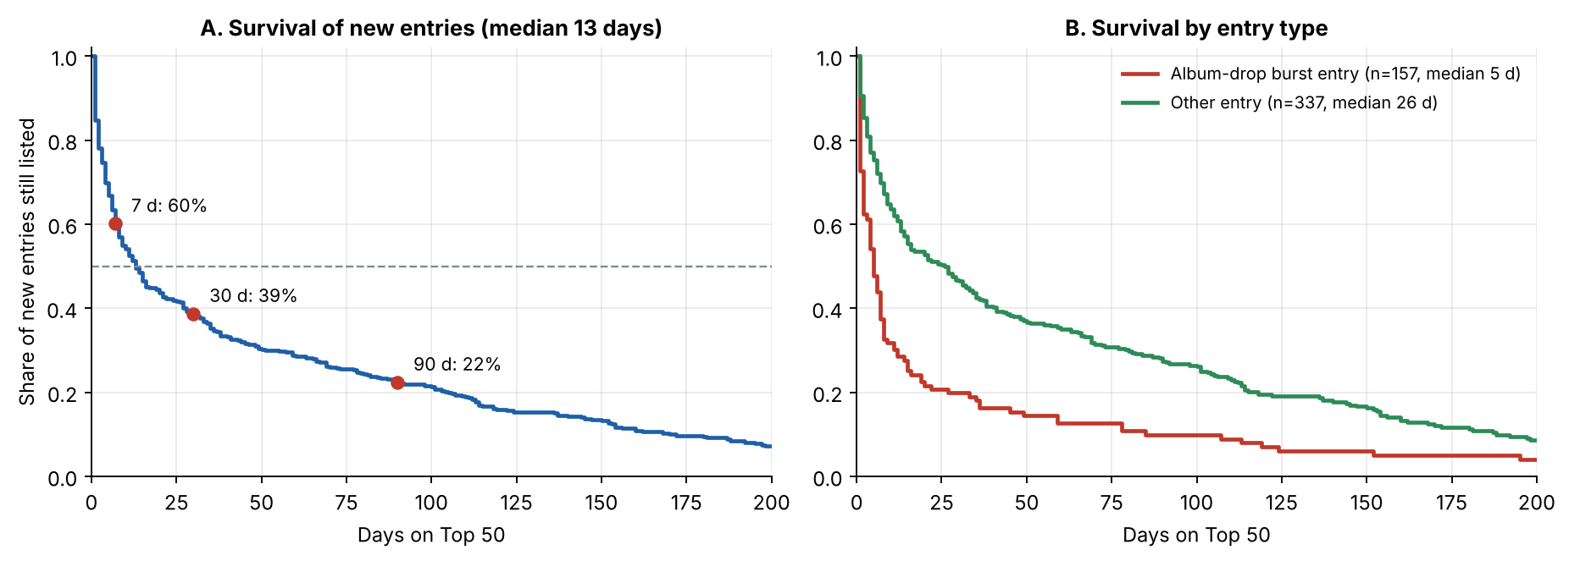
Figure 1. How long new songs stay on Spain’s Top 50: (A) share still listed by days since entry; (B) the split between album-drop entries and all others.

