RESEARCH PAPER
Content Maturity, Release Lifecycle & Playlist Rotation Analysis of Spain’s Top 50 Songs
Prepared for Atlantic Recording Corporation · Unified Mentor project
Author: Swaraj Dattaram Tawade · October 2026
Data: 27,800 playlist rows · 555 daily snapshots · 18 May 2024 – 27 Nov 2025

Abstract
We reconstruct the life of every song on Spain’s daily Top 50 playlist (18 May 2024 – 27 Nov 2025, 555 snapshots) to learn how long songs last, how they mature, and how the list rotates. After validation — one duplicated day, 4 missing days, 106 zero-popularity glitches, and spelling variants — the data yield 544 distinct tracks by 201 lead artists. Lifecycles are barbell-shaped: the median new entry survives 13 days and 40% of songs are gone within a week, yet the 21% that last more than 90 days occupy 73% of all playlist slot-days. Rotation is episodic: 17 album-drop days (3.1% of days) generate 20% of all entries, and tracks that enter in such a burst have a median life of 5 days versus 26 for other entries. The headline contrasts in the brief largely dissolve once this is recognised: singles outlast album tracks by 1.73× overall but only 1.23× (not significant) outside album drops, and explicit and clean songs do not differ overall (1.07×). Rank in the first days after entry, not the popularity score, is the best early indicator of longevity. We deliver the six requested KPIs, an interactive dashboard and evidence-based recommendations for release timing, marketing intensity and catalogue balance.
Key findings
1. Two-speed list. 61% of entries land at ranks 41–50 and 81% of exits leave from there, while the Top 10 changes by only 0.59 tracks a day.
2. Fresh flow, mature stock. Entries average 1.67 a day (mean tenure ≈ 30 days), but songs older than 90 days hold 44% of slots in steady state.
3. Album drops drive rotation and early exits. Drop tracks: median 5 days vs 26; 75% of a typical drop’s tracks leave within 7 days, yet 9 of 18 drops produced at least one track that stayed 60+ days.
4. Format effects are mostly a drop effect. Single vs album 1.73× → 1.23× once drops are set aside; in a multivariable model the single effect is OR 1.09 (0.69–1.73).
5. Explicit content has no overall lifecycle penalty or premium (1.07×, 95% CI 0.79–1.43); a possible premium outside drops is exploratory.
6. Start strong. 69% of Top-10 entries are still listed after 30 days versus 26%–38% for other entry bands.

1. Introduction

1.1 Context and problem statement
Atlantic Recording Corporation records daily snapshots of Spain’s Top 50 playlist but lacks lifecycle intelligence: how long songs survive, whether the list favours fresh or mature tracks, and how song attributes shape entry speed and exit. Without it, release strategy risks being imported from the US or UK rather than fitted to Spain. The brief poses five questions, which this paper answers in Section 5:
- Q1. How long do songs typically survive on Spain’s Top 50?
- Q2. Do Spanish playlists favour fresh releases or mature tracks?
- Q3. How do song attributes affect entry speed and exit rate?
- Q4. Does explicit content mature differently from clean content?
- Q5. How do album and single tracks behave across their lifecycle?

1.2 Scope
The analysis follows the brief’s methodology step by step: validation and normalisation, lifecycle construction, stage classification, rotation and churn, attribute-versus-lifecycle comparisons, popularity versus maturity, and six KPIs. The brief’s background statements about Spain relative to the UK and US (faster rotation, freshness sensitivity) describe comparisons this single-market dataset cannot test; we therefore report Spain’s behaviour in absolute terms and flag where a cross-market comparison would be needed.

2. Data and methodology

2.1 Dataset
The file contains 27,800 rows with ten fields: date, position (1–50), song, artist, popularity (0–100, API score), duration_ms, album_type (single/album), total_tracks, is_explicit and album_cover_url (not used analytically). The window spans 559 calendar days; 555 have a snapshot.

2.2 Validation and cleaning
Table 1. Data-quality checks and treatment
Check | Finding | Treatment
Entries per day = 50 | 1 Mar 2025 has 100 rows (two near-identical scrapes, 15 rows exactly identical); all other days have 50 | Keep the last row per (date, position) → every day has exactly 50 and positions 1–50
Calendar gaps | 4 missing days: 14 Mar 2025, 25 Mar 2025, 11 Jul 2025, 13 Aug 2025 | Not imputed. Transitions spanning a gap are excluded from churn averages
Missing values | None in any column | —
Popularity = 0 | 106 rows on 25 days; 87% fall on a track’s first two days | Treated as ‘not yet scored’ (missing), not as a score
Duration outliers | 91–555 seconds; 872 IQR-outlier rows, all plausible tracks | Kept; length analysed in quartiles
Naming consistency | 583 raw song–artist strings → 544 tracks after normalisation (case, accents, spacing, featured-artist credits) | Track key = normalised title + normalised primary artist; no same-day key collisions
Attribute drift | album_type changes for 41 tracks, total_tracks for 48, explicit flag for 6 | Most frequent value used per track

2.3 Lifecycle construction and censoring
For each track we record entry date (first appearance), exit date (last appearance), total days on playlist (distinct days listed, re-entries included), peak position and time to peak (days from first appearance to the first day at the best rank). 35% of tracks leave and later re-enter the list, so we also keep contiguous ‘spells’.
Censoring. 50 tracks were already listed on day 1 and 50 were still listed on the last day, so their true entry or exit is unknown. We therefore (i) restrict duration KPIs to completed lifecycles (entry and exit both observed; n=444), (ii) analyse entry speed on the 494 tracks whose entry was observed, and (iii) use Kaplan–Meier survival curves, which treat still-listed songs as censored rather than as exits.

2.4 Lifecycle stage classification
The brief names five stages but not thresholds. We classify every song-day with transparent rules, evaluated in this order:
- New Entry — first 7 listed days of a spell whose start was observed (the brief’s ≤7-day rule).
- Peak Phase — 7-day median rank in the Top 10.
- Growth Phase — trailing 7-day rank slope ≤ −0.75 positions/day (improving).
- Decline Phase — trailing 7-day rank slope ≥ +0.75 positions/day (deteriorating).
- Mature Phase — everything else (stable, mid-table).
The slope threshold is an analyst choice; Appendix B shows how stage shares move with 0.5 and 1.0.

2.5 Rotation, churn and stability
Because the list is always 50 songs, daily entries equal daily exits. Churn rate = entries ÷ 50 on days that follow a snapshot exactly one day earlier (550 of 555 transitions). Rank volatility is the mean absolute daily rank move across the list. Album-drop burst (our term) = three or more tracks by the same primary artist entering on the same day; 18 such events cover 157 tracks.

2.6 Statistical methods
Group comparisons use Kaplan–Meier medians and the log-rank test (censoring-aware), the Mann–Whitney test and a bootstrap 95% interval for the ratio of mean days (completed lifecycles), and the restricted mean survival time to 90 days (RMST-90) as a censoring-robust average. A logistic model of surviving 30+ days after entry adjusts for explicit flag, single/album, album-drop entry, track length and entry rank. Correlations are Spearman. With 6 primary group comparisons, a Bonferroni-adjusted threshold is p<0.008; results between that and 0.05 are labelled exploratory.

2.7 KPI definitions
Table 2. KPI definitions (the brief names the KPIs but not their formulas; these are our defensible readings)
KPI | Definition
Average Days on Playlist | Mean days listed, completed lifecycles (entry and exit observed)
Entry-to-Peak Time | Mean (and median) days from first appearance to first day at best rank, tracks with observed entry
Playlist Churn Rate | Mean daily entries ÷ 50 over valid consecutive-day transitions
Retention Stability Index | Mean over songs of 1 − (mean |daily rank change| ÷ 49); 1 = never moves
Explicit Content Lifecycle Score | Mean days explicit ÷ mean days clean, completed lifecycles (>1 = explicit lasts longer)
Single vs Album Longevity Ratio | Mean days single ÷ mean days album, completed lifecycles (>1 = singles last longer)

3. Exploratory analysis and results

3.1 How long do songs last?
Of 494 new entries, 60% are still listed after 7 days, 39% after 30 days, 22% after 90 days and 9% after 180 days; the Kaplan–Meier median is 13 days (Figure 1A). Among completed lifecycles the mean is 45.6 days but the median only 10.5 (IQR 3–59): a long right tail. The longest-lived track was listed 538 days.
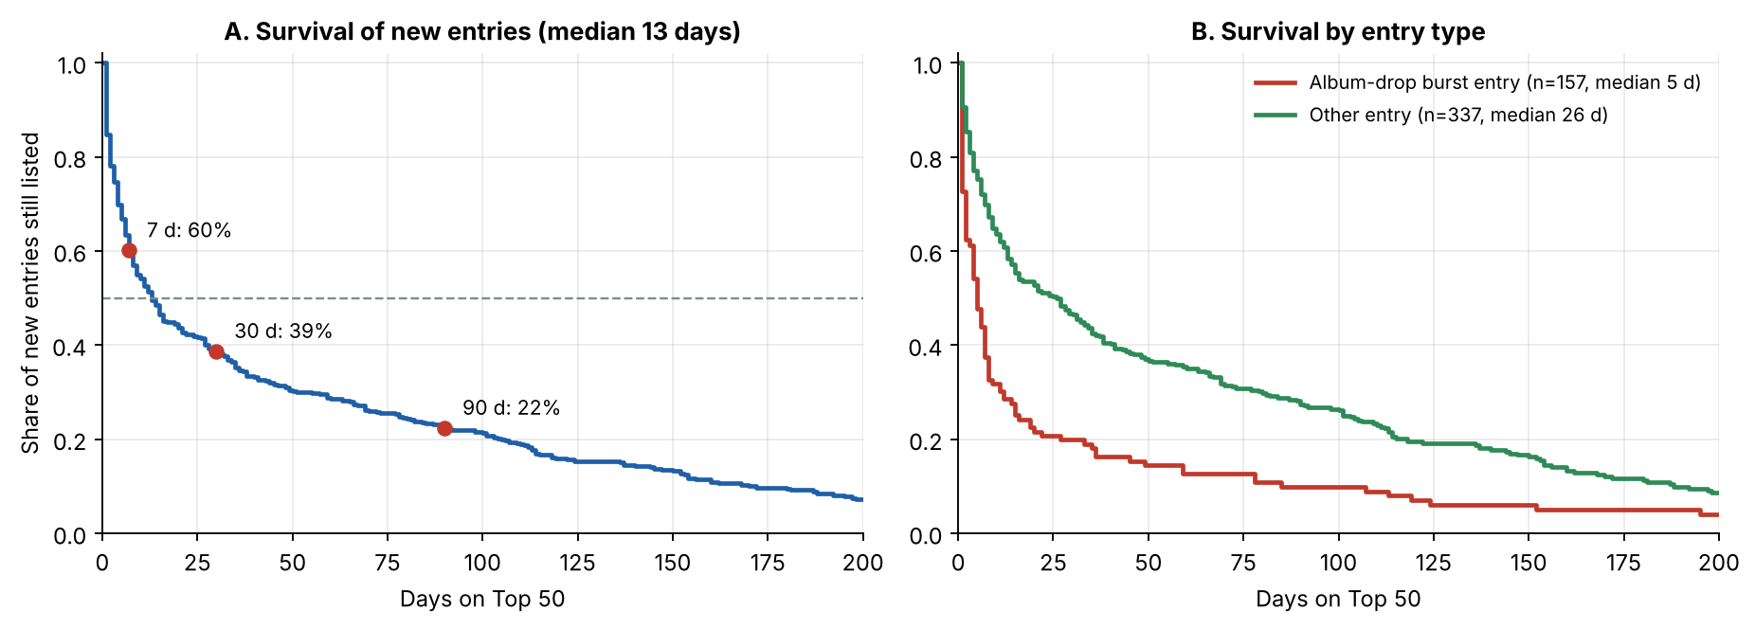
Figure 1. (A) Kaplan–Meier survival of 494 observed entries. (B) Survival splits sharply by entry type: album-drop entries versus all others.
The distribution is a barbell (Figure 2): 40% of songs are flash entries (≤7 days) that together hold just 2.4% of slot-days, whereas 21% of songs last over 90 days and hold 73%. The top 10% of songs by days listed occupy 46% of all slots (Gini 0.69).
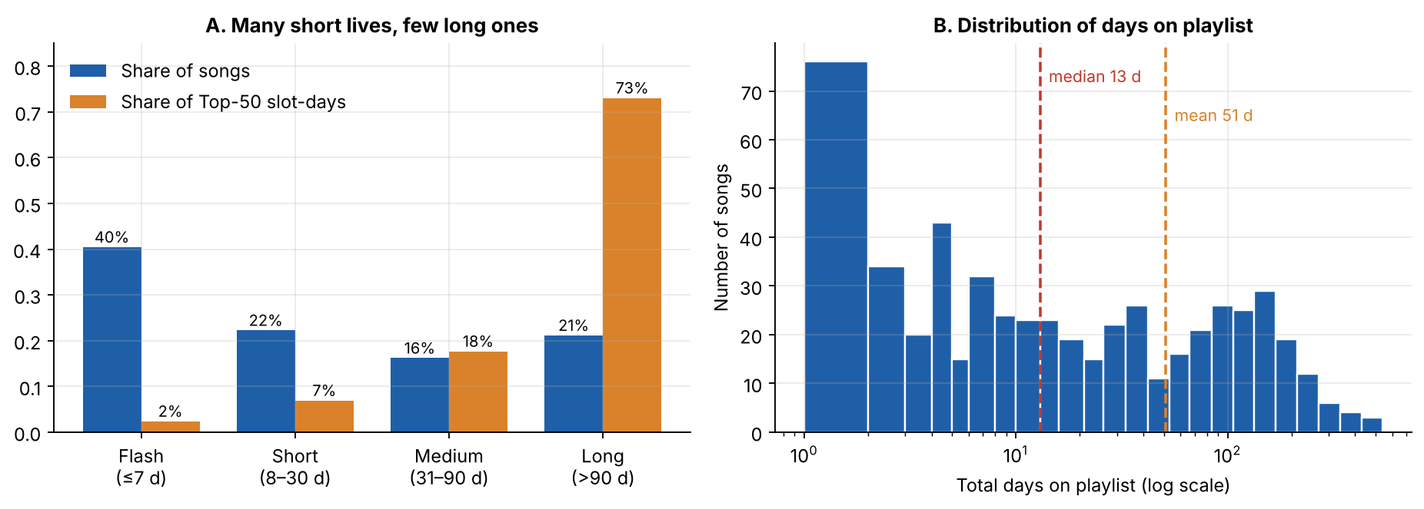
Figure 2. (A) Share of songs versus share of playlist slot-days by lifespan class. (B) Histogram of days on playlist (log axis).

3.2 How songs enter and peak
The median first-day rank is 36; only 16% of new entries start in the Top 10 and 38% start at 41–50. Half of all songs hit their best rank on their entry day (median time to peak 0.5 days; 62% within 3 days). The mean of 10.3 days is pulled up by slow climbers (maximum 426 days). Album-drop tracks peak almost immediately (mean 1.7 days; 85% on day one), while other entries take a median of 4 days to peak (mean 14.3). Only 30% of new entries ever reach the Top 10 (median best rank 19).
Table 3. Entry rank is a strong predictor of survival (tracks with observed entry)
Entry rank | Songs | Peak on entry day | Median days (KM) | Still listed day 7 | Day 30 | Day 90 | Share in album drops
1–10 | 78 | 76% | 59 | 88% | 69% | 41% | 51%
11–25 | 109 | 72% | 8 | 52% | 26% | 15% | 50%
26–40 | 117 | 45% | 8 | 51% | 32% | 22% | 31%
41–50 | 190 | 29% | 13 | 59% | 38% | 19% | 14%

Rank over the first three days is even more informative among songs that survive that long: those averaging a Top-10 rank have a median life of 111 days and 53% are still listed at day 90, versus 28%, 30% and 24% for the lower bands. Across completed lifecycles the Spearman correlation between entry rank and days listed is -0.16 (p=0.001).

3.3 Lifecycle stages
Across all song-days the list is 41% Mature, 19% Peak, 17% Decline, 15% New Entry and 8% Growth (Figure 3). Growth is the rarest stage: songs mostly arrive near their eventual peak and then drift, rather than climb. 58% of tracks are last seen still in the New Entry stage (the flash entries) and 22% in Decline. Stage mix is nearly identical for explicit and clean songs; singles spend more time in Peak (22% of slot-days) than album tracks (16%).
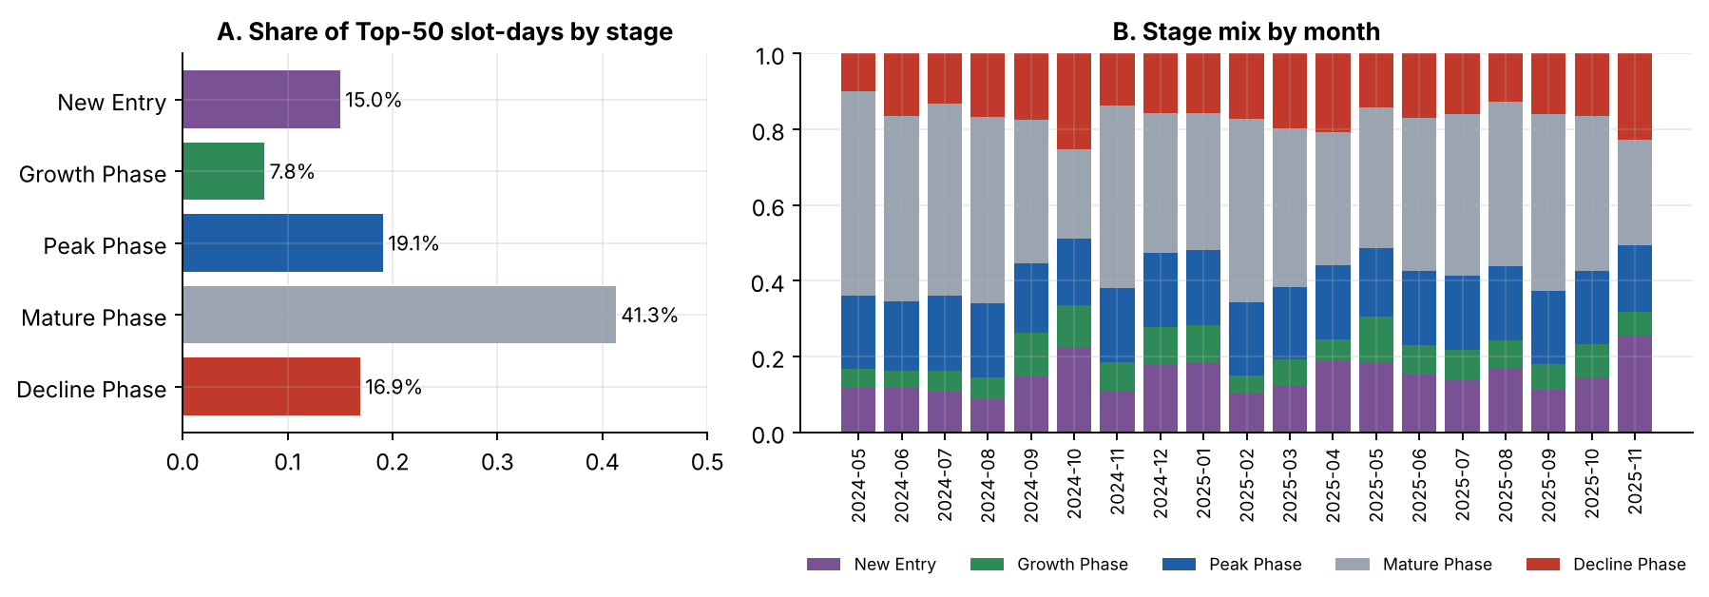
Figure 3. (A) Share of slot-days by lifecycle stage. (B) Monthly stage mix (first week excluded).
Table 4. Stage profile (all song-days)
Stage | Share of slot-days | Mean rank | Mean popularity | Popularity change over 7 days
New Entry | 15.0% | 34.2 | 75.2 | n/a
Growth Phase | 7.8% | 25.5 | 79.2 | +0.71
Peak Phase | 19.1% | 6.1 | 86.0 | +1.12
Mature Phase | 41.3% | 27.7 | 82.2 | +0.06
Decline Phase | 16.9% | 34.4 | 80.8 | +0.16

A noteworthy pattern: songs in the Decline stage still have a popularity score of 80.8 and that score is not falling (+0.16 over seven days). Rank decline reflects displacement by newcomers more than fading appeal (Section 3.6).

3.4 Playlist rotation and churn
Entries average 1.67 a day (3.33% churn); the median is 1 and 29% of days have no entry at all. Little’s law (50 ÷ 1.67) implies a mean tenure of about 30 days. Figure 4 shows why averages mislead: rotation arrives in spikes. 17 album-drop days — 3.1% of days — bring 20% of all entries (10.9 per day versus 1.37 on other days) and push list-wide rank volatility from 1.74 to 6.61 positions a day. 12 of 17 drops registered on a Monday.
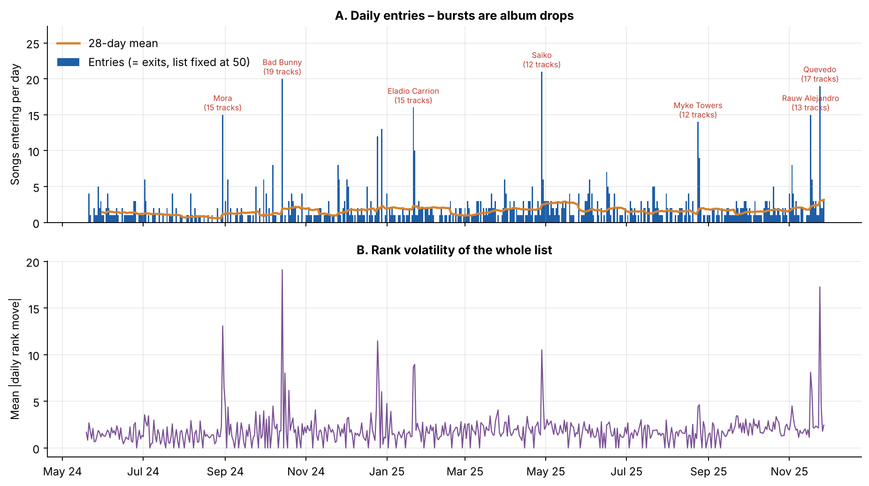
Figure 4. (A) Daily entries (equal to daily exits) with the 28-day mean; labelled spikes are album drops. (B) Mean absolute daily rank move across the list.
Rotation across months. Monthly churn ranges from 1.9% (2025-02) to 6.5% (2025-11), a 3.4-fold spread, but the peaks coincide with drops (Figure 5A). Setting drop days aside, baseline churn averaged 1.9% a day in Jun–Nov 2024 versus 3.2% from Dec 2024 on, a rising trend (Spearman ρ=0.58, p=0.012, 18 monthly points) that we treat as a hypothesis worth monitoring. The weekday pattern is also strong (Kruskal–Wallis p<0.001): outside drops, Tuesday (2.13) and Monday (1.84) average the most entries and Sunday the fewest (0.85). This may reflect how and when the daily snapshot is compiled rather than listener behaviour, and should be validated before it drives release-day decisions.
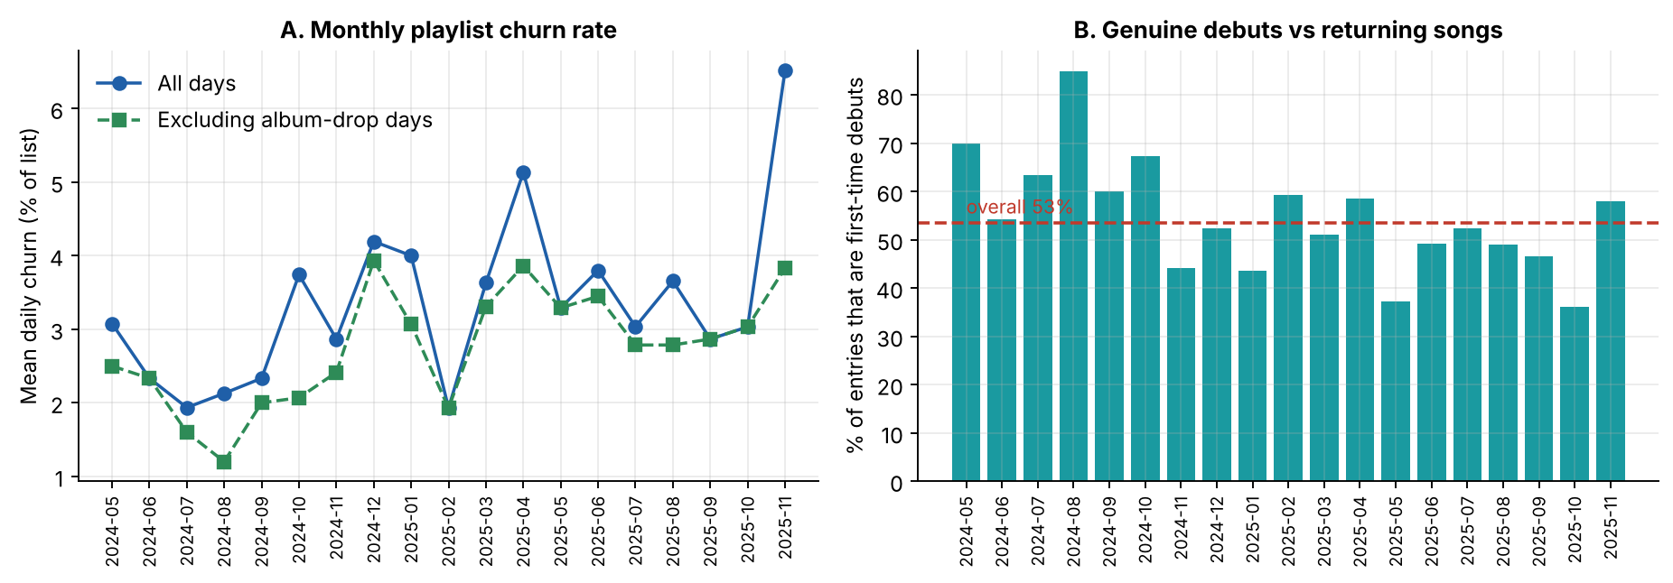
Figure 5. (A) Monthly churn with and without album-drop days. (B) Share of entries that are first-time debuts rather than returning songs.
Debuts versus returns. 53% of entries are genuine first-time debuts; 47% are returns, typically songs hovering around the cut-off.
Gatekeeping at the bottom. 61% of entries land at ranks 41–50 and 81% of exits leave from there (median last rank 47); the Top 10 moves by a mean of 0.57 positions a day against 2.50 at 41–50 (Figure 6). 164 different tracks visited the Top 10 and 37 held number one during the period.
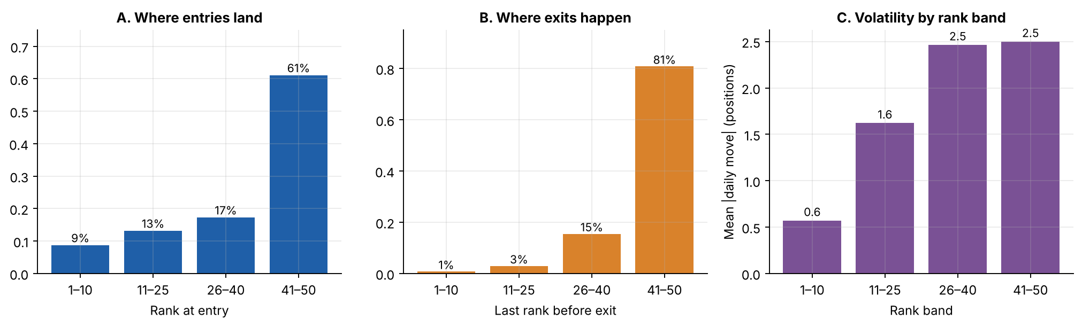
Figure 6. (A) Where entries land, (B) where exits occur, (C) volatility by rank band.
Table 5. Album-drop events (≥3 tracks by one artist entering on the same day)
Date | Artist | Tracks in | Best rank | Median days* | Longest* | Still listed on last day | Gone ≤7 d
28 May 2024 | Cruz Cafuné | 4 | 6 | 1.5 | 20 | 0 | 75%
2 Jul 2024 | Tainy | 4 | 6 | 15.0 | 33 | 0 | 25%
30 Aug 2024 | Mora | 15 | 1 | 4.0 | 229 | 0 | 67%
30 Sept 2024 | Feid | 5 | 7 | 2.0 | 124 | 0 | 80%
7 Oct 2024 | Bizarrap | 4 | 1 | 21.5 | 59 | 0 | 50%
14 Oct 2024 | Bad Bunny | 19 | 1 | 8.0 | 195 | 0 | 37%
25 Nov 2024 | Myke Towers | 7 | 1 | 1.0 | 359 | 0 | 86%
2 Dec 2024 | Feid | 5 | 2 | 1.0 | 357 | 1 | 80%
21 Jan 2025 | Eladio Carrion | 15 | 7 | 1.0 | 78 | 0 | 87%
31 Mar 2025 | The Academy: Segunda Misión | 4 | 3 | 30.0 | 107 | 0 | 50%
28 Apr 2025 | Rels B | 5 | 29 | 1.0 | 16 | 0 | 80%
28 Apr 2025 | SAIKO | 12 | 1 | 8.0 | 208 | 0 | 42%
16 Jun 2025 | DELLAFUENTE | 4 | 29 | 3.5 | 6 | 0 | 100%
21 Jul 2025 | Cruz Cafuné | 4 | 34 | 1.0 | 4 | 0 | 100%
24 Aug 2025 | Myke Towers | 12 | 5 | 1.0 | 88 | 1 | 75%
3 Nov 2025 | Duki | 8 | 3 | 6.0 | 25 | 1 | 63%
17 Nov 2025 | Rauw Alejandro | 13 | 1 | 5.0 | 11 | 3 | 77%
24 Nov 2025 | Quevedo | 17 | 1 | 4.0 | 4 | 17 | n/a
*Days are censored for tracks still listed on the last snapshot. “Gone ≤7 d” counts only tracks that actually exited within 7 days and is n/a where fewer than 8 days were observed (the final drop, 24 Nov 2025: all 17 tracks were still listed). Median across observable drops: 75%.
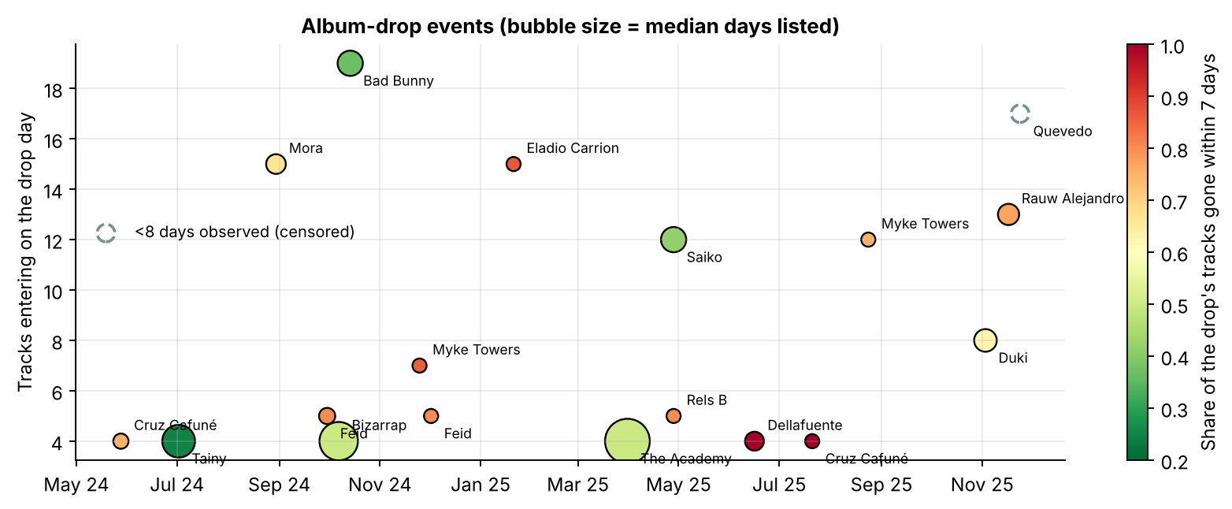
Figure 7. Album-drop events: tracks entering on the drop day, share gone within 7 days (colour) and median days listed (size).

3.5 Content attributes versus lifecycle

Explicit versus clean (Q4)
Explicit tracks occupy 42% of slot-days (41% in Jun–Dec 2024, 43% in 2025; monthly trend ρ=0.46, p=0.054). They mature the same way: Kaplan–Meier median 12 versus 14 days, mean days 47.3 versus 44.1, ratio 1.07 (95% CI 0.79–1.43; log-rank p=0.719). RMST-90 differs by -2.9 days (CI -9.2 to 3.3). There is no difference within singles (0.97×) or within albums (1.49×, n.s.). Outside album-drop entries explicit tracks last longer (1.41×, CI 1.04–1.90, log-rank p=0.022; RMST-90 +7.8 days, CI -0.2 to 16.1), but this subgroup result does not meet the Bonferroni threshold and the RMST interval touches zero, so we call it exploratory. The adjusted odds ratio for surviving 30+ days is 1.32 (0.86–2.03, p=0.206).

Single versus album (Q5) — and the album-drop confounder
Singles appear to last far longer: Kaplan–Meier median 28 versus 8 days, ratio 1.73 (CI 1.28–2.36, log-rank p<0.001; RMST-90 +14.4 days, CI 7.9 to 21.1). But release format is entangled with release behaviour: 95% of album-drop tracks are album tracks and 56% of album tracks entered in a drop. Excluding drop entries, the ratio falls to 1.23 (CI 0.90–1.74, p=0.225) and the RMST-90 gap to 6.5 days (CI -2.0 to 14.7). In logistic models of surviving 30+ days the single-track odds ratio goes from 2.02 alone, to 1.18 adding album-drop entry, to 1.09 in the full model, where album-drop entry has OR 0.17 (0.09–0.32, p<0.001) and each 10 positions of worse entry rank cuts the odds by a factor of 0.77 (0.67–0.88).
Table 6. Longevity comparisons (tracks with observed entry; ratio = mean days of completed lifecycles)
Comparison (A vs B) | n (A/B) | KM median A / B (d) | Ratio A÷B (95% CI) | RMST-90 A−B, days (95% CI) | Log-rank
Explicit vs clean — all | 228/266 | 12 / 14 | 1.07 (0.79–1.43) | -2.9 (-9.2 to 3.3) | p=0.719
Explicit vs clean — excl. album drops | 127/210 | 31 / 15 | 1.41 (1.04–1.90) | +7.8 (-0.2 to 16.1) | p=0.022
Single vs album — all | 230/264 | 28 / 8 | 1.73 (1.28–2.36) | +14.4 (7.9 to 21.1) | p<0.001
Single vs album — excl. album drops | 222/115 | 28 / 16 | 1.23 (0.90–1.74) | +6.5 (-2.0 to 14.7) | p=0.225
Album-drop entry vs other entry | 157/337 | 5 / 26 | 0.36 (0.22–0.54) | -21.2 (-27.4 to -14.5) | p<0.001

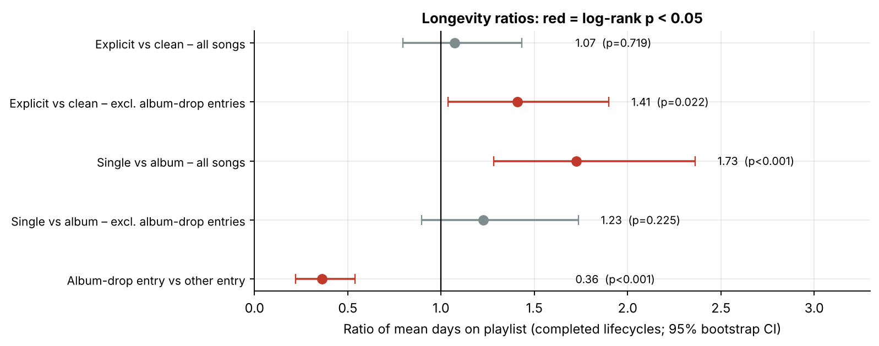
Figure 8. Ratios of mean days on playlist with 95% bootstrap intervals; red = log-rank p<0.05.
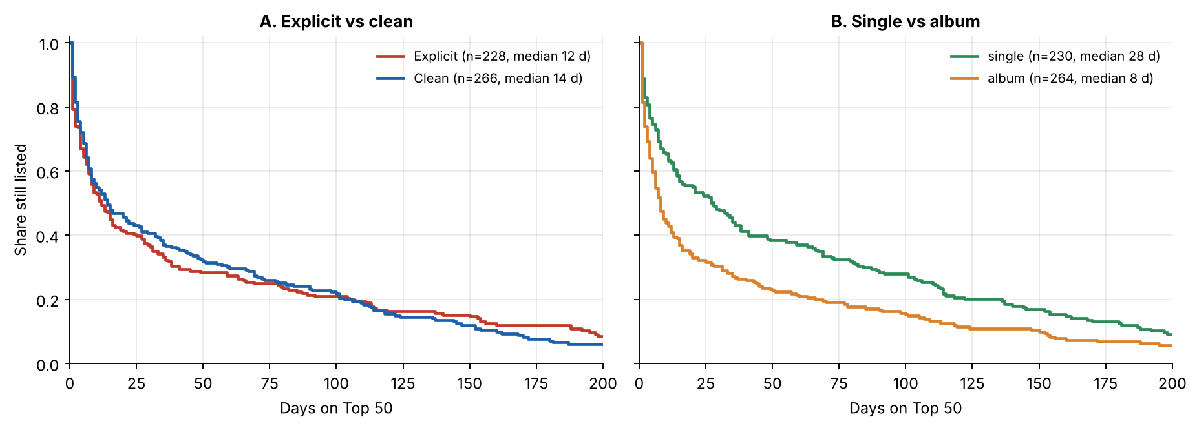
Figure 9. Kaplan–Meier survival for (A) explicit versus clean and (B) single versus album tracks.
Table 7. Adjusted odds ratios for still being listed 30+ days after entry (n=443, base rate 41%)
Predictor | Odds ratio | 95% CI | p
Explicit (vs clean) | 1.32 | 0.86–2.03 | p=0.206
Single (vs album) | 1.09 | 0.69–1.73 | p=0.706
Album-drop entry | 0.17 | 0.09–0.32 | p<0.001
Track length (per extra minute) | 0.98 | 0.77–1.24 | p=0.879
Entry rank (per 10 positions worse) | 0.77 | 0.67–0.88 | p<0.001

Song length and release size
Longer songs last somewhat longer overall (completed lifecycles: Spearman ρ=0.13, p=0.008; the shortest quartile, 1.5–2.7 min, has a median of 6.0 days versus 10.5–13.0 for the others). The association vanishes outside drops (ρ=0.06, p=0.276) and in the adjusted model (OR 0.98 per minute), so we do not recommend using track length as a lever. Album size shows a strong overall negative association with longevity (ρ=-0.25, p<0.001) and with rank stability (ρ=-0.13, p=0.007), but again it is explained by drops: 63% of tracks from 13–20-track releases and 75% from 21+-track releases entered in a drop, and outside drops the correlation is ρ=-0.08 (p=0.170).
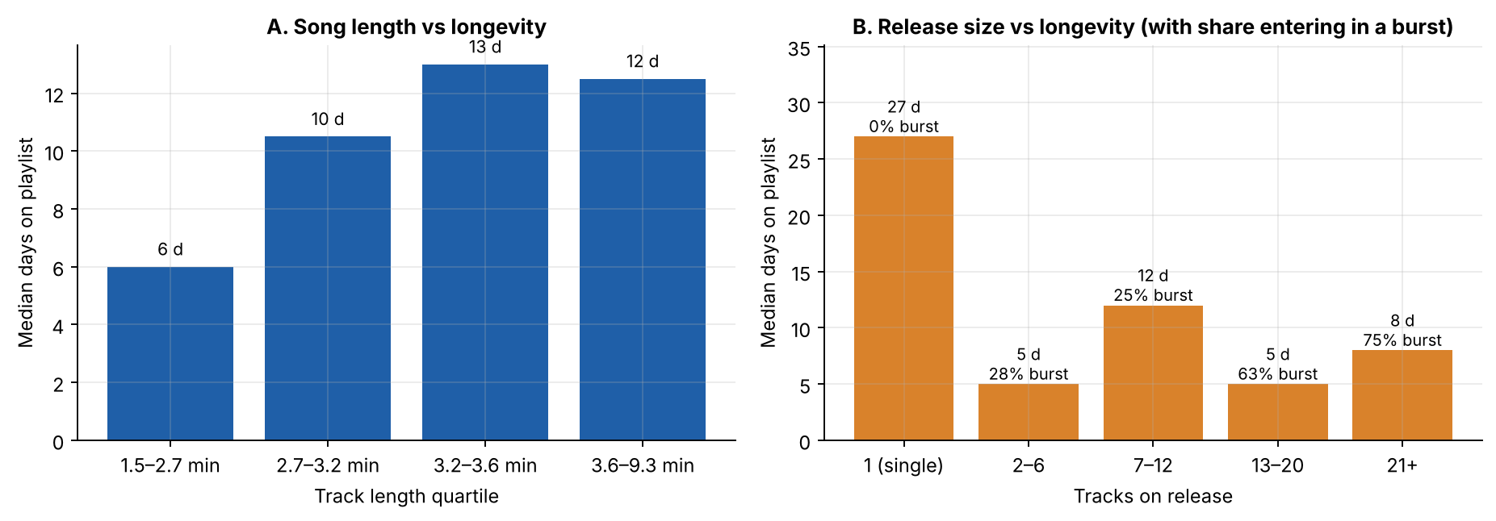
Figure 10. Median days on playlist by (A) song-length quartile and (B) release size, with the share entering in a drop.
Rank stability tells the same story from another angle: the Retention Stability Index averages 0.927 but rises with lifespan, from 0.878 for flash songs to 0.968 for songs lasting over 90 days.

3.6 Popularity versus lifecycle maturity
Popularity builds after entry: the mean score is 71.0 on day 1, 77.5 on day 7, 81.3 on day 30 and plateaus near 82.5 (Figure 10A). Songs reach their popularity peak a median of 10 days after entry (only 16% on day one), compared with a rank peak on day one for half of songs: the score lags the chart. Popularity is also only weakly tied to rank (Spearman ρ=-0.25) and mildly to survival (entry popularity vs days listed ρ=0.20, p<0.001).
Decay is not what ends a stay. For 153 songs that lasted 30+ days and then exited, popularity was 95% of the song’s peak 45 days before exit and still 93% on the last day (Figure 10B). Songs leave the Top 50 because newcomers outrank them, not because their popularity collapses — consistent with the Decline-stage finding above.
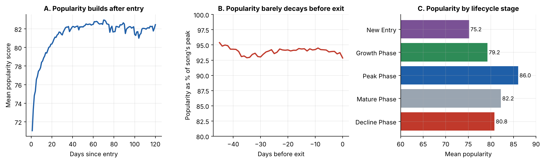
Figure 11. (A) Mean popularity by days since entry. (B) Popularity as a share of each song’s peak in the 45 days before exit. (C) Mean popularity by stage.
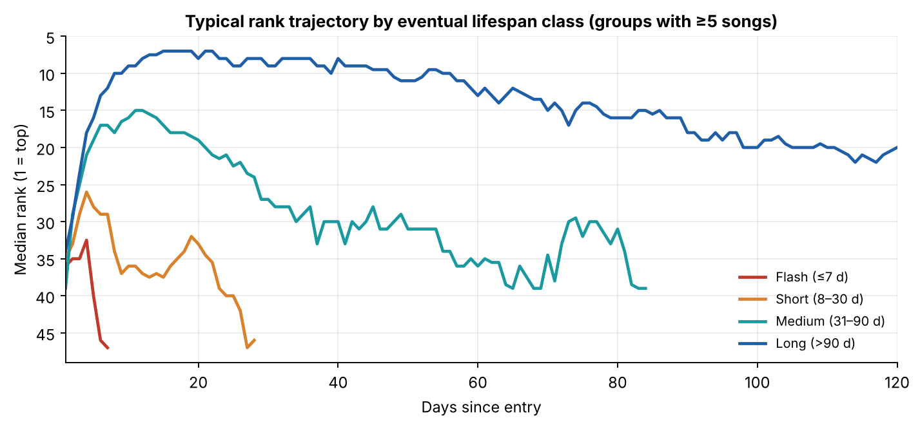
Figure 12. Typical rank trajectory by eventual lifespan class: long-lived songs start in the Top 10–15 and erode slowly; short-lived songs never leave the lower half.

3.7 Market structure: age mix and concentration (Q2)
Once the list has been observed for 90 days (to avoid start-up distortion), 44% of slots are held by songs first seen more than 90 days earlier (monthly range 23%–60%), 29% by songs 31–90 days old, 17% by 8–30 days and only 10% by songs in their first week. The caveat is that ‘age’ is measured from first appearance in the data. Artist concentration is moderate: the top five artists (Saiko 5.6%, Myke Towers 4.9%, Quevedo 4.6%, KAROL G 3.5%, Feid 3.5%) and the top ten together hold 36% of slot-days across 201 lead artists (HHI 0.020). Seasonal tracks are brief: 8 Christmas songs had a median stay of 3 days (maximum 20).
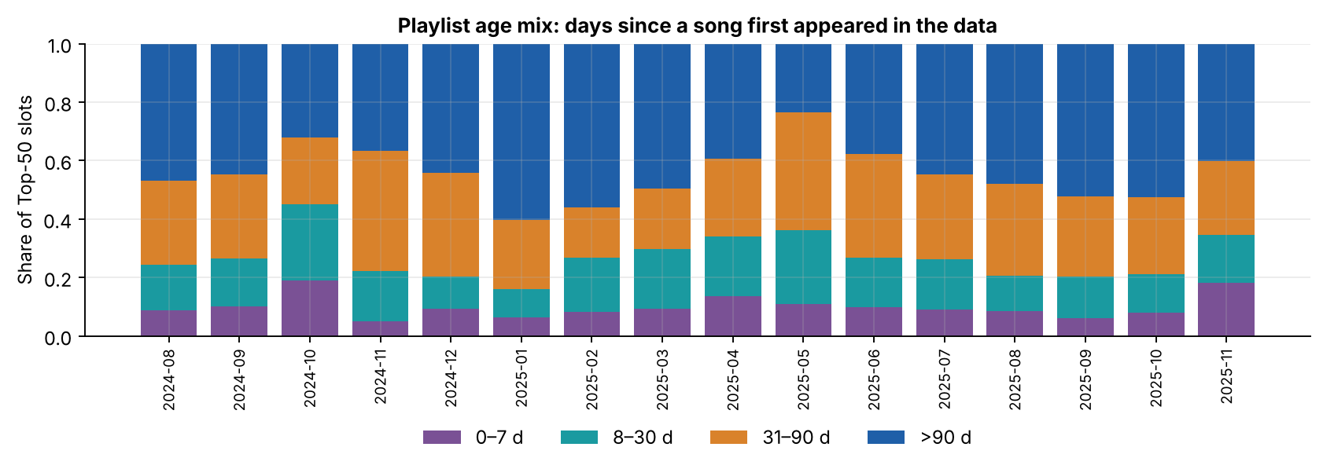
Figure 13. Monthly age mix of the Top 50 (after the first 91 days).

4. Key performance indicators
Table 8. The six KPIs
KPI | Value | Context and interpretation
Average Days on Playlist | 45.6 days | Completed lifecycles (n=444); median 10.5; Kaplan–Meier median of all new entries 13. Quote the median, not the mean
Entry-to-Peak Time | 10.3 days (median 0.5) | Half of songs peak on day one; excluding album drops median 4 days (mean 14.3)
Playlist Churn Rate | 3.33% per day | 1.67 entries a day; 2.75% on non-drop days; rank volatility 1.89 positions a day
Retention Stability Index | 0.927 | Flash songs 0.878, long-lived songs 0.968
Explicit Content Lifecycle Score | 1.07× | 95% CI 0.79–1.43; p=0.719 — no reliable difference
Single vs Album Longevity Ratio | 1.73× | 95% CI 1.28–2.36; falls to 1.23× (CI 0.90–1.74) outside album drops

5. Answers to the five business questions
Q1. How long do songs survive? A new entry has a median stay of 13 days; 60% reach day 7, 39% day 30, 22% day 90. Lives are barbell-shaped: 40% of songs last a week or less, 21% last over 90 days and hold 73% of slot-days.
Q2. Fresh or mature? Both, in different layers. Flow is fresh (1.67 entries a day, 61% landing at 41–50), but the stock is mature: songs older than 90 days hold 44% of slots and songs in their first week only 10%. Whether Spain favours freshness more than the UK or US cannot be tested with one market.
Q3. Which attributes affect entry speed and exit? Entry rank and entry type dominate: Top-10 entries have 69% 30-day survival against 32%–38% lower down, and album-drop entries peak on day one but exit fast (OR 0.17). Track length, release size and format add nothing once those are controlled. Exits happen at ranks 41–50 (81%) through displacement, not popularity decay.
Q4. Does explicit content mature differently? No overall: ratio 1.07 (CI 0.79–1.43), identical stage mix. A possible 1.41× premium outside album drops is exploratory.
Q5. How do singles and albums behave? Singles last 1.73× longer on the raw KPI, but that gap is largely a release-behaviour effect: 95% of drop tracks are album tracks. Outside drops the gap is 1.23× and not significant. Singles also spend more time in the Peak stage and show higher rank stability (0.936 vs 0.909).

6. Recommendations
These follow from observational data; where a recommendation implies a change in practice we suggest a controlled pilot rather than a wholesale switch.

R1. Treat an album as a focus track plus a tail, and stagger the tail
Evidence. Album-drop entries have a median life of 5 days versus 26 (ratio 0.36, CI 0.22–0.54; robust to the 2–5-track threshold: 0.35–0.40). A typical drop loses 75% of its tracks within a week, yet 9 of 18 drops produced at least one track that lasted 60+ days.
Action. Pick one or two focus tracks per album before release, concentrate early promotion on them, and release additional tracks in later waves rather than all at once. Pilot on one upcoming album and compare with the historic drop baseline.
Monitor. Days listed of the focus track; share of drop tracks still listed on day 7 and day 30; number of tracks with 60+ days.

R2. Use early rank as the go/no-go signal, with checkpoints at day 3 and day 7
Evidence. Top-10 entries have 69% day-30 survival versus 26%–38% for other bands; a Top-10 average over the first three days implies a median life of 111 days. Each 10 positions of worse entry rank multiplies 30-day survival odds by 0.77.
Action. Define day-3 and day-7 rank thresholds that trigger scale-up or wind-down of marketing spend. Outside the Top 10, songs entering at 11–40 with no climb within a week typically exit (median life about 8 days).
Monitor. Share of spend on tracks that are Top-10 by day 3; survival to day 30 by checkpoint decision.

R3. Front-load marketing; do not steer by the popularity score in the first fortnight
Evidence. Half of songs peak on their entry day (85% of album-drop tracks, 34% of other entries, whose median is 4 days), whereas popularity peaks a median 10 days after entry and correlates only 0.25 with rank.
Action. Concentrate promotion in the pre-release and first-week window, and use rank and day-over-day rank change, not popularity, as the leading indicator.
Monitor. Rank at days 1, 3, 7; lag between rank peak and popularity peak.

R4. Protect the catalogue core
Evidence. Songs older than 90 days hold 44% of slots in steady state and long-lived songs hold 73% of all slot-days, with a stability index of 0.968. Their exits are caused by displacement, not decay (popularity 93% of peak at exit).
Action. Keep a standing evergreen budget for songs that reach the Mature stage, and avoid launching a new release against a competing mega-drop when a catalogue song is in the 41–50 band.
Monitor. Share of Top-50 slots held by Atlantic songs older than 90 days; days in band 41–50 before exit.

R5. Plan release calendars around drops and validate day-of-week effects first
Evidence. Rotation is spiky (17 drop days = 20% of entries) and baseline churn appears to be rising (1.9% → 3.2% a day). 12 of 17 drops registered on Mondays and non-drop entries peak Monday–Tuesday (p<0.001), which may be a data-compilation artefact. Seasonal songs last about 3 days.
Action. Maintain a calendar of competitor album drops and avoid launching single-track campaigns on those days; confirm how the snapshot date maps to release date before choosing a release weekday; compress seasonal campaigns into the two weeks around the holiday.
Monitor. Entries per day, rank volatility, and Atlantic’s entry rank by release weekday once the mapping is verified.

R6. Do not alter explicit/clean strategy on lifecycle grounds
Evidence. No overall difference (1.07×, CI 0.79–1.43) and identical stage mix; the outside-drop premium (1.41×) is exploratory.
Action. Make content-rating decisions on creative and commercial grounds; re-test the exploratory premium after another 6–12 months of data.
Monitor. Explicit-versus-clean log-rank test and RMST-90 gap, refreshed quarterly.

R7. Do not import UK/US playbooks by assumption — test them
Evidence. The brief’s claims about faster Spanish rotation and freshness sensitivity cannot be evaluated from one market.
Action. Run the same lifecycle pipeline on the UK and US Top 50 data and compare survival curves, churn and album-drop share directly.
Monitor. Cross-market median survival and baseline churn.

R8. Fix the data feed and enrich it
Evidence. The feed contained a duplicated day, 4 missing days and 106 cold-start zero scores; there are no release dates, genres, stream counts or artist-origin fields.
Action. Add snapshot-integrity checks (exactly 50 rows, no gaps), a release-date field and artist metadata. Release date would let us measure true time-to-peak and separate release-day from chart-entry timing.
Monitor. Share of days passing integrity checks; metadata coverage.

7. Limitations, assumptions and ambiguities

7.1 Limitations
- Observational data. Associations are not causal. For example, album-drop entry may reflect fan curiosity, playlist algorithms or marketing intensity; we cannot separate them.
- Single market, 559 days. One market and 18 months cannot establish seasonality (one Christmas) or cross-market contrasts.
- Censoring. 50 songs enter before and 50 survive past the window; the final drops (Nov 2025) have only days of follow-up. Kaplan–Meier and RMST handle this; the brief’s mean-based KPIs use completed lifecycles and are biased toward shorter stays. A subset with at least 90 days of follow-up (n=405, 98% completed) gives the same conclusions (single vs album 1.69×, drop vs other 0.37×, explicit vs clean 1.10×).
- Top-50 truncation. Exiting the Top 50 does not mean disappearing from listening.
- Track identity. Two distinct songs with identical titles and the same primary artist would merge into one track. Attribute drift (album_type changes for 41 tracks, total_tracks for 48) suggests that some re-releases are treated as the same track; each track is labelled by its most frequent attribute value.
- Multiple testing. Six primary comparisons were run; only the album-drop, single-versus-album (overall) and entry-rank results clear the Bonferroni threshold (p<0.008).
- Analyst-defined thresholds. Stage slopes and the three-track burst rule are our choices; stage shares move materially with the slope threshold (Appendix B) whereas the burst finding is stable for 2–5 tracks.
- Popularity is a lagging, smoothed score that mixes streams, recency and other signals; it is not a stream count.

7.2 Ambiguities in the brief and how we resolved them
Table 9. Assumptions
Ambiguity | Assumption
50 entries per day, but one day has 100 rows | Two scrapes of the same day; kept the later row per position (the two blocks share 49 of 50 tracks)
Missing calendar days | Not imputed; excluded from consecutive-day transitions
Stage thresholds (‘rank improving’, ‘stable mid-rank’) | Trailing 7-day slope ±0.75 positions a day; Top-10 7-day median for Peak; sensitivity reported
‘Exit date’ | Last day listed (the day after is the first day absent); re-entries are tracked as spells
‘Total days on playlist’ | Distinct days listed, not calendar span (span is also stored)
Explicit Content Lifecycle Score and Retention Stability Index have no formula | Defined in Table 2
Filter list repeats ‘Explicit content toggle’ | Treated as one control (explicit all / only / clean only)
Spain vs UK/US claims | Not testable with this dataset; reported as such

8. Conclusion
Spain’s Top 50 behaves like a two-speed system: a high-turnover fringe at ranks 41–50, repeatedly shaken by album drops, wrapped around a durable core of long-lived songs that hold nearly three quarters of all slot-days. The lifecycle lens changes the headline comparisons in the brief: singles versus albums and short versus long releases are mostly proxies for whether tracks arrive in a mass drop, explicit content has no overall effect, and entry rank, not popularity, is the early signal of staying power. For Atlantic, the practical implications are to stagger album tracks behind one or two focus songs, front-load promotion and judge it by early rank, protect the catalogue core, and test the UK/US playbooks rather than assume them.

Appendix A. Monthly rotation
Table 10. Monthly rotation (valid consecutive-day transitions; first and last months are partial)
Month | Days | Avg entries/day | Churn % | Excl. drops % | Rank volatility | Debut share
2024-05 | 13 | 1.54 | 3.08 | 2.50 | 1.46 | 70%
2024-06 | 30 | 1.17 | 2.33 | 2.33 | 1.42 | 54%
2024-07 | 31 | 0.97 | 1.94 | 1.60 | 1.36 | 63%
2024-08 | 31 | 1.06 | 2.13 | 1.20 | 1.85 | 85%
2024-09 | 30 | 1.17 | 2.33 | 2.00 | 1.66 | 60%
2024-10 | 31 | 1.87 | 3.74 | 2.07 | 2.55 | 67%
2024-11 | 30 | 1.43 | 2.87 | 2.41 | 1.74 | 44%
2024-12 | 31 | 2.10 | 4.19 | 3.93 | 2.17 | 52%
2025-01 | 31 | 2.00 | 4.00 | 3.07 | 2.07 | 44%
2025-02 | 28 | 0.96 | 1.93 | 1.93 | 1.63 | 59%
2025-03 | 27 | 1.81 | 3.63 | 3.31 | 1.89 | 51%
2025-04 | 30 | 2.57 | 5.13 | 3.86 | 2.26 | 58%
2025-05 | 31 | 1.65 | 3.29 | 3.29 | 1.97 | 37%
2025-06 | 30 | 1.90 | 3.80 | 3.45 | 1.50 | 49%
2025-07 | 29 | 1.52 | 3.03 | 2.79 | 1.54 | 52%
2025-08 | 29 | 1.83 | 3.66 | 2.79 | 1.46 | 49%
2025-09 | 30 | 1.43 | 2.87 | 2.87 | 1.84 | 47%
2025-10 | 31 | 1.52 | 3.03 | 3.03 | 2.16 | 36%
2025-11 | 27 | 3.26 | 6.52 | 3.83 | 3.14 | 58%

Appendix B. Sensitivity analyses
Table 11. Stage shares of slot-days under alternative slope thresholds
Stage | |slope| ≥ 0.5 | ≥ 0.75 (used) | ≥ 1.0
New Entry | 15.0% | 15.0% | 15.0%
Growth Phase | 11.5% | 7.8% | 5.5%
Peak Phase | 19.1% | 19.1% | 19.1%
Mature Phase | 30.6% | 41.3% | 48.5%
Decline Phase | 23.8% | 16.9% | 12.0%

Table 12. Album-drop definition: minimum same-artist tracks entering on one day
Threshold (tracks) | Songs flagged | KM median drop / other (d) | Ratio of mean days (95% CI)
≥ 2 | 171 | 5 / 27 | 0.35 (0.22–0.50)
≥ 3 | 157 | 5 / 26 | 0.36 (0.22–0.53)
≥ 4 | 157 | 5 / 26 | 0.36 (0.22–0.53)
≥ 5 | 133 | 5 / 21 | 0.40 (0.23–0.62)

Table 13. Follow-up subset: only tracks entering at least 90 days before the end of the data (n=405)
Comparison | Ratio (95% CI) | Log-rank
Explicit vs clean — all | 1.10 (0.83–1.47) | p=0.894
Explicit vs clean — excl. drops | 1.40 (1.02–1.91) | p=0.028
Single vs album — all | 1.69 (1.29–2.32) | p<0.001
Single vs album — excl. drops | 1.24 (0.90–1.73) | p=0.305
Album-drop vs other entry | 0.37 (0.22–0.57) | p<0.001

Appendix C. Reproducibility
The complete workflow is delivered as a Google Colab notebook (Spain_Top50_Lifecycle_Colab.ipynb) that writes three modules to disk and runs them end to end: lifecycle_analysis.py (validation, lifecycles, stages, churn, statistics, KPIs, findings), charts.py (all figures) and app.py (Streamlit dashboard). The dashboard, this paper and the executive summary all read the same module output, and the six headline KPIs were independently recomputed from the raw CSV with separate code and matched exactly. Parameters (stage slope threshold, burst size, trend window) are declared at the top of lifecycle_analysis.py.

