AI Usage DISCLOSURE FORM

1. Team Details
Team Name: InnoVerse
Project / Product Name: Samsung Guided Troubleshooting
Organization / Institution (if any): SRM Institute of Science and Technology (SRMIST)
Submission Date: 30 September 2026

2. AI Usage Declaration
Did your team use any Artificial Intelligence (AI) in developing this project? Yes
Yes. AI was used as a development assistant and as an optional component of the troubleshooting workflow.

3. Purpose of AI Usage ( Brief Details)
Idea generation / brainstorming : No
Code generation or assistance : Yes — AI-assisted code generation, refactoring, implementation guidance and debugging; the team reviewed and integrated the code.
UI / UX design : No
Content creation : Yes — AI-assisted preparation and refinement of presentation content, README/documentation and demo narration.
Data analysis : Yes — AI-assisted review of benchmark cases, SIIS/deeplink data, validation outputs and test results.
Testing / debugging : No- All the testings were done by the team members
Other AI-assisted prompt design, technical documentation and development workflow; Gemini 2.5 Flash is also supported as an optional runtime AI component.

4. Feature Origin Classification ( Please add/delete based on the number of the feature)
1. Feature Name: Natural-language Troubleshooting & Guided Response Generation
2. Self-Generated/AI-Generated/Both: Both
3. Description (include AI tools/platform Used, prompt used, Output Summary, Modification): ChatGPT and Gemini 2.5 Flash were used for ideation, implementation assistance and optional response generation. Prompt focus: convert a user's natural-language complaint and supplied Samsung SIIS context into structured troubleshooting guidance. Output: draft reasoning/steps and implementation guidance. Modification: the team integrated, constrained and validated the final output against the required schema, SIIS grounding rules and deeplink catalog.

1. Feature Name: Guided Troubleshooting UI / UX
2. Self-Generated/AI-Generated/Both: Both
3. Description (include AI tools/platform Used, prompt used, Output Summary, Modification): ChatGPT/Claude were used for UI/UX ideation, screen-flow refinement and presentation/demo design. Prompt focus: design a clear Samsung-inspired troubleshooting journey from complaint to guided steps, Settings shortcut and saved session. Output: layout, interaction and copy suggestions. Modification: the team implemented and refined the final React interface, responsive behaviour, accessibility and interaction logic.
3. Feature Name: Official Deeplink Mapping, Validation & Benchmark Evaluation
4. Self-Generated/AI-Generated/Both: Both
5. Description (include AI tools/platform Used, prompt used, Output Summary, Modification): AI tools were used to assist with implementation review, debugging and evaluation-script refinement. Prompt focus: validate structured responses against the supplied schema, official deeplink catalog, URL-leak constraints and benchmark cases. Output: suggested validation/test logic and debugging guidance. Modification: the team retained the supplied Samsung reference data as authoritative and implemented the final validation, repair, caching and benchmark checks.

5. Ethical & Compliance Confirmation
AI usage complies with guidelines and policies. Yes
No proprietary or copyrighted data misused. I Agree

6. Declaration & Sign-Off
Name of Team Representative: Swarnava Sarkar
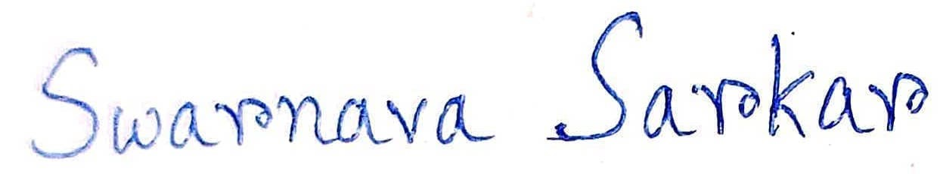
Role: Team Leader
Signature:
Date: 30 September 2026

