#### Summer Project Report on

**“ONLINE SHOPPING CART-**

**AZcart”**

**By**

Abigael Rachel Kumar (501802)

Swaroop Gogate (501822)

Arnav Panday (501847)

Pranav Patil (501849)



**Department of Information Technology**

**Fr. Conceicao Rodrigues Institute of Technology**

Sector 9A, Vashi, Navi Mumbai – 400703

University of Mumbai

2020-2021

## Abstract

The purpose of the project entitled as “**AZkart**” is to computerize the Front Office Management of online store to develop software which is user friendly simple, fast and cost – effective, for personal use and makes the data processing very fast. Shopping Cart System is the Simple shopping Solution. It’s a full featured website and shopping cart system that bends over backwards to give us the flexibility we need to run our online store. The basic concept of the application is to allow the customer to shop virtually using the Internet and allow customers to buy the items and articles of their desire from the store. The information pertaining to the products are stores on an **MONGODB** at the server side (Local store). The Server processes the customers and the items are shipped to the address submitted by them. The details of the items are brought forward from the database for the customer view based on the selection through the menu and the database of all the products are updated at the end of each transaction.

###### I

**TABLE OF CONTENTS**

|  |  |  |  |
| --- | --- | --- | --- |
| **Sr. No.** |  | **Topic** | **Page No.** |
|  | **Introduction**  1.1 Background |  |  |
| 1 | 1.2 Motivation/ need/ purpose  1.3 Problem Definition  1.4 Scope  1.5 Proposed System Features  1.6 Objectives  1.7 Issues /Limitations |  | 1 |
| 2 | **Literature Survey** |  |  |
|  | 2.1 EXISTING SYSTEM2.2 Technology Used Overview of the technology 2.3 Why To Use MONGODB  2.4.Hardware requirements: |  | 6 |
| 3 | **System Design**    3.1 Architecture Diagram |  | 10 |
|  | **System Requirement** |  |  |
| 4 | 4.1 Hardware  4.2 Software |  | 13 |

###### II

|  |  |  |  |
| --- | --- | --- | --- |
| **Sr. No.** |  | **Topic** | **Page No.** |
| 5 | **Implementation** **Details** |  |  |
|  | 5.1 User Interface    5.2 Database Details |  | 15 |
| 6 | **Conclusion/Future Scope** |  |  |
|  | 6.1 Conclusion    6.2 Future Scope |  | 20 |
| 7 | **Appendix : Code Sample** |  | 22 |
| 8 | **References** |  | 25 |
| 9 | **Acknowledgement** |  | 27 |

**LIST OF FIGURES**

|  |  |  |
| --- | --- | --- |
| **Fig. No.** | **Figure Name** | **Page No.** |
| Fig 3.1 | Initial flow of Application | 11 |
| Fig 3.2 | Control flow at User’s end | 11 |
| Fig 3.3 | Control flow at Admin’s end | 12 |
| Fig 5.1 | Main Page | 16 |
| Fig 5.2 | User Login | 16 |
| Fig 5.3 | User Dashboard | 17 |
| Fig 5.4 | Bookings | 17 |

**LIST OF TABLES**

|  |  |  |
| --- | --- | --- |
| **Table. No.** | **Table Name** | **Page No.** |
| Table 1 | Existing Systems | 9 |

**1 INTRODUCTION**

##### 1.1 BACKGROUND

The project AZkart has been developed on **HTML**, **EJS**, **CSS**, JavaScript and **MONGODB** .An online shopping store which will allow formal and informal merchants in developing countries to advertise and sell their good on the internet. This would permit rural communities to make their wares available to the rest of the world via the World Wide Web. The web portal will have an online interface in the form of an e-commerce website that will allow users to buy goods from the merchants. There are two types of users available in the project. First one is **Logged** In **User** and other is **Anonymous** User. Customers user have limited access right to access the system while the admin users have full control over the system. I have used **EJS** for business logic, **MOGODB** as a database, **HTML** for structure designing, **CSS** for web page formatting, **JavaScript** and **PASSPORTJS**  for form **validation** and **authentication** . I have also used **STRIPE** for online secure payments.

##### 1.2 MOTIVATION / NEED / PURPOSE

Since, this is my first Internet Programming course, I want to create a project which is easy but also challenging. Then I decided to work AZkart.

I would also like to mention that I was repeatedly advised and motivated by my colleagues and **FACULTY**.

##### 1.3 PROBLEM DEFINITION

This projects aims to develop an online shopping for customers with the goal so that it is very easy to shop for an extensive number of products available on the web. Customers can purchase products from the safety their homes.

The user simply requires a DEVICE with BROWSER and one important payment sending option to shop online. To get to this online shopping system all the customers will need to have an email and password to login and proceed your shopping. It is extremely **secure password and payment details are completely encrypted** and customer service is accessible.

Upon successful login the customers can purchase a wide range of products can be dispatched to them. Ordered items will be delivered at your door step. Payment making options like net banking, credit card and debit card are required.

##### 1.4 SCOPE

This system can be implemented to any shop in the locality or to multinational branded shops having retail outlet chains. The system recommends a facility to accept the orders 24*7 and a home delivery system which can make customers happy.

##### If shops are providing an online portal where their customers can enjoy easy shopping from anywhere, the shops won’t be losing any more customers to the trending online shops such as flipcart or ebay. Since the application is available in the Smartphone it is easily accessible and always available.

##### 1.5 PROPOSED SYSTEM FEAUTURES

With an online shopping there is no compelling reason to go to the crowed stores or shopping centres. Customers simply require a WEB BROWSER and one important payment sending option. To get to this online shopping system all the customers will need is an email and password to login and proceed.

The login credentials for an online shopping system are **encrypted** under **high** **security** and nobody will have the capacity to crack it. Upon successful login the customers can add products to the cart. Comparing products for desired price range and quality is convenient. Proceed to payment.

Payment making options like net banking, credit card, debit card. It is extremely secure. The ordered products will be delivered to the desired address. Customer service is also accessible.

##### 1.6 OBJECTIVES

The project objectives are:

* To make the shopping easier and comfortable
* To serve the customers without wasting their precious time
* To reach the products to the customer’s address with great care
* To represent as a compete in the e-commerce of INDIA

##### 1.7 ISSUES/LIMITATIONS

Although the website offers a great replacement to the tedious process of

The wait for indefinite amount of time still hinders the smooth functioning of the app. The duration of the booking continues to stay unknown and there is no provision to know when the slot will be available. This however can be resolved to an extent by asking the user to give an approximate duration for the booking so that a new user can be suggested to book in the same location after that amount of time, considering the situation when none of the slots is empty.

Payment options can also be provided. Another limitation is the maintenance of a large database and the availability of an internet connection.

Verification of the user and auto notification can also be added in the future. Subscription

Services for daily commuters can also be implemented for a better experience.

**2. LITERATURE SURVEY**

##### 2.1 EXISTING SYSTEM

Customers prefer purchasing offline so as to examine the product and hold the possession of the product after payment. In this contemporary world, customer loyalty depends upon the consistent ability to deliver quality, value and satisfaction. Offline shopping provides a sense of immediacy. Some limitations are-

* High shipping rates,
* Refund/return disputes,
* No cash back offers
* Bad customer service
* Lack of targeted quality
* Products don’t comply with its promotions

The existing ecommerce websites have the following components-

* **Simple and quick customer log-in with minimum details**
* **User reviews**
* **Smooth checkout**
* **A reliable and safe payment gateway.**
* **Smooth Shipping**
* **Recommendation engine**

##### 2.2 Technology Used Overview of the technology:

##### Front End: HTML, CSS, JavaScript

##### HTML: HTML is used to create and save web document. E.g. Visual Studio IDE.

##### CSS: (Cascading Style Sheets) Create attractive Layout.

##### JavaScript: It is a programming language, commonly use with web browsers. Back End : PHP, MySQL.

##### EJS: EJS is a simple templating language that lets you generate HTML markup with plain JavaScript. No religiousness about how to organize things. No reinvention of iteration and control-flow. It's just plain JavaScript.

* **MongoDB:** is a [cross-platform](https://en.wikipedia.org/wiki/Cross-platform) [document-oriented database](https://en.wikipedia.org/wiki/Document-oriented_database) program. Classified as a [NoSQL](https://en.wikipedia.org/wiki/NoSQL) database program, MongoDB uses [JSON](https://en.wikipedia.org/wiki/JSON)-like documents with optional [schemas](https://en.wikipedia.org/wiki/Database_schema). MongoDB is developed by [MongoDB Inc.](https://en.wikipedia.org/wiki/MongoDB_Inc.) and licensed under the Server Side Public License (SSPL).processing jobs involving data that doesn't fit well in a rigid relational model. Instead of using [tables](https://whatis.techtarget.com/definition/table) and [rows](https://searchoracle.techtarget.com/definition/row) as in [relational databases](https://searchdatamanagement.techtarget.com/definition/relational-database), the MongoDB architecture is made up of collections and documents.

**2.3 Why to Use MONGODB**

MongoDB is a great choice if you need to:

* Represent data with natural clusters and variability over time or in its structure
* Support rapid iterative development.
* Enable collaboration of a large number of teams
* Scale to high levels of read and write traffic.
* Scale your data repository to a massive size.
* Evolve the type of deployment as the business changes.
* Store, manage, and search data with text, geospatial, or time series dimensions.

**2.3. Hardware Requirements**:

* Processor: Pentium 3.0 GHz or higher
* RAM: 1024 Mb or more
* Hard Drive: 10GB or more

**3. SYSTEM DESIGN**

##### 3.1 ARCHITECTURE DESIGN

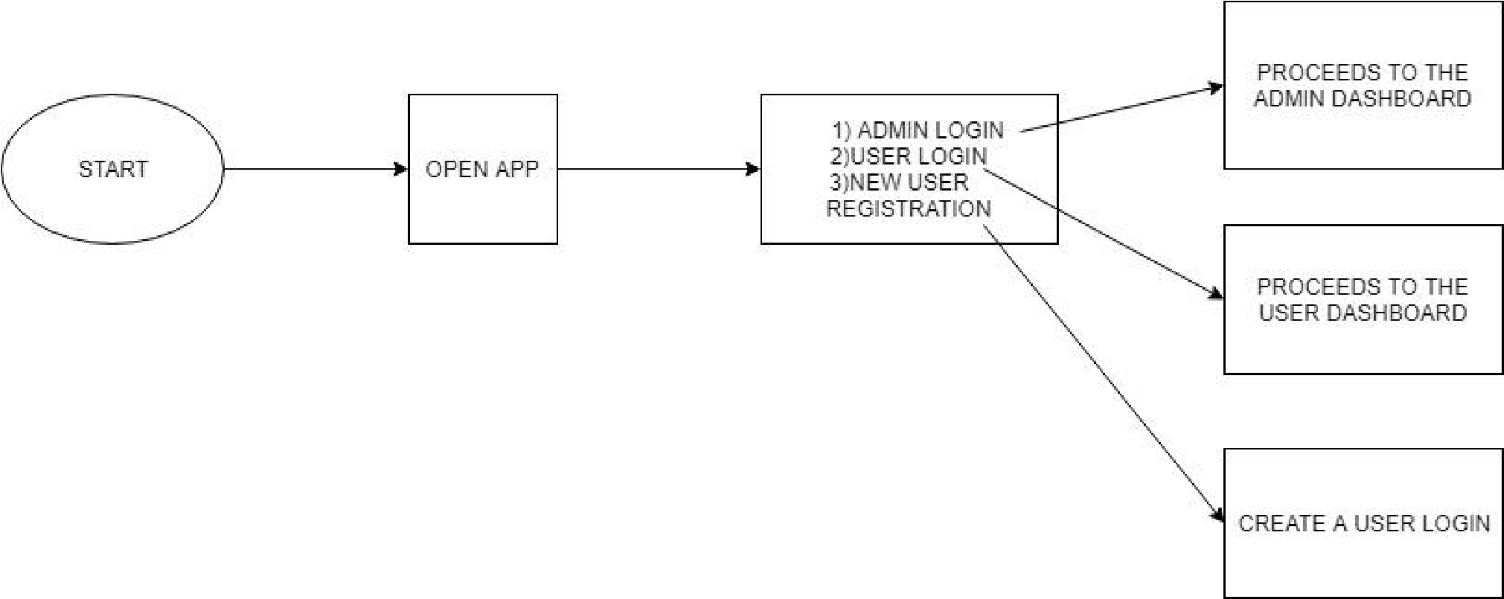

##### FIG 3.1: INITIAL FLOW OF APPLICATION

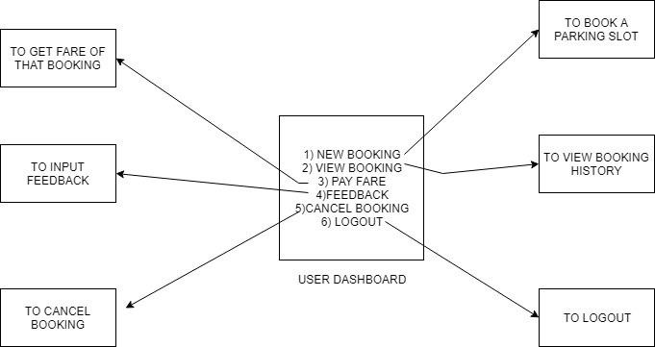

#### FIG 3.2: FLOW CONTROL AT USER’S END

###### 10

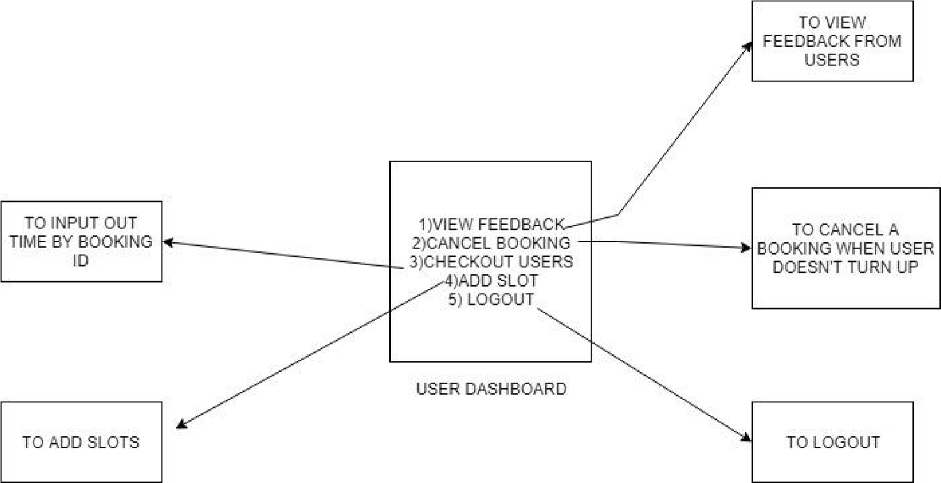

**4. SYSTEM REQUIREMENTS**

##### HARDWARE

* Processor: Pentium 3.0 GHz or higher
* RAM: 1024 Mb or more
* Hard Drive: 10GB or more

##### SOFTWARE

* NodeJS
* MongoDb
* LATEST WEB BROWSER eg.Chrome/Firefox etc.

**5. IMPLEMENTATION DETAILS**

**RUN :NODE APP.JS on cmd**

**OPEN : localhost:2020 on any browser**

**Dynamic Cloning**

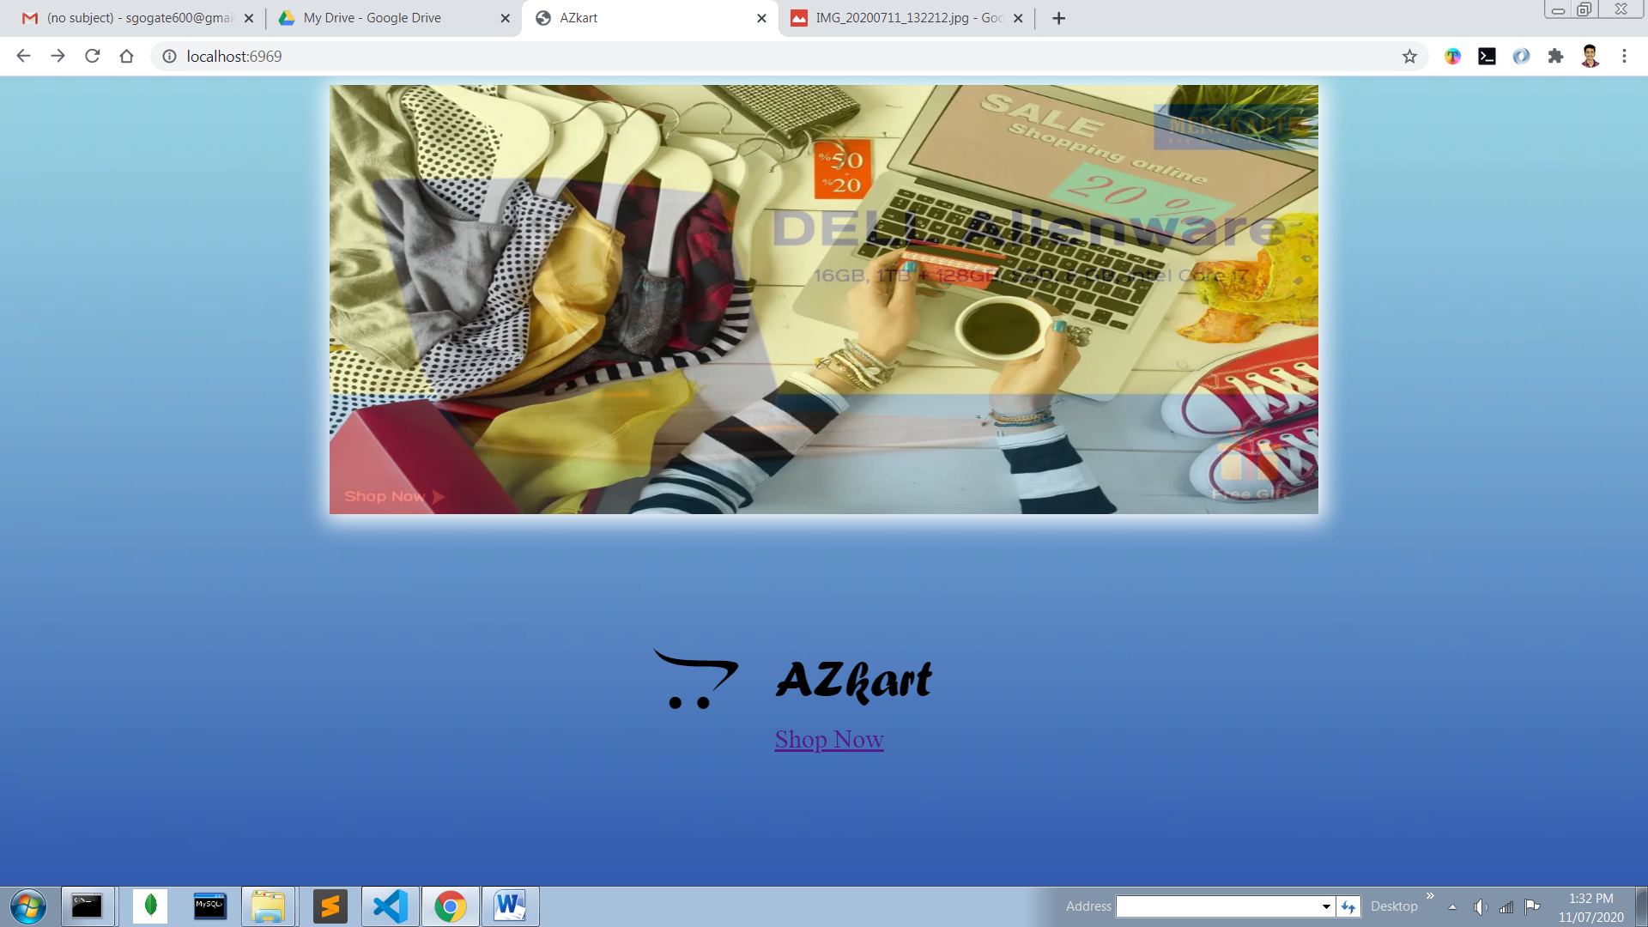

**6. CONCLUSION/FUTURE SCOPE**

**6.1 Future Plan:**

* Want to Increase facilities of this project.
* Want to add printing option.
* Want to develop graphical design.
* Want to add news API
* Want to publish/deploy this website in online.
* Want to remove all the limitation

**6.2 Conclusion:**

After having detail study on online shopping, we can see a great change in the behaviour of people in many manners like their attitude, buying pattern. In earlier times people use to do manual shopping bt now as time changed, people are becoming busy and due to which technology has brought a new revolution i.e. online shopping. As we started doing survey, it came to in notice that young age group people i.e. 15-30 uses of prefer online shopping because it is time and energy saving. But middle age group does not prefer much because they have wrong perception that by seeing the product one can get the goods of proper quality. And even some people does not prefer using plastic money i.e. credit cards. But online shopping has a great future but to be successful it is necessary to spread awareness about its benefit. P a g e | 20 CHA

**7. APPENDIX: CODE SAMPLES**

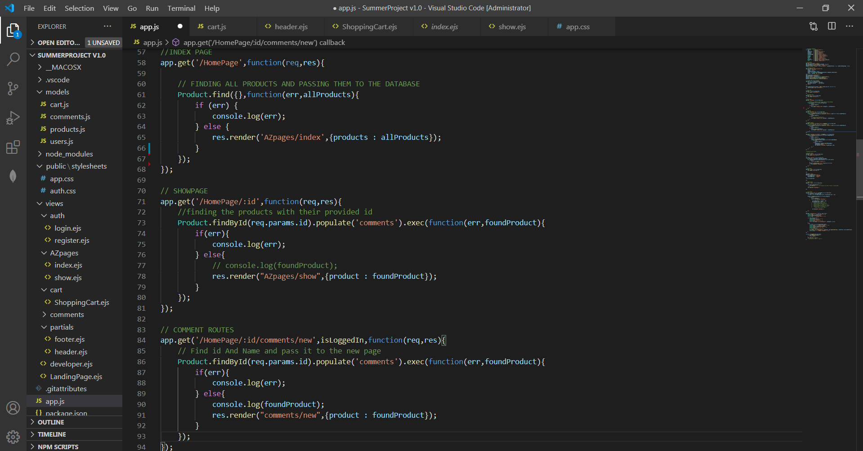

**8. REFERENCE**

**COURSES LEARNED:-**

* <https://www.udemy.com/course/the-web-developer-bootcamp/> - colt steele
* <https://pro.academind.com/p/javascript-the-tricky-parts> - Maximilian Schwarzmüller
* <https://www.udemy.com/course/mongodb-the-complete-developers-guide/?couponCode=D_0720> - Maximilian Schwarzmüller

**DOCUMENTARY REFERED:-**

* **MongoDb**
* **Npm**
* **BootStrap**
* **NodeJs**

**9. ACKNOWLEDGEMENT**

We would like to express our gratitude to our college Fr. Conceicao Rodrigues Institute of Technology to work on this project. We are grateful to our H.O.D Ms. Dhanashree H for this opportunity to work on this project in our course of engineering. We are thankful to, and fortunate enough to get constant encouragement, support and guidance from all teachers of IT Department who helped us in successfully completing our project.

We would also like to thank our parents for their support throughout, and the constant efforts and motivation by our teammates and friends which helped us attain successfully completion of the project.