1. Write a code to design this table named Web Informax IT Solutions.

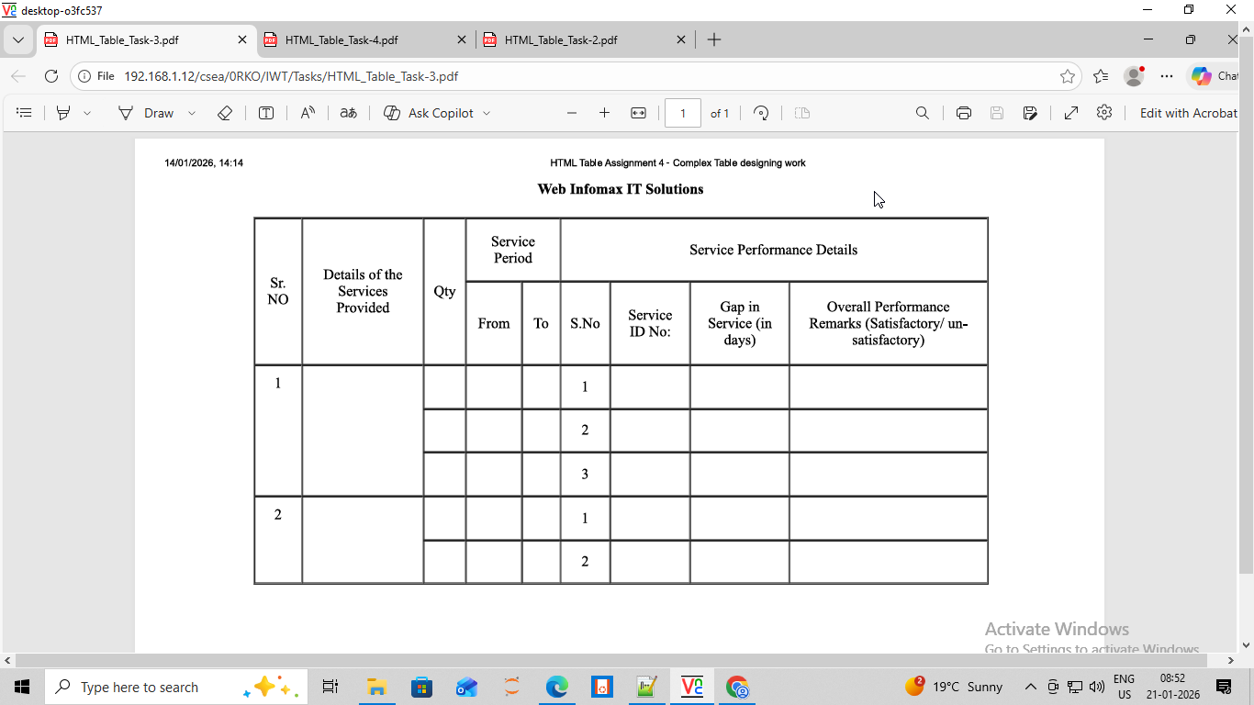

<html>
<head>
<title>Web Informax IT Solutions</title>
</head>

<h2><center><u>Web Informax IT Solutions</center></u></h2>
<center>
<table width="900" height="500" border="3" cellpadding="0" cellspacing="0" bgcolor="white">
<tr>
<th rowspan="2">Sr No.</th>
<th rowspan="2">Details of The Sevices Provided</th>
<th rowspan="2">Qty</th>
<th colspan="2">Service Period</th>
<th colspan="20">Service Performance Details</th>
</tr>

<tr>
<th>From</th>
<th>To</th>
<th>S.No.</th>
<th>Service Id No:</th>
<th>Gap in Service(in days)</th>
<th>Overall Performance Remarks(Satisfactory/Un-satisfactory)</th>
</tr>

<tr>
<td rowspan="3">1</td>
<td rowspan="3"></td>
<td></td>
<td></td>

<td></td>
<td>1</td>
<td></td>
<td></td>
<td></td>
</tr>

<tr>
<td></td>
<td></td>
<td></td>
<td>2</td>
<td></td>
<td></td>
<td></td>
</tr>
<tr>
<td></td>
<td></td>
<td></td>
<td>3</td>
<td></td>
<td></td>
<td></td>
</tr>
<tr>
<td rowspan="2">1</td>
<td rowspan="2"></td>
<td></td>
<td></td>
<td></td>
<td>1</td>
<td></td>
<td></td>
<td></td>
</tr>
<tr>
<td></td>
<td></td>
<td></td>
<td>2</td>
<td></td>
<td></td>
<td></td>
</tr>
</table>
</center>
</html>

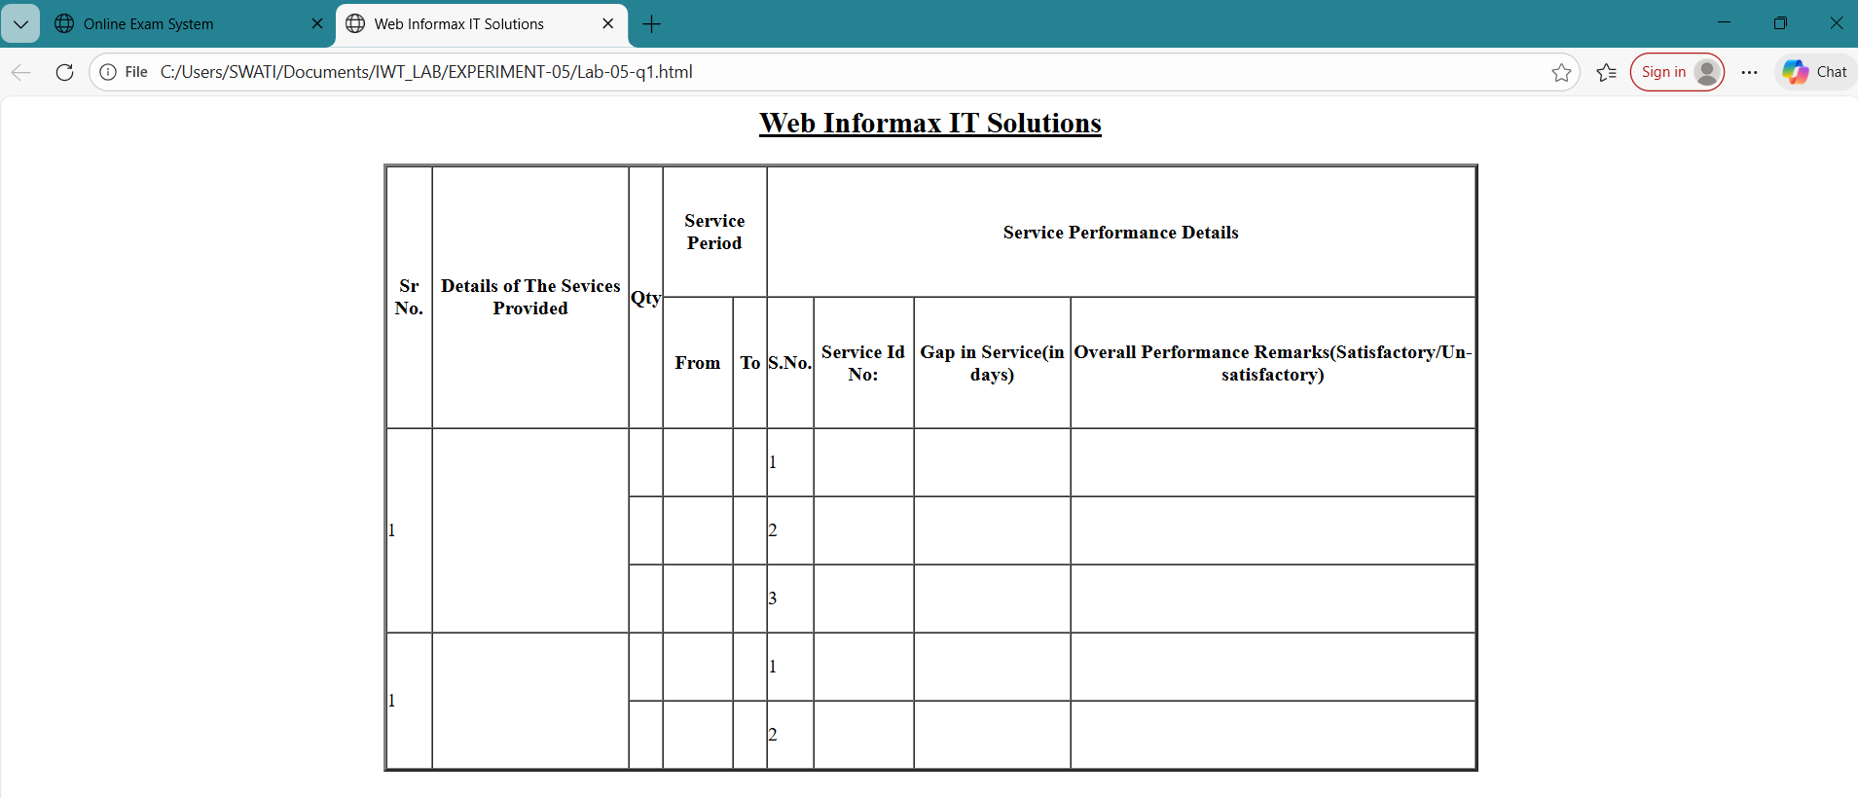

2. Write a code to design this web page named Online Exam System.

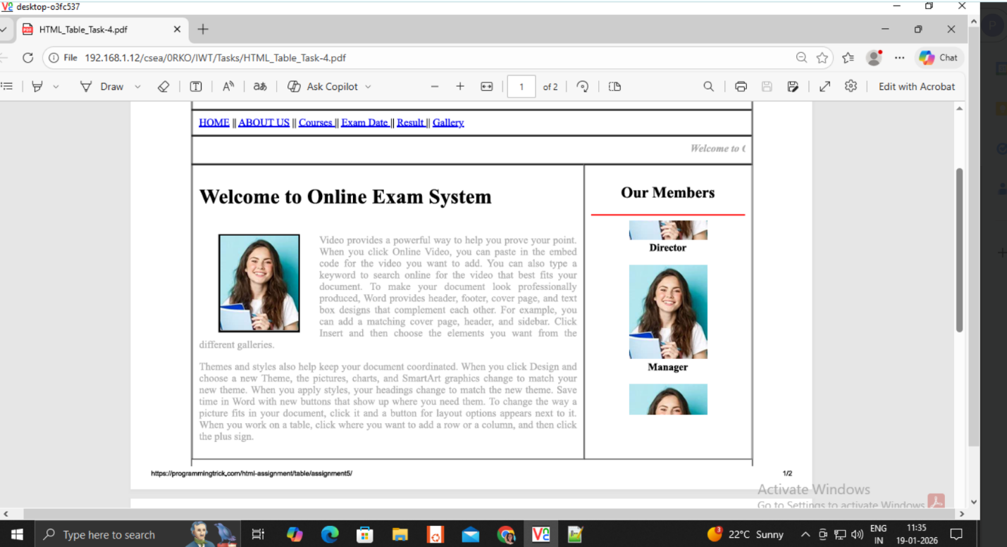

<html>
<head>
<title>Online Exam System</title>
</head>
<center>
<table width="950" height="400" border="3" cellpadding="3" cellspacing="0" bgcolor="white">

<tr>
<th colspan="15"><h2>Online Exam System</h2></font></th>
</tr>

<tr height="50">
<td colspan="9">
<a href="Lab-05-q1.html">HOME</a>||
<a href="Lab-05-q1.html">ABOUT US</a>||
<a href="Lab-05-q1.html">Courses</a>||
<a href="Lab-05-q1.html">Exam Date</a>
<a href="Lab-05-q1.html">Result</a>||
<a href="Lab-05-q1.html">Gallery</a>
</td>
</tr>

<tr height="50">
<td colspan="9"><font color="gray"><marquee direction="right" width="100%" text scrolldelay=10 scrollamount=10><i>Welcome To Online Exam System</i></marquee></font></td>
</tr>

<tr colspan="4">
<td valign="top">
<h1>Welcome To Online Exam System</h1></th>

<img src="Smiling_Woman.jpeg" height="240" width="200" align="left" hspace="25" vspace="15">

<pre="left"><font size="4">
Video provides a powerful way to help you prove your point. When you click Online Video, you can paste in the embed code for the video you want to add. You can also type a keyword to search online for the video that best fits your document. To make your document look professionally produced, Word provides Header, Footer, Cover Page, and Text Box designs that complement each other. For example, you can add a matching cover page, header, and sidebar. Click, insert and then choose the elements you want from the different galleries.<br><br>

Themes and styles also help keep your document co-ordinated. When you click Design and choose a new Theme, the pictures, charts, and SmartArt graphics change to match your new theme. When you apply styles, your headings change to match the new theme. Save time in Word with new buttons that show up where you need them. To change the way a picture fits in your document, click it and a button for layout options appears next to it. When you work on a table, click where you want to add a row or a column, and then click the plus sign.
</font></pre>
</td>

<td colspan="28">
<center><h2>Our Members</h2></center>

<hr color="red" width="200">

<marquee direction="down" color="gray" width=100% secolldelay=10 scrollamount=10>

<img src="Smiling_Woman.jpeg" height="140" width="140" align="center" hspace="28">
<b><center>Director</center></b><br>

<img src="Smiling_Woman.jpeg" height="140" width="140" align="center" hspace="28">
<b><center>Manager</center></b><br>

<img src="Smiling_Woman.jpeg" height="140" width="140" align="center" hspace="28"
</marquee>
</td>
</tr>

<tr>
<td><center>Copyright</center></td>
</tr>

</table>
</center>
</html>

