TASK-06:

Q. Write a code to design this Registration Form.

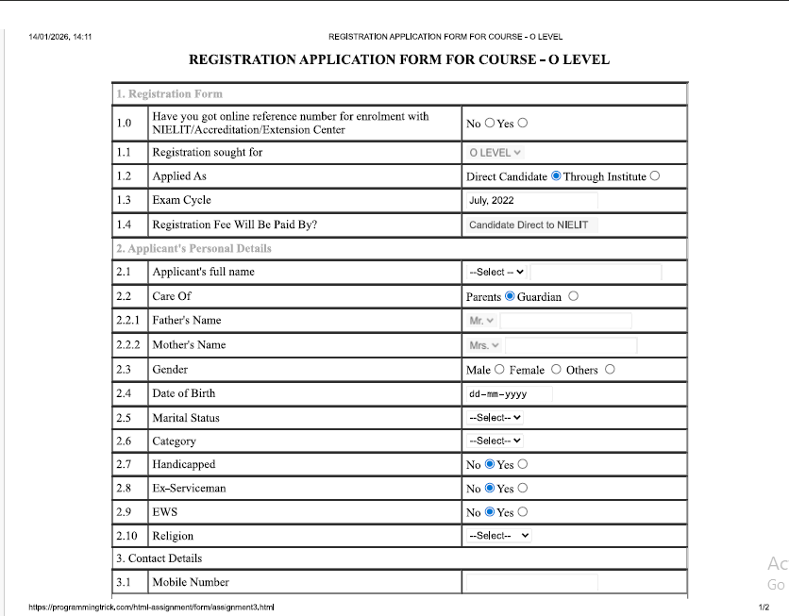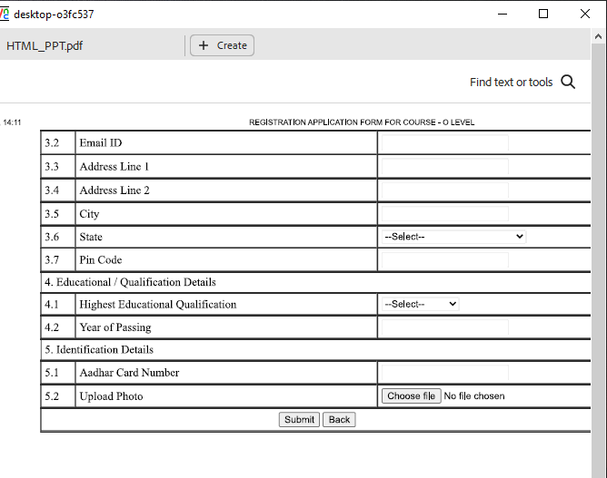

<html>
<head>
<title>Task-06</title>
</head>
<center>
<h3><u>REGISTRATION APPLICATION FORM FOR COURSE-O LEVEL</u></h3>

<table width="800" height="400" border="3" cellpadding="10" cellspacing="0" bgcolor="white">

<tr align="left">
<th colspan="20" align="left"><font color="gray">1.Registration Form</font></th>
</tr>

<tr align="left">
<th>1.0</th>
<th>Have you got online reference number for enrollment with NIELIT/Accrediation/Extension Center</th>
<th>No<input type="radio" name="No">Yes<input type="radio" name="Yes"></th>
</tr>

<tr align="left">
<th>1.1</th>
<th>Registration sought for</th>
<th><select name="LEVEL">
<option value="O LEVEL">O LEVEL</option>
<option value="A LEVEL">A LEVEL</option>
</select></th>
</tr>

<tr align="left">
<th>1.2</th>
<th>Applied As</th>
<th>Direct Candidate<input type="radio">Through Institute<input type="radio"></th>
</tr>

<tr align="left">
<th>1.3</th>
<th>Exam Cycle</th>
<th>July, 2022</th>
</tr>

<tr align="left">
<th>1.4</th>
<th>Registration Fee Will Be Paid By?</th>
<th><input type="text" placeholder="Candidate Direct To NIELIT"></th>
</tr>

<tr align="left">
<th colspan="20" align="left"><font color="gray">2.Applicant's Personal Details</font></th>
</tr>
<tr align="left">
<th>2.1</th>
<th>Applicant's Full Name</th>
<th><select name="--Select--">
<option value="--Select--">--Select--</option>
<option value="First Name">First Name</option>
<option value="Middle Name">Middle Name</option>
<option value="Last name">Last Name</option>
</select></th>
</tr>

<tr align="left">
<th>2.2</th>
<th>Care Of</th>
<th>Parents<input type="radio">Guardian<input type="radio"></th>
</tr>

<tr align="left">
<th>2.2.1</th>
<th>Father's Name</th>
<th><select name="Mr.">
<option value="Mr.">Mr.</option>
<option value="Mr."></option>
<option value="Uttam">UTTAM</option>
<option value="Ashish">ASHISH</option>
</select></th>
</tr>

<tr align="left">
<th>2.2.2</th>
<th>Mother's Name</th>
<th><select name="Mrs.">
<option value="Mrs.">Mrs.</option>
<option value="Mrs."></option>
<option value="Sipra">SIPRA</option>
<option value="Pramila">PRAMILA</option>
</select></th>
</tr>

<tr align="left">
<th>2.3</th>
<th>Gender</th>
<th>Male<input type="radio">Female<input type="radio">Others<input type="radio"></th>
</tr>

<tr align="left">
<th>2.4</th>
<th>Date of Birth</th>

<th>
<select name="dd">
<option value="dd">dd</option>
<option value="12">12</option>
<option value="13">13</option>
<option value="14">14</option>
<option value="15">15</option>
</select>

<select name="mm">
<option value="mm">mm</option>
<option value="Jan">Jan</option>
<option value="Feb">Feb</option>
<option value="Mar">Mar</option>
<option value="Apr">Apr</option>
</select>

<select name="yyyy">
<option value="yyyy">yyyy</option>
<option value="2006">2006</option>
<option value="2007">2007</option>
<option value="2005">2005</option>
<option value="2001">2001</option>
</select>
</th>
</tr>

<tr align="left">
<th>2.5</th>
<th>Marital Status</th>
<th><select name="--Select--">
<option value="--Select--">--Select--</option>
<option value="Married">MARRIED</option>
<option value="Un-Married">UN-MARRIED</option>
</select></th>
</tr>

<tr align="left">
<th>2.6</th>
<th>Category</th>
<th><select name="--Select--">
<option value="--Select--">--Select--</option>
<option value="Gen">Gen</option>
<option value="OBC">OBC</option>
<option value="SC/ST">SC/ST</option>
</select></th>
</tr>

<tr align="left">
<th>2.7</th>
<th>Handicapped</th>
<th>No<input type="radio">Yes<input type="radio"></th>
</tr>

<tr align="left">
<th>2.8</th>
<th>Ex-Serviceman</th>
<th>No<input type="radio">Yes<input type="radio"></th>
</tr>

<tr align="left">
<th>2.9</th>
<th>EWS</th>
<th>No<input type="radio">Yes<input type="radio"></th>
</tr>

<tr align="left">
<th>2.10</th>
<th>Religion</th>
<th><select name="--Select--">
<option value="--Select--">--Select--</option>
<option value="Hindu">Hindu</option>
<option value="Christian">Christian</option>
<option value="Sikh">Sikh</option>
<option value="Jain">Jain</option>
</select></th>
</tr>

<tr align="left">
<th colspan="20"><font color="gray">3.Contact Details</font></th>
</tr>

<tr align="left">
<th>3.1</th>
<th>Mobile Number</th>
<th></th>
</tr>
<tr align="left">
<th>3.2</th>
<th>Email ID</th>
<th></th>
</tr>

<tr align="left">
<th>3.3</th>
<th>Address Line 1</th>
<th></th>
</tr>
<tr align="left">
<th>3.4</th>
<th>Address Line 2</th>
<th></th>
</tr>

<tr align="left">
<th>3.5</th>
<th>City</th>
<th><select name="--Select--">
<option value="--Select--">--Select--</option>
<option value="Bhubaneswar">Bhubaneswar</option>
<option value="Bengaluru">Bengaluru</option>
<option value="Mumbai">Mumbai</option>
</select></th>
</tr>

<tr align="left">
<th>3.6</th>
<th>State</th>
<th><select name="--Select--">
<option value="--Select--">--Select--</option>
<option value="Odisha">Odisha</option>
<option value="Karnataka">Karnataka</option>
<option value="Maharashtra">Maharashtra</option>
</select></th
</tr>

<tr align="left">
<th>3.7</th>
<th>Pin Code</th>
<th></th>
</tr>

<tr align="left">
<th colspan="20"><font color="gray">4.Educational/Qualification Details</font></th>
</tr>

<tr align="left">
<th>4.1</th>
<th>Highest Educational Qualification</th>
<th><select name="--Select--">
<option value="--Select--">--Select--</option>
<option value="Matriculation">Matriculation</option>
<option value="Senior Secondary">Senior Secondary</option>
<option value="Diploma">Diploma</option>
<option value="UG">UG</option>
<option value="PG">PG</option>
</select></th>
</tr>
<tr align="left">
<th>4.2</th>
<th>Year Of Passing</th>
<th></th>
</tr>

<tr align="left">
<th colspan="20"><font color="gray">5.Identification Details</font></th>
</tr>
<tr align="left">
<th>5.1</th>
<th>Aadhar Card Number</th>
<th></th>
</tr>
<tr align="left">
<th>5.2</th>
<th>Upload Photo</th>
</tr>

<tr>
<th colspan="20" align="center"><input type="button" value="Submit">
<input type="button" value="Back"></th>
</tr>
</table>
</center>
</html>

