1. TASK-07: Design this DOCTOR APPOINTMENT FORM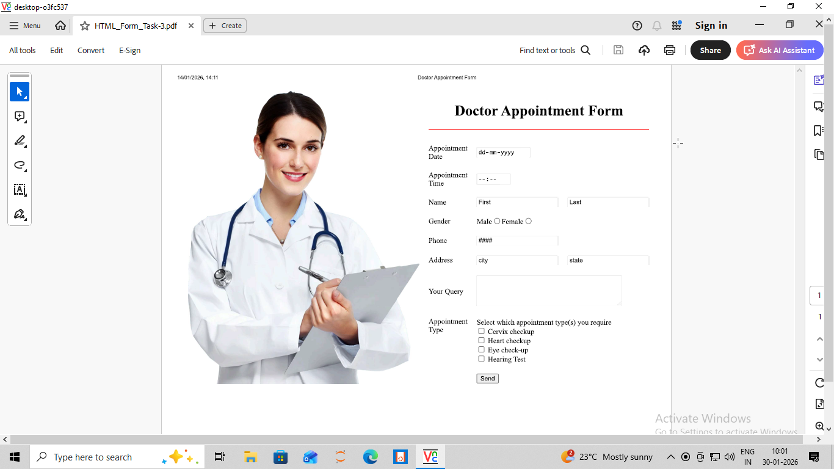

<html>
<head>
<title>TASK-07[FINAL ONE]</title>
</head>
<body>
<center>
<form name="fm1" method="POST" action="">
<table width="70%" height="800" border="0" cellpadding="10" cellspacing="0">
<tr>
<td rowspan="10" width="45%">
<img src="Doctor.png" height="600" width="100%">
</td>
<td colspan="2">
<h1 align="center">Doctor Appointment Form</h1>
<hr color="red" width="100%" size="2">
</td>
</tr>

<tr>
<td width="10%">Appointment Date</td>
<td width="30%"><input Type="text" placeholder="dd-mm-yy" size="9" ></td>
</tr>

<tr>
<td>Appointment Time</td>
<td><input type="text" placeholder="--:--" size="2"></td>
</tr>

<tr>
<td>Name</td>
<td>
<input type="text" name="first_name" placeholder="First">&nbsp;&nbsp;&nbsp;&nbsp;
<input type="text" name="last_name" placeholder="Last">
</td>
</tr>

<tr>
<td>Gender</td>
<td>
Male<input type="radio" name="gender">
Female<input type="radio" name="gender">
</td>
</tr>

<tr>
<td>Phone</td>
<td><input type="tel" placeholder="####"></td>
</tr>

<tr>
<td>Address</td>
<td>
<input type="text" name="state" placeholder="State">&nbsp;&nbsp;&nbsp;&nbsp;
<input type="text" name="city" placeholder="City">
</td>
</tr>

<tr>
<td>Your Query</td>
<td>
<textarea rows="4" cols="40"></textarea>
</td>
</tr>

<tr>
<td valign="top">Appointment Type</td>
<td valign="top">Select with Appointment type(s) you require<br>
<input type="checkbox" name="Cervix Checkup">Cervix Checkup<br>
<input type="checkbox" name="Heart Checkup">Heart Checkup<br>
<input type="checkbox" name="Eye Checkup">Eye Checkup<br>
<input type="checkbox" name="Hearing Test">Hearing Test
</td>
</tr>

<tr>
<td></td>
<td>
<input type="button" value="Send">
</td>
</tr>

</table>
</form>
</center>
</body>
</html>



2. TASK-08: Design this APPLICATION FORM

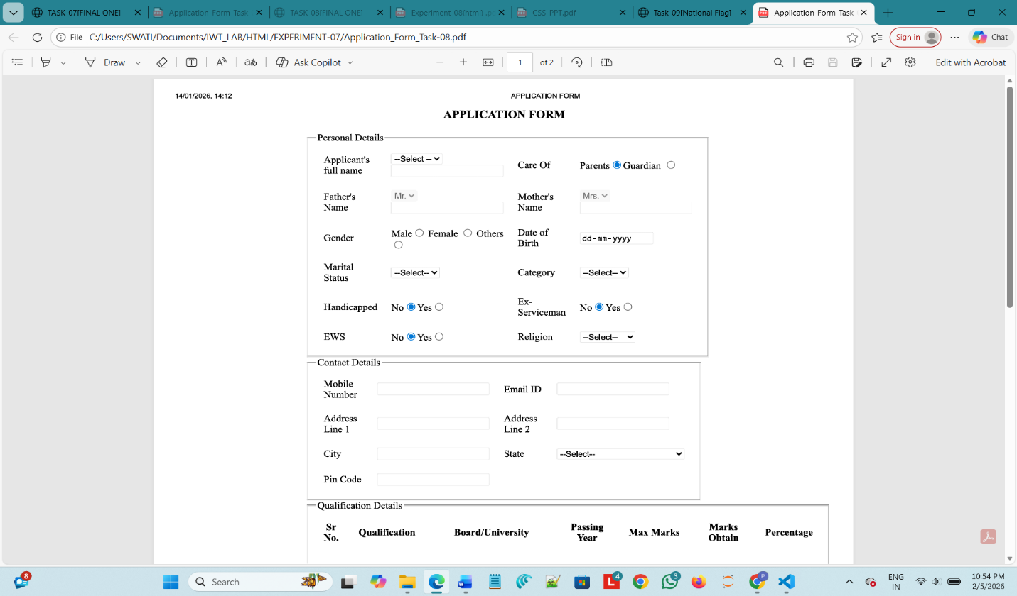

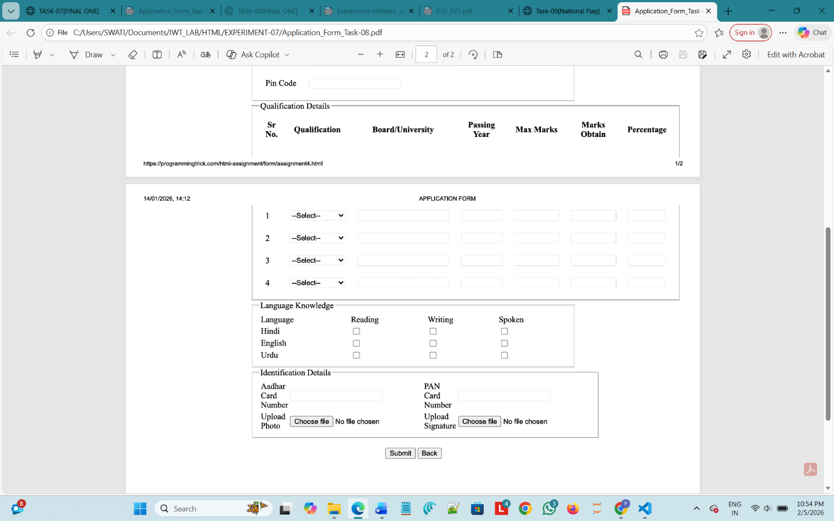

<html>
<head>
<title>TASK-08[FINAL ONE]</title>
</head>

<body>

<center>
<h1>APPLICATION FORM</h1>
</center>

<center>
<form>
<table width="850" border="0" height="300">
<tr>
<td>
<fieldset>
<legend>Personal Details</legend>
<table width="850" border="0" cellpadding="8" cellspacing="0">

<tr>
<td width="10%">Applicant's<br>Full Name</td>
<td width="20%">
<select>
<option>--Select--</option>
<option>Mr.</option>
<option>Ms.</option>
<option>Mrs.</option>
</select>
<br>
<input type="text">
</td>

<td width="10%">Care Of</td>
<td width="20%">
Parents<input type="radio" name="careof">
Guardian<input type="radio" name="careof">
</td>
</tr>

<tr>
<td>Father's<br>Name</td>
<td>
<select>
<option>Mr.</option>
<option>Dr.</option>
</select>
<br>
<input type="text">
</td>

<td>Mother's<br>Name</td>
<td>
<select>
<option>Mrs.</option>
<option>Ms.</option>
<option>Dr.</option>
</select>
<br>
<input type="text">
</td>
</tr>

<tr>
<td>Gender</td>
<td>
Male <input type="radio" name="gender">
Female <input type="radio" name="gender">
Others <input type="radio" name="gender">
</td>

<td>Date<br>of Birth</td>
<td>
<input type="date">
</td>
</tr>

<tr>
<td>Marital<br>Status</td>
<td>
<select>
<option>--Select--</option>
<option>Married</option>
<option>Un-Married</option>
</select>
</td>

<td>Category</td>
<td>
<select>
<option>--Select--</option>
<option>Gen</option>
<option>OBC</option>
<option>SC/ST</option>
</select>
</td>
</tr>

<tr>
<td>Handicapped</td>
<td>
No <input type="radio" name="handicapped">
Yes <input type="radio" name="handicapped">
</td>

<td>Ex-<br>Serviceman</td>
<td>
No <input type="radio" name="exservice">
Yes <input type="radio" name="exservice">
</td>
</tr>

<tr>
<td>EWS</td>
<td>
No <input type="radio" name="ews">
Yes <input type="radio" name="ews">
</td>

<td>Religion</td>
<td>
<select>
<option>--Select--</option>
<option>Hindu</option>
<option>Christian</option>
<option>Sikh</option>
<option>Jain</option>
</select>
</td>
</tr>
</table>
</fieldset>
</td>
</tr>
</table>

<br>

<table width="800" border="0">
<tr><td>
<fieldset>
<legend>Contact Details</legend>
<table width="800" border="0" cellpadding="5" cellspacing="0">
<tr>
<td width="20%">Mobile<br>Number</td>
<td width="30%"><input type="tel"></td>

<td width="20%">Email ID</td>
<td width="30%"><input type="text"></td>
</tr>

<tr>
<td colspan="4"></td>
</tr>

<tr>
<td>Address<br>Line 1</td>
<td><input type="text" size="40"></td>

<td>Address<br>Line 2</td>
<td><input type="text" size="40"></td>
</tr>

<tr>
<td colspan="4"></td>
</tr>

<tr>
<td>City</td>
<td><input type="text"></td>

<td>State</td>
<td>
<select>
<option>--Select--</option>
<option>Odisha</option>
<option>Delhi</option>
<option>Maharashtra</option>
<option>West Bengal</option>
</select>
</td>
</tr>

<tr>
<td colspan="4"></td>
</tr>

<tr>
<td>Pin Code</td>
<td><input type="tel"></td>
<td></td>
<td></td>
</tr>
</table>
</fieldset>
</td>
</tr>
</table>

<br>

<table width="1200" border="0" align="right">
<tr>
<td>
<fieldset>
<legend>Qualification Details</legend>
<table width="900" border="0" cellpadding="5" cellspacing="0">
<tr align="center">
<th>Sr No.</th>
<th>Qualification</th>
<th>Board/University</th>
<th>Passing Year</th>
<th>Max Marks</th>
<th>Marks Obtain</th>
<th>Percentage</th>
</tr>

<tr align="center">
<td>1</td>
<td>
<select>
<option>--Select--</option>
<option>10th</option>
<option>12th</option>
<option>Diploma</option>
<option>Graduation</option>
</select>
</td>
<td><input type="text"></td>
<td><input type="text"></td>
<td><input type="text"></td>
<td><input type="text"></td>
<td><input type="text"></td>
</tr>

<tr align="center">
<td>2</td>
<td>
<select>
<option>--Select--</option>
<option>10th</option>
<option>12th</option>
<option>Diploma</option>
<option>Graduation</option>
</select>
</td>
<td><input type="text"></td>
<td><input type="text"></td>
<td><input type="text"></td>
<td><input type="text"></td>
<td><input type="text"></td>
</tr>

<tr align="center">
<td>3</td>
<td>
<select>
<option>--Select--</option>
<option>10th</option>
<option>12th</option>
<option>Diploma</option>
<option>Graduation</option>
</select>
</td>
<td><input type="text"></td>
<td><input type="text"></td>
<td><input type="text"></td>
<td><input type="text"></td>
<td><input type="text"></td>
</tr>

<tr align="center">
<td>4</td>
<td>
<select>
<option>--Select--</option>
<option>10th</option>
<option>12th</option>
<option>Diploma</option>
<option>Graduation</option>
</select>
</td>
<td><input type="text"></td>
<td><input type="text"></td>
<td><input type="text"></td>
<td><input type="text"></td>
<td><input type="text"></td>
</tr>
</table>
</fieldset>
</td>
</tr>
</table>

<br>

<table width="900" border="0">
<tr>
<td>
<fieldset>
<legend>Language Knowledge</legend>
<table width="700" border="0" cellpadding="5" cellspacing="0">
<tr align="center">
<td>Language</td>
<td>Reading</td>
<td>Writing</td>
<td>Spoken</td>
</tr>
<tr align="center">
<td>Hindi</td>
<td><input type="checkbox"></td>
<td><input type="checkbox"></td>
<td><input type="checkbox"></td>
</tr>
<tr align="center">
<td>English</td>
<td><input type="checkbox"></td>
<td><input type="checkbox"></td>
<td><input type="checkbox"></td>
</tr>
<tr align="center">
<td>Urdu</td>
<td><input type="checkbox"></td>
<td><input type="checkbox"></td>
<td><input type="checkbox"></td>
</tr>
</table>
</fieldset>
</td>
</tr>
</table>

<br>

<table width="850" border="0">
<tr>
<td>
<fieldset>
<legend>Identification Details</legend>
<table width="850" border="0" cellpadding="5" cellspacing="0">
<tr>
<td width="20%">Aadhar<br>Card<br>Number</td>
<td width="30%"><input type="text"></td>

<td width="20%">PAN<br>Card<br>Number</td>
<td width="30%"><input type="text"></td>
</tr>

<tr>
<td colspan="4"></td>
</tr>

<tr>
<td>Upload<br>Photo</td>
<td><input type="file"></td>

<td>Upload<br>Signature</td>
<td><input type="file"></td>
</tr>
</table>
</fieldset>
</td>
</tr>
</table>

<br>

<input type="submit" value="Submit">
<input type="button" value="Back">

</form>
</center>

</body>
</html>

