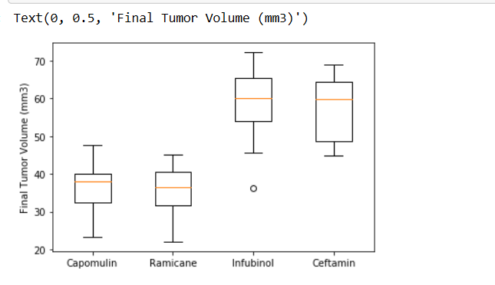

* Based on the above boxplot it appears that Infubinol followed by Ceftamin is least effective in treating cancer as they have on average higher tumor volume.

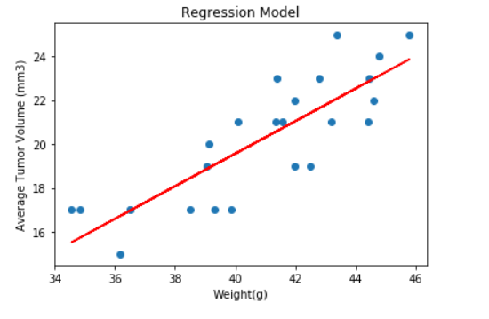

* Based on the above regression model it appears that there is direct correlation between average tumor volume and weight of the mouse for Capomulin regimen

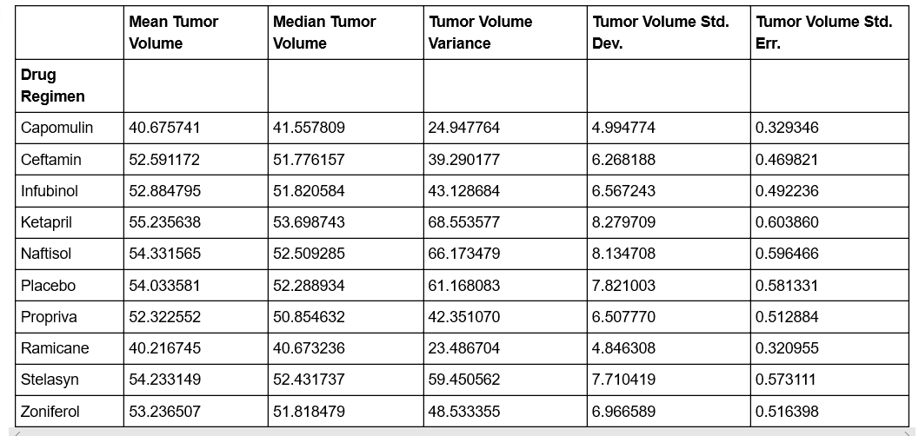

* Based on the tumor volume variance we say that Capomulin and Ramicane has data points less spread out from the mean